# **🌾 Kuyash Integrated Farm Management System (FMS)**

A comprehensive multi-branch farm management platform combining **Poultry**, **Fishery**, **Livestock**, and **Auxiliary Production Units** to improve operations, monitoring, profitability, and scalability.

## **🧩 Core Modules**

### **1. 🐔 Poultry Management**

Tracks all poultry operations including layers, broilers, and breeders.

**Features:**

* **Flock Management:** Batch ID, breed, quantity, age, sex, date of arrival, source.
* **Growth Stage Monitoring:** Chicks, growers, adults.
* **Feed Tracking:** Feed inventory, daily consumption, feed conversion ratio (FCR).
* **Health & Vaccination:** Vaccination schedules, illness tracking, mortality, culling, disease response logs.
* **Egg Production:** Daily egg count, grading, packaging, size & quality metrics.
* **Sales & Disposal:** Eggs, live birds, spent layers/broilers, manure.

### **2. 🐟 Fish Pond Management**

Handles fish lifecycle, water quality, and harvest activities.

**Features:**

* **Pond Records:** Pond type, size, location, fish species, stocking date.
* **Water Quality:** pH, temperature, oxygen, salinity.
* **Feeding Schedule:** Feed types, quantity, frequency.
* **Growth Monitoring:** Weight sampling, size analysis, mortality tracking.
* **Harvest & Sales:** Quantities harvested, mortality, sales logs.

### **3. 🐄 Livestock Management (Animal Husbandry)**

Tracks animals such as cows, goats, sheep, pigs.

**Features:**

* **Animal Inventory:** Breed, ID/tag number, age, gender, acquisition date, origin.
* **Health & Treatments:** Vet visits, vaccination records, medical history.
* **Feeding & Nutrition:** Feed plans, pasture usage, supplements.
* **Breeding Management:** Heat cycles, insemination dates, pregnancy tracking, calving records.
* **Production Logs:** Milk yield, meat yield, weight gains.
* **Sales & Disposal:** Deadstock records, live/meat sales.

### **4. 🛠 Asset & Auxiliary Unit Management**

Track non-animal production and fixed assets.

**Features:**

* **Asset Management:** Vehicles, machinery, tools – with maintenance schedules.
* **Paper Crate Production:** Production logs, dispatch, cost and price tracking.
* **Ice Block Production:** Batch tracking, quantity produced/dispatched, cost/profit logs.
* **Manual Packaging:** Quantities packaged, cost, price, and dispatch logs.

## **📦 Cross-Module Shared Features**

### **✅ Inventory Management**

* Real-time feed, medicine, equipment, and tool tracking.
* Low stock alerts and expiry reminders.

### **💵 Finance & Expense Management**

* Tracks income (eggs, fish, meat, services).
* Operational expenses (feed, medicine, labor, utilities).
* Profit & loss calculations.
* Cost of production per product/unit.

### **👥 Employee/HR Management**

* Staff profiles (role, department, bio).
* Attendance, payroll, performance.
* Duty assignment and accountability.

### **📈 Reports & Analytics**

* Custom reports by date range, module, batch, or activity.
* Growth and productivity reports.
* Sales performance and expense trend analysis.
* Exportable in PDF/Excel.

### **📲 Alerts & Notifications**

* Vaccination reminders.
* Feed time and low inventory warnings.
* Harvest and task reminders.
* System alerts (e.g., pond pH abnormality).

### **🛡 Access Control & User Roles**

* Role-based access (Admin, Manager, Worker).
* Audit trail/log of user activities.

### **📊 Central Dashboard**

* At-a-glance KPIs across all modules.
* Real-time visualization of stock, revenue, expenses, and alerts.

## **🌍 Additional Features (Based on Global Best Practices)**

### **🛰 GIS & IoT Integration *(optional advanced tier)***

* GPS mapping of ponds, pens, and pasture.
* Sensor integration for water quality and climate data.
* Smart alerts from IoT sensors (temperature, ammonia, water levels).

### **🧾 Traceability & Compliance**

* Full animal/batch traceability (from origin to sale).
* Export documentation & compliance log (for food safety & veterinary standards).

### **🗓 Calendar & Task Management**

* Daily/weekly task planner for staff.
* Seasonal planning (e.g., vaccination cycles, breeding seasons).

### **📥 CRM & Order Management *(optional add-on)***

* Customer database for regular buyers.
* Sales orders, delivery tracking, invoicing.

### **📱 Mobile Access / Offline Mode**

* Mobile app support for field workers.
* Offline record-keeping synced when back online.

### **🧮 Production Forecasting & Planning**

* Estimate yields based on historical data.
* Feed budgeting based on animal growth and production cycles.

🏗 Kuyash Integrated Farm Management System – Architecture (Visual)

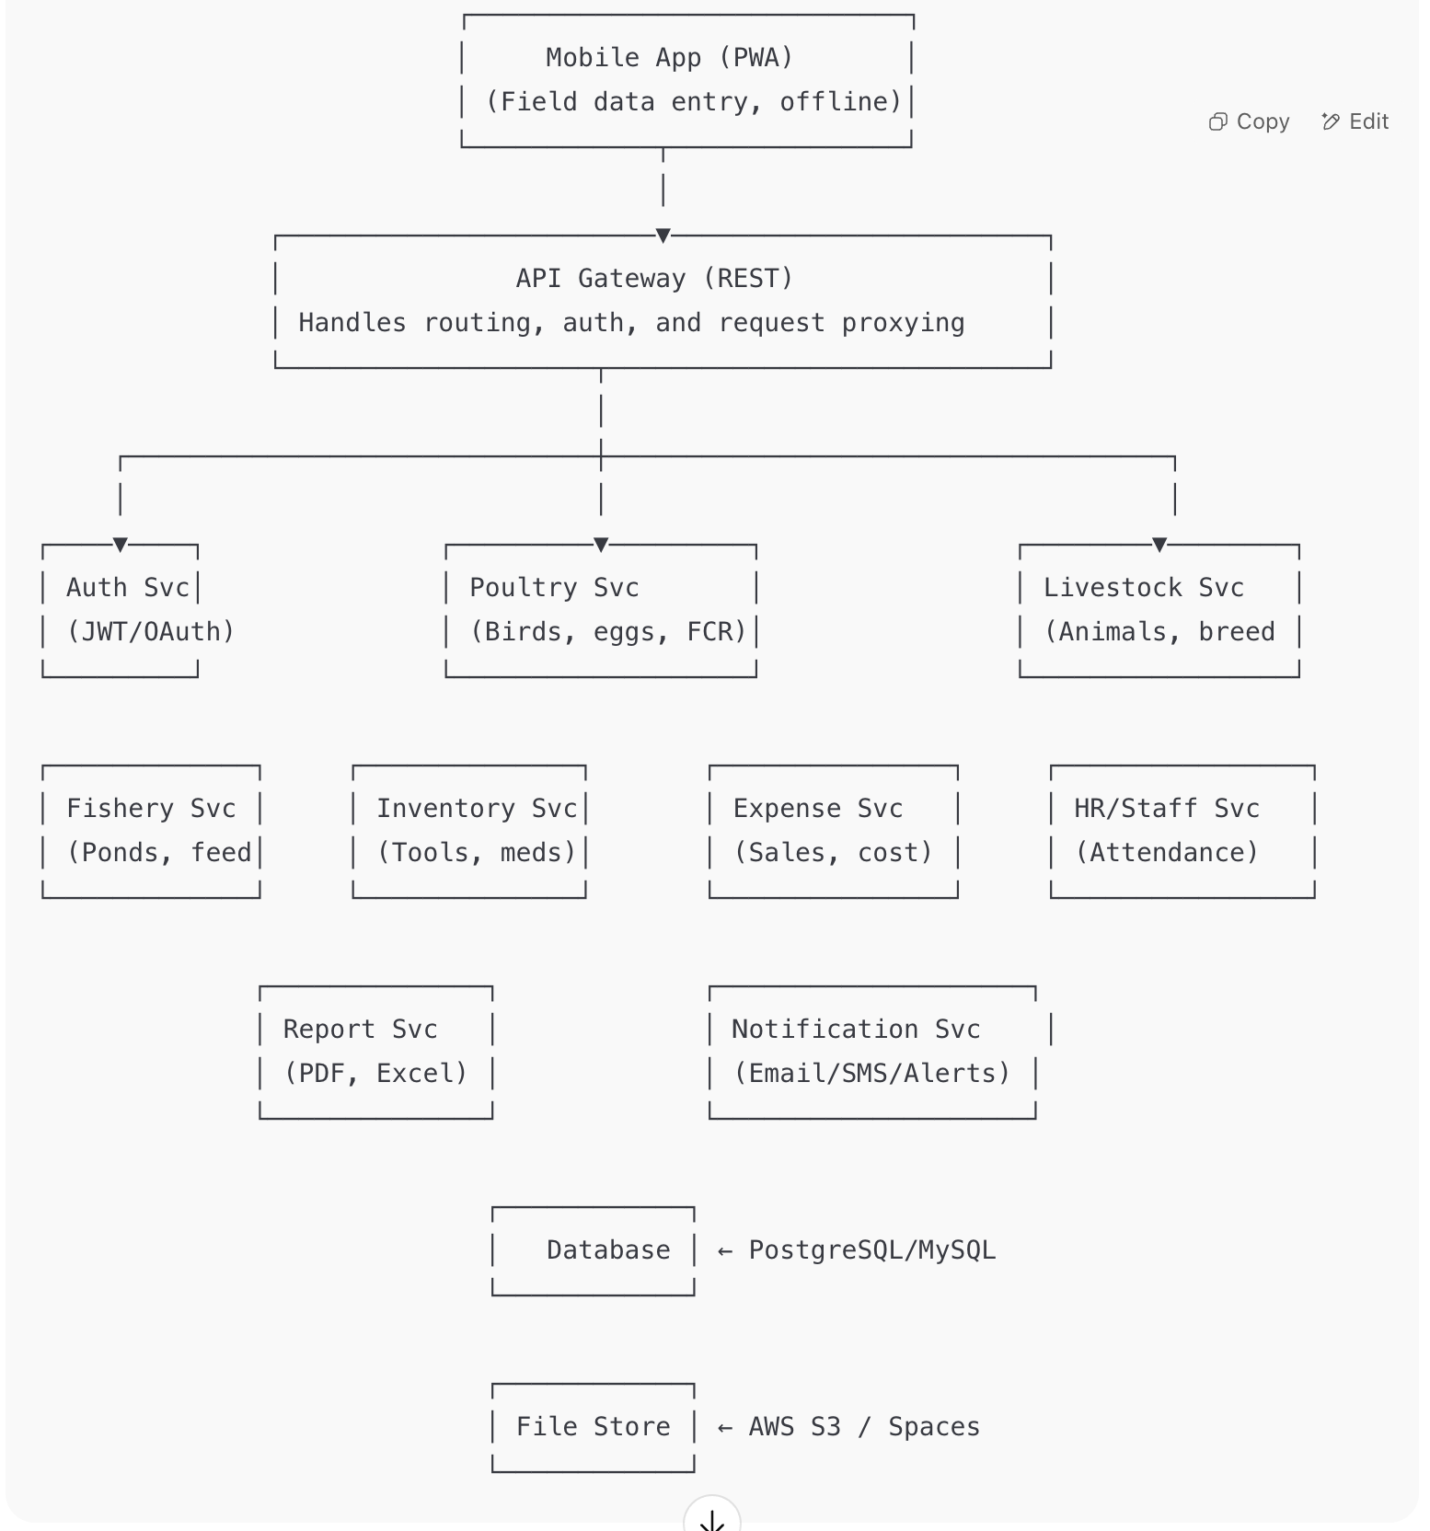

🗂 DATABASE SCHEMA OUTLINE

## **🔐 1. User & Role Management**

users

- id (PK)

- name

- email

- password_hash

- role_id (FK to roles)

- status (active/inactive)

- created_at

- updated_at

roles

- id (PK)

- name (admin, manager, worker)

- permissions (JSON)

## **🐔 2. Poultry Management**

bird_batches

- id (PK)

- batch_code

- bird_type (layer, broiler, breeder)

- breed

- quantity

- arrival_date

- source

- house_location

- status (active/sold/culled)

bird_feeding_logs

- id (PK)

- batch_id (FK to bird_batches)

- date

- feed_type

- quantity_kg

- remarks

egg_production_logs

- id (PK)

- batch_id (FK to bird_batches)

- date

- egg_count

- grade (A/B/cracked)

- packaging_status

bird_health_records

- id (PK)

- batch_id (FK)

- date

- vaccine_or_disease

- action_taken

- remarks

bird_sales

- id (PK)

- batch_id (FK)

- date

- bird_type

- quantity

- unit_price

- buyer_name

## **🐄 3. Livestock Management**

animals

- id (PK)

- tag_number

- species (cow, goat, pig)

- breed

- gender

- date_of_birth

- acquisition_date

- source

- status (alive/sold/dead)

animal_health_records

- id (PK)

- animal_id (FK)

- date

- treatment/vaccine

- notes

breeding_records

- id (PK)

- female_id (FK to animals)

- male_id (FK to animals)

- insemination_date

- pregnancy_confirmed (bool)

- calving_date

- calf_tag

production_logs

- id (PK)

- animal_id (FK)

- date

- milk_yield_liters

- meat_weight_kg

## **🐟 4. Fish Pond Management**

ponds

- id (PK)

- name

- location

- type (earthen/concrete/tank)

- size_m2

- species_stocked

- stocking_date

- initial_stock_count

pond_water_quality

- id (PK)

- pond_id (FK)

- date

- ph

- temperature

- oxygen_level

- remarks

fish_feeding_logs

- id (PK)

- pond_id (FK)

- date

- feed_type

- quantity_kg

fish_sampling_logs

- id (PK)

- pond_id (FK)

- date

- average_weight_g

- survival_rate

- notes

fish_harvests

- id (PK)

- pond_id (FK)

- date

- quantity_harvested

- average_weight

- total_weight

- sales_id (optional FK)

## **🏭 5. Asset & Auxiliary Production**

assets

- id (PK)

- asset_name

- category (vehicle, tool, machine)

- serial_number

- purchase_date

- condition

- location

- assigned_to (FK to users)

- maintenance_logs (JSON or separate table)

auxiliary_production

- id (PK)

- type (paper_crate, ice_block, manual_pack)

- date

- quantity_produced

- cost_of_production

- quantity_dispatched

- unit_price

## **📦 6. Inventory & Consumables**

inventory_items

- id (PK)

- item_name

- category (feed, medicine, tools)

- unit

- reorder_level

- current_stock

- expiry_date

- supplier

inventory_transactions

- id (PK)

- item_id (FK)

- type (in/out/adjustment)

- date

- quantity

- reason

- user_id (FK)

## **💵 7. Finance, Sales & Expenses**

sales

- id (PK)

- item_type (egg, bird, fish, meat, crate)

- item_id (FK to relevant table)

- date

- quantity

- unit_price

- total_amount

- buyer_name

expenses

- id (PK)

- category (feed, salary, med, utility)

- description

- amount

- date

- payment_method

- recorded_by (FK to users)

## **🔔 8. Notifications & Task Reminders**

notifications

- id (PK)

- type (vaccine_due, feed_low, water_alert)

- reference_id

- module (poultry, pond, etc.)

- content

- status (unread/read)

- triggered_at

tasks

- id (PK)

- title

- description

- assigned_to (FK to users)

- related_module

- due_date

- status (pending/completed)

### **🧱 2. Tech Stack Recommendation**

| **Layer** | **Tech Suggestions** |
| --- | --- |
| Frontend (Web) | React.js |
| Frontend (Mobile) | PWA |
| Backend API | Node.js (Express) |
| Database | MySQL |
| Notifications | Email service, [Socket.IO](http://socket.io), **Web Push API, IndexedDB + Background Sync API** |
| File Storage | AWS S3 / Google Drive / |
| Authentication | JWT / OAuth2 + Role-based ACL |
|  |  |
|  |  |