Nudge
  - Small Nudges. Big Streaks.
  - MVP Product Specification — Meta AI Developer 7-Day Hackathon
A voice-first habit and task companion that learns your rhythm and nudges you with warm, perfectly timed reminders — in your tone, with your name.

1. Executive Summary
Nudge is a voice-first habit and task companion. It learns a person’s rhythm once, keeps a small set of habits and tasks straight, and speaks a warm reminder at the moment it will actually be useful. It is not a project-management suite, not a calendar, and not a generic chatbot. Its job is consistency without guilt.
The MVP proves one closed loop. The user describes who they are and how their day runs in a five-step setup, builds habits and tasks once, and then Nudge handles the remembering and the timing. Nudges arrive as push notifications, optionally spoken aloud, in a tone the user chose, using the user’s first name and their current streak. Sleep is protected by quiet hours. Missed nudges are summarised the next morning instead of being stacked up as guilt. Progress, streaks and consistency are shown as evidence, and a Nudge AI Insight turns the pattern into one concrete suggestion.
Everything the assistant does, it proposes. Nudge can reschedule a task, suggest a habit, or offer to clear the morning — but the user confirms before anything changes.

2. One-Line Pitch
Nudge is a voice-first habit and task companion that learns your rhythm, keeps your habits and tasks straight, and nudges you with warm, perfectly timed reminders — in your tone, with your name.

3. Product Thesis
Traditional productivity software asks people to maintain the system. Nudge reverses that relationship. You teach Nudge your rhythm once; it maintains continuity between intention and action.
Product category | Primary abstraction | What it cannot do
Alarms | A fixed time | Adapt to context, tone, or what actually happened yesterday.
To-do lists | Tasks | Tell you when to do them, or notice you stopped.
Habit apps | Checkboxes | Speak to you, adapt, or connect a habit to your real schedule.
Calendars | Events | Hold habits, streaks, or a sense of whether you are keeping up.
AI chatbots | Conversation | Run on their own, at the right moment, without being asked.
Nudge | Your rhythm, habits and tasks — spoken back at the right moment | Nothing about the loop is manual after setup.

4. Problem
People do not lack tools for tracking habits and tasks. They lack continuity. They set up reminders, the reminders startle rather than help, a bad night breaks a streak, and the system quietly stops being worth opening.
Current approach | Problem
Fixed alarms | Fire at a predetermined time regardless of context, sleep, or energy.
To-do lists | Require continuous manual maintenance, re-prioritisation and re-typing.
Habit trackers | Count checkboxes, then punish a missed day instead of adapting.
Calendars | Represent time commitments but not the routines around them.
AI chatbots | Can answer when asked but do not maintain an actionable loop.
Nudge | Combines habits, tasks, context, behaviour and adaptive intervention.

5. Product Insight
The insight is that a habit is not a task with a checkbox. A habit is a promise about a time of day that only works if the reminder arrives warm, on time, and knows what happened yesterday. A task is a promise about a window. Nudge holds both, and treats the person’s rhythm as the context that makes either one land.
GOAL -> HABITS + TASKS -> CONTEXT -> BEHAVIOUR -> DECIDE
|
LEARN <- ACTION <- NUDGE <- TIME <-----+

6. Target Users
- Individuals building a daily routine — fitness, reading, hydration, nutrition, mindfulness, journaling, sleep
- Students and researchers with recurring study and revision routines
- Knowledge workers with a handful of daily habits plus time-boxed tasks
- People who have already failed at alarms because alarms startle, they do not adapt
Initial wedge: individual habit-builders who want consistency without guilt and who will pay to stop tapping. Team features are explicitly out of scope for the MVP.

7. MVP Goals
- Set up a profile in five steps: first name, wake-up time, focus areas, sleep time, and preferred nudge tone.
- Create habits with a time of day, category, duration and frequency.
- Create tasks with a time window, duration, priority, repeat days and notes.
- Deliver nudges as push notifications and, on Pro, as spoken reminders in the chosen tone using the user’s first name.
- Protect sleep with quiet hours, an urgent-task exception, and a morning summary for anything missed.
- Track streaks, consistency, and weekly completion for habits and tasks separately.
- Generate a Nudge AI Insight and let the assistant create or reschedule items by voice or text, with confirmation.
- Hold the free/paid boundary on habits, tasks, voice reminders, habit stacking and insights.

8. Non-Goals for the Hackathon
- Team collaboration, shared accounts, or accountability between other people
- Full project management — boards, Gantt charts, complex dependencies
- Replacing the user’s calendar or task manager
- Autonomous email sending or unattended writes to a calendar
- Dozens of integrations
- A sophisticated custom ML training pipeline
- Social feeds, leaderboards, or streak leagues
- Wearable and health-device ingestion

9. Core Concepts and Domain Model
The MVP holds two user-facing objects — a Habit and a Task — plus the machinery that makes a reminder land. Everything else in the data model supports those two.
Entity | Purpose | Key fields
User | The person, and the settings that make a nudge feel personal. | full_name, email, wake_time, sleep_time, timezone, plan, tone_preference, quiet_hours, reminders_enabled
Habit | A recurring promise tied to a time of day. | name, category, time_of_day, duration_mins, frequency, notes, active, created_at
Task | A one-off or repeating promise inside a time window. | name, date, start_time, end_time, duration_mins, priority, category, notes, repeat_days, status
HabitCompletion | One habit, one day. The atom of every statistic. | habit_id, date, state, completed_at
TaskCompletion | One task, one occurrence. | task_id, due_at, state, completed_at
Streak | Consecutive days a habit or the user kept the promise. | subject_type, subject_id, current_streak, longest_streak, last_success_date
HabitStack | A dependency: complete A, then nudge B. | trigger_habit_id, target_type, target_id, enabled
Nudge | A single intervention, spoken or written. | subject_type, subject_id, scheduled_at, channel, tone, message, spoken, state
NudgeResponse | What the user did with it. | nudge_id, response, responded_at
Insight | A generated observation about a pattern. | kind, period, body, generated_at
ChatMessage | One turn with the assistant. | role, text, created_at, day
ContextEvent | A calendar event surfaced as task context. | provider, external_id, title, start, end

9.1 Time of day
Habits are bucketed by Morning, Afternoon and Evening. The bucket is chosen at creation, drives the default nudge window, and is the unit the assistant reasons over — “you complete 85% of your tasks in the morning” is only computable because of it.

9.2 Categories
Fitness, Learning, Health, Mindfulness, Productivity, Nutrition, Hydration. Chosen at setup, per habit or task, and used to group the list and to drive suggestions.

9.3 Priority and state
Tasks carry High, Medium or Low priority, and move through Upcoming, Completed or Overdue. Completions are graded Missed, Some progress or Completed, so partial credit is visible rather than being rounded to a failure.

10. Onboarding and Personalization
Onboarding is five questions, not a form. Each answer changes something concrete in the product, which is why the setup finishes with a live preview rather than an empty dashboard.
Step | Question | Options | What it configures
1 of 5 | What should we call you? | Free text first name | The name used in every nudge, and whether reminders address the user as “Rophy” or “Hey there…”
2 of 5 | When do you usually wake up? | Before 6:00 am, 6:00–7:00 am, 7:00–8:00 am, After 8:00 am | Anchors the morning habit nudges and the morning summary
3 of 5 | What are you working on? | Multi-select: Fitness, Deep work, Mindfulness, Journaling, Nutrition, Reading, Hydration, Sleep, Focus, Work | Tailors the first habit suggestions around the user’s focus areas
4 of 5 | When do you usually sleep? | Before 9:00 pm, 9:00–10:30 pm, 10:30 pm–12:00 am, After midnight | Sets quiet hours so the last nudge of the day never interrupts rest
5 of 5 | How would you like to be Nudged? | Gentle & Warm, Firm & Motivating, Mix it up | The tone persona used to write and speak every reminder

Step 1 previews a real nudge while the user types their name, so the personalisation is visible before it is committed. Step 3 seeds habit suggestions. Steps 4 and 5 together define when Nudge is allowed to speak and how.
The flow closes on a confirmation rather than a dashboard: “Nudge is ready for you, Rophy!” and “Your AI is all set. Warm reminders, perfect timing — built around you.” Finish Setup then lands on Home.
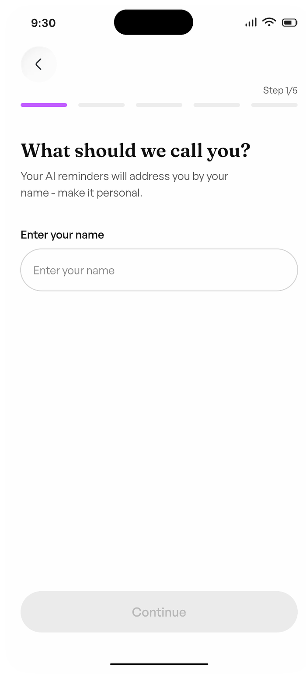
Figure 1 — Onboarding 1/5 — What should we call you?
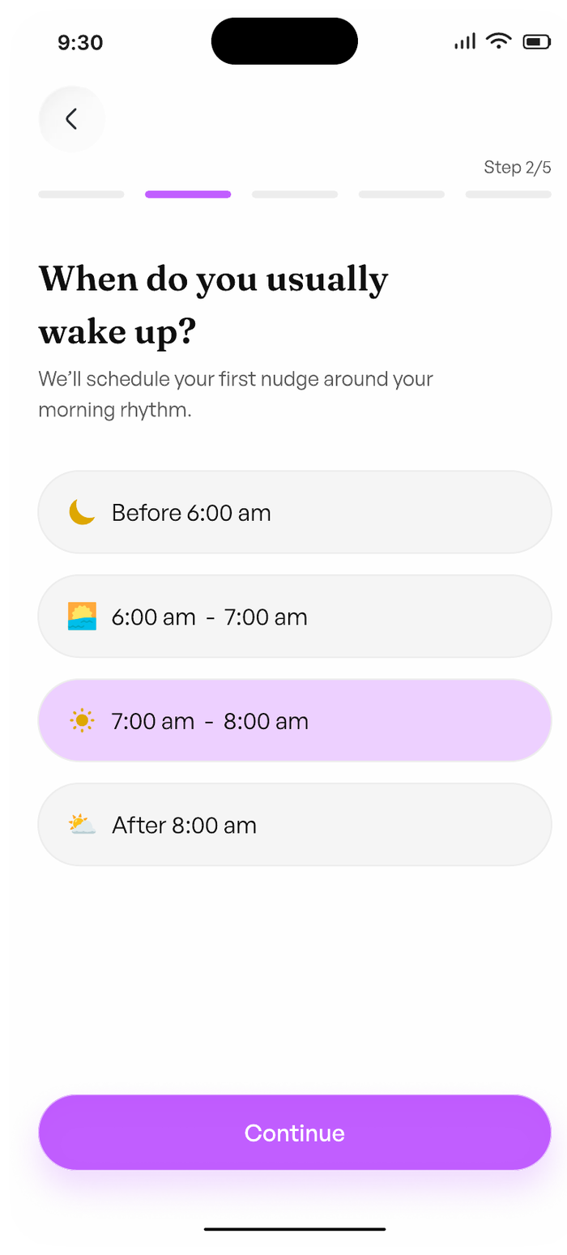
Figure 2 — Onboarding 2/5 — When do you usually wake up?
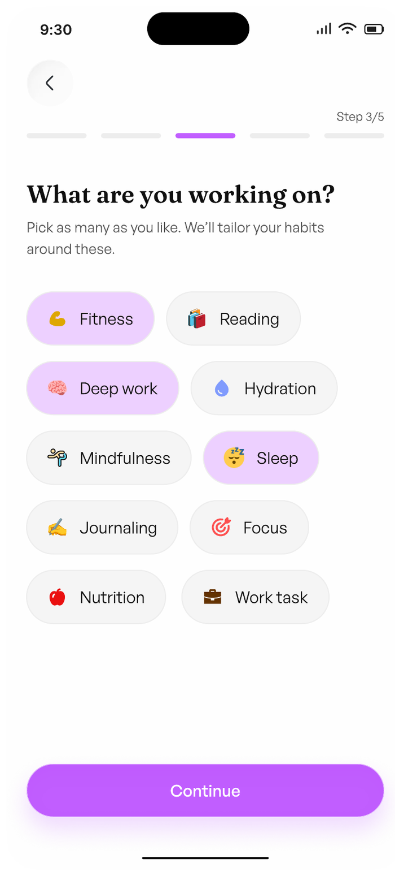
Figure 3 — Onboarding 3/5 — What are you working on?
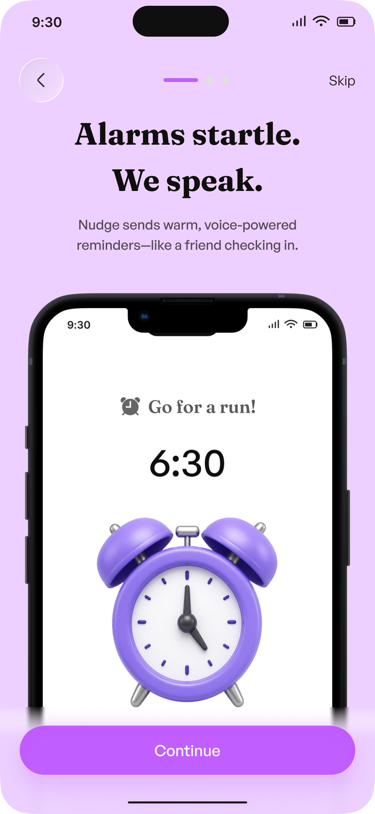
Figure 4 — Onboarding 4/5 — When do you usually sleep?
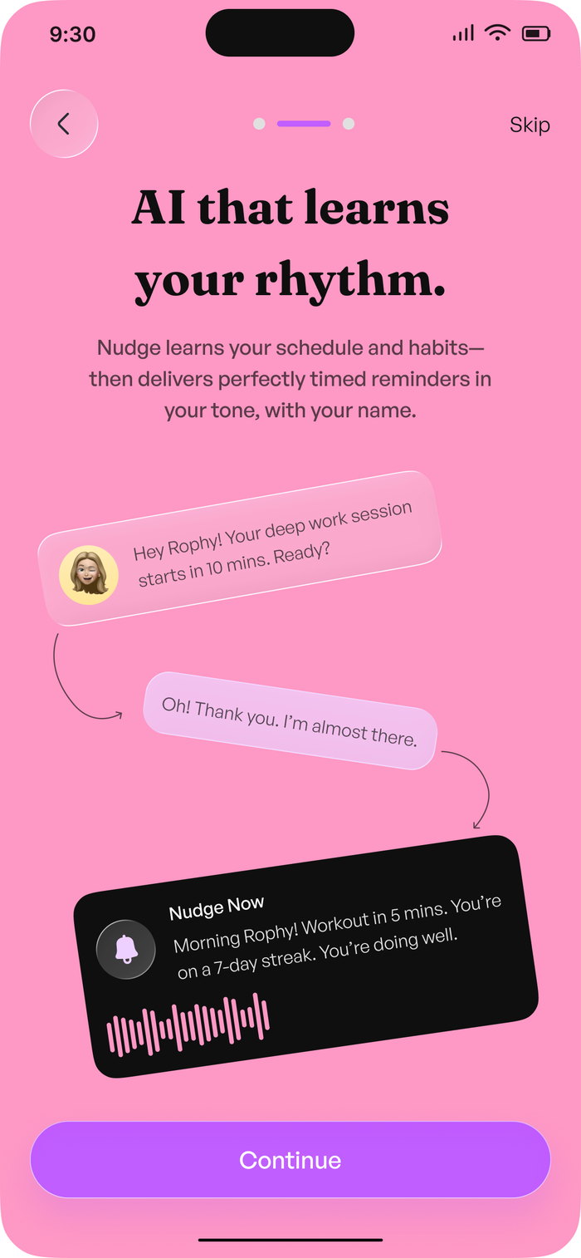
Figure 5 — Onboarding 5/5 — How would you like to be Nudged?
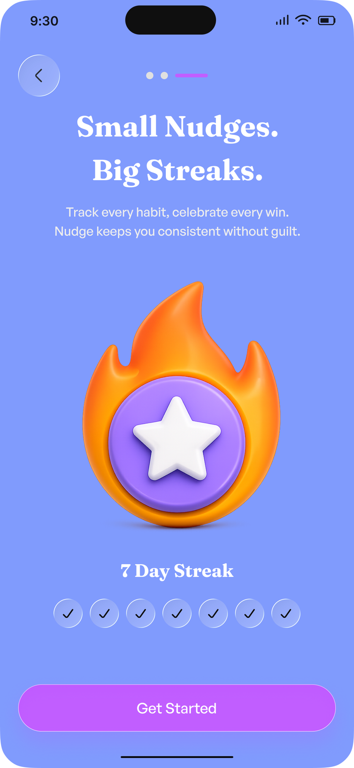
Figure 6 — Nudge is ready for you — onboarding complete

11. Authentication and Account

11.1 Create account
Full name, email address and password, with Sign Up with Google and Sign Up with Apple. The form is shown in empty, active and completed states. The promise in the header — “Start building better habits today!” — matches the free-tier position in Section 25.
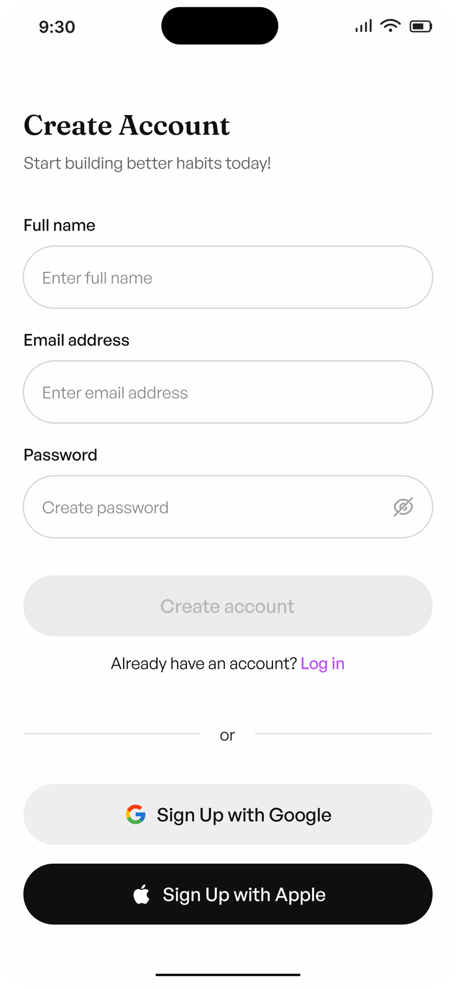
Figure 7 — Create account — empty form
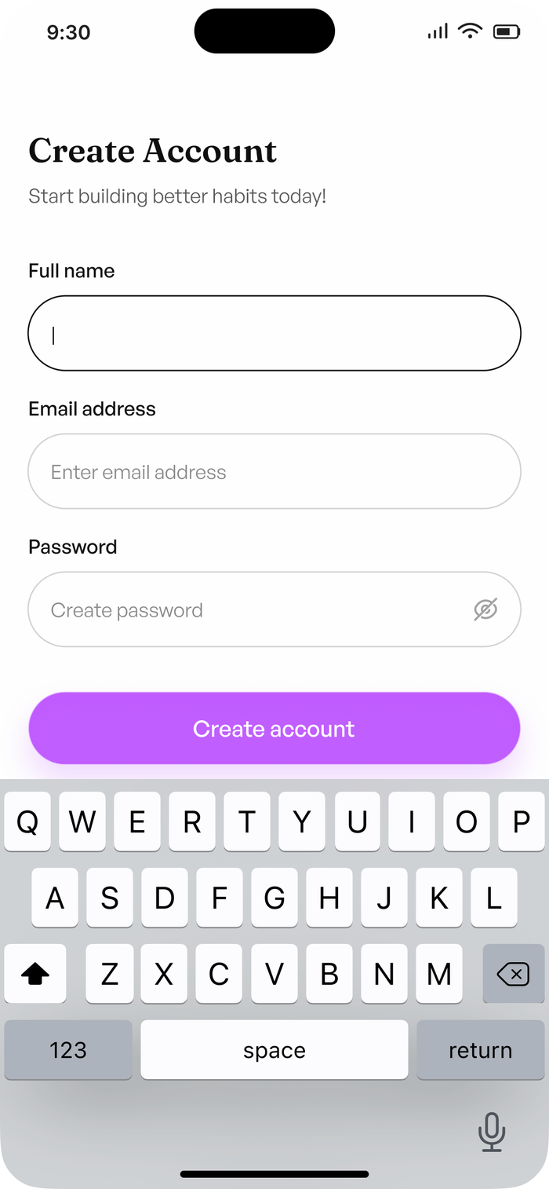
Figure 8 — Create account — active state
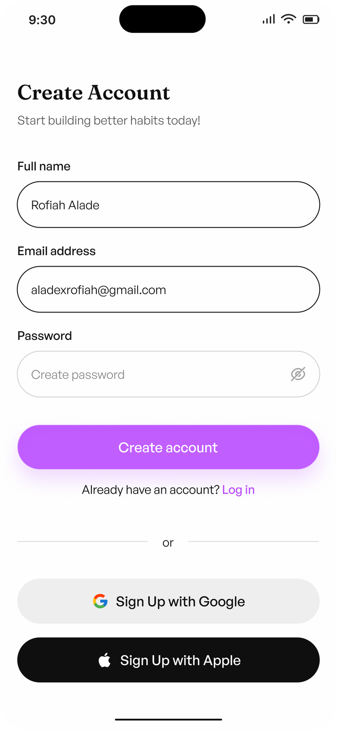
Figure 9 — Create account — details entered

11.2 Verify your account
A six-digit security code is emailed to the registered address and entered into a segmented field. A resend is available behind a 60-second countdown (“Didn’t receive code? Resend - 00:59”). Success is its own screen — “You’re verified! Your email address has been confirmed. You can now continue setting up your account.” — and Continue setup hands off to the five-step onboarding.
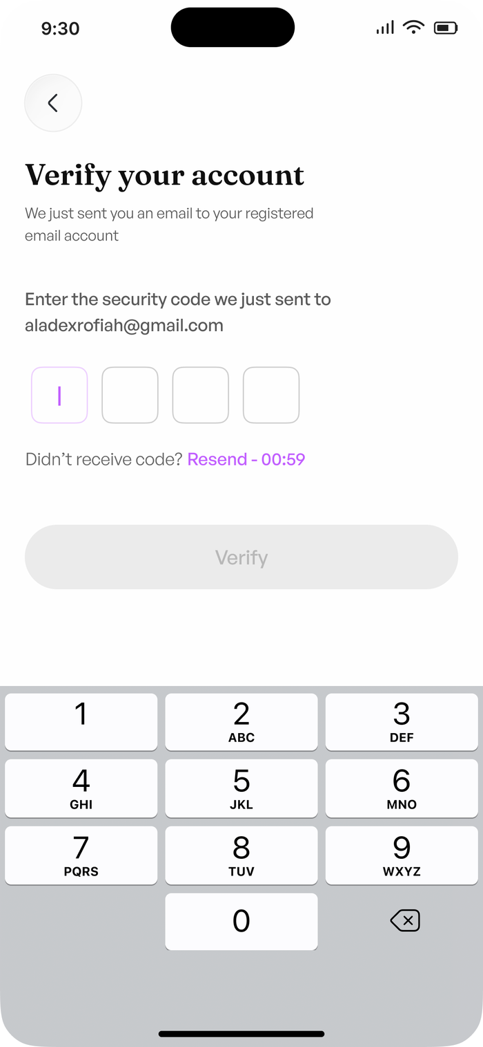
Figure 10 — Verify your account — security code entry

11.3 Log in
“Welcome back! Keep your streak alive. Let’s go.” Email and password, a forgot-password link, and Continue with Google / Continue with Apple.
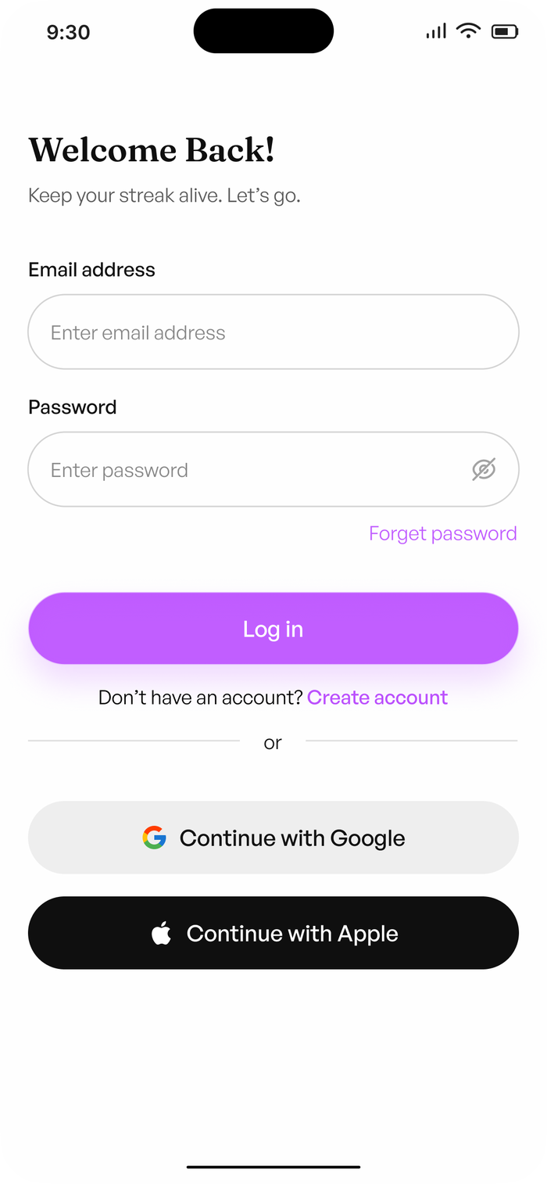
Figure 11 — Log in

11.4 Reset password
The reset is a three-step flow, not a single email link: request a code, verify it, then set a new password. The policy is stated inline — minimum 8 characters, one special character, caps, and a number. Success is explicit — “You’re all set! Your password has been reset successfully. You can now log back in.” — with a route back to login.
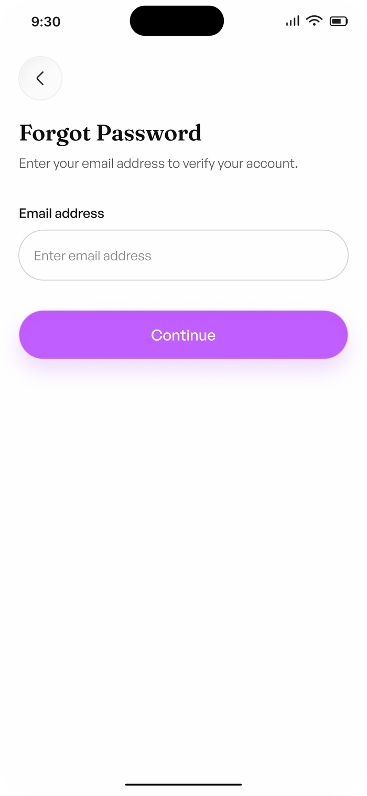
Figure 12 — Forgot password — request a reset code
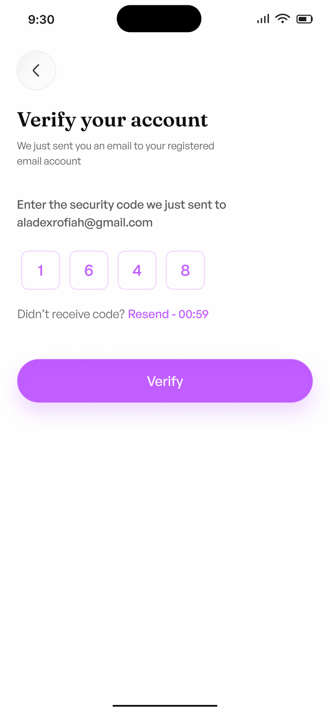
Figure 13 — Verify your account — password reset step, code entry
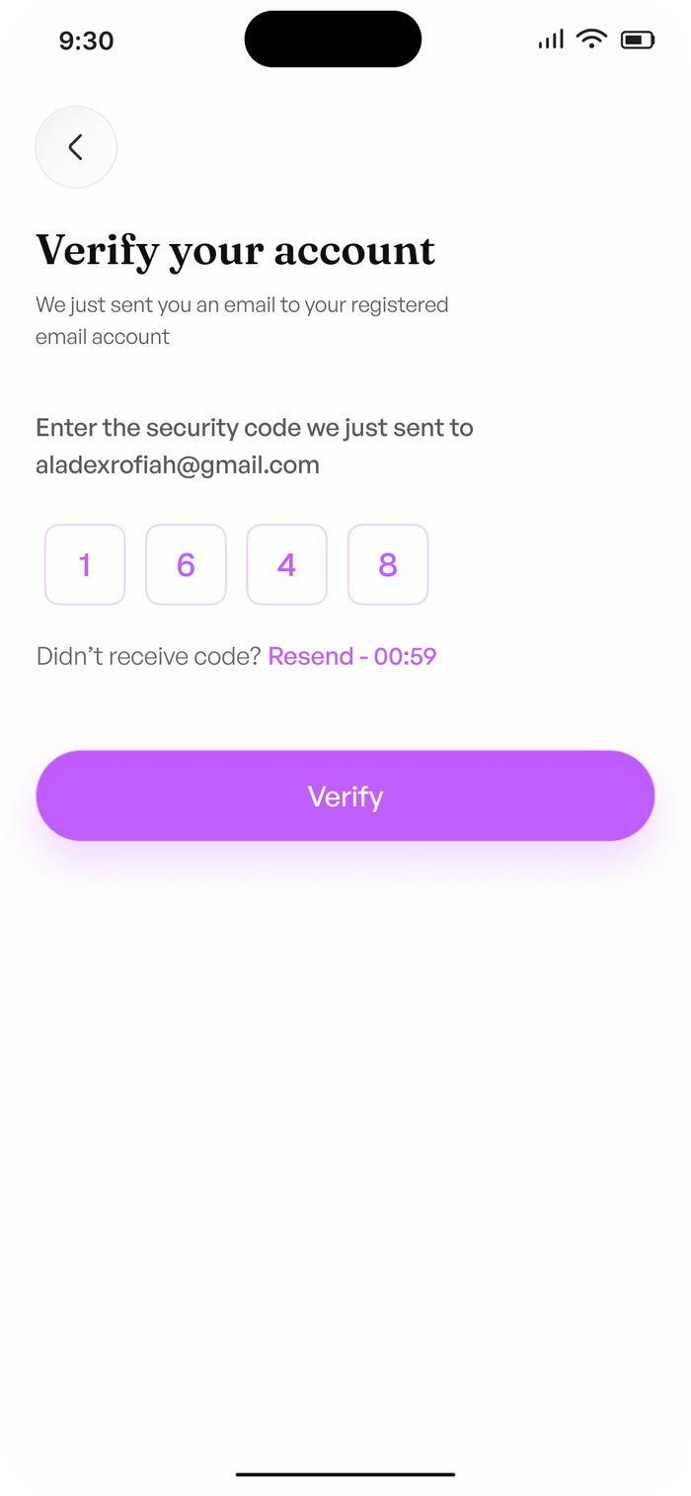
Figure 14 — Verify your account — password reset step, code confirmed
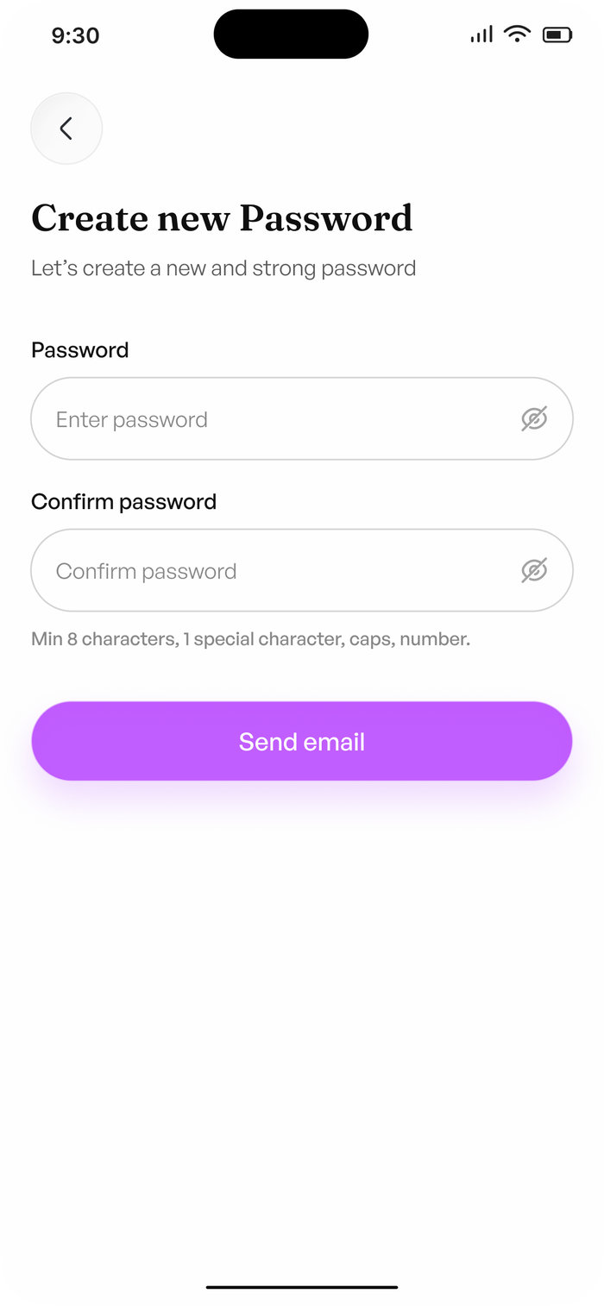
Figure 15 — Create new password — policy shown
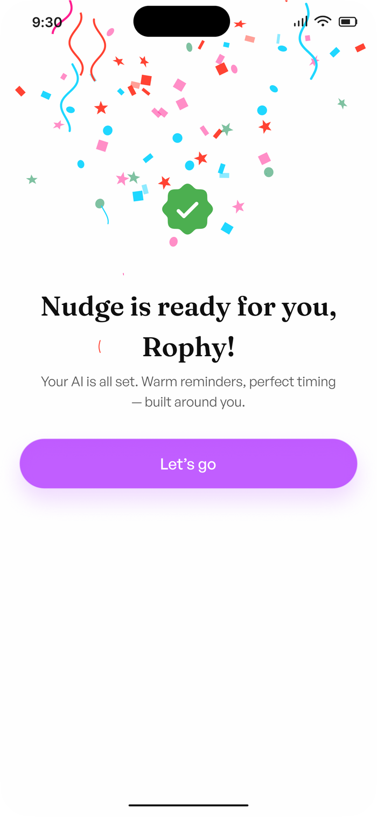
Figure 16 — Password reset success — You're all set!

11.5 Success states and log out
The set also carries two generic success states, used after a confirmable action completes. Logging out is a deliberate confirmation rather than an instant tap: “Are you sure you want to log out?”
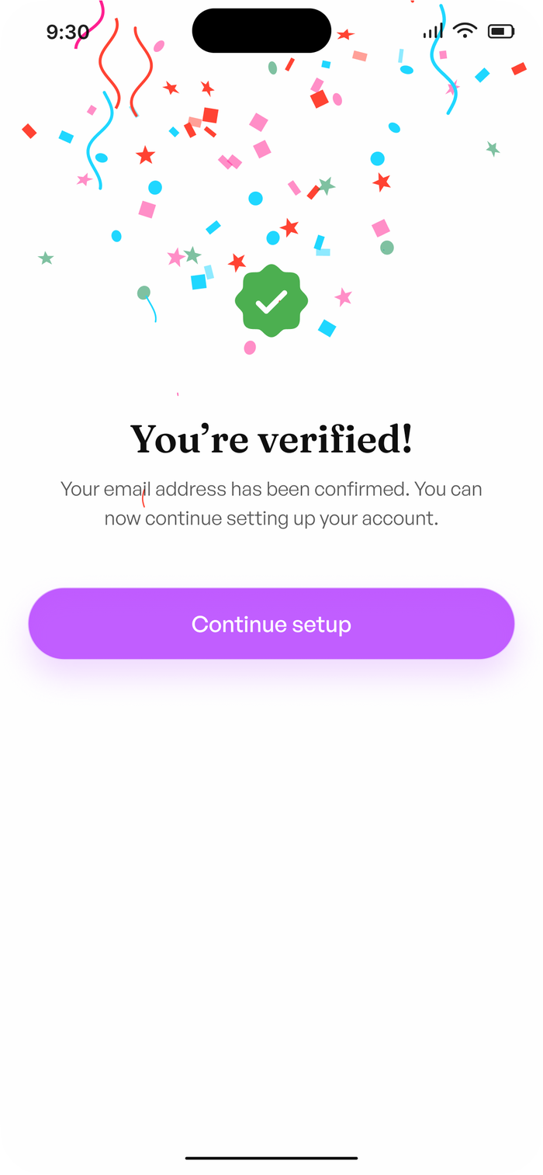
Figure 17 — Success state
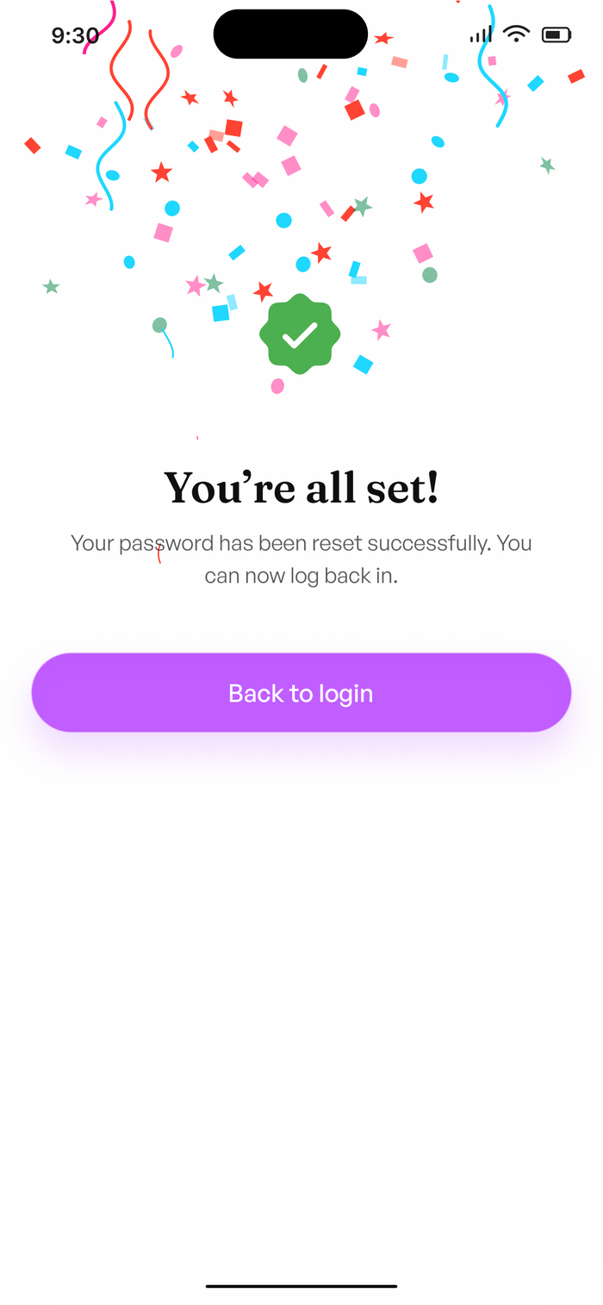
Figure 18 — Success state
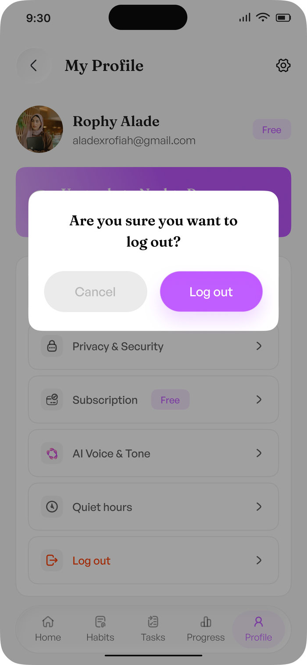
Figure 19 — Log out — confirmation modal

12. Home
Home is the one screen that answers “what should I do now?” without being asked, and it is the only place the proactive Nudge appears.
- Greeting by first name — “Good morning, Rophy”.
- Streak chip — 7 days.
- Today’s progress, Today’s Habits and Tasks done counters.
- The proactive Nudge: “Deep work in 10 mins. You’re on a 7-day streak. Keep going Rophy.”
- Today’s Habits grouped Morning, Afternoon and Evening, each showing its daily goal as X/7 days.
- A to-do list preview with priority chips.
- The Nudge composer — “Ask Nudge anything…” — so the assistant is one tap away everywhere.
On first run the screen does not show zeroes. It shows “Your day starts here”, “Add your first habit and Nudge will take care of the rest.” and a single Add first habit action.
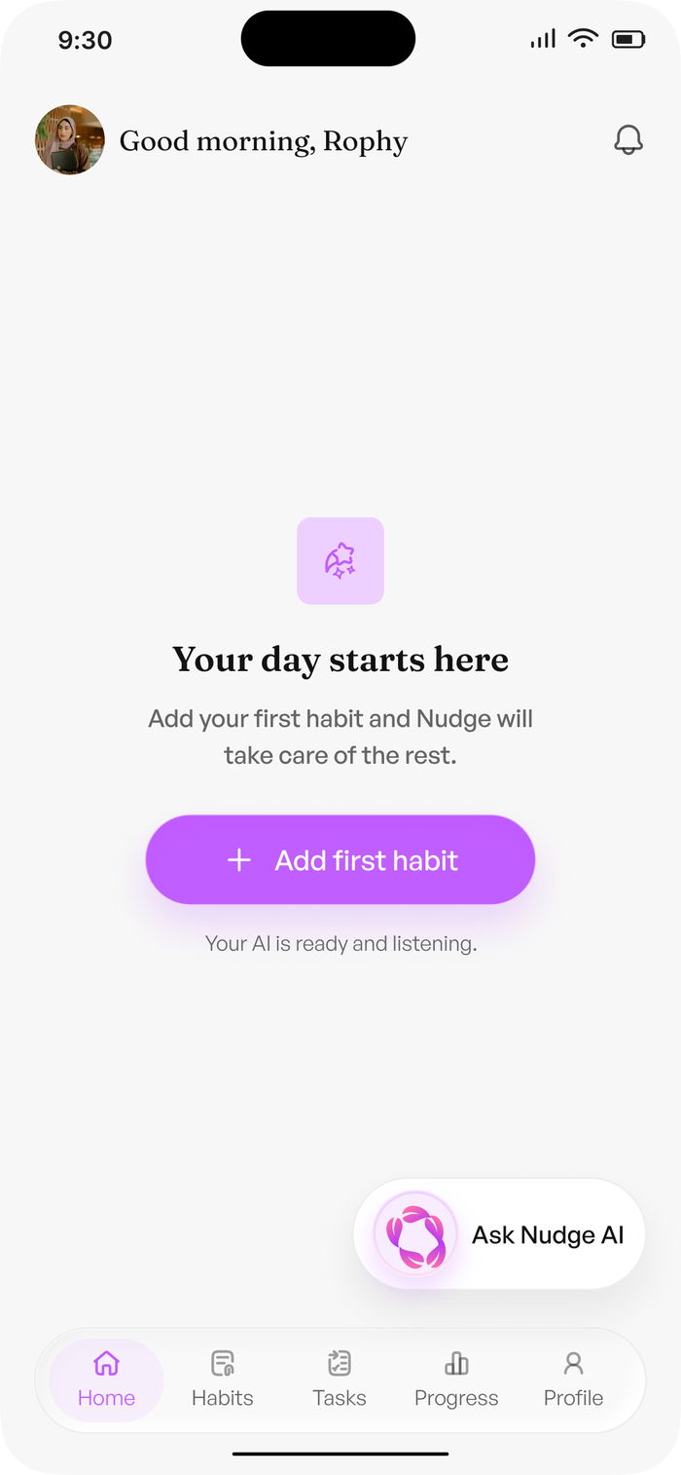
Figure 20 — Home — first run, no habits yet
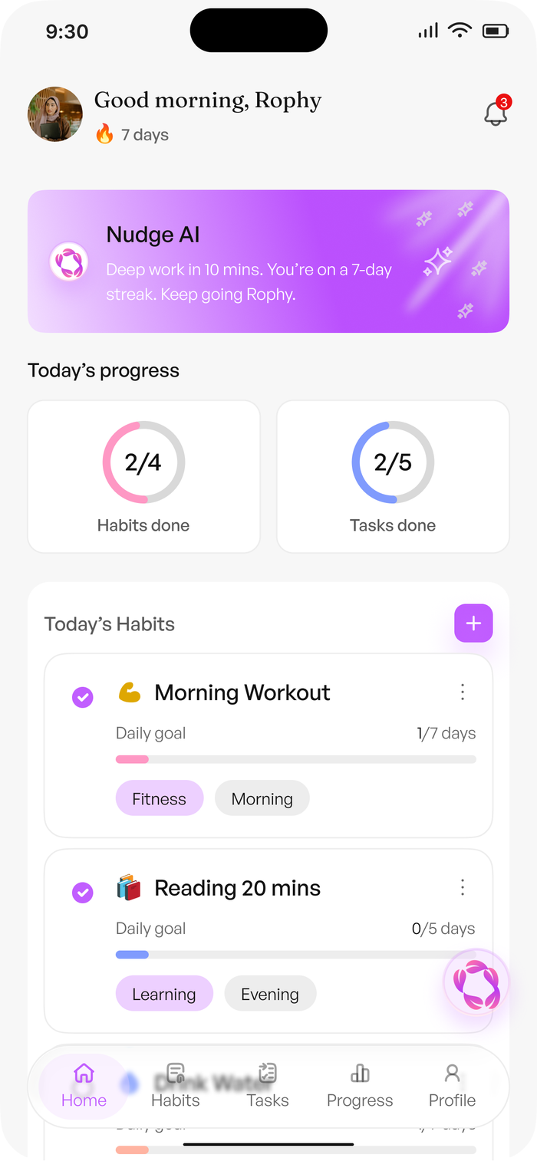
Figure 21 — Home
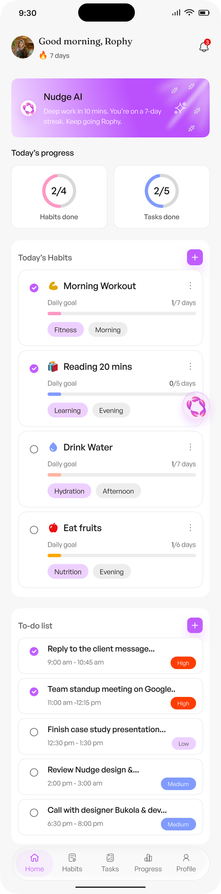
Figure 22 — Home — full scroll

13. Habits
My Habits is the habit library. The header carries the user’s streak and the subtitle “Building consistency”, which sets the tone for the whole surface. The All / Morning / Afternoon / Evening filter is the same bucketing used everywhere else, so the list can be read the same way it is nudged.
A habit card carries the name, its category, its duration in minutes, and its daily goal as X/7 days. Completion state is shown per card rather than aggregated, because a single visible card is what the user acts on.
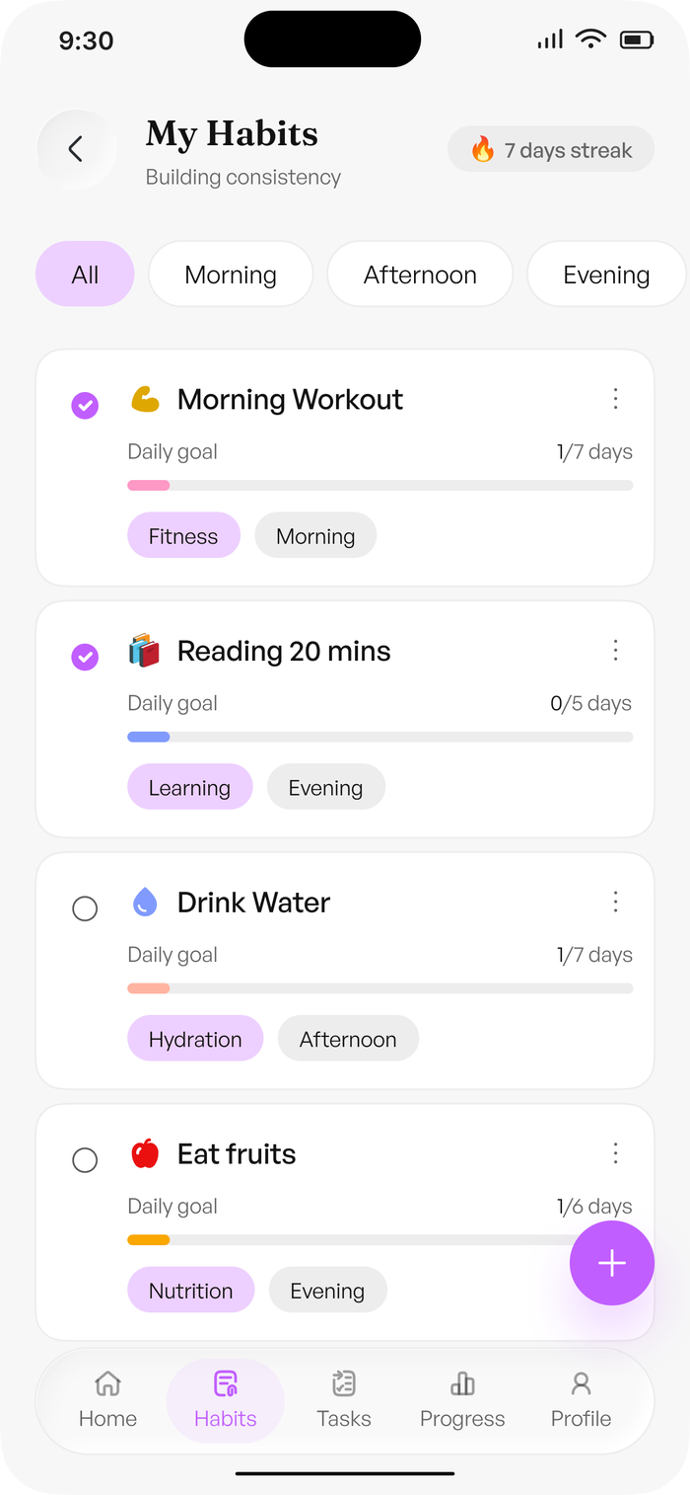
Figure 23 — My Habits

13.1 Create Habit
Field | Values
Habit Name | Free text, e.g. “morning workout”
Category | Fitness, Learning, Health, Mindfulness, Productivity, Nutrition, Hydration
Time of the day | Morning, Afternoon, Evening
Frequency | Daily, plus the selected days of the week
Duration | Minutes
Stack this habit | Optional — attach to an existing habit or set a trigger habit (see Section 15)

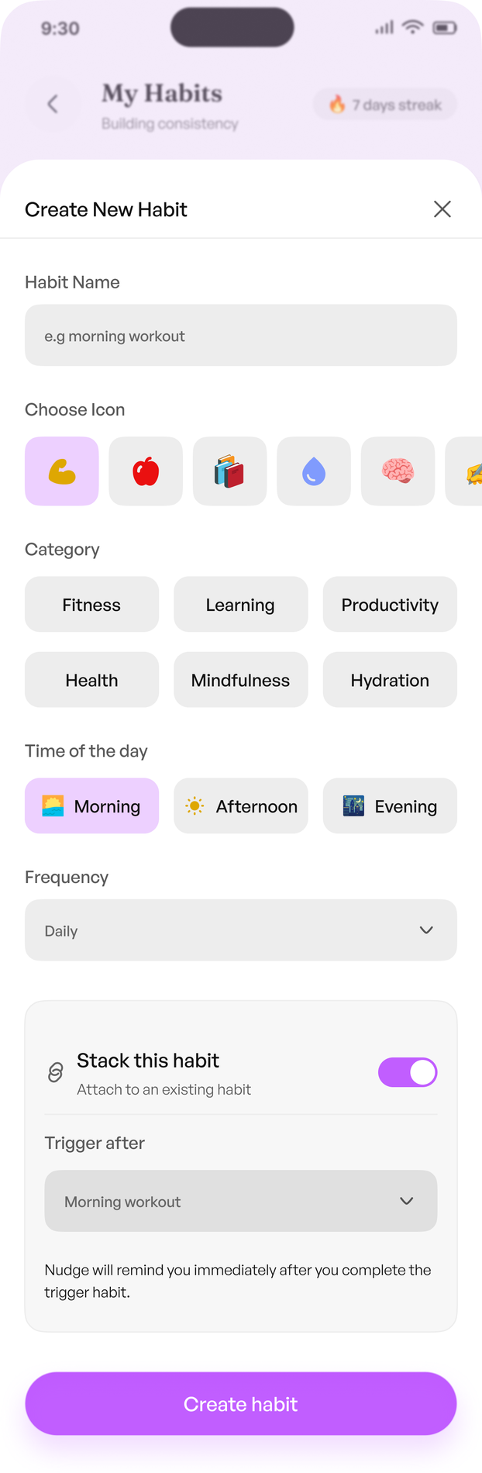
Figure 24 — Create Habit

14. Tasks
My Tasks is a full task surface, not a by-product of habits. It is scoped to a date (“Monday, May 10”) and filtered by All, Completed, Upcoming and Overdue, so the four states a task can be in are all one tap away.
A task card carries the name, its time window, and a priority chip. Calendar-sourced entries appear with their provider label so a meeting and a personal task are never confused.
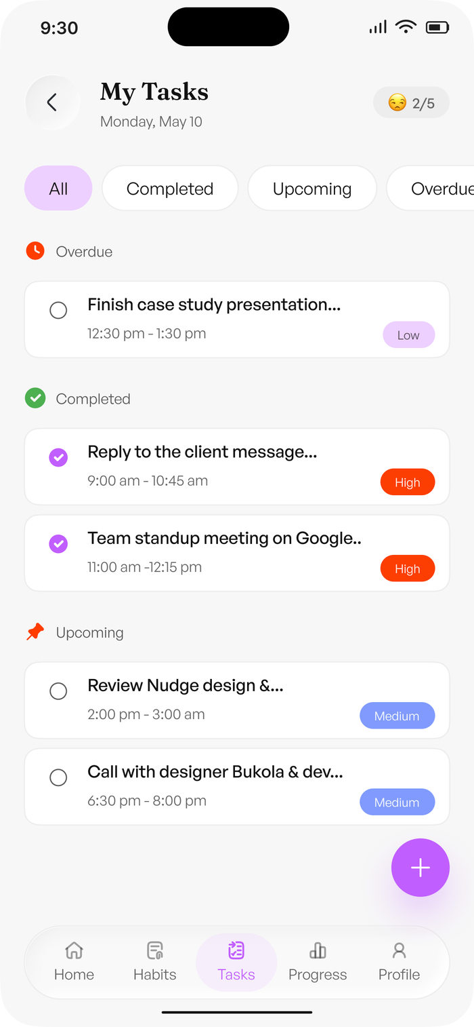
Figure 25 — My Tasks

14.1 Add task
Field | Values
Task Name | Free text, e.g. “finish case study deck”
Date | Calendar date picker, defaulting to today
Time | Start and end time — tasks occupy a window, not a point
Duration | Minutes
Priority | High, Medium, Low
Category | As for habits
Notes | Optional — “Add context, links, or reminders…”
Repeat this task | Per-day selection, Mon through Sun
Make it a recurring reminder | Turns a one-off task into a repeating one
Stack this habit | Optional — attach to an existing habit or set a trigger habit

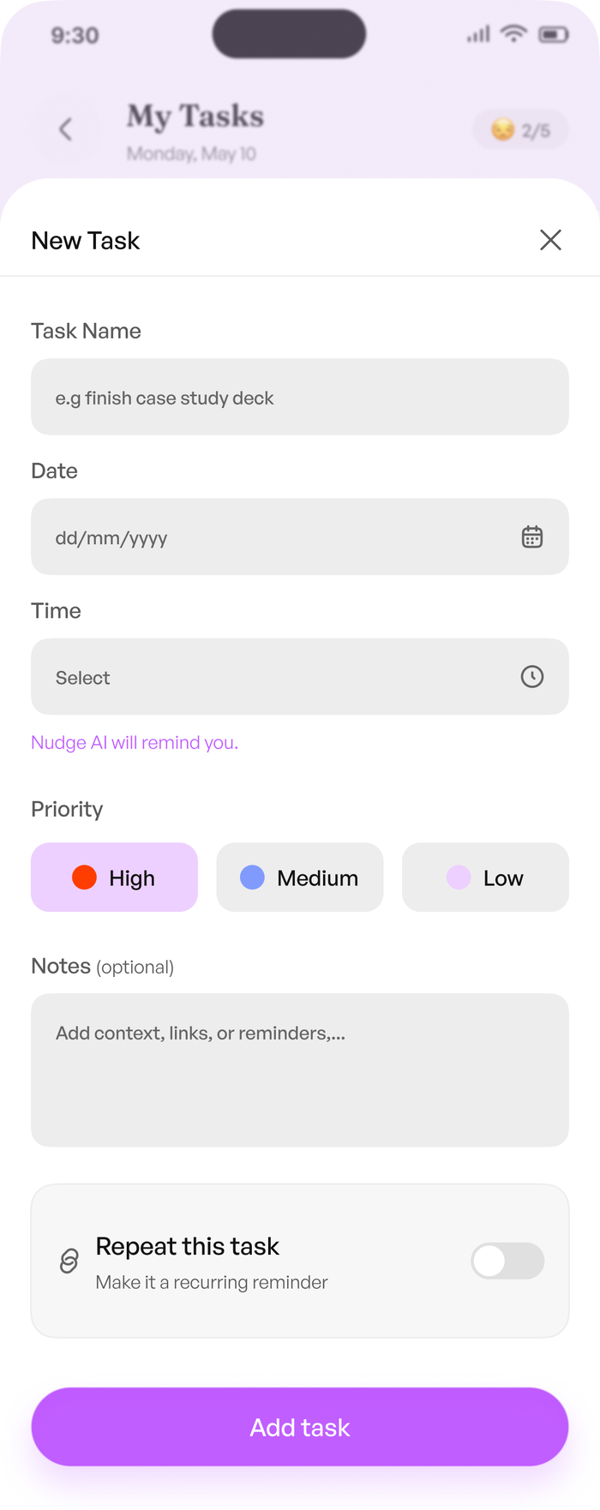
Figure 26 — Add task

14.2 Overdue
Overdue is treated as a first-class list rather than an error state. Progress shows the most overdue tasks with a repeat count — “Case study deck, Overdue 2x this week” — so a repeatedly slipping task is visibly different from one that slipped once. The completion legend (Missed, Some progress, Completed) is the same vocabulary used by Progress.

15. Habit Stacking
Habit stacking is the feature that makes habits a system rather than a list. A new habit or task can be attached to an existing habit as its trigger, and Nudge then fires the dependent item immediately after the trigger completes: “Nudge will remind you immediately after you complete the trigger habit.”
- The design’s own example chains Morning Workout into Drink Water.
- The link is event-driven, not time-driven — the dependent nudge fires on completion, so it survives a day where the trigger ran late.
- Stacking is also the recommended remedy in a Nudge AI Insight when it detects a weekend consistency dip.
- This is a Pro capability and is the primary paid upgrade alongside voice.

16. Streaks and Gamification
Streaks are the visible proof that the loop is working, and they appear in three places: the Home chip, the My Habits header, and inside the reminder copy itself.
- Day streak — consecutive days the user kept at least one promise.
- Per-habit streak — shown on the habit card and in Progress, e.g. “5 days streak”.
- All time wins — the total, surfaced on Progress as “24”.
- Streak at risk — a notification setting, “Notify me when my streak is at risk”.
- Include streak in reminders — a user toggle, so the streak can be part of the nudge copy or left out.
Streak mechanics are deliberately forgiving in line with the product promise of consistency without guilt: a missed day is surfaced as Missed and rolled into the next morning’s summary, not announced as a failure. There is no streak-loss shaming copy and no league or leaderboard.

17. Nudge Engine
The Nudge Engine is the explicit decision layer. It answers four questions for every candidate intervention, and it is deterministic except for the wording of the sentence it writes.
Should I nudge? -> When? -> Voice or text? -> What tone, what words?

Input | Example
Habit schedule and time-of-day bucket | Reading, Evening, 20 minutes
Task time window and priority | Finish case study presentation, 2:30–3:30 pm, Low
Current time and the user’s wake/sleep times | Evening, inside the quiet period
Quiet hours and the urgent-task exception | Quiet 7:00 am–10:00 pm, High priority may still fire
Streak state | 7-day streak, at risk if today slips
Completion history and recent skip pattern | Morning completes 85% of tasks
Tone preference | Gentle & Warm
Personalisation toggles | Use my name, include streak, use emojis
Calendar context | Team standup meeting on Google…
Nudge volume since the last intervention | A cooldown keeps nudges few

Nudge types: habit reminder, task reminder, overdue prompt, streak prompt, morning summary, weekly report, and the Nudge AI Insight. Every nudge records the decision inputs it used, which is what makes the adaptive loop inspectable during a demo.

18. Quiet Hours and Digest Nudges
Sleep is treated as a hard constraint, not a preference. The design captures this as a first-class settings surface with its own screens, and the onboarding sleep question seeds it.
Control | Behaviour
Enable quiet hours | Master switch. Off, Nudge may speak at any hour.
Quiet period | An explicit window — 7:00 am to 10:00 pm in the design — with a live readout: “9 hours of quiet. All reminders paused.”
Repeat on | Per-day selection, Mon through Sun
Allow high priority tasks | Exception that lets High-priority tasks still interrupt quiet hours
Weekend quiet hours | Optional — apply the same schedule on weekends too
Morning summary | “Daily overview when you wake up” — anchors the morning habit reminders
Weekly AI report | “Progress summary every Monday” — anchors the evening habit reminders

Anything missed during quiet hours is not lost. “Missed reminders during quiet hours will appear as a summary when you wake up.” This is the mechanism that lets Nudge be both quiet and trustworthy.

19. Voice Experience
Voice is the product’s headline, not a feature: “Alarms startle. We speak.” It runs in both directions, and both directions have designed states.

19.1 Speaking to Nudge
- Nudge voice toggle, available from the composer on any screen.
- Listening… — the waveform state while the user speaks.
- Transcribing… — partial text resolves into the composer.
- Voice mode paused while generating — so the user knows why Nudge has gone quiet.
- Generate loading — acknowledgement before the answer arrives.
- Messages render as voice and text, so the transcript is always reviewable.
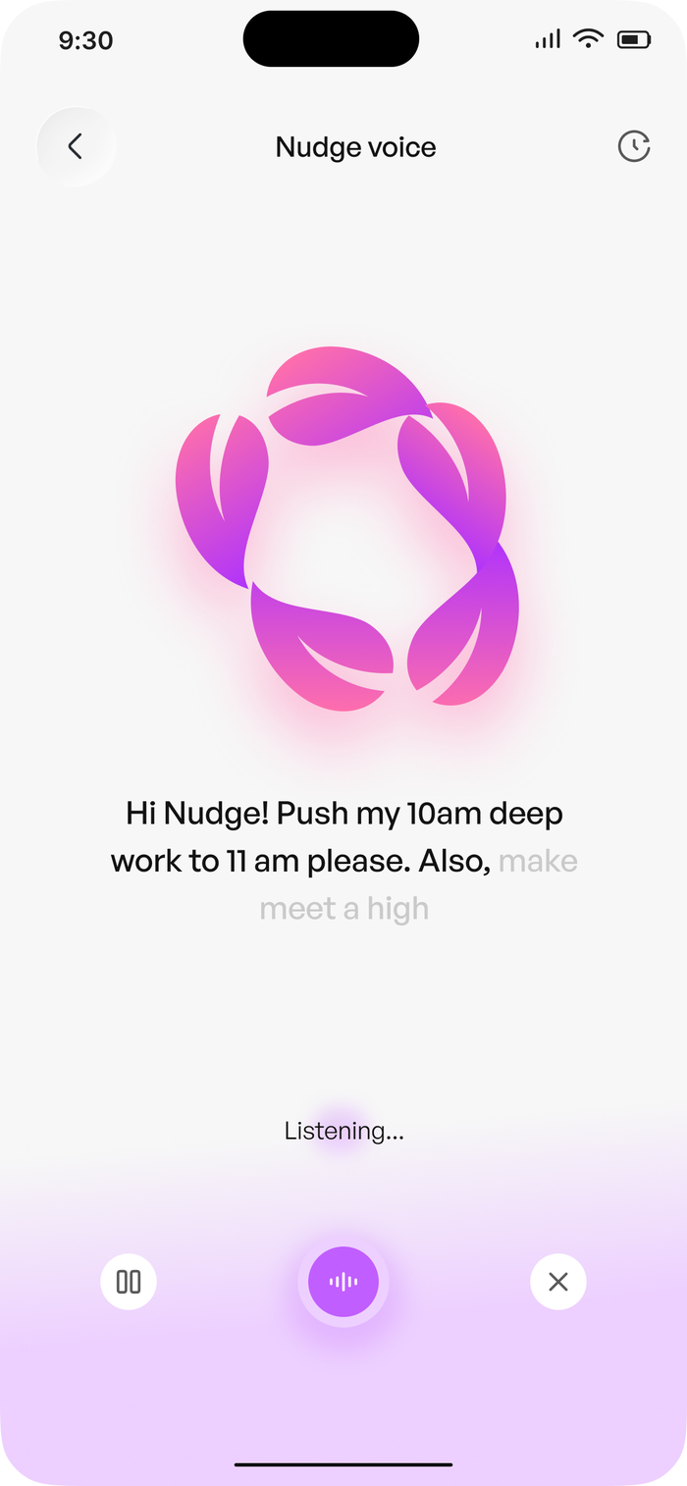
Figure 27 — Nudge voice — listening
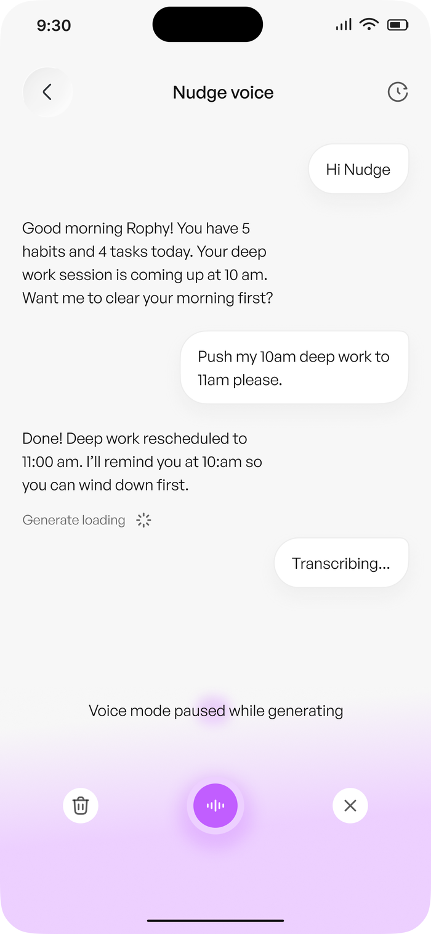
Figure 28 — Nudge voice — transcribing

19.2 Nudge speaking to the user
“AI speaks your nudges aloud.” Voice reminders are a Pro capability, and the spoken message is generated in the same tone persona and with the same personalisation toggles as the written one, so the voice never contradicts the screen. The spoken and written turns of a conversation are shown together in Figure 31, and the persisted thread in Figure 32.

20. Nudge AI Assistant
The assistant is reachable from the Home composer and from its own thread. It opens with a proactive read of the day rather than an empty box: “Good morning Rophy! You have 5 habits and 4 tasks today. Your deep work session is coming up at 10 am. Want me to clear your morning first?”
It answers a narrow set of intents well and proposes the change before making it.
Intent | Evidence in the design | Response shape
Reschedule a task | “Push my 10am deep work to 11am please.” | “Done! Deep work rescheduled to 11:00 am. I’ll remind you at 10:am so you can wind down first.”
Reschedule a meeting | “Reschedule my google meet with developer Josh” | Confirm, then propose the new window
Add a habit | “Add gym to my evening habits.” | Confirm, then create in the chosen time-of-day bucket
Suggest habits | “Suggest habits for better sleep at night or napping during the day” | A short ranked list drawn from the user’s focus areas
Day summary | Day summary action in the composer | Habits done, tasks done, streak, and the next thing

Two rules keep the assistant trustworthy. First, it proposes — every write is confirmed before it lands. Second, it acts on the user’s own data: the nudge time it moves is one it also chooses to send, so the user hears the consequence immediately. Chat is persisted, grouped by Today and Yesterday, with a day summary per group. The voice states of the same thread are shown in Figures 27 and 28.
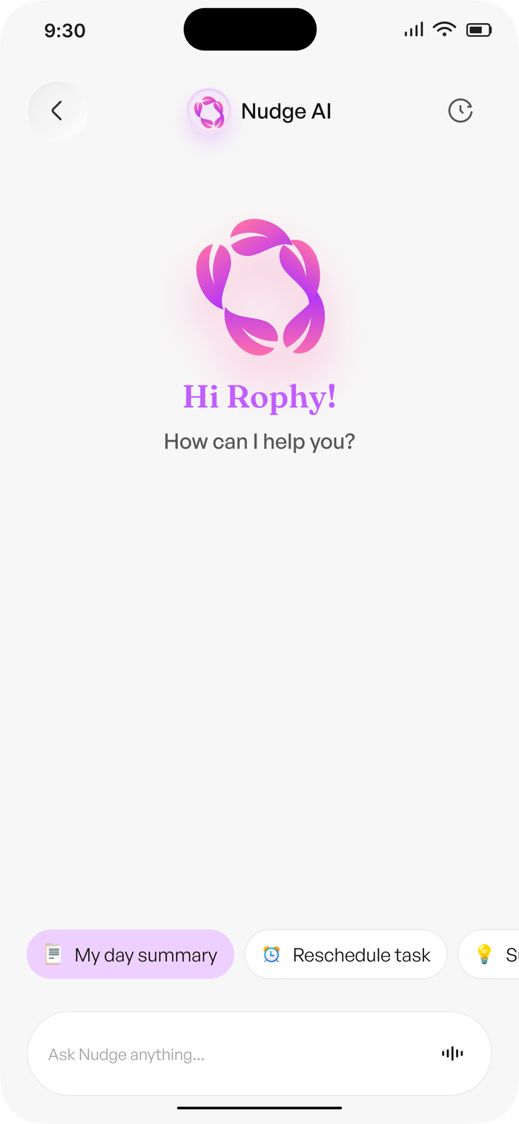
Figure 29 — Nudge AI — greeting and proactive summary
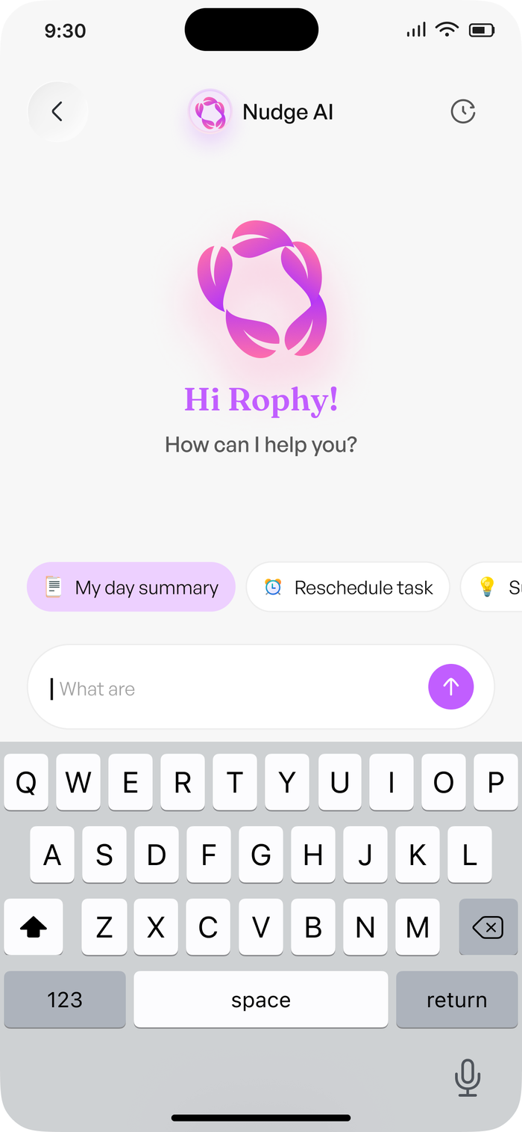
Figure 30 — Nudge AI — asking Nudge anything
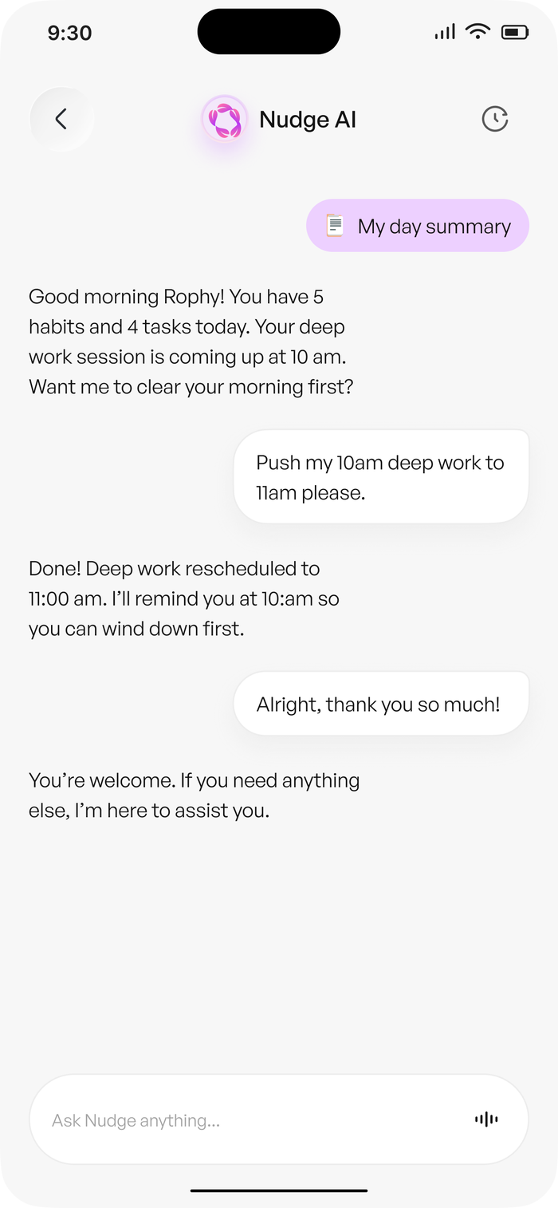
Figure 31 — Nudge AI — conversation and confirmed action
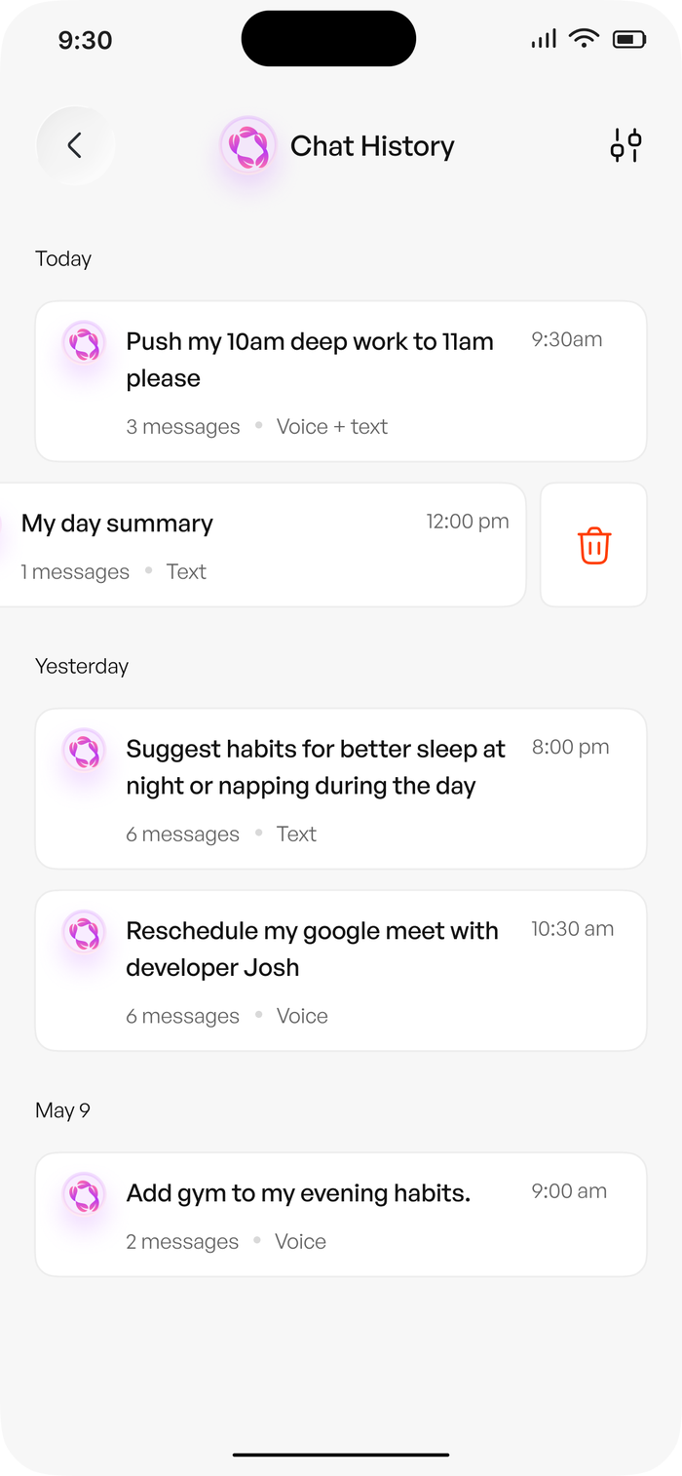
Figure 32 — Chat history — grouped by day

21. Progress and Analytics
Progress answers one question — am I keeping up — and separates habits from tasks, because they fail for different reasons.
- Overview and Weekly views.
- Stat cards: Day streak, Consistency (e.g. 92%), All time wins (e.g. 24).
- Habits completed this week: 18/25, 72% completion rate.
- Tasks completed this week: 85%, plus the one-time rate for tasks that are not recurring.
- A Monday-to-Sunday bar chart at 0–100%, so a weak day is visible rather than averaged away.
- Top performing habits with a per-habit completion percentage and streak, and top performing tasks split by Morning, Afternoon and Evening.
- Most overdue tasks, with the repeat count.
- A Consistency Map for the selected date, with the Missed / Some progress / Completed legend.
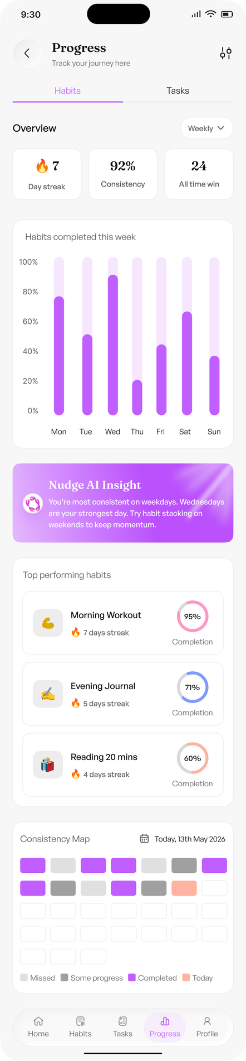
Figure 33 — Progress — habits
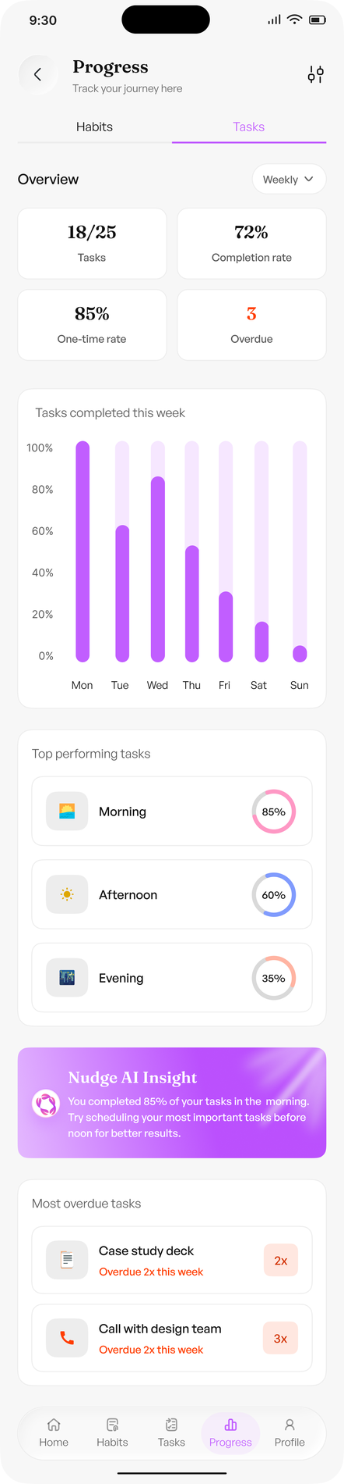
Figure 34 — Progress — tasks

22. Nudge AI Insight
The Insight is a single generated card that turns a pattern in the user’s own data into one concrete next move. It appears on Home and on both Progress views, and it is a Pro capability. Two templates are fixed in the design, which is the right MVP scope:
- Consistency pattern — “You’re most consistent on weekdays. Wednesdays are your strongest day. Try habit stacking on weekends to keep momentum.”
- Time-of-day pattern — “You completed 85% of your tasks in the morning. Try scheduling your most important tasks before noon for better results.”
The arithmetic is deterministic — the numbers come from HabitCompletion and TaskCompletion. The LLM only phrases them, and the suggestion must name an action that exists in the product. “Try habit stacking” is only ever offered because habit stacking is a real feature.

23. Settings, Notifications and Profile

23.1 Settings
Settings is a single scrolling surface with five sections: AI Voice & Tone, Notifications, Preferences, Account and Support. Account holds Edit Profile, Privacy & Security and Subscription; Support holds Help & FAQ, Send feedback and Log out.
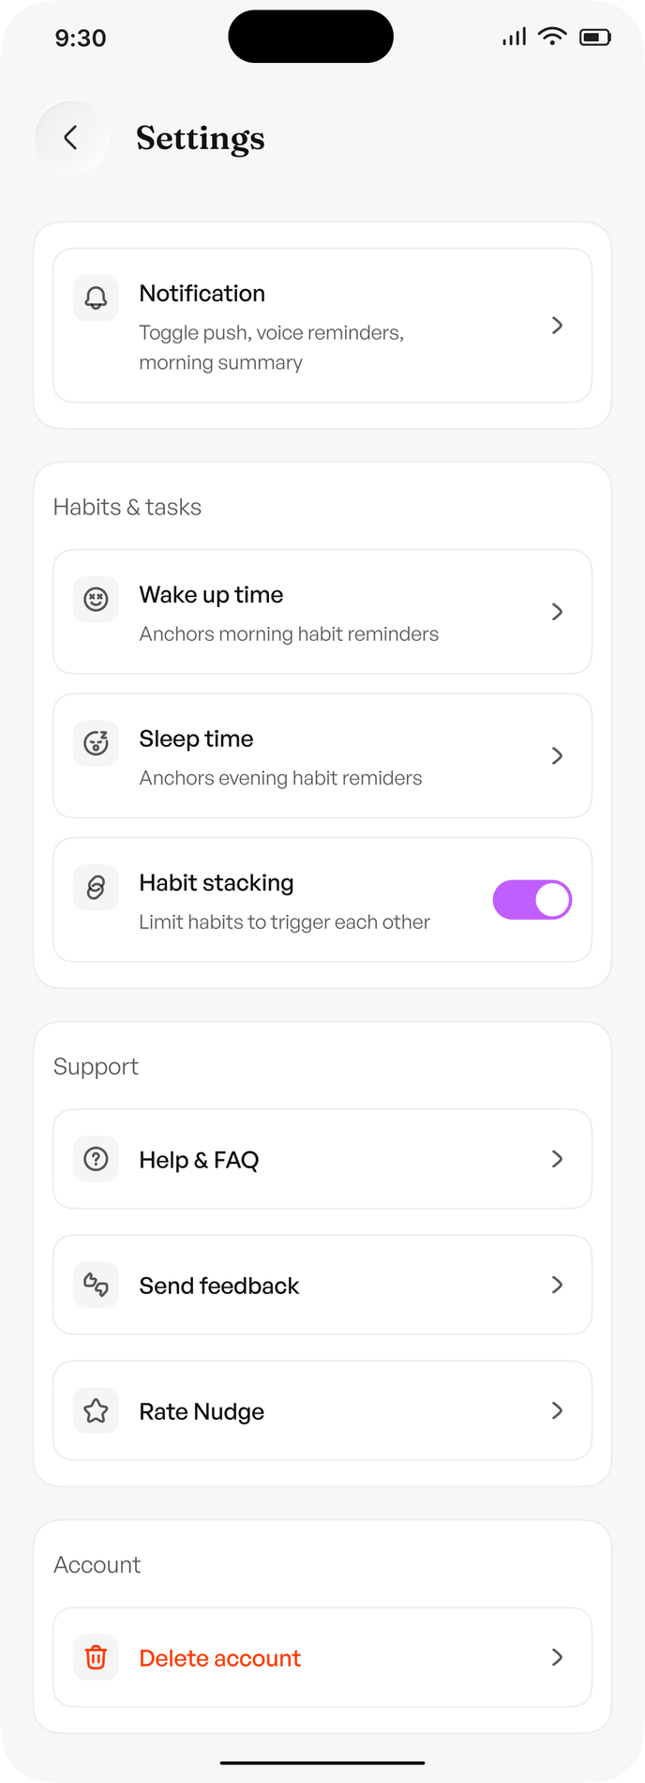
Figure 35 — Settings
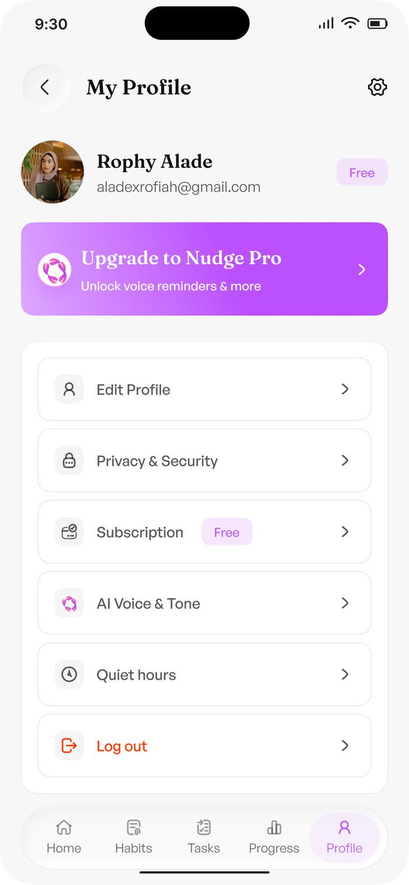
Figure 36 — My Profile
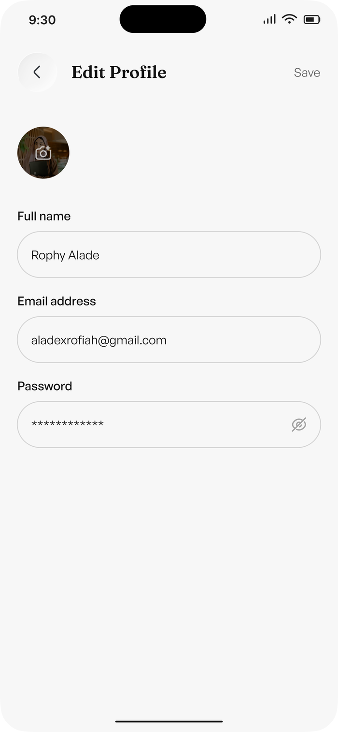
Figure 37 — Edit Profile

23.2 AI Voice & Tone
The tone persona chosen at onboarding is editable here, and each option shows the sentence it produces so the choice is concrete. Gentle & Warm — “Soft, friendly nudges that feel like a check-in from a friend.” Firm & Motivating — “Direct, energetic reminders that push you to act now.” Mix it up — “AI picks the mood based on your day.” A live Preview your Nudge renders a full reminder before saving.
Three personalisation toggles sit underneath, each of which the design exposes as a user-facing promise:
- Use my name in reminders — “Hey Rophy…” instead of “Hey there…”
- Include streak in reminders — mention the streak count for motivation
- Use emojis in reminders — adds a little personality to each nudge
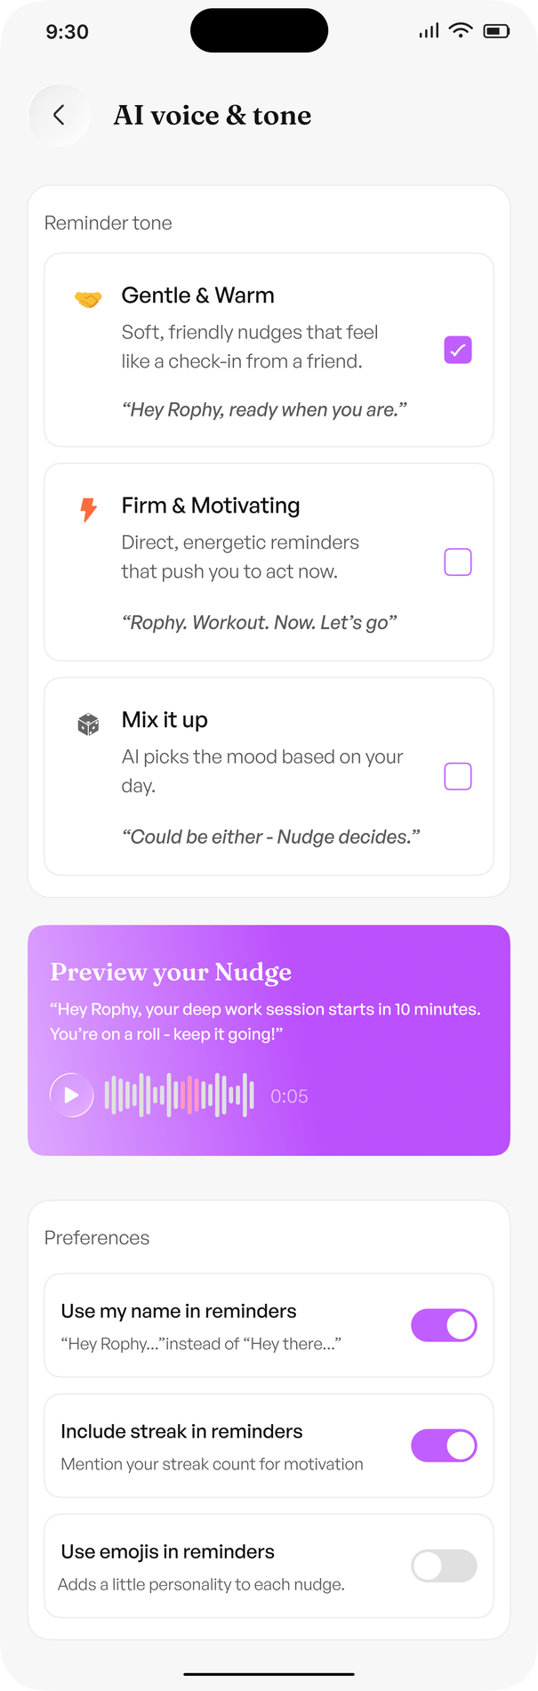
Figure 38 — AI Voice & Tone — reminder tone and preview

23.3 Quiet hours
The quiet-period controls described in Section 18, including the urgent-task exception, weekend quiet hours, and the promise that missed reminders return as a morning summary.
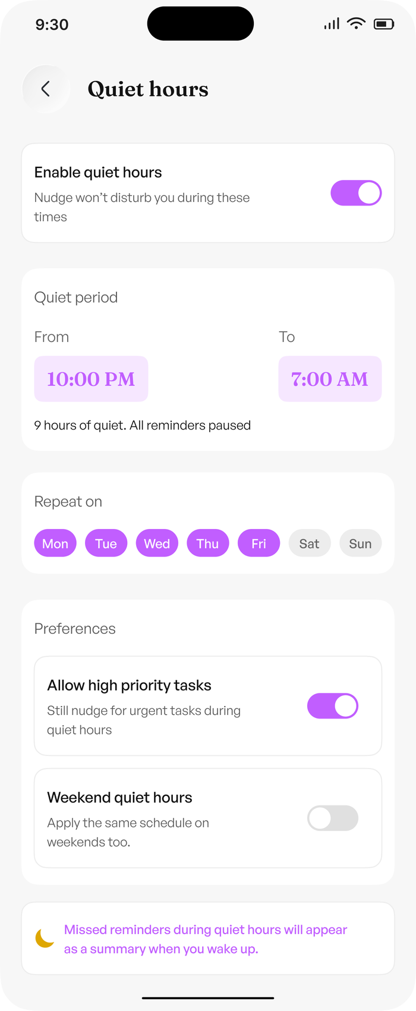
Figure 39 — Quiet hours — quiet period and repeat days

23.4 Notification settings
The full notification matrix, each row gated by plan.
Notification | Description | Plan
Push notifications | Habits and task alerts | Free
Voice reminders | AI speaks your nudges aloud | Pro
Morning summary | Daily overview when you wake up | Free
Weekly AI report | Progress summary every Monday | Pro
Streak alerts | Notify me when my streak is at risk | Free

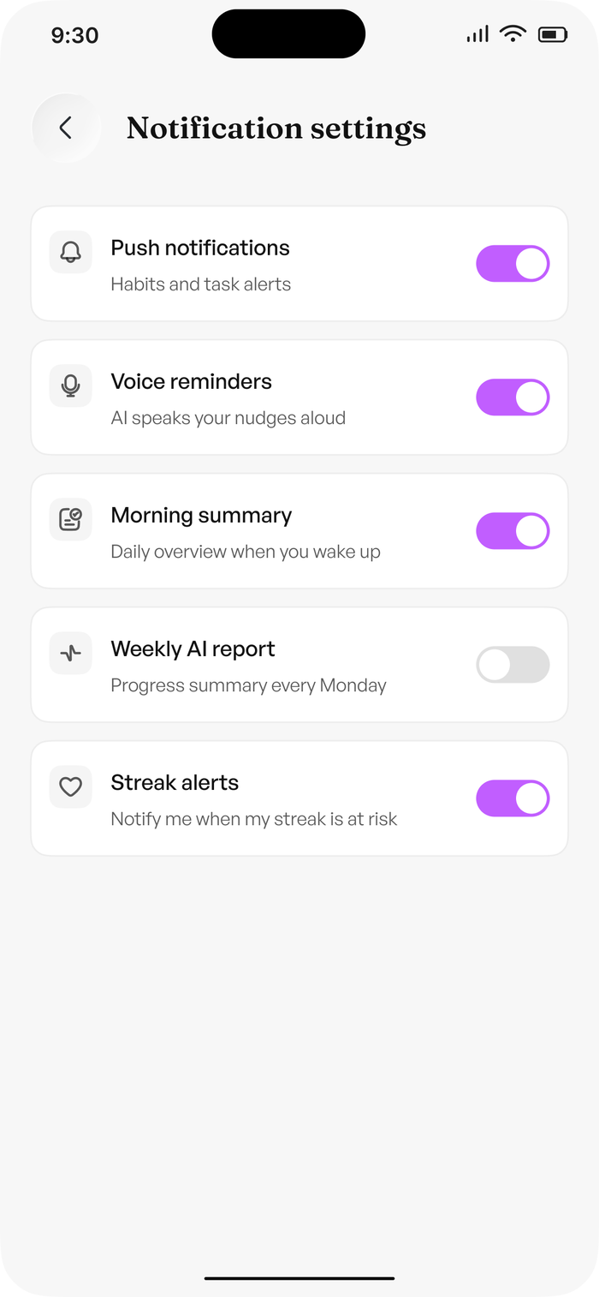
Figure 40 — Notification settings

24. Subscription and Feature Gating
The product is free to start and paid where the value is. The design states the limits in the user’s own terms rather than as a feature matrix, and uses a single upgrade prompt — “Upgrade to Nudge Pro”, “Unlock voice reminders & more” — placed on Profile, in Settings, and on the plan screen.
Plan | Price | What it includes
Free | $0 | Create up to 3 habits. Create up to 5 daily tasks. All priority levels. 7-day streak tracking. Basic text notifications only. Always free.
Pro | $4.99 / month | Unlimited habits and tasks. AI voice reminders. Habit stacking feature. AI insights and weekly reports. Custom reminder tone and voice style. Monthly or yearly billing, with a saving on yearly.

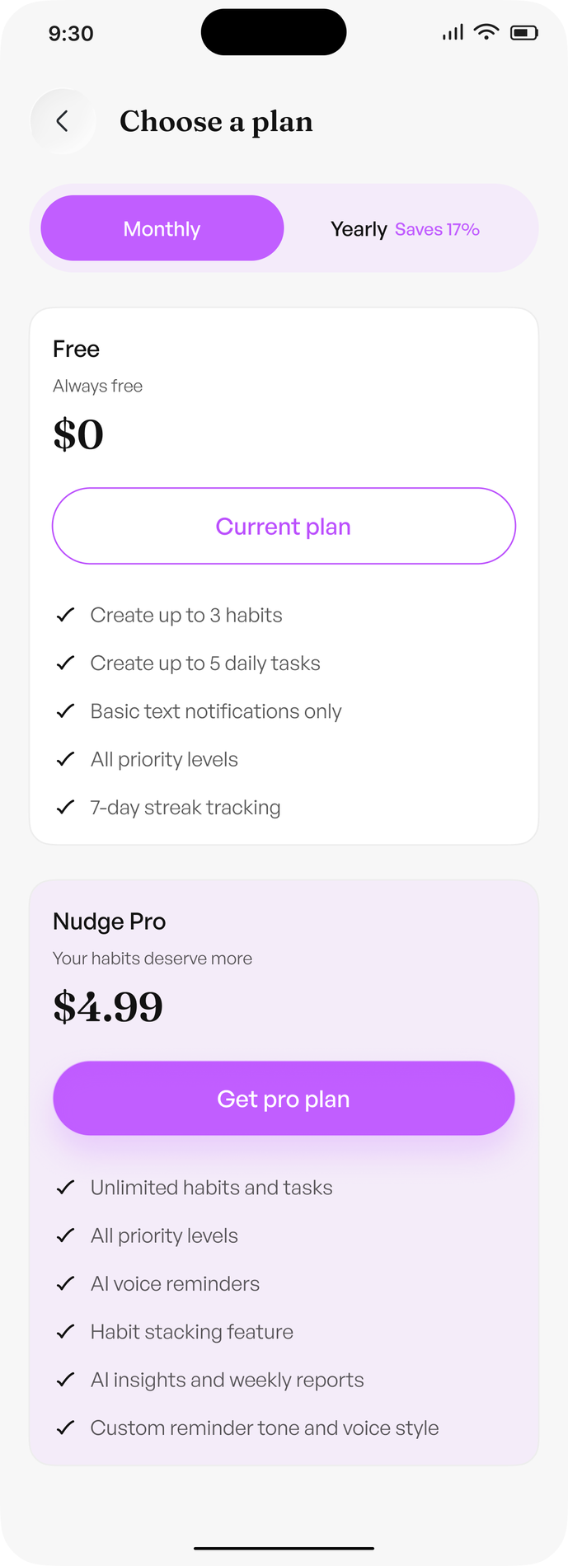
Figure 41 — Subscription — choose a plan

25. Feature Access Matrix
Capability | Free | Pro
Habits | Up to 3 | Unlimited
Tasks | Up to 5 per day | Unlimited
Priority levels | High, Medium, Low | High, Medium, Low
Streak tracking | 7-day | 7-day and all-time wins
Notifications | Push only | Push, plus spoken nudges
Morning summary | Yes | Yes
Weekly AI report | — | Yes
Nudge AI Insight | — | Yes
Habit stacking | — | Yes
Custom reminder tone and voice style | Gentle & Warm | All three personas
Quiet hours and weekend quiet hours | Yes | Yes
Google Calendar context | Read-only | Read-only

26. Interface Architecture
Nudge is a mobile app with a five-tab bottom bar, present on every authenticated screen.
Tab | Responsibility
Home | Greeting, streak, today’s progress, the proactive Nudge, today’s habits, the task preview, and the Nudge composer
Habits | My Habits list with time-of-day filters, plus habit creation and habit stacking
Tasks | My Tasks for a date with All / Completed / Upcoming / Overdue filters, plus task creation
Progress | Overview and Weekly analytics, the Nudge AI Insight, and the Consistency Map
Profile | Identity, plan, AI Voice & Tone, quiet hours, notifications, preferences, and support

26.1 Empty and first-run states
Screen | Empty state
Home | “Your day starts here” — “Add your first habit and Nudge will take care of the rest.” with an Add first habit action
Habits | “My Habits” with an Add first habit action; Nudge AI is already present and listening
Tasks | “All Task Completed” when the day is clear
Tasks | “Most overdue tasks” with a repeat count when the day is not clear
Profile | Name, email, current plan, and the single upgrade prompt

The Nudge composer is deliberately present on empty states. A new user with nothing tracked is exactly the user who should be able to say what they want to change first.

27. Context Integrations
The MVP reads one external source, and only reads it.
Integration | MVP use | Mode
Google Calendar | Surfaces meetings as tasks with a time window and a provider label, and gives the Nudge Engine real free/busy context so nudges avoid a meeting | Read-only
Device notifications | Delivers the push nudge and, on Pro, the spoken nudge | Write (outbound only)

The assistant can propose rescheduling a meeting — “Reschedule my google meet with developer Josh” — but the write is confirmed by the user, and there is no path that changes a calendar without that confirmation. There is no GitHub integration and no inbox integration in the MVP.

28. Personal Memory Model
Memory layer | Contents
Long-term | Wake and sleep times, tone persona, quiet hours, focus areas, categories actually used, recurring patterns, repeated postponements.
Habit and task memory | Every habit with its bucket, category, duration and streak. Every recurring task with its window, priority and repeat days.
Short-term | Today’s habits and tasks, their completion state, the current streak, recent nudges, and the active chat context.

Together these answer: who are you, how does your day run, what did you do yesterday, and what is happening right now. That is the whole input to a nudge.

29. Nudge Design Principles
- Warm, not jarring. “Alarms startle. We speak.” A nudge reads like a friend checking in, never like an alert.
- Fewer, better nudges. Volume is a bug, not engagement. Cooldowns and quiet hours both exist to keep the count low.
- No guilt. “Nudge keeps you consistent without guilt.” Missed days are summarised the next morning, not scolded.
- Sleep is sacred. The last nudge of the day must never interrupt rest, unless the user asked for High-priority tasks to break through.
- Learn the rhythm, respect the deviation. Timing adapts to what actually happened; a late day changes the plan rather than breaking it.
- Personal, by default. Use the name. Include the streak if the user wants it. Match the tone they chose.
- Propose, then act. The assistant never changes a task, a habit or a meeting without confirmation.
- Say something true. Every insight must be backed by the user’s own completion data and must name an action that exists.

30. Technical Architecture
USER
|
v
+---------------------------+
| NudgeAI Mobile Client | Home / Habits / Tasks / Progress / Profile
| (React Native) | voice in, voice out
+------------+--------------+
|
v
+---------------------------+
| API / Backend (FastAPI) |
+-----+---------+--------+-+
| | |
v v v
+--------+ +--------+ +--------+
| Habit &| | Nudge | | Voice |
| Task | | Engine | | Service|
| Engine | +--------+ | STT/TTS|
+---+----+ | +---+------+
| v |
| +---------| +-----------+
+---->| Insight |-->| Push / TTS|
| Service | | Channel |
+---------+ +-----------+
|
v
+-------------+
| PostgreSQL |
+-------------+

31. Suggested Technology Stack
Layer | Technology
Mobile client | React Native (Expo), TypeScript
Backend | FastAPI / Python
Database | PostgreSQL
Background jobs | Redis + Celery — quiet hours, digests, weekly report, insight generation
AI | LLM API with structured outputs for assistant intents, insight phrasing and suggestion ranking
Voice | Speech-to-text for input, text-to-speech for spoken nudges
Notifications | APNs / FCM push, plus the device TTS channel on Pro
Integrations | Google Calendar, read-only
Auth | Email one-time code plus Google and Apple social sign-in

32. AI versus Deterministic Logic
AI / LLM | Deterministic backend
Assistant intent parsing for create, reschedule and suggest | Authentication, social sign-in, one-time codes and password policy
Nudge wording in the chosen tone | Schedules, recurrence, quiet hours and the urgent exception
Insight phrasing from a computed pattern | Streaks, consistency, completion rates and the consistency map
Habit and task suggestions from focus areas | Habit stacking triggers
Conversational follow-up in chat | Cooldowns, nudge state, digests and event persistence

The separation keeps the MVP predictable and cheap. The LLM is never responsible for scheduling, permissions or state. An insight may only be emitted when the deterministic analysis found a real pattern, which is why the number in the sentence and the number on the Progress screen can never disagree.

33. Data Model
User
+-- Profile (name, wake, sleep, tone, quiet hours, plan)
+-- Habit
| +-- HabitCompletion (habit, date, state)
| +-- Streak
| +-- HabitStack ----> Habit (trigger -> target)
+-- Task
| +-- TaskCompletion (task, due_at, state)
| +-- RepeatDays
| +-- HabitStack ----> Habit
+-- Nudge
| +-- NudgeResponse (started, completed, snoozed, dismissed, missed)
+-- Insight
+-- ChatMessage
+-- ContextEvent
+-- BehaviourEvent

Behaviour events: habit_created, habit_completed, habit_missed, task_created, task_completed, task_overdue, task_rescheduled, stack_triggered, nudge_shown, nudge_spoken, nudge_started, nudge_completed, nudge_snoozed, nudge_dismissed, nudge_missed, summary_opened, report_opened, assistant_action_confirmed.

34. Hackathon Demo Story
- Open on the premise: alarms startle, they do not adapt. Nudge speaks, and it learns your rhythm.
- Run the five-step setup for a new user, showing the name, the wake and sleep answers shaping the first nudge, and the tone preview rendering before it is saved.
- Create a habit and a task from the onboarding focus areas, showing category, time-of-day bucket, duration and priority.
- Show a nudge arriving on Home with the user’s name, their streak, and the spoken version on Pro.
- Turn on quiet hours and show the late nudge suppressed, then the morning summary carrying it instead.
- Ask Nudge to push the 10 am deep work to 11 am, and show the proposed change, the confirmation, and the adjusted reminder.
- Show Progress for habits and tasks separately, then the Nudge AI Insight naming a pattern and the action that fixes it.
- Close on the claim: Nudge is not sending more reminders. It is sending fewer, better ones, and it is learning when to send them.

35. Competitive Positioning
Product category | Primary abstraction | Weakness Nudge exploits
Alarms and timers | Time | No context, no tone, no learning
To-do apps | Tasks | No habits, no streaks, no timing
Habit trackers | Checkboxes | Silent, guilt-driven, no voice
Calendars | Events | No habits, no consistency
AI chatbots | Conversation | Only present when asked
Nudge | Your rhythm, and the habits and tasks inside it | —

Nudge should not claim to have no competitors. The differentiation is the closed loop across voice, rhythm, habits and tasks — not a generic claim of being an AI productivity app.

36. Business Model
Tier | Offering
Free — $0 | Up to 3 habits, up to 5 daily tasks, all priority levels, 7-day streak tracking, basic text notifications, Google Calendar context.
Pro — $4.99/month | Unlimited habits and tasks, AI voice reminders, habit stacking, Nudge AI Insight and weekly reports, custom reminder tone and voice style. Monthly or yearly billing, with a saving on yearly.
Team — later | Shared household or team rhythms, shared streaks and accountability, once the individual loop has proven retention.

The commercial wedge is the individual. Voice reminders, habit stacking and insight are the three paid surfaces, and they are exactly the three that make the loop hard to leave.

37. North-Star and Product Metrics
Metric | Definition
Day-7 Habit Retention | Share of users still completing at least one habit seven days after setup.
Consistency | Share of scheduled habit-days completed over the trailing 30 days.
Nudge Effectiveness | Share of nudges that lead to a start or completion within the target window.
Time-to-Action | Time between a useful nudge and the user acting on it.
Streak Survival | Share of active streaks still alive after seven days.
Voice Adoption | Share of Pro users with spoken reminders enabled.
Quiet-Hours Respect | Share of nudges suppressed or deferred correctly — a trust metric, not a growth metric.
Morning Summary Open Rate | Share of morning summaries opened, the main route for deferred nudges.
Free to Pro Conversion | Share of free users who hit a limit or want voice.

Day-7 Habit Retention is the north star. A Nudge that annoys people fails this metric even if notification volume looks healthy, which is why quiet hours and low volume are treated as product requirements rather than as settings.

38. Privacy and Trust
- Explicit integration permissions, requested per source, with Google Calendar read-only.
- Spoken reminders are opt-in and separately controllable from written ones.
- User-visible habit, task, nudge and history views, and editable memory in Profile and Settings.
- Ability to disconnect any integration and revoke its access.
- Ability to delete habit history, task history and chat history.
- Configurable data retention.
- No sale of personal behavioural data. Streaks and consistency are the user’s own, computed on-device-of-record and never surfaced socially.
- No autonomous external action. Every task, habit and calendar change is confirmed by the user.
- Voice transcripts are retained as text so the user can review exactly what Nudge heard.
Nudge should learn a person’s rhythm without creating the feeling that the system owns their day. Everything it remembers is visible, and everything it changes is confirmed.

39. MVP Scope and Build Order
Priority | Capability
P0 | Account: sign up, email one-time code, log in, password reset, social sign-in
P0 | Five-step onboarding: name, wake time, focus areas, sleep time, tone
P0 | Habit creation and the My Habits list with time-of-day filters
P0 | Task creation and the My Tasks list with status filters
P0 | Nudge Engine: scheduling, tone, name, streaks, cooldowns
P0 | Push notifications
P0 | Quiet hours with the urgent exception and weekend repeat
P0 | Morning summary for nudges missed during quiet hours
P0 | Streaks and Home progress counters
P0 | Nudge AI assistant: create and reschedule with confirmation
P1 | Progress and analytics: Overview, Weekly, consistency map, charts
P1 | Nudge AI Insight
P1 | Google Calendar read-only context
P1 | Weekly AI report
P1 | Habit stacking
P1 | Free and Pro limits, and the upgrade prompts
P2 | Voice input via speech-to-text
P2 | Spoken nudges via text-to-speech
P2 | Custom reminder tone and voice style
P2 | Yearly billing and the subscription screen
P2 | Help and FAQ, send feedback

40. Product Principles
- The rhythm is the primitive, not the task.
- Context beats fixed time.
- Fewer, better nudges beat notification volume.
- Consistency without guilt.
- Sleep is never interrupted.
- Learning comes from behaviour, not assumptions.
- AI reasons and phrases; deterministic systems enforce state and safety.
- Propose, then act. The user confirms.
- Say their name.
- Prove one powerful loop before expanding the product.

41. Final Product Definition
Nudge is a voice-first habit and task companion. It takes a person’s name, wake and sleep times, focus areas, tone preference, habits and tasks; understands them alongside the current time, the quiet period, the calendar and the person’s own completion history; decides whether a nudge is useful and when it should arrive; speaks it in the chosen tone with the chosen personalisation; watches what happens next; and learns.
DEFINE -> BUILD -> OBSERVE -> DECIDE -> NUDGE -> ACT -> LEARN -> repeat

Appendix A. Design Figures
Every figure in this specification is taken from the Nudge design set. Pre-launch splash and intro screens, low-fidelity wireframes, the icon asset sheet and the post-onboarding quiz screens are intentionally excluded, as is Verify account-1.png, which is a byte-identical duplicate of Verify account.png. Onboarding steps 1 to 3 exist only inside the design board and were cropped from it at source resolution.
Figure | Screen | Source
Figure 1 | Onboarding 1/5 — What should we call you? | onb1_name.png
Figure 2 | Onboarding 2/5 — When do you usually wake up? | onb2_wake.png
Figure 3 | Onboarding 3/5 — What are you working on? | onb3_goals.png
Figure 4 | Onboarding 4/5 — When do you usually sleep? | Onboarding 4.png
Figure 5 | Onboarding 5/5 — How would you like to be Nudged? | Onboarding 5.png
Figure 6 | Nudge is ready for you — onboarding complete | Onboarding 6.png
Figure 7 | Create account — empty form | Sign up-inactive.png
Figure 8 | Create account — active state | Sign up-active.png
Figure 9 | Create account — details entered | Sign up-active-1.png
Figure 10 | Verify your account — security code entry | Verify account.png
Figure 11 | Log in | Login.png
Figure 12 | Forgot password — request a reset code | Forgot password.png
Figure 13 | Verify your account — password reset step, code entry | 2.png
Figure 14 | Verify your account — password reset step, code confirmed | 2-1.png
Figure 15 | Create new password — policy shown | Create new password.png
Figure 16 | Password reset success — You're all set! | 2.png
Figure 17 | Success state | Success.png
Figure 18 | Success state | Success-1.png
Figure 19 | Log out — confirmation modal | Logot modal.png
Figure 20 | Home — first run, no habits yet | Dashboard-empty.png
Figure 21 | Home | Dashboard-full short.png
Figure 22 | Home — full scroll | Dashboard-ful long.png
Figure 23 | My Habits | Habits.png
Figure 24 | Create Habit | long.png
Figure 25 | My Tasks | Tasks.png
Figure 26 | Add task | Add tasks.png
Figure 27 | Nudge voice — listening | voice.png
Figure 28 | Nudge voice — transcribing | transcribing.png
Figure 29 | Nudge AI — greeting and proactive summary | empty.png
Figure 30 | Nudge AI — asking Nudge anything | typing.png
Figure 31 | Nudge AI — conversation and confirmed action | chat.png
Figure 32 | Chat history — grouped by day | AI chat history.png
Figure 33 | Progress — habits | Progress-habit.png
Figure 34 | Progress — tasks | Progress-tasks.png
Figure 35 | Settings | Settings.png
Figure 36 | My Profile | Profile.png
Figure 37 | Edit Profile | Edit profile.png
Figure 38 | AI Voice & Tone — reminder tone and preview | AI voice tone.png
Figure 39 | Quiet hours — quiet period and repeat days | AI voice tone-1.png
Figure 40 | Notification settings | Notification settings.png
Figure 41 | Subscription — choose a plan | Sub.png

