BooknBorrow

Library-Management

Table of Contents

Database diagrams 3

Entity-relationship diagram 3

Table structure diagram 3

Planned gantt diagram 4

Use case diagrams 5

Borrowing Process Use Case Diagram 5

Library and Book Management Use Case Diagram 6

User Management Use Case Diagram: 7

# Database diagrams

## Entity-relationship diagram

## Table structure diagram

# Planned gantt diagram

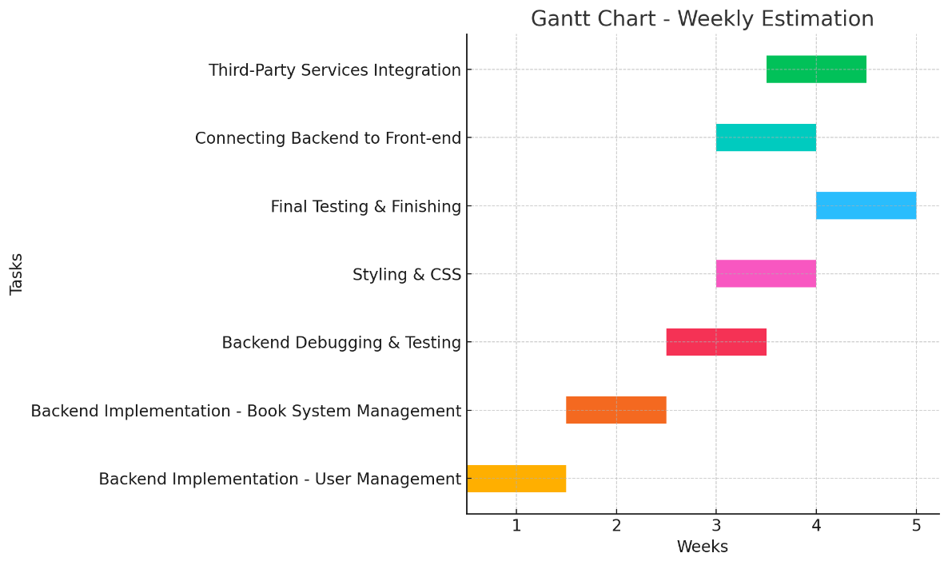

# Use case diagrams

## Borrowing Process Use Case Diagram

- Actors: User, Admin

- Use Cases: Borrow Book, Reserve Book, Return Book, Check Book Availability, Extend Borrowing Period, Pay Fine (User), Manage Borrow Records (Admin).

## Library and Book Management Use Case Diagram

- Actors: Admin, User

- Use Cases: Add New Library (Admin), View Library Details, Add New Book (Admin), View Book Details, View books read in the past, Update Book Information (Admin), Update Library Information (Admin), Search for Books, Search for Libraries, View Borrowing Statistics (Admin).

## User Management Use Case Diagram:

- Actors: Admin, User

- Use Cases: Register, Login, Update Profile, View User Details, Manage User Roles (Admin only), Delete Account, Manage Users (Admin only).