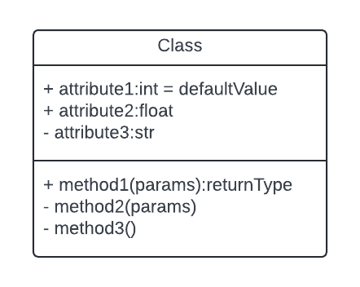

+ attributes are the public attributes and, – attributes are the private attributes.

+ methods are the public methods.

And - methods are the private methods.

