Hong Kong Baptist University
Department of Computer Science
COMP4878-9 Innovative Computing Project I
Project: Digital Platform for Telemedicine
Supervisor: Prof. LEUNG, Yiu Wing
Student Name: Ma Chun Kit
Student Number: 23230215
Second Progress Report
10 November 2026

Abstract
This report records the work finished after the first progress report. The client is a Flutter app. It talks only to a Node.js API, and that API is the only part that talks to MongoDB Atlas. The build now covers booking with a confirmation page, meetings with a waiting room, sick-leave certificates, a Hong Kong map, medicine-order status, visit notes, a course-demo notice, typed health readings, and a fixed app guide. Live video, PayPal, a courier GPS feed, the HKBU GenAI API, and a wearable library are not connected. On 10 November 2026 the automated test command flutter test finished with 27 passed.
Note on AI usage: Cursor was used to draft this report from the current source and the passing test run. The diagrams were drawn for this report. The student should read the report before submitting it.

Project Background
The project is a course information system for a remote clinic. A patient should be able to book a visit, meet the doctor, receive a certificate, and follow a medicine order without leaving the same app. The first report chose Flutter for the client and MongoDB for storage, and it listed several outside services. This second report keeps that client and database, and it records which of those services are now replaced by a local course-demo behaviour.

The objectives of your project
The objective is still one system for the visit from booking through follow-up. The patient books a doctor, joins a meeting, reads a sick-leave certificate, and sees whether medicine is preparing, in transit, or delivered. The doctor publishes times, hosts the meeting, writes the certificate and the visit note, and updates the medicine order. An admin can read records and does not change them.

Proposed system solution or changes made to your previously proposed solution
The running shape is Flutter to HTTP, then Node.js and Express to MongoDB Atlas, database name telemedicine. The phone never opens the database. Language, colour, font size, and easy mode stay on the device.
Changes from the first report: sick-leave files use the pdf package on the device instead of Syncfusion. The map uses OpenFreeMap vector tiles and a saved copy of public clinic and hospital data, instead of the Hong Kong Vector Map API. The meeting room keeps a room number and a waiting room, and it does not send the camera. Payment is a pending row of HKD 0 with provider demo, and PayPal is not called. The app guide uses three fixed answers, and the HKBU GenAI API is not called. Health readings are numbers the patient types, and the health package is not installed.
Figure 1 shows the path from an open time to a completed visit.
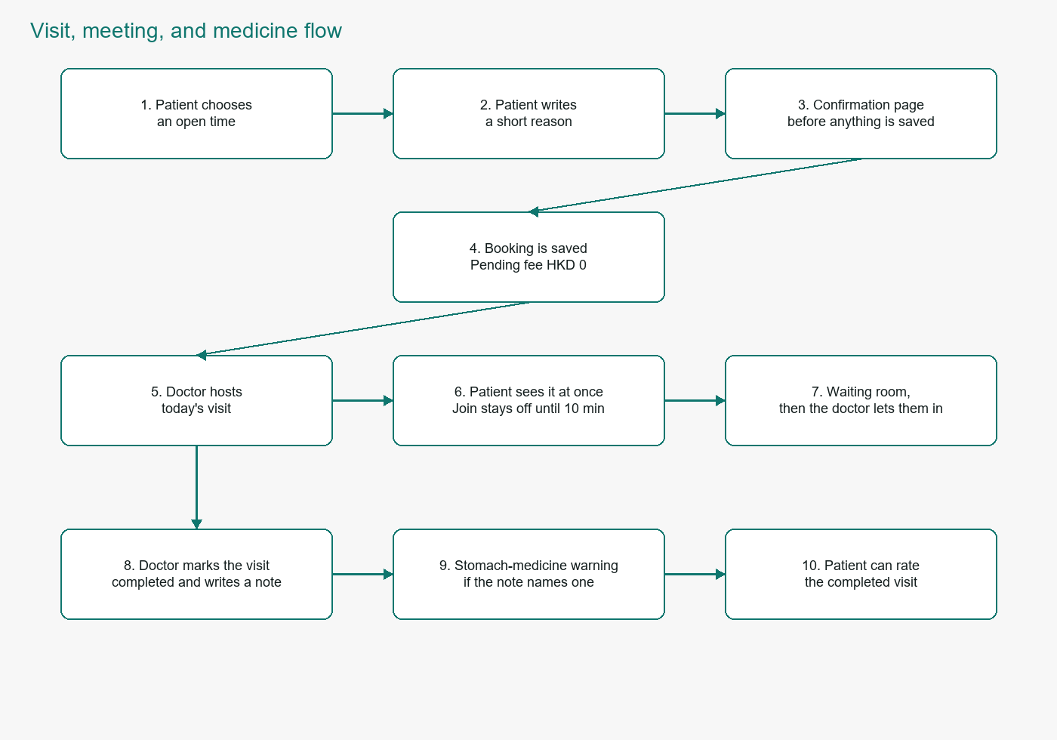
Figure 1. Flow from booking to a completed visit.
Figure 2 shows the main records and how they link. It is not a SQL schema. MongoDB stores these as collections.
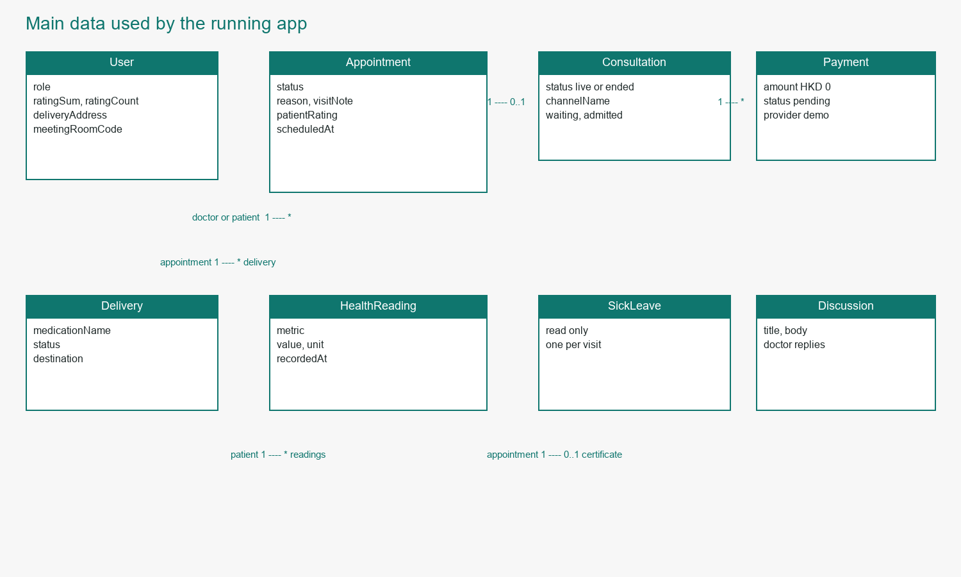
Figure 2. Entity relationship of the records used by the app.

Proposed schedule & what you have achieved so far
The first report planned core booking and certificates in November, video and map APIs in December, and the chatbot and wearable work in February. By 10 November 2026 the following are in the app and covered by the plan file.
- Sign-in, sign-up, three roles, and a course-demo checkbox that must be ticked before an account is created.
- Appointments: a doctor publishes a future time, a patient books it only after a confirmation page, and a cancel at least one day ahead is described as free. No money is taken.
- Meetings: the doctor hosts today's visit. The patient sees that hosted meeting immediately. The join button stays off until 10 minutes before the booked time. The room does not send a live picture.
- A doctor can mark a booked visit completed, write a visit note, and the patient can read it. If the note names aspirin, ibuprofen, naproxen, or diclofenac, the card warns that a stomach medicine should be paired with it. The patient can rate a completed visit once.
- Sick-leave certificates, direct messages, and the public discussion board.
- A Hong Kong map pinned at Hong Kong Baptist University, Kowloon Tong, plus public clinics and hospitals. A doctor can create a medicine order for a booked visit and move its status. The patient's typed address is the destination text. It is not drawn as a moving van.
- Settings for language, dark mode, colour, font size, easy mode, and action notices. An action notice is a line stored on the device after a booking. It is not email, SMS, or a push message.
- An app guide with fixed answers, and a health screen where a patient types a heart rate, step count, or blood oxygen.

Problems (if any) you are having with the project
The outside services named in the first report need accounts or keys that this course build does not have. Because of that, live video, PayPal, courier GPS, the HKBU assistant, a wearable, and a password-reset email are not connected. The demo sign-in buttons are still on the login screen so the three sample accounts can be shown. Formal legal terms are not written; the sign-up checkbox is only a course-demo notice. A new API route does nothing until the Node process is started again from the backend folder.

What activities you are currently engaging in
The current work is to keep the client, the API, and plan.md describing the same behaviour, and to test that behaviour. The automated suite was run on 10 November 2026 and reported 27 passed. The separate test-case PDF lists each case. The next useful work, once a vendor is chosen, is one live-video SDK and one real payment or courier account. Until then the local status fields are the course-demo stand-in.

Reference
[1] Flutter, https://flutter.dev/ (accessed 10 Nov. 2026).
[2] Dart, https://dart.dev/ (accessed 10 Nov. 2026).
[3] MongoDB, https://www.mongodb.com (accessed 10 Nov. 2026).
[4] Express, https://expressjs.com/ (accessed 10 Nov. 2026).
[5] OpenFreeMap, https://openfreemap.org/ (accessed 10 Nov. 2026).

