# 3. APPROACH

The Horse Health Monitoring system (HHM) is a device that will monitor the temperature and pulse rate of a horse. The HHM device will monitor for fluctuations in these vitals that could be indicative of the onset of illness. The device will be battery-operated and portable and will send the vitals data to the user at regular set intervals via text message. Design constraints have been evaluated to establish a means for subsystem and sensor selections as well as software usage which will be discussed in the following sections.

## 3.1 System Overview

The HHM device will utilize several subsystems in order to dynamically track the horse’s health. The microcontroller will gather the vitals data from the temperature and pulse sensors. It will then submit the data to the Global System for Mobile Communications (GSM) module to send to the user via text message. These devices will perform vitals analysis at a user-specified time intervals in order to conserve power usage. Figure 3.1 below shows the overall functionality of the subsystems that comprise the HHM system.

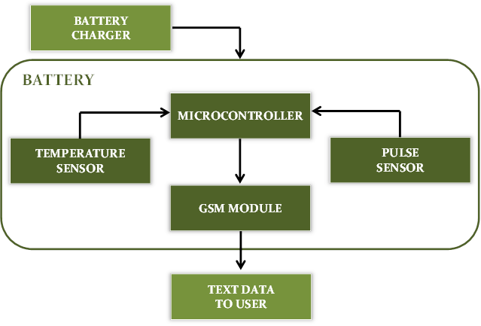

**Figure 3.1.1 – HHM System Overview**

## 3.2 Hardware

The hardware subsystems that are essential to the HHM device are the temperature sensor, pulse sensor, microcontroller, GMS module, and battery. These subsystems are discussed in further detail in the following sections.

**3.2.1 Temperature Sensor**

The temperature sensor must be able to gather the horse’s core body temperature in rugged environments and would possibly be exposed to excessive moisture. The sensor must be non-invasive to the horse and have a range of at least 90˚F to 110˚F to accommodate the horse’s core temperature range of 99.5˚F to 101.5˚F. With these considerations, several temperature sensors were evaluated and are listed below.

**Table 3.2.1 – Temperature Sensor Evaluation**

|  |  |  |  |  |  |
| --- | --- | --- | --- | --- | --- |
| *Model* | *Style* | *Supply*  *Voltage* | *Measurement*  *Range* | *Accuracy* | *Cost* |
| SEN-12871 | Analog Probe,  Thermistor | N/A | -40◦F to 257◦F | 32◦F: ± 0.36◦F  212◦F: ± 0.9◦F | $28.95 |
| MLX90614 | Non-Contact  IR Sensor | 2.6 to 3.6V | -40◦F to 257◦F | 32◦F to 122◦F: ± 0.9◦F | $19.95 |
| DS18B20 | Digital Probe | 3.0 to 5.5V | -67◦F to 257◦F | 14◦F to 185◦F: ± 0.9◦F  -67◦F to 257◦F: ± 5.6◦F | $9.95 |

Model SEN-12871 is a stainless steel temperature probe that uses thermistor technology. The thermistor is a variable resistor that reduces in value as temperature is increased. To compensate for this non-linear resistance pattern, the Steinhart Equation is used which states T=[K0=K1(ln1000R)=K2(1000R)3]-1-273.15, where T is the temperature in degrees Celsius, R is the measured resistance in kilo-ohms, and K0, K1, and K2 are specified constants by the manufacturer [1]. An advantage of this sensor is that is does not require any external power, since it is only interpreted as a resistance value. It is also more accurate at the core body temperature range needed than the other sensors. However, it is also the most expensive of the top sensors evaluated and its response time to temperature changes is undesirable. Although it is advertised as rugged construction and the probe itself is waterproof, the handle and cabling is not waterproof. This could be problematic depending on the horse’s environment and limits placement options.

The non-contact infrared (IR) sensor was also considered as a potential temperature sensor. This technology would allow temperature measurement to be taken from a mounted device without actually coming in contact with the horse. It would allow measurements to be taken from the HHM device packaging and be able to connect directly to other circuitry in the device. There is a major disadvantage to this feature, though. According to the manufacturer, it is imperative to ensure that there are no temperature differences in the packaging of the sensor. It is highly susceptible to ambient interferences such as heat from other electronics, or an object close enough to the sensor to cause the sensing element to heat or cool internally [2]. Unfortunately, given the rugged environment this sensor would be exposed to, the implementation would not be feasible or reliable.

The chosen temperature sensor for the HHM system is the DS18B20 digital probe. Although the accuracy is not the most ideal, the biggest selling-point of this sensor is that it is rugged and waterproof. It is also very economical and efficient on power consumption which will be discussed in a later section [3]. This sensor allows for flexibility of placement on the horse which would allow the HHM system to select the optimal location to measure the horse’s temperature in comparison to the rectal temperature. Also, this sensor utilizes a 1-wire interface which reduces hardwiring needs.

Other styles of temperature sensors were also considered, but were not practical for the HHM system application. Thermocouples are used in several industrial applications and would have worked well for the rugged design constraint, but they would not be ideal for response time and accuracy requirements. Integrated circuit (IC) temperature sensors were also considered. These devices would be the most accurate by far, but due to their sensitive nature, they would be impractical as well.

**3.2.2 Pulse Sensor**

For pulse, the only two competitive styles of sensors are electrocardiogram (ECG) and IR technologies. ECG sensors are very accurate and have a very low current draw (≈170µA) [4]. However, they are impractical for use on a horse. First, the electronics incorporated in an ECG sensor are very sensitive and subject to damage from electrostatic discharge. Second, an ECG sensor must be used with biomedical sensor pads which are designed to adhere to a human’s skin. This would render an ECG sensor useless on a horse’s fur.

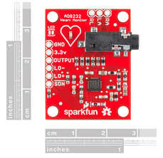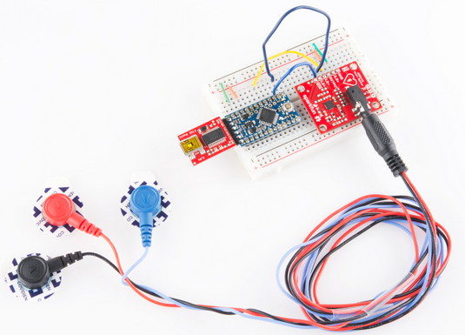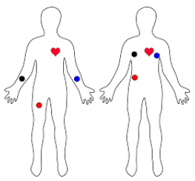

**Figure 3.2.2.a – ECG Functionality (Model AD8232)**

The pulse sensor that will be used with the HHM system is the Pulse Sensor Amped IR sensor. It has a higher than desired current draw at 4mA with a 5V source (will be less for a 3.3V source), but its versatility is crucial. It meets the beats per minute (bpm) design constraint and has a range of 0 to 200 bpm. It also matches the voltage source specifications with an input range of 3V to 5V. This sensor will allow for placement in multiple locations on the horse to ensure an accurate reading. It is not as durable as necessary for the environment, but it can very easily be reinforced. It has a very simple analog voltage interface which will make programming and interpreting measurements user-friendly [5]. Overall, with the extremely limited market for pulse sensors, the Pulse Sensor Amped is the best option for the HHM system design.

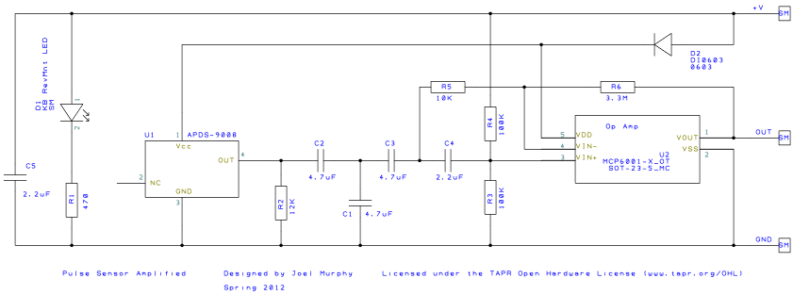

**Figure 3.2.2.b – Pulse Sensor Amped Equivalent Circuit**

**3.2.3 Microcontroller**

The microcontroller selection for the HHM system is the dsPIC33EP128GP502 (dsPIC33). This is a microcontroller that satisfies pin-out criteria to accommodate the sensors and GSM module. It operates at a 3.3 voltage source which also corresponds to the voltage source ratings of other devices in the system it will control. The most important aspect of the dsPIC33 is that every member of the team is familiar with the software and programming elements of this microcontroller.

**3.2.4 GSM module**

Several wireless communication technologies were evaluated for the HHM system. Wireless internet was explored as an option to transmit the sensor data to the user, but, considering the remote areas the HHM system might be used in, wireless internet might not be available to the user. Bluetooth technology was also considered. Although there are low power Bluetooth modules that can now transmit data a substantial distance and are very cost-effective, this technology would still limit users to only getting data when they are nearby. Radio frequency identification (RFID) is a similar technology to Bluetooth, as far as its range limitations, and it is also very expensive. The most viable option for the HHM system is a GSM module. GSM is a cellular technology used to transmit mobile data to and from the user and the device. The following modules were evaluated as potential options for the HHM system.

The GSM module model SIM808 is 1.75"x1.6" in size. It operates with a supply voltage of 3.4 to 4.0V. In addition to being able to send and receive text messages and voice calls, it also has a fully-integrated global positioning system (GPS). While this would be a nice feature to have, it is unnecessary and would cause additional power consumption. Also, this module is a bit more costly due to this additional feature. It retails for $49.95. Figure 3.2.4.a demonstrates a functional diagram of the module operation [6].

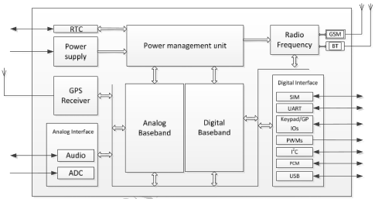

**Figure 3.2.4.a – SIM808 Functional Diagram**

Similar to the SIM808, the SIM800H model has all the same features except the GPS tracking. This reduces power consumption as well as the cost. This module retails for $39.95. Figure 3.2.4.b demonstrates the functional diagram of this module’s operation, which notes the similarities apart from the GPS functionality. Also, this module is slightly more compact, measuring 1.75"x1.25." Overall, this would be a better fit for the HHM system. It satisfies the lower power consumption and cost-effective design constraints.

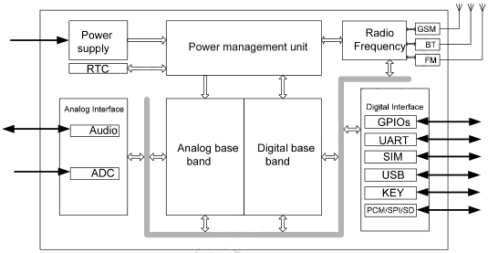

**Figure 3.2.4.b – SIM800H Functional Diagram**

**3.2.5 Battery**

Incomplete.

**3.3 Software**

The code operating on the dsPIC microcontroller is responsible for accessing the multiple peripherals being utilized in the Horse Health Monitoring (HHM) system. The dsPIC microcontroller is programmed using C code written specifically for the operation of each peripheral in tandem.

HHM will operate in three different states: idle, polling and transmitting. The state of the system is dependent upon the selected update schedule from the user as well as any immediate update requests by the user. Details of these different states are described in the following subsections.

**3.3.1. Idle State**

The idle state will be the starting state for the HHM device upon powering on the device as well as when the device is conducting no other operations. The flowchart for this state is illustrated in Figure 3.3.1.

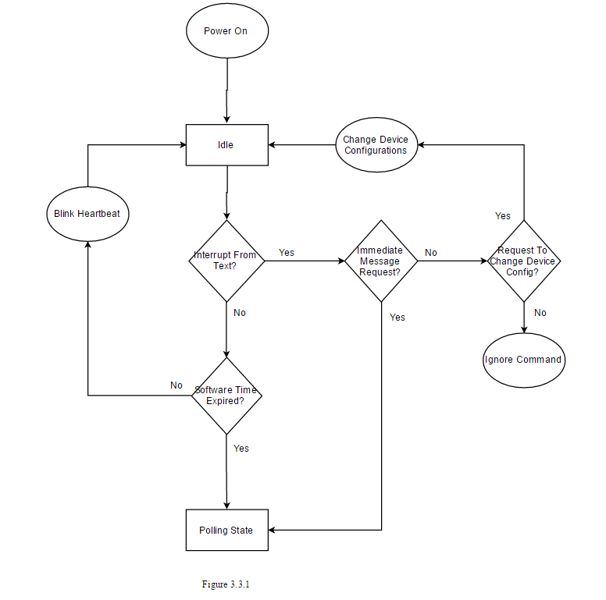

**Figure 3.3.1 – Idle State Flowchart**

In the idle state, the dsPIC microcontroller will consistently blink a “heartbeat” LED to signify to the user that the device is active, continually check a software timer to determine if the device should continue to the polling and transmission states and standby for any text message interrupts from the GSM module, changing user configurations for the device or immediately transitioning to the polling and transmission states upon request.

**3.3.2. Polling State**

The polling state, illustrated by a flowchart in Figure 3.3.2, is initiated by the dsPIC microcontroller when transitioning from the idle state.

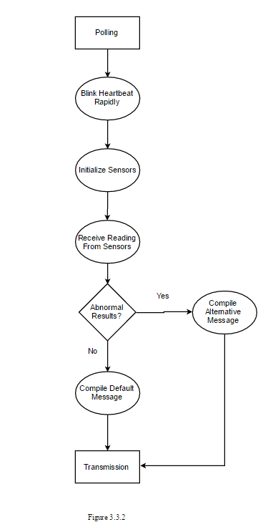

**Figure 3.3.2 – Polling State Flowchart**

This state will supply power to both the temperature sensor and the pulse rate monitor, initialize and configure the settings for each peripheral, and capture the digital information from each sensor. After translating the digital information from each sensor into Fahrenheit and beats per minute (bpm) calculations, results of the polling state will be checked for abnormality. The results will then be packaged into a string message to be sent over serial to the GSM module. If the temperature and heart rate results are abnormal, an alternative string message including an alert will be sent over serial to the GSM module. In this state the heartbeat LED will blink rapidly.

**3.3.3. Transmission State**

The transmission state occurs directly after the polling state, communicating to the user via the GSM module. A flowchart detailing the operations of this state can be found in Figure 3.3.3.

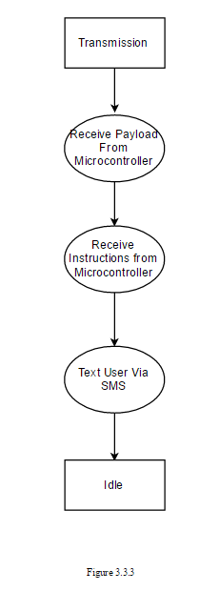

**Figure 3.3.3 – Transmission State Flowchart**

The GSM module will communicate with the microcontroller via serial and receive commands to begin SMS communication with the user. The GSM module will receive a string message from the microcontroller and text the user string message containing the metrics of the horse’s health. After this transaction, the HHM device will return to the idle state.

**3.3.4. Usage Cases**

A “sunny day” case for the HHM device details a successful day of operations without errors. This case details a day in which the HHM device is able to quickly and accurately acquire the metrics of a horse and communicate the information over GSM. Figure 3.3.4.a illustrates the “sunny day” case of operation.

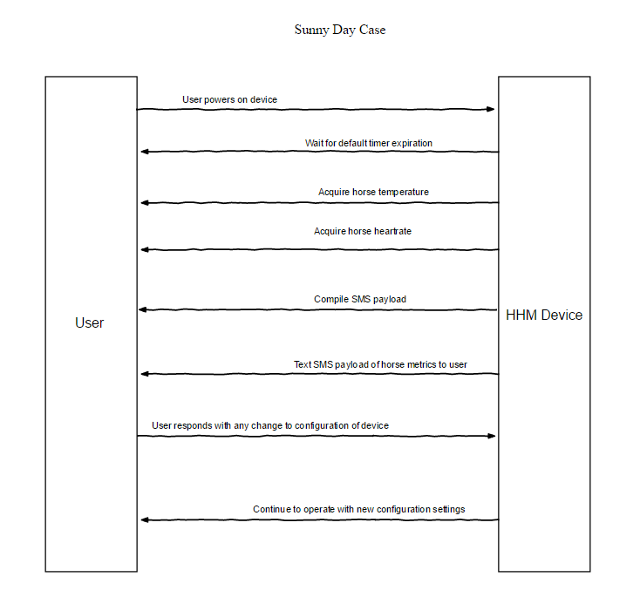

**Figure 3.3.4.a – Sunny Day Case**

A “rainy day” case the for HHM device is a day of operations when the GSM module cannot communicate with the user via text. In this case, while the HHM device may be able to acquire the temperature and heart rate of the horse, the GSM module will not have a cell connection and cannot send the acquired data to the user. Figure 3.3.4.b illustrates the “rainy day” case of operation.

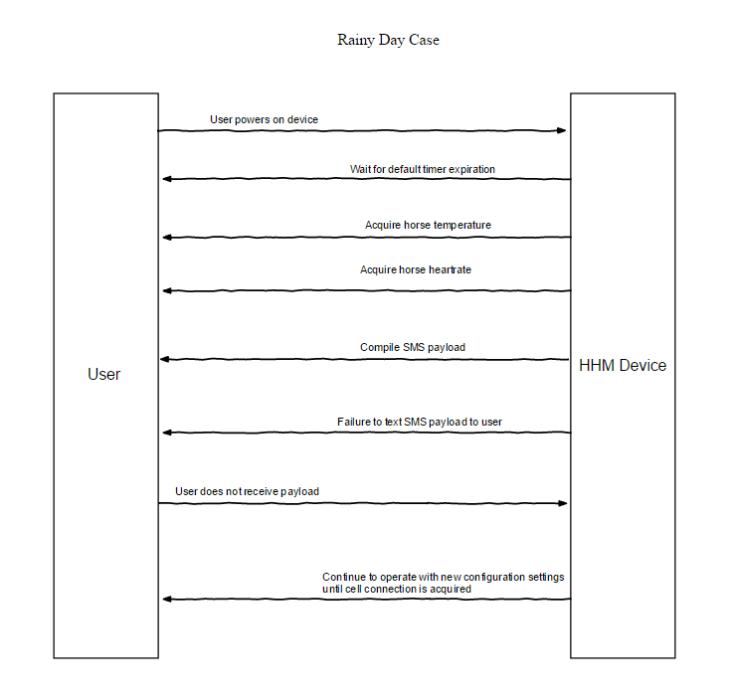

**Figure 3.3.4.b – Rainy Day Case**

References

[1] Vernier, “Stainless Steel Temperature Probe,” TMP-BTA datasheet, [Revised Dec. 2012].

[2] Melexis, “MLX90614 family: Single and Dual Zone Infrared Thermometer in TO-39,” 3901090614 datasheet, Feb. 2007 [Revised May 2009].

[3] Dallas Semiconductor, “DS18B20: Programmable Resolution 1-Wire Digital Thermometer,” 050400 datasheet.

[4] Analog Devices, “Single-Lead, Heart Rate Monitor Front End,” AD8232 datasheet, [Revision A].

[5] Murphy, J. “Pulse Sensor Amplified,” schematic, Spring 2012. Access URL: <https://cdn.shopify.com/s/files/1/0100/6632/files/PulseSensorAmpd_-_Schematic.pdf?1862089645030619491>

[6] SIMCom, “SIM808_Hardware Design_V1.02,” SIM808_Hardware Design Manual, Mar. 2015 [Revision 1.02].

[7] SIMCom, “SIM800H_Hardware_Design,” SIM808_Hardware_Design_V1.00 Manual, Aug. 2013 [Revision 1.00].