# 3. APPROACH

The Horse Health Monitoring system (HHM) is a device that will monitor the temperature and pulse rate of a horse. The HHM device will monitor for fluctuations in these vitals that could be indicative of the onset of illness. The device will be battery-operated and portable and will send the vitals data to the user at regularly set intervals via text message. Design constraints have been evaluated to establish a means for subsystem and sensor selections as well as software usage, which are in the following sections.

## 3.1 System Overview

The HHM device will utilize several subsystems in order to dynamically track the horse’s health. The microcontroller will gather the vitals data from the temperature and pulse sensors. It will then submit the data to the Global System for Mobile Communications (GSM) module to send to the user via text message. These devices will perform vitals analysis at a user-specified time interval in order to conserve power usage. Figure 3.1 shows the overall functionality of the subsystems that comprise the HHM system.

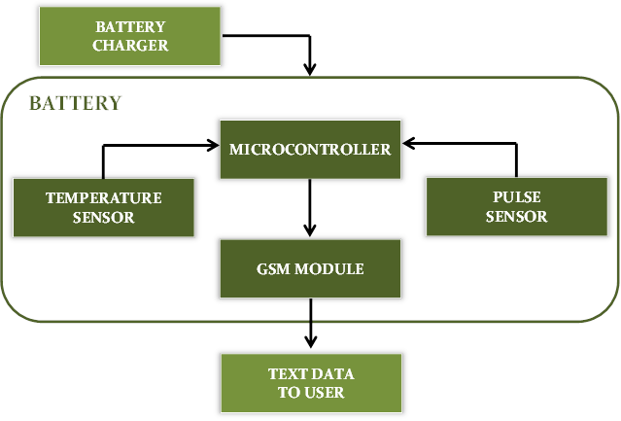

**Figure 3.1.1 – HHM System Overview**

## 3.2 Hardware

The hardware subsystems that are essential to the HHM device are the temperature sensor, pulse sensor, microcontroller, GMS module, and battery. These subsystems are discussed in further detail in the following sections.

**3.2.1 Temperature Sensor**

The temperature sensor must be able to gather the horse’s core body temperature in rugged environments and would possibly be exposed to excessive moisture. The sensor must be non-invasive to the horse and have a range of at least 90˚F to 110˚F to accommodate the horse’s core temperature range of 99.5˚F to 101.5˚F. With these considerations, several temperature sensors were evaluated and are listed in Table 3.2.1.

**Table 3.2.1 – DS18B20 Sensor Selection Evaluation**

|  |  |  |  |  |  |
| --- | --- | --- | --- | --- | --- |
| *Model* | *Style* | *Supply*  *Voltage* | *Measurement*  *Range* | *Accuracy* | *Cost* |
| SEN-12871 | Analog Probe,  Thermistor | N/A | -40◦F to 257◦F | 32◦F: ± 0.36◦F  212◦F: ± 0.9◦F | $28.95  [1] |
| MLX90614 | Non-Contact  IR Sensor | 2.6 to 3.6V | -40◦F to 257◦F | 32◦F to 122◦F: ± 0.9◦F | $19.95  [2] |
| DS18B20 | Digital Probe | 3.0 to 5.5V | -67◦F to 257◦F | 14◦F to 185◦F: ± 0.9◦F  -67◦F to 257◦F: ± 5.6◦F | $9.95  [3] |

Model SEN-12871 is a stainless steel temperature probe that uses thermistor technology. The thermistor is a variable resistor that reduces in value as temperature is increased. An advantage of this sensor is that is does not require any external power, since it is only interpreted as a resistance value. It is also more accurate at the core body temperature range needed than the other sensors [1]. However, it is also the most expensive of the top sensors evaluate. Although it is advertised as rugged construction and the probe itself is waterproof, the handle and cabling is not waterproof. This could be problematic depending on the horse’s environment and limits placement options.

The non-contact infrared (IR) sensor was also considered as a potential temperature sensor. This technology would allow temperature measurement to be taken from a mounted device without actually coming in contact with the horse. It would allow measurements to be taken from the HHM device packaging and be able to connect directly to other circuitry in the device. There is a major disadvantage to this feature, though. According to the manufacturer, it is imperative to ensure that there are no temperature differences in the packaging of the sensor. It is highly susceptible to ambient interferences such as heat from other electronics, or an object close enough to the sensor to cause the sensing element to heat or cool internally [2]. Given the rugged environment this sensor would be exposed to, the implementation would not be feasible or reliable.

The chosen temperature sensor for the HHM system is the DS18B20 digital probe. Although the accuracy is not the most ideal, the biggest advantage of this sensor is that it is rugged and waterproof. It is also very economical and efficient on power consumption which is discussed in a later section [3]. This sensor allows for flexibility of placement on the horse which would allow the HHM system to select the optimal location to measure the horse’s temperature in comparison to the rectal temperature. Also, this sensor utilizes a 1-wire interface which reduces hardwiring needs.

Other styles of temperature sensors were also considered but were not practical for the HHM system application. Thermocouples are used in several industrial applications and would have worked well for the rugged design constraint, but they would not be ideal for response time and accuracy requirements. Integrated circuit (IC) temperature sensors were also considered. These devices would be the most accurate by far, but due to their sensitive nature, they would be impractical as well.

**3.2.2 Pulse Sensor**

For pulse, the only two competitive styles of sensors are electrocardiogram (ECG) and IR technologies. ECG sensors are very accurate and have a very low current draw (≈170µA) [4]. However, they are impractical for use on a horse. First, the electronics incorporated in an ECG sensor are very sensitive and subject to damage from electrostatic discharge. Second, an ECG sensor must be used with biomedical sensor pads which are designed to adhere to a human’s skin. This would render an ECG sensor useless on a horse’s fur.

The pulse sensor that will be used with the HHM system is the Pulse Sensor Amped IR sensor. It has a higher than desired current draw at 4mA with a 5V source (will be less for a 3.3V source), but its versatility is crucial. The sensor has a range of 0 to 200 beats per minute (bpm) which satisfies the design constraint of 25 to 200 bpm. It also matches the voltage source specifications with an input range of 3V to 5V. This sensor will allow for placement in multiple locations on the horse to ensure an accurate reading. It is not as durable as necessary for the environment, but it can very easily be reinforced. It has a very simple analog voltage interface which will make programming and interpreting measurements user-friendly [5]. Overall, with the extremely limited market for pulse sensors, the Pulse Sensor Amped is the best option for the HHM system design.

**3.2.3 Microcontroller**

For the microcontroller selection, an Arduino option was desired due to a plethora of open-source code for both the sensors as well as the GSM module. The Arduino Uno was a very cost-effective option for the HHM system and satisfies the pin-out criteria to accommodate the system. The sensors and GSM module will utilize a total of 1 analog input port and 4 digital I/O ports for logic programming. The Arduino Uno provides 6 analog input ports and 14 digital I/O ports, which is more than sufficient. This microcontroller allows for 5V or 3.3V operating voltage [6].

**3.2.4 GSM Module**

Several wireless communication technologies were evaluated for the HHM system. Wireless internet was explored as an option to transmit the sensor data to the user, but, considering the remote areas the HHM system might be used in, wireless internet might not be available to the user. Bluetooth technology was also considered. Although there are low power Bluetooth modules that can now transmit data a substantial distance and are very cost-effective, this technology would still limit users to only getting data when they are nearby. Radio frequency identification (RFID) is a similar technology to Bluetooth, as far as its range limitations, and it is also very expensive. The most viable option for the HHM system is a GSM module. GSM is a cellular technology used to transmit mobile data to and from the user and the device. The following modules were evaluated as potential options for the HHM system.

The Arduino GSM Shield V2 was evaluated as a possible option. It has all the basic features needed for the HHM system communication and also includes internet connectivity. There are several disadvantages of this model though. It is only compatible with an Arduino microcontroller. Considering the Shield retails at $71.50 per unit, the lack of compatibility options is undesirable. Also, it has a single operating voltage of 5V and draws 700 – 1000 mA of current, which would conflict with the low power design constraint goals as well as the operating voltages of other devices selected. Its rather large size of 4x3” does not conform to the size constraint [7].

The selected GSM module for the HHM system is the Adafruit FONA MiniGSM SIM800H. Unlike the Shield, the Adafruit module is compatible with multiple microcontrollers, allowing for flexibility in programming and communications. Its operating voltage encompasses a range of 2.8 – 5V and only draws 500mA, which is much more compatible with the low power design constraint. The Adafruit module is available in a much smaller size than the Shield at 1.8x1.3” and is also much more cost-effective at $39.95 per unit [8].

**3.2.5 Battery**

In accordance with the HHM battery life constraint, the system must maintain a battery life of at least 12 hours. The user will select a timing interval of 30 minutes, 1 hour, or 2 hours to gather the horse vitals data. The overall battery life will be dependent upon this timing interval. The HHM system will cycle between an active mode and a standby mode. During the active mode, measurements are taken and the data is transmitted to the user. Between these periods of active mode, the system will be in standby until the interval timer initiates the active mode once again. Table 3.2.5 indicates the current consumption of each device in the system in both active and standby modes.

**Table 3.2.5.a – Device Current Consumption**

|  |  |  |  |
| --- | --- | --- | --- |
| *Device* | *Model* | *Active Current* | *Standby Current* |
| Microcontroller | Arduino Uno | 172 mA | 50 mA |
| Temperature Sensor | DS18B20 | 1 mA | 750 nA |
| Pulse Sensor | Pulse Sensor Amped | 4 mA | 0 mA |
| GSM Module | SIM800H | 500 mA* | 2 mA |

* The GSM Module has a current draw spike of 2A during data transmission.

Total battery life for the HHM system, which accounts for the active and standby modes, is calculated by the following equation:

$$Battery Capacity=\frac{Battery Life}{\left(Active Time*Active Current\right)+(Standby Time*Standby Current}$$

The current draw spike of the GSM module causes a voltage drop in the system which could potentially cause damage to the microcontroller and sensors. Therefore, a separate battery was selected to isolate the GSM module power supply from the rest of the system. The LP-503562 battery was selected due to manufacturer recommendations. It has a 1200mAh capacity and supplies a voltage of 3.7V [9].

For the remaining system, the sensors will be powered through the microcontroller. The microcontroller requires and external voltage supply of 7V – 12V. For battery selection, lithium-ion polymer was preferred due to higher capacity, low discharge, low profile, and much safer than a lithium-ion battery, which would need an external protection circuit [10]. Model CU-J699 was selected as the battery choice which provides 7.4V and has a capacity of 2.1Ah [11]. Table 3.2.5.b shows the calculated battery life based off user selection for various timing intervals for both the main system and the GSM module. It is evident that both these batteries will satisfy the battery life constraint of at least 12 hours.

**Table 3.2.5.b – Calculated Battery Life**

|  |  |  |  |
| --- | --- | --- | --- |
| *Main System* | *30 Minutes* | *1 Hour* | *2 Hours* |
| Main System | 41.07 hrs / 3.42 days | 42.48 hrs / 3.54 days | 43.23 hrs / 3.60 days |
| GSM Module | 64.32 hrs / 5.36 days | 115.88 hrs / 9.66 days | 193.58 hrs / 16.11 days |

**3.3 Software**

The code operating on the Arduino Uno is responsible for accessing the multiple peripherals being utilized in the Horse Health Monitoring (HHM) system. The Arduino Uno is programmed using C code written specifically for the operation of each peripheral in tandem.

HHM will operate in three different states: wake-up, polling and transmission. The state of the system is dependent upon the selected update schedule from the user as well as any immediate update requests by the user. Details of these different states are described in the following subsections.

**3.3.1. Wake-Up State**

The wake-up state will be the starting state for the HHM device upon powering on the device as well as when the device has just woken from sleep. The flowchart for this state is illustrated in Figure 3.3.1.

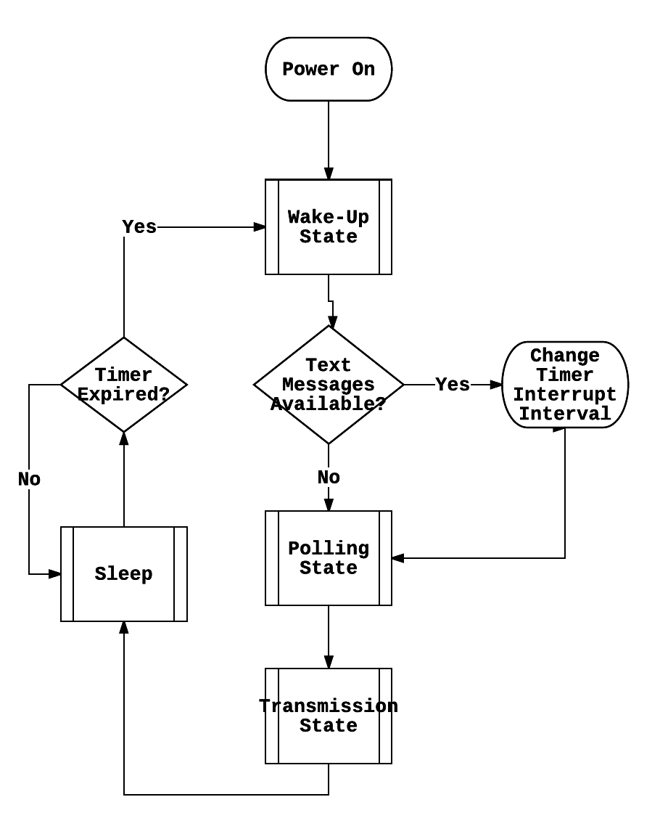

**Figure 3.3.1 – Wake-Up State Flowchart**

In the wake-up state, the Arduino Uno will consistently blink a “heartbeat” light emitting diode (LED) to signify to the user that the device is active, check for any text messages from the GSM module, and then proceed to change the interrupt timer interval based upon the text received. If no texts are available, the device will operate on previously set device configurations and transition to the polling and transmission states. After these two states have executed, the Arduino Uno will resume sleep until woken by the interrupt timer.

**3.3.2. Polling State**

The polling state, illustrated by a flowchart in Figure 3.3.2, is initiated by the Arduino Uno when transitioning from the wake-up state.

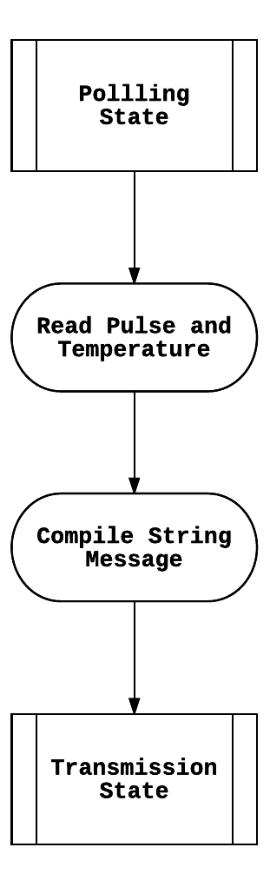

**Figure 3.3.2 – Polling State Flowchart**

This state will supply power to both the temperature sensor and the pulse rate monitor, initialize and configure the settings for each peripheral, and capture the digital information from each sensor. After translating the digital information from each sensor into Fahrenheit and beats per minute (bpm) calculations, results of the polling state will be checked for abnormality. The results will then be packaged into a string message to be sent over serial to the GSM module. In this state the heartbeat LED will blink rapidly.

**3.3.3. Transmission State**

The transmission state occurs directly after the polling state, communicating to the user via the GSM module. A flowchart detailing the operations of this state can be found in Figure 3.3.3.

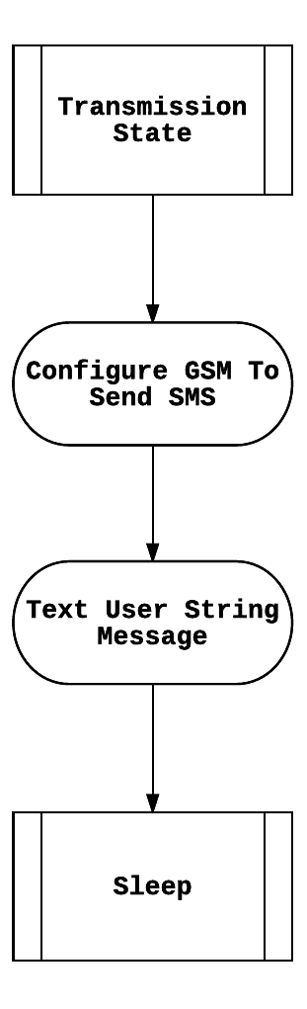

**Figure 3.3.3 – Transmission State Flowchart**

The GSM module will communicate with the microcontroller via serial and receive commands to begin SMS communication with the user. The GSM module will receive a string message from the microcontroller and text the user the string message containing the metrics of the horse’s health. The format of the string message is as such:

(“From HHM System ID: %d, Horse Name: %s, Temperature: %d, Heartrate: %d. Next update in: %d days %d hours %d minutes.”, systemIDNo, horseName, temperature, heartrate, days, hours, minutes)

After this transaction, the HHM device will return to sleep.

**3.3.4. Usage Cases**

A “sunny day” case for the HHM device details a successful day of operations without errors. This case details a day in which the HHM device is able to quickly and accurately acquire the metrics of a horse and communicate the information over GSM. Figure 3.3.4.a illustrates the “sunny day” case of operation.

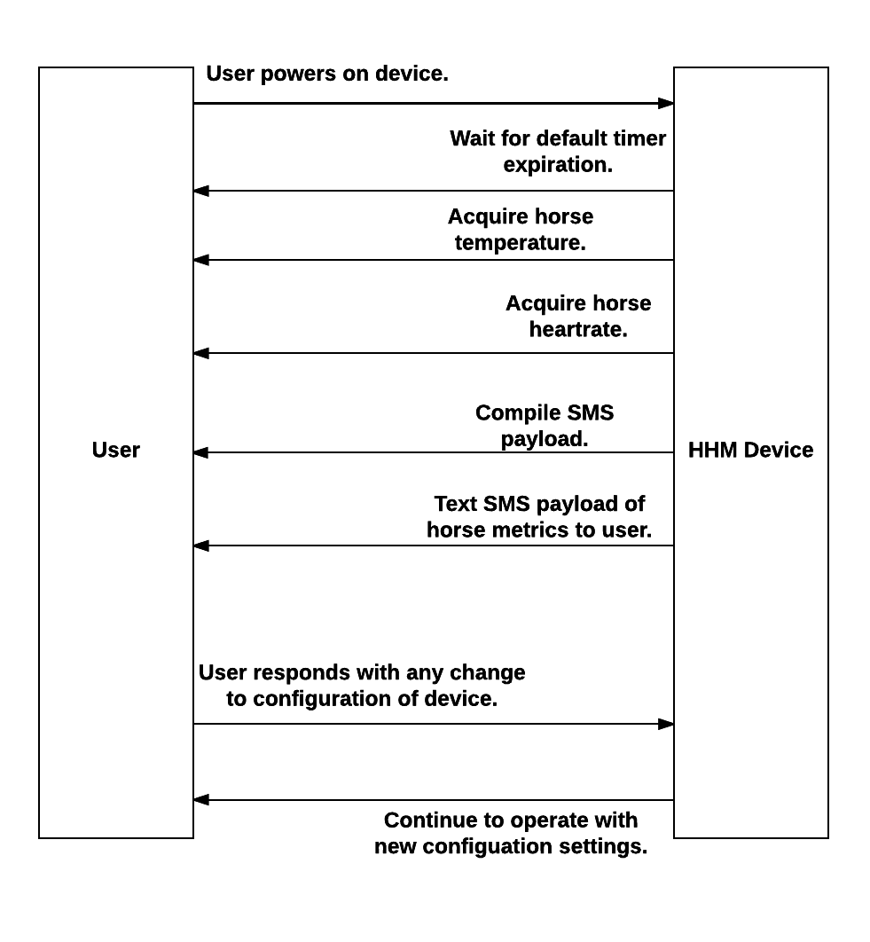

**Figure 3.3.4.a – Sunny Day Case**

A “rainy day” case for the HHM device is a day of operations when the GSM module cannot communicate with the user via text. In this case, while the HHM device may be able to acquire the temperature and heart rate of the horse, the GSM module will not have a cell connection and cannot send the acquired data to the user. Figure 3.3.4.b illustrates the “rainy day” case of operation. 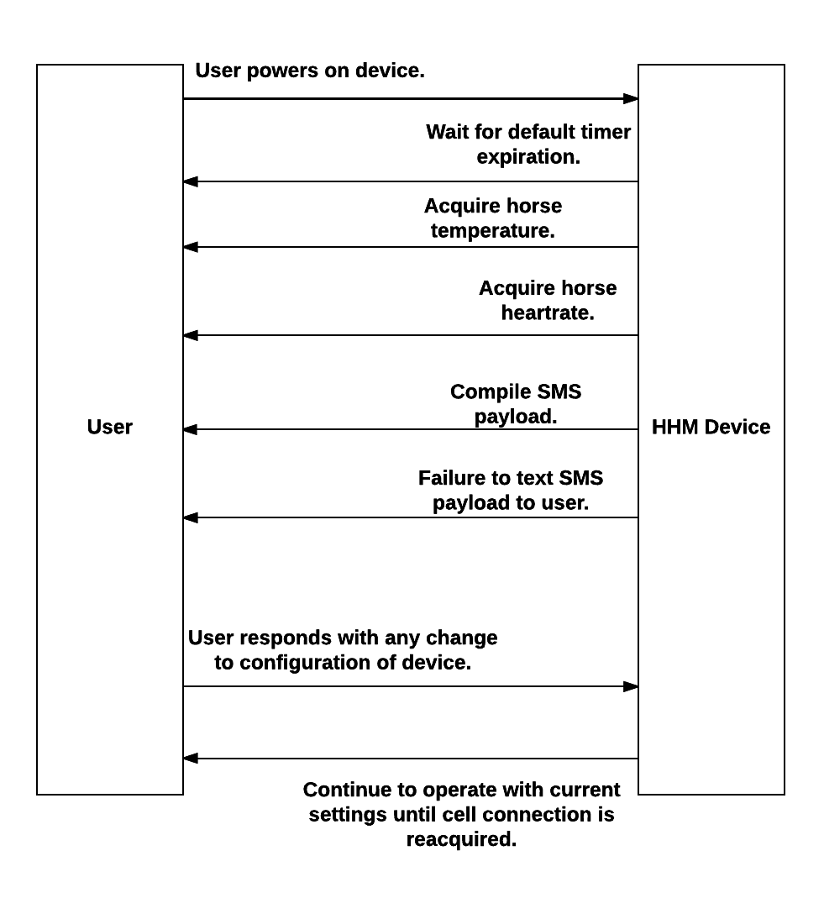

**Figure 3.3.4.b – Rainy Day Case**

References

[1] Vernier, “Stainless Steel Temperature Probe,” TMP-BTA datasheet, [Revised Dec. 2012].

[2] Melexis, “MLX90614 family: Single and Dual Zone Infrared Thermometer in TO-39,” 3901090614 datasheet, Feb. 2007 [Revised May 2009].

[3] Dallas Semiconductor, “DS18B20: Programmable Resolution 1-Wire Digital Thermometer,” 050400 datasheet.

[4] Analog Devices, “Single-Lead, Heart Rate Monitor Front End,” AD8232 datasheet, [Revision A].

[5] Murphy, J. “Pulse Sensor Amplified,” schematic, Spring 2012. Access URL: <https://cdn.shopify.com/s/files/1/0100/6632/files/PulseSensorAmpd_-_Schematic.pdf?1862089645030619491>

[6] Arduino. “Arduino UNO & Genuino UNO.” n.d. Access URL: <https://www.arduino.cc/en/Main/ArduinoBoardUno>

[7] Arduino. “Arduino GSM Shield V2.” n.d. Access URL: <https://www.arduino.cc/en/Main/ArduinoGSMShield>

[8] SIMCom, “SIM800H_Hardware_Design,” SIM808_Hardware_Design_V1.00 Manual, Aug. 2013 [Revision 1.00].

[9] Hunan Sounddon New Energy Co. Ltd. “Product Specification Model: 503562 1200mAh.” Product Specification Doc No. Q/WAPL503562-1011. [Revision 1].

[10] Battery University. “What’s the Best Battery?” March 2017. Access URL: <http://batteryuniversity.com/learn/archive/whats_the_best_battery>

[11] AA Portable Power Corp. “Product Specification Polymer Li-ion 7.4V 2100 mah.” Product Specification Doc No. 16-01-2007. [Revision 1].