# EVALUATION

The following sections illustrate the testing done to evaluate the Horse Health Monitoring System’s performance and conformity to the design constraints.

**Table 4.1 -- Technical Design Constraints**

|  |  |
| --- | --- |
| **Constraint** | **Description** |
| Temperature Sensor Accuracy | The temperature sensor must measure the horse’s temperature within a degree Fahrenheit of the rectal thermometer measurement between the range of 90˚F and 110˚F. |
| Pulse Sensor Accuracy | The pulse sensor must be able to give an accurate heart rate between the range of 25 and 200 beats per minute (bpm). |
| Ingress Protection | The device must adhere to Ingress Protection Rating IP56. |
| Battery Life | The device battery must maintain device operation for a minimum of 12 hours. |
| User Notifications | The device must update the user via text message at certain intervals based upon the user’s discretion as well as alert the user to unusual horse health activity. |

* 1. **Test Certification – Temperature Sensor Accuracy**

The Horse Health Monitoring System’s temperature sensor must be able to measure with a range of 90˚F and 110˚F within one degree Fahrenheit accuracy. The sensor has been tested in cool temperatures shown in the figure below by placing the sensor in water from the Simrall water fountain.

**Figure 4.1.1: Cool Temperature Readings**

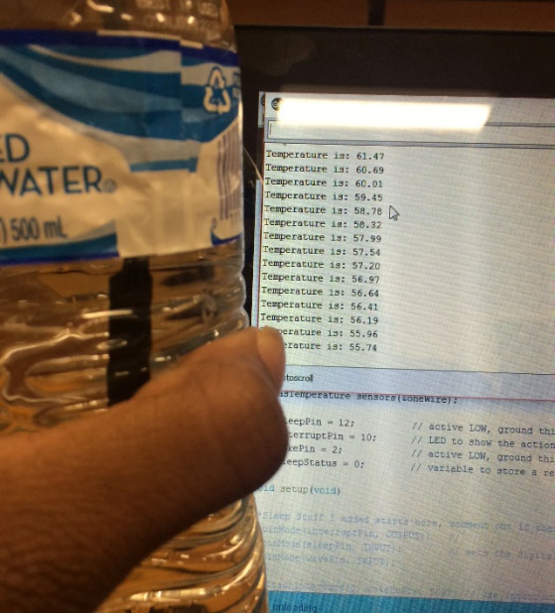

Figure 4.1.2 shows the readings are more visible.

**Figure 4.1.2: Cool Temperature Readings**

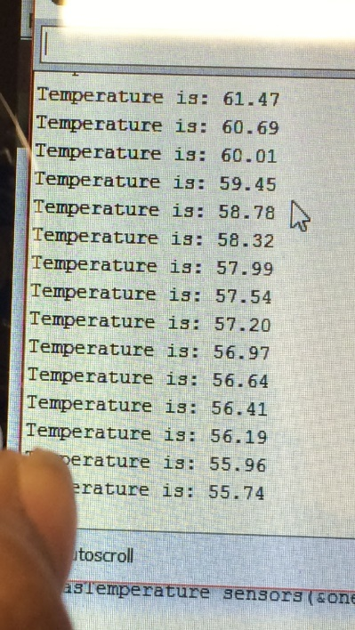

The sensor was also tested on human skin to see if the sensor would find a warm temperature value. Figure 4.1.3 represents those temperature results and Figure 4.1.4 gives you a closer look at the temperature readings.

**Figure 4.1.3: Warm Temperature Readings**

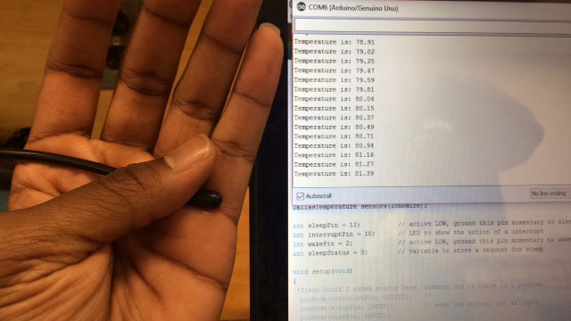

**Figure 4.1.4: Warm Temperature Readings**

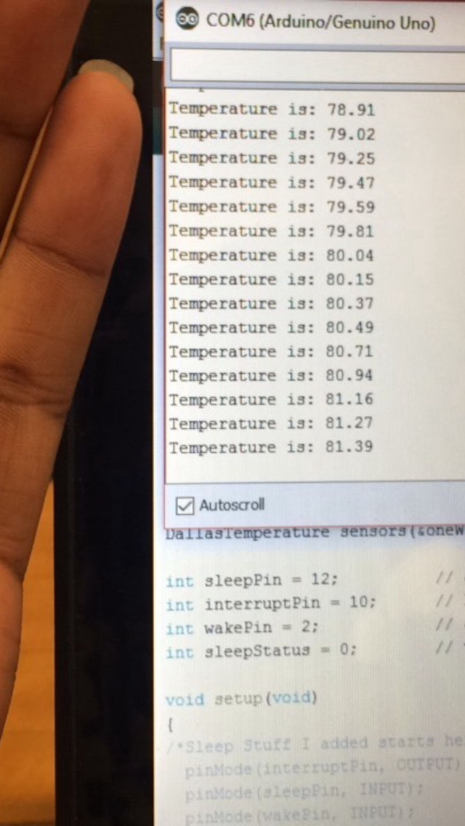

Once the device was tested on cool and warm environments, the sensor was tested on a horse a week later. A bandage wrap was used to insulate the temperature probe while it was placed on the horse’s leg so the outside temperature would not affect the readings. Our readings were four degrees away from the accuracy of the rectal temperature probe which needs to be within one degree based on the constraint.

**Figure 4.1.5: Horse Testing**

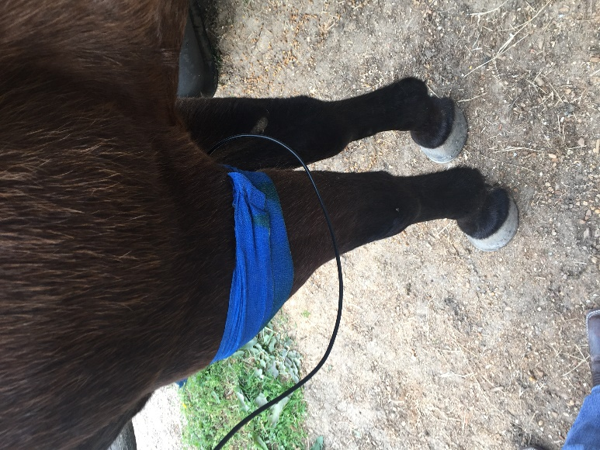

**Figure 4.1.6: Horse Testing**

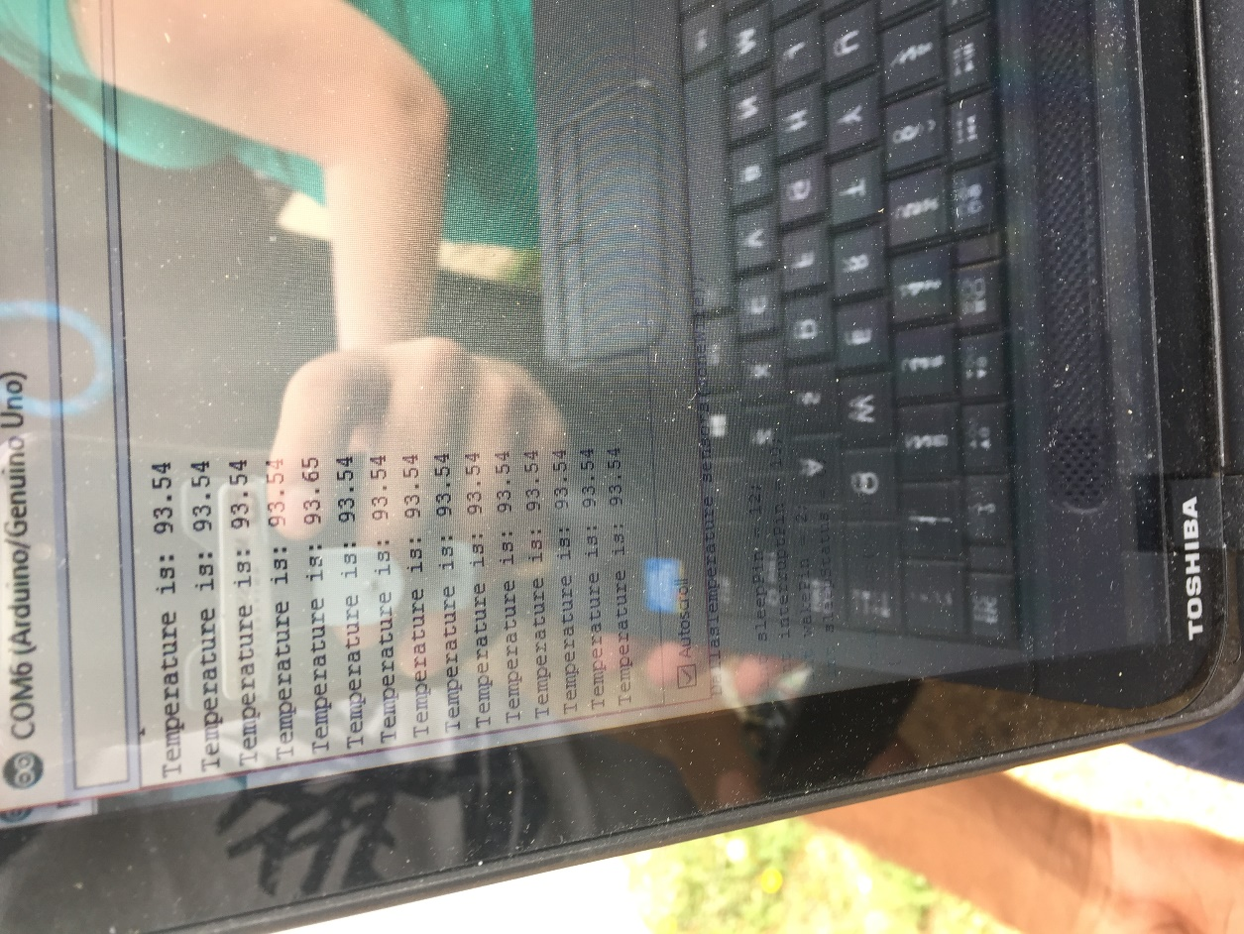

**4.2 Test Certification – Pulse Sensor Accuracy**

The prototype will incorporate a heart rate sensor to measure the pulse, in beats per minute, of a horse. The pulse sensor must give an accurate heart rate between the range of 20 to 200 beats per minute (bpm). The sensor will be placed on the horse’s leg, where the pulse is easy to find, to generate a heartbeat measurement. During the test, the sensor could not find a consistent reading because of its sensitivity. The pulse sensor was previously tested on a finger as shown in Figure 4.2.1 and a closer look in Figure 4.2.2.

**Figure 4.2.1: Pulse Sensor Testing**

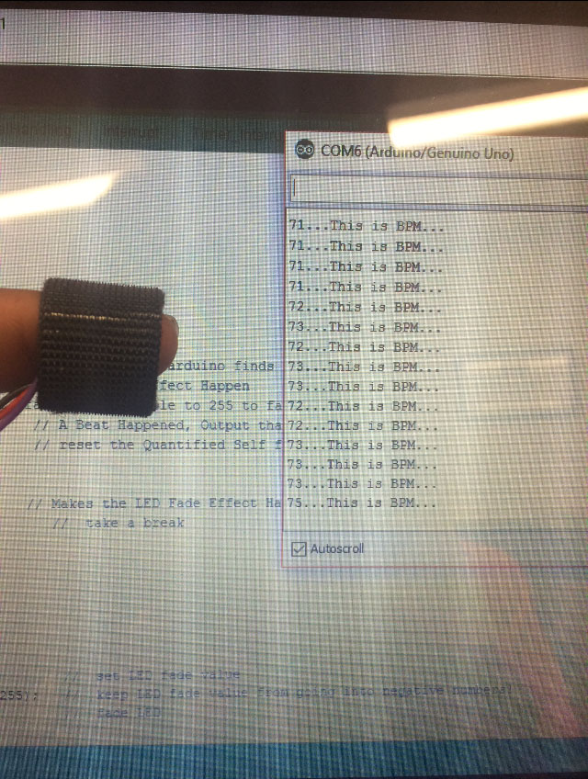

**Figure 4.2.2: Pulse Sensor Testing**

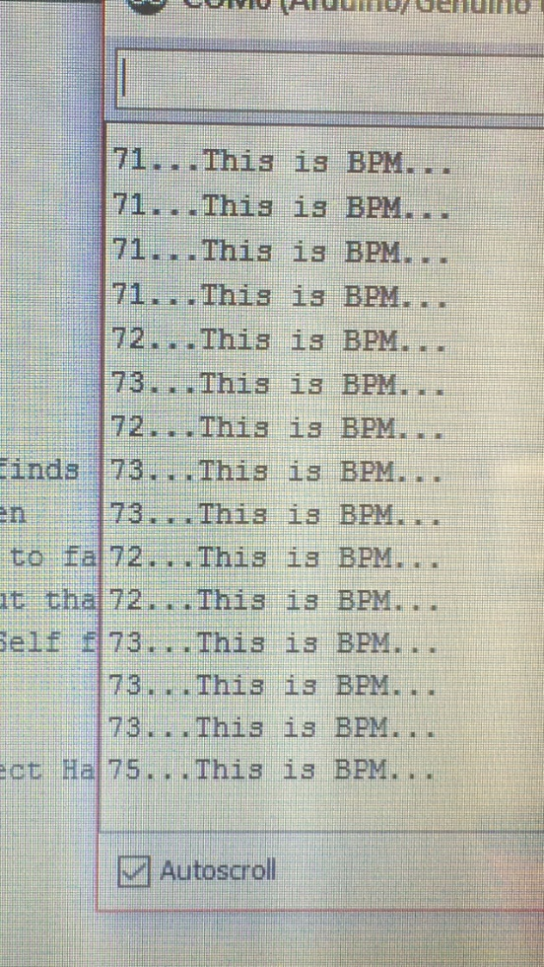

**4.3 Test Certification – Ingress Protection**

The device must adhere to Ingress Protection Rating IP56. The protection states that water and dust must not invade the system in any way possible. This will be tested closely once the prototype is developed.

**4.4 Test Certification – Battery Life**

The HHM must be able to operate on battery power for 12 hours. To test the longevity of the device, the prototype will be operated for 12 hours. At the current state of the design, the system is run thru USB, but will implement a battery source soon. This can be done because the device will operate in a wake state until the user wants received data. Then the system will go back into sleep mode for the entirety of the testing process until the user needs the data again.

**4.5 Test Certification – User Notifications**

The device must update the user via text message at certain intervals based upon the user’s discretion. The user’s information will be provided once they start the device for the first time. After the user places their information to the device, the prototype will let them receive data in a certain time interval. Figure 4.5.1 represents how the text messages will be received.

**Figure 4.5.1 Text messages**

