**Executive Summary**

Current methods used in obtaining a horse’s vitals can be time consuming and potentially dangerous. The fundamental goal of the Horse Health Monitoring System (HHM System) is to safely and efficiently monitor the essential vitals of a horse as an indicator of the horse’s overall health. This system aims to assure horse owners and veterinarians about the actual status of their horse by detecting early symptoms. Early detection through HHM System relieves the financial and emotional burden to all parties involved. A visual representation of HHM System can be seen in Figure 1.

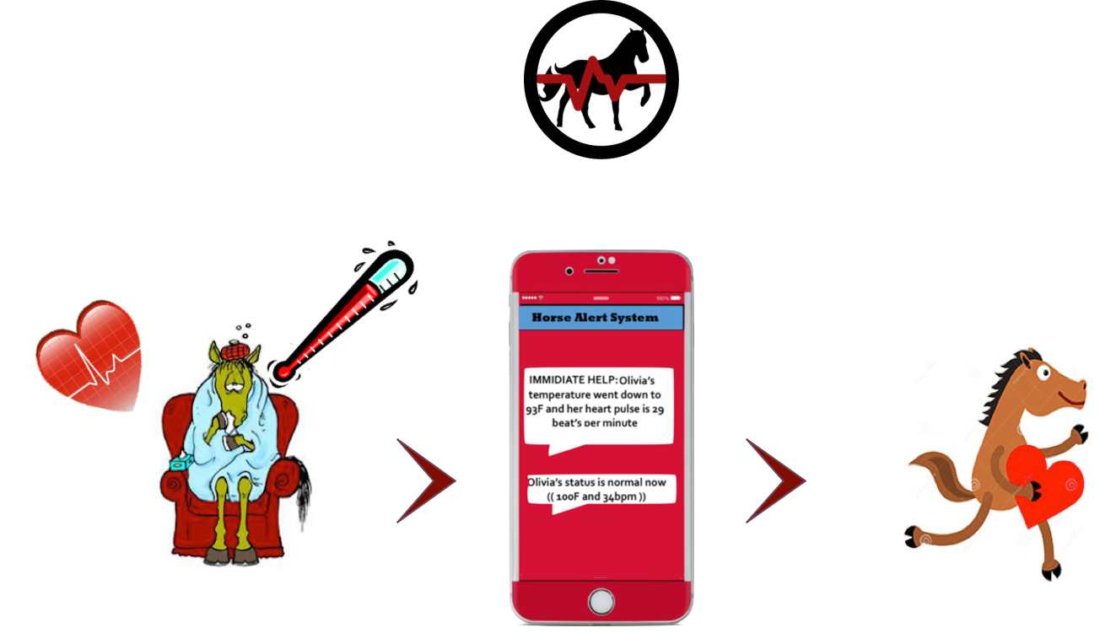

Figure 1. Horse Health Monitoring System Overview

In the quest to develop a flawless device, several technical and practical design constraints must be addressed. Examples of technical constraints are accuracy of temperature and heart rate sensors, battery life, ingress protection, and user notifications. The most important aspect of a horse’s health diagnosis is an accurate measurement of the vitals. Therefore, the HHM System must provide users with a precise measurement of temperature within a range of 90˚F to 110˚F and a heart rate within range of 25 and 200 beats per minute (bpm). Examples of practical design constraints are safety, cost, durability, reliability, and size of the device. The HHM device must not endanger the horses, be cost-effective, must be compact and installed on a comfortable and non-invasive location on the horse.

Critical to the overall performance of the HHM system, a horse-compatible pulse sensor, highly durable temperature sensor, and robust long-range communication system were selected. The microcontroller will gather the vitals from the temperature and pulse sensors. Subsequently, the device submits the data to the Global System for Mobile Communications (GSM) module which sends it to the user via text message. This device will be provided with a portable long-lasting battery.

Several horse health monitoring systems exist today but are quite expensive and not durable. The originality in designing the HHM System is its affordability and flexibility compared to other already existing monitoring systems. However, safety is also one of the main priorities of the team design. The HHM system reduces the discomfort that horses, owners, and veterinarians may experience.