The effect of cation charge and concentration on the salt-induced deswelling of sodium polyacrylate
  - IB Chemistry Higher Level — Internal Assessment
  - Candidate code: ______ · Word count: 2,962

1. Introduction
Hydrogels are an area of innovation in biomedical chemistry because their cross-linked polymer chains retain large amounts of water, suggesting uses such as wound dressings. Whilst their interaction with pure water has been closely examined, a dressing is in practice exposed to electrolyte solutions such as wound exudate, which contain Na⁺, K⁺, Mg²⁺ and Ca²⁺. A polymer that absorbs 120 times its mass of water may absorb far less of a body fluid.
This investigation therefore studies how the concentration of dissolved salt, and the charge and identity of its cation, change the swelling of sodium polyacrylate, the superabsorbent polymer used in nappies and some dressings. The anion (Cl⁻) is kept constant so the cations can be compared directly.

2. Research question
How does increasing the concentration (0.00–0.20 mol dm⁻³) of aqueous NaCl, KCl, MgCl₂ and CaCl₂ affect the apparent swelling degree of sodium polyacrylate, measured as its percentage mass gain after 120 s of immersion?

3. Background

3.1 Structure and swelling of sodium polyacrylate
Sodium polyacrylate is a lightly cross-linked network of poly(acrylic acid) chains in which many carboxylic acid groups are present as sodium carboxylate, –[CH₂–CH(COO⁻Na⁺)]ₙ–. In water, the Na⁺ counter-ions dissociate from the fixed –COO⁻ groups but cannot leave the network, because the solution outside must stay electrically neutral. Three effects then drive swelling:
- Osmotic pressure. The mobile Na⁺ ions trapped inside the gel create a much higher concentration of dissolved particles inside than outside, so water enters by osmosis (a Donnan equilibrium).
- Electrostatic repulsion. Neighbouring –COO⁻ groups repel each other and stretch the chains apart.
- Mixing. Polar carboxylate groups are hydrated by water through ion–dipole interactions.
The cross-links oppose expansion with an elastic restoring force. Swelling continues until this force balances the swelling pressure.

3.2 Effect of salt concentration
Adding salt to the external solution raises its ion concentration and reduces the concentration difference across the gel boundary, which lowers the osmotic driving force. Cations entering the gel also cluster around –COO⁻ groups and screen their charges, reducing repulsion. Both effects depend on the ionic strength I of the solution:
I=12i​cizi2
where c_{i} is the concentration and z_{i} the charge of each ion. For NaCl, I = c, but for CaCl₂, I = ½(4c + 2c) = 3c.
Flory (1953) combined these ideas into an expression for the equilibrium volume swelling ratio Q of an ionic gel. When the ionic term dominates, it reduces to
$$Q^{5/3}∝\frac{1}{I} ⇒ Q∝I^{−3/5}$$
For a highly swollen gel the percentage mass gain S is approximately proportional to Q, and for a single salt I ∝ c, so
$$S=k c^{ n} ⇒ lnS=nlnc+lnk, n_{\text{Flory}}=−0.60$$
A graph of ln S against ln c should therefore be linear with gradient n. This limiting law assumes equilibrium, and an external salt concentration much larger than the fixed-charge concentration inside the gel; both are examined in Section 6.

3.3 Effect of cation charge and identity
Divalent cations screen more strongly: at equal concentration they give a larger ionic strength (3c compared with c). They can also bind two –COO⁻ groups on different chains at once, forming ionic cross-links that tighten the network. This specific binding is not described by ionic strength alone.
Cation identity within each charge group also matters. Table 1 shows that Mg²⁺ has a higher charge density than Ca²⁺ and a more exothermic hydration enthalpy, so it holds its hydration shell more tightly. Vazquez de Vasquez et al. (2021) found that Ca²⁺ forms direct contact ion pairs with carboxylate, whereas Mg²⁺ rarely does and remains separated from –COO⁻ by water molecules. Similarly, Vrbka et al. (2006) showed that Na⁺ pairs with carboxylate more strongly than K⁺ does.
Table 1. Properties of the four cations (IBO, 2023).
Ion | Charge | Ionic radius / pm | Charge ÷ radius / pm⁻¹ | Enthalpy of hydration / kJ mol⁻¹
Na⁺ | +1 | 102 | 0.0098 | −424
K⁺ | +1 | 138 | 0.0072 | −340
Mg²⁺ | +2 | 72 | 0.0278 | −1963
Ca²⁺ | +2 | 100 | 0.0200 | −1616

3.4 Hypotheses
- Swelling will decrease as salt concentration increases for all four salts, with ln S against ln c approximately linear and gradient near −0.60 for NaCl and KCl.
- The divalent salts will reduce swelling much more than the monovalent salts, even when compared at equal ionic strength, because of ionic cross-linking.
- CaCl₂ will reduce swelling more than MgCl₂, and NaCl slightly more than KCl, because of stronger direct cation–carboxylate pairing.

4. Methodology

4.1 Variables
Table 2. Variables.
Type | Variable | How it was controlled or measured | Why it matters
Independent | Salt concentration: 0.00, 0.05, 0.10, 0.15, 0.20 mol dm⁻³ | Salt weighed (±0.001 g) and made up to 50.00 cm³ in a volumetric flask; actual concentration calculated from actual mass | Five levels allow a trend and a power-law fit; the range includes the ionic strength of body fluids (≈0.15 mol dm⁻³)
Independent | Cation: Na⁺, K⁺, Mg²⁺, Ca²⁺ | Chloride salt of each cation used | Compares charge (+1 against +2) and, within each charge, ion size and hydration
Dependent | Apparent swelling degree, S / % | S = (F − T)/(T − B) × 100 from three balance readings | Mass of solution absorbed per unit mass of dry polymer
Controlled | Anion (Cl⁻) | All salts are chlorides | Anions also affect swelling; a common anion isolates the cation effect
Controlled | Dry polymer mass (0.050 ± 0.002 g) | Weighed into the bag; S uses each trial’s actual mass | Sample size changes how tightly the swollen gel fills the bag
Controlled | Solution volume (50.00 cm³) | Whole contents of one volumetric flask | Keeps cations in large excess so the external concentration stays constant
Controlled | Immersion time (120 s) | Stopwatch started as the bag was submerged | Swelling increases with time until equilibrium
Controlled | Draining and blotting | Drained until dripping stopped; three 30 s blots on fresh tissue | Surface liquid left on the bag would increase F
Controlled | Tea bag type and folding | Identical bags, each folded twice | The bag itself holds some solution; identical bags keep this similar
Controlled | Polymer | Same sodium polyacrylate product throughout | Cross-link density sets the maximum swelling
Controlled (limited) | Temperature | All trials in the same laboratory; not measured | Swelling depends on temperature (see Section 8)

4.2 Apparatus and materials
Table 3. Apparatus and materials.
Item | Quantity | Uncertainty
Electronic balance | 1 | ±0.001 g
Volumetric flask, 50.00 cm³ (Class A) | 1 | ±0.06 cm³
Beakers, 50 cm³ and 100 cm³ | 1 each | –
Stopwatch | 1 | ±0.01 s
Weighing boats, spatula, glass rod, funnel, wash bottle, tweezers | – | –
Empty paper tea bags | 60 | –
Paper tissue | – | –
Sodium polyacrylate granules | ≈3 g | –
NaCl, KCl, anhydrous CaCl₂, anhydrous MgCl₂ | ≈3–6 g each | –
Distilled water | ≈3 dm³ | –

4.3 Procedure
Solution preparation (a fresh solution for every trial)
- Calculate the salt mass needed, m = cVM with V = 0.0500 dm³ (e.g. 0.146 g NaCl for 0.05 mol dm⁻³).
- Tare a weighing boat and add salt until the reading is within 0.005 g of the target. Record the actual mass.
- Dissolve the salt in some distilled water in a 50 cm³ beaker, stirring with a glass rod.
- Transfer through a funnel into the 50.00 cm³ volumetric flask, rinsing the beaker, rod and funnel into the flask.
- Make up to the mark, stopper and invert several times. For 0.00 mol dm⁻³, use distilled water only.
Sample preparation
- Weigh an empty tea bag (B).
- Add sodium polyacrylate with a spatula until the combined mass T exceeds B by 0.050 ± 0.002 g. Record T.
- Shake the granules to the bottom of the bag and fold the top twice to close it.
Swelling measurement
- Pour the whole solution into a 100 cm³ beaker.
- Submerge the bag fully with tweezers, starting the stopwatch at the same moment.
- At 120 s, remove the bag and hold it against the beaker wall until dripping stops.
- Place the bag on dry tissue for 30 s, then turn it onto a fresh dry area; repeat until it has been turned three times.
- Weigh the bag immediately (F).
- Repeat to give three trials at each concentration for each salt (60 trials).

4.4 Methodological considerations
- Fresh solution per trial. A preparation error affects only one trial.
- Constant ion excess. 50.00 cm³ of 0.05 mol dm⁻³ solution contains 2.5 × 10⁻³ mol of cations, against at most 5.3 × 10⁻⁴ mol of –COO⁻ in 0.050 g of polymer (M = 94.04 g mol⁻¹ per repeating unit). With this four-fold excess, and under 5% of the solution absorbed, the external concentration stays approximately constant.
- Sample size. 0.050 g was chosen so that the gel swollen in water (about 6 g) could still expand inside the bag. Swelling was calculated from each trial’s measured T − B, not the nominal 0.050 g, so small differences in sample size do not matter.
- Three trials per condition give a standard deviation for each mean within a manageable 60 trials.
- Fixed immersion time. 120 s allowed 60 trials to be completed consistently, so the result is a fixed-time (apparent) swelling, not an equilibrium value, as the research question specifies.

4.5 Safety, ethical and environmental considerations
Table 4. Safety and environmental considerations.
Hazard | Risk | Precaution / disposal
Sodium polyacrylate powder | Dust irritates eyes and airways; wet spills are very slippery | Safety glasses; transferred gently with a spatula; spills swept up while dry
Anhydrous CaCl₂ | Serious eye irritant; dissolves strongly exothermically | Safety glasses; added to water gradually with stirring
NaCl, KCl, MgCl₂ | Low hazard; mild eye irritants | Safety glasses; hands washed after use
Glassware | Cuts from breakage | Glassware checked for chips; breakages reported
Swollen gel (environmental) | Can block drains | Disposed of in solid waste, never the sink
Salt solutions (environmental) | Dilute (≤ 0.20 mol dm⁻³) and of low toxicity | Poured to drain with plenty of water; salt masses kept small
No living organisms were involved, so there were no ethical concerns.

5. Results and data processing

5.1 Raw data
All masses were read from the same balance (±0.001 g). The four 0.00 mol dm⁻³ groups are distilled-water controls run within each series.
Table 5. Raw data for NaCl.
Target c / mol dm⁻³ | Trial | Salt mass, m / g ±0.001 | Empty bag, B / g ±0.001 | Bag + dry polymer, T / g ±0.001 | Final mass, F / g ±0.001
0.00 | 1 | 0.000 | 0.468 | 0.519 | 6.786
0.00 | 2 | 0.000 | 0.483 | 0.532 | 6.583
0.00 | 3 | 0.000 | 0.477 | 0.528 | 7.010
0.05 | 1 | 0.143 | 0.478 | 0.527 | 2.634
0.05 | 2 | 0.147 | 0.485 | 0.534 | 2.588
0.05 | 3 | 0.147 | 0.490 | 0.541 | 2.731
0.10 | 1 | 0.292 | 0.488 | 0.537 | 2.045
0.10 | 2 | 0.294 | 0.482 | 0.531 | 2.098
0.10 | 3 | 0.290 | 0.483 | 0.534 | 2.117
0.15 | 1 | 0.440 | 0.479 | 0.530 | 1.896
0.15 | 2 | 0.439 | 0.479 | 0.528 | 1.865
0.15 | 3 | 0.439 | 0.489 | 0.540 | 1.879
0.20 | 1 | 0.586 | 0.488 | 0.538 | 1.710
0.20 | 2 | 0.582 | 0.484 | 0.535 | 1.676
0.20 | 3 | 0.584 | 0.484 | 0.533 | 1.570

Table 6. Raw data for KCl.
Target c / mol dm⁻³ | Trial | Salt mass, m / g ±0.001 | Empty bag, B / g ±0.001 | Bag + dry polymer, T / g ±0.001 | Final mass, F / g ±0.001
0.00 | 1 | 0.000 | 0.466 | 0.516 | 6.544
0.00 | 2 | 0.000 | 0.455 | 0.504 | 6.441
0.00 | 3 | 0.000 | 0.486 | 0.535 | 6.528
0.05 | 1 | 0.186 | 0.491 | 0.541 | 2.599
0.05 | 2 | 0.186 | 0.492 | 0.543 | 2.594
0.05 | 3 | 0.188 | 0.493 | 0.544 | 2.663
0.10 | 1 | 0.375 | 0.495 | 0.544 | 2.190
0.10 | 2 | 0.374 | 0.498 | 0.547 | 2.201
0.10 | 3 | 0.375 | 0.489 | 0.539 | 2.242
0.15 | 1 | 0.560 | 0.508 | 0.559 | 2.004
0.15 | 2 | 0.559 | 0.497 | 0.547 | 2.016
0.15 | 3 | 0.559 | 0.476 | 0.526 | 2.008
0.20 | 1 | 0.746 | 0.448 | 0.499 | 1.728
0.20 | 2 | 0.745 | 0.472 | 0.522 | 1.624
0.20 | 3 | 0.744 | 0.487 | 0.536 | 1.663

Table 7. Raw data for CaCl₂.
Target c / mol dm⁻³ | Trial | Salt mass, m / g ±0.001 | Empty bag, B / g ±0.001 | Bag + dry polymer, T / g ±0.001 | Final mass, F / g ±0.001
0.00 | 1 | 0.000 | 0.483 | 0.534 | 6.638
0.00 | 2 | 0.000 | 0.468 | 0.519 | 6.779
0.00 | 3 | 0.000 | 0.477 | 0.526 | 6.584
0.05 | 1 | 0.278 | 0.479 | 0.528 | 1.489
0.05 | 2 | 0.277 | 0.470 | 0.519 | 1.296
0.05 | 3 | 0.278 | 0.483 | 0.533 | 1.365
0.10 | 1 | 0.555 | 0.483 | 0.533 | 0.978
0.10 | 2 | 0.557 | 0.465 | 0.516 | 0.993
0.10 | 3 | 0.555 | 0.472 | 0.523 | 0.987
0.15 | 1 | 0.832 | 0.458 | 0.507 | 0.802
0.15 | 2 | 0.832 | 0.477 | 0.528 | 0.851
0.15 | 3 | 0.833 | 0.478 | 0.529 | 0.843
0.20 | 1 | 1.110 | 0.468 | 0.519 | 0.756
0.20 | 2 | 1.109 | 0.478 | 0.529 | 0.741
0.20 | 3 | 1.114 | 0.491 | 0.542 | 0.733

Table 8. Raw data for MgCl₂.
Target c / mol dm⁻³ | Trial | Salt mass, m / g ±0.001 | Empty bag, B / g ±0.001 | Bag + dry polymer, T / g ±0.001 | Final mass, F / g ±0.001
0.00 | 1 | 0.000 | 0.478 | 0.527 | 6.453
0.00 | 2 | 0.000 | 0.479 | 0.529 | 6.301
0.00 | 3 | 0.000 | 0.483 | 0.532 | 6.356
0.05 | 1 | 0.240 | 0.477 | 0.527 | 1.545
0.05 | 2 | 0.239 | 0.476 | 0.526 | 1.503
0.05 | 3 | 0.239 | 0.485 | 0.535 | 1.549
0.10 | 1 | 0.475 | 0.485 | 0.536 | 1.005
0.10 | 2 | 0.475 | 0.477 | 0.526 | 1.039
0.10 | 3 | 0.479 | 0.477 | 0.527 | 0.994
0.15 | 1 | 0.714 | 0.477 | 0.526 | 0.861
0.15 | 2 | 0.713 | 0.489 | 0.540 | 0.901
0.15 | 3 | 0.713 | 0.478 | 0.529 | 0.897
0.20 | 1 | 0.954 | 0.470 | 0.521 | 0.767
0.20 | 2 | 0.953 | 0.455 | 0.504 | 0.793
0.20 | 3 | 0.949 | 0.475 | 0.525 | 0.788

5.2 Processing
Concentration. The actual concentration was calculated from each measured salt mass. For NaCl, 0.05 mol dm⁻³, trial 1:
$$c=\frac{m}{MV}=\frac{0.143 \text{g}}{58.44 {\text{g mol}}^{−1}×0.0500 {\text{dm}}^{3}}=0.04894 {\text{mol dm}}^{−3}$$
Swelling degree. With dry polymer mass H = T − B and mass gain D = F − T, the apparent swelling degree is
$$S=\frac{D}{H}×100=\frac{F−T}{T−B}×100$$
For the same trial: H = 0.527 − 0.478 = 0.049 g, D = 2.634 − 0.527 = 2.107 g, so
$$S=\frac{2.107}{0.049}×100=4300\%$$
That is, the polymer gained 43.0 times its own mass. S was calculated for every trial before averaging, and unrounded values were carried through.
Ionic strength. For CaCl₂ at a mean concentration of 0.05004 mol dm⁻³:
$$I=1/2\left(0.05004×2^{2}+2×0.05004×1^{2}\right)=0.1501 {\text{mol dm}}^{−3}$$

5.3 Uncertainties
Propagated (apparatus) uncertainty. Each balance reading is ±0.001 g, so each difference has ±0.002 g. Relative uncertainties add for division:
$$\frac{ΔS}{S}=\frac{ΔH}{H}+\frac{ΔD}{D}=\frac{0.002}{0.049}+\frac{0.002}{2.107}=0.0408+0.0009=0.0418$$
$$S=4300±180\% (4.2\%)$$
The dry polymer mass contributes 98% of this, because 0.002 g is 4% of a 0.050 g sample. Across all 60 trials the propagated uncertainty ranged from 4.0% to 5.0%.
For concentration, the relative uncertainties of the mass and the flask volume add:
$$\frac{Δc}{c}=\frac{0.001}{0.143}+\frac{0.06}{50.00}=0.0070+0.0012=0.0082 ⇒ c=0.04894±0.00040 {\text{mol dm}}^{−3}$$
Concentration and ionic-strength uncertainties are therefore below 1%, too small to show as horizontal error bars.
Random uncertainty. The sample standard deviation s describes the spread of the three trials. For NaCl at 0.05 mol dm⁻³:
$$\overset{‾}{S}=\frac{4300.0+4191.8+4294.1}{3}=4262.0\%, s=\sqrt{\frac{∑(S_{i}−\overset{‾}{S})^{2}}{n−1}}=60.8\%$$
Uncertainty used. Each mean is quoted with the larger of s and the mean propagated uncertainty, so the uncertainty is not underestimated; here, 4260 ± 180% (4.1%, rounded to 2 significant figures). The propagated value was the larger in 14 of 20 conditions; the spread between trials was larger in the other six.

5.4 Processed results
Table 9. Processed results. The result’s uncertainty is the larger of s and the propagated ΔS, rounded to 2 s.f.
Salt | Actual c / mol dm⁻³ | S₁ / % | S₂ / % | S₃ / % | Mean / % | s / % | Propagated ΔS / % | Result / %
NaCl | 0 (water) | 12,288 | 12,349 | 12,710 | 12,449 | 228 | 499 | 12,450 ± 500
NaCl | 0.0499 ± 0.0004 | 4,300 | 4,192 | 4,294 | 4,262 | 61 | 176 | 4,260 ± 180
NaCl | 0.0999 ± 0.0005 | 3,078 | 3,198 | 3,104 | 3,126 | 63 | 130 | 3,130 ± 130
NaCl | 0.1504 ± 0.0005 | 2,678 | 2,729 | 2,625 | 2,677 | 52 | 110 | 2,680 ± 110
NaCl | 0.1999 ± 0.0006 | 2,344 | 2,237 | 2,116 | 2,233 | 114 | 93 | 2,230 ± 110
KCl | 0 (water) | 12,056 | 12,116 | 12,231 | 12,134 | 89 | 496 | 12,130 ± 500
KCl | 0.0501 ± 0.0003 | 4,116 | 4,022 | 4,155 | 4,097 | 69 | 166 | 4,100 ± 170
KCl | 0.1005 ± 0.0004 | 3,359 | 3,376 | 3,406 | 3,380 | 24 | 141 | 3,380 ± 140
KCl | 0.1501 ± 0.0004 | 2,833 | 2,938 | 2,964 | 2,912 | 69 | 120 | 2,910 ± 120
KCl | 0.1999 ± 0.0005 | 2,410 | 2,204 | 2,300 | 2,305 | 103 | 96 | 2,300 ± 100
CaCl₂ | 0 (water) | 11,969 | 12,275 | 12,363 | 12,202 | 207 | 489 | 12,200 ± 490
CaCl₂ | 0.0500 ± 0.0002 | 1,961 | 1,586 | 1,664 | 1,737 | 198 | 74 | 1,740 ± 200
CaCl₂ | 0.1001 ± 0.0003 | 890 | 935 | 910 | 912 | 23 | 40 | 912 ± 40
CaCl₂ | 0.1500 ± 0.0004 | 602 | 633 | 616 | 617 | 16 | 28 | 617 ± 28
CaCl₂ | 0.2002 ± 0.0004 | 465 | 416 | 375 | 418 | 45 | 20 | 418 ± 45
MgCl₂ | 0 (water) | 12,094 | 11,544 | 11,886 | 11,841 | 278 | 484 | 11,840 ± 480
MgCl₂ | 0.0503 ± 0.0003 | 2,036 | 1,954 | 2,028 | 2,006 | 45 | 84 | 2,006 ± 84
MgCl₂ | 0.1001 ± 0.0003 | 920 | 1,047 | 934 | 967 | 70 | 43 | 967 ± 70
MgCl₂ | 0.1498 ± 0.0004 | 684 | 708 | 722 | 704 | 19 | 32 | 704 ± 32
MgCl₂ | 0.2000 ± 0.0005 | 482 | 590 | 526 | 533 | 54 | 25 | 533 ± 54
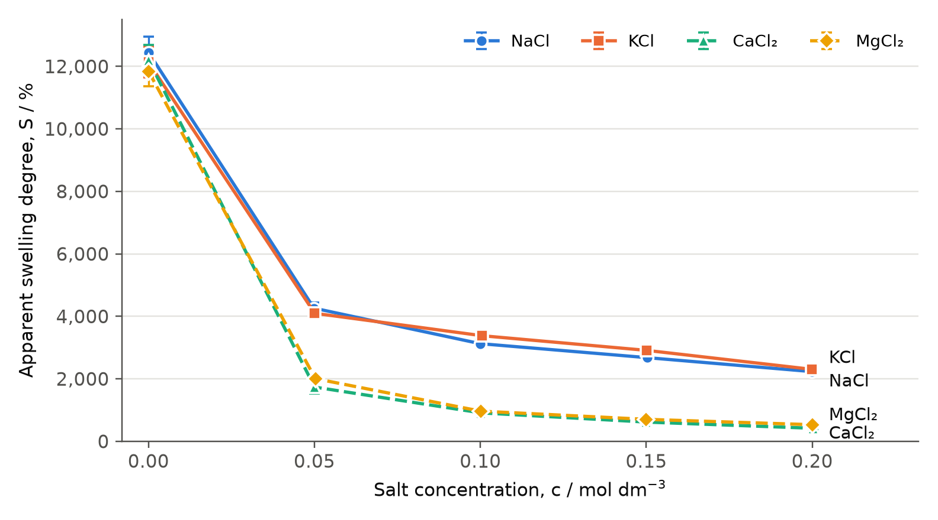
Figure 1. Mean apparent swelling degree against salt concentration. Error bars show the uncertainty in Table 9; some are smaller than the markers.

6. Analysis

6.1 Effect of concentration
Figure 1 shows that swelling fell with every increase in concentration for all four salts. The fall was not linear: most of it happened between 0.00 and 0.05 mol dm⁻³, where swelling dropped by 66% for NaCl and KCl and by 83–86% for MgCl₂ and CaCl₂. By 0.20 mol dm⁻³ the total reductions were 82% (NaCl), 81% (KCl), 96% (MgCl₂) and 97% (CaCl₂). This steep-then-shallow shape is consistent with the inverse power law in Section 3.2.
The twelve distilled-water controls gave a mean of 12,157% with a relative standard deviation of 2.4%, so the method was reproducible across the four series.

6.2 Power-law analysis
To test the Flory model, ln S was plotted against ln c for the non-zero concentrations (Figure 2). The uncertainty in ln S equals the relative uncertainty in S. The gradient uncertainty was found from the steepest and shallowest lines that pass through the error bars of the first and last points:
$$Δn=\frac{n_{\text{shallowest}}−n_{\text{steepest}}}{2}=\frac{−0.399−(−0.532)}{2}=0.066 (\text{NaCl})$$
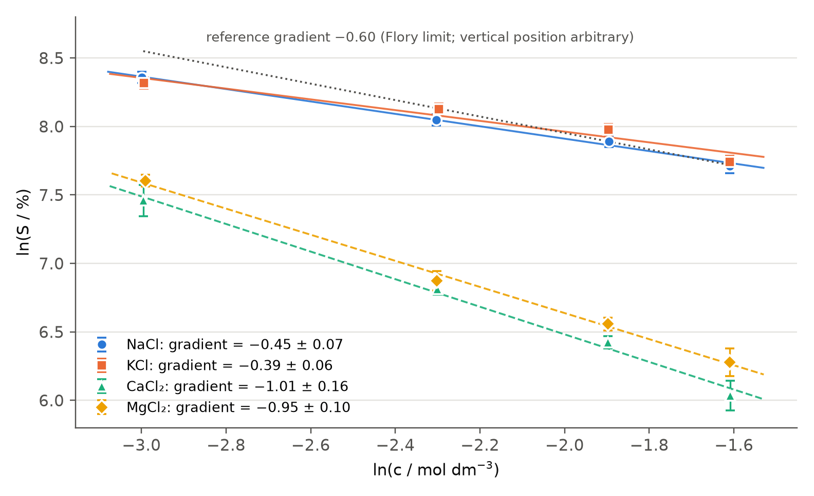
Figure 2. ln S against ln c with least-squares lines. The dotted line shows the Flory limiting gradient of −0.60 for comparison.
Table 10. Gradients of ln S against ln c.
Salt | Least-squares gradient | Steepest | Shallowest | n ± Δn | R²
NaCl | -0.453 | -0.532 | -0.399 | -0.45 ± 0.07 | 0.994
KCl | -0.392 | -0.477 | -0.354 | -0.39 ± 0.06 | 0.939
CaCl₂ | -1.007 | -1.187 | -0.867 | -1.01 ± 0.16 | 0.994
MgCl₂ | -0.953 | -1.064 | -0.856 | -0.95 ± 0.10 | 0.996
Flory limit | −0.60 |  |  | −0.60
All four plots are strongly linear (R² ≥ 0.94), so swelling does follow a power law in concentration. However, the gradients split into two distinct groups:
- Monovalent salts (n ≈ −0.4 to −0.45). The gradients are 25% (NaCl) and 35% (KCl) shallower than −0.60, and neither uncertainty range (steepest −0.53) includes the Flory value. The limiting-law assumption explains part of this. Taking all 5.3 × 10⁻⁴ mol of –COO⁻ in the absorbed solution, the fixed-charge concentration inside the gel was about 0.25 mol dm⁻³ at 0.05 mol dm⁻³ NaCl and 0.48 mol dm⁻³ at 0.20 mol dm⁻³. Even allowing for incomplete neutralisation of commercial polyacrylate, this is comparable to or larger than the external salt concentration, not much smaller as the model requires. In this regime swelling is less sensitive to added salt, so the gradient is shallower. The systematic errors in Section 8 act in the same direction.
- Divalent salts (n ≈ −1.0). The gradients are about twice as steep as the monovalent ones and steeper than the Flory value. Screening cannot explain this, because Flory’s model already includes it. The extra decrease supports ionic cross-linking: each Ca²⁺ or Mg²⁺ that bridges two –COO⁻ groups both removes charge and tightens the network, and more bridges form as concentration rises.

6.3 Separating charge from ionic strength
At equal molarity, a divalent salt has three times the ionic strength of a monovalent salt, so Figure 1 does not isolate the effect of charge. Figure 3 therefore plots swelling against ionic strength. At I = 0.15 mol dm⁻³, measured directly for all four salts (0.15 mol dm⁻³ NaCl and KCl; 0.05 mol dm⁻³ CaCl₂ and MgCl₂):
- CaCl₂ gave 1740 ± 200%, 35% lower than NaCl (2680 ± 110%).
- MgCl₂ gave 2006 ± 84%, 31% lower than KCl (2910 ± 120%).
The error bars do not overlap, so the divalent salts suppress swelling more than their ionic strength predicts, supporting hypothesis 2. Comparing solutions with the same total ion concentration (0.30 mol dm⁻³) gives a larger difference: 912% for CaCl₂ (0.10 mol dm⁻³) against 2680% for NaCl (0.15 mol dm⁻³), a 66% reduction. A higher external osmotic pressure is therefore not the explanation either. Both comparisons point to specific cation–carboxylate binding.
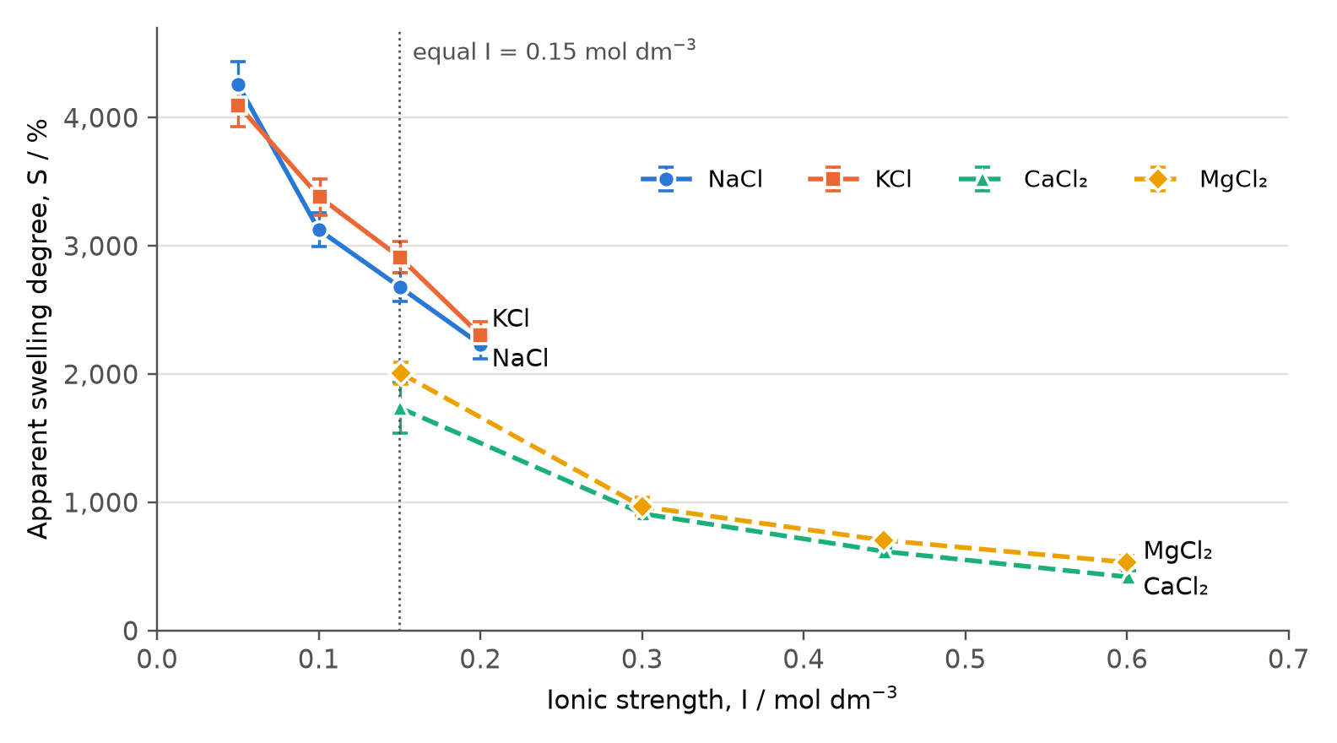
Figure 3. Mean apparent swelling degree against ionic strength for the non-zero concentrations. Error bars show the uncertainty in Table 9.

6.4 Differences within each charge group
CaCl₂ gave lower swelling than MgCl₂ at all four non-zero concentrations, by 13% on average (range 6–22%). The error bars separate at 0.15 and 0.20 mol dm⁻³ but overlap at 0.05 and 0.10 mol dm⁻³. The difference is consistent with hypothesis 3: Ca²⁺ forms contact ion pairs with –COO⁻, whereas the tightly bound hydration shell of Mg²⁺ (−1963 against −1616 kJ mol⁻¹) keeps it further from the carboxylate. Direct pairing produces stronger cross-links.
NaCl and KCl did not differ consistently: NaCl was higher at 0.05 mol dm⁻³ and lower at the other three concentrations, and the error bars overlap at three of the four. Stronger Na⁺–carboxylate pairing may explain KCl being slightly higher at 0.10–0.20 mol dm⁻³, but the average difference (4%) is similar to the measurement uncertainty, so these data cannot resolve it.

7. Conclusion
Increasing the concentration of every chloride salt from 0.00 to 0.20 mol dm⁻³ decreased the apparent swelling degree of sodium polyacrylate after 120 s. At 0.20 mol dm⁻³ it was 2230 ± 110% (NaCl), 2300 ± 100% (KCl), 533 ± 54% (MgCl₂) and 418 ± 45% (CaCl₂), compared with about 12,200% in distilled water.
The decrease followed a power law, S = kcⁿ. For the monovalent salts, n = −0.45 ± 0.07 (NaCl) and −0.39 ± 0.06 (KCl). These agree with Flory’s theory in form but are 25–35% shallower than its limiting value of −0.60. This is partly because the fixed-charge concentration inside the gel (up to 0.25–0.48 mol dm⁻³) was comparable to the salt concentration, so the limiting condition was not reached, and partly because of the systematic errors in Section 8. The divalent salts gave much steeper exponents: n = −1.01 ± 0.16 (CaCl₂) and −0.95 ± 0.10 (MgCl₂).
Cation charge was the dominant factor. At 0.20 mol dm⁻³ the divalent salts gave 4 to 5.5 times lower swelling than the monovalent salts, and even at equal ionic strength (0.15 mol dm⁻³) swelling was 31–35% lower. The effect of divalent cations is therefore more than extra screening, and is best explained by Ca²⁺ and Mg²⁺ bridging carboxylate groups. This agrees with Horkay, Tasaki and Basser (2000), who reported that small amounts of CaCl₂ make polyacrylate gels in NaCl solution shrink sharply, and with Mussel, Basser and Horkay (2019), who found that divalent cations lower the swelling pressure of these gels far more than monovalent cations. CaCl₂ gave on average 13% less swelling than MgCl₂, consistent with the stronger contact ion pairing of Ca²⁺; NaCl and KCl could not be distinguished.
Hypotheses 1 and 2 are therefore supported, except for the monovalent gradient values, and hypothesis 3 only for Ca²⁺/Mg²⁺. In practice, a polyacrylate dressing would absorb far less of a fluid containing divalent ions than tests in water suggest.

8. Evaluation

8.1 Strengths
A freshly prepared solution in each of the 60 trials made every result independent, and the water controls agreed within 2.4% across all four series. The main findings are large compared with the uncertainties: at 0.20 mol dm⁻³ the monovalent and divalent means differ by a factor of four or more, while the uncertainties are 4–11%.

8.2 Weaknesses and improvements
The weaknesses are listed in order of their likely effect on the conclusion.
1. Solution retained by the tea bag (systematic). The empty bag was weighed dry, so any solution soaked up by the paper was counted as polymer swelling. This raises every S value by a fixed mass r, which affects low swelling values most. The data sets an upper limit: the smallest mass gain in any trial was 0.191 g (CaCl₂, 0.20 mol dm⁻³), so r < 0.19 g. That is still up to 380 percentage points, as much as 90% of the CaCl₂ result at 0.20 mol dm⁻³. Correcting for r would make all gradients steeper, but even the maximum possible correction only changes the NaCl gradient from −0.45 to −0.52, so bag retention alone cannot explain the difference from −0.60. Because the correction lowers the small divalent values proportionally most, it would widen, not remove, the difference between the charge groups. Improvement: treat three empty bags in each solution exactly as in steps 9–13 and subtract their mean mass gain, as recommended for the tea-bag method by Snoeck, Schröfl and Mechtcherine (2018).
2. 120 s may not reach equilibrium (systematic). If swelling was still increasing, every S value is below its equilibrium value. The gel has the most water still to absorb in the most dilute solutions, so the shortfall is probably largest there, which would also make the gradients shallower. This is the main threat to the charge conclusion: if divalent cations only slowed absorption, the gap could shrink at equilibrium. However, equilibrium studies (Horkay, Tasaki and Basser, 2000; Mussel, Basser and Horkay, 2019) show the same strong divalent effect, so a reversal is unlikely. Improvement: use a preliminary trial to measure S at 2, 5, 10, 20, 40 and 60 min in water and in 0.20 mol dm⁻³ CaCl₂ to find when mass stops changing (for example, less than 2% change between readings), then use that immersion time.
3. Removing surface liquid (random). “Until it stops dripping” depends on judgement, and blotting pressure was not controlled. This is the most likely cause of the highest relative standard deviations: 11.4% for CaCl₂ at 0.05 mol dm⁻³ and 10–11% for both divalent salts at 0.20 mol dm⁻³, where the whole gain was only 0.19–0.29 g, so a few hundredths of a gram of surface liquid is significant. Improvement: hang each bag for a fixed 60 s, then blot once for a fixed time on the same grade of tissue without pressing.
4. Small polymer mass (random). The ±0.002 g uncertainty in H was about 98% of the propagated uncertainty. Improvement: in salt solutions, use 0.200 g of polymer, which reduces this contribution to 1%. In water, 0.050 g should be kept, because a larger sample would swell to over 20 g and would not fit freely in the bag.
5. Temperature not measured (systematic). Swelling depends on temperature, and “the same room” does not control it. The good agreement of the water controls suggests this effect was small. Improvement: carry out the immersion in a water bath at 25.0 ± 0.5 °C.
6. Equal molarity confounds charge with ionic strength. Only one point per salt could be compared at equal ionic strength (Section 6.3). Improvement: design a second experiment at matched ionic strengths, for example 0.15, 0.30 and 0.45 mol dm⁻³ NaCl against 0.05, 0.10 and 0.15 mol dm⁻³ CaCl₂.

8.3 Extensions
- Test body-fluid-like mixtures (0.15 mol dm⁻³ NaCl with 2.5 × 10⁻³ mol dm⁻³ CaCl₂) to see whether a little Ca²⁺ has a large effect.
- Test whether calcium cross-linking is reversible by transferring CaCl₂-treated gels into EDTA solution, which complexes Ca²⁺.
- Use infrared spectroscopy to detect a shift in the carboxylate stretching absorption (about 1550–1610 cm⁻¹) when Ca²⁺ binds.

9. References
Flory, P. J. (1953). Principles of polymer chemistry. Cornell University Press.
Horkay, F., Tasaki, I., & Basser, P. J. (2000). Osmotic swelling of polyacrylate hydrogels in physiological salt solutions. Biomacromolecules, 1(1), 84–90. https://doi.org/10.1021/bm9905031
International Baccalaureate Organization. (2023). Chemistry data booklet (for first assessment 2025). IBO.
International Organization for Standardization. (1998). ISO 1042:1998 Laboratory glassware — One-mark volumetric flasks. ISO.
Mussel, M., Basser, P. J., & Horkay, F. (2019). Effects of mono- and divalent cations on the structure and thermodynamic properties of polyelectrolyte gels. Soft Matter, 15(20), 4153–4161. https://doi.org/10.1039/C9SM00464E
Snoeck, D., Schröfl, C., & Mechtcherine, V. (2018). Recommendation of RILEM TC 260-RSC: Testing sorption by superabsorbent polymers (SAP) prior to implementation in cement-based materials. Materials and Structures, 51, Article 116. https://doi.org/10.1617/s11527-018-1242-8
Vazquez de Vasquez, M. G., Wellen Rudd, B. A., Baer, M. D., Beasley, E. E., & Allen, H. C. (2021). Role of hydration in magnesium versus calcium ion pairing with carboxylate: Solution and the aqueous interface. The Journal of Physical Chemistry B, 125(40), 11308–11319. https://doi.org/10.1021/acs.jpcb.1c06108
Vrbka, L., Vondrášek, J., Jagoda-Cwiklik, B., Vácha, R., & Jungwirth, P. (2006). Quantification and rationalization of the higher affinity of sodium over potassium to protein surfaces. Proceedings of the National Academy of Sciences, 103(42), 15440–15444. https://doi.org/10.1073/pnas.0606959103

