Hive-HBase Assignment
Environment Validation: Set up and implementation
A lot of moving parts for this assignment so I decided to make sure my workspace was ready by taking the following steps.
1. Uploaded all CSVs into the VM.
2. Set up terminal at port 4200
3. Verify HBase with ‘hbase shell’
4. Verify Hive with ‘beeline’
5. Verify Zeppelin by running test paragraphs in a notebook
6. Activate HBase REST component and test out connectivity with a python script

Python connectivity test to hbase.
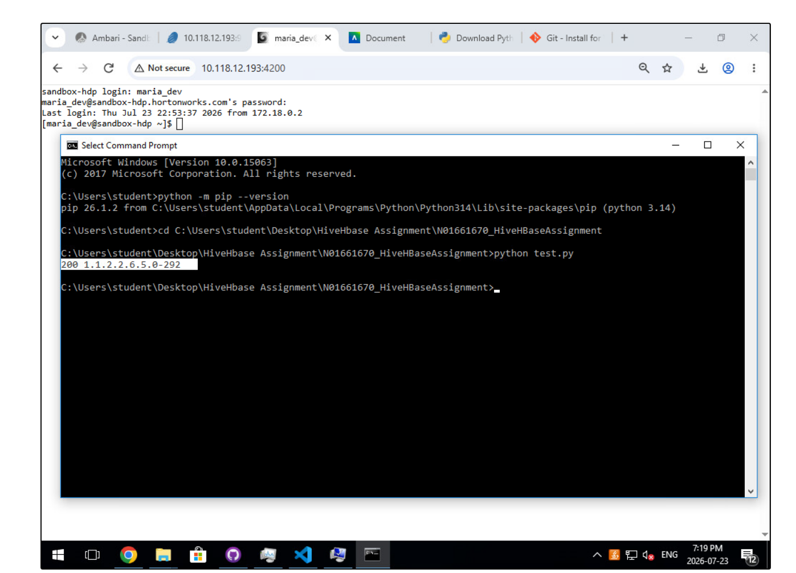
Table Creation : Create HBase Tables
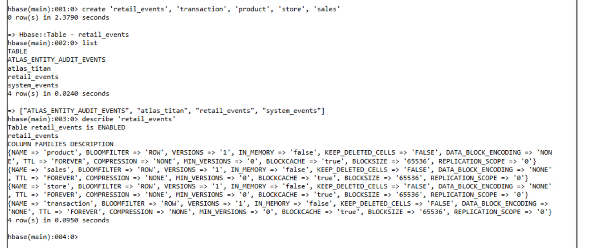
Python ingestion: Run Dataset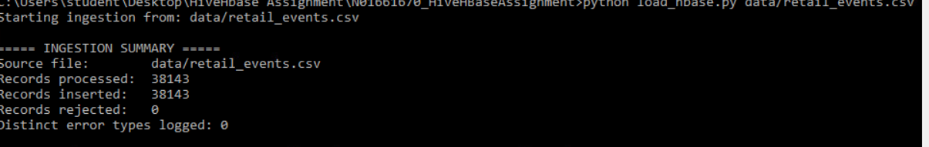
Error Handling: malformed_retail_events.csv
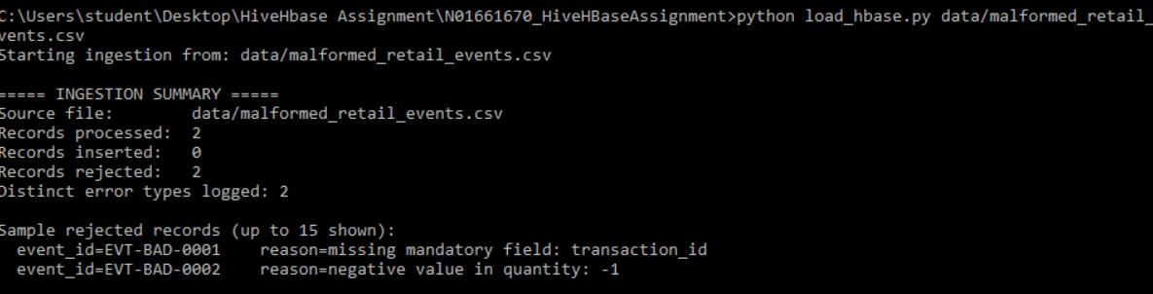

HBase Validation: Sanity check(Check if the data is actually present on hbase)
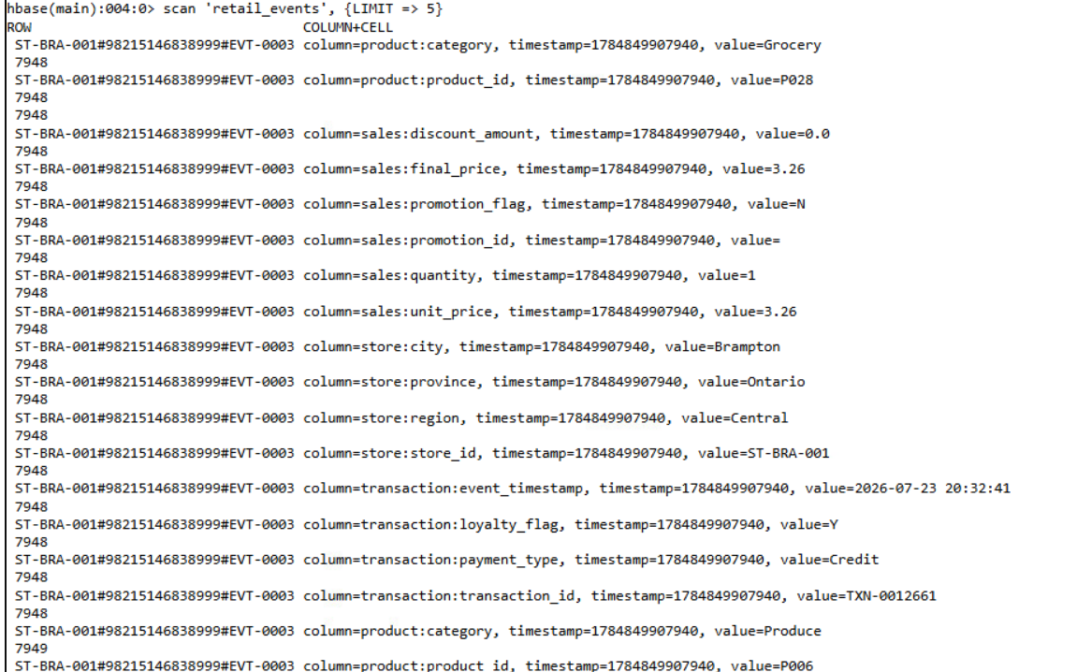

Hive Validation: results Equal to data
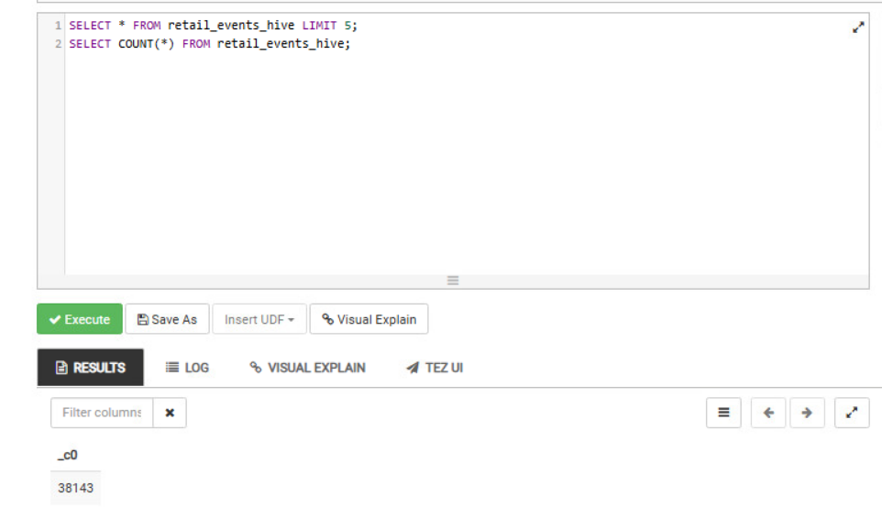
Proof of HBase and Hive connection
Test Data in Hbase:
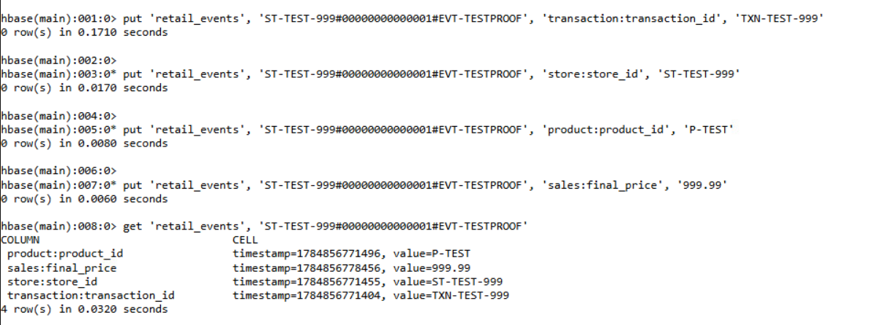
Retrieved in Hive:
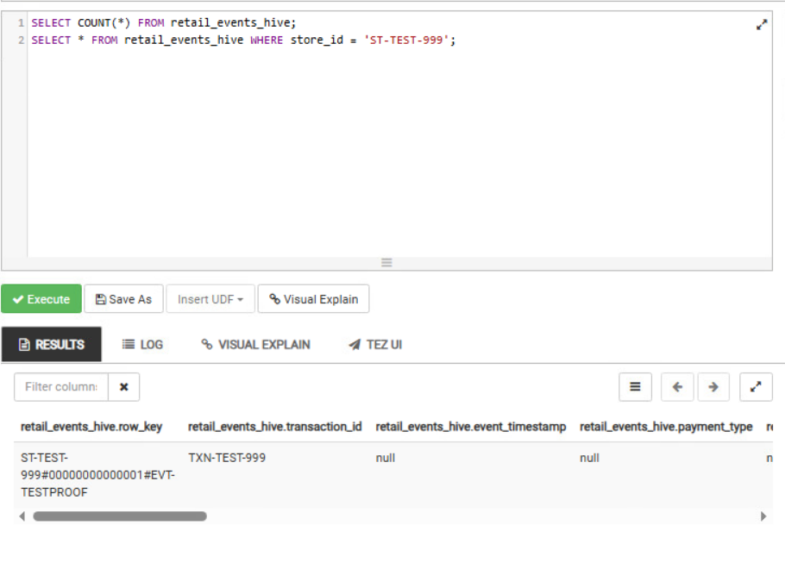

Total Sales:
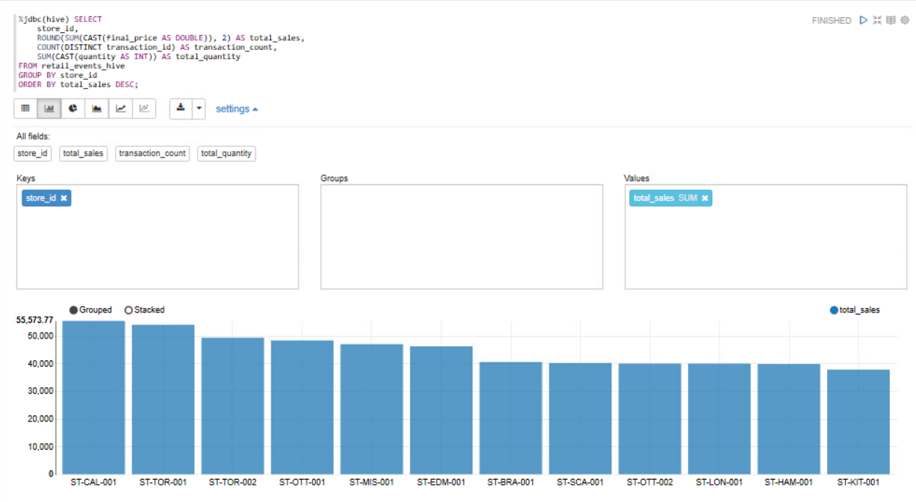
Transaction count
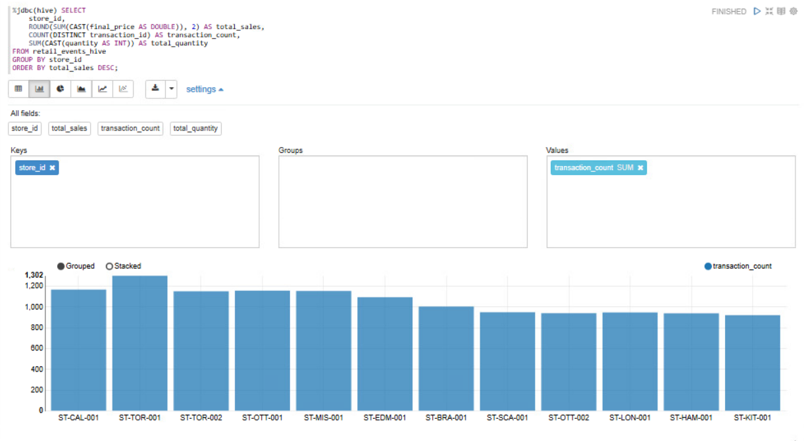

Average Value:
