Contents

ESP32 board view 2

ESP32 Firmware 3

Flash erase 3

Firmware upload 3

Modbus 3

Aplikacja ww do stanow system thingspeak 4

ESP32 DHT 11 sensor 4

ESP32 Web Server 4

## ESP32 board view

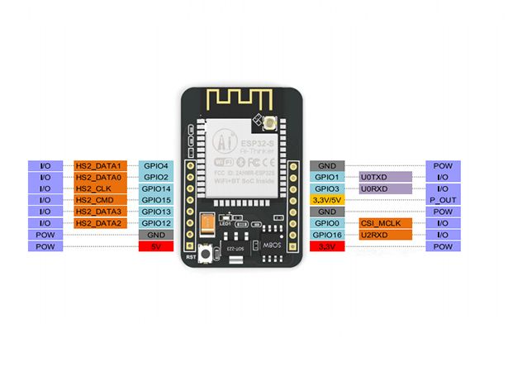

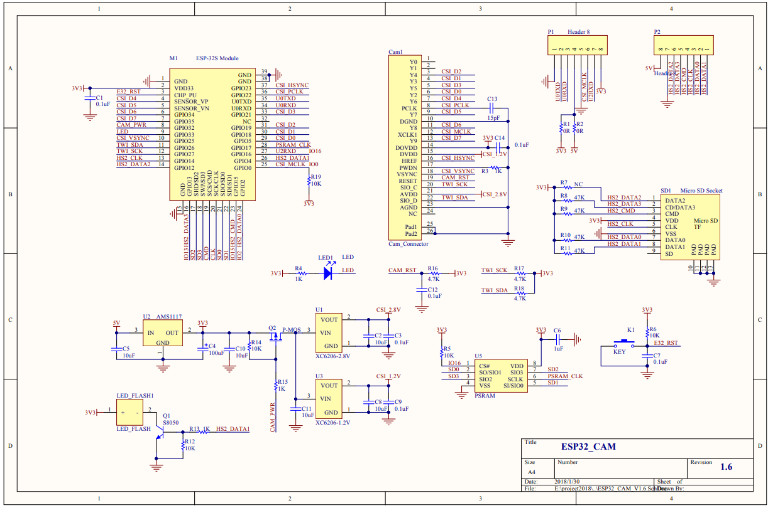

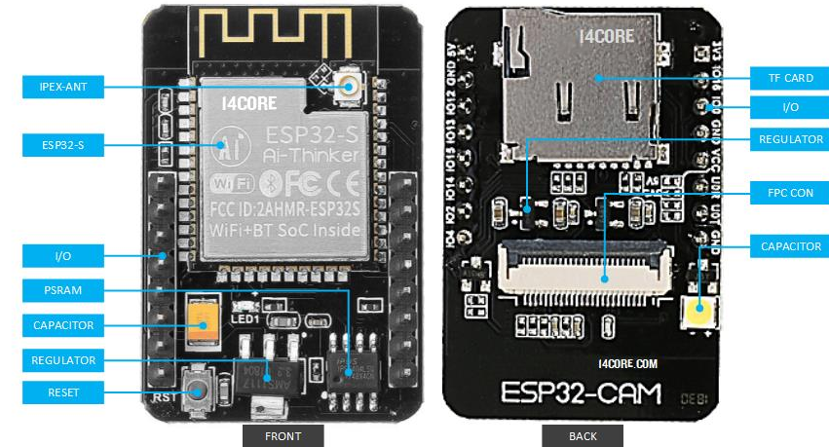

## ESP32 Firmware

https://micropython.org/download#esp32

### Flash erase

python -m esptool --port COM4 erase_flash

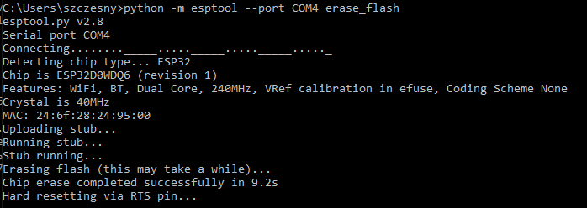

### Firmware upload

esptool.py --chip esp32 --port COM7 --baud 115200 write_flash -z 0x1000 esp

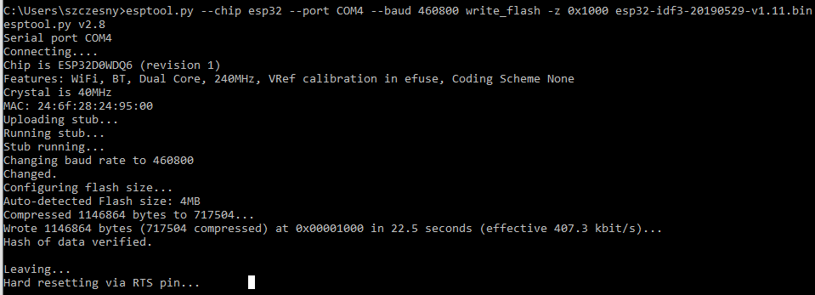

## Modbus

register number - each relay is another register

02 06 0001 0100 CRC

0x0001 (1)

0x0002 (2)

0x0003 (etc.)

0x0004

0x0005

0x0006

0x0007

0x0008 (8)

commands

0x0100 (256) ON

0x0200 (512) OFF

0x0300 (768) Change state if ON it changes to OFF lob if currently OFF it changes to ON

0x0400 (1024) extinguishes all other lights selected

0x0500 (1280) extinguishes all and turns the selected one on for 1 sec

0x0601 - 0x06FF (1537-1791) is a time switch on from 1-255 sec

## Aplikacja ww do stanow system thingspeak

## ESP32 DHT 11 sensor

Link <https://randomnerdtutorials.com/micropython-esp32-esp8266-dht11-dht22-web-server/>

## ESP32 Web Server

Link <https://randomnerdtutorials.com/esp32-dht11-dht22-temperature-humidity-web-server-arduino-ide/>

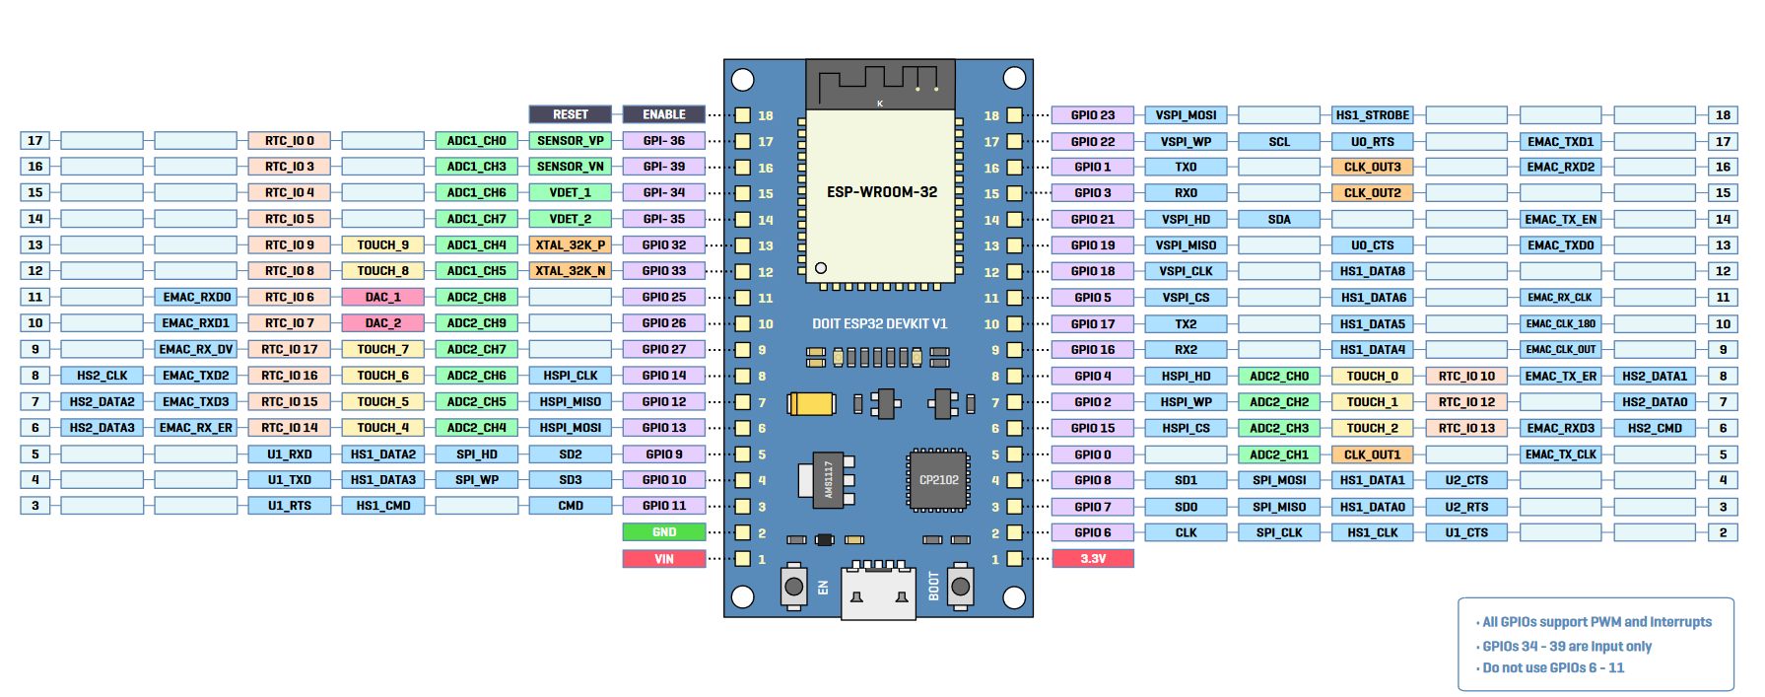

<https://www.espressif.com/sites/default/files/documentation/esp32-wroom-32_datasheet_en.pdf>

