# System application

In the following chapter, we will discuss the system app and its features.

## C:\Users\Hesha\OneDrive\Desktop\png-clipart-bluetooth-wireless-serial-communication-transceiver-serial-port-bluetooth-electronics-bluetooth-removebg-preview.pngRemote Controlled (via Bluetooth)

At the heart of our innovation is Bluetooth technology, a wireless communication standard that enables seamless connectivity between devices. By leveraging Bluetooth, our RC car can be controlled remotely using a smartphone or a dedicated controller, offering a level of flexibility and interactivity that was once reserved for larger-scale vehicles.

### Working Theory

1. Pairing and Connection:

Figure ‎0.1 Bluetooth module (HC-05)

The RC car is equipped with a Bluetooth module that establishes a connection with the controlling device, whether it's a smartphone, tablet, or a custom-made controller.

Pairing is a one-time process, creating a secure and reliable link between the controller and the RC car.

1. Intuitive Control Interface:

The controlling device becomes the interface for steering, acceleration, and other functionalities.

Through a user-friendly app or controller, operators can enjoy precise control over the RC car's movements, creating a more immersive driving experience.

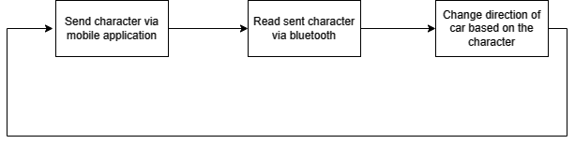

Figure ‎0.2 Bluetooth controlled sequence

## C:\Users\Hesha\OneDrive\Desktop\image-removebg-preview.pngAdaptive light control

Figure 1.‎0.3 LDR sensor

Adaptive Light Control transcends the limitations of traditional static headlights. Instead of a fixed beam, ALC harnesses the power of LDR sensors to intelligently modulate the direction and intensity of light. The result is a dynamic lighting system that adapts to the ever-changing conditions of the road.

### Working Theory

1. Sensing Ambient Light:

LDR sensors monitor the ambient light conditions, gauging factors such as natural sunlight, streetlights, and oncoming headlights.

1. Dynamic Adjustment:

The data gathered by LDR sensors is processed in real-time by the Adaptive Light Control system.

The PWM signal, generated by the Adaptive Light Control system, regulates the power supplied to the headlights.

In response to changes in ambient light, the system adjusts the intensity of the vehicle's headlights to optimize visibility

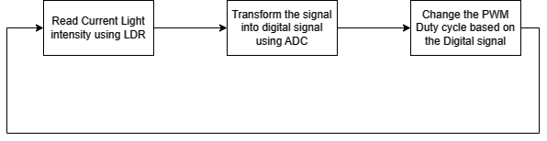

Figure 1.‎0.4 LDR working Diagram

## Adaptive cruise control

At the heart of our Adaptive Cruise Control systems lie ultrasonic sensors – unassuming devices that emit high-frequency sound waves and interpret their echoes. These sensors function as the vehicle's silent guardians.

### Working Theory

1. Sensing the Environment:

Ultrasonic sensors continuously emit sound waves, which bounce off objects in the vehicle's vicinity.

By measuring the time it takes for the echoes to return, the sensors calculate the distance to these objects.

1. Dynamic Speed Adjustment:

In the context of ACC, this real-time distance data is used to assess the vehicle's proximity to the one ahead.

If the system detects a slower-moving vehicle in the same lane, it intelligently adjusts the speed to maintain a safe following distance.

1. Seamless Driving Experience:

The beauty of ACC lies in its seamless integration with the driver's intentions. If the road ahead is clear, the system allows the driver to enjoy a constant speed. However, when traffic conditions change, ACC steps in to dynamically adapt the speed, offering a stress-free and safer driving experience.

## C:\Users\Hesha\OneDrive\Desktop\image-removebg-preview.pngEmergency system

Figure 1.‎0.5 FSR sensor

At the core of our emergency system lies the Force-Sensing Resistor (FSR), a remarkable sensor capable of detecting changes in pressure and force. Placed strategically within the vehicle, FSR sensors act as sensitive touchpoints that can assess the severity and location of impact, offering a level of precision crucial for effective emergency response.

### Working Theory

1. Constant Monitoring:

FSR sensors continuously monitor the force exerted on them, providing real-time data on the pressure distribution.

1. Impact Assessment:

During a collision or sudden deceleration, the FSR sensors detect changes in force and pressure.

If any collision is detected, a task with the highest priority in the RTOS-based system is enabled to start the Airbag system and all system tasks is suspended.

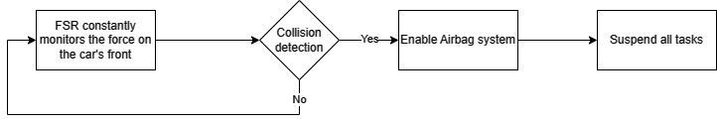

Figure1.‎0.6 Emergency Airbag system diagram

## Lane Keep Assistance

Lane Keep Assist (LKA) is a feature designed to prevent unintentional lane departure, offering a helping hand to drivers in maintaining proper lane positioning. Traditional systems rely on predefined rules and thresholds, but our project takes a leap forward by integrating a simple machine learning model that adapts and refines its performance based on real-world driving data.

### Working Theory

1. Data Collection:

Sensors, such as camera, continuously collect data on the vehicle's position within the lane.

This data is fed into the machine learning model, allowing it to learn patterns and correlations between driver inputs and lane-keeping behaviors.

1. Real-Time Decision Making:

During actual driving scenarios, the model analyzes incoming data in real time.

If it detects signs of unintentional lane departure, the Lane Keep Assist system intervenes by gently adjusting the steering to guide the vehicle back into the lane.

1. Communication with the main ECU

Communication with the main ECU is done through the SPI communication protocol.

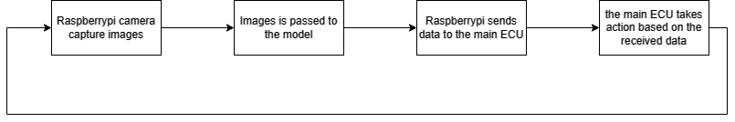Based on the received data the ECU, the steering rotation is changed to stay in the same lane.

Figure ‎0.7 Lane keep assist diagram