

Sharif University of Technology  
*Department of Aeronautics and Astronautics*  
B.Sc. Project – Reliability Analysis & Risk Assessment (Spring 2025)

Probabilistic Safety Assessment of Aircraft Crew Oxygen Systems

*Technical Report*

Written by

Hosein Asghari Hosouri

Ali Moradi

Course Instructor

Dr. Khodabakhsh

Submission Date:

9.4.2025

|  |  |
| --- | --- |
| Page | Table of Contents |

Chapter 1: Introduction 1

Chapter 2: Background and Literature Review 2

2.1 Reliability and Safety in Aerospace Systems 2

2.2 Analytical Methods for Reliability Assessment 2

2.3 Data Sources and Standards 2

2.4 Relevance to Crew Oxygen Systems 2

Chapter 3: System Modeling & Reliability Prediction 3

Chapter 4: Failure Criticality & Scenario Modeling 8

Chapter 5: Risk Mitigation & Decision Analysis 16

Chapter 6: Optional: FORM Analysis 24

Chapter 7: Conclusion & Recommendations 29

Appendix 30  
References…………………………………………………………………………………………31

# Chapter 1: Introduction

The crew oxygen system is one of the most critical life-support subsystems in commercial aircraft. Its primary role is to ensure the availability of breathable oxygen to pilots and crew members in the event of cabin depressurization or other emergency scenarios. The failure of such a system can rapidly escalates into catastrophic consequences, threatening the safety of both crew and passengers.

A notable example of the dangers of inadequate oxygen provision occurred in the **Helios Airways Flight 522 accident (2005)**, where a failure in recognizing and responding to cabin pressure warnings ultimately led to crew incapacitation and the loss of the aircraft. This tragedy highlights the ethical responsibility of aerospace engineers: even seemingly small oversights in design, analysis, or certification can cause irreversible human and financial losses.

The goal of this project is to conduct a **Probabilistic Safety Assessment (PSA)** of a crew oxygen system similar to that installed on the **Boeing 737** platform. The assessment must comply with **FAA Part 25.1309**, which requires that catastrophic failures be “extremely improbable,” i.e., less than once in 10⁻⁹ flight hours. To achieve this, the project integrates system modeling, criticality analysis, and decision-making frameworks to determine whether the system satisfies the regulatory thresholds and to recommend cost-effective improvements.

The project roadmap is structured as follows:

1. **System Modeling & Reliability Prediction** – Using a **Reliability Block Diagram (RBD)** and failure rate data (OREDA, FAA ASRS).
2. **Failure Criticality & Scenario Modeling** – Performing **FMECA** on five critical components and building a **Fault Tree Analysis (FTA)** for the top event of insufficient oxygen delivery.
3. **Risk Mitigation & Decision Analysis** – Evaluating design upgrades using decision tree analysis and sensitivity studies.
4. **Optional Extension** – Application of FORM to a simplified limit state.

This report is organized into eight chapters. Chapter 2 reviews the theoretical foundations of reliability and risk assessment, while Chapters 3–6 present the technical analyses. Chapter 7 discusses the results, and Chapter 8 concludes with recommendations for system improvement and certification.

# Chapter 2: Background and Literature Review

## 2.1 Reliability and Safety in Aerospace Systems

Reliability is the probability that a system or component performs its intended function under stated conditions for a specified duration. In the aerospace domain, reliability analysis is inseparable from safety assessment, since even a low-probability failure can result in catastrophic consequences.

Modern regulations, particularly **FAA AC 25.1309** and **MIL-STD-882E**, establish explicit probabilistic safety objectives. For catastrophic failures, the allowable probability is ≤ 10⁻⁹ per flight hour. These requirements form the backbone of aerospace certification and justify the use of probabilistic tools for system assessment.

## 2.2 Analytical Methods for Reliability Assessment

Several well-established techniques are used in aerospace reliability engineering and will be applied in this project:

* **Reliability Block Diagram (RBD):** Represents the logical structure of the oxygen supply chain and allows computation of overall system reliability from component-level failure rates.
* **Failure Modes, Effects, and Criticality Analysis (FMECA):** A bottom-up approach that identifies potential failure modes, their effects, and assigns criticality levels using **severity, occurrence, and detection** criteria.
* **Fault Tree Analysis (FTA):** A top-down method that models how combinations of component failures can lead to a top-level undesired event, such as “insufficient oxygen delivery”.
* **Monte Carlo Simulation:** A probabilistic tool used to validate analytical reliability models and quantify uncertainties by generating thousands of random scenarios.
* **Decision Analysis:** A structured approach for selecting cost-effective risk mitigations, using decision trees and sensitivity analysis.

## 2.3 Data Sources and Standards

This project relies on a combination of **empirical databases** and **regulatory guidelines**:

* **OREDA (Offshore Reliability Data Handbook):** Provides statistical failure rates for valves, generators, and sensors.
* **FAA ASRS (Aviation Safety Reporting System):** Offers incident reports related to oxygen system malfunctions.
* **Regulatory Standards:** FAA AC 25.1309, and MIL-STD-882E establish acceptable risk thresholds and classification schemes.

## 2.4 Relevance to Crew Oxygen Systems

The crew oxygen system typically consists of **storage & control, distribution & delivery, and User detection & usage**. Failures in any of these elements can compromise oxygen delivery, particularly during decompression events. Due to the system’s critical role in maintaining crew consciousness, probabilistic safety analysis is essential for verifying compliance with certification standards and preventing Helios-like cascades.

# Chapter 3: System Modeling & Reliability Prediction

## 3.1 System description

Based on the conducted research, the new crew oxygen systems in the next-generation Boeing 737 aircraft incorporate high-pressure oxygen gas cylinders instead of chemical generators to enhance reliability. These cylinders are pre-charged and installed beneath the cockpit. The system components have been designed with consideration for various aircraft types, particularly the next-generation Boeing 737.

## 3.2 Reliability Block Diagram (RBD)

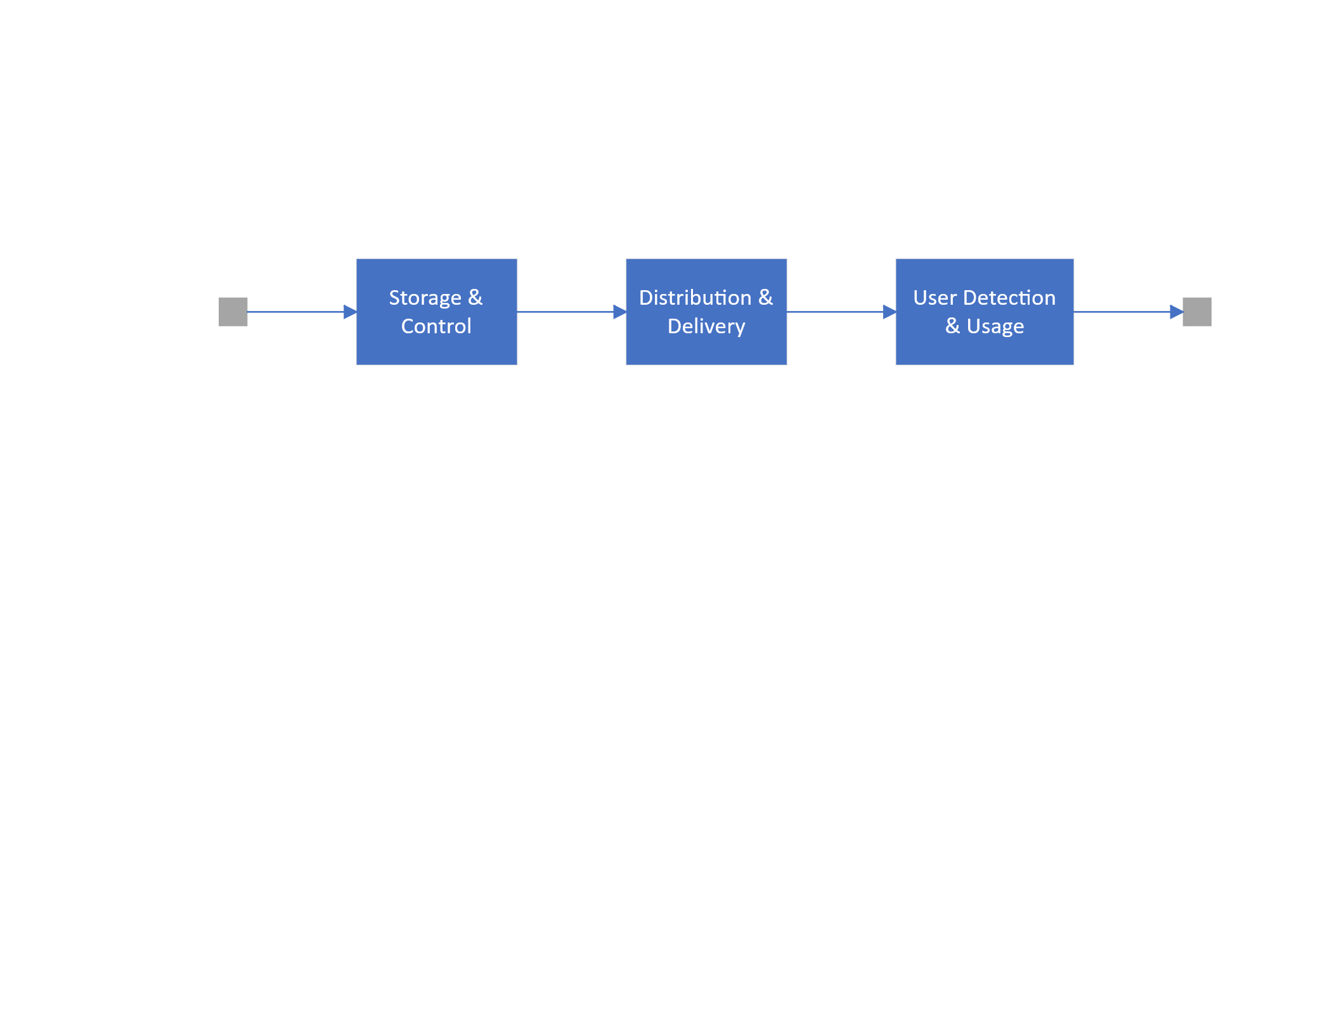

Figure - System RBD

This system can be divided into three subsystems: Storage & Control, Distribution & Delivery, and User Usage & Detection.

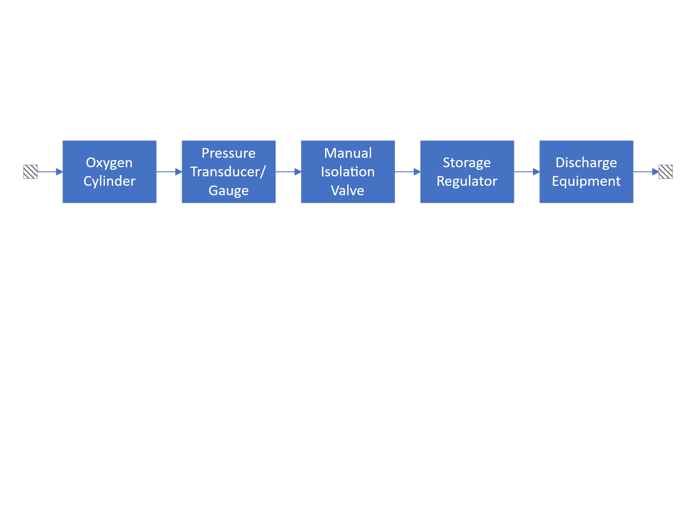

Figure - Storage & Control RBD

The Storage & Control subsystem is responsible for storing and maintaining the oxygen supply beneath the pilot's cockpit. Additionally, this subsystem monitors the pressure in the pipes and reservoir, and it reports the oxygen gas reservoir pressure to the flight crew.

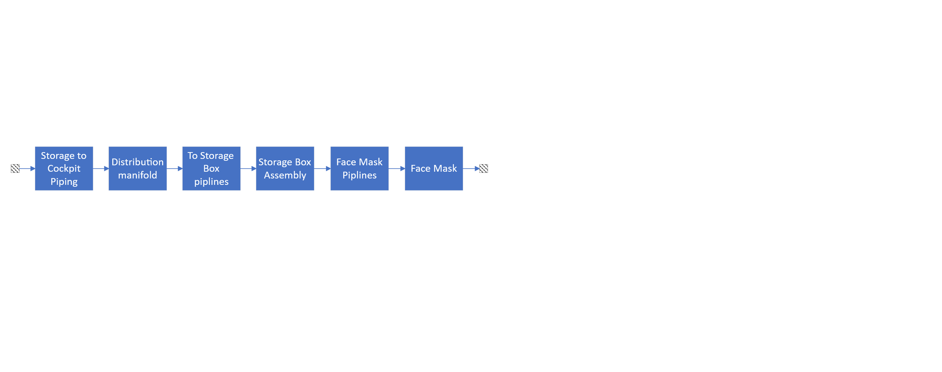

Figure - Distribution & Delivery RBD

The Distribution & Delivery subsystem is responsible for transporting oxygen to the flight crew's masks. This subsystem comprises various valves, hoses, clamps interconnecting the valves, and the pilot's mask itself. Each of these components can be examined in greater detail; however, for the purposes of this project, the current level of analysis is sufficient. In particular, the mask and its associated enclosure could be analyzed in a far more complex manner, which would introduce interdependencies among all components, and a comprehensive analysis of these has not been fully addressed in the available documentation.

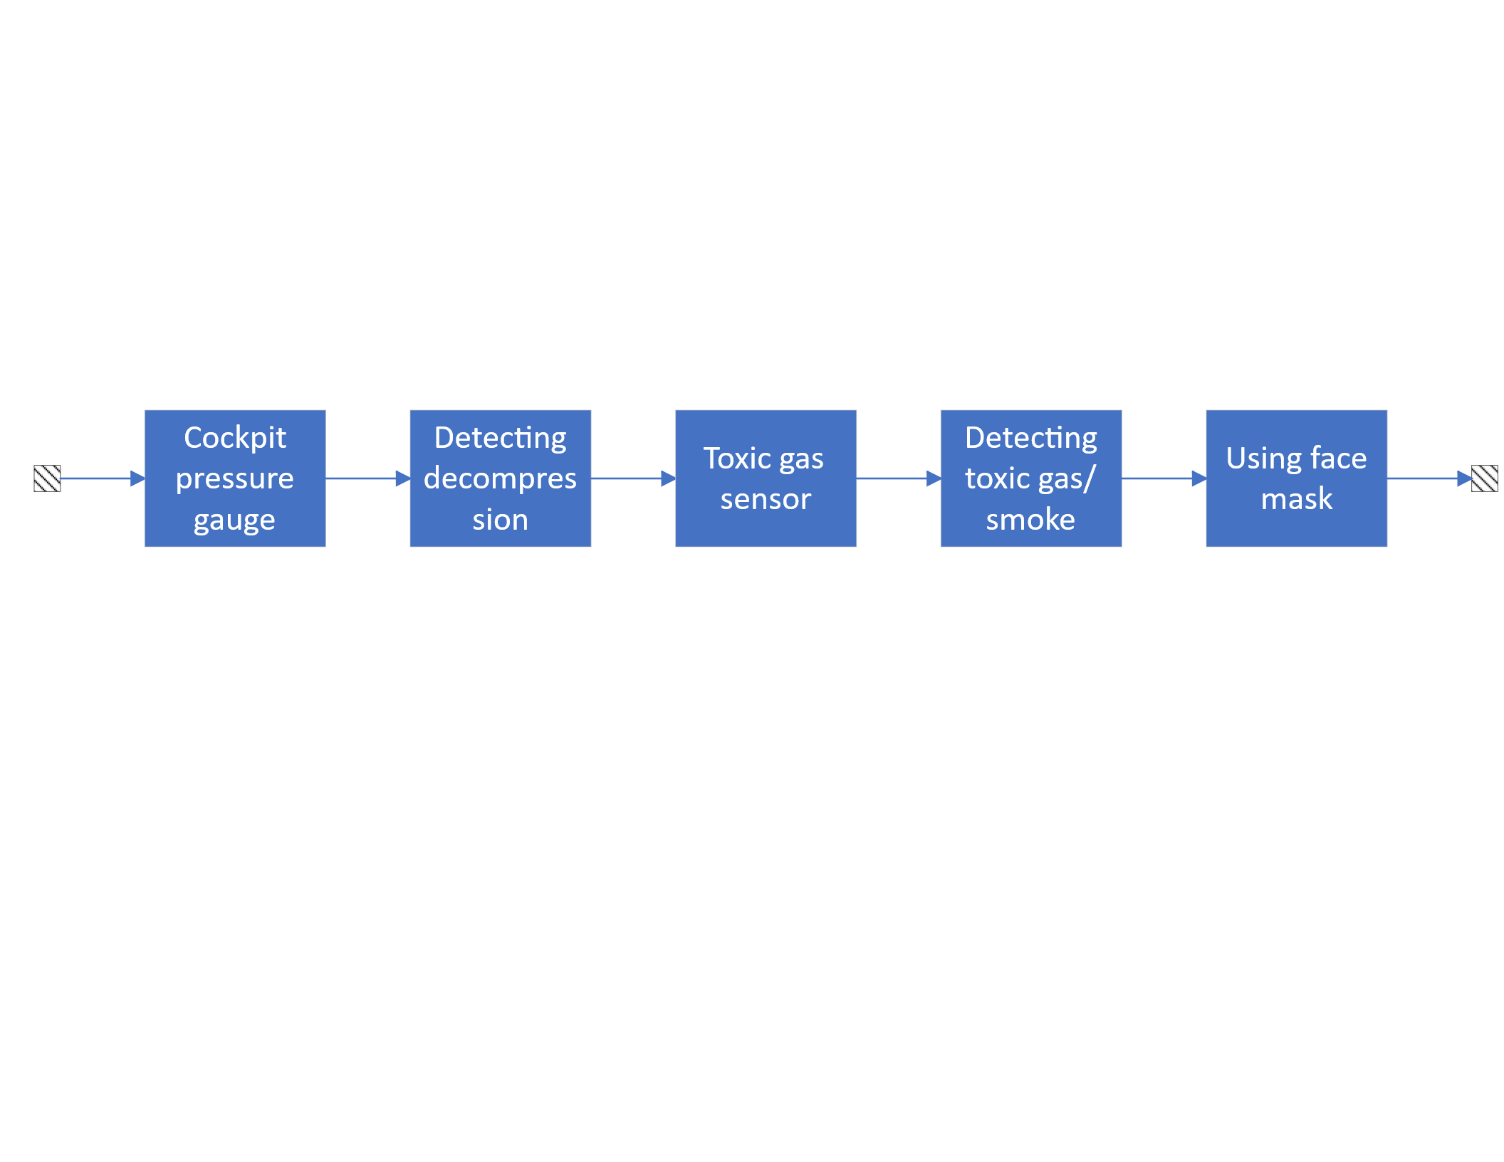

Figure - User usage & detection RBD

The final subsystem pertains to User Usage and Detection. In this subsystem, the human factor (i.e., the pilot) exerts a direct influence. This arises from the fact that the accurate identification of gas leakage indicators or reductions in oxygen pressure through sensors, as well as their associated effects, is the responsibility of the flight crew. Moreover, the capability to properly and appropriately utilize the oxygen mask will be incorporated into the analysis, thereby increasing the overall complexity of the evaluation.

## 3.3 Failure rate assumptions

|  |  |  |  |
| --- | --- | --- | --- |
| Component | Failure rate (1/hour) | Distribution | Reference |
| Oxygen Cylinder | 0.001 (analog to pressure vessels/coils) | Exponential | MIL-HDBK-217F Sec. 12.2; NASA reports |
| Pressure Transducer/Gauge | 0.0055 (analog to photo-transistors/sensors) | Exponential | MIL-HDBK-217F Sec. 6.11 |
| Manual Isolation Valve | 0.0059 (analog to mechanical relays) | Exponential | MIL-HDBK-217F Sec. 13.1 |
| Storage Regulator | 0.0022 (analog to thyristors/regulators) | Exponential | MIL-HDBK-217F Sec. 6.10 |
| Supply Lines/Manifold | 0.00005 (analog to crimp connections) | Exponential | MIL-HDBK-217F Sec. 17.1 |
| Face Masks | 0.10 (analog to fiber optic connectors) | Exponential | MIL-HDBK-217F Sec. 23.1 |
| human errors (using face mask) | 0.01 | Exponential |  |
| storage box assembly | 0.00001 | Exponential |  |
| toxic gas sensor | 0.000001 | Exponential |  |

According to given Failure rate of the components in the “Failure Rate for RBD.xlsx “ we can construct

For exponential distribution with respect to

For Weibull Distribution with respect to

## 3.4 Calculation

system reliability over 50,000 flight hours.

Now we can determine minimal cutsets :

1. Storage & Control
2. Distribution & Delivery
3. User Detection & Usage

According to information above and definition below we can say :

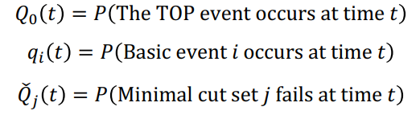

We have 3 approaches to calculate :

1. If it is a series of basic events we multiply them
2. If it is a parallel of basic events
3. Or we can construct minimal cutsets and calculate their failure probability and then claim that

And

We use 1th approach because we have already construct minimal cutsets

1. Storage & Control
2. Distribution & Delivery
3. User Detection & Usage

But the formulas above are valid when t is small but for our problem where t=50000 we can not use the approximation

So we have :

so our top event will occur according to the formula below :

## 3.5 Critical question

Does baseline design meet FAA’s “extremely improbable” threshold?

As you can see it does not meet FAA extremely improbable threshold which is

# Chapter 4: Failure Criticality & Scenario Modeling

## 4.1 FMECA

To account for FMECA, two approaches will be employed: either the more critical components must be identified through a series of sensitivity analyses and importance ranking calculations, or data from previous incidents and prior safety analyses will be utilized. Furthermore, in accordance with the MIL-STD-882 document, severity levels for incidents are selected on a scale from 1 to 4 (with 1 representing the highest severity), and probability of occurrence is denoted using letters from A to F (with A indicating the highest probability of occurrence).

Table 1 - Every component reason for FMECA

|  |  |  |
| --- | --- | --- |
| Component | Reason for Being Critical | Reliable Source |
| Oxygen Cylinder | The oxygen cylinder stores high-pressure oxygen essential for crew survival during depressurization; failure (e.g., leak or rupture) can cause immediate oxygen loss, hypoxia, or explosion risk due to overpressurization in extreme conditions. | SKYbrary Aviation Safety article on aircraft oxygen systems; B737.org.uk emergency equipment page. |
| Pressure Regulator | It controls and reduces oxygen pressure for safe delivery; failures can lead to insufficient flow (causing crew incapacitation) or excessive pressure (damaging masks/system), as seen in FAA-mandated inspections for switch failures that delay warnings. | TechXplore report on US regulator orders for Boeing inspections; Business Insider on Boeing 737 switch issue. |
| Oxygen Masks | Masks provide direct oxygen to crew during emergencies; faults like displacement or blockage prevent effective delivery, potentially leading to rapid hypoxia and loss of aircraft control, prompting FAA airworthiness directives for inspections. | Reuters on FAA orders for 2,600 Boeing 737 inspections; Simple Flying on FAA checks for oxygen mask faults. |
| Pressure Transducer | This sensor monitors system pressure to detect issues early; failures result in undetected leaks or false readings, delaying crew response and risking oxygen depletion, as highlighted in FAA orders for cabin pressure sensor inspections. | NBC DFW on FAA orders for Boeing 737 cabin pressure sensors; Business Insider on switch failure leading to low oxygen. |
| Tubing/Lines | These lines distribute oxygen throughout the system; issues like leaks from corrosion or vibration cause pressure loss and contamination, compromising the entire system, as noted in FAA reports on passenger oxygen supply failures. | Reuters on FAA inspections for oxygen mask issues (including supply lines); Aviation Week on FAA order for 737 oxygen system inspections. |

Table 2 - FMECA

|  |  |  |  |  |  |  |  |  |  |  |
| --- | --- | --- | --- | --- | --- | --- | --- | --- | --- | --- |
| Component | Failure Mode | Causes | Effects | Severity | Probability | Risk | Mitigation Measures | Post-Mitigation Risk | Detection | Verification |
| Oxygen Cylinder | Pressure leak or explosion | Corrosion, mechanical damage, overpressure | Oxygen depletion, crew hypoxia, fire risk | 1 (Catastrophic) | C (Occasional) | High | Periodic inspections, use of resistant materials, backup system | Medium | 5 (Moderate detection with test tools) | Annual pressure testing (e.g., C35001-37) |
| Pressure Regulator | Improper pressure regulation (high/low) | Mechanical failure, clogging | Insufficient or excessive oxygen, mask damage | 2 (Critical) | B (Probable) | High | Redundant design, input filters, automatic monitoring | Low | 3 (Easy detection with indicators) | Simulation testing in AMM 35-12 |
| Oxygen Masks | Failure in oxygen delivery (leak or blockage) | Physical damage, wear | Immediate crew hypoxia, loss of aircraft control | 1 (Catastrophic) | C (Occasional) | High | Quick-donning masks, pre-flight testing | Medium | 4 (Detection via checklist) | FAA inspections for B737 models |
| Pressure Transducer | Incorrect pressure reading | Electronic failure, miscalibration | Undetected leak, delayed response | 2 (Critical) | D (Remote) | Serious | Redundant sensors, automatic alerts | Low | 6 (Difficult detection without tools) | Periodic calibration with pressure gauge |
| Tubing/Lines | Leak or crack | Corrosion, vibration, weak connections | System pressure loss, contamination | 2 (Critical) | B (Probable) | High | Stainless steel usage, flareless fittings, visual inspections | Medium | 2 (Easy detection with leak tests) | Pressure testing per FAA AD |

## 4.2 Fault Tree Analysis (FTA)

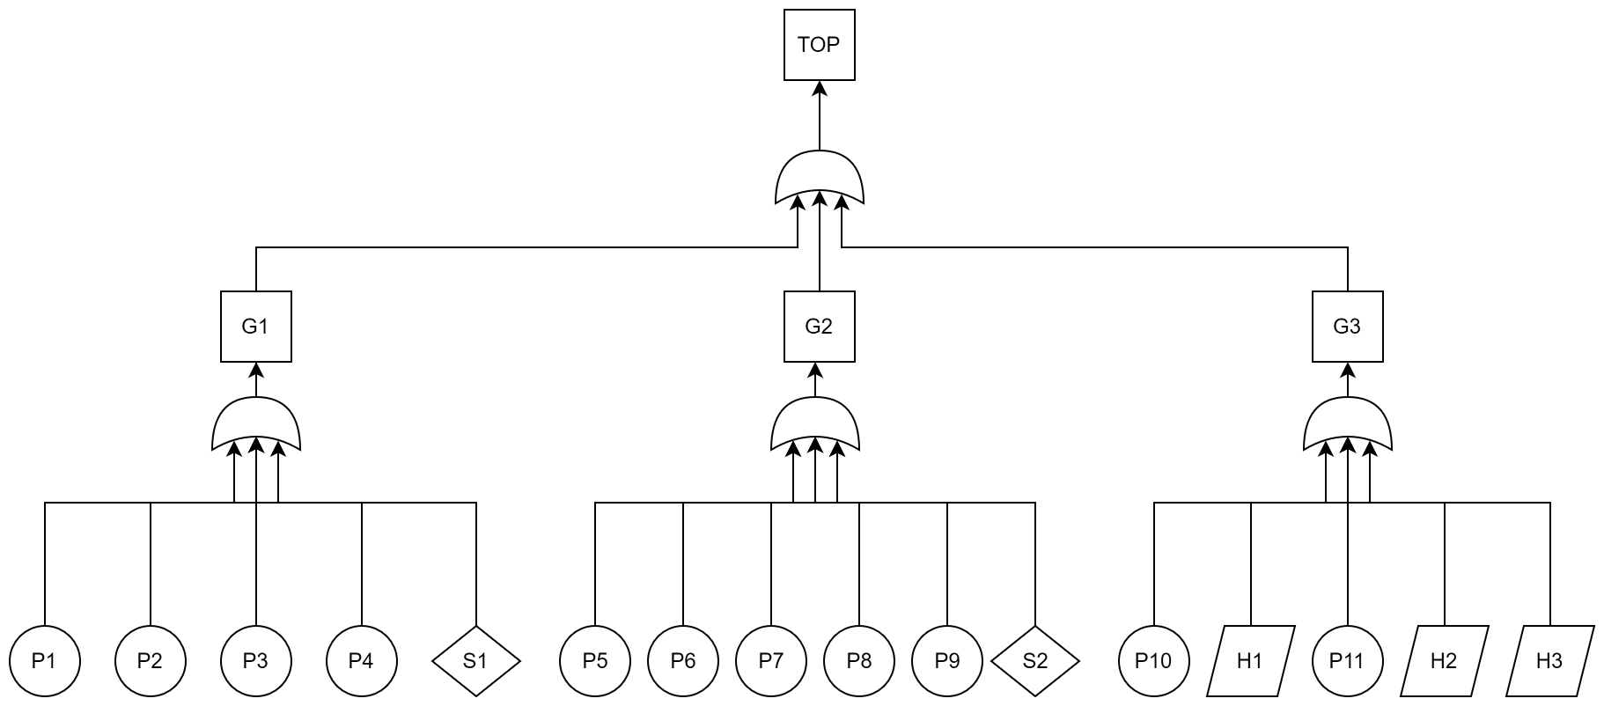

|  |  |  |
| --- | --- | --- |
| No. | ID | Description |
| 1 | TOP | Insufficient oxygen delivery during decompression |
| 2 | G1 | Leaks and pressure problems in the tank |
| 3 | G2 | Leaks in transmission lines |
| 4 | G3 | Inability of the crew to recognize and use the oxygen system |
| 5 | P1 | Gas leak or burst oxygen cylinder |
| 6 | P2 | Gas leak in the pressure gauge or failure to measure pressure |
| 7 | P3 | Gas not passing through the manual valve |
| 8 | P4 | Failure to adjust the gas pressure output from the tank |
| 9 | P5 | Gas not reaching the cockpit |
| 10 | P6 | Lack of/improper distribution of gas |
| 11 | P7 | Gas not reaching from the distribution plate to the storage box |
| 12 | P8 | Leakage in storage box |
| 13 | P9 | No gas flow in the mask hose |
| 14 | P10 | Error in cockpit oxygen pressure report |
| 15 | P11 | Error in cockpit toxic gas/smoke report |
| 16 | S1 | Failure to relieve excess pressure from the tank and pipes |
| 17 | S2 | Oxygen mask failure |
| 18 | H1 | Pilot's failure to understand oxygen pressure drop |
| 19 | H2 | Pilot's failure to understand toxic gas/smoking |
| 20 | H3 | Incorrect use of masks |

Minimal cut sets:

## 4.3 Monte Carlo Simulation

* Run ~10,000 trials to validate analytical probabilities.
* Compare with deterministic results.
* Are your assumed failure rates defensible given realworld incidents like Alaska Airlines Flight 261

Because all elements are series so we have 16 minimal cutest in size of 1 for our system which are as follows:

Monte Carlo simulation :

It is a bit vague in this situation for this concept because we do not have limit state function for our project yet and limit state function can be reached via physical model of the problem and distribution of each variables that we do not have .

But I struggle to string somethings together to create a limit state function whole system

According to our code in RBD.m and RBD_Id=1

Our

Due to our denominator is nonzero then our equivalent limit state function will be :

You can see our answer in detail in “Q_2_MC.docx” but I bring only some details here and its matlab code is available in “Q2.mlx”:

Oxygen System

# INITIALIZE UQLAB

Clear all variables from the workspace, set the random number generator for reproducible results, and initialize the UQLab framework:

clc; clear all; close all;

rng(100,'twister');

uqlab;

# COMPUTATIONAL MODEL

ModelOpts.mString = 'X(:,1).*X(:,2).*X(:,3).*X(:,4).*X(:,5).*X(:,6).*X(:,7).*X(:,8).*X(:,9).*X(:,10).*X(:,11).*X(:,12).*X(:,13).*X(:,14).*X(:,15).*X(:,16)';

ModelOpts.isVectorized = true;

myModel = uq_createModel(ModelOpts);

# PROBABILISTIC INPUT MODEL

The probabilistic input model consists of eight independent lognormal random variables.

Define an INPUT object using the following marginals:

InputOpts.Marginals(1).Name = 'X1'; %failure of Oxygen Cylinder

InputOpts.Marginals(1).Type = 'Exponential';

InputOpts.Marginals(1).Moments = 1/0.001.*ones(1,2);

InputOpts.Marginals(2).Name = 'X2'; %failure of Pressure Transducer/Gauge

InputOpts.Marginals(2).Type = 'Exponential';

InputOpts.Marginals(2).Moments = 1/0.0055.*ones(1,2);

InputOpts.Marginals(3).Name = 'X3'; %failure of Manual Isolation Valve

InputOpts.Marginals(3).Type = 'Exponential';

InputOpts.Marginals(3).Moments = 1/0.0059.*ones(1,2);

InputOpts.Marginals(4).Name = 'X4'; % failure of Storage Regulator

InputOpts.Marginals(4).Type = 'Exponential';

InputOpts.Marginals(4).Moments = 1/0.0022.*ones(1,2);

InputOpts.Marginals(5).Name = 'X5'; % failure of Discharge Equipment

InputOpts.Marginals(5).Type = 'Exponential';

InputOpts.Marginals(5).Moments = 1/0.00005.*ones(1,2);

InputOpts.Marginals(6).Name = 'X6'; % failure of Storage to Cockpit Piping

InputOpts.Marginals(6).Type = 'Exponential';

InputOpts.Marginals(6).Moments = 1/0.00005.*ones(1,2);

InputOpts.Marginals(7).Name = 'X7'; % failure of Distribution manifold

InputOpts.Marginals(7).Type = 'Exponential';

InputOpts.Marginals(7).Moments = 1/0.00005.*ones(1,2);

InputOpts.Marginals(8).Name = 'X8'; % failure of Distribution manifold

InputOpts.Marginals(8).Type = 'Exponential';

InputOpts.Marginals(8).Moments = 1/0.00005.*ones(1,2);

InputOpts.Marginals(9).Name = 'X9'; % failure of Storage Box Assembly

InputOpts.Marginals(9).Type = 'Exponential';

InputOpts.Marginals(9).Moments = 1/0.00001.*ones(1,2);

InputOpts.Marginals(10).Name = 'X10'; % failure of face mask pipeline

InputOpts.Marginals(10).Type = 'Exponential';

InputOpts.Marginals(10).Moments = 1/0.00005.*ones(1,2);

InputOpts.Marginals(11).Name = 'X11'; % failure of face mask

InputOpts.Marginals(11).Type = 'Exponential';

InputOpts.Marginals(11).Moments = 10.*ones(1,2);

InputOpts.Marginals(12).Name = 'X12'; % failure of cockpit pressure gague

InputOpts.Marginals(12).Type = 'Exponential';

InputOpts.Marginals(12).Moments = 1/0.0055.*ones(1,2);

InputOpts.Marginals(13).Name = 'X13'; % failure of detecting decompression

InputOpts.Marginals(13).Type = 'Exponential';

InputOpts.Marginals(13).Moments = 100.*ones(1,2);

InputOpts.Marginals(14).Name = 'X14'; %p failure of toxic gas sensor

InputOpts.Marginals(14).Type = 'Exponential';

InputOpts.Marginals(14).Moments = 1/0.000001.*ones(1,2);

InputOpts.Marginals(15).Name = 'X15'; % failure of Detecting toxic gas/smoke

InputOpts.Marginals(15).Type = 'Exponential';

InputOpts.Marginals(15).Moments = 100.*ones(1,2);

InputOpts.Marginals(16).Name = 'X16'; % failure of using face mask

InputOpts.Marginals(16).Type = 'Exponential';

InputOpts.Marginals(16).Moments = 100.*ones(1,2);

Create an INPUT object based on the defined marginals:

myInput = uq_createInput(InputOpts);

# RELIABILITY ANALYSIS

Failure event is defined as . The failure probability is then defined as .

# Monte Carlo simulation (MCS)

Select the Reliability module and the Monte Carlo simulation (MCS) method:

MCSOpts.Type = 'Reliability';

MCSOpts.Method = 'MCS';

Specify the sample size and the target coefficient of variation (CoV):

MCSOpts.Simulation.BatchSize = 5e3;

MCSOpts.Simulation.MaxSampleSize = 1e4;

MCSOpts.Simulation.TargetCoV = 5e-2;

Run the Monte Carlo simulation:

MCSAnalysis = uq_createAnalysis(MCSOpts);

Print out a report of the results:

uq_print(MCSAnalysis)

---------------------------------------------------

Monte Carlo simulation

---------------------------------------------------

Pf 0000

Beta Inf

CoV NaN

ModelEvaluations 10000

PfCI [0.0000e+00 0.0000e+00]

BetaCI [Inf Inf ]

---------------------------------------------------

Create a graphical representation of the results:

uq_display(MCSAnalysis)

so it does not evaluates it as 1.25e-2

Are your assumed failure rates defensible given realworld incidents like Alaska Airlines Flight 261?

This airplane incidence is fully scrutinized in file “Alaska Airlines Flight 261.docx” and I pay to this in brief here .  
this airplane had problem in autopilot system in horizontal stabilizer and more accurate in its maintenance of greasing the actuator of its jackscrew system . and after this incidence 24 certification obliged to airline companies for this problem and lubrication scheduled was immediately changed to be completed every 650 hours but it does not have nothing to do with our project because the main cause of failure of our aircraft was oxygen system to horizontal stabilizer  
but as we mentioned we can prevent this happening by decreasing test interval for this system.

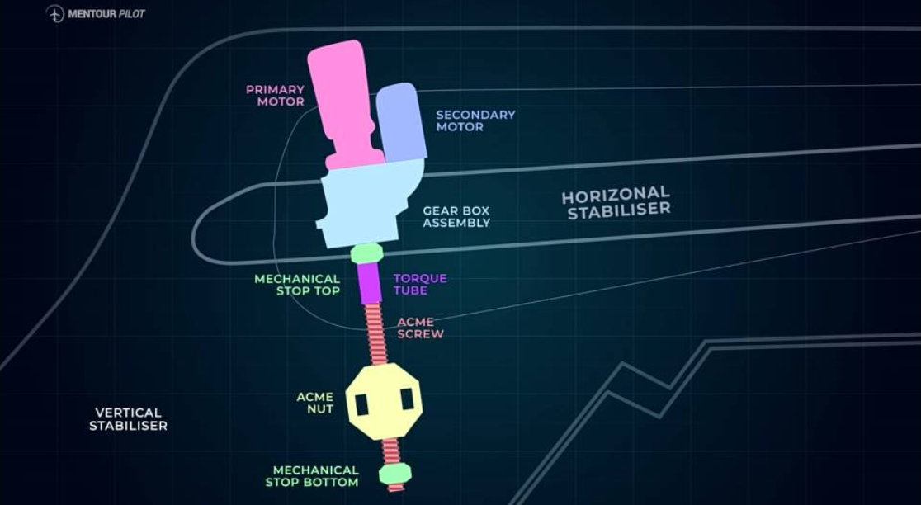

# Chapter 5: Risk Mitigation & Decision Analysis

* **Proposed design upgrades:**
  + Example: add redundant sensors.
  + Example: shorten inspection intervals.
* **Cost estimation:** installation, maintenance, penalties avoided.
* **Decision tree:** calculate utility function
* **Sensitivity analysis:** vary cost parameters; test robustness of decision.
* **Discussion:** which option provides best cost–safety trade-off?

First upgrade (consider redundancy) :

According to sensitivity analysis and criticality analysis both conclude same result as follows:

By running “Pr_1_2.m” we have :

{[ 11]}

{[13 16 15]}

{[ 3]}

{[ 2]}

{[ 4]}

{[ 12 1 5]}

{[6 10 7 8]}

{[ 9]}

{[ 14]}

And their sensitivity values are as follows :

|  |  |
| --- | --- |
| 11 | 3.2512501208286002134303734722992  e-1017 |
| 13 | 1.5377361237193662312667136707989  e-2971 |
| 16 | 1.5377361237193662312667136707989  e-2971 |
| 15 | 1.5377361237193662312667136707989  e-2971 |
| 3 | 1.4338807242705607370591484854784  e-3060 |
| 2 | 2.9554484489750891871587800978959  e-3069 |
| 4 | 6.4868502821996180846860306548628 e-3141 |
| 12 | 5.680217431208191594512646469858  e-3167 |
| 1 | 5.680217431208191594512646469858  e-3167 |
| 5 | 5.680217431208191594512646469858  e-3167 |
| 6 | 1.3346797454480399261493660057375  e-3187 |
| 10 | 1.3346797454480399261493660057375  e-3187 |
| 7 | 1.3346797454480399261493660057375  e-3187 |
| 8 | 1.3346797454480399261493660057375  e-3187 |
| 9 | 1.8062926138038061258758229463926  e-3188 |
| 14 | 1.1517430206277824836706867426372  e-3188 |

Which are sorted in descending order so the most critical element is 11th which is equivalent to

And after that 13,15,16

So if we consider a parallel element for each of elements below :

{[ 11]}

{[13 16 15]}

We can increase our reliability so we do that and according to the slide below

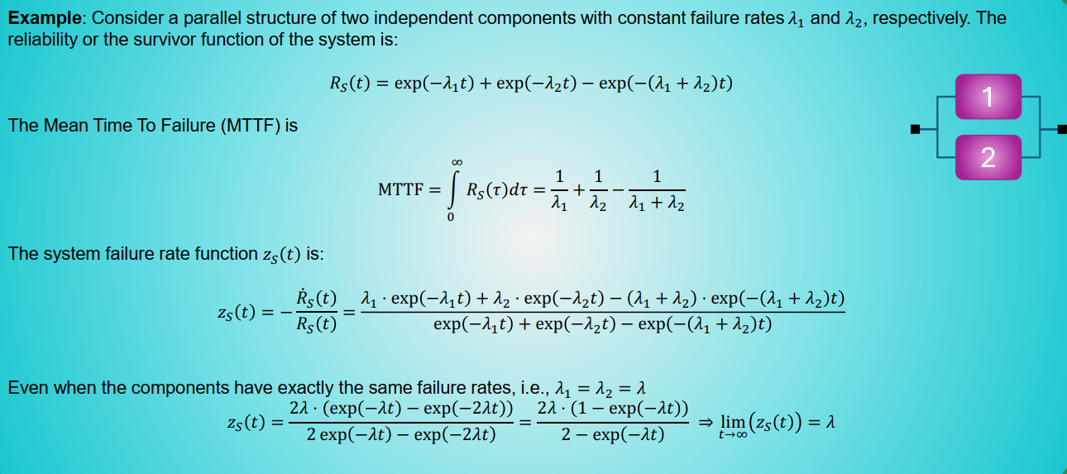

Supposing that we use identical element for all of those mentioned above then

So we implemented that as follows in RBD.m in RBD_Id==2

But as you can see the reliability and failure rate did not change and it is obvious because as   
t approaches infinity it again have same failure rate with single element. It was hot redundancy called active redundancy and it does not meet our needs so it is obvious that if we use another type of redundancy called passive redundancy such as warm or cold it will get worse not better so merely add redundancy to our systems has just cost and to considerable risk reduction

Second upgrade (consider test interval) :

If the test interval were

We implement this technique for those all elements with :

Then failure probability will become

0.000000030326331456987187243107630833772 e-9 << 5 e-5

And it passes our constraint of FAA extremely improbable threshold

And we set for less cost of maintenance

Then failure probability will become (in RBD.m as RBD_Id==3)

9.0520182305513646590043140103646 e-9 << 5 e-5 = 5e4 * 1 e-9

And It also passes our constraint of FAA extremely improbable threshold.

But it is obvious that it is not appliable for all elements for example how can we test our crew !!!

So we do it for elements below in RBD.m as RBD_Id==4 :

Then failure probability will become

9.0520182309285064221663743400875 e-9 << 5 e-5 = 5e4 * 1 e-9

And It also passes our constraint of FAA extremely improbable threshold.

So it is our second upgrade.

Constructing Decision tree :

According to our codes we can define multiple RBD in RBD.m according to our decision tree.

We combine two upgrades for each element and due to we have 16 elements it will get so enormous decision tree so for just conveying that we have understood we consider that we focus only on inspection intervals for (as whole part)

1. Storage & Control according to inspection cost.docx [$1900 - $8600]
2. Distribution & Delivery according for inspection cost.docx [$1350 - $5200]

And not User Detection & Usage

And redundancy only for the most critical element is 11th which is equivalent to according to face mask redundancy.docx [**$37,500 (if only the purchase of additional masks) - $187,500**]

And if boing 737 fails then the cost itself is **$130 million=$130,000,000 .**

So we decision tree (and we have this picture in folder decision tree) as follows :

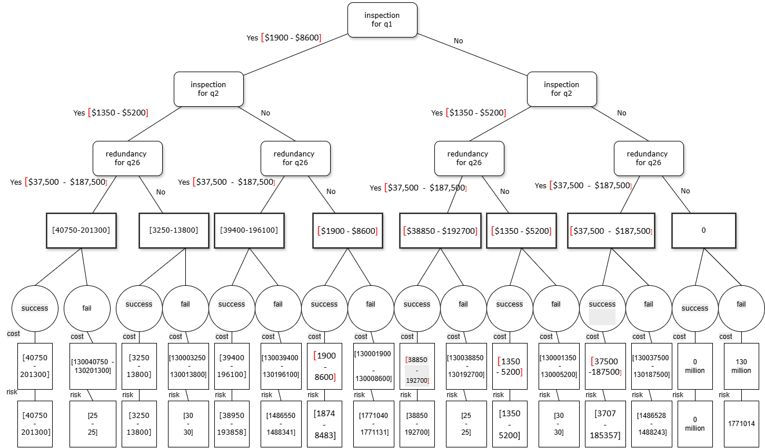

As you can see the branch below has the highest risk (by running pr_3.m):

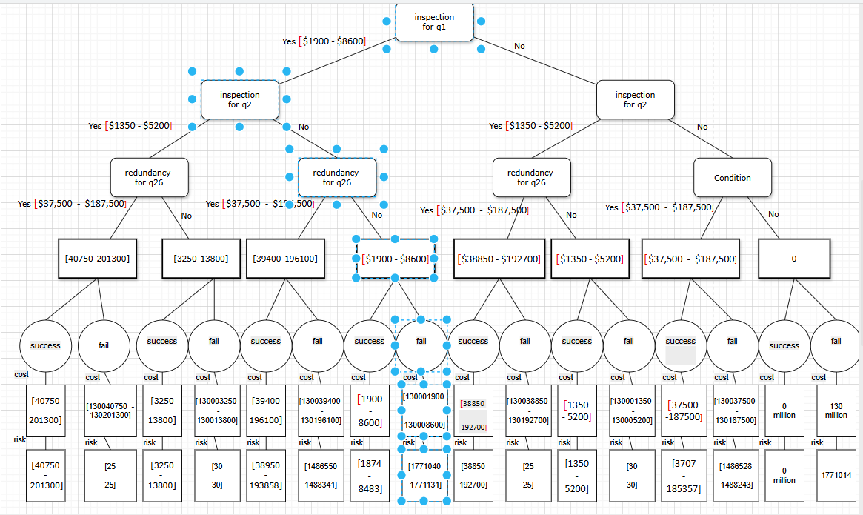

Then by running pr_3.m we conclude the picture below where right hand side is safer:

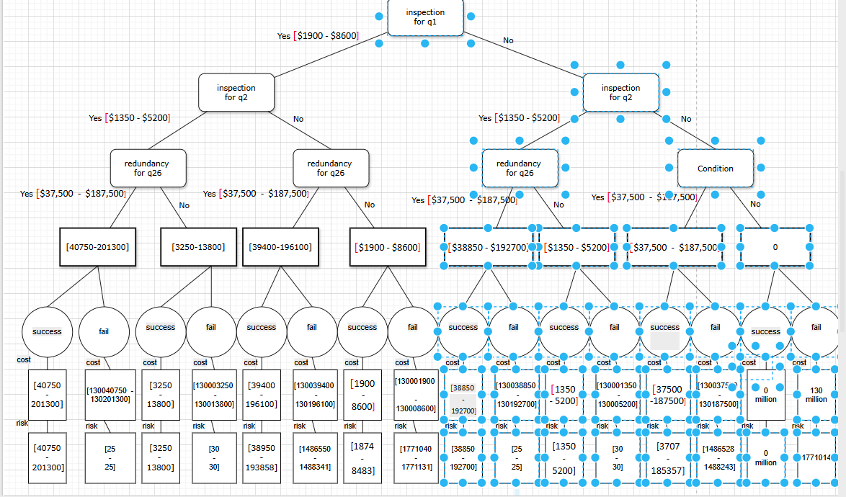

Then by running pr_3.m we conclude the picture below where left hand side is safer:

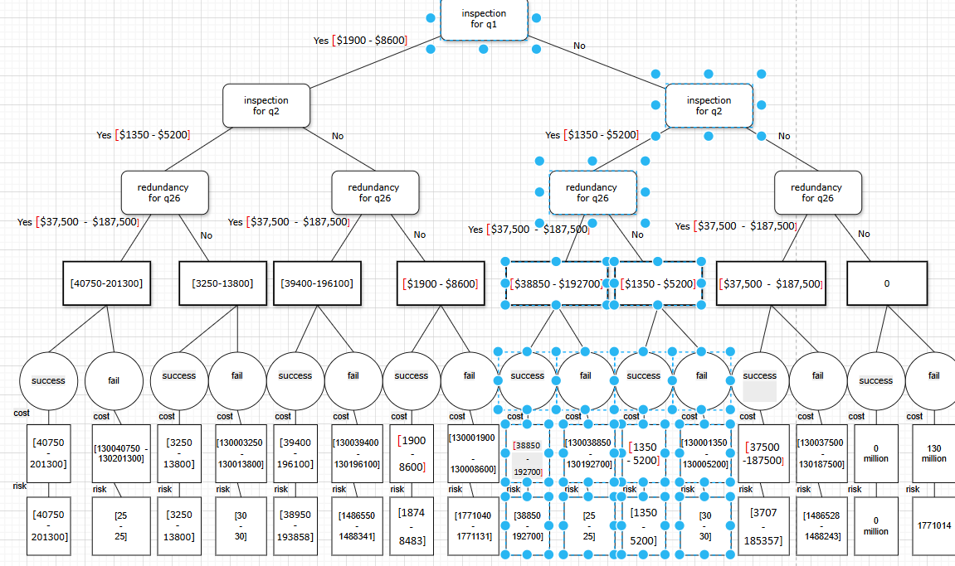

Then by running pr_3.m we conclude the picture below where right hand side is safer:

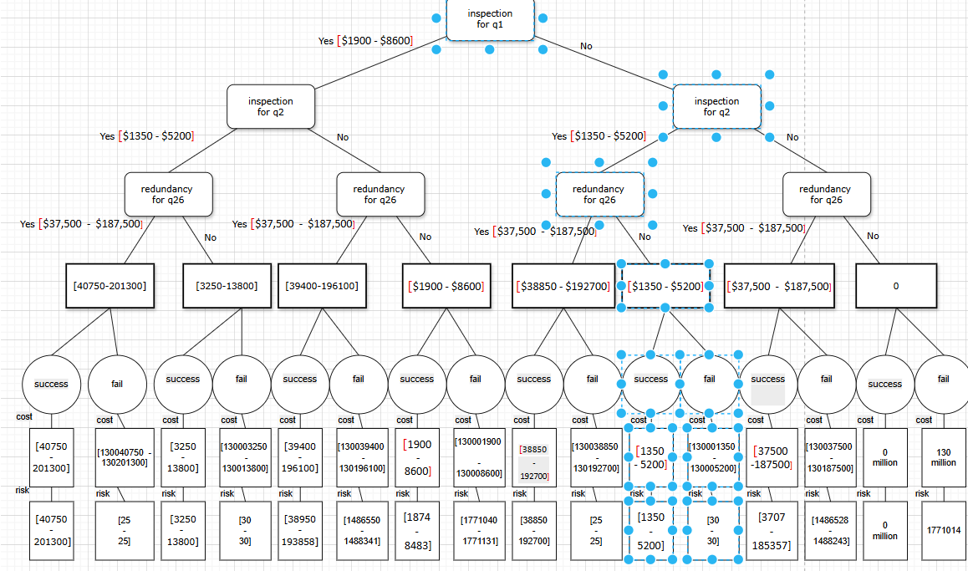

So if we define utility function as

Then it is more  **economical** only choose Distribution & Delivery according for inspection.

But in the question free we are going to set

Where Risk reduction is calculated according to RPN=severity*occurrence *detection and with those facilities mentioned as upgrades we are only able to reduce occurrence so for comparison in practical view we can reduce our utility function as follows:

Then by running pr_3.m we and maximizing utility we conclude that:

we should have q_2 (t): Distribution & Delivery has inspection

as you can see the same result achieved but we can not say exactly this utility function is risk neutral rather due to 50K$ in denominator it means that somehow we want an risk seeking attitude

*Would your solution prevent a Helios-like cascade?*

If we calculate for Distribution & Delivery according for inspection

Which is equivalent to RBD_Id==6 in RBD.m then by running pr_1_2.m for RBD_Id==6 :

And it does not meet FAA extremely improbable threshold

But if we decrease test interval from 5000 hours to 500 hours :

And it does not meet FAA extremely improbable threshold

But if we decrease test interval from 500 hours to 240 hours :

And it meets FAA extremely improbable threshold so we choose test interval=240 hours

# Chapter 6: FORM Analysis

Define a simple **limit state function**

Assume one uncertain variable (e.g., sensor drift).

Apply FORM approximation.

Show how probability of failure compares to Monte Carlo.

As far as I perceived from intention of question I just need to investigate one and only one component and then apply form to this component .

So I choose Oxygen Cylinder and I consider it as a thin-walled pressure vessels. therefor in this case we have two types of tension which are knows as axial and radial(hoop) tension which are as follows :

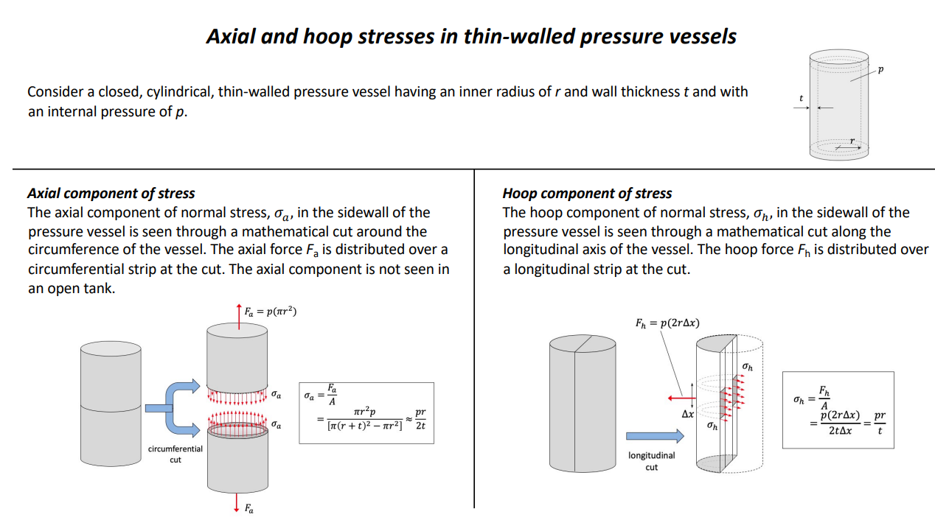

Because this component is inside the airplane so if it enters plastic region of buckles is not that much important and we can neglect deformation so we consider ultimate strength instead of yield strength ('Ultimate strength', 'ultimate tensile strength' and 'tensile strength' mean the same thing)

According to “Aircraft Oxygen Cylinders.docx” in references folder we choose 6061-T6 Aluminum

(UTS = 310 MPa)

Operating Pressure (P): 30 MPa (Approx 2900 PSI) we consider it as

Assume a Safety Factor (SF) = 2 (This is for illustration only. A higher SF is recommended for aircraft) Allowable Stress:

Dimensions:

Radius = 0.1 m (10 cm)

Length = 0.637 m (63.7 cm)

Thickness = 0.02 m (2 cm)

With respect formula hoop stress is twice larger than axial stress so hoop stress is more dangerous and we consider it for reliability analysis :

So the limit state function is

You can see our answer in detail in “Q_4_oxygen_vessel.docx” but I bring only some details here and its matlab code is available in “Q4.mlx”:

Oxygen Cylinder

# INITIALIZE UQLAB

clc; clear all; close all;

uqlab;

# COMPUTATIONAL MODEL

The **P** function is defined as:



Create a limit state function model using a string, written below in a vectorized operation:

ModelOpts.mString = 'X(:,1) -155'; % mSting stands for model string, g(x) = R - S

ModelOpts.isVectorized = true;

myModel = uq_createModel(ModelOpts);

# PROBABILISTIC INPUT MODEL

The probabilistic input model consists of two independent Gaussian random variables:



Specify the probabilistic input model for the p:

InputOpts.Marginals(1).Name = 'P'; % resistance variable

InputOpts.Marginals(1).Type = 'Gaussian';

InputOpts.Marginals(1).Moments = [30 2]; % mean and std dev

Create an INPUT object based on the specified marginals:

myInput = uq_createInput(InputOpts);

# FORM

Select FORM as the reliability analysis method:

FORMOpts.Type = 'Reliability';

FORMOpts.Method = 'FORM';

Run the FORM analysis:

FORMAnalysis = uq_createAnalysis(FORMOpts);

Print out a report of the results:

uq_print(FORMAnalysis)

---------------------------------------------------

FORM

---------------------------------------------------

Pf 0001

BetaHL -62.5000

ModelEvaluations 6

---------------------------------------------------

Variables P

Ustar 62.500000

Xstar 155

Importance 1.000000

---------------------------------------------------

Create a graphical representation of the results:

uq_display(FORMAnalysis)



# Monte Carlo simulation (MCS)

Select the Reliability module and the Monte Carlo simulation (MCS) method:

MCSOpts.Type = 'Reliability';

MCSOpts.Method = 'MCS';

Specify the maximum sample size:

MCSOpts.Simulation.MaxSampleSize = 1e6;

Run reliability analysis with MCS:

MCSAnalysis = uq_createAnalysis(MCSOpts);

Print out a report of the results:

uq_print(MCSAnalysis)

---------------------------------------------------

Monte Carlo simulation

---------------------------------------------------

Pf 0001

Beta -Inf

CoV 0

ModelEvaluations 1000000

PfCI [1.0000e+00 1.0000e+00]

BetaCI [-Inf -Inf ]

---------------------------------------------------

Create a graphical representation of the results:

uq_display(MCSAnalysis)

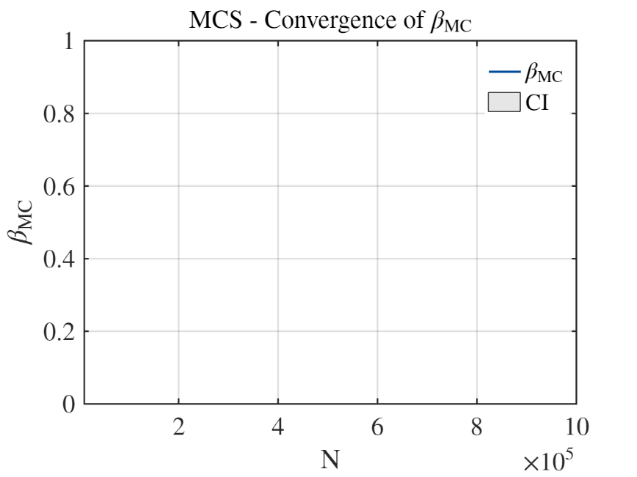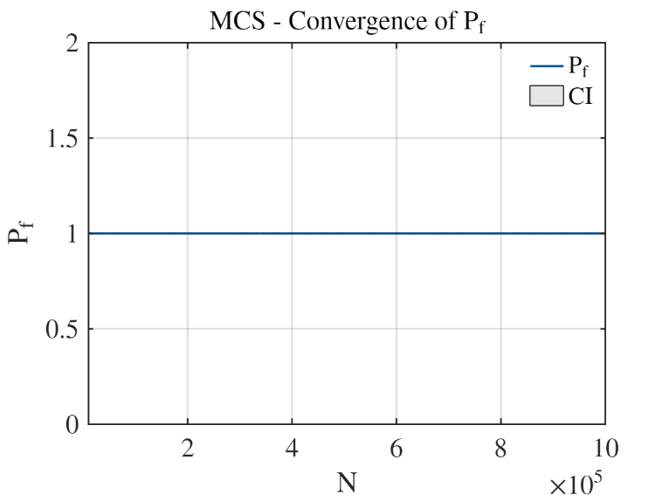

# Chapter 7: Conclusion & Recommendations

Final statement: does the system meet FAA safety objectives?

Yes eventually it does . by Reducing test interval. And we see that according to decision tree it is economical for us to just set 240 hours for test inspection of delivery and distribution subsystem and in this situation we have the highest utility (of course our utility function was a bit risk seeking).

Key improvements required.

Reducing test interval and educating maintenance and crew if I want to say it briefly .

Recommendations for future work (e.g., more accurate data, testing).

Reducing test interval and educating maintenance and crew if I want to say it briefly .

Link back to engineering responsibility and preventing Helios-like accidents.

According to National Geography documentation of this incident . somethings that links back to engineering responsibility for preventing helios like accidents are as follows:

1. In this accident the pilot was German and engineers were Greek and they could barely understand each other English accent and it made relationship hard . so we need better communicational abilities for both sides .
2. We should put the green light button which was in charge with indicating manual decompression system in the place which can be easily visible . as it was explained In the documentation it was barely visible in the morning sunlight .
3. After somewhile our heat sensors alarmed and it was not because the motor had problem (of course late on they experienced one engine inoperative situation) rather it was based on calibration of heat sensors that they malfunctioned in the low pressure so they have heavy dependency on pressure.

# Appendix

|  |  |  |  |
| --- | --- | --- | --- |
| Component | Failure rate (1/hour) | Distribution | Reference |
| Oxygen Cylinder | 0.001 (analog to pressure vessels/coils) | Exponential | MIL-HDBK-217F Sec. 12.2; NASA reports |
| Pressure Transducer/Gauge | 0.0055 (analog to photo-transistors/sensors) | Exponential | MIL-HDBK-217F Sec. 6.11 |
| Manual Isolation Valve | 0.0059 (analog to mechanical relays) | Exponential | MIL-HDBK-217F Sec. 13.1 |
| Storage Regulator | 0.0022 (analog to thyristors/regulators) | Exponential | MIL-HDBK-217F Sec. 6.10 |
| Supply Lines/Manifold | 0.00005 (analog to crimp connections) | Exponential | MIL-HDBK-217F Sec. 17.1 |
| Face Masks | 0.10 (analog to fiber optic connectors) | Exponential | MIL-HDBK-217F Sec. 23.1 |
| human errors (using face mask) | 0.01 | Exponential |  |
| storage box assembly | 0.00001 | Exponential |  |
| toxic gas sensor | 0.000001 | Exponential |  |

# References

1. Folder “references”
2. Folder “Matlab”
3. Folder “julia”
4. Folder “RESOURCES”
5. Folder ” decision tree”
6. AI
7. alaska flight 261.pdf