Author: Rebecca DuPont
Date: October 2025

Program Overview
The Grocery Tracker Application reads an input file containing a list of grocery items and counts how many times each item appears. The program enables the user to search for specific items, view all item frequencies, print a text-based histogram showing the frequency of each product, and exit the program. This project demonstrates the following: file input/output, data structures, and modular program design using C++.

Design Overview
The program is organized into three main components:
- GroceryTracker Class (GroceryTracker.h / .cpp) - Handles business logic and data storage.
  - Loads the grocery list, normalizes input, and counts item frequencies.
  - Supports printing all items, generating histograms, and writing a backup file.
- Menu Module (Menu.h / .cpp) - Contains helper functions for validated user input.
  - Keeps main.cpp clean and focused on program flow.
- main.cpp
  - Constructs the GroceryTracker object and manages the application workflow.
  - Responds to user input and directs program flow via a switch-based menu.

Functionality and Flow
- On startup, the program loads the grocery list from a text file.
- The user selects menu options to search for items, view all frequencies, or print a histogram.
- Input validation ensures users can only select valid options.
- When the program exits, it writes results to a backup file (frequency.dat).

Screenshots
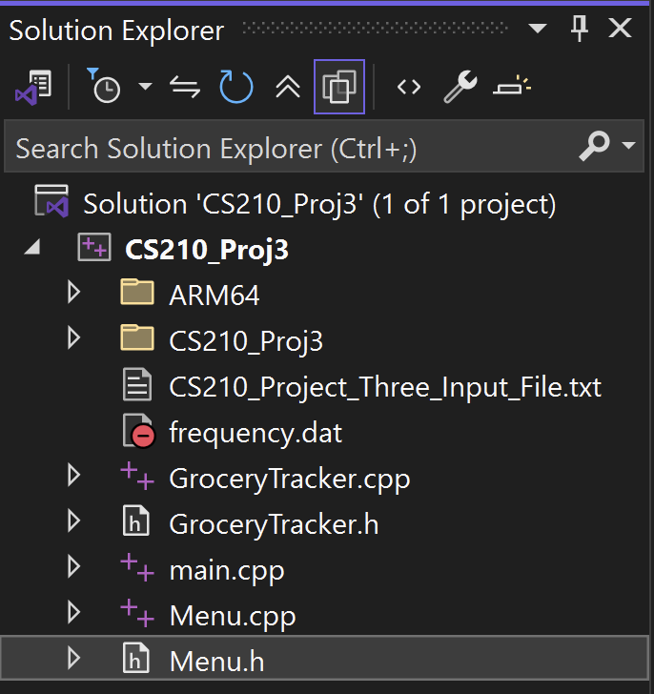
Figure 1: Screenshot of Solution Explore for Grocery App
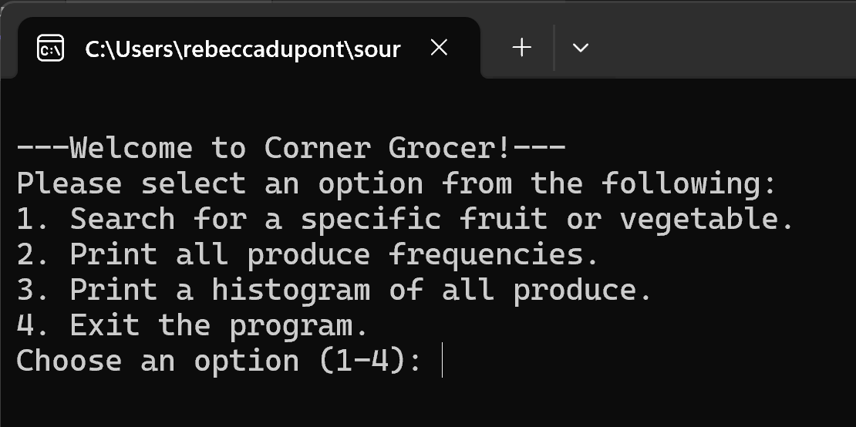
Figure 2: Screenshot of Initial Menu System
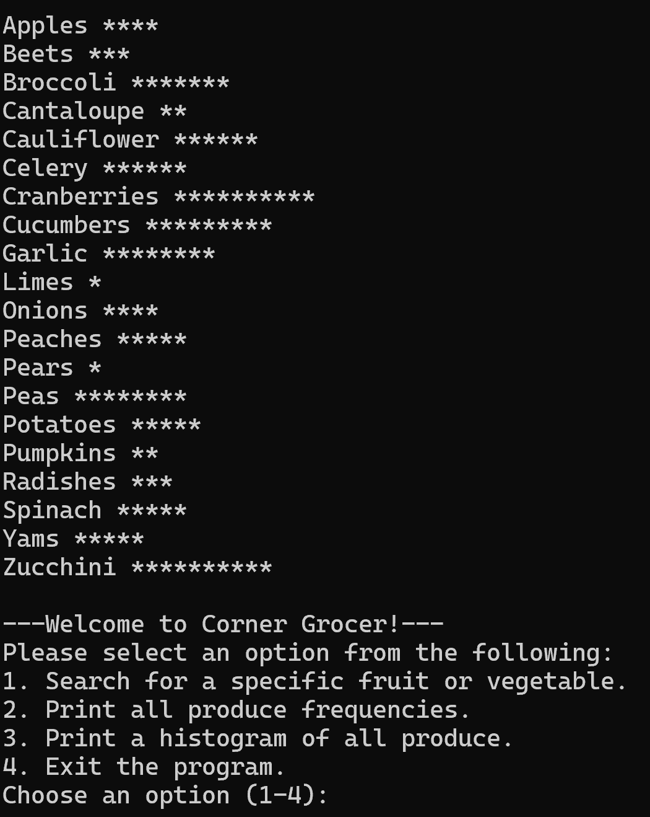
Figure 3: Screenshot of Printed Histogram from provided text file and Menu System

Citations & References:
Gaddis, T., Walters, J., & Muganda, G. (2020). Starting out with C++: Early objects (10th ed.). Pearson.
Stroustrup, B. (2022). A Tour of C++ (4th ed.). Addison-Wesley.
Microsoft. (2025). std::map Class. Microsoft Learn. https://learn.microsoft.com/cpp/standard-library/map-class

