VPN Global Protect Client

CCAC provides VPN access to those college employees with a college owned device. Access to CCAC services and network services are available outside the CCAC network. The VPN client is installed prior to deploying your laptop.

## 1. connecting

Double click the **GlobalProtect** desktop icon



Click **Connect**

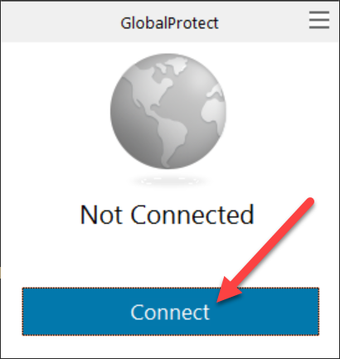

You will be prompted to enter your CCAC network account username and password. Click **Sign in**.

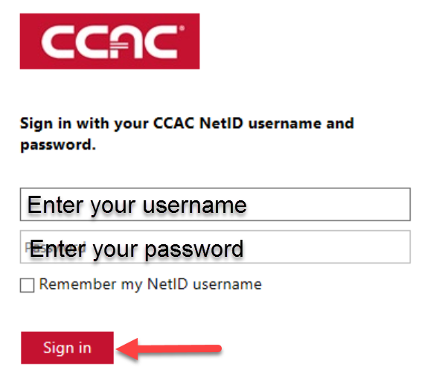

At the Duo prompt, make your selection for authenticating. Verify via the Duo Mobile app or text.

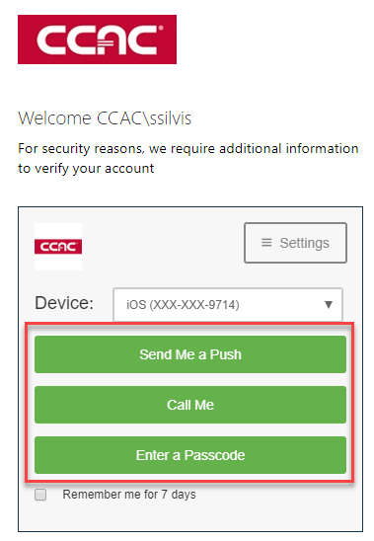

## 2. disconnecting

Click the **Show Hidden Icons arrow** located in the system tray

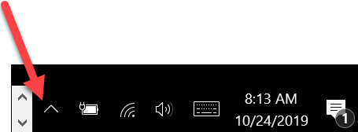

Locate the GlobalProtect icon (small globe with a grey shield)

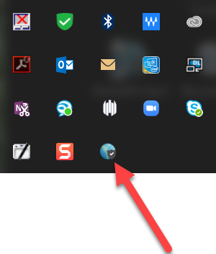

Click on the **GlobalProtect icon** and choose **Disconnect**

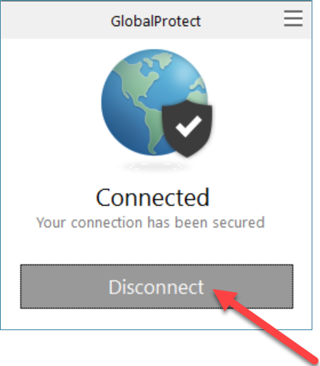

# How to Get Support

If you have any questions regarding VPN, contact the CCAC ITS ServiceDesk:

Voice: 412.237.8700

Email: [help@servicedesk.ccac.edu](mailto:help@servicedesk.ccac.edu)

Chat: <https://chat.ccac.edu>