[1]

Compact Integrated Processor

Jared Hayes, Nick Repetti, Jason Silic

*Abstract*—In this paper the design and operation of the Compact Integrated Processor are described. A detailed explanation of the two-byte instructions is included with specific examples to aid in programming the chip and understanding the various instruction formats. The physical architecture of the chip is then explored with sections explaining the SRAM memory and ALU. The register file and control unit are also mentioned to complete the major components. Finally, a short section explains our testing procedure and PCB design.

# INTRODUCTION

M

IPS (Microprocessor without Interlocked Pipeline Stages) is a popular implementation of a reduced instruction set computer (RISC).  MIPS architectures are typically 32-bit, but 64-bit versions have been developed in more recent years.  It became a widely used processor for embedded systems design and has been implemented in many consumer electronics products.  These included routers, devices that ran Windows CE, and Sony video game consoles.  Due to its popularity in modern electronics in the 1990’s, it has often been studied in computer architecture courses.  It is an effective, yet simple processor that fulfills the features required in a modern processor but without too much unnecessary complexity.

Our Senior Design project is a simple 8-bit CPU with onboard SRAM memory. Our instruction set is loosely based on the MIPS architecture with some significant simplifications. For example, our architecture only supports 21 simple instructions and instruction size has been reduced to two bytes. The 512 bytes of on-die memory is used to store both instructions and data.

The purpose of this project is twofold. Our first objective is to demonstrate the utility of our design. Most microprocessors of this size (the chip only has about 35,000 transistors) will use an external memory chip to store their program. The onboard memory used here results in a more compact design. The second goal is to document our design to provide an example for future students. Since our processor will be much easier to interpret and apply than most modern microprocessors, students can use it to create simple projects as an entry into embedded systems.

# System Overview

## Instruction Set

Our processor uses a modified instruction set with 16-bits per instruction, instead of the typical 32-bit instruction set. This system was chosen because our onboard SRAM is only 512 bytes, so conserving memory is very important. Also, the large instruction size is mostly to accommodate large register files (32 registers is typical) and large memory spaces. We only need nine bits to specify a memory location, so even our jump instructions can store the opcode (4 bits), register to compare (3 bits) and absolute address (9 bits) for a total of 16 bits. There was really no need for a larger instruction size which would have just increased the complexity of our design.

The first thing that should be understood is the various instruction formats. In the below diagrams, the number represent the bit at the end of the field. For example, the opcode is the four most significant bits. In a two byte instruction bit are numbered from 0 (LSB) to 15 (MSB). The opcode therefore has bits numbered from 12 to 15. The text in **bold** indicates the name of the field, such as **opcode** or **L6** (a literal value).

Arithmetic Instruction

|  |  |  |  |  |
| --- | --- | --- | --- | --- |
| 15 **opcode** 12 | 11 **r0** 9 | 8 **r1** 6 | 5 **r2** 3 | 2 **flags** 0 |

Arithmetic Instruction with Literal (L6)

|  |  |  |  |
| --- | --- | --- | --- |
| 15 **opcode** 12 | 11 **r0** 9 | 8       **L6**       3 | 2 **flags** 0 |

Control Instruction

|  |  |  |
| --- | --- | --- |
| 15 **opcode** 12 | 11 **r0** 9 | 8 **L9** 0 |

Data Instruction (bit 8 is unused)

|  |  |  |  |
| --- | --- | --- | --- |
| 15 **opcode** 12 | 11 **r0** 9 | 8 | 7 **L8** 0 |

Shift Instruction (bits 5-3 unused)

|  |  |  |  |  |
| --- | --- | --- | --- | --- |
| 15 **opcode** 12 | 11 **r0** 9 | 8 **r1** 6 | 5 3 | 2   **L3**   0 |

The instructions are fetched in two separate read.  There are 21 instructions accessed through a 4-bit opcode and 3-bit flag field on arithmetic and IO instructions. For example, opcode 0000 is an arithmetic instruction, with the particular instruction (ADD, SUB, XOR, etc.) determined by the bits in the Flags field.

The encoding for the various instructions is as follows:

TABLE III (Cont’d)

Instruction description

|  |  |  |
| --- | --- | --- |
| Instruction | Encoding Format | Notes |
| STORE r0, L9 | Control | Addr. at L9 gets value of r0 |
| SET r0, L8 | Data | r0 = L8 |
| STOP | Any | Stop execution of current program until reset occurs |
| NOP | Any | No operation |
| SHL r0, r1, L3 | Shift | r0 = r1 shifted left by L3 *** |
| SHR r0, r1, L3 | Shift | r0 = r1 shifted right by L3 *** |
| ROR r0, r1, L3 | Shift | r0 = r1 rotated by L3 positions |

* - Signed comparison

** - Sign extend

*** - Shift in zeros

Addr. - Address

The operation depends on the value in the flags field. The IO instructions depend on the least significant bit of the Flags field. If it is 0, the instruction is IN, otherwise the instruction is OUT.

## Instruction Description

The basic operation of the instructions is described here. The following section will describe how the various fields in the 16-bit instruction are used.

TABLE I

Encoding for various instructions

|  |  |  |  |
| --- | --- | --- | --- |
| Opcode | Instruction | Opcode | Instruction |
| 0000 | ARITH | 1000 | JNE |
| *0001* | LOAD | 1001 | JGE |
| *0010* | SHL | 1010 | [unused] |
| *0011* | SET | 1011 | NOP |
| *0100* | IO | 1100 | JE |
| *0101* | STORE | 1101 | JG |
| 0110 | SHR | 1110 | ROR |
| *0111* | STOP | 1111 | STOP |

*Note that the STOP instruction has two opcodes used for it.

The instructions are presented below with this format:

**r0**, **r1**, **r2** are 3-bit fields that specify one of eight registers.

Finally, note that for instructions with unused fields (e.g., the STOP instruction only uses the opcode and has twelve bits unused) these bits are don’t care bits. They can be filled with any sequence of ones and zeros and the CPU will not care.

## Instruction Encoding Examples

TABLE II

arith instruction breakdown

|  |  |  |  |
| --- | --- | --- | --- |
| Flags | Instruction | Flags | Instruction |
| 000 | ADDI | 100 | AND |
| *001* | ADD | 101 | NOT |
| *010* | SUB | 110 | XOR |
| *011* | OR | 111 | [unused] |

The above tables and lists may be a bit confusing, so the following examples will hopefully clear up any confusion. The complete process of forming an instruction is considered and explained, step by step.

TABLE III

Instruction description

|  |  |  |
| --- | --- | --- |
| Instruction | Encoding Format | Notes |
| ADD r0, r1, r2 | Arithmetic L | r0 = r1 + r2 |
| ADDI r0, L6 | Arithmetic | r0 = r0 + L6 ** |
| SUB r0, r1,r2 | Arithmetic | r0 = r1 - r2 |
| OR r0, r1, r2 | Arithmetic | r0 = r1 | r2 |
| AND r0, r1, r2 | Arithmetic | r0 = r1 & r2 |
| NOT r0, r1 | Arithmetic | r0 = ~r1 |
| XOR r0, r1, r2 | Arithmetic | r0 = r1 ^ r2 |
| IN r0 | Arithmetic | r0 = value on input pins |
| OUT r0 | Arithmetic | Value of r0 appears on output pins |
| JE r0, L9 | Control | Jump to addr. L9 if r0 = 0 |
| JNE r0, L9 | Control | Jump to addr. L9 if r0 != 0 |
| JG r0, L9 | Control | Jump to addr.L9 if r0 > 0 * |
| JGE r0, L9 | Control | Jump to addr. L9 if r0 >=0 * |
| LOAD r0, L9 | Control | r0 = data at addr. L9 |

**Example 1**

SHR R4, R3, #6

Here R4 indicates register four (don’t confuse with the register fields above such as r0, r1, and r2). R3 indicates register 3 and #6 is a literal value. The value in register 3 is shifted right six positions and the result is stored in R4.

From Table I above we discover that the opcode for SHR is 0x6. The first field is 0x4 and the first bit of field r1 is 0. The upper eight bits of this instruction is therefore 0x68, or 104 in decimal. The first two bits of the lower byte are ‘11’, from register three. The next three bits we leave as zeros because they are unused. The last three bits are 011, which is our literal ‘6.’ The lower byte is therefore 0xC6, which is 198 in decimal.

The complete instruction is therefore 0x68C6. If you were writing a program on an Arduino like we did to load the SRAM, the first byte loaded is the lower byte, so your data array would be like this, excluding the other instructions:

int data[16] = {.. , .. , 198, 104, .. , .. , ….};

**Example 2**

ADDI R7, #62

Note that this instruction subtracts two from R7 and stores the result back in R7. Remember that the literal for this instruction is sign-extended, so 62 is binary 111110, which is two’s complement for negative two.

Table I shows the opcode is 0x0. Table II tells us to use the Arithmetic Instruction with Literal format. Field **r0** is 111 (R7) and the literal **L6** is 111110. Finally, the flags field should be 000 for the ADDI instruction. The upper byte is therefore 0x0F, or decimal 15. The lower byte is 0xF0, which is 240.

The complete instruction is 0x0FF0, which is loaded into memory as 240, 15 (lower byte first!).

**Example 3**

OUT R2

This is an IO instruction with opcode 0x4. The Arithmetic Instruction format is used, but only the first register field is used. The flags field has to be 001 for the OUT instruction and 000 for the IN instruction. The upper byte is therefore 0x44 = 68. The lower byte is 0x01 = decimal 1.

The complete instruction is 0x4401, which is stored into memory as 1, 68.

**Example 4**

JG R3, #420

The opcode for JG is 0xD. The register field is 011. The address #420 is 1 1010 0100 in binary. The upper byte is therefore 0xD7 which is 215. The lower byte is 0xA4 which is 164 in decimal.

The complete instruction is 0xD7A4, or the decimal numbers 164, 215.

Note that the jump and control instructions use a fixed 9-bit address as their target. However, it is very easy to use the STORE instruction to write another value to the lower eight bits of this address. This feature can be used to implement subroutines. Simply write the return address to the address of a jump instruction at the end of the subroutine. When the program execution reaches this point it will simply return to the location from which it was called (assuming you wrote the correct return address).

## System Architecture

The main components of the MIPS processor include:

* Control Unit
* SRAM
* ALU
* Register File

1. *Control Unit*

This processor is essentially a massive state machine. Neglecting the SRAM for a moment, the CPU’s state is completely defined by the contents of the register file, ALU registers, and control unit registers. The next state is a deterministic result of the current state, and is achieved by the use of only twenty-four control signals. These control signals are generated by combinational logic which has a delay less than one-half of a clock cycle.

Some of these control signals are for the internal use of the Control Unit (CU). For example, the StepReset signal will reset the step counter, which tracks the current instruction’s stage of execution. Other signals are for the ALU arithmetic logic, such as the three ALU control signals.

The control unit does have some additional responsibilities for the shifting instructions. The barrel shifter in the ALU can only shift data one bit position per clock cycle. To implement longer shifts, a small three-bit counter is necessary.

1. *SRAM*

The SRAM is of a standard six transistor (6T) design. A simple precharge is applied to the bitlines when the clock signal is high to prevent a low voltage bitline from flipping the datum stored in a cell. Loading data into the SRAM is accomplished by a specialized circuit that aids in the sequential writing of data to the SRAM.

1. *Arithmetic Logic Unit (ALU)*

The Arithmetic Logic Unit is responsible for all of the Arithmetic and Logic functions that most of the operations rely on.  The ALU can perform multiple operations which will be discussed in a later section. Data is clocked into Registers A and B from their respective buses and the appropriate action is performed based on the input signals from the Control Unit.  The ALU also handles the calculations for the jump instructions.

1. *Register File (RF)*

The register file is responsible for storing data in registers specified by the instruction register for use by the ALU.  Since this is an 8-bit processor it reads in 3-bit opcodes and decodes them into the clocks of each register.  This register file can read two registers and write to a single register at once.  Two 3-to-8 decoders help to drive multiplexing for each of the two buses leading out of it.  The bus A decoder is also responsible for gating the clock of the registers to select which register to write to.  Instead of using multiplexers to determine which registers to output to the buses, 8-bit transmission gates powered by the decoders are used for each register.  There are two sets of the 8-bit transmission gates in total, one for each bus.

We present a top-level schematic with the various parts of the processor labeled on the next page. Note the precharge circuit used to always define the voltage on BusA. This is important because when all the tri-state buffers are in the Hi-Z state, the voltage on the bus could float, possibly leading to contention current in inverters connected to the bus. This could lead to failure of the chip, or fluctuations in the power supply voltage.

## Functional Analysis and Requirements

Our processor is designed and simulated using Cadence Virtuoso design software with Spectre and Ultrasim simulation plugins.  The processor was designed from scratch on the transistor level and fabricated on a chip using the MOSIS On Semiconductor 500 nm rules and the C5 CMOS process, which contains 2 polysilicon layers and 3 metal layers. Therefore, all digital logic and components will be custom made in order to fit the specifications of our project and the MOSIS design rules.  Cadence allows us to design the chip layout according to those rules and will make checks to ensure that our layout stays consistent with them.  The fabrication process takes considerable time and resources; therefore, we must ensure that our design is properly simulated so that our fabricated chip works as intended in our design.  We use Spectre and Ultrasim to simulate the schematics of all of our components to ensure proper operation. Then, Cadence checks that our layouts exactly match the schematics in order to adhere to our simulation results.

## Trade-offs

We had to consider many trade-offs in order to simplify our processor to fit our time constraints and resources.  Designing an 8-bit processor instead of a 32-bit processor obviously reduces the chip’s processing power and capabilities.  Using a two byte instruction length allows the user to have a simpler and more streamlined set of instructions, but at the cost of flexibility.  We also chose to forego implementing a pipelined microarchitecture.  A pipelined architecture would have improved our processor’s execution time enormously; however, the added design complexity would not have been feasible to implement in our project, considering our time limitations.  So, we implemented a multi-cycle architecture instead.

We chose to include on-board memory in our processor. This eliminates many additional off-chip components, such as an external memory chips. Unfortunately, the SRAM memory is “volatile” and loses its data after losing power. The programs must therefore be loaded onto the chip again every time the power is turned on again. This is a severe problem for the commercialization of this design. Our process technology can not be used to fabricate flash memory cells or other non-volatile forms of storage.

# sram

## SRAM Design and Implementation

The basic SRAM cell stores one bit of information. Our design is the quite common 6T (six transistors) cell. Although a four transistor cell exists, the resistors it used are difficult to fabricate in a small space and contribute to static power dissipation. The basic schematic is presented below, consisting of two cross-coupled inverters and two NMOS access transistors.

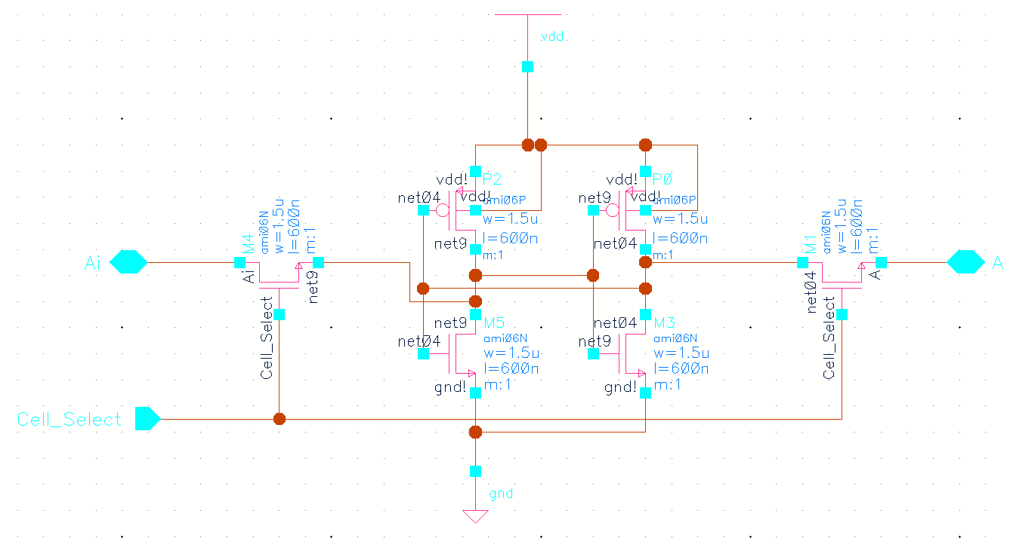

Writing data to the cell is accomplished by overpowering the internal transistors to “flip the bit.” Only writing a low voltage (actually 0V) will work, because the NMOS pass gate passes a logic ‘0’ better and the PMOS transistor is easier to overpower. Therefore, a low voltage on the “A” bitline writes a zero to the cell, and a low voltage on the “Ai” bitline writes a logic one into the cell.

Below is the layout of the SRAM cell, with prominent features illustrated. The bitlines run vertically on Metal3, while the row select and byte select signals run horizontally on Metal2.

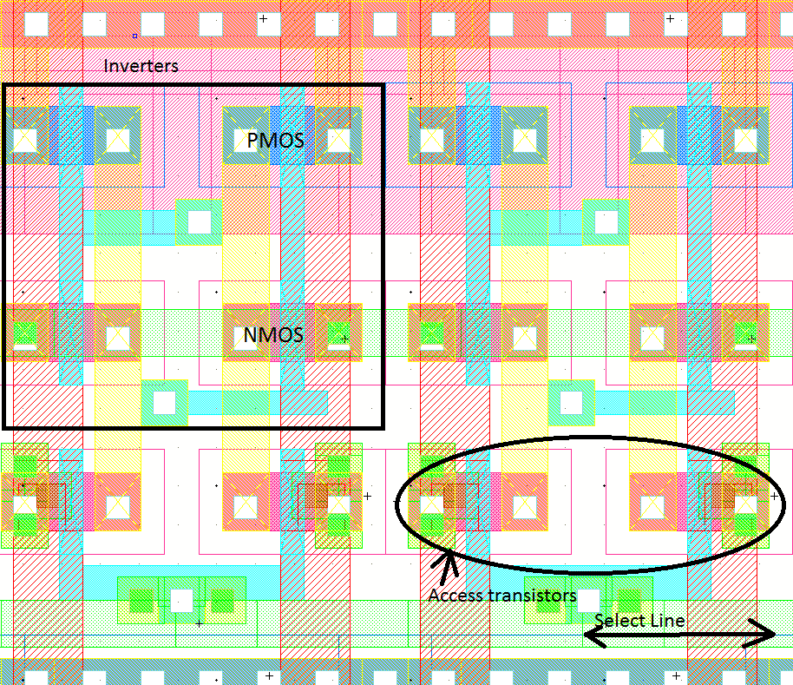

## Precharging Circuit

The original plan did not include provision for precharging the bitlines. While this would have simplified the design, simulations revealed that a bitline at ground potential could actually write data into another cell when the select line for that cell was asserted. The solution involves “precharging” the bitlines to a high enough voltage to avoid this problem. Although charging the bitlines to VDD- Vthn through an NMOS transistor could have worked, I decided to do a more complicated three-transistor design to get a more precise voltage. The stable output voltage of the below circuit is about 3.24V, with a 10MEG load to ground. The long length transistors limit the current that can flow, making sure the maximum sustained current is less than 100uA/via.

When the input is low, the PMOS transistors turn on and move the voltage on the output line toward 3.2V.

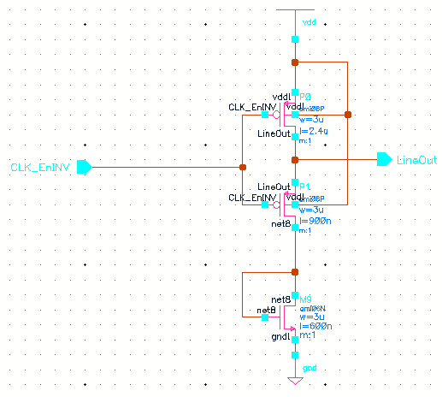

## Write Driver Circuit

When data is loaded into the SRAM, the data comes from an external source. In addition, data is loaded into sequential memory locations, starting at 0x000. Therefore, the address bus is connected to a nine-bit upcounter, and the write bus is connected to the external input. The external procedure for writing data to the SRAM is simple. Assert the Load Write Enable signal, and send a reset signal (Reset is active low) to reset the address counter. The values on the 8 input lines will be written to the SRAM on active clock edges. Additional schematics can be found in the Appendix.

The write circuit may also be of interest in this design. In the below schematic, powerful 6 micron wide NMOS transistors are strong enough to write data into the SRAM cells. The logic for writing is simple enough. A high signal at the gate of the NMOS will write a zero into the 6T cell. Therefore, the write signals need to be inverted first, a task accomplished by the NOR gate. When the enablei signal is low, the NOR gate is an inverter, and correct data is written into the SRAM. When the enablei signal is high, the output of the NOR gate is low, and the transistors are off. This allows read operations to proceed.

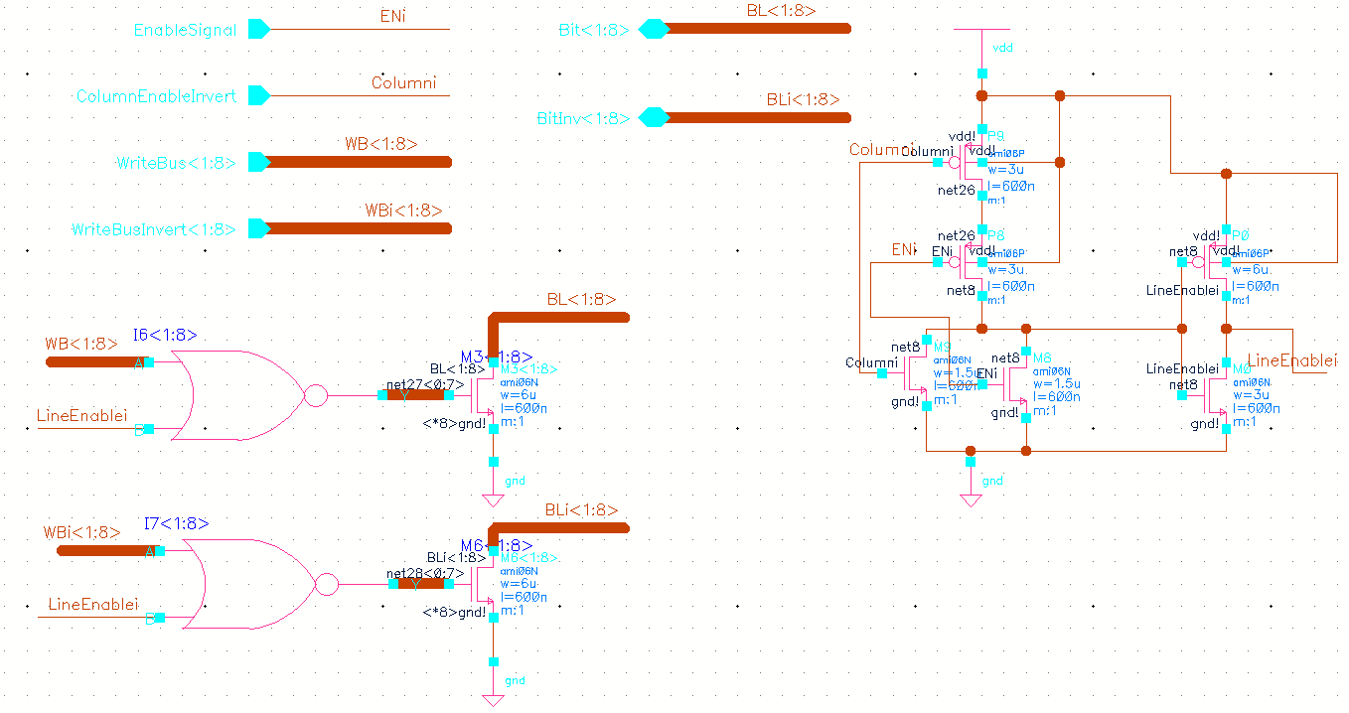

# Control unit

## Overview

The control unit is probably the most complex part of the processor. It includes the instruction register (IR), a 3-bit downcounter for the shift instructions, a step counter to track the current stage of the instruction, and a large block of combinational logic to generate control signals for the entire CPU. The Control Unit (CU) controls not only the ALU but also the SRAM (read and write signals) and the internal state of the CU (when to reset the step counter, for example).

The first stage of the control unit determines the current instruction by decoding the 4-bit opcode and any relevant flags. The main stage of combinational logic determines appropriate control signals to generate based on the current instruction opcode, the value of the step counter, and whether the shift counter has reached zero for the shifting instructions.

# Testing and PCB design

To test our completed chip we needed a platform that would be more elegant than a breadboard and also provide dedicated IO capabilities. We designed a Printed Circuit Board with eight LEDs to visually show the output from the chip. Because the output pads on the CPU can only source about 1mA of current, we included NMOS driver transistors to provide about 20mA to our LEDs. Input is provided by eight push buttons with pull-down resistors connected to the eight input pins of the CPU. A 555 timer IC provides a clock signal ranging from a frequency of about 600Hz to 7kHz. Other convenient features such as a programming port and seven-segment LED outputs were also included.

After testing our chip is became apparent that whenever a new value was written to the output register the entire output would be driven high for one complete clock cycle before the correct value would be latched in. This problem was visible in simulations and can be remedied by a single inverter. Unfortunately, this ruined any chance of communicating with the seven-segment driver chip using a serial protocol. All the other logic and arithmetic functions worked as expected and our instruction set proved to be flexible enough to implement simple subroutines.

Overall the outcome of the project achieved expectations. Our design files can now be used as an example to future students. We successfully presented and attended the Senior Design competition with an advanced technical project. The knowledge we gained from our low level design experience should prove very useful in our careers.

1.