Increasing Energy Efficiency in Las Vegas Homes

Jared Hayes

Carlo Lopez-Tello

Edgar Solorio

EGG 307

May 6th, 2014

University of Las Vegas, Nevada

# Executive Summary

With Las Vegas constantly growing in population and in tourism, there is a need to reduce energy consumption in a city that never sleeps. This study focuses on energy efficient options that residents can explore to reduce their electricity while simultaneously helping the city reduce the load of energy it needs to supply. Three options were analyzed; the purchase of energy efficient appliances, retrofitting a home with insulation, and installation of solar panels. With the aid of federal tax credit for energy efficiency improvements on a home, these three options are feasible for the average Las Vegas resident. Evaluation criteria for energy efficient appliances and solar panels are dependent on the savings seen in electric bill costs per year. The criteria for insulation are monthly energy savings. Based on the average stock market return rate, we used a MARR value of 11.5% for analysis. We concluded that certain appliances such as Fluorescent bulbs are economically good choices but appliances such as energy-efficient refrigerators may not be. Solar panel installations are a good investment for families with less aggressive investment strategies, i.e., lower MARR values. And finally, homes insulated with an average thermal resistance of R19 is the most economical amount of insulation for a Las Vegas home

Table of Contents

Introduction 1

Alternative Solutions 1

Home Insulation 1

Power-Efficient Appliances 1

Solar Panel Systems 2

Methodology of Evaluation 2

Presentation and Discussion of Results 2

Appliances Analysis 2

Insulation Analysis 5

Solar Panel Installation Analysis 7

Conclusion and Recommendations 10

References 11

# Introduction

The cost of electricity is a big part of a home’s monthly budget in Las Vegas. This is caused by constant use of air conditioning for half of the year, when temperatures can exceed 80° F. In the summer, temperatures can exceed 100° F, so air conditioning becomes essential for every home. The objective of this study is to compare different alternatives to lower the average annual power consumption of homes in Las Vegas; and then, choose the most cost efficient one. Even if the amount of energy used to cool homes cannot be reduced, lowering the energy consumption of other appliances can be a valuable alternative.

# Alternative Solutions

## Home Insulation

One alternative to lower the cost of air conditioning needs is the installation of insulation around the home. The insulation layers would reduce the conduction of heat going into and out of the home to keep cold air in during summer and warm air in during the winter seasons.  A big advantage of insulation is that it reduces energy costs without consuming energy utilities, so there are no recurring costs until it needs to be replaced and can last for about ten years.  The major downsides to insulation include the higher risk of a house fire, toxic chemical release from the material catching fire, possible structural damage from certain materials such as expanding foam breaking through walls, and the possibility of reduced efficiency of the material over time.

## Power-Efficient Appliances

A second alternative would involve replacing current home appliances with power efficient models; this includes items such as A/C units, refrigerators, and light bulbs. The benefit of power efficient appliances is reduced energy consumption. The cons to energy efficient appliances are close to none except for the initial higher upfront cost.

## Solar Panel Systems

The third alternative we will focus on involves installing solar panels to a home to reduce the amount of home energy use. The downsides to solar panels include a high initial investment cost and the need to live in a region with high sunlight concentration and weather.

# Methodology of Evaluation

The MARR value we chose was 11.5 percent, which is the average return for the stock market from 1928 to 2013. We chose this value because it seems like the best long term investment alternative. Since it would be difficult to come up with an average home to compare the different appliances, insulation, and solar panel benefits, we are going to consider the viewpoint of someone moving into a new house. To find the best appliances we are going to find the most economical by comparing their initial value and yearly energy cost for the life of the device. Similarly, for insulation we are going to compare no insulation, average insulation, and high end insulation and see which is the most economical for a 10 year period. The analysis for solar panels will be different, since there is not much variation in performance between different panels. Instead of comparing different models, we are going to choose one and see how good of an investment it is at ten, twenty, and thirty years.

# Presentation and Discussion of Results

## Appliances Analysis

We chose three different types of light bulbs with similar brightness, to evaluate the most economical light bulb type a new homeowner can buy. We used annual worth analysis to compare the three alternatives.. The reason for choosing this analysis was that each type of light bulb has different lifetimes. To calculate the annual cost of each light bulb we converted the initial cost to annual cost, and added the cost of running the light bulb three hours a day for a year. The price of electricity used is the residential single family cost of $.11826 per kWh offered by NV Energy.

|  |  |  |  |
| --- | --- | --- | --- |
| Light Bulbs | 60 Watt Incandescent | Fluorescent | LED |
| Initial Cost | $1.47 | $3.88 | $23.97 |
| Life (Hours) | 1,000 | 10,000 | 45,000 |
| Brightness (Lumens) | 860 | 900 | 450 |
| Color Temp | 2,700 | 2,700 | 2,700 |
| Power (Watts) | 60 | 13 | 8 |
| Cost of electricity per Wh | 0.00011826 | 0.00011826 | 0.00011826 |
| Hours per Day used | 3 | 3 | 3 |
| MARR | 11.50% | 11.50% | 11.50% |
| Electricity Cost per Year | $7.77 | $1.68 | $1.04 |
| AW | -$9.56 | **-$2.39** | -$3.82 |

*Figure 1.1 -HW analysis of Light Bulbs. The most economical light bulb types to buy given the current cost of electricity are Fluorescent light bulbs.*

We chose to compare two refrigerators, one that was Energy Star rated and one that was not, to see which was the better purchase for a new home owner. We compared two refrigerators of identical sizes and performed AW analysis.  The price of electricity used is the residential single family cost of $.11826 offered by NV Energy. We used a period of 17 years, since that is the expected life of refrigerators according to the U.S. Department of Housing and Urban Development's Residential Rehabilitation Inspection Guide. We converted the initial cost of each refrigerator into its AW and added the annual electricity cost to determine the AW of each refrigerator.

|  |  |  |
| --- | --- | --- |
| Fridges Top Freezer | Not Energy Star Certified | Energy Star Certified |
| Initial Cost | $499.99 | $669.99 |
| Capacity Freezer (cubic Ft.) | 4.1 | 4.1 |
| Capacity Total (cubic Ft) | 17.6 | 17.6 |
| Power consumption per year (kWh) | 470 | 378 |
| MARR | 11.50% | 11.50% |
| Electricity Cost per kWh | 0.11826 | 0.11826 |
| Years | 17 | 17 |
| Annual Electricity cost | $55.58 | $44.70 |
| AW | **-$123.80** | -$136.12 |

*Figure 1.2 -AW analysis of refrigerators. The most economical refrigerator to buy given constant energy prices is the non-Energy Star one.*

As part of our uncertainty analysis we decided to graph the AW of both refrigerators as the price of electricity changes. According to the analysis the Energy Star refrigerator only becomes economical after the price of electricity is higher than $.225 per kWh.

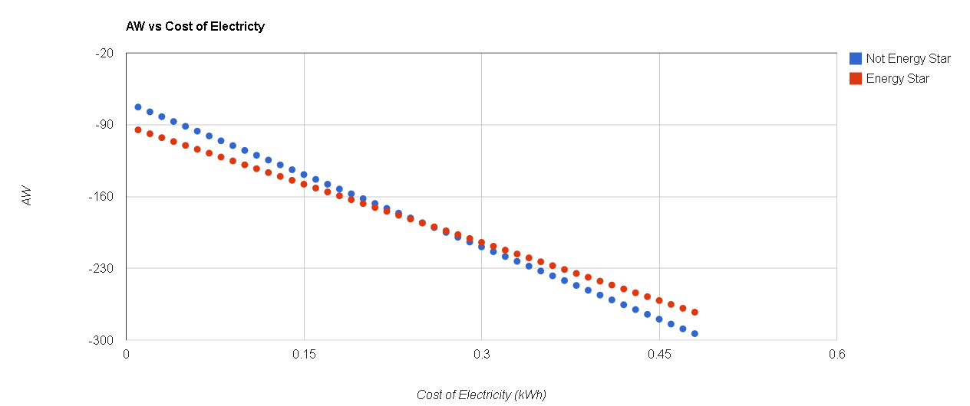

*Figure 1.3 -Uncertainty analysis of refrigerators.*

We compared three different types of air conditioners from the same manufacturer. They each had different seasonal energy efficiency ratings (SEER). We assumed they had to use 30,000 BTUs to cool a home of 1700 ft2. We also assumed that they would be in constant use 6 months out of the year, and would have identical installation and repair costs. The price of electricity used is the residential single family cost of $.11826 offered by NV Energy. We used a period of 20 years, since that is the expected life of refrigerators according to the U.S. Department of Housing and Urban Development's Residential Rehabilitation Inspection Guide. We used present worth analysis to compare each alternative. To calculate the energy consumption of each A/C unit we divided the estimated energy needed by the SEER. Using the following formula: $\frac{BTU}{SEER }=Watts$. Then, we calculated the annual energy cost of each unit, and found the PW of all annual energy costs.

|  |  |  |  |
| --- | --- | --- | --- |
| Central air units of various efficiency ratings (SEER). | 13 | 16 | 18 |
| BTU | 30,000 | 30,000 | 30,000 |
| Average Power | 2,307.69 | 1,875.00 | 1,666.67 |
| Electricity Cost per kWh | 0.11826 | 0.11826 | 0.11826 |
| Cost per hour | $0.27 | $0.22 | $0.20 |
| Cost per Year (Assuming it is used constantly for 6 months) | $1,195.34 | $971.21 | $863.30 |
| Unit Cost | $1,586.59 | $2,427.94 | $3,271.31 |
| MARR | 11.50% | 11.50% | 11.50% |
| Year | 20 | 20 | 20 |
| PW | -$10,802.41 | **-$9,915.79** | -$9,927.18 |

*Figure 1.2 -PW analysis of the A/C units. The most economical A/C unit is the one with a SEER of 16.*

## Insulation Analysis

The insulation analysis was conducted under the premise that the home in question has no insulation, but has an initial thermal value of 5 (R5), since the amount can be widely varied between different homes.  This also allows us to better compare low, medium, and high levels of insulation amongst each other and to more clearly display their benefits over having no insulation at all.  We also assume in our analysis that the homeowners are going to install the insulation themselves and will not be paying any additional costs by hiring professional services.

For this analysis, we compared the insulation costs and savings of a home under three different levels of thermal resistance (R-Values).  We used R-values of 19, 38, and 60 for low, medium and high insulation respectively.  The default heating method chosen for all of the cases was use of a heat pump with an efficiency of 80 percent. Similarly we assumed the A/C unit to cool the house was 80 percent efficient.  The cost of energy used in the analysis was sampled from Southwest Gas’ residential rates and the value used for Heating Degree Days, and Cooling Degree Days per year is an average value taken from Las Vegas data over the past century. The price of electricity used is the residential single family cost of $.11826 offered by NV Energy.

|  |  |  |  |
| --- | --- | --- | --- |
| **Monthly Savings** |  |  |  |
|  | Energy Bill | Insulation Savings | New Bill |
| R19 | $150.00 | $23.73 | $126.28 |
| R38 | $150.00 | $26.48 | $123.52 |
| R60 | $150.00 | $27.67 | $122.33 |

*Figure 2.1 - Monthly savings for varying R-values*

Using the aforementioned data, we calculated the initial investment and annual savings for implementing each level of insulation and conducted a present-worth analysis.  The calculations show a monthly energy savings of about $20 dollars a month for all cases as shown in Figure 2.2, which implies that there are heavy diminishing returns for higher R-values.  The initial investment for each level of insulation is more than double that of the previous level, but does not yield a similar jump in annual savings.

|  |  |  |  |  |
| --- | --- | --- | --- | --- |
| Insulation to be added to current R5 | None | R19 | R38 | R60 |
| Period | 10 | 10 | 10 | 10 |
| MARR | 11.50% | 11.50% | 11.50% | 11.50% |
| Cost/sq. ft. | $0.00 | $0.40 | $1.00 | $2.25 |
| Square Feet | 1700 | 1700 | 1700 | 1700 |
| Efficiency of Cooling/Heating | 0.8 | 0.8 | 0.8 | 0.8 |
| Cost of Natural Gas | 0.334 | 0.334 | 0.334 | 0.334 |
| Cost of Electricity per kWh | 0.11826 | 0.11826 | 0.11826 | 0.11826 |
| Heating Degree Days/yr | 2500 | 2500 | 2500 | 2500 |
| CDD | 3000 | 3000 | 3000 | 3000 |
| Initial Investment | 0 | $680.00 | $1,700.00 | $3,825.00 |
| Annual Savings | $0.00 | $284.70 | $317.80 | $332.00 |
| Annual Costs | 1800 | $1,515.30 | $1,482.20 | $1,468.00 |
| AW | -$1,800.00 | **-$1,633.20** | -$1,776.94 | -$2,131.17 |

*Figure 2.2 - Annual worth analysis of insulation types*

From these results, it is clear that installing insulation with an R-value of around 19 is the most economical.  While our calculations are supposed to take into account the weather conditions of Las Vegas to an extent, it may still be questionable whether R19 insulation is sufficient.  In the event that it is not, upgrading to R38 installation is more economical than no insulation.

## Solar Panel Installation Analysis

Weather in Las Vegas makes this city a great candidate for solar panel installations. Dry climate, long sun exposure time, and low cloud coverage are critical factors that allow a solar panel system to be as efficient as possible. An economic analysis was done on an average family home in Las Vegas. NV Energy utility bills were used to obtain an average monthly electricity bill for a residential home, this value came out to be an average of $150 monthly. A local solar panel installation company online tool gave a quote for a residential home for the following three systems shown below.

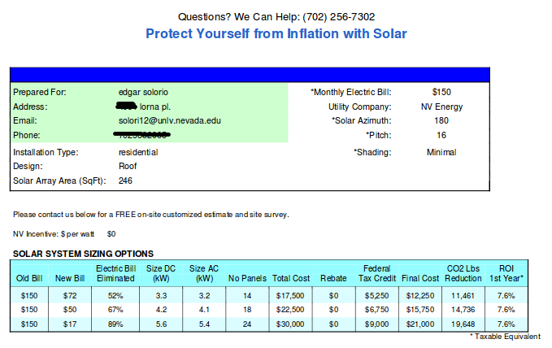

*Figure 3.1 - Solar panel installation quote for a residential home with 246 square feet of solar array area. Three systems are proposed as shown in the blue table.*

An equivalent uniform annual cost analysis was done with a MARR value of 11.5% as an average return from the stock market. A second analysis was also conducted with a much lower MARR value of 1.05% for family units with less aggressive investment strategies, such as investment in CD’s. Four different service life terms were tested to simulate a family who expect to live at their current residence for a short period or a longer period of time. Solar panel data and service life terms are shown below.

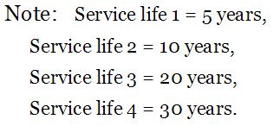

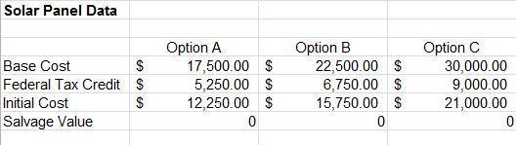

*Fig 3.2 - Solar panel data for three differently sized solar panel installations and service life term declarations.*

The first equivalent uniform annual cost analysis with MARR value of 11.5% suggests that it is not an economical decision to have solar panel installations for either sizing option, this holds for all four service period life terms as the figure below shows.

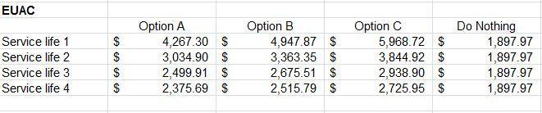

*Fig 3.3 - The do nothing option is the best course of action with the lowest EUAC for an analysis using MARR = 11.5%*

A second EUAC analysis was conducted with the premise that a family has a minimal investment strategy, such as only purchasing CD’s with a much lower rate of return. The analysis was done again with a MARR value of 1.05%, this time option C is the most economical choice when the service life is 20 years, 30 years, or higher in general. The figure below shows the results.

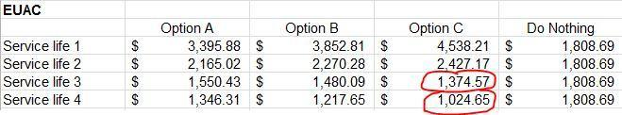

*Fig 3.4 - Option C is the most economical choice for service life times of 20 years or 30 years when the analysis is done for a MARR = 1.05%*

# 

# Conclusion and Recommendations

We conclude that energy use needs to be reduced for the growing population of Las Vegas. Electricity bills can increase dramatically during the summer months due to the need for air conditioning, the three alternatives discussed in this report can help make a resident home more energy efficient and thus reduce the load amount of the energy grid during peak months.

Three different appliances were analyzed and the results show that the best light bulbs are Fluorescent light bulbs. The most economical refrigerator was the non Energy Star rated choice, but only as long as the price of electricity is less than $.3 per kWh. The most economical A/C unit for a 1700 ft2 home is one with a SEER of 16. As for home insulation, the results show heavier insulation yields notable diminishing returns, so low to medium levels of thermal resistance will provide a home with an economical means to reduce energy and heating costs with a relatively low payback period. Finally, solar panels appear to be a bad investment for a savvy investor with a MARR value of 11.5% but become great economical additions to a home when a family has little or no investment schemes as reflected with a low MARR value of 1.05%.

The economical decision is to buy the insulation and appliances with the best AW however a homeowner may only be able to buy the best insulation and the appliances with the cheapest initial cost, or vice versa. To determine the best mutually exclusive alternative we computed the AW of having the most economical insulation, and the appliances with the cheapest cost, and compared it to the AW of having the most economical appliances, and no extra insulation. According to our calculations the best mutually exclusive alternative is to install the best insulation, and to buy the cheapest appliances.

|  |  |  |
| --- | --- | --- |
|  | Best Insulation + Cheapest Appliances | Best Appliances + No extra Insulation |
| AAW | **-$3,167.68** | -3212.32 |

*Fig 3.4 - AW of mutually exclusive alternatives.*

# References

"NV Energy." *NV Energy*. N.p., n.d. Web. 19 Apr. 2014.

<<https://www.nvenergy.com/brochures_arch/rate_schedules/np_res_rate.pdf>>

*Insulation Savings Calculator to Determine Savings by Adding or Upgrading Home Insulation*. N.p., n.d. Web. 19 Apr. 2014. <<http://www.cellulose.org/HomeOwners/CalculateSavings.php>>.

"Nevada Gas Tariff No. 7." *Southwest Gas*. N.p., n.d. Web. 19 Apr. 2014. <<http://www.swgas.com/tariffs/nevada_rates_and_tariffs.php>>.

"LAS VEGAS, NEVADA." *Monthly Heating Degree Days,*. N.p., n.d. Web. 19 Apr. 2014. <<http://www.wrcc.dri.edu/cgi-bin/cliMONthdd.pl?nv4429>>.

"Types of Insulation." *Energy.gov*. N.p., n.d. Web. 17 Apr. 2014. <<http://energy.gov/energysaver/articles/types-insulation>>.

Free solar quote online tool

<<http://www.renewableenergyelectric.com>>

Incandescent Light Bulb Specifications and Prices

<<http://www.homedepot.com/p/Philips-60-Watt-Incandescent-A19-Household-Light-Bulb-4-Pack-374843/100080337?N=5yc1vZbmbuZ1z0xeui#specifications>>

Fluorescent Light Bulb Specifications and Prices

<<http://www.homedepot.com/p/Philips-60W-Equivalent-Soft-White-2700K-Spiral-GU24-CFL-Light-Bulb-E-417238/203536943?N=5yc1vZ25ecodZbmatZ15bZ1z0xeui#specifications>>

LED Light Bulb Specifications and Prices

<<http://www.homedepot.com/p/Philips-50W-Equivalent-Soft-White-2700K-PAR20-Dimmable-LED-Flood-Light-Bulb-426122/204109115?N=5yc1vZbm79Z15bZ2bctr6#specifications>>

Non Energy Star Refrigerator Power Consumption

<<http://www.homedepot.com/catalog/pdfImages/20/2001cc3d-effc-4e9b-9443-d95a76eccf6d.pdf>>

Non Energy Star Refrigerator Specifications and Prices

<<http://www.homedepot.com/p/Amana-17-6-cu-ft-Top-Freezer-Refrigerator-in-White-A8TCNWFAW/203353268?N=5yc1vZc3nsZ2bcqsuZ2bctgu#specifications>>

Energy Star Refrigerator Power Consumption

<<http://www.homedepot.com/catalog/pdfImages/be/be38d756-f425-40e2-a879-c3b3201e9261.pdf>>

Non Energy Star Refrigerator Specifications and Prices

<<http://www.homedepot.com/p/Whirlpool-17-6-cu-ft-Top-Freezer-Refrigerator-in-Black-W8TXEWFYB/203582394?N=5yc1vZc3nsZ2bcqsuZ2bctguZ1z0tlzw#specifications>>

SEER 13 A/C unit price

<<http://www.goodmanmfg.com/ResidentialProducts/AirConditioners/13SEERGSX13/tabid/1312/Default.aspx>>

SEER 16 A/C unit price

<<http://www.goodmanmfg.com/ResidentialProducts/ACSystems/16SEERDSXC16/tabid/1309/Default.aspx>>

SEER 18 A/C unit price

<<http://www.goodmanmfg.com/ResidentialProducts/ACSystems/18SEERDSXC18/tabid/1308/Default.aspx>>

U.S. Department of Housing and Urban Development's Residential Rehabilitation Inspection Guide

<<http://ciohi.com/page5.html>>