Massachusetts General Hospital Performance Analysis

This Project is presenting insights for last 10 years of Massachusetts General Hospital’s data for providing several views.
Program: DEPI – Power BI Track 2025

Project Idea
The goal of this project is to analyze the operational and financial performance of Massachusetts General Hospital using an interactive Power BI dashboard. The analysis focuses on identifying patterns in admissions, encounters, procedures, and revenue to evaluate hospital efficiency and patient care outcomes. The findings highlight areas of excellence and improvement for academic and administrative review.

Work Plan
- Data Preparation: Import hospital data into Power BI, clean and model relationships between tables (patients, admissions, procedures, and payers).
2. Measure Creation: Develop DAX measures for KPIs such as occupancy rate, average length of stay, procedure efficiency, and readmission rate.
3. Dashboard Design: Create interactive pages (Landing, Encounters, Procedures, Revenue, and Demographics).
4. Testing: Validate calculations and KPIs for accuracy.
5. Documentation & Presentation: Compile academic and professional reports for final evaluation.

Research & Analysis
The Power BI dashboard provides a multidimensional view of the hospital’s performance, integrating clinical, financial, and operational data. It helps stakeholders understand how efficiently resources are being used, where costs can be optimized, and how patient care quality correlates with revenue.

Dashboards

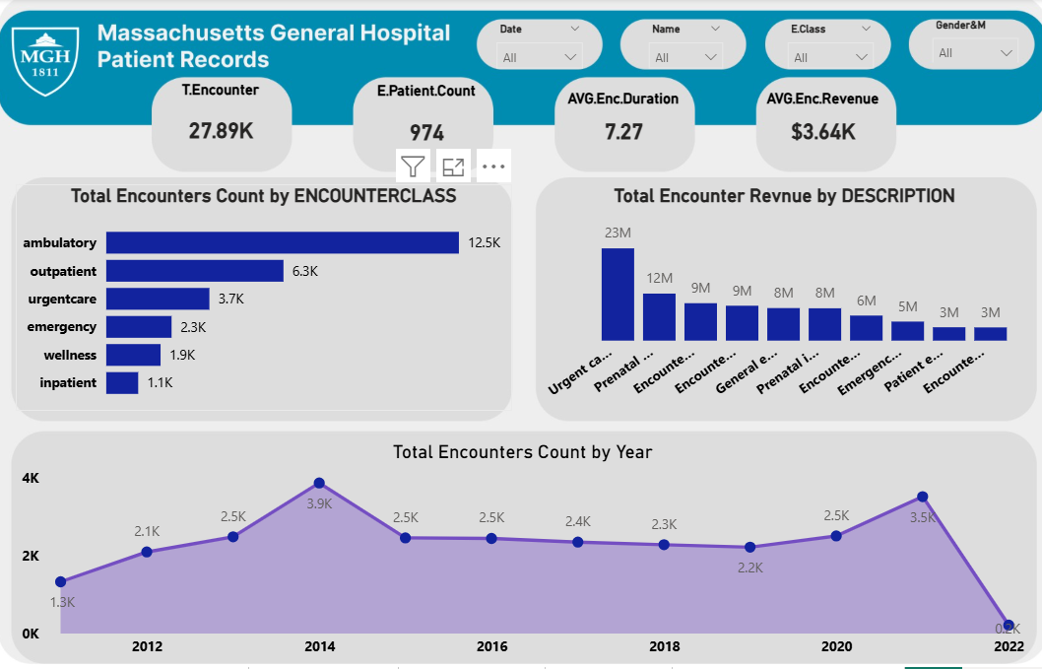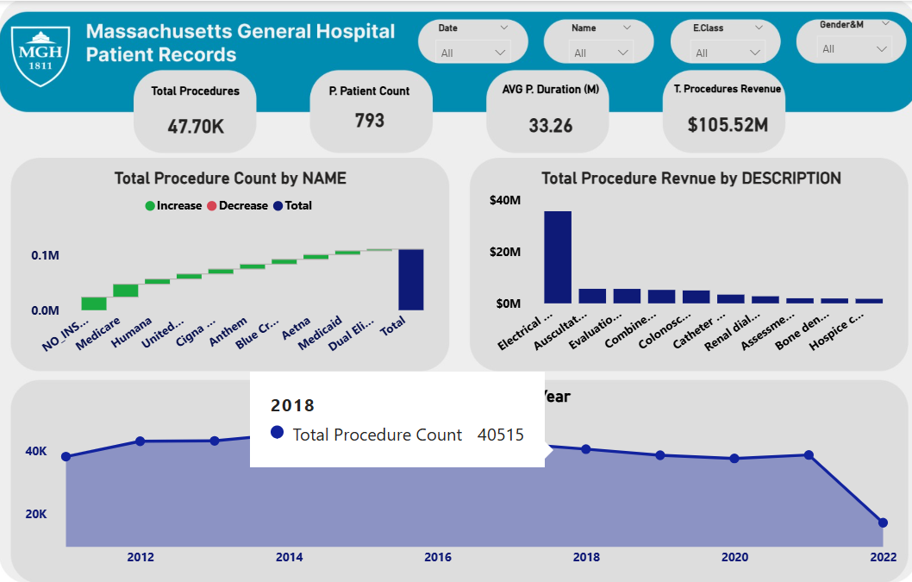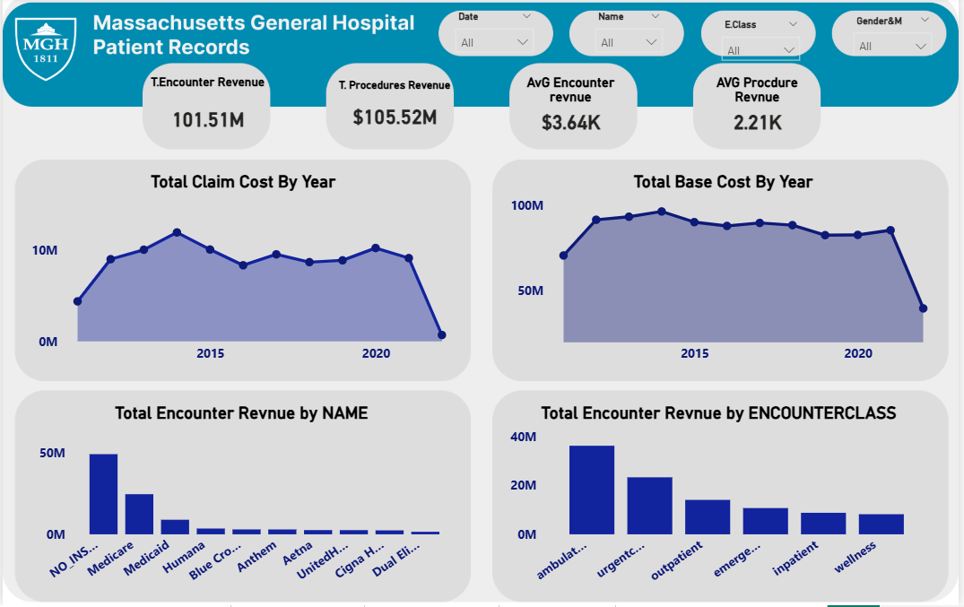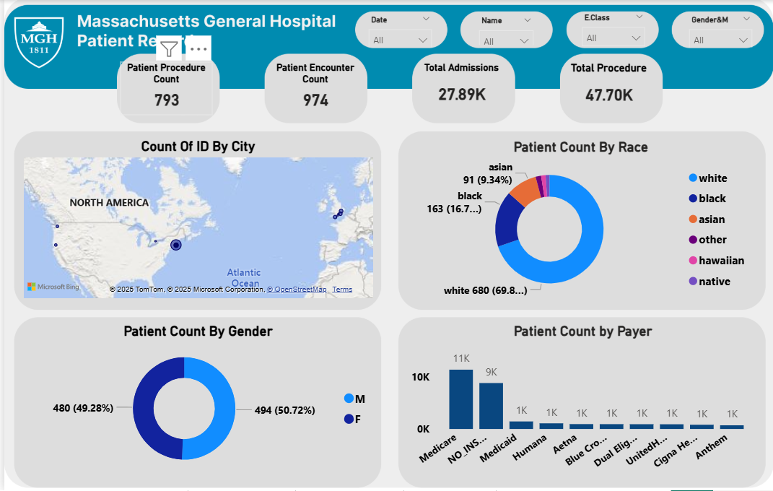

Extracted KPIs
KPI | Value | Interpretation
Admissions by Class | 6 | Six distinct admission categories are monitored.
Avg. Encounter Duration | 7.27 days | Indicates moderately complex inpatient cases.
Avg. Encounter Revenue | $3.64K | Reflects solid revenue per encounter.
Avg. Length of Stay | 0.31 days | Suggests inclusion of short-stay outpatients.
Avg. Procedure Duration | 34.32 min | Efficient procedural turnaround time.
Avg. Procedure Revenue | $2.03K | Strong financial return per procedure.
Revnue per Day | $11.92K | High operational cost; tertiary hospital standard.
Coverage % | 0.31% | high patient burden.
Encounter Patient Count | 974 | Total unique patients during period.
Total Admissions | 28K | Indicates hospital throughput capacity.
Total Encounter Revenue | $101.51M | Matches cost, suggesting financial equilibrium.
Total Encounter Cost | $101.51M | Balanced expenditure management.
Total Procedure Revenue | $79.7M | Key contributor to overall revenue.
Total Procedure Cost | $80M | Marginal deficit (<1%).
Total Procedures | 39K | Demonstrates large operational volume.
Out-of-Pocket Cost | $70.42M | Heavy patient financial burden.
Total Hospital Cost | $181.22M | Total annual expense footprint.
Total Payer Coverage | $31.10M | Insurance coverage remains minimal.
Top Procedure Cost | $290K | Highest-cost medical procedure.

Interpretation
The Total Encounter Revenue ($101.51M)
The Out-of-Pocket Cost ($70.42M) highlights dependence on self-paying patients, while Coverage (0.31%) shows inadequate insurance utilization.
Procedure efficiency is strong — average duration 34.32 minutes and 1.41 procedures per encounter.

Audience Personas
1. Clinical Director: Uses the dashboard to monitor care outcomes and readmission trends.
2. Hospital Administrator: Tracks patient flow, occupancy, and departmental efficiency.
3. Finance Officer: Assesses profitability and cost control.
4. Data Analyst: Leverages data models to predict performance trends.

Visual Identity
Theme: CY24SU10 (embedded Power BI theme). Style: Academic tone with minimalistic professional design. Colors: Soft neutrals with high-contrast titles for readability.

Main Dashboard Designs
1. Landing Page: Overview of key KPIs (Admissions, Revenue, Costs).
2. Encounters Page: Displays encounter trends and durations.
3. Procedures Page: Shows frequency, costs, and outcomes of procedures.
4. Revenue Page: Breaks down revenue by payer and service line.
5. Demographics Page: Displays age, gender, and regional breakdowns.

KPI Evaluation
KPI | Target | Status
Total Admissions | ≥ 25 K | ✅ On Target
Encounter Revenue | > 3 K | ✅ Good
Procedure Revenue/Cost | > 1.05 | ⚖ Marginal

Review & Finalization
The Power BI model enables transparent monitoring of hospital performance. It shows that while Massachusetts General Hospital operates efficiently, it must address patient coverage and readmission management to improve sustainability and care quality.

Final Presentation
Deliverables include:
- Interactive Power BI dashboard
- Academic analytical report (this document)
- Executive summary (professional version)

Roles & Responsibilities
Sara Mohamed – Data modeling, dashboard integration, report coordination.
Aya Farid – DAX measure creation and KPI calculations.
Noha Yassin – Visualization design and theme formatting.
Alshaymaa Mostafa – Documentation, editing, and presentation design.

License
Creative Commons Attribution (CC BY 4.0)

