Cocktail Recommendation System

1. System Overview
This is a home-bar cocktail ordering and recommendation platform, built as a MLOps course project and a practical tool for hosting real home parties. It combines a guest-facing Telegram bot, an admin Telegram bot for inventory and order management, a FastAPI backend, and a full cloud-based MLOps pipeline for training and serving a collaborative-filtering recommendation model.

1.1 Components
- Guest Bot
- Admin Bot
- FastAPI service – recommendation, and ordering endpoints
- PostgreSQL + pgvector (AWS RDS) – cocktail catalog, embeddings, orders, inventory
- S3 – three buckets for dataset storage, MLflow artifacts, generated cocktail images
- AWS SageMaker –MLflow tracking/registry, and Training Jobs for model training
- Apache Airflow (self-hosted on EC2 via Docker Compose) – pipeline orchestration
- Recommendation logic – collaborative filtering (SVD / ALS / BPR, model-selected via champion-challenger) with a content-based fallback for cold-start and free-text session preferences
- OpenAI (preference dialogue, recipe adaptation), BytePlus Seedream (cocktail card image generation)

1.2 High-Level Data & Control Flow
The system has two independent flows: one for serving recommendations to a guest in real time, and one for retraining the recommendation model
Serving flow. When a guest interacts with the guest bot on Telegram, the bot forwards the request to the FastAPI backend, which passes it to the recommender. The recommender then follows one of two paths depending on the situation. If the guest has enough order history for the currently trained model to recognize them, the request is served through the collaborative-filtering path, which loads the current MLflow champion model. If the guest is new, or is writing free-text preferences through the Q&A flow, the request instead goes through the content-based path, which compares the guest's preferences against cocktail embeddings stored in pgvector and re-ranks the results with an LLM.
A guest's taste profile is not fixed at first contact – it evolves with use. When a guest first completes the Q&A flow, their stated preferences are converted into embedding (local sentence-transformers model) and stored with the raw preference text. After every order, the system treats that order as a new taste signal. It asks an LLM to rewrite the guest's profile text to reinforce or adjust it based on what was just ordered, then re-embeds and overwrites the stored profile.
Training flow. Airflow DAG runs on a daily schedule. It first exports fresh order data to S3, then preprocesses it into a training-ready format. Then it launches four model-training tasks in parallel, one each for SVD, ALS, BPR, and a hyperparameter-tuned variant before a final task compares their results and selects a new champion.

2. Airflow
Data export and model training were originally implemented as two separately-scheduled DAGs. This was changed into a single DAG

DAG Structure
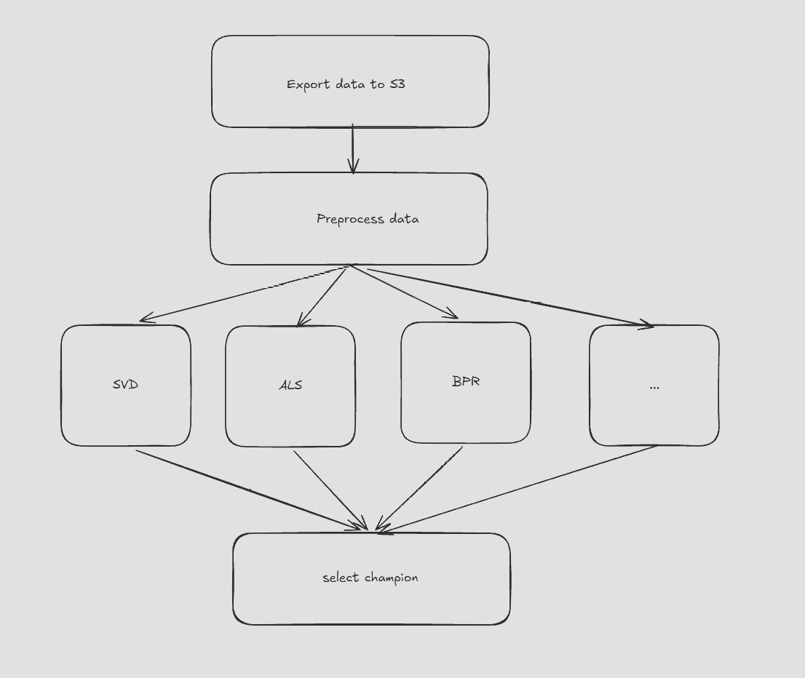
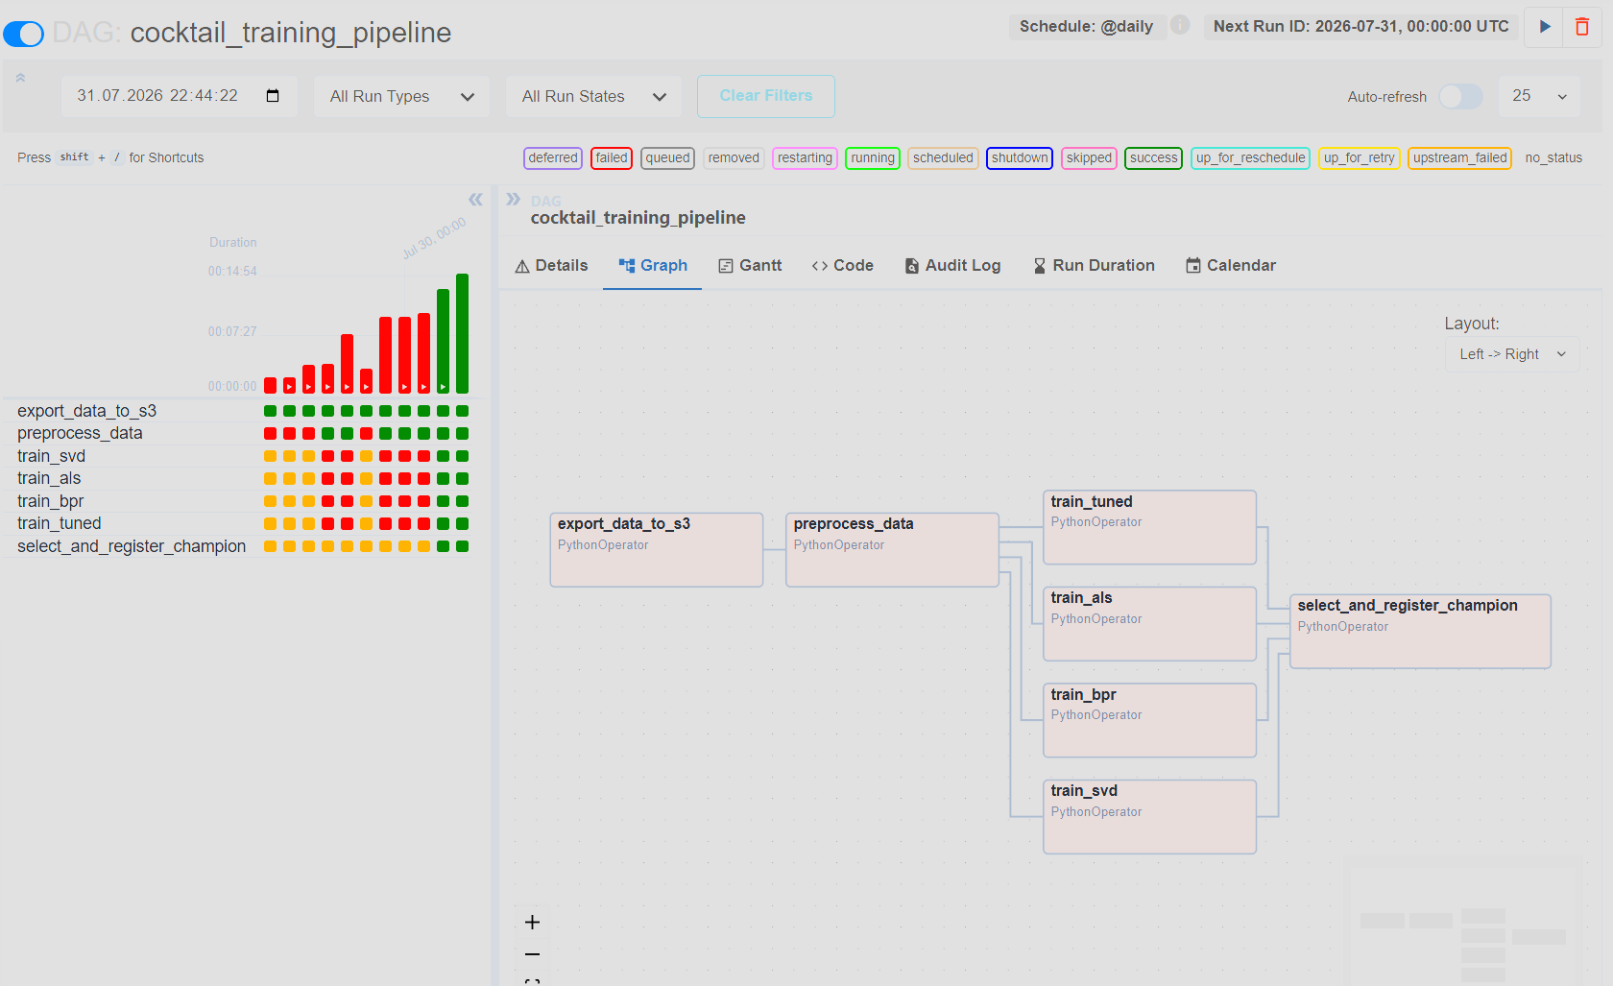
Because four training tasks log to MLflow independently and in parallel, each run is tagged with a batch_id equal to the Airflow DAG run_id. This lets the final task compare only the models trained in this specific pipeline run, instead of the entire historical run log.

3. SageMaker Training Jobs
Each parallel training task launches its own SageMaker Training Job. Airflow task does a fresh git clone of the repository, then submits a SageMaker Estimator job pointing at the corresponding entry point (train_single_model.py --model svd|als|bpr|tuned).

4. MLFLOW
All training runs log parameters, metrics, and model artifacts to a SageMaker Managed MLflow App. Model comparison and promotion follow a champion-challenger pattern implemented in training/select_champion.py.
Example results from one of the pipeline runs
Model | precision@5 | precision@10 | precision@20 | precision@30
svd | 0.113 | 0.187 | 0.284 | 0.327
tuned (ALS, factors=40) | 0.101 | 0.140 | 0.206 | 0.245
als (factors=20) | 0.089 | 0.140 | 0.206 | 0.253
bpr | 0.008 | 0.004 | 0.011 | 0.033

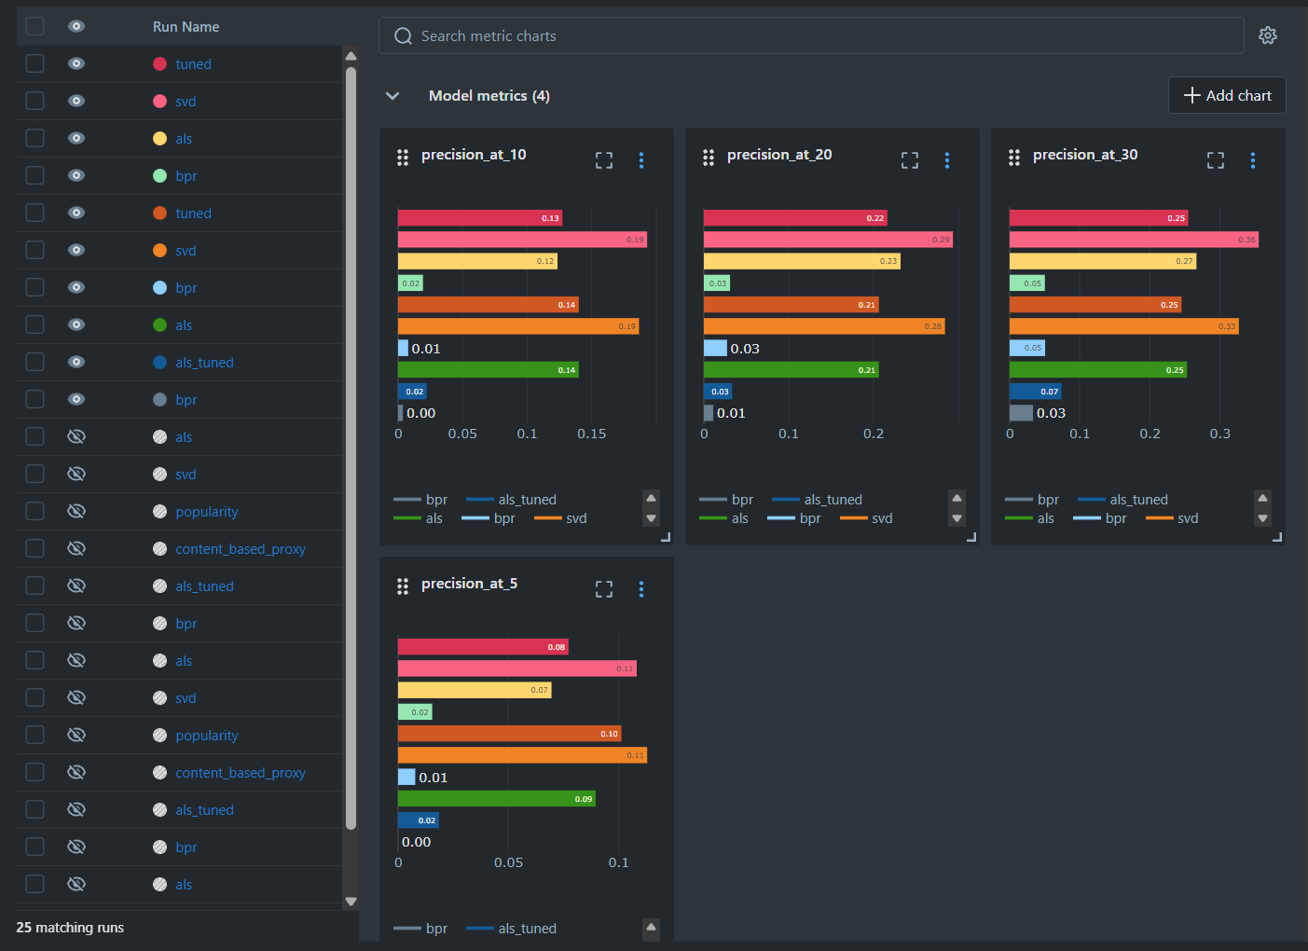
After all four models finish, select_champion.py queries MLflow for every run tagged with the current batch_id, selects the highest precision@5, and compares it against the current champion. If the challenger wins, its model version is registered and the champion alias is moved to it:
best_run = max(batch_runs, key=lambda r: r.metrics['precision_at_5'])
if best_run.metric > current_champion_metric:
new_version = client.create_model_version(model_name, source, run_id)
client.set_registered_model_alias(model_name, 'champion', new_version.version)

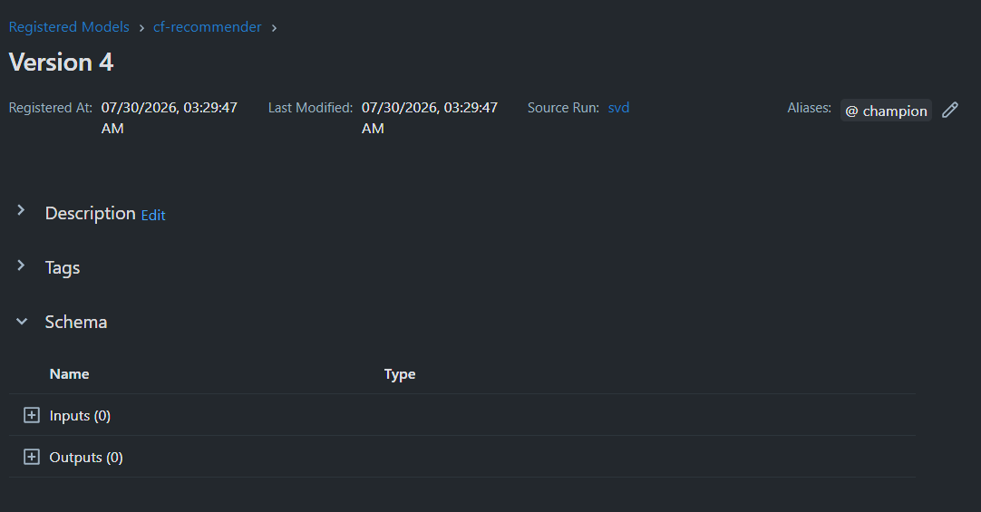

6. Serving and Recommendation Logic
The FastAPI service loads the current MLflow champion model. Recommendations are served through two paths:
- Collaborative filtering - used when the requesting guest has sufficient order history in the champion model's training set
- Content-based filtering - an embedding similarity + LLM re-ranking fallback, used for cold-start guests and for free-text session preferences gathered through the bot's Q&A flow
The Q&A preference-discovery flow always uses the CBF path, since it operates on freshly-collected natural-language preferences rather than historical user-item interactions that the CF model was trained on.
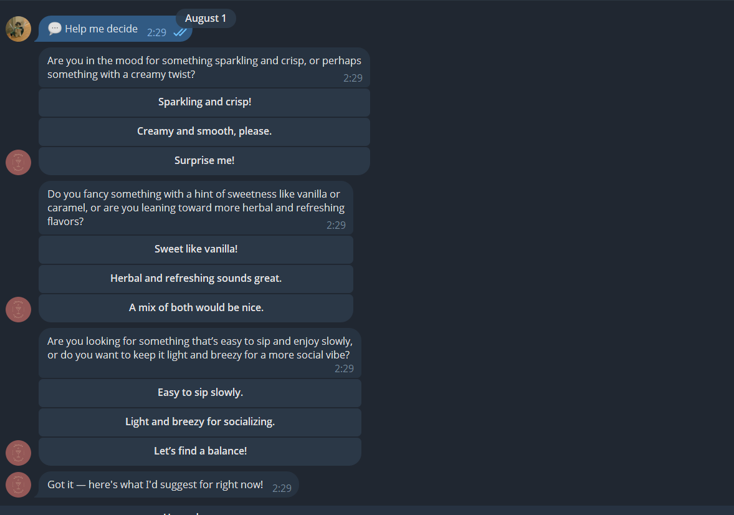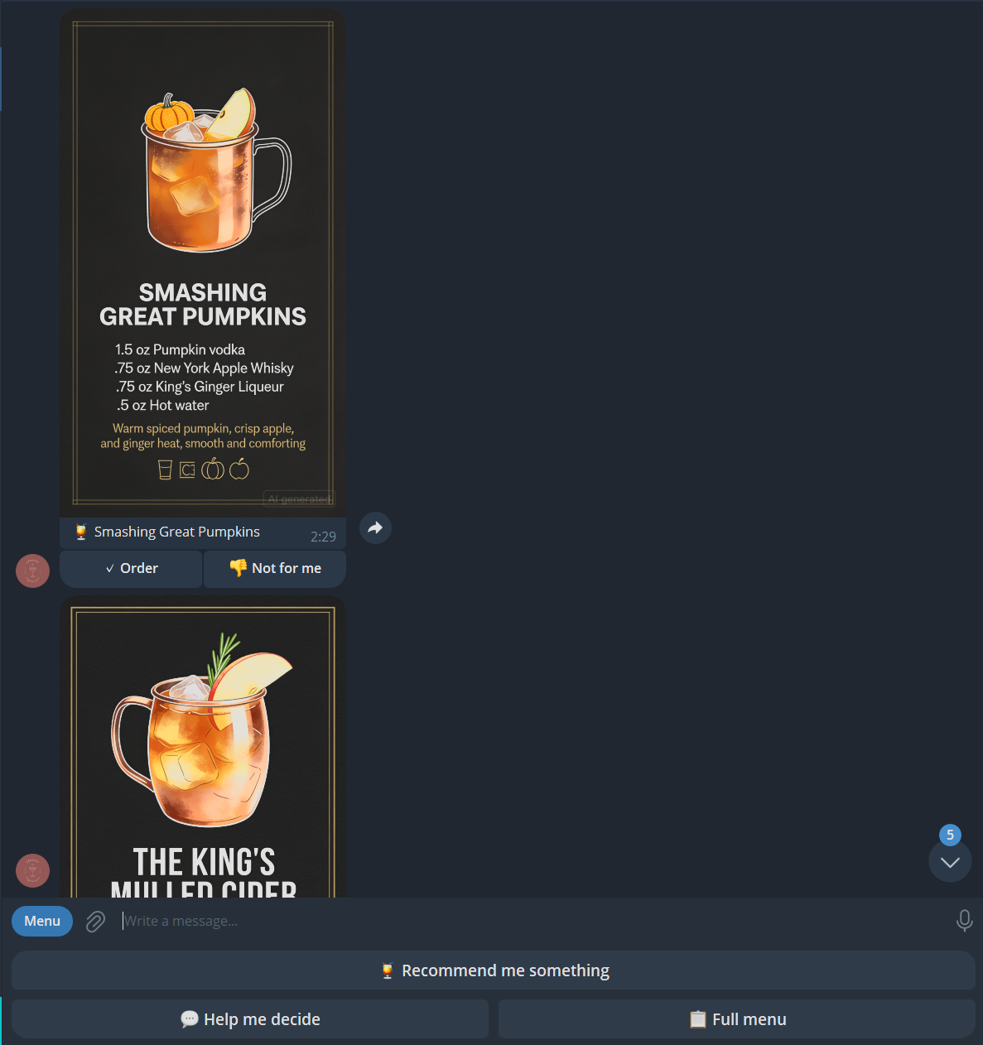

7. Cocktail Card Images
Each cocktail's visual card is generated on first request via BytePlus Seedream, then cached permanently. the model's response URL is short-lived (24 hours), so the image is immediately re-uploaded to a S3 bucket, and it’s durable URL is stored in the cocktails table. Every request for the same cocktail is just a database read now, with no repeat generation cost.
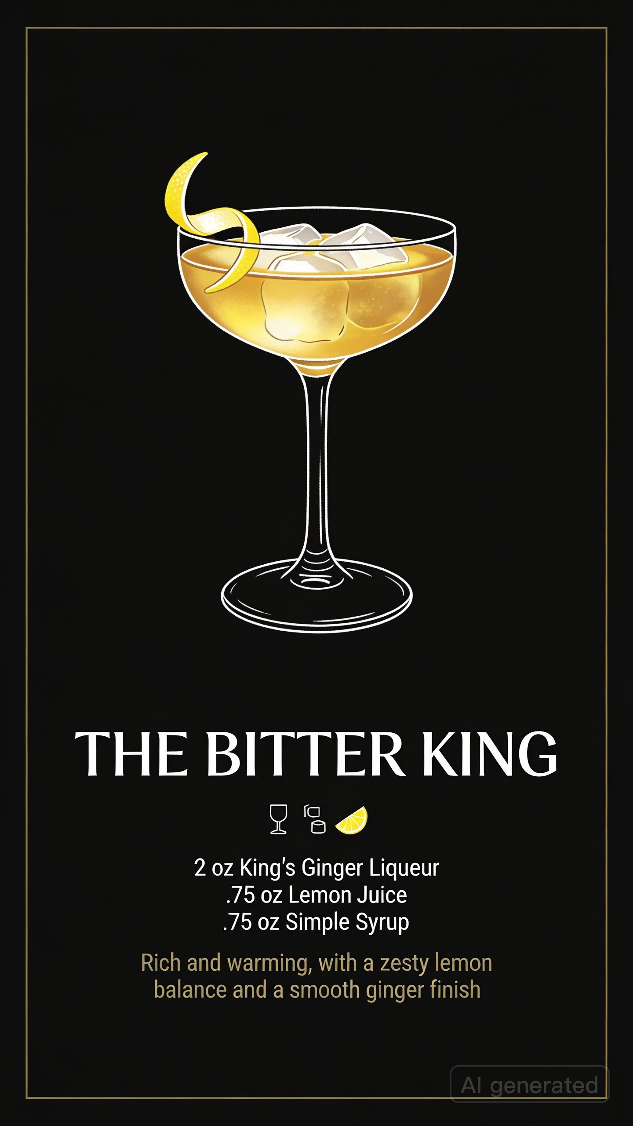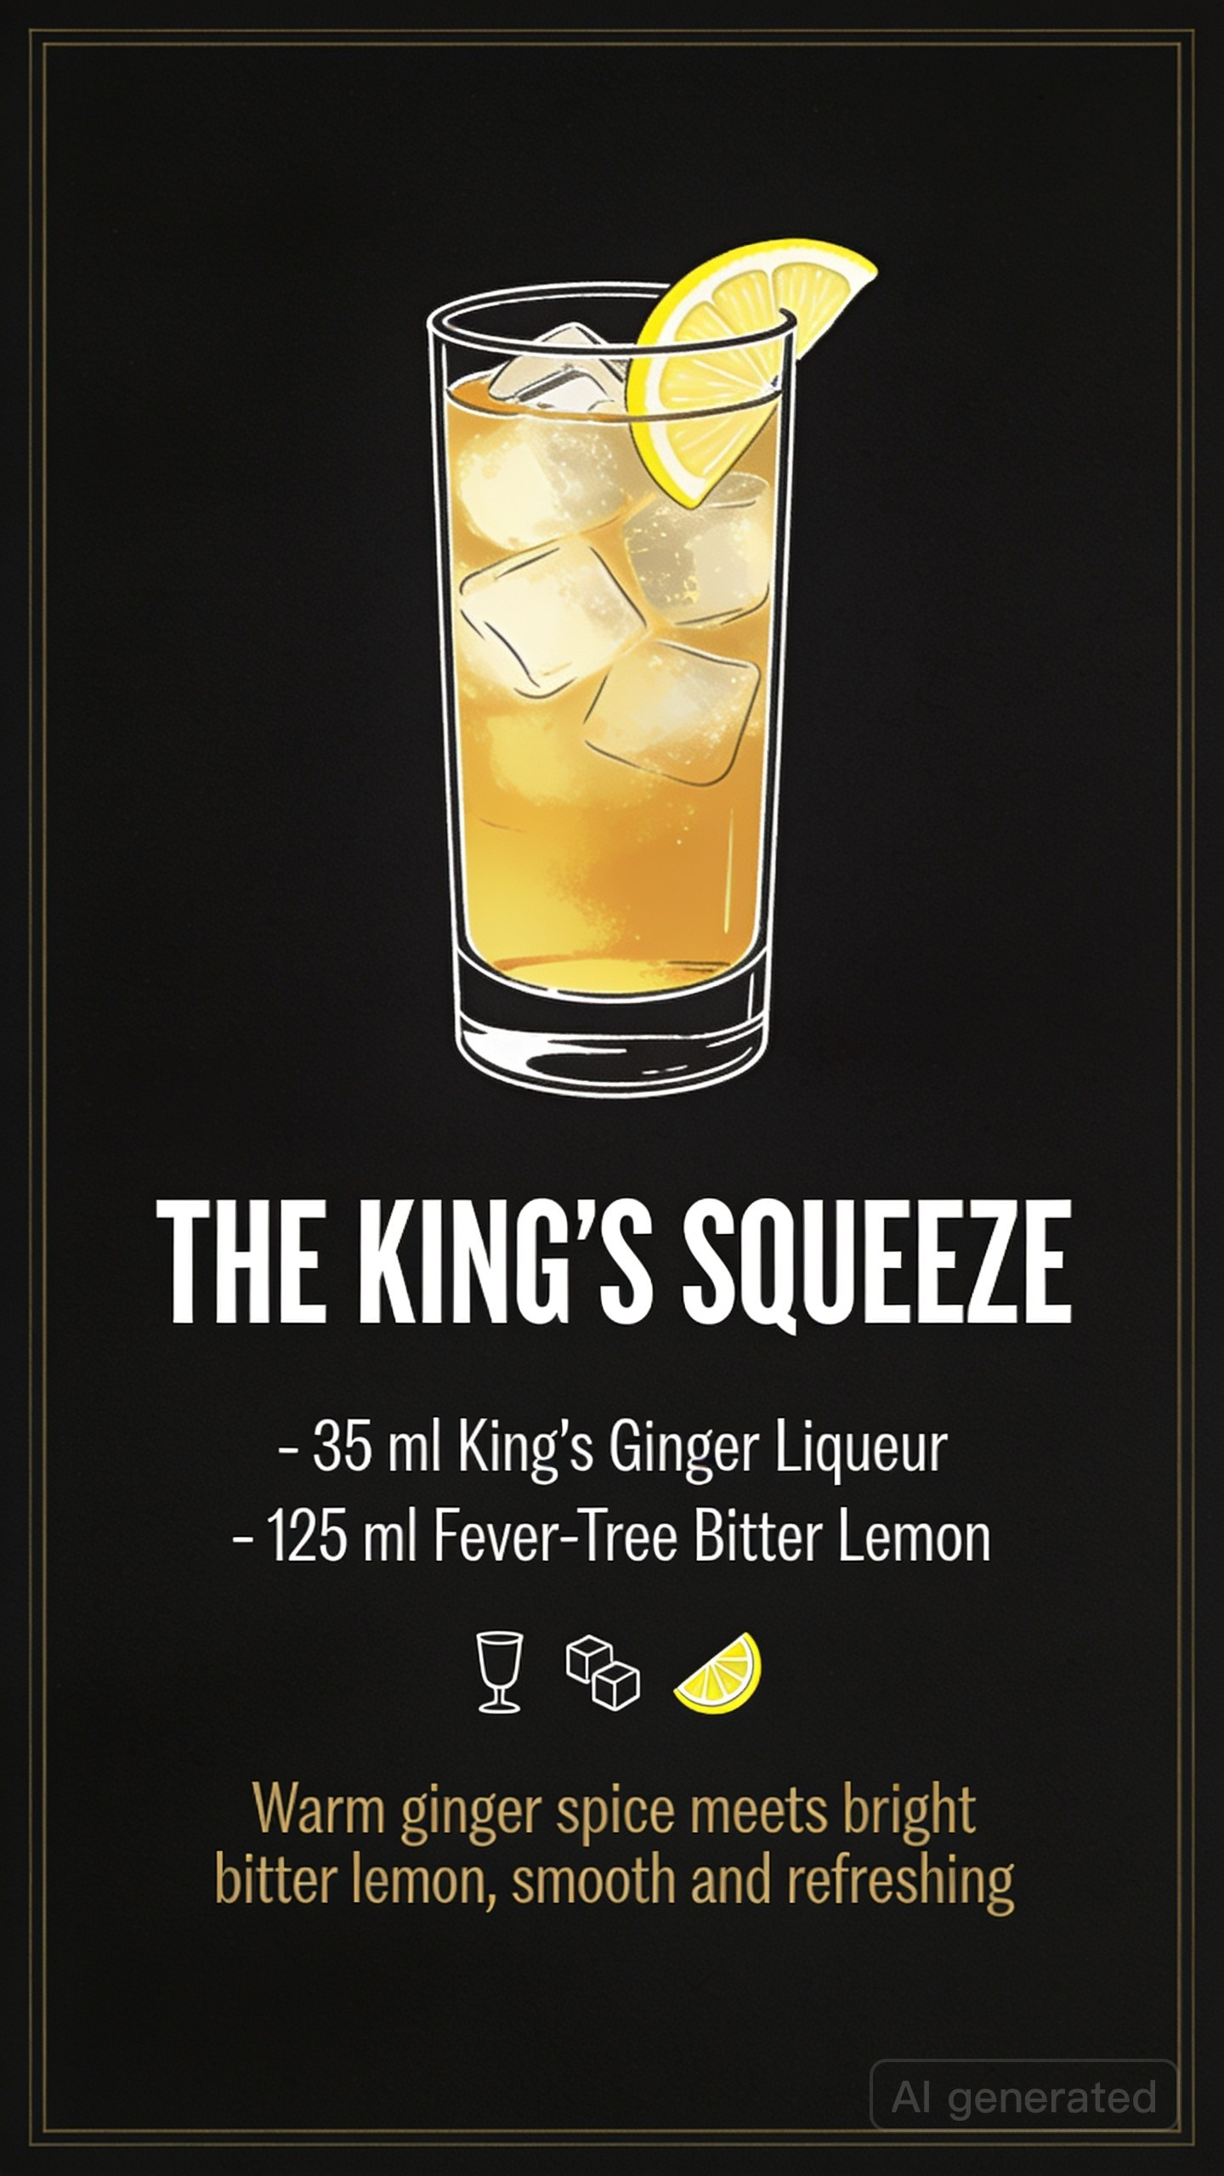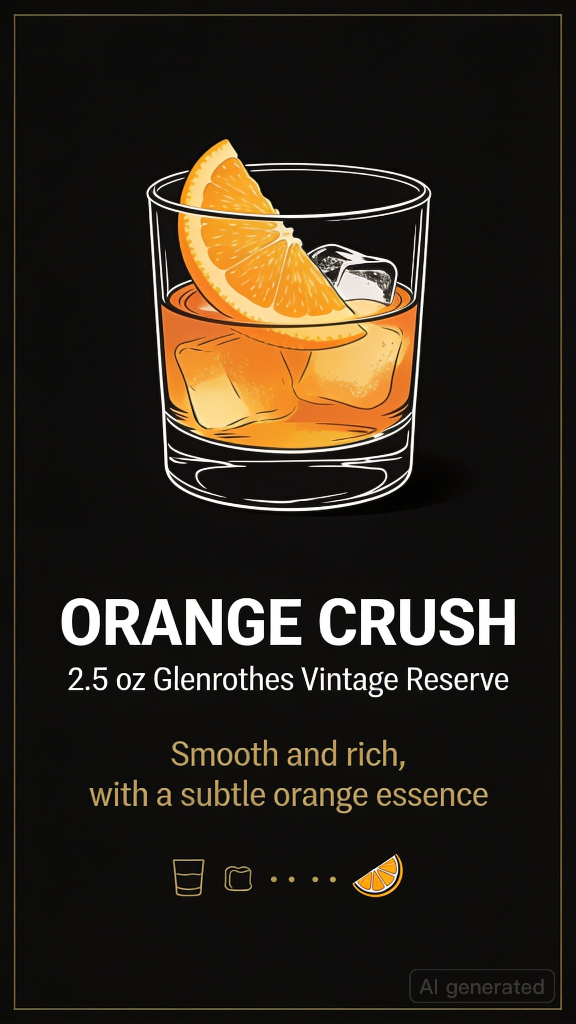

8. Link to Telegram geuest bot: https://t.me/bartenderrrr_bot

