2 ways to activate Windows 10 for FREE without additional software

**Step 1:** Select the right key for your Windows.  
Here is the list of Windows 10 volume license keys.

***Home:****TX9XD-98N7V-6WMQ6-BX7FG-H8Q99****Home N:****3KHY7-WNT83-DGQKR-F7HPR-844BM****Home Single Language:****7HNRX-D7KGG-3K4RQ-4WPJ4-YTDFH****Home Country Specific:****PVMJN-6DFY6-9CCP6-7BKTT-D3WVR****Professional:****W269N-WFGWX-YVC9B-4J6C9-T83GX****Professional N:****MH37W-N47XK-V7XM9-C7227-GCQG9****Education:****NW6C2-QMPVW-D7KKK-3GKT6-VCFB2****Education N:****2WH4N-8QGBV-H22JP-CT43Q-MDWWJ****Enterprise:****NPPR9-FWDCX-D2C8J-H872K-2YT43****Enterprise N:****DPH2V-TTNVB-4X9Q3-TJR4H-KHJW4*

**Step 2:** Right-click on the start button and open Command Prompt (Admin).

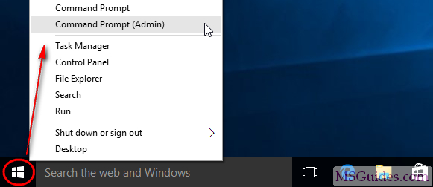

**Step 3:** Use the command “slmgr /ipk yourlicensekey” to install a license key (yourlicensekey is the activation key you got above).  
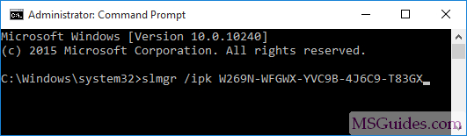

(**\*Note*:** You need to hit [Enter] key to execute commands.)

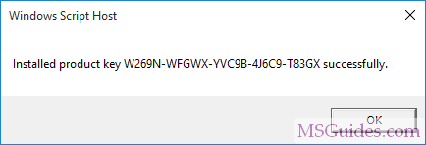

**Step 4:** Use the command “slmgr /skms kms8.msguides.com” to connect to my KMS server.  
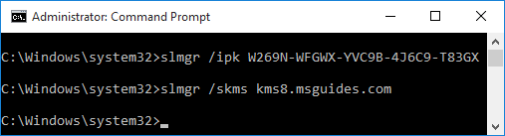  
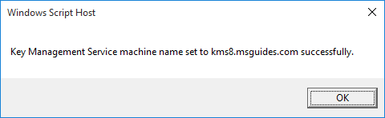

**Step 5:** The last step is to activate your Windows using the command “slmgr /ato”.  
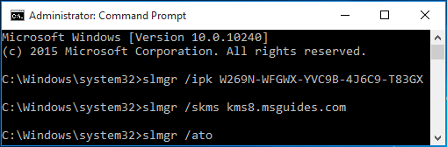  
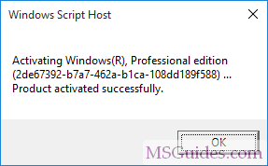

Check the activation status again.  
