

American International University- Bangladesh

Computer Graphics

Project Report

Fall- 2023-24

Project Title: **“Marine Drive”**

Section: **B**

Group: **3**

|  |  |
| --- | --- |
| **Student Name** | **Student Id** |
| **Nammi, Lamyea Farha** | 21-45410-3 |
| **Md. Shahriar Ibne Amin Shakil** | 21-45432-3 |
| **Himangshu Mazumder** | 19-40725-1 |
| **Md. Monoarul Islam** | 17-35313-2 |

Submitted To:

**ANEEM AL AHSAN RUPAI**

**Introduction:**

The name of the project is **“Marine Drive”**. A marine drive project usually refers to the development of a coastal road or promenade along the waterfront to enhance connectivity, tourism, and overall infrastructure in a particular area. Marine Drive projects to enhance waterfront areas, promote tourism, and improve overall urban infrastructure.

**Background:**

The marine drive project unfolds as a mesmerizing scene, with a winding road tracing the coastline towards its destination. The sky undergoes a captivating transformation, mirroring the various hues of nature, all while bustling with the vibrant lives of people. Through the magic of animation, the road comes alive, weaving through green landscapes where dewdrops on grass glisten like pearls, and trees and houses seem to dance in the background. Beneath, ships gracefully navigate the deep blue sea.

The sky, a canvas of ever-changing beauty, is brought to life with floating white clouds and dynamic color shifts, capturing the essence of time passing by. The night sky and the radiant morning sky are depicted with exquisite detail, while the dusk sky appears ablaze with fiery hues. Along the journey, the road halts at significant stations, allowing for moments of pause and reflection.

At the bottom, the vast expanse of the Bay of Bengal unfolds, adding a touch of maritime grandeur to the scene. The animation seamlessly integrates ships gliding through the water, complementing the dynamic movement of the road. This animated tableau aims to vividly imprint the marine drive's story in the viewer's mind, facilitating a rich and immersive experience.

As the sun gradually sets in the western sky, its golden ray’s cascade over the water, casting a breathtaking spectacle. This scenic portrayal subtly conveys a poignant message: amidst the rush of our daily lives, time slips away swiftly. The project encourages us to seize the moment, relish the beauty of our surroundings, and savor life to its fullest along the captivating marine drive.Top of Form

**Objective:**

The primary objective of the "Marine Drive" Computer Graphics Project is to demonstrate the application of pre-built functions in OpenGL to portray scenic views effectively. Computer graphics serve the purpose of presenting visual data in a meaningful way. This project simulates a coastal drive scenario along Marine Drive, incorporating various environmental settings.

The simulation begins with a depiction of a coastal drive where the path follows the curve of the shoreline. The graphics illustrate a beautiful view of the sea, with waves crashing against the rocks. The skyline is enhanced by a clear, sunny sky and a scenic horizon.

As the simulation progresses, the setting transitions to the evening, showcasing a breathtaking sunset over the ocean. The warm hues of the setting sun reflect on the water, creating a serene atmosphere along Marine Drive.

The project further evolves into a night scene, where the city lights along Marine Drive illuminate the surroundings. The moonlight reflects on the calm sea, and the distant mountains provide a picturesque backdrop.

Overall, this project aims to explore both technical and aesthetic aspects of computer graphics in the context of Marine Drive. It serves as a platform to comprehend critical issues in rendering realistic environments and conveying mixed media experiences to the audience.

**Sketch and Graph**

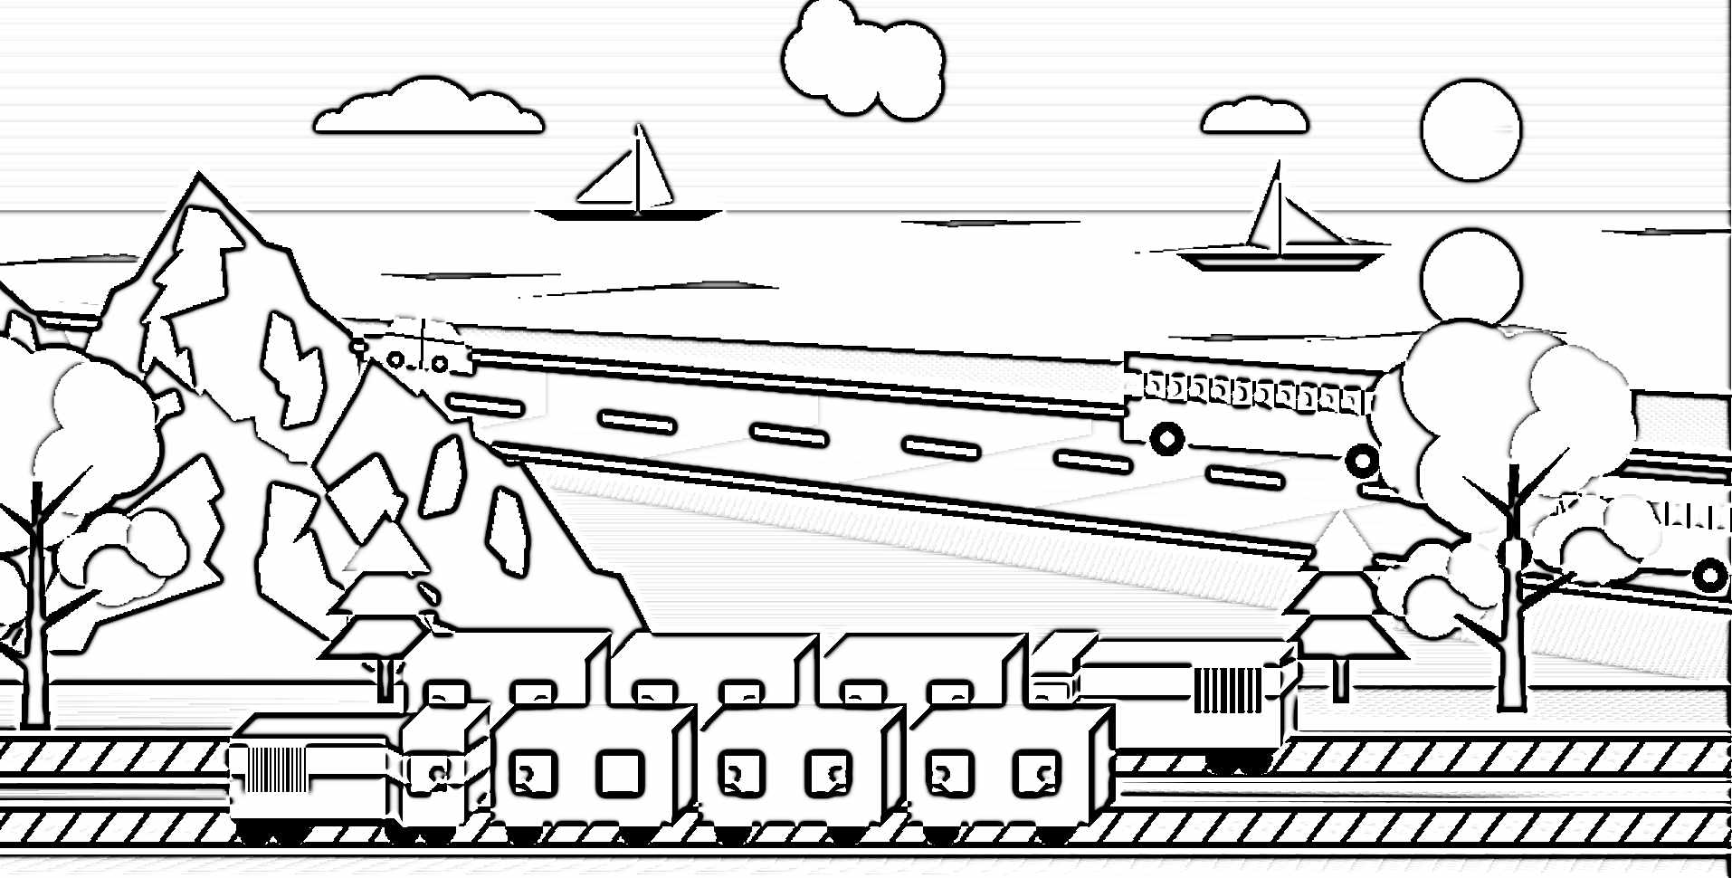

Sketch

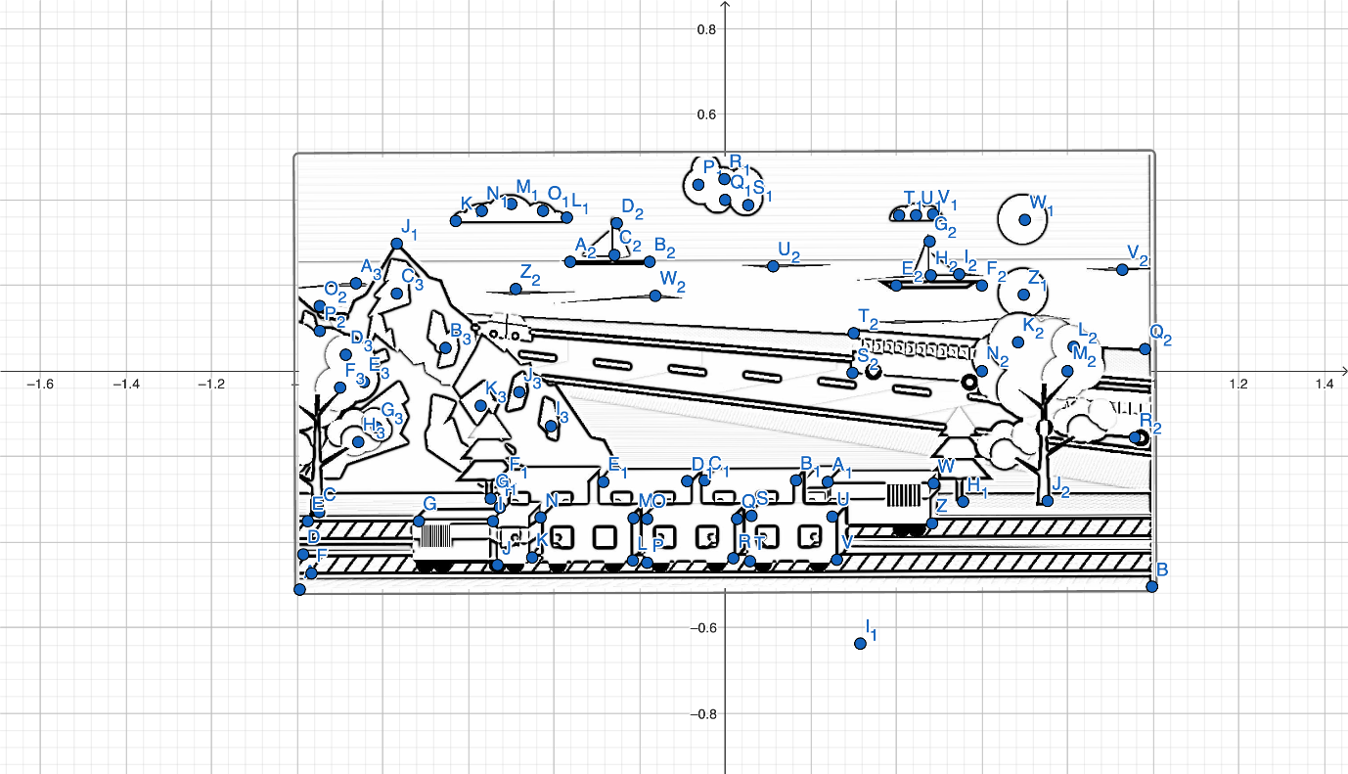

Graph

**Coordinate:-**

C=(-0.94845,-0.32952)

D=(-0.98554,-0.42841)

E=(-0.97494,-0.35071)

F=(-0.96611,-0.47255)

G=(-0.71536,-0.35071)

H=(-0.52642,-0.31893)

I=(-0.54231,-0.35071)

J=(-0.53171,-0.45313)

K=(-0.45049,-0.43547)

L=(-0.21563,-0.44253)

M=(-0.21386,-0.34365)

N=(-0.43106,-0.34188)

O=(-0.18208,-0.34541)

P=(-0.18208,-0.44783)

Q=(0.02806,-0.34541)

R=(0.01923,-0.43724)

S=(0.06161,-0.33835)

T=(0.05808,-0.4443)

U=(0.25055,-0.34012)

V=(0.26115,-0.44077)

W=(0.48718,-0.26242)

Z=(0.48365,-0.35601)

A_{1}=(0.23996,-0.25889)

B_{1}=(0.16579,-0.25535)

C_{1}=(-0.04787,-0.25535)

D_{1}=(-0.08849,-0.25712)

E_{1}=(-0.2845,-0.25889)

F_{1}=(-0.51582,-0.25712)

G_{1}=(-0.54761,-0.29774)

H_{1}=(0.55604,-0.3048)

I_{1}=(0.31589,-0.63678)

J_{1}=(-0.76701,0.29779)

K_{1}=(-0.62928,0.35077)

L_{1}=(-0.3697,0.35872)

M_{1}=(-0.49949,0.3905)

N_{1}=(-0.56835,0.37461)

O_{1}=(-0.42532,0.37461)

P_{1}=(-0.06244,0.43553)

Q_{1}=(0,0.4)

R_{1}=(-0.00152,0.44877)

S_{1}=(0.0541,0.38785)

T_{1}=(0.40639,0.36401)

U_{1}=(0.44612,0.36401)

V_{1}=(0.48585,0.36666)

W_{1}=(0.7004,0.35342)

Z_{1}=(0.69775,0.1786)

A_{2}=(-0.36175,0.25541)

B_{2}=(-0.17634,0.25541)

C_{2}=(-0.25845,0.27131)

D_{2}=(-0.25315,0.34547)

E_{2}=(0.4,0.2)

F_{2}=(0.6,0.2)

G_{2}=(0.47791,0.30309)

H_{2}=(0.48055,0.22363)

I_{2}=(0.54677,0.22628)

J_{2}=(0.75338,-0.30347)

K_{2}=(0.68451,0.06735)

L_{2}=(0.8143,0.05676)

M_{2}=(0.8,0)

N_{2}=(0.6,0)

O_{2}=(-0.94713,0.15211)

P_{2}=(-0.94713,0.09384)

Q_{2}=(0.98117,0.05146)

R_{2}=(0.95733,-0.15514)

S_{2}=(0.29779,-0.00416)

T_{2}=(0.30044,0.08854)

U_{2}=(0.11238,0.24482)

V_{2}=(0.9282,0.23687)

W_{2}=(-0.16309,0.17595)

Z_{2}=(-0.48889,0.19184)

A_{3}=(-0.86237,0.20509)

B_{3}=(-0.65312,0.05411)

C_{3}=(-0.76701,0.18125)

D_{3}=(-0.88621,0.03822)

E_{3}=(-0.84383,-0.02535)

F_{3}=(-0.89945,-0.0386)

G_{3}=(-0.81469,-0.1313)

H_{3}=(-0.85707,-0.16574)

I_{3}=(-0.40678,-0.12866)

J_{3}=(-0.48095,-0.04919)

K_{3}=(-0.571,-0.08098)

**List of objects assigning an object ID –**

|  |  |  |
| --- | --- | --- |
| SL# | Object Name | Object ID |
| 1 | Car | G1- 1000 |
| 2 | Road | Road -5000 |
| 3 | Cloud 1 | Cloud 1 - 2000c |
| 4 | Cloud 2 | Cloud 2 - 2100c |
| 5 | Cloud 3 | Cloud 3- 2300c |
| 6 | Hill | Hill- 6H00 |
| 7 | Tree1 | Tree 1 - 7001 |
| 8 | Tree2 | Tree 2- 7002 |
| 9 | Train1 | Train1 -tr100 |
| 10 | Train2 | Train2-tr101 |
| 11 | Bus 1 | Bus 1-5678 |
| 12 | Bus 2 | Bus 2-7890 |
| 13 | Sky | Sky1-sk1234 |
| 14 | Sky2 | Sky2-sk5678 |
| 15 | Sun | Sun1-su3000 |
| 16 | Sun1 | Sun2-su3002 |
| 17 | Sea1 | Sea-se4103 |
| 18 | Beach | Beach-be2267 |
| 19 | Boat1 | Boat-Bo2180 |
| 20 | Boat2 | Boat- Bo2289 |
| 21 | grass | Grass-gr7865 |
| 22 | Sea2 | Sea-se4203 |
| 23 | Flower | Flower -fl099 |
| 24 | Rain cloud | rrain-508 |
| 25 | Snow ball | sn021 |
| 26 | Sun shadow | sunsh201 |
| 27 | Rail line | RL111 |
| 28 | Tree leaf 1 | TL001 |
| 29 | Tree leaf 1 | TL002 |
| 30 | Kashphul | kashphul1001 |
| 31 | Tree flower 1 | TF-4001 |
| 32 | Tree flower | TF-4002 |

**List of Functions to Represent Objects-**

|  |  |  |
| --- | --- | --- |
| SL# | Object Name | Function Name |
| 1 | Sea | void sea() |
| 2. | Beach | void beach() |
| 3. | Sky | void sky() |
| 4. | Sun | void sun () |
| 5. | Sun 1 | void sun1 () |
| 6. | Cloud1 | void cloud1() |
| 7. | Cloud2 | void cloud2() |
| 8. | Cloud3 | void cloud3() |
| 9. | Road | void road() |
| 10 | Car | void car() |
| 11 | Bus1 | void bus1() |
| 12. | Bus2 | void bus2() |
| 13 | hills | void hills() |
| 14 | Rail_Line | void rail_Line() |
| 15 | Tree1 | void tree1() |
| 16 | Tree2 | void tree2() |
| 17 | Train1 | void train1() |
| 18 | Train2 | void train2() |
| 19 | grass | void grass() |
| 20 | KashPhul Structure | void kashPhulStructure() |
| 21 | kashPhul | void kashPhul() |
| 22 | Boat1 | void boat1() |
| 23 | Boat 2 | void boat2() |
| 24 | flower | void flower() |
| 25 | flowerStructure | void flowerStructure() |
| 26 | tree_flower | void tree_flower() |
| 27 | tree_flower2 | void tree_flower2() |
| 28 | Sea2 | void sea2() |
| 29 | Sky2 | void sky2() |
| 30 | Summer | void summer() |
| 31 | autumn | void autumn( () |
| 32 | winter | void winter() |
| 33 | spring | void spring() |
| 34 | Keyboard | void myKeyboard() |
| 35 | Main function | int main() |

**List of Animation Functions with ID:**

|  |  |  |  |
| --- | --- | --- | --- |
| **Sl#** | **Animation Function ID** | **Animation Function** | **Object/Scene** |
| 1 | flower-ro2145 | flowerUp | Start translation loop for kashphul in autumn |
| 2. | flowerup-up2146 | flowerUp1 | Start translation loop for sun flower in spring |
| 3. | rainup-up2147 | rainUp | Start translation loop for rain in rainy |
| 4. | snowup-up2148 | snowUp | Start translation loop for snow in winter |
| 5. | RcloudUp-up2149 | RcloudUp | Start translation loop for rainy cloud in rainy |
| 6. | treeUp-up2150 | treeUp | Start translation loop for tree leaf fall in winter |
| 7. | motion_vehicle-2151 | motion_vehicle | Start translation loop for vehicle moving left |
| 8. | motion2_vehicle-2152 | motion2_vehicle | Start translation loop for vehicle moving right |
| 9. | motion_rain-2153 | motion_rain | Start translation loop for rain in rainy |
| 10. | flower-001 | flower | Animation function for sun flower moving |
| 11. | kashphul2001 | kashphul | Animation function for sun kashphul moving |

**Contribution:-**

|  |  |  |  |
| --- | --- | --- | --- |
| **Member Name** | **Implemented Functions** | **Implemented Animation Functions** | **Percentage of Contribution** |
| Nammi, Lamyea Farha | beach(),cloud1();cloud2();  cloud3();tree1();tree_leaf1();  tree_leaf2();tree2(); | snowUp , treeUp | 25% |
| Md.shahriar Ibne Amin Shakil | sea();sun();sun_shadow();  hills(); road(); | flowerUp, motion_vehicle | 25% |
| Himangshu Mazumder | sky();grass();boat1();  boat2();rail_Line(); | flowerUp1, motion2_vehicle | 25% |
| Monoar Mithu | car(); bus1(); bus2(); train1(); train2(); | rainUp, motion_rain, RcloudUp | 25% |

**Conclusion:-**

In conclusion, in this project, we have developed a simulation of Marine Drive, creating a virtual environment that accurately represents various seasons. Utilizing polygon mode, we have designed a dynamic landscape for Marine Drive, incorporating quadrilateral elements for different parts of the scene.

To enhance the user experience, we have implemented a key-based system:

Press "S" for the spring view.

Press "R" for the rainy season view.

Press "W" for the winter view.

Press "A" for the autumn view.

These keys allow users to switch between different seasonal scenarios, providing a comprehensive and immersive experience of Marine Drive throughout the year.

Screenshot:

