CLEANORA FRONTEND HANDOFF
RELEASE 1 — PHASE 04
Customer Profiles, Preferences, Text Addresses, Signup & Verification
Frontend Screens and API Integration Guide
Purpose: A complete, implementation-ready handoff for Bassam covering R1-P04A public signup/email verification and R1-P04 authenticated customer self-service—without Provider or later-phase leakage.

15 functional screens • 25 API operations • 18 generated visual references • 3 actor/role sections
Prepared for Bassam
Frontend implementation reference | 1 September 2026 | English guide with Arabic RTL product screens
Scope: Part A: category-aware customer signup and email-only activation. Part B: owner-private customer profiles, shared profile image, contact state, preferences, peer text addresses, and privacy-request intake/tracking.

How to use this guide
- Start with the master board and the two journey boards to understand route order and boundaries.
- Implement screens in numeric order within each actor section; use the Suggested frontend route as a routing recommendation, not a backend endpoint.
- Create one Axios wrapper per API card. Shared operations are cross-referenced from screen tables and are not documented twice.
- Treat the generated Arabic screens as visual/interaction specifications. Treat the repository-grounded API cards as the source for backend integration.
- Keep Phase 04 request-only privacy behavior and customer-only authorization visible in every relevant state.

Screen catalog
# | Actor / role | Screen | Suggested frontend route
01 | Public / New Customer | Category-aware customer signup | /signup
02 | Email Verification | Email OTP verification | /verify-email
03 | Authenticated Customer | Add a customer category | /account/customer-categories/new
04 | Authenticated Customer | Customer self-service center | /account
05 | Authenticated Customer | Individual profile | /account/profiles/individual
06 | Authenticated Customer | Company profile | /account/profiles/company
07 | Authenticated Customer | Engineer profile | /account/profiles/engineer
08 | Authenticated Customer | Shared profile image | /account/profile-image
09 | Authenticated Customer | Contact verification state | /account/contact-state
10 | Authenticated Customer | Language and notifications | /account/preferences
11 | Authenticated Customer | Address book | /account/addresses
12 | Authenticated Customer | Create or edit a text address | /account/addresses/new or /account/addresses/:addressId/edit
13 | Authenticated Customer | Privacy request center | /account/privacy
14 | Authenticated Customer | Submit a privacy request | /account/privacy/new
15 | Authenticated Customer | Privacy request details and pending cancel | /account/privacy/:privacyRequestId

Important: The overview route is client-composed. Phase 04 exposes no dedicated customer overview endpoint and no public Staff Admin/privacy-processor UI.

Frontend integration foundation

Client split and base URL
Shared Axios clients
import axios from 'axios';
export const publicApi = axios.create({ baseURL: '/api/v1' });
export const api = axios.create({ baseURL: '/api/v1' });
api.interceptors.request.use((config) => {
const accessToken = sessionStore.getAccessToken();
if (accessToken) config.headers.Authorization = `Bearer ${accessToken}`;
return config;
});

- Use publicApi only for signup, OTP request, and OTP verification. Use api for category enrollment and all /customers operations.
- Do not log request/response bodies. Never persist passwords, OTPs, challenge IDs, full contact values, addresses, regulatory identifiers, signed image URLs, or privacy-request IDs in analytics.
- Pass AbortSignal to route reads and cancel stale requests when navigation or identity changes.
- Never automatically retry a mutation. Respect explicit 429 Retry-After for signup/OTP calls.

Success and error envelopes
Success envelope
{
"success": true,
"data": {
"...": "operation-specific safe data"
},
"requestId": "uuid"
}

Error envelope
{
"success": false,
"error": {
"code": "REQUEST_VALIDATION_FAILED",
"statusCode": 400,
"message": "Request validation failed",
"details": {
"issues": [
{
"path": "fullName",
"code": "too_small",
"message": "This field is required"
}
]
}
},
"requestId": "uuid"
}

Concurrency, caching, uploads, and state
Family | Contract behavior | Frontend rule
Profiles | No version token | Replace the profile cache from PUT; no partial client merge.
Profile image | expectedAssociationVersion | Refetch GET after 409; FormData only; never set multipart boundary manually.
Preferences | version | Full replacement only; 409 requires refetch and deliberate reapply.
Addresses | version | Create starts at 1; update/delete 409 requires refetch/reconfirm.
Privacy submit | Active request reuse | The server returns the existing active identity+purpose request; no idempotency key header.
Reads | AbortSignal | Cancel stale requests; render loading, empty, success, error independently.

No copied Provider semantics: R1-P04 does not use Provider expectedVersion conventions, Provider membership, worker readiness, payout proof, or Provider idempotency headers. Only the CAS/version rules above apply.

Complete Phase 04 flows
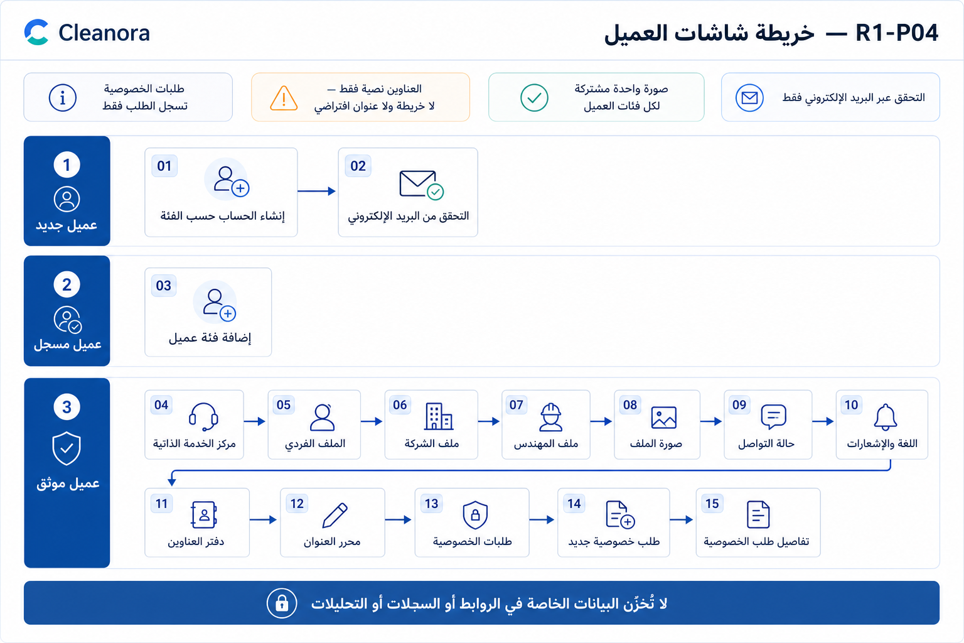
Figure 1 — Master screen order. Use the numbers as the shared vocabulary for routes, tickets, and API cross-references.
Implementation use: The master board defines the approved screen order and separates public signup, email verification, category enrollment, and authenticated self-service.

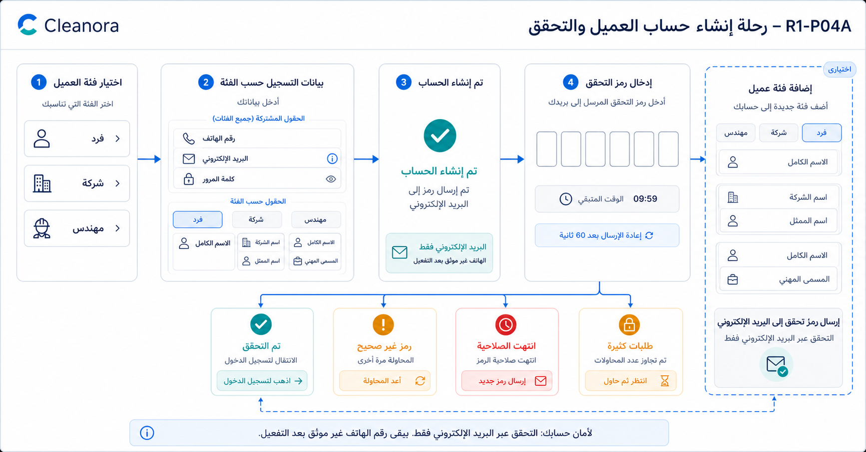
Figure 2 — R1-P04A signup and verification. Email is the only activation channel; phone remains unverified.
Implementation use: Build one strict category-discriminated signup surface and one reusable email verifier. Category enrollment returns to the same verifier but starts from an authenticated full session.

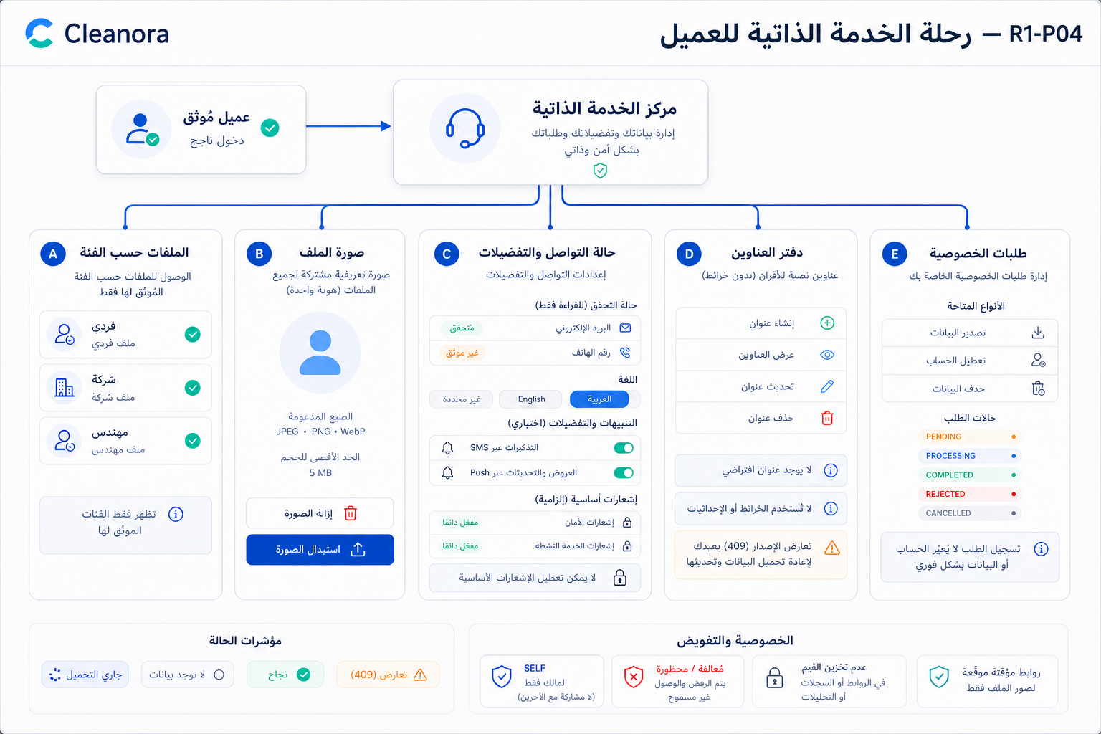
Figure 3 — Authenticated customer self-service. The hub composes existing reads; it is not a backend overview endpoint.
Implementation use: Treat each branch as independently loadable and recoverable. Preserve SELF ownership, private data, signed-image URL expiry, version conflicts, and request-only privacy semantics.

ACTOR SECTION 1
Public / New Customer
Starts a strict customer-category signup. No session exists yet.
Screen | Title | Suggested route
01 | Category-aware customer signup | /signup

Boundary: Anonymous operations are limited to APIs 01, 03, and 04. Provider Owner and Worker are not public self-signup categories in the live schema.

Screen 01 — Category-aware customer signup
Actor / role | Suggested frontend route | Purpose
Public / New Customer | /signup | Select Individual, Company, or Engineer and create the matching profile plus identity in one operation.

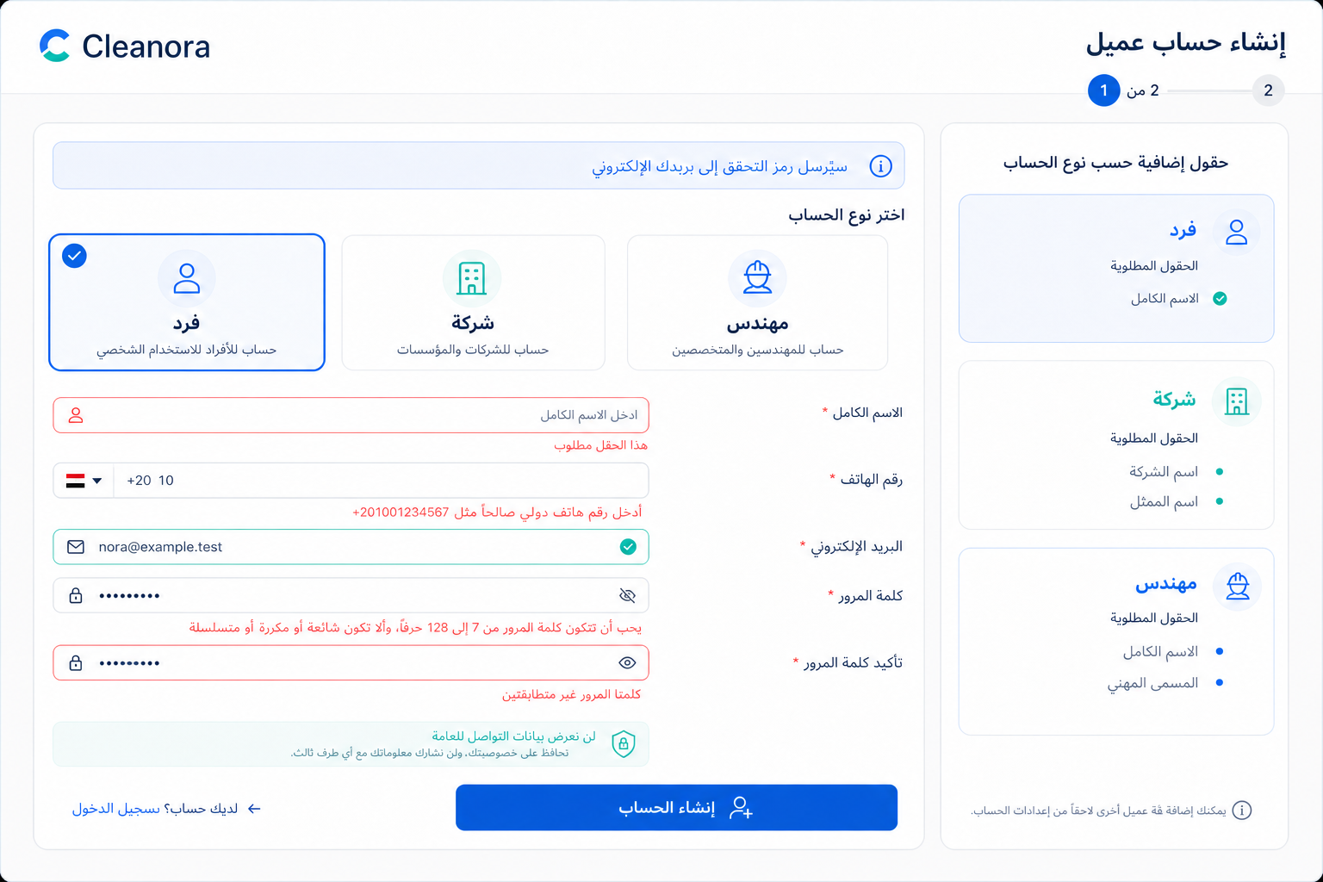
Figure 4 — Screen 01: Category-aware customer signup. Visual reference; the API cards in this guide are authoritative for integration details.

Exact frontend flow
- Choose exactly one supported customer category.
- Render the category-specific fields while retaining common phone/email/password input.
- Validate the complete strict variant locally without sending fields from another category.
- Submit API 01 once and keep the button disabled until the 202/error response.
- On 202, transfer only safe challenge UI data to Screen 02.

Main fields and components
- Three category cards: Individual, Company, Engineer
- Common identity and password controls
- Category-specific name/title panel
- Inline field issues plus sign-in link
- Email-only verification and privacy notices

State implementation
State | Required behavior
Loading | Disable category changes and submit; keep a stable form skeleton and announce progress.
Empty | Fresh form with no category preselected, unless the entry route deliberately supplies one.
Validation | Use details.issues; show duplicate phone/email conflicts on their exact controls.
Success | Display the masked email and advance to Screen 02; never label the phone verified.
Error / recovery | For 429 honor Retry-After; for email-provider failure remain on signup because the failed new identity is rolled back.

Permission & privacy: Public form values stay in component memory; no password, phone, email, or challenge ID in URLs/logs/analytics.

Navigation — Previous: sign-in entry. Next: Screen 02 with the returned email challenge.

APIs used on this screen
Method | Endpoint | Purpose | Detailed-guide reference
POST | /api/v1/auth/signup | Atomically creates an identity plus the matching customer profile, then sends the blocking category-verification OTP by email. | API 01 — detailed on canonical Screen 01

ACTOR SECTION 2
Email Verification
Completes the blocking email-only category gate and recovers invalid, expired, resend, and throttled states.
Screen | Title | Suggested route
02 | Email OTP verification | /verify-email

Boundary: OTP channel=EMAIL. Never render an SMS or phone-verification recovery path.

Screen 02 — Email OTP verification
Actor / role | Suggested frontend route | Purpose
Email Verification | /verify-email | Enter, resend, and consume the six-digit email verification code.

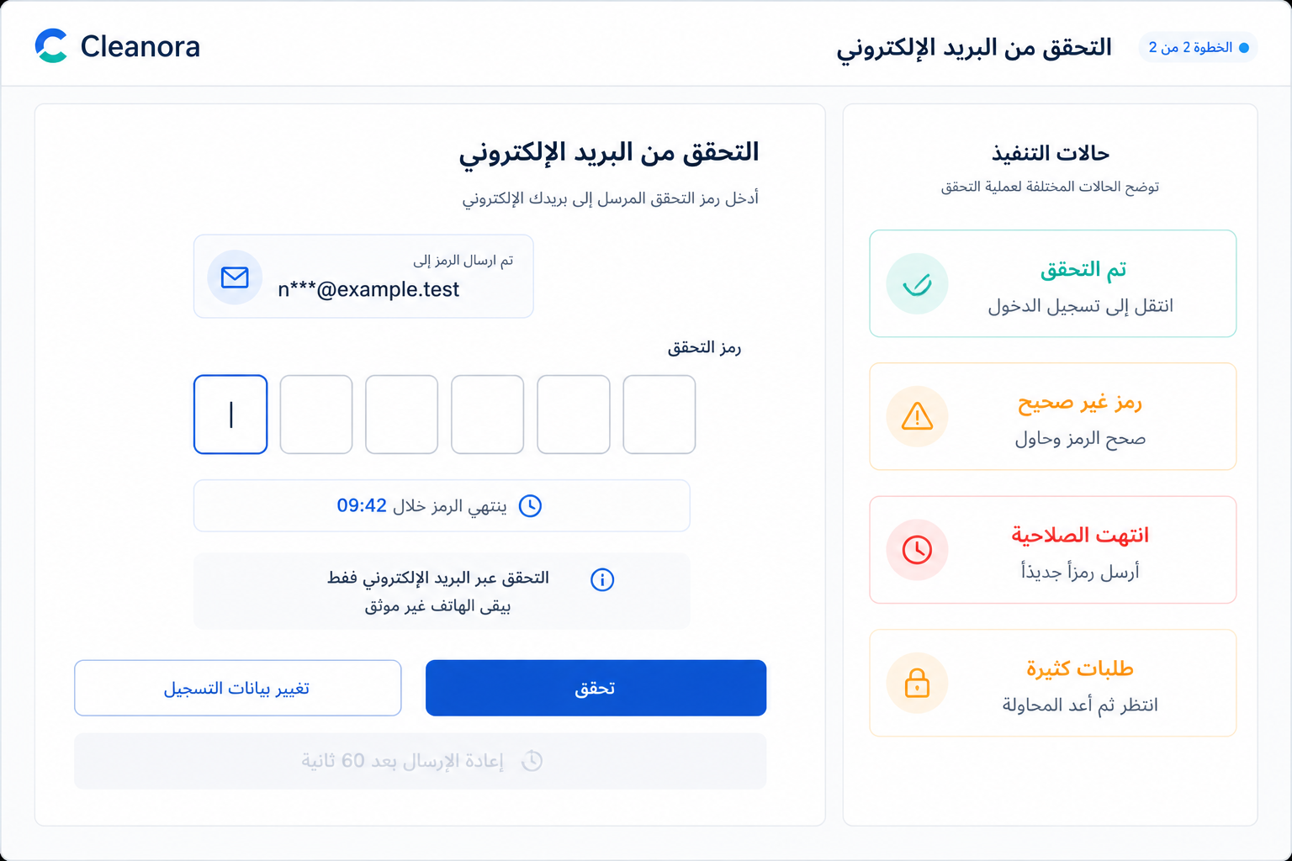
Figure 5 — Screen 02: Email OTP verification. Visual reference; the API cards in this guide are authoritative for integration details.

Exact frontend flow
- Render maskedDestination and the server timestamps from API 01/02/03.
- Accept exactly six numeric digits without storing them outside component state.
- Enable resend only at resendAvailableAt and call API 03 deliberately.
- Call API 04 once per Verify click.
- On LOGIN clear all OTP state and navigate to sign-in.

Main fields and components
- Masked email summary
- Six-cell OTP control
- Expiry and resend countdowns
- Verify and resend buttons
- Invalid, expired, throttled, and verified state cards

State implementation
State | Required behavior
Loading | Disable Verify/Resend separately and announce which request is active.
Empty | Missing challenge state cannot render the verifier; route to signup/enrollment recovery.
Validation | Reject non-six-digit input before the call; API verification failures remain non-enumerating.
Success | Show verified confirmation, clear code/challenge state, then route to sign-in.
Error / recovery | Invalid/expired/exhausted/replayed share AUTH_VERIFICATION_FAILED; a 429 uses Retry-After and a visible countdown.

Permission & privacy: Never persist or log OTP/challenge. Email verification does not verify the phone.

Navigation — Previous: Screen 01 or 03. Next: sign-in after nextAction=LOGIN.

APIs used on this screen
Method | Endpoint | Purpose | Detailed-guide reference
POST | /api/v1/auth/otp/request | Returns the active challenge during cooldown or supersedes it with a newly delivered email OTP when resend is available. | API 03 — detailed on canonical Screen 02
POST | /api/v1/auth/otp/verify | Consumes one active six-digit category-verification code and marks that category email-verified; the public flow then proceeds to login. | API 04 — detailed on canonical Screen 02

ACTOR SECTION 3
Authenticated Customer
Manages only SELF-owned customer data through a full or category-eligible authenticated session.
Screen | Title | Suggested route
03 | Add a customer category | /account/customer-categories/new
04 | Customer self-service center | /account
05 | Individual profile | /account/profiles/individual
06 | Company profile | /account/profiles/company
07 | Engineer profile | /account/profiles/engineer
08 | Shared profile image | /account/profile-image
09 | Contact verification state | /account/contact-state
10 | Language and notifications | /account/preferences
11 | Address book | /account/addresses
12 | Create or edit a text address | /account/addresses/new or /account/addresses/:addressId/edit
13 | Privacy request center | /account/privacy
14 | Submit a privacy request | /account/privacy/new
15 | Privacy request details and pending cancel | /account/privacy/:privacyRequestId

Boundary: No Staff Admin page exists. Processor claim/resolve and staff_admin reassignment are composition-only contracts without public HTTP routes.

Screen 03 — Add a customer category
Actor / role | Suggested frontend route | Purpose
Authenticated Customer | /account/customer-categories/new | Add another supported customer category and its required profile fields.

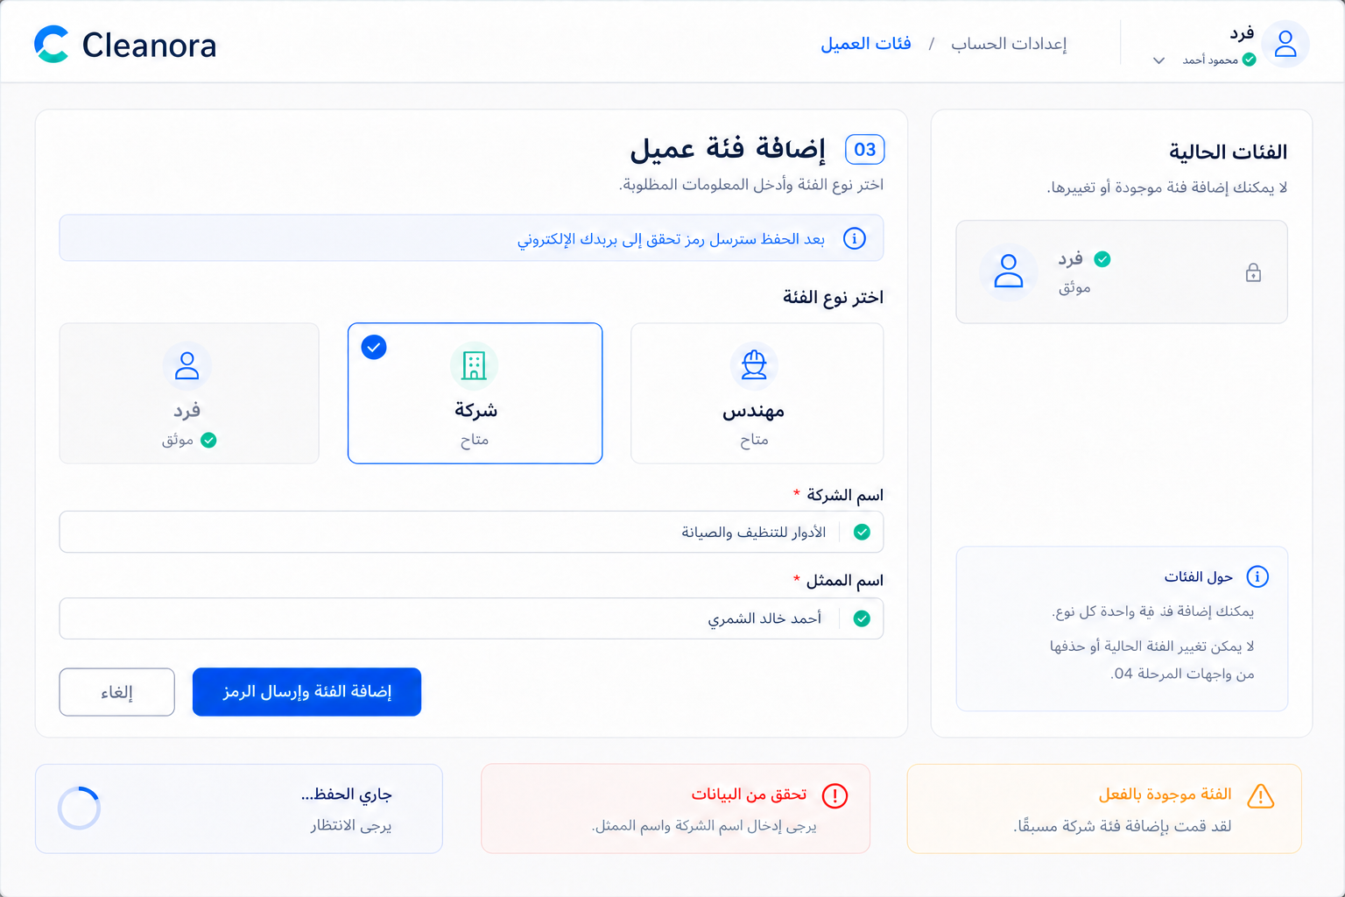
Figure 6 — Screen 03: Add a customer category. Visual reference; the API cards in this guide are authoritative for integration details.

Exact frontend flow
- Load current identity categories from the established authentication session state.
- Disable categories already enrolled; do not present remove/change controls.
- Render only the selected category's required profile fields.
- Submit API 02 once.
- On 202 add a pending chip and open Screen 02 for the returned email challenge.

Main fields and components
- Current verified/pending category list
- Available category selector
- Category-specific profile form
- Email-only handoff banner
- Atomic error/recovery messages

State implementation
State | Required behavior
Loading | Lock the selected category and submit button while enrollment is in flight.
Empty | If every supported category exists, show no available categories and hide the form.
Validation | Strict discriminated fields; existing-category conflict triggers a refetch.
Success | The category is pending, not verified, until Screen 02 succeeds.
Error / recovery | Do not fabricate partial enrollment after atomic failure or email-delivery failure.

Permission & privacy: Uses the current identity; never accepts a client owner ID.

Navigation — Previous: Screen 04. Next: Screen 02 for the new category challenge.

APIs used on this screen
Method | Endpoint | Purpose | Detailed-guide reference
POST | /api/v1/auth/account-categories | Adds a new pending customer category and its matching profile to the signed-in identity, then sends an email verification challenge. | API 02 — detailed on canonical Screen 03

Screen 04 — Customer self-service center
Actor / role | Suggested frontend route | Purpose
Authenticated Customer | /account | Client-composed overview of category profiles, image, contact state, preferences, addresses, and privacy requests.

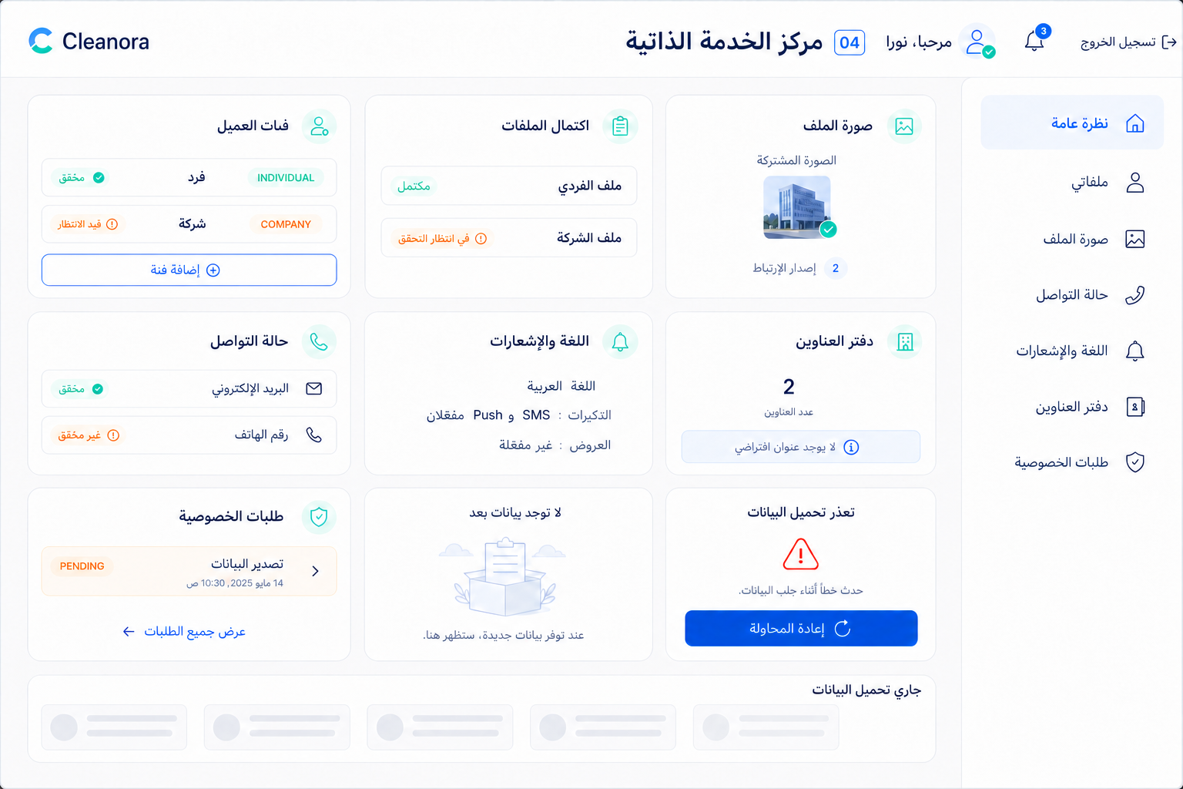
Figure 7 — Screen 04: Customer self-service center. Visual reference; the API cards in this guide are authoritative for integration details.

Exact frontend flow
- Start independent cancellable reads for only the visible summary cards.
- Use profile GETs only for categories the authenticated identity actually holds.
- Treat 204 image and empty arrays as normal empty states.
- Let one failed widget retry without blanking successful widgets.
- Navigate to the canonical detail screen for all mutations.

Main fields and components
- Customer-category/profile completion cards
- Shared-image card
- Contact and preference summaries
- Peer-address count
- Privacy-request status summary
- Customer-only navigation

State implementation
State | Required behavior
Loading | Per-card skeletons, not a blocking full-page spinner.
Empty | Dedicated empty cards for no image, addresses, or privacy requests.
Validation | No editable form on the hub; route to a canonical screen.
Success | Cards may finish independently and preserve their own cache timestamps.
Error / recovery | Retry the failed query only; do not repeatedly call mutations or invent an overview endpoint.

Permission & privacy: Do not aggregate protected values into analytics or durable client storage.

Navigation — Entry after sign-in; each card opens Screens 05–15.

APIs used on this screen
Method | Endpoint | Purpose | Detailed-guide reference
GET | /api/v1/customers/profiles/individual | Returns the owner-private Individual profile or an explicit created:false state. | API 05 — detailed on canonical Screen 05
GET | /api/v1/customers/profiles/company | Returns the owner-private Company profile or created:false, including nullable regulatory identifiers. | API 07 — detailed on canonical Screen 06
GET | /api/v1/customers/profiles/engineer | Returns the owner-private Engineer profile or an explicit created:false state. | API 09 — detailed on canonical Screen 07
GET | /api/v1/customers/profile-image | Returns a fresh signed Cloudinary delivery URL and safe image metadata, or HTTP 204 when no image is associated. | API 11 — detailed on canonical Screen 08
GET | /api/v1/customers/contact-state | Projects email/phone presence and verification from Authentication without exposing mutation controls. | API 14 — detailed on canonical Screen 09
GET | /api/v1/customers/preferences | Returns current or default identity-wide language and the complete optional/mandatory notification matrix. | API 15 — detailed on canonical Screen 10
GET | /api/v1/customers/addresses | Returns every owned peer text address; no item is default or primary. | API 17 — detailed on canonical Screen 11
GET | /api/v1/customers/privacy-requests | Returns the customer's non-purged privacy-request records and their visible lifecycle metadata. | API 22 — detailed on canonical Screen 13

Screen 05 — Individual profile
Actor / role | Suggested frontend route | Purpose
Authenticated Customer | /account/profiles/individual | Read and save the verified Individual profile.

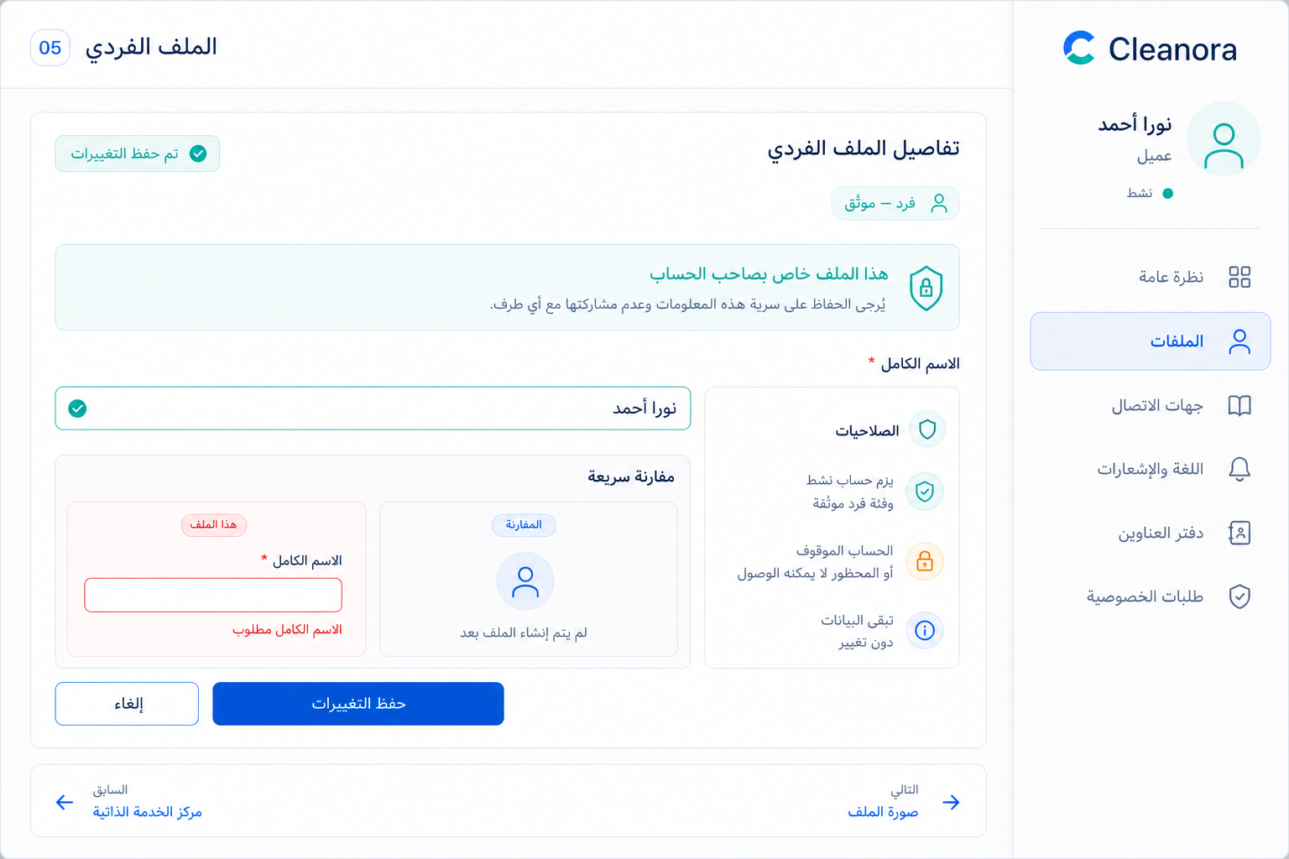
Figure 8 — Screen 05: Individual profile. Visual reference; the API cards in this guide are authoritative for integration details.

Exact frontend flow
- Read API 05.
- If created:false, render an empty fullName form.
- Let the user edit only fullName.
- Submit API 06 once.
- Replace the cache with the canonical response.

Main fields and components
- Verified Individual badge
- Full-name field
- Owner-private callout
- Saved indicator
- Save/Cancel actions

State implementation
State | Required behavior
Loading | Show a one-field form skeleton and disable Save.
Empty | created:false is a successful create-first state.
Validation | Required, trimmed, non-blank, maximum 200 characters; unknown fields are never sent.
Success | Update the profile cache and announce the save.
Error / recovery | 403 removes protected content and explains account/category eligibility without exposing another profile.

Permission & privacy: Owner-private; matching verified category and active SELF principal required.

Navigation — Previous: Screen 04. Next: Screen 08 or another verified profile.

APIs used on this screen
Method | Endpoint | Purpose | Detailed-guide reference
GET | /api/v1/customers/profiles/individual | Returns the owner-private Individual profile or an explicit created:false state. | API 05 — detailed on canonical Screen 05
PUT | /api/v1/customers/profiles/individual | Upserts the owner-private Individual profile with a trimmed non-blank full name. | API 06 — detailed on canonical Screen 05

Screen 06 — Company profile
Actor / role | Suggested frontend route | Purpose
Authenticated Customer | /account/profiles/company | Read and fully replace Company names and nullable regulatory identifiers.

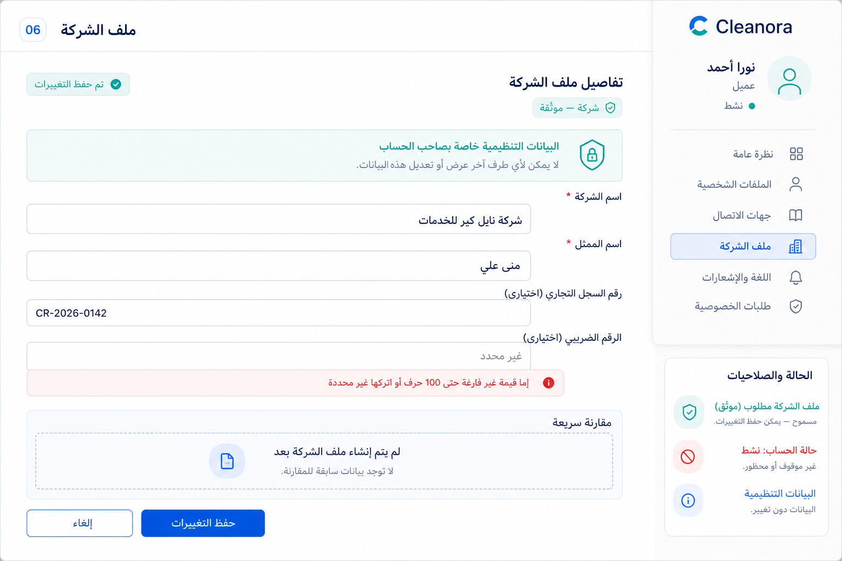
Figure 9 — Screen 06: Company profile. Visual reference; the API cards in this guide are authoritative for integration details.

Exact frontend flow
- Read API 07.
- Initialize nullable regulatory identifiers explicitly as null.
- Edit the complete four-field Company body.
- Submit API 08 once.
- Replace the cache with returned private state.

Main fields and components
- Verified Company badge
- Company and representative names
- Commercial/tax identifier controls
- Private-data notice
- Full-replacement Save action

State implementation
State | Required behavior
Loading | Skeleton all four controls; never display stale regulatory values from another identity.
Empty | created:false starts names blank and regulatory values null.
Validation | All four keys are required; identifiers are non-blank ≤100 characters or null.
Success | Replace local state from the response and clear dirty flags.
Error / recovery | Keep safe form values in memory only; never echo identifiers into diagnostics.

Permission & privacy: All values are owner-private; regulatory identifiers never enter URLs/logs/analytics/durable browser storage.

Navigation — Previous: Screen 04. Next: Screen 08.

APIs used on this screen
Method | Endpoint | Purpose | Detailed-guide reference
GET | /api/v1/customers/profiles/company | Returns the owner-private Company profile or created:false, including nullable regulatory identifiers. | API 07 — detailed on canonical Screen 06
PUT | /api/v1/customers/profiles/company | Full-replacement save for Company names and nullable commercial/tax registration identifiers. | API 08 — detailed on canonical Screen 06

Screen 07 — Engineer profile
Actor / role | Suggested frontend route | Purpose
Authenticated Customer | /account/profiles/engineer | Read and save the verified Engineer profile.

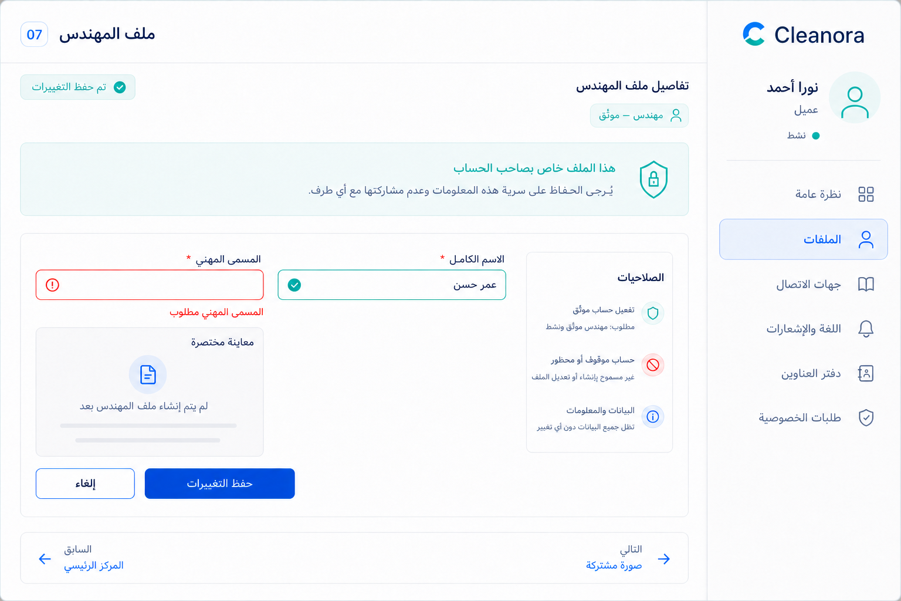
Figure 10 — Screen 07: Engineer profile. Visual reference; the API cards in this guide are authoritative for integration details.

Exact frontend flow
- Read API 09.
- Render created:false as a create-first form.
- Edit fullName and professionalTitle.
- Submit API 10 once.
- Replace the cached profile.

Main fields and components
- Verified Engineer badge
- Full name
- Professional title
- Owner-private callout
- Save/Cancel actions

State implementation
State | Required behavior
Loading | Two-field skeleton and disabled Save.
Empty | created:false with both fields blank.
Validation | Both fields required, trimmed, non-blank, maximum 200 characters.
Success | Returned canonical state becomes the form source of truth.
Error / recovery | Forbidden state hides the data and returns to the self-service center.

Permission & privacy: Owner-private; matching verified category and active SELF principal required.

Navigation — Previous: Screen 04. Next: Screen 08.

APIs used on this screen
Method | Endpoint | Purpose | Detailed-guide reference
GET | /api/v1/customers/profiles/engineer | Returns the owner-private Engineer profile or an explicit created:false state. | API 09 — detailed on canonical Screen 07
PUT | /api/v1/customers/profiles/engineer | Upserts the Engineer profile with a trimmed name and professional title. | API 10 — detailed on canonical Screen 07

Screen 08 — Shared profile image
Actor / role | Suggested frontend route | Purpose
Authenticated Customer | /account/profile-image | View, upload/replace, or remove the one image shared by all customer categories.

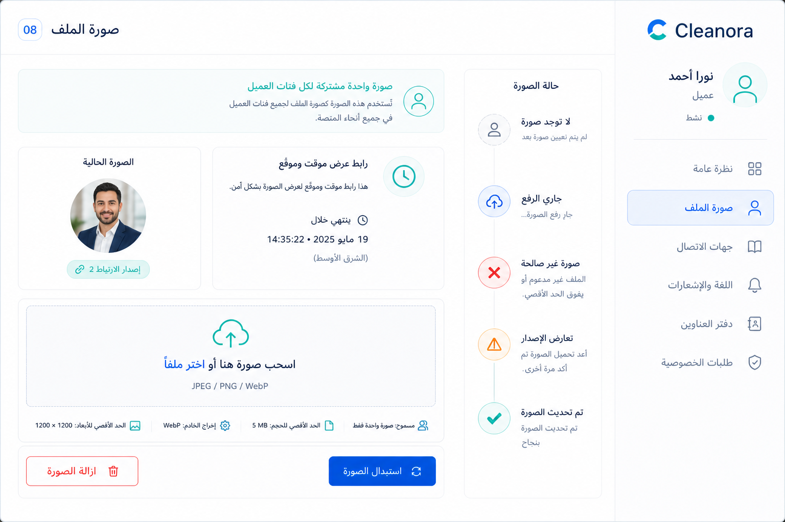
Figure 11 — Screen 08: Shared profile image. Visual reference; the API cards in this guide are authoritative for integration details.

Exact frontend flow
- Call API 11; treat 204 as no image.
- Validate one JPEG/PNG/WebP file ≤5 MiB and preview it locally.
- Upload through API 12 with the current associationVersion.
- On 409 refetch API 11 before another confirmation.
- Remove through API 13 only after a destructive confirmation.

Main fields and components
- Current signed image or empty avatar
- File picker/drop zone
- Format/size guidance
- Association-version status
- Replace and Remove actions

State implementation
State | Required behavior
Loading | Keep the current image visible; show upload progress and disable destructive controls.
Empty | HTTP 204 renders the no-image state without an error banner.
Validation | Reject wrong MIME, size, corrupt/animated/SVG input; the server normalizes to WebP.
Success | Replace caches from the aggregate or removal acknowledgement.
Error / recovery | Never remove the prior image on failed upload/CAS; 409 requires refetch and reconfirmation.

Permission & privacy: Signed URL is temporary; no Cloudinary key/public_id/credential is displayed or stored.

Navigation — Previous: profile. Next: Screen 09.

APIs used on this screen
Method | Endpoint | Purpose | Detailed-guide reference
GET | /api/v1/customers/profile-image | Returns a fresh signed Cloudinary delivery URL and safe image metadata, or HTTP 204 when no image is associated. | API 11 — detailed on canonical Screen 08
PUT | /api/v1/customers/profile-image | Always replaces the identity-wide image using multipart upload, Sharp normalization, Cloudinary protected storage, and association-version CAS. | API 12 — detailed on canonical Screen 08
DELETE | /api/v1/customers/profile-image | Clears the current association using CAS and schedules the prior Cloudinary asset for bounded asynchronous cleanup. | API 13 — detailed on canonical Screen 08

Screen 09 — Contact verification state
Actor / role | Suggested frontend route | Purpose
Authenticated Customer | /account/contact-state | Display authoritative read-only email/phone presence and verification.

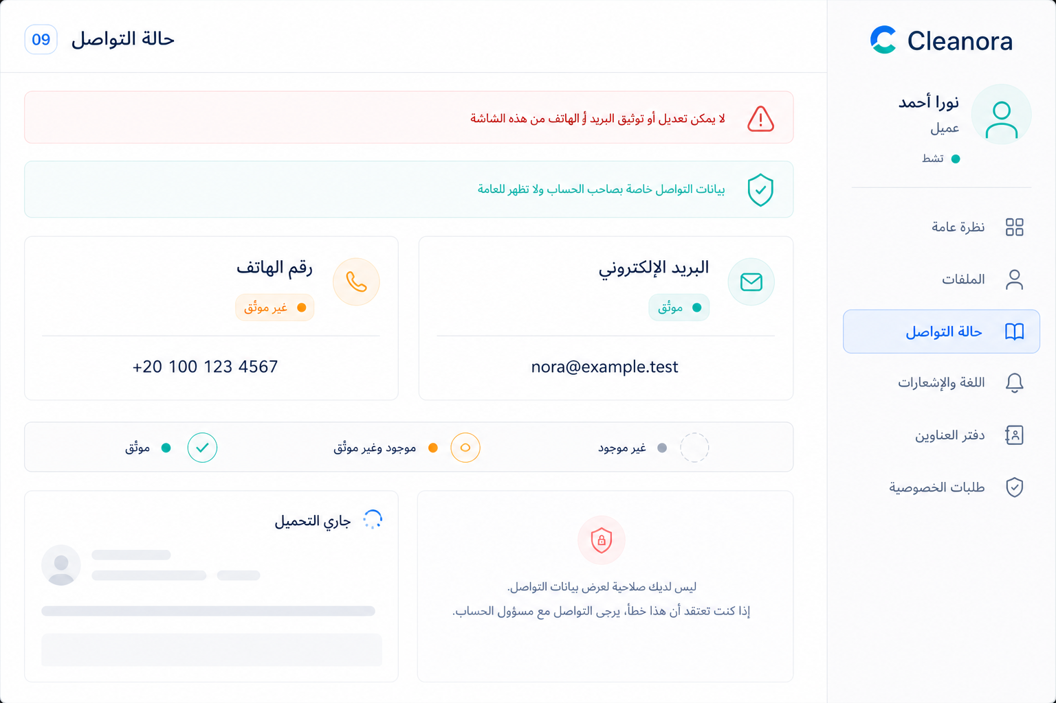
Figure 12 — Screen 09: Contact verification state. Visual reference; the API cards in this guide are authoritative for integration details.

Exact frontend flow
- Read API 14 on entry.
- Render email and phone independently as absent, unverified, or verified.
- Use exact values only in the owner-private view.
- Do not render edit or verify controls.
- Refetch after a later authentication-owned change, not on a timer.

Main fields and components
- Email state card
- Phone state card
- Read-only policy banner
- Verification legend
- Privacy notice

State implementation
State | Required behavior
Loading | Mask the values with skeletons rather than showing a prior user's contacts.
Empty | Null value renders Absent; it is distinct from present/unverified.
Validation | None—this screen accepts no mutation input.
Success | R1-P04A normally shows verified email and unverified phone.
Error / recovery | Hide both values on authorization/session failure; never put them in a toast diagnostic.

Permission & privacy: Private owner-only values; no edit or verify controls exist in Phase 04.

Navigation — Previous: Screen 08. Next: Screen 10.

APIs used on this screen
Method | Endpoint | Purpose | Detailed-guide reference
GET | /api/v1/customers/contact-state | Projects email/phone presence and verification from Authentication without exposing mutation controls. | API 14 — detailed on canonical Screen 09

Screen 10 — Language and notifications
Actor / role | Suggested frontend route | Purpose
Authenticated Customer | /account/preferences | Choose AR/EN/unset and replace the complete notification matrix.

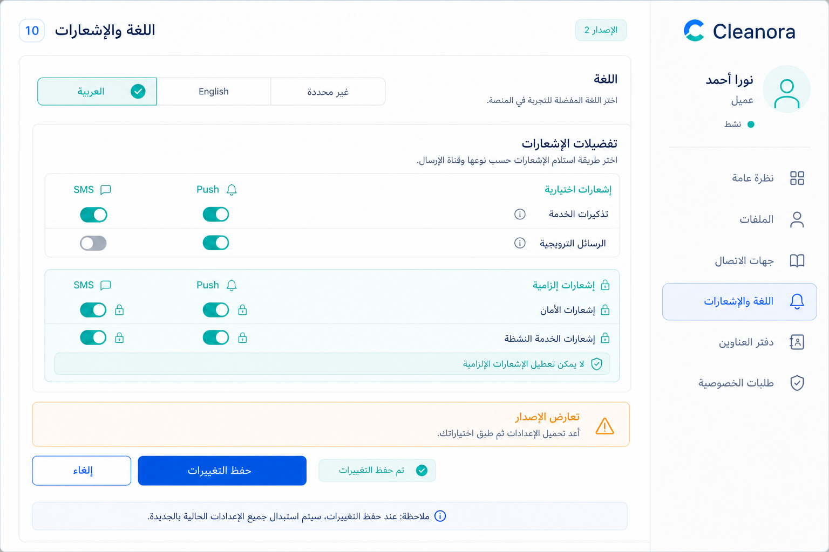
Figure 13 — Screen 10: Language and notifications. Visual reference; the API cards in this guide are authoritative for integration details.

Exact frontend flow
- Read API 15 and retain version.
- Let the user choose AR, EN, or explicit unset.
- Edit every reminders/promotional SMS/push flag while mandatory rows remain locked true.
- Submit the entire matrix through API 16.
- On 409 refetch and let the user deliberately reapply choices.

Main fields and components
- Language selector
- Optional reminders matrix
- Optional promotions matrix
- Locked mandatory matrix
- Version-aware Save action

State implementation
State | Required behavior
Loading | Skeleton the matrix and disable Save.
Empty | Server defaults are a valid preference state with version 1 and optional flags false.
Validation | Omitted fields or mandatory=false reject the whole request.
Success | Replace state with the returned incremented version.
Error / recovery | Never silently merge a 409; explain that settings changed elsewhere.

Permission & privacy: Identity-wide settings; do not infer consent for mandatory policy notices.

Navigation — Previous: Screen 09. Next: Screen 11.

APIs used on this screen
Method | Endpoint | Purpose | Detailed-guide reference
GET | /api/v1/customers/preferences | Returns current or default identity-wide language and the complete optional/mandatory notification matrix. | API 15 — detailed on canonical Screen 10
PUT | /api/v1/customers/preferences | Atomically replaces language plus every optional preference using version CAS; mandatory notices must remain enabled. | API 16 — detailed on canonical Screen 10

Screen 11 — Address book
Actor / role | Suggested frontend route | Purpose
Authenticated Customer | /account/addresses | List peer text addresses, open one, and confirm deletion.

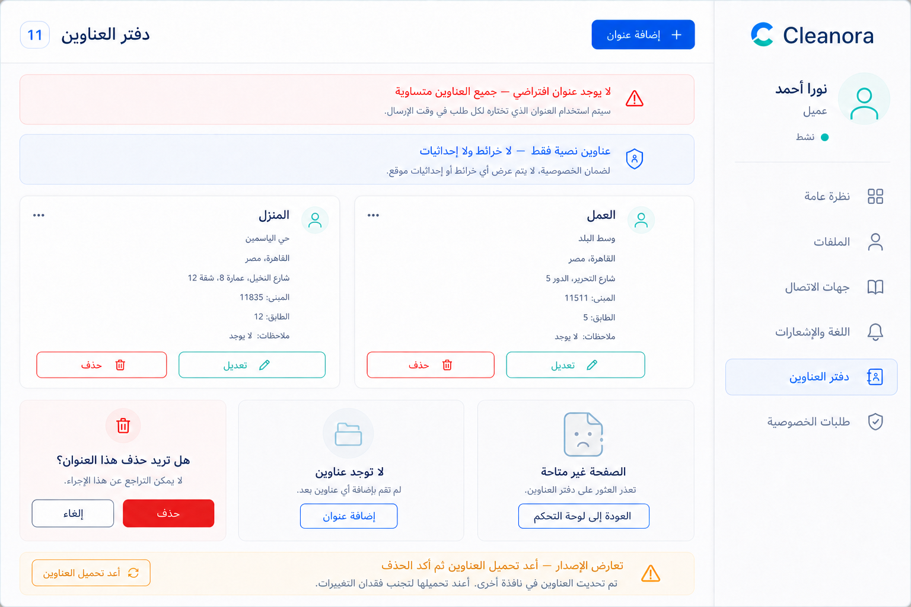
Figure 14 — Screen 11: Address book. Visual reference; the API cards in this guide are authoritative for integration details.

Exact frontend flow
- Read API 17.
- Render each peer address with Edit and Delete; never mark one default.
- Open one item with API 19 when details are needed.
- Confirm deletion and send API 21 with its version.
- Invalidate/refetch the list after create/update/delete.

Main fields and components
- Peer-address cards/list
- Add address button
- Edit action
- Delete confirmation
- No-default/no-map notice

State implementation
State | Required behavior
Loading | Address-card skeletons with all mutations disabled.
Empty | Friendly empty state and Add address call-to-action.
Validation | Delete requires a positive current version.
Success | Remove the deleted address from cache and announce completion.
Error / recovery | 404 removes stale items; 409 refetches and asks for a fresh confirmation.

Permission & privacy: Full address content must not appear in URLs, logs, analytics, or denial messages.

Navigation — Previous: Screen 10. Next: Screen 12 for create/edit.

APIs used on this screen
Method | Endpoint | Purpose | Detailed-guide reference
GET | /api/v1/customers/addresses | Returns every owned peer text address; no item is default or primary. | API 17 — detailed on canonical Screen 11
GET | /api/v1/customers/addresses/{addressId} | Returns one owned address; missing and cross-customer identifiers are deliberately indistinguishable. | API 19 — detailed on canonical Screen 12
DELETE | /api/v1/customers/addresses/{addressId} | Removes an owned peer address using the current version. | API 21 — detailed on canonical Screen 11

Screen 12 — Create or edit a text address
Actor / role | Suggested frontend route | Purpose
Authenticated Customer | /account/addresses/new or /account/addresses/:addressId/edit | Create version 1 or fully replace an owned address with CAS.

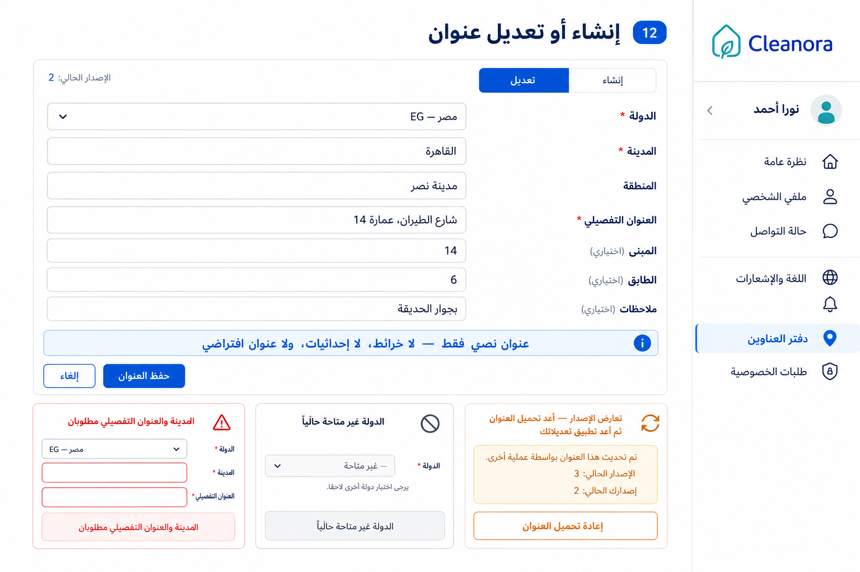
Figure 15 — Screen 12: Create or edit a text address. Visual reference; the API cards in this guide are authoritative for integration details.

Exact frontend flow
- For edit, read API 19; for create, initialize an empty text-address form.
- Accept country, city, district, address text and optional building/floor/notes only.
- Call API 18 for create or API 20 with current version for update.
- On 409 refetch the current address and preserve edits for deliberate reapplication.
- Return to Screen 11 after success.

Main fields and components
- Country code selector
- Required city/district/address text
- Optional building/floor/notes
- No-map/no-default notice
- Version-aware Save

State implementation
State | Required behavior
Loading | For edit, skeleton the form; for create, the form is immediately available.
Empty | New-address form with optional values null.
Validation | Strictly reject geo/default fields; unknown/inactive country yields CUSTOMER_ADDRESS_INVALID.
Success | Use the returned canonical address and version.
Error / recovery | 404 returns to list; 409 never overwrites the newer address automatically.

Permission & privacy: No map, coordinates, default, or primary control; owner is derived from the session.

Navigation — Previous/next: Screen 11.

APIs used on this screen
Method | Endpoint | Purpose | Detailed-guide reference
POST | /api/v1/customers/addresses | Creates one owned text address and resolves countryCode to an active Configuration country; version starts at 1. | API 18 — detailed on canonical Screen 12
GET | /api/v1/customers/addresses/{addressId} | Returns one owned address; missing and cross-customer identifiers are deliberately indistinguishable. | API 19 — detailed on canonical Screen 12
PUT | /api/v1/customers/addresses/{addressId} | Full-replacement update for an owned text address using its current version. | API 20 — detailed on canonical Screen 12

Screen 13 — Privacy request center
Actor / role | Suggested frontend route | Purpose
Authenticated Customer | /account/privacy | List and inspect visible request metadata across all five lifecycle states.

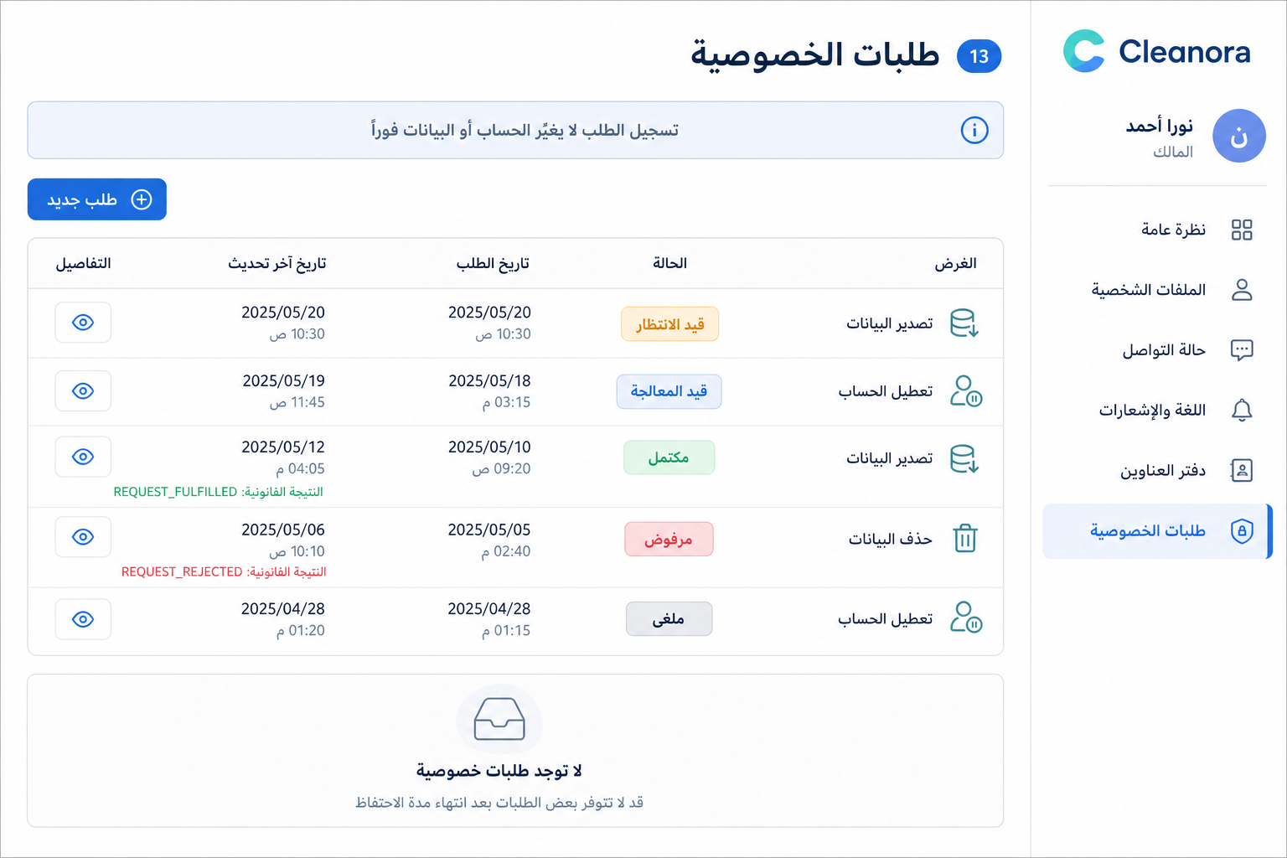
Figure 16 — Screen 13: Privacy request center. Visual reference; the API cards in this guide are authoritative for integration details.

Exact frontend flow
- Read API 22.
- Group/display owned metadata without adding unsupported filters or pagination.
- Render all five status badges and legal closed outcomes.
- Open Screen 15 with API 24 for detail.
- Start Screen 14 for a new purpose.

Main fields and components
- Purpose/status filters in client memory
- Request timeline rows
- Empty state
- New request action
- Retention/request-only explanation

State implementation
State | Required behavior
Loading | List skeletons; do not show stale data from a prior identity.
Empty | No requests is a normal state.
Validation | No list query parameters exist in Phase 04.
Success | Purged metadata is already excluded by the server.
Error / recovery | Authorization failure hides all metadata; individual 404 is handled on Screen 15.

Permission & privacy: No rationale, processor identity, purge date, account data, or export archive is exposed.

Navigation — Previous: Screen 04. Next: Screen 14 or 15.

APIs used on this screen
Method | Endpoint | Purpose | Detailed-guide reference
GET | /api/v1/customers/privacy-requests | Returns the customer's non-purged privacy-request records and their visible lifecycle metadata. | API 22 — detailed on canonical Screen 13
GET | /api/v1/customers/privacy-requests/{privacyRequestId} | Returns one owner-visible, non-purged request; missing, purged, and cross-customer IDs are indistinguishable. | API 24 — detailed on canonical Screen 15

Screen 14 — Submit a privacy request
Actor / role | Suggested frontend route | Purpose
Authenticated Customer | /account/privacy/new | Explain consequences and submit EXPORT, DEACTIVATION, or DELETION intent.

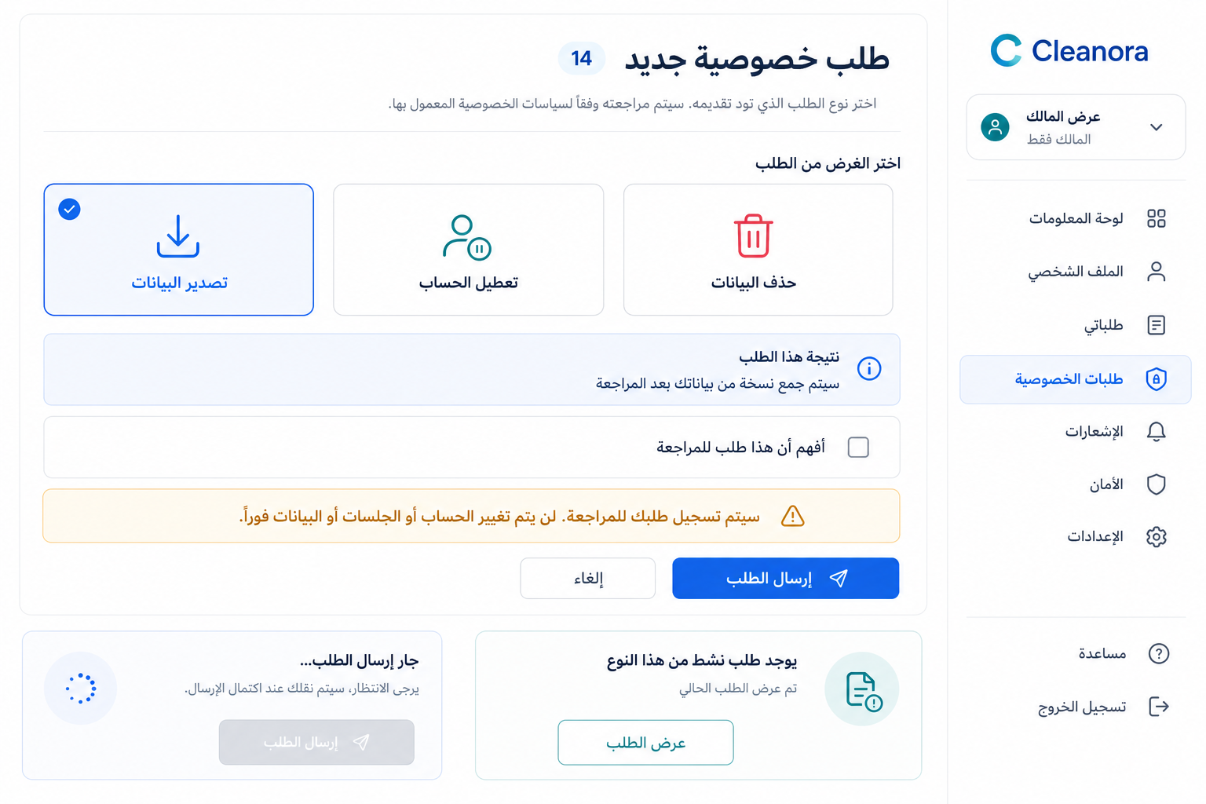
Figure 17 — Screen 14: Submit a privacy request. Visual reference; the API cards in this guide are authoritative for integration details.

Exact frontend flow
- Choose EXPORT, DEACTIVATION, or DELETION.
- Show exact request-intake consequences and clarify that no immediate action occurs.
- Require explicit confirmation.
- Submit API 23 once.
- Navigate to Screen 15 using the returned request, including an existing active request.

Main fields and components
- Three purpose cards
- Consequence callout
- Request-only disclaimer
- Confirm checkbox
- Submit/Cancel actions

State implementation
State | Required behavior
Loading | Disable all purpose changes and submit while in flight.
Empty | No purpose selected; Submit disabled.
Validation | Only the three closed purpose values are valid.
Success | Show PENDING or the existing active request; never show fulfilled.
Error / recovery | Keep selection and allow manual retry; do not invent account/data side effects.

Permission & privacy: Submission is request intake only; never claim immediate deactivation/deletion/export fulfillment.

Navigation — Previous: Screen 13. Next: Screen 15.

APIs used on this screen
Method | Endpoint | Purpose | Detailed-guide reference
POST | /api/v1/customers/privacy-requests | Creates a PENDING request for EXPORT, DEACTIVATION, or DELETION—or returns the existing active request for the same purpose. | API 23 — detailed on canonical Screen 14

Screen 15 — Privacy request details and pending cancel
Actor / role | Suggested frontend route | Purpose
Authenticated Customer | /account/privacy/:privacyRequestId | Track one request and cancel it only while PENDING.

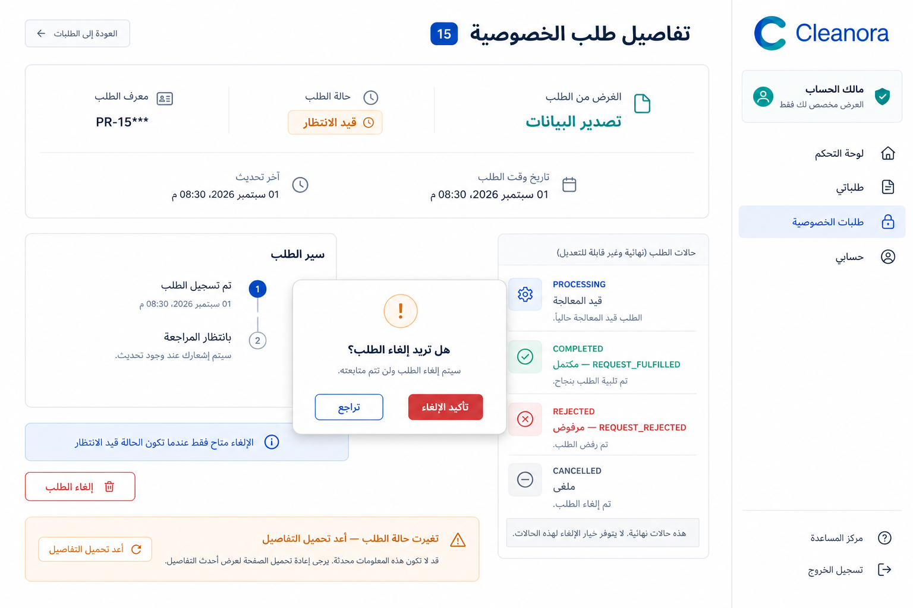
Figure 18 — Screen 15: Privacy request details and pending cancel. Visual reference; the API cards in this guide are authoritative for integration details.

Exact frontend flow
- Read API 24.
- Render the lifecycle timeline and closed outcome if present.
- Show Cancel only when status=PENDING.
- After confirmation call API 25 once.
- Replace list/detail caches from the result or refetch after a conflict.

Main fields and components
- Purpose/status header
- Timestamp timeline
- Closed outcome panel
- Pending-only Cancel action
- Ownership-safe unavailable state

State implementation
State | Required behavior
Loading | Detail skeleton with Cancel hidden.
Empty | 404/unavailable routes back to the request center without ownership disclosure.
Validation | Cancel has no body and is legal only from PENDING.
Success | CANCELLED becomes terminal; the screen remains read-only.
Error / recovery | Transition/conflict triggers a refetch; never retry cancellation automatically.

Permission & privacy: Opaque request ID only; ownership-safe 404; no customer data or processor fields.

Navigation — Previous/next: Screen 13.

APIs used on this screen
Method | Endpoint | Purpose | Detailed-guide reference
GET | /api/v1/customers/privacy-requests/{privacyRequestId} | Returns one owner-visible, non-purged request; missing, purged, and cross-customer IDs are indistinguishable. | API 24 — detailed on canonical Screen 15
POST | /api/v1/customers/privacy-requests/{privacyRequestId}/cancel | Transitions an owned PENDING request to CANCELLED before any processor claim and schedules terminal metadata retention. | API 25 — detailed on canonical Screen 15

Complete API documentation
The following 25 cards are the canonical detailed explanations for the Phase 04 family. Every operation appears exactly once as a full card. Screen tables cross-reference these cards instead of duplicating them.
API | Method | Full endpoint | Canonical screen
API 01 | POST | /api/v1/auth/signup | Screen 01
API 02 | POST | /api/v1/auth/account-categories | Screen 03
API 03 | POST | /api/v1/auth/otp/request | Screen 02
API 04 | POST | /api/v1/auth/otp/verify | Screen 02
API 05 | GET | /api/v1/customers/profiles/individual | Screen 05
API 06 | PUT | /api/v1/customers/profiles/individual | Screen 05
API 07 | GET | /api/v1/customers/profiles/company | Screen 06
API 08 | PUT | /api/v1/customers/profiles/company | Screen 06
API 09 | GET | /api/v1/customers/profiles/engineer | Screen 07
API 10 | PUT | /api/v1/customers/profiles/engineer | Screen 07
API 11 | GET | /api/v1/customers/profile-image | Screen 08
API 12 | PUT | /api/v1/customers/profile-image | Screen 08
API 13 | DELETE | /api/v1/customers/profile-image | Screen 08
API 14 | GET | /api/v1/customers/contact-state | Screen 09
API 15 | GET | /api/v1/customers/preferences | Screen 10
API 16 | PUT | /api/v1/customers/preferences | Screen 10
API 17 | GET | /api/v1/customers/addresses | Screen 11
API 18 | POST | /api/v1/customers/addresses | Screen 12
API 19 | GET | /api/v1/customers/addresses/{addressId} | Screen 12
API 20 | PUT | /api/v1/customers/addresses/{addressId} | Screen 12
API 21 | DELETE | /api/v1/customers/addresses/{addressId} | Screen 11
API 22 | GET | /api/v1/customers/privacy-requests | Screen 13
API 23 | POST | /api/v1/customers/privacy-requests | Screen 14
API 24 | GET | /api/v1/customers/privacy-requests/{privacyRequestId} | Screen 15
API 25 | POST | /api/v1/customers/privacy-requests/{privacyRequestId}/cancel | Screen 15

API 01 — Create a category-aware customer account
API CARD 01 | operationId: signup | canonical Screen 01
POST | /api/v1/auth/signup | Create a category-aware customer account

What it does | Who can use it | Authentication
Atomically creates an identity plus the matching customer profile, then sends the blocking category-verification OTP by email. | Anonymous new customer selecting INDIVIDUAL, COMPANY, or ENGINEER. PROVIDER_OWNER and WORKER are rejected by the live schema. | Public client; no bearer token.

Inputs
Path parameters | Query parameters | Material headers
None. | None. | Content-Type: application/json; Accept: application/json.

Representative request body
{
"accountCategory": "INDIVIDUAL",
"fullName": "Nora Ahmed",
"phone": "+201001234567",
"email": "nora@example.test",
"password": "Nora-4829517"
}

- INDIVIDUAL requires fullName; COMPANY requires companyName and representativeFullName; ENGINEER requires fullName and professionalTitle.
- All variants require E.164 phone, email, and a 7–128 character password that is not common, repeated, or sequential.
- The union is strict: fields belonging to another category are rejected. Commercial/tax identifiers are not signup fields.
- The returned channel is EMAIL. Successful activation does not verify the phone.

Representative success
HTTP 202
{
"success": true,
"data": {
"accepted": true,
"challengeId": "otp_challenge_01",
"nextAction": "VERIFY_ACCOUNT",
"accountCategory": "INDIVIDUAL",
"purpose": "CATEGORY_VERIFICATION",
"channel": "EMAIL",
"maskedDestination": "n***@example.test",
"expiresAt": "2026-09-01T16:10:00.000Z",
"resendAvailableAt": "2026-09-01T16:01:00.000Z"
},
"requestId": "8b7d1f6a-5c2f-4ca1-a905-7f49f99f0d11"
}

- challengeId is opaque.
- maskedDestination is display-safe.
- expiresAt and resendAvailableAt drive the OTP UI.

Efficient frontend usage and cache behavior
- Disable submit while the mutation is in flight; do not retry automatically because identity creation is a mutation.
- Store challengeId only in short-lived in-memory/session flow state, never in a URL or analytics event.
- Navigate to Screen 02 with maskedDestination, expiresAt, and resendAvailableAt from the response.
Copyable Axios TypeScript integration
export async function signupCustomer(body: SignupBody, signal?: AbortSignal) {
const response = await publicApi.post<ApiEnvelope<VerificationChallenge>>(
'/auth/signup', body, { signal }
);
return response.data.data;
}

Possible errors and exact frontend recovery
HTTP | Stable code | Meaning | Frontend recovery
400 | REQUEST_VALIDATION_FAILED | The strict body/path contract rejected one or more fields; details.issues contains safe field paths. | Map issues to controls, keep valid input in memory, and focus the first invalid field.
409 | AUTH_PHONE_ALREADY_REGISTERED | The normalized phone already belongs to an account. | Focus phone and offer sign-in.
409 | AUTH_EMAIL_ALREADY_REGISTERED | The normalized email already belongs to an account. | Focus email and offer sign-in.
409 | AUTH_SIGNUP_IDENTIFIERS_ALREADY_REGISTERED | Both phone and email already belong to an account. | Show both field errors and offer sign-in.
409 | AUTH_SIGNUP_UNAVAILABLE | The transaction could not complete with the supplied data or lost a creation race. | Keep non-secret form data and let the user resubmit after reviewing conflicts.
429 | RATE_LIMIT_EXCEEDED | The signup IP/subject policy rejected the attempt. | Honor Retry-After, disable submit, and show a countdown.
503 | RATE_LIMITER_UNAVAILABLE | Request protection is temporarily unavailable. | Show a temporary-service message and allow a manual retry.
503 | AUTH_PROVIDER_UNAVAILABLE | Email OTP delivery failed; the failed new signup is rolled back. | Do not advance; let the user retry signup later.

Retry rule: Never silently retry this operation if it mutates state. Reads may be manually retried and should support AbortSignal cancellation.

API 02 — Enroll another customer category
API CARD 02 | operationId: enrollCategory | canonical Screen 03
POST | /api/v1/auth/account-categories | Enroll another customer category

What it does | Who can use it | Authentication
Adds a new pending customer category and its matching profile to the signed-in identity, then sends an email verification challenge. | Fully authenticated customer; verification-only sessions cannot enroll. Only INDIVIDUAL, COMPANY, and ENGINEER are accepted. | Authenticated client with a full bearer session.

Inputs
Path parameters | Query parameters | Material headers
None. | None. | Accept: application/json. The authenticated client also sends Authorization: Bearer <accessToken>.

Representative request body
{
"accountCategory": "COMPANY",
"companyName": "Nile Care Services",
"representativeFullName": "Mona Ali"
}

- Use the same category-specific profile fields as signup, but do not resend phone/email/password.
- Enrollment/profile creation is atomic. The category remains pending until the email OTP succeeds.
- The live API does not expose category removal or changing one category into another.

Representative success
HTTP 202
{
"success": true,
"data": {
"accepted": true,
"challengeId": "otp_challenge_01",
"nextAction": "VERIFY_ACCOUNT",
"accountCategory": "COMPANY",
"purpose": "CATEGORY_VERIFICATION",
"channel": "EMAIL",
"maskedDestination": "n***@example.test",
"expiresAt": "2026-09-01T16:10:00.000Z",
"resendAvailableAt": "2026-09-01T16:01:00.000Z"
},
"requestId": "8b7d1f6a-5c2f-4ca1-a905-7f49f99f0d11"
}

Efficient frontend usage and cache behavior
- Refetch identity/category state after 202.
- Open Screen 02 with the returned challenge.
- Do not optimistically mark the category verified.
Copyable Axios TypeScript integration
export async function enrollCustomerCategory(body: EnrollCategoryBody, signal?: AbortSignal) {
const response = await api.post<ApiEnvelope<VerificationChallenge>>(
'/auth/account-categories', body, { signal }
);
return response.data.data;
}

Possible errors and exact frontend recovery
HTTP | Stable code | Meaning | Frontend recovery
400 | REQUEST_VALIDATION_FAILED | The strict body/path contract rejected one or more fields; details.issues contains safe field paths. | Map issues to controls, keep valid input in memory, and focus the first invalid field.
401 | AUTHENTICATION_REQUIRED | No bearer session is present. | Route to sign-in and preserve only a safe return path.
401 | AUTH_ACCESS_TOKEN_INVALID | The access token is invalid or expired. | Refresh through the established session flow once; otherwise sign in again.
403 | AUTH_VERIFICATION_REQUIRED | The current session is verification-only. | Finish its pending verification first.
409 | AUTH_CATEGORY_STATE_CONFLICT | The category already exists or cannot be enrolled in its current state. | Refetch category state; disable the already-enrolled choice.
409 | AUTH_SIGNUP_UNAVAILABLE | Atomic enrollment/profile creation failed. | Keep the form and allow one deliberate retry.
503 | AUTH_PROVIDER_UNAVAILABLE | The verification email could not be delivered. | Do not show the category as ready; retry later.

Retry rule: Never silently retry this operation if it mutates state. Reads may be manually retried and should support AbortSignal cancellation.

API 03 — Request or resend the email OTP
API CARD 03 | operationId: requestVerificationOtp | canonical Screen 02
POST | /api/v1/auth/otp/request | Request or resend the email OTP

What it does | Who can use it | Authentication
Returns the active challenge during cooldown or supersedes it with a newly delivered email OTP when resend is available. | Customer holding an opaque R1-P04A verification challenge. | Public client; the opaque challenge is the selector.

Inputs
Path parameters | Query parameters | Material headers
None. | None. | Content-Type: application/json; Accept: application/json.

Representative request body
{
"challengeId": "otp_challenge_01"
}

- Preferred input is challengeId. The alternate userId + accountCategory selector is not needed by the public frontend flow.
- purpose is CATEGORY_VERIFICATION.
- Cooldown is represented by resendAvailableAt; current default is 60 seconds.

Representative success
HTTP 202
{
"success": true,
"data": {
"accepted": true,
"challengeId": "otp_challenge_01",
"nextAction": "VERIFY_ACCOUNT",
"accountCategory": "INDIVIDUAL",
"purpose": "CATEGORY_VERIFICATION",
"channel": "EMAIL",
"maskedDestination": "n***@example.test",
"expiresAt": "2026-09-01T16:10:00.000Z",
"resendAvailableAt": "2026-09-01T16:01:00.000Z"
},
"requestId": "8b7d1f6a-5c2f-4ca1-a905-7f49f99f0d11"
}

Efficient frontend usage and cache behavior
- Disable resend until resendAvailableAt.
- Replace local challenge state with the returned values.
- Never reveal whether an unrelated account exists.
Copyable Axios TypeScript integration
export async function requestVerificationOtp(challengeId: string, signal?: AbortSignal) {
const response = await publicApi.post<ApiEnvelope<VerificationChallenge>>(
'/auth/otp/request', { challengeId }, { signal }
);
return response.data.data;
}

Possible errors and exact frontend recovery
HTTP | Stable code | Meaning | Frontend recovery
400 | REQUEST_VALIDATION_FAILED | The strict body/path contract rejected one or more fields; details.issues contains safe field paths. | Map issues to controls, keep valid input in memory, and focus the first invalid field.
400 | AUTH_VERIFICATION_FAILED | The selector is invalid, expired, invitation-owned, or unavailable. | Return to signup/enrollment recovery; do not guess another selector.
429 | RATE_LIMIT_EXCEEDED | OTP-send limits were exceeded. | Honor Retry-After and keep resend disabled.
503 | RATE_LIMITER_UNAVAILABLE | Request protection is temporarily unavailable. | Allow manual retry later.
503 | AUTH_PROVIDER_UNAVAILABLE | Email delivery is temporarily unavailable. | Keep the current screen and allow manual resend later.

Retry rule: Never silently retry this operation if it mutates state. Reads may be manually retried and should support AbortSignal cancellation.

API 04 — Verify the six-digit email OTP
API CARD 04 | operationId: verifyOtp | canonical Screen 02
POST | /api/v1/auth/otp/verify | Verify the six-digit email OTP

What it does | Who can use it | Authentication
Consumes one active six-digit category-verification code and marks that category email-verified; the public flow then proceeds to login. | Customer with an active R1-P04A email challenge. | Public client; no bearer session is required for the public flow.

Inputs
Path parameters | Query parameters | Material headers
None. | None. | Content-Type: application/json; Accept: application/json.

Representative request body
{
"challengeId": "otp_challenge_01",
"code": "482951"
}

- code is exactly six decimal digits.
- The challenge expires after the configured TTL (current default 10 minutes) and has at most five attempts.
- Success verifies email for the category. phoneVerified remains false.

Representative success
HTTP 200
{
"success": true,
"data": {
"verified": true,
"nextAction": "LOGIN"
},
"requestId": "8b7d1f6a-5c2f-4ca1-a905-7f49f99f0d11"
}

Efficient frontend usage and cache behavior
- Disable Verify during the call.
- On LOGIN, clear OTP/code state and navigate to sign-in.
- Never log code or challengeId; do not auto-retry a failed verification mutation.
Copyable Axios TypeScript integration
export async function verifyEmailOtp(body: { challengeId: string; code: string }, signal?: AbortSignal) {
const response = await publicApi.post<ApiEnvelope<VerificationResult>>(
'/auth/otp/verify', body, { signal }
);
return response.data.data;
}

Possible errors and exact frontend recovery
HTTP | Stable code | Meaning | Frontend recovery
400 | REQUEST_VALIDATION_FAILED | The strict body/path contract rejected one or more fields; details.issues contains safe field paths. | Map issues to controls, keep valid input in memory, and focus the first invalid field.
400 | AUTH_VERIFICATION_FAILED | The code/challenge is invalid, expired, exhausted, replayed, or already used. | Show one non-enumerating message; clear the code and enable resend when permitted.
429 | RATE_LIMIT_EXCEEDED | OTP verification requests exceeded the IP policy. | Honor Retry-After and disable Verify.
503 | RATE_LIMITER_UNAVAILABLE | Request protection is temporarily unavailable. | Keep the screen and allow a later manual retry.

Retry rule: Never silently retry this operation if it mutates state. Reads may be manually retried and should support AbortSignal cancellation.

API 05 — Read the Individual profile
API CARD 05 | operationId: getIndividualProfile | canonical Screen 05
GET | /api/v1/customers/profiles/individual | Read the Individual profile

What it does | Who can use it | Authentication
Returns the owner-private Individual profile or an explicit created:false state. | Active SELF principal with a verified INDIVIDUAL category. | Authenticated customer client.

Inputs
Path parameters | Query parameters | Material headers
None. | None. | Accept: application/json. The authenticated client also sends Authorization: Bearer <accessToken>.

Request body
No request body.

- created:false is a successful empty state, not a 404.
- Only fullName belongs to the Individual profile.

Representative success
HTTP 200
{
"success": true,
"data": {
"category": "INDIVIDUAL",
"created": true,
"fullName": "Nora Ahmed"
},
"requestId": "8b7d1f6a-5c2f-4ca1-a905-7f49f99f0d11"
}

Efficient frontend usage and cache behavior
- Cache per signed-in identity and invalidate after API 06.
- Abort stale route loads with AbortSignal.
Copyable Axios TypeScript integration
export async function getIndividualProfile(signal?: AbortSignal) {
const response = await api.get<ApiEnvelope<CustomerProfile>>(
'/customers/profiles/individual', { signal }
);
return response.data.data;
}

Possible errors and exact frontend recovery
HTTP | Stable code | Meaning | Frontend recovery
401 | AUTHENTICATION_REQUIRED | No bearer session is present. | Route to sign-in and preserve only a safe return path.
401 | AUTH_ACCESS_TOKEN_INVALID | The access token is invalid or expired. | Refresh through the established session flow once; otherwise sign in again.
403 | CUSTOMER_PROFILE_FORBIDDEN | The principal is inactive, lacks an eligible verified/pending customer category for this family, or cannot satisfy SELF access. | Hide protected content, do not retry automatically, and show the account-eligibility message.

Retry rule: Never silently retry this operation if it mutates state. Reads may be manually retried and should support AbortSignal cancellation.

API 06 — Create or replace the Individual profile
API CARD 06 | operationId: putIndividualProfile | canonical Screen 05
PUT | /api/v1/customers/profiles/individual | Create or replace the Individual profile

What it does | Who can use it | Authentication
Upserts the owner-private Individual profile with a trimmed non-blank full name. | Active SELF principal with a verified INDIVIDUAL category. | Authenticated customer client.

Inputs
Path parameters | Query parameters | Material headers
None. | None. | Accept: application/json. The authenticated client also sends Authorization: Bearer <accessToken>.

Representative request body
{
"fullName": "Nora Ahmed"
}

- fullName is required, trimmed, non-blank, and at most 200 characters.
- Unknown fields—including phone/email—are rejected.

Representative success
HTTP 200
{
"success": true,
"data": {
"category": "INDIVIDUAL",
"created": true,
"fullName": "Nora Ahmed"
},
"requestId": "8b7d1f6a-5c2f-4ca1-a905-7f49f99f0d11"
}

Efficient frontend usage and cache behavior
- Disable Save in flight; do not auto-retry.
- Replace the cached profile with the returned canonical state.
Copyable Axios TypeScript integration
export async function putIndividualProfile(body: { fullName: string }, signal?: AbortSignal) {
const response = await api.put<ApiEnvelope<CustomerProfile>>(
'/customers/profiles/individual', body, { signal }
);
return response.data.data;
}

Possible errors and exact frontend recovery
HTTP | Stable code | Meaning | Frontend recovery
400 | REQUEST_VALIDATION_FAILED | The strict body/path contract rejected one or more fields; details.issues contains safe field paths. | Map issues to controls, keep valid input in memory, and focus the first invalid field.
401 | AUTHENTICATION_REQUIRED | No bearer session is present. | Route to sign-in and preserve only a safe return path.
401 | AUTH_ACCESS_TOKEN_INVALID | The access token is invalid or expired. | Refresh through the established session flow once; otherwise sign in again.
403 | CUSTOMER_PROFILE_FORBIDDEN | The principal is inactive, lacks an eligible verified/pending customer category for this family, or cannot satisfy SELF access. | Hide protected content, do not retry automatically, and show the account-eligibility message.

Retry rule: Never silently retry this operation if it mutates state. Reads may be manually retried and should support AbortSignal cancellation.

API 07 — Read the Company profile
API CARD 07 | operationId: getCompanyProfile | canonical Screen 06
GET | /api/v1/customers/profiles/company | Read the Company profile

What it does | Who can use it | Authentication
Returns the owner-private Company profile or created:false, including nullable regulatory identifiers. | Active SELF principal with a verified COMPANY category. | Authenticated customer client.

Inputs
Path parameters | Query parameters | Material headers
None. | None. | Accept: application/json. The authenticated client also sends Authorization: Bearer <accessToken>.

Request body
No request body.

- commercialRegistrationNumber and taxRegistrationNumber are private nullable strings.
- A new Company profile exposes both regulatory values as null.

Representative success
HTTP 200
{
"success": true,
"data": {
"category": "COMPANY",
"created": true,
"companyName": "Nile Care Services",
"representativeFullName": "Mona Ali",
"commercialRegistrationNumber": "CR-2026-0142",
"taxRegistrationNumber": null
},
"requestId": "8b7d1f6a-5c2f-4ca1-a905-7f49f99f0d11"
}

Efficient frontend usage and cache behavior
- Cache per identity and invalidate after API 08.
- Do not place regulatory identifiers in routes, logs, or analytics.
Copyable Axios TypeScript integration
export async function getCompanyProfile(signal?: AbortSignal) {
const response = await api.get<ApiEnvelope<CustomerProfile>>(
'/customers/profiles/company', { signal }
);
return response.data.data;
}

Possible errors and exact frontend recovery
HTTP | Stable code | Meaning | Frontend recovery
401 | AUTHENTICATION_REQUIRED | No bearer session is present. | Route to sign-in and preserve only a safe return path.
401 | AUTH_ACCESS_TOKEN_INVALID | The access token is invalid or expired. | Refresh through the established session flow once; otherwise sign in again.
403 | CUSTOMER_PROFILE_FORBIDDEN | The principal is inactive, lacks an eligible verified/pending customer category for this family, or cannot satisfy SELF access. | Hide protected content, do not retry automatically, and show the account-eligibility message.

Retry rule: Never silently retry this operation if it mutates state. Reads may be manually retried and should support AbortSignal cancellation.

API 08 — Create or replace the Company profile
API CARD 08 | operationId: putCompanyProfile | canonical Screen 06
PUT | /api/v1/customers/profiles/company | Create or replace the Company profile

What it does | Who can use it | Authentication
Full-replacement save for Company names and nullable commercial/tax registration identifiers. | Active SELF principal with a verified COMPANY category. | Authenticated customer client.

Inputs
Path parameters | Query parameters | Material headers
None. | None. | Accept: application/json. The authenticated client also sends Authorization: Bearer <accessToken>.

Representative request body
{
"companyName": "Nile Care Services",
"representativeFullName": "Mona Ali",
"commercialRegistrationNumber": "CR-2026-0142",
"taxRegistrationNumber": null
}

- All four keys are required in the strict body.
- Regulatory values are either trimmed non-blank strings up to 100 characters or null.
- Omitting a nullable key is invalid; send null to clear it.

Representative success
HTTP 200
{
"success": true,
"data": {
"category": "COMPANY",
"created": true,
"companyName": "Nile Care Services",
"representativeFullName": "Mona Ali",
"commercialRegistrationNumber": "CR-2026-0142",
"taxRegistrationNumber": null
},
"requestId": "8b7d1f6a-5c2f-4ca1-a905-7f49f99f0d11"
}

Efficient frontend usage and cache behavior
- Disable Save in flight and send the entire current form.
- Replace the cache from the response; never persist identifiers in durable browser storage.
Copyable Axios TypeScript integration
export async function putCompanyProfile(body: CompanyProfilePut, signal?: AbortSignal) {
const response = await api.put<ApiEnvelope<CustomerProfile>>(
'/customers/profiles/company', body, { signal }
);
return response.data.data;
}

Possible errors and exact frontend recovery
HTTP | Stable code | Meaning | Frontend recovery
400 | REQUEST_VALIDATION_FAILED | The strict body/path contract rejected one or more fields; details.issues contains safe field paths. | Map issues to controls, keep valid input in memory, and focus the first invalid field.
401 | AUTHENTICATION_REQUIRED | No bearer session is present. | Route to sign-in and preserve only a safe return path.
401 | AUTH_ACCESS_TOKEN_INVALID | The access token is invalid or expired. | Refresh through the established session flow once; otherwise sign in again.
403 | CUSTOMER_PROFILE_FORBIDDEN | The principal is inactive, lacks an eligible verified/pending customer category for this family, or cannot satisfy SELF access. | Hide protected content, do not retry automatically, and show the account-eligibility message.

Retry rule: Never silently retry this operation if it mutates state. Reads may be manually retried and should support AbortSignal cancellation.

API 09 — Read the Engineer profile
API CARD 09 | operationId: getEngineerProfile | canonical Screen 07
GET | /api/v1/customers/profiles/engineer | Read the Engineer profile

What it does | Who can use it | Authentication
Returns the owner-private Engineer profile or an explicit created:false state. | Active SELF principal with a verified ENGINEER category. | Authenticated customer client.

Inputs
Path parameters | Query parameters | Material headers
None. | None. | Accept: application/json. The authenticated client also sends Authorization: Bearer <accessToken>.

Request body
No request body.

- Only fullName and professionalTitle are category fields.

Representative success
HTTP 200
{
"success": true,
"data": {
"category": "ENGINEER",
"created": true,
"fullName": "Omar Hassan",
"professionalTitle": "Facilities Engineer"
},
"requestId": "8b7d1f6a-5c2f-4ca1-a905-7f49f99f0d11"
}

Efficient frontend usage and cache behavior
- Cache per identity and invalidate after API 10.
- Abort stale route loads.
Copyable Axios TypeScript integration
export async function getEngineerProfile(signal?: AbortSignal) {
const response = await api.get<ApiEnvelope<CustomerProfile>>(
'/customers/profiles/engineer', { signal }
);
return response.data.data;
}

Possible errors and exact frontend recovery
HTTP | Stable code | Meaning | Frontend recovery
401 | AUTHENTICATION_REQUIRED | No bearer session is present. | Route to sign-in and preserve only a safe return path.
401 | AUTH_ACCESS_TOKEN_INVALID | The access token is invalid or expired. | Refresh through the established session flow once; otherwise sign in again.
403 | CUSTOMER_PROFILE_FORBIDDEN | The principal is inactive, lacks an eligible verified/pending customer category for this family, or cannot satisfy SELF access. | Hide protected content, do not retry automatically, and show the account-eligibility message.

Retry rule: Never silently retry this operation if it mutates state. Reads may be manually retried and should support AbortSignal cancellation.

API 10 — Create or replace the Engineer profile
API CARD 10 | operationId: putEngineerProfile | canonical Screen 07
PUT | /api/v1/customers/profiles/engineer | Create or replace the Engineer profile

What it does | Who can use it | Authentication
Upserts the Engineer profile with a trimmed name and professional title. | Active SELF principal with a verified ENGINEER category. | Authenticated customer client.

Inputs
Path parameters | Query parameters | Material headers
None. | None. | Accept: application/json. The authenticated client also sends Authorization: Bearer <accessToken>.

Representative request body
{
"fullName": "Omar Hassan",
"professionalTitle": "Facilities Engineer"
}

- Both fields are required, trimmed, non-blank, and at most 200 characters.
- Unknown fields are rejected.

Representative success
HTTP 200
{
"success": true,
"data": {
"category": "ENGINEER",
"created": true,
"fullName": "Omar Hassan",
"professionalTitle": "Facilities Engineer"
},
"requestId": "8b7d1f6a-5c2f-4ca1-a905-7f49f99f0d11"
}

Efficient frontend usage and cache behavior
- Disable Save in flight; do not retry automatically.
- Replace the cache with the returned state.
Copyable Axios TypeScript integration
export async function putEngineerProfile(body: EngineerProfilePut, signal?: AbortSignal) {
const response = await api.put<ApiEnvelope<CustomerProfile>>(
'/customers/profiles/engineer', body, { signal }
);
return response.data.data;
}

Possible errors and exact frontend recovery
HTTP | Stable code | Meaning | Frontend recovery
400 | REQUEST_VALIDATION_FAILED | The strict body/path contract rejected one or more fields; details.issues contains safe field paths. | Map issues to controls, keep valid input in memory, and focus the first invalid field.
401 | AUTHENTICATION_REQUIRED | No bearer session is present. | Route to sign-in and preserve only a safe return path.
401 | AUTH_ACCESS_TOKEN_INVALID | The access token is invalid or expired. | Refresh through the established session flow once; otherwise sign in again.
403 | CUSTOMER_PROFILE_FORBIDDEN | The principal is inactive, lacks an eligible verified/pending customer category for this family, or cannot satisfy SELF access. | Hide protected content, do not retry automatically, and show the account-eligibility message.

Retry rule: Never silently retry this operation if it mutates state. Reads may be manually retried and should support AbortSignal cancellation.

API 11 — Read the shared profile image
API CARD 11 | operationId: getProfileImage | canonical Screen 08
GET | /api/v1/customers/profile-image | Read the shared profile image

What it does | Who can use it | Authentication
Returns a fresh signed Cloudinary delivery URL and safe image metadata, or HTTP 204 when no image is associated. | Active SELF principal with at least one verified supported customer category. | Authenticated customer client.

Inputs
Path parameters | Query parameters | Material headers
None. | None. | Accept: application/json; Authorization: Bearer <accessToken>.

Request body
No request body.

- profileImage is identity-wide and shared by all customer categories.
- url is time-limited; urlExpiresAt controls refresh.
- mediaId is opaque and is not a Cloudinary public_id.

Representative success
HTTP 200
{
"success": true,
"data": {
"profileImage": {
"mediaId": "media_profile_01",
"url": "https://res.cloudinary.com/cleanora/image/authenticated/profile.webp",
"urlExpiresAt": "2026-09-01T16:10:00.000Z",
"associationVersion": 2,
"contentType": "image/webp",
"width": 600,
"height": 600
}
},
"requestId": "8b7d1f6a-5c2f-4ca1-a905-7f49f99f0d11"
}

- HTTP 204 has no body.
- HTTP 200 wraps { profileImage }.

Efficient frontend usage and cache behavior
- Treat 204 as the normal empty state.
- Do not durable-cache the signed URL beyond urlExpiresAt; refetch after upload/delete.
Copyable Axios TypeScript integration
export async function getProfileImage(signal?: AbortSignal) {
const response = await api.get<ApiEnvelope<ProfileImage> | void>(
'/customers/profile-image', { signal, validateStatus: s => s === 200 || s === 204 }
);
return response.status === 204 ? null : (response.data as ApiEnvelope<ProfileImage>).data;
}

Possible errors and exact frontend recovery
HTTP | Stable code | Meaning | Frontend recovery
401 | AUTHENTICATION_REQUIRED | No bearer session is present. | Route to sign-in and preserve only a safe return path.
401 | AUTH_ACCESS_TOKEN_INVALID | The access token is invalid or expired. | Refresh through the established session flow once; otherwise sign in again.
403 | CUSTOMER_PROFILE_FORBIDDEN | The principal is inactive, lacks an eligible verified/pending customer category for this family, or cannot satisfy SELF access. | Hide protected content, do not retry automatically, and show the account-eligibility message.

Retry rule: Never silently retry this operation if it mutates state. Reads may be manually retried and should support AbortSignal cancellation.

API 12 — Upload or replace the shared profile image
API CARD 12 | operationId: putProfileImage | canonical Screen 08
PUT | /api/v1/customers/profile-image | Upload or replace the shared profile image

What it does | Who can use it | Authentication
Always replaces the identity-wide image using multipart upload, Sharp normalization, Cloudinary protected storage, and association-version CAS. | Active SELF principal with at least one verified supported customer category. | Authenticated customer client.

Inputs
Path parameters | Query parameters | Material headers
None. | None. | Accept: application/json; Authorization: Bearer <accessToken>. Let the browser set multipart/form-data boundary.

Request body / upload
multipart/form-data: file=<binary>; expectedAssociationVersion=1

- FormData fields: file and expectedAssociationVersion.
- Input JPEG/PNG/WebP only, one file, at most 5 MiB; output is metadata-stripped WebP within 1200×1200.
- Do not set a multipart Content-Type header manually; Axios/browser supplies the boundary.

Representative success
HTTP 200
{
"success": true,
"data": {
"profiles": [
{
"category": "INDIVIDUAL",
"created": true,
"fullName": "Nora Ahmed"
}
],
"profileImage": {
"mediaId": "media_profile_01",
"url": "https://res.cloudinary.com/cleanora/image/authenticated/profile.webp",
"urlExpiresAt": "2026-09-01T16:10:00.000Z",
"associationVersion": 2,
"contentType": "image/webp",
"width": 600,
"height": 600
}
},
"requestId": "8b7d1f6a-5c2f-4ca1-a905-7f49f99f0d11"
}

Efficient frontend usage and cache behavior
- Preview locally but keep Save disabled in flight.
- On success replace profile/image caches from the aggregate.
- On 409 discard the local version, refetch API 11, and ask the user to confirm another replacement.
Copyable Axios TypeScript integration
export async function putProfileImage(file: File, expectedAssociationVersion: number, signal?: AbortSignal) {
const form = new FormData();
form.append('file', file);
form.append('expectedAssociationVersion', String(expectedAssociationVersion));
const response = await api.put<ApiEnvelope<CustomerProfileAggregate>>(
'/customers/profile-image', form, { signal }
);
return response.data.data;
}

Possible errors and exact frontend recovery
HTTP | Stable code | Meaning | Frontend recovery
401 | AUTHENTICATION_REQUIRED | No bearer session is present. | Route to sign-in and preserve only a safe return path.
401 | AUTH_ACCESS_TOKEN_INVALID | The access token is invalid or expired. | Refresh through the established session flow once; otherwise sign in again.
403 | CUSTOMER_PROFILE_FORBIDDEN | The principal is inactive, lacks an eligible verified/pending customer category for this family, or cannot satisfy SELF access. | Hide protected content, do not retry automatically, and show the account-eligibility message.
400 | CUSTOMER_PROFILE_IMAGE_INVALID | The multipart fields, MIME, size, image bytes, animation, SVG, or Sharp decode/normalization failed. | Keep the prior image; clear the invalid file and show accepted formats/size.
409 | CUSTOMER_PROFILE_IMAGE_CONFLICT | expectedAssociationVersion is stale; the prior association is preserved. | Refetch API 11 and require a new confirmation.

Retry rule: Never silently retry this operation if it mutates state. Reads may be manually retried and should support AbortSignal cancellation.

API 13 — Remove the shared profile image
API CARD 13 | operationId: deleteProfileImage | canonical Screen 08
DELETE | /api/v1/customers/profile-image | Remove the shared profile image

What it does | Who can use it | Authentication
Clears the current association using CAS and schedules the prior Cloudinary asset for bounded asynchronous cleanup. | Active SELF principal with at least one verified supported customer category. | Authenticated customer client.

Inputs
Path parameters | Query parameters | Material headers
None. | None. | Accept: application/json. The authenticated client also sends Authorization: Bearer <accessToken>.

Representative request body
{
"expectedAssociationVersion": 2
}

- expectedAssociationVersion is required and comes from API 11/12.
- Deletion removes the association first; it never returns a storage key.

Representative success
HTTP 200
{
"success": true,
"data": {
"removed": true,
"associationVersion": 3
},
"requestId": "8b7d1f6a-5c2f-4ca1-a905-7f49f99f0d11"
}

Efficient frontend usage and cache behavior
- Use a confirmation dialog; disable Confirm in flight.
- On success set the image cache to null and store the returned associationVersion.
Copyable Axios TypeScript integration
export async function deleteProfileImage(expectedAssociationVersion: number, signal?: AbortSignal) {
const response = await api.delete<ApiEnvelope<ProfileImageRemoval>>(
'/customers/profile-image', { data: { expectedAssociationVersion }, signal }
);
return response.data.data;
}

Possible errors and exact frontend recovery
HTTP | Stable code | Meaning | Frontend recovery
400 | REQUEST_VALIDATION_FAILED | The strict body/path contract rejected one or more fields; details.issues contains safe field paths. | Map issues to controls, keep valid input in memory, and focus the first invalid field.
401 | AUTHENTICATION_REQUIRED | No bearer session is present. | Route to sign-in and preserve only a safe return path.
401 | AUTH_ACCESS_TOKEN_INVALID | The access token is invalid or expired. | Refresh through the established session flow once; otherwise sign in again.
403 | CUSTOMER_PROFILE_FORBIDDEN | The principal is inactive, lacks an eligible verified/pending customer category for this family, or cannot satisfy SELF access. | Hide protected content, do not retry automatically, and show the account-eligibility message.
404 | CUSTOMER_PROFILE_IMAGE_ABSENT | No current image association exists. | Refetch and render the empty image state.
409 | CUSTOMER_PROFILE_IMAGE_CONFLICT | The association version is stale. | Refetch API 11 before another delete.

Retry rule: Never silently retry this operation if it mutates state. Reads may be manually retried and should support AbortSignal cancellation.

API 14 — Read authoritative contact verification state
API CARD 14 | operationId: getCustomerContactState | canonical Screen 09
GET | /api/v1/customers/contact-state | Read authoritative contact verification state

What it does | Who can use it | Authentication
Projects email/phone presence and verification from Authentication without exposing mutation controls. | Active principal enrolled in a supported customer category; pending-only is allowed. | Authenticated customer client.

Inputs
Path parameters | Query parameters | Material headers
None. | None. | Accept: application/json. The authenticated client also sends Authorization: Bearer <accessToken>.

Request body
No request body.

- Each contact has value:string|null and verified:boolean.
- R1-P04A activation verifies email only; phone normally remains unverified.
- This endpoint is read-only—there is no Phase 04 phone/email edit or contact-verification API.

Representative success
HTTP 200
{
"success": true,
"data": {
"email": {
"value": "nora@example.test",
"verified": true
},
"phone": {
"value": "+201001234567",
"verified": false
}
},
"requestId": "8b7d1f6a-5c2f-4ca1-a905-7f49f99f0d11"
}

Efficient frontend usage and cache behavior
- Render absent, present-unverified, and verified distinctly.
- Use no-store/private handling and never log full values.
Copyable Axios TypeScript integration
export async function getContactState(signal?: AbortSignal) {
const response = await api.get<ApiEnvelope<ContactState>>(
'/customers/contact-state', { signal }
);
return response.data.data;
}

Possible errors and exact frontend recovery
HTTP | Stable code | Meaning | Frontend recovery
401 | AUTHENTICATION_REQUIRED | No bearer session is present. | Route to sign-in and preserve only a safe return path.
401 | AUTH_ACCESS_TOKEN_INVALID | The access token is invalid or expired. | Refresh through the established session flow once; otherwise sign in again.
403 | CUSTOMER_PROFILE_FORBIDDEN | The principal is inactive, lacks an eligible verified/pending customer category for this family, or cannot satisfy SELF access. | Hide protected content, do not retry automatically, and show the account-eligibility message.

Retry rule: Never silently retry this operation if it mutates state. Reads may be manually retried and should support AbortSignal cancellation.

API 15 — Read language and notification preferences
API CARD 15 | operationId: getCustomerPreferences | canonical Screen 10
GET | /api/v1/customers/preferences | Read language and notification preferences

What it does | Who can use it | Authentication
Returns current or default identity-wide language and the complete optional/mandatory notification matrix. | Active principal enrolled in a supported customer category; pending-only is allowed. | Authenticated customer client.

Inputs
Path parameters | Query parameters | Material headers
None. | None. | Accept: application/json. The authenticated client also sends Authorization: Bearer <accessToken>.

Request body
No request body.

- language is AR, EN, or null (explicitly unset).
- Optional reminders/promotional SMS/push flags default false.
- Mandatory security and active-service SMS/push values are always true and non-disableable.

Representative success
HTTP 200
{
"success": true,
"data": {
"version": 2,
"language": "AR",
"reminders": {
"sms": true,
"push": true
},
"promotional": {
"sms": false,
"push": false
},
"mandatory": {
"security": {
"sms": true,
"push": true
},
"activeService": {
"sms": true,
"push": true
}
}
},
"requestId": "8b7d1f6a-5c2f-4ca1-a905-7f49f99f0d11"
}

Efficient frontend usage and cache behavior
- Keep version with the form.
- Refetch after a 409 from API 16; do not merge omitted client fields.
Copyable Axios TypeScript integration
export async function getPreferences(signal?: AbortSignal) {
const response = await api.get<ApiEnvelope<Preferences>>(
'/customers/preferences', { signal }
);
return response.data.data;
}

Possible errors and exact frontend recovery
HTTP | Stable code | Meaning | Frontend recovery
401 | AUTHENTICATION_REQUIRED | No bearer session is present. | Route to sign-in and preserve only a safe return path.
401 | AUTH_ACCESS_TOKEN_INVALID | The access token is invalid or expired. | Refresh through the established session flow once; otherwise sign in again.
403 | CUSTOMER_PROFILE_FORBIDDEN | The principal is inactive, lacks an eligible verified/pending customer category for this family, or cannot satisfy SELF access. | Hide protected content, do not retry automatically, and show the account-eligibility message.

Retry rule: Never silently retry this operation if it mutates state. Reads may be manually retried and should support AbortSignal cancellation.

API 16 — Replace the complete preference matrix
API CARD 16 | operationId: replaceCustomerPreferences | canonical Screen 10
PUT | /api/v1/customers/preferences | Replace the complete preference matrix

What it does | Who can use it | Authentication
Atomically replaces language plus every optional preference using version CAS; mandatory notices must remain enabled. | Active principal enrolled in a supported customer category; pending-only is allowed. | Authenticated customer client.

Inputs
Path parameters | Query parameters | Material headers
None. | None. | Accept: application/json. The authenticated client also sends Authorization: Bearer <accessToken>.

Representative request body
{
"version": 2,
"language": "AR",
"reminders": {
"sms": true,
"push": true
},
"promotional": {
"sms": false,
"push": false
},
"mandatory": {
"security": {
"sms": true,
"push": true
},
"activeService": {
"sms": true,
"push": true
}
}
}

- The body requires version, language, reminders, promotional, and mandatory.
- All nested sms/push values are required. language may be null.
- Omission is invalid; this is not PATCH and has no silent defaults.

Representative success
HTTP 200
{
"success": true,
"data": {
"version": 3,
"language": "AR",
"reminders": {
"sms": true,
"push": true
},
"promotional": {
"sms": false,
"push": false
},
"mandatory": {
"security": {
"sms": true,
"push": true
},
"activeService": {
"sms": true,
"push": true
}
}
},
"requestId": "8b7d1f6a-5c2f-4ca1-a905-7f49f99f0d11"
}

Efficient frontend usage and cache behavior
- Send the entire current matrix and disable Save in flight.
- On success replace local state; on 409 refetch API 15 and let the user reapply choices.
Copyable Axios TypeScript integration
export async function replacePreferences(body: PreferencesPut, signal?: AbortSignal) {
const response = await api.put<ApiEnvelope<Preferences>>(
'/customers/preferences', body, { signal }
);
return response.data.data;
}

Possible errors and exact frontend recovery
HTTP | Stable code | Meaning | Frontend recovery
400 | REQUEST_VALIDATION_FAILED | The strict body/path contract rejected one or more fields; details.issues contains safe field paths. | Map issues to controls, keep valid input in memory, and focus the first invalid field.
401 | AUTHENTICATION_REQUIRED | No bearer session is present. | Route to sign-in and preserve only a safe return path.
401 | AUTH_ACCESS_TOKEN_INVALID | The access token is invalid or expired. | Refresh through the established session flow once; otherwise sign in again.
403 | CUSTOMER_PROFILE_FORBIDDEN | The principal is inactive, lacks an eligible verified/pending customer category for this family, or cannot satisfy SELF access. | Hide protected content, do not retry automatically, and show the account-eligibility message.
400 | CUSTOMER_PREFERENCES_INVALID | The complete matrix violates policy, including an attempt to disable mandatory notices. | Restore mandatory switches and show the policy message.
409 | CUSTOMER_PREFERENCES_CONFLICT | The submitted version is stale. | Refetch API 15; do not silently overwrite newer choices.

Retry rule: Never silently retry this operation if it mutates state. Reads may be manually retried and should support AbortSignal cancellation.

API 17 — List the customer's text addresses
API CARD 17 | operationId: listCustomerAddresses | canonical Screen 11
GET | /api/v1/customers/addresses | List the customer's text addresses

What it does | Who can use it | Authentication
Returns every owned peer text address; no item is default or primary. | Active SELF principal with at least one verified supported customer category. | Authenticated customer client.

Inputs
Path parameters | Query parameters | Material headers
None. | None. | Accept: application/json. The authenticated client also sends Authorization: Bearer <accessToken>.

Request body
No request body.

- The list is not paginated in Phase 04.
- Addresses are peers; no isDefault/isPrimary field exists.
- There are no coordinates, maps, cities table, or districts table in this phase.

Representative success
HTTP 200
{
"success": true,
"data": [
{
"id": "address_01",
"countryCode": "EG",
"city": "Cairo",
"district": "Nasr City",
"addressText": "12 Mostafa El-Nahas Street",
"building": "12",
"floor": "3",
"notes": "Use the east entrance",
"version": 1
}
],
"requestId": "8b7d1f6a-5c2f-4ca1-a905-7f49f99f0d11"
}

Efficient frontend usage and cache behavior
- Cache as one identity-owned collection.
- Invalidate after APIs 18, 20, and 21; use an empty-state card for [].
Copyable Axios TypeScript integration
export async function listAddresses(signal?: AbortSignal) {
const response = await api.get<ApiEnvelope<Address[]>>(
'/customers/addresses', { signal }
);
return response.data.data;
}

Possible errors and exact frontend recovery
HTTP | Stable code | Meaning | Frontend recovery
401 | AUTHENTICATION_REQUIRED | No bearer session is present. | Route to sign-in and preserve only a safe return path.
401 | AUTH_ACCESS_TOKEN_INVALID | The access token is invalid or expired. | Refresh through the established session flow once; otherwise sign in again.
403 | CUSTOMER_PROFILE_FORBIDDEN | The principal is inactive, lacks an eligible verified/pending customer category for this family, or cannot satisfy SELF access. | Hide protected content, do not retry automatically, and show the account-eligibility message.

Retry rule: Never silently retry this operation if it mutates state. Reads may be manually retried and should support AbortSignal cancellation.

API 18 — Create a text address
API CARD 18 | operationId: createCustomerAddress | canonical Screen 12
POST | /api/v1/customers/addresses | Create a text address

What it does | Who can use it | Authentication
Creates one owned text address and resolves countryCode to an active Configuration country; version starts at 1. | Active SELF principal with at least one verified supported customer category. | Authenticated customer client.

Inputs
Path parameters | Query parameters | Material headers
None. | None. | Accept: application/json. The authenticated client also sends Authorization: Bearer <accessToken>.

Representative request body
{
"countryCode": "EG",
"city": "Cairo",
"district": "Nasr City",
"addressText": "12 Mostafa El-Nahas Street",
"building": "12",
"floor": "3",
"notes": "Use the east entrance"
}

- Required: countryCode, city, district, addressText.
- Optional building/floor/notes accept strings or null; blank values normalize to null.
- Strict schema rejects latitude, longitude, map, and default/primary fields.

Representative success
HTTP 201
{
"success": true,
"data": {
"id": "address_01",
"countryCode": "EG",
"city": "Cairo",
"district": "Nasr City",
"addressText": "12 Mostafa El-Nahas Street",
"building": "12",
"floor": "3",
"notes": "Use the east entrance",
"version": 1
},
"requestId": "8b7d1f6a-5c2f-4ca1-a905-7f49f99f0d11"
}

Efficient frontend usage and cache behavior
- Disable Save in flight; do not retry automatically.
- Append/replace collection cache from the returned canonical address.
Copyable Axios TypeScript integration
export async function createAddress(body: AddressWrite, signal?: AbortSignal) {
const response = await api.post<ApiEnvelope<Address>>(
'/customers/addresses', body, { signal }
);
return response.data.data;
}

Possible errors and exact frontend recovery
HTTP | Stable code | Meaning | Frontend recovery
400 | REQUEST_VALIDATION_FAILED | The strict body/path contract rejected one or more fields; details.issues contains safe field paths. | Map issues to controls, keep valid input in memory, and focus the first invalid field.
401 | AUTHENTICATION_REQUIRED | No bearer session is present. | Route to sign-in and preserve only a safe return path.
401 | AUTH_ACCESS_TOKEN_INVALID | The access token is invalid or expired. | Refresh through the established session flow once; otherwise sign in again.
403 | CUSTOMER_PROFILE_FORBIDDEN | The principal is inactive, lacks an eligible verified/pending customer category for this family, or cannot satisfy SELF access. | Hide protected content, do not retry automatically, and show the account-eligibility message.
400 | CUSTOMER_ADDRESS_INVALID | countryCode is unknown/inactive or normalized address content is invalid. | Focus the address/country control and retain safe input.

Retry rule: Never silently retry this operation if it mutates state. Reads may be manually retried and should support AbortSignal cancellation.

API 19 — Read one owned text address
API CARD 19 | operationId: getCustomerAddress | canonical Screen 12
GET | /api/v1/customers/addresses/{addressId} | Read one owned text address

What it does | Who can use it | Authentication
Returns one owned address; missing and cross-customer identifiers are deliberately indistinguishable. | Active SELF principal with at least one verified supported customer category. | Authenticated customer client.

Inputs
Path parameters | Query parameters | Material headers
addressId — opaque owned address identifier from API 17. | None. | Accept: application/json. The authenticated client also sends Authorization: Bearer <accessToken>.

Request body
No request body.

- addressId is an opaque path selector.
- version is the CAS token for update/delete.

Representative success
HTTP 200
{
"success": true,
"data": {
"id": "address_01",
"countryCode": "EG",
"city": "Cairo",
"district": "Nasr City",
"addressText": "12 Mostafa El-Nahas Street",
"building": "12",
"floor": "3",
"notes": "Use the east entrance",
"version": 1
},
"requestId": "8b7d1f6a-5c2f-4ca1-a905-7f49f99f0d11"
}

Efficient frontend usage and cache behavior
- Use only IDs obtained from API 17.
- On 404 remove stale list entries and return to the address book.
Copyable Axios TypeScript integration
export async function getAddress(addressId: string, signal?: AbortSignal) {
const response = await api.get<ApiEnvelope<Address>>(
`/customers/addresses/${encodeURIComponent(addressId)}`, { signal }
);
return response.data.data;
}

Possible errors and exact frontend recovery
HTTP | Stable code | Meaning | Frontend recovery
401 | AUTHENTICATION_REQUIRED | No bearer session is present. | Route to sign-in and preserve only a safe return path.
401 | AUTH_ACCESS_TOKEN_INVALID | The access token is invalid or expired. | Refresh through the established session flow once; otherwise sign in again.
403 | CUSTOMER_PROFILE_FORBIDDEN | The principal is inactive, lacks an eligible verified/pending customer category for this family, or cannot satisfy SELF access. | Hide protected content, do not retry automatically, and show the account-eligibility message.
404 | CUSTOMER_ADDRESS_NOT_FOUND | The address is missing, expired from UI state, or belongs to another customer; the response is identical. | Return to the address list without revealing ownership.

Retry rule: Never silently retry this operation if it mutates state. Reads may be manually retried and should support AbortSignal cancellation.

API 20 — Replace an owned text address
API CARD 20 | operationId: updateCustomerAddress | canonical Screen 12
PUT | /api/v1/customers/addresses/{addressId} | Replace an owned text address

What it does | Who can use it | Authentication
Full-replacement update for an owned text address using its current version. | Active SELF principal with at least one verified supported customer category. | Authenticated customer client.

Inputs
Path parameters | Query parameters | Material headers
addressId — opaque owned address identifier from API 17. | None. | Accept: application/json. The authenticated client also sends Authorization: Bearer <accessToken>.

Representative request body
{
"countryCode": "EG",
"city": "Cairo",
"district": "Nasr City",
"addressText": "12 Mostafa El-Nahas Street",
"building": "12",
"floor": "3",
"notes": "Use the east entrance",
"version": 1
}

- Body contains the complete AddressWrite shape plus version.
- Success increments version by one.
- Country is resolved again; geo/default fields remain forbidden.

Representative success
HTTP 200
{
"success": true,
"data": {
"id": "address_01",
"countryCode": "EG",
"city": "Cairo",
"district": "Nasr City",
"addressText": "12 Mostafa El-Nahas Street",
"building": "12",
"floor": "3",
"notes": "Use the east entrance",
"version": 2
},
"requestId": "8b7d1f6a-5c2f-4ca1-a905-7f49f99f0d11"
}

Efficient frontend usage and cache behavior
- Disable Save; never retry a 409 automatically.
- On conflict refetch API 19 and offer to reapply edits.
Copyable Axios TypeScript integration
export async function updateAddress(addressId: string, body: AddressUpdate, signal?: AbortSignal) {
const response = await api.put<ApiEnvelope<Address>>(
`/customers/addresses/${encodeURIComponent(addressId)}`, body, { signal }
);
return response.data.data;
}

Possible errors and exact frontend recovery
HTTP | Stable code | Meaning | Frontend recovery
400 | REQUEST_VALIDATION_FAILED | The strict body/path contract rejected one or more fields; details.issues contains safe field paths. | Map issues to controls, keep valid input in memory, and focus the first invalid field.
401 | AUTHENTICATION_REQUIRED | No bearer session is present. | Route to sign-in and preserve only a safe return path.
401 | AUTH_ACCESS_TOKEN_INVALID | The access token is invalid or expired. | Refresh through the established session flow once; otherwise sign in again.
403 | CUSTOMER_PROFILE_FORBIDDEN | The principal is inactive, lacks an eligible verified/pending customer category for this family, or cannot satisfy SELF access. | Hide protected content, do not retry automatically, and show the account-eligibility message.
400 | CUSTOMER_ADDRESS_INVALID | The country/address content is invalid. | Focus the relevant field and retain safe edits.
404 | CUSTOMER_ADDRESS_NOT_FOUND | Missing or cross-customer address; same response. | Return to list without disclosing ownership.
409 | CUSTOMER_ADDRESS_CONFLICT | The version is stale. | Refetch API 19 and require a deliberate new save.

Retry rule: Never silently retry this operation if it mutates state. Reads may be manually retried and should support AbortSignal cancellation.

API 21 — Delete an owned text address
API CARD 21 | operationId: deleteCustomerAddress | canonical Screen 11
DELETE | /api/v1/customers/addresses/{addressId} | Delete an owned text address

What it does | Who can use it | Authentication
Removes an owned peer address using the current version. | Active SELF principal with at least one verified supported customer category. | Authenticated customer client.

Inputs
Path parameters | Query parameters | Material headers
addressId — opaque owned address identifier from API 17. | None. | Accept: application/json. The authenticated client also sends Authorization: Bearer <accessToken>.

Representative request body
{
"version": 2
}

- version is required in the DELETE request body.
- No default-address reassignment occurs because defaults do not exist.

Representative success
HTTP 200
{
"success": true,
"data": {
"removed": true
},
"requestId": "8b7d1f6a-5c2f-4ca1-a905-7f49f99f0d11"
}

Efficient frontend usage and cache behavior
- Confirm the destructive action; disable Confirm in flight.
- On success remove from the list; on 409 refetch API 17.
Copyable Axios TypeScript integration
export async function deleteAddress(addressId: string, version: number, signal?: AbortSignal) {
const response = await api.delete<ApiEnvelope<{ removed: true }>>(
`/customers/addresses/${encodeURIComponent(addressId)}`, { data: { version }, signal }
);
return response.data.data;
}

Possible errors and exact frontend recovery
HTTP | Stable code | Meaning | Frontend recovery
400 | REQUEST_VALIDATION_FAILED | The strict body/path contract rejected one or more fields; details.issues contains safe field paths. | Map issues to controls, keep valid input in memory, and focus the first invalid field.
401 | AUTHENTICATION_REQUIRED | No bearer session is present. | Route to sign-in and preserve only a safe return path.
401 | AUTH_ACCESS_TOKEN_INVALID | The access token is invalid or expired. | Refresh through the established session flow once; otherwise sign in again.
403 | CUSTOMER_PROFILE_FORBIDDEN | The principal is inactive, lacks an eligible verified/pending customer category for this family, or cannot satisfy SELF access. | Hide protected content, do not retry automatically, and show the account-eligibility message.
404 | CUSTOMER_ADDRESS_NOT_FOUND | Missing or cross-customer address; same response. | Remove stale UI state and return to list.
409 | CUSTOMER_ADDRESS_CONFLICT | The address version changed. | Refetch; do not issue another delete without confirmation.

Retry rule: Never silently retry this operation if it mutates state. Reads may be manually retried and should support AbortSignal cancellation.

API 22 — List owned privacy-request metadata
API CARD 22 | operationId: listPrivacyRequests | canonical Screen 13
GET | /api/v1/customers/privacy-requests | List owned privacy-request metadata

What it does | Who can use it | Authentication
Returns the customer's non-purged privacy-request records and their visible lifecycle metadata. | Active principal enrolled in a supported customer category; pending-only is allowed. | Authenticated customer client.

Inputs
Path parameters | Query parameters | Material headers
None. | None. | Accept: application/json. The authenticated client also sends Authorization: Bearer <accessToken>.

Request body
No request body.

- No pagination is defined in Phase 04.
- Rows at or past purge_after are excluded server-side.
- The response contains no free-text rationale, processor ID, purge_after, or export file.

Representative success
HTTP 200
{
"success": true,
"data": [
{
"id": "privacy_request_01",
"purpose": "EXPORT",
"status": "PENDING",
"requestedAt": "2026-09-01T15:00:00.000Z",
"updatedAt": "2026-09-01T15:00:00.000Z",
"cancelledAt": null,
"processingAt": null,
"terminalAt": null,
"outcomeCode": null
}
],
"requestId": "8b7d1f6a-5c2f-4ca1-a905-7f49f99f0d11"
}

Efficient frontend usage and cache behavior
- Cache one identity-owned list and invalidate after APIs 23/25.
- Render all five statuses; [] is a normal empty state.
Copyable Axios TypeScript integration
export async function listPrivacyRequests(signal?: AbortSignal) {
const response = await api.get<ApiEnvelope<PrivacyRequest[]>>(
'/customers/privacy-requests', { signal }
);
return response.data.data;
}

Possible errors and exact frontend recovery
HTTP | Stable code | Meaning | Frontend recovery
401 | AUTHENTICATION_REQUIRED | No bearer session is present. | Route to sign-in and preserve only a safe return path.
401 | AUTH_ACCESS_TOKEN_INVALID | The access token is invalid or expired. | Refresh through the established session flow once; otherwise sign in again.
403 | CUSTOMER_PROFILE_FORBIDDEN | The principal is inactive, lacks an eligible verified/pending customer category for this family, or cannot satisfy SELF access. | Hide protected content, do not retry automatically, and show the account-eligibility message.

Retry rule: Never silently retry this operation if it mutates state. Reads may be manually retried and should support AbortSignal cancellation.

API 23 — Submit a privacy request
API CARD 23 | operationId: submitPrivacyRequest | canonical Screen 14
POST | /api/v1/customers/privacy-requests | Submit a privacy request

What it does | Who can use it | Authentication
Creates a PENDING request for EXPORT, DEACTIVATION, or DELETION—or returns the existing active request for the same purpose. | Active principal enrolled in a supported customer category; pending-only is allowed. | Authenticated customer client.

Inputs
Path parameters | Query parameters | Material headers
None. | None. | Accept: application/json. The authenticated client also sends Authorization: Bearer <accessToken>.

Representative request body
{
"purpose": "EXPORT"
}

- purpose is one of DEACTIVATION, DELETION, EXPORT.
- Submission records intent only. It does not change account status, sessions, customer data, or create an export file.
- One active PENDING/PROCESSING request per identity and purpose is idempotently reused.

Representative success
HTTP 201
{
"success": true,
"data": {
"id": "privacy_request_01",
"purpose": "EXPORT",
"status": "PENDING",
"requestedAt": "2026-09-01T15:00:00.000Z",
"updatedAt": "2026-09-01T15:00:00.000Z",
"cancelledAt": null,
"processingAt": null,
"terminalAt": null,
"outcomeCode": null
},
"requestId": "8b7d1f6a-5c2f-4ca1-a905-7f49f99f0d11"
}

Efficient frontend usage and cache behavior
- Use a consequence explanation and explicit confirmation.
- On success replace/append the returned request and route to Screen 15; do not claim fulfillment.
Copyable Axios TypeScript integration
export async function submitPrivacyRequest(purpose: PrivacyPurpose, signal?: AbortSignal) {
const response = await api.post<ApiEnvelope<PrivacyRequest>>(
'/customers/privacy-requests', { purpose }, { signal }
);
return response.data.data;
}

Possible errors and exact frontend recovery
HTTP | Stable code | Meaning | Frontend recovery
400 | REQUEST_VALIDATION_FAILED | The strict body/path contract rejected one or more fields; details.issues contains safe field paths. | Map issues to controls, keep valid input in memory, and focus the first invalid field.
401 | AUTHENTICATION_REQUIRED | No bearer session is present. | Route to sign-in and preserve only a safe return path.
401 | AUTH_ACCESS_TOKEN_INVALID | The access token is invalid or expired. | Refresh through the established session flow once; otherwise sign in again.
403 | CUSTOMER_PROFILE_FORBIDDEN | The principal is inactive, lacks an eligible verified/pending customer category for this family, or cannot satisfy SELF access. | Hide protected content, do not retry automatically, and show the account-eligibility message.

Retry rule: Never silently retry this operation if it mutates state. Reads may be manually retried and should support AbortSignal cancellation.

API 24 — Read one owned privacy request
API CARD 24 | operationId: getPrivacyRequest | canonical Screen 15
GET | /api/v1/customers/privacy-requests/{privacyRequestId} | Read one owned privacy request

What it does | Who can use it | Authentication
Returns one owner-visible, non-purged request; missing, purged, and cross-customer IDs are indistinguishable. | Active principal enrolled in a supported customer category; pending-only is allowed. | Authenticated customer client.

Inputs
Path parameters | Query parameters | Material headers
privacyRequestId — opaque owned request identifier from API 22/23. | None. | Accept: application/json. The authenticated client also sends Authorization: Bearer <accessToken>.

Request body
No request body.

- privacyRequestId is opaque.
- Visible statuses: PENDING, PROCESSING, COMPLETED, REJECTED, CANCELLED.
- outcomeCode is null except COMPLETED→REQUEST_FULFILLED or REJECTED→REQUEST_REJECTED.

Representative success
HTTP 200
{
"success": true,
"data": {
"id": "privacy_request_01",
"purpose": "EXPORT",
"status": "PENDING",
"requestedAt": "2026-09-01T15:00:00.000Z",
"updatedAt": "2026-09-01T15:00:00.000Z",
"cancelledAt": null,
"processingAt": null,
"terminalAt": null,
"outcomeCode": null
},
"requestId": "8b7d1f6a-5c2f-4ca1-a905-7f49f99f0d11"
}

Efficient frontend usage and cache behavior
- Poll only while the screen is visible and only if product refresh policy requires it; cancel stale reads.
- On 404 return to list without ownership disclosure.
Copyable Axios TypeScript integration
export async function getPrivacyRequest(privacyRequestId: string, signal?: AbortSignal) {
const response = await api.get<ApiEnvelope<PrivacyRequest>>(
`/customers/privacy-requests/${encodeURIComponent(privacyRequestId)}`, { signal }
);
return response.data.data;
}

Possible errors and exact frontend recovery
HTTP | Stable code | Meaning | Frontend recovery
401 | AUTHENTICATION_REQUIRED | No bearer session is present. | Route to sign-in and preserve only a safe return path.
401 | AUTH_ACCESS_TOKEN_INVALID | The access token is invalid or expired. | Refresh through the established session flow once; otherwise sign in again.
403 | CUSTOMER_PROFILE_FORBIDDEN | The principal is inactive, lacks an eligible verified/pending customer category for this family, or cannot satisfy SELF access. | Hide protected content, do not retry automatically, and show the account-eligibility message.
404 | PRIVACY_REQUEST_NOT_FOUND | The request is missing, purged, or belongs to another customer; the response is identical. | Return to the list without disclosing ownership.

Retry rule: Never silently retry this operation if it mutates state. Reads may be manually retried and should support AbortSignal cancellation.

API 25 — Cancel a pending privacy request
API CARD 25 | operationId: cancelPrivacyRequest | canonical Screen 15
POST | /api/v1/customers/privacy-requests/{privacyRequestId}/cancel | Cancel a pending privacy request

What it does | Who can use it | Authentication
Transitions an owned PENDING request to CANCELLED before any processor claim and schedules terminal metadata retention. | Active principal enrolled in a supported customer category; pending-only is allowed. | Authenticated customer client.

Inputs
Path parameters | Query parameters | Material headers
privacyRequestId — opaque owned request identifier from API 22/23. | None. | Accept: application/json. The authenticated client also sends Authorization: Bearer <accessToken>.

Request body
No request body.

- No body is accepted.
- Only PENDING may cancel; PROCESSING and terminal statuses cannot.
- Cancellation does not restore/change account or business data because submission never changed them.

Representative success
HTTP 200
{
"success": true,
"data": {
"id": "privacy_request_01",
"purpose": "EXPORT",
"status": "CANCELLED",
"requestedAt": "2026-09-01T15:00:00.000Z",
"updatedAt": "2026-09-01T15:05:00.000Z",
"cancelledAt": "2026-09-01T15:05:00.000Z",
"processingAt": null,
"terminalAt": "2026-09-01T15:05:00.000Z",
"outcomeCode": null
},
"requestId": "8b7d1f6a-5c2f-4ca1-a905-7f49f99f0d11"
}

Efficient frontend usage and cache behavior
- Show Cancel only for PENDING and use a confirmation dialog.
- Disable in flight; on success replace request/list caches.
Copyable Axios TypeScript integration
export async function cancelPrivacyRequest(privacyRequestId: string, signal?: AbortSignal) {
const response = await api.post<ApiEnvelope<PrivacyRequest>>(
`/customers/privacy-requests/${encodeURIComponent(privacyRequestId)}/cancel`, undefined, { signal }
);
return response.data.data;
}

Possible errors and exact frontend recovery
HTTP | Stable code | Meaning | Frontend recovery
401 | AUTHENTICATION_REQUIRED | No bearer session is present. | Route to sign-in and preserve only a safe return path.
401 | AUTH_ACCESS_TOKEN_INVALID | The access token is invalid or expired. | Refresh through the established session flow once; otherwise sign in again.
403 | CUSTOMER_PROFILE_FORBIDDEN | The principal is inactive, lacks an eligible verified/pending customer category for this family, or cannot satisfy SELF access. | Hide protected content, do not retry automatically, and show the account-eligibility message.
404 | PRIVACY_REQUEST_NOT_FOUND | The request is missing, purged, or belongs to another customer; the response is identical. | Return to the list without disclosing ownership.
409 | PRIVACY_REQUEST_TRANSITION_INVALID | The request is not PENDING and cannot be cancelled. | Refetch API 24 and remove the Cancel action.
409 | PRIVACY_REQUEST_CONFLICT | A concurrent claim/cancel changed the request. | Refetch API 24; do not retry automatically.

Retry rule: Never silently retry this operation if it mutates state. Reads may be manually retried and should support AbortSignal cancellation.

Phase 04 scope boundaries
Phase 04 owns: Category-aware customer signup/email activation, customer category profiles, one shared profile image, read-only contact verification state, language/notification preferences, peer text addresses, and privacy-request intake/tracking.

Adjacent capability | Owner | What must not appear in Phase 04 UI
Provider onboarding / verification | R1-P05/R1-P06 | No Provider application, gallery, documents, approval, lifecycle, or public profile controls.
Worker / team management | R1-P07 | No members, workers, invitations, access, readiness, or team-impact controls.
Services, pricing, coverage, availability | Later phases | No service catalog, price, coverage map, operating zone, or availability editor.
Public Browse | Later phase | No customer profile becomes public; no Browse eligibility or public listing control.
Booking, scheduling, execution | Later phases | No order, booking address snapshot, schedule, assignment, or service execution.
Payments and payouts | Later phases | No wallet, checkout, payment method, payout destination, balance, or proof flow.
Privacy processing / staff reassignment | Composition-only Phase 04 contracts | No public processor or Staff Admin HTTP route/UI. Do not invent a page.

Private data and browser-storage rules
- Profiles, regulatory identifiers, contact values, image metadata/URLs, addresses, preferences, and privacy-request metadata are owner-private.
- Email/phone verification facts may be displayed only to the authenticated owner; contact state is read-only in Phase 04.
- Never store protected values in URLs, logs, error telemetry, analytics, localStorage, indexedDB, or other durable browser stores.
- Keep access tokens and refresh-session handling inside the established R1-P02 authentication architecture. Do not expose refresh credentials to application JavaScript.
- Signed image URLs expire; do not treat them as durable public assets. Never expose Cloudinary public_id, storage key, folder, or credentials.
- Address ownership-safe 404 and privacy-request ownership-safe 404 must not reveal whether another customer owns the resource.
- Submitting a privacy request does not alter account status, sessions, customer data, or export-file state. UI language must say requested/submitted, never completed, until the returned status proves it.

Bassam’s frontend delivery checklist

Screens and routes
- ☐ All Screens 01–15 implemented in the master-board order.
- ☐ Public signup, email verification, category enrollment, and customer-only route guards implemented.
- ☐ Self-service overview composes existing APIs; no fake overview endpoint.
- ☐ No Provider, worker, staff, service, booking, payment, payout, scheduling, or public Browse controls.

API wrappers and state
- ☐ Exactly 25 API wrappers; no duplicate wrapper for a shared operation.
- ☐ Exact request/response contracts and stable error codes used.
- ☐ AbortSignal supported on stale-prone reads; unsafe mutations never auto-retried.
- ☐ Loading, empty, validation, success, 401/403/404/409/429/503 recovery states implemented where applicable.
- ☐ Cache invalidation matches the API-card guidance.

Signup and OTP
- ☐ Strict Individual/Company/Engineer form variants; unknown/inapplicable fields rejected client-side.
- ☐ Email-only verification UI; no SMS or phone-verification path.
- ☐ OTP invalid/expired/exhausted/replayed, resend cooldown, throttling, and provider-unavailable states implemented.
- ☐ Phone remains visibly unverified after successful category activation.

Customer self-service
- ☐ All three profile families, created:false state, and Company nullable regulatory identifiers implemented.
- ☐ Profile-image 204 empty, multipart replace, 5 MiB/type validation, signed URL expiry, CAS conflict, and delete confirmation implemented.
- ☐ Contact state is read-only and supports absent/unverified/verified.
- ☐ Preferences use complete replacement, version CAS, AR/EN/null, and locked mandatory notices.
- ☐ Addresses are peer text addresses with no default/map/geo; create/edit/delete and CAS recovery implemented.
- ☐ Privacy requests implement three purposes, five statuses, request-only wording, existing-active reuse, pending-only cancel, and unavailable/purged state.

Privacy, accessibility, RTL/LTR
- ☐ Protected values excluded from URLs, logs, analytics, and durable browser storage.
- ☐ Arabic product UI uses RTL; email, phone, IDs, enum labels, dates, and technical tokens use isolated LTR rendering.
- ☐ Keyboard order, visible focus, labels, descriptions, error associations, status announcements, and color-independent state cues implemented.
- ☐ Images/icons have accessible names where meaningful; decorative icons are hidden from assistive technology.
- ☐ Responsive behavior preserves form order and action visibility without converting customer-only screens into unsupported mobile flows.

Canonical implementation sources
Only the repository-local paths below were used for Phase 04 facts. The R1-P05 DOCX and attached images were used solely as document/UI design references.
- AGENTS.md
- docs/ai/context-router.md
- docs/product/current.md
- specs/R1-P04-customer-profiles-preferences-text-addresses/spec.md
- specs/R1-P04-customer-profiles-preferences-text-addresses/plan.md
- specs/R1-P04-customer-profiles-preferences-text-addresses/tasks.md
- specs/R1-P04-customer-profiles-preferences-text-addresses/quickstart.md
- specs/R1-P04-customer-profiles-preferences-text-addresses/data-model.md
- specs/R1-P04-customer-profiles-preferences-text-addresses/implementation-summary.md
- specs/R1-P04-customer-profiles-preferences-text-addresses/completion-report.md
- specs/R1-P04-customer-profiles-preferences-text-addresses/traceability.md
- specs/R1-P04-customer-profiles-preferences-text-addresses/checklists/requirements.md
- specs/R1-P04-customer-profiles-preferences-text-addresses/contracts/customer-self-service.openapi.yaml
- specs/R1-P04-customer-profiles-preferences-text-addresses/contracts/customer-self-service.md
- specs/R1-P04-customer-profiles-preferences-text-addresses/contracts/media-profile-image.md
- specs/R1-P04-customer-profiles-preferences-text-addresses/contracts/privacy-processor.md
- specs/R1-P04-customer-profiles-preferences-text-addresses/contracts/privacy-privileged-reassign.md
- specs/R1-P04-customer-profiles-preferences-text-addresses/contracts/transaction-boundaries.md
- specs/R1-P04A-category-aware-customer-signup-verification/spec.md
- specs/R1-P04A-category-aware-customer-signup-verification/plan.md
- specs/R1-P04A-category-aware-customer-signup-verification/tasks.md
- specs/R1-P04A-category-aware-customer-signup-verification/quickstart.md
- specs/R1-P04A-category-aware-customer-signup-verification/data-model.md
- specs/R1-P04A-category-aware-customer-signup-verification/implementation-summary.md
- specs/R1-P04A-category-aware-customer-signup-verification/implementation-review-report.md
- specs/R1-P04A-category-aware-customer-signup-verification/completion-report.md
- specs/R1-P04A-category-aware-customer-signup-verification/checklists/requirements.md
- specs/R1-P04A-category-aware-customer-signup-verification/contracts/authentication-and-company-profile.md
- docs/apis/openapi/r1-p02-authentication.yaml
- docs/apis/openapi/r1-p04-customer-self-service.yaml
- postman/R1-P04-customer-self-service.postman_collection.json
- postman/readme_R1-P04.md
- src/modules/authentication/auth.routes.ts
- src/modules/authentication/auth.schema.ts
- src/modules/authentication/auth.controller.ts
- src/modules/authentication/auth.service.ts
- src/modules/authentication/domain/auth.policy.ts
- src/modules/authentication/domain/authentication.errors.ts
- src/modules/customers/customers.routes.ts
- src/modules/customers/customers.schema.ts
- src/modules/customers/customers.controller.ts
- src/modules/customers/domain/customers.types.ts
- src/modules/customers/domain/customers.errors.ts
- src/modules/customers/profile.service.ts
- src/modules/customers/profile-image.service.ts
- src/modules/customers/address.service.ts
- src/modules/customers/preferences.service.ts
- src/modules/customers/privacy-request.service.ts
- src/swagger/openapi.document.ts
- src/middlewares/validate-request.ts
- src/middlewares/rate-limit.middleware.ts
- src/middlewares/error.middleware.ts
Resolved contract drift: Where a published/static OpenAPI description lagged the live Phase 04 route/schema—for example Company regulatory fields or now-disallowed public Provider Owner signup—the current route, Zod schema, controller/service DTO, and completed-phase sources were used. This guide includes only Individual, Company, and Engineer customer frontend paths.

END OF FRONTEND HANDOFF

