CLEANORA | RELEASE 1 | PHASE 05

Frontend Screens and API Integration Guide
Provider Onboarding, Profile and Lifecycle
Purpose: A complete implementation handoff for Bassam: every R1-P05 screen shown as a high-fidelity page reference, the APIs used by that screen, request and success samples, error recovery, and copyable Axios integration.
41 operations | 35 paths | 15 frontend screens | 5 user roles
Contract source: canonical R1-P05 OpenAPI and Postman collection

How to Use This Guide
Recommended reading order: Read the integration foundation and full flow once. Then open the role section and screen you are implementing. Each screen now includes a production-style page reference, while each API remains documented in full at its first canonical screen; the Provider Admin reuse screen points to those same service functions.
Visual authority: The screenshots define intended layout, hierarchy, states, privacy cues, and action placement. The canonical OpenAPI contract and the API cards in this guide remain authoritative for paths, payloads, status codes, and capability enforcement.
- Integration foundation: base URL, authorization, expectedVersion, FormData, pagination, and safe errors.
- Complete R1-P05 flow and explicit boundaries with later phases.
- Provider Applicant / Application Owner screens 01-06.
- Provider Owner screens 07-08.
- Provider Admin screen 09 and its reused API surface.
- Invited Provider Admin screens 10-12.
- Staff Admin screens 13-15.
- Customer, Worker, and public-browse scope boundary plus delivery checklist.

Screen Catalog
# | Role | Screen | Suggested route
1 | Provider Applicant / Application Owner | Start Provider Application and Choose Kind | /provider/apply
2 | Provider Applicant / Application Owner | Provider Profile | /provider/apply/:providerId/profile
3 | Provider Applicant / Application Owner | Private Operational Contacts | /provider/apply/:providerId/contacts
4 | Provider Applicant / Application Owner | Logo, Cover and Gallery Media | /provider/apply/:providerId/media
5 | Provider Applicant / Application Owner | Review, Safe Preview and Submit | /provider/apply/:providerId/review
6 | Provider Applicant / Application Owner | Application Status, Completion and History | /provider/apply/:providerId/status
7 | Provider Owner | Provider Owner Dashboard and Settings | /provider/:providerId/dashboard
8 | Provider Owner | Provider Members and Admin Invitations | /provider/:providerId/admins

Screen Catalog — continued
# | Role | Screen | Suggested route
9 | Provider Admin | Provider Admin Workspace | /provider/:providerId/workspace
10 | Invited Provider Admin | Invitation Landing and Safe Inspection | /provider-admin/invitation
11 | Invited Provider Admin | Invitation-Only Account Onboarding | /provider-admin/invitation/onboarding
12 | Invited Provider Admin | Accept Provider Admin Invitation | /provider-admin/invitation/accept
13 | Staff Admin | Staff Application Review Queue | /staff/providers/applications
14 | Staff Admin | Staff Application Dossier and Decision | /staff/providers/applications/:providerId
15 | Staff Admin | Staff Provider Operational Lifecycle | /staff/providers/:providerId/lifecycle

Frontend Integration Foundation
Base URL rule: Every endpoint shown in this guide includes /api/v1. Configure that prefix once in the Axios client and use paths such as /providers inside service functions.
Shared apiClient.ts
import axios from "axios";
export const api = axios.create({
baseURL: import.meta.env.VITE_API_BASE_URL, // http://localhost:8000/api/v1
withCredentials: true,
});
api.interceptors.request.use((config) => {
const accessToken = authStore.getState().accessToken;
if (accessToken) config.headers.Authorization = `Bearer ${accessToken}`;
return config;
});

Rules that prevent duplicate work and race conditions
1. After every Provider mutation, replace the local providerVersion with response.data.data.version.
2. Run Provider mutations sequentially; do not submit profile, contacts, and uploads in parallel with the same expectedVersion.
3. On PROVIDER_VERSION_CONFLICT, refetch authoritative state, preserve user intent, and require an explicit retry.
4. Use cursor/nextCursor for lists and history; do not invent page-number pagination.
5. With FormData, never set Content-Type manually; Axios/browser must add the multipart boundary.
6. Keep invitation tokens in transient memory only and remove them from the browser URL immediately.
7. Build customer-facing preview components only from the preview DTO; never merge private contacts or members.
8. Provider OWNER/ADMIN memberships are administrative users, not cleaning workers. Worker management starts in R1-P07.
Shared error extractor
export function getProviderError(error: unknown) {
if (!axios.isAxiosError(error)) {
return { code: "UNKNOWN", message: "Unexpected error" };
}
return {
code: error.response?.data?.error?.code ?? "NETWORK_ERROR",
message: error.response?.data?.error?.message ?? "Request failed",
details: error.response?.data?.error?.details,
};
}

Role and capability boundary
Role | Before approval | After approval | Must not do
Application Owner | Creates, edits, and submits the draft | Becomes OWNER after Staff approval | Has no Provider membership before approval
OWNER | Does not exist before approval | Manages content, members, and invitations | Cannot approve the application or make Provider LIVE
ADMIN | Does not exist before approval | Manages allowed content | Cannot submit or manage members/invitations
STAFF_ADMIN | Reviews submitted applications | Manages application and operational lifecycle | Must not expose private contacts to customers

Complete R1-P05 Workflow
Core idea: The frontend may look like one wizard, but each step persists through an independent API resource. Submit locks the review snapshot. Staff approval creates the OWNER membership but leaves the Provider operationally INACTIVE.
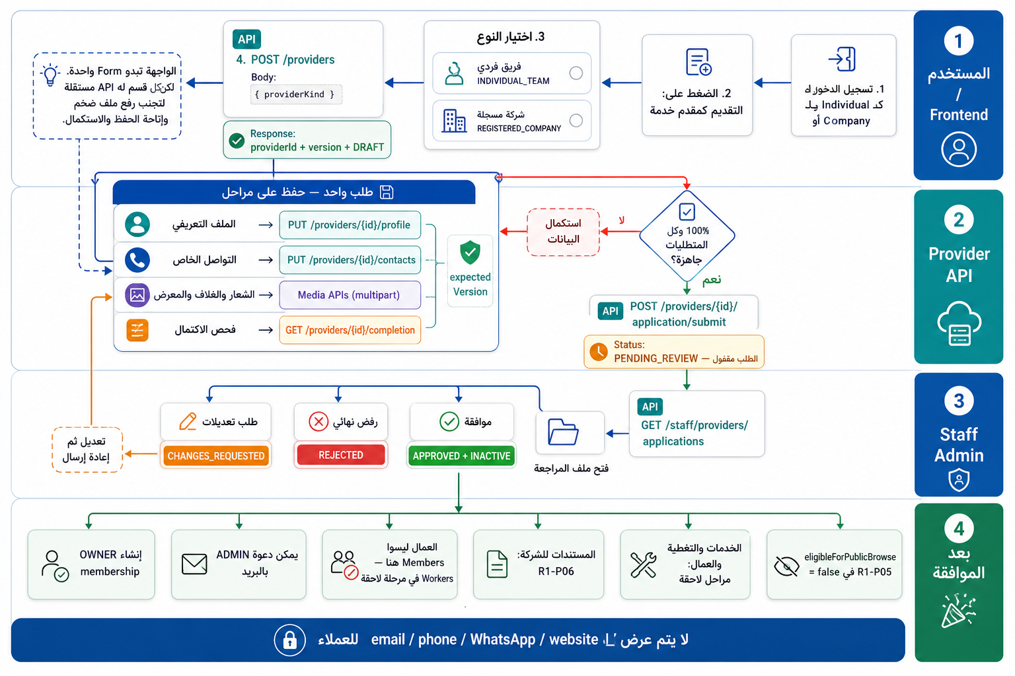
Figure 1 — Complete R1-P05 role and API flow, including resubmission and post-approval boundaries.
Out of phase: No public customer browse, worker/crew management, company-document verification, payout setup, service/coverage setup, booking, or command that makes the Provider LIVE.

PAGES BY ROLE
Pages for Provider Applicant / Application Owner
Role responsibility: Creates and resumes one draft, completes profile/contacts/media, reviews server completion, and submits or resubmits after requested changes.

Screen 01 — Start Provider Application and Choose Kind
Suggested route: /provider/apply
Screen purpose: Resume the caller's existing Provider draft or create the one permitted application, then choose INDIVIDUAL_TEAM or REGISTERED_COMPANY before the first submission.
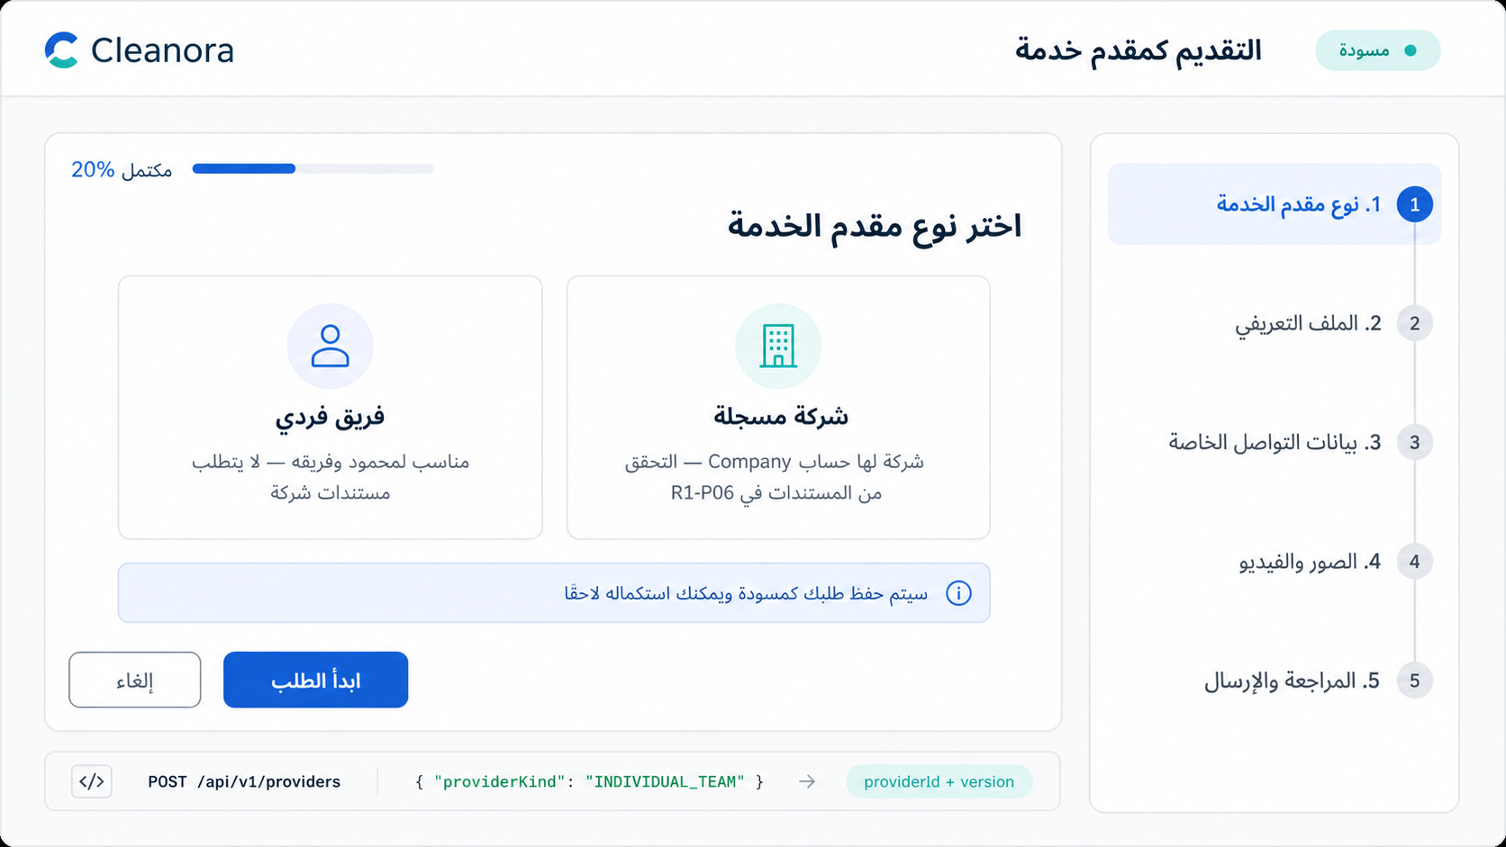
Screen 01 — Provider type choice and draft creation. High-fidelity implementation reference; API contracts remain authoritative.

Frontend flow on this screen
1. Load the caller's visible Providers before showing a Create button.
2. Resume the existing draft when the user already owns an application.
3. Create a new application only when no conflicting Provider exists.
4. Allow kind changes only while the application has never been submitted.

APIs used on this screen

API 01 — List Own Providers
GET /api/v1/providers
List Own Providers
What it does: Lists Provider aggregates visible to the authenticated Application Owner or accepted Provider Admin. Optional query parameters: cursor and limit (1-100).
Who can use it: Eligible authenticated Application Owner; exact state rules apply.
Efficient frontend usage: Use cursor/nextCursor pagination and cancel stale filter requests.
Sample request body
No request body
Success response sample — HTTP 200
{
"success": true,
"data": [
{
"id": "provider_example_01",
"providerKind": "INDIVIDUAL_TEAM",
"applicationStatus": "DRAFT",
"operationalStatus": "INACTIVE",
"version": 1,
"createdAt": "2026-08-13T10:00:00.000Z",
"updatedAt": "2026-08-13T10:00:00.000Z"
}
],
"requestId": "request_example_01",
"meta": {
"nextCursor": null
}
}
Copyable Axios integration
export async function listOwnProviders(params: Record<string, unknown> = {}) {
const response = await api.get(`/providers`, { params });
return response.data.data;
}
Possible error codes and recovery
HTTP 401 — AUTHENTICATION_REQUIRED
Meaning: The access token or authenticated session is missing or invalid.
Frontend recovery: Attempt one safe refresh; if it fails, send the user to sign-in and preserve only non-sensitive form state.
HTTP 400 — VALIDATION_ERROR
Meaning: The body, query, file, or Content-Type does not match the API contract.
Frontend recovery: Map field details to the form, correct the payload, and do not retry unchanged input.
HTTP 503 — PROVIDER_DEPENDENCY_UNAVAILABLE
Meaning: A required media, email, or configuration dependency is temporarily unavailable.
Frontend recovery: Offer a safe retry, keep local form state, and never launch parallel duplicate writes.

API 02 — Create Provider Application
POST /api/v1/providers
Create Provider Application
What it does: Creates the caller's single Provider draft or returns the existing Provider. Requires an ACTIVE eligible Individual or Company customer identity with a complete matching customer profile. Captures providerId and providerVersion.
Who can use it: Eligible authenticated Application Owner; exact state rules apply.
Efficient frontend usage: Serialize Provider mutations and replace local providerVersion with the returned version.
Sample request body
{
"providerKind": "INDIVIDUAL_TEAM"
}
Success response sample — HTTP 201
{
"success": true,
"data": {
"id": "provider_example_01",
"providerKind": "INDIVIDUAL_TEAM",
"applicationStatus": "DRAFT",
"operationalStatus": "INACTIVE",
"version": 1,
"createdAt": "2026-08-13T10:00:00.000Z",
"updatedAt": "2026-08-13T10:00:00.000Z"
},
"requestId": "request_example_01"
}
Copyable Axios integration
export async function createProviderApplication(payload: Record<string, unknown>) {
const response = await api.post(`/providers`, payload);
return response.data.data;
}
Possible error codes and recovery
HTTP 400 — VALIDATION_ERROR
Meaning: The body, query, file, or Content-Type does not match the API contract.
Frontend recovery: Map field details to the form, correct the payload, and do not retry unchanged input.
HTTP 403 — PROVIDER_ELIGIBILITY_DENIED
Meaning: The identity category, active state, or prerequisite customer profile is not eligible.
Frontend recovery: Show the missing eligibility step and block local draft creation until the prerequisite is resolved.
HTTP 409 — PROVIDER_ALREADY_EXISTS
Meaning: The caller already owns a Provider or a conflicting draft exists.
Frontend recovery: Call List Own Providers and resume the existing resource instead of creating another one.

API 03 — Change Never-Submitted Kind
PATCH /api/v1/providers/{providerId}/kind
Change Never-Submitted Kind
What it does: Changes INDIVIDUAL_TEAM to REGISTERED_COMPANY or the reverse only before the application has ever been submitted. Eligibility is re-evaluated for the new kind.
Who can use it: Eligible authenticated Application Owner; exact state rules apply.
Efficient frontend usage: Serialize Provider mutations and replace local providerVersion with the returned version.
Sample request body
{
"providerKind": "<alternateProviderKind>",
"expectedVersion": 12
}
Success response sample — HTTP 200
{
"success": true,
"data": {
"id": "provider_example_01",
"providerKind": "REGISTERED_COMPANY",
"applicationStatus": "DRAFT",
"operationalStatus": "INACTIVE",
"version": 2,
"createdAt": "2026-08-13T10:00:00.000Z",
"updatedAt": "2026-08-13T10:00:00.000Z"
},
"requestId": "request_example_01"
}
Copyable Axios integration
export async function changeNeverSubmittedKind(providerId: string, payload: Record<string, unknown>) {
const response = await api.patch(`/providers/${providerId}/kind`, payload);
return response.data.data;
}
Possible error codes and recovery
HTTP 400 — VALIDATION_ERROR
Meaning: The body, query, file, or Content-Type does not match the API contract.
Frontend recovery: Map field details to the form, correct the payload, and do not retry unchanged input.
HTTP 403 — PROVIDER_ELIGIBILITY_DENIED
Meaning: The identity category, active state, or prerequisite customer profile is not eligible.
Frontend recovery: Show the missing eligibility step and block local draft creation until the prerequisite is resolved.
HTTP 409 — PROVIDER_VERSION_CONFLICT
Meaning: expectedVersion is stale because another write completed first.
Frontend recovery: Refetch the Provider, replace the local version, preserve the user's intent, and ask for an explicit retry.
HTTP 409 — PROVIDER_STATE_CONFLICT
Meaning: The command is not allowed in the Provider's current application or operational state.
Frontend recovery: Reload the aggregate and enable only actions permitted by the returned state/capability flags.

Screen 02 — Provider Profile
Suggested route: /provider/apply/:providerId/profile
Screen purpose: Collect the public display name, description, optional English copy, and country in a resumable profile step.
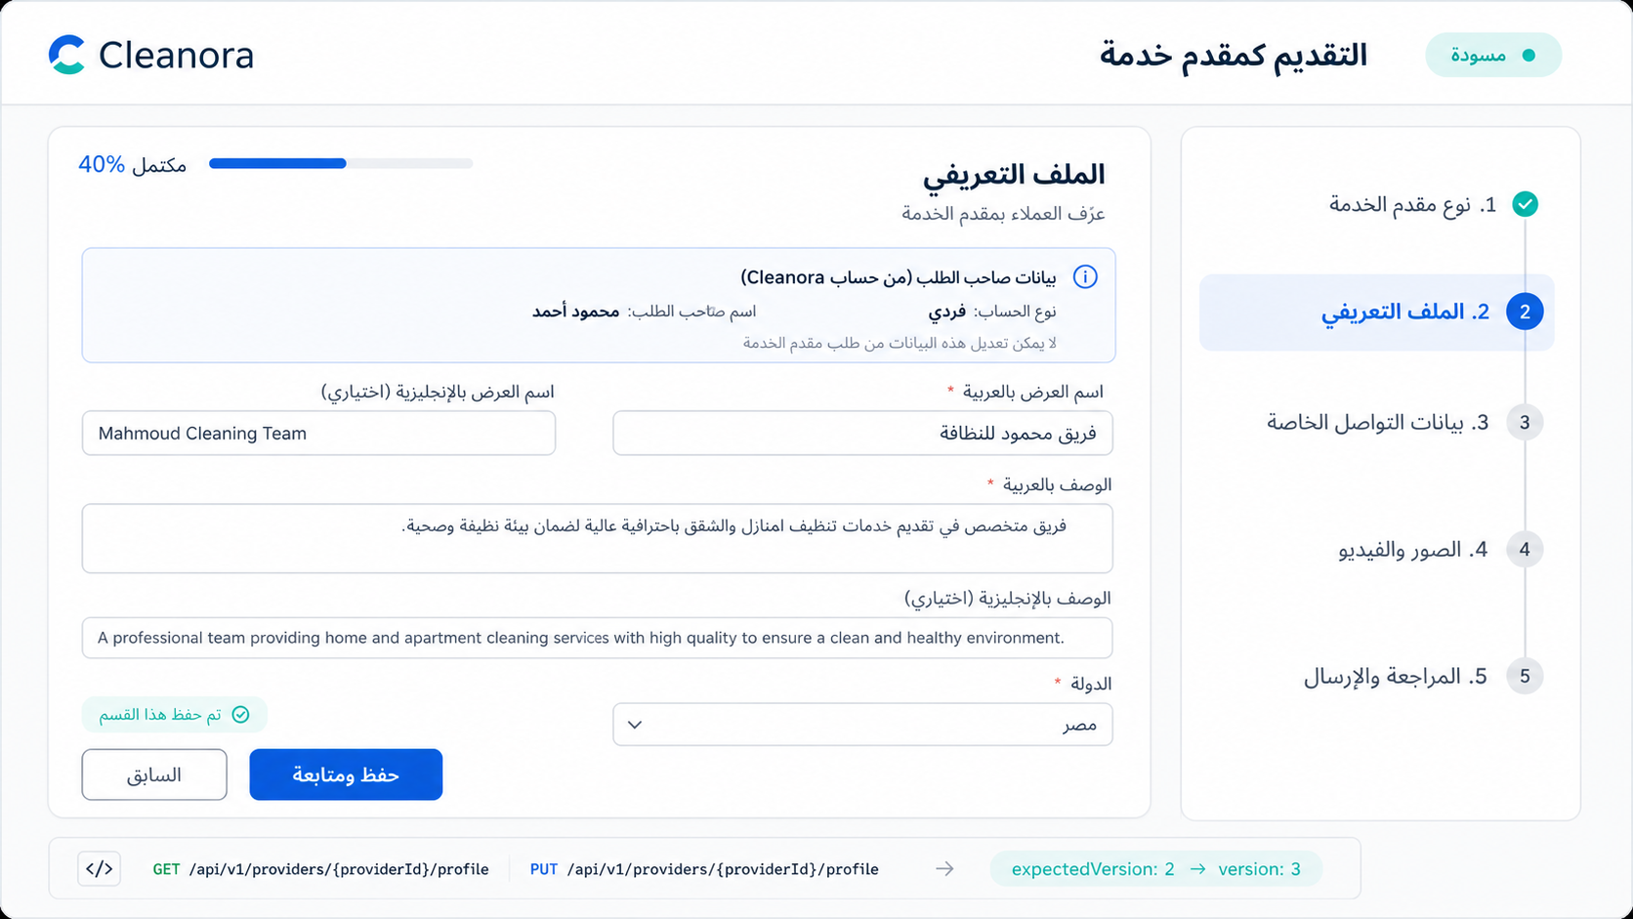
Screen 02 — Public provider profile form with immutable applicant facts. High-fidelity implementation reference; API contracts remain authoritative.

Frontend flow on this screen
1. Fetch the current profile when the route opens.
2. Use one full-replacement PUT rather than separate field mutations.
3. Save sequentially and replace the local Provider version with the response version.

APIs used on this screen

API 04 — Get Profile
GET /api/v1/providers/{providerId}/profile
Get Profile
What it does: Reads the editable bilingual Provider profile.
Who can use it: Application Owner before approval; active exact-Provider OWNER/ADMIN after approval. Staff reads submitted evidence through the Staff dossier.
Efficient frontend usage: Use the shared Axios client, show API error codes, and avoid duplicate in-flight requests.
Sample request body
No request body
Success response sample — HTTP 200
{
"success": true,
"data": {
"providerId": "provider_example_01",
"displayNameAr": "<Arabic-language value supplied by the provider>",
"displayNameEn": "Cleanora Cleaning Team",
"descriptionAr": "<Arabic-language value supplied by the provider>",
"descriptionEn": "A professional team specializing in high-quality home and apartment cleaning.",
"countryCode": "EG",
"version": 2
},
"requestId": "request_example_01"
}
Copyable Axios integration
export async function getProfile(providerId: string) {
const response = await api.get(`/providers/${providerId}/profile`);
return response.data.data;
}
Possible error codes and recovery
HTTP 401 — AUTHENTICATION_REQUIRED
Meaning: The access token or authenticated session is missing or invalid.
Frontend recovery: Attempt one safe refresh; if it fails, send the user to sign-in and preserve only non-sensitive form state.
HTTP 403/404 — PROVIDER_ACCESS_DENIED
Meaning: The caller lacks the required identity, relationship, or exact-Provider authority.
Frontend recovery: Stop the action, refresh the caller's Provider list/capabilities, and do not reveal whether another Provider exists.
HTTP 404 — PROVIDER_NOT_FOUND
Meaning: The requested Provider is not available inside the caller's allowed scope.
Frontend recovery: Return to the visible Provider list and never guess or substitute another providerId.

API 05 — Replace Profile
PUT /api/v1/providers/{providerId}/profile
Replace Profile
What it does: Full-replaces the Provider profile. English display name and description may be null. countryCode must identify an active configured country.
Who can use it: Application Owner before approval; active exact-Provider OWNER/ADMIN after approval. Staff reads submitted evidence through the Staff dossier.
Efficient frontend usage: Serialize Provider mutations and replace local providerVersion with the returned version.
Sample request body
{
"displayNameAr": "<providerDisplayNameAr>",
"displayNameEn": "<providerDisplayNameEn>",
"descriptionAr": "<providerDescriptionAr>",
"descriptionEn": "<providerDescriptionEn>",
"countryCode": "<countryCode>",
"expectedVersion": 12
}
Success response sample — HTTP 200
{
"success": true,
"data": {
"providerId": "provider_example_01",
"displayNameAr": "<Arabic-language value supplied by the provider>",
"displayNameEn": "Cleanora Cleaning Team",
"descriptionAr": "<Arabic-language value supplied by the provider>",
"descriptionEn": "A professional team specializing in high-quality home and apartment cleaning.",
"countryCode": "EG",
"version": 2
},
"requestId": "request_example_01"
}
Copyable Axios integration
export async function replaceProfile(providerId: string, payload: Record<string, unknown>) {
const response = await api.put(`/providers/${providerId}/profile`, payload);
return response.data.data;
}
Possible error codes and recovery
HTTP 400 — VALIDATION_ERROR
Meaning: The body, query, file, or Content-Type does not match the API contract.
Frontend recovery: Map field details to the form, correct the payload, and do not retry unchanged input.
HTTP 409 — PROVIDER_VERSION_CONFLICT
Meaning: expectedVersion is stale because another write completed first.
Frontend recovery: Refetch the Provider, replace the local version, preserve the user's intent, and ask for an explicit retry.
HTTP 409 — PROVIDER_STATE_CONFLICT
Meaning: The command is not allowed in the Provider's current application or operational state.
Frontend recovery: Reload the aggregate and enable only actions permitted by the returned state/capability flags.
HTTP 403/404 — PROVIDER_ACCESS_DENIED
Meaning: The caller lacks the required identity, relationship, or exact-Provider authority.
Frontend recovery: Stop the action, refresh the caller's Provider list/capabilities, and do not reveal whether another Provider exists.

Screen 03 — Private Operational Contacts
Suggested route: /provider/apply/:providerId/contacts
Screen purpose: Manage private operational email, phone, WhatsApp, and website details without exposing them in the customer-facing preview.
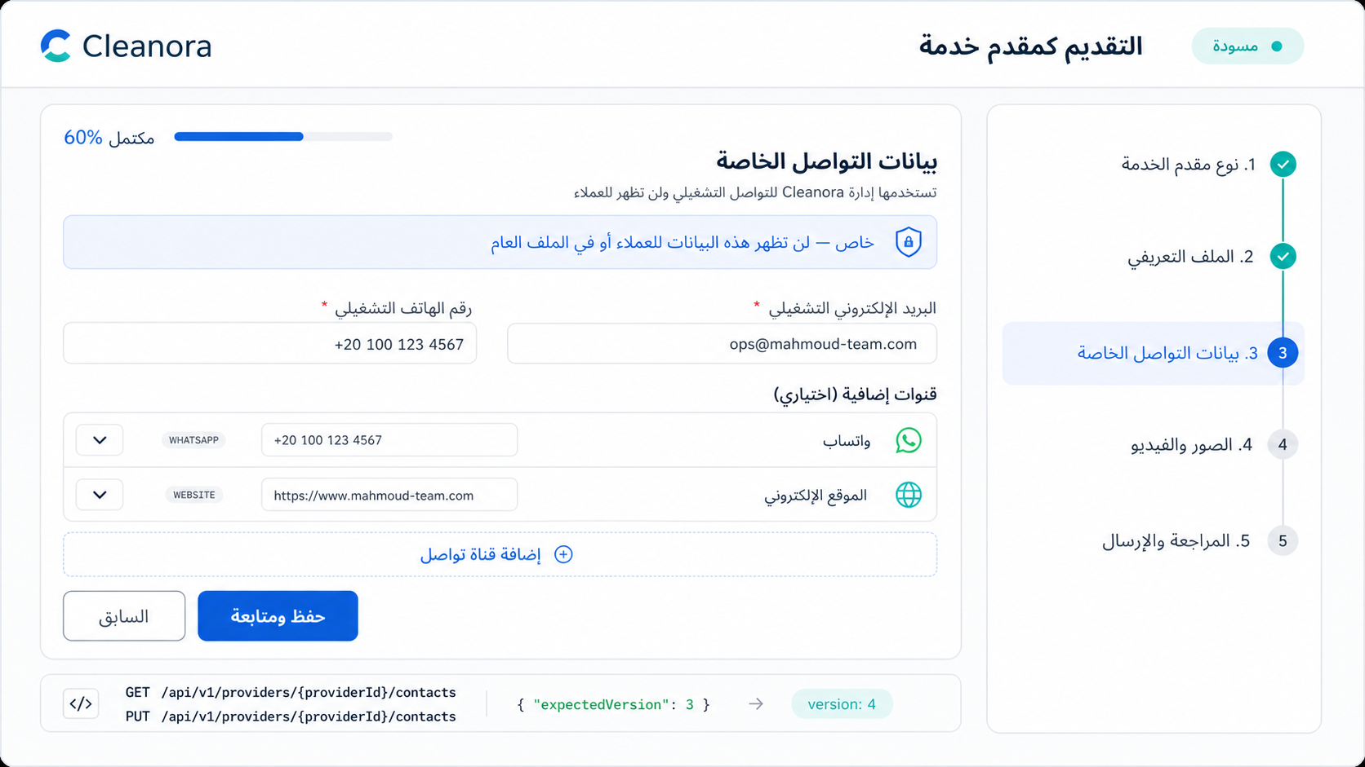
Screen 03 — Private operational contacts and optional communication channels. High-fidelity implementation reference; API contracts remain authoritative.

Frontend flow on this screen
1. Load private contacts only for an authorized Provider actor.
2. Send the complete channel set because the endpoint is a full replacement.
3. Display a clear privacy notice: these values are never customer-facing in R1-P05.

APIs used on this screen

API 06 — Get Private Contacts
GET /api/v1/providers/{providerId}/contacts
Get Private Contacts
What it does: Reads private operational email, phone, and optional contact channels. These values are not returned by the public-style preview.
Who can use it: Application Owner before approval; active exact-Provider OWNER/ADMIN after approval. Staff reads submitted evidence through the Staff dossier.
Efficient frontend usage: Use the shared Axios client, show API error codes, and avoid duplicate in-flight requests.
Sample request body
No request body
Success response sample — HTTP 200
{
"success": true,
"data": {
"providerId": "provider_example_01",
"operationalEmail": "provider.ops@example.com",
"operationalPhone": "+201000000000",
"channels": [
{
"type": "WHATSAPP",
"value": "+201000000000"
},
{
"type": "WEBSITE",
"value": "https://example.com/cleanora-provider"
}
],
"version": 3
},
"requestId": "request_example_01"
}
Copyable Axios integration
export async function getPrivateContacts(providerId: string) {
const response = await api.get(`/providers/${providerId}/contacts`);
return response.data.data;
}
Possible error codes and recovery
HTTP 401 — AUTHENTICATION_REQUIRED
Meaning: The access token or authenticated session is missing or invalid.
Frontend recovery: Attempt one safe refresh; if it fails, send the user to sign-in and preserve only non-sensitive form state.
HTTP 403/404 — PROVIDER_ACCESS_DENIED
Meaning: The caller lacks the required identity, relationship, or exact-Provider authority.
Frontend recovery: Stop the action, refresh the caller's Provider list/capabilities, and do not reveal whether another Provider exists.
HTTP 404 — PROVIDER_NOT_FOUND
Meaning: The requested Provider is not available inside the caller's allowed scope.
Frontend recovery: Return to the visible Provider list and never guess or substitute another providerId.

API 07 — Replace Private Contacts
PUT /api/v1/providers/{providerId}/contacts
Replace Private Contacts
What it does: Full-replaces private operational contacts. Phone and WhatsApp examples use E.164 format. Supported channel types: WHATSAPP, SOCIAL, WEBSITE, EXTERNAL_BOOKING.
Who can use it: Application Owner before approval; active exact-Provider OWNER/ADMIN after approval. Staff reads submitted evidence through the Staff dossier.
Efficient frontend usage: Serialize Provider mutations and replace local providerVersion with the returned version.
Sample request body
{
"operationalEmail": "<providerOperationalEmail>",
"operationalPhone": "<providerOperationalPhone>",
"channels": [
{
"type": "WHATSAPP",
"value": "<providerWhatsApp>"
},
{
"type": "WEBSITE",
"value": "<providerWebsite>"
}
],
"expectedVersion": 12
}
Success response sample — HTTP 200
{
"success": true,
"data": {
"providerId": "provider_example_01",
"operationalEmail": "provider.ops@example.com",
"operationalPhone": "+201000000000",
"channels": [
{
"type": "WHATSAPP",
"value": "+201000000000"
},
{
"type": "WEBSITE",
"value": "https://example.com/cleanora-provider"
}
],
"version": 3
},
"requestId": "request_example_01"
}
Copyable Axios integration
export async function replacePrivateContacts(providerId: string, payload: Record<string, unknown>) {
const response = await api.put(`/providers/${providerId}/contacts`, payload);
return response.data.data;
}
Possible error codes and recovery
HTTP 400 — VALIDATION_ERROR
Meaning: The body, query, file, or Content-Type does not match the API contract.
Frontend recovery: Map field details to the form, correct the payload, and do not retry unchanged input.
HTTP 409 — PROVIDER_VERSION_CONFLICT
Meaning: expectedVersion is stale because another write completed first.
Frontend recovery: Refetch the Provider, replace the local version, preserve the user's intent, and ask for an explicit retry.
HTTP 409 — PROVIDER_STATE_CONFLICT
Meaning: The command is not allowed in the Provider's current application or operational state.
Frontend recovery: Reload the aggregate and enable only actions permitted by the returned state/capability flags.
HTTP 403/404 — PROVIDER_ACCESS_DENIED
Meaning: The caller lacks the required identity, relationship, or exact-Provider authority.
Frontend recovery: Stop the action, refresh the caller's Provider list/capabilities, and do not reveal whether another Provider exists.

Screen 04 — Logo, Cover and Gallery Media
Suggested route: /provider/apply/:providerId/media
Screen purpose: Upload and organize one logo, one cover, up to 12 gallery images, and up to 2 gallery videos while showing processing status.
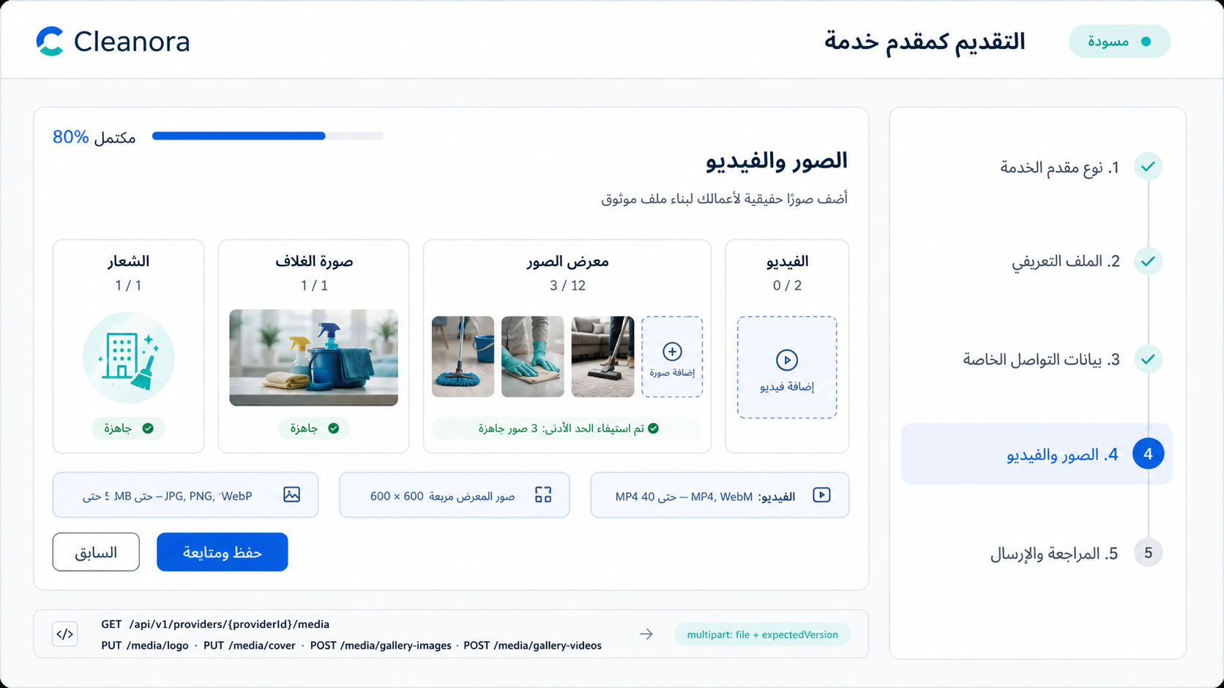
Screen 04.1 — Media requirements and ready-state overview. High-fidelity implementation reference; API contracts remain authoritative.
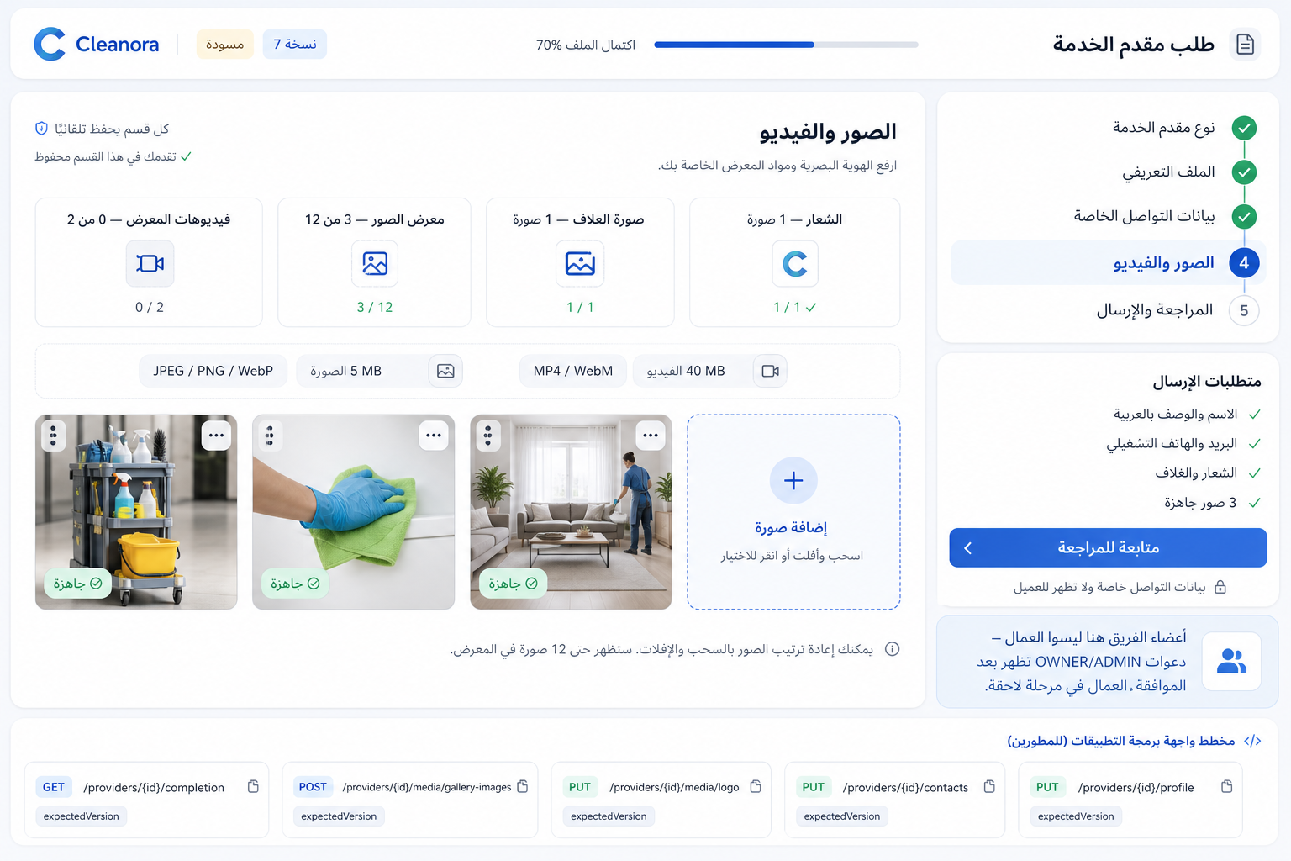
Screen 04.2 — Detailed logo, cover, gallery, upload-limit, and ordering behavior. High-fidelity implementation reference; API contracts remain authoritative.

Frontend flow on this screen
1. Load all current media and server processing states.
2. Validate file type, image limits, and video size before upload.
3. Upload with FormData and never set multipart Content-Type manually.
4. Serialize mutations because every write uses the Provider aggregate version.

APIs used on this screen

API 08 — List Media
GET /api/v1/providers/{providerId}/media
List Media
What it does: Lists authorized logo, cover, and gallery media references and processing states.
Who can use it: Application Owner before approval; active exact-Provider OWNER/ADMIN after approval. Staff reads submitted evidence through the Staff dossier.
Efficient frontend usage: Use the shared Axios client, show API error codes, and avoid duplicate in-flight requests.
Sample request body
No request body
Success response sample — HTTP 200
{
"success": true,
"data": {
"providerId": "provider_example_01",
"logo": {
"id": "media_logo_01",
"type": "LOGO",
"status": "READY",
"url": "https://res.cloudinary.com/example/image/upload/provider-logo.webp"
},
"cover": {
"id": "media_cover_01",
"type": "COVER",
"status": "READY",
"url": "https://res.cloudinary.com/example/image/upload/provider-cover.webp"
},
"gallery": [
{
"id": "gallery_image_01",
"type": "GALLERY_IMAGE",
"status": "READY",
"position": 1,
"url": "https://res.cloudinary.com/example/image/upload/gallery-01.webp"
}
],
"version": 6
},
"requestId": "request_example_01"
}
Copyable Axios integration
export async function listMedia(providerId: string) {
const response = await api.get(`/providers/${providerId}/media`);
return response.data.data;
}
Possible error codes and recovery
HTTP 401 — AUTHENTICATION_REQUIRED
Meaning: The access token or authenticated session is missing or invalid.
Frontend recovery: Attempt one safe refresh; if it fails, send the user to sign-in and preserve only non-sensitive form state.
HTTP 403/404 — PROVIDER_ACCESS_DENIED
Meaning: The caller lacks the required identity, relationship, or exact-Provider authority.
Frontend recovery: Stop the action, refresh the caller's Provider list/capabilities, and do not reveal whether another Provider exists.
HTTP 503 — PROVIDER_DEPENDENCY_UNAVAILABLE
Meaning: A required media, email, or configuration dependency is temporarily unavailable.
Frontend recovery: Offer a safe retry, keep local form state, and never launch parallel duplicate writes.

API 09 — Replace Logo
PUT /api/v1/providers/{providerId}/media/logo
Replace Logo
What it does: Uploads or replaces the single Provider logo. Select providerLogoPath. Images must satisfy the server content-type, size, and normalized-dimension policy.
Who can use it: Application Owner before approval; active exact-Provider OWNER/ADMIN after approval. Staff reads submitted evidence through the Staff dossier.
Efficient frontend usage: Use FormData and let Axios/browser generate the multipart boundary. Serialize Provider mutations and replace local providerVersion with the returned version.
Sample request body
multipart/form-data
{
"file": "<File selected by the user>",
"expectedVersion": "12"
}
Success response sample — HTTP 200
{
"success": true,
"data": {
"providerId": "provider_example_01",
"logo": {
"id": "media_logo_01",
"type": "LOGO",
"status": "READY",
"url": "https://res.cloudinary.com/example/image/upload/provider-logo.webp"
},
"cover": {
"id": "media_cover_01",
"type": "COVER",
"status": "READY",
"url": "https://res.cloudinary.com/example/image/upload/provider-cover.webp"
},
"gallery": [
{
"id": "gallery_image_01",
"type": "GALLERY_IMAGE",
"status": "READY",
"position": 1,
"url": "https://res.cloudinary.com/example/image/upload/gallery-01.webp"
}
],
"version": 6
},
"requestId": "request_example_01"
}
Copyable Axios integration
export async function replaceLogo(providerId: string, file: File, expectedVersion: number) {
const form = new FormData();
form.append("file", file);
form.append("expectedVersion", String(expectedVersion));
const response = await api.put(`/providers/${providerId}/media/logo`, form);
return response.data.data;
}
Possible error codes and recovery
HTTP 400/409 — PROVIDER_MEDIA_INVALID
Meaning: The uploaded media violates type, size, dimensions, or processing policy.
Frontend recovery: Validate client-side first, show the server reason, and require the user to choose a compliant file.
HTTP 409 — PROVIDER_VERSION_CONFLICT
Meaning: expectedVersion is stale because another write completed first.
Frontend recovery: Refetch the Provider, replace the local version, preserve the user's intent, and ask for an explicit retry.
HTTP 503 — PROVIDER_DEPENDENCY_UNAVAILABLE
Meaning: A required media, email, or configuration dependency is temporarily unavailable.
Frontend recovery: Offer a safe retry, keep local form state, and never launch parallel duplicate writes.
HTTP 409 — PROVIDER_STATE_CONFLICT
Meaning: The command is not allowed in the Provider's current application or operational state.
Frontend recovery: Reload the aggregate and enable only actions permitted by the returned state/capability flags.

API 10 — Replace Cover
PUT /api/v1/providers/{providerId}/media/cover
Replace Cover
What it does: Uploads or replaces the single Provider cover. Select providerCoverPath.
Who can use it: Application Owner before approval; active exact-Provider OWNER/ADMIN after approval. Staff reads submitted evidence through the Staff dossier.
Efficient frontend usage: Use FormData and let Axios/browser generate the multipart boundary. Serialize Provider mutations and replace local providerVersion with the returned version.
Sample request body
multipart/form-data
{
"file": "<File selected by the user>",
"expectedVersion": "12"
}
Success response sample — HTTP 200
{
"success": true,
"data": {
"providerId": "provider_example_01",
"logo": {
"id": "media_logo_01",
"type": "LOGO",
"status": "READY",
"url": "https://res.cloudinary.com/example/image/upload/provider-logo.webp"
},
"cover": {
"id": "media_cover_01",
"type": "COVER",
"status": "READY",
"url": "https://res.cloudinary.com/example/image/upload/provider-cover.webp"
},
"gallery": [
{
"id": "gallery_image_01",
"type": "GALLERY_IMAGE",
"status": "READY",
"position": 1,
"url": "https://res.cloudinary.com/example/image/upload/gallery-01.webp"
}
],
"version": 7
},
"requestId": "request_example_01"
}
Copyable Axios integration
export async function replaceCover(providerId: string, file: File, expectedVersion: number) {
const form = new FormData();
form.append("file", file);
form.append("expectedVersion", String(expectedVersion));
const response = await api.put(`/providers/${providerId}/media/cover`, form);
return response.data.data;
}
Possible error codes and recovery
HTTP 400/409 — PROVIDER_MEDIA_INVALID
Meaning: The uploaded media violates type, size, dimensions, or processing policy.
Frontend recovery: Validate client-side first, show the server reason, and require the user to choose a compliant file.
HTTP 409 — PROVIDER_VERSION_CONFLICT
Meaning: expectedVersion is stale because another write completed first.
Frontend recovery: Refetch the Provider, replace the local version, preserve the user's intent, and ask for an explicit retry.
HTTP 503 — PROVIDER_DEPENDENCY_UNAVAILABLE
Meaning: A required media, email, or configuration dependency is temporarily unavailable.
Frontend recovery: Offer a safe retry, keep local form state, and never launch parallel duplicate writes.
HTTP 409 — PROVIDER_STATE_CONFLICT
Meaning: The command is not allowed in the Provider's current application or operational state.
Frontend recovery: Reload the aggregate and enable only actions permitted by the returned state/capability flags.

API 11 — Add Gallery Image
POST /api/v1/providers/{providerId}/media/gallery-images
Add Gallery Image
What it does: Adds one gallery image, up to 12 total. Select providerGalleryImagePath. At least 3 images must be READY before submission.
Who can use it: Application Owner before approval; active exact-Provider OWNER/ADMIN after approval. Staff reads submitted evidence through the Staff dossier.
Efficient frontend usage: Use FormData and let Axios/browser generate the multipart boundary. Serialize Provider mutations and replace local providerVersion with the returned version.
Sample request body
multipart/form-data
{
"file": "<File selected by the user>",
"expectedVersion": "12"
}
Success response sample — HTTP 201
{
"success": true,
"data": {
"providerId": "provider_example_01",
"logo": {
"id": "media_logo_01",
"type": "LOGO",
"status": "READY",
"url": "https://res.cloudinary.com/example/image/upload/provider-logo.webp"
},
"cover": {
"id": "media_cover_01",
"type": "COVER",
"status": "READY",
"url": "https://res.cloudinary.com/example/image/upload/provider-cover.webp"
},
"gallery": [
{
"id": "gallery_image_01",
"type": "GALLERY_IMAGE",
"status": "READY",
"position": 1,
"url": "https://res.cloudinary.com/example/image/upload/gallery-01.webp"
}
],
"version": 8,
"id": "gallery_image_01",
"galleryItemId": "gallery_image_01"
},
"requestId": "request_example_01"
}
Copyable Axios integration
export async function addGalleryImage(providerId: string, file: File, expectedVersion: number) {
const form = new FormData();
form.append("file", file);
form.append("expectedVersion", String(expectedVersion));
const response = await api.post(`/providers/${providerId}/media/gallery-images`, form);
return response.data.data;
}
Possible error codes and recovery
HTTP 400/409 — PROVIDER_MEDIA_INVALID
Meaning: The uploaded media violates type, size, dimensions, or processing policy.
Frontend recovery: Validate client-side first, show the server reason, and require the user to choose a compliant file.
HTTP 409 — PROVIDER_MEDIA_LIMIT_EXCEEDED
Meaning: The logo/cover/gallery image/video count limit would be exceeded.
Frontend recovery: Reload media counts and require deletion or replacement before another upload.
HTTP 409 — PROVIDER_VERSION_CONFLICT
Meaning: expectedVersion is stale because another write completed first.
Frontend recovery: Refetch the Provider, replace the local version, preserve the user's intent, and ask for an explicit retry.
HTTP 503 — PROVIDER_DEPENDENCY_UNAVAILABLE
Meaning: A required media, email, or configuration dependency is temporarily unavailable.
Frontend recovery: Offer a safe retry, keep local form state, and never launch parallel duplicate writes.

API 12 — Add Gallery Video
POST /api/v1/providers/{providerId}/media/gallery-videos
Add Gallery Video
What it does: Adds one optional gallery video, up to 2 total. Select providerGalleryVideoPath. MP4 or WebM; authoritative maximum 40 MiB.
Who can use it: Application Owner before approval; active exact-Provider OWNER/ADMIN after approval. Staff reads submitted evidence through the Staff dossier.
Efficient frontend usage: Use FormData and let Axios/browser generate the multipart boundary. Serialize Provider mutations and replace local providerVersion with the returned version.
Sample request body
multipart/form-data
{
"file": "<File selected by the user>",
"expectedVersion": "12"
}
Success response sample — HTTP 201 (representative excerpt; OpenAPI/Postman remains authoritative)
{
"requestId": "request_example_01",
"success": true,
"data": {
"id": "gallery_video_01",
"providerId": "provider_example_01",
"version": 9,
"logo": {
"id": "media_logo_01",
"status": "READY",
"type": "LOGO",
"url": "https://res.cloudinary.com/example/image/upload/provider-logo.webp"
},
"cover": {
"id": "media_cover_01",
"status": "READY",
"type": "COVER",
"url": "https://res.cloudinary.com/example/image/upload/provider-cover.webp"
},
"gallery": [
{
"id": "gallery_image_01",
"type": "GALLERY_IMAGE",
"status": "READY",
"position": 1
}
],
"galleryItemId": "gallery_video_01"
}
}
Copyable Axios integration
export async function addGalleryVideo(providerId: string, file: File, expectedVersion: number) {
const form = new FormData();
form.append("file", file);
form.append("expectedVersion", String(expectedVersion));
const response = await api.post(`/providers/${providerId}/media/gallery-videos`, form);
return response.data.data;
}
Possible error codes and recovery
HTTP 400/409 — PROVIDER_MEDIA_INVALID
Meaning: The uploaded media violates type, size, dimensions, or processing policy.
Frontend recovery: Validate client-side first, show the server reason, and require the user to choose a compliant file.
HTTP 409 — PROVIDER_MEDIA_LIMIT_EXCEEDED
Meaning: The logo/cover/gallery image/video count limit would be exceeded.
Frontend recovery: Reload media counts and require deletion or replacement before another upload.
HTTP 409 — PROVIDER_VERSION_CONFLICT
Meaning: expectedVersion is stale because another write completed first.
Frontend recovery: Refetch the Provider, replace the local version, preserve the user's intent, and ask for an explicit retry.
HTTP 503 — PROVIDER_DEPENDENCY_UNAVAILABLE
Meaning: A required media, email, or configuration dependency is temporarily unavailable.
Frontend recovery: Offer a safe retry, keep local form state, and never launch parallel duplicate writes.

API 13 — Reorder Gallery
PUT /api/v1/providers/{providerId}/media/gallery-order
Reorder Gallery
What it does: Full-replaces the gallery display order. Add every current gallery item ID to orderedGalleryItemIds in the desired order.
Who can use it: Application Owner before approval; active exact-Provider OWNER/ADMIN after approval. Staff reads submitted evidence through the Staff dossier.
Efficient frontend usage: Serialize Provider mutations and replace local providerVersion with the returned version.
Sample request body
{
"orderedGalleryItemIds": [
"gallery_item_example_01"
],
"expectedVersion": 12
}
Success response sample — HTTP 200
{
"success": true,
"data": {
"providerId": "provider_example_01",
"logo": {
"id": "media_logo_01",
"type": "LOGO",
"status": "READY",
"url": "https://res.cloudinary.com/example/image/upload/provider-logo.webp"
},
"cover": {
"id": "media_cover_01",
"type": "COVER",
"status": "READY",
"url": "https://res.cloudinary.com/example/image/upload/provider-cover.webp"
},
"gallery": [
{
"id": "gallery_image_01",
"type": "GALLERY_IMAGE",
"status": "READY",
"position": 1,
"url": "https://res.cloudinary.com/example/image/upload/gallery-01.webp"
}
],
"version": 10
},
"requestId": "request_example_01"
}
Copyable Axios integration
export async function reorderGallery(providerId: string, payload: Record<string, unknown>) {
const response = await api.put(`/providers/${providerId}/media/gallery-order`, payload);
return response.data.data;
}
Possible error codes and recovery
HTTP 400 — VALIDATION_ERROR
Meaning: The body, query, file, or Content-Type does not match the API contract.
Frontend recovery: Map field details to the form, correct the payload, and do not retry unchanged input.
HTTP 409 — PROVIDER_VERSION_CONFLICT
Meaning: expectedVersion is stale because another write completed first.
Frontend recovery: Refetch the Provider, replace the local version, preserve the user's intent, and ask for an explicit retry.
HTTP 409 — PROVIDER_STATE_CONFLICT
Meaning: The command is not allowed in the Provider's current application or operational state.
Frontend recovery: Reload the aggregate and enable only actions permitted by the returned state/capability flags.
HTTP 403/404 — PROVIDER_ACCESS_DENIED
Meaning: The caller lacks the required identity, relationship, or exact-Provider authority.
Frontend recovery: Stop the action, refresh the caller's Provider list/capabilities, and do not reveal whether another Provider exists.

API 14 — Delete Logo
DELETE /api/v1/providers/{providerId}/media/logo
Delete Logo
What it does: Clears the logo association using optimistic concurrency.
Who can use it: Application Owner before approval; active exact-Provider OWNER/ADMIN after approval. Staff reads submitted evidence through the Staff dossier.
Efficient frontend usage: Serialize Provider mutations and replace local providerVersion with the returned version.
Sample request body
{
"expectedVersion": 12
}
Success response sample — HTTP 200
{
"success": true,
"data": {
"providerId": "provider_example_01",
"logo": null,
"cover": {
"id": "media_cover_01",
"type": "COVER",
"status": "READY",
"url": "https://res.cloudinary.com/example/image/upload/provider-cover.webp"
},
"gallery": [
{
"id": "gallery_image_01",
"type": "GALLERY_IMAGE",
"status": "READY",
"position": 1,
"url": "https://res.cloudinary.com/example/image/upload/gallery-01.webp"
}
],
"version": 11
},
"requestId": "request_example_01"
}
Copyable Axios integration
export async function deleteLogo(providerId: string, payload: Record<string, unknown>) {
const response = await api.delete(`/providers/${providerId}/media/logo`, { data: payload });
return response.data.data;
}
Possible error codes and recovery
HTTP 409 — PROVIDER_VERSION_CONFLICT
Meaning: expectedVersion is stale because another write completed first.
Frontend recovery: Refetch the Provider, replace the local version, preserve the user's intent, and ask for an explicit retry.
HTTP 409 — PROVIDER_STATE_CONFLICT
Meaning: The command is not allowed in the Provider's current application or operational state.
Frontend recovery: Reload the aggregate and enable only actions permitted by the returned state/capability flags.
HTTP 503 — PROVIDER_DEPENDENCY_UNAVAILABLE
Meaning: A required media, email, or configuration dependency is temporarily unavailable.
Frontend recovery: Offer a safe retry, keep local form state, and never launch parallel duplicate writes.

API 15 — Delete Cover
DELETE /api/v1/providers/{providerId}/media/cover
Delete Cover
What it does: Clears the cover association using optimistic concurrency.
Who can use it: Application Owner before approval; active exact-Provider OWNER/ADMIN after approval. Staff reads submitted evidence through the Staff dossier.
Efficient frontend usage: Serialize Provider mutations and replace local providerVersion with the returned version.
Sample request body
{
"expectedVersion": 12
}
Success response sample — HTTP 200
{
"success": true,
"data": {
"providerId": "provider_example_01",
"logo": {
"id": "media_logo_01",
"type": "LOGO",
"status": "READY",
"url": "https://res.cloudinary.com/example/image/upload/provider-logo.webp"
},
"cover": null,
"gallery": [
{
"id": "gallery_image_01",
"type": "GALLERY_IMAGE",
"status": "READY",
"position": 1,
"url": "https://res.cloudinary.com/example/image/upload/gallery-01.webp"
}
],
"version": 11
},
"requestId": "request_example_01"
}
Copyable Axios integration
export async function deleteCover(providerId: string, payload: Record<string, unknown>) {
const response = await api.delete(`/providers/${providerId}/media/cover`, { data: payload });
return response.data.data;
}
Possible error codes and recovery
HTTP 409 — PROVIDER_VERSION_CONFLICT
Meaning: expectedVersion is stale because another write completed first.
Frontend recovery: Refetch the Provider, replace the local version, preserve the user's intent, and ask for an explicit retry.
HTTP 409 — PROVIDER_STATE_CONFLICT
Meaning: The command is not allowed in the Provider's current application or operational state.
Frontend recovery: Reload the aggregate and enable only actions permitted by the returned state/capability flags.
HTTP 503 — PROVIDER_DEPENDENCY_UNAVAILABLE
Meaning: A required media, email, or configuration dependency is temporarily unavailable.
Frontend recovery: Offer a safe retry, keep local form state, and never launch parallel duplicate writes.

API 16 — Delete Gallery Item
DELETE /api/v1/providers/{providerId}/media/gallery/{galleryItemId}
Delete Gallery Item
What it does: Removes the selected gallery image or video from this Provider.
Who can use it: Application Owner before approval; active exact-Provider OWNER/ADMIN after approval. Staff reads submitted evidence through the Staff dossier.
Efficient frontend usage: Serialize Provider mutations and replace local providerVersion with the returned version.
Sample request body
{
"expectedVersion": 12
}
Success response sample — HTTP 200
{
"success": true,
"data": {
"providerId": "provider_example_01",
"logo": {
"id": "media_logo_01",
"type": "LOGO",
"status": "READY",
"url": "https://res.cloudinary.com/example/image/upload/provider-logo.webp"
},
"cover": {
"id": "media_cover_01",
"type": "COVER",
"status": "READY",
"url": "https://res.cloudinary.com/example/image/upload/provider-cover.webp"
},
"gallery": [],
"version": 11
},
"requestId": "request_example_01"
}
Copyable Axios integration
export async function deleteGalleryItem(providerId: string, galleryItemId: string, payload: Record<string, unknown>) {
const response = await api.delete(`/providers/${providerId}/media/gallery/${galleryItemId}`, { data: payload });
return response.data.data;
}
Possible error codes and recovery
HTTP 404 — PROVIDER_NOT_FOUND
Meaning: The requested Provider is not available inside the caller's allowed scope.
Frontend recovery: Return to the visible Provider list and never guess or substitute another providerId.
HTTP 409 — PROVIDER_VERSION_CONFLICT
Meaning: expectedVersion is stale because another write completed first.
Frontend recovery: Refetch the Provider, replace the local version, preserve the user's intent, and ask for an explicit retry.
HTTP 409 — PROVIDER_STATE_CONFLICT
Meaning: The command is not allowed in the Provider's current application or operational state.
Frontend recovery: Reload the aggregate and enable only actions permitted by the returned state/capability flags.
HTTP 503 — PROVIDER_DEPENDENCY_UNAVAILABLE
Meaning: A required media, email, or configuration dependency is temporarily unavailable.
Frontend recovery: Offer a safe retry, keep local form state, and never launch parallel duplicate writes.

Screen 05 — Review, Safe Preview and Submit
Suggested route: /provider/apply/:providerId/review
Screen purpose: Show the aggregate, a contact-free customer preview, and the final submission action without leaking private contact or membership data.
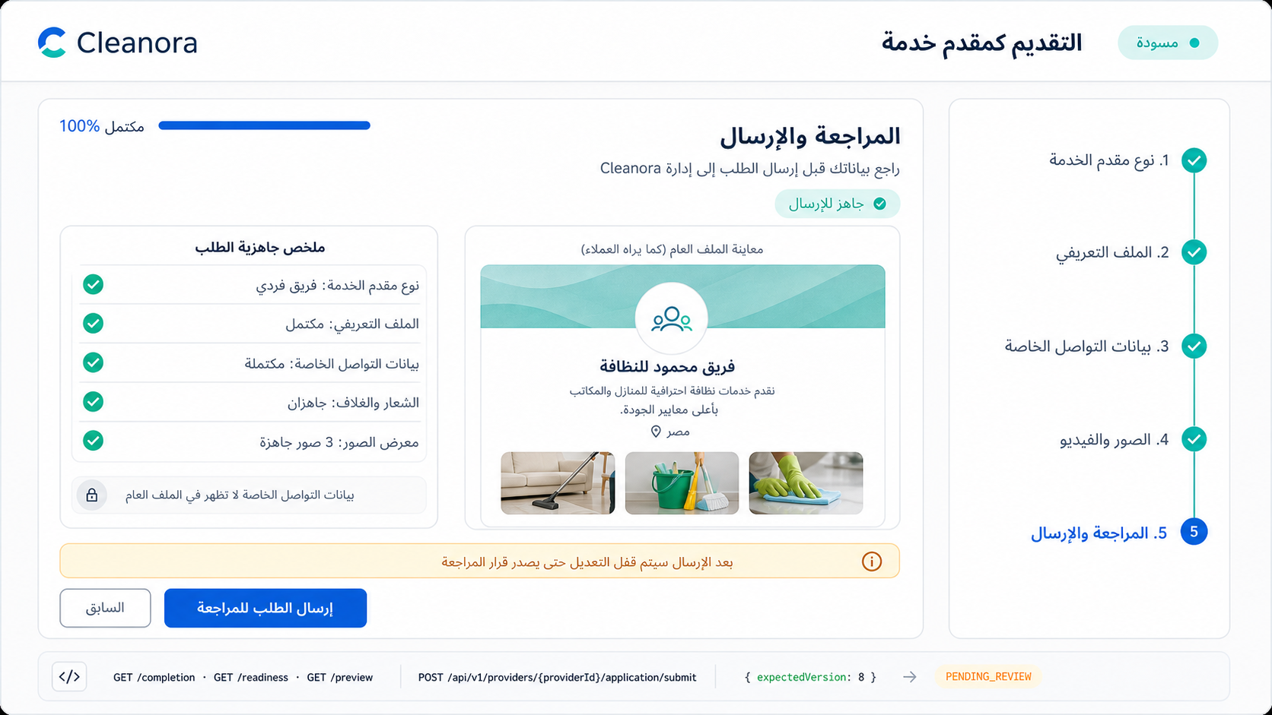
Screen 05 — Server-owned completion summary, safe public preview, and submission action. High-fidelity implementation reference; API contracts remain authoritative.

Frontend flow on this screen
1. Load the aggregate and safe preview independently.
2. Render only the preview DTO in customer-facing components.
3. Submit only when server completion says the application is complete.
4. After submission, switch the UI to read-only while Staff review is pending.

APIs used on this screen

API 17 — Get Provider
GET /api/v1/providers/{providerId}
Get Provider
What it does: Reloads the authorized private Provider aggregate. Use this request to refresh providerVersion after a 409 version conflict.
Who can use it: Application Owner before approval; active exact-Provider OWNER/ADMIN after approval. Staff reads submitted evidence through the Staff dossier.
Efficient frontend usage: Use the shared Axios client, show API error codes, and avoid duplicate in-flight requests.
Sample request body
No request body
Success response sample — HTTP 200 (representative excerpt; OpenAPI/Postman remains authoritative)
{
"requestId": "request_example_01",
"success": true,
"data": {
"id": "provider_example_01",
"providerKind": "INDIVIDUAL_TEAM",
"applicationStatus": "DRAFT",
"operationalStatus": "INACTIVE",
"version": 1,
"createdAt": "2026-08-13T10:00:00.000Z",
"updatedAt": "2026-08-13T10:00:00.000Z",
"profile": {
"providerId": "provider_example_01",
"version": 2,
"displayNameAr": "<Arabic-language value supplied by the provider>",
"displayNameEn": "Cleanora Cleaning Team",
"descriptionAr": "<Arabic-language value supplied by the provider>",
"descriptionEn": "A professional team specializing in high-quality home and apartment cleaning."
},
"completion": {
"missingRequirementCodes": [],
"policyVersion": "r1-p05-v1",
"percentage": 40,
"checks": [
{
"code": "ELIGIBLE_CATEGORY_VERIFIED",
"satisfied": true
}
]
}
}
}
Copyable Axios integration
export async function getProvider(providerId: string) {
const response = await api.get(`/providers/${providerId}`);
return response.data.data;
}
Possible error codes and recovery
HTTP 401 — AUTHENTICATION_REQUIRED
Meaning: The access token or authenticated session is missing or invalid.
Frontend recovery: Attempt one safe refresh; if it fails, send the user to sign-in and preserve only non-sensitive form state.
HTTP 403/404 — PROVIDER_ACCESS_DENIED
Meaning: The caller lacks the required identity, relationship, or exact-Provider authority.
Frontend recovery: Stop the action, refresh the caller's Provider list/capabilities, and do not reveal whether another Provider exists.
HTTP 404 — PROVIDER_NOT_FOUND
Meaning: The requested Provider is not available inside the caller's allowed scope.
Frontend recovery: Return to the visible Provider list and never guess or substitute another providerId.

API 18 — Protected Contact-Free Preview
GET /api/v1/providers/{providerId}/preview
Protected Contact-Free Preview
What it does: Returns the authorized customer-facing preview without operational email or phone. R1-P05 exposes no anonymous Provider browse endpoint.
Who can use it: Application Owner before approval; active exact-Provider OWNER/ADMIN after approval. Staff reads submitted evidence through the Staff dossier.
Efficient frontend usage: Use this DTO alone for customer-facing preview components; never merge private contacts or members.
Sample request body
No request body
Success response sample — HTTP 200
{
"success": true,
"data": {
"providerId": "provider_example_01",
"providerKind": "INDIVIDUAL_TEAM",
"displayNameAr": "<Arabic-language value supplied by the provider>",
"displayNameEn": "Cleanora Cleaning Team",
"descriptionAr": "<Arabic-language value supplied by the provider>",
"countryCode": "EG",
"logo": {
"id": "media_logo_01",
"type": "LOGO",
"status": "READY",
"url": "https://res.cloudinary.com/example/image/upload/provider-logo.webp"
},
"cover": {
"id": "media_cover_01",
"type": "COVER",
"status": "READY",
"url": "https://res.cloudinary.com/example/image/upload/provider-cover.webp"
},
"gallery": [
{
"id": "gallery_image_01",
"type": "GALLERY_IMAGE",
"status": "READY",
"position": 1,
"url": "https://res.cloudinary.com/example/image/upload/gallery-01.webp"
}
]
},
"requestId": "request_example_01"
}
Copyable Axios integration
export async function protectedContactFreePreview(providerId: string) {
const response = await api.get(`/providers/${providerId}/preview`);
return response.data.data;
}
Possible error codes and recovery
HTTP 401 — AUTHENTICATION_REQUIRED
Meaning: The access token or authenticated session is missing or invalid.
Frontend recovery: Attempt one safe refresh; if it fails, send the user to sign-in and preserve only non-sensitive form state.
HTTP 403/404 — PROVIDER_ACCESS_DENIED
Meaning: The caller lacks the required identity, relationship, or exact-Provider authority.
Frontend recovery: Stop the action, refresh the caller's Provider list/capabilities, and do not reveal whether another Provider exists.
HTTP 404 — PROVIDER_NOT_FOUND
Meaning: The requested Provider is not available inside the caller's allowed scope.
Frontend recovery: Return to the visible Provider list and never guess or substitute another providerId.

API 19 — Submit Application
POST /api/v1/providers/{providerId}/application/submit
Submit Application
What it does: Submits a complete draft or resubmits after CHANGES_REQUESTED. Successful submission moves the application to PENDING_REVIEW and locks editable content during review.
Who can use it: Eligible authenticated Application Owner; exact state rules apply.
Efficient frontend usage: Serialize Provider mutations and replace local providerVersion with the returned version.
Sample request body
{
"expectedVersion": 12
}
Success response sample — HTTP 200
{
"success": true,
"data": {
"id": "provider_example_01",
"providerKind": "INDIVIDUAL_TEAM",
"applicationStatus": "PENDING_REVIEW",
"operationalStatus": "INACTIVE",
"version": 9,
"createdAt": "2026-08-13T10:00:00.000Z",
"updatedAt": "2026-08-13T10:00:00.000Z"
},
"requestId": "request_example_01"
}
Copyable Axios integration
export async function submitApplication(providerId: string, payload: Record<string, unknown>) {
const response = await api.post(`/providers/${providerId}/application/submit`, payload);
return response.data.data;
}
Possible error codes and recovery
HTTP 409 — PROVIDER_SUBMISSION_INCOMPLETE
Meaning: The application is missing one or more server-required completion items.
Frontend recovery: Read completion/missing requirement codes, deep-link to those steps, and do not calculate eligibility locally.
HTTP 409 — PROVIDER_VERSION_CONFLICT
Meaning: expectedVersion is stale because another write completed first.
Frontend recovery: Refetch the Provider, replace the local version, preserve the user's intent, and ask for an explicit retry.
HTTP 409 — PROVIDER_STATE_CONFLICT
Meaning: The command is not allowed in the Provider's current application or operational state.
Frontend recovery: Reload the aggregate and enable only actions permitted by the returned state/capability flags.
HTTP 403/404 — PROVIDER_ACCESS_DENIED
Meaning: The caller lacks the required identity, relationship, or exact-Provider authority.
Frontend recovery: Stop the action, refresh the caller's Provider list/capabilities, and do not reveal whether another Provider exists.

Screen 06 — Application Status, Completion and History
Suggested route: /provider/apply/:providerId/status
Screen purpose: Explain what is complete, what remains blocked, the current application/readiness state, and the chronological lifecycle timeline.
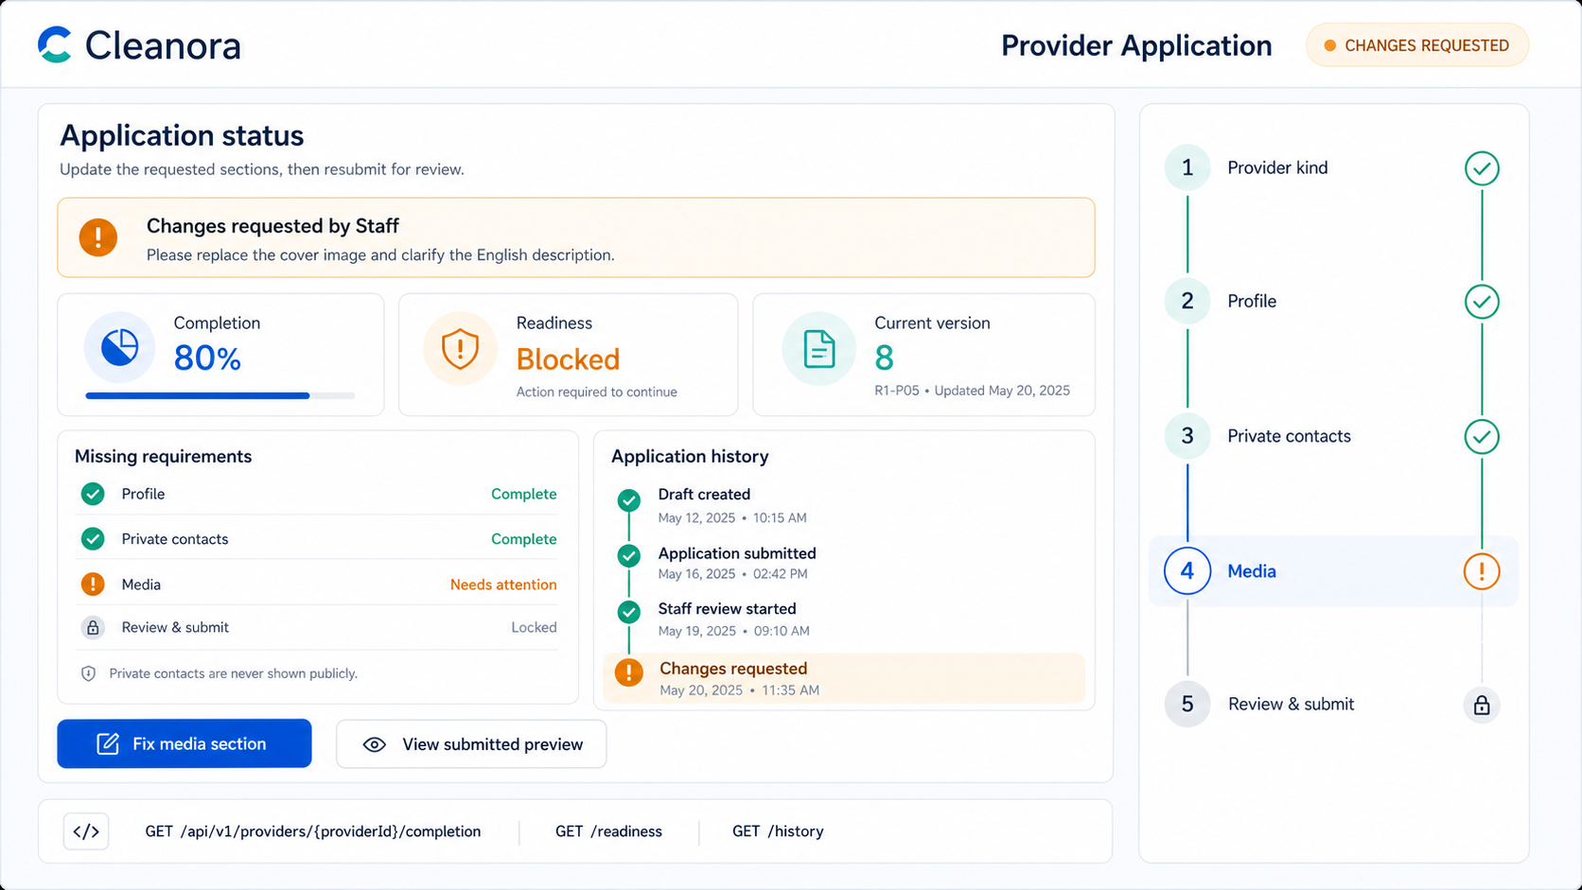
Screen 06 — Changes-requested state, missing requirements, and chronological application history. High-fidelity implementation reference; API contracts remain authoritative.

Frontend flow on this screen
1. Treat completion and readiness as server-owned facts; never calculate them locally.
2. Use missing requirement codes to deep-link the user to the correct step.
3. Paginate history with cursor and nextCursor, not page numbers.

APIs used on this screen

API 20 — Get Completion
GET /api/v1/providers/{providerId}/completion
Get Completion
What it does: Returns kind-aware R1-P05 application completion and actionable blockers.
Who can use it: Application Owner before approval; active exact-Provider OWNER/ADMIN after approval. Staff reads submitted evidence through the Staff dossier.
Efficient frontend usage: Render the server result directly; do not reproduce readiness calculations in the frontend.
Sample request body
No request body
Success response sample — HTTP 200 (representative excerpt; OpenAPI/Postman remains authoritative)
{
"requestId": "request_example_01",
"success": true,
"data": {
"missingRequirementCodes": [],
"policyVersion": "r1-p05-v1",
"percentage": 100,
"checks": [
{
"code": "ELIGIBLE_CATEGORY_VERIFIED",
"satisfied": true
}
]
}
}
Copyable Axios integration
export async function getCompletion(providerId: string) {
const response = await api.get(`/providers/${providerId}/completion`);
return response.data.data;
}
Possible error codes and recovery
HTTP 401 — AUTHENTICATION_REQUIRED
Meaning: The access token or authenticated session is missing or invalid.
Frontend recovery: Attempt one safe refresh; if it fails, send the user to sign-in and preserve only non-sensitive form state.
HTTP 403/404 — PROVIDER_ACCESS_DENIED
Meaning: The caller lacks the required identity, relationship, or exact-Provider authority.
Frontend recovery: Stop the action, refresh the caller's Provider list/capabilities, and do not reveal whether another Provider exists.
HTTP 404 — PROVIDER_NOT_FOUND
Meaning: The requested Provider is not available inside the caller's allowed scope.
Frontend recovery: Return to the visible Provider list and never guess or substitute another providerId.

API 21 — Get Readiness
GET /api/v1/providers/{providerId}/readiness
Get Readiness
What it does: Returns marketplace readiness gates. Approval alone does not make a Provider LIVE or eligible for public browse.
Who can use it: Application Owner before approval; active exact-Provider OWNER/ADMIN after approval. Staff reads submitted evidence through the Staff dossier.
Efficient frontend usage: Render the server result directly; do not reproduce readiness calculations in the frontend.
Sample request body
No request body
Success response sample — HTTP 200 (representative excerpt; OpenAPI/Postman remains authoritative)
{
"requestId": "request_example_01",
"success": true,
"data": {
"eligibleForPublicBrowse": false,
"gates": [
{
"key": "profileComplete",
"status": "SATISFIED",
"satisfied": true,
"owningPhase": "R1-P05"
}
]
}
}
Copyable Axios integration
export async function getReadiness(providerId: string) {
const response = await api.get(`/providers/${providerId}/readiness`);
return response.data.data;
}
Possible error codes and recovery
HTTP 401 — AUTHENTICATION_REQUIRED
Meaning: The access token or authenticated session is missing or invalid.
Frontend recovery: Attempt one safe refresh; if it fails, send the user to sign-in and preserve only non-sensitive form state.
HTTP 403/404 — PROVIDER_ACCESS_DENIED
Meaning: The caller lacks the required identity, relationship, or exact-Provider authority.
Frontend recovery: Stop the action, refresh the caller's Provider list/capabilities, and do not reveal whether another Provider exists.
HTTP 503 — PROVIDER_DEPENDENCY_UNAVAILABLE
Meaning: A required media, email, or configuration dependency is temporarily unavailable.
Frontend recovery: Offer a safe retry, keep local form state, and never launch parallel duplicate writes.

API 22 — Get History
GET /api/v1/providers/{providerId}/history
Get History
What it does: Returns bounded append-only Provider application and operational history. Optional query parameters: cursor and limit.
Who can use it: Application Owner before approval; active exact-Provider OWNER/ADMIN after approval. Staff reads submitted evidence through the Staff dossier.
Efficient frontend usage: Use cursor/nextCursor pagination and cancel stale filter requests.
Sample request body
No request body
Success response sample — HTTP 200
{
"success": true,
"data": [
{
"id": "history_example_01",
"eventType": "APPLICATION_SUBMITTED",
"occurredAt": "2026-08-13T10:00:00.000Z",
"actorType": "APPLICATION_OWNER"
}
],
"requestId": "request_example_01",
"meta": {
"nextCursor": null
}
}
Copyable Axios integration
export async function getHistory(providerId: string, params: Record<string, unknown> = {}) {
const response = await api.get(`/providers/${providerId}/history`, { params });
return response.data.data;
}
Possible error codes and recovery
HTTP 400 — VALIDATION_ERROR
Meaning: The body, query, file, or Content-Type does not match the API contract.
Frontend recovery: Map field details to the form, correct the payload, and do not retry unchanged input.
HTTP 403/404 — PROVIDER_ACCESS_DENIED
Meaning: The caller lacks the required identity, relationship, or exact-Provider authority.
Frontend recovery: Stop the action, refresh the caller's Provider list/capabilities, and do not reveal whether another Provider exists.
HTTP 404 — PROVIDER_NOT_FOUND
Meaning: The requested Provider is not available inside the caller's allowed scope.
Frontend recovery: Return to the visible Provider list and never guess or substitute another providerId.

PAGES BY ROLE
Pages for Provider Owner
Role responsibility: Exists after Staff approval, manages Provider content and Provider Admins, but cannot approve applications or make the Provider LIVE.

Screen 07 — Provider Owner Dashboard and Settings
Suggested route: /provider/:providerId/dashboard
Screen purpose: Give an approved Provider Owner one operational workspace that summarizes readiness, next actions, capabilities, and editable settings.
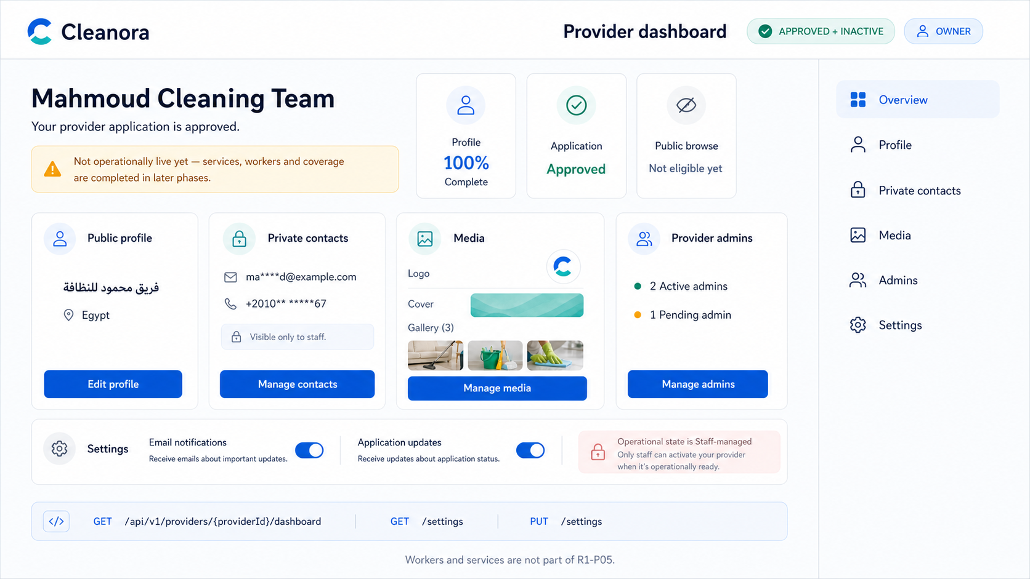
Screen 07 — Approved-but-inactive Provider Owner dashboard and settings. High-fidelity implementation reference; API contracts remain authoritative.

Frontend flow on this screen
1. Load dashboard and settings in parallel because both calls are read-only.
2. Render actions from server capability flags rather than hard-coded role guesses.
3. Do not present approval as LIVE or publicly browsable.

APIs used on this screen

API 23 — Get Dashboard
GET /api/v1/providers/{providerId}/dashboard
Get Dashboard
What it does: Returns a bounded Provider workspace aggregate including the current next action.
Who can use it: Active exact-Provider OWNER or accepted ADMIN.
Efficient frontend usage: Use the shared Axios client, show API error codes, and avoid duplicate in-flight requests.
Sample request body
No request body
Success response sample — HTTP 200 (representative excerpt; OpenAPI/Postman remains authoritative)
{
"requestId": "request_example_01",
"success": true,
"data": {
"nextAction": {
"code": "COMPLETE_LATER_READINESS_GATES",
"label": "Complete the remaining marketplace readiness steps"
},
"provider": {
"id": "provider_example_01",
"providerKind": "INDIVIDUAL_TEAM",
"applicationStatus": "APPROVED",
"operationalStatus": "INACTIVE",
"version": 1,
"createdAt": "2026-08-13T10:00:00.000Z"
},
"completion": {
"missingRequirementCodes": [],
"policyVersion": "r1-p05-v1",
"percentage": 100,
"checks": [
{
"code": "ELIGIBLE_CATEGORY_VERIFIED",
"satisfied": true
}
]
},
"readiness": {
"eligibleForPublicBrowse": false,
"gates": [
{
"key": "profileComplete",
"status": "SATISFIED",
"satisfied": true,
"owningPhase": "R1-P05"
}
]
}
}
}
Copyable Axios integration
export async function getDashboard(providerId: string) {
const response = await api.get(`/providers/${providerId}/dashboard`);
return response.data.data;
}
Possible error codes and recovery
HTTP 401 — AUTHENTICATION_REQUIRED
Meaning: The access token or authenticated session is missing or invalid.
Frontend recovery: Attempt one safe refresh; if it fails, send the user to sign-in and preserve only non-sensitive form state.
HTTP 403/404 — PROVIDER_ACCESS_DENIED
Meaning: The caller lacks the required identity, relationship, or exact-Provider authority.
Frontend recovery: Stop the action, refresh the caller's Provider list/capabilities, and do not reveal whether another Provider exists.
HTTP 503 — PROVIDER_DEPENDENCY_UNAVAILABLE
Meaning: A required media, email, or configuration dependency is temporarily unavailable.
Frontend recovery: Offer a safe retry, keep local form state, and never launch parallel duplicate writes.

API 24 — Get Settings
GET /api/v1/providers/{providerId}/settings
Get Settings
What it does: Returns capability-only settings. The UI must render actions from capabilities rather than infer them from status strings.
Who can use it: Active exact-Provider OWNER or accepted ADMIN.
Efficient frontend usage: Use the shared Axios client, show API error codes, and avoid duplicate in-flight requests.
Sample request body
No request body
Success response sample — HTTP 200
{
"success": true,
"data": {
"providerId": "provider_example_01",
"capabilities": {
"canEditProfile": true,
"canEditContacts": true,
"canManageMedia": true,
"canManageAdmins": true,
"canSubmitApplication": true
}
},
"requestId": "request_example_01"
}
Copyable Axios integration
export async function getSettings(providerId: string) {
const response = await api.get(`/providers/${providerId}/settings`);
return response.data.data;
}
Possible error codes and recovery
HTTP 401 — AUTHENTICATION_REQUIRED
Meaning: The access token or authenticated session is missing or invalid.
Frontend recovery: Attempt one safe refresh; if it fails, send the user to sign-in and preserve only non-sensitive form state.
HTTP 403/404 — PROVIDER_ACCESS_DENIED
Meaning: The caller lacks the required identity, relationship, or exact-Provider authority.
Frontend recovery: Stop the action, refresh the caller's Provider list/capabilities, and do not reveal whether another Provider exists.
HTTP 404 — PROVIDER_NOT_FOUND
Meaning: The requested Provider is not available inside the caller's allowed scope.
Frontend recovery: Return to the visible Provider list and never guess or substitute another providerId.

Screen 08 — Provider Members and Admin Invitations
Suggested route: /provider/:providerId/admins
Screen purpose: Let the active Provider Owner list OWNER/ADMIN memberships and manage single-use Provider Admin invitations.
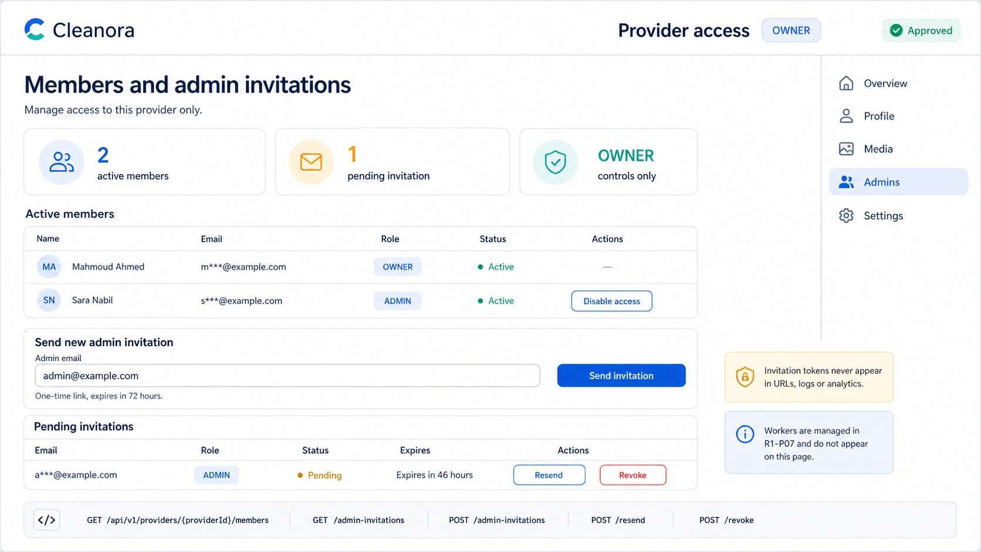
Screen 08 — OWNER-only membership list and single-use Provider Admin invitations. High-fidelity implementation reference; API contracts remain authoritative.

Frontend flow on this screen
1. Keep worker or cleaning-team management out of this page; workers belong to R1-P07.
2. Allow only the active OWNER to create, resend, revoke invitations, or disable an ADMIN.
3. Never expose raw invitation tokens in logs, analytics, or URLs.

APIs used on this screen

API 25 — List Members
GET /api/v1/providers/{providerId}/members
List Members
What it does: Lists Provider OWNER and ADMIN memberships.
Who can use it: Active OWNER membership for the exact Provider.
Efficient frontend usage: Use the shared Axios client, show API error codes, and avoid duplicate in-flight requests.
Sample request body
No request body
Success response sample — HTTP 200
{
"success": true,
"data": [
{
"userId": "user_owner_01",
"role": "OWNER",
"enabled": true,
"joinedAt": "2026-08-13T10:00:00.000Z"
}
],
"requestId": "request_example_01"
}
Copyable Axios integration
export async function listMembers(providerId: string) {
const response = await api.get(`/providers/${providerId}/members`);
return response.data.data;
}
Possible error codes and recovery
HTTP 401 — AUTHENTICATION_REQUIRED
Meaning: The access token or authenticated session is missing or invalid.
Frontend recovery: Attempt one safe refresh; if it fails, send the user to sign-in and preserve only non-sensitive form state.
HTTP 403/404 — PROVIDER_ACCESS_DENIED
Meaning: The caller lacks the required identity, relationship, or exact-Provider authority.
Frontend recovery: Stop the action, refresh the caller's Provider list/capabilities, and do not reveal whether another Provider exists.
HTTP 404 — PROVIDER_NOT_FOUND
Meaning: The requested Provider is not available inside the caller's allowed scope.
Frontend recovery: Return to the visible Provider list and never guess or substitute another providerId.

API 26 — Disable Admin Member
DELETE /api/v1/providers/{providerId}/members/{userId}
Disable Admin Member
What it does: Soft-disables an ADMIN membership. The target cannot be OWNER, and the final enabled administration invariant is enforced.
Who can use it: Active OWNER membership for the exact Provider.
Efficient frontend usage: Serialize Provider mutations and replace local providerVersion with the returned version.
Sample request body
{
"expectedVersion": 12
}
Success response sample — HTTP 200
{
"success": true,
"data": {
"member": {
"userId": "user_admin_01",
"role": "ADMIN",
"enabled": false
}
},
"requestId": "request_example_01"
}
Copyable Axios integration
export async function disableAdminMember(providerId: string, userId: string, payload: Record<string, unknown>) {
const response = await api.delete(`/providers/${providerId}/members/${userId}`, { data: payload });
return response.data.data;
}
Possible error codes and recovery
HTTP 404 — PROVIDER_MEMBER_NOT_FOUND
Meaning: The target ADMIN membership is not active or not available to this Provider Owner.
Frontend recovery: Refresh the membership list and remove stale UI rows without probing another Provider.
HTTP 409 — PROVIDER_VERSION_CONFLICT
Meaning: expectedVersion is stale because another write completed first.
Frontend recovery: Refetch the Provider, replace the local version, preserve the user's intent, and ask for an explicit retry.
HTTP 409 — PROVIDER_STATE_CONFLICT
Meaning: The command is not allowed in the Provider's current application or operational state.
Frontend recovery: Reload the aggregate and enable only actions permitted by the returned state/capability flags.
HTTP 403/404 — PROVIDER_ACCESS_DENIED
Meaning: The caller lacks the required identity, relationship, or exact-Provider authority.
Frontend recovery: Stop the action, refresh the caller's Provider list/capabilities, and do not reveal whether another Provider exists.

API 27 — List Admin Invitations
GET /api/v1/providers/{providerId}/admin-invitations
List Admin Invitations
What it does: Lists invitation lifecycle rows. Optional query parameters: status, cursor, and limit.
Who can use it: Active OWNER membership for the exact Provider.
Efficient frontend usage: Use cursor/nextCursor pagination and cancel stale filter requests. Keep invitation tokens in transient memory only; never place them in URLs, logs, or analytics.
Sample request body
No request body
Success response sample — HTTP 200
{
"success": true,
"data": [
{
"id": "invitation_example_01",
"providerId": "provider_example_01",
"email": "provider.admin@example.com",
"status": "PENDING",
"expiresAt": "2026-08-20T10:00:00.000Z",
"createdAt": "2026-08-13T10:00:00.000Z"
}
],
"requestId": "request_example_01",
"meta": {
"nextCursor": null
}
}
Copyable Axios integration
export async function listAdminInvitations(providerId: string, params: Record<string, unknown> = {}) {
const response = await api.get(`/providers/${providerId}/admin-invitations`, { params });
return response.data.data;
}
Possible error codes and recovery
HTTP 400 — VALIDATION_ERROR
Meaning: The body, query, file, or Content-Type does not match the API contract.
Frontend recovery: Map field details to the form, correct the payload, and do not retry unchanged input.
HTTP 403/404 — PROVIDER_ACCESS_DENIED
Meaning: The caller lacks the required identity, relationship, or exact-Provider authority.
Frontend recovery: Stop the action, refresh the caller's Provider list/capabilities, and do not reveal whether another Provider exists.
HTTP 404 — PROVIDER_NOT_FOUND
Meaning: The requested Provider is not available inside the caller's allowed scope.
Frontend recovery: Return to the visible Provider list and never guess or substitute another providerId.

API 28 — Create Admin Invitation
POST /api/v1/providers/{providerId}/admin-invitations
Create Admin Invitation
What it does: Invites a Provider ADMIN by normalized email. The raw token is delivered out of band and is never returned as durable list data.
Who can use it: Active OWNER membership for the exact Provider.
Efficient frontend usage: Serialize Provider mutations and replace local providerVersion with the returned version. Keep invitation tokens in transient memory only; never place them in URLs, logs, or analytics.
Sample request body
{
"email": "<providerAdminInviteEmail>",
"expectedVersion": 12
}
Success response sample — HTTP 202
{
"success": true,
"data": {
"invitation": {
"id": "invitation_example_01",
"providerId": "provider_example_01",
"email": "provider.admin@example.com",
"status": "PENDING",
"expiresAt": "2026-08-20T10:00:00.000Z",
"createdAt": "2026-08-13T10:00:00.000Z"
},
"deliveryAccepted": true,
"version": 12
},
"requestId": "request_example_01"
}
Copyable Axios integration
export async function createAdminInvitation(providerId: string, payload: Record<string, unknown>) {
const response = await api.post(`/providers/${providerId}/admin-invitations`, payload);
return response.data.data;
}
Possible error codes and recovery
HTTP 400 — VALIDATION_ERROR
Meaning: The body, query, file, or Content-Type does not match the API contract.
Frontend recovery: Map field details to the form, correct the payload, and do not retry unchanged input.
HTTP 409 — PROVIDER_INVITATION_CONFLICT
Meaning: The invitation state conflicts with the requested resend, revoke, onboarding, or acceptance action.
Frontend recovery: Re-inspect or reload the invitation and render actions from its current state.
HTTP 409 — PROVIDER_VERSION_CONFLICT
Meaning: expectedVersion is stale because another write completed first.
Frontend recovery: Refetch the Provider, replace the local version, preserve the user's intent, and ask for an explicit retry.
HTTP 503 — PROVIDER_DEPENDENCY_UNAVAILABLE
Meaning: A required media, email, or configuration dependency is temporarily unavailable.
Frontend recovery: Offer a safe retry, keep local form state, and never launch parallel duplicate writes.

API 29 — Resend Admin Invitation
POST /api/v1/providers/{providerId}/admin-invitations/{invitationId}/resend
Resend Admin Invitation
What it does: Rotates the pending invitation verifier and sends the replacement invitation. The prior token becomes unusable.
Who can use it: Active OWNER membership for the exact Provider.
Efficient frontend usage: Serialize Provider mutations and replace local providerVersion with the returned version. Keep invitation tokens in transient memory only; never place them in URLs, logs, or analytics.
Sample request body
{
"expectedVersion": 12
}
Success response sample — HTTP 202
{
"success": true,
"data": {
"invitation": {
"id": "invitation_example_01",
"providerId": "provider_example_01",
"email": "provider.admin@example.com",
"status": "PENDING",
"expiresAt": "2026-08-20T10:00:00.000Z",
"createdAt": "2026-08-13T10:00:00.000Z",
"updatedAt": "2026-08-13T10:00:00.000Z"
},
"deliveryAccepted": true,
"version": 13
},
"requestId": "request_example_01"
}
Copyable Axios integration
export async function resendAdminInvitation(providerId: string, invitationId: string, payload: Record<string, unknown>) {
const response = await api.post(`/providers/${providerId}/admin-invitations/${invitationId}/resend`, payload);
return response.data.data;
}
Possible error codes and recovery
HTTP 409 — PROVIDER_INVITATION_CONFLICT
Meaning: The invitation state conflicts with the requested resend, revoke, onboarding, or acceptance action.
Frontend recovery: Re-inspect or reload the invitation and render actions from its current state.
HTTP 409 — PROVIDER_VERSION_CONFLICT
Meaning: expectedVersion is stale because another write completed first.
Frontend recovery: Refetch the Provider, replace the local version, preserve the user's intent, and ask for an explicit retry.
HTTP 503 — PROVIDER_DEPENDENCY_UNAVAILABLE
Meaning: A required media, email, or configuration dependency is temporarily unavailable.
Frontend recovery: Offer a safe retry, keep local form state, and never launch parallel duplicate writes.

API 30 — Revoke Admin Invitation
POST /api/v1/providers/{providerId}/admin-invitations/{invitationId}/revoke
Revoke Admin Invitation
What it does: Revokes a pending Provider Admin invitation.
Who can use it: Active OWNER membership for the exact Provider.
Efficient frontend usage: Serialize Provider mutations and replace local providerVersion with the returned version. Keep invitation tokens in transient memory only; never place them in URLs, logs, or analytics.
Sample request body
{
"expectedVersion": 12
}
Success response sample — HTTP 200
{
"success": true,
"data": {
"invitation": {
"id": "invitation_example_01",
"providerId": "provider_example_01",
"email": "provider.admin@example.com",
"status": "REVOKED",
"expiresAt": "2026-08-20T10:00:00.000Z",
"createdAt": "2026-08-13T10:00:00.000Z"
},
"version": 13
},
"requestId": "request_example_01"
}
Copyable Axios integration
export async function revokeAdminInvitation(providerId: string, invitationId: string, payload: Record<string, unknown>) {
const response = await api.post(`/providers/${providerId}/admin-invitations/${invitationId}/revoke`, payload);
return response.data.data;
}
Possible error codes and recovery
HTTP 409 — PROVIDER_INVITATION_CONFLICT
Meaning: The invitation state conflicts with the requested resend, revoke, onboarding, or acceptance action.
Frontend recovery: Re-inspect or reload the invitation and render actions from its current state.
HTTP 409 — PROVIDER_VERSION_CONFLICT
Meaning: expectedVersion is stale because another write completed first.
Frontend recovery: Refetch the Provider, replace the local version, preserve the user's intent, and ask for an explicit retry.
HTTP 403/404 — PROVIDER_ACCESS_DENIED
Meaning: The caller lacks the required identity, relationship, or exact-Provider authority.
Frontend recovery: Stop the action, refresh the caller's Provider list/capabilities, and do not reveal whether another Provider exists.

PAGES BY ROLE
Pages for Provider Admin
Role responsibility: Manages authorized content for the exact Provider through reused capabilities, without ownership, submission, or membership-management controls.

Screen 09 — Provider Admin Workspace
Suggested route: /provider/:providerId/workspace
Screen purpose: Reuse the approved Provider content-management screens for an accepted ADMIN while hiding ownership, submission, member, and invitation controls.
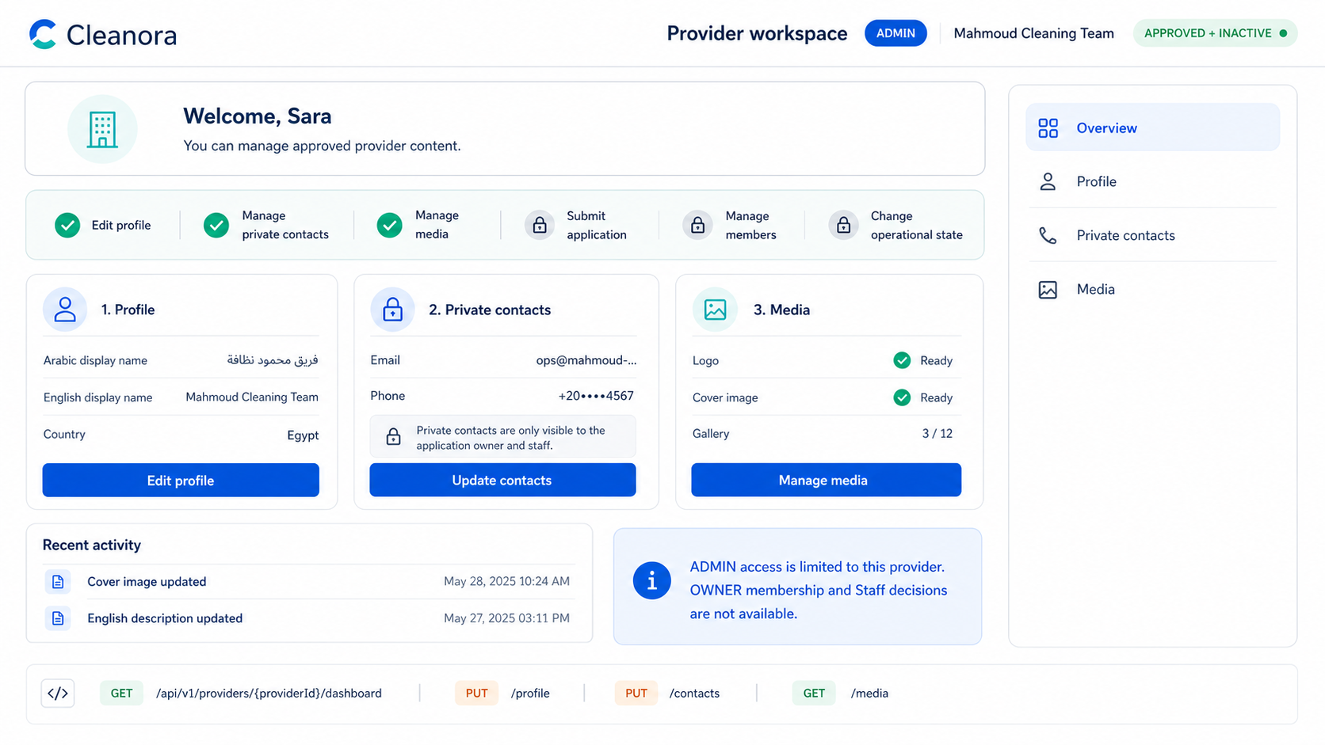
Screen 09 — Provider Admin content workspace with explicit capability boundaries. High-fidelity implementation reference; API contracts remain authoritative.

Frontend flow on this screen
1. Reuse the same API service functions documented for profile, contacts, media, preview, and status.
2. Drive visible actions from the returned relationship and capability flags.
3. Do not duplicate API wrappers solely for the ADMIN route.

APIs reused by this screen
Implementation rule: Import the same service functions documented on the canonical Applicant/Owner screens. Do not create duplicate wrappers for Provider Admin.
API | Canonical screen | Provider Admin usage
Get Dashboard | Screen 07 | Use when returned capability flags permit the action.
Get Settings | Screen 07 | Use when returned capability flags permit the action.
Get Profile | Screen 02 | Use when returned capability flags permit the action.
Replace Profile | Screen 02 | Use when returned capability flags permit the action.
Get Private Contacts | Screen 03 | Use when returned capability flags permit the action.
Replace Private Contacts | Screen 03 | Use when returned capability flags permit the action.
List Media | Screen 04 | Use when returned capability flags permit the action.
Replace Logo | Screen 04 | Use when returned capability flags permit the action.
Replace Cover | Screen 04 | Use when returned capability flags permit the action.
Add Gallery Image | Screen 04 | Use when returned capability flags permit the action.
Add Gallery Video | Screen 04 | Use when returned capability flags permit the action.
Reorder Gallery | Screen 04 | Use when returned capability flags permit the action.
Delete Logo | Screen 04 | Use when returned capability flags permit the action.
Delete Cover | Screen 04 | Use when returned capability flags permit the action.
Delete Gallery Item | Screen 04 | Use when returned capability flags permit the action.
Get Completion | Screen 06 | Use when returned capability flags permit the action.
Get Readiness | Screen 06 | Use when returned capability flags permit the action.
Get History | Screen 06 | Use when returned capability flags permit the action.
Protected Contact-Free Preview | Screen 05 | Use when returned capability flags permit the action.

PAGES BY ROLE
Pages for Invited Provider Admin
Role responsibility: Inspects a single-use invitation, completes constrained onboarding if needed, verifies email, and accepts the ADMIN membership.

Screen 10 — Invitation Landing and Safe Inspection
Suggested route: /provider-admin/invitation
Screen purpose: Inspect a single-use invitation token from the request body and display only safe Provider/invite facts before authentication or onboarding.
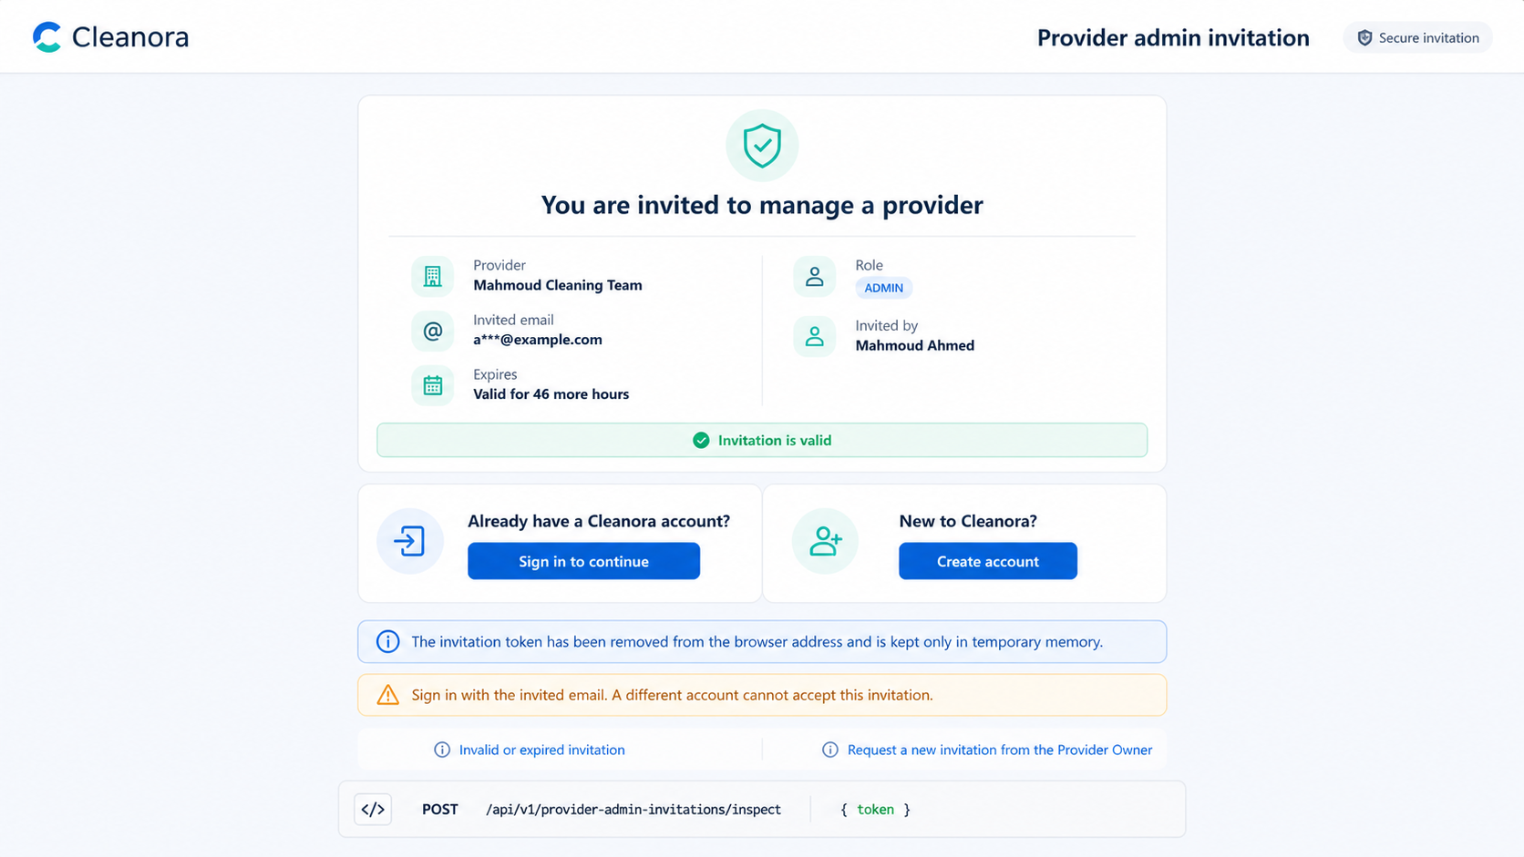
Screen 10 — Safe invitation inspection before authentication or onboarding. High-fidelity implementation reference; API contracts remain authoritative.

Frontend flow on this screen
1. Read the token from memory or the initial link, then remove it from the browser URL.
2. Send the token in the POST body, never as a path or query parameter.
3. Route existing users to sign-in and new users to invitation-only onboarding.

APIs used on this screen

API 31 — Inspect Invitation
POST /api/v1/provider-admin-invitations/inspect
Inspect Invitation
What it does: Publicly inspects a body-supplied invitation token and returns only safe invitation facts. The token must never be placed in a URL.
Who can use it: Invitation holder; token and identity requirements depend on the onboarding step.
Efficient frontend usage: Keep invitation tokens in transient memory only; never place them in URLs, logs, or analytics.
Sample request body
{
"token": "<single-use-invitation-token>"
}
Success response sample — HTTP 200
{
"success": true,
"data": {
"providerId": "provider_example_01",
"providerDisplayName": "Cleanora Cleaning Team",
"invitedEmailMasked": "pr********@example.com",
"expiresAt": "2026-08-20T10:00:00.000Z",
"nextAction": "START_ONBOARDING"
},
"requestId": "request_example_01"
}
Copyable Axios integration
export async function inspectInvitation(payload: Record<string, unknown>) {
const response = await api.post(`/provider-admin-invitations/inspect`, payload);
return response.data.data;
}
Possible error codes and recovery
HTTP 400 — VALIDATION_ERROR
Meaning: The body, query, file, or Content-Type does not match the API contract.
Frontend recovery: Map field details to the form, correct the payload, and do not retry unchanged input.
HTTP 400/410 — PROVIDER_INVITATION_INVALID
Meaning: The token is missing, expired, revoked, consumed, or otherwise invalid.
Frontend recovery: Clear the token from memory and show a safe expired/invalid invitation state without exposing Provider internals.
HTTP 503 — PROVIDER_DEPENDENCY_UNAVAILABLE
Meaning: A required media, email, or configuration dependency is temporarily unavailable.
Frontend recovery: Offer a safe retry, keep local form state, and never launch parallel duplicate writes.

Screen 11 — Invitation-Only Account Onboarding
Suggested route: /provider-admin/invitation/onboarding
Screen purpose: Create an invitee account using the invitation's fixed email, then verify the email challenge without allowing a different email address.
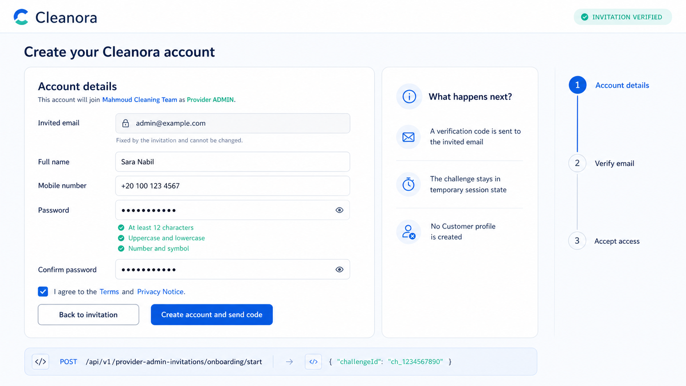
Screen 11 — Invitation-only account creation with a fixed invited email. High-fidelity implementation reference; API contracts remain authoritative.

Frontend flow on this screen
1. Start onboarding with the invitation token and required account data.
2. Store challengeId only in transient state.
3. Verify the email code and continue to acceptance only after success.

APIs used on this screen

API 32 — Start Invitation Onboarding
POST /api/v1/provider-admin-invitations/onboarding/start
Start Invitation Onboarding
What it does: Starts categoryless invitation-only onboarding for an invitee without a Cleanora identity. Uses the invitation's fixed email and captures challengeId when returned.
Who can use it: Invitation holder; token and identity requirements depend on the onboarding step.
Efficient frontend usage: Keep invitation tokens in transient memory only; never place them in URLs, logs, or analytics.
Sample request body
{
"token": "<single-use-invitation-token>",
"phone": "<invitedAdminPhone>",
"password": "<testPassword>"
}
Success response sample — HTTP 202
{
"success": true,
"data": {
"challengeId": "challenge_example_01",
"channel": "EMAIL",
"maskedDestination": "pr********@example.com",
"expiresAt": "2026-08-13T10:10:00.000Z",
"nextAction": "VERIFY_EMAIL"
},
"requestId": "request_example_01"
}
Copyable Axios integration
export async function startInvitationOnboarding(payload: Record<string, unknown>) {
const response = await api.post(`/provider-admin-invitations/onboarding/start`, payload);
return response.data.data;
}
Possible error codes and recovery
HTTP 400 — VALIDATION_ERROR
Meaning: The body, query, file, or Content-Type does not match the API contract.
Frontend recovery: Map field details to the form, correct the payload, and do not retry unchanged input.
HTTP 400/410 — PROVIDER_INVITATION_INVALID
Meaning: The token is missing, expired, revoked, consumed, or otherwise invalid.
Frontend recovery: Clear the token from memory and show a safe expired/invalid invitation state without exposing Provider internals.
HTTP 409 — PROVIDER_INVITATION_CONFLICT
Meaning: The invitation state conflicts with the requested resend, revoke, onboarding, or acceptance action.
Frontend recovery: Re-inspect or reload the invitation and render actions from its current state.
HTTP 503 — PROVIDER_DEPENDENCY_UNAVAILABLE
Meaning: A required media, email, or configuration dependency is temporarily unavailable.
Frontend recovery: Offer a safe retry, keep local form state, and never launch parallel duplicate writes.

API 33 — Verify Invitation Email
POST /api/v1/provider-admin-invitations/onboarding/verify-email
Verify Invitation Email
What it does: Consumes the invitation onboarding email code for the fixed invited email.
Who can use it: Invitation holder; token and identity requirements depend on the onboarding step.
Efficient frontend usage: Keep invitation tokens in transient memory only; never place them in URLs, logs, or analytics.
Sample request body
{
"token": "<single-use-invitation-token>",
"challengeId": "<challengeId>",
"code": "<emailOtp>"
}
Success response sample — HTTP 200
{
"success": true,
"data": {
"userId": "user_invited_admin_01",
"emailNormalized": "provider.admin@example.com",
"capability": "PROVIDER_ADMIN_INVITATION_ONBOARDING",
"allowedActions": [
"ACCEPT_PROVIDER_ADMIN_INVITATION"
],
"accessToken": "<access-token>",
"accessExpiresAt": "2026-08-13T10:15:00.000Z",
"refreshToken": "<refresh-token-set-in-secure-client-storage>",
"refreshExpiresAt": "2026-09-12T10:00:00.000Z"
},
"requestId": "request_example_01"
}
Copyable Axios integration
export async function verifyInvitationEmail(payload: Record<string, unknown>) {
const response = await api.post(`/provider-admin-invitations/onboarding/verify-email`, payload);
return response.data.data;
}
Possible error codes and recovery
HTTP 400 — VALIDATION_ERROR
Meaning: The body, query, file, or Content-Type does not match the API contract.
Frontend recovery: Map field details to the form, correct the payload, and do not retry unchanged input.
HTTP 400/410 — PROVIDER_INVITATION_INVALID
Meaning: The token is missing, expired, revoked, consumed, or otherwise invalid.
Frontend recovery: Clear the token from memory and show a safe expired/invalid invitation state without exposing Provider internals.
HTTP 403 — PROVIDER_INVITATION_EMAIL_MISMATCH
Meaning: The authenticated identity does not match the invitation's fixed email.
Frontend recovery: Sign out the wrong identity and authenticate with the invited email; never allow the email to be edited.
HTTP 503 — PROVIDER_DEPENDENCY_UNAVAILABLE
Meaning: A required media, email, or configuration dependency is temporarily unavailable.
Frontend recovery: Offer a safe retry, keep local form state, and never launch parallel duplicate writes.

Screen 12 — Accept Provider Admin Invitation
Suggested route: /provider-admin/invitation/accept
Screen purpose: Atomically accept a still-valid invitation for the authenticated invited identity and create the Provider ADMIN membership.
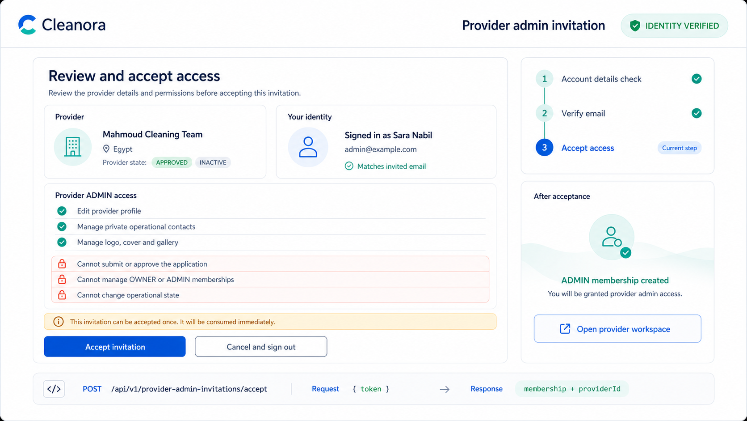
Screen 12 — Final ADMIN permission review and single-use invitation acceptance. High-fidelity implementation reference; API contracts remain authoritative.

Frontend flow on this screen
1. Require the authenticated identity to match the invitation email.
2. Treat the token as single-use and clear all local copies after acceptance.
3. Redirect to the Provider Admin workspace returned by the API.

APIs used on this screen

API 34 — Accept Invitation
POST /api/v1/provider-admin-invitations/accept
Accept Invitation
What it does: Atomically consumes the one-time invitation and creates the Provider ADMIN membership. Authenticate as the verified invitee whose email matches the invitation.
Who can use it: Authenticated invited identity whose verified email matches the invitation.
Efficient frontend usage: Keep invitation tokens in transient memory only; never place them in URLs, logs, or analytics.
Sample request body
{
"token": "<single-use-invitation-token>"
}
Success response sample — HTTP 200
{
"success": true,
"data": {
"providerId": "provider_example_01",
"membership": {
"userId": "user_invited_admin_01",
"role": "ADMIN",
"enabled": true
},
"invitationStatus": "ACCEPTED",
"version": 14
},
"requestId": "request_example_01"
}
Copyable Axios integration
export async function acceptInvitation(payload: Record<string, unknown>) {
const response = await api.post(`/provider-admin-invitations/accept`, payload);
return response.data.data;
}
Possible error codes and recovery
HTTP 400/410 — PROVIDER_INVITATION_INVALID
Meaning: The token is missing, expired, revoked, consumed, or otherwise invalid.
Frontend recovery: Clear the token from memory and show a safe expired/invalid invitation state without exposing Provider internals.
HTTP 403 — PROVIDER_INVITATION_EMAIL_MISMATCH
Meaning: The authenticated identity does not match the invitation's fixed email.
Frontend recovery: Sign out the wrong identity and authenticate with the invited email; never allow the email to be edited.
HTTP 409 — PROVIDER_INVITATION_CONFLICT
Meaning: The invitation state conflicts with the requested resend, revoke, onboarding, or acceptance action.
Frontend recovery: Re-inspect or reload the invitation and render actions from its current state.
HTTP 401 — AUTHENTICATION_REQUIRED
Meaning: The access token or authenticated session is missing or invalid.
Frontend recovery: Attempt one safe refresh; if it fails, send the user to sign-in and preserve only non-sensitive form state.

PAGES BY ROLE
Pages for Staff Admin
Role responsibility: Reviews the application queue and dossiers, makes application decisions, and manages operational suspension/reinstatement with audited reasons.

Screen 13 — Staff Application Review Queue
Suggested route: /staff/providers/applications
Screen purpose: List submitted Provider applications in a deterministic Staff queue with status, kind, date, cursor, and limit filters.
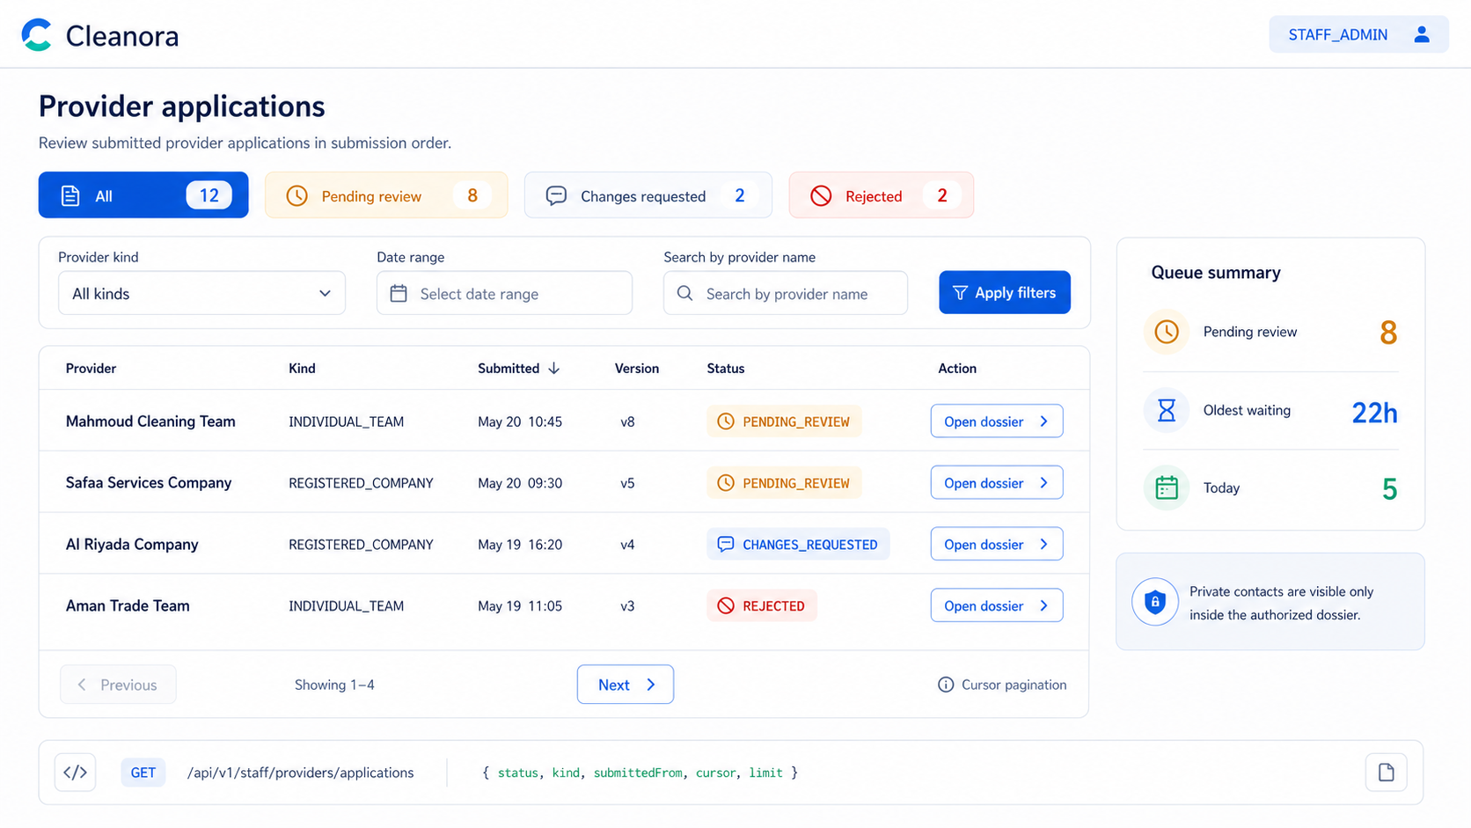
Screen 13 — Private Staff review queue with deterministic filters and cursor pagination. High-fidelity implementation reference; API contracts remain authoritative.

Frontend flow on this screen
1. Require an active STAFF_ADMIN session before loading the page.
2. Debounce filters and reset the cursor when filter values change.
3. Open the selected Provider dossier without exposing cross-Provider existence details on access failure.

APIs used on this screen

API 35 — List Applications Queue
GET /api/v1/staff/providers/applications
List Applications Queue
What it does: Lists the deterministic Staff review queue. Optional filters: status, providerKind, submittedFrom, submittedTo, cursor, and limit.
Who can use it: Active STAFF_ADMIN only.
Efficient frontend usage: Use cursor/nextCursor pagination and cancel stale filter requests.
Sample request body
No request body
Success response sample — HTTP 200
{
"success": true,
"data": [
{
"id": "provider_example_01",
"providerKind": "INDIVIDUAL_TEAM",
"applicationStatus": "PENDING_REVIEW",
"operationalStatus": "INACTIVE",
"version": 1,
"createdAt": "2026-08-13T10:00:00.000Z",
"updatedAt": "2026-08-13T10:00:00.000Z",
"submittedAt": "2026-08-13T10:00:00.000Z",
"completionPercentage": 100
}
],
"requestId": "request_example_01",
"meta": {
"nextCursor": null
}
}
Copyable Axios integration
export async function listApplicationsQueue(params: Record<string, unknown> = {}) {
const response = await api.get(`/staff/providers/applications`, { params });
return response.data.data;
}
Possible error codes and recovery
HTTP 401 — AUTHENTICATION_REQUIRED
Meaning: The access token or authenticated session is missing or invalid.
Frontend recovery: Attempt one safe refresh; if it fails, send the user to sign-in and preserve only non-sensitive form state.
HTTP 403/404 — PROVIDER_ACCESS_DENIED
Meaning: The caller lacks the required identity, relationship, or exact-Provider authority.
Frontend recovery: Stop the action, refresh the caller's Provider list/capabilities, and do not reveal whether another Provider exists.
HTTP 400 — VALIDATION_ERROR
Meaning: The body, query, file, or Content-Type does not match the API contract.
Frontend recovery: Map field details to the form, correct the payload, and do not retry unchanged input.

Screen 14 — Staff Application Dossier and Decision
Suggested route: /staff/providers/applications/:providerId
Screen purpose: Review the private submitted dossier and approve, request changes, or reject the exact application version with a meaningful reason where required.
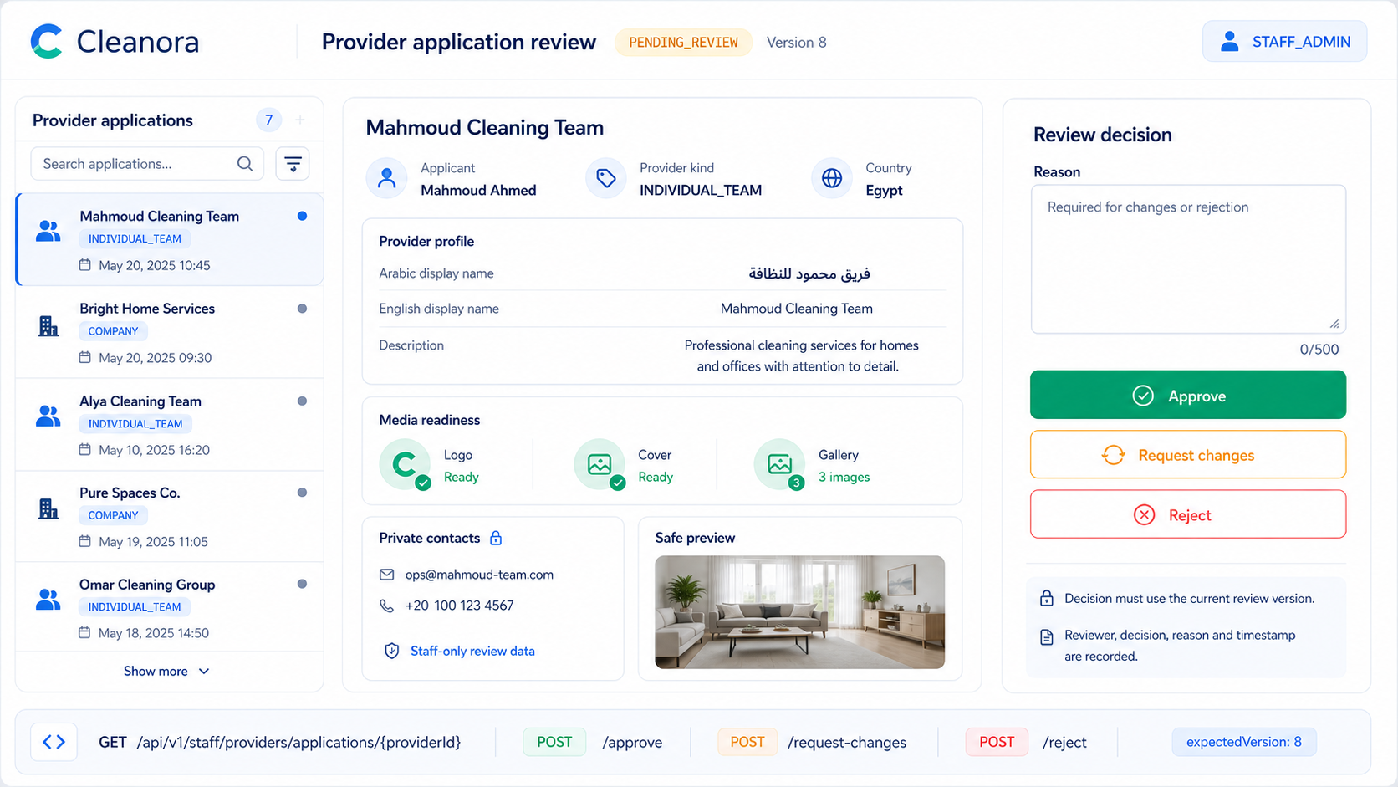
Screen 14 — Staff dossier, private evidence, exact review version, and three decision paths. High-fidelity implementation reference; API contracts remain authoritative.

Frontend flow on this screen
1. Load the dossier before enabling any decision button.
2. Send the exact application/review version to prevent stale decisions.
3. Disable all decision buttons while one command is in flight.
4. Refresh the queue and dossier after a successful decision.

APIs used on this screen

API 36 — Get Application Dossier
GET /api/v1/staff/providers/applications/{providerId}
Get Application Dossier
What it does: Reads the private Staff dossier for one submitted Provider application.
Who can use it: Active STAFF_ADMIN only.
Efficient frontend usage: Use the shared Axios client, show API error codes, and avoid duplicate in-flight requests.
Sample request body
No request body
Success response sample — HTTP 200 (representative excerpt; OpenAPI/Postman remains authoritative)
{
"requestId": "request_example_01",
"success": true,
"data": {
"provider": {
"id": "provider_example_01",
"providerKind": "INDIVIDUAL_TEAM",
"applicationStatus": "PENDING_REVIEW",
"operationalStatus": "INACTIVE",
"version": 9,
"createdAt": "2026-08-13T10:00:00.000Z"
},
"profile": {
"providerId": "provider_example_01",
"version": 2,
"displayNameAr": "<Arabic-language value supplied by the provider>",
"displayNameEn": "Cleanora Cleaning Team",
"descriptionAr": "<Arabic-language value supplied by the provider>",
"descriptionEn": "A professional team specializing in high-quality home and apartment cleaning."
},
"contacts": {
"providerId": "provider_example_01",
"version": 3,
"operationalEmail": "provider.ops@example.com",
"operationalPhone": "+201000000000",
"channels": [
{
"type": "WHATSAPP",
"value": "+201000000000"
}
]
},
"media": {
"providerId": "provider_example_01",
"version": 6,
"logo": {
"id": "media_logo_01",
"type": "LOGO",
"status": "READY",
"url": "https://res.cloudinary.com/example/image/upload/provider-logo.webp"
},
"cover": {
"id": "media_cover_01",
"type": "COVER",
"status": "READY",
"url": "https://res.cloudinary.com/example/image/upload/provider-cover.webp"
},
"gallery": [
{
"id": "gallery_image_01",
"type": "GALLERY_IMAGE",
"status": "READY",
"position": 1,
"url": "https://res.cloudinary.com/example/image/upload/gallery-01.webp"
}
]
},
"completion": {
"missingRequirementCodes": [],
"policyVersion": "r1-p05-v1",
"percentage": 100,
"checks": [
{
"code": "ELIGIBLE_CATEGORY_VERIFIED",
"satisfied": true
}
]
},
"readiness": {
"eligibleForPublicBrowse": false,
"gates": [
{
"key": "profileComplete",
"status": "SATISFIED",
"satisfied": true,
"owningPhase": "R1-P05"
}
]
},
"submittedAt": "2026-08-13T10:00:00.000Z"
}
}
Copyable Axios integration
export async function getApplicationDossier(providerId: string) {
const response = await api.get(`/staff/providers/applications/${providerId}`);
return response.data.data;
}
Possible error codes and recovery
HTTP 401 — AUTHENTICATION_REQUIRED
Meaning: The access token or authenticated session is missing or invalid.
Frontend recovery: Attempt one safe refresh; if it fails, send the user to sign-in and preserve only non-sensitive form state.
HTTP 403/404 — PROVIDER_ACCESS_DENIED
Meaning: The caller lacks the required identity, relationship, or exact-Provider authority.
Frontend recovery: Stop the action, refresh the caller's Provider list/capabilities, and do not reveal whether another Provider exists.
HTTP 404 — PROVIDER_NOT_FOUND
Meaning: The requested Provider is not available inside the caller's allowed scope.
Frontend recovery: Return to the visible Provider list and never guess or substitute another providerId.

API 37 — Approve Application
POST /api/v1/staff/providers/applications/{providerId}/approve
Approve Application
What it does: Approves the application atomically. Approval creates the OWNER membership but leaves operational status INACTIVE.
Who can use it: Active STAFF_ADMIN only.
Efficient frontend usage: Serialize Provider mutations and replace local providerVersion with the returned version. Disable competing Staff buttons while the command is in flight and refresh authoritative state afterward.
Sample request body
{
"expectedVersion": 12
}
Success response sample — HTTP 200 (representative excerpt; OpenAPI/Postman remains authoritative)
{
"requestId": "request_example_01",
"success": true,
"data": {
"provider": {
"id": "provider_example_01",
"providerKind": "INDIVIDUAL_TEAM",
"applicationStatus": "APPROVED",
"operationalStatus": "INACTIVE",
"version": 10,
"createdAt": "2026-08-13T10:00:00.000Z"
},
"completion": {
"missingRequirementCodes": [],
"policyVersion": "r1-p05-v1",
"percentage": 100,
"checks": [
{
"code": "ELIGIBLE_CATEGORY_VERIFIED",
"satisfied": true
}
]
},
"readiness": {
"eligibleForPublicBrowse": false,
"gates": [
{
"key": "profileComplete",
"status": "SATISFIED",
"satisfied": true,
"owningPhase": "R1-P05"
}
]
}
}
}
Copyable Axios integration
export async function approveApplication(providerId: string, payload: Record<string, unknown>) {
const response = await api.post(`/staff/providers/applications/${providerId}/approve`, payload);
return response.data.data;
}
Possible error codes and recovery
HTTP 409 — PROVIDER_VERSION_CONFLICT
Meaning: expectedVersion is stale because another write completed first.
Frontend recovery: Refetch the Provider, replace the local version, preserve the user's intent, and ask for an explicit retry.
HTTP 409 — PROVIDER_STATE_CONFLICT
Meaning: The command is not allowed in the Provider's current application or operational state.
Frontend recovery: Reload the aggregate and enable only actions permitted by the returned state/capability flags.
HTTP 403/404 — PROVIDER_ACCESS_DENIED
Meaning: The caller lacks the required identity, relationship, or exact-Provider authority.
Frontend recovery: Stop the action, refresh the caller's Provider list/capabilities, and do not reveal whether another Provider exists.
HTTP 503 — PROVIDER_DEPENDENCY_UNAVAILABLE
Meaning: A required media, email, or configuration dependency is temporarily unavailable.
Frontend recovery: Offer a safe retry, keep local form state, and never launch parallel duplicate writes.

API 38 — Request Changes
POST /api/v1/staff/providers/applications/{providerId}/request-changes
Request Changes
What it does: Returns the application to the owner as editable CHANGES_REQUESTED with a private Staff reason.
Who can use it: Active STAFF_ADMIN only.
Efficient frontend usage: Serialize Provider mutations and replace local providerVersion with the returned version. Disable competing Staff buttons while the command is in flight and refresh authoritative state afterward.
Sample request body
{
"reason": "<staffReviewReason>",
"expectedVersion": 12
}
Success response sample — HTTP 200 (representative excerpt; OpenAPI/Postman remains authoritative)
{
"requestId": "request_example_01",
"success": true,
"data": {
"provider": {
"id": "provider_example_01",
"providerKind": "INDIVIDUAL_TEAM",
"applicationStatus": "CHANGES_REQUESTED",
"operationalStatus": "INACTIVE",
"version": 10,
"createdAt": "2026-08-13T10:00:00.000Z"
},
"completion": {
"missingRequirementCodes": [],
"policyVersion": "r1-p05-v1",
"percentage": 100,
"checks": [
{
"code": "ELIGIBLE_CATEGORY_VERIFIED",
"satisfied": true
}
]
},
"readiness": {
"eligibleForPublicBrowse": false,
"gates": [
{
"key": "profileComplete",
"status": "SATISFIED",
"satisfied": true,
"owningPhase": "R1-P05"
}
]
}
}
}
Copyable Axios integration
export async function requestChanges(providerId: string, payload: Record<string, unknown>) {
const response = await api.post(`/staff/providers/applications/${providerId}/request-changes`, payload);
return response.data.data;
}
Possible error codes and recovery
HTTP 400 — PROVIDER_REASON_REQUIRED
Meaning: A Staff or lifecycle command requires a meaningful non-empty reason.
Frontend recovery: Keep the confirmation dialog open, validate the reason, and send the command only after it is complete.
HTTP 409 — PROVIDER_VERSION_CONFLICT
Meaning: expectedVersion is stale because another write completed first.
Frontend recovery: Refetch the Provider, replace the local version, preserve the user's intent, and ask for an explicit retry.
HTTP 409 — PROVIDER_STATE_CONFLICT
Meaning: The command is not allowed in the Provider's current application or operational state.
Frontend recovery: Reload the aggregate and enable only actions permitted by the returned state/capability flags.
HTTP 403/404 — PROVIDER_ACCESS_DENIED
Meaning: The caller lacks the required identity, relationship, or exact-Provider authority.
Frontend recovery: Stop the action, refresh the caller's Provider list/capabilities, and do not reveal whether another Provider exists.

API 39 — Reject Application
POST /api/v1/staff/providers/applications/{providerId}/reject
Reject Application
What it does: Rejects the application with a required Staff reason. Rejection is terminal in R1-P05.
Who can use it: Active STAFF_ADMIN only.
Efficient frontend usage: Serialize Provider mutations and replace local providerVersion with the returned version. Disable competing Staff buttons while the command is in flight and refresh authoritative state afterward.
Sample request body
{
"reason": "<staffRejectionReason>",
"expectedVersion": 12
}
Success response sample — HTTP 200 (representative excerpt; OpenAPI/Postman remains authoritative)
{
"requestId": "request_example_01",
"success": true,
"data": {
"provider": {
"id": "provider_example_01",
"providerKind": "INDIVIDUAL_TEAM",
"applicationStatus": "REJECTED",
"operationalStatus": "INACTIVE",
"version": 10,
"createdAt": "2026-08-13T10:00:00.000Z"
},
"completion": {
"missingRequirementCodes": [],
"policyVersion": "r1-p05-v1",
"percentage": 100,
"checks": [
{
"code": "ELIGIBLE_CATEGORY_VERIFIED",
"satisfied": true
}
]
},
"readiness": {
"eligibleForPublicBrowse": false,
"gates": [
{
"key": "profileComplete",
"status": "SATISFIED",
"satisfied": true,
"owningPhase": "R1-P05"
}
]
}
}
}
Copyable Axios integration
export async function rejectApplication(providerId: string, payload: Record<string, unknown>) {
const response = await api.post(`/staff/providers/applications/${providerId}/reject`, payload);
return response.data.data;
}
Possible error codes and recovery
HTTP 400 — PROVIDER_REASON_REQUIRED
Meaning: A Staff or lifecycle command requires a meaningful non-empty reason.
Frontend recovery: Keep the confirmation dialog open, validate the reason, and send the command only after it is complete.
HTTP 409 — PROVIDER_VERSION_CONFLICT
Meaning: expectedVersion is stale because another write completed first.
Frontend recovery: Refetch the Provider, replace the local version, preserve the user's intent, and ask for an explicit retry.
HTTP 409 — PROVIDER_STATE_CONFLICT
Meaning: The command is not allowed in the Provider's current application or operational state.
Frontend recovery: Reload the aggregate and enable only actions permitted by the returned state/capability flags.
HTTP 403/404 — PROVIDER_ACCESS_DENIED
Meaning: The caller lacks the required identity, relationship, or exact-Provider authority.
Frontend recovery: Stop the action, refresh the caller's Provider list/capabilities, and do not reveal whether another Provider exists.

Screen 15 — Staff Provider Operational Lifecycle
Suggested route: /staff/providers/:providerId/lifecycle
Screen purpose: Suspend or reinstate an approved Provider without changing the underlying application approval or making the Provider LIVE.
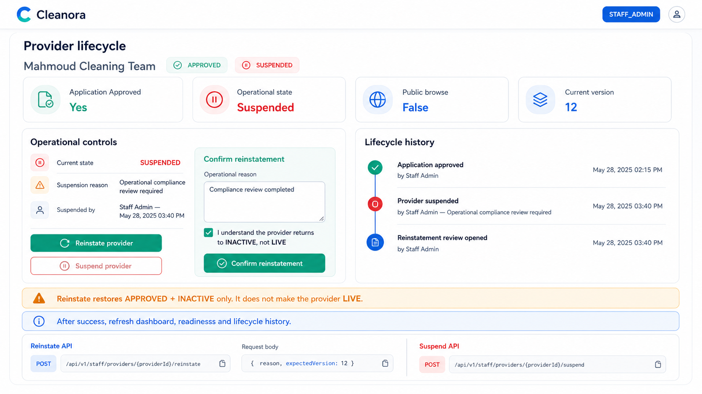
Screen 15 — Audited Staff suspension and reinstatement without making the Provider LIVE. High-fidelity implementation reference; API contracts remain authoritative.

Frontend flow on this screen
1. Require a non-empty operational reason.
2. Send the current Provider version and handle stale-version conflicts with a refetch.
3. After success, refresh dashboard, readiness, and lifecycle history.

APIs used on this screen

API 40 — Suspend Provider
POST /api/v1/staff/providers/{providerId}/suspend
Suspend Provider
What it does: Suspends an approved Provider with a required audited reason.
Who can use it: Active STAFF_ADMIN only.
Efficient frontend usage: Serialize Provider mutations and replace local providerVersion with the returned version. Disable competing Staff buttons while the command is in flight and refresh authoritative state afterward.
Sample request body
{
"reason": "<staffLifecycleReason>",
"expectedVersion": 12
}
Success response sample — HTTP 200 (representative excerpt; OpenAPI/Postman remains authoritative)
{
"requestId": "request_example_01",
"success": true,
"data": {
"provider": {
"id": "provider_example_01",
"providerKind": "INDIVIDUAL_TEAM",
"applicationStatus": "APPROVED",
"operationalStatus": "SUSPENDED",
"version": 15,
"createdAt": "2026-08-13T10:00:00.000Z"
},
"completion": {
"missingRequirementCodes": [],
"policyVersion": "r1-p05-v1",
"percentage": 100,
"checks": [
{
"code": "ELIGIBLE_CATEGORY_VERIFIED",
"satisfied": true
}
]
},
"readiness": {
"eligibleForPublicBrowse": false,
"gates": [
{
"key": "profileComplete",
"status": "SATISFIED",
"satisfied": true,
"owningPhase": "R1-P05"
}
]
}
}
}
Copyable Axios integration
export async function suspendProvider(providerId: string, payload: Record<string, unknown>) {
const response = await api.post(`/staff/providers/${providerId}/suspend`, payload);
return response.data.data;
}
Possible error codes and recovery
HTTP 400 — PROVIDER_REASON_REQUIRED
Meaning: A Staff or lifecycle command requires a meaningful non-empty reason.
Frontend recovery: Keep the confirmation dialog open, validate the reason, and send the command only after it is complete.
HTTP 409 — PROVIDER_VERSION_CONFLICT
Meaning: expectedVersion is stale because another write completed first.
Frontend recovery: Refetch the Provider, replace the local version, preserve the user's intent, and ask for an explicit retry.
HTTP 409 — PROVIDER_STATE_CONFLICT
Meaning: The command is not allowed in the Provider's current application or operational state.
Frontend recovery: Reload the aggregate and enable only actions permitted by the returned state/capability flags.
HTTP 403/404 — PROVIDER_ACCESS_DENIED
Meaning: The caller lacks the required identity, relationship, or exact-Provider authority.
Frontend recovery: Stop the action, refresh the caller's Provider list/capabilities, and do not reveal whether another Provider exists.

API 41 — Reinstate Provider
POST /api/v1/staff/providers/{providerId}/reinstate
Reinstate Provider
What it does: Reinstates a suspended Provider to INACTIVE. It never bypasses later readiness gates by setting LIVE directly.
Who can use it: Active STAFF_ADMIN only.
Efficient frontend usage: Serialize Provider mutations and replace local providerVersion with the returned version. Disable competing Staff buttons while the command is in flight and refresh authoritative state afterward.
Sample request body
{
"reason": "<staffLifecycleReason>",
"expectedVersion": 12
}
Success response sample — HTTP 200 (representative excerpt; OpenAPI/Postman remains authoritative)
{
"requestId": "request_example_01",
"success": true,
"data": {
"provider": {
"id": "provider_example_01",
"providerKind": "INDIVIDUAL_TEAM",
"applicationStatus": "APPROVED",
"operationalStatus": "INACTIVE",
"version": 16,
"createdAt": "2026-08-13T10:00:00.000Z"
},
"completion": {
"missingRequirementCodes": [],
"policyVersion": "r1-p05-v1",
"percentage": 100,
"checks": [
{
"code": "ELIGIBLE_CATEGORY_VERIFIED",
"satisfied": true
}
]
},
"readiness": {
"eligibleForPublicBrowse": false,
"gates": [
{
"key": "profileComplete",
"status": "SATISFIED",
"satisfied": true,
"owningPhase": "R1-P05"
}
]
}
}
}
Copyable Axios integration
export async function reinstateProvider(providerId: string, payload: Record<string, unknown>) {
const response = await api.post(`/staff/providers/${providerId}/reinstate`, payload);
return response.data.data;
}
Possible error codes and recovery
HTTP 400 — PROVIDER_REASON_REQUIRED
Meaning: A Staff or lifecycle command requires a meaningful non-empty reason.
Frontend recovery: Keep the confirmation dialog open, validate the reason, and send the command only after it is complete.
HTTP 409 — PROVIDER_VERSION_CONFLICT
Meaning: expectedVersion is stale because another write completed first.
Frontend recovery: Refetch the Provider, replace the local version, preserve the user's intent, and ask for an explicit retry.
HTTP 409 — PROVIDER_STATE_CONFLICT
Meaning: The command is not allowed in the Provider's current application or operational state.
Frontend recovery: Reload the aggregate and enable only actions permitted by the returned state/capability flags.
HTTP 403/404 — PROVIDER_ACCESS_DENIED
Meaning: The caller lacks the required identity, relationship, or exact-Provider authority.
Frontend recovery: Stop the action, refresh the caller's Provider list/capabilities, and do not reveal whether another Provider exists.

Customer, Worker and Public-Browse Pages
Important: These page groups are intentionally absent from R1-P05. Do not build them against this phase's API surface.
Customer pages: There is no anonymous/public Provider listing or detail page. The protected preview is for authorized preview only and contains no direct contacts.
Worker pages: There are no workers, teams, or crews inside the Provider application. Provider members are OWNER/ADMIN administrative users. Workforce management begins in R1-P07.
Registered-company documents: Commercial registration and tax registration verification belong to R1-P06.
Payout pages: Mobile-wallet and bank-account payout destinations belong to R1-P06.
Services and coverage: Service catalog, prices, coverage, availability, capacity, and booking belong to later phases.
LIVE/public eligibility: Approval or reinstatement does not make a Provider LIVE. R1-P05 keeps eligibleForPublicBrowse false.

Bassam's Frontend Delivery Checklist
Definition of done: The frontend follows the current contracts, does not recalculate completion/readiness, does not leak private contacts, and does not introduce routes, states, or roles outside R1-P05.
☐ Every protected request uses the shared Axios client and current Bearer token.
☐ Every Provider mutation sends expectedVersion and stores the returned version.
☐ Every 409 version conflict triggers authoritative refetch and an explicit retry path.
☐ Every media request uses FormData without a manually written multipart Content-Type.
☐ Every list/history screen uses cursor/nextCursor and cancels stale requests.
☐ Every Staff decision locks competing buttons and validates the required reason.
☐ Every invitation token stays out of URLs, logs, analytics, and durable storage.
☐ Every customer-facing preview component uses only the safe preview DTO.
☐ Provider Admin cannot see submission, ownership, members, or invitations controls.
☐ No worker, public browse, document, payout, service, coverage, or booking pages are included in this delivery.

Canonical implementation sources
docs/apis/openapi/r1-p05-provider-onboarding-profile-lifecycle.yaml
specs/R1-P05-provider-onboarding-profile-lifecycle/contracts/provider-api.md
specs/R1-P05-provider-onboarding-profile-lifecycle/contracts/provider-api.openapi.yaml
postman/Cleanora-R1-P05.postman_collection.json
docs/design/r1-p05/provider-application-frontend-handoff.md

