CLEANORA FRONTEND HANDOFF

R1-P12 Browse Marketplace & Provider Details
Frontend Reference Screens and HTTP API Integration Guide
Prepared for Bassam: Implementation-grade English handoff for Phase 12's guest-capable marketplace discovery routes, optional authentication, P11 Eligibility integration, contact-free Provider projections, deterministic filtering and cursor pagination, and the explicit Phase 13 booking boundary.

6  HTTP GET operations | 12  Postman requests | 10  reference screens | 6  workflow diagrams
Release 1 - Phase 12 | 10 September 2026
Phase status: READY_FOR_OWNER_REVIEW (DEC-087) - not Complete

GUIDE NAVIGATION

Guide Map
Recommended reading order: Read HTTP Integration Foundation and the six end-to-end flows first. Use the ten numbered screen concepts for product and implementation discussion, then use each operation card, DTO reference, pagination rules, error matrix, privacy boundary, and verification record while coding and testing.

Screen and Route Inventory
# | Frontend context | Reference screen | Primary route
01 | Guest or optionally authenticated marketplace visitor | Marketplace Entry and Optional Authentication | All six /api/v1/browse GET operations
02 | Guest or authenticated service discovery | Service Catalog Browser | GET /browse/services; GET /browse/services/:serviceId
03 | Guest or authenticated location selection | Textual Location Selector | GET /browse/countries/:countryCode/cities; GET /browse/countries/:countryCode/cities/:cityId/districts
04 | Guest or authenticated provider discovery form | Browse Search Request Composer | GET /browse/providers
05 | Guest or authenticated marketplace results | Eligible Provider Results | GET /browse/providers
06 | Provider result filtering and page navigation | Search Filter Sort and Cursor Pagination | GET /browse/providers
07 | Guest or authenticated provider detail | Provider and Team Detail | GET /browse/providers/:providerId/teams/:teamId
08 | Provider result and detail media rendering | Gallery and Signed Media States | GET /browse/providers; GET /browse/providers/:providerId/teams/:teamId
09 | Provider detail facts | Crew Summary and Price Facts | GET /browse/providers/:providerId/teams/:teamId
10 | All Phase 12 browse pages | Booking Prerequisites Error and Empty States | All six /api/v1/browse GET operations

Flow Diagram Inventory
# | Flow | Primary use
01 | Complete Guest Browse Journey | Shows the visitor journey from localized services and textual locality through an eligible provider page and re-evaluated contact-free detail.
02 | Optional Bearer Authentication | Separates a true guest request from a request that supplied credentials and therefore must pass Bearer authentication.
03 | Eligibility Enrichment Filter Sort and Paginate | Shows the Bookings-owned sequence over P11 safe candidates: privacy-safe enrichment, optional filtering, canonical sorting, and cursor pagination.
04 | Cursor Validation and Page Walk | Explains resultHash and filterDigest binding, the opaque offset, the bounded snapshot lifetime, and restart behavior.
05 | Provider Detail Re-Evaluation and Projection | Shows fail-closed detail behavior: the selected provider/team pair must still be P11-eligible before the contact-free projection is returned.
06 | Phase 12 to Phase 13 Boundary | Makes the ownership handoff explicit: Phase 12 ends with discovery facts and false side effects; Phase 13 or later owns booking and payment mutations.

HTTP Operation Inventory
Contract | Method and path | Access | Primary consumer
01 | GET /api/v1/browse/services | Guest or Bearer | Service catalog list
02 | GET /api/v1/browse/services/:serviceId | Guest or Bearer | Service definition
03 | GET /api/v1/browse/countries/:countryCode/cities | Guest or Bearer | City selector
04 | GET /api/v1/browse/countries/:countryCode/cities/:cityId/districts | Guest or Bearer | District selector
05 | GET /api/v1/browse/providers | Guest or Bearer | Eligible result list
06 | GET /api/v1/browse/providers/:providerId/teams/:teamId | Guest or Bearer | Provider/team detail

HTTP INTEGRATION FOUNDATION

HTTP Integration Foundation
Section purpose: R1-P12 mounts six read-only operations under /api/v1/browse. Bookings owns the transport and orchestration, Catalog and Configuration expose narrow discovery contracts, Providers supplies contact-free projection data, and P11 Eligibility remains the sole policy source for eligible provider/team pairs.

- All six operations are available to a true guest or an optionally authenticated principal.
- Provider list and detail call getStandardBrowseCandidates; the frontend must never recreate Eligibility filters.
- Every response uses the shared success or failure envelope and carries requestId.
- Provider reads are rate-limited; all operations are GET and create no booking or payment side effect.

Base URL and Transport
Concern | Contract
API base | /api/v1
Browse prefix | /browse
Media type | application/json for success and failure envelopes
Authentication | No Authorization header for guest; otherwise Authorization: Bearer <access-token>
Localization | locale query is AR or EN where present; names remain bilingual in Provider profile DTOs
Dates | Exact ISO 8601 instants with Z or an explicit UTC offset
Identifiers | Opaque stable strings; do not parse, shorten, or infer ownership from them

Standard Success Envelope
Representative envelope - meta is optional and currently added by the service-list handler
{
"success": true,
"data": { "...": "operation-specific payload" },
"requestId": "req_01H...",
"meta": { "requestId": "req_01H..." }
}

Standard Failure Envelope
Shared runtime failure shape
{
"success": false,
"error": {
"code": "VALIDATION_FAILED",
"statusCode": 400,
"message": "Browse request validation failed",
"details": { "issues": [] }
},
"requestId": "req_01H..."
}

Documentation alignment: The checked-in P12 OpenAPI intentionally validates the route surface but leaves success data generic and documents a narrower error object than the shared runtime envelope. Use this guide and the public TypeScript DTOs for concrete payloads, then keep generated clients behind an adapter until the OpenAPI schemas are made fully specific.

AUTHENTICATION AND SAFETY

Optional Authentication Decision Table
Request credential | Middleware behavior | Frontend behavior
No Authorization header | Continue as guest; principal is null | Browse normally
Bearer <valid token> | Authenticate and attach the principal | Browse normally
Valid verification-only principal | Allowed for all Phase 12 reads | Browse normally; booking remains unavailable
Malformed or empty Bearer header | 401 AUTHENTICATION_REQUIRED | Repair/remove header or sign in
Invalid or expired token | 401 AUTH_ACCESS_TOKEN_INVALID in current Authentication runtime | Refresh once or sign in; do not silently downgrade

Provider Browse Security Controls
- Provider list is limited to 60 requests per 60 seconds per privacy-hashed IP subject.
- Provider detail is limited to 120 requests per 60 seconds per privacy-hashed IP subject.
- The cursor is HMAC-signed for integrity and binds resultHash, filterDigest, and offset; it is not an access token.
- Media delivery URLs are signed and short-lived; object keys and signing credentials remain server-side.
- Safe server messages and requestId may be shown for support. Stack traces, dependency DTOs, IP hashes, and signing internals may not be shown.

Ownership and Dependency Direction
Module | Phase 12 responsibility | Frontend implication
Bookings | Owns /browse routes, validation, orchestration, filters, sort, cursor, and response composition | Integrate only through HTTP
Eligibility | Returns standard safe candidate pairs and deterministic metadata | Never reproduce policy client-side
Providers | Returns contact-free profile, signed media and booking-safe Team facts | Render only allowlisted projection
Catalog | Returns selectable services and snapshot-ready definitions | Drive service UI from response
Configuration | Returns active countries/cities/districts | Use textual locality only
Authentication | Optionally resolves a presented Bearer token | Omit header for a real guest

ARCHITECTURE AND BEHAVIOR

Complete Screen and API Flows
Section purpose: The six diagrams show the user-visible journey and the server-owned behavior behind it: optional identity, Eligibility-safe discovery, enrichment, deterministic pagination, detail re-evaluation, privacy projection, and the no-mutation boundary.

Flow 01 Complete Guest Browse Journey
Shows the visitor journey from localized services and textual locality through an eligible provider page and re-evaluated contact-free detail.
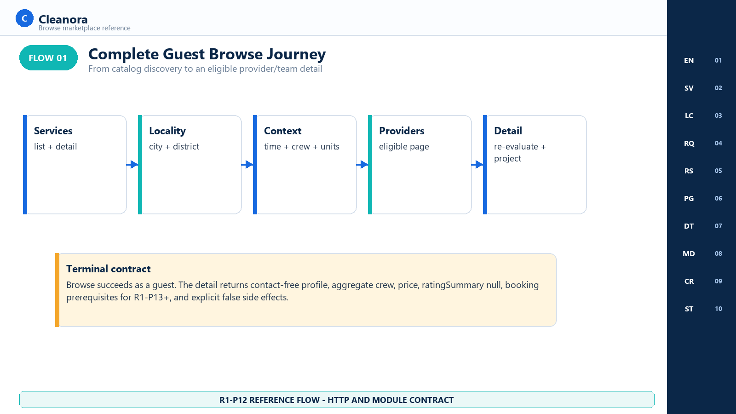
Flow 01 - Complete Guest Browse Journey
Implementation reading: Start with this flow when implementing page-level routing and data dependencies. Service and locality selection produce the exact context reused by both provider list and detail.

Authority represented: bookings.routes.ts; bookings.controller.ts; bookings.service.ts

Flow 02 Optional Bearer Authentication
Separates a true guest request from a request that supplied credentials and therefore must pass Bearer authentication.
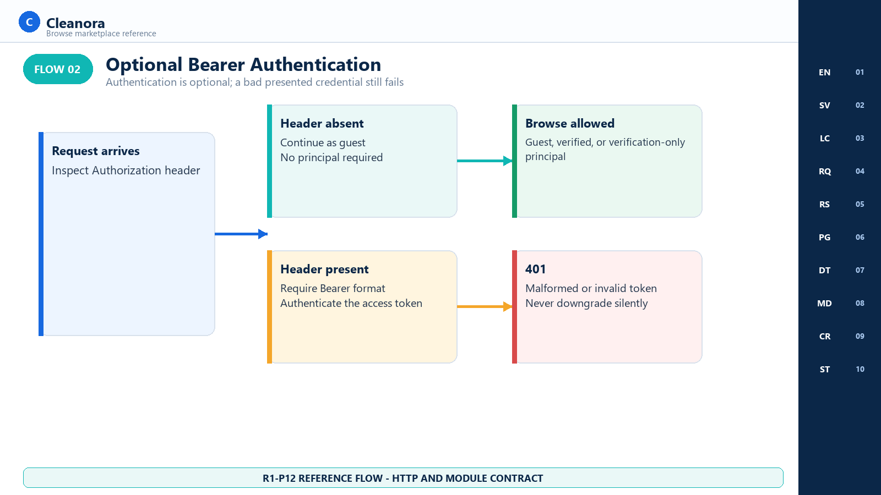
Flow 02 - Optional Bearer Authentication
Implementation reading: Guest access means the header is absent. Once a client sends Authorization, the credential must succeed or the request must fail; do not hide session errors by falling back silently.

Authority represented: auth.middleware.ts; bookings.routes.ts

Flow 03 Eligibility Enrichment Filter Sort and Paginate
Shows the Bookings-owned sequence over P11 safe candidates: privacy-safe enrichment, optional filtering, canonical sorting, and cursor pagination.
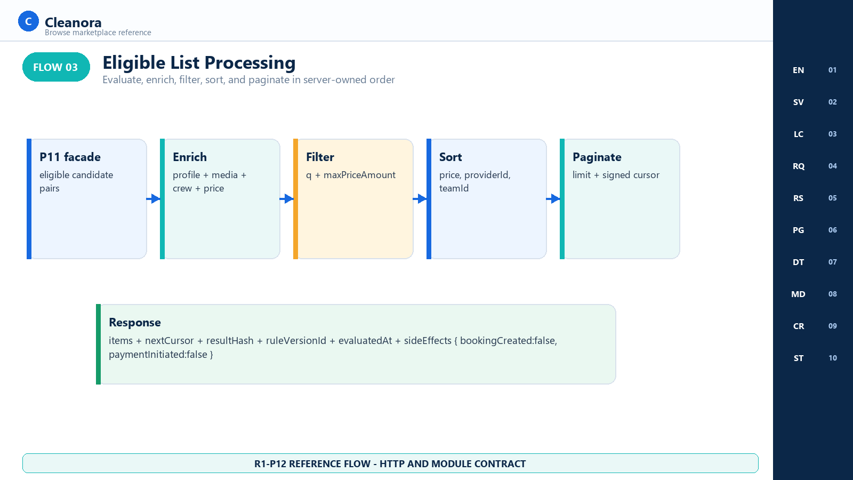
Flow 03 - Eligibility Enrichment Filter Sort and Paginate
Implementation reading: The server owns the order: P11 safe candidates, contact-free enrichment, q and price filtering, price/provider/team sorting, then cursor pagination.

Authority represented: bookings.service.ts; bookings.sort-filter.ts; provider-browse-projection.service.ts

Flow 04 Cursor Validation and Page Walk
Explains resultHash and filterDigest binding, the opaque offset, the bounded snapshot lifetime, and restart behavior.
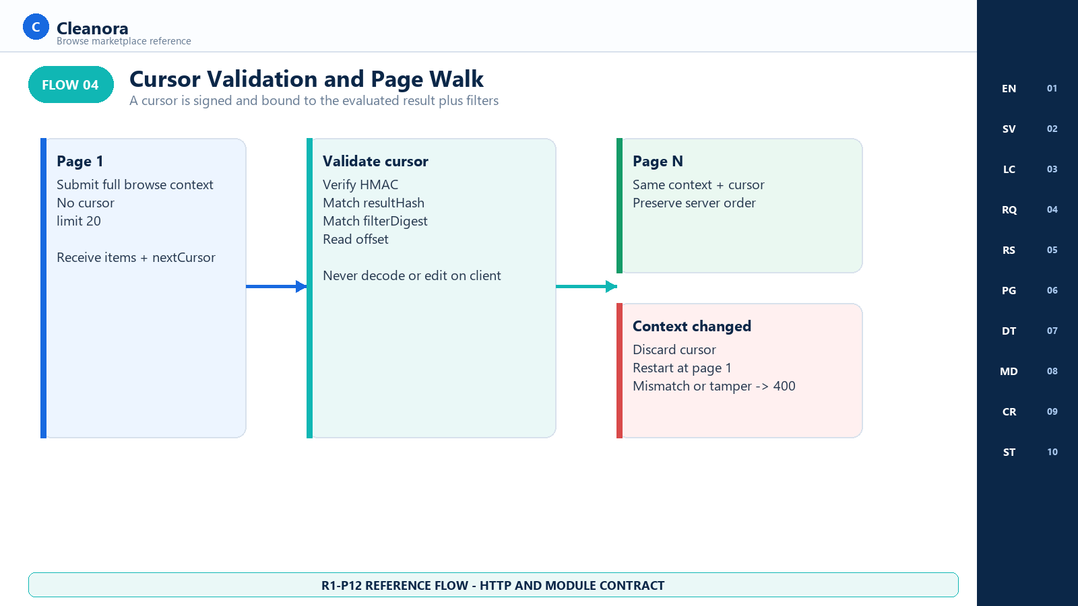
Flow 04 - Cursor Validation and Page Walk
Implementation reading: Treat nextCursor as opaque and short-lived. Any context or filter edit starts a new result walk from page one.

Authority represented: bookings.cursor.ts; bookings.service.ts

Flow 05 Provider Detail Re-Evaluation and Projection
Shows fail-closed detail behavior: the selected provider/team pair must still be P11-eligible before the contact-free projection is returned.
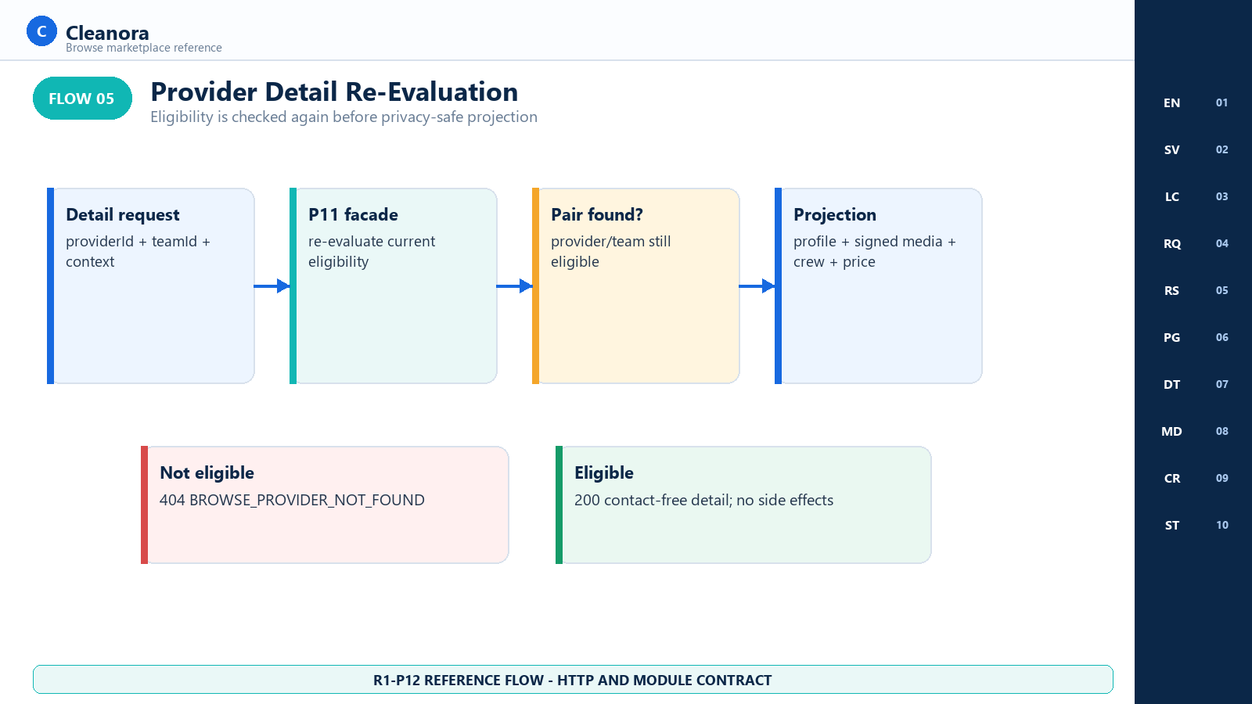
Flow 05 - Provider Detail Re-Evaluation and Projection
Implementation reading: A detail URL is not a durable eligibility grant. The provider/team pair is checked again, so the frontend needs a normal stale-result 404 path.

Authority represented: bookings.service.ts; providers.public.ts; provider-browse-projection.service.ts

Flow 06 Phase 12 to Phase 13 Boundary
Makes the ownership handoff explicit: Phase 12 ends with discovery facts and false side effects; Phase 13 or later owns booking and payment mutations.
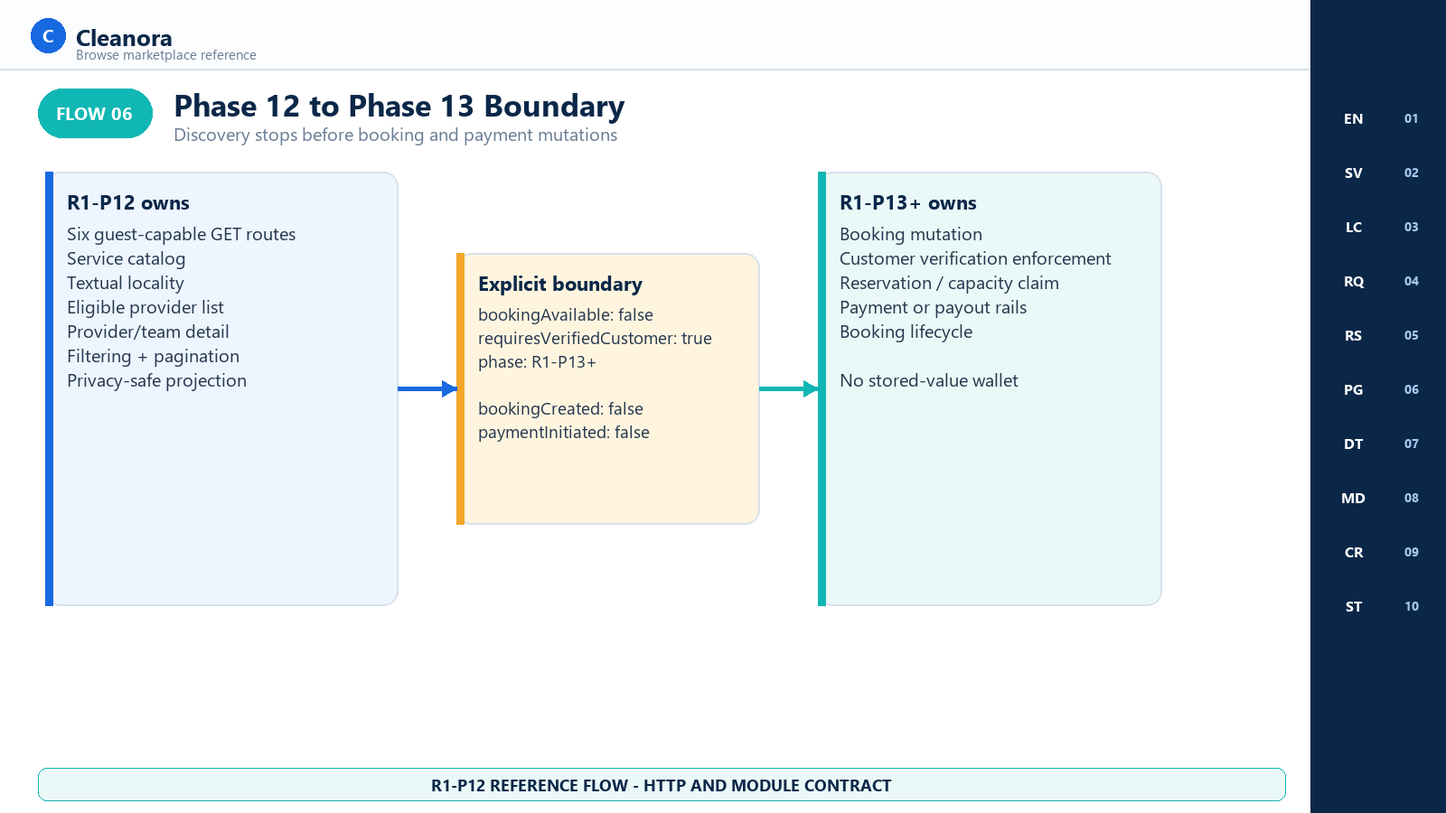
Flow 06 - Phase 12 to Phase 13 Boundary
Implementation reading: Discovery ends with prerequisites and false side effects. Do not fabricate a booking POST or call a payment route from a Phase 12 screen.

Authority represented: bookings.public.ts; privacy-projection.md; current.md
FRONTEND CONTEXTS

Pages by Consumer Context
Section purpose: R1-P12 is deliberately guest-first. The same six HTTP reads support anonymous visitors, authenticated customers, and verification-only principals; sensitive Provider, Staff, booking, and payment pages are not added by this phase.

PAGES BY CONTEXT

Anonymous Guest Browse
Reference coverage: Screens 01-10

- Send no Authorization header.
- List services and textual localities, compose the evaluation context, browse eligible providers, and open one provider/team detail.
- Receive the same public contact-free projection as an authenticated browser.
- Do not request identity, verification, contact, address, booking, or payment data to complete discovery.

PAGES BY CONTEXT

Authenticated or Verification-Only Browse
Reference coverage: Screens 01-10

- Send one valid access token only when the app has a current session.
- Verification-only principals are allowed because the routes are discovery reads.
- The current response payload is not personalized and does not reveal additional contact data.
- Authentication does not change bookingAvailable or sideEffects in R1-P12.

PAGES BY CONTEXT

Frontend Resilience and QA
Reference coverage: Screens 06, 08, and 10

- Exercise cursor tamper, context change, snapshot expiry, and page-one restart behavior.
- Exercise nullable logo/cover, omitted gallery item, expired media and detail refetch behavior.
- Exercise empty 200, 400, 401, 404, 429, and 503 states without revealing internal data.
- Verify every provider result and detail response keeps bookingCreated and paymentInitiated false.

BOUNDARY

Absent Phase 12 Page Groups
Reference coverage: No Phase 12 screens

- No booking creation, reservation, checkout, payment, payout, wallet, rating, review, or provider-contact page.
- No map, radius, coordinate, live socket, location tracking, or geographic ranking page.
- No Provider setup editor, workforce roster, private profile, document, payout, or availability-management page.
- No Staff browse-rule editor, analytics dashboard, Docker, cloud, deployment, or production migration surface.
REFERENCE SCREENS

Browse Marketplace Reference Screens
Section purpose: Every numbered visual below is a routed-experience concept. Each carries the label REFERENCE CONCEPT - ROUTED R1-P12 EXPERIENCE: the HTTP route exists, but this backend phase does not claim that a production frontend screen has shipped.

Screen 01 Marketplace Entry and Optional Authentication
Frontend context | Route coverage | Screen purpose
Guest or optionally authenticated marketplace visitor | All six /api/v1/browse GET operations | Start a country-and-locale browse journey without requiring sign-in while treating every presented credential as authoritative.

Visual authority: This image is a frontend handoff concept for implemented HTTP behavior. Exact fields and states come from the operation cards and public TypeScript contracts; visual placement does not create a new endpoint, role, side effect, or product promise.

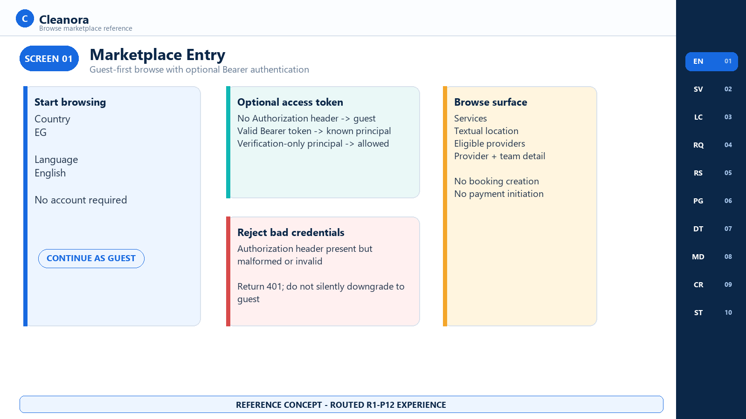
Screen 01 - Marketplace Entry and Optional Authentication - R1-P12 reference concept

Screen 01 Frontend Notes

Frontend Flow on This Screen
- Choose the active country and interface locale before requesting localized catalog and locality data.
- Omit Authorization to browse as a guest, or send one valid Bearer access token to browse with a principal.
- Allow verification-only principals to browse; no full-verification gate applies to these reads.
- If a credential is malformed or invalid, show a session-recovery state and do not retry as a guest with the same header.

Contracts Used on This Screen
Contracts 01-06; Optional Authentication decision table.

States and Recovery
Guest and valid-principal requests continue. A malformed header returns AUTHENTICATION_REQUIRED. An invalid or expired access token currently surfaces AUTH_ACCESS_TOKEN_INVALID; see Implementation Alignment Notes.

Security and Privacy Rules
The entry screen does not request contact data, customer identity, coordinates, raw addresses, or payment facts.

Boundary and Non-Deliverables
Boundary: Browse is read-only. Account creation, customer verification, booking mutation, and payment remain outside R1-P12.

Screen 02 Service Catalog Browser
Frontend context | Route coverage | Screen purpose
Guest or authenticated service discovery | GET /browse/services; GET /browse/services/:serviceId | List selectable services and open one localized snapshot-ready service definition before composing a provider search.

Visual authority: This image is a frontend handoff concept for implemented HTTP behavior. Exact fields and states come from the operation cards and public TypeScript contracts; visual placement does not create a new endpoint, role, side effect, or product promise.

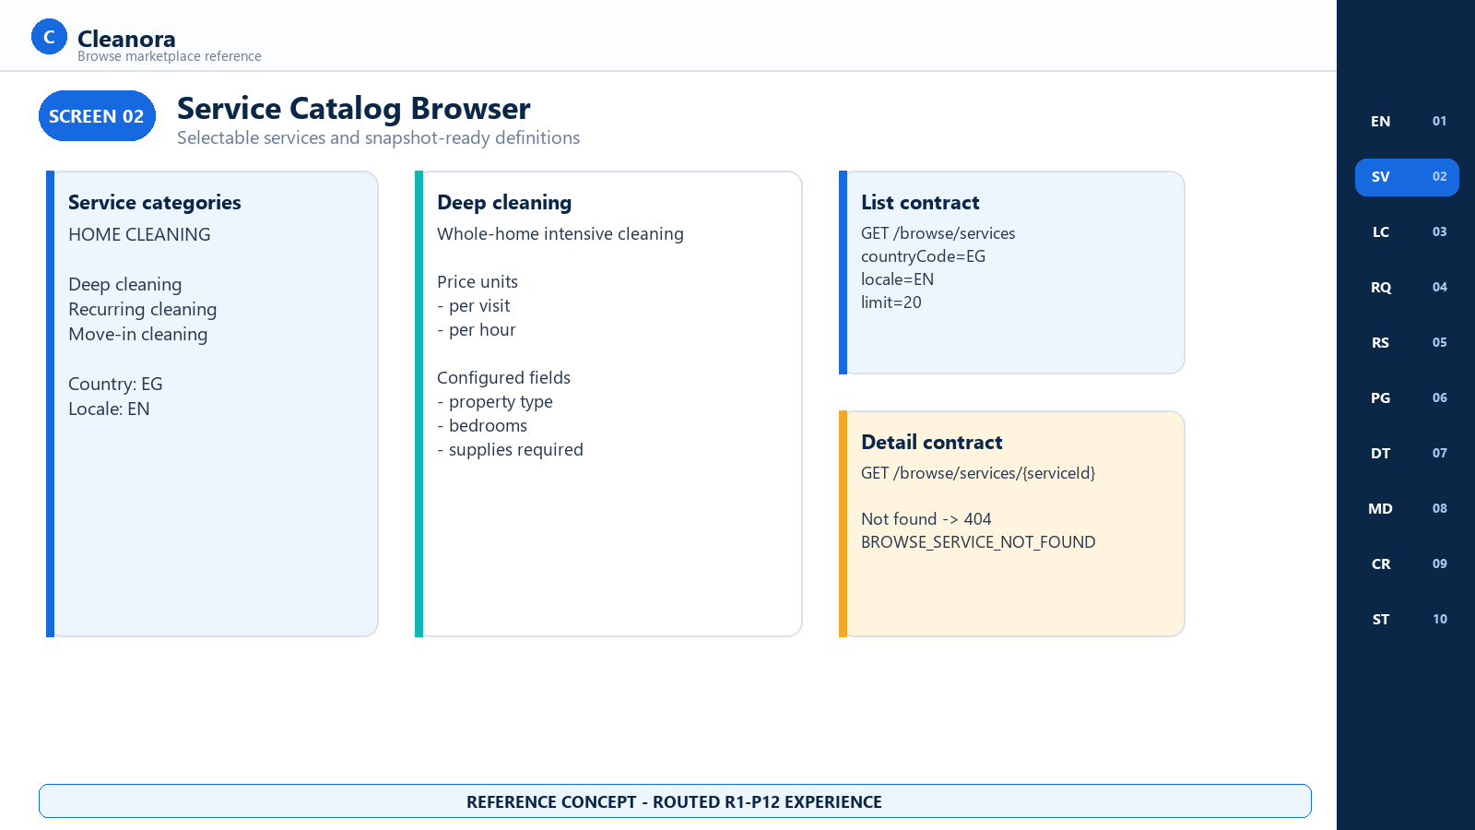
Screen 02 - Service Catalog Browser - R1-P12 reference concept

Screen 02 Frontend Notes

Frontend Flow on This Screen
- Request selectable services with countryCode, locale, limit, and an optional Catalog cursor.
- Render service and category names from the localized response rather than from hard-coded frontend text.
- Open the definition route to obtain fields, media, price units, service version, and category facts needed for a booking-ready form later.
- Treat a missing or no-longer-selectable service as a 404 and return the visitor to the service list.

Contracts Used on This Screen
Contract 01 List Browse Services; Contract 02 Get Browse Service.

States and Recovery
The list may be empty with HTTP 200. List pagination uses the Catalog cursor. Detail may fail with BROWSE_SERVICE_NOT_FOUND.

Security and Privacy Rules
Catalog responses are public product configuration. Do not combine them with user identity or persist signed media URLs as stable identifiers.

Boundary and Non-Deliverables
Boundary: A service definition prepares the frontend; it does not create a quote, reservation, or booking snapshot in R1-P12.

Screen 03 Textual Location Selector
Frontend context | Route coverage | Screen purpose
Guest or authenticated location selection | GET /browse/countries/:countryCode/cities; GET /browse/countries/:countryCode/cities/:cityId/districts | Resolve an active city and optional district through Configuration-owned textual locality contracts.

Visual authority: This image is a frontend handoff concept for implemented HTTP behavior. Exact fields and states come from the operation cards and public TypeScript contracts; visual placement does not create a new endpoint, role, side effect, or product promise.

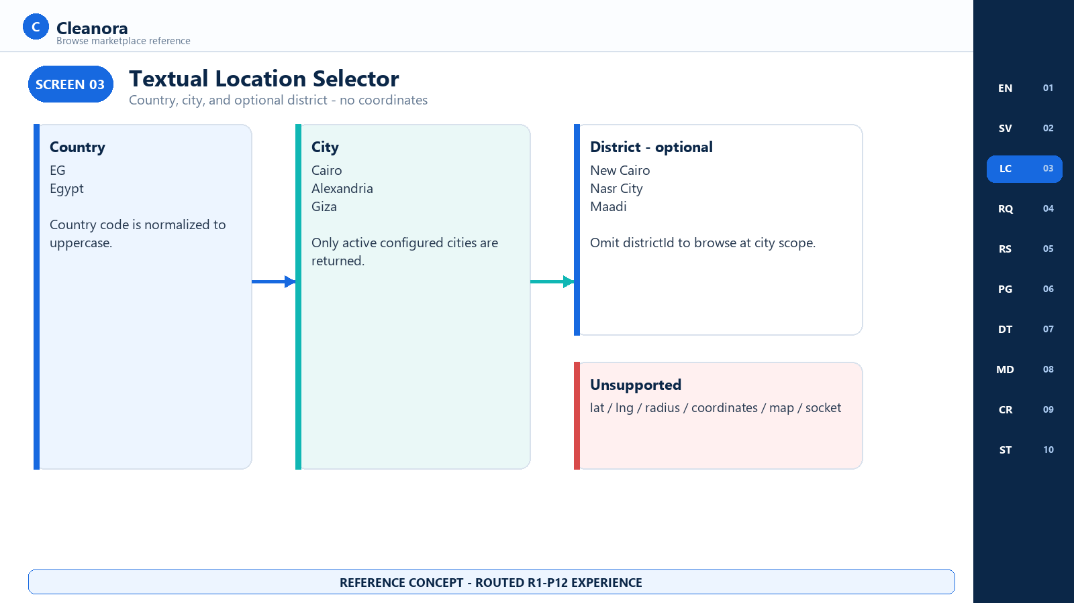
Screen 03 - Textual Location Selector - R1-P12 reference concept

Screen 03 Frontend Notes

Frontend Flow on This Screen
- Normalize a two-letter country code and request active cities for that country.
- After a city is selected, request its active districts using the same country context.
- Send cityId in every provider evaluation; omit districtId when city-wide discovery is intended.
- Reset district and provider-result state whenever country or city changes.

Contracts Used on This Screen
Contract 03 List Browse Cities; Contract 04 List Browse Districts.

States and Recovery
Unavailable countries return COUNTRY_UNAVAILABLE. A valid country or city may return an empty items array when no active locality rows exist.

Security and Privacy Rules
The contract returns stable locality IDs and bilingual names only. It does not accept or return latitude, longitude, radius, coordinates, a map payload, or a raw street address.

Boundary and Non-Deliverables
Boundary: Radius and map search are not latent frontend controls; they are explicitly absent from Phase 12.

Screen 04 Browse Search Request Composer
Frontend context | Route coverage | Screen purpose
Guest or authenticated provider discovery form | GET /browse/providers | Create one valid eligibility context and optional filter set without leaking unsupported query fields.

Visual authority: This image is a frontend handoff concept for implemented HTTP behavior. Exact fields and states come from the operation cards and public TypeScript contracts; visual placement does not create a new endpoint, role, side effect, or product promise.

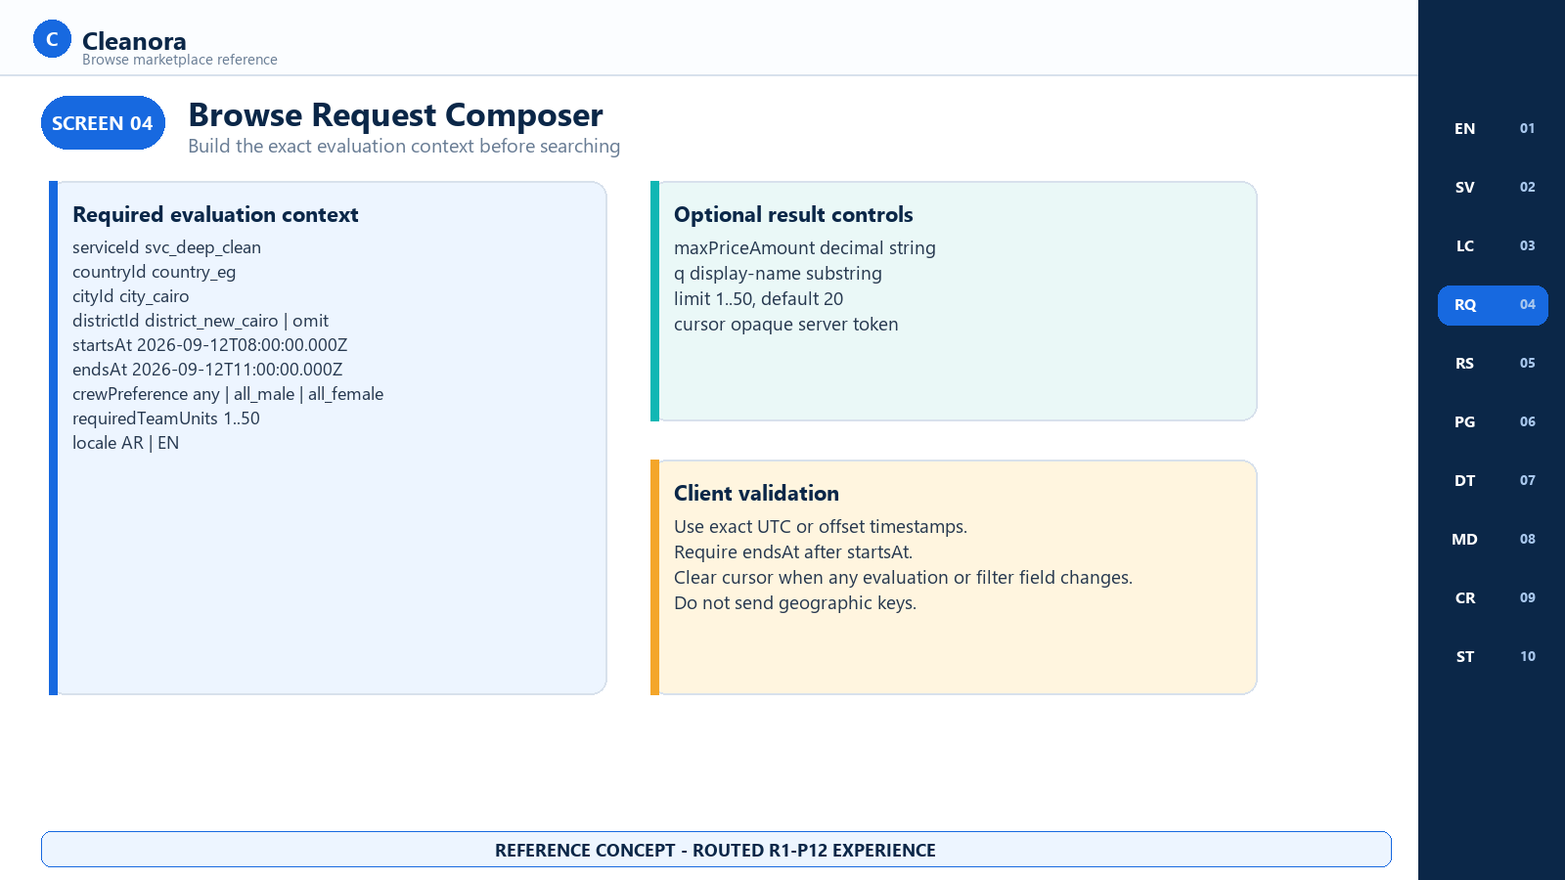
Screen 04 - Browse Search Request Composer - R1-P12 reference concept

Screen 04 Frontend Notes

Frontend Flow on This Screen
- Collect serviceId, countryId, cityId, optional districtId, startsAt, endsAt, crewPreference, requiredTeamUnits, and locale.
- Use exact ISO instants with UTC Z or an explicit offset and require endsAt to be later than startsAt.
- Optionally send maxPriceAmount, a case-insensitive display-name query q, limit, and the opaque nextCursor.
- Clear the cursor whenever any evaluation context or result filter changes.

Contracts Used on This Screen
Contract 05 List Eligible Browse Providers; BrowseProvidersQuery type reference.

States and Recovery
requiredTeamUnits is 1-50, limit is 1-50 with default 20, locale is AR or EN, and q is 1-160 characters when present.

Security and Privacy Rules
Never append lat, lng, latitude, longitude, radius, coordinates, map, socket, customer identity, or contact details.

Boundary and Non-Deliverables
Boundary: The form requests discovery only. It must not expose providerIds input or simulate P11 explicit evaluation mode.

Screen 05 Eligible Provider Results
Frontend context | Route coverage | Screen purpose
Guest or authenticated marketplace results | GET /browse/providers | Render only P11-eligible provider/team pairs after server enrichment, filtering, deterministic sorting, and pagination.

Visual authority: This image is a frontend handoff concept for implemented HTTP behavior. Exact fields and states come from the operation cards and public TypeScript contracts; visual placement does not create a new endpoint, role, side effect, or product promise.

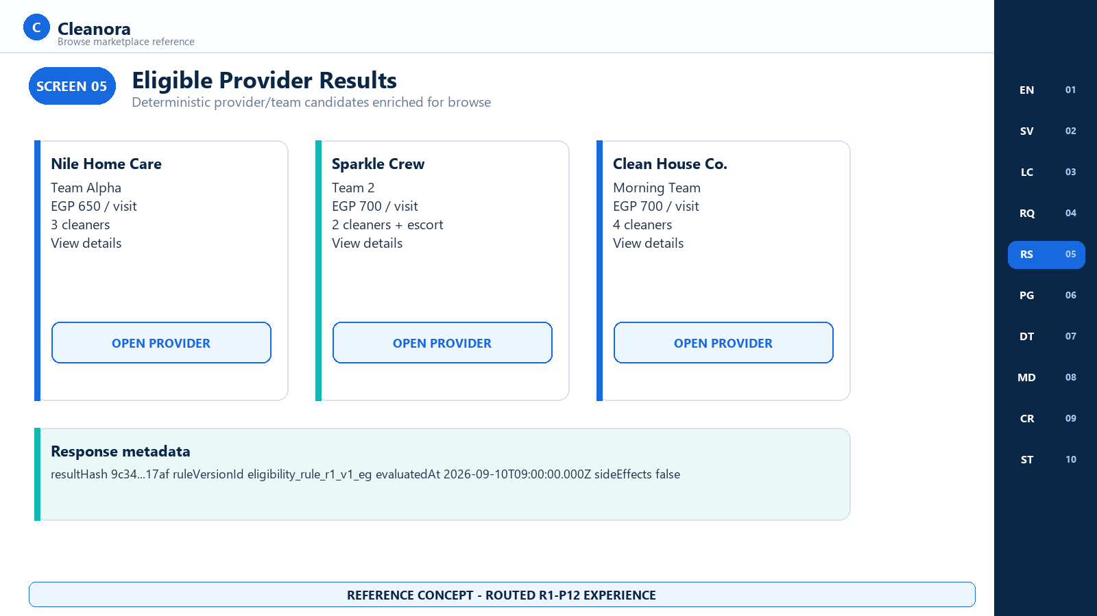
Screen 05 - Eligible Provider Results - R1-P12 reference concept

Screen 05 Frontend Notes

Frontend Flow on This Screen
- Render each returned providerId/teamId pair exactly once and retain both IDs for the detail route.
- Use displayName selected for the requested locale, the optional signed thumb, and the server sortingFacts.
- Preserve server order: priceAmount, then providerId, then teamId, all ascending.
- Show a normal empty state for items: [] and fetch the next page only when nextCursor is non-null.

Contracts Used on This Screen
Contract 05 List Eligible Browse Providers.

States and Recovery
The response includes items, nextCursor, metadata, and sideEffects. Empty eligibility is a successful 200 response; evaluation dependency failure is a 503.

Security and Privacy Rules
Results are contact-free and contain no excluded diagnostics, reason arrays, Worker/member identities, phones, emails, addresses, documents, payouts, or customer facts.

Boundary and Non-Deliverables
Boundary: A result card is not a reservation. The sideEffects object must remain visibly and behaviorally false.

Screen 06 Search Filter Sort and Cursor Pagination
Frontend context | Route coverage | Screen purpose
Provider result filtering and page navigation | GET /browse/providers | Use q, maxPriceAmount, and limit without breaking the signed snapshot-bound pagination contract.

Visual authority: This image is a frontend handoff concept for implemented HTTP behavior. Exact fields and states come from the operation cards and public TypeScript contracts; visual placement does not create a new endpoint, role, side effect, or product promise.

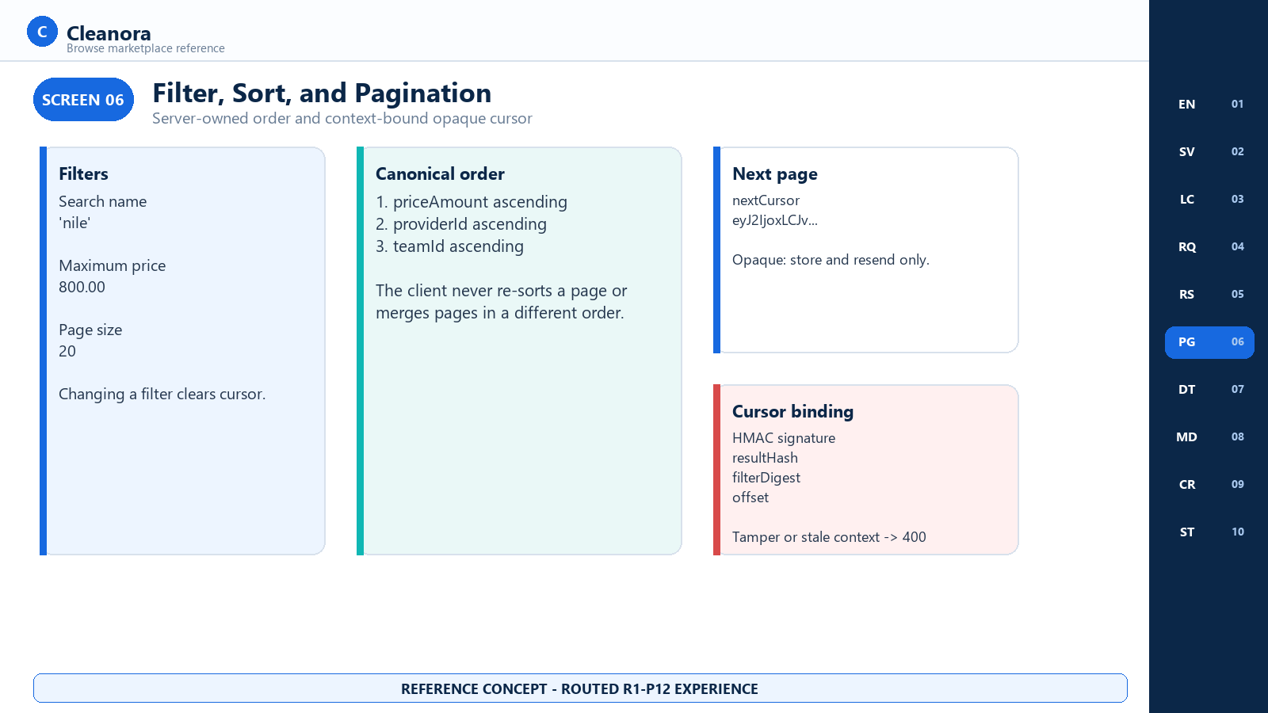
Screen 06 - Search Filter Sort and Cursor Pagination - R1-P12 reference concept

Screen 06 Frontend Notes

Frontend Flow on This Screen
- Apply q as a case-insensitive substring over the server-selected display name and maxPriceAmount as a decimal-string ceiling.
- Accept the canonical server ordering and never re-sort within or across pages.
- Store nextCursor opaquely and resend it with the same evaluation context and filters.
- On cursor validation failure, discard the token, restart at page 1, and preserve the user's visible filters.

Contracts Used on This Screen
Contract 05; Cursor and Sorting Reference.

States and Recovery
The signed cursor binds version, resultHash, filterDigest, and offset. Server snapshots live for five minutes with a bounded in-memory cache; an expired or unavailable snapshot requires a fresh page-one search.

Security and Privacy Rules
Do not log the full cursor or use it as analytics identity. It is integrity-protected navigation state, not authorization.

Boundary and Non-Deliverables
Boundary: Cursor contents are an implementation detail. Frontend decoding, rewriting, or synthesizing is unsupported.

Screen 07 Provider and Team Detail
Frontend context | Route coverage | Screen purpose
Guest or authenticated provider detail | GET /browse/providers/:providerId/teams/:teamId | Re-evaluate the selected provider/team pair and render a contact-free profile, aggregate crew, and current service price.

Visual authority: This image is a frontend handoff concept for implemented HTTP behavior. Exact fields and states come from the operation cards and public TypeScript contracts; visual placement does not create a new endpoint, role, side effect, or product promise.

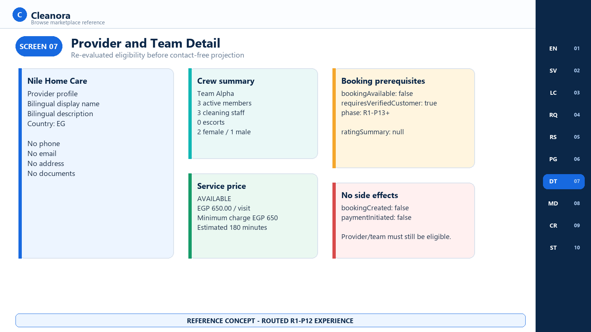
Screen 07 - Provider and Team Detail - R1-P12 reference concept

Screen 07 Frontend Notes

Frontend Flow on This Screen
- Send providerId, teamId, and the same complete evaluation context used for the list.
- Treat eligibility as current: the server re-runs the P11 safe facade and returns 404 if the pair is no longer eligible.
- Render bilingual profile facts, signed media, aggregate crew counts, and the AVAILABLE or UNAVAILABLE servicePrice union.
- Render ratingSummary as unavailable and show the R1-P13+ booking prerequisite without creating a booking CTA that calls a Phase 12 mutation.

Contracts Used on This Screen
Contract 06 Get Eligible Browse Provider Detail.

States and Recovery
Eligible pairs return 200. Missing, stale, or ineligible pairs return BROWSE_PROVIDER_NOT_FOUND. ratingSummary is always null in R1-P12.

Security and Privacy Rules
No phone, email, raw address, Worker identity, member array, documents, payout data, or excluded Eligibility diagnostics may be inferred or displayed.

Boundary and Non-Deliverables
Boundary: bookingAvailable is false and requiresVerifiedCustomer is true for phase R1-P13+; bookingCreated and paymentInitiated are false.

Screen 08 Gallery and Signed Media States
Frontend context | Route coverage | Screen purpose
Provider result and detail media rendering | GET /browse/providers; GET /browse/providers/:providerId/teams/:teamId | Display short-lived Provider media without turning a signing problem into a profile or browse failure.

Visual authority: This image is a frontend handoff concept for implemented HTTP behavior. Exact fields and states come from the operation cards and public TypeScript contracts; visual placement does not create a new endpoint, role, side effect, or product promise.

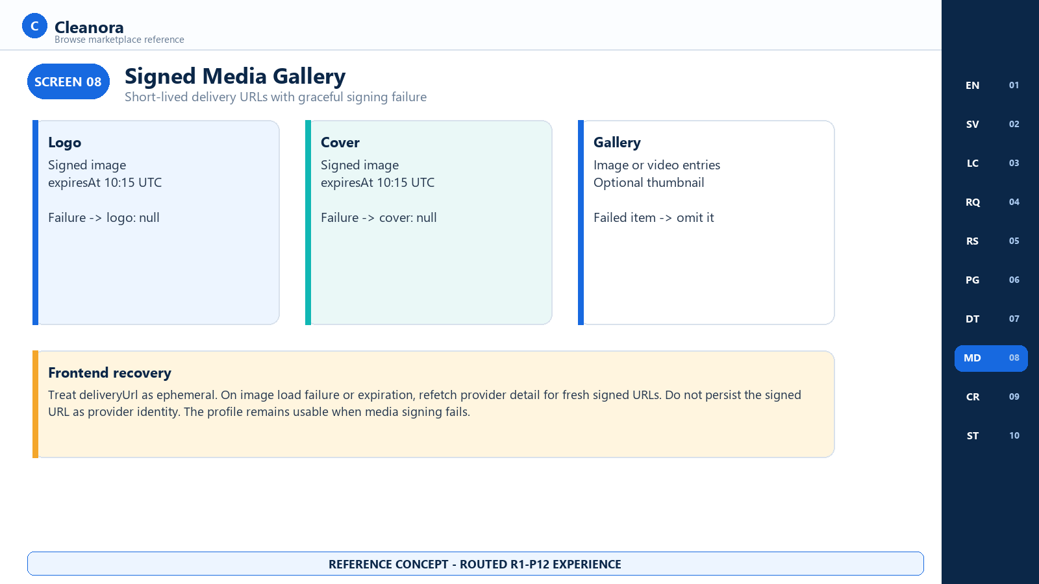
Screen 08 - Gallery and Signed Media States - R1-P12 reference concept

Screen 08 Frontend Notes

Frontend Flow on This Screen
- Use deliveryUrl only until urlExpiresAt and render thumbnailUrl when the media item supplies one.
- Treat a logo-signing failure as logo: null and a cover-signing failure as cover: null.
- Omit only the gallery item whose signing failed; keep the rest of the detail response usable.
- On client load failure or expiry, refetch the detail route to receive freshly signed delivery URLs.

Contracts Used on This Screen
Contracts 05-06; ProviderBrowseMediaDto and EX-01 privacy projection.

States and Recovery
Image and video media are possible. contentType, width, height, and thumbnailUrl may be null. The profile remains valid with zero media.

Security and Privacy Rules
Never persist a signed delivery URL as stable Provider identity or expose an internal object key, storage credential, or signing secret.

Boundary and Non-Deliverables
Boundary: R1-P12 does not provide media upload, edit, delete, moderation, or permanent public URLs.

Screen 09 Crew Summary and Price Facts
Frontend context | Route coverage | Screen purpose
Provider detail facts | GET /browse/providers/:providerId/teams/:teamId | Present booking-safe crew aggregates and a discriminated price result without exposing workforce membership.

Visual authority: This image is a frontend handoff concept for implemented HTTP behavior. Exact fields and states come from the operation cards and public TypeScript contracts; visual placement does not create a new endpoint, role, side effect, or product promise.

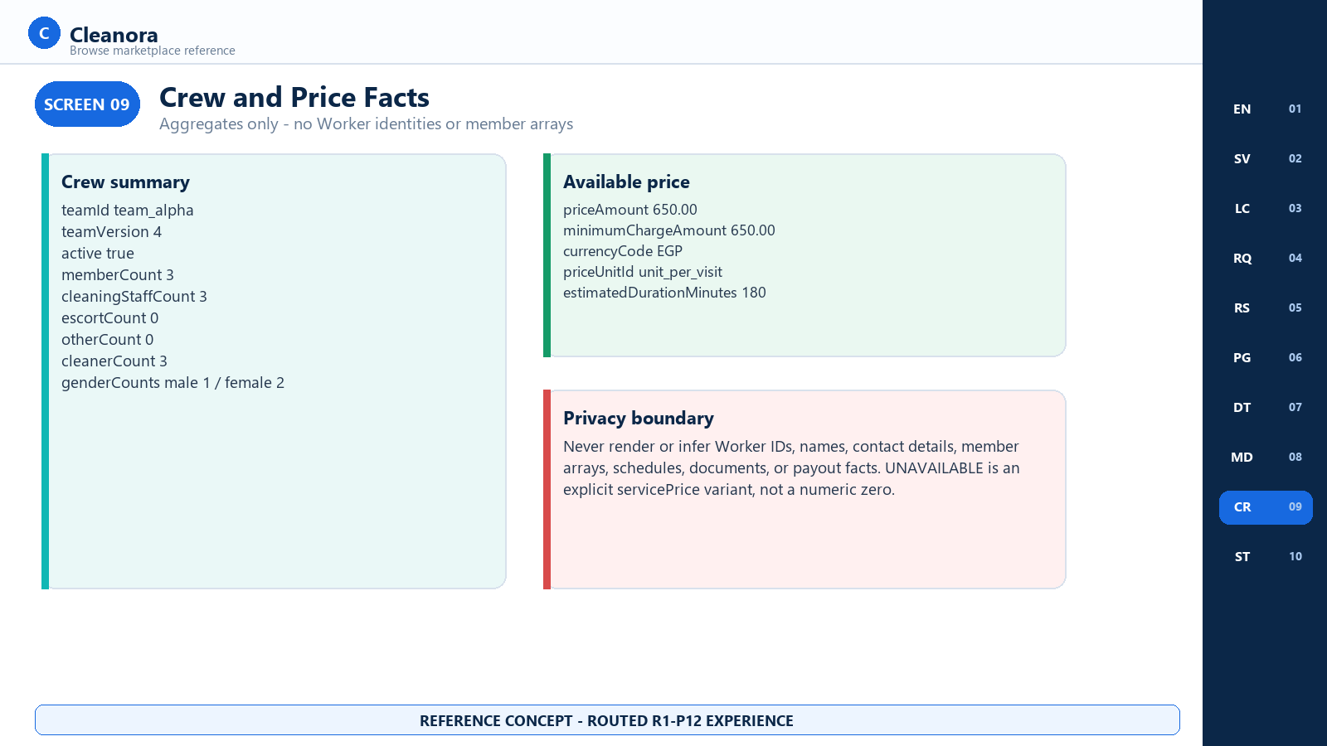
Screen 09 - Crew Summary and Price Facts - R1-P12 reference concept

Screen 09 Frontend Notes

Frontend Flow on This Screen
- Render team identity/version and aggregate member, cleaner, escort, other, and gender counts.
- Do not derive or display individual Worker rows from the aggregate totals.
- For AVAILABLE price, render amount, minimum charge, currency, unit, and optional estimated duration.
- For UNAVAILABLE price, show an unavailable state rather than a zero or an invented fallback amount.

Contracts Used on This Screen
Contract 06; ProviderCrewSummaryDto and BrowseServicePrice union.

States and Recovery
Crew facts are aggregates only. AVAILABLE and UNAVAILABLE are exhaustive servicePrice states for the frontend.

Security and Privacy Rules
Worker IDs, names, contact data, raw member arrays, schedules, documents, and payout facts are prohibited.

Boundary and Non-Deliverables
Boundary: Crew capacity is discovery information. R1-P12 does not assign or reserve a Team.

Screen 10 Booking Prerequisites Error and Empty States
Frontend context | Route coverage | Screen purpose
All Phase 12 browse pages | All six /api/v1/browse GET operations | Give frontend and QA one recovery matrix for successful emptiness, invalid input, authentication, not-found, dependency failure, and the Phase 13 handoff.

Visual authority: This image is a frontend handoff concept for implemented HTTP behavior. Exact fields and states come from the operation cards and public TypeScript contracts; visual placement does not create a new endpoint, role, side effect, or product promise.

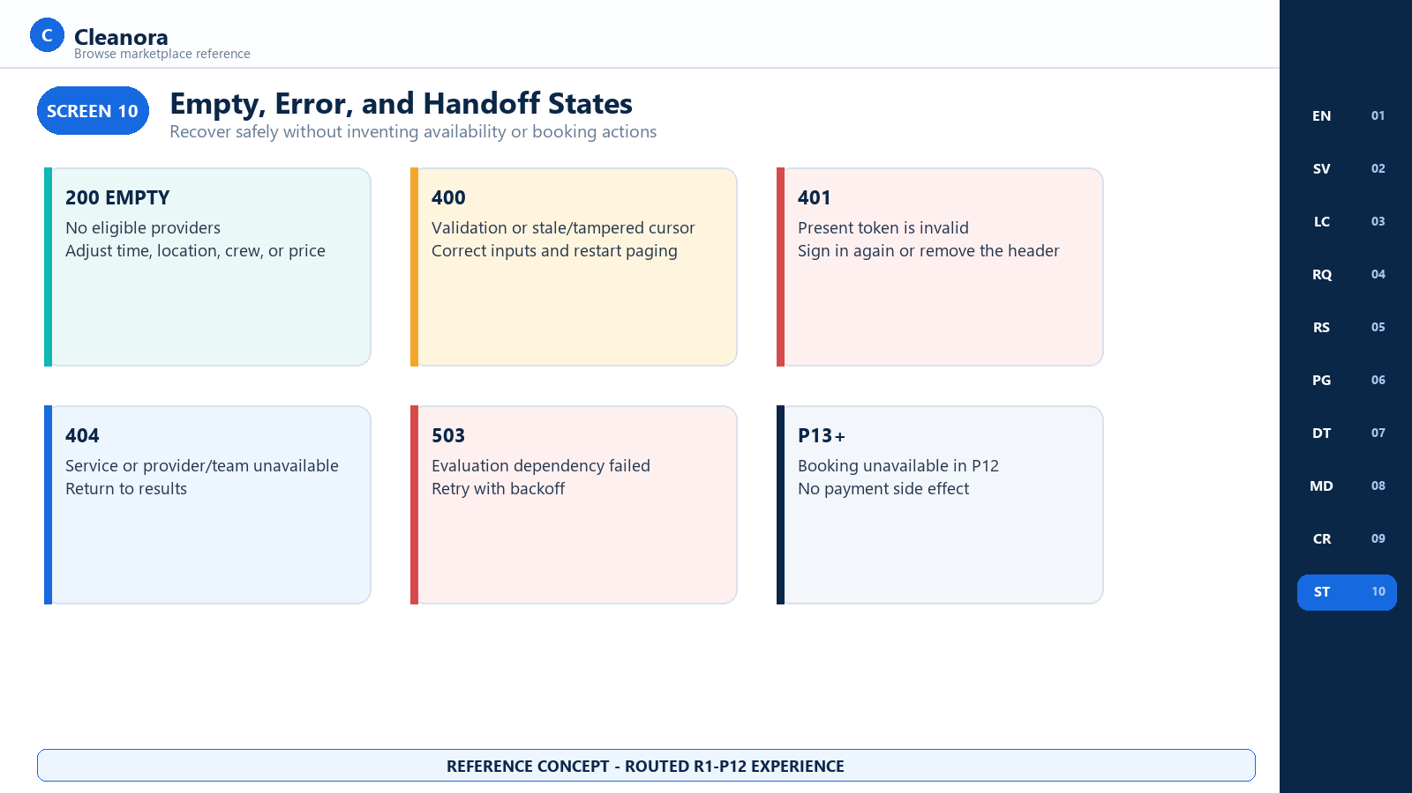
Screen 10 - Booking Prerequisites Error and Empty States - R1-P12 reference concept

Screen 10 Frontend Notes

Frontend Flow on This Screen
- Treat an empty item list as a successful state and offer context adjustments without claiming no providers exist globally.
- For validation failure, keep safe user input, identify invalid fields from details.issues, clear the cursor, and resubmit only after correction.
- For 401, remove or refresh the credential deliberately; do not loop or silently downgrade the same request.
- For 404 return to the prior list; for 503 retry with bounded backoff; keep booking and payment actions disabled throughout R1-P12.

Contracts Used on This Screen
Contracts 01-06; Error and Recovery Reference.

States and Recovery
200 empty, 400 VALIDATION_FAILED, 401 authentication failures, 404 service/provider/country failures, 429 rate limit for provider reads, and 503 BROWSE_EVALUATION_FAILED.

Security and Privacy Rules
Display safe server messages and a requestId for support. Do not expose stack traces, cursor contents, signing details, IP hashes, or dependency DTOs.

Boundary and Non-Deliverables
Boundary: The Phase 13 handoff is explanatory only. There is no booking, reservation, payment, payout, or wallet mutation in this guide.

HTTP CONTRACTS

HTTP Operation Reference
Section purpose: Each implemented GET operation is documented once in full. Screen and flow sections link back to these cards. All examples are synthetic and representative; IDs, request IDs, signed URLs, hashes, and cursor values are placeholders rather than production data.

Contract 01 List Browse Services
Attribute | Value
Method and path | GET /api/v1/browse/services
Purpose | List localized selectable Catalog services for one country
Access | Guest or authenticated; Authorization is optional
Owner | Bookings HTTP adapter over Catalog public listSelectable
Screens | 01 Marketplace Entry; 02 Service Catalog Browser
Side effects | None

Query Parameters
Name | Type | Required | Rule
countryCode | string | Yes | Two letters; runtime normalizes to uppercase
locale | "AR" | "EN" | Yes | Controls localized service and category text
cursor | string | No | Catalog-owned opaque cursor; maximum 512 characters
limit | integer | No | 1-50; default 20

Request example
GET /api/v1/browse/services?countryCode=EG&locale=EN&limit=20
Accept: application/json
# Guest request: intentionally omit Authorization
# Authenticated request: Authorization: Bearer <access-token>

Contract 01 Representative 200 Response
Synthetic response
{
"success": true,
"data": {
"items": [{
"serviceId": "svc_deep_clean",
"serviceCode": "DEEP_CLEANING",
"serviceVersion": 3,
"categoryId": "cat_home",
"categoryCode": "HOME_CLEANING",
"name": "Deep cleaning",
"description": "Whole-home intensive cleaning",
"categoryName": "Home cleaning",
"displayOrder": 10
}],
"nextCursor": null
},
"requestId": "req_example"
}

Errors and Frontend Handling
Status | Code | Handling
400 | VALIDATION_FAILED | Correct countryCode, locale, cursor, or limit
401 | Authentication code | Refresh/remove deliberately; do not silent-fallback
404 | COUNTRY_UNAVAILABLE | Return to active-country selection

- Treat items: [] as a successful catalog state.
- Store and resend nextCursor opaquely; do not assume it shares the provider-list cursor format.
- Use serviceId for navigation and serviceCode only as returned domain data.
- Do not cache localized text under countryCode or locale combinations that differ from the request.

Contract 02 Get Browse Service
Attribute | Value
Method and path | GET /api/v1/browse/services/:serviceId
Purpose | Return one localized snapshot-ready Catalog service definition
Access | Guest or authenticated
Path parameter | serviceId, 1-64 characters
Screens | 02 Service Catalog Browser; 04 Browse Request Composer
Side effects | None

Query Parameters
Name | Type | Required | Rule
countryCode | string | Yes | Two letters; normalized to uppercase
locale | "AR" | "EN" | Yes | Selects localized names and descriptions

Request example
GET /api/v1/browse/services/svc_deep_clean?countryCode=EG&locale=EN

Frontend purpose: Use this definition to render service details and collect configured values. Preserve serviceId and serviceVersion for later snapshot work, but do not post a booking in Phase 12.

Contract 02 Representative 200 Response
Synthetic response - nested Catalog field details follow the public Catalog DTO
{
"success": true,
"data": {
"serviceId": "svc_deep_clean",
"serviceCode": "DEEP_CLEANING",
"serviceVersion": 3,
"category": {
"id": "cat_home",
"code": "HOME_CLEANING",
"name": "Home cleaning",
"description": "Cleaning services for homes"
},
"locale": "EN",
"countryCode": "EG",
"name": "Deep cleaning",
"description": "Whole-home intensive cleaning",
"priceUnits": [{ "id": "unit_per_visit", "code": "PER_VISIT", "name": "Per visit" }],
"fields": [{ "id": "field_bedrooms", "code": "BEDROOMS", "required": true }],
"media": []
},
"requestId": "req_example"
}

Errors and Frontend Handling
Status | Code | Handling
400 | VALIDATION_FAILED | Correct serviceId, countryCode, or locale
401 | Authentication code | Recover the optional session deliberately
404 | BROWSE_SERVICE_NOT_FOUND | Return to service list and refresh selectables
404 | COUNTRY_UNAVAILABLE | Return to active-country selection

Alignment note: BROWSE_SERVICE_NOT_FOUND is implemented in bookings.errors.ts and used by the service, but the checked-in P12 HTTP contract and OpenAPI error enum do not currently list it. Frontend adapters should still handle the runtime 404 code.

Contract 03 List Browse Cities
Attribute | Value
Method and path | GET /api/v1/browse/countries/:countryCode/cities
Purpose | List active cities in an active configured country
Access | Guest or authenticated
Path parameter | countryCode, two letters, normalized to uppercase
Screens | 03 Textual Location Selector
Side effects | None

Request example
GET /api/v1/browse/countries/EG/cities

Representative 200 Response
Synthetic response
{
"success": true,
"data": {
"items": [
{ "cityId": "city_cairo", "code": "CAIRO", "nameAr": "القاهرة", "nameEn": "Cairo" },
{ "cityId": "city_giza", "code": "GIZA", "nameAr": "الجيزة", "nameEn": "Giza" }
]
},
"requestId": "req_example"
}

Errors and Frontend Handling
Status | Code | Handling
400 | VALIDATION_FAILED | Correct countryCode
401 | Authentication code | Recover the optional session deliberately
404 | COUNTRY_UNAVAILABLE | Return to active-country selection

- Render the requested locale from nameAr or nameEn while retaining the stable cityId.
- Reset districtId and provider results when the selected city changes.
- An empty items array is valid for an active country with no active city rows.
- Do not add coordinate, radius, or map data to this request.

Contract 04 List Browse Districts
Attribute | Value
Method and path | GET /api/v1/browse/countries/:countryCode/cities/:cityId/districts
Purpose | List active districts in one active city and country
Access | Guest or authenticated
Path parameters | countryCode: two letters; cityId: 1-64 characters
Screens | 03 Textual Location Selector
Side effects | None

Request example
GET /api/v1/browse/countries/EG/cities/city_cairo/districts

Representative 200 Response
Synthetic response
{
"success": true,
"data": {
"items": [
{
"districtId": "district_new_cairo",
"cityId": "city_cairo",
"code": "NEW_CAIRO",
"nameAr": "القاهرة الجديدة",
"nameEn": "New Cairo"
}
]
},
"requestId": "req_example"
}

Errors and Frontend Handling
Status | Code | Handling
400 | VALIDATION_FAILED | Correct countryCode or cityId
401 | Authentication code | Recover the optional session deliberately
404 | COUNTRY_UNAVAILABLE | Return to active-country selection

- Allow the visitor to omit districtId and continue with city-wide discovery.
- Treat items: [] as no active districts for the requested city context, not as a transport failure.
- Retain cityId on every district row and reject stale district selections after a city change.
- Use only textual locality identifiers; Phase 12 has no radius or coordinate semantics.

Contract 05 List Eligible Browse Providers
Attribute | Value
Method and path | GET /api/v1/browse/providers
Purpose | Return P11-eligible Provider/Team cards after enrichment, filter, sort, and pagination
Access | Guest or authenticated
Rate limit | 60 requests per 60 seconds per privacy-hashed IP subject
Screens | 04 Browse Composer; 05 Results; 06 Filters and Pagination
Side effects | bookingCreated false; paymentInitiated false

Required Evaluation Query
Name | Type | Required | Rule
serviceId | string | Yes | 1-64 characters
countryId | string | Yes | 1-64 characters; active Eligibility context
cityId | string | Yes | 1-64 characters; active textual city
districtId | string | No | 1-64 characters; omit for city scope
startsAt | ISO instant | Yes | Exact UTC or explicit offset
endsAt | ISO instant | Yes | Later than startsAt
crewPreference | enum | Yes | all_male | all_female | any
requiredTeamUnits | integer | Yes | 1-50
locale | enum | Yes | AR | EN

Optional Result Query
Name | Type | Rule
maxPriceAmount | decimal string | Digits with optional decimal fraction; inclusive maximum
q | string | 1-160 characters; case-insensitive substring over selected displayName
limit | integer | 1-50; default 20
cursor | string | 1-2048 characters; opaque signed provider cursor

Request example - line breaks are for readability only
GET /api/v1/browse/providers?
serviceId=svc_deep_clean&countryId=country_eg&cityId=city_cairo&
districtId=district_new_cairo&
startsAt=2026-09-12T08%3A00%3A00.000Z&endsAt=2026-09-12T11%3A00%3A00.000Z&
crewPreference=any&requiredTeamUnits=1&locale=EN&
maxPriceAmount=800.00&q=nile&limit=20

Contract 05 Representative 200 Response
Synthetic response - signed URL is intentionally non-production
{
"success": true,
"data": {
"items": [{
"providerId": "prov_nile_home",
"teamId": "team_alpha",
"displayName": "Nile Home Care",
"thumb": {
"kind": "IMAGE",
"contentType": "image/webp",
"width": 512,
"height": 512,
"deliveryUrl": "https://media.example.invalid/signed/logo",
"urlExpiresAt": "2026-09-10T10:15:00.000Z",
"thumbnailUrl": null
},
"sortingFacts": {
"priceAmount": "650.00",
"minimumChargeAmount": "650.00",
"currencyCode": "EGP",
"priceUnitId": "unit_per_visit",
"estimatedDurationMinutes": 180
}
}],
"nextCursor": null,
"metadata": {
"resultHash": "9c34_example_17af",
"ruleVersionId": "eligibility_rule_r1_v1_eg",
"evaluatedAt": "2026-09-10T09:00:00.000Z"
},
"sideEffects": { "bookingCreated": false, "paymentInitiated": false }
},
"requestId": "req_example"
}

Errors and Frontend Handling
Status | Code | Handling
400 | VALIDATION_FAILED | Correct query or discard stale/tampered cursor and restart
401 | Authentication code | Refresh/remove deliberately; never silent-fallback
429 | Shared rate-limit error | Honor retry guidance and stop eager paging
503 | BROWSE_EVALUATION_FAILED | Retry with bounded backoff; do not show stale eligibility as current

Ordering invariant: The server sorts priceAmount ascending, then providerId ascending, then teamId ascending. The client preserves that order and does not merge separately filtered result sets.

- An empty items array with nextCursor null is a successful complete result.
- displayName may be null and thumb may be null; render deterministic fallbacks without requesting private profile data.
- On any service, locality, time, crew, units, locale, q, price, or limit change, discard nextCursor and start at page one.
- Never send forbidden keys: lat, lng, latitude, longitude, radius, coordinates, map, or socket.

Contract 06 Get Eligible Browse Provider Detail
Attribute | Value
Method and path | GET /api/v1/browse/providers/:providerId/teams/:teamId
Purpose | Re-evaluate one Provider/Team pair and return contact-free detail
Access | Guest or authenticated
Rate limit | 120 requests per 60 seconds per privacy-hashed IP subject
Screens | 07 Provider Detail; 08 Media; 09 Crew and Price; 10 States
Side effects | bookingCreated false; paymentInitiated false

Path and Query
Location | Name | Required | Rule
Path | providerId | Yes | 1-64 characters
Path | teamId | Yes | 1-64 characters
Query | serviceId, countryId, cityId | Yes | Same context as list
Query | districtId | No | Same presence/value as intended detail evaluation
Query | startsAt, endsAt | Yes | Exact instants; end after start
Query | crewPreference | Yes | all_male | all_female | any
Query | requiredTeamUnits | Yes | Integer 1-50
Query | locale | Yes | AR | EN

Request example - q, maxPriceAmount, limit, and cursor do not belong on detail
GET /api/v1/browse/providers/prov_nile_home/teams/team_alpha?
serviceId=svc_deep_clean&countryId=country_eg&cityId=city_cairo&
districtId=district_new_cairo&
startsAt=2026-09-12T08%3A00%3A00.000Z&endsAt=2026-09-12T11%3A00%3A00.000Z&
crewPreference=any&requiredTeamUnits=1&locale=EN

Fail-closed detail: The server calls the same P11 Browse-safe facade again. If the exact providerId/teamId pair is absent from the new eligible candidate set, the detail route returns 404 instead of exposing a stale profile.

Contract 06 Representative 200 Response
Synthetic response - signed media objects are shown in the DTO reference
{
"success": true,
"data": {
"providerId": "prov_nile_home",
"teamId": "team_alpha",
"profile": {
"providerId": "prov_nile_home",
"providerKind": "COMPANY",
"displayNameAr": "نايل هوم كير",
"displayNameEn": "Nile Home Care",
"descriptionAr": null,
"descriptionEn": "Home cleaning teams in Cairo",
"countryCode": "EG",
"logo": null,
"cover": null,
"gallery": []
},
"crewSummary": {
"teamId": "team_alpha", "teamVersion": 4, "active": true,
"memberCount": 3, "cleaningStaffCount": 3,
"escortCount": 0, "otherCount": 0, "cleanerCount": 3,
"genderCounts": { "male": 1, "female": 2 }
},
"servicePrice": {
"status": "AVAILABLE", "priceAmount": "650.00",
"minimumChargeAmount": "650.00", "currencyCode": "EGP",
"priceUnitId": "unit_per_visit", "estimatedDurationMinutes": 180
},
"ratingSummary": null,
"bookingPrerequisites": {
"bookingAvailable": false,
"requiresVerifiedCustomer": true,
"phase": "R1-P13+"
},
"sideEffects": { "bookingCreated": false, "paymentInitiated": false }
},
"requestId": "req_example"
}

Errors and Frontend Handling
Status | Code | Handling
400 | VALIDATION_FAILED | Correct path/query context
401 | Authentication code | Recover the optional session deliberately
404 | BROWSE_PROVIDER_NOT_FOUND | Return to refreshed eligible results
404 | COUNTRY_UNAVAILABLE | Return to active country/location selection
429 | Shared rate-limit error | Pause automatic refetch and retry later
503 | BROWSE_EVALUATION_FAILED | Retry with bounded backoff

- Treat profile text and media as a contact-free public projection, not a full Provider account object.
- If servicePrice.status is UNAVAILABLE, do not display zero or reuse the prior list price as a confirmed detail price.
- ratingSummary is null because Phase 12 does not own ratings or reviews.
- Do not enable booking or payment from this response; the prerequisites and sideEffects fields are normative.
TYPED INTEGRATION

Request and Result Type Reference
Section purpose: The tables in this section are the concrete frontend shapes behind the six HTTP operations. The checked-in OpenAPI success envelope currently leaves data generic, so TypeScript consumers should map wire responses into these documented DTOs behind one adapter.

Browse Evaluation Context
Shared provider list/detail evaluation context
interface BrowseEvaluationContextQuery {
serviceId: string;
countryId: string;
cityId: string;
districtId?: string;
startsAt: string;
endsAt: string;
crewPreference: "all_male" | "all_female" | "any";
requiredTeamUnits: number;
locale: "AR" | "EN";
}

Validation invariant | Frontend rule
Strict object | Send only documented keys
Exact date-time | Use Z or an explicit offset; no local-time-only strings
Positive interval | endsAt must be later than startsAt
Crew preference | Send one closed enum value
Units | Integer 1-50
Forbidden geography | Never send lat/lng/latitude/longitude/radius/coordinates/map/socket

Selectable Service Summary
Field | Type | Frontend meaning
serviceId | string | Stable route and evaluation identity
serviceCode | string | Catalog code; display logic must not infer ID from it
serviceVersion | number | Version of the selected definition
categoryId | string | Stable category identity
categoryCode | string | Category domain code
name | string | Localized service name
description | string | null | Localized optional description
categoryName | string | Localized category name
displayOrder | number | Catalog-owned display ordering fact

Snapshot-Ready Service Definition
- Carries serviceId, serviceCode, serviceVersion, requested locale and countryCode.
- Carries category id, code, localized name and optional localized description.
- Carries localized service name and optional description.
- Carries configured priceUnits, fields, and media required to build a later booking-ready form.
- The frontend preserves server IDs and versions; it does not create a booking snapshot in Phase 12.

Locality Projections
DTO | Fields | Notes
ActiveCityProjection | cityId, code, nameAr, nameEn | Only active configured cities
ActiveDistrictProjection | districtId, cityId, code, nameAr, nameEn | Only active districts for the requested active city and country

Browse Provider List Types
Public Bookings list result
interface BrowseProviderListItem {
providerId: string;
teamId: string;
displayName: string | null;
thumb: ProviderBrowseMediaDto | null;
sortingFacts: SortingFacts;
}
interface BrowseProviderListResult {
items: readonly BrowseProviderListItem[];
nextCursor: string | null;
metadata: {
resultHash: string;
ruleVersionId: string;
evaluatedAt: string;
};
sideEffects: { bookingCreated: false; paymentInitiated: false };
}

SortingFacts
Field | Type | Rendering and sort use
priceAmount | decimal string | Primary numeric ascending sort and displayed service price
minimumChargeAmount | decimal string | Minimum commercial charge
currencyCode | string | Display currency, for example EGP
priceUnitId | string | Stable Catalog price-unit identity
estimatedDurationMinutes | integer | Estimated duration; display only when meaningful to the product

Null rendering: displayName and thumb are nullable by design. Use a neutral localized fallback and a branded placeholder; never fetch or reveal a private Provider profile to fill the gap.

Contact-Free Provider Preview
Field | Type | Privacy and frontend rule
providerId | string | Stable public browse identity
providerKind | domain enum | Render only supported product label; do not infer person/company contact data
displayNameAr / displayNameEn | string | null | Select by locale with deterministic fallback
descriptionAr / descriptionEn | string | null | Localized optional public description
countryCode | string | null | Public textual country code
logo / cover | media | null | Null when absent or signing fails
gallery | readonly media[] | A failed signing item is omitted

Signed Provider Media
ProviderBrowseMediaDto
interface ProviderBrowseMediaDto {
kind: "IMAGE" | "VIDEO";
contentType: string | null;
width: number | null;
height: number | null;
deliveryUrl: string;
urlExpiresAt: string;
thumbnailUrl: string | null;
}

- deliveryUrl is short-lived delivery state, not a stable record key.
- Use urlExpiresAt to avoid knowingly requesting expired media and refetch detail for new URLs.
- contentType, width, height, and thumbnailUrl may be null; media rendering must remain defensive.
- No Media ID, internal storage locator, object key, or signing secret crosses the Browse boundary.

Crew Summary and Service Price
Booking-safe aggregate and discriminated price union
interface ProviderCrewSummaryDto {
teamId: string;
teamVersion: number;
active: boolean;
memberCount: number;
cleaningStaffCount: number;
escortCount: number;
otherCount: number;
cleanerCount: number;
genderCounts: { male: number; female: number };
}
type BrowseServicePrice =
| { status: "AVAILABLE"; priceAmount: string;
minimumChargeAmount: string; currencyCode: string;
priceUnitId: string; estimatedDurationMinutes: number }
| { status: "UNAVAILABLE" };

Workforce privacy: The counts are deliberately aggregate. The client must not request, infer, log, or render Worker IDs, Worker names, raw member arrays, schedules, private contacts, identity documents, or payout facts.

Detail Terminal Fields
Field | Phase 12 value | Frontend behavior
ratingSummary | null | Show no rating or a neutral not-yet-available state
bookingPrerequisites.bookingAvailable | false | Do not call a booking mutation
bookingPrerequisites.requiresVerifiedCustomer | true | Explain future verification requirement only
bookingPrerequisites.phase | R1-P13+ | Treat as roadmap boundary, not an endpoint
sideEffects.bookingCreated | false | Assert in tests
sideEffects.paymentInitiated | false | Assert in tests

RESULT MECHANICS

Filter Sort and Cursor Reference
Section purpose: Provider discovery has one authoritative order and one context-bound cursor protocol. The frontend may choose when to request another page, but it does not own ranking, cursor contents, or snapshot validity.

Filter Semantics
Filter | Semantics | Cursor effect
q | Trimmed 1-160 character case-insensitive substring over selected displayName | Changing it discards cursor
maxPriceAmount | Decimal-string inclusive ceiling compared against priceAmount | Changing it discards cursor
limit | Integer 1-50, default 20 | Changing it discards cursor
Evaluation context | All service/locality/time/crew/units/locale fields | Any change discards cursor

Canonical Sort
Priority | Key | Direction | Reason
1 | priceAmount | Ascending numeric decimal | Primary marketplace price order
2 | providerId | Ascending stable string | Deterministic tie break
3 | teamId | Ascending stable string | Deterministic final tie break

Cursor Contents and Lifetime
Element | Server meaning | Client rule
Version | Cursor payload version | Opaque
resultHash | P11 evaluated result identity | Never edit or compare as authorization
filterDigest | Digest of evaluation context, filters and page size | Resend only with identical context
offset | Next stable candidate offset | Never synthesize
HMAC signature | Tamper detection | Never validate or generate client-side
Server snapshot | Bounded cache; five-minute TTL; maximum 256 entries | Restart page one if unavailable

Pagination recovery: A cursor validation or snapshot error is recoverable. Preserve the visible service, locality, time, crew and filter selections; remove cursor; request page one; replace the old result list instead of merging incompatible snapshots.

FRONTEND RESILIENCE

Typed Error and Recovery Reference
Section purpose: Every failure uses the shared API envelope with a stable code, numeric statusCode, safe message, optional details, and requestId. Recovery depends on the code and never exposes an internal exception.

Browse Error Catalog
HTTP | Runtime code | Meaning | Frontend recovery
400 | VALIDATION_FAILED | Path or query is invalid, including forbidden geo or bad cursor | Highlight safe issues, clear cursor, correct and retry
401 | AUTHENTICATION_REQUIRED | Presented credential is missing its required Bearer form | Remove header for guest or sign in
401 | AUTH_ACCESS_TOKEN_INVALID | Presented access token is invalid or expired in current runtime | Refresh once or sign in
404 | BROWSE_SERVICE_NOT_FOUND | Service detail is not selectable or does not exist | Refresh service list
404 | BROWSE_PROVIDER_NOT_FOUND | Provider/team is absent or no longer eligible | Return to refreshed results
404 | COUNTRY_UNAVAILABLE | Country is inactive or unknown | Return to country selection
429 | Shared rate-limit error | Provider read rate limit exceeded | Stop eager refetch and retry later
503 | BROWSE_EVALUATION_FAILED | P11 Eligibility or dependent browse evaluation failed | Retry with bounded backoff

Validation details.issues
Representative issue entry
{
"path": "endsAt",
"code": "custom",
"message": "endsAt must be after startsAt"
}

- Use issue.path to focus the relevant frontend control, but use product-owned localized copy rather than echoing unreviewed technical text everywhere.
- Log requestId with the stable code for support correlation; avoid logging complete signed URLs, cursors, Bearer tokens, or private input.
- Do not treat business emptiness as an error. items: [] is a successful browse state.
- Do not keep stale Provider detail visible as current after BROWSE_PROVIDER_NOT_FOUND or BROWSE_EVALUATION_FAILED.

Recovery Matrix by Screen
Screen | Primary failure | Recovery interaction
01 Marketplace Entry | 401 | Remove invalid header, refresh session, or sign in
02 Service Catalog | 404 service/country | Refresh list or return to country
03 Locality | 404 country; empty list | Return to country or choose another city
04 Composer | 400 validation | Preserve safe values, highlight fields, clear cursor
05 Results | 503 or empty 200 | Backoff retry or adjust context
06 Pagination | 400 cursor | Restart from page one with same filters
07 Detail | 404 provider/team | Return to refreshed results
08 Media | Image load/signing gap | Use placeholder; refetch detail after expiry
09 Crew/Price | UNAVAILABLE price | Show unavailable, not zero
10 Handoff | Booking unavailable | Keep action disabled; explain R1-P13+

TRUST BOUNDARY

Security and Privacy Reference
Section purpose: Browse is public-capable, not data-unrestricted. The server returns a deliberately narrow Provider projection, aggregate Team facts, signed delivery URLs, deterministic metadata, and no customer, Worker, contact, document, address, payout, or diagnostic payload.

Allowlist and Prohibited Data
Surface | Allowed | Explicitly prohibited
Provider list | providerId, teamId, localized displayName, optional signed thumb, sortingFacts | contacts, raw address, documents, payouts, diagnostics
Provider profile | kind, bilingual name/description, countryCode, signed logo/cover/gallery | email, phone, channels, applicant identity, object keys
Crew | Team id/version/active and aggregate counts | Worker IDs/names, member arrays, schedules, private identity
Eligibility | eligible candidate identities and safe metadata | excluded rows, reason arrays, rule outcomes, evidence DTOs
Locality | textual country/city/district identifiers and bilingual names | coordinates, radius, map, raw street address
Side effects | explicit false booleans and future prerequisite | booking, reservation, payment, payout, wallet mutation

EX-01 Media Failure Rule
Media slot | Signing failure result | Frontend result
logo | logo: null | Render branded placeholder
cover | cover: null | Render neutral cover treatment
one gallery item | Omit only that item | Render remaining gallery
all gallery items | gallery: [] | Profile and crew/price remain usable

Client Storage and Logging
- Never persist Bearer tokens in URLs, analytics properties, screenshots, support text, or logs.
- Avoid durable storage of signed delivery URLs and opaque cursors; they are short-lived transport state.
- Cache only according to product policy and invalidate provider detail when the evaluation context changes.
- Log stable error code plus requestId. Redact Authorization, delivery URLs, full cursor, and any unexpected private field.
- Do not derive a Provider contact channel or precise location from public fields.
DATA AND SIDE EFFECTS

No Phase 12 Persistence or Mutation
Section purpose: Phase 12 adds no Prisma schema change or migration. Its browse HTTP operations read module-owned projections and P11 results, maintain only bounded in-memory cursor snapshots, and make booking and payment non-effects explicit in every provider response.

Persistence Matrix
Concern | Phase 12 behavior | Owner / lifetime
Catalog and locality | Read existing module-owned data | Catalog / Configuration persistence
Eligibility evaluations | P11 facade evaluates and owns its persistence contract | Eligibility module
Provider projection | Read contact-free Provider and booking-safe Team facts | Providers module
Provider page snapshot | In-memory map keyed by result/filter; TTL five minutes; max 256 | Bookings process memory
Booking | Not created | R1-P13+
Payment | Not initiated | R1-P13+ or later payment rail
Ratings | Not stored; ratingSummary null | Future ratings module
Migration | Not applicable; no schema delta | P12 migration gate

Explicit Non-Effects
Provider detail boundary
{
"bookingPrerequisites": {
"bookingAvailable": false,
"requiresVerifiedCustomer": true,
"phase": "R1-P13+"
},
"sideEffects": {
"bookingCreated": false,
"paymentInitiated": false
}
}

Operational note: The provider cursor secret must be configured safely outside development. The current composition has a development fallback when JWT_ACCESS_SECRET is absent; Release deployment work is deferred and must not treat that fallback as a production configuration.

SCOPE PROTECTION

Absent Page Groups and Phase Boundaries
Section purpose: The following capabilities are intentionally absent. Frontend implementation must not fill the gaps with guessed endpoints, hidden calls, direct module access, or placeholder mutations that appear to work.

Capability | Phase 12 status | Expected owner
Booking create / reserve Team | Not implemented | R1-P13+
Customer verification enforcement for booking | Prerequisite only | R1-P13+
Payment / payout | No initiation | Later external rail phase
Cleanora stored-value wallet | Prohibited | No phase
Ratings and reviews | ratingSummary null | Future module
Provider contact reveal | Prohibited from Browse | Separate approved scope if ever specified
Map / radius / coordinates | Not supported; query keys rejected | Future owner decision
Realtime socket / live tracking | Not supported | Future phase if approved
Premium boost or sponsored ranking | Not supported | Future product decision
Docker / cloud / deployment | Deferred | Release 3
Production migration | Not applicable and not authorized | Human-approved deployment workflow

No invented API: The only Phase 12 browse routes are the six GET operations in this guide. A frontend must stop at the documented bookingPrerequisites boundary and wait for an approved later-phase booking contract.

DELIVERY READINESS

Frontend and Integration Delivery Checklist
Section purpose: Use this checklist before calling the frontend integration ready. It protects the optional-auth distinction, exact query contract, Eligibility ownership, contact-free projection, deterministic pagination, error recovery, and Phase 13 boundary.

HTTP and Authentication
- [ ] The API adapter uses /api/v1/browse and only the six documented GET operations.
- [ ] A guest request omits Authorization entirely.
- [ ] A valid session sends exactly one Bearer access token.
- [ ] A malformed or invalid presented token produces an explicit 401 recovery path.
- [ ] Verification-only principals are allowed to browse.
- [ ] requestId is captured for support without logging tokens or private payloads.

Catalog and Locality
- [ ] Service UI is driven by localized selectable and snapshot-ready Catalog responses.
- [ ] Country code is two letters and locale is AR or EN.
- [ ] City and district selections use stable IDs and reset dependent state on change.
- [ ] districtId can be omitted for city-wide discovery.
- [ ] No coordinate, radius, map, socket, or raw-address parameter exists in the client.

Provider Search and Pagination
- [ ] Every required evaluation field is sent and exact timestamps satisfy endsAt > startsAt.
- [ ] q, maxPriceAmount, limit, and cursor use the documented formats and ranges.
- [ ] The client preserves server order: priceAmount, providerId, teamId.
- [ ] nextCursor is opaque and is cleared after any context, filter, or limit change.
- [ ] Cursor failure or snapshot expiry restarts page one without merging incompatible pages.
- [ ] items: [] is rendered as successful emptiness, not a crash or global no-provider claim.

Provider Detail and Privacy
- [ ] The detail request reuses the complete evaluation context and handles stale eligibility as 404.
- [ ] Nullable displayName, logo, cover, media metadata, and empty gallery have tested fallbacks.
- [ ] Signed URLs are refreshed through detail refetch and are not stored as stable identity.
- [ ] Crew UI uses aggregates only and never requests or renders Worker/member identities.
- [ ] AVAILABLE and UNAVAILABLE prices are separate states; unavailable is never rendered as zero.
- [ ] No contact, document, address, payout, excluded diagnostic, or evidence payload crosses Browse.

Errors Tests and Phase Boundary
- [ ] 400, 401, 404, 429, and 503 states follow the recovery matrix.
- [ ] BROWSE_SERVICE_NOT_FOUND and AUTH_ACCESS_TOKEN_INVALID are handled despite current OpenAPI enum gaps.
- [ ] Provider list and detail tests assert bookingCreated false and paymentInitiated false.
- [ ] ratingSummary null has a non-deceptive not-available presentation.
- [ ] The UI does not call booking, reservation, payment, payout, wallet, ratings, map, or socket APIs.
- [ ] Reference visuals are treated as implementation concepts, not proof of a shipped production frontend.
REPOSITORY AUTHORITY

Canonical Implementation Sources
Section purpose: Repository-local phase artifacts and executable source are the authority for this guide. The files below are intentionally limited to the active Phase 12 surface and its direct public-contract dependencies.

Area | Canonical source
Current phase | docs/product/current.md
Activation and scope | specs/R1-P12-browse-marketplace-provider-details/activation.md
Feature requirements | specs/R1-P12-browse-marketplace-provider-details/spec.md
Implementation plan | specs/R1-P12-browse-marketplace-provider-details/plan.md
HTTP contract | specs/R1-P12-browse-marketplace-provider-details/contracts/http-api.md
Privacy projection | specs/R1-P12-browse-marketplace-provider-details/contracts/privacy-projection.md
OpenAPI | docs/apis/openapi/r1-p12-browse-marketplace.yaml
Postman | docs/apis/postman/r1-p12-browse-marketplace.postman_collection.json
Public DTOs | src/modules/bookings/bookings.public.ts
Query validation | src/modules/bookings/bookings.schema.ts
Routing and optional auth | src/modules/bookings/bookings.routes.ts; src/modules/authentication/auth.middleware.ts
HTTP handlers | src/modules/bookings/bookings.controller.ts
Browse orchestration | src/modules/bookings/bookings.service.ts
Filter and sort | src/modules/bookings/bookings.sort-filter.ts
Cursor | src/modules/bookings/bookings.cursor.ts
Provider projection | src/modules/providers/provider-browse-projection.service.ts; provider.dto.ts
Implementation evidence | implementation-summary.md; implementation-evidence.md; test-strategy.md
Review status | review-report.md; work-on-next-phase-progress.md; module-boundary-review.md

Authority order: When prose and executable behavior differ, do not silently choose one. Confirm the active phase specification, inspect the public DTO and handler behavior, record the mismatch, and have the owner or implementation workflow align the contract before shipping a generated client assumption.

VERIFICATION AND HANDOFF

Implementation Alignment Notes
Section purpose: A documentation-time review compared the active phase artifacts, HTTP contract, OpenAPI, Postman collection, and current source. These notes do not change the API; they prevent frontend work from relying on gaps in the checked-in documentation.

# | Observation | Frontend-safe action | Owner follow-up
A1 | Runtime implements BROWSE_SERVICE_NOT_FOUND, but P12 HTTP contract and OpenAPI error enum omit it. | Handle the 404 code and return to the refreshed service list. | Add the code to canonical HTTP/OpenAPI docs.
A2 | Malformed Bearer maps to AUTHENTICATION_REQUIRED; invalid/expired token comes from Authentication as AUTH_ACCESS_TOKEN_INVALID, while P12 contract describes one code. | Treat both as explicit 401 session recovery; never silent-downgrade. | Align contract/OpenAPI enum with shared Authentication behavior.
A3 | OpenAPI BrowseSuccessEnvelope leaves data as an untyped object. | Keep wire parsing behind a hand-written adapter using public DTOs and this guide. | Publish operation-specific success schemas.
A4 | OpenAPI BrowseErrorEnvelope omits runtime error.statusCode and some shared error codes. | Parse statusCode defensively from runtime and use HTTP status plus stable code. | Align the OpenAPI error schema with ApiFailure.
A5 | The Postman collection has 12 requests but no saved response examples; Hosted duplicates are not evidence of a live deployment. | Use synthetic fixtures and live local contract tests; do not infer deployment readiness. | Add reviewed examples when the contract is finalized and host exists.
A6 | Cursor signing has a development fallback secret when JWT_ACCESS_SECRET is absent. | Treat cursors as opaque and environment-specific. | Require an explicit safe secret before deployment work.

Phase status: The canonical status is READY_FOR_OWNER_REVIEW under DEC-087, not Complete. The final Codex review could not be obtained because of repeated 503 timeouts; the owner substituted the decision. This guide does not relabel that substitution as a Codex PASS.

QUALITY RECORD

Verification Record
This record distinguishes repository evidence from the document-generation checks performed for this handoff. Replace no status with a stronger claim than the available evidence supports.

Repository Phase Evidence
Gate | Recorded result
TypeScript typecheck | PASS in Phase 12 implementation evidence
Focused Phase 12 coverage | PASS - 91.80% statements, 77.64% branches, 89.09% functions, 92.18% lines; 6 files / 22 tests
OpenAPI validation | PASS
Postman validation | PASS
Documentation checks | PASS
Migration gate | NOT_APPLICABLE - no Prisma schema change
Module boundaries | PASS
Final review | OWNER_SUBSTITUTED under DEC-087; not a Codex PASS
Phase completion | Not Complete; READY_FOR_OWNER_REVIEW

Document Build Verification
Check | Result
Template source | Phase 11 DOCX copied; reference SHA-256 verified unchanged
Page geometry and header/footer | Preserved from Phase 11 template; live PAGE field retained
HTTP operation inventory | 6 unique GET operation cards
Postman request inventory | 12 requests: 6 Local + 6 Hosted
Screen number scan | 01 through 10 unique and sequential
Flow number scan | 01 through 06 unique and sequential
Image alternative text | 16 meaningful descriptions required and audited
Repeated table headers | Applied to all data tables
Latest render page count | [[DOCX_PAGE_COUNT]]
Latest document word count | [[DOCX_WORD_COUNT]]
Latest document table count | [[DOCX_TABLE_COUNT]]
Full-page PNG inspection | Required before delivery

Release note: This guide is a frontend and integration reference for the current Phase 12 implementation. It is not merge approval, deployment approval, production-migration authorization, or proof that a production frontend has shipped.

