CLEANORA FRONTEND HANDOFF

R1 P13 Booking Draft Pricing Snapshot and Status Machine
Frontend Reference Screens and HTTP API Integration Guide
Prepared for Bassam: Implementation-grade English handoff for the completed Phase 13 verified-customer booking journey: browse-path draft creation, server-authoritative pricing, immutable submitted snapshots, the persisted status machine, self-only reads, image attachments, and fee-free cancellation.

7  HTTP operations | 18  Postman requests | 12  reference screens | 7  workflow diagrams
Release 1 Phase 13 | 12 September 2026
GUIDE NAVIGATION

Guide Map
Recommended reading order: Read the HTTP foundation and seven flows first. Use the twelve numbered screens for product and implementation discussion, then consult each operation card and the request, snapshot, pricing, status, error, security, persistence, and delivery references while coding and testing.

Screen and Route Inventory
# | Frontend context | Reference screen | Primary route
01 | Verified customer arriving from one eligible provider and team detail | Browse to Booking Handoff | P12 Browse detail then POST /api/v1/bookings
02 | Verified customer creating one browse-path booking | Booking Draft Composer | POST /api/v1/bookings
03 | Verified customer completing selected service requirements | Answers and Notes | PATCH /api/v1/bookings/{bookingId}
04 | Verified customer reviewing the current draft quote | Server Quote Review | POST /api/v1/bookings then GET or PATCH booking aggregate
05 | Verified customer reading one owned booking | Draft Detail and Version | GET /api/v1/bookings/{bookingId}
06 | Verified customer editing mutable draft content | Update Draft | PATCH /api/v1/bookings/{bookingId}
07 | Verified customer attaching prepared images to a draft | Booking Attachment Gallery | POST /api/v1/bookings/{bookingId}/media
08 | Verified customer completing a valid booking draft | Submit for Deposit | POST /api/v1/bookings/{bookingId}/submit-for-deposit
09 | Verified customer reading submitted booking facts | Frozen Snapshot | GET /api/v1/bookings/{bookingId}
10 | Verified customer listing owned bookings | My Bookings | GET /api/v1/bookings
11 | Verified customer cancelling an owned draft or awaiting-deposit booking | Cancel Booking | POST /api/v1/bookings/{bookingId}/cancel
12 | All Phase 13 booking pages | Conflict and Boundary States | All seven /api/v1/bookings operations

Flow Diagram Inventory
# | Flow | Primary use
01 | Complete Booking Draft Journey | Shows the verified customer journey from a current Browse result through DRAFT completion and immutable AWAITING_DEPOSIT.
02 | Verified Customer Gate | Separates authentication, full activation, verified customer-category authorization, and self-only booking access.
03 | Create Idempotency and Eligibility | Shows strict validation, customer-scoped command identity, explicit Eligibility evaluation, persistence, and safe replay.
04 | Server Quote Calculation | Explains the decimal-safe maximum-price, configured-percent, round-half-up deposit, and remainder sequence.
05 | Draft Mutation and Concurrency | Coordinates GET, PATCH, Media association, atomic version claims, stale-write recovery, and returned aggregate replacement.
06 | Submit and Immutable Freeze | Shows the persisted transition rule, final validation, explicit re-evaluation, immutable snapshot transaction, and history append.
07 | Cancel and Later Phase Boundary | Shows customer cancellation from the two executable source states and the explicit absence of fees, ledger, payment, and confirmation.

HTTP Operation Inventory
Contract | Method and path | Success | Primary consumer
01 | POST /api/v1/bookings | 201 | Draft composer
02 | GET /api/v1/bookings | 200 | My bookings
03 | GET /api/v1/bookings/{bookingId} | 200 | Booking detail
04 | PATCH /api/v1/bookings/{bookingId} | 200 | Draft editor
05 | POST /api/v1/bookings/{bookingId}/submit-for-deposit | 200 | Submit review
06 | POST /api/v1/bookings/{bookingId}/cancel | 200 | Cancel dialog
07 | POST /api/v1/bookings/{bookingId}/media | 200 | Attachment gallery

HTTP INTEGRATION FOUNDATION

HTTP Integration Foundation
Section purpose: Phase 13 mounts seven verified-customer operations under /api/v1/bookings. The server owns identity, eligibility re-evaluation, price arithmetic, address copy, status transitions, immutable snapshots, idempotency, optimistic concurrency, and self-only projection.

Base URL and Transport
Concern | Contract
API base | /api/v1
Booking prefix | /bookings
Media type | application/json for every Phase 13 booking request and response
Authentication | Authorization: Bearer <access-token>; full authenticated verified customer required
Command identity | Idempotency-Key on create, submit, cancel, and media attach
Concurrency | version on PATCH, submit, cancel, and media attach
Dates | Exact ISO 8601 instants with Z or an explicit UTC offset
Money | Canonical decimal strings; no client-authored totals

Standard Success Envelope
Representative response envelope
{
"success": true,
"data": { "...": "operation-specific payload" },
"requestId": "7ebf45ad-7384-41ab-8e74-e864ae048d30"
}

Standard Failure Envelope
Shared runtime failure shape
{
"success": false,
"error": {
"code": "VALIDATION_FAILED",
"statusCode": 400,
"message": "Booking request validation failed",
"details": { "issues": [] }
},
"requestId": "7ebf45ad-7384-41ab-8e74-e864ae048d30"
}

AUTHENTICATION AND SAFETY

Verified Customer Decision Table
Request state | Server behavior | Frontend behavior
No Authorization header | 401 AUTHENTICATION_REQUIRED | Open sign-in and preserve safe draft intent
Malformed, invalid, or expired token | 401 authentication failure | Refresh once or sign in; do not silently retry as guest
Verification-only or invitation onboarding | 403 FORBIDDEN | Continue the appropriate verification journey
Verified Individual, Company, or Engineer customer | Allow self-only Phase 13 operations | Mount booking screens normally
Foreign booking id | 404 NOT_FOUND | Show unavailable without confirming another owner

Command Safety Controls
- Create and submit are limited to 30 requests per 60 seconds using a privacy-HMAC IP subject.
- Idempotency-Key is 1 to 128 characters and is scoped by customer and command type.
- The same key and request body returns the original command result; a different body for that key returns CONFLICT.
- version is claimed atomically for optimistic concurrency; stale writes leave state unchanged.
- Errors expose stable safe messages and requestId, not stack traces or dependency objects.
Frontend rule: Idempotency prevents duplicate intent; version prevents overwriting newer state. They solve different problems and neither is authorization.

Ownership and Dependency Direction
Module | Phase 13 responsibility | Frontend implication
Bookings | Owns HTTP, orchestration, booking persistence, status matrix, snapshots, history, idempotency | Integrate only through the documented HTTP operations
Authentication | Supplies trusted principal and full-authentication gate | Send one valid Bearer token; never send identity in the body
Eligibility | Re-evaluates the selected Provider and Team in explicit mode | Return to Browse after NOT_ELIGIBLE; no diagnostics are exposed
Catalog | Supplies snapshot-ready service definition and answer rules | Render controls from response facts and preserve field IDs
Providers | Supplies offering, version, price, minimum, duration, and safe Provider facts | Display server quote and frozen projection only
Customers | Supplies an owned address snapshot | Send userAddressId, not a client-authored ownership assertion
Configuration | Supplies country commercial.deposit_percent | Show unavailable if missing; never hard-code fallback math
Media | Owns READY BOOKING_ATTACHMENT images and delivery signing | Upload first, then associate mediaId; refresh expired URLs

Server Authority Summary
Concern | Server authority | Client responsibility
Customer | Bearer principal and verified category | Maintain deliberate session recovery
Eligibility | Explicit evaluation at create and submit | Preserve selection; refresh Browse if rejected
Price | Minor-unit math and country configuration | Render decimal strings; send no totals
Status | Persisted actor from to rules | Offer only actions valid for current status
Snapshot | Immutable Catalog Provider and price evidence | Render submitted facts; never refresh from live price
Ownership | Self-only repository query | Never use customerUserId filters

ARCHITECTURE AND BEHAVIOR

Booking Lifecycle and Server Authority
Section purpose: Phase 13 turns a current Browse selection into a customer-owned DRAFT, computes the quote on the server, supports bounded draft completion, freezes submitted Catalog, Provider, and price facts at AWAITING_DEPOSIT, and records cancellation without fees.

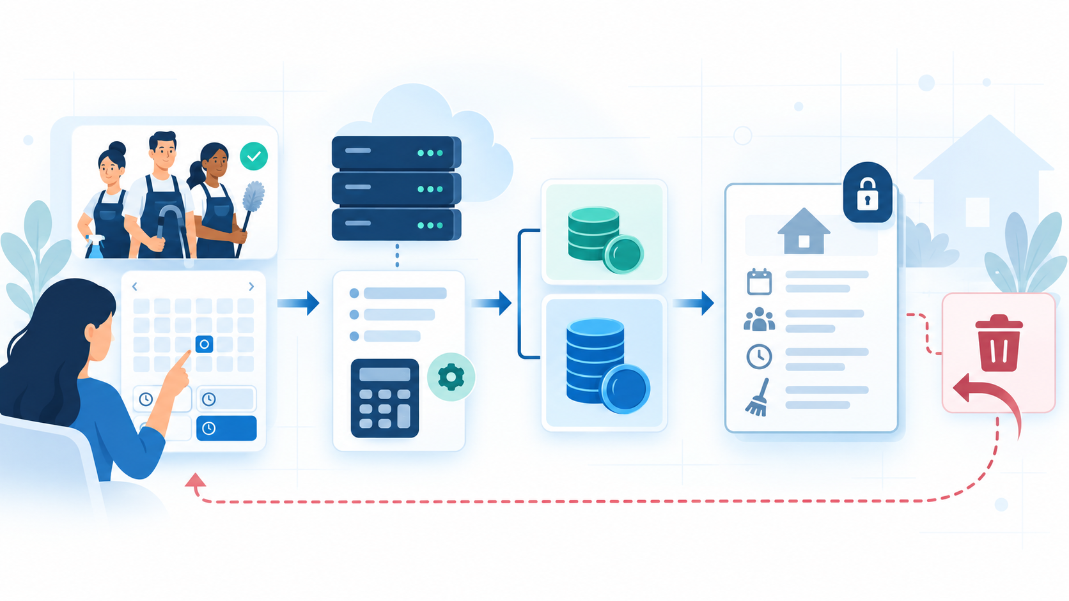
Phase 13 booking lifecycle concept generated for this guide
Implementation reading: Use the generated illustration only as orientation. The seven deterministic flows below define the implementation sequence and the operation cards define every routable contract.

Flow 01 Complete Booking Draft Journey
Shows the verified customer journey from a current Browse result through DRAFT completion and immutable AWAITING_DEPOSIT.
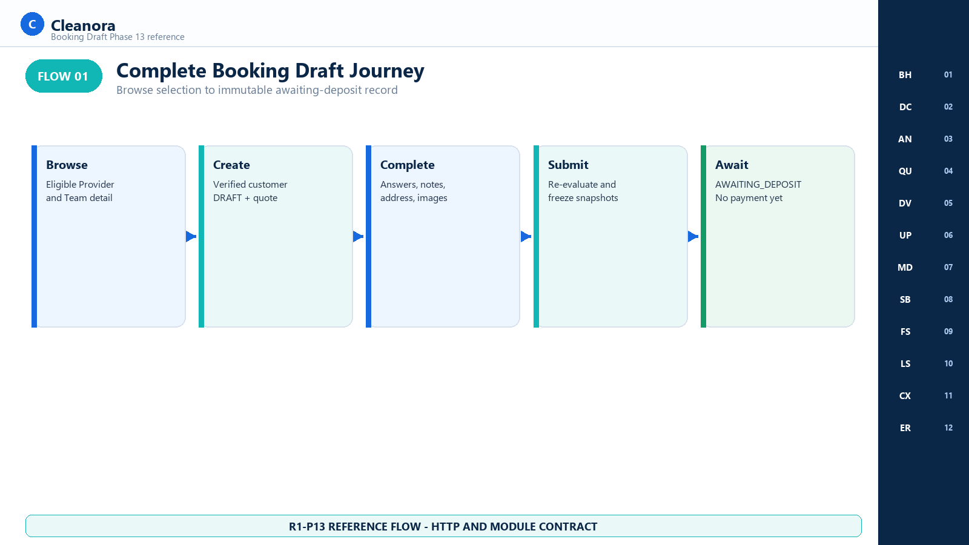
Flow 01 - Complete Booking Draft Journey
Implementation reading: Treat the AWAITING_DEPOSIT result as the end of the Phase 13 happy path. No money has moved.

Authority represented: bookings.command.routes.ts; bookings.command.service.ts

Flow 02 Verified Customer Gate
Separates authentication, full activation, verified customer-category authorization, and self-only booking access.
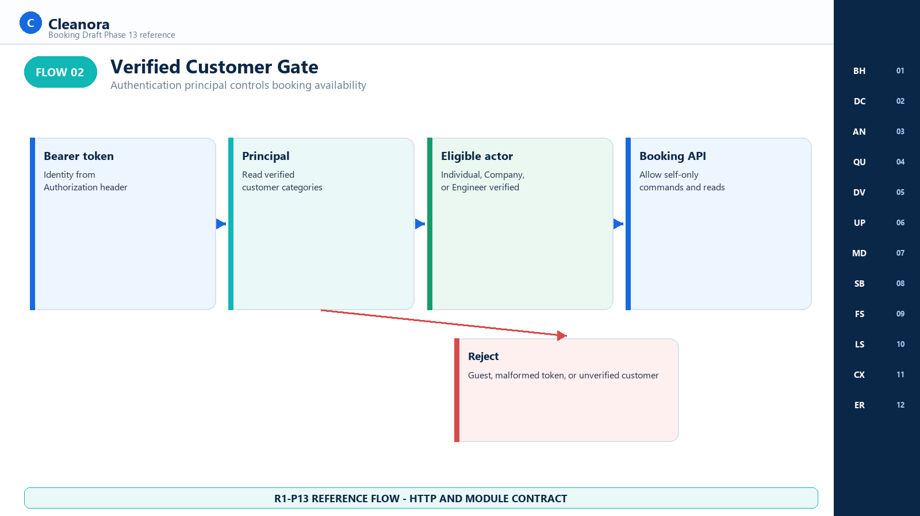
Flow 02 - Verified Customer Gate
Implementation reading: A valid token is necessary but not sufficient; the principal must represent a verified supported customer.

Authority represented: auth.middleware.ts; bookings.command.service.ts

Flow 03 Create Idempotency and Eligibility
Shows strict validation, customer-scoped command identity, explicit Eligibility evaluation, persistence, and safe replay.
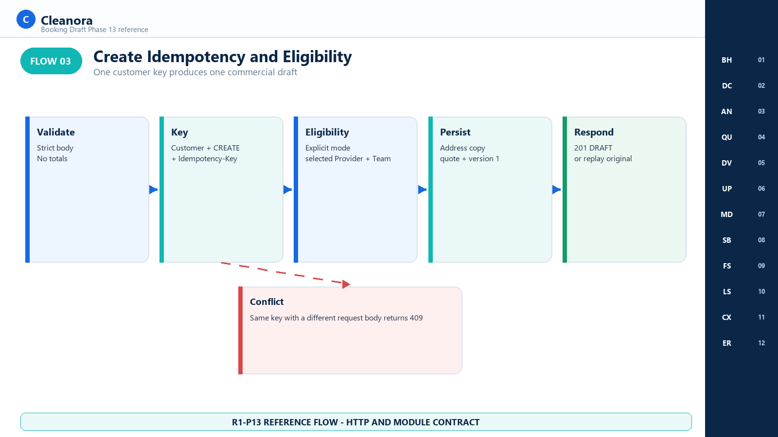
Flow 03 - Create Idempotency and Eligibility
Implementation reading: Reuse an idempotency key only for a byte-equivalent user intent. Generate a new key for a corrected request.

Authority represented: bookings.command.controller.ts; bookings.command.service.ts

Flow 04 Server Quote Calculation
Explains the decimal-safe maximum-price, configured-percent, round-half-up deposit, and remainder sequence.
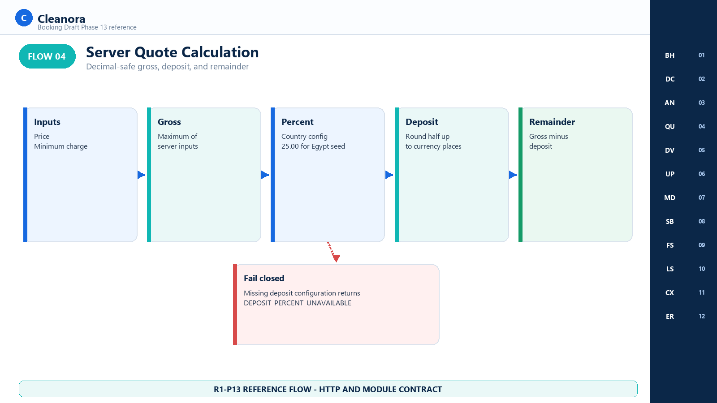
Flow 04 - Server Quote Calculation
Implementation reading: Display canonical decimal strings and keep the formula version. Do not reproduce authoritative pricing in the browser.

Authority represented: bookings.money.ts; bookings.command.service.ts

Flow 05 Draft Mutation and Concurrency
Coordinates GET, PATCH, Media association, atomic version claims, stale-write recovery, and returned aggregate replacement.
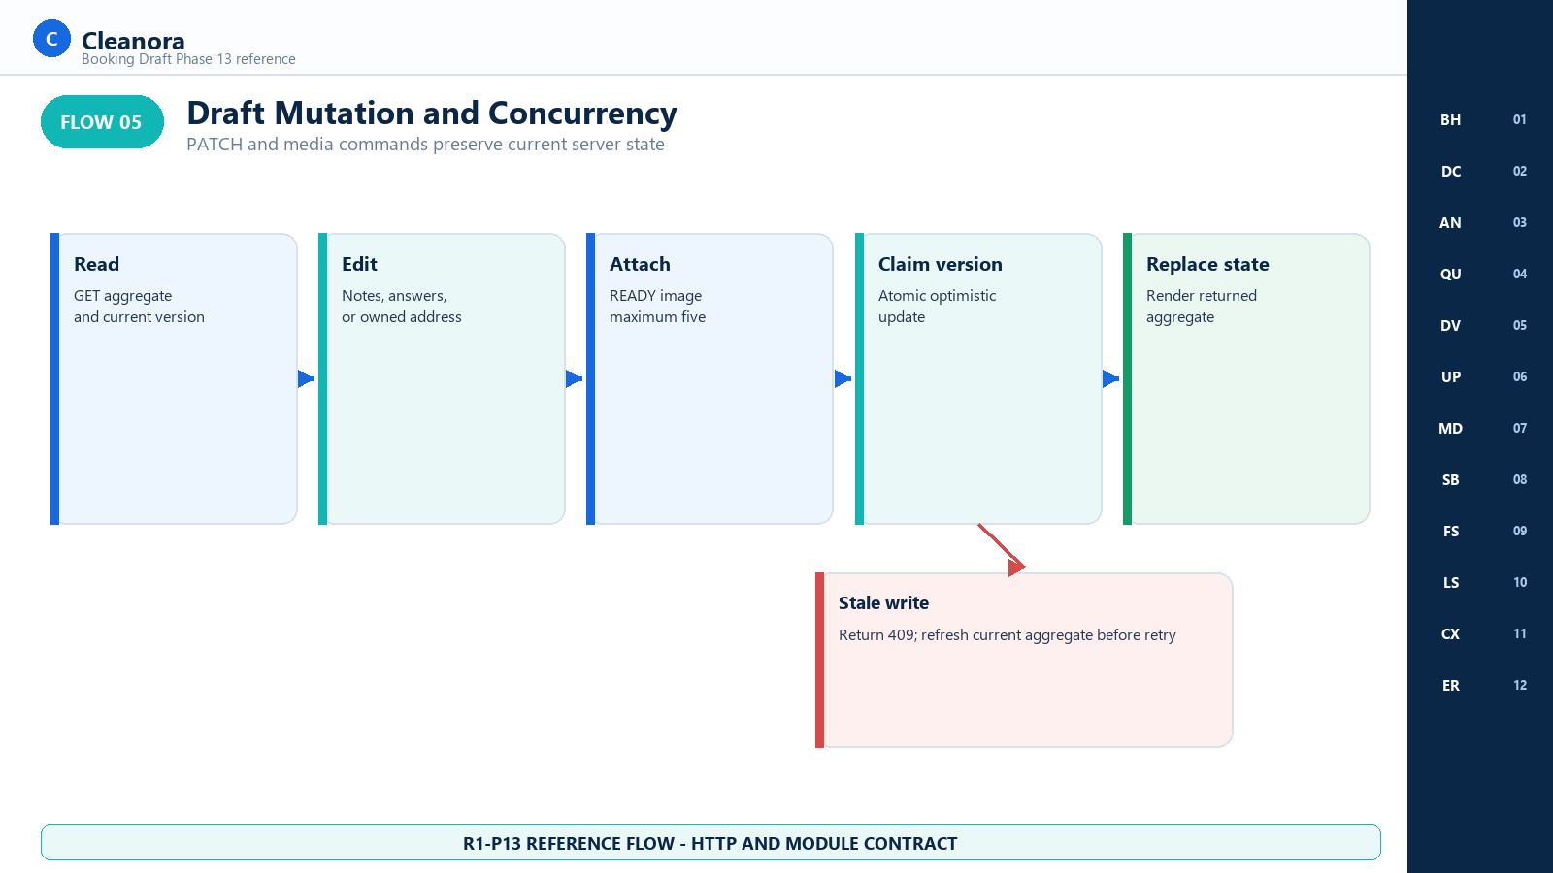
Flow 05 - Draft Mutation and Concurrency
Implementation reading: Always adopt the aggregate returned by the command. A 409 requires refresh and user-visible reconciliation.

Authority represented: bookings.command.routes.ts; prisma-bookings.repository.ts

Flow 06 Submit and Immutable Freeze
Shows the persisted transition rule, final validation, explicit re-evaluation, immutable snapshot transaction, and history append.
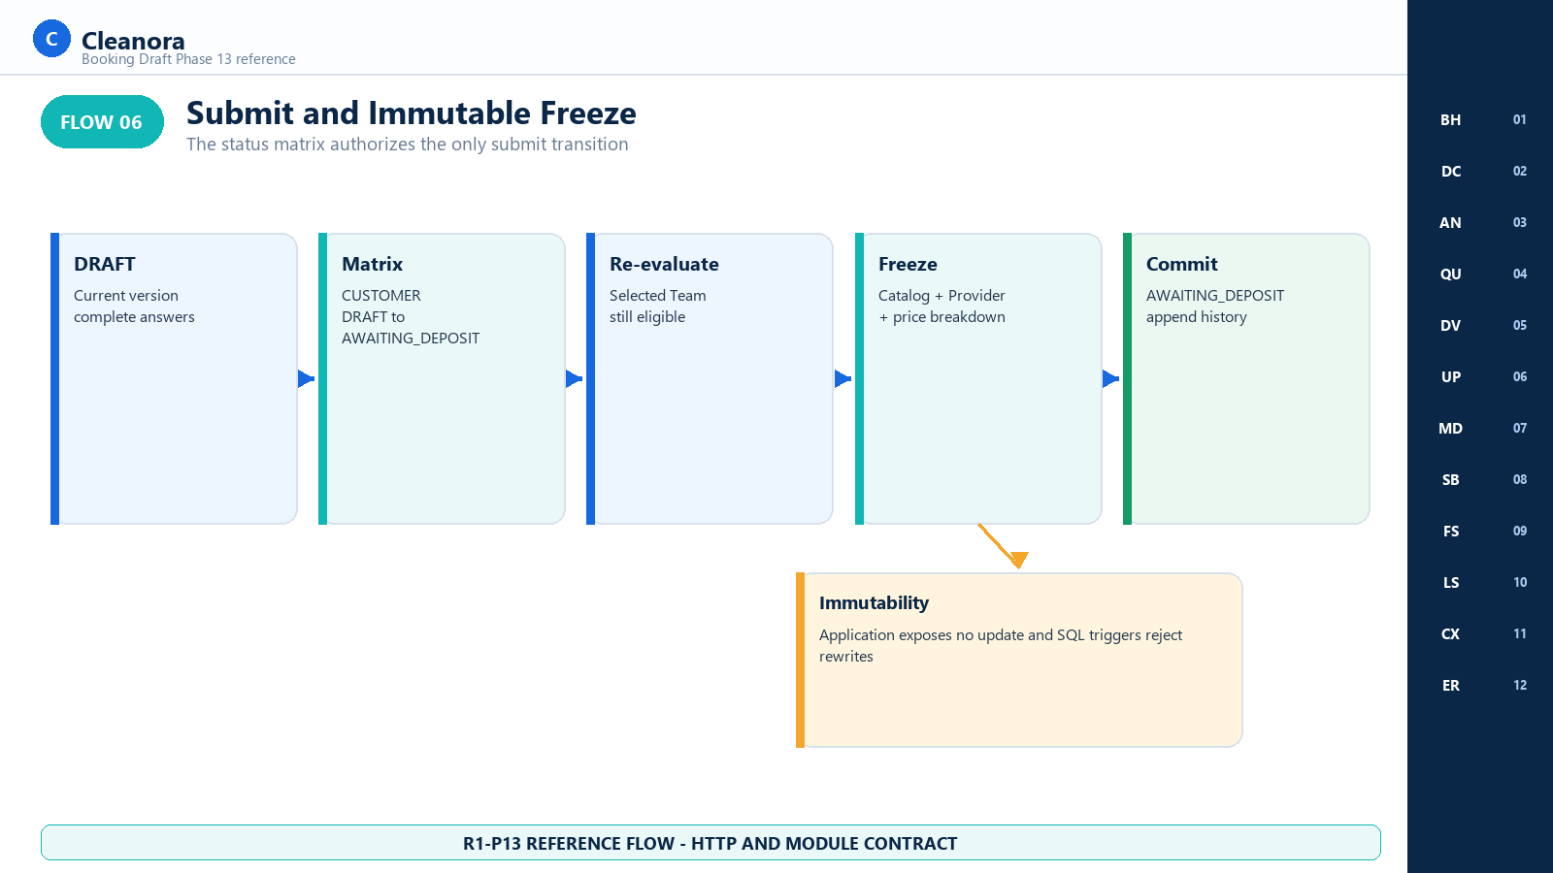
Flow 06 - Submit and Immutable Freeze
Implementation reading: The snapshot and breakdown are write-once evidence. Never offer a recalculate or update action after submit.

Authority represented: bookings.status-machine.ts; prisma-bookings.repository.ts; migration.sql

Flow 07 Cancel and Later Phase Boundary
Shows customer cancellation from the two executable source states and the explicit absence of fees, ledger, payment, and confirmation.
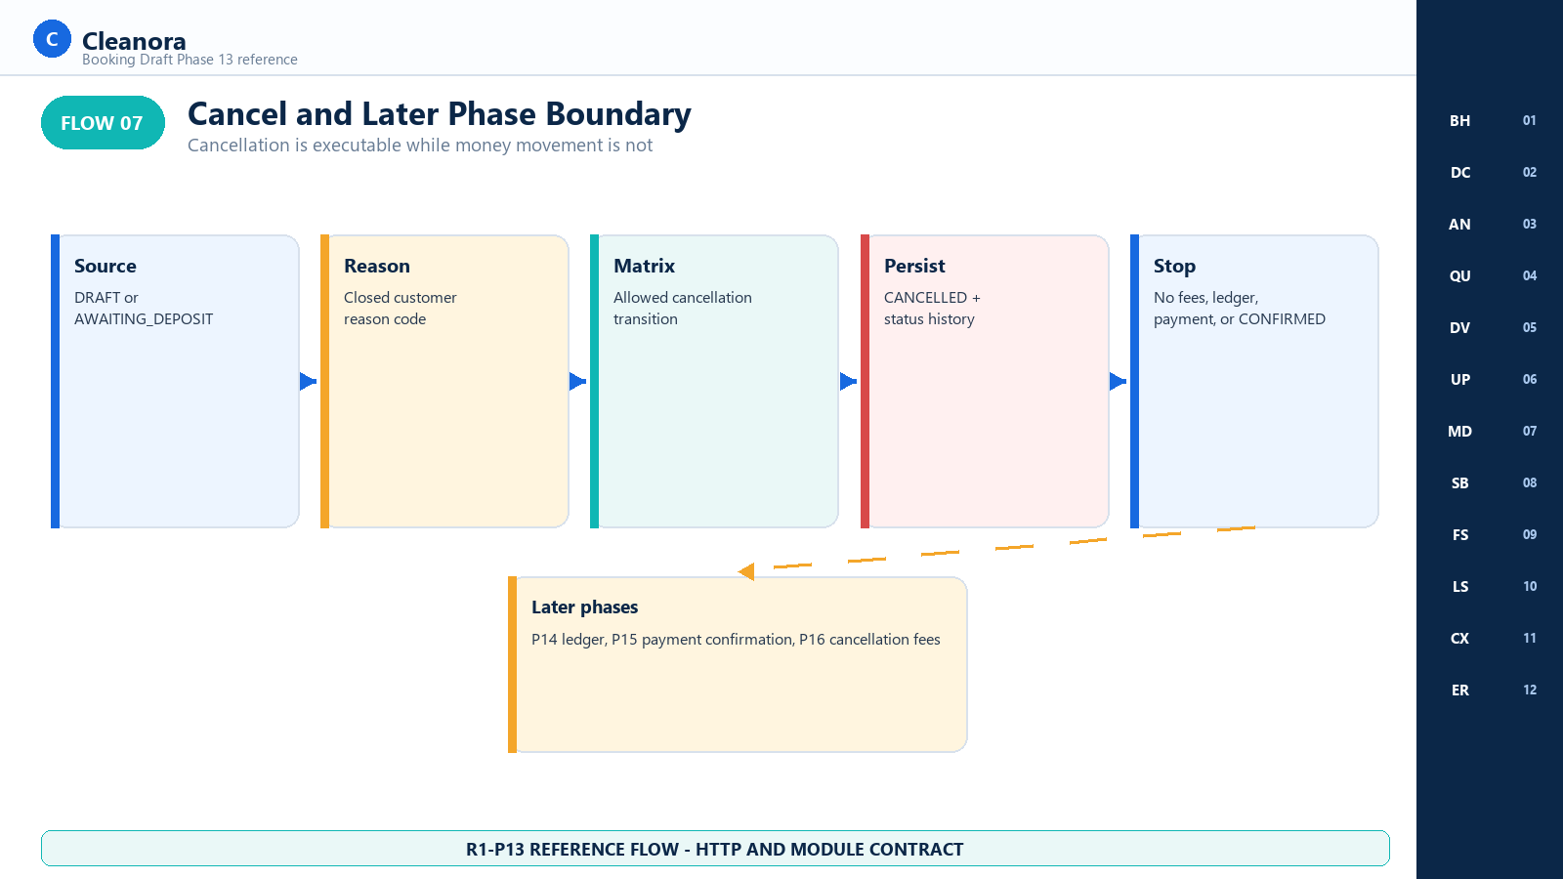
Flow 07 - Cancel and Later Phase Boundary
Implementation reading: Cancellation has no Phase 13 fee or refund arithmetic. Later payment and fee phases remain absent.

Authority represented: bookings.command.service.ts; status_transition_rules seed

PAGES BY CONTEXT

Verified Customer Booking
Reference coverage: Screens 01 through 12

- Require one current verified customer session.
- Enter from a current eligible Browse provider and team pair.
- Keep all booking routes self-only and use server-returned versions.
- Display deposit requirements without implying payment capture.

PAGES BY CONTEXT

Draft Authoring
Reference coverage: Screens 02 through 07

- Create one DRAFT with one idempotency key.
- Edit notes, answers, and the owned address only.
- Associate no more than five READY booking images.
- Treat the quote as server-authored but not frozen until submit.

PAGES BY CONTEXT

Awaiting Deposit and Historical Read
Reference coverage: Screens 08 through 11

- Submit only after required answers and locality are complete.
- Render immutable snapshots and the price breakdown from GET.
- Allow cancellation without fee calculation.
- Do not expose edit, payment, confirmation, or assignment actions.

BOUNDARY

Absent Phase 13 Page Groups
Reference coverage: No Phase 13 screens

- No payment method, checkout, Paymob, receipt, wallet, payout, ledger, or financial posting page.
- No CONFIRMED command, Provider acceptance, worker assignment, order execution, completion code, or panic page.
- No cancellation fee, reschedule, refund, or deposit-forfeit calculator.
- No Recommended path, premium ranking, map, coordinates, socket tracking, Docker, cloud, deployment, or production migration surface.
REFERENCE SCREENS

Booking Frontend Reference Screens
Section purpose: Every numbered visual below is a routed-experience concept for the implemented Phase 13 booking HTTP surface. The route exists, but exact page composition remains a frontend decision; the operation cards and checked-in contracts control behavior.

Screen 01 Browse to Booking Handoff
Frontend context | Route coverage | Screen purpose
Verified customer arriving from one eligible provider and team detail | P12 Browse detail then POST /api/v1/bookings | Carry the exact Browse selection into the authenticated Phase 13 booking workflow.

Visual authority: This image is a frontend handoff concept for implemented Phase 13 HTTP behavior. Exact fields and states come from the operation cards, checked-in OpenAPI contract, and runtime source; visual placement does not create a new endpoint, role, side effect, or product promise.

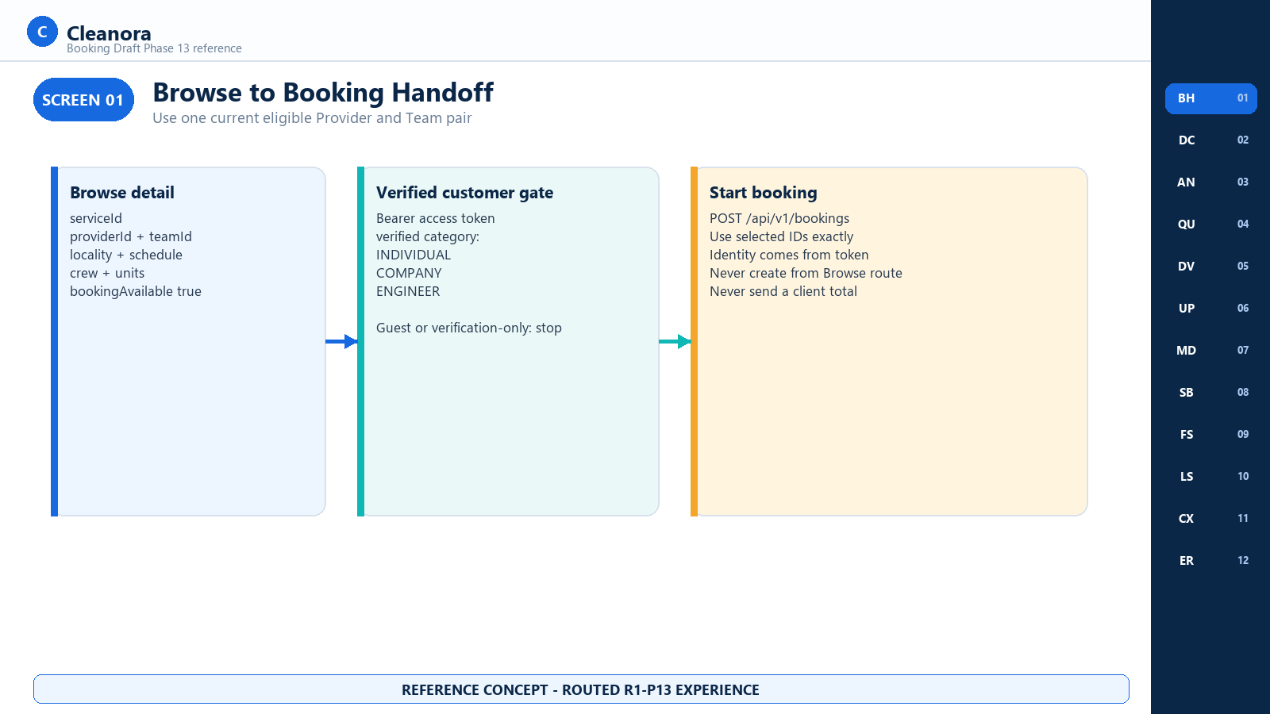
Screen 01 - Browse to Booking Handoff - R1-P13 reference concept

Screen 01 Frontend Notes

Frontend Flow on This Screen
- Open booking only when the P12 detail response reports bookingPrerequisites.bookingAvailable as true and phase as R1-P13.
- Keep serviceId, providerId, teamId, locality, schedule, crewPreference, requiredTeamUnits, and locale from the selected Browse context.
- Require a current Bearer session and a verified customer category before mounting the booking composer.
- Create through POST /api/v1/bookings; never post to a Browse route or treat a Browse result as a reservation.

Contracts Used on This Screen
Phase 12 provider detail prerequisite plus Contract 01 Create Booking Draft.

States and Recovery
Guests and unverified principals stop at the verification or sign-in path. A stale provider and team selection can fail with NOT_ELIGIBLE and must return to Browse.

Security and Privacy Rules
Identity comes from the access token. The create body must not contain customerUserId, roles, verification flags, price totals, or excluded Eligibility diagnostics.

Boundary and Non Deliverables
Boundary: Browse supplies discovery context only. Phase 13 owns booking mutation; no payment, ledger posting, Team reservation, or CONFIRMED transition occurs here.

Screen 02 Booking Draft Composer
Frontend context | Route coverage | Screen purpose
Verified customer creating one browse-path booking | POST /api/v1/bookings | Collect the strict create payload and obtain a server-calculated DRAFT quote.

Visual authority: This image is a frontend handoff concept for implemented Phase 13 HTTP behavior. Exact fields and states come from the operation cards, checked-in OpenAPI contract, and runtime source; visual placement does not create a new endpoint, role, side effect, or product promise.

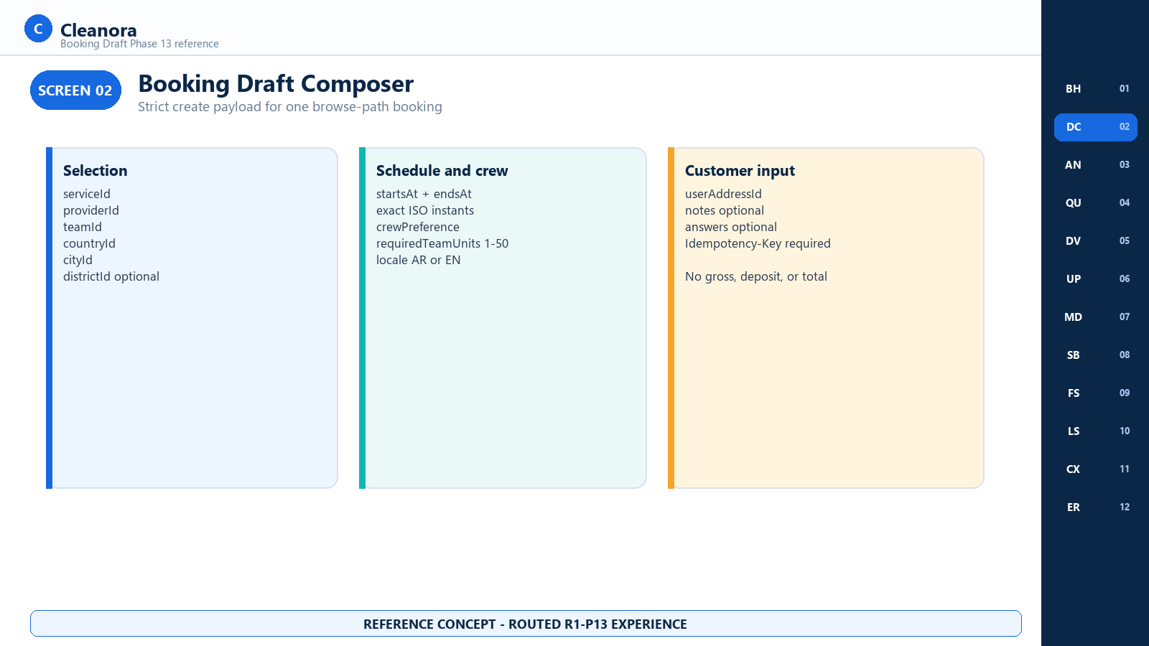
Screen 02 - Booking Draft Composer - R1-P13 reference concept

Screen 02 Frontend Notes

Frontend Flow on This Screen
- Submit service, Provider, Team, country, city, optional district, exact UTC interval, crew preference, required Team units, locale, and one owned userAddressId.
- Allow bounded notes and optional answers when the frontend already has the selected Catalog field definition.
- Generate one fresh Idempotency-Key for the create intent and reuse it only when retrying the same request body.
- Replace the local form state with the returned booking aggregate and version 1 after a 201 response.

Contracts Used on This Screen
Contract 01 Create Booking Draft; CreateBookingRequest; BookingData; BookingQuote.

States and Recovery
Validation errors preserve safe input and focus the affected field. NOT_ELIGIBLE returns the customer to current Browse results. DEPOSIT_PERCENT_UNAVAILABLE is a retryable service-configuration state, not permission to assume 25 percent in the client.

Security and Privacy Rules
Never send gross, deposit, remainder, total, customer identity, or eligibility results. The server re-evaluates the selected Team in explicit mode.

Boundary and Non Deliverables
Boundary: The create route produces DRAFT only. It does not reserve capacity, collect a deposit, create a ledger entry, or confirm fulfillment.

Screen 03 Answers and Notes
Frontend context | Route coverage | Screen purpose
Verified customer completing selected service requirements | PATCH /api/v1/bookings/{bookingId} | Render Catalog-owned fields and persist canonical draft answers and notes.

Visual authority: This image is a frontend handoff concept for implemented Phase 13 HTTP behavior. Exact fields and states come from the operation cards, checked-in OpenAPI contract, and runtime source; visual placement does not create a new endpoint, role, side effect, or product promise.

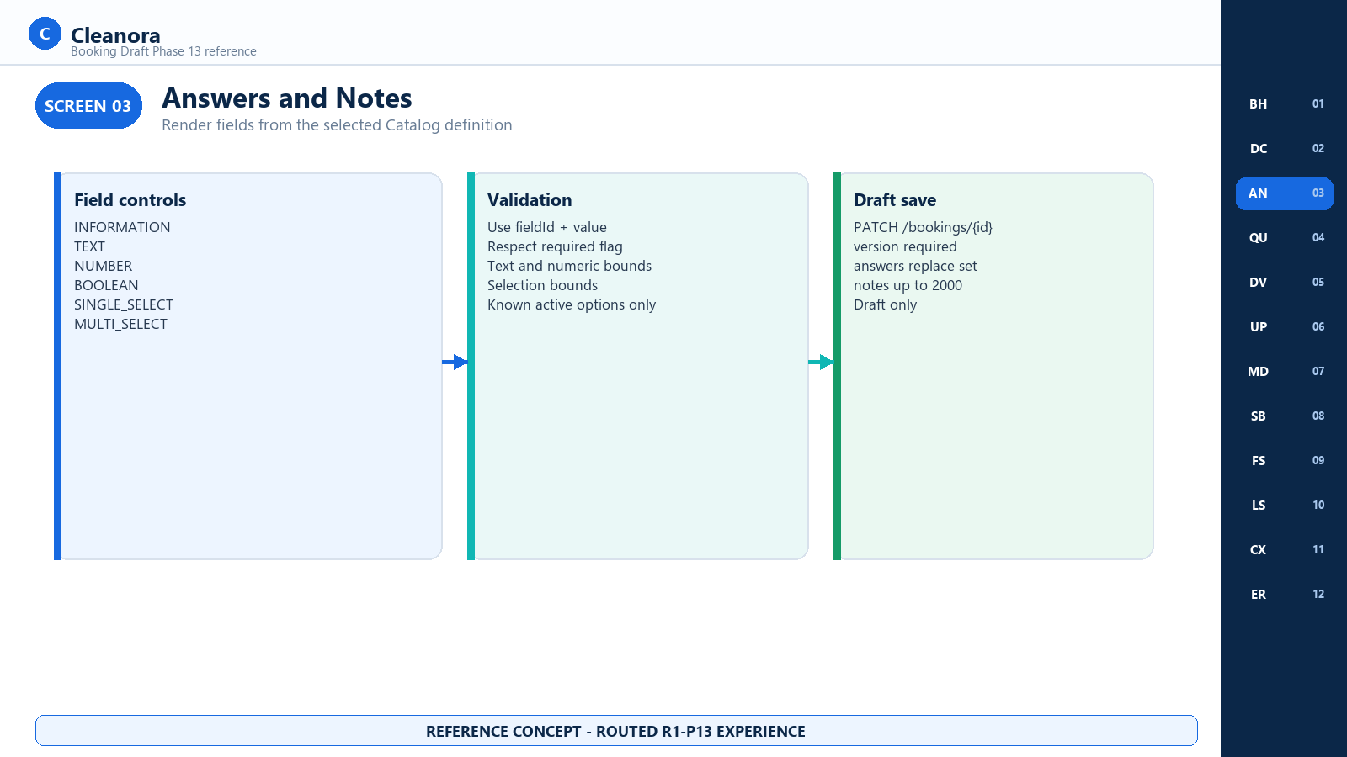
Screen 03 - Answers and Notes - R1-P13 reference concept

Screen 03 Frontend Notes

Frontend Flow on This Screen
- Render INFORMATION, TEXT, NUMBER, BOOLEAN, SINGLE_SELECT, and MULTI_SELECT controls from the selected service definition.
- Submit fieldId and value only, respecting required flags, bounds, numeric mode, selection counts, and current option values.
- Treat PATCH answers as a replacement set and include the current booking version.
- Use product-localized validation copy while retaining the server code and requestId for support correlation.

Contracts Used on This Screen
Contract 04 Patch Booking Draft; PatchBookingRequest; BookingCatalogFieldSnapshot.

States and Recovery
A DRAFT may have incomplete required answers. Submit for deposit refuses incompleteness while preserving DRAFT. A stale version returns CONFLICT and requires a fresh GET.

Security and Privacy Rules
Do not invent field definitions or accept raw HTML. Preserve field IDs as opaque values and never log private answer content or notes unnecessarily.

Boundary and Non Deliverables
Boundary: PATCH cannot change service, Provider, Team, schedule, crew preference, required units, country, city, district, or locale. Recreate the draft if those choices must change.

Screen 04 Server Quote Review
Frontend context | Route coverage | Screen purpose
Verified customer reviewing the current draft quote | POST /api/v1/bookings then GET or PATCH booking aggregate | Display gross, deposit, remainder, currency, percent, and formula version as server facts.

Visual authority: This image is a frontend handoff concept for implemented Phase 13 HTTP behavior. Exact fields and states come from the operation cards, checked-in OpenAPI contract, and runtime source; visual placement does not create a new endpoint, role, side effect, or product promise.

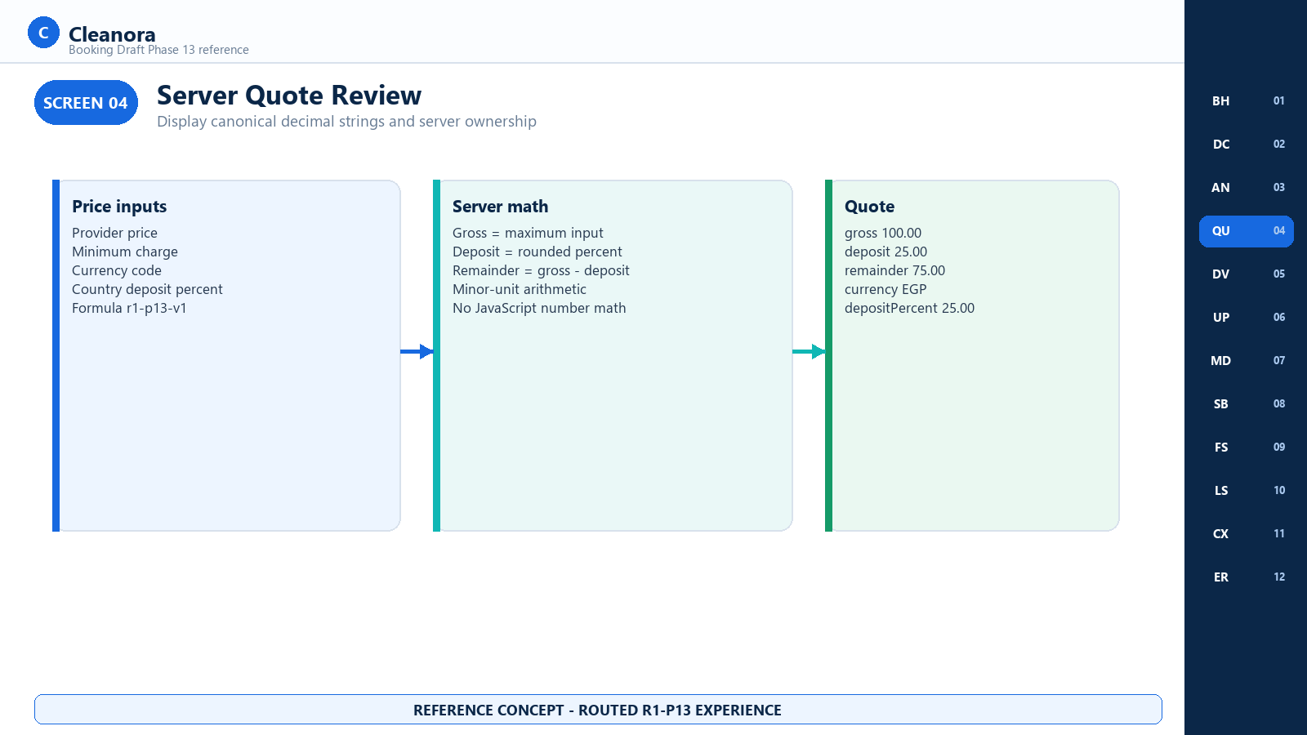
Screen 04 - Server Quote Review - R1-P13 reference concept

Screen 04 Frontend Notes

Frontend Flow on This Screen
- Render canonical decimal strings exactly as returned; format them for display without converting server arithmetic into client authority.
- Explain that gross is the higher of the offering price and minimum charge and that the deposit uses the configured country percent.
- Keep quote and booking version together so a later mutation never submits against a visually stale amount.
- Show a service-unavailable state when configuration or an owning dependency fails; do not replace it with a cached or fabricated amount.

Contracts Used on This Screen
BookingQuote; BookingPriceBreakdown; Contract 01, Contract 03, and Contract 05.

States and Recovery
DRAFT quote is current but not frozen. At AWAITING_DEPOSIT the immutable priceBreakdown becomes authoritative. CANCELLED keeps historical facts but cannot resume.

Security and Privacy Rules
Never accept a client total, run JavaScript floating-point math as authoritative, or log raw provider pricing inputs beyond approved diagnostics.

Boundary and Non Deliverables
Boundary: A deposit amount is a requirement, not a collected amount. Phase 13 has no payment method, checkout, gateway, ledger, wallet, or receipt.

Screen 05 Draft Detail and Version
Frontend context | Route coverage | Screen purpose
Verified customer reading one owned booking | GET /api/v1/bookings/{bookingId} | Render the server aggregate and preserve optimistic concurrency state.

Visual authority: This image is a frontend handoff concept for implemented Phase 13 HTTP behavior. Exact fields and states come from the operation cards, checked-in OpenAPI contract, and runtime source; visual placement does not create a new endpoint, role, side effect, or product promise.

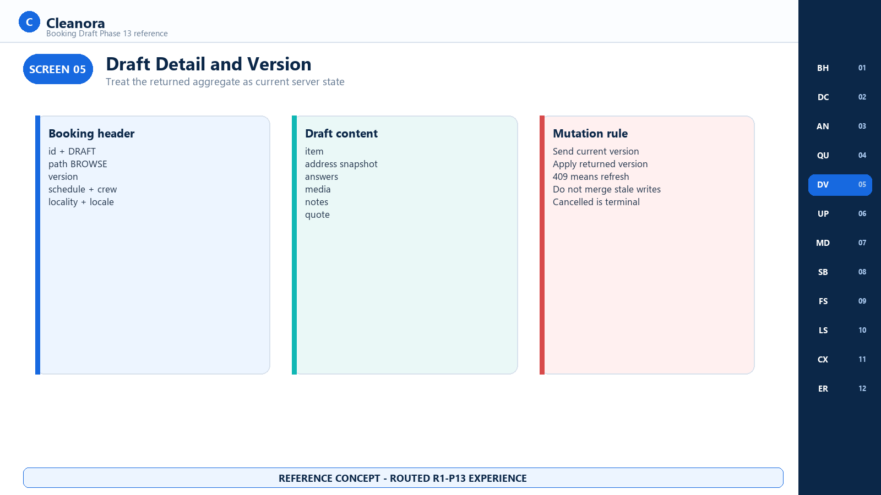
Screen 05 - Draft Detail and Version - R1-P13 reference concept

Screen 05 Frontend Notes

Frontend Flow on This Screen
- Load the booking by opaque id and render status, version, path, schedule, crew, locality, item, address, answers, media, notes, quote, and history.
- Keep the returned version beside every enabled mutation and replace it after each successful response.
- Derive edit controls from status: DRAFT may patch or attach; DRAFT and AWAITING_DEPOSIT may cancel; CANCELLED is terminal.
- Treat 404 as absent without revealing whether another customer owns the id.

Contracts Used on This Screen
Contract 03 Get Booking; BookingData; BookingStatus; BookingQuote; BookingSnapshot.

States and Recovery
snapshot and priceBreakdown are null while DRAFT and present after submit. Media delivery URLs may be omitted individually when signing fails.

Security and Privacy Rules
Self-only authorization is server enforced. Do not infer ownership from an id, display foreign identifiers, or persist signed media URLs as durable record keys.

Boundary and Non Deliverables
Boundary: Version is an optimistic write precondition, not a lock token or authorization credential.

Screen 06 Update Draft
Frontend context | Route coverage | Screen purpose
Verified customer editing mutable draft content | PATCH /api/v1/bookings/{bookingId} | Replace notes, answers, or the owned address while preserving create-time selection facts.

Visual authority: This image is a frontend handoff concept for implemented Phase 13 HTTP behavior. Exact fields and states come from the operation cards, checked-in OpenAPI contract, and runtime source; visual placement does not create a new endpoint, role, side effect, or product promise.

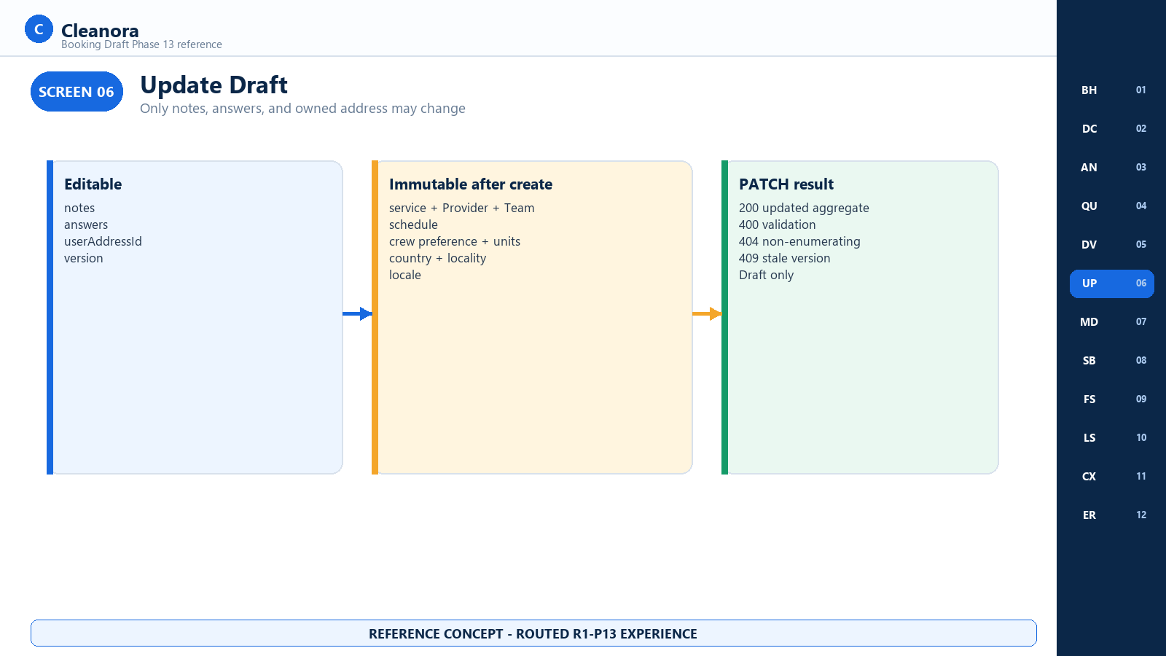
Screen 06 - Update Draft - R1-P13 reference concept

Screen 06 Frontend Notes

Frontend Flow on This Screen
- Send version and at least one supported editable field: notes, answers, or userAddressId.
- When address changes, expect the server to copy the current owned address snapshot and validate locality consistency.
- Replace local aggregate state from the 200 response rather than manually applying a partial optimistic patch.
- On 409, fetch current state and ask the user to reapply intentional edits instead of silently overwriting.

Contracts Used on This Screen
Contract 04 Patch Booking Draft; PatchBookingRequest.

States and Recovery
Only DRAFT is mutable. Validation can reject unknown fields, invalid answers, a foreign address, or an address whose city and district do not match the booking locality.

Security and Privacy Rules
The client sends userAddressId only; the Customers module supplies the owned textual snapshot. Do not send raw ownership flags or bypass the public snapshot reader.

Boundary and Non Deliverables
Boundary: No schedule or selected service change is implemented. The client must not smuggle unsupported properties into the strict body.

Screen 07 Booking Attachment Gallery
Frontend context | Route coverage | Screen purpose
Verified customer attaching prepared images to a draft | POST /api/v1/bookings/{bookingId}/media | Associate up to five READY booking images and render best-effort signed delivery links.

Visual authority: This image is a frontend handoff concept for implemented Phase 13 HTTP behavior. Exact fields and states come from the operation cards, checked-in OpenAPI contract, and runtime source; visual placement does not create a new endpoint, role, side effect, or product promise.

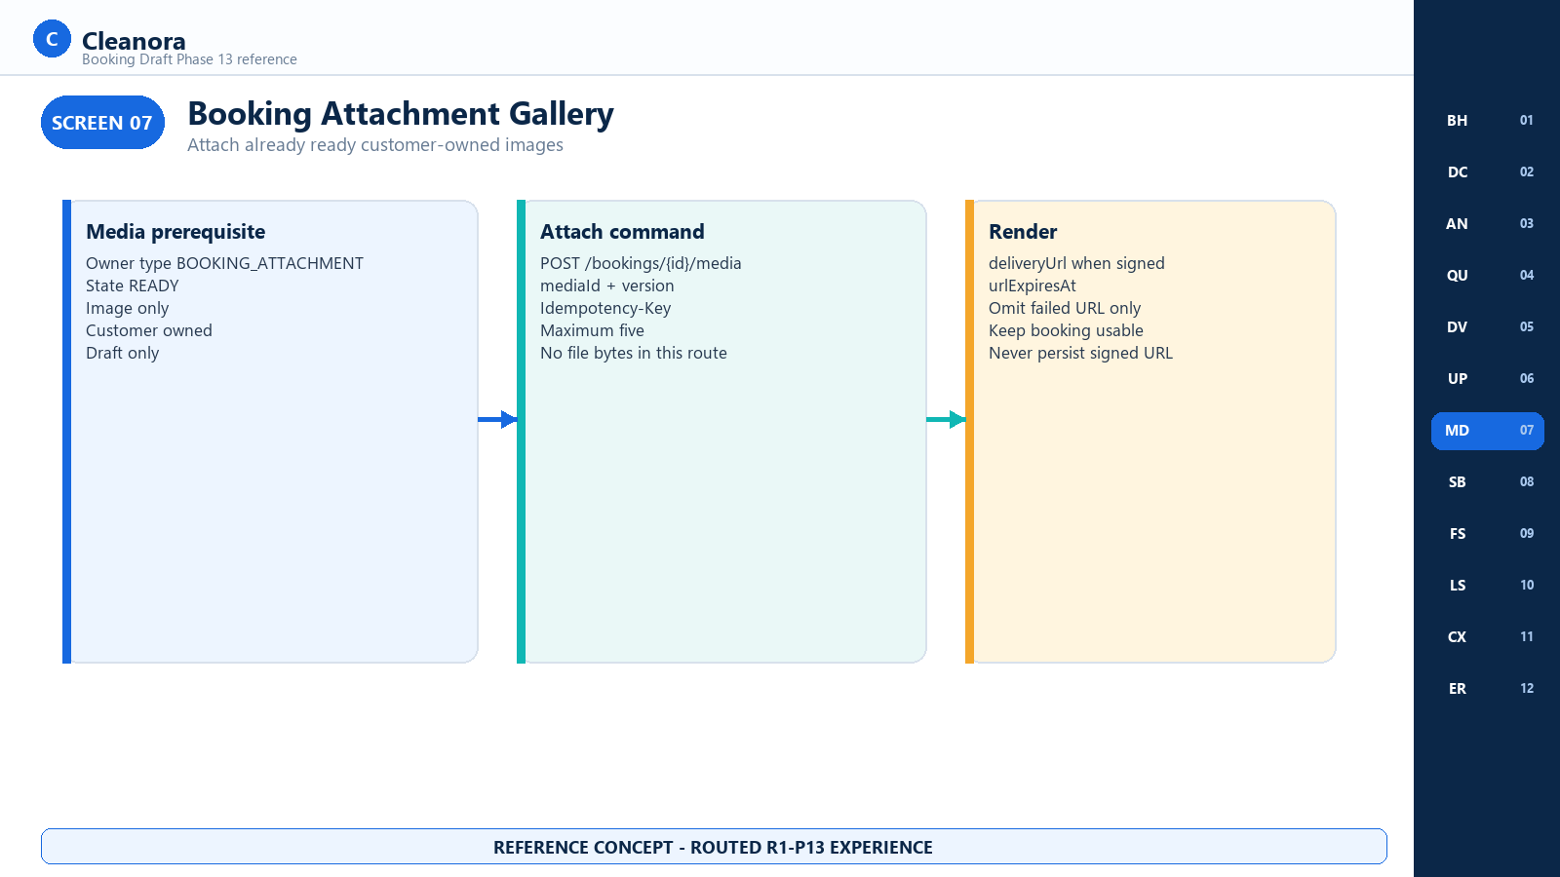
Screen 07 - Booking Attachment Gallery - R1-P13 reference concept

Screen 07 Frontend Notes

Frontend Flow on This Screen
- Complete the Media-owned upload workflow first and obtain a READY mediaId whose owner type is BOOKING_ATTACHMENT.
- Submit booking version, mediaId, and an Idempotency-Key to the Phase 13 association route.
- Render media in displayOrder and use deliveryUrl only until urlExpiresAt.
- When one signing attempt fails, omit that delivery link while keeping the booking and remaining media usable.

Contracts Used on This Screen
Contract 07 Attach Booking Media; AttachBookingMediaRequest; BookingData.media.

States and Recovery
A sixth image, a non-image, a non-READY item, a foreign item, a duplicate association, a stale version, or a non-DRAFT booking is rejected.

Security and Privacy Rules
Never persist a signed URL as a stable identifier or expose object keys, signing secrets, storage credentials, or another customer's media.

Boundary and Non Deliverables
Boundary: This route associates an existing Media item; it does not accept multipart file bytes, moderate content, or create public permanent URLs.

Screen 08 Submit for Deposit
Frontend context | Route coverage | Screen purpose
Verified customer completing a valid booking draft | POST /api/v1/bookings/{bookingId}/submit-for-deposit | Move DRAFT to AWAITING_DEPOSIT after final validation and immutable snapshot creation.

Visual authority: This image is a frontend handoff concept for implemented Phase 13 HTTP behavior. Exact fields and states come from the operation cards, checked-in OpenAPI contract, and runtime source; visual placement does not create a new endpoint, role, side effect, or product promise.

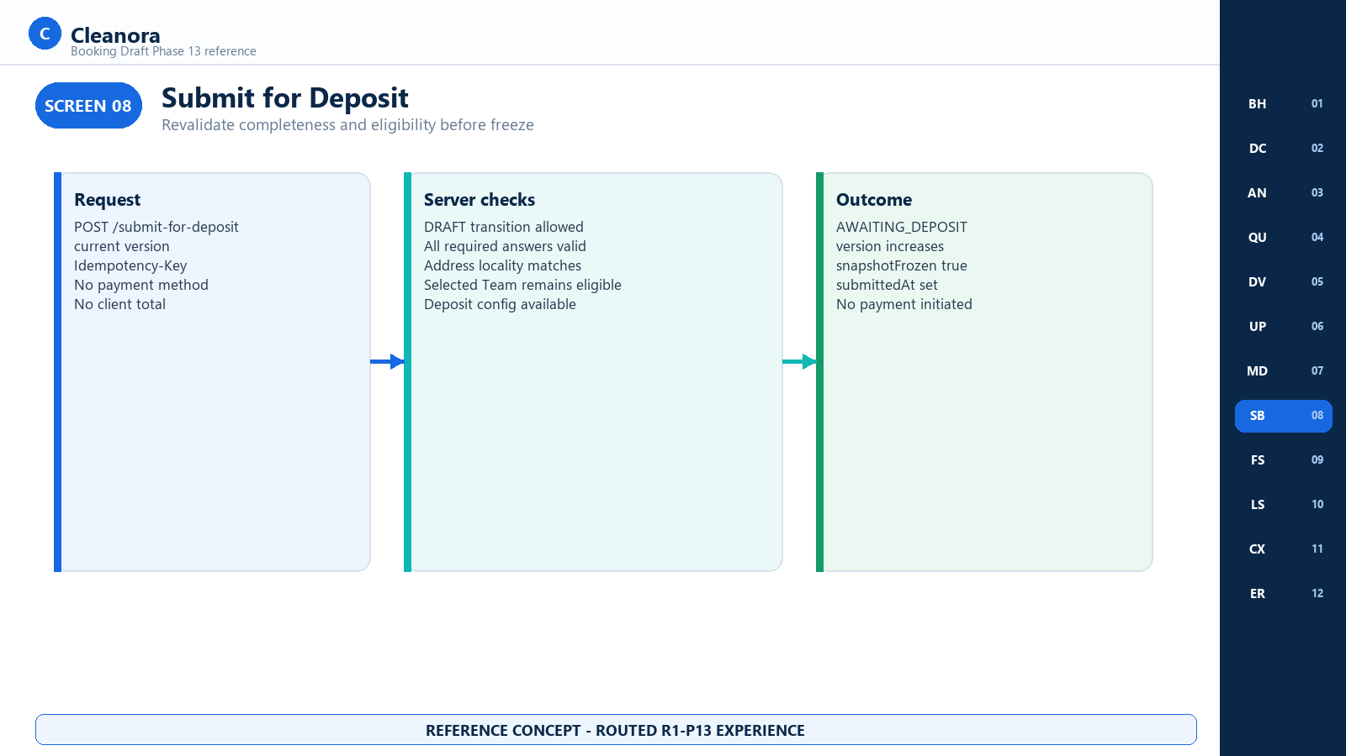
Screen 08 - Submit for Deposit - R1-P13 reference concept

Screen 08 Frontend Notes

Frontend Flow on This Screen
- Send current version and one fresh Idempotency-Key for the submit intent.
- Display progress while the server checks the transition rule, required Catalog answers, address locality, deposit configuration, and explicit Team eligibility.
- On success, replace the complete aggregate and show AWAITING_DEPOSIT, the increased version, submittedAt, snapshotFrozen, snapshot, and priceBreakdown.
- On a stable validation or eligibility failure, keep the customer in DRAFT and link to the incomplete or stale section.

Contracts Used on This Screen
Contract 05 Submit Booking for Deposit; BookingVersionRequest; BookingSnapshot; BookingPriceBreakdown.

States and Recovery
Repeated same-key same-body requests return the original result. A different body for the same key, stale version, illegal state, or unavailable transition returns 409 without partial writes.

Security and Privacy Rules
Never provide CONFIRMED as a client target. The server status matrix is the only transition authority.

Boundary and Non Deliverables
Boundary: Submit freezes a deposit requirement only. It does not collect money, call Paymob, post a ledger, or reserve workers.

Screen 09 Frozen Snapshot
Frontend context | Route coverage | Screen purpose
Verified customer reading submitted booking facts | GET /api/v1/bookings/{bookingId} | Render immutable Catalog, Provider, and price evidence after submit.

Visual authority: This image is a frontend handoff concept for implemented Phase 13 HTTP behavior. Exact fields and states come from the operation cards, checked-in OpenAPI contract, and runtime source; visual placement does not create a new endpoint, role, side effect, or product promise.

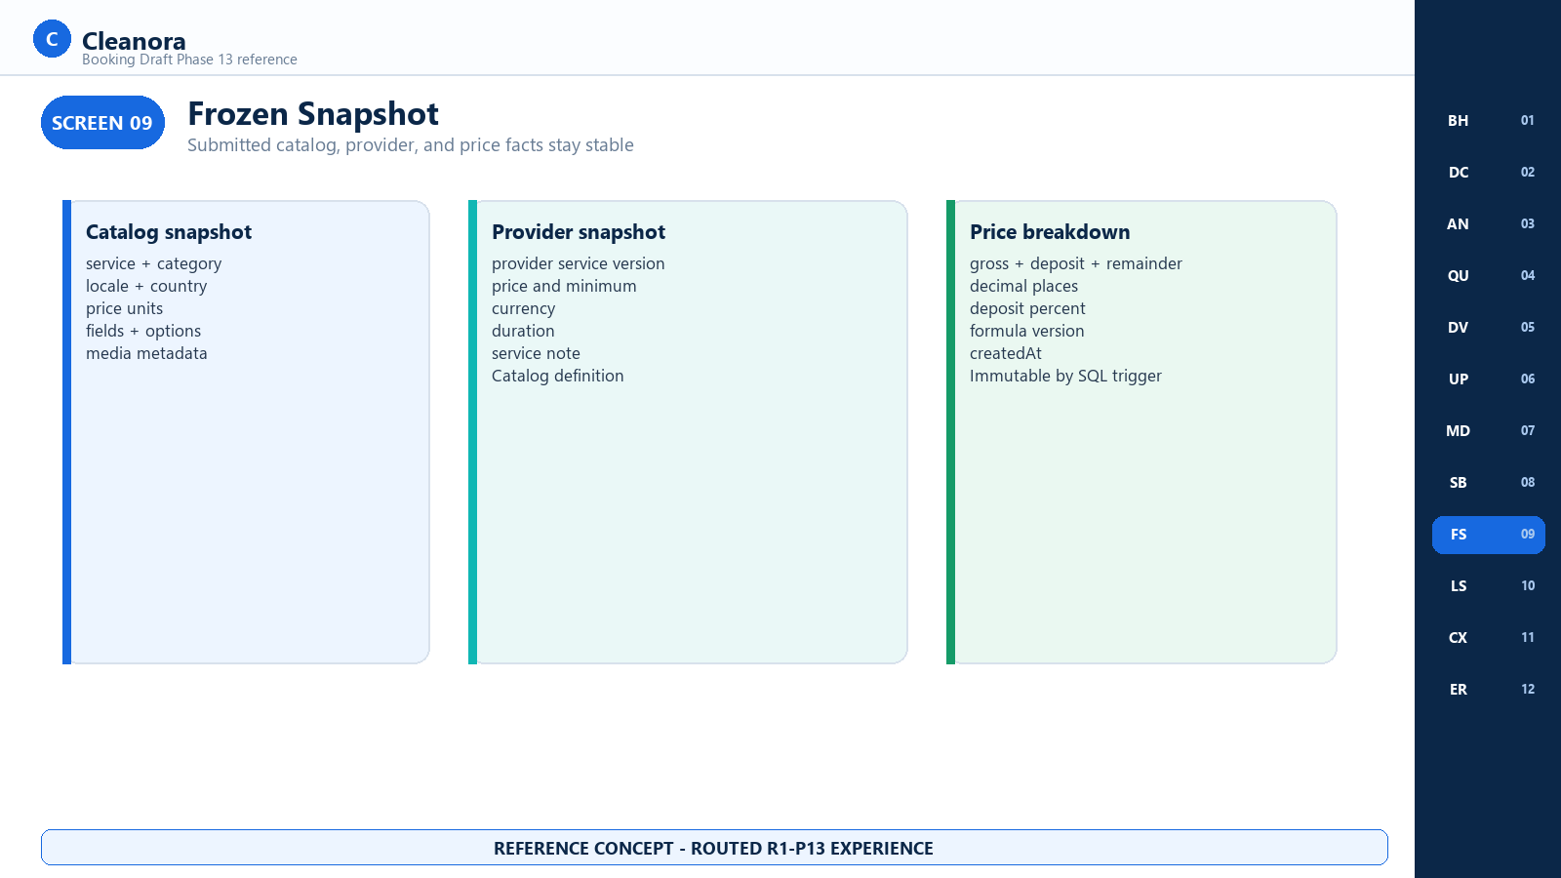
Screen 09 - Frozen Snapshot - R1-P13 reference concept

Screen 09 Frontend Notes

Frontend Flow on This Screen
- Use snapshot.catalog for submitted service, category, localized definition, price units, fields, options, and media metadata.
- Use snapshot.provider for submitted provider service, versions, price inputs, currency, duration, and service note.
- Use priceBreakdown for gross, deposit, remainder, decimal places, deposit percent, formula version, and creation time.
- Label the information as the submitted quote; never replace it with a later live Catalog or Provider price response.

Contracts Used on This Screen
Contract 03 Get Booking; BookingSnapshot; BookingCatalogSnapshot; BookingProviderSnapshot; BookingPriceBreakdown.

States and Recovery
snapshotFrozen is false with null snapshot and breakdown while DRAFT. It is true with immutable values at AWAITING_DEPOSIT and remains historical if later cancelled.

Security and Privacy Rules
The snapshot is booking evidence, not permission to expose private Provider contacts, workers, excluded eligibility reasons, or internal hash inputs beyond the public DTO.

Boundary and Non Deliverables
Boundary: The frontend has no snapshot edit, recalculate, or replace command. SQL triggers and repository contracts reject rewrites.

Screen 10 My Bookings
Frontend context | Route coverage | Screen purpose
Verified customer listing owned bookings | GET /api/v1/bookings | Render a self-only status-filtered list with opaque cursor pagination.

Visual authority: This image is a frontend handoff concept for implemented Phase 13 HTTP behavior. Exact fields and states come from the operation cards, checked-in OpenAPI contract, and runtime source; visual placement does not create a new endpoint, role, side effect, or product promise.

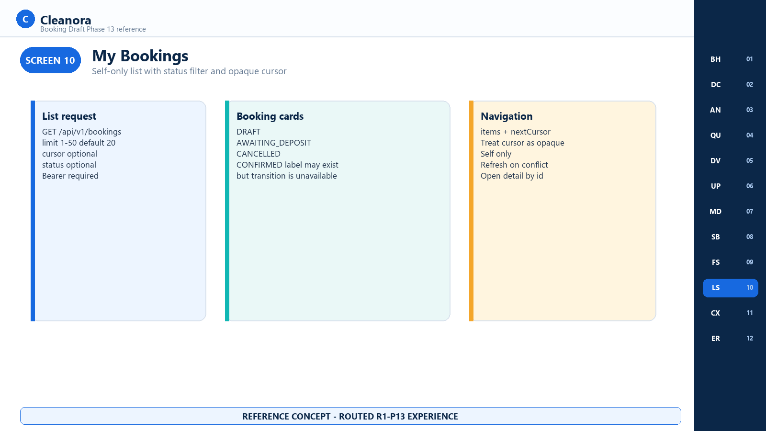
Screen 10 - My Bookings - R1-P13 reference concept

Screen 10 Frontend Notes

Frontend Flow on This Screen
- Request limit from 1 to 50, default 20, and optionally one BookingStatus filter.
- Treat nextCursor as opaque and resend it only with the intended list context.
- Render an empty items array as a successful state and offer a return to Browse.
- Open a booking using the detail route and preserve the list filter for back navigation.

Contracts Used on This Screen
Contract 02 List Bookings; BookingListData; BookingStatus.

States and Recovery
DRAFT, AWAITING_DEPOSIT, and CANCELLED are user-visible current states. CONFIRMED is a frozen enum label but Phase 13 cannot execute the transition into it.

Security and Privacy Rules
The server filters by the authenticated customer. Do not accept customerUserId as a query, cursor, or local authorization substitute.

Boundary and Non Deliverables
Boundary: The list is not an operations queue, Provider schedule, Worker assignment board, ledger, or payment history.

Screen 11 Cancel Booking
Frontend context | Route coverage | Screen purpose
Verified customer cancelling an owned draft or awaiting-deposit booking | POST /api/v1/bookings/{bookingId}/cancel | Capture a closed customer reason and append a fee-free cancellation history event.

Visual authority: This image is a frontend handoff concept for implemented Phase 13 HTTP behavior. Exact fields and states come from the operation cards, checked-in OpenAPI contract, and runtime source; visual placement does not create a new endpoint, role, side effect, or product promise.

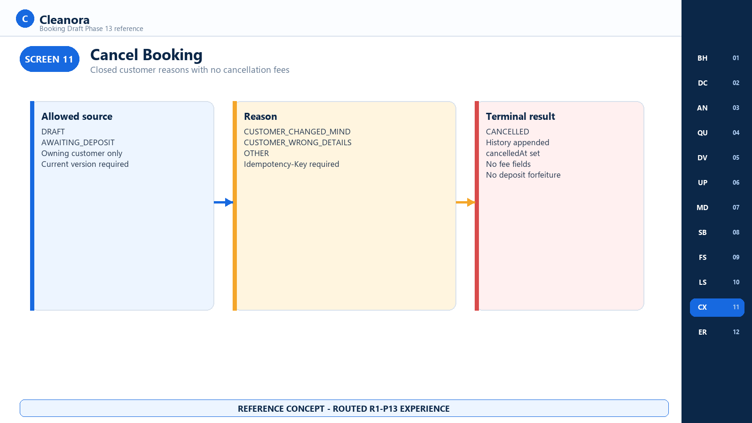
Screen 11 - Cancel Booking - R1-P13 reference concept

Screen 11 Frontend Notes

Frontend Flow on This Screen
- Enable cancellation only for DRAFT and AWAITING_DEPOSIT and show the three server reason codes with product-localized labels.
- Send current version, selected reason, and a fresh Idempotency-Key.
- Replace the aggregate with CANCELLED, the increased version, cancelledAt, and updated status history.
- Disable all later mutations and preserve the immutable submitted snapshot when cancellation followed AWAITING_DEPOSIT.

Contracts Used on This Screen
Contract 06 Cancel Booking; CancelBookingRequest; BookingCancelReason; status transition rules.

States and Recovery
A same-key replay returns the original cancellation. A stale version, terminal booking, or unavailable transition returns 409 with no partial history.

Security and Privacy Rules
Another customer's id returns the non-enumerating not-found policy. Do not log free-form invented reasons because the API accepts a closed enum only.

Boundary and Non Deliverables
Boundary: Phase 13 calculates and stores no cancellation fee, percent, refund, deposit forfeiture, payment reversal, or compensation.

Screen 12 Conflict and Boundary States
Frontend context | Route coverage | Screen purpose
All Phase 13 booking pages | All seven /api/v1/bookings operations | Provide one recovery model for validation, authorization, concurrency, dependency, and later-phase boundaries.

Visual authority: This image is a frontend handoff concept for implemented Phase 13 HTTP behavior. Exact fields and states come from the operation cards, checked-in OpenAPI contract, and runtime source; visual placement does not create a new endpoint, role, side effect, or product promise.

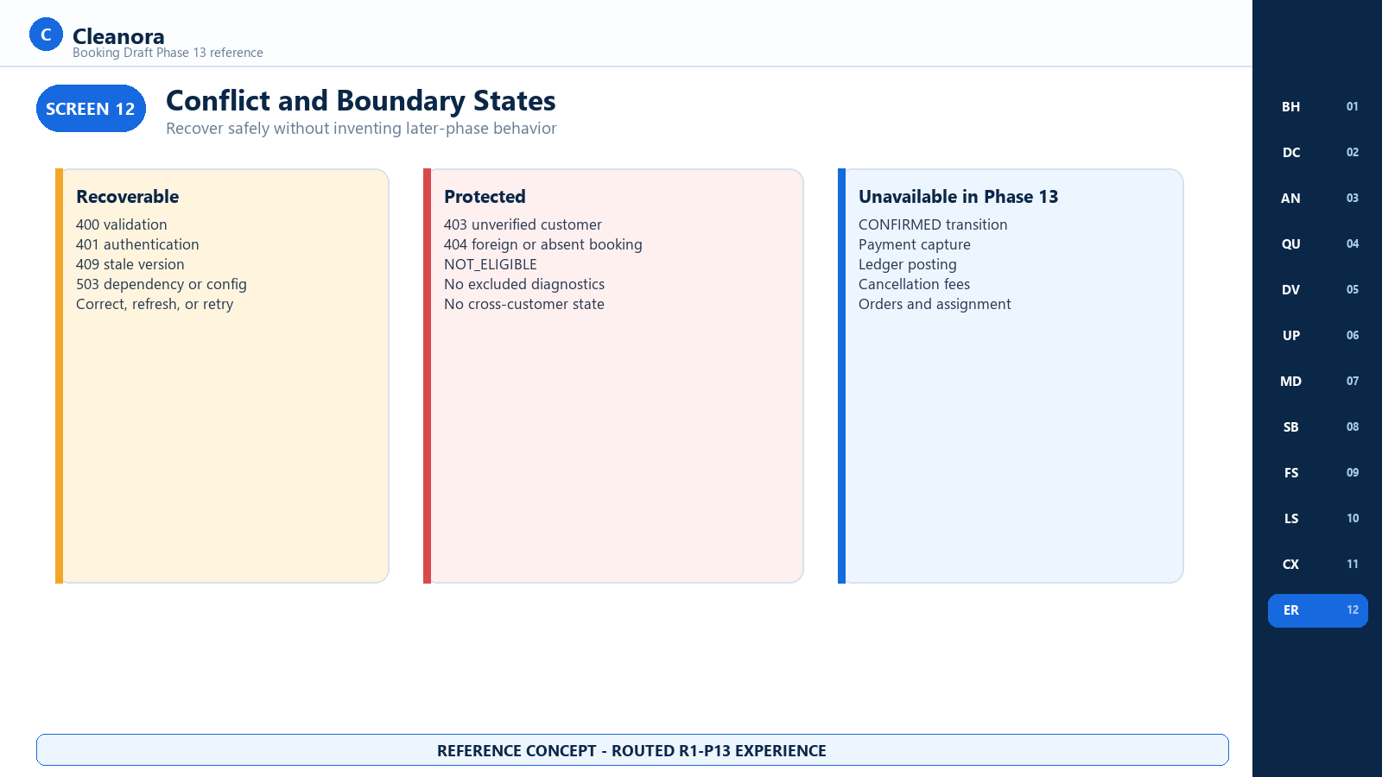
Screen 12 - Conflict and Boundary States - R1-P13 reference concept

Screen 12 Frontend Notes

Frontend Flow on This Screen
- Map 400 to field correction, 401 to deliberate session recovery, 403 to verified-customer onboarding, and 404 to an absent resource state.
- Map 409 NOT_ELIGIBLE to refreshed Browse selection, CONFLICT to refresh and review, and TRANSITION_NOT_AVAILABLE to a disabled action.
- Map 503 dependency or deposit configuration failure to bounded retry without fabricating current state.
- Keep payment, ledger, CONFIRMED, cancellation fees, orders, assignment, and emergency actions absent from the UI.

Contracts Used on This Screen
Typed Error and Recovery Reference; all Contracts 01 through 07.

States and Recovery
Every failure uses the shared failure envelope with a stable code, statusCode, safe message, optional details, and requestId. State-changing failures leave the previous aggregate unchanged.

Security and Privacy Rules
Never show stack traces, private dependency DTOs, rejected eligibility diagnostics, idempotency hashes, HMAC subjects, or another customer's existence.

Boundary and Non Deliverables
Boundary: CONFIRMED remains documented but not executable until the later verified payment event. emergencySignaled stays false and has no Phase 13 panic HTTP.

HTTP CONTRACTS

HTTP Operation Reference
Section purpose: Each implemented Phase 13 booking operation is documented once in full. Examples are synthetic and representative; IDs, request IDs, media URLs, timestamps, and cursor values are placeholders rather than production data.

Contract 01 Create Booking Draft
Attribute | Value
Method and path | POST /api/v1/bookings
Purpose | Create one browse-path DRAFT with a server quote
Access | Verified Individual, Company, or Engineer customer
Headers | Authorization Bearer token; Idempotency-Key required
Success | 201 BookingData
Rate limit | 30 requests per 60 seconds by privacy-HMAC IP subject
Side effects | Booking aggregate, address copy, quote, initial history, command record

Required Request Fields
Field | Type | Rule
serviceId providerId teamId | string | Exact selected Browse identities
countryId cityId districtId | string | District optional; textual locality only
startsAt endsAt | date-time | Exact instants; end after start
crewPreference | enum | all_male, all_female, or any
requiredTeamUnits | integer | 1 through 50
locale | enum | AR or EN
userAddressId | string | Owned Customers address
notes | string | Optional; maximum 2000 characters
answers | array | Optional; maximum 50 fieldId and value objects

Request example
POST /api/v1/bookings
Authorization: Bearer <access-token>
Idempotency-Key: 01J7P13CREATE000000000001
Content-Type: application/json
{
"serviceId": "svc_home_cleaning",
"providerId": "prv_1",
"teamId": "team_1",
"countryId": "ctry_eg",
"cityId": "city_cairo",
"districtId": "dist_nasr",
"startsAt": "2026-09-14T08:00:00.000Z",
"endsAt": "2026-09-14T12:00:00.000Z",
"crewPreference": "any",
"requiredTeamUnits": 1,
"locale": "EN",
"userAddressId": "addr_1"
}

Contract 01 Representative 201 Response
Synthetic response
{
"success": true,
"data": {
"id": "booking_1",
"status": "DRAFT",
"path": "BROWSE",
"version": 1,
"serviceId": "svc_home_cleaning",
"providerId": "prv_1",
"teamId": "team_1",
"countryId": "ctry_eg",
"cityId": "city_cairo",
"districtId": "dist_nasr",
"startsAt": "2026-09-14T08:00:00.000Z",
"endsAt": "2026-09-14T12:00:00.000Z",
"crewPreference": "any",
"requiredTeamUnits": 1,
"locale": "EN",
"emergencySignaled": false,
"quote": {
"gross": "100.00", "deposit": "25.00", "remainder": "75.00",
"currencyCode": "EGP", "depositPercent": "25.00",
"formulaVersion": "r1-p13-v1"
},
"snapshot": null, "priceBreakdown": null, "snapshotFrozen": false,
"createdAt": "2026-09-12T07:00:00.000Z",
"submittedAt": null, "cancelledAt": null
},
"requestId": "7ebf45ad-7384-41ab-8e74-e864ae048d30"
}

Errors and Frontend Handling
Status | Code | Handling
400 | VALIDATION_FAILED | Correct strict body; never add client totals
401 | AUTHENTICATION_REQUIRED | Sign in or refresh deliberately
403 | FORBIDDEN | Complete supported customer verification
409 | NOT_ELIGIBLE | Return to refreshed eligible Browse results
409 | CONFLICT | Use a new key after changing the request
503 | DEPENDENCY_FAILURE | Retry with bounded backoff
503 | DEPOSIT_PERCENT_UNAVAILABLE | Show quote unavailable; do not assume a value

Contract 02 List Bookings
Attribute | Value
Method and path | GET /api/v1/bookings
Purpose | List the authenticated customer's bookings
Access | Verified customer; self only
Query | cursor optional; limit 1 to 50 default 20; status optional
Success | 200 BookingListData with items and nextCursor
Side effects | None

Query | Type | Required | Rule
cursor | string | No | 1 to 512 characters; opaque
limit | integer | No | 1 to 50; default 20
status | BookingStatus | No | DRAFT, AWAITING_DEPOSIT, CONFIRMED, or CANCELLED

Request example
GET /api/v1/bookings?status=AWAITING_DEPOSIT&limit=20
Authorization: Bearer <access-token>

Representative list response
{
"success": true,
"data": {
"items": [{ "id": "booking_1", "status": "AWAITING_DEPOSIT", "version": 2 }],
"nextCursor": null
},
"requestId": "7ebf45ad-7384-41ab-8e74-e864ae048d30"
}

- Treat items: [] as successful empty state.
- Do not decode, edit, combine, or use nextCursor as authorization.
- CONFIRMED is a legal filter label but Phase 13 provides no transition that creates it.

Contract 03 Get Booking
Attribute | Value
Method and path | GET /api/v1/bookings/{bookingId}
Purpose | Read one owned aggregate including submitted evidence
Access | Verified customer; self only with non-enumerating not-found
Path parameter | bookingId, 1 to 64 characters
Success | 200 BookingData
Side effects | Best-effort signing of current media delivery URLs only

State Dependent Fields
Field | DRAFT | AWAITING_DEPOSIT | CANCELLED
quote | Current server quote | Submitted quote | Historical quote
snapshot | null | Immutable object | Preserved when previously submitted
priceBreakdown | null | Immutable object | Preserved when previously submitted
snapshotFrozen | false | true | Depends on prior state
submittedAt | null | Timestamp | Preserved if submitted
cancelledAt | null | null | Timestamp

Media rule: When delivery signing fails for one attachment, the response omits that delivery URL instead of failing the whole GET. The client should render a placeholder for that item and retain the rest of the booking.

Request Example
GET /api/v1/bookings/booking_1
Authorization: Bearer <access-token>

Contract 03 Submitted Booking Projection
Synthetic abbreviated response; the full DTO also includes item, address, answers, media, and history
{
"success": true,
"data": {
"id": "booking_1",
"status": "AWAITING_DEPOSIT",
"version": 2,
"quote": {
"gross": "100.00", "deposit": "25.00", "remainder": "75.00",
"currencyCode": "EGP", "depositPercent": "25.00",
"formulaVersion": "r1-p13-v1"
},
"snapshot": {
"catalog": { "serviceId": "svc_home_cleaning", "serviceVersion": 3 },
"provider": { "providerId": "prv_1", "providerServiceVersion": 4 },
"frozenAt": "2026-09-12T07:10:00.000Z"
},
"priceBreakdown": {
"gross": "100.00", "deposit": "25.00", "remainder": "75.00",
"currencyCode": "EGP", "decimalPlaces": 2,
"depositPercent": "25.00", "formulaVersion": "r1-p13-v1",
"createdAt": "2026-09-12T07:10:00.000Z"
},
"snapshotFrozen": true,
"submittedAt": "2026-09-12T07:10:00.000Z",
"cancelledAt": null
},
"requestId": "7ebf45ad-7384-41ab-8e74-e864ae048d30"
}

Errors and Frontend Handling
Status | Code | Handling
401 | AUTHENTICATION_REQUIRED | Recover the session deliberately
403 | FORBIDDEN | Complete verified-customer onboarding
404 | NOT_FOUND | Show unavailable without ownership disclosure

Contract 04 Patch Booking Draft
Attribute | Value
Method and path | PATCH /api/v1/bookings/{bookingId}
Purpose | Replace draft notes, answers, or owned address
Access | Verified owning customer; DRAFT only
Idempotency | No Idempotency-Key on PATCH
Concurrency | version required
Success | 200 updated BookingData

Field | Type | Rule
version | integer | Required; minimum 1
notes | string or null | Optional; maximum 2000
userAddressId | string | Optional owned address snapshot replacement
answers | array | Optional replacement set; maximum 50

Request example
PATCH /api/v1/bookings/booking_1
Authorization: Bearer <access-token>
Content-Type: application/json
{
"version": 1,
"notes": "Please call upon arrival.",
"answers": [{ "fieldId": "field_bedrooms", "value": 3 }]
}

Recovery: A 409 CONFLICT means another write already advanced the version. GET current state, show what changed, and let the customer decide whether to reapply the draft edit.

Contract 05 Submit Booking for Deposit
Attribute | Value
Method and path | POST /api/v1/bookings/{bookingId}/submit-for-deposit
Purpose | Validate, freeze, and transition DRAFT to AWAITING_DEPOSIT
Access | Verified owning customer
Headers | Authorization Bearer token; Idempotency-Key required
Body | { version: integer >= 1 }
Success | 200 BookingData with snapshotFrozen true
Rate limit | 30 requests per 60 seconds by privacy-HMAC IP subject

Atomic Server Sequence
Step | Server action | Failure behavior
1 | Validate customer, id, version, idempotency key, and DRAFT source state | Reject without changing booking
2 | Validate required Catalog answers and owned address locality | VALIDATION_FAILED; remain DRAFT
3 | Re-evaluate selected Provider and Team through Eligibility explicit mode | NOT_ELIGIBLE; remain DRAFT
4 | Resolve deposit percent and compute canonical minor-unit breakdown | 503 if configuration or dependency unavailable
5 | Write immutable Catalog Provider and price snapshots | Transaction rollback on failure
6 | Transition to AWAITING_DEPOSIT and append history | Atomic version claim; no partial effects
7 | Store idempotent command response | Same-key replay returns original result

Request example
POST /api/v1/bookings/booking_1/submit-for-deposit
Authorization: Bearer <access-token>
Idempotency-Key: 01J7P13SUBMIT00000000001
Content-Type: application/json
{ "version": 1 }

Contract 05 Representative 200 Response
Synthetic abbreviated response
{
"success": true,
"data": {
"id": "booking_1",
"status": "AWAITING_DEPOSIT",
"version": 2,
"snapshotFrozen": true,
"snapshot": {
"catalog": { "serviceId": "svc_home_cleaning", "serviceVersion": 3 },
"provider": {
"providerId": "prv_1",
"providerServiceId": "provider_service_1",
"providerServiceVersion": 4,
"price": "100.00",
"minimumCharge": "80.00",
"currencyCode": "EGP"
},
"frozenAt": "2026-09-12T07:10:00.000Z"
},
"priceBreakdown": {
"gross": "100.00", "deposit": "25.00", "remainder": "75.00",
"currencyCode": "EGP", "decimalPlaces": 2,
"depositPercent": "25.00", "formulaVersion": "r1-p13-v1",
"createdAt": "2026-09-12T07:10:00.000Z"
},
"submittedAt": "2026-09-12T07:10:00.000Z"
},
"requestId": "7ebf45ad-7384-41ab-8e74-e864ae048d30"
}

Errors and Frontend Handling
Status | Code | Handling
400 | VALIDATION_FAILED | Focus incomplete or invalid answer or locality input
404 | NOT_FOUND | Return to owned bookings
409 | NOT_ELIGIBLE | Refresh Browse selection
409 | CONFLICT | Refresh current version and review
409 | TRANSITION_NOT_AVAILABLE | Disable action; state is not executable
503 | DEPENDENCY_FAILURE | Retry with bounded backoff
503 | DEPOSIT_PERCENT_UNAVAILABLE | Keep DRAFT and show quote unavailable

Contract 06 Cancel Booking
Attribute | Value
Method and path | POST /api/v1/bookings/{bookingId}/cancel
Purpose | Cancel DRAFT or AWAITING_DEPOSIT without fees
Access | Verified owning customer
Headers | Authorization Bearer token; Idempotency-Key required
Body | version plus one closed BookingCancelReason
Success | 200 BookingData with CANCELLED and appended history

Reason code | Frontend meaning
CUSTOMER_CHANGED_MIND | Customer no longer wants this booking
CUSTOMER_WRONG_DETAILS | Customer needs a different service, schedule, crew, or selection
OTHER | Other customer reason; no free-text reason is accepted by this contract

Request example
POST /api/v1/bookings/booking_1/cancel
Authorization: Bearer <access-token>
Idempotency-Key: 01J7P13CANCEL00000000001
Content-Type: application/json
{ "version": 2, "reason": "CUSTOMER_CHANGED_MIND" }

Fee boundary: The response and persistence model contain no cancellation fee amount, percent, deposit forfeiture, refund, or payment reversal. Do not fabricate any of them in the client.

Contract 07 Attach Booking Media
Attribute | Value
Method and path | POST /api/v1/bookings/{bookingId}/media
Purpose | Associate an existing READY booking image with a DRAFT
Access | Verified owning customer
Headers | Authorization Bearer token; Idempotency-Key required
Body | version and mediaId
Limits | Maximum five associated images
Success | 200 updated BookingData

Request example
POST /api/v1/bookings/booking_1/media
Authorization: Bearer <access-token>
Idempotency-Key: 01J7P13MEDIA000000000001
Content-Type: application/json
{ "version": 1, "mediaId": "media_booking_1" }

Validation | Requirement | Frontend recovery
Owner type | BOOKING_ATTACHMENT | Use the booking attachment upload flow
State | READY | Wait for Media processing before association
Kind | image/jpeg, image/png, or image/webp | Reject unsupported local selection
Ownership | Current customer | Do not reuse another account's id
Booking state | DRAFT | Disable attachment after submit or cancel
Cardinality | No more than five | Hide add control at the limit

Transport boundary: This JSON route associates mediaId. It is not a multipart upload endpoint and does not accept image bytes.

TYPED INTEGRATION

Request and Result Type Reference
Section purpose: These tables are the concrete frontend shapes behind the seven operations. The checked-in OpenAPI uses generic object slots for some nested aggregates, so this guide preserves only facts established by the Phase 13 contract and implementation summaries.

CreateBookingRequest
Field | Type | Required | Frontend rule
serviceId providerId teamId | string | Yes | Opaque selected identities
countryId cityId | string | Yes | Booking locality and eligibility context
districtId | string | No | Omit for city-wide context
startsAt endsAt | date-time | Yes | Exact instants; half-open interval
crewPreference | enum | Yes | all_male, all_female, or any
requiredTeamUnits | integer | Yes | 1 through 50
locale | enum | Yes | AR or EN
userAddressId | string | Yes | Owned address id
notes | string | No | Maximum 2000
answers | array | No | Maximum 50 fieldId and value records

Mutation Request Types
Type | Required fields | Optional fields | Idempotency-Key
PatchBookingRequest | version | notes userAddressId answers | No
BookingVersionRequest | version | None | Yes for submit
CancelBookingRequest | version reason | None | Yes
AttachBookingMediaRequest | version mediaId | None | Yes

BookingData
Field group | Fields | Frontend meaning
Identity | id, path, serviceId, providerId, teamId | Opaque booking and selected browse identities
Lifecycle | status, version, createdAt, submittedAt, cancelledAt | Current state and optimistic write version
Context | countryId, cityId, districtId, startsAt, endsAt, locale | Booked textual locality and exact schedule
Crew | crewPreference, requiredTeamUnits | Customer's selected aggregate crew constraint
Content | notes, item, address, answers, media | Draft or historical booking detail
Price | quote, snapshot, priceBreakdown, snapshotFrozen | Current or frozen server-authoritative commercial facts
Evaluation | eligibilityEvaluationId | Nullable audit identity; never a browser authorization token
History | statusHistory | Append-only transition summary
Emergency | emergencySignaled | Always false in Phase 13; no panic HTTP

BookingQuote
Field | Type | Rule
gross | decimal string | Maximum of provider price and minimum charge
deposit | decimal string | Rounded configured percentage of gross
remainder | decimal string | Gross minus deposit
currencyCode | three-letter string | For example EGP
depositPercent | decimal string | Configured country value; Egypt seed 25.00
formulaVersion | r1-p13-v1 | Persist for audit and display diagnostics

Booking Catalog Snapshot
Object | Required public facts | Frontend use
Service | serviceId code version locale countryCode name description | Submitted localized service identity
Category | id code name description | Submitted category label
Price units | id code label displayOrder | Submitted pricing unit labels
Fields | id code kind label helpText required rules options displayOrder | Render historical submitted requirement definition
Media | associationId mediaId contentType width height displayOrder | Historical catalog media metadata

Catalog Field Rules
Kind | Value form | Relevant frozen rules
INFORMATION | No customer value | Label helpText displayOrder
TEXT | string | required textBounds
NUMBER | number | INTEGER or DECIMAL mode and min max
BOOLEAN | boolean | required
SINGLE_SELECT | string | options and selection bounds
MULTI_SELECT | string array | options and selection bounds

Historical rendering: After submit, render snapshot.catalog rather than a fresh Catalog definition when showing what the customer agreed to.

Booking Provider Snapshot
Field group | Fields | Meaning
Provider | providerId | Selected Provider identity
Offering | providerServiceId, providerServiceVersion | Selected offering and immutable version
Catalog link | catalogServiceId, code, version, catalogDefinition | Snapshot-ready service definition
Price | providerServicePriceId, price, minimumCharge, currencyCode | Inputs that produced the submitted gross
Delivery | estimatedDurationMinutes, serviceNote, effectiveAt | Submitted offering facts
Unit | priceUnit id code label | Submitted unit label

Booking Price Breakdown
Field | Type | Invariant
gross deposit remainder | decimal strings | Canonical submitted amounts
currencyCode | string | Same submitted currency
decimalPlaces | integer 0 to 8 | Rounding scale
depositPercent | decimal string | Submitted configuration value
formulaVersion | r1-p13-v1 | Calculation contract
createdAt | date-time | Freeze transaction time

Immutability: The application exposes no update contract and the Phase 13 migration installs database triggers that reject snapshot or price-breakdown rewrites.

STATUS MACHINE

Booking Status and Transition Reference
Status | Phase 13 meaning | Customer actions
DRAFT | Editable booking with a current server quote | PATCH, attach media, submit, cancel, get, list
AWAITING_DEPOSIT | Submitted booking with frozen snapshots | Get, list, cancel
CONFIRMED | Frozen enum label for later verified payment event | No executable Phase 13 transition
CANCELLED | Terminal customer cancellation | Get and list only

Executable Customer Rows
Actor | From | To | Category | Required effect
CUSTOMER | NONE | DRAFT | NORMAL | Create aggregate and initial history
CUSTOMER | DRAFT | AWAITING_DEPOSIT | NORMAL | Freeze snapshots and append history
CUSTOMER | DRAFT | CANCELLED | CANCELLATION | Append reason history; no fee
CUSTOMER | AWAITING_DEPOSIT | CANCELLED | CANCELLATION | Append reason history; preserve snapshot

Documented Non Executable Rows
- SYSTEM AWAITING_DEPOSIT to CONFIRMED belongs to the later verified gateway event and returns TRANSITION_NOT_AVAILABLE in Phase 13.
- Order labels PENDING_FULFILLMENT, ASSIGNED, ON_THE_WAY, IN_PROGRESS, COMPLETED, and FAILED are matrix documentation only; no orders table or order HTTP exists.
- PRIVILEGED_OVERRIDE and EMERGENCY_RELATED categories are documented but blocked. emergencySignaled is a parallel false boolean, not a booking status.

COMMAND INTEGRITY

Idempotency and Optimistic Concurrency
Operation | Idempotency-Key | version | Safe retry rule
Create | Required | No | Reuse key only for the same create body
List | No | No | GET may be repeated
Get | No | No | GET may be repeated
Patch | No | Required | On conflict GET current state before editing again
Submit | Required | Required | Same key and version replays original success
Cancel | Required | Required | Same key and reason replays original success
Attach media | Required | Required | Same key and mediaId replays original success

Conflict Decision Table
Condition | Server result | Frontend response
Same key and same canonical request | Return original result | Adopt response without creating a duplicate
Same key and different request | 409 CONFLICT | Create a new intent and key after user confirmation
Stale version | 409 CONFLICT | GET current booking and reconcile
Illegal source status | 409 TRANSITION_NOT_AVAILABLE or CONFLICT | Disable action and render current state
Submit replay after success | Original AWAITING_DEPOSIT aggregate | Do not freeze or show payment twice

Storage rule: Do not persist full Bearer tokens, raw idempotency keys, signed media URLs, or private request bodies in analytics, crash reports, screenshots, or support logs.

FRONTEND RESILIENCE

Typed Error and Recovery Reference
Section purpose: Every Phase 13 failure uses the shared API envelope with a stable code, numeric statusCode, safe message, optional details, and requestId. Recovery depends on the code and current booking state.

Booking Error Catalog
HTTP | Runtime code | Meaning | Frontend recovery
400 | VALIDATION_FAILED | Path query body or answer is invalid | Preserve safe input; focus issues; correct and retry
401 | AUTHENTICATION_REQUIRED | No acceptable authenticated principal | Refresh once or sign in
403 | FORBIDDEN | Verified supported customer is required | Continue verification; do not retry unchanged
404 | NOT_FOUND | Booking absent or not owned | Return to self-only list
409 | NOT_ELIGIBLE | Selected Provider and Team no longer eligible | Refresh Browse selection
409 | CONFLICT | Idempotency mismatch or stale current state | Refresh or create a distinct user intent
409 | TRANSITION_NOT_AVAILABLE | Status move is not executable | Disable the action and keep current state
503 | DEPENDENCY_FAILURE | Owning dependency failed | Retry with bounded backoff
503 | DEPOSIT_PERCENT_UNAVAILABLE | Country deposit config unavailable | Keep DRAFT and show quote unavailable

Validation details issues
Representative issue entry
{
"path": "answers.0.value",
"code": "custom",
"message": "Booking request validation failed"
}

- Use issue.path to focus a control, but show product-owned localized copy.
- Log requestId and stable code only for correlation.
- State-changing errors must not update the visible aggregate unless a fresh GET confirms new state.

Recovery Matrix by Screen
Screen | Primary failure | Recovery interaction
01 Handoff | 401, 403, NOT_ELIGIBLE | Sign in, verify, or refresh Browse
02 Composer | 400, 409, 503 | Correct, use a new intent, or retry later
03 Answers | 400, stale version | Focus field or refresh booking
04 Quote | 503 deposit configuration | Show unavailable; never substitute amount
05 Detail | 404 | Return to owned list
06 Update | 409 CONFLICT | Reload and reconcile
07 Media | validation or signing gap | Repair media state or render placeholder
08 Submit | validation, eligibility, transition, dependency | Keep DRAFT and route to precise repair
09 Snapshot | media signing gap | Keep frozen facts; retry URL only
10 List | 400 cursor or filter | Clear cursor and request page one
11 Cancel | 409 | Refresh; disable if already terminal
12 Boundary | Unavailable later-phase action | Do not synthesize a request

TRUST BOUNDARY

Security and Privacy Reference
Section purpose: Booking HTTP is authenticated but remains deliberately narrow. The server returns customer-owned booking data, copied address facts, allowed images, current or frozen price data, and safe history without exposing other customers, private Provider operations, workers, or Eligibility diagnostics.

Allowlist and Prohibited Data
Surface | Allowed | Never include
Create body | Selected IDs, locality, interval, crew, units, locale, addressId, notes, answers | customerUserId, roles, verification flags, totals, eligibility diagnostics
Booking response | Owned aggregate, address copy, answers, media, quote, snapshot, history | foreign bookings, private contacts, workers, payout or bank facts
Media | mediaId, displayOrder, best-effort deliveryUrl and expiry | object key, signing secret, storage credential, permanent public URL
Errors | stable code, statusCode, safe message, optional safe details, requestId | stack trace, SQL, dependency DTO, idempotency hash
Logs | requestId, route, stable code, coarse timing | Bearer token, raw key, notes, answers, address, signed URL

Self Only and Non Enumeration
- Every list query is scoped from the authenticated customer principal.
- Every get and mutation resolves an owned booking and returns NOT_FOUND for a foreign id.
- The frontend never sends customerUserId to choose scope and never distinguishes absent from foreign.
- Idempotency keys and versions cannot bypass ownership or customer verification.

Signed Media Handling
- Use deliveryUrl only until urlExpiresAt.
- Refresh by re-reading the booking; do not extend or rewrite the URL.
- Render a placeholder when signing fails for one item and keep the rest of the aggregate usable.
- Avoid analytics, screenshot, or error-report capture of signed URLs.
DATA AND SIDE EFFECTS

Phase 13 Persistence and Mutation
Section purpose: Phase 13 adds booking-owned commercial state and an incremental migration. The tables preserve a customer-owned draft, immutable submitted evidence, append-only history, the persisted transition matrix, and command idempotency without adding a ledger, payment, wallet, order, or cancellation-fee table.

Persistence Matrix
Table | Purpose | Mutation rule
bookings | Commercial header, status, quote amounts, version, timestamps | Create; draft update; atomic transitions
booking_items | Single selected service Provider Team offering | Create once
booking_answers | Canonical Catalog answer values | Replace while DRAFT
booking_addresses | Copied owned textual address | Replace while DRAFT
booking_media | Associated Media ids and display order | Append while DRAFT; max five
booking_snapshots | Catalog and Provider JSON plus hashes | Insert at submit; immutable
booking_price_breakdowns | Gross deposit remainder percent formula | Insert at submit; immutable
booking_status_history | Actor from to reason request and time | Append only
status_transition_rules | Actor from to preconditions effects audit failure | Seeded matrix authority
booking_commands | Customer command key request hash and response | Insert once; replay read

Configuration and Media Additions
Owner | Addition | Contract
Configuration | country_configs commercial.deposit_percent | NUMBER 0 to 100; two decimals maximum; Egypt seed 25
Configuration | app_configs resolution | COUNTRY_REQUIRED; fail closed when missing
Media | MediaOwnerType BOOKING_ATTACHMENT | Customer-owned READY images for a DRAFT

Migration: The phase-owned migration is r1_p13_booking_draft_pricing_snapshot_status_machine. Applied migrations remain immutable.

SCOPE PROTECTION

Absent Page Groups and Phase Boundaries
Capability | Phase 13 status | Expected owner
Ledger accounts and posting | Not implemented | R1-P14
Payment methods gateway webhooks and capture | Not implemented | R1-P15
CONFIRMED transition from money | Documented but non-executable | R1-P15
Cancellation or reschedule fee matrix | No fields or calculations | R1-P16
Worker assignment | Not implemented | R1-P17
Orders and execution statuses | Labels documented; no table or HTTP | Later order phases
Emergency action | Boolean false only; no panic HTTP | Later emergency scope
Recommended path premium maps sockets | Not supported | Future explicit decision
Stored-value wallet | Prohibited | No phase
Docker cloud deployment production migration | Deferred or not authorized | Release 3 and human-approved operations

No invented API: The only Phase 13 booking routes are the seven operations in this guide. A frontend must not add confirm, pay, checkout, refund, assign, emergency, reschedule, or fee-preview requests.

DELIVERY READINESS

Frontend and Integration Delivery Checklist
Section purpose: Use this checklist before calling the Phase 13 booking integration ready. Each item protects a shipped API contract, customer boundary, price invariant, snapshot invariant, status rule, or recovery path.

HTTP and Authentication
- [ ] The adapter uses /api/v1/bookings and only the seven documented operations.
- [ ] Every request sends a current Bearer token and handles 401 deliberately.
- [ ] Verified-customer 403 has a product-owned verification path.
- [ ] Foreign and absent booking ids share the same 404 experience.
- [ ] requestId is available for support without logging tokens or private payloads.

Create and Quote
- [ ] Create sends the exact Browse selection and no customer identity or price total.
- [ ] One Idempotency-Key is reused only for a byte-equivalent create retry.
- [ ] NOT_ELIGIBLE returns the user to refreshed Browse results.
- [ ] gross, deposit, remainder, currency, percent, and formulaVersion come from the response.
- [ ] Missing deposit configuration is unavailable state, never a client 25 percent fallback.

Draft Editing and Media
- [ ] PATCH edits only notes, answers, or userAddressId and always includes version.
- [ ] Service, Provider, Team, schedule, crew, units, locality, and locale are not patched.
- [ ] Catalog field controls preserve required flags, bounds, modes, options, and field ids.
- [ ] Media upload completes before association; only READY customer-owned images are attached.
- [ ] The add-image control stops at five and disables outside DRAFT.

Submit Snapshot and Status
- [ ] Submit sends current version and a distinct Idempotency-Key.
- [ ] Required answer, locality, eligibility, transition, and configuration failures keep DRAFT.
- [ ] AWAITING_DEPOSIT renders snapshotFrozen true and the immutable snapshot and breakdown.
- [ ] Historical submitted content uses snapshot facts instead of refreshed live pricing.
- [ ] CONFIRMED is never offered as a Phase 13 action.

Cancellation and Recovery
- [ ] Cancel is offered only from DRAFT and AWAITING_DEPOSIT.
- [ ] The request uses one of the three closed reason codes and current version.
- [ ] CANCELLED disables further mutation and preserves prior snapshot evidence.
- [ ] No fee, refund, forfeiture, payment, or ledger value appears in the UI.
- [ ] A stale-version 409 triggers GET and user-visible reconciliation.

List Detail and Media Delivery
- [ ] List is self-only, status filtering is exact, and cursor remains opaque.
- [ ] Empty items is success and nextCursor null ends pagination.
- [ ] Detail renders status-dependent null and frozen fields defensively.
- [ ] deliveryUrl expires and is refreshed by re-reading the booking.
- [ ] One media-signing failure does not make the booking unusable.

Errors Security and Boundaries
- [ ] 400, 401, 403, 404, 409, and 503 use the documented recovery matrix.
- [ ] Stable error codes drive behavior; safe product copy drives presentation.
- [ ] Bearer tokens, raw idempotency keys, addresses, notes, answers, signed URLs, and private DTOs are not logged.
- [ ] Eligibility exclusions and Provider operational data never reach the customer UI.
- [ ] Payment, ledger, fees, orders, assignment, emergency, maps, Recommended, Docker, cloud, and production operations remain absent.
REPOSITORY AUTHORITY

Canonical Implementation Sources
Section purpose: Repository-local Phase 13 artifacts and executable source are the authority for this guide. Frontend code should depend on the checked-in OpenAPI and runtime response behavior rather than inferred future-phase contracts.

Area | Canonical source
Current phase pointer | docs/product/current.md
Phase specification | specs/R1-P13-booking-draft-pricing-snapshot-status-machine/spec.md
HTTP contract | specs/R1-P13-booking-draft-pricing-snapshot-status-machine/contracts/http-api.md
Data model | specs/R1-P13-booking-draft-pricing-snapshot-status-machine/data-model.md
Completion evidence | specs/R1-P13-booking-draft-pricing-snapshot-status-machine/completion-report.md
Implementation summary | specs/R1-P13-booking-draft-pricing-snapshot-status-machine/implementation-summary.md
OpenAPI | docs/apis/openapi/r1-p13-booking-draft.yaml
Postman | postman/Cleanora-R1-P13-Booking-Draft.postman_collection.json
Routing and rate limits | src/modules/bookings/bookings.command.routes.ts
HTTP handlers | src/modules/bookings/bookings.command.controller.ts
Boundary validation | src/modules/bookings/bookings.command.schema.ts
Application workflows | src/modules/bookings/bookings.command.service.ts
Public booking types | src/modules/bookings/bookings.command.types.ts
Persistence | src/modules/bookings/infrastructure/prisma-bookings.repository.ts
Migration | prisma/migrations/r1_p13_booking_draft_pricing_snapshot_status_machine/migration.sql

Authority order: Resolve a discrepancy against the completed Phase 13 specification, public HTTP contract, checked-in OpenAPI, and executable runtime together. Do not silently choose a future Phase 14 or Phase 15 behavior.

VERIFICATION AND HANDOFF

Implementation Alignment Notes
# | Observation | Frontend safe action | Evidence
A1 | OpenAPI paths are relative to /api/v1 while runtime examples use the full prefix | Configure one /api/v1 base and append /bookings paths once | OpenAPI servers and command routes
A2 | Idempotency is required on four POST commands but not on PATCH | Use per-command keys exactly as the operation cards specify | HTTP contract and controller
A3 | version is required on PATCH submit cancel and media | Store and replace the returned version with every successful mutation | OpenAPI request schemas
A4 | CONFIRMED is an enum and status filter but not executable | Render it defensively but never offer a Phase 13 confirm action | Spec EX-01 and status matrix
A5 | A DRAFT quote and frozen priceBreakdown have related but different roles | Use quote for current draft display and priceBreakdown after submit | BookingData and snapshot contract
A6 | Media association is JSON after Media-owned preparation | Upload through Media first; then post mediaId to the booking | AttachBookingMediaRequest
A7 | Postman contains 9 requests in each Local and Hosted group | Use 18 examples for parity while recognizing only 7 unique operations | Postman validation evidence

Phase status: R1-P13 is Complete under DEC-093 with fresh Codex re-review PASS and zero unresolved BLOCKER, MAJOR, or MINOR findings. Publication, merge, deployment, and production migration remain separate human-controlled actions.

QUALITY RECORD

Verification Record
This record separates repository implementation evidence from document-generation verification. It does not claim deployment or production readiness.

Repository Phase Evidence
Gate | Recorded result
Phase status | Complete under DEC-093
Phase tests | PASS - 15 files and 118 tests
Phase coverage | PASS - 91.64 statements, 82.76 branches, 97.15 functions, 91.60 lines
Typecheck and build | PASS
Repository lint | PASS
Prisma validation | PASS
OpenAPI and Postman | PASS; 9 Phase 13 requests per environment
Documentation checks | PASS
Live migration proofs | PASS clean install and populated P12 to P13 upgrade
Module boundaries | PASS
Final re-review | PASS; no unresolved findings

Document Build Verification
Check | Result
Template source | Phase 12 DOCX copied; reference SHA-256 verified unchanged
Page geometry and header footer | Preserved from Phase 12; live PAGE field retained
HTTP operation inventory | 7 unique Phase 13 operations
Postman request inventory | 18 requests: 9 Local and 9 Hosted
Screen number scan | 01 through 12 unique and sequential
Flow number scan | 01 through 07 unique and sequential
Image alternative text | 20 meaningful descriptions required and audited
Repeated table headers | Applied to every table
Latest render page count | 72
Latest document word count | 8983
Latest document table count | 134
Full-page PNG inspection | Required before delivery

Release note: This guide is a frontend and integration reference for the completed Phase 13 implementation. It is not merge approval, deployment approval, production migration authorization, or proof that a production frontend has shipped.

