CLEANORA FRONTEND HANDOFF

R1-P11 Eligibility Engine V1
Frontend Readiness Reference Screens and In Process Integration Guide
Prepared for Bassam: Implementation-grade English handoff for the completed internal Eligibility domain, its diagnostic and Browse-safe contracts, the R1-P11 to R1-P12 ownership boundary, and the evidence needed by frontend, integration, backend, QA, and product reviewers.

0  new HTTP operations | 3  public in-process methods | 10  reference screens | 6  workflow diagrams
Release 1 - Phase 11 | 9 September 2026
Real routed R1-P11 frontend screens: 0

GUIDE NAVIGATION

Guide Map
Recommended reading order: Read the Integration Foundation and six flows first. Use the numbered screen concepts for implementation discussion, then use each full contract card and the type, rule, error, persistence, and security references while coding and testing.

Consumer and Visual Inventory
# | Consumer context | Reference screen | Route status | Contract link
01 | Internal Eligibility consumer and composition | Eligibility Integration Overview | No routed P11 page | CONTRACT 01 and CONTRACT 02
02 | Internal consumer request construction | Eligibility Request Composer | No routed P11 page | CONTRACT 01 accepts discovery and explicit inputs. CONTRACT 02 accepts discovery-shaped input only.
03 | Composition, dependency readers, and transaction boundary | Evaluation Processing and Consistent Snapshot | No routed P11 page | CONTRACT 01 and CONTRACT 02 share this evaluator path. CONTRACT 03 also uses the Eligibility unit of work with one captured cutoff.
04 | Approved internal diagnostic consumer | Eligibility Evaluation Summary | No routed P11 page | CONTRACT 01 returns DiagnosticResult. CONTRACT 02 intentionally removes the excluded portions shown here.
05 | Internal diagnostics and QA | Provider Rule Outcome Detail | No routed P11 page | CONTRACT 01 only. See Rule and Reason Reference for the closed catalogs.
06 | Eligibility policy, integration, and QA | Team Crew Preference and Capacity Detail | No routed P11 page | CONTRACT 01 evaluates and returns TeamResult rows. CONTRACT 02 emits only eligible Team candidates.
07 | Browse-safe projection consumer and R1-P12 handoff | Browse Safe Candidate Projection | No routed P11 page | CONTRACT 02. CONTRACT 01 is an internal diagnostic path and is not a browser substitute.
08 | Eligibility policy inspection and engineering operations | Rule Version and Policy Details | No routed P11 page | CONTRACT 01 and CONTRACT 02 select the rule version during evaluation. No public method mutates it.
09 | Determinism, replay analysis, and QA | Evidence and Deterministic Hash Trace | No routed P11 page | CONTRACT 01 returns all three hashes. CONTRACT 02 carries the same safe hash values in metadata.
10 | Application operations and retention | Evaluation Retention and Purge Operations | No routed P11 page | CONTRACT 03 is the operations method. CONTRACT 01 and CONTRACT 02 create the retained evaluation trees.

Flow Diagram Inventory
# | Flow | Primary use
01 | Complete R1-P11 Eligibility Lifecycle | Shows the complete internal lifecycle from trusted request through validation, rule selection, candidate acquisition, dependency facts, fixed rules, atomic persistence, and diagnostic or Browse-safe output.
02 | Fixed Rule Evaluation Order | Locks the nine public EligibilityRuleId values in presentation order and shows that an earlier business FAIL does not automatically suppress later independently readable rules.
03 | Rule Outcomes and Dependency Propagation | Separates PASS, FAIL, NOT_APPLICABLE, and NOT_EVALUATED, including independent multi-failure collection, dependency blocking, business exclusion, and whole-operation technical failure.
04 | Provider Team Crew Escort and Capacity Algebra | Explains how Team structure, full-interval availability, cleaner-only preference, optional Escort aggregates, post-filter capacity, Provider eligibility, and Team eligibility combine.
05 | Transaction Retry Hashing and Persistence | Shows one captured evaluatedAt across at most three RepeatableRead attempts, canonical hashing, atomic inserts, conflict handling, and 720-hour expiration.
06 | Phase 11 to Phase 12 Boundary | Makes the ownership handoff explicit: R1-P11 returns an in-process Browse-safe projection; R1-P12 will own HTTP, browser integration, ranking, and pagination.

Public Method Inventory
Contract | Public method | Transport | Primary consumer
01 | evaluateEligibility | In-process | Approved internal diagnostic consumer
02 | getStandardBrowseCandidates | In-process | R1-P12 application consumer
03 | purgeExpiredEvaluations | In-process | Application operations

INTEGRATION FOUNDATION

Integration Foundation
Section purpose: R1-P11 is a backend module contract. A browser cannot import or invoke the service directly. Composition creates the service and supplies transaction-bound readers; R1-P12 will later mount the public marketplace HTTP and frontend surface.

Authoritative Boundary
Critical integration rule: R1-P11 has no browser-callable endpoint. P12 will define the HTTP and browser integration.

- The Phase 11 public surface is EligibilityApplicationService in src/modules/eligibility/eligibility.public.ts.
- Composition constructs one service instance and supplies the Eligibility unit of work plus bound Catalog, Configuration, Providers, and optional performance readers.
- Caller-supplied role strings, Provider IDs, or evaluation IDs are data, not authentication.
- Provider setup readiness eligibleForPublicBrowse remains a placeholder and is not an Eligibility rule or runtime filter.
- P12 owns authentication, authorization, HTTP transport, marketplace ranking, pagination, and browser behavior.

Diagnostic Result and Browse Safe Projection
Concern | DiagnosticResult | BrowseSafeProjection
Eligible Provider and Team rows | Yes | Eligible Team candidates only
Excluded rows and reason codes | Yes | No
Rule outcomes | Yes | No rejected diagnostics
Sorting facts | Eligible rows | Required on every candidate
Metadata | Full EvaluationMetadata | Explicit safe subset
Worker or member identity | Never | Never

Success and Technical Error Shapes
In-process TypeScript shapes - not HTTP envelopes
type Success = DiagnosticResult | BrowseSafeProjection | PurgeResult;
interface EligibilityError extends Error {
readonly code: EligibilityErrorCode;
readonly details?: Readonly<Record<string, unknown>>;
}

Business exclusions are values inside a successful DiagnosticResult. Technical failures reject the Promise with the EligibilityError shape. Consumers must not convert Provider or Team exclusions into transport-style failures.

Snapshot Determinism and Retention
- Capture evaluatedAt once before the retry loop and reuse it through each attempt.
- Use one RepeatableRead transaction for rule selection, discovery or explicit IDs, dependency reads, evaluation, and successful persistence.
- Compute requestHash, evidenceHash, and resultHash from canonical JSON according to the frozen contract; compare results only when evaluatedAt and pinned facts match.
- Retain successful evaluation trees for 720 elapsed hours, then purge in bounded batches ordered by expiresAt and id.
Implementation alignment: The canonical phase status is Complete. A documentation-time source inspection found contract-alignment risks in runtime geo rejection, Provider conflict retry recognition, resultHash inputs, stored completion time, source-version population, verification projection wiring, and pause-clock use. The Verification Record states them precisely so P12 engineers do not code against an assumption.

ARCHITECTURE AND BEHAVIOR

Complete Screen and Consumer Flows
Section purpose: The six diagrams summarize the contract from the in-process trust boundary through rule outcomes, algebra, persistence, and the P12 handoff. They are reference flows, not routed pages.

Flow 01 Complete R1-P11 Eligibility Lifecycle
Shows the complete internal lifecycle from trusted request through validation, rule selection, candidate acquisition, dependency facts, fixed rules, atomic persistence, and diagnostic or Browse-safe output.
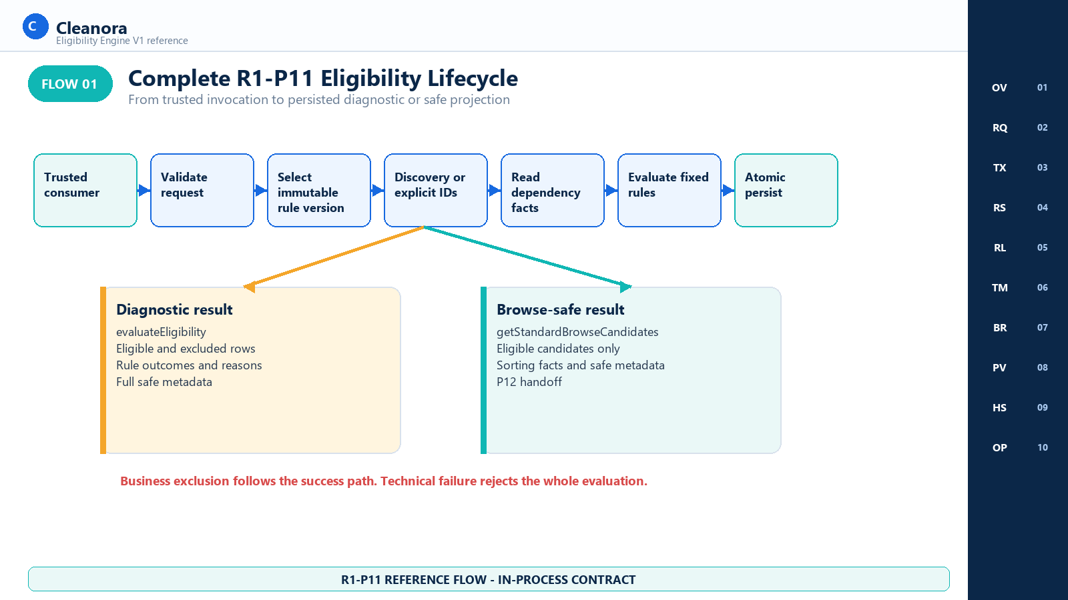
Flow 01 - Complete R1-P11 Eligibility Lifecycle
Implementation reading: Use this flow to choose the right public method and keep diagnostic and Browse-safe consumers separate.

Authority represented: eligibility.public.ts; eligibility.service.ts; browse-consumer-contract.md

Flow 02 Fixed Rule Evaluation Order
Locks the nine public EligibilityRuleId values in presentation order and shows that an earlier business FAIL does not automatically suppress later independently readable rules.
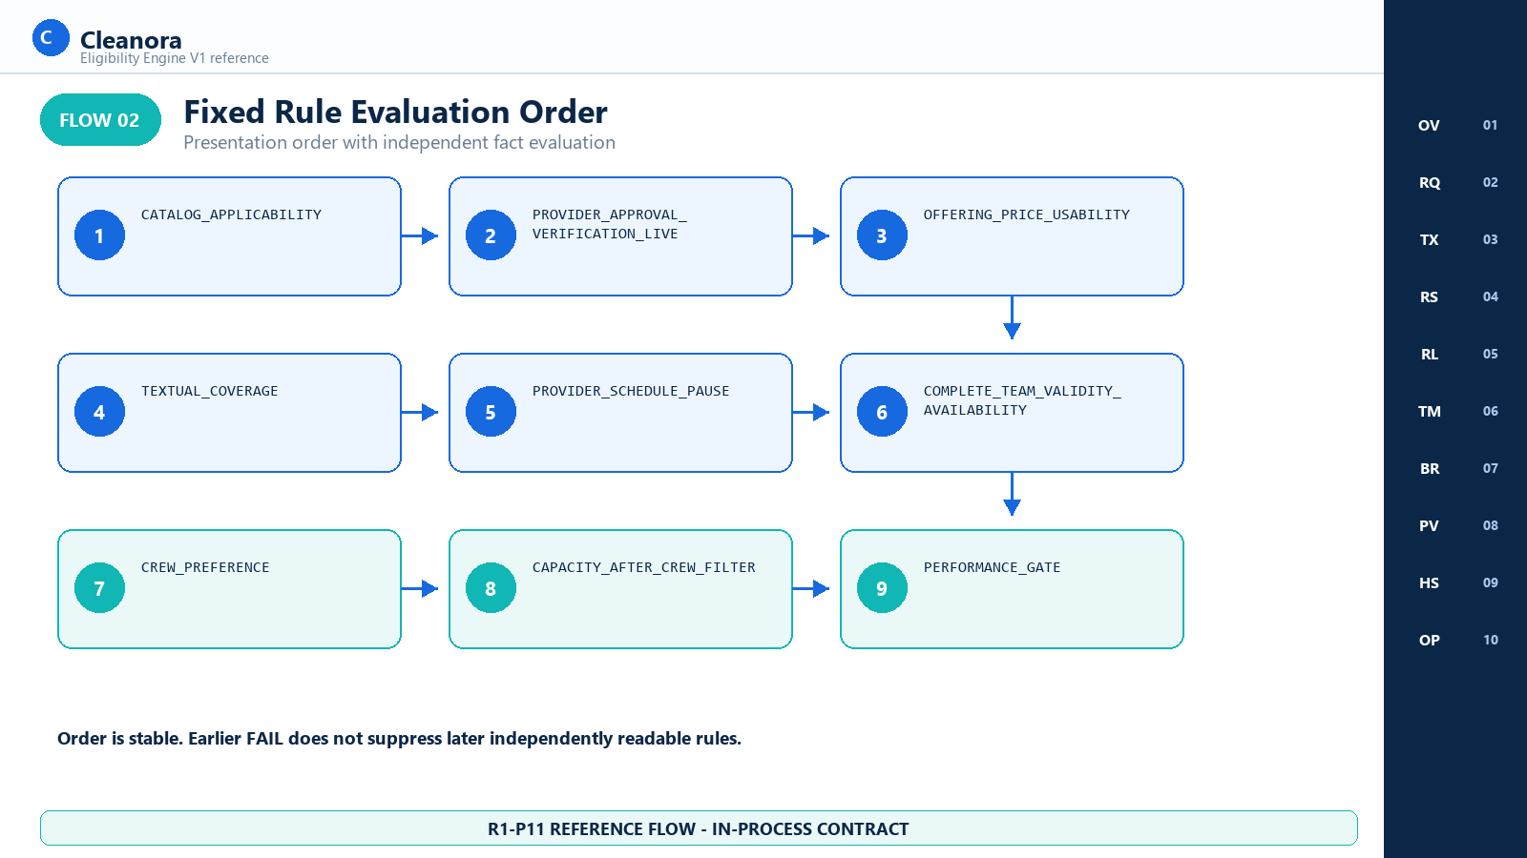
Flow 02 - Fixed Rule Evaluation Order
Implementation reading: The numeric order is both evaluation and presentation order; independence depends on readable facts, not on the prior row being PASS.

Authority represented: eligibility.reasons.ts; eligibility.rules.ts; reason-codes.md

Flow 03 Rule Outcomes and Dependency Propagation
Separates PASS, FAIL, NOT_APPLICABLE, and NOT_EVALUATED, including independent multi-failure collection, dependency blocking, business exclusion, and whole-operation technical failure.
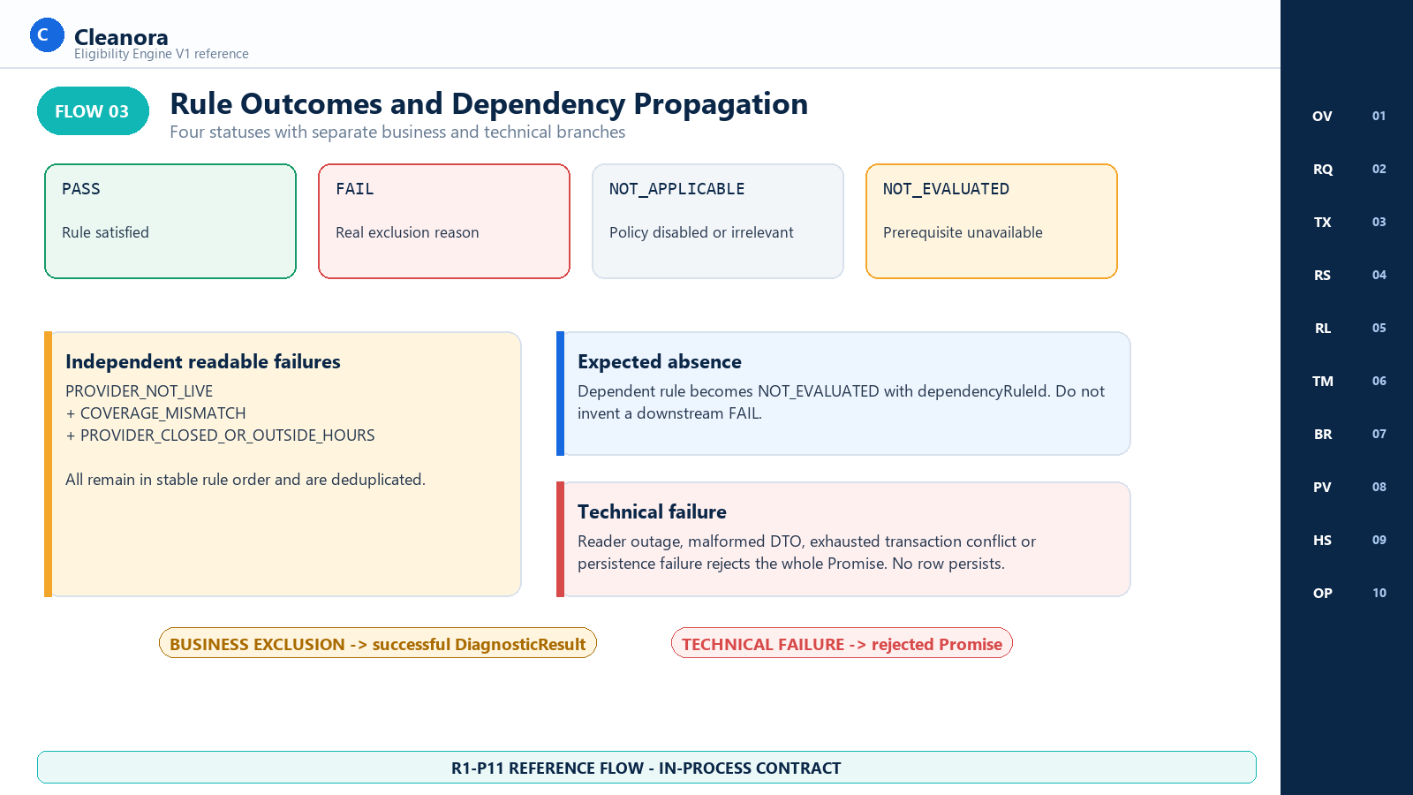
Flow 03 - Rule Outcomes and Dependency Propagation
Implementation reading: Only real exclusion reasons decide candidate rejection. Informational performance evidence states remain visible diagnostically but do not exclude.

Authority represented: eligibility.rules.ts; eligibility.performance.ts; reason-codes.md

Flow 04 Provider Team Crew Escort and Capacity Algebra
Explains how Team structure, full-interval availability, cleaner-only preference, optional Escort aggregates, post-filter capacity, Provider eligibility, and Team eligibility combine.
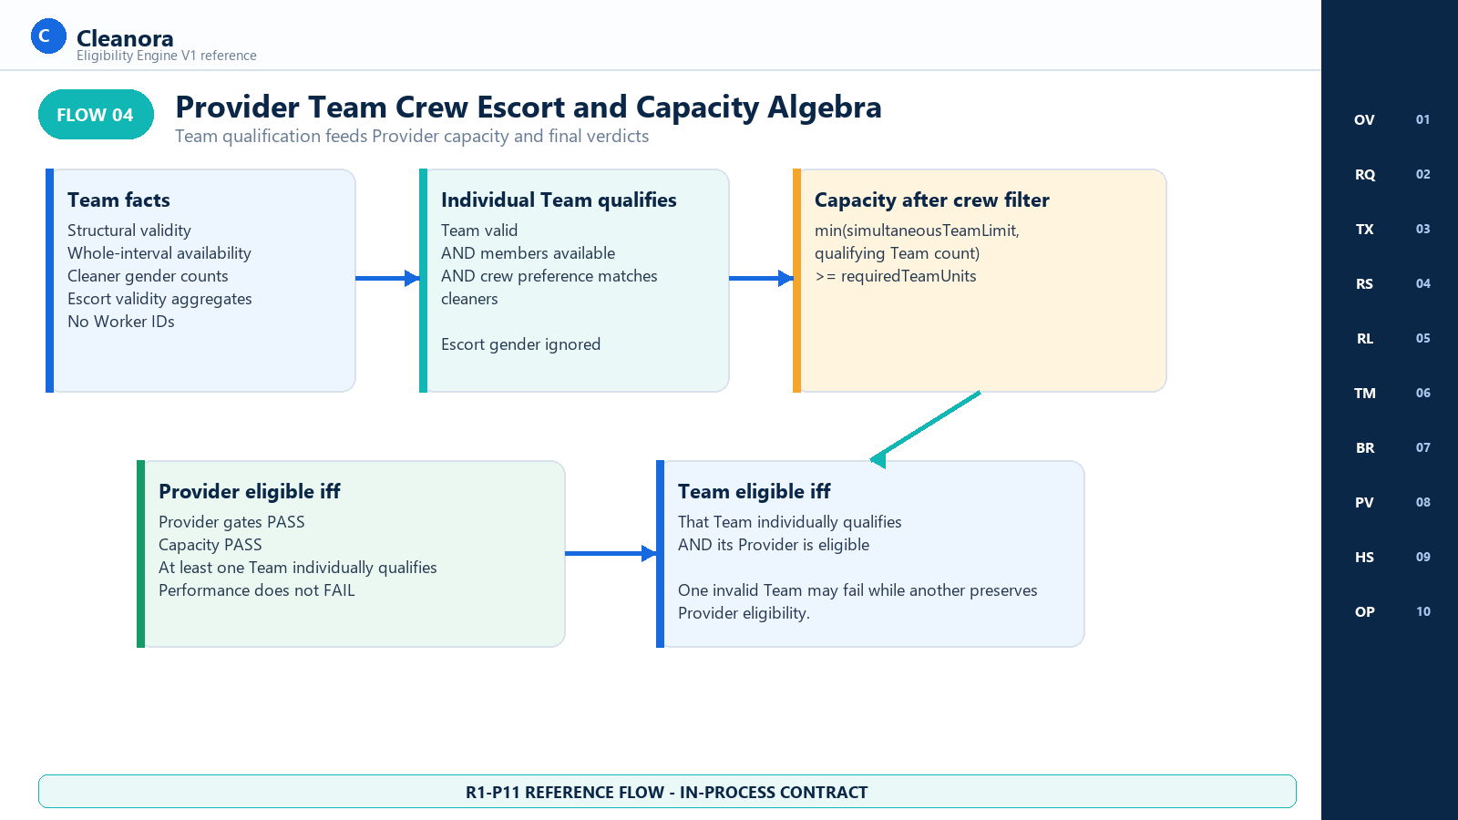
Flow 04 - Provider Team Crew Escort and Capacity Algebra
Implementation reading: Provider eligibility and Team eligibility are related predicates. An eligible Provider needs sufficient post-filter capacity and at least one individually qualifying Team.

Authority represented: eligibility.crew-capacity.ts; eligibility.rules.ts; providers.public.ts

Flow 05 Transaction Retry Hashing and Persistence
Shows one captured evaluatedAt across at most three RepeatableRead attempts, canonical hashing, atomic inserts, conflict handling, and 720-hour expiration.
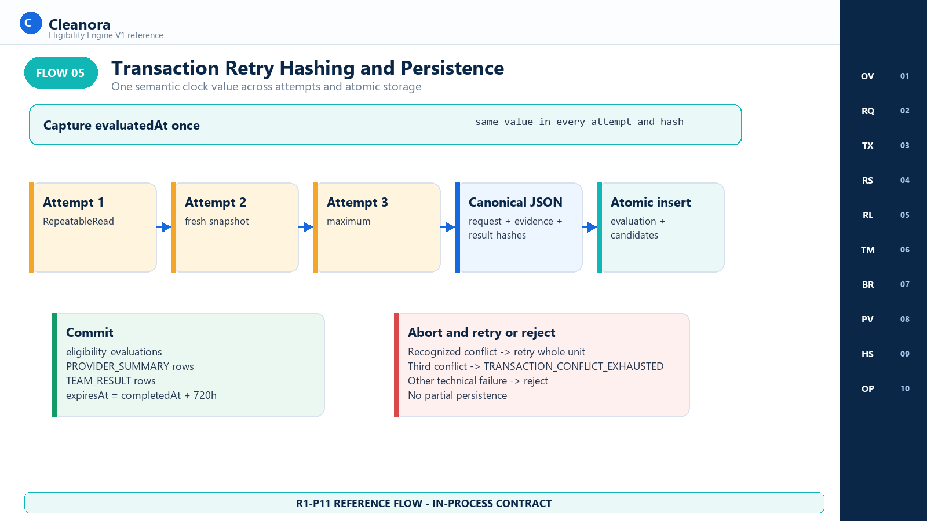
Flow 05 - Transaction Retry Hashing and Persistence
Implementation reading: The service returns one atomic success tree or a rejected Promise. Failed-attempt evidence is not merged into a later attempt.

Authority represented: eligibility.service.ts; eligibility.hashes.ts; eligibility.unit-of-work.ts; prisma-eligibility.repository.ts

Flow 06 Phase 11 to Phase 12 Boundary
Makes the ownership handoff explicit: R1-P11 returns an in-process Browse-safe projection; R1-P12 will own HTTP, browser integration, ranking, and pagination.
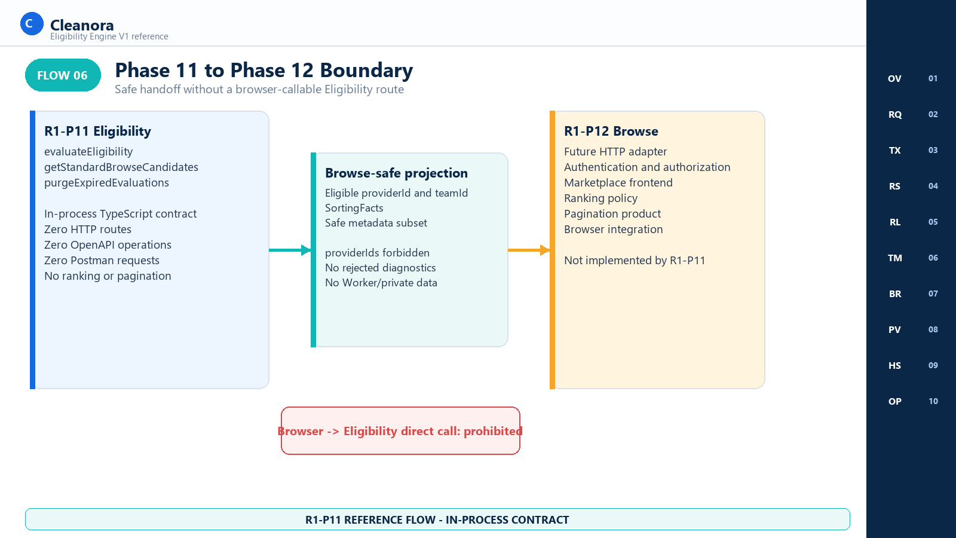
Flow 06 - Phase 11 to Phase 12 Boundary
Implementation reading: P12 may call the in-process facade from its own server-side adapter; it must not expose DiagnosticResult or create a browser-to-module shortcut.

Authority represented: browse-consumer-contract.md; http-api.md; docs/apis/README.md
CONSUMER CONTEXTS

Pages by Consumer Context
Section purpose: The following groupings replace the role-based page taxonomy used by endpoint-driven phases. Phase 11 has trusted application consumers, a future Browse-safe consumer, and an operations consumer, but no end-user actor pages.

PAGES BY CONSUMER

Internal Eligibility Consumer and Composition
Reference coverage: Screens 01 through 06, 08, and 09

- Runs only through composition-wired application code.
- May receive DiagnosticResult for diagnosis, testing, or approved internal orchestration.
- Must preserve the distinction between business exclusions and technical failures.
- Must not expose diagnostic or evidence payloads to a browser.

PAGES BY CONSUMER

Browse Safe Projection Consumer R1 P12 Handoff
Reference coverage: Screen 07

- Calls getStandardBrowseCandidates server-side.
- Uses the same evaluator and does not repeat eligibility filters.
- Receives eligible identities, SortingFacts, and a safe metadata subset.
- Owns future HTTP, authentication, authorization, ranking, pagination, and browser rendering in R1-P12.

PAGES BY CONSUMER

Application Operations and Retention
Reference coverage: Screen 10

- Calls purgeExpiredEvaluations from an application or operations boundary.
- Uses a composition clock cutoff, not a caller-supplied asOf.
- Deletes only expired evaluation trees in batches of 1 through 500.
- Never deletes immutable rule versions or unrelated product data.

BOUNDARY

Absent R1 P11 User Facing Page Groups
Reference coverage: No screens

- No Customer or anonymous Browse page.
- No Provider eligibility settings page.
- No Staff eligibility administration or rule editor.
- No public eligibility history, ranking, pagination, booking, payment, wallet, payout, coordinate, or radius feature.
REFERENCE SCREENS

Eligibility Integration Reference Screens
Section purpose: Every numbered visual below is a documentation concept. Each carries the visible label REFERENCE CONCEPT - NOT A ROUTED R1-P11 PAGE and exists to help engineering teams discuss the in-process contract without inventing a product route.

Screen 01 Eligibility Integration Overview
Consumer context | Route status | Screen purpose
Internal Eligibility consumer and composition | No routed P11 page | Orient engineers to the trusted caller, evaluator, diagnostic output, Browse-safe projection, and persistence boundary.

Visual authority: This image is an implementation handoff aid. Exact behavior comes from the public TypeScript contract and executable source; the screen does not create a route, permission, actor, or product page.

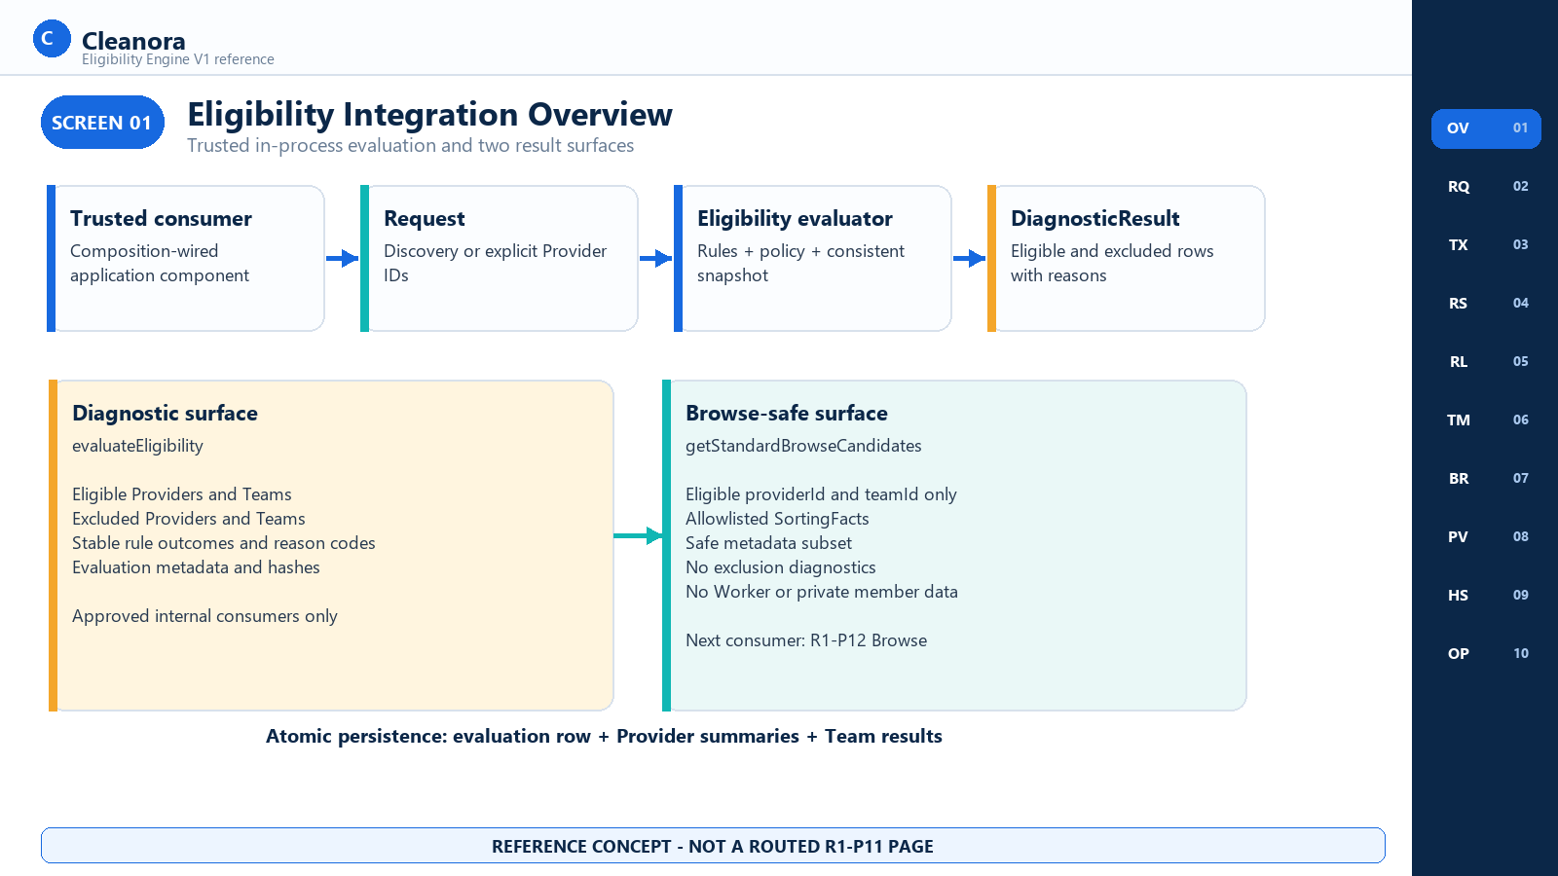
Screen 01 - Eligibility Integration Overview - reference concept only

Screen 01 Consumer Notes

Frontend and Consumer Flow on This Screen
- Receive a request through a composition-wired application component.
- Choose evaluateEligibility for diagnostics or getStandardBrowseCandidates for the safe facade.
- Treat business exclusions as successful diagnostic data; treat typed technical errors as whole-operation failures.
- Persist each successful application evaluation atomically.

Contracts Used on This Screen
CONTRACT 01 and CONTRACT 02; persistence behavior links to CONTRACT 03 only for later retention.

States and Outcomes
DiagnosticResult contains eligible and excluded Provider/Team rows. BrowseSafeProjection contains eligible Team candidates only. Both carry deterministic metadata.

Security and Privacy Rules
The browser is outside this trust boundary. No role string, Provider ID, evaluation ID, or hidden route authenticates a caller.

Boundary and Non Deliverables
Boundary: Zero routed R1-P11 pages and zero Eligibility HTTP operations. P12 owns future browser integration.

Screen 02 Eligibility Request Composer
Consumer context | Route status | Screen purpose
Internal consumer request construction | No routed P11 page | Show exact discovery, explicit, and Browse facade request shapes before a consumer integrates.

Visual authority: This image is an implementation handoff aid. Exact behavior comes from the public TypeScript contract and executable source; the screen does not create a route, permission, actor, or product page.

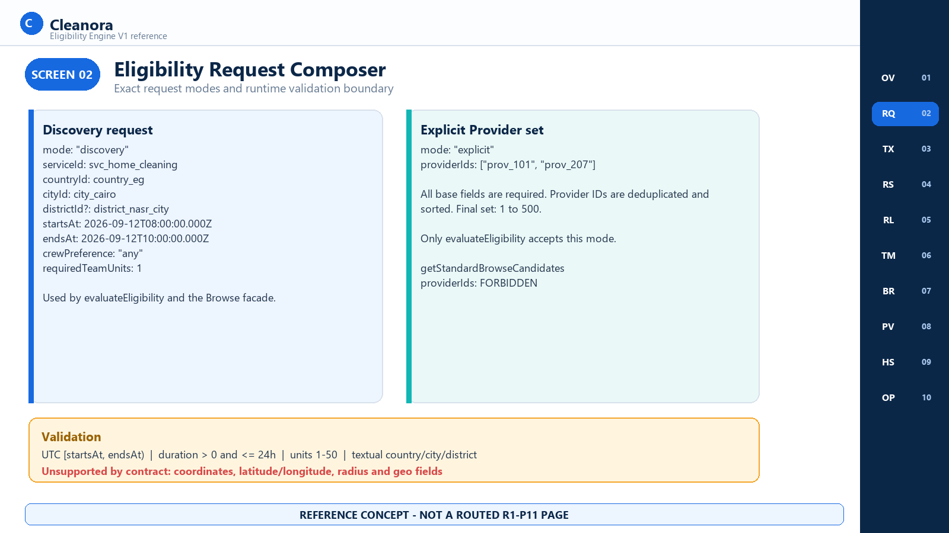
Screen 02 - Eligibility Request Composer - reference concept only

Screen 02 Consumer Notes

Frontend and Consumer Flow on This Screen
- Supply serviceId, countryId, cityId, optional districtId, UTC startsAt and endsAt, crewPreference, and requiredTeamUnits.
- Use mode discovery for textual candidate discovery.
- Use mode explicit plus 1-500 unique Provider IDs only with evaluateEligibility.
- Never send providerIds to getStandardBrowseCandidates.

Contracts Used on This Screen
CONTRACT 01 accepts discovery and explicit inputs. CONTRACT 02 accepts discovery-shaped input only.

States and Outcomes
crewPreference is all_male, all_female, or any. requiredTeamUnits is an integer from 1 through 50. Duration must be greater than zero and at most 24 elapsed hours.

Security and Privacy Rules
The request contains stable identifiers and no customer identity, contact details, raw addresses, Worker IDs, or credentials.

Boundary and Non Deliverables
Boundary: Coordinates, radius, and other geographic search fields are outside the contract. See the Implementation Alignment Notes for current runtime-rejection coverage.

Screen 03 Evaluation Processing and Consistent Snapshot
Consumer context | Route status | Screen purpose
Composition, dependency readers, and transaction boundary | No routed P11 page | Explain the one-clock, one-snapshot, bounded retry model used by the application service.

Visual authority: This image is an implementation handoff aid. Exact behavior comes from the public TypeScript contract and executable source; the screen does not create a route, permission, actor, or product page.

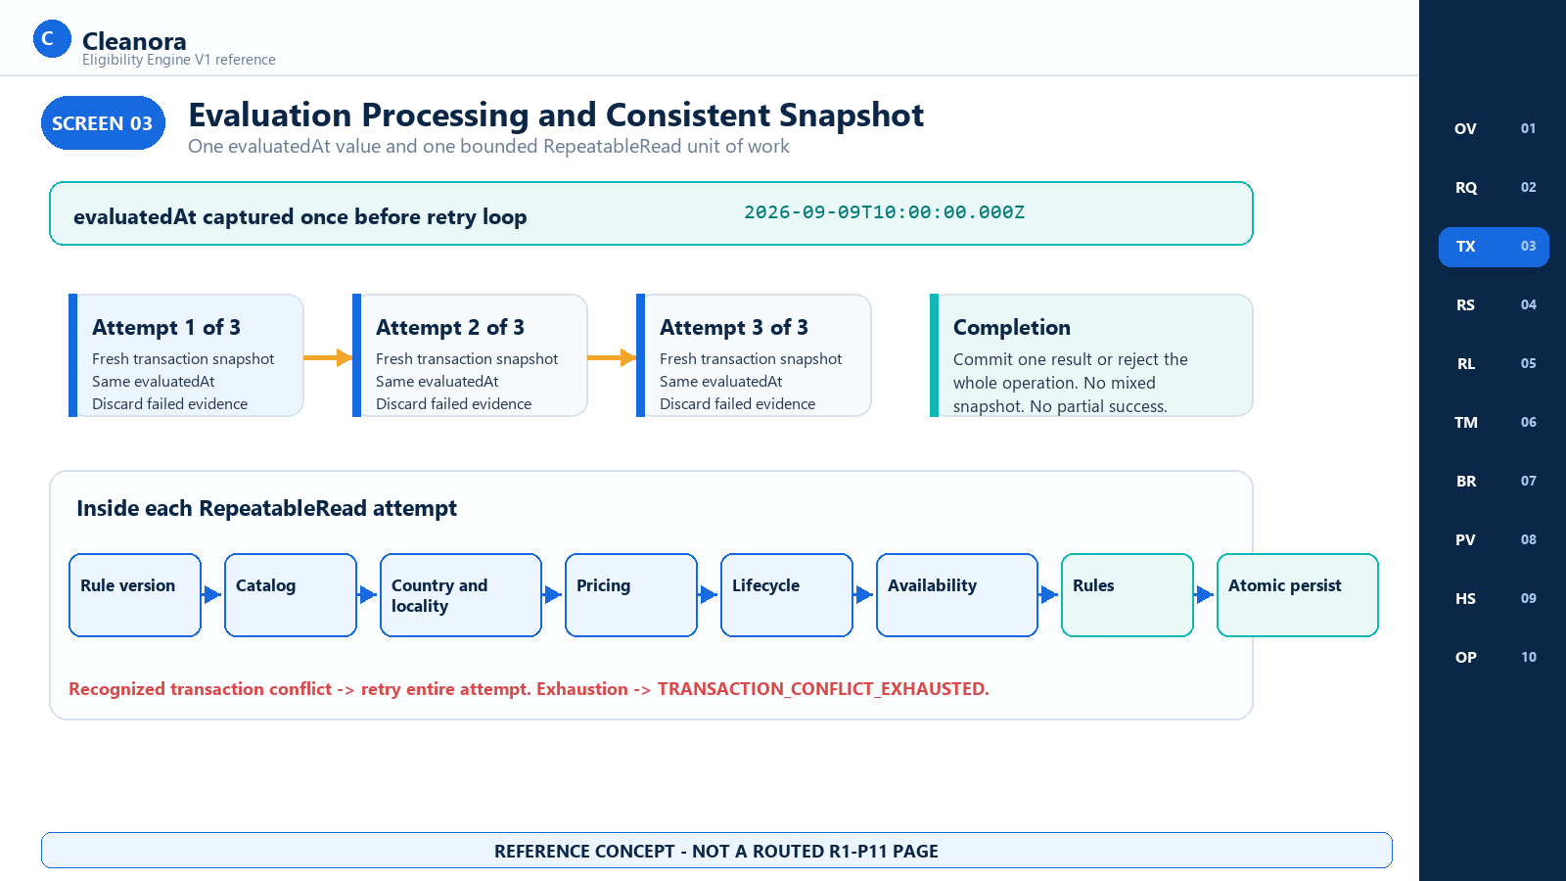
Screen 03 - Evaluation Processing and Consistent Snapshot - reference concept only

Screen 03 Consumer Notes

Frontend and Consumer Flow on This Screen
- Capture evaluatedAt once before any attempt.
- Open one Eligibility-owned RepeatableRead transaction per attempt.
- Bind Catalog, Configuration, Providers, and Eligibility persistence to the same transaction.
- Retry the entire unit for a recognized conflict, at most three total attempts; discard evidence from failed attempts.

Contracts Used on This Screen
CONTRACT 01 and CONTRACT 02 share this evaluator path. CONTRACT 03 also uses the Eligibility unit of work with one captured cutoff.

States and Outcomes
Successful completion commits one evaluation tree. Technical failure aborts; there is no mixed-snapshot candidate list or partial success response.

Security and Privacy Rules
Readers return narrow DTOs. Eligibility never imports another module's private repository or Prisma layer.

Boundary and Non Deliverables
Boundary: The diagram shows intended conflict handling. Current source alignment for Provider pricing conflicts is called out later.

Screen 04 Eligibility Evaluation Summary
Consumer context | Route status | Screen purpose
Approved internal diagnostic consumer | No routed P11 page | Present the complete DiagnosticResult at a reviewable level without leaking member-level facts.

Visual authority: This image is an implementation handoff aid. Exact behavior comes from the public TypeScript contract and executable source; the screen does not create a route, permission, actor, or product page.

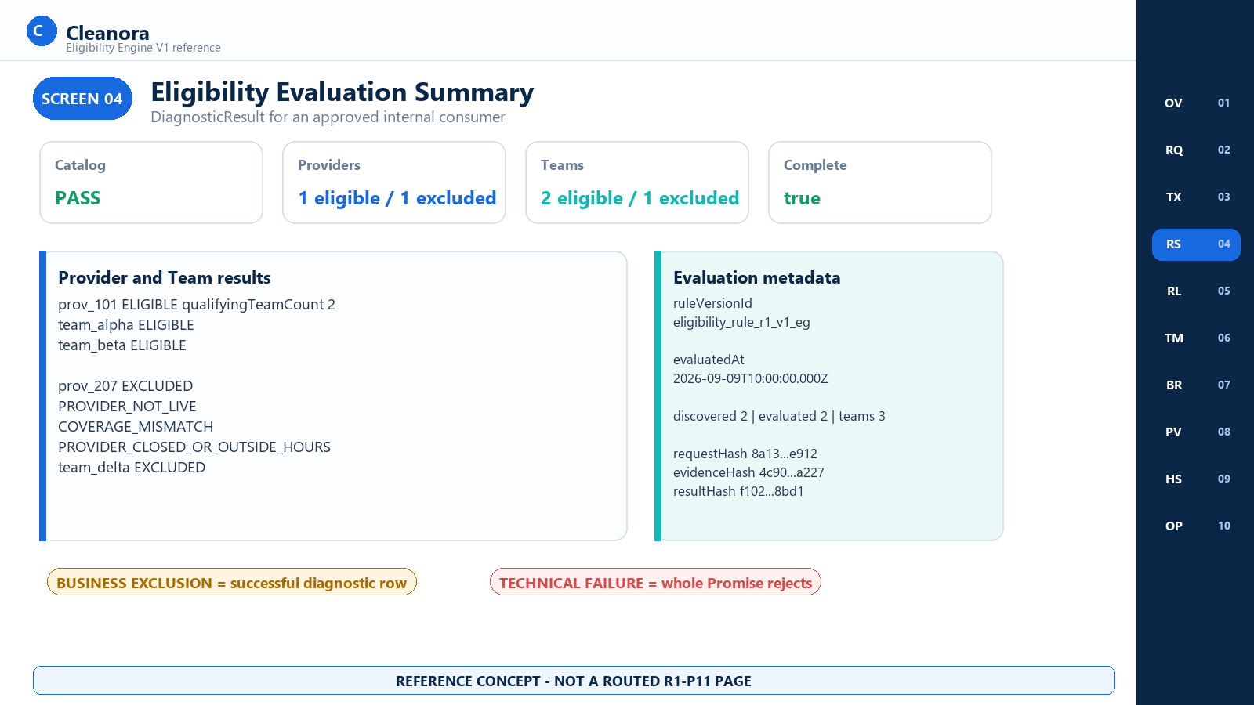
Screen 04 - Eligibility Evaluation Summary - reference concept only

Screen 04 Consumer Notes

Frontend and Consumer Flow on This Screen
- Read the global Catalog outcome first.
- Inspect eligible and excluded Provider summaries and Team results separately.
- Use discovery counts and complete to confirm evaluation scope.
- Use hashes and the pinned rule identity for trace and replay comparisons.

Contracts Used on This Screen
CONTRACT 01 returns DiagnosticResult. CONTRACT 02 intentionally removes the excluded portions shown here.

States and Outcomes
Business exclusions carry stable reasons in a successful result. Validation, dependency, conflict exhaustion, and persistence failures reject the Promise.

Security and Privacy Rules
Diagnostic data is limited to approved in-process consumers and still excludes Worker identities, private contacts, raw member arrays, and documents.

Boundary and Non Deliverables
Boundary: This is not an operations console or a public eligibility history page.

Screen 05 Provider Rule Outcome Detail
Consumer context | Route status | Screen purpose
Internal diagnostics and QA | No routed P11 page | Show Provider-grain outcomes in implemented order and demonstrate independent multi-failure collection.

Visual authority: This image is an implementation handoff aid. Exact behavior comes from the public TypeScript contract and executable source; the screen does not create a route, permission, actor, or product page.

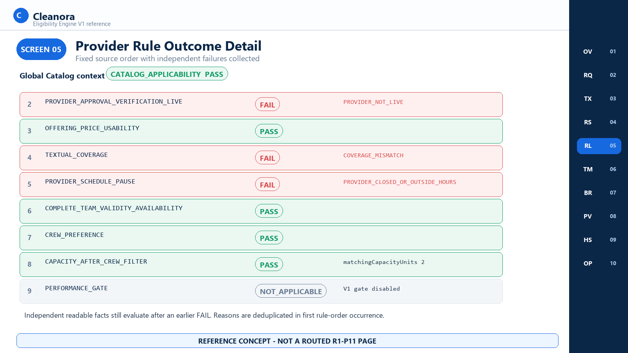
Screen 05 - Provider Rule Outcome Detail - reference concept only

Screen 05 Consumer Notes

Frontend and Consumer Flow on This Screen
- Evaluate lifecycle, price, coverage, schedule, complete-Team facts, crew, capacity, and performance in fixed order after the global Catalog outcome.
- Continue evaluating later independently readable facts even after an earlier FAIL.
- Deduplicate reasons while preserving first rule-order occurrence.
- Keep informational performance reasons out of exclusion reasons.

Contracts Used on This Screen
CONTRACT 01 only. See Rule and Reason Reference for the closed catalogs.

States and Outcomes
Only PASS, FAIL, NOT_APPLICABLE, and NOT_EVALUATED are valid. dependencyRuleId appears when a required factual prerequisite prevents evaluation.

Security and Privacy Rules
Reason codes explain policy outcomes without exposing the dependency DTO or personal data.

Boundary and Non Deliverables
Boundary: Catalog applicability is evaluation-level and appears separately from ProviderSummary.ruleOutcomes.

Screen 06 Team Crew Preference and Capacity Detail
Consumer context | Route status | Screen purpose
Eligibility policy, integration, and QA | No routed P11 page | Make Team validity, crew preference, Escort handling, and post-filter capacity algebra concrete.

Visual authority: This image is an implementation handoff aid. Exact behavior comes from the public TypeScript contract and executable source; the screen does not create a route, permission, actor, or product page.

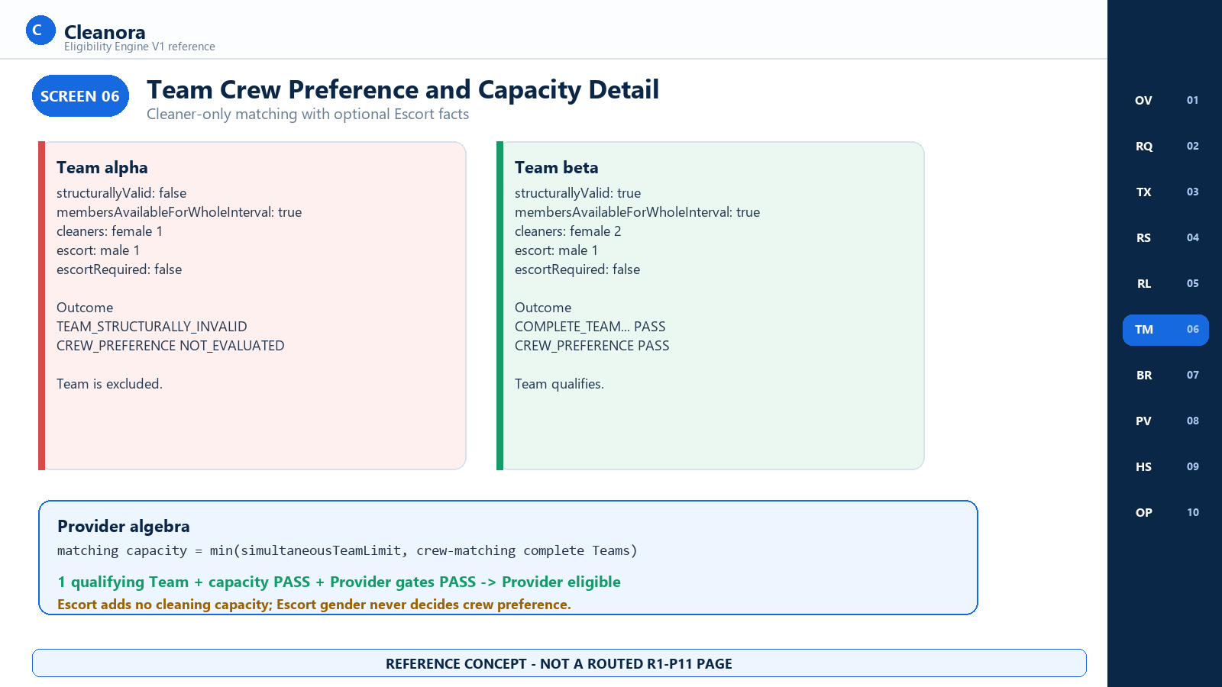
Screen 06 - Team Crew Preference and Capacity Detail - reference concept only

Screen 06 Consumer Notes

Frontend and Consumer Flow on This Screen
- Use Providers-owned Team aggregate facts without Worker IDs.
- Require structural validity and whole-interval member availability before crew preference can run.
- Apply gender preference only to cleaners; an Escort adds no cleaning capacity.
- Count qualifying Teams, cap by simultaneousTeamLimit, then compare with requiredTeamUnits.

Contracts Used on This Screen
CONTRACT 01 evaluates and returns TeamResult rows. CONTRACT 02 emits only eligible Team candidates.

States and Outcomes
One structurally invalid Team fails with TEAM_STRUCTURALLY_INVALID. Another valid crew-matching Team can preserve Provider eligibility when capacity and Provider gates pass.

Security and Privacy Rules
Persist cleaner gender counts and Escort booleans only; never Worker IDs or raw member arrays.

Boundary and Non Deliverables
Boundary: R1-P11 does not assign Teams to bookings or reserve capacity.

Screen 07 Browse Safe Candidate Projection
Consumer context | Route status | Screen purpose
Browse-safe projection consumer and R1-P12 handoff | No routed P11 page | Show the exact safe result P12 may consume without forwarding R1-P11 diagnostics to a browser.

Visual authority: This image is an implementation handoff aid. Exact behavior comes from the public TypeScript contract and executable source; the screen does not create a route, permission, actor, or product page.

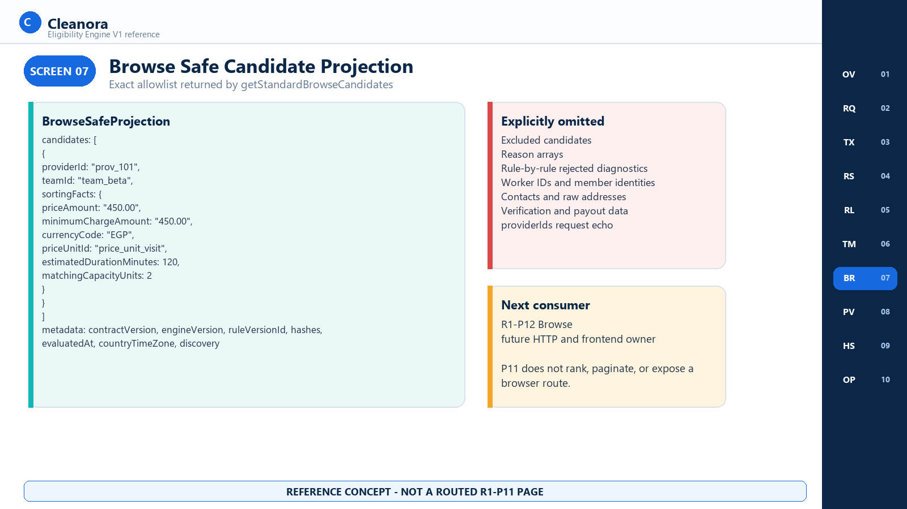
Screen 07 - Browse Safe Candidate Projection - reference concept only

Screen 07 Consumer Notes

Frontend and Consumer Flow on This Screen
- Call getStandardBrowseCandidates with discovery-shaped input.
- Reuse the same evaluator; do not duplicate filters.
- Map eligible Team rows with non-null SortingFacts into canonical Provider/Team order.
- Forward only the allowlisted metadata subset.

Contracts Used on This Screen
CONTRACT 02. CONTRACT 01 is an internal diagnostic path and is not a browser substitute.

States and Outcomes
Candidates are eligible providerId/teamId pairs with SortingFacts. An empty candidates array can be a successful complete projection.

Security and Privacy Rules
Excluded diagnostics, reason arrays, Worker/member facts, contacts, addresses, documents, payouts, and providerIds request echo are omitted.

Boundary and Non Deliverables
Boundary: R1-P12 owns future HTTP, authentication, authorization, ranking, pagination, and frontend rendering.

Screen 08 Rule Version and Policy Details
Consumer context | Route status | Screen purpose
Eligibility policy inspection and engineering operations | No routed P11 page | Document the immutable Egypt V1 seed and rule-selection behavior without implying a staff editor.

Visual authority: This image is an implementation handoff aid. Exact behavior comes from the public TypeScript contract and executable source; the screen does not create a route, permission, actor, or product page.

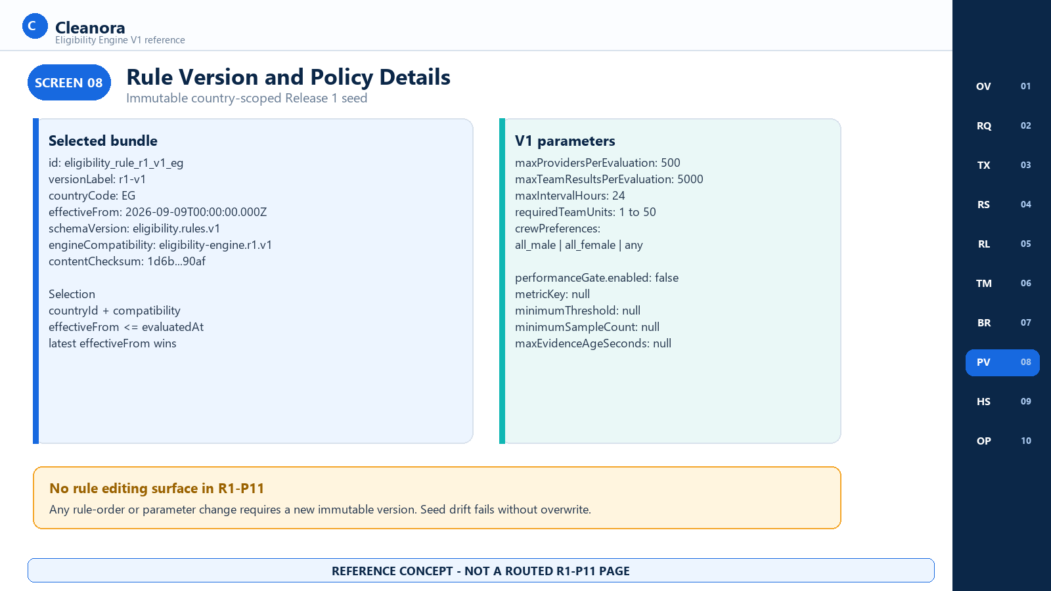
Screen 08 - Rule Version and Policy Details - reference concept only

Screen 08 Consumer Notes

Frontend and Consumer Flow on This Screen
- Filter by countryId and engineCompatibility.
- Keep versions effective at or before the captured evaluatedAt.
- Choose the latest effectiveFrom; validate the parameter schema and rule IDs.
- Verify every immutable seed field on repeat seed; fail on drift.

Contracts Used on This Screen
CONTRACT 01 and CONTRACT 02 select the rule version during evaluation. No public method mutates it.

States and Outcomes
The Release 1 seed is eligibility_rule_r1_v1_eg, r1-v1, country EG, effective 2026-09-09T00:00:00.000Z. Performance gate is disabled.

Security and Privacy Rules
The bundle contains policy configuration, not executable code. No dynamic formula loading or caller-selected version exists.

Boundary and Non Deliverables
Boundary: There is no Phase 11 rule-version editing page or HTTP operation.

Screen 09 Evidence and Deterministic Hash Trace
Consumer context | Route status | Screen purpose
Determinism, replay analysis, and QA | No routed P11 page | Explain the three hashes, canonical ordering, semantic clock, and strict privacy boundary.

Visual authority: This image is an implementation handoff aid. Exact behavior comes from the public TypeScript contract and executable source; the screen does not create a route, permission, actor, or product page.

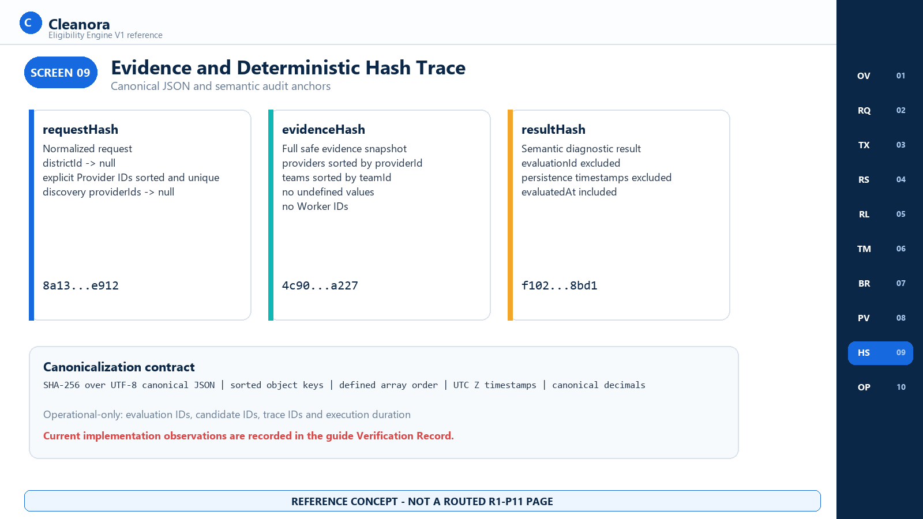
Screen 09 - Evidence and Deterministic Hash Trace - reference concept only

Screen 09 Consumer Notes

Frontend and Consumer Flow on This Screen
- Normalize the request with null for omitted district and discovery Provider IDs.
- Build the typed safe evidence snapshot in canonical Provider/Team order.
- Build the semantic result and compute SHA-256 over UTF-8 canonical JSON.
- Compare hashes only with the same evaluatedAt and pinned facts.

Contracts Used on This Screen
CONTRACT 01 returns all three hashes. CONTRACT 02 carries the same safe hash values in metadata.

States and Outcomes
evaluatedAt is semantic. Generated evaluation/candidate IDs, trace IDs, durations, and persistence timestamps are operational.

Security and Privacy Rules
Evidence contains Team aggregates and allowlisted commercial facts, not Worker IDs, raw members, contacts, customer identity, documents, or payout data.

Boundary and Non Deliverables
Boundary: The frozen contract and current resultHash helper differ; the exact observation is recorded in Implementation Alignment Notes.

Screen 10 Evaluation Retention and Purge Operations
Consumer context | Route status | Screen purpose
Application operations and retention | No routed P11 page | Show evaluation persistence, result-row cardinality, 720-hour expiration, and bounded purge behavior.

Visual authority: This image is an implementation handoff aid. Exact behavior comes from the public TypeScript contract and executable source; the screen does not create a route, permission, actor, or product page.

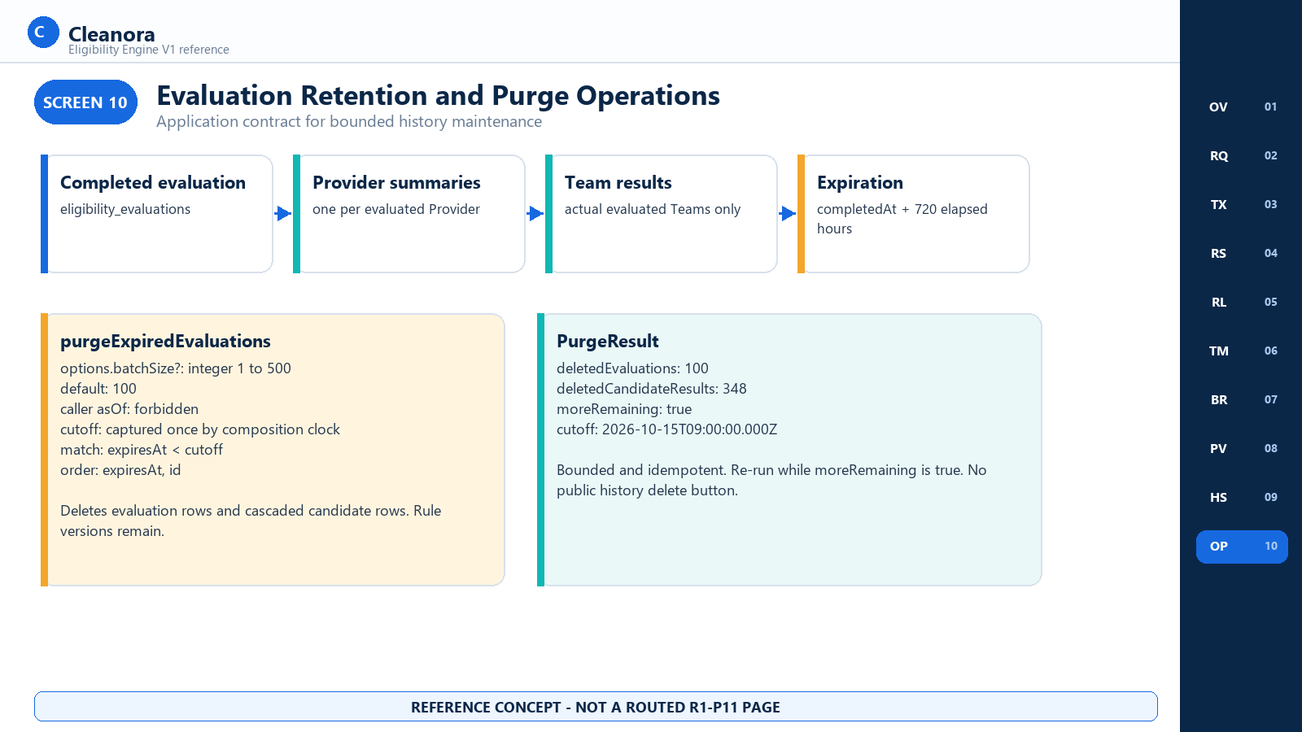
Screen 10 - Evaluation Retention and Purge Operations - reference concept only

Screen 10 Consumer Notes

Frontend and Consumer Flow on This Screen
- Persist one evaluation and its candidate rows atomically after successful evaluation.
- Store exactly one Provider summary for every evaluated Provider and Team rows only for actual evaluated Teams.
- Set expiresAt 720 elapsed hours after the stored completion timestamp.
- Call purgeExpiredEvaluations with batchSize 1-500; re-run while moreRemaining is true.

Contracts Used on This Screen
CONTRACT 03 is the operations method. CONTRACT 01 and CONTRACT 02 create the retained evaluation trees.

States and Outcomes
Purge matches expiresAt strictly earlier than a single captured cutoff, orders by expiresAt then id, and returns deleted evaluation and candidate counts.

Security and Privacy Rules
Purge removes only expired Eligibility evaluations and cascaded candidate rows. It never removes rule versions or inherited user data.

Boundary and Non Deliverables
Boundary: This is not a public admin page and has no user-facing Delete history action.

APPLICATION CONTRACTS

In Process Contract Reference
Section purpose: Each implemented public method is documented once in full. Screen and flow sections cross-reference these cards rather than duplicating the method contracts. None of these methods is an HTTP API.

Contract 01 evaluateEligibility
Attribute | Value
Source | src/modules/eligibility/eligibility.public.ts
What it does | Evaluates discovery or an explicit Provider set and returns full diagnostics.
Caller | Trusted composition-wired application component
Transport | In-process Promise; no HTTP method, path, headers, or status code
Persistence | Every successful application evaluation, including empty candidates, persists atomically

Exact TypeScript signature
evaluateEligibility(
input: EvaluateEligibilityRequest,
): Promise<DiagnosticResult>;

Input and Validation
Field | Type | Required | Rule
mode | "discovery" | "explicit" | Yes | Explicit requires providerIds
serviceId | string | Yes | Non-empty stable service identity
countryId | string | Yes | Active configured country
cityId | string | Yes | Active city in country
districtId | string | No | If present, active district in city and country
startsAt | string | Yes | Exact ISO UTC instant
endsAt | string | Yes | Exact ISO UTC instant; after start; <=24h
crewPreference | CrewPreference | Yes | all_male | all_female | any
requiredTeamUnits | number | Yes | Integer 1-50
providerIds | readonly string[] | Explicit only | Non-empty; unique count <=500; sorted after dedupe

Success Business Exclusions and Failure
- Success returns DiagnosticResult with one global Catalog outcome, eligible and excluded Provider/Team arrays, and EvaluationMetadata.
- Business exclusions remain successful rows. A well-formed unavailable service can produce Catalog FAIL with zero Providers and still persist.
- Technical errors reject the whole operation. No partial result is returned.
- One evaluatedAt value is captured before the retry loop. Intended policy retries the complete RepeatableRead unit at most three attempts for recognized transaction conflicts.
Copyable server-side integration
const request: EvaluateEligibilityRequest = {
mode: "discovery",
serviceId: "svc_home_cleaning",
countryId: "country_eg",
cityId: "city_cairo",
districtId: "district_nasr_city",
startsAt: "2026-09-12T08:00:00.000Z",
endsAt: "2026-09-12T10:00:00.000Z",
crewPreference: "any",
requiredTeamUnits: 1,
};
const result = await eligibility.evaluateEligibility(request);

Contract 01 Representative Success
Representative structure - abbreviated arrays are descriptive, not copy-ready fixtures
{
"evaluationId": "eval_7f7c",
"evaluationOutcomes": {
"catalog": { "ruleId": "CATALOG_APPLICABILITY", "status": "PASS", "reasons": [] }
},
"eligibleProviders": [{
"providerId": "prov_101",
"eligible": true,
"ruleOutcomes": ["eight ordered Provider outcomes"],
"reasons": [],
"sortingFacts": {
"priceAmount": "450.00", "minimumChargeAmount": "450.00",
"currencyCode": "EGP", "priceUnitId": "price_unit_visit",
"estimatedDurationMinutes": 120, "matchingCapacityUnits": 2
},
"qualifyingTeamCount": 2
}],
"eligibleTeams": [{ "providerId": "prov_101", "teamId": "team_beta",
"eligible": true, "ruleOutcomes": ["ordered Team outcomes"],
"reasons": [], "sortingFacts": "same allowlisted sorting facts" }],
"excludedProviders": [], "excludedTeams": [],
"metadata": {
"contractVersion": "eligibility.public.v1",
"engineVersion": "eligibility-engine.r1.v1",
"ruleVersionId": "eligibility_rule_r1_v1_eg",
"ruleChecksum": "sha256-full-value",
"requestHash": "sha256-full-value", "evidenceHash": "sha256-full-value",
"resultHash": "sha256-full-value",
"evaluatedAt": "2026-09-09T10:00:00.000Z",
"countryTimeZone": "Africa/Cairo",
"calendarRuntimeVersion": "providers-availability-calendar.r1.v1",
"sourceVersions": {},
"discovery": { "mode": "discovery", "countryId": "country_eg",
"cityId": "city_cairo", "districtId": "district_nasr_city",
"discoveredProviderCount": 1, "evaluatedProviderCount": 1,
"teamResultCount": 1, "complete": true },
"limits": { "maxProviders": 500, "maxTeamResults": 5000 }
}
}

Contract 01 Representative Business Exclusion
Business exclusion remains a successful diagnostic result
{
"evaluationOutcomes": {
"catalog": { "ruleId": "CATALOG_APPLICABILITY", "status": "PASS", "reasons": [] }
},
"eligibleProviders": [], "eligibleTeams": [],
"excludedProviders": [{
"providerId": "prov_207", "eligible": false,
"reasons": ["PROVIDER_NOT_LIVE", "COVERAGE_MISMATCH",
"PROVIDER_CLOSED_OR_OUTSIDE_HOURS"],
"sortingFacts": null, "qualifyingTeamCount": 0
}],
"excludedTeams": []
}

Consumer Recovery
- Render or log only approved diagnostic summaries; do not send this payload to a browser.
- For VALIDATION_FAILED or UNSUPPORTED_GEO_INPUT, correct the request before retrying.
- For business exclusions, use the ordered reasons as decision data; do not retry unchanged facts.
- For typed technical errors, follow the error matrix. Do not assume persistence unless the method returned success.

Contract 02 getStandardBrowseCandidates
Attribute | Value
Source | src/modules/eligibility/eligibility.public.ts
What it does | Calls the same evaluator in discovery mode and maps eligible Team rows to the Browse-safe allowlist.
Caller | Future R1-P12 server-side Browse application component
Transport | In-process Promise; R1-P11 defines no HTTP surface
Persistence | The shared evaluator persists the successful diagnostic evaluation before projection

Exact TypeScript signature
getStandardBrowseCandidates(
input: BrowseCandidatesRequest,
): Promise<BrowseSafeProjection>;

Input and Projection
The input uses all EligibilityRequestBase fields. mode may be omitted or discovery. Any runtime providerIds property with a defined value is rejected with VALIDATION_FAILED. Explicit Provider evaluation belongs to Contract 01.
Copyable server-side Browse facade call
const projection = await eligibility.getStandardBrowseCandidates({
serviceId: "svc_home_cleaning",
countryId: "country_eg",
cityId: "city_cairo",
districtId: "district_nasr_city",
startsAt: "2026-09-12T08:00:00.000Z",
endsAt: "2026-09-12T10:00:00.000Z",
crewPreference: "any",
requiredTeamUnits: 1,
});

Representative successful Browse-safe output
{
"candidates": [{
"providerId": "prov_101",
"teamId": "team_beta",
"sortingFacts": {
"priceAmount": "450.00",
"minimumChargeAmount": "450.00",
"currencyCode": "EGP",
"priceUnitId": "price_unit_visit",
"estimatedDurationMinutes": 120,
"matchingCapacityUnits": 2
}
}],
"metadata": {
"contractVersion": "eligibility.public.v1",
"engineVersion": "eligibility-engine.r1.v1",
"ruleVersionId": "eligibility_rule_r1_v1_eg",
"requestHash": "sha256-full-value",
"evidenceHash": "sha256-full-value",
"resultHash": "sha256-full-value",
"evaluatedAt": "2026-09-09T10:00:00.000Z",
"countryTimeZone": "Africa/Cairo",
"discovery": { "mode": "discovery", "countryId": "country_eg",
"cityId": "city_cairo", "districtId": "district_nasr_city",
"discoveredProviderCount": 1, "evaluatedProviderCount": 1,
"teamResultCount": 1, "complete": true }
}
}

Privacy and Efficient Usage
- Use candidates exactly as the eligibility-qualified input to future Browse policy. Do not add a second eligibility filter.
- SortingFacts are ranking inputs only. R1-P11 does not define marketplace order.
- Do not join Worker/member data into this projection or forward diagnostic exclusions.
- Cache or deduplicate only under a P12 policy that respects evaluatedAt and hash semantics; R1-P11 does not define browser caching.
Recovery: Typed evaluation errors surface unchanged. Correct validation errors; retry transient dependencies according to P12 server policy; never fall back to excluded candidates or the Providers setup placeholder.

Contract 03 purgeExpiredEvaluations
Attribute | Value
Source | src/modules/eligibility/eligibility.public.ts
What it does | Deletes expired Eligibility evaluation trees in stable bounded batches.
Caller | Trusted application or operations component
Transport | In-process Promise; no public admin endpoint
Persistence | Deletes eligibility_evaluations and cascaded candidate rows; retains rule versions

Exact TypeScript signature
purgeExpiredEvaluations(
options?: PurgeOptions,
): Promise<PurgeResult>;

Input | Type | Behavior
options | PurgeOptions | undefined | Omitted uses default batchSize 100
batchSize | number | undefined | Integer 1-500; invalid values reject; never clamped
asOf | Forbidden | Production options reject caller-supplied asOf

Copyable bounded operations loop
let more = true;
while (more) {
const result = await eligibility.purgeExpiredEvaluations({ batchSize: 100 });
more = result.moreRemaining;
}

Representative PurgeResult
{
"deletedEvaluations": 100,
"deletedCandidateResults": 348,
"moreRemaining": true,
"cutoff": "2026-10-15T09:00:00.000Z"
}

Operational Response
- Re-run while moreRemaining is true; each invocation captures its own cutoff once.
- Treat VALIDATION_FAILED as an operations configuration error and correct batchSize or remove caller asOf.
- A database failure rejects the method. Investigate the disposable or approved environment before retrying.
- Do not modify applied migration SQL or delete rule versions to recover from a purge incident.
TYPE SYSTEM

Request and Result Reference
Section purpose: These tables reproduce the actual public TypeScript contract. Optional means the property may be absent. Nullable means the property is present and may carry null. Runtime validation details are separated from compile-time shapes.

Request Variants
Request | Discriminator | Additional field | Public method
DiscoveryRequest | mode: "discovery" | None | evaluateEligibility
ExplicitRequest | mode: "explicit" | providerIds: readonly string[] | evaluateEligibility
BrowseCandidatesRequest | mode?: "discovery" | providerIds forbidden | getStandardBrowseCandidates

EligibilityRequestBase
Field | Type | Optional or null | Runtime rule
serviceId | string | Required, non-null | Non-empty
countryId | string | Required, non-null | Active country
cityId | string | Required, non-null | Active ancestry
districtId | string | Optional | Non-empty and active ancestry if present
startsAt | string | Required | Exact UTC ISO instant
endsAt | string | Required | Exact UTC; later than start; <=24h
crewPreference | CrewPreference | Required | all_male | all_female | any
requiredTeamUnits | number | Required | Integer 1-50

Unsupported Request Fields
Field family | Contract treatment | Current source note
coordinates or geo | UNSUPPORTED_GEO_INPUT | evaluateEligibility checks geo, latitude, longitude
radius | UNSUPPORTED_GEO_INPUT | Not explicitly checked by current validator
providerIds on Browse | VALIDATION_FAILED | Defined runtime property is rejected
caller rule version | Not accepted | Service selects by country, compatibility, and evaluatedAt
caller purge asOf | VALIDATION_FAILED | Explicit property check in purge method

RuleOutcome and SortingFacts
Type and field | Type | Meaning
RuleOutcome.ruleId | EligibilityRuleId | Closed rule identity
RuleOutcome.status | RuleOutcomeStatus | PASS | FAIL | NOT_APPLICABLE | NOT_EVALUATED
RuleOutcome.reasons | readonly EligibilityReasonCode[] | FAIL reasons or informational performance reasons
RuleOutcome.dependencyRuleId | EligibilityRuleId | undefined | Required factual prerequisite that blocked evaluation
SortingFacts.priceAmount | string | Canonical decimal
SortingFacts.minimumChargeAmount | string | Canonical decimal
SortingFacts.currencyCode | string | Currency identity
SortingFacts.priceUnitId | string | Catalog price unit identity
SortingFacts.estimatedDurationMinutes | number | Offering duration
SortingFacts.matchingCapacityUnits | number | Capacity after crew filter
SortingFacts.performanceMetricKey | string | undefined | Only with valid allowlisted performance PASS
SortingFacts.performanceValue | string | undefined | Canonical decimal only with valid performance PASS

ProviderSummary and TeamResult
Field | ProviderSummary | TeamResult
providerId | string | string
teamId | Absent | string
eligible | boolean | boolean
ruleOutcomes | readonly RuleOutcome[] | readonly RuleOutcome[]
reasons | Exclusion reasons only | Exclusion reasons only
sortingFacts | SortingFacts | null | SortingFacts | null
qualifyingTeamCount | number | Absent

DiscoveryMetadata
Field | Type | Meaning
mode | "discovery" | "explicit" | Candidate-source mode
countryId | string | Resolved request scope
cityId | string | Resolved request scope
districtId | string | null | Null when omitted
discoveredProviderCount | number | Discovery or explicit count before Catalog-unavailable clearing
evaluatedProviderCount | number | Provider facts actually evaluated
teamResultCount | number | Actual Team rows
complete | boolean | Successful bounded evaluation completed

Evaluation Metadata and Outcomes
Field | Type | Meaning
contractVersion | string | eligibility.public.v1
engineVersion | string | eligibility-engine.r1.v1
ruleVersionId | string | Pinned immutable version
ruleChecksum | string | Pinned content checksum
requestHash | string | Normalized request hash
evidenceHash | string | Safe evidence snapshot hash
resultHash | string | Semantic result hash; current-source note applies
evaluatedAt | string | UTC semantic instant
countryTimeZone | string | Configured IANA zone
calendarRuntimeVersion | string | providers-availability-calendar.r1.v1
sourceVersions | Readonly<Record<string,string>> | Current service populates an empty object
discovery | DiscoveryMetadata | Scope counts and completeness
limits | { maxProviders: 500; maxTeamResults: 5000 } | Fixed bounds

EvaluationOutcomes field | Type | Requirement
catalog | RuleOutcome | Always present, including zero Providers

DiagnosticResult
Field | Type | Notes
evaluationId | string | Operational; outside semantic equality
evaluationOutcomes | EvaluationOutcomes | Global Catalog outcome
eligibleProviders | readonly ProviderSummary[] | Canonical providerId order
eligibleTeams | readonly TeamResult[] | providerId then teamId order
excludedProviders | readonly ProviderSummary[] | Business exclusions
excludedTeams | readonly TeamResult[] | Business exclusions
metadata | EvaluationMetadata | Pinned versions, hashes, scope, bounds

Browse Types
Type | Fields | Notes
BrowseSafeCandidate | providerId; teamId; sortingFacts | Eligible Team only; SortingFacts non-null
BrowseSafeProjection | candidates; metadata | Canonical order; safe metadata Pick
Browse metadata Pick | contractVersion; engineVersion; ruleVersionId; requestHash; evidenceHash; resultHash; evaluatedAt; countryTimeZone; discovery | No ruleChecksum, sourceVersions, calendarRuntimeVersion, limits, or diagnostics

Purge Types
Type and field | Type | Rule
PurgeOptions.batchSize | number | undefined | Integer 1-500; default 100
PurgeResult.deletedEvaluations | number | Deleted parent rows
PurgeResult.deletedCandidateResults | number | Count before cascade
PurgeResult.moreRemaining | boolean | Lookahead found another expired row
PurgeResult.cutoff | string | Fixed invocation cutoff as UTC ISO

EligibilityEvidenceSnapshot
Object | Fields | Ordering and privacy
normalizedRequest | mode, ids, interval, crew, units, providerIds | districtId and discovery providerIds normalized to null
evaluatedAt | UTC string | Semantic and reused across retries
pinnedRule | id, checksum, schema, compatibility, label | Immutable selected bundle
countryLocality | country code/zone, city, district, ancestryVersion | Current ancestryVersion is null
evaluationOutcomes | catalog | Always present
providers | lifecycle, pricing, availability, performance | Sorted by providerId; no Worker IDs
engineCalendar | engine, calendar, contract versions | Stable runtime identities
sourceVersions | record | Current service uses empty object

Evidence Provider Variants
Area | Variants | Required safe fields
lifecycle | MISSING | PRESENT | approved, live, suspended, verificationSatisfiedOrNotRequired, aggregateVersion
pricing | AVAILABLE | UNAVAILABLE | Commercial facts or owning reason and optional sourceVersion
availability | MISSING_CONFIGURATION | AVAILABLE_FACTS | OVERFLOW | Coverage, schedule, pause, suspension, capacity limit, Team aggregates
performance | NOT_APPLICABLE | MISSING | OK | Metric identity/value/sample/observedAt only for OK

Performance Evidence and Policy
Condition | Rule status | Reason and exclusion
Gate disabled | NOT_APPLICABLE | No reason; port not called
Enabled and port MISSING | NOT_EVALUATED | PERFORMANCE_EVIDENCE_MISSING; informational
Insufficient samples | NOT_EVALUATED | PERFORMANCE_EVIDENCE_INSUFFICIENT_SAMPLES; informational
Stale evidence | NOT_EVALUATED | PERFORMANCE_EVIDENCE_STALE; informational
Fresh value below threshold | FAIL | PERFORMANCE_GATE_FAILED; excludes Provider and Teams
Fresh value meets threshold | PASS | Optional metric and value may enter SortingFacts
Malformed, future-dated, or policy mismatch | Technical error | INVALID_DEPENDENCY_DTO

ELIGIBILITY POLICY

Rule and Reason Reference
Section purpose: R1-P11 uses one fixed rule order and a closed reason vocabulary. Evaluation order is presentation order, not a universal prerequisite chain. Readable facts remain independently evaluable after an earlier business FAIL.

Fixed Rule Order
# | EligibilityRuleId | Grain | Purpose
1 | CATALOG_APPLICABILITY | Evaluation | Global service/country applicability
2 | PROVIDER_APPROVAL_VERIFICATION_LIVE | Provider | Approval, live, suspension, verification
3 | OFFERING_PRICE_USABILITY | Provider | Owned offering/price plus interval duration
4 | TEXTUAL_COVERAGE | Provider | Country/city/district coverage
5 | PROVIDER_SCHEDULE_PAUSE | Provider | Schedule, pause, suspension
6 | COMPLETE_TEAM_VALIDITY_AVAILABILITY | Provider and Team | Team structure and whole-interval availability
7 | CREW_PREFERENCE | Provider and Team | Cleaner-only gender preference
8 | CAPACITY_AFTER_CREW_FILTER | Provider and Team | Post-filter capacity vs required units
9 | PERFORMANCE_GATE | Provider | Disabled V1 or versioned evidence policy

RuleOutcomeStatus
Status | Meaning | Exclusion effect
PASS | Rule satisfied | None
FAIL | Rule produced one or more real business reasons | Excludes when the rule participates in the candidate predicate
NOT_APPLICABLE | Policy disabled or not relevant | None
NOT_EVALUATED | Required factual prerequisite absent or informational performance state | No invented downstream failure; informational reasons do not exclude

Provider and Team Algebra
- A Provider is eligible only when applicable Provider gates pass, crew-filtered capacity meets requiredTeamUnits, at least one Team individually qualifies, and performance does not FAIL.
- A Team is eligible only when that Team individually qualifies and its Provider is eligible.
- A capacity or performance FAIL excludes every Team alternative for the Provider.
- One invalid Team does not exclude a Provider when another Team qualifies and capacity remains sufficient.
- Catalog FAIL with zero Providers is a successful persisted diagnostic that is distinct from an available service with no supply.

EligibilityReasonCode Catalog
Reason code | Typical rule | Excludes | Meaning
SERVICE_NOT_AVAILABLE_IN_COUNTRY | Catalog | Yes | Well-formed service unavailable in country
SERVICE_INACTIVE_OR_UNKNOWN | Catalog | Yes | Well-formed unknown or inactive service
PROVIDER_NOT_APPROVED | Lifecycle | Yes | Provider not approved or explicit Provider missing
PROVIDER_NOT_LIVE | Lifecycle | Yes | Provider not live or explicit Provider missing
PROVIDER_SUSPENDED | Lifecycle or schedule | Yes | Provider suspended
VERIFICATION_NOT_SATISFIED | Lifecycle | Yes | Verification projection returns unsatisfied
OFFERING_OR_PRICE_UNAVAILABLE | Price | Yes | Owned price/offering facts unavailable
REQUESTED_INTERVAL_TOO_SHORT | Price | Yes | Estimated duration exceeds request interval
CAPACITY_RULE_MISSING | Team/capacity | Yes | Capacity configuration absent
COVERAGE_MISMATCH | Coverage | Yes | Textual area not covered
PROVIDER_CLOSED_OR_OUTSIDE_HOURS | Schedule | Yes | Schedule unavailable or missing
PROVIDER_PAUSED | Schedule | Yes | Temporary pause blocks interval
NO_VALID_COMPLETE_TEAM | Provider summary | Yes | No qualifying Team structure
TEAM_STRUCTURALLY_INVALID | Team | Yes | Specific Team fails structure
TEAM_MEMBERS_UNAVAILABLE | Team | Yes | Member availability does not cover interval
CREW_PREFERENCE_MISMATCH | Team | Yes | Cleaner counts do not match preference
INSUFFICIENT_CAPACITY_AFTER_CREW_FILTER | Capacity | Yes | Post-filter capacity below required units
PERFORMANCE_GATE_FAILED | Performance | Yes | Fresh sufficient evidence below threshold
PERFORMANCE_EVIDENCE_MISSING | Performance | No | Enabled gate has no evidence
PERFORMANCE_EVIDENCE_INSUFFICIENT_SAMPLES | Performance | No | Sample count below policy
PERFORMANCE_EVIDENCE_STALE | Performance | No | Evidence too old
NOT_IN_DISCOVERY_SCOPE | Metadata | N/A | Metadata-only vocabulary

Ordering: Candidate reasons are deduplicated while preserving the first occurrence produced by fixed rule order. Informational performance codes and NOT_IN_DISCOVERY_SCOPE never enter exclusion reasons.

FAILURE HANDLING

Typed Error and Recovery Reference
Section purpose: Eligibility business exclusions do not use the error channel. The codes below describe whole-operation technical or validation failures exposed through the in-process EligibilityError interface.

Code | Typical cause | Whole eval fails | Retry | Consumer response
VALIDATION_FAILED | Malformed shape, UTC interval, ancestry, units, Browse providerIds, or purge option | Yes | No | Correct input; retry only after change
UNSUPPORTED_GEO_INPUT | Forbidden geo, latitude, or longitude at current evaluate validator | Yes | No | Remove unsupported fields; contract also forbids radius
RULE_VERSION_UNAVAILABLE | No compatible effective version for country and evaluatedAt | Yes | No | Seed or deploy a valid version; then retry
RULE_VERSION_INVALID | Selected parameters or performance configuration invalid | Yes | No | Repair immutable-version rollout; never overwrite seed drift
DEPENDENCY_FAILURE | Required performance port unavailable or dependency failure mapped by caller | Yes | Maybe | Retry only if transient and bounded
INVALID_DEPENDENCY_DTO | Malformed or incompatible dependency evidence | Yes | No | Repair source contract; do not downgrade to exclusion
EVALUATION_LIMIT_EXCEEDED | More than 500 Providers or 5000 Team results | Yes | No | Narrow explicit set or discovery; never truncate
TRANSACTION_CONFLICT_EXHAUSTED | Recognized conflict on all three attempts | Yes | Later | Back off and retry as a new invocation
PERSISTENCE_FAILED | Atomic insert rejected | Yes | Caution | Investigate database; no success payload returned
CONFLICT | Eligibility transaction timeout or Providers pricing serialization conflict | Yes | Bounded | Expected service policy retries recognized conflicts

Typed Error Handling Example
Server-side consumer pattern
try {
return await eligibility.evaluateEligibility(input);
} catch (error) {
const candidate = error as Partial<EligibilityError>;
if (candidate.code === "VALIDATION_FAILED" ||
candidate.code === "UNSUPPORTED_GEO_INPUT") {
return { kind: "invalid-internal-request", details: candidate.details };
}
throw error; // server-side policy handles bounded retry or incident logging
}

Persistence and Browser Exposure
- Validation and technical failures do not return a success payload. The intended atomic model commits no partial evaluation tree.
- Do not forward Error.cause, stack traces, raw Prisma errors, dependency DTOs, database identifiers, or secrets to a browser.
- Routine logs may include the stable code, evaluation ID when available, trace ID, hashes, counts, and durations; they must not include full evidence or Worker/member data.
- P12 must define its own safe HTTP error mapping. R1-P11 supplies no status codes.
Current retry alignment risk: isRetryableConflict currently requires error instanceof EligibilityError. The Providers pricing reader throws a code-bearing ordinary Error for CONFLICT. That path can bypass the intended three-attempt service retry until the runtime boundary is normalized or the guard accepts the public error shape.

DATA AND AUDIT

Persistence Audit and Retention
Section purpose: Eligibility owns three additive tables. Successful evaluations, including successful empty candidate sets, persist as immutable evaluation trees. Provider and Team identifiers are historical logical references rather than live foreign keys.

eligibility_rule_versions
Field | Physical type | Null | Contract
id | TEXT PK | No | Deterministic seed ID
countryId | TEXT FK | No | RESTRICT to countries
versionLabel | TEXT | No | Unique per country
schemaVersion | TEXT | No | eligibility.rules.v1
engineCompatibility | TEXT | No | eligibility-engine.r1.v1
ruleOrder | JSONB | No | Ordered rule IDs
parameters | JSONB | No | Typed immutable parameters
effectiveFrom | TIMESTAMP(3) | No | Inclusive selection instant
contentChecksum | TEXT | No | SHA-256 canonical content
createdAt | TIMESTAMP(3) | No | Database default now
createdByProvenance | TEXT | No | Controlled system operation

Uniqueness: (id, countryId), (countryId, versionLabel), and (countryId, effectiveFrom). Rule versions remain after evaluation purge.

eligibility_evaluations
Field | Physical type | Meaning
id | TEXT PK | Operational UUID string
ruleVersionId + countryId | TEXT composite FK | RESTRICT and enforce country agreement
evaluatedAt | TIMESTAMP(3) | Captured semantic instant
completedAt | TIMESTAMP(3) | Stored completion timestamp; current service uses evaluatedAt
createdAt | TIMESTAMP(3) | Repository/database timestamp
expiresAt | TIMESTAMP(3) | Stored completedAt + 720 elapsed hours
requestNormalized | JSONB | Allowlisted normalized input
requestHash | TEXT | Not unique; fresh row per invocation
evidenceSafe | JSONB | Typed snapshot without Worker IDs
evidenceHash + resultHash | TEXT | Deterministic audit anchors
metadata + outcomeSummary | JSONB | Versions, scope, counts, global outcome
traceId | TEXT nullable | Operational only
engineVersion | TEXT | Runtime identity

eligibility_candidate_results
Field | Physical type | Meaning
id | TEXT PK | Operational UUID
evaluationId | TEXT FK | CASCADE on evaluation delete
providerId | TEXT | Historical logical reference; no live FK
teamId | TEXT nullable | Null only for Provider summary
rowKind | enum | PROVIDER_SUMMARY | TEAM_RESULT
eligible | BOOLEAN | Final row verdict
ruleOutcomes | JSONB | Ordered outcomes
reasons | JSONB | Deduplicated exclusion reasons
sortingFacts | JSONB nullable | Eligible commercial/availability facts
diagnosticsSafe | JSONB nullable | Allowlisted diagnostics only
createdAt | TIMESTAMP(3) | Required timestamp

Cardinality and Integrity
- PROVIDER_SUMMARY requires teamId null. TEAM_RESULT requires teamId non-null.
- One Provider summary is unique per evaluation and provider.
- One Team result is unique per evaluation, provider, and team.
- Every evaluated Provider gets exactly one summary, including a nonexistent explicit Provider.
- Team rows exist only for actual evaluated Teams within the 5000-row bound.
- The rule-version and evaluation country pair is protected by a restrictive composite foreign key.

Retention and Purge
Rule | Exact behavior
Window | 720 elapsed hours from stored completedAt
Eligibility | expiresAt < one captured cutoff
Order | expiresAt ascending, then id ascending
Batch | 1-500; default 100; invalid values rejected
Delete | Evaluation rows plus cascaded candidate rows
Retain | Rule versions and all non-P11 data

Persistence Privacy Allowlist
Allowed | Prohibited
Service and textual locality IDs; UTC interval; mode; crew; units | Raw street address; coordinates; radius; customer identity
Pinned rule identity; hashes; rule outcomes; reason codes | Worker IDs, names, contacts, raw member arrays
Team aggregate cleaner counts and Escort booleans | Verification documents, payout identifiers, ownerUserId
Allowlisted performance facts when evaluated | Raw dependency DTOs and unrestricted diagnostic dumps

TRUST AND PRIVACY

Security and Privacy
Section purpose: R1-P11 relies on a trusted composition boundary and narrow data contracts. The absence of an HTTP route is part of the security design, not an invitation to add a hidden internal-secret endpoint.

Trust Model
Layer | Trust and obligation
Composition | Trusted wiring of Eligibility, unit of work, readers, clock, and optional performance port
In-process caller | Approved application component only; no self-authorization by input strings
HTTP in P11 | No Eligibility route
Dependency DTO | Validate discriminated shape; malformed data is a hard failure
Browser | May consume only a future P12 response, never the P11 module object

Four Separate Allowlists
Surface | Allowed | Never include
Persistence | Normalized request, safe evidence, outcomes, reasons, sorting facts | Worker/member identity, contacts, addresses, documents, payouts
DiagnosticResult | Provider/Team outcomes and approved metadata | Raw dependency objects or personal data
BrowseSafeProjection | Eligible IDs, SortingFacts, safe metadata Pick | Excluded rows, reasons, Worker/private data
Routine logs | Codes, counts, hashes, durations, evaluation/trace IDs | Full evidence, reason dumps with PII, dependency DTOs

Logging and Error Redaction
- Log stable error code and bounded operational metadata. Keep Error.cause and stack details inside protected server diagnostics.
- Never log Worker IDs, raw member arrays, customer identifiers, contacts, private addresses, verification data, payout identifiers, or full evidence snapshots.
- Do not expose excluded diagnostics through the Browse-safe result.
- Safe SortingFacts are priceAmount, minimumChargeAmount, currencyCode, priceUnitId, estimatedDurationMinutes, matchingCapacityUnits, and optional valid performance metric/value.
SCOPE BOUNDARY

Absent Page Groups and Phase Boundaries
Section purpose: Phase 11 intentionally delivers an internal eligibility domain. The reference screens in this guide are engineering aids and do not change the following zero-surface boundary.

Important: Do not invent a Customer, anonymous, Provider, Staff, operations-console, or hidden internal Eligibility page for R1-P11.

- No Phase 11 Customer page or anonymous Browse page.
- No Provider eligibility settings page.
- No Staff eligibility administration or rule-version editing page.
- No public eligibility-history page.
- No Eligibility HTTP API, OpenAPI operation, Postman request, browser client, or Axios wrapper.
- No marketplace ranking or pagination product.
- No booking, reservation, assignment, checkout, tax, discount, payment, wallet, or payout behavior.
- No coordinate or radius search.
- R1-P12 owns marketplace Browse HTTP and frontend. R1-P13 and later phases own booking behavior.
DELIVERY CONTROL

Frontend and Integration Delivery Checklist
Section purpose: Use this checklist during P12 planning, implementation review, and QA. Every item protects an R1-P11 contract, privacy rule, or phase boundary.

Check | Verification item
☐ | All ten reference screens are numbered once and sequentially.
☐ | All six workflow diagrams are numbered once and sequentially.
☐ | Every screen visual states REFERENCE CONCEPT - NOT A ROUTED R1-P11 PAGE.
☐ | No fake endpoint, HTTP method, status code, Authorization header, OpenAPI entry, Postman request, or Axios client is shown for Eligibility.
☐ | No browser directly invokes EligibilityApplicationService.
☐ | All three public methods are fully documented once; reused methods are cross-referenced.
☐ | providerIds are rejected by getStandardBrowseCandidates and remain available only in evaluateEligibility explicit mode.
☐ | Business exclusions remain successful diagnostic data; technical failures reject the whole operation.
☐ | EligibilityRuleId, RuleOutcomeStatus, EligibilityReasonCode, and EligibilityErrorCode values match source.
☐ | No Worker ID, raw member array, private contact, address, verification document, payout data, or customer identity leaks.
☐ | Request times use exact UTC strings and half-open [startsAt, endsAt) semantics.
☐ | Country, city, and optional district form a valid active textual ancestry.
☐ | Crew preference applies to cleaners only; Escort gender and presence do not create cleaning capacity.
☐ | Capacity is recalculated after crew filtering and capped by simultaneousTeamLimit.
☐ | One evaluatedAt value is reused across all retry attempts.
☐ | Hash comparisons preserve canonical ordering, null semantics, and evaluatedAt as semantic.
☐ | Successful empty Catalog-fail results still persist with evaluationOutcomes.catalog.
☐ | Every evaluated Provider has a summary row; Team rows represent only actual evaluated Teams.
☐ | Retention is 720 elapsed hours and purge uses a fixed cutoff, stable order, and bounded batch.
☐ | The Providers eligibleForPublicBrowse placeholder is never used as an Eligibility oracle.
☐ | R1-P11 exposes zero HTTP operations; P12 ownership is explicit.
☐ | The guide reports the canonical Complete status and separately records current contract-alignment risks.

AUTHORITY

Canonical Implementation Sources
Section purpose: The repository-local files below were used as authority. Source code and executable tests establish current implementation behavior; accepted Phase 11 specifications and contracts establish intended behavior; status and evidence files establish completion claims.

Phase and scope
docs/product/current.md
specs/R1-P11-eligibility-engine-v1/spec.md
specs/R1-P11-eligibility-engine-v1/plan.md
specs/R1-P11-eligibility-engine-v1/tasks.md
specs/R1-P11-eligibility-engine-v1/checkpoint.md

Contracts
specs/R1-P11-eligibility-engine-v1/contracts/eligibility-public-contract.md
specs/R1-P11-eligibility-engine-v1/contracts/browse-consumer-contract.md
specs/R1-P11-eligibility-engine-v1/contracts/dependency-readers.md
specs/R1-P11-eligibility-engine-v1/contracts/reason-codes.md
specs/R1-P11-eligibility-engine-v1/contracts/rule-version-contract.md
specs/R1-P11-eligibility-engine-v1/contracts/http-api.md

Eligibility source
src/modules/eligibility/eligibility.public.ts
src/modules/eligibility/eligibility.service.ts
src/modules/eligibility/eligibility.rules.ts
src/modules/eligibility/eligibility.crew-capacity.ts
src/modules/eligibility/eligibility.performance.ts
src/modules/eligibility/eligibility.hashes.ts
src/modules/eligibility/eligibility.reasons.ts
src/modules/eligibility/eligibility.errors.ts
src/modules/eligibility/performance-evidence.port.ts
src/modules/eligibility/infrastructure/eligibility.unit-of-work.ts
src/modules/eligibility/infrastructure/prisma-eligibility.repository.ts

Composition and dependencies
src/composition.ts
src/modules/providers/providers.public.ts
src/modules/providers/eligibility-pricing.reader.ts
src/modules/providers/eligibility-lifecycle.reader.ts
src/modules/providers/eligibility-availability.reader.ts

Persistence and status
prisma/schema.prisma
prisma/migrations/r1_p11_eligibility_engine_v1/migration.sql
specs/R1-P11-eligibility-engine-v1/data-model.md
specs/R1-P11-eligibility-engine-v1/security-design.md
specs/R1-P11-eligibility-engine-v1/operations-runbook.md
specs/R1-P11-eligibility-engine-v1/implementation-evidence.md
specs/R1-P11-eligibility-engine-v1/implementation-review-report.md
specs/R1-P11-eligibility-engine-v1/review-resolution.md
specs/R1-P11-eligibility-engine-v1/migration-evidence.md
specs/R1-P11-eligibility-engine-v1/completion-report.md

Tests and API evidence
vitest.r1-p11.config.ts
tests/unit/modules/eligibility/
tests/integration/eligibility/
tests/integration/database/r1-p11-schema-constraints.test.ts
tests/integration/providers/r1-p11-eligibility-readers.test.ts
tests/unit/modules/r1-p11-module-boundaries.test.ts
docs/apis/README.md
src/swagger/openapi.document.ts
postman/
scripts/openapi-validate.ts
scripts/validate-postman.ts

VERIFICATION

Verification Record
Section purpose: This record separates canonical phase evidence, fresh documentation-time checks, document QA, and source-alignment observations. A historical PASS is not relabeled as a fresh run.

Artifact Inventory
Field | Recorded value
Date generated | 2026-09-09
Phase status | Complete under DEC-062 and DEC-085; P12 not activated
Public in-process methods | 3
New Eligibility HTTP/OpenAPI/Postman operations | 0 / 0 / 0
Real routed Phase 11 frontend screens | 0
Numbered reference screens | 10
Numbered flows | 6
Embedded visuals | 16
DOCX page count | 69
DOCX word count | 8520
DOCX table count | 121
DOCX package integrity | PASS
Full-page visual inspection | PASS

Fresh Documentation Time Checks
Check | Result | Evidence
npm run typecheck | PASS | Exit 0
npm run prisma:validate | PASS | Schema valid
npm run openapi:validate | PASS | Nine declared contract files plus runtime document; no P11 Eligibility path source
npm run postman:validate | PASS | 12 JSON files; runtime parity true; no P11 Eligibility collection
npm run docs:check | PASS | 14 checks
npm run test:r1-p11 - first attempt | PARTIAL | 23/24 files passed; 127 tests passed; 4 skipped after live seed setup PrismaClientKnownRequestError
Targeted retry r1-p11-evaluate.test.ts | PASS | 1 file; 5/5 tests passed against configured disposable database
Distinct Phase 11 tests observed across attempts | PASS | 131/131 distinct tests passed; initial failing live subset passed on retry
Fresh coverage command | NOT RUN | Canonical closeout evidence remains 91.84/86.98/93.57/91.75
Fresh migration validators | NOT RUN | Canonical disposable clean and populated-upgrade proofs remain PASS

Live-database status: the configured disposable Phase 11 test target was used by the phase suite and targeted retry. No production-looking database, production migration, deployment, or destructive operation was used for this documentation task.

Implementation Alignment Notes
Canonical status: The current phase pointer and completion report record R1-P11 as Complete with review PASS and no unresolved BLOCKER or MAJOR. The observations below were found during documentation-time source comparison and are not listed as open gates in that canonical completion record.

Area | Frozen contract | Observed source | P12 or engineering action
Geo rejection | Contract forbids coordinates, radius, and geo fields. | validateEvaluateEligibilityRequest checks geo, latitude, and longitude, but not radius. Browse validation rebuilds a known-field object, so other unknown geo properties can be dropped before the check. | Triage before P12 accepts untyped runtime payloads.
Conflict retry | Recognized transaction conflict retries the whole evaluation up to three attempts. | The retry guard requires EligibilityError instanceof. The Providers pricing reader emits a code-bearing ordinary Error for CONFLICT. | Normalize dependency errors or widen the guard to the public error shape.
resultHash input | Frozen contract excludes requestHash, evidenceHash, resultHash, evaluationId, and operational timestamps. | computeResultHash hashes the object it receives; evaluateOnce passes metadataBase, which includes requestHash and evidenceHash. | Align helper input with the frozen semantic projection before using hashes across implementations.
Completion time | completedAt represents persistence completion; expiry is completedAt + 720 hours. | evaluateOnce assigns completedAt = evaluatedAt, so stored expiry is 720 hours after the captured evaluation instant. | Decide whether to preserve current behavior or capture actual completion time.
Source versions | Evidence and metadata expose sourceVersions; locality supports ancestryVersion. | evaluateOnce currently writes sourceVersions as an empty object and ancestryVersion as null. | P12 must not assume populated source-version keys.
Verification projection | Lifecycle includes verificationSatisfiedOrNotRequired. | Composition does not inject a verification override; the Providers reader defaults this field to true. | Treat the value as current V1 behavior, not proof of document verification.
Pause clock | Evaluation should use one consistent semantic time. | The Providers availability reader uses new Date() for runtime pause checks instead of the captured evaluatedAt passed by Eligibility. | Align the clock before relying on historical or retry determinism for pause edges.

Outstanding Gates and Final Disposition
- Canonical Phase 11 completion gates: none outstanding; phase status is Complete.
- Repository-wide whole-tree lint and unit failures remain recorded as inherited Phase 8/9/10 dirty-tree issues, not as P11 passes.
- Documentation-time contract-alignment risks above require engineering triage before P12 treats the in-process contract as transport-ready.
- P12 activation, HTTP design, frontend implementation, production migration, deployment, merge, and new Git actions remain outside this deliverable.

Document Quality Gates
Gate | Result
DOCX reopen | PASS
ZIP package test | PASS
Heading hierarchy audit | PASS
Image alternative text | 16 meaningful descriptions verified
Repeated table headers | Applied to all data tables
Screen number scan | 01 through 10 unique and sequential
Flow number scan | 01 through 06 unique and sequential
Fake Eligibility URL scan | No prohibited route literal found
Latest render page count | 69
Full page PNG inspection | PASS

