CLEANORA FRONTEND HANDOFF

Cleanora R1 P15 Deposit Payments Methods and Webhooks
Frontend Screens and API Integration Guide
Purpose | A screen-by-screen implementation reference for the R1-P15 customer deposit journey, Staff Admin payment-method controls, Paymob handoff, verified webhook authority, receipt display, failure recovery and frontend safety rules.

8  Functional screens | 7  API operations | 4  Flow boards | 3  Actor and system sections
Release 1 Phase 15
Implementation scope follows the repository R1-P15 contract and implemented HTTP surface

Guide Map
Recommended reading order: Read the integration foundation and flow boards once. Then use the exact screen or API operation being implemented. Each API is documented in detail once and cross-referenced from every screen that reuses it.

Actor and Screen Inventory
Number | Actor group | Screen | Suggested frontend route
01 | Verified customer | Choose Payment Method | /customer/bookings/:bookingId/deposit
02 | Verified customer | Review Deposit | /customer/bookings/:bookingId/deposit/review
03 | Verified customer | Gateway Handoff | /customer/payments/:paymentId/handoff
04 | Customer or signed return | Verify Return Status | /payments/return
05 | Verified customer | Failure and New Attempt | /customer/payments/:paymentId/retry
06 | Verified customer | Success and Receipt | /customer/payments/:paymentId/success
07 | Owner customer or Staff Admin | Payment Details | /customer/payments/:paymentId
08 | Staff Admin | Payment Method Settings | /staff/payments/methods/:methodId

API Operation Inventory
API | Method | Endpoint | Primary consumer
01 | GET | /api/v1/payments/methods | Verified customer
02 | POST | /api/v1/payments/deposits | Verified customer
03 | GET | /api/v1/payments/return | Customer or signed return token
04 | POST | /api/v1/webhooks/paymob | Paymob only
05 | GET | /api/v1/payments/{paymentId} | Owner customer or Staff Admin
06 | PATCH | /api/v1/staff/payments/methods/{methodId} | Staff Admin
07 | PUT | /api/v1/staff/payments/methods/{methodId} | Staff Admin

Frontend Integration Foundation
Base contract: Use one authenticated Axios client for customer and Staff Admin operations. The Paymob webhook is a server-to-server callback and must never be called by frontend code. The browser return can use the authenticated customer session or the signed opaque return token issued by deposit initiation.
Shared authenticated Axios client
import axios from 'axios';
const baseURL = `${import.meta.env.VITE_API_ORIGIN}/api/v1`;
export const api = axios.create({
baseURL,
headers: { Accept: 'application/json' },
});
api.interceptors.request.use((config) => {
const token = accessTokenStore.get();
if (token) config.headers.Authorization = `Bearer ${token}`;
return config;
});

Stable Success and Error Envelopes
Success envelope
{
"success": true,
"data": {},
"requestId": "00000000-0000-4000-8000-000000000015"
}

Failure envelope
{
"success": false,
"error": {
"code": "PAYMENT_ALREADY_SUCCEEDED",
"statusCode": 409,
"message": "A succeeded deposit already exists for this booking"
},
"requestId": "00000000-0000-4000-8000-000000000015"
}

Rules the Frontend Should Implement Once
- Treat the booking deposit amount and currency returned by the server as authoritative. Do not recalculate money in the browser.
- Keep all money values as digit-string minor units with currencyCode and currencyDecimalPlaces. Never use JavaScript number arithmetic for payment money.
- Create one Idempotency-Key for one deposit-initiation intent. Reuse it only for an exact safe retry with the same booking and method.
- Never mark a payment successful or a booking confirmed from redirect parameters, a success-looking query value, or client-side inference.
- After return, read status from GET /payments/return or GET /payments/{paymentId}. The verified webhook remains the only success authority.
- Keep the returnToken in transient navigation state only. Do not write it to analytics, logs, localStorage or durable application state.
- Do not render disabled methods, invent InstaPay, expose a Cleanora stored-value balance, or present a gateway refund action.
- After FAILED or EXPIRED, create a new attempt only while the booking remains AWAITING_DEPOSIT. Never overwrite the prior terminal attempt.
- Refetch payment and booking state after the return flow and after any retry. Do not optimistically patch a payment to SUCCEEDED.
- Treat Payment, PaymentAttempt and Booking as separate UI states. A pending attempt does not change the booking from AWAITING_DEPOSIT.
One intent one key exact retry
export async function initiateDepositOnce(
bookingId: string,
paymentMethodId: string,
idempotencyKey = crypto.randomUUID(),
) {
return api.post('/payments/deposits',
{ bookingId, paymentMethodId },
{ headers: { 'Idempotency-Key': idempotencyKey } },
);
}

Complete R1 P15 Screen and Actor Flows
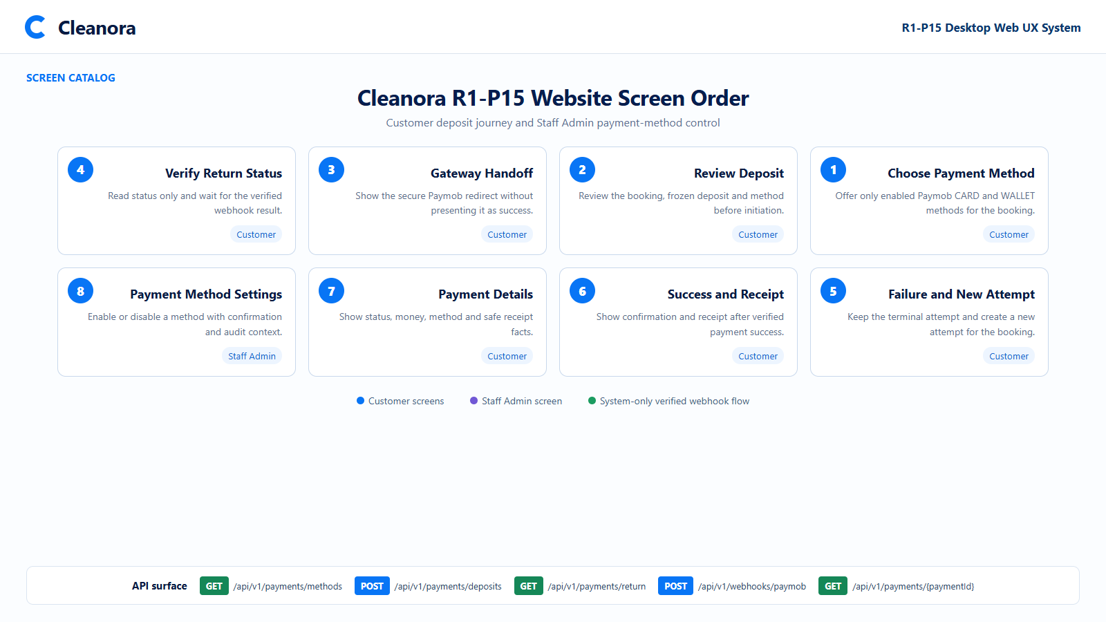
Flow reference 1 - Screen order across the verified-customer journey and Staff Admin control surface.
The screen set expresses the intended product flow. Backend state, authorization and transitions must follow the API cards in this guide.

Complete Customer Deposit Journey
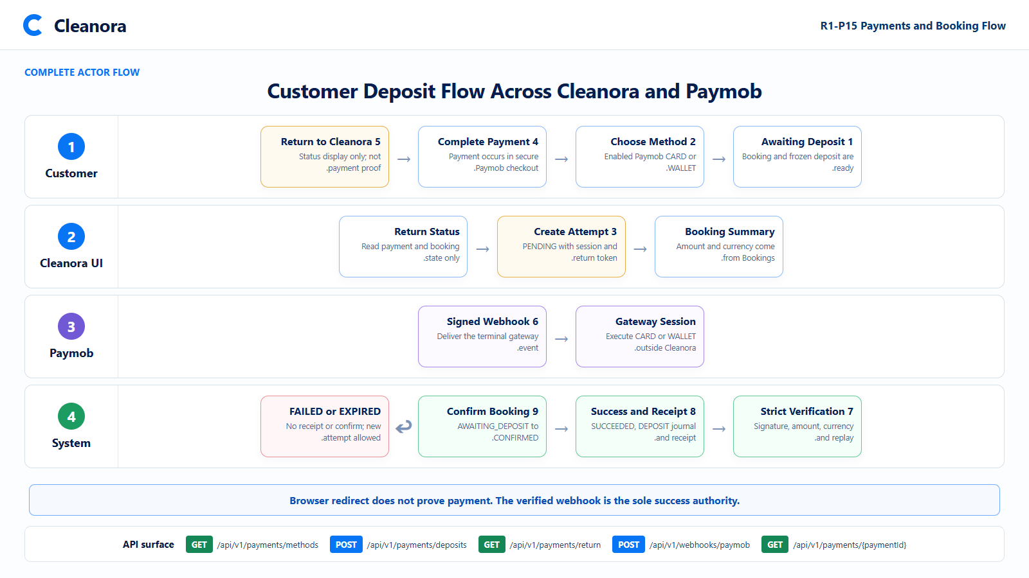
Flow reference 2 - Customer, Cleanora, Paymob and system responsibilities from AWAITING_DEPOSIT to CONFIRMED.
The frontend owns presentation and navigation. Paymob owns checkout. The system owns verification, commercial effects and booking confirmation.

Browser Return and Verified Webhook Authority
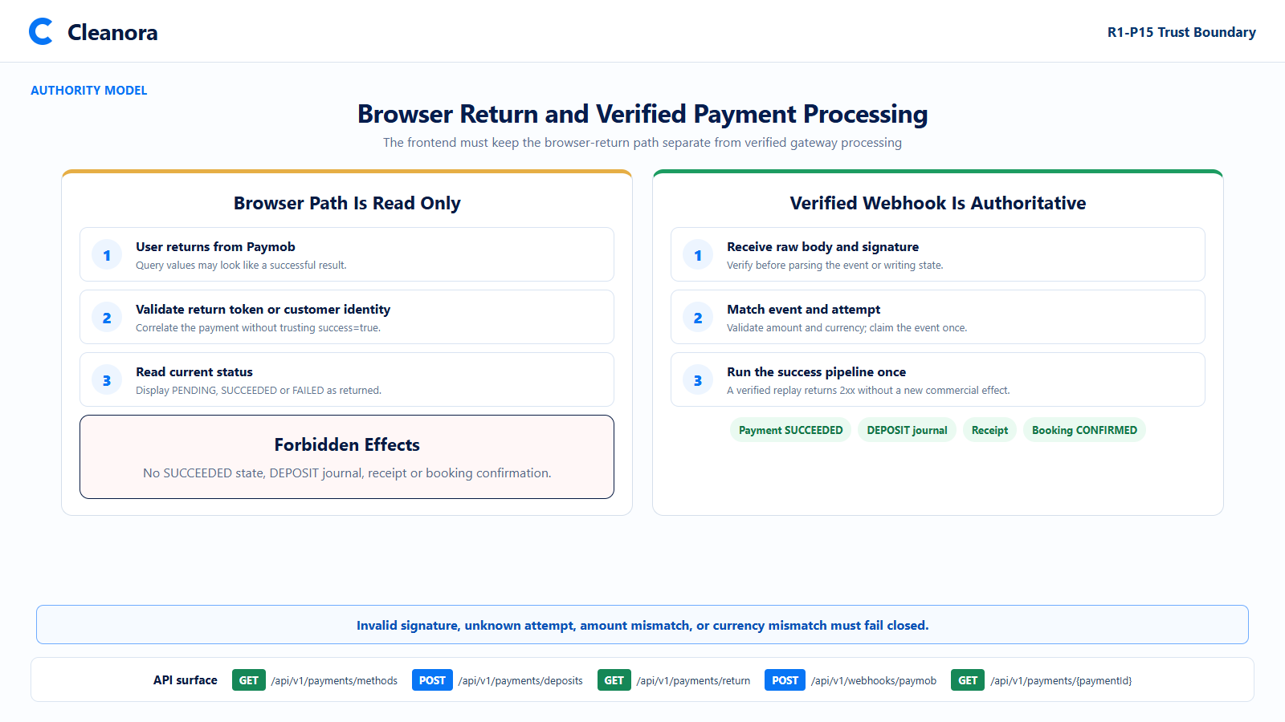
Flow reference 3 - Read-only browser return versus the verified, idempotent webhook success pipeline.
The return screen can display a later SUCCEEDED state if the webhook has already completed, but the return request itself does not create that state.

Attempt Payment and Booking State Model
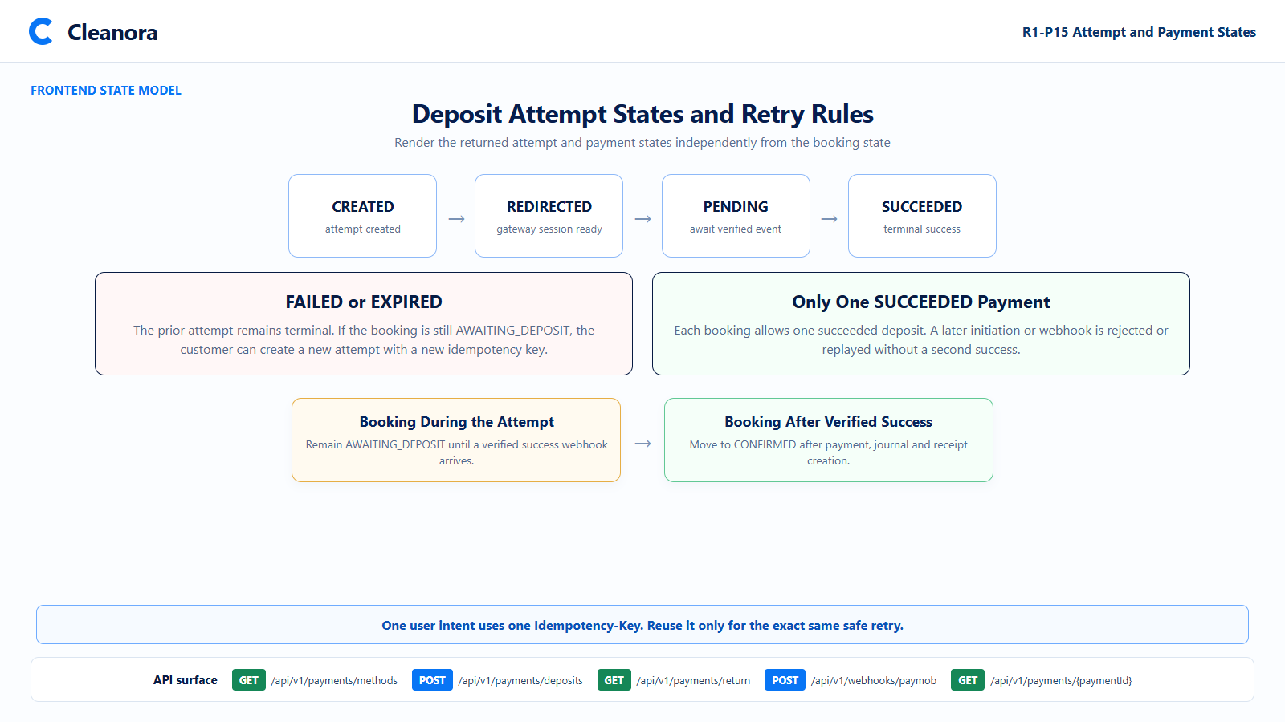
Flow reference 4 - Attempt lifecycle, retry behavior and the single-success invariant.
A failed or expired attempt remains terminal. A new attempt receives a new idempotency key and can succeed only if no prior deposit already succeeded.

PAGES FOR VERIFIED CUSTOMERS

Screen 01 Choose Payment Method
Suggested route | /customer/bookings/:bookingId/deposit
Screen purpose | Show an owned AWAITING_DEPOSIT booking and offer only the payment methods enabled for the booking country.
Visual authority | Future-state UI concept in the Phase 7 Cleanora design language. The API cards in this guide remain authoritative for behavior and integration.

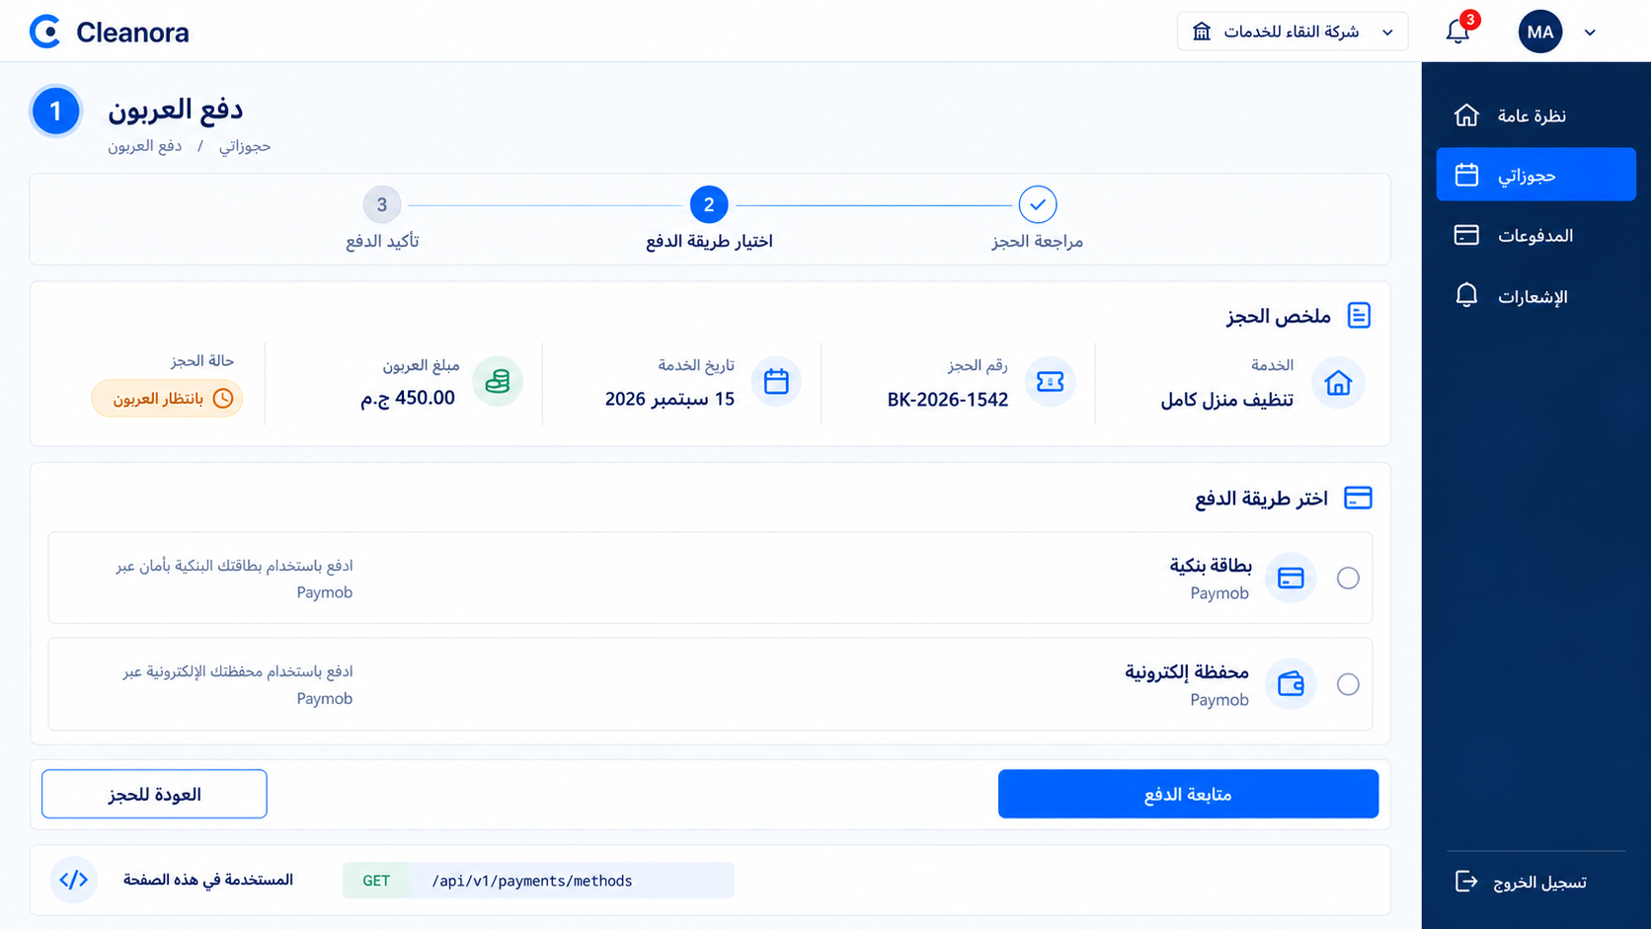
Screen 01A - Future customer payment-method selection with server-owned booking and deposit facts.

Screen 01 Frontend Flow
- Load the booking from the existing customer booking experience and require AWAITING_DEPOSIT before showing payment controls.
- Load enabled methods for the booking country. Render only returned enabled methods and keep their ids as opaque identifiers.
- Display Paymob CARD and WALLET as separate choices. Do not add a disabled or invented rail.
- Keep the deposit as amountMinorUnits plus currency metadata. Format for display without floating-point arithmetic.
- Disable Continue until exactly one returned method is selected, then navigate to deposit review without initiating payment yet.

APIs Used on This Screen
Method | Endpoint | Guide reference
GET | /api/v1/payments/methods?countryId={countryId} | API 01 detailed below

API 01 List Enabled Country Payment Methods
GET | /api/v1/payments/methods?countryId={countryId}
What it does: Returns only payment methods currently enabled for the requested active country.
Who can use it: A fully authenticated verified customer in the supported customer categories.
What it takes: Required countryId query parameter and Bearer authentication. No request body.
What it returns: items containing id, code, provider, methodKind, localized names, enabled and sortOrder.
Efficient frontend usage: Cache by countryId and invalidate after a relevant configuration change; never hard-code method ids.

API 01 Request Response and Recovery
Sample request body
No request body

Success response sample HTTP 200
{
"success": true,
"data": {
"items": [
{
"id": "pm-eg-paymob-card",
"countryId": "country-eg",
"code": "PAYMOB_CARD",
"provider": "PAYMOB",
"methodKind": "CARD",
"displayNameAr": "بطاقة بنكية",
"displayNameEn": "Bank card",
"enabled": true,
"sortOrder": 10
},
{
"id": "pm-eg-paymob-wallet",
"countryId": "country-eg",
"code": "PAYMOB_WALLET",
"provider": "PAYMOB",
"methodKind": "WALLET",
"displayNameAr": "محفظة إلكترونية",
"displayNameEn": "Mobile wallet",
"enabled": true,
"sortOrder": 20
}
]
},
"requestId": "00000000-0000-4000-8000-000000000015"
}

Copyable Axios integration
export async function listPaymentMethods(countryId: string) {
const response = await api.get('/payments/methods', {
params: { countryId },
});
return response.data.data.items;
}

Possible Error Codes and Frontend Recovery
400 VALIDATION_FAILED
Frontend recovery: Keep the booking context, highlight the invalid country value and do not retry until corrected.
401 AUTHENTICATION_REQUIRED
Frontend recovery: Refresh or reauthenticate once, then repeat this idempotent read.
403 FORBIDDEN
Frontend recovery: Route away from payment selection and refresh the authenticated customer profile.
404 NOT_FOUND
Frontend recovery: Treat the country as unavailable, clear method selection and return to the booking.

Screen 02 Review Deposit
Suggested route | /customer/bookings/:bookingId/deposit/review
Screen purpose | Confirm the server-provided booking, frozen deposit and selected method before creating a gateway attempt.
Visual authority | Future-state UI concept in the Phase 7 Cleanora design language. The API cards in this guide remain authoritative for behavior and integration.

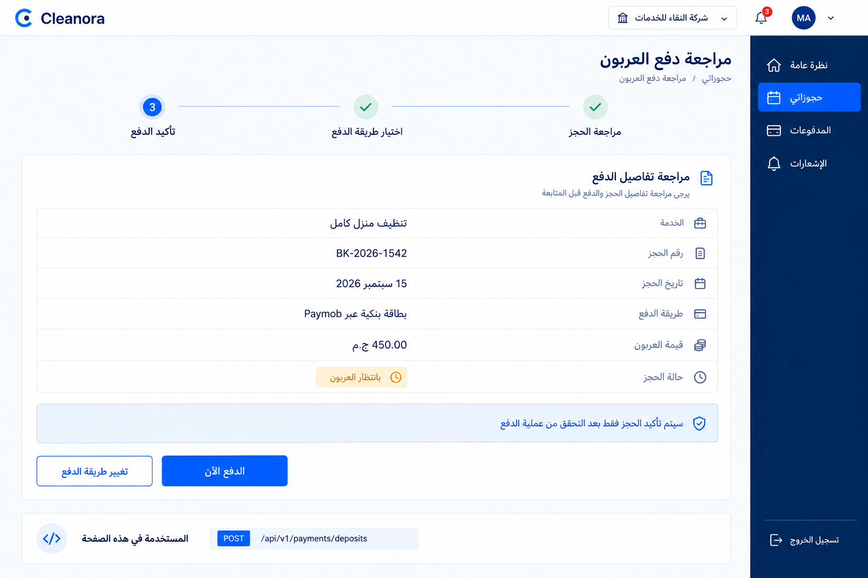
Screen 02A - Deposit review before the idempotent initiation command.

Screen 02 Frontend Flow
- Carry only bookingId and paymentMethodId into the submit command; do not send a client-calculated amount.
- Generate the Idempotency-Key when the user confirms this exact payment intent, not when the page first loads.
- Disable duplicate submit while the request is in flight. Preserve the same key for a transport retry with the same payload.
- On success, store paymentId and attemptId in transient flow state and use the returned redirectUrl for the Paymob handoff.
- Keep returnToken out of logs and analytics. Pass it only through the approved return navigation mechanism.

APIs Used on This Screen
Method | Endpoint | Guide reference
POST | /api/v1/payments/deposits | API 02 detailed below

API 02 Initiate Booking Deposit
POST | /api/v1/payments/deposits
What it does: Creates or safely replays a deposit attempt and Paymob session for an owned AWAITING_DEPOSIT booking.
Who can use it: A fully authenticated verified customer who owns the booking.
What it takes: bookingId and paymentMethodId plus the required Idempotency-Key header of 1 to 128 characters.
What it returns: paymentId, attemptId, status, exact money metadata, gateway session data and returnToken.
Critical invariant: This endpoint does not mark the payment SUCCEEDED and does not confirm the booking.

API 02 Request Response and Recovery
Sample request
POST /api/v1/payments/deposits
Authorization: Bearer <access-token>
Idempotency-Key: 23681efc-5d9d-4f92-8e85-24f7618eb645
{
"bookingId": "booking-1542",
"paymentMethodId": "pm-eg-paymob-card"
}

Success response sample HTTP 201
{
"success": true,
"data": {
"paymentId": "payment-701542",
"attemptId": "attempt-701542-01",
"status": "REDIRECTED",
"amountMinorUnits": "45000",
"currencyCode": "EGP",
"currencyDecimalPlaces": 2,
"gateway": {
"provider": "PAYMOB",
"redirectUrl": "https://accept.paymob.com/secure-session",
"sessionRef": "pmb-session-8741"
},
"returnToken": "opaque-signed-return-token"
},
"requestId": "00000000-0000-4000-8000-000000000015"
}

Copyable Axios integration
export async function initiateBookingDeposit(input: {
bookingId: string;
paymentMethodId: string;
idempotencyKey: string;
}) {
const response = await api.post('/payments/deposits',
{ bookingId: input.bookingId, paymentMethodId: input.paymentMethodId },
{ headers: { 'Idempotency-Key': input.idempotencyKey } },
);
return response.data.data;
}

API 02 Error Recovery

Possible Error Codes and Frontend Recovery
400 VALIDATION_FAILED
Frontend recovery: Map the invalid field, keep safe form state and create no new key until the user changes the intent.
404 NOT_FOUND
Frontend recovery: Use a non-enumerating booking-unavailable state and return to the customer booking list.
409 IDEMPOTENCY_CONFLICT
Frontend recovery: Never change the booking or method under the same key; create a new key only for a genuinely new intent.
409 TRANSITION_NOT_AVAILABLE
Frontend recovery: Refetch the booking. Hide payment initiation unless it is still AWAITING_DEPOSIT.
409 PAYMENT_ALREADY_SUCCEEDED
Frontend recovery: Load payment details and route to the receipt or confirmed booking state.
503 GATEWAY_MISCONFIGURED
Frontend recovery: Keep the booking unchanged, show a temporary payment-unavailable state and do not imply payment was attempted.

Screen 03 Gateway Handoff
Suggested route | /customer/payments/:paymentId/handoff
Screen purpose | Explain the external Paymob transition and continue only with the session returned by deposit initiation.
Visual authority | Future-state UI concept in the Phase 7 Cleanora design language. The API cards in this guide remain authoritative for behavior and integration.

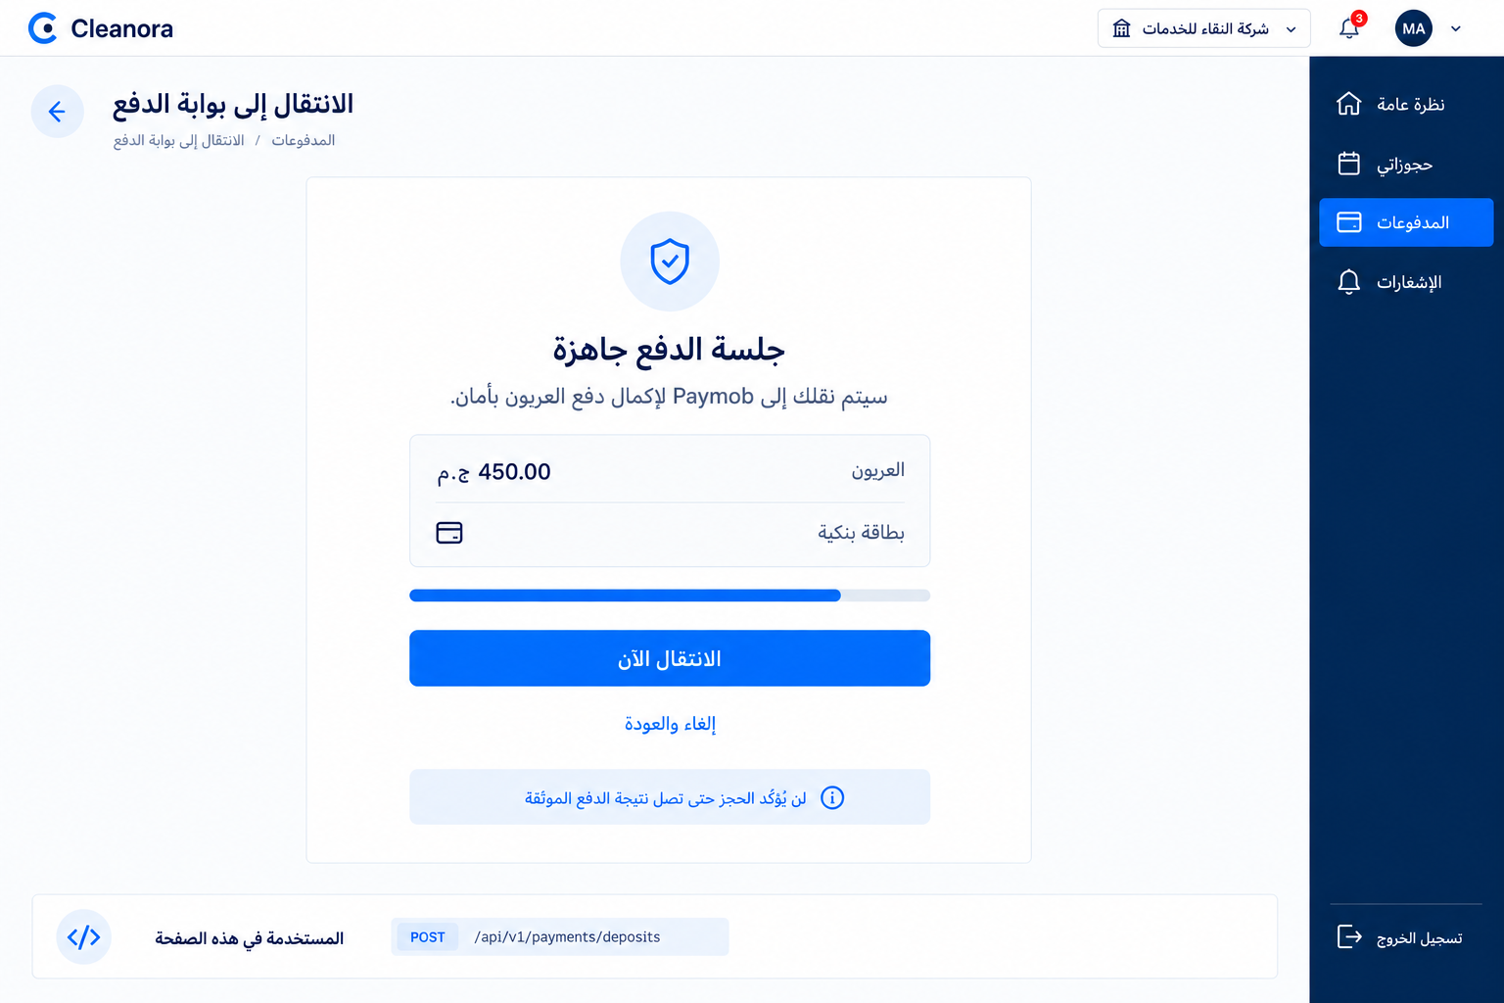
Screen 03A - Secure handoff using the returned Paymob redirect URL.

Screen 03 Frontend Flow
- Use only the redirectUrl returned by API 02. Do not construct a gateway URL or expose gateway credentials in frontend code.
- Show the deposit amount and selected method from the initiation response so the user can verify the handoff.
- Open the approved Paymob checkout in the expected navigation mode and retain only safe correlation state.
- Do not display a paid or confirmed result after redirect. Navigate to the return-status screen and read authoritative state.
- If redirectUrl is absent, treat initiation as incomplete and do not attempt an invented fallback rail.

APIs Used on This Screen
Method | Endpoint | Guide reference
POST | /api/v1/payments/deposits | API 02 detailed on Screen 02

The Paymob checkout itself is external and is not a Cleanora-owned screen. Its exact card and wallet fields follow gateway configuration, security and compliance requirements.

Screen 04 Verify Return Status
Suggested route | /payments/return
Screen purpose | Display the current payment and booking status after Paymob returns the browser without treating redirect data as proof.
Visual authority | Future-state UI concept in the Phase 7 Cleanora design language. The API cards in this guide remain authoritative for behavior and integration.

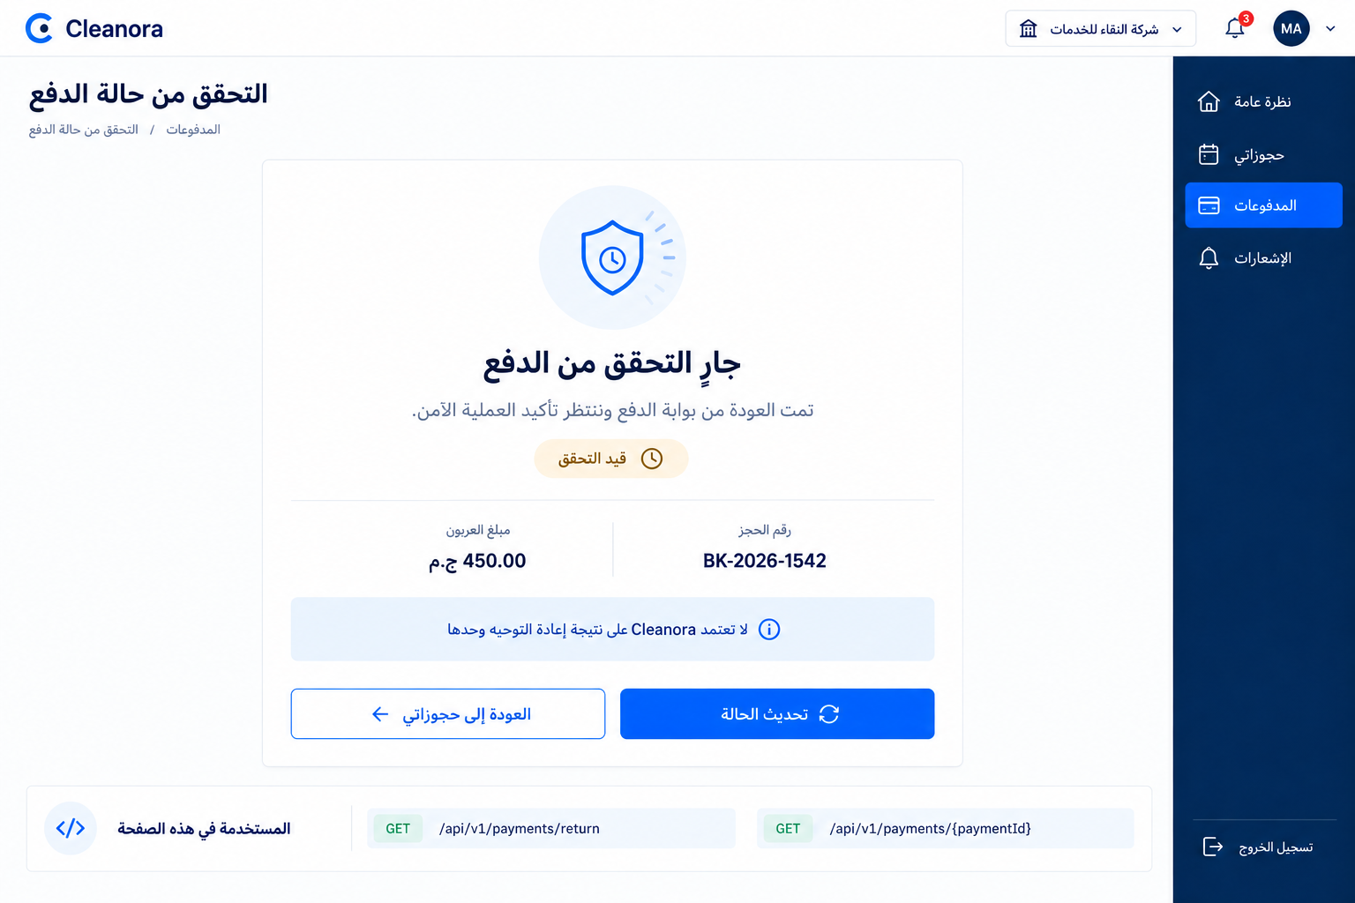
Screen 04A - Read-only browser-return status while verified processing is pending.

Screen 04 Frontend Flow
- Call the return endpoint with the issued paymentId or attemptId and either the signed returnToken or the authenticated customer session.
- Ignore success=true and every other gateway echo parameter as payment authority.
- Render PENDING as a verification state and offer a deliberate Refresh action with bounded polling rather than an endless spinner.
- If the endpoint already returns SUCCEEDED and the booking is CONFIRMED, route to the success and receipt screen.
- If it returns FAILED, route to retry. If the correlation cannot be resolved, fail closed and return to the booking list.

APIs Used on This Screen
Method | Endpoint | Guide reference
GET | /api/v1/payments/return | API 03 detailed below
GET | /api/v1/payments/{paymentId} | API 05 detailed on Screen 06

API 03 Get Browser Return Status
GET | /api/v1/payments/return
What it does: Returns the current payment and booking status projection after browser return.
Who can use it: An authenticated customer or a caller holding the signed opaque returnToken issued for the attempt.
What it takes: paymentId, attemptId or returnToken query correlation. No request body.
What it returns: paymentId, attemptId, paymentStatus, bookingStatus and a safe status message.
Critical invariant: The handler writes no paid state, ledger journal, receipt or booking confirmation.

API 03 Request Response and Recovery
Sample request
GET /api/v1/payments/return
?paymentId=payment-701542
&attemptId=attempt-701542-01
&returnToken=opaque-signed-return-token
&success=true

Success response sample HTTP 200
{
"success": true,
"data": {
"paymentId": "payment-701542",
"attemptId": "attempt-701542-01",
"paymentStatus": "PENDING",
"bookingStatus": "AWAITING_DEPOSIT",
"message": "Browser return is status-only; webhook remains payment authority"
},
"requestId": "00000000-0000-4000-8000-000000000015"
}

Copyable Axios integration
export async function getPaymentReturnStatus(params: {
paymentId?: string;
attemptId?: string;
returnToken?: string;
}) {
const response = await api.get('/payments/return', { params });
return response.data.data;
}

Possible Error Codes and Frontend Recovery
401 AUTHENTICATION_REQUIRED
Frontend recovery: Require a customer session when no signed return token is available.
403 FORBIDDEN
Frontend recovery: Discard the invalid return token and do not reveal payment or booking details.
404 NOT_FOUND
Frontend recovery: Show a safe unresolved-payment state and return to My Bookings without inferring failure or success.
400 VALIDATION_FAILED
Frontend recovery: Remove malformed correlation values and do not retry with untrusted gateway query data.

Screen 05 Failure and New Attempt
Suggested route | /customer/payments/:paymentId/retry
Screen purpose | Explain a FAILED or EXPIRED terminal attempt and let the customer create a new attempt while the booking still awaits deposit.
Visual authority | Future-state UI concept in the Phase 7 Cleanora design language. The API cards in this guide remain authoritative for behavior and integration.

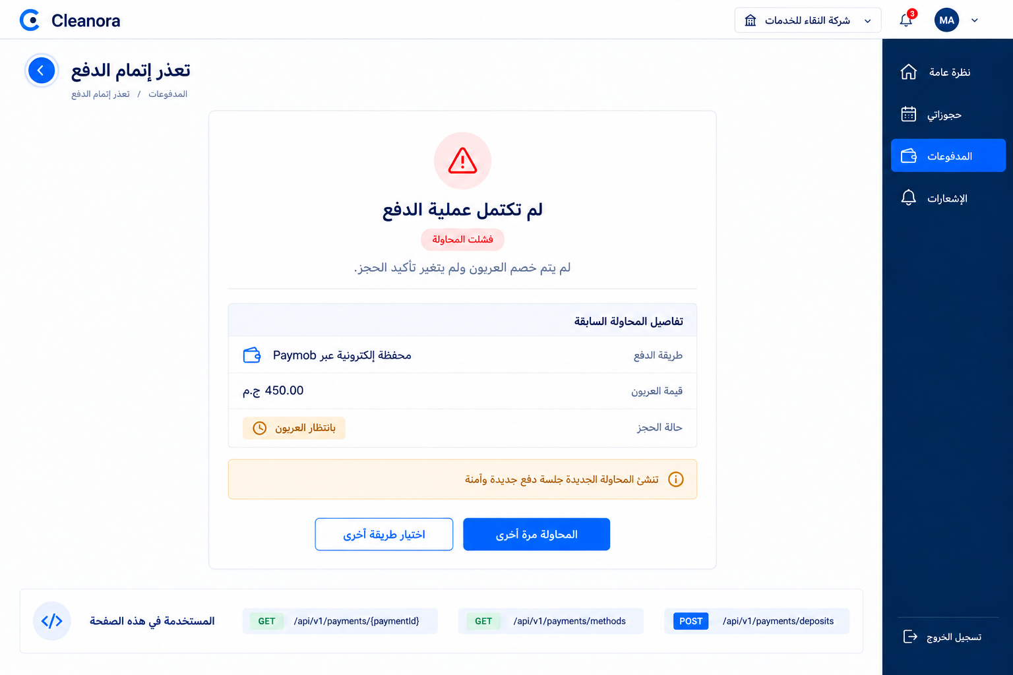
Screen 05A - Failure state that preserves the prior attempt and starts a new intent safely.

Screen 05 Frontend Flow
- Load payment detail and refetch the booking before presenting retry. The booking must still be AWAITING_DEPOSIT.
- Keep the prior FAILED or EXPIRED attempt visible as history; do not reset or mutate it in the browser.
- Reload enabled methods because Staff Admin configuration may have changed since the prior attempt.
- Generate a new Idempotency-Key for the new intent. A prior key belongs only to the prior payload and attempt.
- If the payment already succeeded concurrently, stop retry and route to the successful payment details.

APIs Used on This Screen
Method | Endpoint | Guide reference
GET | /api/v1/payments/{paymentId} | API 05 detailed on Screen 06
GET | /api/v1/payments/methods | API 01 detailed on Screen 01
POST | /api/v1/payments/deposits | API 02 detailed on Screen 02

Screen 06 Success and Receipt
Suggested route | /customer/payments/:paymentId/success
Screen purpose | Show the receipt and confirmed booking only after the server returns a SUCCEEDED payment and the booking is CONFIRMED.
Visual authority | Future-state UI concept in the Phase 7 Cleanora design language. The API cards in this guide remain authoritative for behavior and integration.

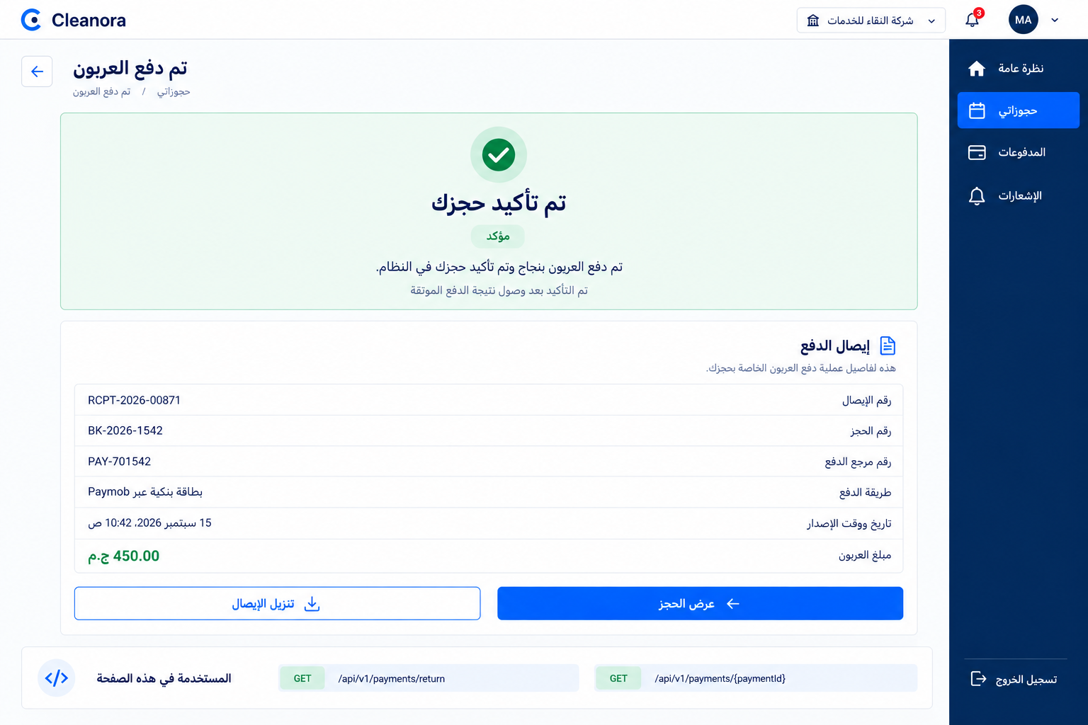
Screen 06A - Verified success, booking confirmation and immutable receipt facts.

Screen 06 Frontend Flow
- Read payment detail after the return status reports success or when the user opens a known payment reference.
- Render status, amount, currency, method code and receipt facts exactly as returned.
- Link to the confirmed booking only after the booking projection is also authoritative; do not infer confirmation from the receipt alone.
- Do not show full raw gateway payloads, signatures, secrets or card data. providerRef is an optional safe reference only.
- Receipt download can be implemented from returned receipt facts, but P15 exposes no separate receipt-file endpoint. Do not invent one.

APIs Used on This Screen
Method | Endpoint | Guide reference
GET | /api/v1/payments/{paymentId} | API 05 detailed below

API 05 Get Payment and Receipt
GET | /api/v1/payments/{paymentId}
What it does: Returns one payment and its optional receipt projection.
Who can use it: The owning customer or an active Staff Admin.
What it takes: paymentId path parameter and Bearer authentication. No request body.
What it returns: payment, booking, purpose, status, exact money, method code and optional receipt facts.
Privacy rule: A non-owner receives a non-enumerating denial and no gateway secret or sensitive payload is exposed.

API 05 Request Response and Recovery
Sample request body
No request body

Success response sample HTTP 200
{
"success": true,
"data": {
"paymentId": "payment-701542",
"bookingId": "booking-1542",
"purpose": "BOOKING_DEPOSIT",
"status": "SUCCEEDED",
"amountMinorUnits": "45000",
"currencyCode": "EGP",
"currencyDecimalPlaces": 2,
"methodCode": "PAYMOB_CARD",
"receipt": {
"receiptId": "receipt-00871",
"issuedAt": "2026-09-15T08:42:00.000Z",
"providerRef": "PMB-8741"
}
},
"requestId": "00000000-0000-4000-8000-000000000015"
}

Copyable Axios integration
export async function getPayment(paymentId: string) {
const response = await api.get(`/payments/${paymentId}`);
return response.data.data;
}

Possible Error Codes and Frontend Recovery
401 AUTHENTICATION_REQUIRED
Frontend recovery: Refresh or reauthenticate once, then repeat this idempotent read.
403 FORBIDDEN
Frontend recovery: Remove payment data from memory and navigate to a safe access-denied state.
404 NOT_FOUND
Frontend recovery: Do not reveal whether the payment exists outside the reader's scope; return to the appropriate payment or booking list.

Screen 07 Payment Details
Suggested route | /customer/payments/:paymentId
Screen purpose | Present the durable payment record and optional receipt as a reusable customer or Staff Admin detail projection.
Visual authority | Future-state UI concept in the Phase 7 Cleanora design language. The API cards in this guide remain authoritative for behavior and integration.

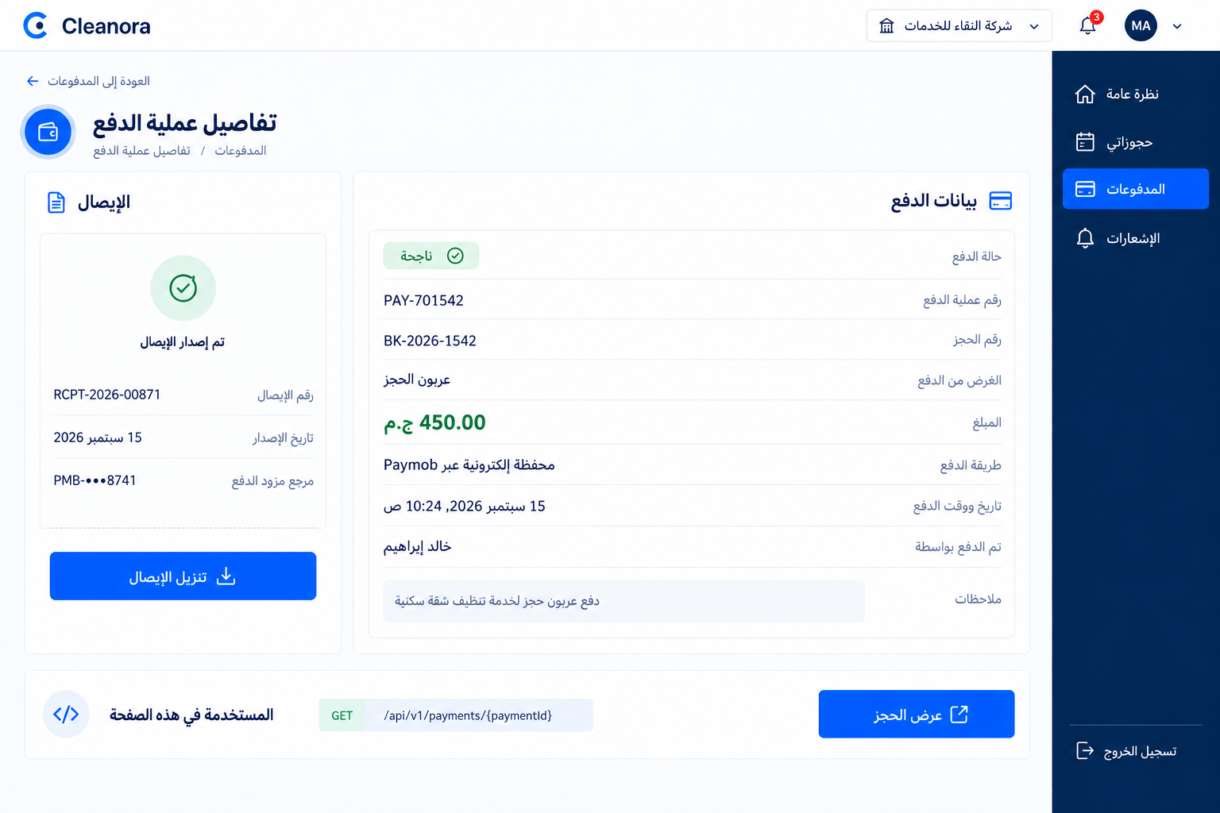
Screen 07A - Payment details with safe receipt facts and no raw gateway payload.

Screen 07 Frontend Flow
- Use one typed payment-details component for owner customer and Staff Admin readers, but apply actor-specific surrounding navigation and controls.
- Format minor units using currencyDecimalPlaces. Keep the original digit string available for exact comparisons and audit display.
- Render the receipt section only when receipt is present. PENDING and FAILED payments legitimately have no receipt.
- Do not expose a refund execution control. Refund requests are an internal foundation in P15 and have no HTTP route in this phase.
- Do not infer a customer payment list endpoint from this detail route. P15 publishes only direct detail by paymentId.

APIs Used on This Screen
Method | Endpoint | Guide reference
GET | /api/v1/payments/{paymentId} | API 05 detailed on Screen 06

SYSTEM AND GATEWAY INTEGRATION

Paymob Verified Webhook Processing
System reference - The webhook is the only HTTP path that can create payment-success effects.
This operation has no frontend screen or Axios wrapper. The UI observes its outcome through the return-status and payment-detail reads.

API 04 Process Paymob Webhook
POST | /api/v1/webhooks/paymob
What it does: Verifies the Paymob signature over the raw request body and processes the gateway event idempotently.
Who can use it: Paymob through the signature-gated server-to-server callback. It has no user principal.
What it takes: Raw bytes exactly as delivered and the hmac, x-paymob-hmac or x-hmac signature header.
What it returns: A 200 accepted result including replayed and, when applicable, paymentId.
Success authority: A verified success may mark SUCCEEDED, post the DEPOSIT journal, create the receipt and confirm the booking.
Replay rule: A duplicate verified event returns successfully without a second payment, journal, receipt or confirmation.

Representative server callback
POST /api/v1/webhooks/paymob
Content-Type: application/json
hmac: <paymob-signature>
<raw Paymob request bytes>

Accepted response sample HTTP 200
{
"success": true,
"data": {
"replayed": false,
"paymentId": "payment-701542"
},
"requestId": "00000000-0000-4000-8000-000000000015"
}

Possible Error Codes and Frontend Recovery
401 WEBHOOK_SIGNATURE_INVALID
Frontend recovery: Frontend action is not applicable. Operations should alert on rejected signature volume; no payment or booking mutation occurs.
400 VALIDATION_FAILED
Frontend recovery: Treat the verified body as malformed and investigate gateway contract drift; do not mark paid.
409 AMOUNT_MISMATCH
Frontend recovery: Fail closed, preserve evidence and surface the payment as unresolved for operations; do not confirm the booking.
503 DEPENDENCY_FAILURE
Frontend recovery: Allow gateway retry according to the integration policy and preserve idempotency; do not simulate success in the UI.

PAGES FOR STAFF ADMIN

Screen 08 Payment Method Settings
Suggested route | /staff/payments/methods/:methodId
Screen purpose | Let an active Staff Admin enable or disable a known country payment method with an explicit confirmation step.
Visual authority | Future-state UI concept in the Phase 7 Cleanora design language. The API cards in this guide remain authoritative for behavior and integration.

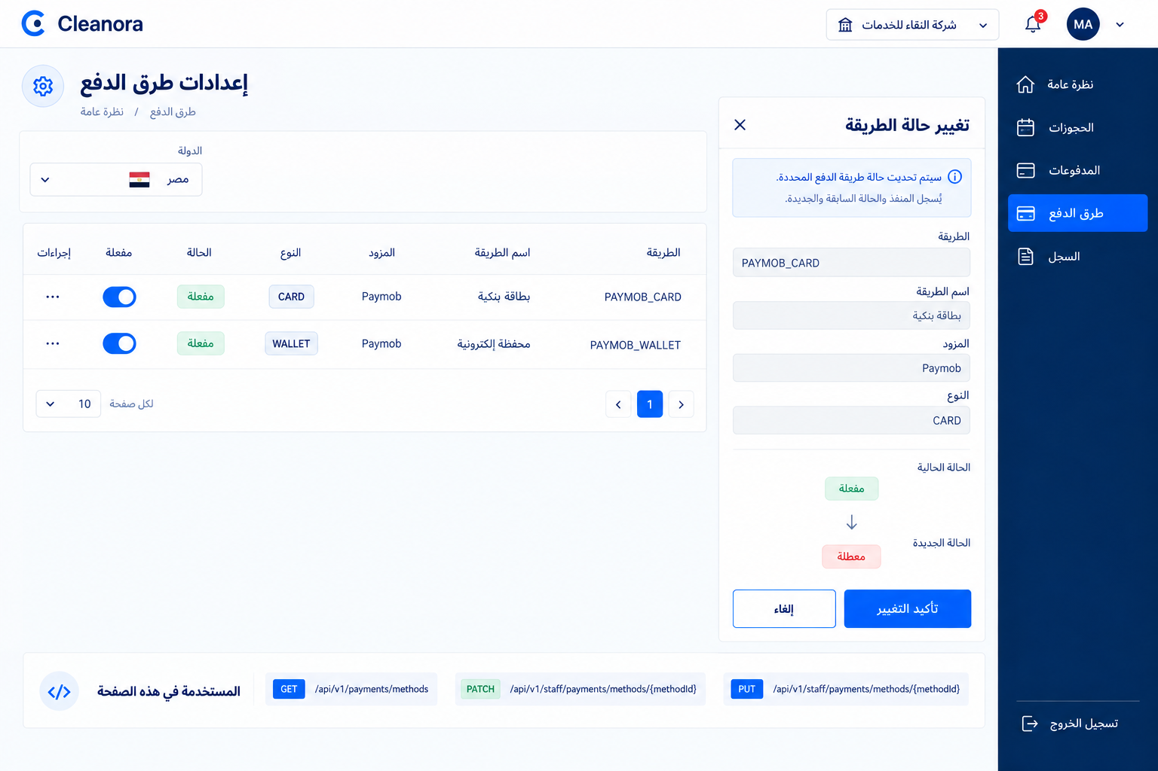
Screen 08A - Future Staff Admin configuration view with a focused enable or disable confirmation.

Screen 08 Frontend Flow
- Require an active Staff Admin session before rendering the control and re-check authorization on every mutation.
- Show the method identity, country, provider, kind and current enabled state. The mutation body contains enabled only.
- Use either PATCH for a partial state change or PUT with the same P15 semantics. Do not send a method definition replacement payload.
- Confirm the before and after states before submit, disable duplicate submit and refetch the authoritative method after success.
- Record the actor and before or after state through backend audit behavior; the frontend must not fabricate an audit result.
Implementation boundary: P15 does not publish a Staff Admin list endpoint. The full table shown in the concept requires an approved staff-facing read projection before production. Do not reuse the verified-customer methods endpoint as a staff configuration list.

APIs Used on This Screen
Method | Endpoint | Guide reference
PATCH | /api/v1/staff/payments/methods/{methodId} | API 06 detailed below
PUT | /api/v1/staff/payments/methods/{methodId} | API 07 detailed below

API 06 Patch Payment Method Enabled State
PATCH | /api/v1/staff/payments/methods/{methodId}
What it does: Changes the enabled state of one known payment method.
Who can use it: An active Staff Admin.
What it takes: methodId path parameter and body containing enabled as a boolean.
What it returns: The updated method projection with country, code, provider, kind, localized names and enabled state.
Audit rule: The privileged write should preserve actor and before or after facts in backend audit records.

API 06 Request Response and Recovery
Sample request
PATCH /api/v1/staff/payments/methods/pm-eg-paymob-card
Authorization: Bearer <staff-admin-access-token>
{
"enabled": false
}

Success response sample HTTP 200
{
"success": true,
"data": {
"id": "pm-eg-paymob-card",
"countryId": "country-eg",
"code": "PAYMOB_CARD",
"provider": "PAYMOB",
"methodKind": "CARD",
"displayNameAr": "بطاقة بنكية",
"displayNameEn": "Bank card",
"enabled": false,
"sortOrder": 10
},
"requestId": "00000000-0000-4000-8000-000000000015"
}

Copyable Axios integration
export async function patchPaymentMethod(
methodId: string,
enabled: boolean,
) {
const response = await api.patch(
`/staff/payments/methods/${methodId}`,
{ enabled },
);
return response.data.data;
}

Possible Error Codes and Frontend Recovery
400 VALIDATION_FAILED
Frontend recovery: Keep the dialog open and require a boolean enabled value.
401 AUTHENTICATION_REQUIRED
Frontend recovery: Reauthenticate and do not replay the write automatically.
403 FORBIDDEN
Frontend recovery: Hide the control after capability refresh and never attempt client-side role escalation.
404 NOT_FOUND
Frontend recovery: Close the stale method context and refetch from an approved staff read source when available.

API 07 Put Payment Method Enabled State
PUT | /api/v1/staff/payments/methods/{methodId}
Semantics: P15 allows PUT with the same minimal enabled-state behavior as PATCH.
Request: The path contains methodId and the body is exactly enabled as a boolean.
Response: The updated PaymentMethodPublic projection returned with HTTP 200.
Frontend choice: Choose one method consistently in the client service. PATCH best expresses the partial state update.

Copyable Axios integration
export async function putPaymentMethod(
methodId: string,
enabled: boolean,
) {
const response = await api.put(
`/staff/payments/methods/${methodId}`,
{ enabled },
);
return response.data.data;
}

Possible Error Codes and Frontend Recovery
400 VALIDATION_FAILED
Frontend recovery: Keep the current server state visible and correct the body before an explicit retry.
401 AUTHENTICATION_REQUIRED
Frontend recovery: Reauthenticate and ask the Staff Admin to confirm the state change again.
403 FORBIDDEN
Frontend recovery: Remove the mutation control and refresh Staff Admin capability state.
404 NOT_FOUND
Frontend recovery: Discard the stale method id and return to a safe configuration entry point.

Absent Screens and Phase Boundaries
Important: Phase 15 contains a narrow deposit-payment surface. Frontend implementation must not imply capabilities that the backend contract does not provide.
- No Cleanora stored-value wallet, wallet balance, top-up, transfer or withdrawal screen exists. Paymob WALLET means an external payment rail, not a Cleanora balance.
- No executable InstaPay route, callback or selection exists. Egypt enables Paymob CARD and Paymob WALLET only.
- No browser redirect can mark paid or confirm a booking. Only the verified gateway-event path owns those effects.
- No customer or Staff Admin gateway-refund execution screen exists. P15 can record an internal refund request in REQUESTED only and publishes no refund HTTP endpoint.
- No full Staff finance console, reconciliation list, payment search or method-list administration endpoint is published in P15.
- No remaining-balance or cash-on-delivery collection, payout execution, provider accept, assignment or order-execution screen belongs to this phase.
- No customer payment-list endpoint is published. The frontend can render direct payment detail only when it already has an authorized paymentId.
- Do not expose raw gateway events, HMAC material, environment secrets, return-token hashes, complete unsigned payloads or cardholder data.

Refund Request Foundation
The payments public contract can create a RefundRequest row in REQUESTED state for a SUCCEEDED payment. The function executes no Paymob refund and posts no REFUND journal. Because P15 exposes no HTTP operation for this method, the frontend must not add a refund button or fabricate a success state.

Stable Payment Error Matrix
HTTP | Code | Frontend treatment
400 | VALIDATION_FAILED | Map field issues or show a safe malformed-request state. Do not retry unchanged input.
401 | AUTHENTICATION_REQUIRED | Refresh or reauthenticate for reads. Require explicit reconfirmation for writes.
401 | WEBHOOK_SIGNATURE_INVALID | No frontend retry. Operations investigate; no payment effects occurred.
403 | FORBIDDEN | Hide unauthorized controls and avoid revealing resource existence.
404 | NOT_FOUND | Clear stale selection and return to a safe booking or payment entry point.
409 | CONFLICT | Refetch payment and booking state before any explicit retry.
409 | IDEMPOTENCY_CONFLICT | Never change the payload under the same Idempotency-Key.
409 | TRANSITION_NOT_AVAILABLE | Use the returned booking or payment state and remove the unavailable action.
409 | PAYMENT_ALREADY_SUCCEEDED | Load payment detail and route to success instead of initiating again.
409 | AMOUNT_MISMATCH | Fail closed. Do not confirm, display paid or retry automatically.
503 | GATEWAY_MISCONFIGURED | Keep booking state unchanged and show temporary payment unavailability.
503 | DEPENDENCY_FAILURE | Preserve the intent and use controlled retry only when safe; never simulate success.

Loading Empty and Stale States
- Methods loading: retain the booking summary but disable payment continuation.
- No enabled methods: explain that deposit payment is temporarily unavailable and offer return to the booking.
- Pending verification: use bounded refresh with visible last-updated time and no success animation.
- Stale method after Staff Admin change: refetch methods, clear the selection and require a new explicit choice.
- Unknown return correlation: reveal no commercial facts and send the user to My Bookings.

Frontend Delivery Checklist
Definition of done: The frontend is ready when all eight screens follow the R1-P15 contract, preserve gateway trust boundaries and add no behavior owned by another phase.
- All six frontend endpoint wrappers are typed once and shared across screens. No frontend wrapper exists for the Paymob webhook.
- Payment-method selection uses only server-returned enabled methods for the booking country.
- Every deposit initiation uses one Idempotency-Key per exact intent and never sends a client-calculated amount.
- returnToken and payment secrets never enter logs, analytics, localStorage or durable client state.
- Redirect values never change payment or booking state in the browser.
- PENDING, FAILED, EXPIRED and SUCCEEDED states have distinct UI treatments and recovery paths.
- A retry creates a new attempt and a new idempotency key only while the booking still awaits deposit.
- The successful receipt view is driven by GET payment detail after verified server success.
- Staff Admin method changes require explicit confirmation and use PATCH or PUT with enabled only.
- The full Staff Admin list concept is not shipped until an approved staff-facing read projection exists.
- No stored-value wallet, InstaPay, refund execution, remaining-balance collection or payout UI is introduced.
- Responsive, keyboard, focus, screen-reader, empty, loading, error and stale-state behavior is verified before release.

Canonical Implementation Sources
- specs/R1-P15-deposit-payments-methods-webhooks/spec.md
- specs/R1-P15-deposit-payments-methods-webhooks/contracts/http-api.md
- specs/R1-P15-deposit-payments-methods-webhooks/contracts/payments-deposit-public-contract.md
- docs/apis/openapi/r1-p15-deposit-payments-methods-webhooks.yaml
- src/modules/payments/payments.controller.ts
- src/modules/payments/payments.routes.ts
- src/modules/payments/payments.schemas.ts
- src/modules/payments/payments.public.ts
- Cleanora R1-P07 Frontend Screens and API Integration Guide visual reference

