|  |  |
| --- | --- |
| **Name** | حسام محمد عبدالمعطى |
| **B.N** | 288 |
| **Date** | 2-6-2020 |
| **Topic** | Programming Languages |
| **Github link** |  |
| **Github page** |  |

**\*Application brief \***

The programming language is an educational system to describe mathematics in a form readable by machine and readable by man. The programming language is a tool for a class of problem areas to develop actionable models. Each language is easy to pronounce, but to facilitate its pronunciation this requires learning the structure and basis of the language. The programming languages are regarded as a communication tool between programmers. It is characterized by numerous uses. Some programming languages are used to create programs for problem solving or data interpretation.

**\*Screenshots\***

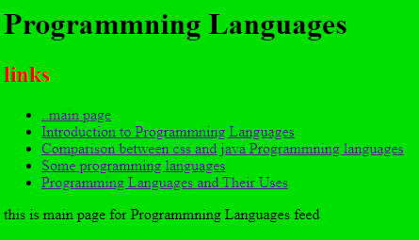

**1**

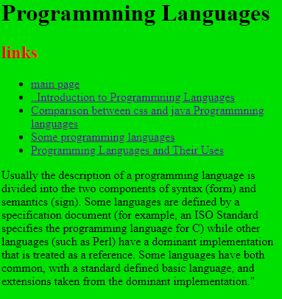

**2**

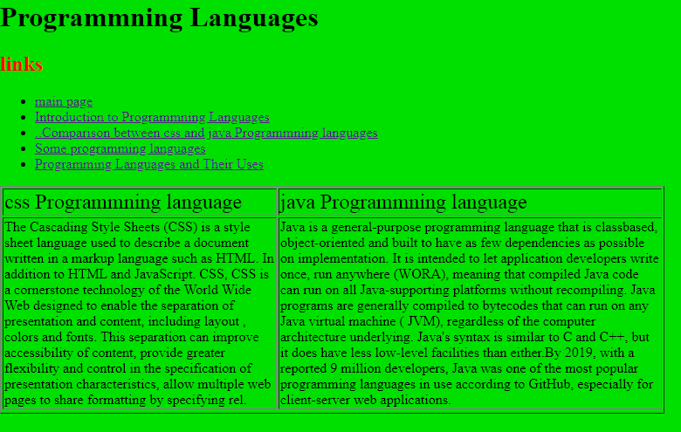

**3**

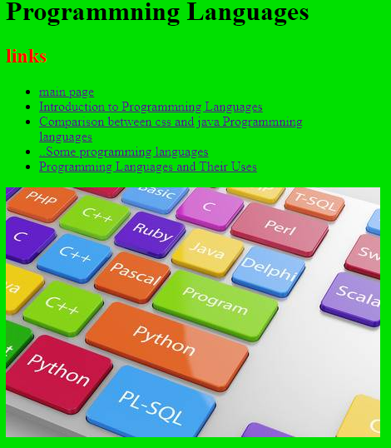

**4**

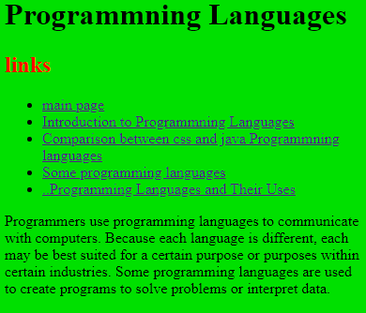

**5**

**Source code**

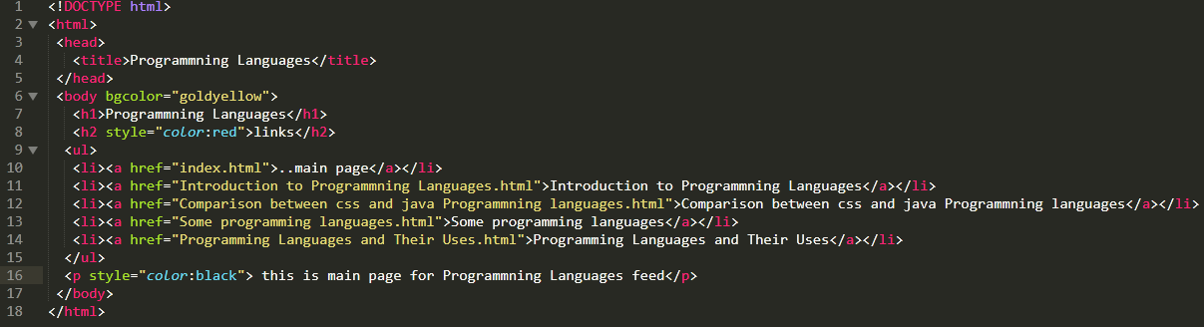

**Code of 1**

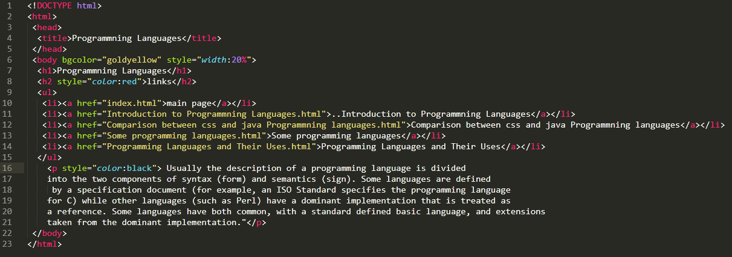

**Code of 2**

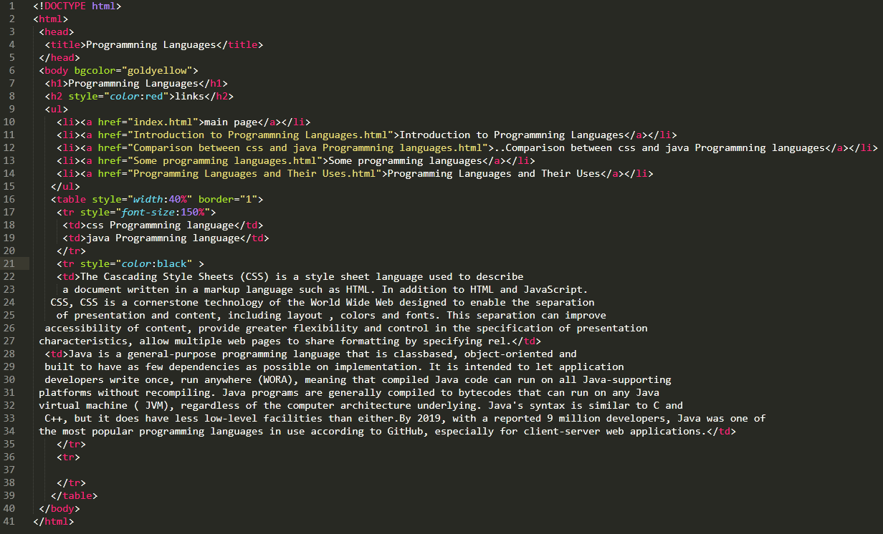

**Code of 3**

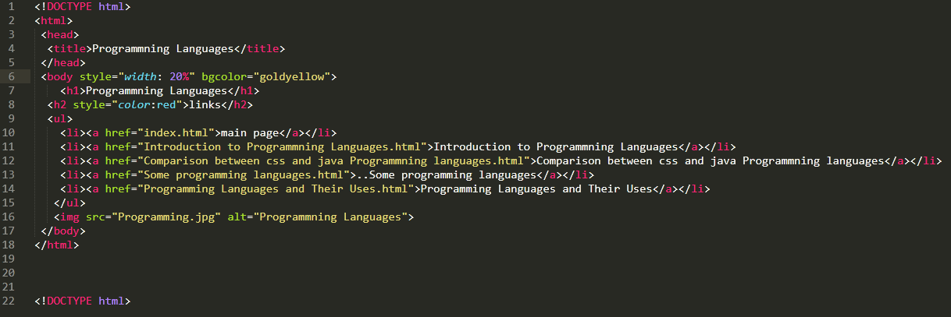

**Code of 4**

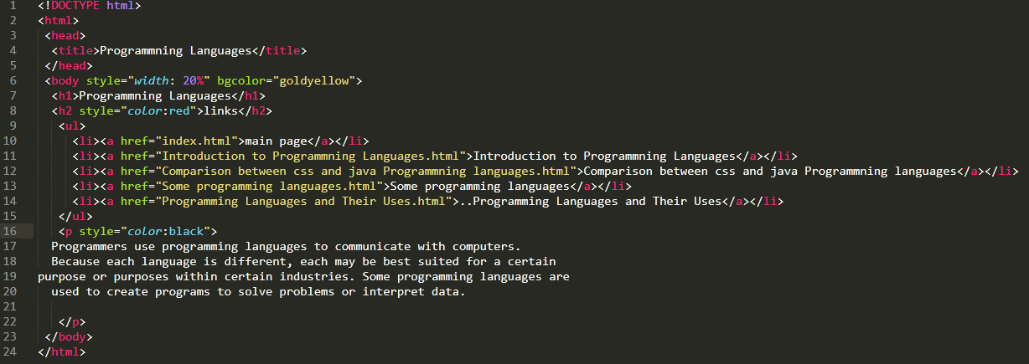

**Code of 5**