Face Recognition

Yahia Ibrahim AlKaranshawy, Hossam Osama Iraqi, Ali Hassan Ali

Abril 29, 2025

# Problem statement

It’s required to implement a PCA, kmeans model and GMM model from scratch and compare the performance of the two approaches with the PCA using [AT&T Database of Faces](https://www.kaggle.com/datasets/kasikrit/att-database-of-faces)[.](https://www.kaggle.com/datasets/fedesoriano/heart-failure-prediction)

## Dataset Loading and Preprocessing

We used the **ORL face dataset** (also known as the AT&T face dataset), which contains:

* **40 subjects**, each with **10 grayscale facial images**
* Each image has a resolution of **92×112 pixels**, resulting in **10304 features** when flattened

The dataset was loaded using OpenCV (cv2). Each image was converted to grayscale and flattened into a 1D vector of size 10304. These vectors were stacked to form the **data matrix** D, and corresponding subject IDs (1 to 40) were stored in the **label vector** y.

## Dataset Splitting

To ensure balanced training and testing across all subjects, we split the dataset using the following strategy:

* For each subject (10 images), we selected:
  + **5 images** for **training** → **odd-indexed images** (1st, 3rd, 5th, 7th, 9th)
  + **5 images** for **testing** → **even-indexed images** (2nd, 4th, 6th, 8th, 10th)

This resulted in:

* **Training set**: 200 samples (5 per subject × 40 subjects)
* **Testing set**: 200 samples (5 per subject × 40 subjects)

# PCA

implemented PCA **from scratch** to reduce the dimensionality of the facial dataset.

**PCA Process:**

1. **Center the data** by subtracting the mean.
2. **Compute covariance matrix** of the centered data.
3. **Compute eigenvalues and eigenvectors** of the covariance matrix.
4. **Sort** them in descending order of eigenvalues.
5. **Choose the number of components** to retain a desired percentage α of the total variance.

🎯 Results for Different α (Variance Thresholds)

|  |  |
| --- | --- |
| α (Variance Retained) | Number of Components |
| 0.80 (80%) | 36 |
| 0.85 (85%) | 52 |
| 0.90 (90%) | 76 |
| 0.95 (95%) | 115 |

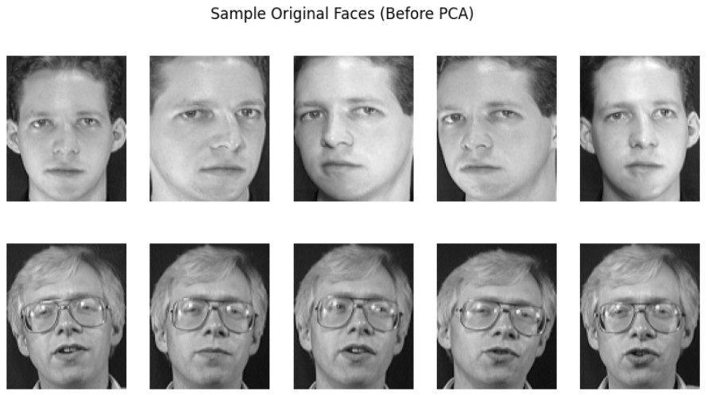

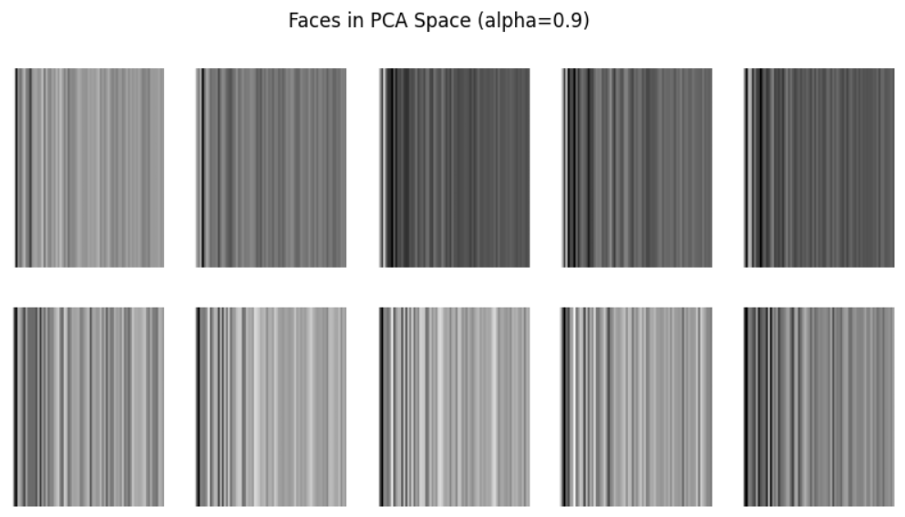**After PCA**

# GMM

This implementation fits a **Gaussian Mixture Model (GMM)** using the **Expectation-Maximization (EM)** algorithm.

**Model Equation:**

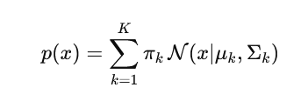

**Steps:**

**1. Initialization**

* Means μₖ: via KMeans
* Weights πₖ: proportional to cluster sizes
* Covariances Σₖ: empirical with regularization

**2. E-Step (Expectation):**

Compute responsibilities:

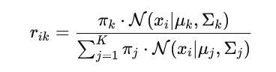

(log-sum-exp used for numerical stability)

**3. M-Step (Maximization):**

Update parameters using the computed responsibilities:

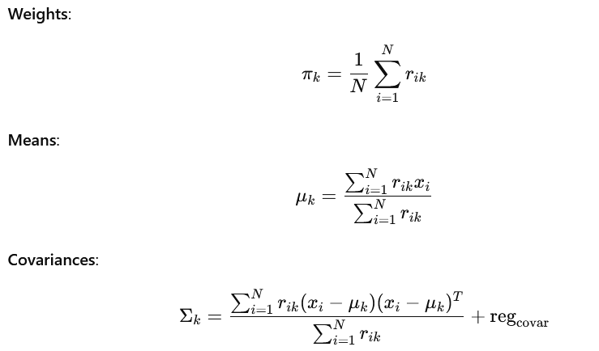

**4. Convergence Check:**

Stop if log-likelihood change is below tolerance:

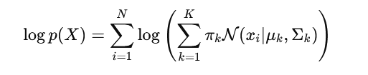

# Bonus

As part of the bonus objective, we implemented a **simple autoencoder** to perform **nonlinear dimensionality reduction** on the facial dataset, followed by **K-Means** and **Gaussian Mixture Model (GMM)** clustering on the learned latent representations.

**🧠 Autoencoder Architecture**

The autoencoder was implemented using **PyTorch** and consists of:

* **Input layer:** 10304 neurons (92×112 pixel images)
* **Encoder:**
  + Linear(10304 → 1024) → ReLU
  + Linear(1024 → 256) → ReLU
  + Linear(256 → 50) → Latent space (bottleneck)
* **Decoder (mirror structure):**
  + Linear(50 → 256) → ReLU
  + Linear(256 → 1024) → ReLU
  + Linear(1024 → 10304) → Sigmoid (to normalize output to [0, 1])

The model was trained using **Mean Squared Error (MSE) loss** and **Adam optimizer** for 100 epochs on the training set.

**🔍 Bottleneck Feature Extraction**

Once trained, we used the encoder part of the autoencoder to extract **50-dimensional latent features** from the input data. These features capture essential facial characteristics while filtering out noise and redundancy.

**🧪 Clustering in Latent Space**

Using the 50D encoded features, we applied:

* **K-Means clustering** with k=40 (matching the number of subjects)
* **GMM clustering** with n_components=40

Both models were evaluated using **clustering accuracy** by aligning predicted clusters to true labels via the **Hungarian algorithm**.

**📊 Clustering Performance**

| **Algorithm** | **Accuracy (%)** | | **F1 Score (Macro)** |
| --- | --- | --- | --- |
| K-Means | *0.575* | | *0.61547932330827* |
| GMM | | *0.505* | *0.53598928848928* |
|  | |  |  |

**Confusion matrix**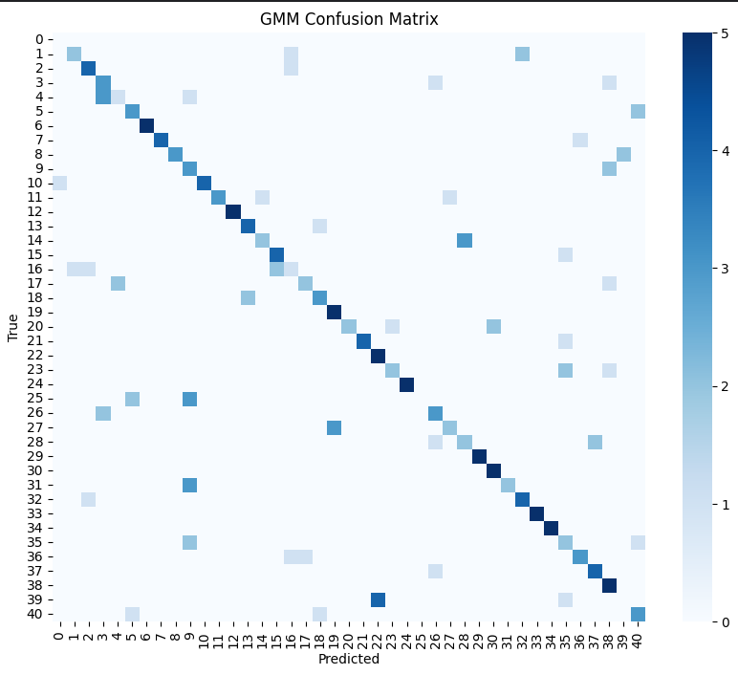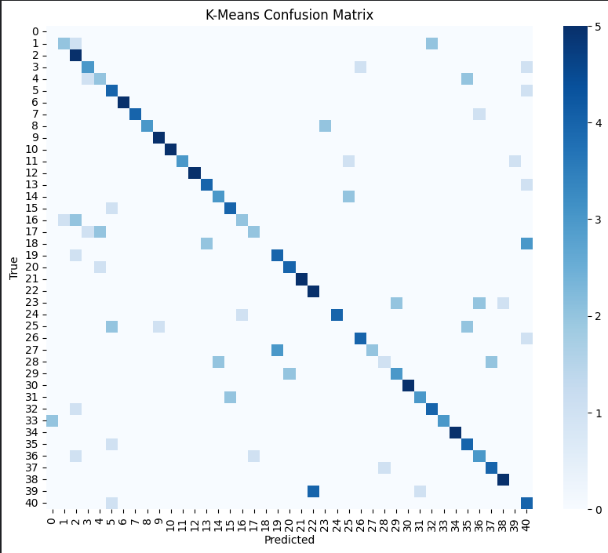

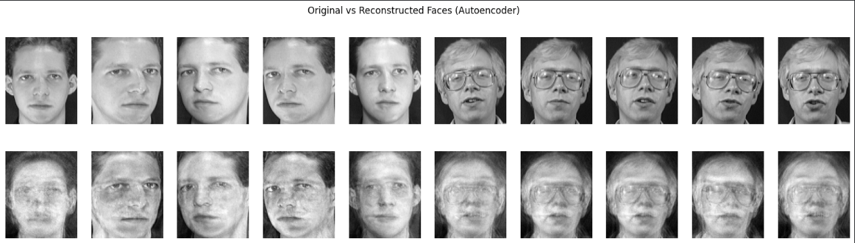

Performance in both kmeans and gmm in autoencoder less than Kmeans and gmm when they applied on PCA

# Evaluations

| **Alpha** | **K** | **Kmeans Accuracy** | **GMM Accuracy** |
| --- | --- | --- | --- |

|  |  |  |  |
| --- | --- | --- | --- |
| 0.80 | 20 | 0.4400 | 0.4250 |

|  |  |  |  |
| --- | --- | --- | --- |
| 0.80 | 40 | 0.6150 | 0.6400 |

|  |  |  |  |
| --- | --- | --- | --- |
| 0.80 | 60 | 0.6850 | 0.7650 |

|  |  |  |  |
| --- | --- | --- | --- |
| 0.85 | 20 | 0.4200 | 0.4350 |

|  |  |  |  |
| --- | --- | --- | --- |
| 0.85 | 40 | 0.6050 | 0.6900 |

|  |  |  |  |
| --- | --- | --- | --- |
| 0.85 | 60 | 0.6700 | 0.7300 |

|  |  |  |  |
| --- | --- | --- | --- |
| 0.90 | 20 | 0.4250 | 0.4450 |

|  |  |  |  |
| --- | --- | --- | --- |
| 0.90 | 40 | 0.6000 | 0.6700 |

|  |  |  |  |
| --- | --- | --- | --- |
| 0.90 | 60 | 0.6600 | 0.7050 |

|  |  |  |  |
| --- | --- | --- | --- |
| 0.95 | 20 | 0.4350 | 0.4550 |

|  |  |  |  |
| --- | --- | --- | --- |
| 0.95 | 40 | 0.5850 | 0.6350 |

|  |  |  |  |
| --- | --- | --- | --- |
| 0.95 | 60 | 0.6500 | 0.7300 |

**As we saw in this table, accuracy increases when K increase.**

**Kmenas**

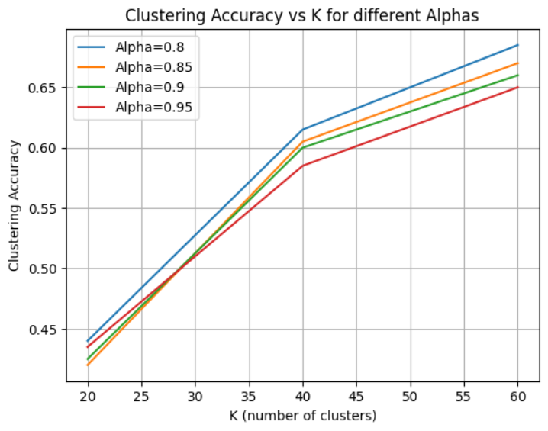

**GMM**

**