

Zewail City of Science, Technology and Innovation
University of Science and Technology
School of Computational Sciences and Artificial Intelligence

GRADUATION PROJECT
MARKET VISIBILITY REPORT

Fekry | AI-Powered Mobile Assistant for Egyptian Arabic, Mixed Ar-En and Arabizi Speakers
Submitted by:
Hossam Nabil
Muhammed Ahmed
Ahmed Wael
Supervised by: Dr. Mayada Mansour Ali Hadhoud
Fall 2026 | 2026 - 2027

1. Executive Summary

FEKRY is a proposed Android personal assistant for Egyptian Arabic, English and mixed-language interaction, including typed Arabizi. Android users often need to move between separate task, calendar and email interfaces, especially when a request contains several dependent steps or lacks key details. FEKRY aims to turn conversational requests into reviewable actions, not merely answer questions. Its planned pipeline accepts voice, text and selected-image text, detects intent and required details, maintains short-term conversation context, asks clarifying questions, and checks permissions and user confirmation before creating reminders, calendar events or sending Gmail messages or any other request. The design also gives users direct control over saved preferences and connected accounts. Research on Arabic-English code-switching, speech recognition, multilingual understanding and tool-using agents provides useful methods, but published benchmarks do not establish reliable end-to-end task completion for this particular audience. Google Gemini, Apple Siri and Samsung Bixby already offer substantial assistant functions; therefore FEKRY does not claim they lack calendars, reminders or natural dialogue. Its proposed contribution is an explicitly evaluated, Egyptian-oriented combination of conversational clarification, multi-step productivity workflows and transparent confirmation. A staged GP1/GP2 build and independent usability and reliability tests will determine feasibility and actual performance.

2. Problem Statement & Motivation
Digital personal assistants can help users retrieve information, but everyday productivity requires more than interpreting isolated commands. Egyptian users routinely express requests in colloquial Arabic, English, Arabic-English code-switching, and Arabizi; a single request may also require several dependent actions across a task list, calendar, and email service. Such requests introduce a combined language-understanding and workflow-execution problem: the assistant must identify the intended action, resolve informal dates and names, retain context across follow-up turns, and translate a confirmed interpretation into the correct application operation. FEKRY focuses on this core problem rather than assuming that speech recognition or conversational fluency alone produces successful task completion.

2.1 Core Problem Definition
The core problem is the lack of a consistently evaluable, Egyptian-oriented assistant workflow that transforms informal, potentially ambiguous, multi-step Arabic-English voice or text requests into accurate and user-approved productivity actions. The challenge includes recognizing dialectal and code-switched expressions, extracting the required entities and constraints, identifying missing details, maintaining cross-turn references, and executing the intended task without repeatedly asking users to restart or re-enter context.

2.2 Problem Context & Real-World Impact
A user may interact with FEKRY using natural everyday Egyptian Arabic commands, such as:
- Music: «يا فكري، شغّلّي شوية أغاني هادية وأنا بذاكر.»
- Alarm: «يا فكري، ظبّطلي منبّه بكرة الساعة ٧ الصبح.»
- Reminder: «يا فكري، فكّرني آخد الدوا الساعة ٩ بالليل.»
- Mixed Arabic-English: «يا فكري، set a reminder بكرة الساعة ٥ عشان عندي meeting.»
These scenarios illustrate how FEKRY aims to understand natural Egyptian Arabic, English, and mixed-language requests, maintain conversational context, and ask follow-up questions when necessary. Task reminders are part of the planned core functionality, while direct phone-alarm control and music playback would require additional supported integrations.

2.3 Motivation & Urgency
The project is timely because multilingual speech recognition and tool-using language models are available for practical evaluation, while colloquial Egyptian Arabic, code-switching and romanized Arabic create unresolved adaptation and testing challenges [1]–[9]. Major assistants now provide calendar and task integrations, making honest competition depend on local-language handling, task success, user trust and execution safeguards rather than simply listing generic AI features.

3. Proposed Solution & Program Focus
FEKRY is proposed as a modular Android application with a controlled backend for language understanding, task planning and approved API actions. The computing contribution spans application architecture (SWD), multilingual NLP and speech evaluation (DSAI), and secure API integration and data handling. Architecture, model selection and performance remain design hypotheses until validated during GP1 and GP2.

3.1 Solution Overview & System Workflow
A user enters a request via typed Egyptian Arabic, English, mixed language or Arabizi, or records speech; selected screenshots may supply text after OCR. An input layer normalizes available text and provides a visible transcript for correction. An understanding and planning layer identifies tasks, entities, dates, references to earlier turns and missing constraints. A context store holds current-dialogue state; a separate, user-managed store keeps only preferences explicitly chosen for persistence. An action validator presents the planned recipients, times and operations, checks granted scopes and obtains confirmation before externally consequential actions. Feature adapters then create FEKRY tasks/reminders, manage permitted Google Calendar events, or send a confirmed Gmail draft. The app returns per-step success/failure status and allows recovery from partial execution. Wake-word operation, if included, is limited to the foreground Android experience with microphone permission, not unconditional background listening.
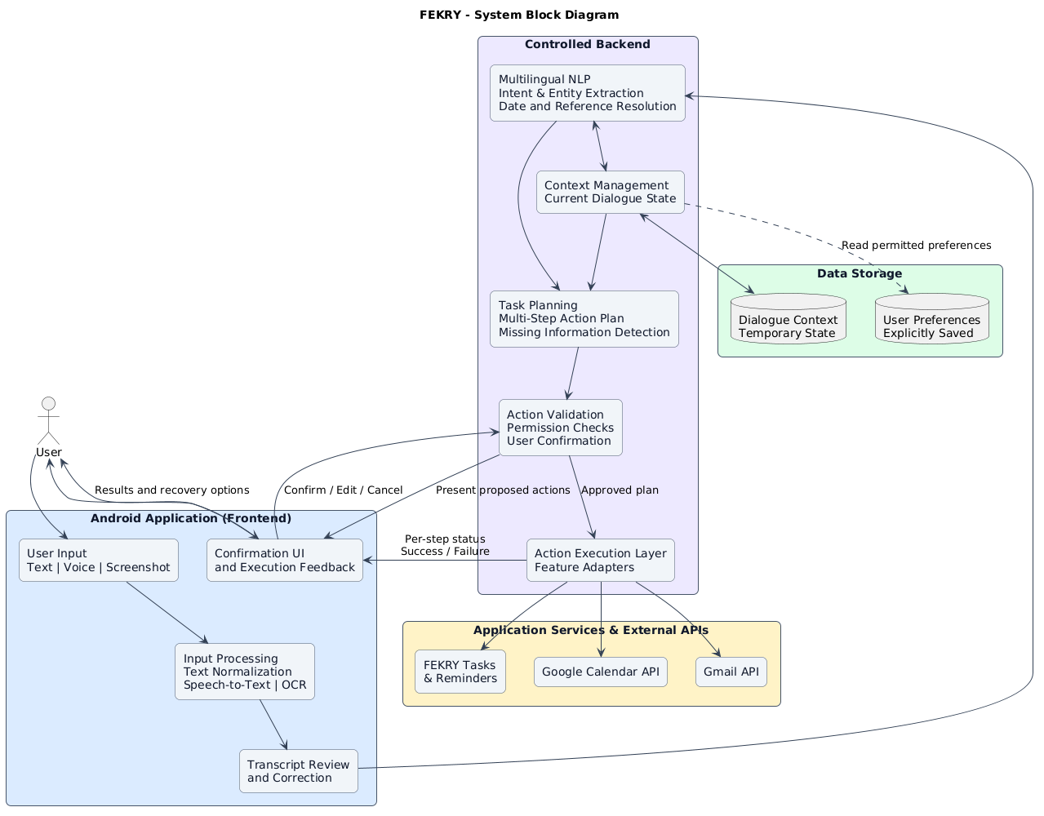

3.2 Key System Features
Feature 1: Tasks/reminders (create, view, revise, complete; time-based notifications under Android permissions).
Feature 2: Calendar/study planning (ask for subjects, deadlines, duration, priorities and availability; propose slots and request approval before calendar writes).
Feature 3: Gmail-supported email drafting, recipient/subject/body preview, iterative edits and explicit fresh confirmation before sending; permission and delivery failure reporting.
Feature 4: context-aware multi-step planning (references, clarification, partial failure reporting)
Feature 5: Editable user-controlled preferences/memory and account disconnection; voice, text, typed Arabizi and user-selected OCR inputs support the flows.

3.3 Track-Specific Technical Focus
The project combines Software Development and Data Science & AI contributions. The items below define engineering work to be designed and compared, not technologies already deployed:
- SWD (Software Development): Android UI and accessibility; modular API/backend service; action-state machine (draft → clarify → preview → confirm → execute → report); typed connector contracts for tasks, calendar and Gmail; testable error and retry paths. Candidate mobile frameworks include Kotlin/Jetpack Compose or Flutter, subject to team proof of concept.
- IT (Information Technology): Google OAuth consent and role-based access control.
- DSAI (Data Science & AI): investigate Egyptian Arabic, English, code-switched speech and typed Arabizi using candidate resources such as ArzEn-ST, ZAEBUC-Spoken, ArzEn-MultiGenre and MASSIVE [1]–[3], [5], supplemented where needed by consented or generated FEKRY task examples. The planned workflow covers data collection and licensing, cleaning and annotation of intents/entities, train–validation–test splits, and comparison of candidate ASR (e.g., Whisper [6]), Arabic/multilingual NLU encoders (e.g., MARBERT [4]), and rule-based versus structured planning approaches [8], [9]. Evaluation will report WER/CER, intent and slot F1, clarification quality, and end-to-end task success; final models depend on experimental results.

The initial baseline uses a conventional speech-to-text component plus an evaluated intent/slot extractor and deterministic task executor. An optional language-model planner may be introduced behind validation rules only if it improves held-out task completion. OCR is limited initially to extracting text relevant to an explicit user-selected task. No specific model or database is presented as a final selection prior to comparative experiments. F1–F5 describe the five committed workflow groups; advanced emotion recognition, speaker identification and dialect-origin classification are outside the baseline scope.

4. Target Audience & User Persona Analysis
Primary users are Egyptian Arabic-speaking Android users who manage everyday activities in mixed Arabic-English communication. Persona descriptions below are design hypotheses for research and usability recruitment, not profiles derived from a completed market survey.

4.1 Primary User Persona
FEKRY is designed for general everyday users who want a convenient and intelligent way to manage their daily activities through natural voice interaction.
The primary target audience includes individuals of different ages, backgrounds, and occupations who use smartphones in their daily lives and prefer a simple, hands-free method of interacting with technology.
These users may rely on FEKRY to perform everyday activities such as setting alarms and reminders, managing tasks, organizing schedules, and accessing information without navigating multiple applications manually.
FEKRY particularly aims to serve Egyptian users by supporting everyday Egyptian Arabic, English, and mixed Arabic-English conversations, allowing users to communicate naturally without needing to memorize specific commands.

4.2 User Characteristics, Goals, and Usage Context
Typical characteristics include colloquial wording, mixed-script messages and occasional typed Arabizi; varying network quality and microphone noise; intermittent attention; and existing use of a calendar, email and task list. Goals are to record deadlines reliably, reserve feasible study sessions, revise requests in follow-up turns, and control stored preferences and external permissions. Pain points are duplicate entry, ambiguous times, forgotten context and fear of accidental external actions. Secondary contexts include early-career productivity and users who gain from voice-first or hands-free access. Support for accessibility is a design objective requiring testing, not an established certified capability.

4.3 User Need & Value Proposition
FEKRY proposes one reviewable flow from “tell the assistant what I need” to “see the plan and approve each external action.” Its value proposition is a localized, transparent workflow combining Egyptian Arabic/English understanding, clarification, calendar-aware planning, confirmed email and controllable memory. Benefits will be tested using end-to-end task success, clarification count, editing effort, latency, permission errors and participant feedback; no percentage improvement is asserted at proposal stage.

5. Literature Review & Background Research
The following literature combines peer-reviewed datasets, language models and agent methods relevant to FEKRY. Cross-paper scores are not directly comparable because tasks, languages and evaluation protocols differ. The table lists the reported contribution, the type of evidence and the limitation for an Egyptian productivity assistant.

5.1 Background & Key Concepts
The system draws on four related ideas: (1) automatic speech recognition (ASR), measured with word/character error rate; (2) natural-language understanding, including intent classification and slot/entity extraction, measured with Macro-F1 and slot F1; (3) dialogue-state tracking and controlled tool execution, measured by multi-step task completion and authorization safety; and (4) Egyptian Arabic-English code-switching and Arabizi normalization, evaluated with language-specific held-out data. A speech corpus is not automatically an intent-labeled dataset, while a translation corpus is not automatically a voice-assistant benchmark. FEKRY must obtain proper licenses, documented annotation guidelines and participant consent when collecting new speech [1]–[7]. Research on interleaved reasoning and external tools informs planning but does not replace permission checks [8], [9].

5.2 Summary of Related Work
Table 1. Summary of related research, evidence, and limitations relevant to FEKRY.
Ref. | Author(s), Year | Method / Approach | Dataset / Context | Key Results | Limitations
[1] | Hamed et al., 2022 | Code-switched speech/translation corpus; baseline MT and speech translation | ArzEn-ST: Egyptian Arabic-English | Three-way translations and task baselines reported | Translation focus; not assistant intent/actions
[2] | Hamed et al., 2024 | Arabic-English speech corpus and transcription guidelines | ZAEBUC-Spoken; 12 h role-play meetings | Multilingual, mixed-language ASR evaluation resource | Small; multi-variety and classroom/work style
[3] | Al-Sabbagh, 2024 | Human-aligned parallel translation data | ArzEn-MultiGenre; 25,557 pairs | Egyptian Arabic/English aligned segments | Text translation; not live speech or intents
[4] | Abdul-Mageed et al., 2021 | Arabic pretrained transformer encoders | ARBERT/MARBERT; ARLUE benchmarks | Best Arabic model led 37/48 classification tasks | No tool execution; social-media domain shift
[5] | FitzGerald et al., 2023 | Multilingual intent and slot benchmark | MASSIVE; ~1M, 51 languages | 60 intents and 55 slots; NLU benchmarks | Translated language may not reflect Egyptian colloquial use
[6] | Radford et al., 2023 | Weakly supervised multilingual ASR (Whisper) | 680,000 h diverse audio training | Competitive zero-shot speech results | ASR alone cannot guarantee task correctness
[7] | Shazal et al., 2020 | Seq2seq Arabizi detection and transliteration | Romanized Arabic code-mixed text | 80.6% word accuracy; 58.7 BLEU (paper test) | Orthography and vocabulary depend on corpus
[8] | Yao et al., 2023 | ReAct: interleaved reasoning/actions | ALFWorld, WebShop, QA benchmarks | Higher task success than key prompted baselines | Simulated/general tasks; no Android permission layer
[9] | Schick et al., 2023 | Toolformer self-supervised API-use model | QA, translation, calendar, tools | Improved zero-shot downstream tool-use tasks | Tool-call selection not end-user consent validation
Table 1 summarizes each study’s method, dataset, reported results, and limitations for FEKRY.

5.3 Critical Synthesis & Research Gap
Across the studies, multilingual models and code-switched corpora provide useful starting points, while tool-using agent papers show the value of external actions and feedback [1]–[9]. Their central mismatch with FEKRY is evaluation context: speech/translation corpora measure transcription or translation, NLU datasets measure intents and slots, and agent benchmarks use simulated or general tasks rather than approved Android productivity workflows in Egyptian Arabic-English conversation. Reported scores are consequently not evidence of FEKRY performance. The proposed research gap is an end-to-end, consent-based evaluation set combining local colloquial input, clarification of missing calendar/email details, cross-turn references, safe tool execution and measurable user effort. The project will compare a non-agent pipeline with an optional planner, test clean versus noisy speech and mixed-language conditions, and publish failures and constraints rather than claim automatic superiority.

6. Market Visibility: Existing Solutions & Competitive Analysis
The market comparison considers three established assistants with official documentation: Google Gemini, Apple Siri and Samsung Bixby. Each already supports useful voice or productivity tasks, so differences below concern device ecosystems, documented integration paths and FEKRY’s planned emphasis, not unsupported claims that competitors cannot understand language or execute multi-step work. Feature availability may vary by region, device, account and product version [10]–[12].

6.1 Review of Similar Systems & Existing Solutions
Table 2. Overview of existing commercial assistant solutions.
Solution / Provider | Type | Description & Core Functionality | Target Users | Availability / Pricing
Google Gemini [10] | Commercial | Conversational AI, connected-app tasks and Calendar/Gmail/Tasks assistance; available actions depend on account and settings | Android and Google users | App/web; free/paid access varies by account and region
Apple Siri [11] | Commercial / platform | Voice actions for Apple apps and supported apps; reminders, calendar and phone operations | iPhone/iPad/Apple ecosystem | On compatible Apple devices; hardware/region limits
Samsung Bixby [12] | Commercial / platform | Galaxy voice control, reminders, device settings and Modes & Routines | Samsung Galaxy users | Compatible Galaxy devices; version/region limits
Table 2 summarizes the scope and ecosystem of the three existing assistant solutions.

6.2 Feature Comparison Matrix
Table 3. Qualitative feature comparison of FEKRY and selected assistants.
Evaluation Feature | Fekry | Google Gemini | Apple Siri | Samsung Bixby
Core Technology | Android ASR/NLU; guarded tools; connected apps actions | AI + connected apps | Apple voice assistant | Galaxy voice/device control
Key Features | Tasks, calendar, email, reminders, opt-in memory, app actions | Calendar, Gmail help, tasks and app actions | Reminders, calendar, app actions | Reminders, settings, routines
Performance / Accuracy | Not measured Yet | Not shared | Not shared | Not shared
User Experience | Mixed-language Android; confirmation before writes | Android/web; account-dependent | Voice-first Apple devices | Galaxy voice and controls
Integration Capability | Calendar, Gmail APIs; FEKRY tasks | Google connected apps | Apple and compatible apps | Samsung apps and Reminder
Platform & Availability | Compatible android devices | Android/web; access varies | Compatible Apple devices | Compatible Galaxy devices
Cost Structure | TBD | Free/paid tiers | With supported devices | With supported Galaxy devices
Table 3 compares FEKRY’s planned features with the documented capabilities of established assistants.

6.3 Strengths & Weaknesses Analysis
Table 4. Competitor strengths, limitations, and implications for FEKRY.
Competitor | Strengths | Weaknesses / Limitations | Implication for Your Solution
Google Gemini [10] | Strong multi-app reach; conversational productivity | Supported actions, terms and connections differ across plans, regions and devices. | Use same-task benchmarks; prioritize local mixed speech, confirmations and transparent status
Apple Siri [11] | Low-friction Apple controls; native reminders and calendar | Apple-device ecosystem is a mismatch for Android-first FEKRY | Keep Android usability and explicit review central
Samsung Bixby [12] | Native Galaxy control, reminders and routines | Device/version-dependent availability and phone-level focus | Differentiate through planning input capture and auditable Google actions
Table 4 identifies each competitor’s main strengths, limitations, and implications for FEKRY.

6.4 Gap Analysis & Key Differentiators
Table 5. Proposed research gaps and FEKRY differentiators.
# | Identified Gap | Evidence (Lit. / Competitor Ref.) | How Your Solution Addresses It
1 | Local mixed-language workflow evaluation | ArzEn-ST [1], ZAEBUC [2], MASSIVE [5]; assistants [10]–[12] | Build held-out Egyptian Arabic-English and typed Arabizi task scripts; report intent/ASR and end-to-end success
2 | Explicit missing-detail clarification and step-level visibility | ReAct [8], Toolformer [9]; comparison [10]–[12] | Reviewable workflow with clarification, dependency checks, approval previews and per-step outcomes
3 | Seamless everyday task management and user control | General-user scenarios; competitor and API documentation [10]–[12] | Enable users to manage daily tasks, reminders, schedules, and emails through natural voice commands, with contextual follow-ups, clear action confirmations, and user-controlled preferences.
Table 5 outlines the identified research gaps, supporting evidence, and proposed FEKRY responses.

7. Project Roadmap & Deliverables

Project Timeline & Work Breakdown
Table 6. GP1 and GP2 project roadmap and key deliverables.
# | Phase | Key Activities | Start / End | Milestone
1 | GP1: proposal & landscape | Proposal (W4); literature and market review (W6); progress talk (W8) | Fall W4–W8 | Proposal, related-work report, slides
2 | GP1: requirements & design | SRS/AI data and test plan (W10); architecture, ERD, Gantt and PoC (W12) | Fall W10–W12 | Requirements, design and PoC
3 | GP1: review & defense | Draft report and review (W13); final report, slides and defense (W15) | Fall W13–W15 | GP1 report and defense
4 | GP2: MVP & tests | Working version (W4); MVP (W9); progress talk (W10); tests/report (W11) | Spring W4–W11 | F1–F5 MVP and evaluation
5 | GP2: final delivery | Full demo/GitHub (W12); report, poster and 3–4 min video (W14); defense after exams | Spring W12–post-exam | Final app, guides and defense
Table 6 summarizes the scheduled work and expected milestone outputs.

8. Risk Management & Professional Ethics
Table 7. Project risks, likelihood, impact, and mitigations.
Identified Risk | Likelihood / Impact | Mitigation Strategy
Egyptian Arabic/English ASR & dataset mismatch | High / High | License-check corpora; separate speakers across splits; collect consented task speech; compare ASR baselines; test noisy audio and code-switching; report failure rates.
Incorrect date/recipient inference or unauthorized tool action | Medium / High | Use deterministic validation, OAuth least-privilege scopes, preview + explicit confirmation for writes, audit statuses and safe failure/retry handling.
Integration/API outages and Android permission behavior | Medium / Medium | Mock interfaces early; versioned adapters; fallback text interaction; user-facing errors; API quotas tests; permission-revocation tests.
Schedule slippage, uneven contribution, or unlicensed data | Medium / High | Weekly Git task reviews; named owners; freeze F1–F5 MVP; milestone demos and documented model choices; check permissions/licenses and disclose AI tool use.
Table 7 summarizes anticipated challenges and planned mitigation actions.

References
[1] I. Hamed, N. Habash, S. Abdennadher, and N. T. Vu, “ArzEn-ST: A Three-way Speech Translation Corpus for Code-Switched Egyptian Arabic-English,” Proc. WANLP, 2022. https://aclanthology.org/2022.wanlp-1.12/
[2] I. Hamed, F. Eryani, D. Palfreyman, and N. Habash, “ZAEBUC-Spoken: A Multilingual Multidialectal Arabic-English Speech Corpus,” Proc. LREC-COLING, 2024. https://aclanthology.org/2024.lrec-main.1546/
[3] R. Al-Sabbagh, “ArzEn-MultiGenre: An aligned parallel dataset of Egyptian Arabic song lyrics, novels, and subtitles, with English translations,” Data in Brief, vol. 54, art. 110271, 2024. https://doi.org/10.1016/j.dib.2024.110271
[4] M. Abdul-Mageed, A. Elmadany, and E. M. B. Nagoudi, “ARBERT & MARBERT: Deep Bidirectional Transformers for Arabic,” Proc. ACL, 2021. https://aclanthology.org/2021.acl-long.551/
[5] J. FitzGerald et al., “MASSIVE: A 1M-Example Multilingual Natural Language Understanding Dataset with 51 Typologically-Diverse Languages,” Proc. ACL, pp. 4277–4302, 2023. https://aclanthology.org/2023.acl-long.235/
[6] A. Radford et al., “Robust Speech Recognition via Large-Scale Weak Supervision,” Proc. ICML, PMLR, vol. 202, pp. 28492–28518, 2023. https://proceedings.mlr.press/v202/radford23a.html
[7] A. Shazal, A. Usman, and N. Habash, “A Unified Model for Arabizi Detection and Transliteration using Sequence-to-Sequence Models,” Proc. WANLP, pp. 167–177, 2020. https://aclanthology.org/2020.wanlp-1.15/
[8] S. Yao et al., “ReAct: Synergizing Reasoning and Acting in Language Models,” Proc. ICLR, 2023. https://react-lm.github.io/
[9] T. Schick et al., “Toolformer: Language Models Can Teach Themselves to Use Tools,” Proc. NeurIPS, vol. 36, 2023. https://arxiv.org/abs/2302.04761
[10] Google, “Use & manage Connected Apps in Gemini,” Gemini Apps Help, 2026. https://support.google.com/gemini/answer/13695044
[11] Apple, “Use Siri to find information and get things done on iPhone,” iPhone User Guide, 2026. https://support.apple.com/en-euro/guide/iphone/ipha48873ed6/ios
[12] Samsung, “Manage your day with Bixby reminders,” Samsung Support, 2026. https://www.samsung.com/us/support/answer/ANS10001408/

