horizontal line

Mobile Application AIChE 22/23

Saturday, 20.05.2023

**─**

# Abstract

Through this chapter, we started from the basic beginner level to junior mobile developers aware of some software engineering topics including version control, Agile/Scrum, and diagrams like use case diagrams in addition to that the member learned UI/UX basics and of course dart and flutter.

Although we faced some drawbacks, the members achieved almost the goals with mentoring and regular weekly online meetings

# What we did

## GitHub and version control

In the first 3-weeks, we learned GitHub with this [playlist](https://www.youtube.com/watch?v=ACOiGZoqC8w&list=PLDoPjvoNmBAw4eOj58MZPakHjaO3frVMF)

## Dart

1. We learned in the first term dart from this [playlist](https://www.youtube.com/playlist?list=PL93xoMrxRJIsYc9L0XBSaiiuq01JTMQ_o)
2. The playlist doesn’t provide exercises so I wrote questions and asked the members to solve them to practice coding
3. [Project1](https://docs.google.com/document/d/1TINzqrNIVkn23fQyieaVOyoHRDmQNTZp-VE-EjMqFog/edit?usp=sharing), [project2](https://docs.google.com/document/d/1TfSDIOzr0luZFvefddt_adGc_S1C08aZzmN6iZd_YBQ/edit#heading=h.mudvz4tnvt67), and [project3](https://docs.google.com/document/d/1yjT39HkexknBa0GIww52Rtgth0okUWL3doFGZ9kJwso/edit) these projects I wrote and asked members to solve them
4. In the OOP topic, I suggested a new [playlist](https://www.youtube.com/watch?v=OdsLzFXLQZw&list=PLoMmMinVeSkukLN6FRnGV6yX6iLMoILdv) to cover this topic more extensively

## Software engineering basics

The members learned about use-case diagrams and designed a diagram for the application

## UX/UI design

1. the members watched [this video](https://www.youtube.com/watch?v=uL2ZB7XXIgg) to get basic intuition about UI/UX
2. As a result, the members designed some screens for new application

## Agile project management/ Scrum framework

In software development teams or any other production team, they follow the standards of Agile project management the members watched this [playlist](https://www.youtube.com/watch?v=eVDZJ7_c60c&list=PLcdCk5ljWQ-p3t9E_vPcGzZMGLoAeRUO5)

## Flutter

The members started this playlist for [Flutter](https://youtube.com/playlist?list=PLw6Y5u47CYq47oDw63bMqkq06fjuoK_GJ)

## Meetings

We made regular weekly [meetings](https://drive.google.com/drive/folders/1UTNg8M4ogCqFK0tXEovXDoQP0LtxwKM-), meetings reached more than 12 meeting

# Achievements

1. **The members designed screens for the application**

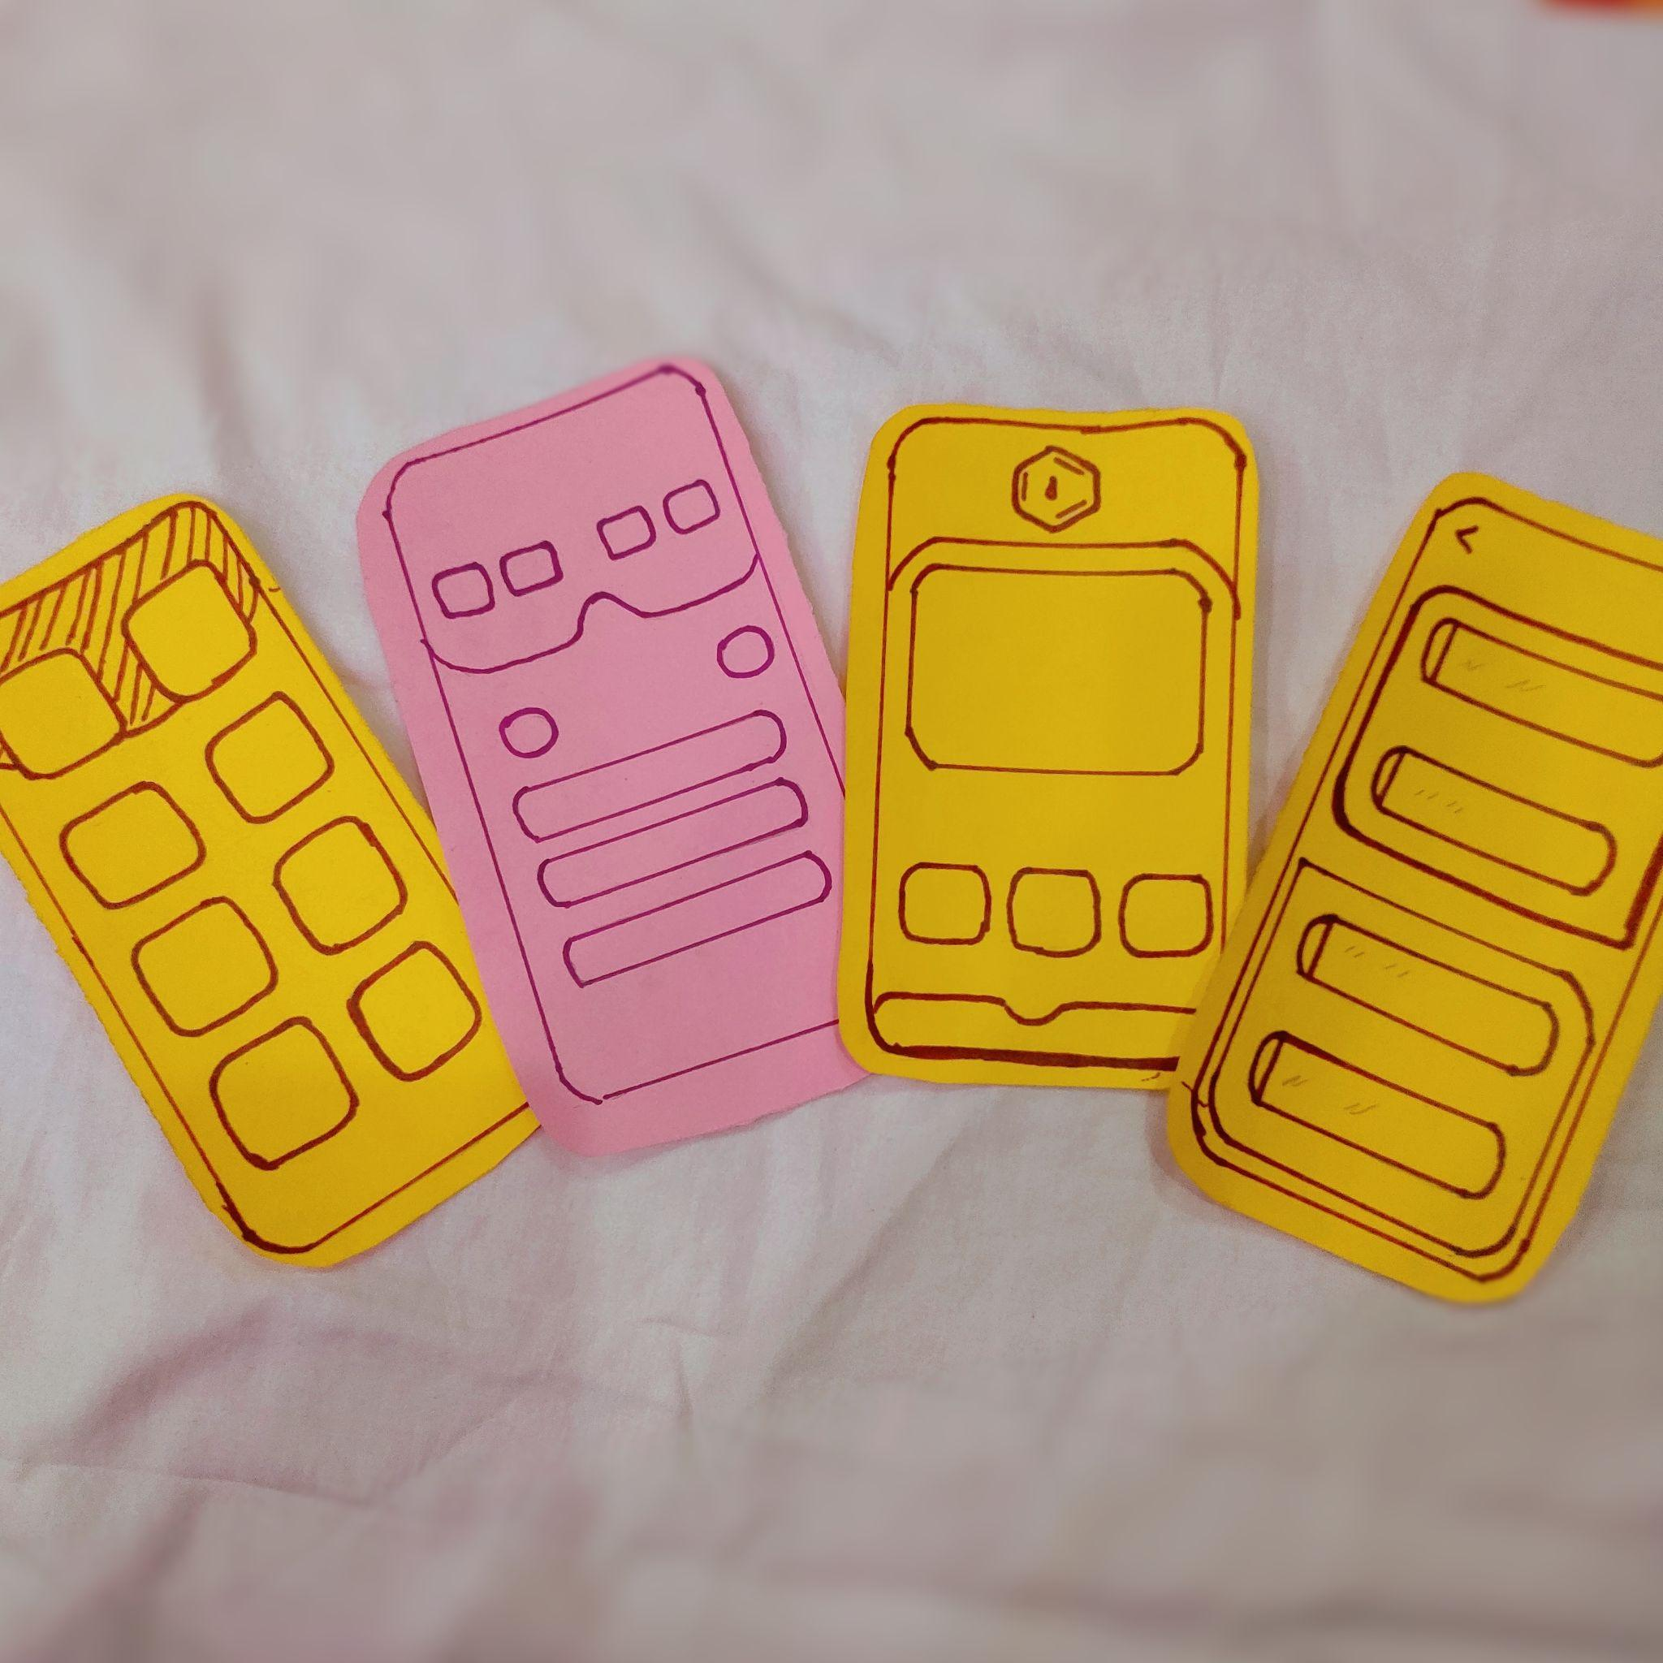

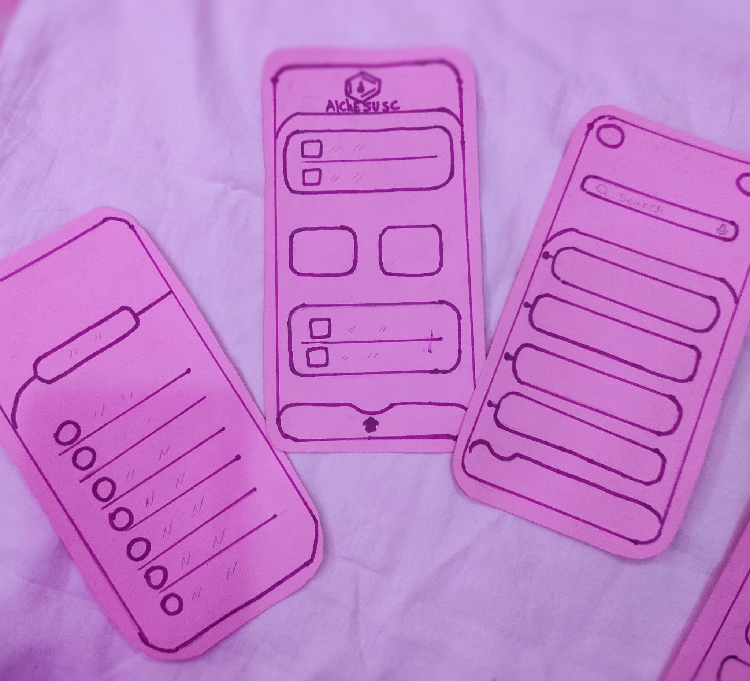

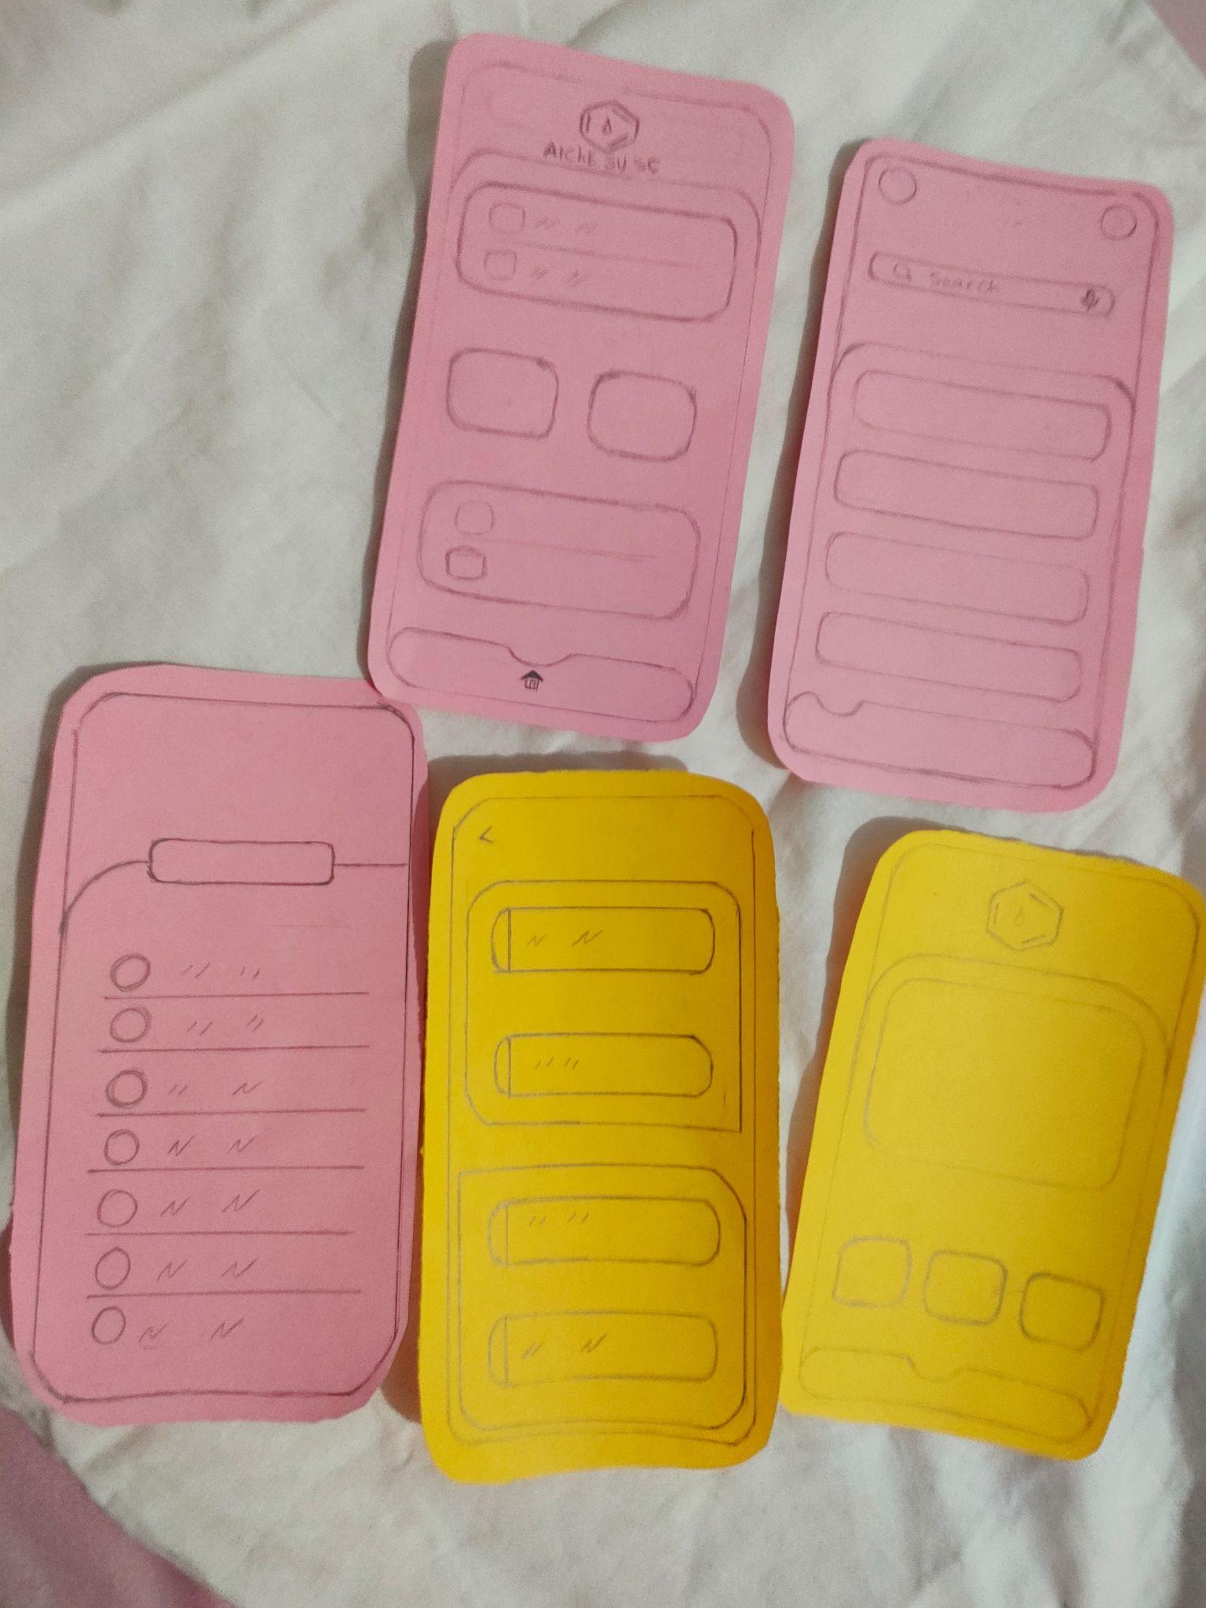

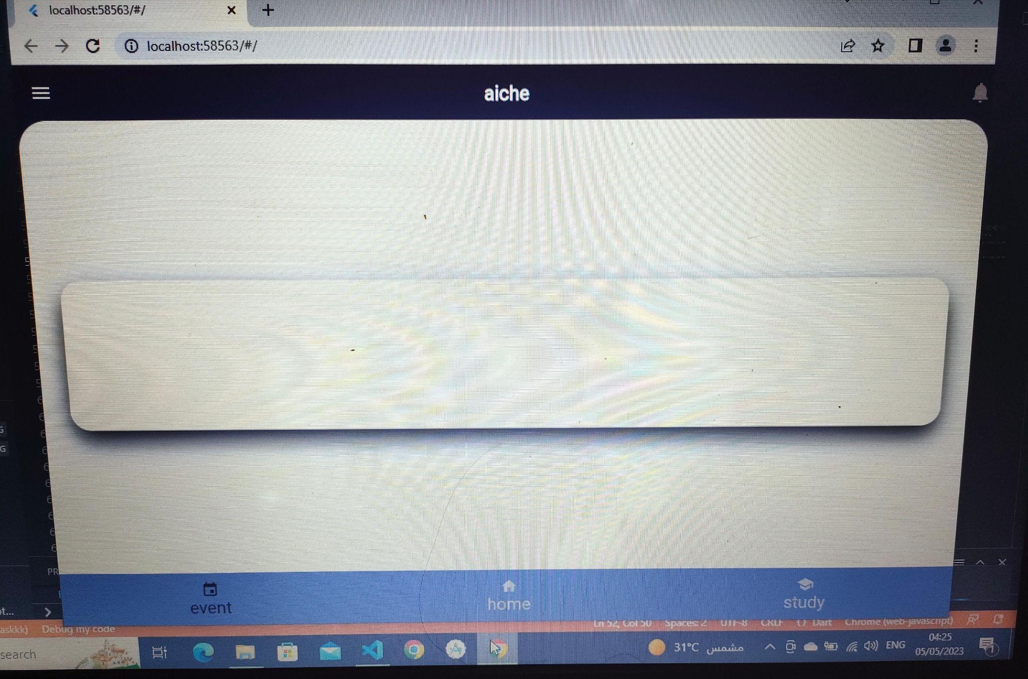

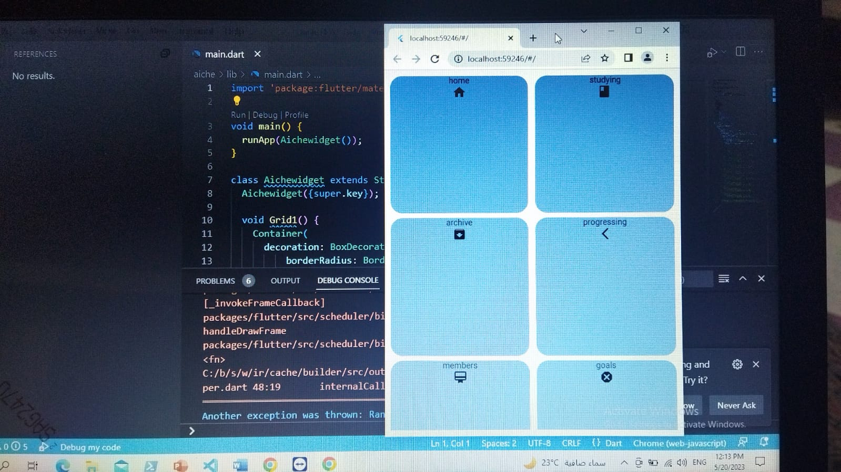

1. **We made two search and share posts**

* [Post 1](https://www.facebook.com/photo/?fbid=765648971812487&set=gm.2185958511603839&idorvanity=137899566409754)
* [Post 2](https://www.facebook.com/photo/?fbid=722196189491099&set=gm.2131785053687852&idorvanity=137899566409754)

1. **The members made use-case diagrams**

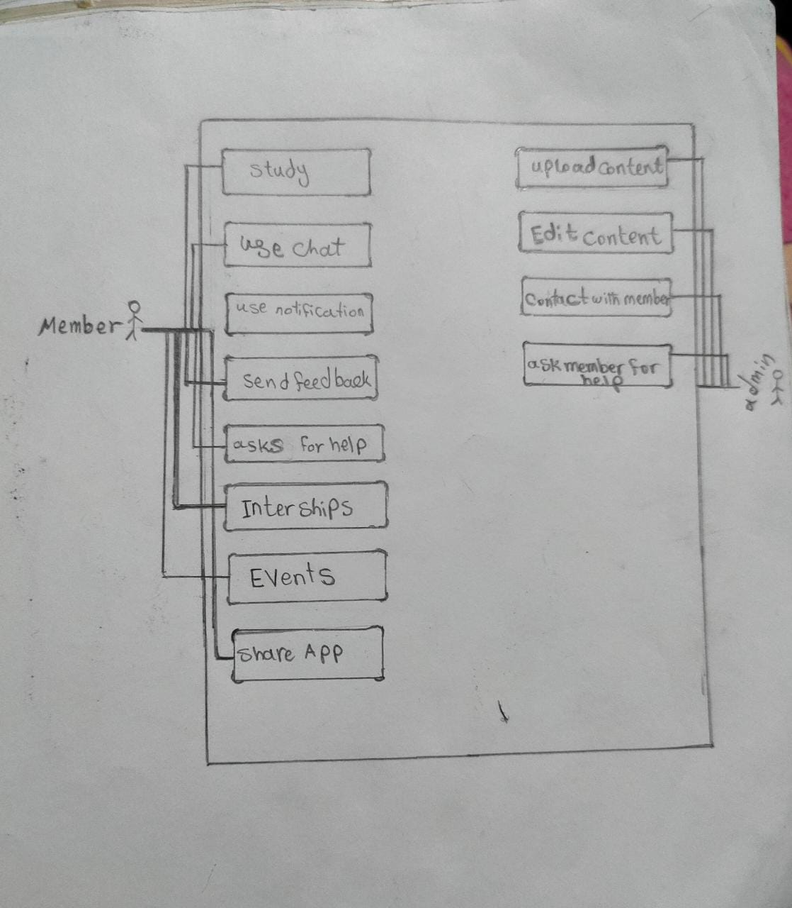

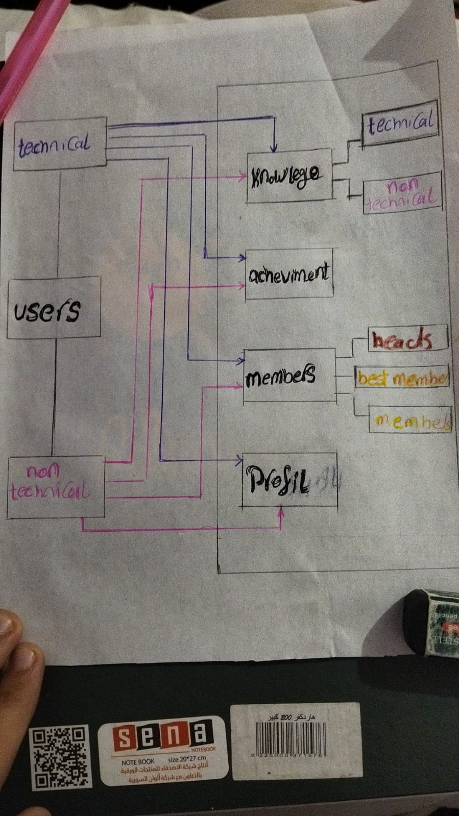

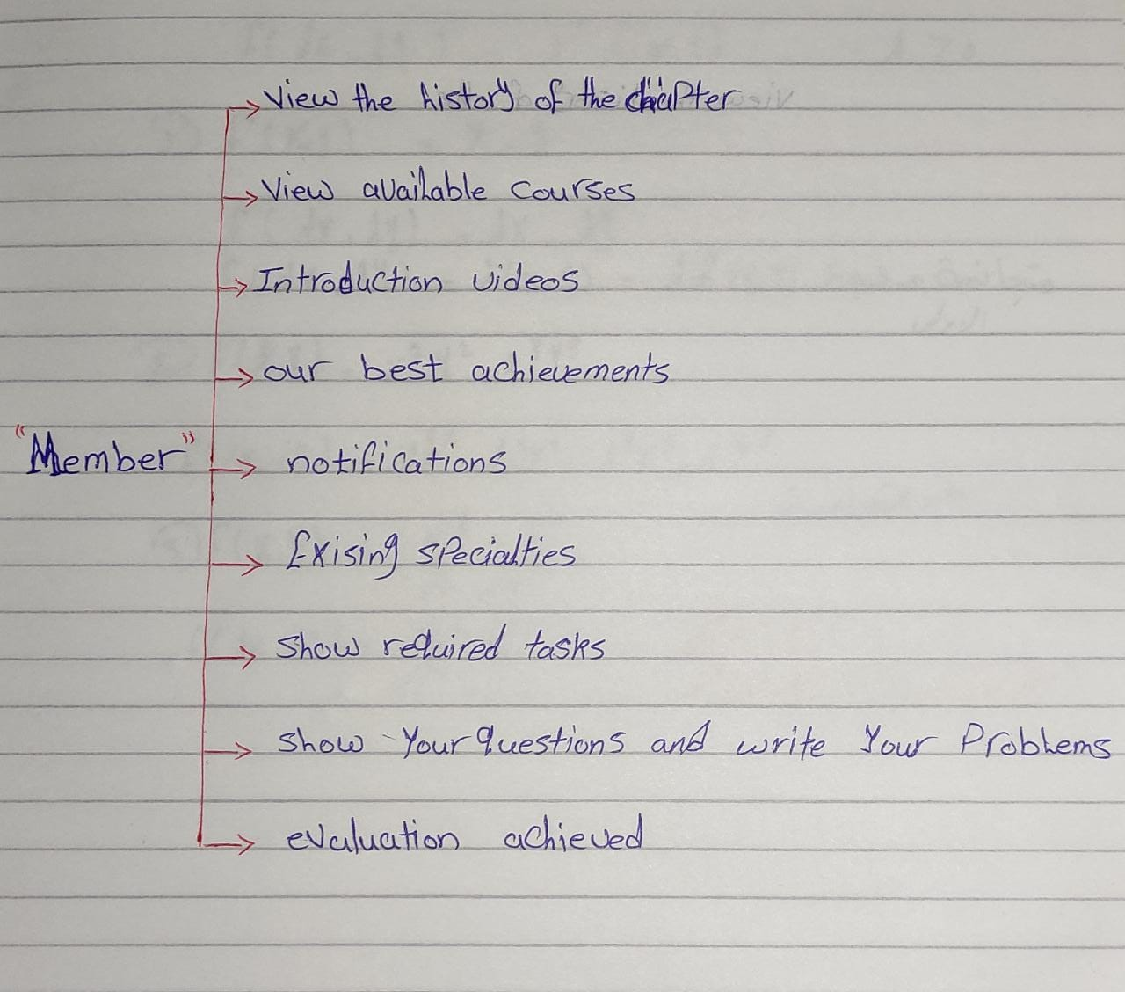

# Drawbacks

1. I wasn’t able to introduce the members to new technologies topics or to introduce them to the advanced topic in programming like clean coding because they were beginners
2. I didn't develop the application at the required time
3. Some members were not able to continue in the mobile application because they didn’t stand the heavy content and learning rate

# Recommendations

At the end of my period in AIChE, I suggest the following to improve the Mobile applications committee and to avoid my mistakes.

1. **Choose the members who are well to learn mobile development and not only want to know what is a mobile application or want to try a new thing he doesn’t know totally about it**

Explanation: learning track is long and members may feel bored, if they don’t have a goal to learn they will drop the committee or negatively affect the other members who want to learn

1. **Design the application and assign the roles at the beginning of the season or at least put the borderlines so the members will know what they are learning for**

Explanation: I tried to make this but because I take the decision of making members to participate with me in developing the application at the end of the first term the time plan didn’t fit with this requirement so I suggest that the members will know that they are going to develop an application so they will learn fastly

# Final words

I enjoyed my time working at AIChE and I loved the management system and friendly environment between members and mangers I hope that this report will contribute to the development of AIChE and the mobile application committee.

**Ziad Assem Muhammad**

Mobile Applications head 22/23