

**Cairo University**

**Faculty of Computers and**

**Information**



CS352 Software Engineering II

Assignment 2

By

|  |  |  |  |
| --- | --- | --- | --- |
| Name | ID | Email | Group |
| Hossam Abd Elhady | 20160092 | Hossam7.fci.cu@gmail.com | CS_2 |
| Gomaa Abied Mohamed | 20160086 | Kkrem551@gmail.com | CS_2 |

10/3/2019

Department of Computer Science

Faculty of Computers and Information

Cairo University

2018/2019

1. Introduction:

Here is the implementation of some application based on Peer to Peer Architecture style which have an arbitrary number of nodes,

which have the functionality GET or POST data to each other,

there could be a server or more to help peers orchestrate their work or discover each other.

1. Implemented use case:

We implemented the first use case which concerned on implementation of peer to peer network between physical devices. which asked to develop an application to generate fake data so receiving, transmitting it in broad cast manner.

1. System Architecture:

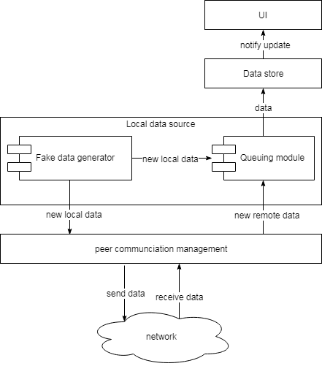

System Architecture Description:

The overall of the design is that Network component establish some connection between Active beers in Same wi-fi network and revieve data from fake data generator and send it to other active peers in network so it synchronous it using queuing module such store the data from all threads and send it sequentially to peers.

IIV. System Design:

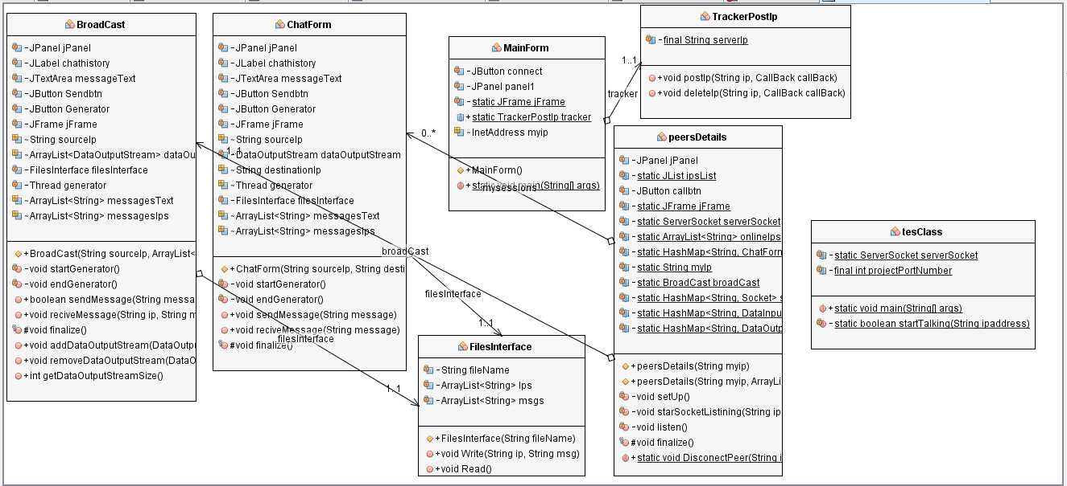

Overall Description:

This class diagram illustrate the relations between the classes in our P2P application

Description:

|  |  |
| --- | --- |
| Class | Responsibility |
| Chat Form | Main class of messaging management which send and receive the data between peers |
| Peer Details | That class hold all info about each peer such as IP, communication threads and establishing / finalizing the connection |
| Broad Cast | The class which manage the Broad cast communication between peers |
| Main Form | The Main class which link all classes with each other to develop the app |
| Tracker Post IP | Class that’s connect to database to get all IPs that active in the network and run the app |
| File Interface | Class that access data store (local Files) to save the data generated from peers |
| Test Class | Test class to make sure that all component communicates in right manner |

1. Installation Guide

## **Academic Honesty Declaration**

Each group should fill this form and submit to his TA.

**جامعة القاهرة – كلية الحاسبات و المعلومات Faculty of Computers and Information الفرقة الأولى – هندسة البرمجيات 2 – 2029 - المسألة 2 -2019 – 2018 -CS352 2Assignment**

**اسم الطالب**.........................................Name **التاريخ** ..............Date **المجموعة**............. Group **اسم الطالب**.........................................Name **التاريخ** ..............Date **المجموعة**............. Group **اسم الطالب**.........................................Name **التاريخ** ..............Date **المجموعة**............. Group

**We give oath that we have fully authored all the programs we submitted for Assignment 2 and we did not copy work from the net, from other colleagues or from any sources.**

**نقسم بالله العظيم نحن الموقعون أدناه أننا قد قمنا بتنفيذ هذه المسألة 2Assignment بأنفسنا و لم نغش مطلقا أو ننقل جهد غيرنا للحصول على درجات بغير حق أو نعطى مجهودنا للآخرين بغير حق و الله على ما نقول شهيد )من يتحرج من صيغة القسم لسبب دينى يكتب ما يناسب معتقده(**

**التوقيع** ... ... ... .......................  **التوقيع** ... ... ... ................ **التوقيع** ... ... ... ....................... **التوقيع** ... ... ... ................

1