**Team #8**

**Names Sec B.N.**

**Hossam Ahmed 1 15**

**Sarah Mohamed Ahmed Lotfy 1 24**

**Nada Adel 2 29**

**Nourhan Gamal 2 33**

**What is not working in our processor?**

Memory cash is implemented but in individual module not merged to the system.

# It is found in the Memory system folder with its .do file and it worked correctly.

# **One operand**

**Without forwarding & hazard & flushing units**

|  |  |  |
| --- | --- | --- |
| **Instruction** | **Result from simulation** | **Correct results** |
| NOT R1 | R1 = **FFFFFFFF** | R1 = **FFFFFFFF** |
| NOP | No change | No change |
| inc R1 | R1 = **1** | R1 = **00000000** |
| IN R1 | R1= **5** | R1 = **5** |
| IN R2 | R2= **10** | R2= **10** |
| NOT R2 | R2 = **FFFFFFFF** | R2 = **FFFFFFEF** |
| inc R1 | R1 = **6** | R1 = **6** |
| Dec R2 | R2 = **0000000F** | R2 = **FFFFFFEE** |
| Out R1 | Port contains **5** | Port should contain **6** |
| OUT R2 | Port contains **FFFFFFFF** | Port should contain **FFFFFFEE** |

**One operand : Solve by adding NOPs**

|  |  |  |  |  |  |  |  |  |  |  |  |  |  |  |  |  |  |  |  |  |  |  |  |
| --- | --- | --- | --- | --- | --- | --- | --- | --- | --- | --- | --- | --- | --- | --- | --- | --- | --- | --- | --- | --- | --- | --- | --- |
| **Instruction** | **Hazard** | **1** | **2** | **3** | **4** | **5** | **6** | **7** | **8** | **9** | **10** | **11** | **12** | **13** | **14** | **15** | **16** | **17** | **18** | **19** | **20** | **21** | **22** |
| **NOT R1** |  | **F** | **D** | **E** | **M** | **W** |  |  |  |  |  |  |  |  |  |  |  |  |  |  |  |  |  |
| **NOP** |  |  | **F** | **D** | **E** | **M** | **W** |  |  |  |  |  |  |  |  |  |  |  |  |  |  |  |  |
| **NOP** |  |  |  | **F** | **D** | **E** | **M** | **W** |  |  |  |  |  |  |  |  |  |  |  |  |  |  |  |
| **INC R1** |  |  |  |  | **F** | **D** | **E** | **M** | **W** |  |  |  |  |  |  |  |  |  |  |  |  |  |  |
| **IN R1** | **WAW R1**  **Data Hazard** |  |  |  |  | **F** | **D** | **E** | **M** | **W** |  |  |  |  |  |  |  |  |  |  |  |  |  |
| **IN R2** |  |  |  |  |  |  | **F** | **D** | **E** | **M** | **W** |  |  |  |  |  |  |  |  |  |  |  |  |
| **NOP** |  |  |  |  |  |  |  | **F** | **D** | **E** | **M** | **W** |  |  |  |  |  |  |  |  |  |  |  |
| **NOP** |  |  |  |  |  |  |  |  | **F** | **D** | **E** | **M** | **W** |  |  |  |  |  |  |  |  |  |  |
| **NOT R2** | **WAW R2**  **Data Hazard** |  |  |  |  |  |  |  |  | **F** | **D** | **E** | **M** | **W** |  |  |  |  |  |  |  |  |  |
| **inc R1** |  |  |  |  |  |  |  |  |  |  | **F** | **D** | **E** | **M** | **W** |  |  |  |  |  |  |  |  |
| **NOP** |  |  |  |  |  |  |  |  |  |  |  | **F** | **D** | **E** | **M** | **W** |  |  |  |  |  |  |  |
| **Dec R2** | **RAW R2**  **Data Hazard** |  |  |  |  |  |  |  |  |  |  |  | **F** | **D** | **E** | **M** | **W** |  |  |  |  |  |  |
| **Out R1** | **RAW R1**  **Data Hazard** |  |  |  |  |  |  |  |  |  |  |  |  | **F** | **D** | **E** | **M** | **W** |  |  |  |  |  |
| **NOP** |  |  |  |  |  |  |  |  |  |  |  |  |  |  | **F** | **D** | **E** | **M** | **W** |  |  |  |  |
| **OUT R2** | **RAW R2**  **Data Hazard** |  |  |  |  |  |  |  |  |  |  |  |  |  |  | **F** | **D** | **E** | **M** | **W** |  |  |  |

**The following waves shows the register file without forwarding unit & hazard detection & flush**

[1] NOT R1

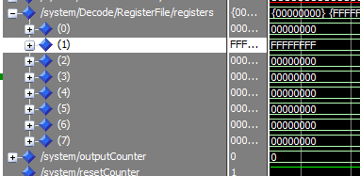

[2]NOP

No change

[3] inc R1

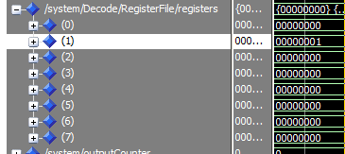

[4] in R1

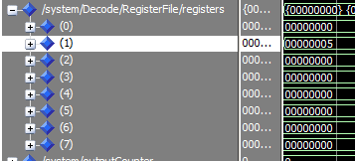

[5] in R2

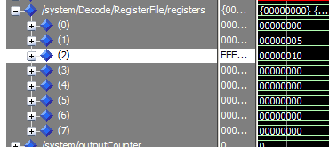

[6] NOT R2

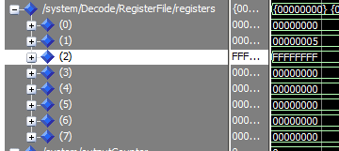

[7] inc R1

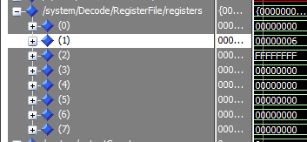

[8] Dec R2

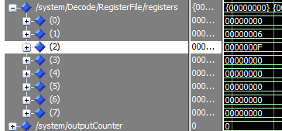

[9] out R1 ( Here is the value of OUtPort)

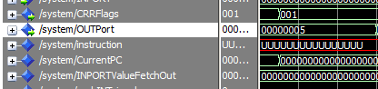

[10] out R2

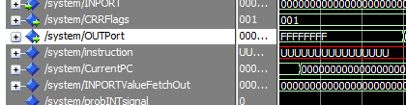

**Here is the correct result with forwarding unit only**

All instructions works CORRECTLY and give the right results with no hazards because all hazards are data hazards that are handled by forwarding unit.

The following wave shows the register file

Z flag is CRRFlag(0)

N flag is CRRFlag(1)

C flag is CRRFlag(2))

[1] NOT R1

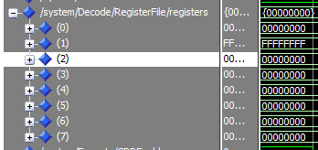

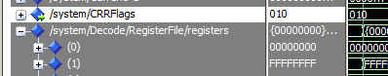

[2]NOP

No change

[3] inc R1

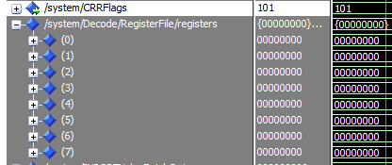

[4] in R1

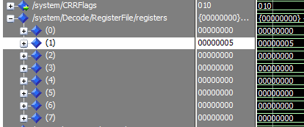

[5] in R2

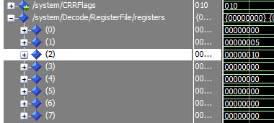

[6] NOT R2

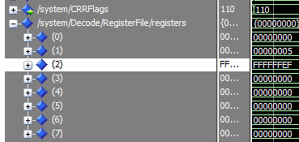

[7] inc R1

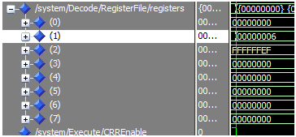

[8] Dec R2

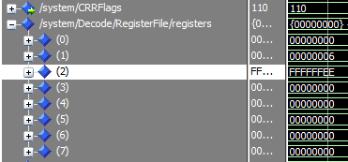

[9] out R1 ( Here is the value of OUtPort)

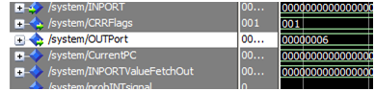

[10] out R2

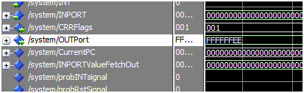

# 

# 

# Two operand

* Without forward & hazard & flushing units

|  |  |  |
| --- | --- | --- |
| Instruction | Result from simulation | Correct results |
| IN R1 | 5 | 5 |
| IN R2 | 19 | 19 |
| IN R3 | FFFD | FFFD |
| IN R4 | F320 | F320 |
| IADD R3,R5,2 | 2 | FFFF |
| ADD R1,R4,R4 | F325 | F325 |
| SUB R5,R4,R6 | FFFF0CE2 | 0CDA |
| AND R7,R6,R6 | 00000000 | 00000000 |
| OR R2,R1,R1 | 1D | 1D |
| SHL R2,2 | 64 | 64 |
| SHR R2,3 | 3 | 0C |
| SWAP R2,R5 | #R5=3 #R2= | #R5=0C #R2 = |
| ADD R5,R2,R2 | 5 | 1000B |

The following screen shots from simulation shows the results without hazard detection unit ,forwad unit and flush

1. IN R1 , IN R2 , IN R3, INR4

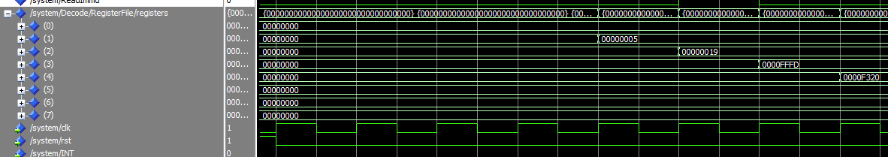

* IADD R3,R5,2

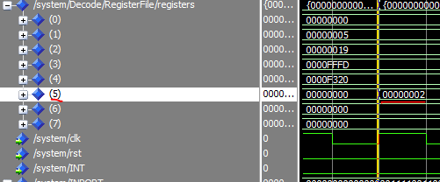

* ADD R1,R4,R4

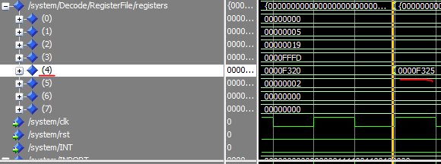

* SUB R5,R4,R6

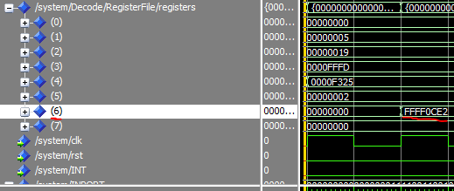

* AND R7,R6,R6

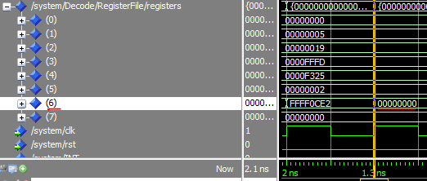

* OR R2,R1,R1

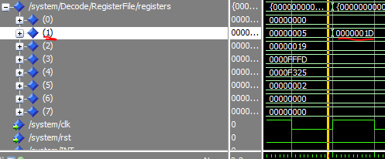

* SHL R2,2

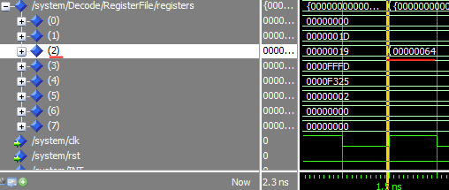

* SHR R2,3

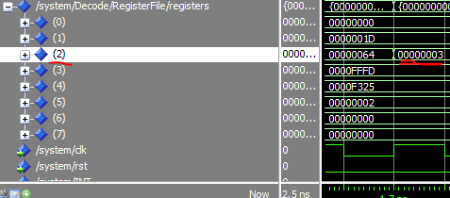

* SWAP R2,R5

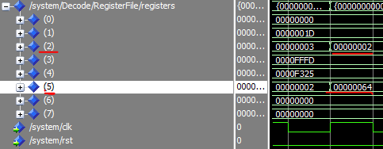

* ADD R5,R2,R2

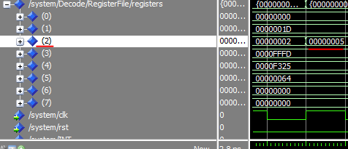

* The following tabe shows the types of hazards happen (without forward unit, hazard detection and flush) and how can we solve it by NOP

|  |  |  |  |  |  |  |  |  |  |  |  |  |  |  |  |  |  |  |  |  |  |  |  |
| --- | --- | --- | --- | --- | --- | --- | --- | --- | --- | --- | --- | --- | --- | --- | --- | --- | --- | --- | --- | --- | --- | --- | --- |
| **Instruction** | **Hazard** | **1** | **2** | **3** | **4** | **5** | **6** | **7** | **8** | **9** | **10** | **11** | **12** | **13** | **14** | **15** | **16** | **17** | **18** | **19** | **20** | **21** | **22** |
| IN R1 |  | F | D | E | M | W |  |  |  |  |  |  |  |  |  |  |  |  |  |  |  |  |  |
| IN R2 |  |  | F | D | E | M | W |  |  |  |  |  |  |  |  |  |  |  |  |  |  |  |  |
| IN R3 |  |  |  | F | D | E | M | W |  |  |  |  |  |  |  |  |  |  |  |  |  |  |  |
| IN R4 |  |  |  |  | F | D | E | M | W |  |  |  |  |  |  |  |  |  |  |  |  |  |  |
| **NOP** |  |  |  |  |  | **F** | **D** | **E** | **M** | **W** |  |  |  |  |  |  |  |  |  |  |  |  |  |
| IADD R3,R5,2 | RAW R3 |  |  |  |  |  | F | D | E | M | W |  |  |  |  |  |  |  |  |  |  |  |  |
| ADD R1,R4,R4 |  |  |  |  |  |  |  | F | D | E | M | W |  |  |  |  |  |  |  |  |  |  |  |
| **NOP** |  |  |  |  |  |  |  |  | **F** | **D** | **E** | **M** | **W** |  |  |  |  |  |  |  |  |  |  |
| **NOP** |  |  |  |  |  |  |  |  |  | **F** | **D** | **E** | **M** | **W** |  |  |  |  |  |  |  |  |  |
| SUB R5,R4,R6 | RAW R5&R4 |  |  |  |  |  |  |  |  |  | F | D | E | M | W |  |  |  |  |  |  |  |  |
| **NOP** |  |  |  |  |  |  |  |  |  |  |  | **F** | **D** | **E** | **M** | **W** |  |  |  |  |  |  |  |
| **NOP** |  |  |  |  |  |  |  |  |  |  |  |  | **F** | **D** | **E** | **M** | **W** |  |  |  |  |  |  |
| AND R7,R6,R6 | RAW R6 |  |  |  |  |  |  |  |  |  |  |  |  | F | D | E | M | W |  |  |  |  |  |
| OR R2,R1,R1 |  |  |  |  |  |  |  |  |  |  |  |  |  |  | F | D | E | M | W |  |  |  |  |
| SHL R2,2 |  |  |  |  |  |  |  |  |  |  |  |  |  |  |  | F | D | E | M | W |  |  |  |
| **NOP** |  |  |  |  |  |  |  |  |  |  |  |  |  |  |  |  | **F** | **D** | **E** | **M** | **W** |  |  |
| **NOP** |  |  |  |  |  |  |  |  |  |  |  |  |  |  |  |  |  | **F** | **D** | **E** | **M** | **W** |  |
| SHR R2,3 | RAW R2 |  |  |  |  |  |  |  |  |  |  |  |  |  |  |  |  |  | F | D | E | M | W |

|  |  |  |  |  |  |  |  |  |  |  |  |
| --- | --- | --- | --- | --- | --- | --- | --- | --- | --- | --- | --- |
| **Instruction** | **Hazard** | **19** | **20** | **21** | **22** | **23** | **24** | **25** | **26** | **27** | **28** |
| **NOP** |  | **F** | **D** | **E** | **M** | **W** |  |  |  |  |  |
| **NOP** |  |  | **F** | **D** | **E** | **M** | **W** |  |  |  |  |
| SWAP R2,R5 |  |  |  | F | D | E | M | W |  |  |  |
| **NOP** |  |  |  |  | **F** | **D** | **E** | **M** | **W** |  |  |
| **NOP** |  |  |  |  |  | **F** | **D** | **E** | **M** | **W** |  |
| ADD R5,R2,R2 | RAW R2 , R5 |  |  |  |  |  | F | D | E | M | W |

* After adding NOP operations like above table , all instructions gives the correct result
* With forwarding only

All instructions works CORRECTLY and give the right results with no hazards because all hazards are data dependency so forward unit can handle it

* The following wave shows the correct result in register file and CCR flags
* in R1
* in R2
* in R3
* in R4

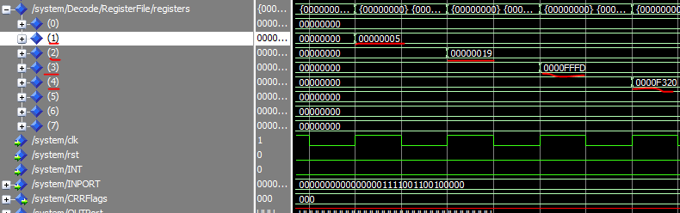

* IADD R3,R5,2

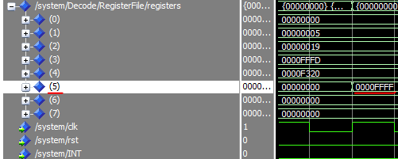

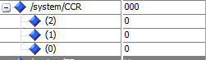

* ADD R1,R4,R4

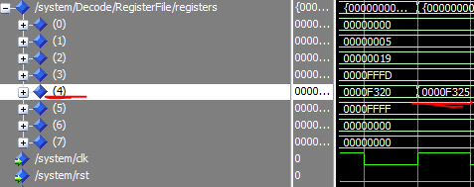



* SUB R5,R4,R6

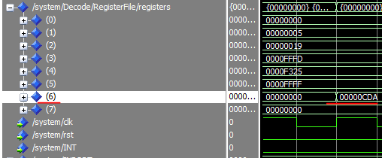

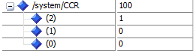

* AND R7,R6,R6

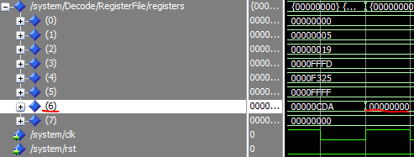

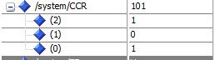

* OR R2,R1,R1

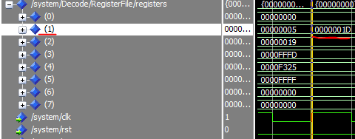



* SHL R2,2

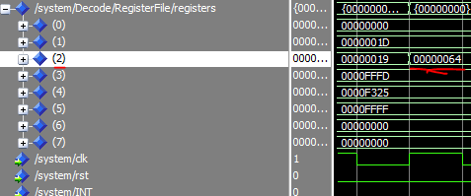



* SHR R2,3

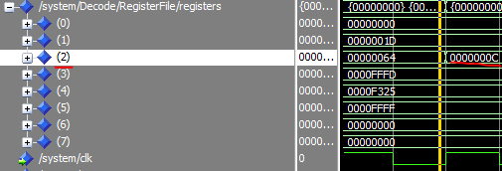



* SWAP R2,R5

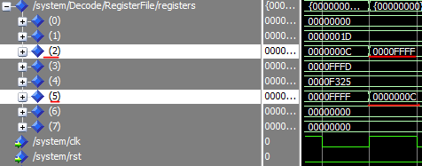



* ADD R5,R2,R2

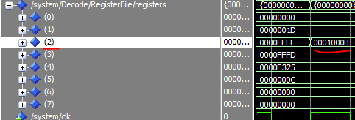



# After adding hazard detection with forward unit give the same result with forward unit only because forward unit can handle all data dependency hazards

* Simlarly , after adding flush with hazard detection unit and forward unit , result are the same with forward unit only .

# 

# **Memory**

Without forwarding unit or hazard detection unit:

Results:

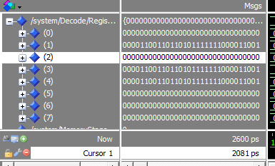

|  |  |  |  |  |  |  |  |  |  |  |  |  |  |  |
| --- | --- | --- | --- | --- | --- | --- | --- | --- | --- | --- | --- | --- | --- | --- |
| instr | hazard | 1 | 2 | 3 | 4 | 5 | 6 | 7 | 8 | 9 | 10 | 11 | 12 | 13 |
| In r2 |  | f | d | e | m | w |  |  |  |  |  |  |  |  |
| In r3 |  |  | f | d | e | m | w |  |  |  |  |  |  |  |
| In r4 |  |  |  | f | d | e | m | w |  |  |  |  |  |  |
| Ldm r1,f5 |  |  |  |  | f | d | e | m | w |  |  |  |  |  |
| nop |  |  |  |  |  | f | d | e | m | w |  |  |  |  |
| nop |  |  |  |  |  |  | f | d | e | m | w |  |  |  |
| Push r1 | Raw  Data hazard |  |  |  |  |  |  | f | d | e | m | w |  |  |
| Push r2 |  |  |  |  |  |  |  |  | f | d | e | m | w |  |
| Pop r1 | WAR |  |  |  |  |  |  |  |  | f | d | e | m | w |
|  |  | 10 | 11 | 12 | 13 | 14 | 15 | 16 | 17 | 18 | 19 | 20 | 21 | 22 |
| Pop r2 | WAR | f | d | e | m | w |  |  |  |  |  |  |  |  |
| nop |  |  | f | d | e | m | w |  |  |  |  |  |  |  |
| nop |  |  |  | f | d | e | m | w |  |  |  |  |  |  |
| Std r2,200 | Raw |  |  |  | f | d | e | m | w |  |  |  |  |  |
| Std r1,202 | RaW |  |  |  |  | f | d | e | m | w |  |  |  |  |
| Ldd r3,202 |  |  |  |  |  |  | f | d | e | m | w |  |  |  |
| Ldd r4,200 |  |  |  |  |  |  |  | f | d | e | m | w |  |  |

With forwarding unit and without hazard detection unit:

Results:

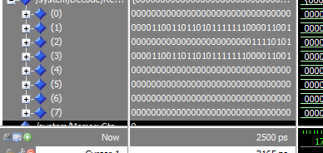

|  |  |  |  |  |  |  |  |  |  |  |  |  |  |  |  |  |  |  |  |  |  |  |
| --- | --- | --- | --- | --- | --- | --- | --- | --- | --- | --- | --- | --- | --- | --- | --- | --- | --- | --- | --- | --- | --- | --- |
| instr | hazard | 1 | 2 | 3 | 4 | 5 | 6 | 7 | 8 | 9 | 10 | 11 | 12 | 13 | 14 | 15 | 16 | 17 | 18 | 19 | 20 | 21 |
| In r2 |  | f | d | e | m | w |  |  |  |  |  |  |  |  |  |  |  |  |  |  |  |  |
| In r3 |  |  | f | d | e | m | w |  |  |  |  |  |  |  |  |  |  |  |  |  |  |  |
| In r4 |  |  |  | f | d | e | m | w |  |  |  |  |  |  |  |  |  |  |  |  |  |  |
| Ldm r1,f5 |  |  |  |  | f | d | e | m | w |  |  |  |  |  |  |  |  |  |  |  |  |  |
| Push r1 | Raw  Data hazard |  |  |  |  | f | d | e | m | w |  |  |  |  |  |  |  |  |  |  |  |  |
| Push r2 |  |  |  |  |  |  | f | d | e | m | w |  |  |  |  |  |  |  |  |  |  |  |
| Pop r1 | WAR |  |  |  |  |  |  | f | d | e | m | w |  |  |  |  |  |  |  |  |  |  |
| Pop r2 | WAR |  |  |  |  |  |  |  | f | d | e | m | w |  |  |  |  |  |  |  |  |  |
| nop |  |  |  |  |  |  |  |  |  | f | d | e | m | w |  |  |  |  |  |  |  |  |
| Std r2,200 | Raw |  |  |  |  |  |  |  |  |  | f | d | e | m | w |  |  |  |  |  |  |  |
| Std r1,202 | RaW |  |  |  |  |  |  |  |  |  |  | f | d | e | m | w |  |  |  |  |  |  |
| Ldd r3,202 |  |  |  |  |  |  |  |  |  |  |  |  | f | d | e | m | w |  | w |  |  |  |
| Ldd r4,200 |  |  |  |  |  |  |  |  |  |  |  |  |  | f | d | e | m | w | m | w |  |  |

With forwarding and unit hazard detection unit:

Results:

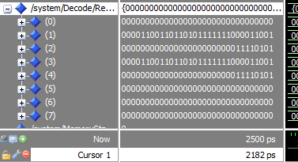

**Branching**

**Without forwarding unit & hazard detection unit & flushing**

Z flag is CRRFlag(0)

N flag is CRRFlag(1)

C flag is CRRFlag(2)

**[1] in R1 ,in R2 ,in R3 ,in R4 ,in R6 ,in R7**

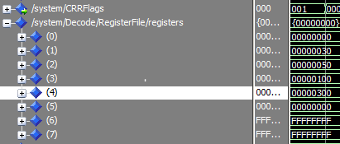

**[2] Push R4**



**[3] JMP R1**

Will jump to 30

**[4] INC R7**

Will not be executed

**[5] AND R1,R5,R5** ( Z is CRRflgs (0))

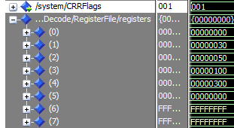

**[6] ADD R0,R0,R0**

**out R6**

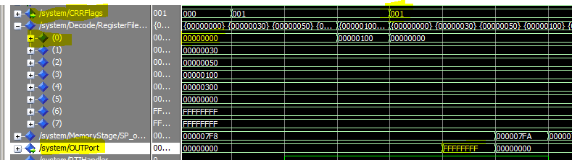

**An error occurred in the Ram.**

**The simulation stopped here and didn’t continue**

**Solve by NOPS**

|  |  |  |  |  |  |  |  |  |  |  |  |  |  |  |  |  |  |  |  |  |  |  |  |
| --- | --- | --- | --- | --- | --- | --- | --- | --- | --- | --- | --- | --- | --- | --- | --- | --- | --- | --- | --- | --- | --- | --- | --- |
| **Instruction** | **Hazard** | **1** | **2** | **3** | **4** | **5** | **6** | **7** | **8** | **9** | **10** | **11** | **12** | **13** | **14** | **15** | **16** | **17** | **18** | **19** | **20** | **21** | **22** |
| **in R1** |  | **F** | **D** | **E** | **M** | **W** |  |  |  |  |  |  |  |  |  |  |  |  |  |  |  |  |  |
| **In R2** |  |  | **F** | **D** | **E** | **M** | **W** |  |  |  |  |  |  |  |  |  |  |  |  |  |  |  |  |
| **In R3** |  |  |  | **F** | **D** | **E** | **M** | **W** |  |  |  |  |  |  |  |  |  |  |  |  |  |  |  |
| **In R4** |  |  |  |  | **F** | **D** | **E** | **M** | **W** |  |  |  |  |  |  |  |  |  |  |  |  |  |  |
| **In R6** |  |  |  |  |  | **F** | **D** | **E** | **M** | **W** |  |  |  |  |  |  |  |  |  |  |  |  |  |
| **In R7** |  |  |  |  |  |  | **F** | **D** | **E** | **M** | **W** |  |  |  |  |  |  |  |  |  |  |  |  |
| **Push R4** |  |  |  |  |  |  |  | **F** | **D** | **E** | **M** | **W** |  |  |  |  |  |  |  |  |  |  |  |
| **Jmp R1** |  |  |  |  |  |  |  |  | **F** | **D** | **E** | **M** | **W** |  |  |  |  |  |  |  |  |  |  |
| **AND R1,R5,R5** |  |  |  |  |  |  |  |  |  | **F** | **D** | **E** | **M** | **W** |  |  |  |  |  |  |  |  |  |

|  |  |  |  |  |  |  |  |  |  |  |  |  |  |
| --- | --- | --- | --- | --- | --- | --- | --- | --- | --- | --- | --- | --- | --- |
| Instruction | Hazards | 10 | 11 | 12 | 13 | 14 | 15 | 16 | 17 | 18 | 19 | 20 | 21 |
| **ADD R0,R0,R0** |  | **F** | **D** | **E** | **M** | **W** |  |  |  |  |  |  |  |
| **out R6** |  |  | **F** | **D** | **E** | **M** | **W** |  |  |  |  |  |  |
| **rti** |  |  |  | **F** | **D** | **E** | **M** | **W** |  |  |  |  |  |
| **JZ R2** |  |  |  |  | **F** | **D** | **E** | **M** | **W** |  |  |  |  |
| **JZ R3** |  |  |  |  |  | **F** | **D** | **E** | **M** | **W** |  |  |  |
| **NOT R5** |  |  |  |  |  |  | **F** | **D** | **E** | **M** | **W** |  |  |
| **NOP** |  |  |  |  |  |  |  | **F** | **D** | **E** | **M** | **W** |  |
| **NOP** |  |  |  |  |  |  |  |  | **F** | **D** | **E** | **M** | **W** |

|  |  |  |  |  |  |  |  |  |  |  |  |  |  |  |  |  |  |  |  |  |  |  |  |
| --- | --- | --- | --- | --- | --- | --- | --- | --- | --- | --- | --- | --- | --- | --- | --- | --- | --- | --- | --- | --- | --- | --- | --- |
| **Instruction** | **Hazard** | **18** | **19** | **20** | **21** | **22** | **23** | **24** | **25** | **26** | **27** | **28** | **29** | **30** | **31** | **32** | **33** | **34** | **35** | **36** | **37** | **38** | **39** |
| **INC R5** | **RAW R5**  **Data Hazard** | **F** | **D** | **E** | **M** | **W** |  |  |  |  |  |  |  |  |  |  |  |  |  |  |  |  |  |
| **in R6** |  |  | **F** | **D** | **E** | **M** | **W** |  |  |  |  |  |  |  |  |  |  |  |  |  |  |  |  |
| **NOP** |  |  |  | **F** | **D** | **E** | **M** | **W** |  |  |  |  |  |  |  |  |  |  |  |  |  |  |  |
| **NOP** |  |  |  |  | **F** | **D** | **E** | **M** | **W** |  |  |  |  |  |  |  |  |  |  |  |  |  |  |
| **JZ R6** | **RAW R6**  **Data Hazard** |  |  |  |  | **F** | **D** | **E** | **M** | **W** |  |  |  |  |  |  |  |  |  |  |  |  |  |
| **POP R6** |  |  |  |  |  |  | **F** | **D** | **E** | **M** | **W** |  |  |  |  |  |  |  |  |  |  |  |  |
| **Call R6** |  |  |  |  |  |  |  | **F** | **D** | **E** | **M** | **W** |  |  |  |  |  |  |  |  |  |  |  |
| **Add R3,R6,R6** |  |  |  |  |  |  |  |  | **F** | **D** | **E** | **M** | **W** |  |  |  |  |  |  |  |  |  |  |
| **Add R1,R2,R1** |  |  |  |  |  |  |  |  |  | **F** | **D** | **E** | **M** | **W** |  |  |  |  |  |  |  |  |  |
| **ret** |  |  |  |  |  |  |  |  |  |  | **F** | **D** | **E** | **M** | **W** |  |  |  |  |  |  |  |  |
| **INC R6** |  |  |  |  |  |  |  |  |  |  |  | **F** | **D** | **E** | **M** | **W** |  |  |  |  |  |  |  |
| **NOP** |  |  |  |  |  |  |  |  |  |  |  |  | **F** | **D** | **E** | **M** | **W** |  |  |  |  |  |  |
| **NOP** |  |  |  |  |  |  |  |  |  |  |  |  |  | **F** | **D** | **E** | **M** | **W** |  |  |  |  |  |

**Branching: With Forwarding unit only**

Z flag is CRRFlag(0)

N flag is CRRFlag(1)

C flag is CRRFlag(2)

**[1] in R1 ,in R2 ,in R3 ,in R4 ,in R6 ,in R7**



**[2] Push R4**



**[3] JMP R1**

Will jump to 30

**[4] INC R7**

Will not be executed

**[5] AND R1,R5,R5** ( Z is CRRflgs (0))



**[6] ADD R0,R0,R0**

**out R6**

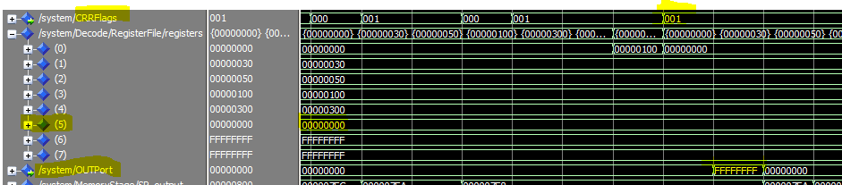

**An error occurred in the Ram.**

**The simulation stopped here and didn’t continue**

**Branching: Solve by NOPS with forwarding unit**

|  |  |  |  |  |  |  |  |  |  |  |  |  |  |  |  |  |  |  |  |  |  |  |  |
| --- | --- | --- | --- | --- | --- | --- | --- | --- | --- | --- | --- | --- | --- | --- | --- | --- | --- | --- | --- | --- | --- | --- | --- |
| **Instruction** | **Hazard** | **1** | **2** | **3** | **4** | **5** | **6** | **7** | **8** | **9** | **10** | **11** | **12** | **13** | **14** | **15** | **16** | **17** | **18** | **19** | **20** | **21** | **22** |
| **in R1** |  | **F** | **D** | **E** | **M** | **W** |  |  |  |  |  |  |  |  |  |  |  |  |  |  |  |  |  |
| **In R2** |  |  | **F** | **D** | **E** | **M** | **W** |  |  |  |  |  |  |  |  |  |  |  |  |  |  |  |  |
| **In R3** |  |  |  | **F** | **D** | **E** | **M** | **W** |  |  |  |  |  |  |  |  |  |  |  |  |  |  |  |
| **In R4** |  |  |  |  | **F** | **D** | **E** | **M** | **W** |  |  |  |  |  |  |  |  |  |  |  |  |  |  |
| **In R6** |  |  |  |  |  | **F** | **D** | **E** | **M** | **W** |  |  |  |  |  |  |  |  |  |  |  |  |  |
| **In R7** |  |  |  |  |  |  | **F** | **D** | **E** | **M** | **W** |  |  |  |  |  |  |  |  |  |  |  |  |
| **Push R4** |  |  |  |  |  |  |  | **F** | **D** | **E** | **M** | **W** |  |  |  |  |  |  |  |  |  |  |  |
| **Jmp R1** |  |  |  |  |  |  |  |  | **F** | **D** | **E** | **M** | **W** |  |  |  |  |  |  |  |  |  |  |
| **AND R1,R5,R5** |  |  |  |  |  |  |  |  |  | **F** | **D** | **E** | **M** | **W** |  |  |  |  |  |  |  |  |  |

|  |  |  |  |  |  |  |  |  |  |  |  |  |  |
| --- | --- | --- | --- | --- | --- | --- | --- | --- | --- | --- | --- | --- | --- |
| Instruction | Hazards | 10 | 11 | 12 | 13 | 14 | 15 | 16 | 17 | 18 | 19 | 20 | 21 |
| **ADD R0,R0,R0** |  | **F** | **D** | **E** | **M** | **W** |  |  |  |  |  |  |  |
| **out R6** |  |  | **F** | **D** | **E** | **M** | **W** |  |  |  |  |  |  |
| **rti** |  |  |  | **F** | **D** | **E** | **M** | **W** |  |  |  |  |  |
| **JZ R2** |  |  |  |  | **F** | **D** | **E** | **M** | **W** |  |  |  |  |
| **JZ R3** |  |  |  |  |  | **F** | **D** | **E** | **M** | **W** |  |  |  |
| **NOT R5** |  |  |  |  |  |  | **F** | **D** | **E** | **M** | **W** |  |  |
| **INC R5** |  |  |  |  |  |  |  | **F** | **D** | **E** | **M** | **W** |  |
| **in R6** |  |  |  |  |  |  |  |  | **F** | **D** | **E** | **M** | **W** |

|  |  |  |  |  |  |  |  |  |  |  |  |  |  |  |  |  |  |  |  |  |  |  |  |
| --- | --- | --- | --- | --- | --- | --- | --- | --- | --- | --- | --- | --- | --- | --- | --- | --- | --- | --- | --- | --- | --- | --- | --- |
| **Instruction** | **Hazard** | **18** | **19** | **20** | **21** | **22** | **23** | **24** | **25** | **26** | **27** | **28** | **29** | **30** | **31** | **32** | **33** | **34** | **35** | **36** | **37** | **38** | **39** |
| **NOP** |  | **F** | **D** | **E** | **M** | **W** |  |  |  |  |  |  |  |  |  |  |  |  |  |  |  |  |  |
| **NOP** |  |  | **F** | **D** | **E** | **M** | **W** |  |  |  |  |  |  |  |  |  |  |  |  |  |  |  |  |
| **JZ R6** | **RAW R6**  **Data Hazard** |  |  | **F** | **D** | **E** | **M** | **W** |  |  |  |  |  |  |  |  |  |  |  |  |  |  |  |
| **POP R6** |  |  |  |  | **F** | **D** | **E** | **M** | **W** |  |  |  |  |  |  |  |  |  |  |  |  |  |  |
| **Call R6** |  |  |  |  |  | **F** | **D** | **E** | **M** | **W** |  |  |  |  |  |  |  |  |  |  |  |  |  |
| **Add R3,R6,R6** |  |  |  |  |  |  | **F** | **D** | **E** | **M** | **W** |  |  |  |  |  |  |  |  |  |  |  |  |
| **Add R1,R2,R1** |  |  |  |  |  |  |  | **F** | **D** | **E** | **M** | **W** |  |  |  |  |  |  |  |  |  |  |  |
| **ret** |  |  |  |  |  |  |  |  | **F** | **D** | **E** | **M** | **W** |  |  |  |  |  |  |  |  |  |  |
| **INC R6** |  |  |  |  |  |  |  |  |  | **F** | **D** | **E** | **M** | **W** |  |  |  |  |  |  |  |  |  |
| **NOP** |  |  |  |  |  |  |  |  |  |  | **F** | **D** | **E** | **M** | **W** |  |  |  |  |  |  |  |  |
| **NOP** |  |  |  |  |  |  |  |  |  |  |  | **F** | **D** | **E** | **M** | **W** |  |  |  |  |  |  |  |

**Branching: With Forwarding unit & Hazard detection unit only**

Z flag is CRRFlag(0)

N flag is CRRFlag(1)

C flag is CRRFlag(2)

**[1] in R1 ,in R2 ,in R3 ,in R4 ,in R6 ,in R7**



**[2] Push R4**



**[3] JMP R1**

Will jump to 30

**[4] INC R7**

Will not be executed

**[5] AND R1,R5,R5** ( Z is CRRflgs (0))



**[6] ADD R0,R0,R0**

**out R6**



**An error occurred in the Ram.**

**The simulation stopped here and didn’t continue**

**Branching: With forwarding & hazard & flushing units**

**[1] in R1 , in R2 , in R3 , in R4 , in R6 ,in R7, Push R4**

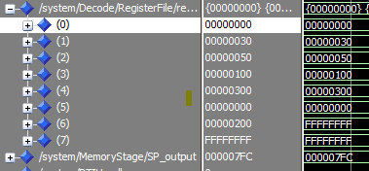

**[2] JMP R1**

Will jump to 30

**[3] INC R7**

this statement will not be executed

**[4] AND R1,R5,R5**  ( Z flag is CRRFlag(0))

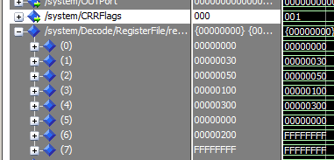

**[5] ADD R0,R0,R0** ( Z flag is CRRFlag(0))

**Out R6**

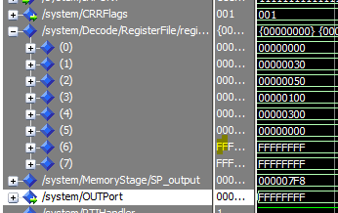

**[6] JZ R2** ( Z flag is CRRFlag(0))

Will Jump to 50



**[7] INC R7**

This statement will not be executed

**[8] JZ R3**

**Jump Not taken**

**[9] NOT R5**

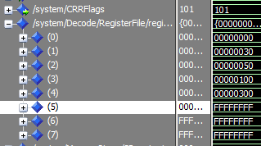

**[10] INC R5** #R5=0, Z=1, C=1, N=0

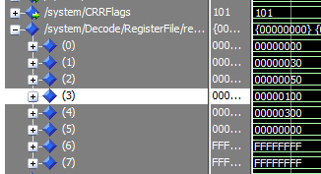

**[11] in R6** #R6=200, flag no change

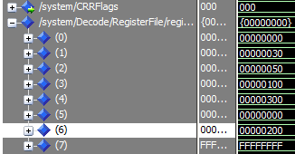

**[11] JZ R6** #jump taken, Z = 0



**[12] INC R1**

This statement will not be executed

**[13] POP R6** #R6=300, SP=7FE

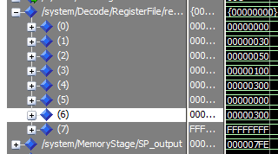

**[14] Call R6**



**[15] Add R3,R6,R6 #R6=400**

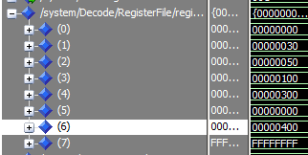

**[16] Add R1,R2,R1 #R1=80, C->0,N=0, Z=0**

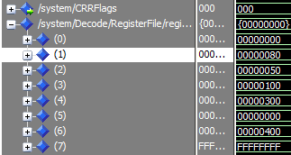

**[17] ret**

**[18] INC R6**

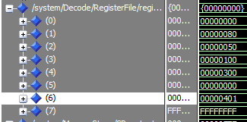

# 

# **Branching Prediction**

**Without forwarding & hazard & flushing units**

[1] LDM R2,0A

[2] LDM R0,0

[3] LDM R1,50

[4] LDM R3,20

[5] LDM R4,2

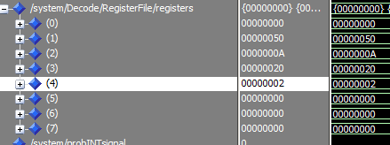

[6]JMP R3

Jump to 20

SUB R0,R2,R5  **( 1st iter.)**, JZ R1 , ADD R4,R4,R4 , OUT R4, INC R0, JMP R3

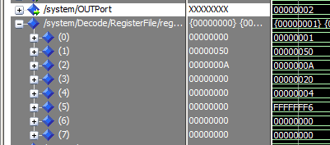

SUB R0,R2,R5  **( 2nd iter.)**, JZ R1 , ADD R4,R4,R4 , OUT R4, INC R0, JMP R3

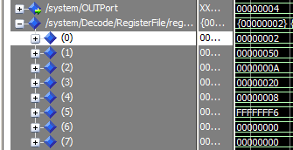

SUB R0,R2,R5  **( 3rd iter.)**, JZ R1 , ADD R4,R4,R4 , OUT R4, INC R0, JMP R3

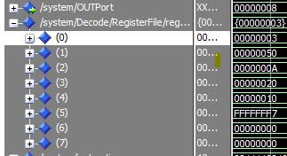

SUB R0,R2,R5  **( 4th iter.)**, JZ R1 , ADD R4,R4,R4 , OUT R4, INC R0, JMP R3

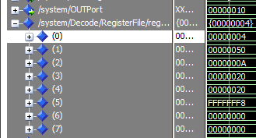

SUB R0,R2,R5  **( 5th iter.)**, JZ R1 , ADD R4,R4,R4 , OUT R4, INC R0, JMP R3

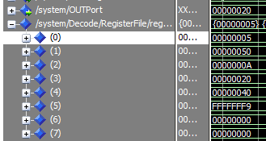

SUB R0,R2,R5  **( 6th iter.)**, JZ R1 , ADD R4,R4,R4 , OUT R4, INC R0, JMP R3

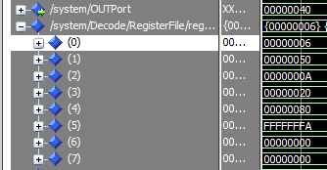

SUB R0,R2,R5  **( 7th iter.)**, JZ R1 , ADD R4,R4,R4 , OUT R4, INC R0, JMP R3

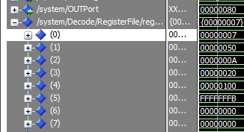

SUB R0,R2,R5  **( 8th iter.)**, JZ R1 , ADD R4,R4,R4 , OUT R4, INC R0, JMP R3

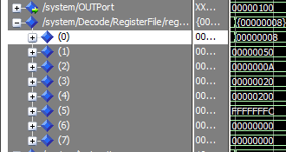

SUB R0,R2,R5  **( 9th iter.)**, JZ R1 , ADD R4,R4,R4 , OUT R4, INC R0, JMP R3

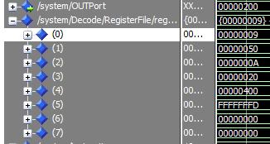

SUB R0,R2,R5  **( 10th iter.)**, JZ R1 , ADD R4,R4,R4 , OUT R4, INC R0, JMP R3

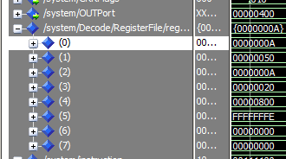

SUB R0,R2,R5  **( 11th iter.)**, JZ R1 , ADD R4,R4,R4 , OUT R4, INC R0, JMP R3

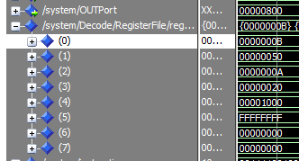

LDM R0,0 , LDM R2,8 , LDM R3,60 , LDM R4,3

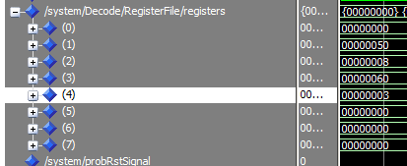

JMP R3

Jump to 60

ADD R4,R4,R4 (1st iter.)

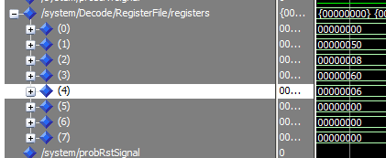

OUT R4

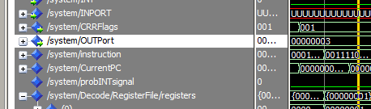

INC R0, AND R0,R2,R5 , JZ R3

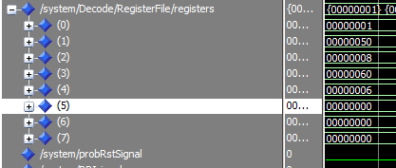

ADD R4,R4,R4 (2nd iter.)

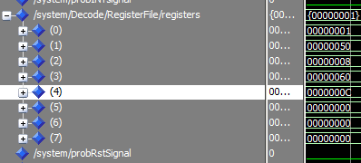

OUT R4

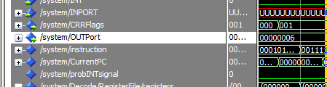

INC R0, AND R0,R2,R5 JZ R3

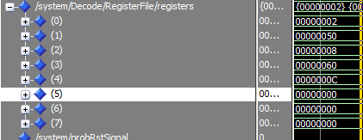

ADD R4,R4,R4 (3rd iteration)

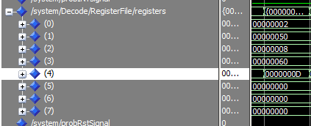

OUT R4

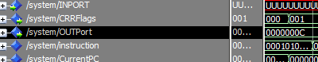

INC R0, AND R0,R2,R5, JZ R3

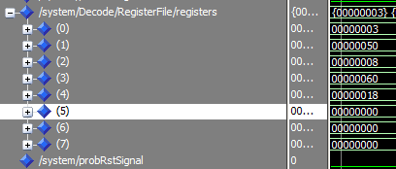

ADD R4,R4,R4 (4th iter.)

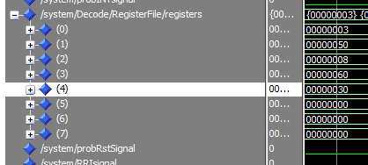

OUT R4

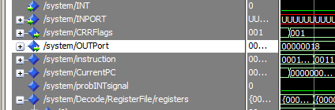

INC R0, AND R0,R2,R5 , JZ R3

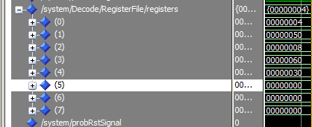

ADD R4,R4,R4 ( 4th iter.)

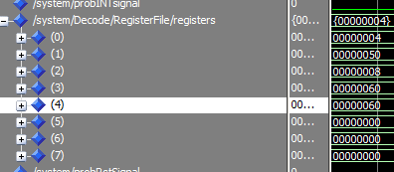

OUT R4

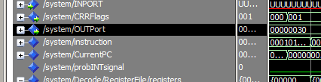

INC R0, AND R0,R2,R5 , JZ R3

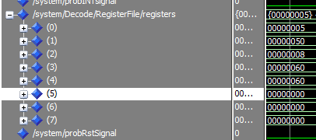

ADD R4,R4,R4 ,OUT R4, INC R0,AND R0,R2,R5, JZ R3 ( 5th iter.)

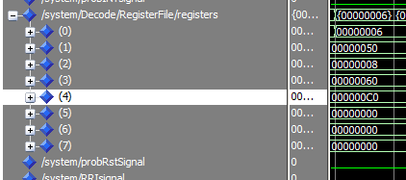

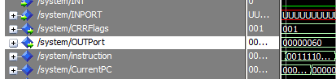

ADD R4,R4,R4 ,OUT R4, INC R0,AND R0,R2,R5, JZ R3 ( 6th iter.)

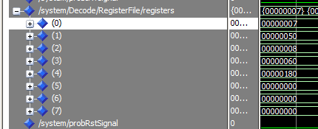

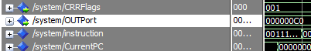

ADD R4,R4,R4 ,OUT R4, INC R0,AND R0,R2,R5, JZ R3 ( 7th iter.)

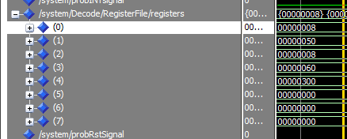

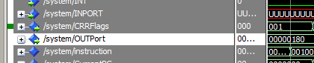

ADD R4,R4,R4 ,OUT R4, INC R0,AND R0,R2,R5 ,JZ R3 ( 8th iter.)

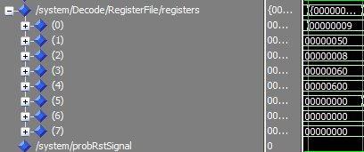



INC R4

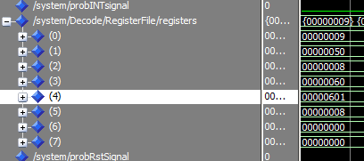

OUT R4

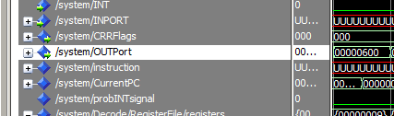

**Solve by adding NOPs**

|  |  |  |  |  |  |  |  |  |  |  |  |  |  |  |  |  |  |  |  |  |  |  |  |
| --- | --- | --- | --- | --- | --- | --- | --- | --- | --- | --- | --- | --- | --- | --- | --- | --- | --- | --- | --- | --- | --- | --- | --- |
| **Instruction** | **Hazard** | **1** | **2** | **3** | **4** | **5** | **6** | **7** | **8** | **9** | **10** | **11** | **12** | **13** | **14** | **15** | **16** | **17** | **18** | **19** | **20** | **21** | **22** |
| **LDM R2,0A** |  | **F** | **D** | **E** | **M** | **W** |  |  |  |  |  |  |  |  |  |  |  |  |  |  |  |  |  |
| **LDM R0,0** |  |  | **F** | **D** | **E** | **M** | **W** |  |  |  |  |  |  |  |  |  |  |  |  |  |  |  |  |
| **LDM R1,50** |  |  |  | **F** | **D** | **E** | **M** | **W** |  |  |  |  |  |  |  |  |  |  |  |  |  |  |  |
| **LDM R3,20** |  |  |  |  | **F** | **D** | **E** | **M** | **W** |  |  |  |  |  |  |  |  |  |  |  |  |  |  |
| **LDM R4,2** |  |  |  |  |  | **F** | **D** | **E** | **M** | **W** |  |  |  |  |  |  |  |  |  |  |  |  |  |
| **JMP R3** |  |  |  |  |  |  | **F** | **D** | **E** | **M** | **W** |  |  |  |  |  |  |  |  |  |  |  |  |
| **SUB R0,R2,R5** |  |  |  |  |  |  |  | **F** | **D** | **E** | **M** | **W** |  |  |  |  |  |  |  |  |  |  |  |
| **JZ R1** |  |  |  |  |  |  |  |  | **F** | **D** | **E** | **M** | **W** |  |  |  |  |  |  |  |  |  |  |
| **ADD R4,R4,R4** |  |  |  |  |  |  |  |  |  | **F** | **D** | **E** | **M** | **W** |  |  |  |  |  |  |  |  |  |

|  |  |  |  |  |  |  |  |  |  |  |  |  |  |  |  |  |  |  |  |
| --- | --- | --- | --- | --- | --- | --- | --- | --- | --- | --- | --- | --- | --- | --- | --- | --- | --- | --- | --- |
| Instruction | Hazards | 10 | 11 | 12 | 13 | 14 | 15 | 16 | 17 | 18 | 19 | 20 | 21 | 22 | 23 | 24 | 25 | 26 | 27 |
| **NOP** |  | **F** | **D** | **E** | **M** | **W** |  |  |  |  |  |  |  |  |  |  |  |  |  |
| **NOP** |  |  | **F** | **D** | **E** | **M** | **W** |  |  |  |  |  |  |  |  |  |  |  |  |
| **OUT R4** | **RAW R4**  **Data Hazard** |  |  | **F** | **D** | **E** | **M** | **W** |  |  |  |  |  |  |  |  |  |  |  |
| **INC R0** |  |  |  |  | **F** | **D** | **E** | **M** | **W** |  |  |  |  |  |  |  |  |  |  |
| **JMP R3**  **(1St iter.)** |  |  |  |  |  | **F** | **D** | **E** | **M** | **W** |  |  |  |  |  |  |  |  |  |
| **NOP** |  |  |  |  |  |  | **F** | **D** | **E** | **M** | **W** |  |  |  |  |  |  |  |  |
| **SUB R0,R2,R5** | **RAW R0**  **Data Hazard** |  |  |  |  |  |  | **F** | **D** | **E** | **M** | **W** |  |  |  |  |  |  |  |
| **JZ R1** |  |  |  |  |  |  |  |  | **F** | **D** | **E** | **M** | **W** |  |  |  |  |  |  |
| **ADD R4,R4,R4** |  |  |  |  |  |  |  |  |  | **F** | **D** | **E** | **M** | **W** |  |  |  |  |  |
| **NOP** |  |  |  |  |  |  |  |  |  |  | **F** | **D** | **E** | **M** | **W** |  |  |  |  |
| **NOP** |  |  |  |  |  |  |  |  |  |  |  | **F** | **D** | **E** | **M** | **W** |  |  |  |
| **OUT R4** | **RAW R4**  **Data Hazard** |  |  |  |  |  |  |  |  |  |  |  | **F** | **D** | **E** | **M** | **W** |  |  |
| **INC R0** |  |  |  |  |  |  |  |  |  |  |  |  |  | **F** | **D** | **E** | **M** | **W** |  |
| **JMP R3**  **(2nd iter.)** |  |  |  |  |  |  |  |  |  |  |  |  |  |  | **F** | **D** | **E** | **M** | **W** |

|  |  |  |  |  |  |  |  |  |  |  |  |  |  |  |
| --- | --- | --- | --- | --- | --- | --- | --- | --- | --- | --- | --- | --- | --- | --- |
| **Instruction** | **Hazard** | **24** | **25** | **26** | **27** | **28** | **29** | **30** | **31** | **32** | **33** | **34** | **35** | **36** |
| **NOP** |  | **F** | **D** | **E** | **M** | **W** |  |  |  |  |  |  |  |  |
| **SUB R0,R2,R5** | **RAW R0**  **Data Hazard** |  | **F** | **D** | **E** | **M** | **W** |  |  |  |  |  |  |  |
| **JZ R1** |  |  |  | **F** | **D** | **E** | **M** | **W** |  |  |  |  |  |  |
| **ADD R4,R4,R4** |  |  |  |  | **F** | **D** | **E** | **M** | **W** |  |  |  |  |  |
| **NOP** |  |  |  |  |  | **F** | **D** | **E** | **M** | **W** |  |  |  |  |
| **NOP** |  |  |  |  |  |  | **F** | **D** | **E** | **M** | **W** |  |  |  |
| **OUT R4** | **RAW R4**  **Data Hazard** |  |  |  |  |  |  | **F** | **D** | **E** | **M** | **W** |  |  |
| **INC R0** |  |  |  |  |  |  |  |  | **F** | **D** | **E** | **M** | **W** |  |
| **JMP R3**  **(3rd iter.)** |  |  |  |  |  |  |  |  |  | **F** | **D** | **E** | **M** | **W** |

|  |  |  |  |  |  |  |  |  |  |  |  |  |  |  |
| --- | --- | --- | --- | --- | --- | --- | --- | --- | --- | --- | --- | --- | --- | --- |
| **Instruction** | **Hazard** | **34** | **35** | **36** | **37** | **38** | **39** | **40** | **41** | **42** | **43** | **44** | **45** | **46** |
| **NOP** |  | **F** | **D** | **E** | **M** | **W** |  |  |  |  |  |  |  |  |
| **SUB R0,R2,R5** | **RAW R0**  **Data Hazard** |  | **F** | **D** | **E** | **M** | **W** |  |  |  |  |  |  |  |
| **JZ R1** |  |  |  | **F** | **D** | **E** | **M** | **W** |  |  |  |  |  |  |
| **ADD R4,R4,R4** |  |  |  |  | **F** | **D** | **E** | **M** | **W** |  |  |  |  |  |
| **NOP** |  |  |  |  |  | **F** | **D** | **E** | **M** | **W** |  |  |  |  |
| **NOP** |  |  |  |  |  |  | **F** | **D** | **E** | **M** | **W** |  |  |  |
| **OUT R4** | **RAW R4**  **Data Hazard** |  |  |  |  |  |  | **F** | **D** | **E** | **M** | **W** |  |  |
| **INC R0** |  |  |  |  |  |  |  |  | **F** | **D** | **E** | **M** | **W** |  |
| **JMP R3**  **(4th iter.)** |  |  |  |  |  |  |  |  |  | **F** | **D** | **E** | **M** | **W** |

|  |  |  |  |  |  |  |  |  |  |  |  |  |  |  |
| --- | --- | --- | --- | --- | --- | --- | --- | --- | --- | --- | --- | --- | --- | --- |
| **Instruction** | **Hazard** | **43** | **44** | **45** | **46** | **47** | **48** | **49** | **50** | **51** | **52** | **53** | **54** | **55** |
| **NOP** |  | **F** | **D** | **E** | **M** | **W** |  |  |  |  |  |  |  |  |
| **SUB R0,R2,R5** | **RAW R0**  **Data Hazard** |  | **F** | **D** | **E** | **M** | **W** |  |  |  |  |  |  |  |
| **JZ R1** |  |  |  | **F** | **D** | **E** | **M** | **W** |  |  |  |  |  |  |
| **ADD R4,R4,R4** |  |  |  |  | **F** | **D** | **E** | **M** | **W** |  |  |  |  |  |
| **NOP** |  |  |  |  |  | **F** | **D** | **E** | **M** | **W** |  |  |  |  |
| **NOP** |  |  |  |  |  |  | **F** | **D** | **E** | **M** | **W** |  |  |  |
| **OUT R4** | **RAW R4**  **Data Hazard** |  |  |  |  |  |  | **F** | **D** | **E** | **M** | **W** |  |  |
| **INC R0** |  |  |  |  |  |  |  |  | **F** | **D** | **E** | **M** | **W** |  |
| **JMP R3**  **(5th iter.)** |  |  |  |  |  |  |  |  |  | **F** | **D** | **E** | **M** | **W** |

|  |  |  |  |  |  |  |  |  |  |  |  |  |  |  |
| --- | --- | --- | --- | --- | --- | --- | --- | --- | --- | --- | --- | --- | --- | --- |
| **Instruction** | **Hazard** | **52** | **53** | **54** | **55** | **56** | **57** | **58** | **59** | **60** | **61** | **62** | **63** | **64** |
| **NOP** |  | **F** | **D** | **E** | **M** | **W** |  |  |  |  |  |  |  |  |
| **SUB R0,R2,R5** | **RAW R0**  **Data Hazard** |  | **F** | **D** | **E** | **M** | **W** |  |  |  |  |  |  |  |
| **JZ R1** |  |  |  | **F** | **D** | **E** | **M** | **W** |  |  |  |  |  |  |
| **ADD R4,R4,R4** |  |  |  |  | **F** | **D** | **E** | **M** | **W** |  |  |  |  |  |
| **NOP** |  |  |  |  |  | **F** | **D** | **E** | **M** | **W** |  |  |  |  |
| **NOP** |  |  |  |  |  |  | **F** | **D** | **E** | **M** | **W** |  |  |  |
| **OUT R4** | **RAW R4**  **Data Hazard** |  |  |  |  |  |  | **F** | **D** | **E** | **M** | **W** |  |  |
| **INC R0** |  |  |  |  |  |  |  |  | **F** | **D** | **E** | **M** | **W** |  |
| **JMP R3**  **(6th iter.)** |  |  |  |  |  |  |  |  |  | **F** | **D** | **E** | **M** | **W** |

|  |  |  |  |  |  |  |  |  |  |  |  |  |  |  |
| --- | --- | --- | --- | --- | --- | --- | --- | --- | --- | --- | --- | --- | --- | --- |
| **Instruction** | **Hazard** | **61** | **62** | **63** | **64** | **65** | **66** | **67** | **68** | **69** | **70** | **71** | **72** | **73** |
| **NOP** |  | **F** | **D** | **E** | **M** | **W** |  |  |  |  |  |  |  |  |
| **SUB R0,R2,R5** | **RAW R0**  **Data Hazard** |  | **F** | **D** | **E** | **M** | **W** |  |  |  |  |  |  |  |
| **JZ R1** |  |  |  | **F** | **D** | **E** | **M** | **W** |  |  |  |  |  |  |
| **ADD R4,R4,R4** |  |  |  |  | **F** | **D** | **E** | **M** | **W** |  |  |  |  |  |
| **NOP** |  |  |  |  |  | **F** | **D** | **E** | **M** | **W** |  |  |  |  |
| **NOP** |  |  |  |  |  |  | **F** | **D** | **E** | **M** | **W** |  |  |  |
| **OUT R4** | **RAW R4**  **Data Hazard** |  |  |  |  |  |  | **F** | **D** | **E** | **M** | **W** |  |  |
| **INC R0** |  |  |  |  |  |  |  |  | **F** | **D** | **E** | **M** | **W** |  |
| **JMP R3**  **(7th iter.)** |  |  |  |  |  |  |  |  |  | **F** | **D** | **E** | **M** | **W** |

|  |  |  |  |  |  |  |  |  |  |  |  |  |  |  |
| --- | --- | --- | --- | --- | --- | --- | --- | --- | --- | --- | --- | --- | --- | --- |
| **Instruction** | **Hazard** | **70** | **71** | **72** | **73** | **74** | **75** | **76** | **77** | **78** | **79** | **80** | **81** | **82** |
| **NOP** |  | **F** | **D** | **E** | **M** | **W** |  |  |  |  |  |  |  |  |
| **SUB R0,R2,R5** | **RAW R0**  **Data Hazard** |  | **F** | **D** | **E** | **M** | **W** |  |  |  |  |  |  |  |
| **JZ R1** |  |  |  | **F** | **D** | **E** | **M** | **W** |  |  |  |  |  |  |
| **ADD R4,R4,R4** |  |  |  |  | **F** | **D** | **E** | **M** | **W** |  |  |  |  |  |
| **NOP** |  |  |  |  |  | **F** | **D** | **E** | **M** | **W** |  |  |  |  |
| **NOP** |  |  |  |  |  |  | **F** | **D** | **E** | **M** | **W** |  |  |  |
| **OUT R4** | **RAW R4**  **Data Hazard** |  |  |  |  |  |  | **F** | **D** | **E** | **M** | **W** |  |  |
| **INC R0** |  |  |  |  |  |  |  |  | **F** | **D** | **E** | **M** | **W** |  |
| **JMP R3**  **(8th iter.)** |  |  |  |  |  |  |  |  |  | **F** | **D** | **E** | **M** | **W** |

|  |  |  |  |  |  |  |  |  |  |  |  |  |  |  |
| --- | --- | --- | --- | --- | --- | --- | --- | --- | --- | --- | --- | --- | --- | --- |
| **Instruction** | **Hazard** | **79** | **80** | **81** | **82** | **83** | **84** | **85** | **86** | **87** | **88** | **89** | **90** | **91** |
| **NOP** |  | **F** | **D** | **E** | **M** | **W** |  |  |  |  |  |  |  |  |
| **SUB R0,R2,R5** | **RAW R0**  **Data Hazard** |  | **F** | **D** | **E** | **M** | **W** |  |  |  |  |  |  |  |
| **JZ R1** |  |  |  | **F** | **D** | **E** | **M** | **W** |  |  |  |  |  |  |
| **ADD R4,R4,R4** |  |  |  |  | **F** | **D** | **E** | **M** | **W** |  |  |  |  |  |
| **NOP** |  |  |  |  |  | **F** | **D** | **E** | **M** | **W** |  |  |  |  |
| **NOP** |  |  |  |  |  |  | **F** | **D** | **E** | **M** | **W** |  |  |  |
| **OUT R4** | **RAW R4**  **Data Hazard** |  |  |  |  |  |  | **F** | **D** | **E** | **M** | **W** |  |  |
| **INC R0** |  |  |  |  |  |  |  |  | **F** | **D** | **E** | **M** | **W** |  |
| **JMP R3**  **(9th iter.)** |  |  |  |  |  |  |  |  |  | **F** | **D** | **E** | **M** | **W** |

|  |  |  |  |  |  |  |  |  |  |  |  |  |  |  |
| --- | --- | --- | --- | --- | --- | --- | --- | --- | --- | --- | --- | --- | --- | --- |
| **Instruction** | **Hazard** | **88** | **89** | **90** | **91** | **92** | **93** | **94** | **95** | **96** | **97** | **98** | **99** | **100** |
| **NOP** |  | **F** | **D** | **E** | **M** | **W** |  |  |  |  |  |  |  |  |
| **SUB R0,R2,R5** | **RAW R0**  **Data Hazard** |  | **F** | **D** | **E** | **M** | **W** |  |  |  |  |  |  |  |
| **JZ R1** |  |  |  | **F** | **D** | **E** | **M** | **W** |  |  |  |  |  |  |
| **ADD R4,R4,R4** |  |  |  |  | **F** | **D** | **E** | **M** | **W** |  |  |  |  |  |
| **NOP** |  |  |  |  |  | **F** | **D** | **E** | **M** | **W** |  |  |  |  |
| **NOP** |  |  |  |  |  |  | **F** | **D** | **E** | **M** | **W** |  |  |  |
| **OUT R4** | **RAW R4**  **Data Hazard** |  |  |  |  |  |  | **F** | **D** | **E** | **M** | **W** |  |  |
| **INC R0** |  |  |  |  |  |  |  |  | **F** | **D** | **E** | **M** | **W** |  |
| **JMP R3**  **(10th iter.)** |  |  |  |  |  |  |  |  |  | **F** | **D** | **E** | **M** | **W** |

|  |  |  |  |  |  |  |  |  |  |  |  |  |  |  |
| --- | --- | --- | --- | --- | --- | --- | --- | --- | --- | --- | --- | --- | --- | --- |
| **Instruction** | **Hazard** | **97** | **98** | **99** | **100** | **101** | **102** | **103** | **104** | **105** | **106** | **107** | **108** | **109** |
| **LDM R0,0** |  | **F** | **D** | **E** | **M** | **W** |  |  |  |  |  |  |  |  |
| **LDM R2,8** |  |  | **F** | **D** | **E** | **M** | **W** |  |  |  |  |  |  |  |
| **LDM R3,60** |  |  |  | **F** | **D** | **E** | **M** | **W** |  |  |  |  |  |  |
| **LDM R4,3** |  |  |  |  | **F** | **D** | **E** | **M** | **W** |  |  |  |  |  |
| **JMP R3** |  |  |  |  |  | **F** | **D** | **E** | **M** | **W** |  |  |  |  |
| **ADD R4,**  **R4,R4** |  |  |  |  |  |  | **F** | **D** | **E** | **M** | **W** |  |  |  |
| **NOP** |  |  |  |  |  |  |  | **F** | **D** | **E** | **M** | **W** |  |  |
| **NOP** |  |  |  |  |  |  |  |  | **F** | **D** | **E** | **M** | **W** |  |
| **OUT R4** | **RAW R4**  **Data Hazard** |  |  |  |  |  |  |  |  | **F** | **D** | **E** | **M** | **W** |

|  |  |  |  |  |  |  |  |  |  |  |  |  |  |  |
| --- | --- | --- | --- | --- | --- | --- | --- | --- | --- | --- | --- | --- | --- | --- |
| **Instruction** | **Hazard** | **106** | **107** | **108** | **109** | **110** | **112** | **113** | **114** | **115** | **116** | **117** | **118** | **119** |
| **INC R0** |  | **F** | **D** | **E** | **M** | **W** |  |  |  |  |  |  |  |  |
| **NOP** |  |  | **F** | **D** | **E** | **M** | **W** |  |  |  |  |  |  |  |
| **NOP** |  |  |  | **F** | **D** | **E** | **M** | **W** |  |  |  |  |  |  |
| **AND R0,R2,R5** | **RAW R0**  **Data Hazard** |  |  |  | **F** | **D** | **E** | **M** | **W** |  |  |  |  |  |
| **JZ R3**  **1st iter.** |  |  |  |  |  | **F** | **D** | **E** | **M** | **W** |  |  |  |  |
| **ADD R4,**  **R4,R4** |  |  |  |  |  |  | **F** | **D** | **E** | **M** | **W** |  |  |  |
| **NOP** |  |  |  |  |  |  |  | **F** | **D** | **E** | **M** | **W** |  |  |
| **NOP** |  |  |  |  |  |  |  |  | **F** | **D** | **E** | **M** | **W** |  |
| **OUT R4** | **RAW R4**  **Data Hazard** |  |  |  |  |  |  |  |  | **F** | **D** | **E** | **M** | **W** |

|  |  |  |  |  |  |  |  |  |  |  |  |
| --- | --- | --- | --- | --- | --- | --- | --- | --- | --- | --- | --- |
| **Instruction** | **Hazard** | **116** | **117** | **118** | **119** | **120** | **122** | **123** | **124** | **125** | **126** |
| **INC R0** |  |  | **F** | **D** | **E** | **M** | **W** |  |  |  |  |
| **NOP** |  |  |  | **F** | **D** | **E** | **M** | **W** |  |  |  |
| **NOP** |  |  |  |  | **F** | **D** | **E** | **M** | **W** |  |  |
| **AND R0,R2,R5** | **RAW R0**  **Data Hazard** |  |  |  |  | **F** | **D** | **E** | **M** | **W** |  |
| **JZ R3**  **(2nd iter.)** |  |  |  |  |  |  | **F** | **D** | **E** | **M** | **W** |

|  |  |  |  |  |  |  |  |  |  |  |  |  |  |  |
| --- | --- | --- | --- | --- | --- | --- | --- | --- | --- | --- | --- | --- | --- | --- |
| **Instruction** | **Hazard** | **123** | **124** | **125** | **126** | **127** | **128** | **129** | **130** | **131** | **132** | **133** | **134** | **135** |
| **ADD R4,**  **R4,R4** |  | **F** | **D** | **E** | **M** | **W** |  |  |  |  |  |  |  |  |
| **NOP** |  |  | **F** | **D** | **E** | **M** | **W** |  |  |  |  |  |  |  |
| **NOP** |  |  |  | **F** | **D** | **E** | **M** | **W** |  |  |  |  |  |  |
| **OUT R4** | **RAW R4**  **Data Hazard** |  |  |  | **F** | **D** | **E** | **M** | **W** |  |  |  |  |  |
| **INC R0** |  |  |  |  |  | **F** | **D** | **E** | **M** | **W** |  |  |  |  |
| **NOP** |  |  |  |  |  |  | **F** | **D** | **E** | **M** | **W** |  |  |  |
| **NOP** |  |  |  |  |  |  |  | **F** | **D** | **E** | **M** | **W** |  |  |
| **AND R0,R2,R5** | **RAW R0**  **Data Hazard** |  |  |  |  |  |  |  | **F** | **D** | **E** | **M** | **W** |  |
| **JZ R3**  **(3rd iter.)** |  |  |  |  |  |  |  |  |  | **F** | **D** | **E** | **M** | **W** |

|  |  |  |  |  |  |  |  |  |  |  |  |  |  |  |
| --- | --- | --- | --- | --- | --- | --- | --- | --- | --- | --- | --- | --- | --- | --- |
| **Instruction** | **Hazard** | **132** | **133** | **134** | **135** | **136** | **137** | **138** | **139** | **140** | **141** | **142** | **143** | **144** |
| **ADD R4,**  **R4,R4** |  | **F** | **D** | **E** | **M** | **W** |  |  |  |  |  |  |  |  |
| **NOP** |  |  | **F** | **D** | **E** | **M** | **W** |  |  |  |  |  |  |  |
| **NOP** |  |  |  | **F** | **D** | **E** | **M** | **W** |  |  |  |  |  |  |
| **OUT R4** | **RAW R4**  **Data Hazard** |  |  |  | **F** | **D** | **E** | **M** | **W** |  |  |  |  |  |
| **INC R0** |  |  |  |  |  | **F** | **D** | **E** | **M** | **W** |  |  |  |  |
| **NOP** |  |  |  |  |  |  | **F** | **D** | **E** | **M** | **W** |  |  |  |
| **NOP** |  |  |  |  |  |  |  | **F** | **D** | **E** | **M** | **W** |  |  |
| **AND R0,R2,R5** | **RAW R0**  **Data Hazard** |  |  |  |  |  |  |  | **F** | **D** | **E** | **M** | **W** |  |
| **JZ R3**  **(4th iter.)** |  |  |  |  |  |  |  |  |  | **F** | **D** | **E** | **M** | **W** |

|  |  |  |  |  |  |  |  |  |  |  |  |  |  |  |
| --- | --- | --- | --- | --- | --- | --- | --- | --- | --- | --- | --- | --- | --- | --- |
| **Instruction** | **Hazard** | **141** | **142** | **143** | **144** | **145** | **146** | **147** | **148** | **149** | **150** | **151** | **152** | **153** |
| **ADD R4,**  **R4,R4** |  | **F** | **D** | **E** | **M** | **W** |  |  |  |  |  |  |  |  |
| **NOP** |  |  | **F** | **D** | **E** | **M** | **W** |  |  |  |  |  |  |  |
| **NOP** |  |  |  | **F** | **D** | **E** | **M** | **W** |  |  |  |  |  |  |
| **OUT R4** | **RAW R4**  **Data Hazard** |  |  |  | **F** | **D** | **E** | **M** | **W** |  |  |  |  |  |
| **INC R0** |  |  |  |  |  | **F** | **D** | **E** | **M** | **W** |  |  |  |  |
| **NOP** |  |  |  |  |  |  | **F** | **D** | **E** | **M** | **W** |  |  |  |
| **NOP** |  |  |  |  |  |  |  | **F** | **D** | **E** | **M** | **W** |  |  |
| **AND R0,R2,R5** | **RAW R0**  **Data Hazard** |  |  |  |  |  |  |  | **F** | **D** | **E** | **M** | **W** |  |
| **JZ R3**  **(5th iter.)** |  |  |  |  |  |  |  |  |  | **F** | **D** | **E** | **M** | **W** |

|  |  |  |  |  |  |  |  |  |  |  |  |  |  |  |
| --- | --- | --- | --- | --- | --- | --- | --- | --- | --- | --- | --- | --- | --- | --- |
| **Instruction** | **Hazard** | **150** | **151** | **152** | **153** | **154** | **155** | **156** | **157** | **158** | **159** | **160** | **161** | **162** |
| **ADD R4,**  **R4,R4** |  | **F** | **D** | **E** | **M** | **W** |  |  |  |  |  |  |  |  |
| **NOP** |  |  | **F** | **D** | **E** | **M** | **W** |  |  |  |  |  |  |  |
| **NOP** |  |  |  | **F** | **D** | **E** | **M** | **W** |  |  |  |  |  |  |
| **OUT R4** | **RAW R4**  **Data Hazard** |  |  |  | **F** | **D** | **E** | **M** | **W** |  |  |  |  |  |
| **INC R0** |  |  |  |  |  | **F** | **D** | **E** | **M** | **W** |  |  |  |  |
| **NOP** |  |  |  |  |  |  | **F** | **D** | **E** | **M** | **W** |  |  |  |
| **NOP** |  |  |  |  |  |  |  | **F** | **D** | **E** | **M** | **W** |  |  |
| **AND R0,R2,R5** | **RAW R0**  **Data Hazard** |  |  |  |  |  |  |  | **F** | **D** | **E** | **M** | **W** |  |
| **JZ R3**  **(6th iter.)** |  |  |  |  |  |  |  |  |  | **F** | **D** | **E** | **M** | **W** |

|  |  |  |  |  |  |  |  |  |  |  |  |  |  |  |
| --- | --- | --- | --- | --- | --- | --- | --- | --- | --- | --- | --- | --- | --- | --- |
| **Instruction** | **Hazard** | **159** | **160** | **161** | **162** | **163** | **164** | **165** | **166** | **167** | **168** | **169** | **170** | **171** |
| **ADD R4,**  **R4,R4** |  | **F** | **D** | **E** | **M** | **W** |  |  |  |  |  |  |  |  |
| **NOP** |  |  | **F** | **D** | **E** | **M** | **W** |  |  |  |  |  |  |  |
| **NOP** |  |  |  | **F** | **D** | **E** | **M** | **W** |  |  |  |  |  |  |
| **OUT R4** | **RAW R4**  **Data Hazard** |  |  |  | **F** | **D** | **E** | **M** | **W** |  |  |  |  |  |
| **INC R0** |  |  |  |  |  | **F** | **D** | **E** | **M** | **W** |  |  |  |  |
| **NOP** |  |  |  |  |  |  | **F** | **D** | **E** | **M** | **W** |  |  |  |
| **NOP** |  |  |  |  |  |  |  | **F** | **D** | **E** | **M** | **W** |  |  |
| **AND R0,R2,R5** | **RAW R0**  **Data Hazard** |  |  |  |  |  |  |  | **F** | **D** | **E** | **M** | **W** |  |
| **JZ R3**  **(7th iter.)** |  |  |  |  |  |  |  |  |  | **F** | **D** | **E** | **M** | **W** |

|  |  |  |  |  |  |  |  |  |  |  |  |  |  |  |
| --- | --- | --- | --- | --- | --- | --- | --- | --- | --- | --- | --- | --- | --- | --- |
| **Instruction** | **Hazard** | **169** | **170** | **171** | **172** | **173** | **174** | **175** | **176** | **177** | **178** | **179** | **180** | **181** |
| **ADD R4,**  **R4,R4** |  | **F** | **D** | **E** | **M** | **W** |  |  |  |  |  |  |  |  |
| **NOP** |  |  | **F** | **D** | **E** | **M** | **W** |  |  |  |  |  |  |  |
| **NOP** |  |  |  | **F** | **D** | **E** | **M** | **W** |  |  |  |  |  |  |
| **OUT R4** | **RAW R4**  **Data Hazard** |  |  |  | **F** | **D** | **E** | **M** | **W** |  |  |  |  |  |
| **INC R0** |  |  |  |  |  | **F** | **D** | **E** | **M** | **W** |  |  |  |  |
| **NOP** |  |  |  |  |  |  | **F** | **D** | **E** | **M** | **W** |  |  |  |
| **NOP** |  |  |  |  |  |  |  | **F** | **D** | **E** | **M** | **W** |  |  |
| **AND R0,R2,R5** | **RAW R0**  **Data Hazard** |  |  |  |  |  |  |  | **F** | **D** | **E** | **M** | **W** |  |
| **JZ R3**  **(8th iter.)** |  |  |  |  |  |  |  |  |  | **F** | **D** | **E** | **M** | **W** |

|  |  |  |  |  |  |  |  |  |  |
| --- | --- | --- | --- | --- | --- | --- | --- | --- | --- |
| **Instruction** | **Hazard** | **178** | **179** | **180** | **181** | **182** | **183** | **184** | **185** |
| **INC R4** |  | **F** | **D** | **E** | **M** | **W** |  |  |  |
| **NOP** |  |  | **F** | **D** | **E** | **M** | **W** |  |  |
| **NOP** |  |  |  | **F** | **D** | **E** | **M** | **W** |  |
| **OUT R4** | **RAW R4**  **Data Hazard** |  |  |  | **F** | **D** | **E** | **M** | **W** |

**Here is the correct result with forwarding unit only**

All instructions works CORRECTLY and give the right results with no hazards because all hazards are data hazards that are handled by forwarding unit.

The following wave shows the register file

# LDM R2,0A, LDM R0,0 , LDM R1,50, LDM R3,20, LDM R4,2 , JMP R3

# 

SUB R0,R2,R5 ,JZ R1, ADD R4,R4,R4 ,OUT R4 ,INC R0, JMP R3 (1st iteration)

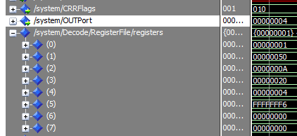

SUB R0,R2,R5 ,JZ R1, ADD R4,R4,R4 ,OUT R4 ,INC R0, JMP R3 (2nd iteration)

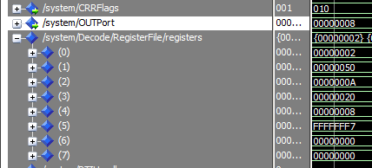

SUB R0,R2,R5 ,JZ R1, ADD R4,R4,R4 ,OUT R4 ,INC R0, JMP R3 (3rd iteration)

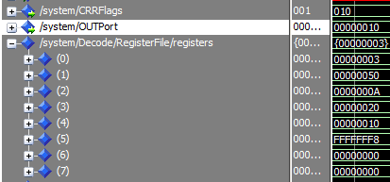

SUB R0,R2,R5 ,JZ R1, ADD R4,R4,R4 ,OUT R4 ,INC R0, JMP R3 (4th iteration)

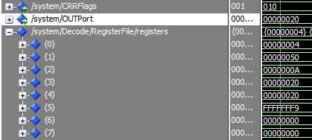

SUB R0,R2,R5 ,JZ R1, ADD R4,R4,R4 ,OUT R4 ,INC R0, JMP R3 (5th iteration)

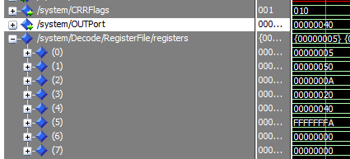

SUB R0,R2,R5 ,JZ R1, ADD R4,R4,R4 ,OUT R4 ,INC R0, JMP R3 (6th iteration)

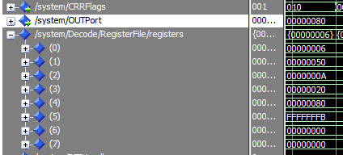

SUB R0,R2,R5 ,JZ R1, ADD R4,R4,R4 ,OUT R4 ,INC R0, JMP R3 (7th iteration)

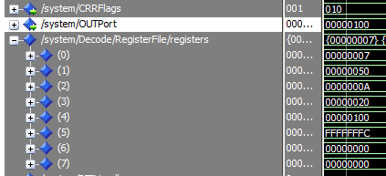

SUB R0,R2,R5 ,JZ R1, ADD R4,R4,R4 ,OUT R4 ,INC R0, JMP R3 (8th iteration)

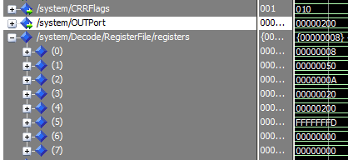

SUB R0,R2,R5 ,JZ R1, ADD R4,R4,R4 ,OUT R4 ,INC R0, JMP R3 (9th iteration)

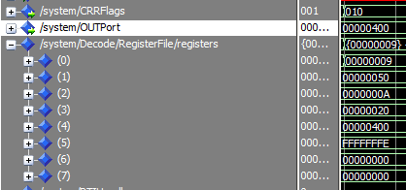

SUB R0,R2,R5 ,JZ R1, ADD R4,R4,R4 ,OUT R4 ,INC R0, JMP R3 (10th iteration)

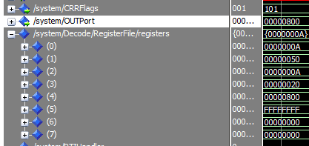

SUB R0,R2,R5 ,JZ R1

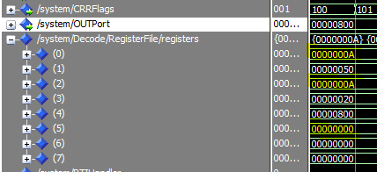

LDM R0,0 , LDM R2,8 , LDM R3,60 , LDM R4,3 , JMP R3

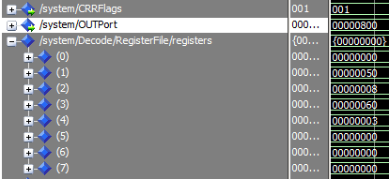

ADD R4,R4,R4 , OUT R4 ,INC R0, AND R0,R2,R5 , JZ R3 (1s iter.)

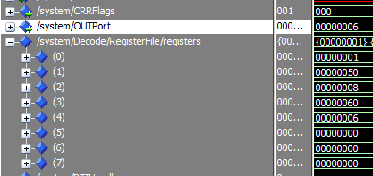

ADD R4,R4,R4 , OUT R4 ,INC R0, AND R0,R2,R5 , JZ R3 (2nd iter.)

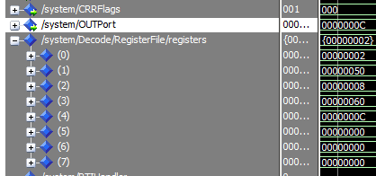

ADD R4,R4,R4 , OUT R4 ,INC R0, AND R0,R2,R5 , JZ R3 (3rd iter.)

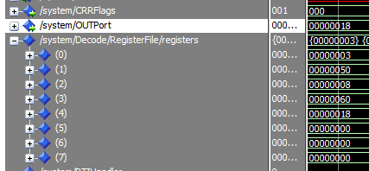

ADD R4,R4,R4 , OUT R4 ,INC R0, AND R0,R2,R5 , JZ R3 (4th iter.)

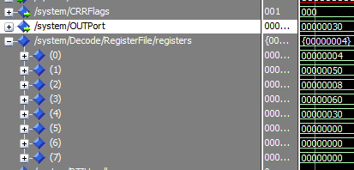

ADD R4,R4,R4 , OUT R4 ,INC R0, AND R0,R2,R5 , JZ R3 (5th iter.)

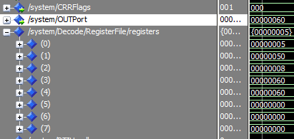

ADD R4,R4,R4 , OUT R4 ,INC R0, AND R0,R2,R5 , JZ R3 (6th iter.)

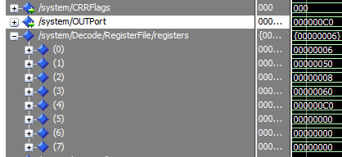

ADD R4,R4,R4 , OUT R4 ,INC R0, AND R0,R2,R5 , JZ R3 (7th iter.)

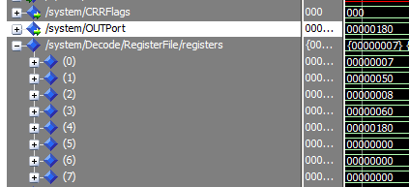

ADD R4,R4,R4 , OUT R4 ,INC R0, AND R0,R2,R5 , JZ R3 (8th iter.)

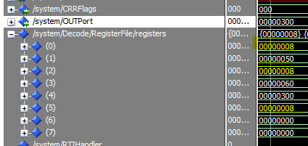

INC R4 OUT R4

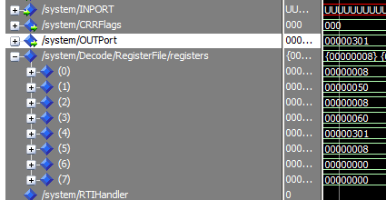

**Design**

Instruction format

* Width of instruction = 16 bits
* 5 bits for opcode for all kind of instruction

Opcodes:

One operand

|  |  |  |  |
| --- | --- | --- | --- |
| Opcode  5 bits | Rdst  3 bits | 000  3 bits | 00000  5 bits |

Two operand (ADD, SUB, OR, AND)

|  |  |  |  |  |
| --- | --- | --- | --- | --- |
| Opcode  5 bits | Rsrc1  3 bits | Rscr2  3bits | Rdst  3 bits | 0  2 bit |

Two operand (SWAP)

|  |  |  |  |  |
| --- | --- | --- | --- | --- |
| Opcode  5 bits | Rsrc1  3 bits | Rscr2  3bits | 000  3 bits | 0  2 bit |

Two operand (SHL, SHR)

|  |  |  |  |  |
| --- | --- | --- | --- | --- |
| Opcode  5 bits | Rsrc  3 bits | 000  3bits | 0000  4 bits | 1  1 bit 32/16 |

|  |
| --- |
| IMM  16 bit |

Two operand (IADD)

|  |  |  |  |  |
| --- | --- | --- | --- | --- |
| Opcode  5 bits | Rsrc  3 bits | 000  3bits | RDst  3 bits | 01  zero+1 bit 32/16 |

|  |
| --- |
| IMM  16 bit |

Memory (PUSH, POP)

|  |  |  |  |
| --- | --- | --- | --- |
| Opcode  5 bits | Rdst  3 bits | 000  3 bits | 00000  5 bit |

Memory (LDM)

|  |  |  |  |  |
| --- | --- | --- | --- | --- |
| Opcode  5 bits | Rdst  3 bits | 000  3 bits | 0000  4 bit | 1  1 bit 32/16 |

|  |
| --- |
| IMM  16 bit |

Memory (LDD, STD)

|  |  |  |  |  |
| --- | --- | --- | --- | --- |
| Opcode  5 bits | Rdst  3 bits | Rsrc  3 bits | EA(19:16)  4 bit | 1  1 bit |

|  |
| --- |
| EA(0:15)  16 bit |

Branch and Change of Control Operations

|  |  |  |  |
| --- | --- | --- | --- |
| Opcode  5 bits | Rdst  3 bits | Rsrc  3bits | 00000  5 bits |

Opcodes for every Instruction

|  |  |
| --- | --- |
| **Instruction** | **Opcode** |
| **NOP** | **00000** |
| **NOT  Rdst** | **00001** |
| **INC Rdst** | **00010** |
| **DEC Rdst** | **00011** |
| **OUT Rdst** | **00100** |
| **IN Rdst** | **00101** |
| **SWAP Rsrc, Rdst** | **00110** |
| **ADD Rscr1, Rscr2, Rdst** | **00111** |
| **IADD Rscr1, Rdst, Imm** | **01000** |
| **SUB Rscr1, Rscr2, Rdst** | **01001** |
| **AND Rscr1, Rscr2, Rdst** | **01010** |
| **OR Rscr1, Rscr2, Rdst** | **01011** |
| **SHL Rscr, Imm** | **01100** |
| SHR Rsrc,Imm | 01101 |
| **PUSH Rdst** | **01110** |
| **POP Rdst** | **01111** |
| **LDM Rdst, Imm** | **10000** |
| **LDD Rdst, EA** | **10001** |
| **STD Rscr, EA** | **10010** |
| **JZ Rdst** | **10011** |
| **JMP Rdst** | **10100** |
| **CALL Rdst** | **10101** |
| **RET** | **10110** |
| **RTI** | **10111** |

Schematic diagram:

Fetch and decode:

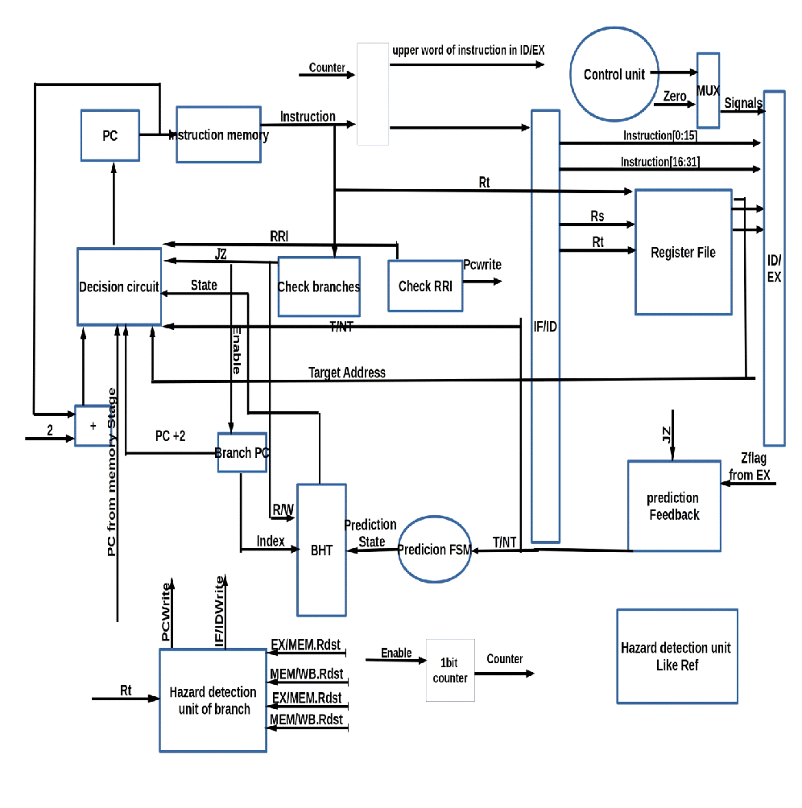

Notes:

There is a bus from instruction fetched to the second 16 bits of instruction section of ID/EX reg, to load the instruction fetched which is the address in case of 32 bit instruction and use it in Execution stage.

There is enable signals from prediction feedback and from check branches to enable the BHT to read or write, (check branches. JZ OR prediction Feedback. Enable) to disable the BHT in the ordinary instructions and enable it in case of JZ to read the state and the instruction next to JZ to write then new state.

**Decision circuit**: is used to determine the next pc value, to be loaded to the pc in falling edge after fetching the current instruction at the beginning of cycle (rising edge).

In case of branch instructions (jz, jmp, call, ret, RTI), at first we check for jz instruction which needs prediction, if the instruction is JZ then we load the current value of the pc to the branch pc.

**Branch pc**: used to save it to use in case of miss prediction (predict token and the prediction is wrong then we need to load the next instruction of branch instruction not the next of the token prediction target address).

**BHT**: used to save the state of JZ instructions, it has R/W input which determined by JZ signal.

**Check RRI**: to check for RET, RTI, interrupt instructions that need to write back the read PC from the memory stage, so it stalls the fetch stage.

**Hazard Detection Unit of branch**: needed to stall the fetch and decode in case of branch WAR data dependency (if.flush=1,pcWrite =0).

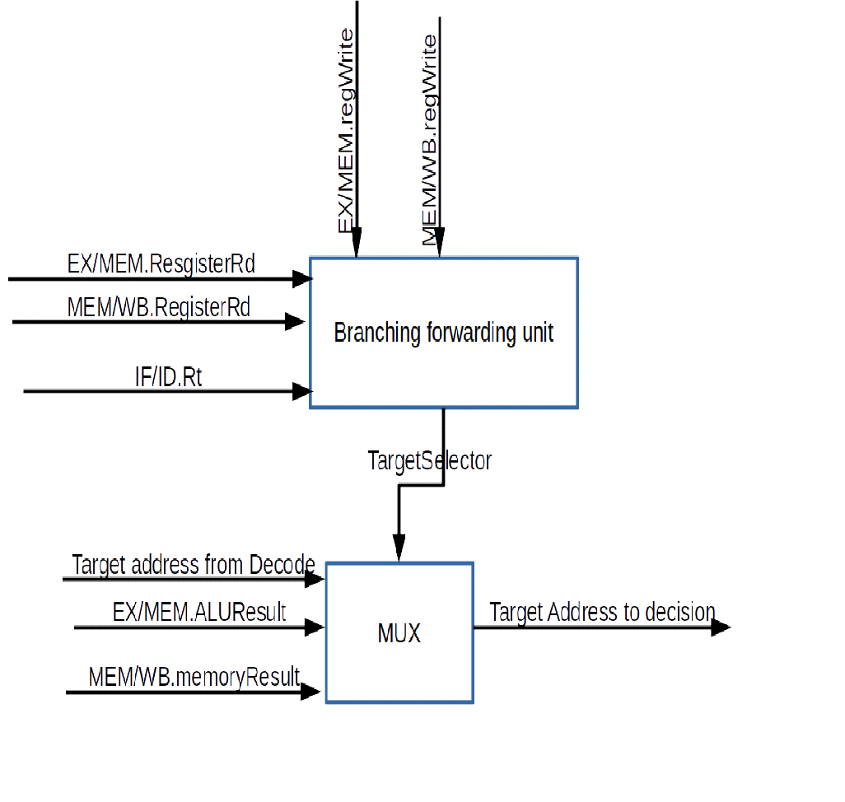

**1bit Counter**: used to determine if the current fetch stage is fetching address not instruction . 1 => address

* enable of counter is ORING of decode signal of 32/16 signal , 0th bit in instruction fetched.

**decision circuit at IF/ID:** its input is the fetched instruction and counter to determine the output which is zeros or the instruction. In case of counter =1 then the output will be the instruction forwarded to ID/EX is the instruction(address) and the another output is zeros to stored , if.flush = 1 ,,if counter =0 then the instruction stored in IF/ID and if.flush = 0.

IF/ID => interrupted 0 in normal flow.

1=> when stage receive interrupt signal it stall fetch make pcwrite =0, put interrupt signal =1 in IF/ID.

Other stages put interrupt signal in the next intermediate register =1, then the next cycle to this stage it will stall itself.

In memory we would operate 4 cycles:

First cycle: to perform the current instruction.

Second cycle: to write PC value in the stack, after this cycle stops WB.

Third cycle: to put the address of M (2), M (3) to PC.

Fourth cycle: to store the flags in stack.

**Decode:**

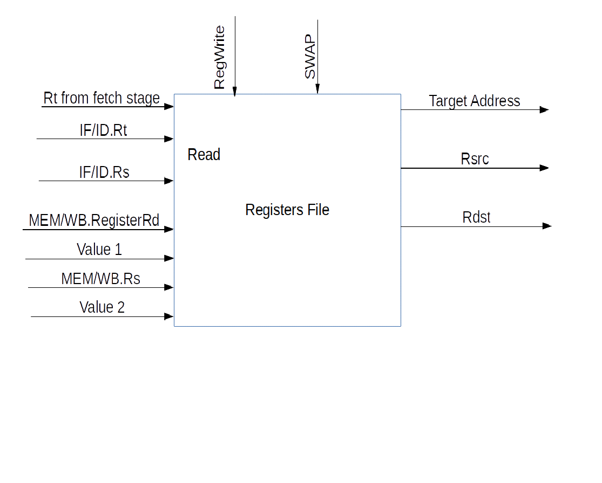

at swap instruction : swap signal =1 then it enable the write functionality of write at Rs register.

**Hazard detection unit**

 Checking for load instructions, the control for the hazard detection unit is this single condition:

if (ID/EX.MemRead and ((ID/EX.RegisterRt = IF/ID.RegisterRs) or

(ID/EX.RegisterRt = IF/ID.RegisterRt)))   stall the pipeline

ID stage is stalled, then the instruction in the IF stage must also be stalled by preventing the PC register and the IF/ID pipeline register from changing. a stall bubble delays everything behind it.

 The hazard detection unit controls the writing of the PC and IF/ID registers plus the multiplexor that chooses between the real control values and all 0s. The hazard detection unit stalls and deasserts the control fields if the load-use hazard test above is true.

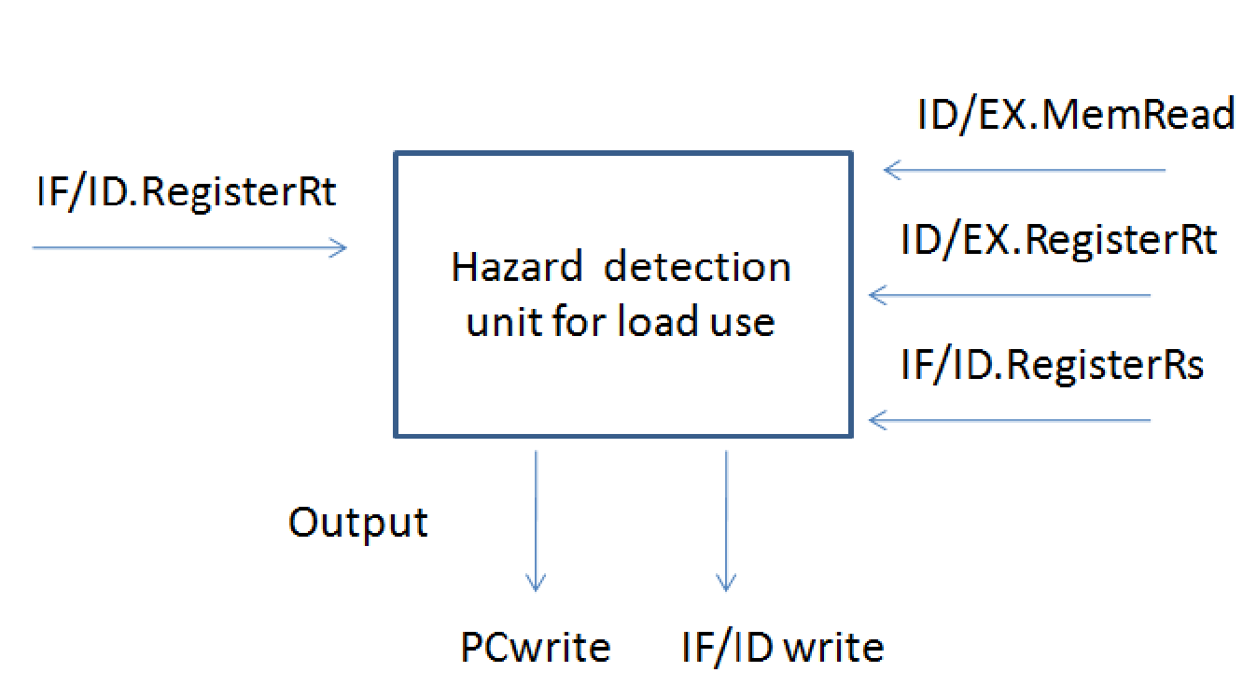

Execution :

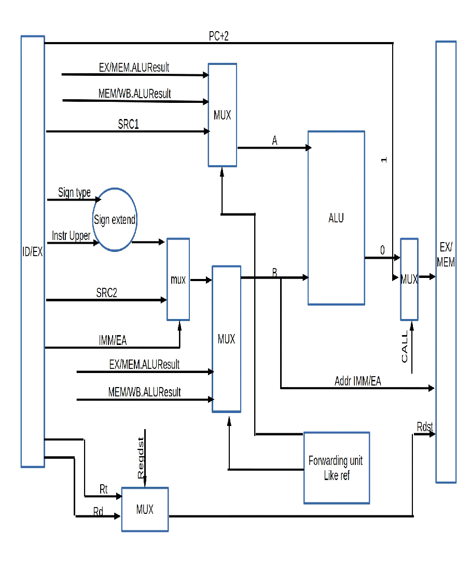

* We add multiplexer before ALU takes A and input port value and selects between them.

In this case selector will be one (signal **in enable =1).**

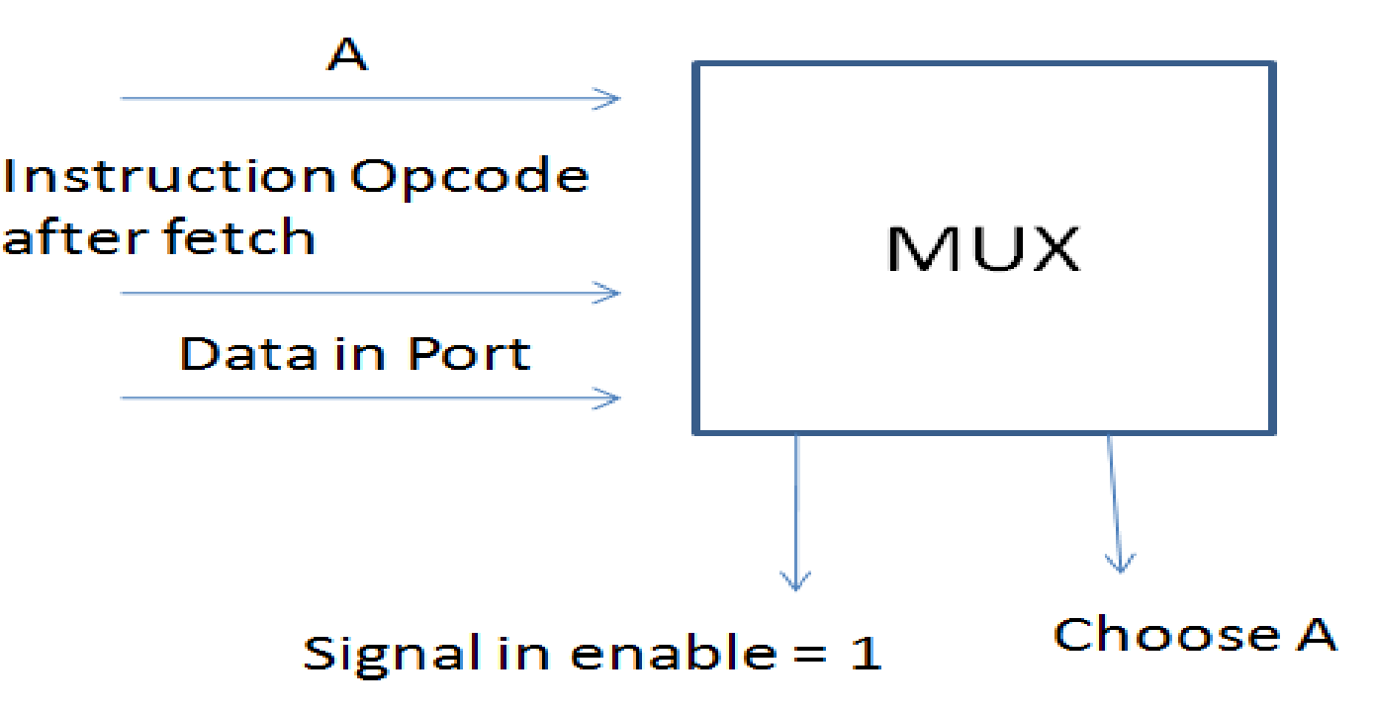

MUX to load to data to be written in the memory take the data from ALUResult , PC+1 from IF/ID register. The selector is Call signal which indicate that the instruction is CALL which need to write the pc value

ALU selectors bits (4 bits):

* NOP: 0000
* A: 0001
* B: 0010
* INC:0011
* DEC:0100
* ADD:0101
* SUB:0110
* NOT: 0111
* AND: 1000
* OR: 1001
* SHL: 1010
* SHR: 1011

1- Data Hazard Forwarding Unit

**Forwarding unit diagram**

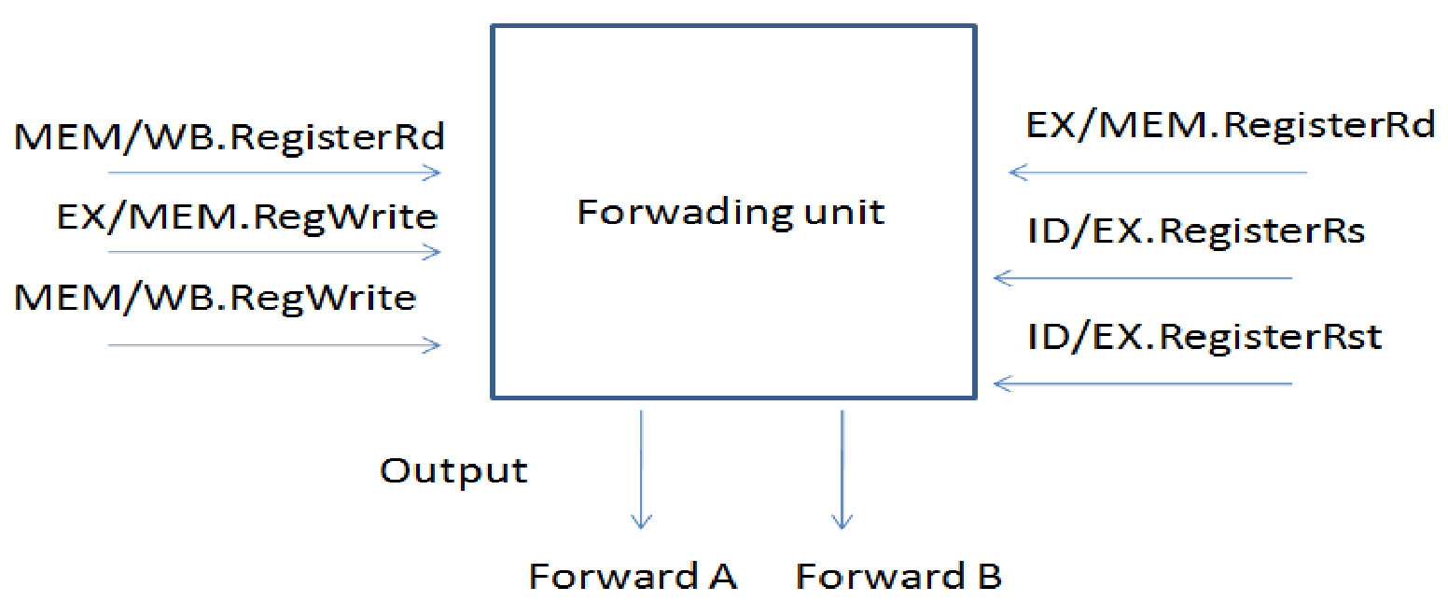

Data Hazard Conditions:

1a. EX/MEM.RegisterRd = ID/EX.RegisterRs

1b. EX/MEM.RegisterRd = ID/EX.RegisterRt

2a. MEM/WB.RegisterRd = ID/EX.RegisterRs

2b. MEM/WB.RegisterRd = ID/EX.RegisterRt

1. EX hazard:

If (EX/MEM.RegWrite and (EX/MEM.RegisterRd ≠ 0) and

(EX/MEM.RegisterRd = ID/EX.RegisterRs)) ForwardA = 10

If (EX/MEM.RegWrite and (EX/MEM.RegisterRd ≠ 0) and

EX/MEM.SWAP and

(EX/MEM.RegisterRs = ID/EX.RegisterRs)) ForwardA = 10

If (EX/MEM.RegWrite and (EX/MEM.RegisterRd ≠ 0) and

(EX/MEM.RegisterRd = ID/EX.RegisterRt)) ForwardB = 10

If (EX/MEM.RegWrite and (EX/MEM.RegisterRd ≠ 0) and

EX/MEM.SWAP and

(EX/MEM.RegisterRs = ID/EX.RegisterRt)) ForwardB = 10

2. MEM hazard:

If (MEM/WB.RegWrite and (MEM/WB.RegisterRd ≠ 0) and

(MEM/WB.RegisterRd = ID/EX.RegisterRs)) ForwardA = 01

If (MEM/WB.RegWrite and (MEM/WB.RegisterRd ≠ 0) and

MEM/WB.SWAP and

(MEM/WB.RegisterRs = ID/EX.RegisterRs)) ForwardA = 01

If (MEM/WB.RegWrite and (MEM/WB.RegisterRd ≠ 0) and

(MEM/WB.RegisterRd = ID/EX.RegisterRt)) ForwardB = 01

If (MEM/WB.RegWrite and (MEM/WB.RegisterRd ≠ 0) and

MEM/WB.SWAP and

(MEM/WB.RegisterRs = ID/EX.RegisterRt)) ForwardB = 01

In this case, the result is forwarded from the MEM stage because the result in the MEM stage is the more recent result. The control for the MEM hazard would be :

if (MEM/WB.RegWrite and (MEM/WB.RegisterRd ≠ 0) and not(EX/MEM.RegWrite and (EX/MEM.RegisterRd ≠ 0) and

(EX/MEM.RegisterRd ≠ ID/EX.RegisterRs)) and (MEM/WB.RegisterRd = ID/EX.RegisterRs)) ForwardA = 01 if (MEM/WB.RegWrite and (MEM/WB.RegisterRd ≠ 0) and not(EX/MEM.RegWrite and (EX/MEM.RegisterRd ≠ 0) and (EX/MEM.RegisterRd ≠ ID/EX.RegisterRt))

 and (MEM/WB.RegisterRd = ID/EX.RegisterRt)) ForwardB = 01

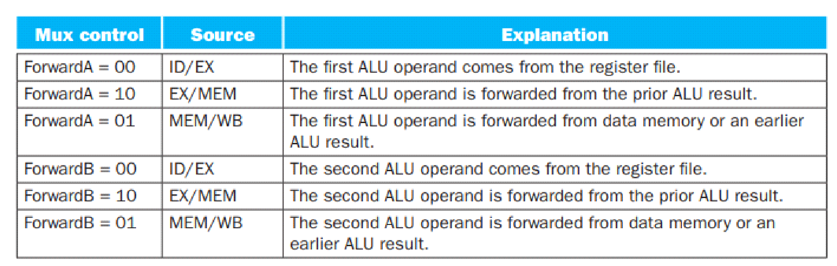

**Control hazards and branching :**

In fetch stage we add check branching and check RTI to determine the current instruction and check if it has control hazard or not ,

in case of unconditional branching JMP ,CALL, it gets the pc new value from decoding stage.

in case of JZ which need prediction at first it will read the prediction state from BHT then according to it it determine whether pc new will be PC+2(NT) or target address from decode,then in the next cycle in fetching of new instruction and decode of JZ instruction , then the prediction feedback circuit out the T/NT/notJZ to determined if the prediction was right or not ,and to determine the new state to store in BHT.

RET,RTI : they need the pc from memory stage then in each stage if RRI =1 then it will stall itself and the previous stage to prevent any new instruction from execution , and in memory stage it will stall itself and the previous stages and determine the logic of memory according to the instruction.

Mem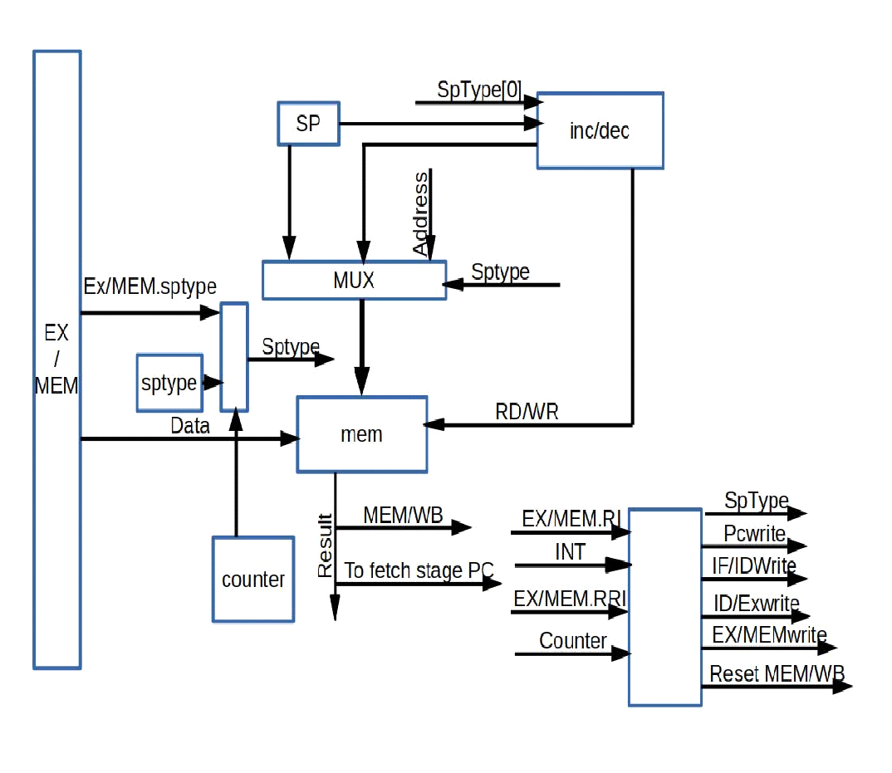

* Counter enable determined by RRI, RI, interrupt signal.
* There is a Decision circuit to determine data input to memory.
* Inputs are counter, RI, RRI, interrupt signal to be selectors, and the data to be selected pc from fetch, flags from ALU, EX/MEM.Data
* There is a Decision circuit to determine address of selector.
* Inputs are  counter ,RI,RRI,interrupt signal, reset signal  to be selectors, and the addresses to be selected 0 for reset ,2 for interrupt, EX/MEM.address.

Pipeline registers details:

IF/ID register

Inputs of this register are IR (2 bytes) + PC new (after incremented) (4 bytes), interrupt signal (1 bit), RET(1 bit),RTI(1 bit), reset (1 bit),INPORTValue(4 bytes). Instruction of fetch stage is navigated to ID/IE to be stored in the lower 16 bits of the register. (84 bits)

In case of data hazards:

* PC needs an enable in case of stall the pipeline.
* IF/ID has an enable so that it will not be changed.

In case of control hazard

In jz instruction when decode decision is opposite to prediction then prediction FSM make make if.flush = 1

ID/EX:

Needs the values are read from the register file of Rscr1 and Rscr2 so  4 Bytes for Rscr1 + 4 Bytes for Rscr2, instruction (4 bytes),PC(after increment)(4 bytes),Ret(1 bit),RTI(1 bit),SWAP, CALL,INT

* WBsignals = 3 signals => memtoreg, regwrite, outenable =>3bits.
* EXsignals =ALUop=>4bits.
* SignExtend, IMM/EA, regDst, INEnableSignal=>4bits.
* MEM signals = memRead, memWrite, spType=>4bits.
* InPortValue(4Bytes)

(180 bits)

EX/MEM:

It must be big enough to hold all possible situations as the following:

* Rsrc2,SWAP,Rt
* ALUresult/pc+1 =>4bytes, address =>4bytes, Rdst (3 bit).
* Interrupt signal (1 bit), RET(1 bit),RTI(1 bit),CALL(1 bit),CRR (flags) (3 bits).
* MEM signals = memRead, memWrite, spType=>4bits.
* WBsignals = 3 signals => memtoreg, regwrite, outenable =>3bits.

(117 bits)

MEM/WB:

* Rsrc2(4bytes),SWAP,Rt,Rd
* WBsignals 3bits
* Result from the memory (.i.e. in load instruction it will result 4bytes for the value to be WB in DST reg).
* Result from ALU (4bytes).

(106 bits)

**Fetching 2 word instructions:**

Bit 1 in instruction is indicator to the type of instruction:

* ‘0’ if the instruction is 16 bits.
* ‘1’ if the instruction is 32 bits.

In fetch stage we know the instruction then use the 1th bit of instruction to enable the counter.

When counter =0 then the stage fetch the first 16 bits of the instruction , then it make decision circuit will store the instruction in IF/ID , and forward zeros to ID/EX upper word of instruction section ,then in the next cycle we decode the first part of instruction and we know that the instruction is 32 bits then 32/16 =1 then counter will be 1 and when 32/16 =1 then if.flush = 1 to insert bubble to the remaining of the fetched instruction which is address. When counter =1 then instruction forwarded to ID/EX instruction section.

Control signal of each instruction:

One operand:

|  |  |  |  |  |  |  |  |  |  |  |  |  |  |
| --- | --- | --- | --- | --- | --- | --- | --- | --- | --- | --- | --- | --- | --- |
| instr\  signals | RegWr | RegDST | Mem  To  Reg | Mem  Rd | MemWR | SP | ALU | PC  write | Imm/  EA | sign | CRR | in enable | Out enable |
| NOP | 0 | 0 | 0 | 0 | 0 | 11 | nop | 1 | 0 | 0 | 0 | 0 | 0 |
| NOT Rdst | 1 | 1 | 0 | 0 | 0 | 11 | A | 1 | 0 | 0 | 0 | 0 | 0 |
| INC Rdst | 1 | 1 | 0 | 0 | 0 | 11 | A+1 | 1 | 0 | 0 | 0 | 0 | 0 |
| DEC Rdst | 1 | 1 | 0 | 0 | 0 | 11 | A-1 | 1 | 0 | 0 | 0 | 0 | 0 |
| OUT Rdst | 0 | 1 | 0 | 0 | 0 | 11 | nop | 1 | 0 | 0 | 0 | 0 | 1 |
| IN Rdst | 1 | 1 | 0 | 0 | 0 | 11 | A | 1 | 0 | 0 | 0 | 1 | 0 |

Branch:

|  |  |  |  |  |  |  |  |  |  |  |  |  |
| --- | --- | --- | --- | --- | --- | --- | --- | --- | --- | --- | --- | --- |
| instr\  signals | Reg  WR | Reg  DST | Mem  To  Reg | out  enable | Mem  Rd | memWR | SP | AlU | 32  /16 | Imm/  EA | sign | CRR |
| PUSH | 0 | x | 0 | 0 | 0 | 1 | 00 | A | 0 | x | 1 | 0 |
| POP | 1 | 1 | 1 | 0 | 1 | 0 | 01 | nop | 0 | 0 | 1 | 0 |
| LDM | 1 | 1 | 0 | 0 | 0 | 0 | 11 | B | 1 | 1 | 1 | 0 |
| LDD | 1 | 1 | 1 | 0 | 1 | 0 | 10 | nop | 1 | 1 | 0 | 0 |
| STD | 0 | 1 | 0 | 0 | 0 | 1 | 10 | A | 1 | 1 | 0 | 0 |
| JZ | 0 | 0 | 0 | 0 | 0 | 0 | 11 | nop | 0 | 0 | x | 0 |
| JMP | 0 | 0 | 0 | 0 | 0 | 0 | 11 | nop | 0 | 0 | x | 0 |
| CALL | 0 | 0 | 0 | 0 | 0 | 1 | 00 | nop | 0 | 0 | x | 1 |
| RET | 0 | x | 0 | 0 | 1 | 0 | 01 | nop | 0 | 0 | x | 1 |
| RTI | 0 | x | 0 | 0 | 1 | 0 | 01 | nop | 0 | 0 | x | 1 |
| instr\signals | RegWR | RegDST | Mem  To  Reg | out  enable | Mem  Rd | memWR | SP | ALU | 32/  16 | Imm/  EA | sign | CRR |
| Swap | 1 | 1 | 0 | 0 | 0 | 0 | 11 | A | 0 |  | 0 | 0 |
| ADD | 1 | 1 | 0 | 0 | 0 | 0 | 11 | Add | 0 | 0 | 0 | 0 |
| IADD | 1 | 1 | 0 | 0 | 0 | 0 | 11 | Add | 0 | 1 | 1 | 0 |
| SUB | 1 | 1 | 0 | 0 | 0 | 0 | 11 | Sub | 0 | 0 | 0 | 0 |
| AND | 1 | 1 | 0 | 0 | 0 | 0 | 11 | And | 0 | 0 | 0 | 0 |
| OR | 1 | 1 | 0 | 0 | 0 | 0 | 1111 | or | 0 | 0 | 0 | 0 |
| SHL | 1 | 0 | 0 | 0 | 0 | 0 | 1111 | shl | 1 | 1 | 0 | 0 |
| SHR | 1 | 0 | 0 | 0 | 0 | 0 | 1111 | shr | 1 | 1 | 0 | 0 |