**Cairo University**

**Faculty of Computers and Artificial Intelligence**

**CS213 – Programming II**

**First Semester 2022 – 2023**

**Group A**

**Assignment #1 Report**

|  |  |  |  |  |
| --- | --- | --- | --- | --- |
| Hossam Ahmed Fouad | 20210124 | group A | 11410120210124@stud.cu.edu.eg | 01116535351 |
| Mohamed Waleed | 20210362 | group A | 11410120210362@stud.cu.edu.eg | 01120292025 |
| Omar Gaafar | 20210263 | group A | 11410120210263@stud.cu.edu.eg | 01128755766 |

**Task 1 - Classes, objects, abstraction and operator overloading**

**Work Done:**

* Hossam Ahmed Fouad – 20210124
  + a - Initialization of number from string constructor - BigDecimalInt (string decStr)
  + b - Initialization of number from int constructor - BigDecimalInt (int decInt)
  + c - Operator overloading for addition (+) to handle addition on strings for BigDecimalInt Class - BigDecimalInt operator+ (BigDecimalInt anotherDec)
* Omar Gaafar – 20210263
  + d - Operator overloading for subtraction (-) to handle subtraction on strings for BigDecimalInt Class - BigDecimalInt operator- (BigDecimalInt anotherDec)
  + e - Operator overloading for inequality sign (<) - bool operator< (BigDecimalInt anotherDec)
* Mohamed Waleed – 20210362
  + f - Operator overloading for inequality sign (>) - bool operator> (BigDecimalInt anotherDec)
  + g - Operator overloading for equality sign (==) - bool operator== (BigDecimalInt anotherDec)
  + h - Operator overloading for assigning operator (=) - bool operator= (BigDecimalInt anotherDec)
  + i - Member function that returns size of number - int size()
  + j - Member function that returns sign of number - int sign()
  + k – Operator overloading for output operator (<<) - friend ostream& operator << (ostream& out, BigDecimalInt b)

**Task 2 – Individual problems from Sheet 1**

Problems Done:

Hossam Ahmed Fouad – 20210124: 0 – 3 – 6

Omar Gaafar – 20210263: 1 – 4 – 7

Mohamed Waleed – 20210362: 2 – 5 – 8

**GitHub Accounts**

Hossam Ahmed Fouad – 20210124

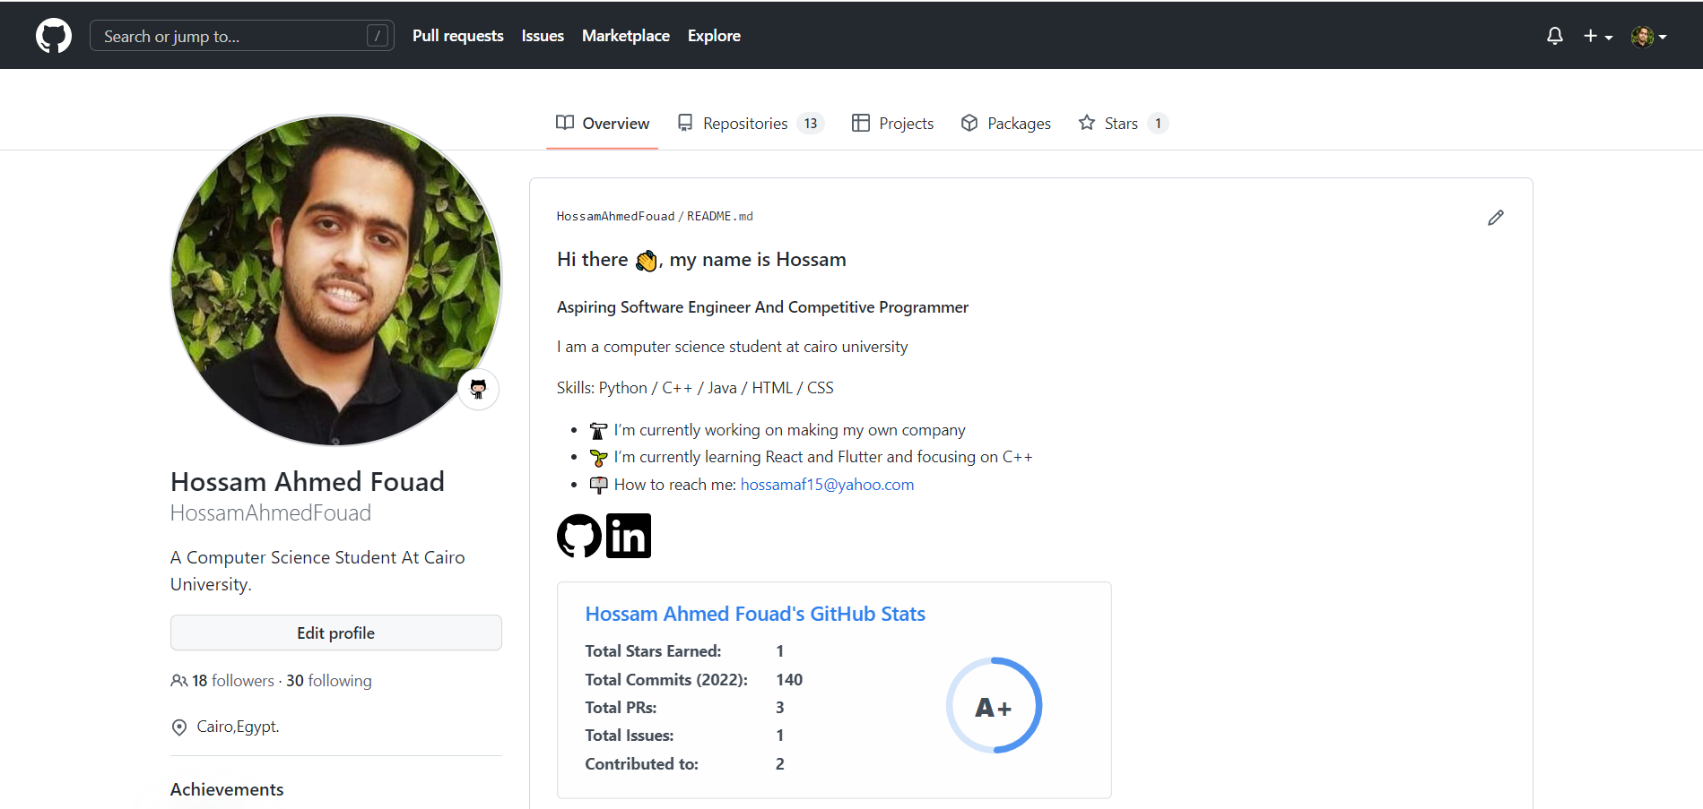

Omar Gaafar – 20210263

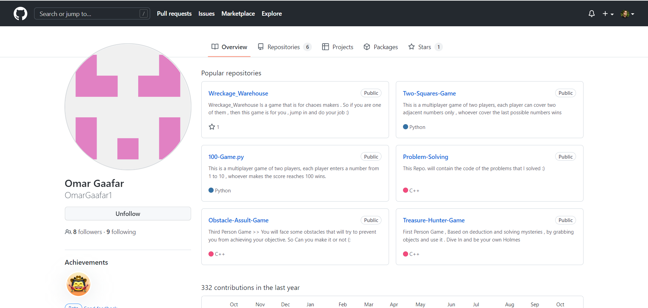

Mohamed Waleed – 20210362

