Assignment 5 – Training SeqTrack on a Reduced Dataset

Objective
This assignment ensures that students can customize the LaSOT dataset and train SeqTrack on a reduced subset of classes. The task will strengthen your understanding of dataset configuration, model training, and performance evaluation by focusing on 5 selected classes out of the full 70-class LaSOT dataset.
The goals are:
- To confirm you can filter and prepare a reduced dataset for training.
- To ensure you can train SeqTrack for sub classes of Lasot dataset and monitor performance.
- To enforce team-level dataset uniqueness so that no two teams use the same 5-class subset.
- To guarantee authenticity through screenshots, logs, and graphs showing performance and inference speed.
Suggested 70 classes of LaSOT are divided into 14 groups of 5 classes each.
• Members 1–4 each take two groups (10 classes total).
• Members 5–10 each take one group (5 classes).
Final allocation:
• Member 1 → Classes 1–5 and 6–10
• Member 2 → Classes 11–15 and 16–20
• Member 3 → Classes 21–25 and 26–30
• Member 4 → Classes 31–35 and 36–40
• Member 5 → Classes 41–45
• Member 6 → Classes 46–50
• Member 7 → Classes 51–55
• Member 8 → Classes 56–60
• Member 9 → Classes 61–65
• Member 10 → Classes 66–70

Task Instructions

Step 1 – Project Setup
- Clone your previous SeqTrack project (Assignment 3).
- Rename the project folder to seqtrack5.
- Modify the dataset loader so it can read from a class selection text file to filter the dataset.

Step 2 – Training the Model
- Adjust your configuration yaml file as given
for training
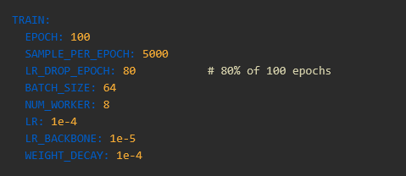
- For testing
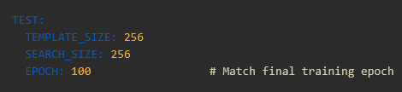

- Save one checkpoint at the end of each 5 epochs (20 checkpoints total).
- Ensure that all team members use the same reduced dataset configuration.

Step 3 – Documentation and Evidence
- Every member must provide his selected classes and his part of work
- Every member must follow the same rules given in assignment 3 and assignment 4 for training and for evaluation
- The team leader collects all these data in one .docx file in the same style

