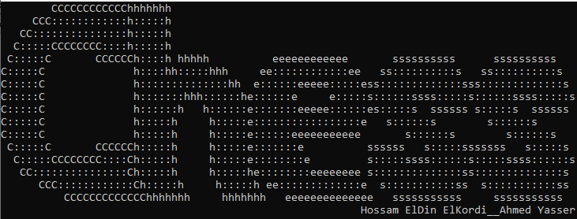**In c**

Report

Chess is a two-player strategy board game played on a chessboard, a checkered gameboard with 64 squares arranged in an 8×8 grid. The game is played by millions of people worldwide. Chess is believed to have originated in India sometime before the 7th century. The game was derived from the Indian game chaturanga, which is also the likely ancestor of the Eastern strategy games xiangqi, janggi, and shogi. Chess reached Europe by the 9th century, due to the Umayyad conquest of Hispania. The pieces assumed their current powers in Spain in the late 15th century; the rules were standardized in the 19th century.

We tried to replicate the game in c, the game supports stalemate, checkmate, pawn promotion, undo, redo, save game and load a saved game. We use a two-dimensional array. The users enter a 4 to 5 letters long entry that indicates where he indicates the place where the piece is located and the place where he wants it to move and the piece he wants to promote his pawn to in case of promotion, the code then validates the user’s input and then moves the pieces; discussing in details all the sections.

**Input validation**

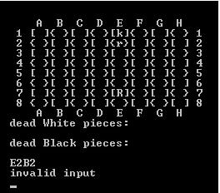the code stores the user’s input in an array of character then proceeds to check if the input is correct or not, first of all we check the length of the input and then we check if the position is inside the board or not and then we check if it’s a valid move for this particular piece and then checks if the destination has a piece of the same player the move is prohibited if it’s not a valid move it asks the user to enter another valid input, the user anytime during the game can enter the letter u to undo the move and this can be done multiple times until the initial move, after undoing the user can enter the letter r to redo, the user can enter the letter s to save the game, and when the game starts the user can enter the letter l to load the saved game .

and each piece has its own validation here are some of them

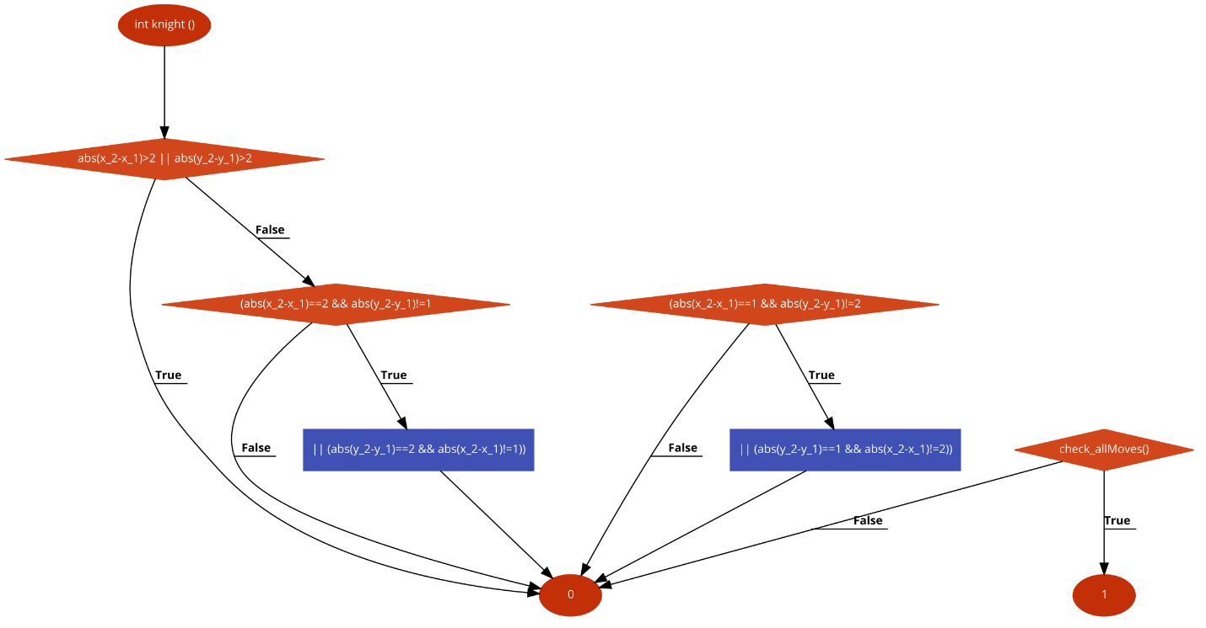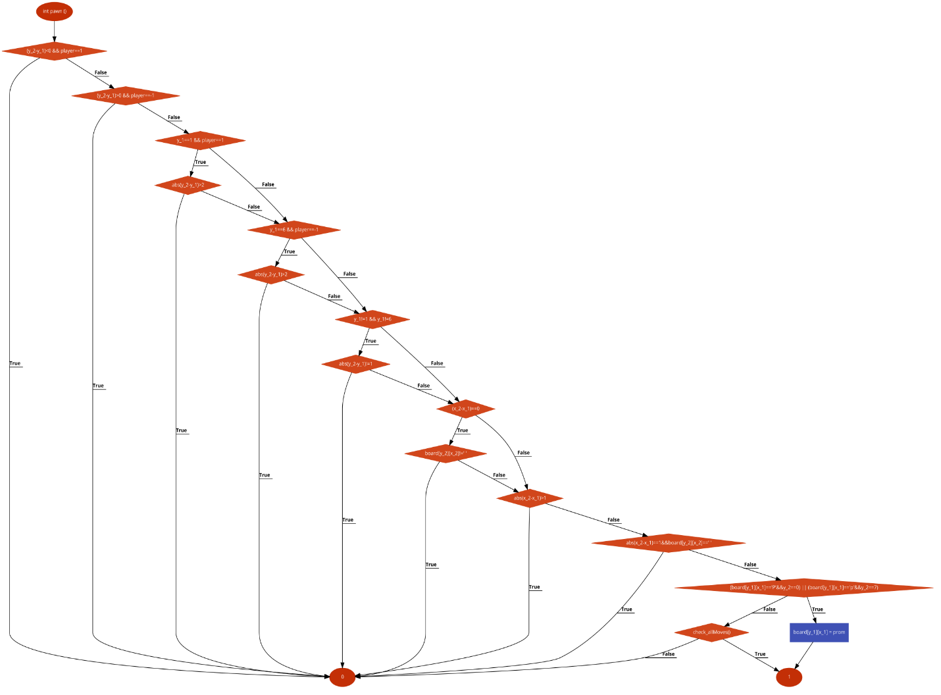

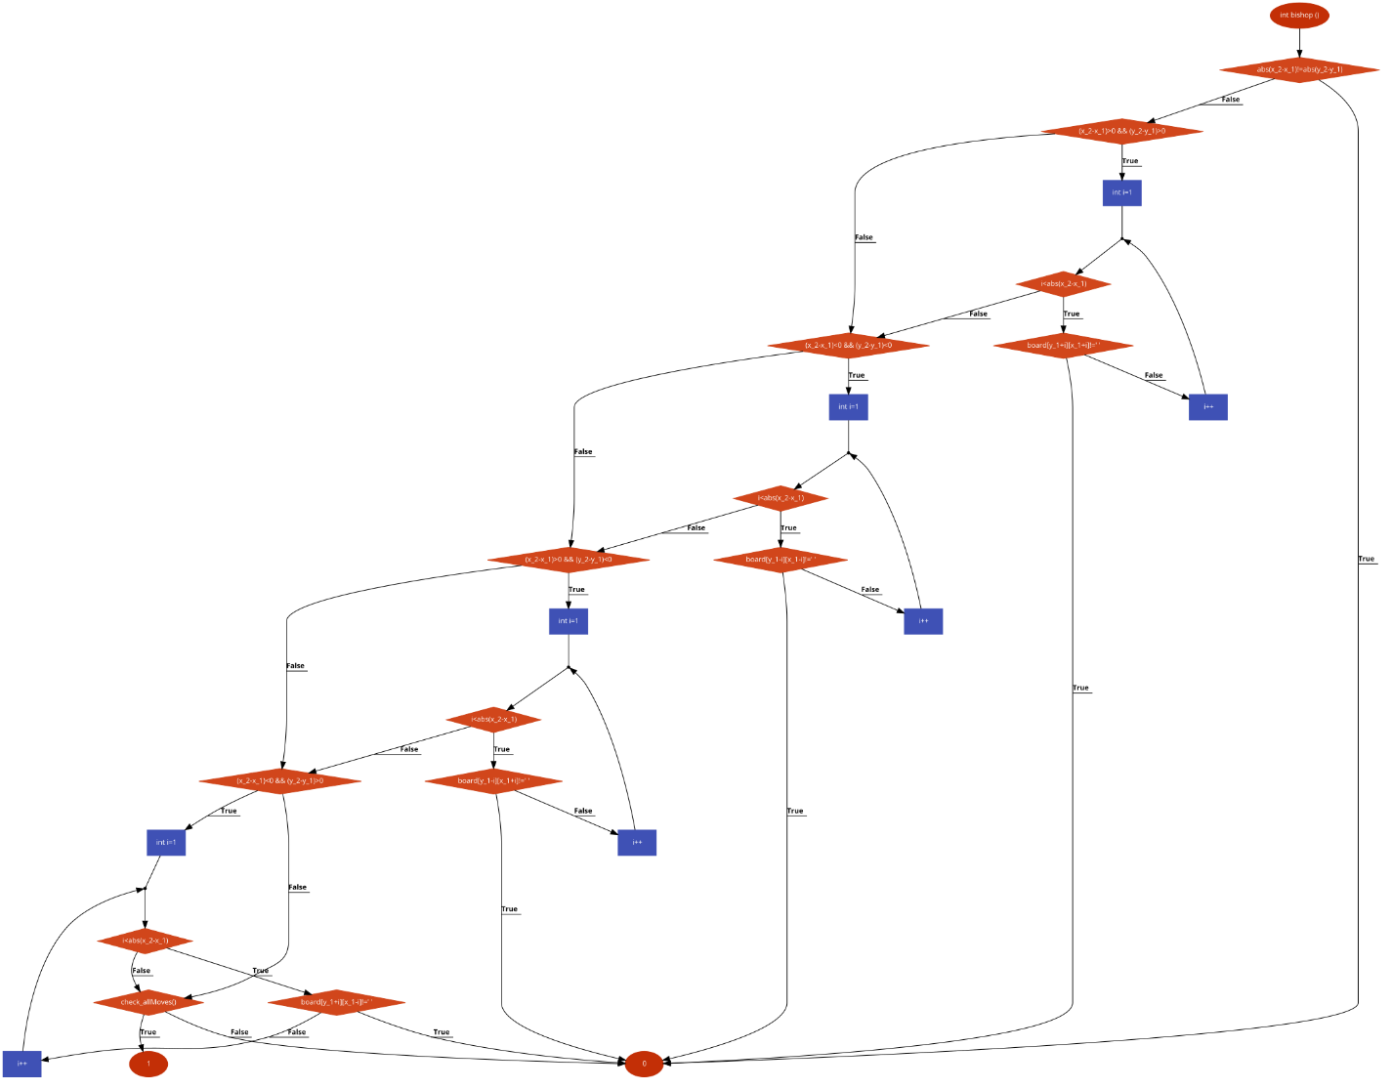

**Dead pieces**

the program shows the dead pieces of both sides during the game .

**Undo and Redo**

By entering the letter u anytime in the game (except for the first move) you can undo the game until the first move with the ability to redo the movement.

This works by saving every step of the game play to an external .txt file.

**Load And Save**

by entering the letter s anytime during the game the program saves the current state of the board and the game can be resumed anytime later.