**Meanshift**

 is falling under the category of a **clustering** algorithm in contrast of Unsupervised learning **that assigns the data points to the clusters iteratively by shifting points towards the mode** (mode is the **highest density of data points** in the region, in the context of the Meanshift). As such, it is also known as the **Mode-seeking algorithm**. Mean-shift algorithm has applications in the field of **image processing** and computer vision.

Given a set of data points, the algorithm iteratively assigns each data point towards the closest cluster centroid and direction to the closest cluster centroid is determined by where most of the points nearby are at. So each iteration each data point will move closer to where the most points are at, which is or will lead to the cluster center. When the algorithm stops, each point is assigned to a cluster.

Unlike the popular K-Means cluster algorithm, mean-shift does not require specifying the number of clusters in advance. The number of clusters is determined by the algorithm with respect to the data.

**Note:** The downside to Mean Shift is that it is computationally expensive O(n²).

**Iterative Mode Search**

1. Initialize random seed and window W.

2. Calculate the center of gravity (mean) of W.

3. Shift the search window to the mean.

4. Repeat Step 2 until convergence.

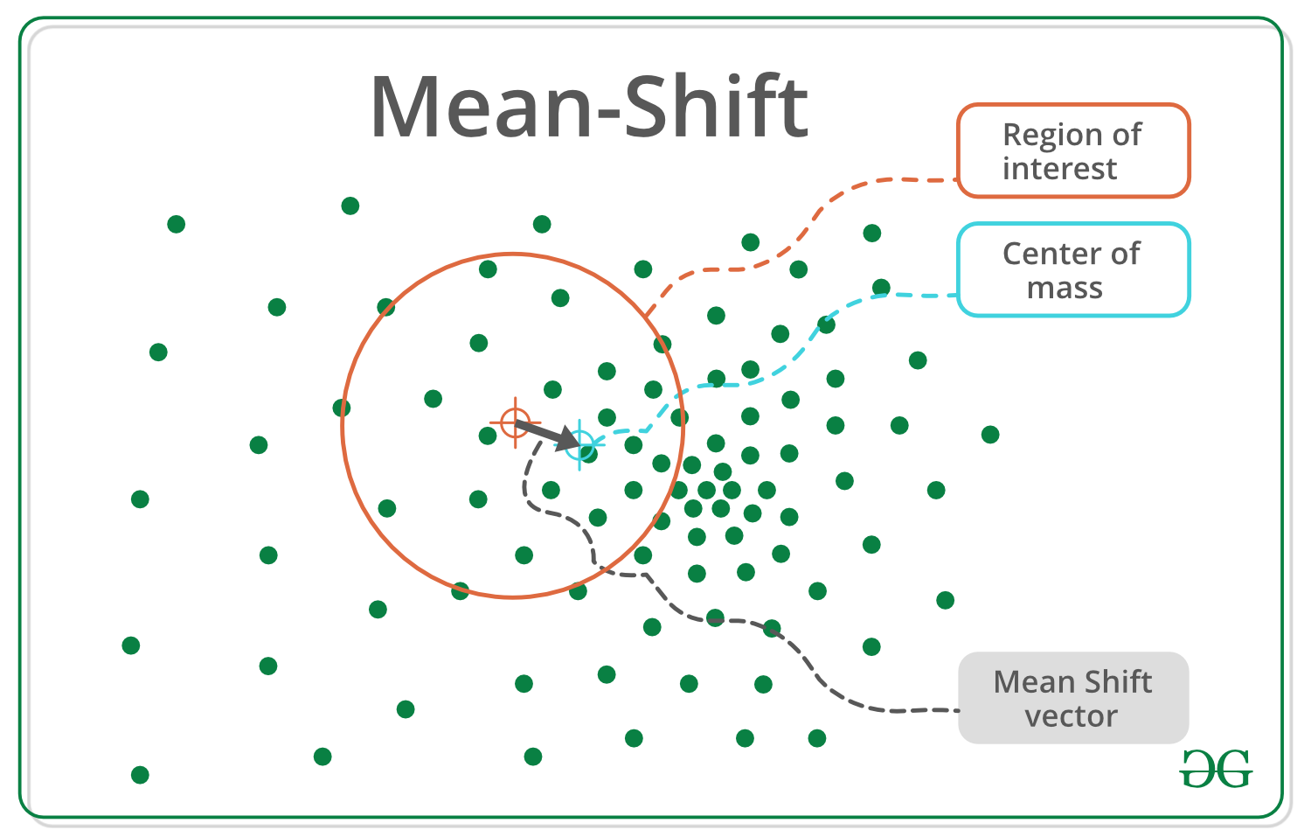

**Pros:**

* Finds variable number of modes
* Robust to outliers
* General, application-independent tool
* Model-free, doesn’t assume any prior shape like spherical, elliptical, etc. on data clusters
* Just a single parameter (window size h) where h has a physical meaning (unlike k-means)

**Cons:**

* Output depends on window size
* Window size (bandwidth) selecHon is not trivial
* Computationally (relatively) expensive (approx 2s/image)
* Doesn’t scale well with dimension of feature space.