

See discussions, stats, and author profiles for this publication at: [https://www.researchgate.net/publication/342040266](https://www.researchgate.net/publication/342040266_LATHE_MACHINE_AND_IT%27S_MECHANISM_11_INTRODUNCTION?enrichId=rgreq-b664bea3d8bc5c46345a8909e1bc9bfb-XXX&enrichSource=Y292ZXJQYWdlOzM0MjA0MDI2NjtBUzo5MDA0NzExODMxMTQyNDNAMTU5MTcwMDQ2ODg5Mw%3D%3D&el=1_x_2&_esc=publicationCoverPdf)

[. LATHE MACHINE AND IT'S MECHANISM 1.1. INTRODUNCTION](https://www.researchgate.net/publication/342040266_LATHE_MACHINE_AND_IT%27S_MECHANISM_11_INTRODUNCTION?enrichId=rgreq-b664bea3d8bc5c46345a8909e1bc9bfb-XXX&enrichSource=Y292ZXJQYWdlOzM0MjA0MDI2NjtBUzo5MDA0NzExODMxMTQyNDNAMTU5MTcwMDQ2ODg5Mw%3D%3D&el=1_x_3&_esc=publicationCoverPdf)

**Article** *in* Mechanics and Mechanical Engineering · June 2020

CITATIONS

0

READS

26,553

**1 author:**

[Zia Sialvi](https://www.researchgate.net/profile/Zia-Sialvi?enrichId=rgreq-b664bea3d8bc5c46345a8909e1bc9bfb-XXX&enrichSource=Y292ZXJQYWdlOzM0MjA0MDI2NjtBUzo5MDA0NzExODMxMTQyNDNAMTU5MTcwMDQ2ODg5Mw%3D%3D&el=1_x_5&_esc=publicationCoverPdf)

[University of Sargodha](https://www.researchgate.net/institution/University-of-Sargodha?enrichId=rgreq-b664bea3d8bc5c46345a8909e1bc9bfb-XXX&enrichSource=Y292ZXJQYWdlOzM0MjA0MDI2NjtBUzo5MDA0NzExODMxMTQyNDNAMTU5MTcwMDQ2ODg5Mw%3D%3D&el=1_x_6&_esc=publicationCoverPdf)

**8** PUBLICATIONS **100** CITATIONS

[SEE PROFILE](https://www.researchgate.net/profile/Zia-Sialvi?enrichId=rgreq-b664bea3d8bc5c46345a8909e1bc9bfb-XXX&enrichSource=Y292ZXJQYWdlOzM0MjA0MDI2NjtBUzo5MDA0NzExODMxMTQyNDNAMTU5MTcwMDQ2ODg5Mw%3D%3D&el=1_x_7&_esc=publicationCoverPdf)

**Some of the authors of this publication are also working on these related projects:**

A former and his son's busy with fields [View project](https://www.researchgate.net/project/A-former-and-his-sons-busy-with-fields?enrichId=rgreq-b664bea3d8bc5c46345a8909e1bc9bfb-XXX&enrichSource=Y292ZXJQYWdlOzM0MjA0MDI2NjtBUzo5MDA0NzExODMxMTQyNDNAMTU5MTcwMDQ2ODg5Mw%3D%3D&el=1_x_9&_esc=publicationCoverPdf)



HAZARDS, RISK ASSESMENT [View project](https://www.researchgate.net/project/HAZARDS-RISK-ASSESMENT?enrichId=rgreq-b664bea3d8bc5c46345a8909e1bc9bfb-XXX&enrichSource=Y292ZXJQYWdlOzM0MjA0MDI2NjtBUzo5MDA0NzExODMxMTQyNDNAMTU5MTcwMDQ2ODg5Mw%3D%3D&el=1_x_9&_esc=publicationCoverPdf)

All content following this page was uploaded by [Zia Sialvi](https://www.researchgate.net/profile/Zia-Sialvi?enrichId=rgreq-b664bea3d8bc5c46345a8909e1bc9bfb-XXX&enrichSource=Y292ZXJQYWdlOzM0MjA0MDI2NjtBUzo5MDA0NzExODMxMTQyNDNAMTU5MTcwMDQ2ODg5Mw%3D%3D&el=1_x_10&_esc=publicationCoverPdf) on 09 June 2020.

The user has requested enhancement of the downloaded file.

1. **LATHE MACHINE AND IT’S MECHANISM**

# INTRODUNCTION

Lathe machine is a general-purpose machine tool, which is used for machining different round objects. We can do different operation on the job by lathe machine. It is commonly used in the mechanical field. It makes the work easier and simplify. Mostly the simple jaws we can make on lathe machine tool. It is easy to install and easy to work on it.

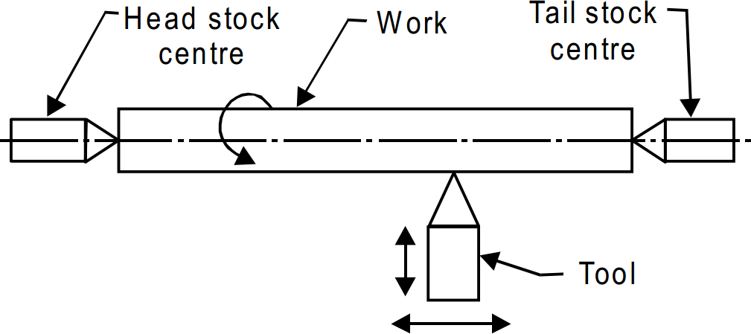

# CONSTRUCTION OF LATHE MACHINE

Lathe machine manufacturing is difficult, so first we make parts of the lathe machine, then we assemble all part of the machine. Mostly of the parts of lathe is made of cost iron and we cast one by one all the parts of lathe machine.

There are five majors’ parts of lathe machine.

* Headstock
* Tailstock
* Bed
* Carriage
* Feed mechanism
* Gears

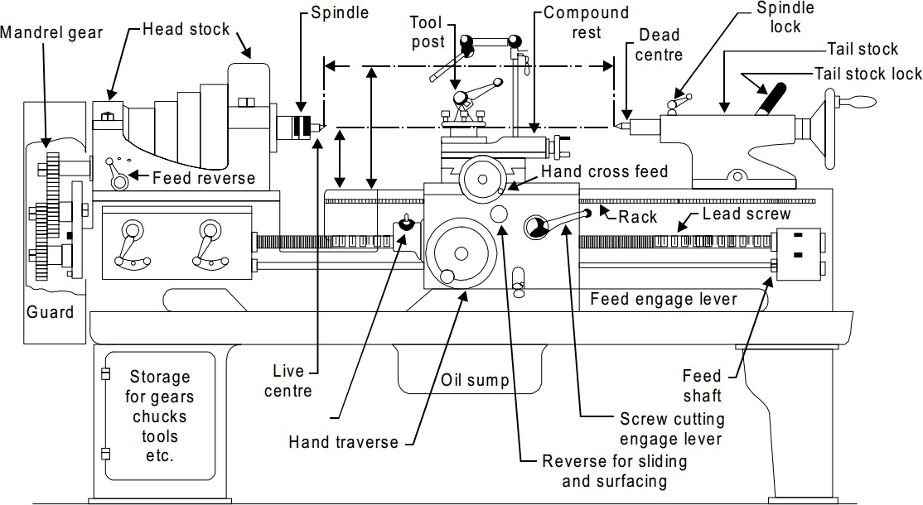

### Headstock

Headstock is a major part of lathe machine which is on the left side of the lathe machine. This part of lathe machine is made up of cast iron. In this part the all mechanism of consolation of machine available in this part. All gears and mother which is used to start and stop to the machine available in this part. There is some sub part of the headstock which is important to discuss like (**motor, gears, chuck, spindle, clutch**) etc.

### Tailstock

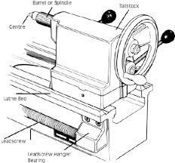Tailstock is the one of most important part of lathe machine. It is on the right side of the machine. It is made up of cast iron by casting. It is also consisting of some sub part’s like (**tailstock spindle, tailstock lock lever, tailstock wheel, tailstock lock spindle lock lever**) etc.

### Bed

Bed is base of lathe machine which is consist of two or four feet. All the structure of lathe machine is based on the bed of lathe machine. It is made up of cost iron by the casting. Under the bed of lathe machine there are some racks are available for the **putting tool’s, jaws, or the other parts of the lathe machine**.

### Carriage

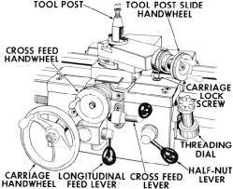Carriage is also a main part of the lathe machine which is in between the headstock and the tailstock. It is also made up of the cast iron by

the casting. It slides on the bed ways which are on the bed of the lathe machine. Its motion is too and frown between the headstock and the tailstock on the bed ways. It is also consisting of some subparts like (**carriage wheel, carriage auto feed lever, cross slide, compound slide, tool post, tool post lock lever**) etc.

### Cross slide

The **Cross-slide** move on the cross-slide keyways on the carriage. It moves vertical to the jab. The purpose of the cross slide is the make the depth of the cut of tool on the jab. we can rotate it at any angle when we need mostly on the tapper cutting etc.

### Compound slide

The **compound slide** offers a way to turn tapers and cut angles on a **lathe** without rotating the headstock. cutting tool can be mounted across the front or on either side of the head.

### Tool post

Tool post is used for the clamping the tool on the lathe machine. We can clamp any tool for the operation in the tool post. There are many types of the tool post which we use on the lathe machine.

### Gears.

Gears of the lathe machine is in the headstock. It is providing the power for the lathe machine. It can speed up and the slow down the machine and we use them for the different process on the lathe. It should completely cover otherwise it can damage anything like body of man.

* 1. **Feed Mechanism**

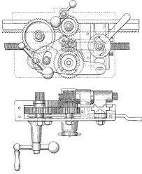Feed always governed by spindle speed as both should be synchronized for a smooth and steady machining process of a component. The speed and feed will be coarse for a conventional machine since the spindle is driven with an induction motor and speed is regulated with different ratio gear meshing. Whereas in a CNC lathe the spindle speed and feed will be optimum as both spindle speed system and feed system is controlled with

servo drives. Hence while describing feed mechanism, it should be separately explained. In a conventional machine the drive through a gear is given to feed box having number of gear ratio meshing combinations give drive to output feed shaft. This rotation of feed shaft is transmitted to a pinion in the apron mechanism fitted on the saddle. Toothed rack throughout the length of bed but under the longitudinal guide way is meshed with this pinion resulted to longitudinal feed. Feed rate can be selected by three selection control levers on feed box. A lever is fitted on the apron mechanism engages or disengages the feed pinion gear causes feed engage or disengage.

In a CNC machine the feed is employed with servo

drive mechanism. A servo drive mechanism consists of a command feeder, a command controller called servo drive, a servo motor and a feed beck mechanism. The command given through a computer is analysed in feed servo drive unit pass instruction to drive motor to move in steps of

* 1. mm order as set in system parameters. The movement will be counted with an optical instrument called encoder which give feedback to controller how much is the speed, then how much to be moved will be calculated by the controller to give further instruction and which will be continued until it reaches the commanded point. This system is called closed loop system.

# ACCESSORIES AND ATTACHMENTS OF LATHE

**Accessories** are the tools and equipment used in routine **lathe** machining operations. Attachments are special fixtures that may be mounted on the **lathe** to expand the use of the **lathe** to include taper cutting, milling, and grinding.

## Accessories

* + - Chuck
    - Lathe faceplate
    - Lathe centers
    - Mandrels
    - Tapper attachments

### Chuck

Workpieces are held to the headstock spindle of the lathe with chucks, faceplates, or lathe centers. A lathe chuck is a device that exerts pressure on the workpiece to hold it secure to the headstock spindle or tailstock spindle.

* + - Independent chuck
    - Universal scroll chuck
    - Combination chuck
    - Drill chuck
    - Collet chuck
    - Step chuck

### Lathe faceplate

A lathe faceplate is a flat, round plate that threads to the headstock spindle of the lathe. The faceplate is used for clamping and machining irregularly shaped workpieces that cannot be successfully held by chucks or mounted between centers.

### Lathe centers

Lathe centers are the most common devices for supporting workpieces in a lathe. Most lathe centers have a tapered point with a 600 included angle to fit the workpiece holes with the same angle. The workpiece is supported between two centers, one in the headstock spindle and one in the tailstock spindle.

* + - Lathe dogs
    - Male center
    - Pipe center
    - Female center
    - Half male center
    - V center

### Mandrels

A workpiece that cannot be held between centers because its axis has been drilled or bored, and which is not suitable for holding in a chuck or against a faceplate, is usually machined on a mandrel. A mandrel is a tapered axle pressed into the bore of the workpiece to support it between centers. A mandrel should not be confused with an arbor, which is a similar device used for holding tools rather than workpieces.

* + - Solid machine mandrel
    - Expansion mandrel

### Taper attachments

The taper attachment is used for turning and boring tapers. It is bolted to the back of the carriage saddle. In operation, it is connected to the cross-slide so that it moves the cross-slide laterally as the carriage moves longitudinally. This action causes the cutting tool to move at an angle to the axis of the workpiece to produce a taper.

### Attachments

* + - Taper Turning Attachment for Lathe
    - Milling Attachment for Lathe
    - Grinding Attachment for Lathe
    - Gear Cutting Attachment for Lathe
    - Spherical Turning Attachment for Lathe

### Taper Turning Attachment for Lathe

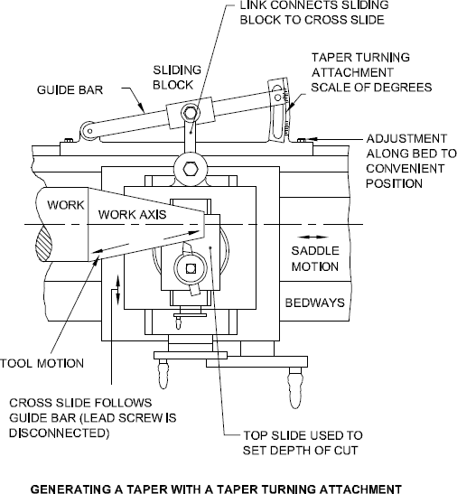Many modern lathes have a taper bar fitted at the back of the bed. This can be set to different angles to the spindle axis. The bar carries a sliding block which, during taper turning, is attached by a link to the back of the cross-slide. The lead screw of the cross-slide is released so that it no longer controls the setting of the depth of cut and the slide is now free. When the saddle is moved along the bed, the cross-slide follows the taper bar, so that the tool moves parallel to the bar and a taper is produced. The top slide is swung through 90° to lie at right angles to the work so that it can be used to apply the depth of cut.

### Milling Attachment for Lathe

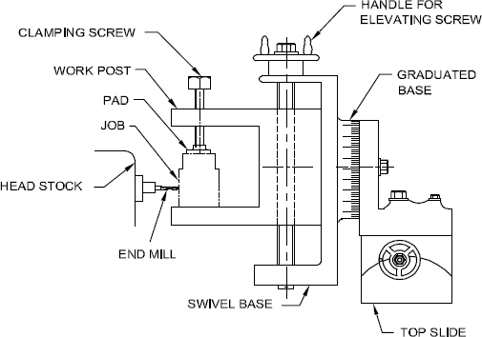This attachment is fitted on to the cross-slide of a lathe in the place of the compound rest. The Milling attachment holds the job

at right angles to the milling cutter, which is mounted in the chuck or collet. In the other type of attachment, the workpiece is held between centers. The milling cutter and the indexing head are mounted on the compound rest. It is provided with a driving unit. Both these attachments have provisions to feed in all the three directions, and it is, therefore, possible to perform operations like keyway cutting, angular milling, Tee slot cutting, and thread milling etc.

### Grinding Attachment for Lathe

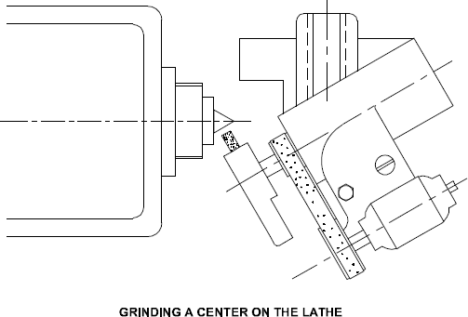With the help of a good electric grinding attachment the lathe can be used for re-sharpening reamers and milling cutters, grinding

hardened bushings and shafts, and many other grinding operations.

# SPECIFICATION OF LATHE

* + - Length between the centers
    - Height of the centers
    - Swing diameter over the bed
    - Swing diameter over the carriage
    - Maximum bar diameter
    - Good working
    - Maximum production minimum time
    - Low cost purchasing

# LATHE OPERATIONS

## Types of Lathe Machine Operations

The **lathe machine operations** are classified into three main categories and are as follows.

Following are the **Lathe machine operations** done either by holding the workpiece between centres or by a chuck:

1. Turning Operation
   1. Plain or Straight Turning
   2. Rough Turning
   3. Shoulder Turning
   4. Taper Turning
   5. Eccentric Turning
2. Facing Operation
3. Chamfering Operation
4. Knurling Operation
5. Thread cutting Operation
6. Filing Operation
7. Polishing Operation
8. Grooving Operation
9. Spinning Operation
10. Spring Winding
11. Forming

**Lathe machine operations** which are performed by holding the work by a chuck or a faceplate or an angle plate are:

1. Drilling
2. Reaming
3. Boring
4. Counterboring
5. Taper boring
6. Tapping
7. Undercutting
8. Internal thread cutting
9. Parting-off

**The operation which is performed by** using special attachments are:

1. Grinding
2. Milling

### Turning:

It is the most common type of operation in [all lathe machine](https://www.theengineerspost.com/types-of-lathe-machines/) operations. Turning is the operation of removing the excess material from the workpiece to produce a cylindrical surface to the desired length.

The job held between the centre or a chuck and rotating at a required speed. The tool moves in a longitudinal direction to give the feed towards the headstock with proper [depth of cut](https://www.theengineerspost.com/lathe-machine-formula/). The surface finish is very good.

### Facing:

It is an operation of reducing the length of the workpiece by feeding the perpendicular to the lathe axis. This operation of reducing a flat surface on the end of the workpiece. For this operation, regular [turning tool or facing tool](https://www.theengineerspost.com/lathe-cutting-tools/) may use. The cutting edge of the tool should set to the same height as the centre of the workpiece.

* Facing consist of 2 operations
  + Roughing: Here the depth of cut is 1.3mm
  + Finishing: Here the depth of cut is 0.2-0.1mm.

### Chamfering operation:

It is the operation of getting a bevelled surface at the edge of a cylindrical workpiece. This operation is done in case of bolt ends and shaft ends. Chamfering helps to avoid damage to the sharp edges and protect the operation getting hurt during other operations. Chamfering on bolt helps to screw the nut easily.

### Knurling operation:

It is an operation of obtaining a diamond shape on the workpiece for the gripping purpose.

This is done to provide a better gripping surface when operated by hands. It is done using a knurling tool. The tool consists of a set of hardened steel roller, and it is held rigidly on the tool post.

Page | 10

Knurling is done at the lowest speed available on a lathe. It is done on the handles and also in case of ends of gauges. The feed varies from 1 to 2 mm per revolution. Two or three cuts may be necessary to give the full impression.

### Thread cutting:

It is the important operation in the lathe to obtain the continuous ”helical grooves” or ” [threads’](https://www.theengineerspost.com/screw-thread-terminology-types-of-screw-threads/)‘.

When the threads or helical grooves are formed on the out surface of the workpiece is [called](https://www.theengineerspost.com/screw-thread-terminology-types-of-screw-threads/) [external thread cutting](https://www.theengineerspost.com/screw-thread-terminology-types-of-screw-threads/). When the threads or helical grooves are formed on the inner surface of the workpiece is called internal thread cutting. The workpiece is rotating between the two centres i.e., live centre and dead centre so the lathe.

Here the tool is moved longitudinally to obtain the required type of the thread. When the tool is moved from right to the left, we get the left-hand thread. Similarly, when the tool is moved from left to the right, we get the right-hand thread.

Here the motion of the carriage is [provided by the lead screw](https://www.theengineerspost.com/screw-thread-terminology-types-of-screw-threads/). A pair of change gears drives the lead screw and by rotating the handle the depth of cut can be controlled.

### Grooving:

It is the process of reducing the diameter of a workpiece over a very narrow surface. It is done by a groove tool. A grooving tool is similar to the parting-off tool. It is often done at the end of a thread or adjacent to a shoulder to leave a small margin.

### Forming:

It is the process of turning a convex, concave or of any irregular shape. Form-turning may be accomplished by the following method:

* + - Using a forming tool.
    - Combining cross and longitudinal feed.
    - Tracing or copying a template.

Forming tools are not supposed to remove much of the material and is used mainly for finishing formed surfaces. Generally, two types of forming tools are used straight and circular. Straight type is used for wider surface and the circular type for narrow surfaces.

