Yousef Tarek Hamdy 191464

Mohamed Amr 182348

Hossam Hassan 180871

Omar Mahmoud 180235

DES 56 block cipher algorithm

In DES_56 first, the 64-bit text is permuted using initial permutation algorism and split into two 32-bit half texts and the 64-bit key is permuted using pc-1 algorism into two 28-bit half keys then the two half keys are shifted according to round then permuted into 16 48-bit subkeys using pc-2 algorism after which the half texts are processed using the subkeys in every round by expanding them into 48-bits then XORing ..etc. afterward, the two halves are swapped and finally permuted using reverse initial permutation algorism.

# Creating work library and compiling all .vhd files



# Simulating encryption

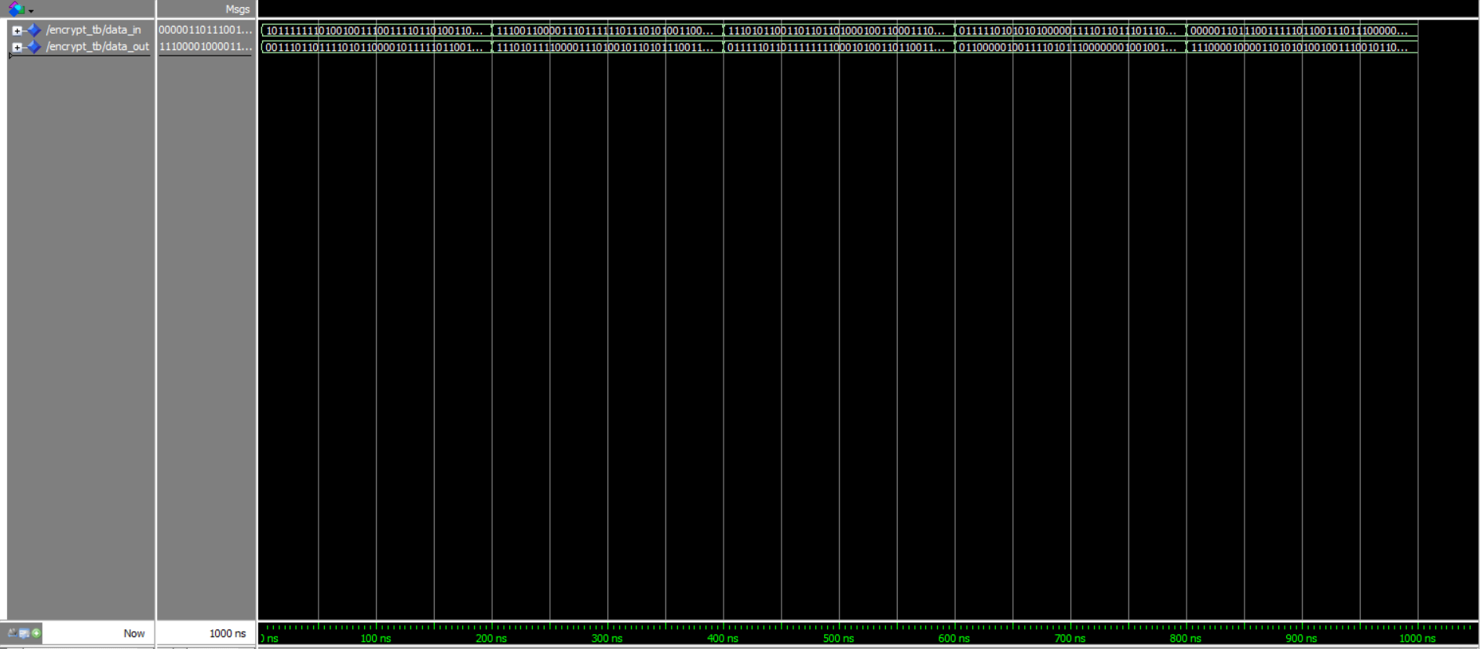

# Simulating decryption

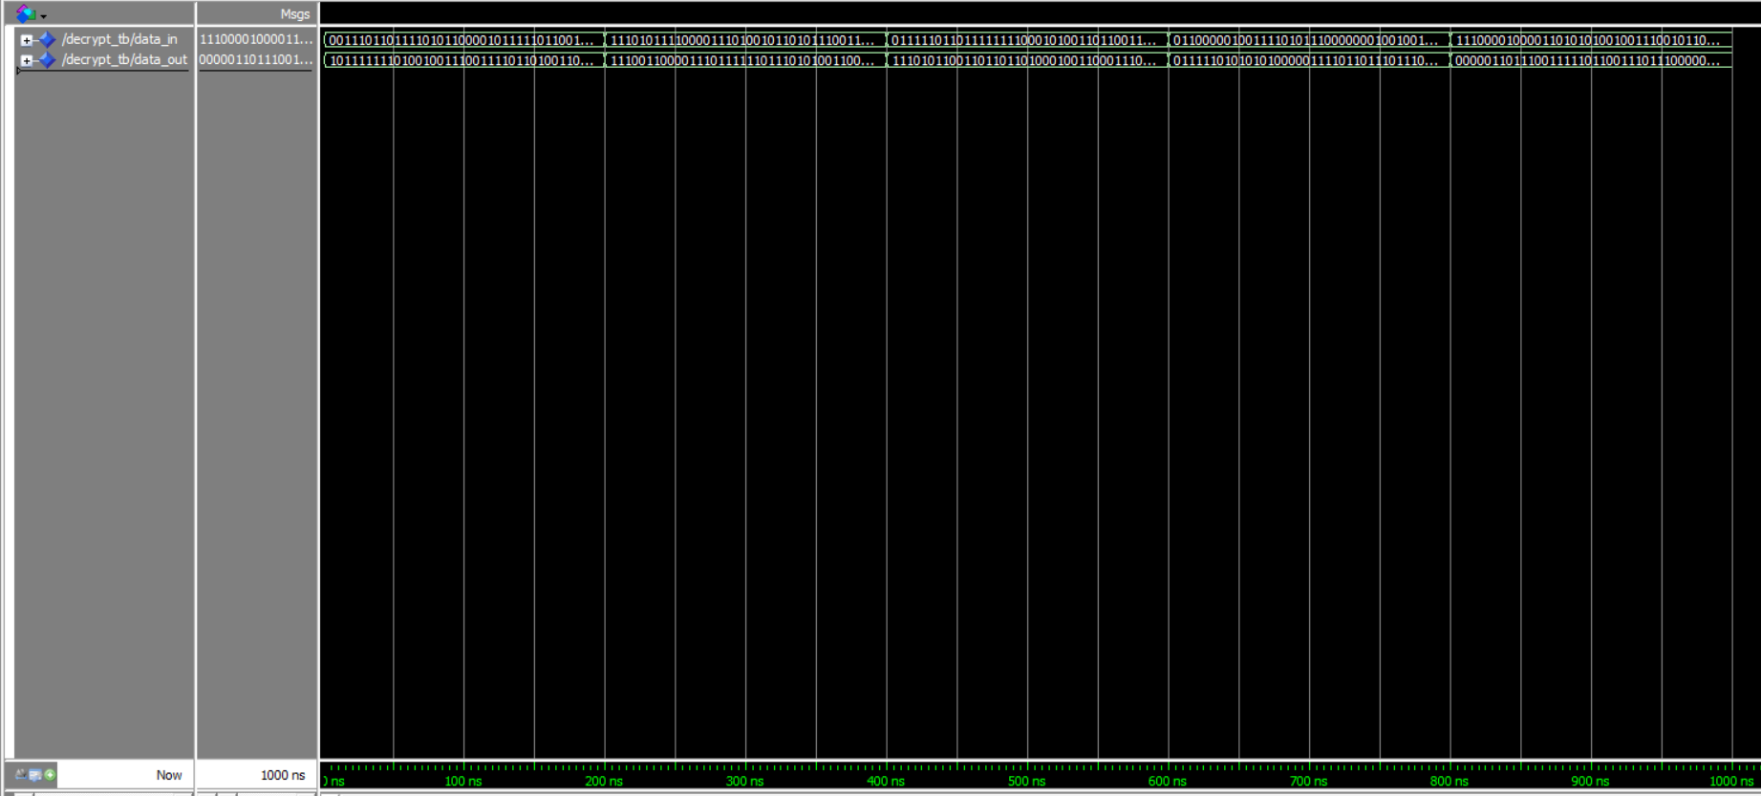

# Creating directories for Quartus



# Creating encryption project

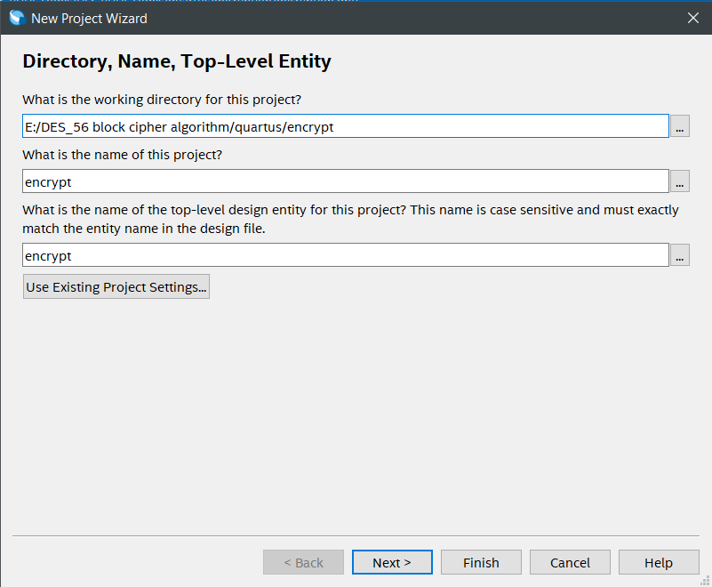

# Choosing files for the encryption project

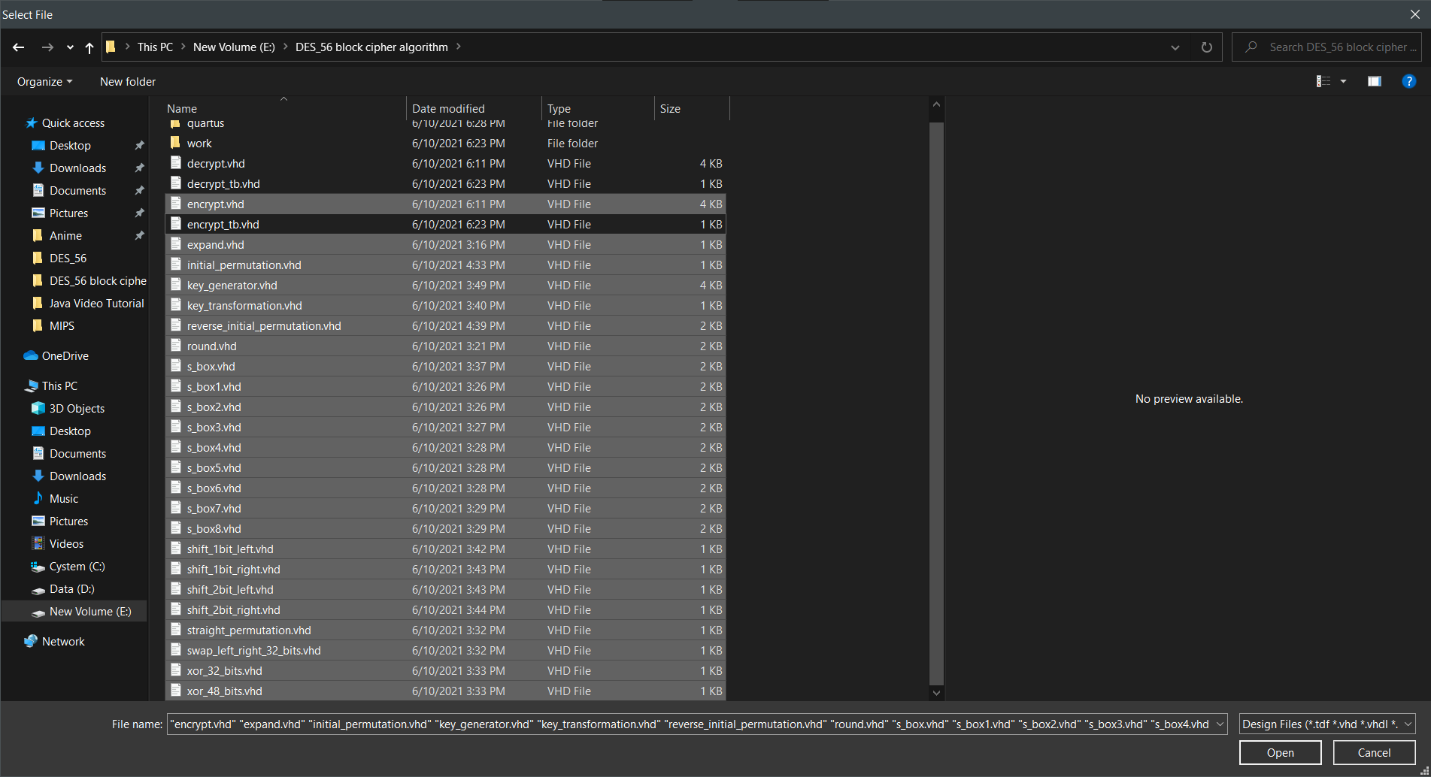

# Compiling the project

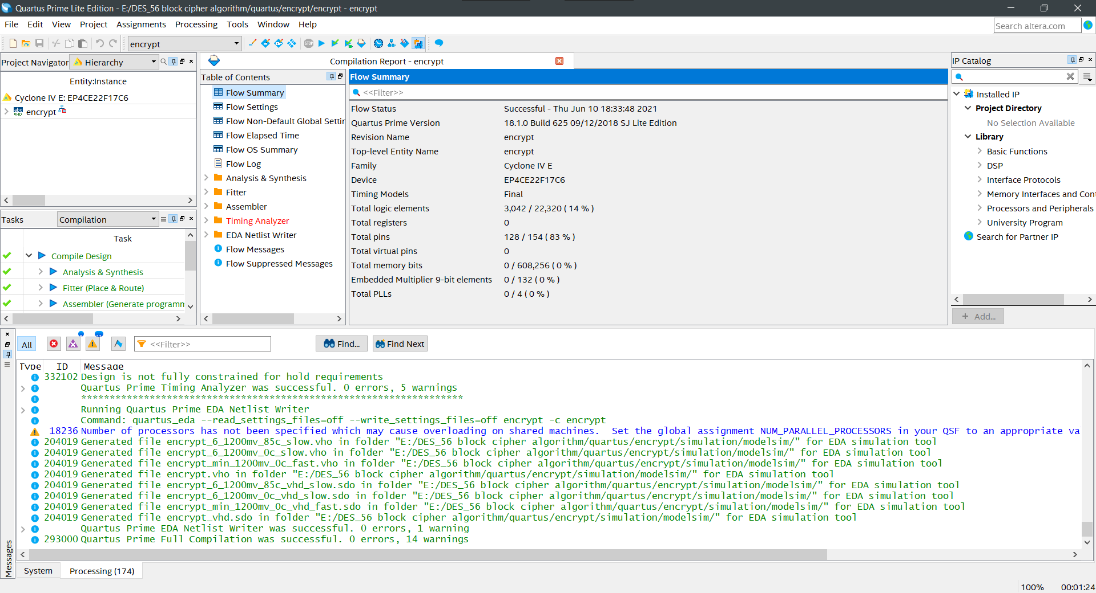

# Creating the decryption project

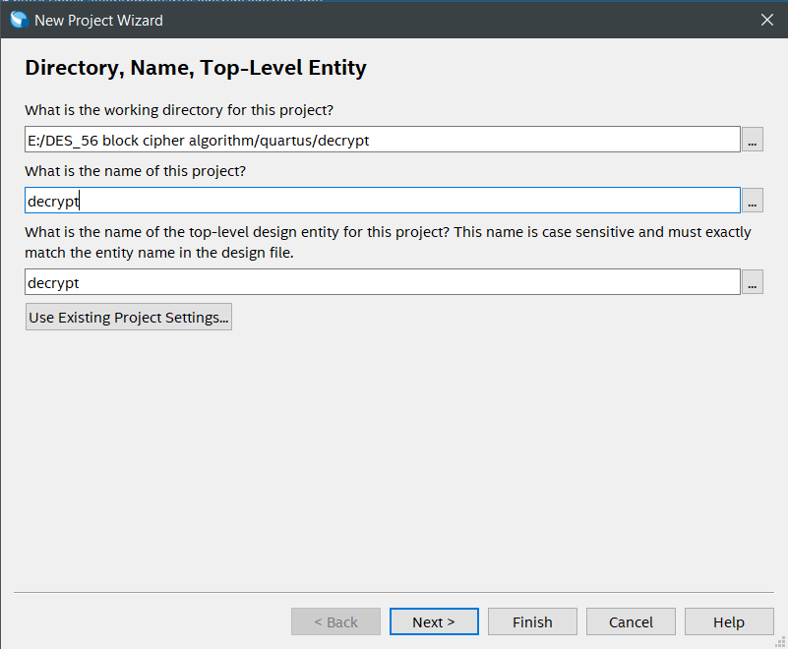

# Choosing files for the project

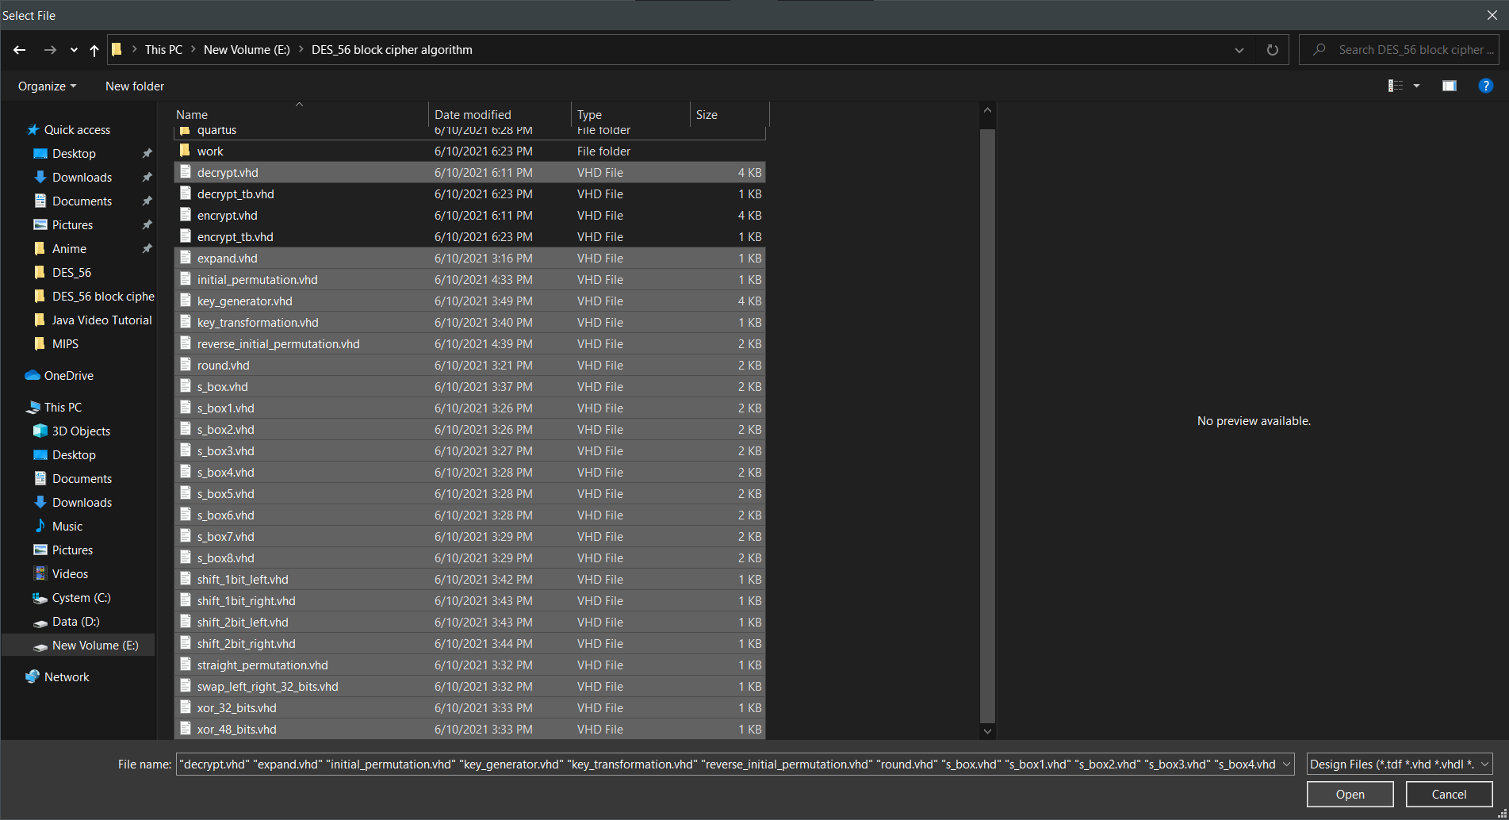

# Compiling project

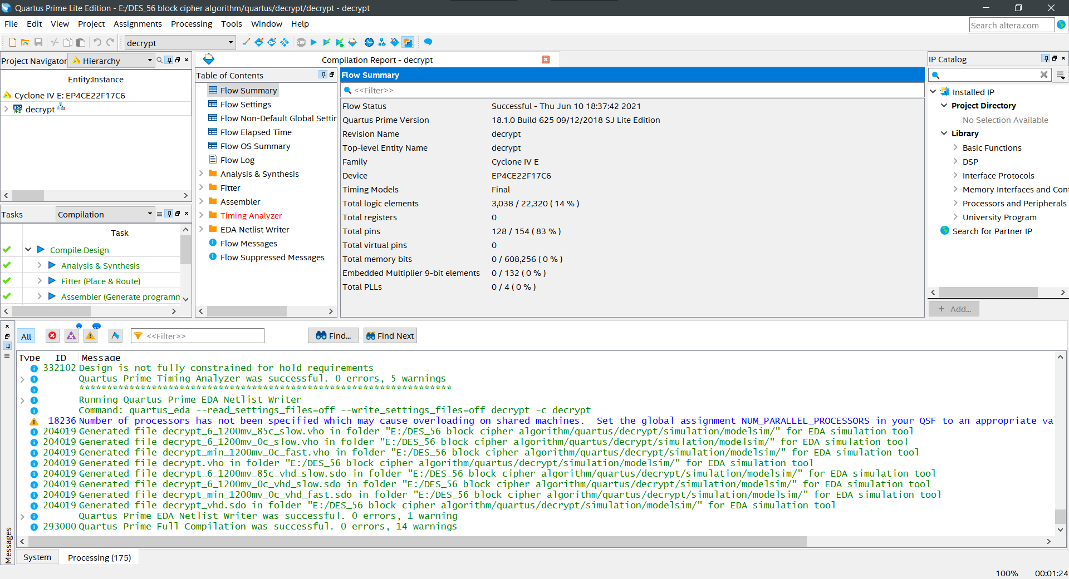

# Compiling created simulation files from Quartus



# Final encryption simulation

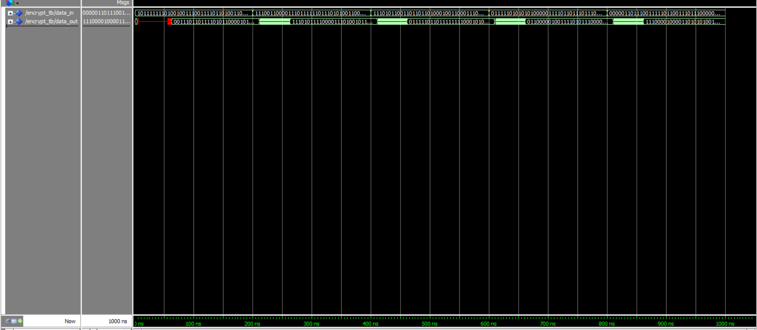

# Final decryption simulation