Assignment 1

Due date: Oct 20, 2017

7% of final mark

Total Marks 100

Your group of two or three people have to solve the following Queries. You have to explain your work during lab on Oct 20.

Assignment must be done in a group. Penalty of 10% applies if done individually.

You must submit the Submissions Form (below) with your assignment (one per group) on the blackboard.

Student Assignment Submission Form

I/we declare that the attached assignment is my/our own work in accordance with the Seneca Academic Policy. No part of this assignment has been copied manually or electronically from any other source (including web sites) or distributed to other students

.

**Name(s) Student ID(s) Signature**

**1 Avinash Singh 115408163**

**2 Danielle**

**3 Niveta Chowdhary**

Create the following table and insert values in it according to following table.

Note: Employees is work table for these queries

Table: Employees

_______________________________________________________________________________________________

Employee First_Name Last_Name Dept Hire_Date Credit Phone Manager_id

Id Code Limit Ext

_______________________________________________________________________________________________

201 Susan Brown Exe 01-Jun-1998 $30.00 3484 (null)

202 Jim Kern Sal 16-Aug-1999 $25.00 8722 201

203 Martha Woods Shp 02-Feb-2004 $25.00 7591 201

204 Ellen Owens Sal 01-Jul-2003 $15.00 6830 202

205 Henry Perkins Sal 01-Mar-2000 $25.00 5286 202

206 Carol Rose Act null null null (null)

207 Dan Smith Shp 01-Dec-2004 $25.00 2259 203

208 Fred Campbell Shp 01-Apr-2003 $30.00 1752 203

209 Paula Jacobs Mkt 17-Mar-1999 $15.00 3357 201

210 Nancy Hoffman Sal 16-Feb-2004 $25.00 2974 203

______________________________________________________________________________________________

**-- CREATE TABLE FOR ASSIGNMENT 1.**

**CREATE TABLE Assignment1_Employee (**

**Employee_ID INT NOT NULL,**

**First_Name VARCHAR(64) NOT NULL,**

**Last_Name VARCHAR(64) NOT NULL,**

**Dept_Code VARCHAR(6) NOT NULL,**

**Hire_Date DATE NULL,**

**Credit_Limit NUMERIC(8,2) NULL,**

**Phone_Ext INT NULL,**

**Manager_ID INT NULL);**

**-- POPULATE THE TABLE ASSIGNMENT1_EMPLOYEE.**

**INSERT INTO Assignment1_Employee VALUES (201,'Susan','Brown','Exe','01-Jun-1998',30.00,3484,NULL);**

**INSERT INTO Assignment1_Employee VALUES (202,'Jim','Kern','Sal','16-Aug-1999',25.00,8722,201);**

**INSERT INTO Assignment1_Employee VALUES(203,'Martha','Woods','Shp','02-Feb-2004',25.00,7591,201);**

**INSERT INTO Assignment1_Employee VALUES(204,'Ellen','Owens','Sal','01-Jul-2003',15.00,6830,202);**

**INSERT INTO Assignment1_Employee VALUES(205,'Henry','Perkins','Sal','01-Mar-2000',25.00,5286,202);**

**INSERT INTO Assignment1_Employee VALUES(206,'Carol','Rose','Act','','',NULL,NULL);**

**INSERT INTO Assignment1_Employee VALUES(207,'Dan','Smith','Shp','01-Dec-2004',25.00,2259,203);**

**INSERT INTO Assignment1_Employee VALUES(208,'Fred','Campbell','Shp','01-Apr-2003',30.00,1752,203);**

**INSERT INTO Assignment1_Employee VALUES(209,'Paula','Jacobs','Mkt','17-Mar-1999',15.00,3357,201);**

**INSERT INTO Assignment1_Employee VALUES(210,'Nancy','Hoffman','Sal','16-Feb-2004',25.00,2974,203);**

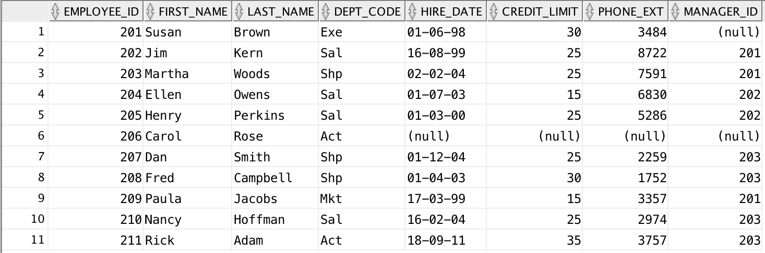

>> Write the query for the following tasks:

#1. List the following columns of the Employees table in this order:

first name, last name, hire_date, phone_ext and department code

Change the name of the hire_date column to Date_of_Joining within the result table. List the employees from the Sales and Marketing department only.

Sort the rows of the result table by the last_name column in descending order.

**SQL Query:**

**SELECT First_Name AS "First Name",**

**Last_Name AS "Last Name",**

**Hire_Date AS "Date of Joining",**

**Phone_Ext AS "Extension",**

**Dept_Code AS "Department Code"**

**FROM Assignment1_Employee**

**WHERE Dept_Code IN ('Sal','Mkt')**

**ORDER BY Last_Name DESC;**

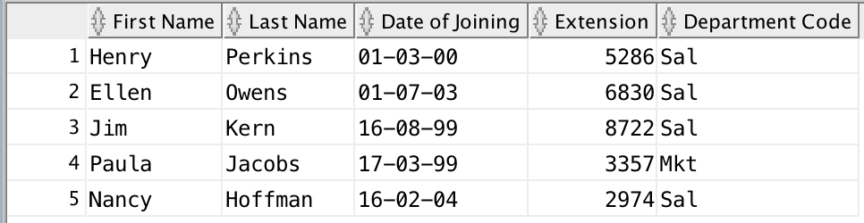

#2. Write a SQL statement to add a new employee Rick Adam to the Employees table. Rick joined the Accounting department.

His date of joining is 18th Sept, 2011. He works for manager with id: 203. He is allotted any phone extension - 3757.

His credit limit is set to $35.00

-----

**SQL Query:**

**INSERT INTO Assignment1_Employee VALUES (211,'Rick','Adam','Act','18-Sep-2011',35.00,3757,203);**

#3. List the employees that have a phone number starting with 7 or whose names are starting with letter - 'N'.

Show the employee_id, first_name, last_name and phone_ext. Sort the rows by employee_id.

-----

**SQL QUery:**

**SELECT Employee_ID AS “Employee ID”,**

**First_Name AS “First Name”,**

**Last_Name AS “Last Name”,**

**Phone_ext AS “Extension”**

**FROM Assignment1_Employee**

**WHERE phone_ext LIKE ‘7%’ OR First_Name LIKE 'N%'**

**ORDER BY Employee_ID;**

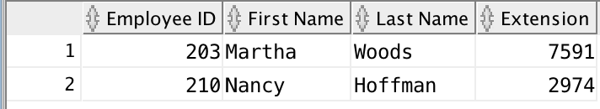

#4. Using the Employees table, list the following columns:

dept_code, credit_limit, last_name, first_name

Place the columns in that order. Sort the rows by :

dept_code in ascending order

credit_limit in descending order

last_name in ascending order.

And get only those employees who are having credit limits between 20 and 40.

------

**Sql Query:**

**SELECT dept_code AS "Department",**

**credit_limit AS "Credit Limit",**

**last_name AS "Last Name",**

**first_name AS "First Name"**

**FROM ASSIGNMENT1_EMPLOYEE**

**WHERE credit_limit BETWEEN 20 AND 40**

**ORDER BY dept_code ASC, credit_limit DESC, last_name ASC;**

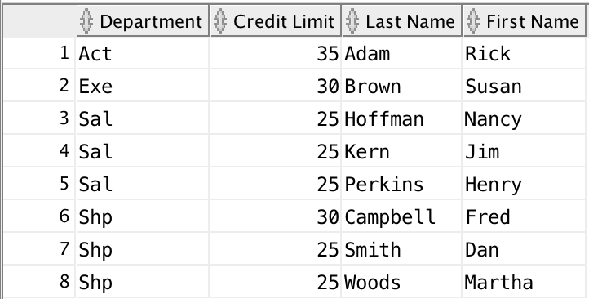

#5. From the Employees table, list the employee_id, first_name, last_name and credit_limit columns for employees

with the first names: Martha, Carol, Nancy

Sort the rows by the last name.

------

**SQl Query:**

**SELECT employee_id AS "Employee ID",**

**First_Name AS "First Name",**

**Last_Name AS "Last Name",**

**credit_limit AS "Credit Limit"**

**FROM ASSIGNMENT1_EMPLOYEE**

**WHERE first_name IN ('Martha', 'Carol', 'Nancy')**

**ORDER BY last_name DESC;**

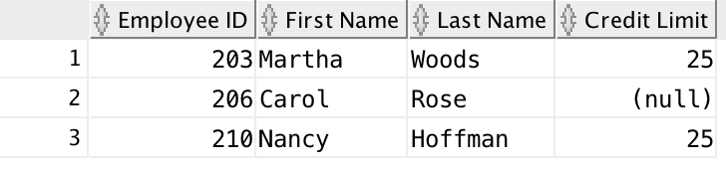

#6. From the Employees table, get the department and credit limits for the employees 'Jim Kern'.

------

**SQl Query:**

**SELECT First_Name || ' ' || Last_Name AS "Full Name",**

**dept_code AS "Department",**

**credit_limit AS "Credit Limit"**

**FROM ASSIGNMENT1_EMPLOYEE**

**WHERE first_name = 'Jim'**

**AND last_name = 'Kern';**

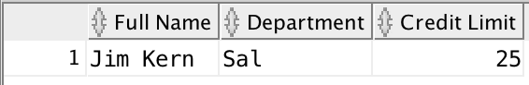

#7. List the department and phone extension for all the employees who don't have a manager.

Sort the rows by the employee_id.

----

**Sql Query:**

**SELECT first_Name AS "First Name",**

**last_Name AS "Last Name",**

**dept_code AS "Department",**

**phone_ext AS "Extension"**

**FROM ASSIGNMENT1_EMPLOYEE**

**WHERE manager_id IS NULL**

**ORDER BY employee_id;**

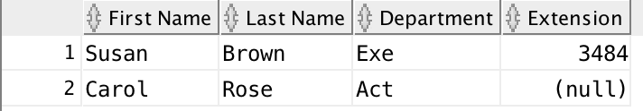

#8. Write a query to display distinct department codes credit_limits.

**SQl Query:**

**SELECT DISTINCT**

**dept_code AS "Distinct Department",**

**credit_limit AS "Credit Limit"**

**FROM ASSIGNMENT1_EMPLOYEE;**

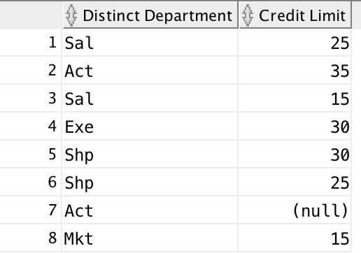

#9. Delete all the employees who work for Shipping Department or who have manager_id null.

----

**SQl Query:**

**DELETE FROM ASSIGNMENT1_EMPLOYEE**

**WHERE dept_code = 'SHP'**

**OR manager_id IS NULL;**

#10. Increase the credit limits of all the employees by $15.00 who work for Accounting department.

----

**SQl Query:**

**UPDATE ASSIGNMENT1_EMPLOYEE**

**SET credit_limit = credit_limit + 15.00**

**WHERE dept_code = 'Act';**

#11. Create sequence to uniquely identify each row in the employees table. Employee_id for the employee table:

Start with 220; do not allow caching of the values. Name the sequence Employee_id Seq. Verify the existence of sequence in the Data Dictionary.

----

**SQL Query:**

**CREATE SEQUENCE employee_id_seq**

**START WITH 220**

**INCREMENT BY 1**

**NOCACHE;**

#12. Write a SQL statement to add a new employee John Adam to the Employees table. John joined the Accounting department.

His date of joining is 18th Sept, 2011. He works for manager with id: 203. He is allotted any phone extension - 3758.

His credit limit is set to $40.00. Use the sequence to uniquely identify the new employee.

**SQL QUery:**

**INSERT INTO Assignment1_Employee VALUES (EMPLOYEE_ID_SEQ.nextval,'John','Adam','Act','18-Sep-2011',40.00,3758,203);**

Task#1:

For each manager_id, list the number of employees ( except the Shipping Department ) each one manages.

Also list the range of their employees's credit limits by showing the minimum and maximum.

Omit the employee having first name: Susan and last name: Brown

>> Sql Query:.......

Task#2:

For each department, find the sum of the credit_limits. Display only those departments

whose total credit limits are greater than $50.00 but less then $100.00.

>> Sql Query:

Task#3: For each manager_id between 202and 203, show the number of employees each manager supervises.

Show only those managers who manage more then 2 employees.

>> SQL Query:

Task#4: Find how many employees have joined between the year 2002 and 2005 in the accounting department.

Task#5: List all the employees, their hire dates and the number of days each person will have worked

for the company as of January 1, 2005.

Task#6: Find out in which month the employee - Carol Rose joined.

Sql Query:

Task#7: Write the Sql statement for the following:

a) Create a table named : Foods which has the following columns:

menu_item as numeric of size 2,

supplier_id as character type of 3,

product_code as character type of 2,

description varchar2(20),

price as numeric with scale and precision of 4, 2,

price_increase as numeric with scale and precision of 4, 2

Sql Query:

b) Rename the product_code to product_id.

Sql Query:

c) Add a check constraint to price column ensuring that price of all the items are less then $10.00

Sql Query:

d) Add a unique constraint to description column.

Sql Query: