L4-W5-DBS301-Group functions

**Name : Avinash Singh**

**Course: DBS301**

**Prof.: Ayesha Manzer**

**Date: 29-SEP-2017**

*STEP 1: Put the SQL and the results after each question below*

*STEP 2: Submit on Blackboard.*

1 Display the difference between the Average pay and Lowest pay in the company.

Name this result *Real Amount*.

Query:

SELECT MIN(salary) AS “Lowest Salary”,

AVG(salary) AS “Average Salary”,

“Average Salary” – “Lowest Salary” AS “Real Amount”

FROM employees;

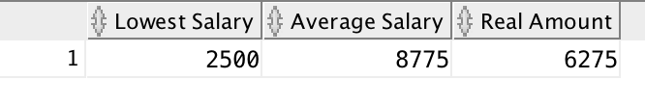

2 Display the department number and Highest, Lowest and Average pay per each department. Name these results *High, Low* and *Avg.*

Sort the output so that the department with highest average salary is shown first.

Query:

SELECT MIN(salary) AS "Low",

ROUND(AVG(salary)) AS "Avg",

MAX(salary) AS "High",

department_id AS "Department"

FROM employees

GROUP BY department_id

ORDER BY AVG(salary) DESC;

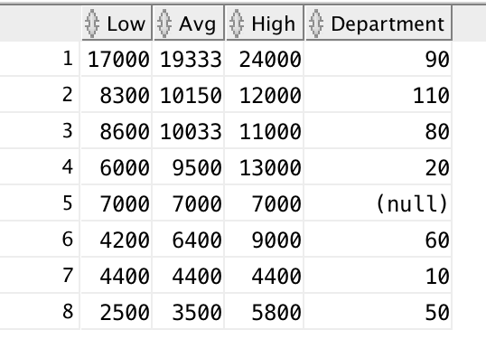

3 Display how many people work the same job in the same department.

Name these results *Dept#, Job* and *How Many.*

Include only jobs that involve more than one person.

Sort the output so that jobs with the most people involved are shown first.

Query:

SELECT department_id AS “Dept#”,

job_id AS “Job”,

COUNT(employee_ID) AS “How Many”

FROM employees

HAVING COUNT(employee_id) > 1

GROUP BY department_id, job_id

ORDER BY COUNT(employee_id) DESC;

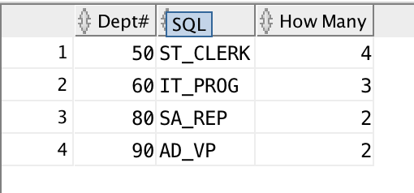

4 For each job title display the job title and total amount paid each month for this type of the job. Exclude titles *AD_PRES* and *AD_VP* and also include only jobs that require more than $15,000.

Sort the output so that top paid jobs are shown first.

Query:

SELECT job_ID AS "Job Title",

SUM(salary) AS "Monthly Payment for Job Title"

FROM employees

WHERE JOB_ID NOT IN ('AD_PRES','AD_VP')

HAVING SUM(salary) > 15000

GROUP BY JOB_ID

ORDER BY "Monthly Payment for Job Title" DESC;

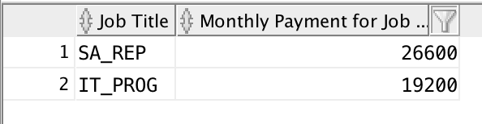

5 For each manager number display how many persons he / she supervises. Exclude managers with numbers 100, 101 and 102 and also include only those managers that supervise more than 2 persons.

Sort the output so that manager numbers with the most supervised persons are shown first.

Query:

SELECT Manager_id AS "Manager",

COUNT(employee_ID) AS "Supervises"

FROM employees

WHERE manager_id NOT IN (100,101,102)

HAVING COUNT(employee_id) > 2

GROUP BY manager_id

ORDER BY "Supervises" DESC;

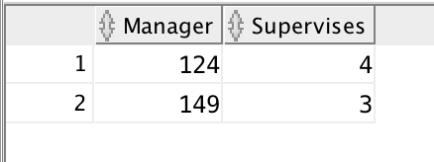

6 For each department show the latest and earliest hire date, BUT

- exclude departments 10 and 20

- also exclude those departments where the last person was hired in this century.

- Sort the output so that the most recent, meaning latest hire dates, are shown first.

Query:

SELECT department_id,

MIN(hire_date) AS "Earliest Hire Date",

MAX(hire_date) AS "Latest Hire Date"

FROM employees

WHERE department_id NOT IN (10,20)

HAVING TO_CHAR(MAX(hire_date), 'YY') != '01'

GROUP BY department_id

ORDER BY "Latest Hire Date" DESC;

