DJAGADA ERP — Pricing Module Guide

Pricing — Supplier Prices & Selling Prices
This module answers: "At what price did suppliers offer, and at what price do we sell?" Supplier prices are INTERNAL and confidential — regular staff never see cost or margin. Red circles: 1 = main button, 2 = search, 3 = table rows.
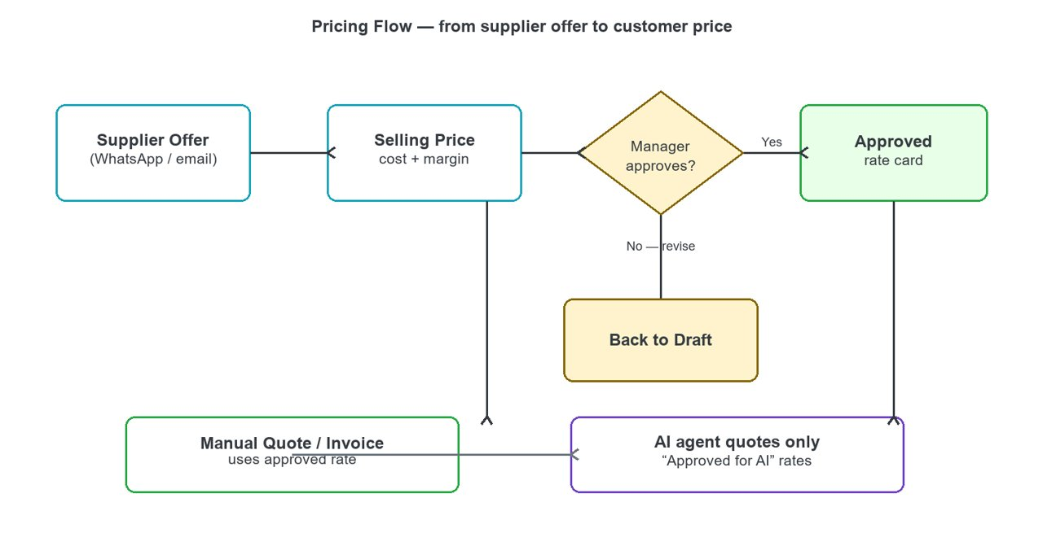
Pricing flow — offer, selling price, approval, quote.

Supplier Prices (confidential)
- Open Pricing (left sidebar) > Supplier Prices. Click 1 "Record Supplier Offer".
- Select Supplier and Product (both come from your masters), enter the offered price, currency, incoterm, destination port, quantities, date received and validity.
- Source records where the offer came from: WhatsApp, email or other.
- Press 1 Save. The offer appears in the list and on the supplier profile.
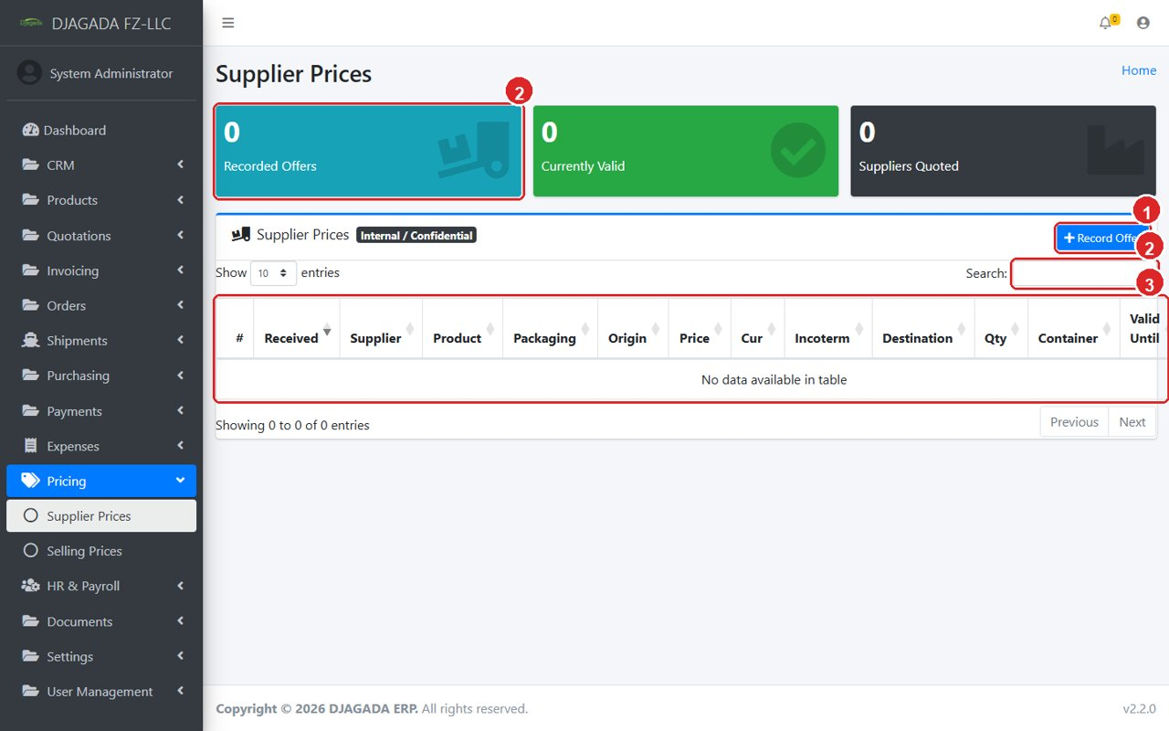
Supplier Prices list page (Pricing menu > Supplier Prices).
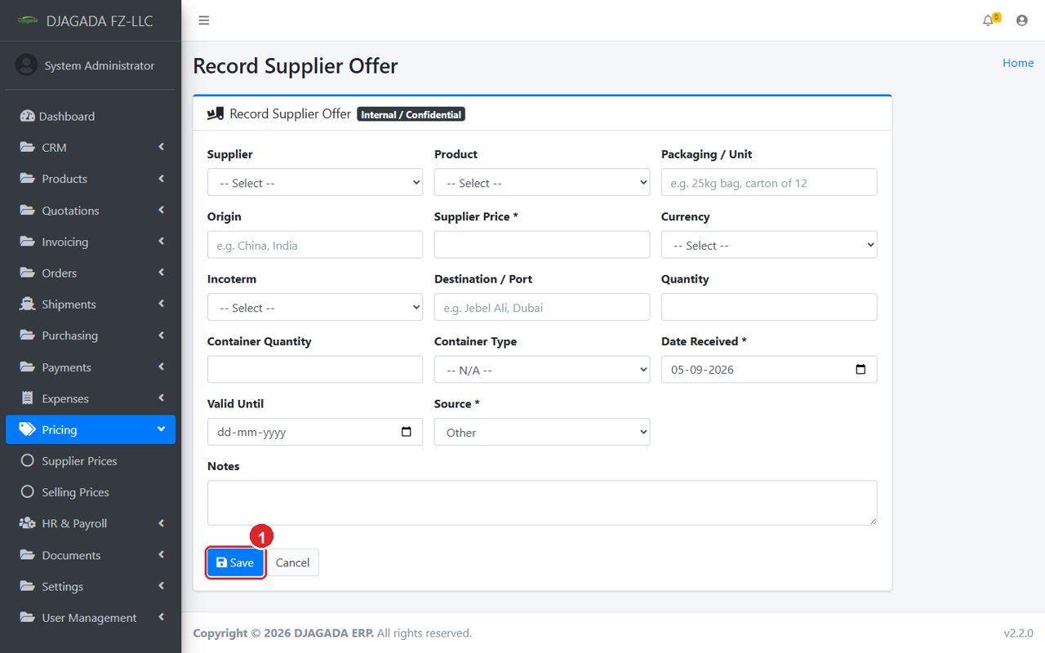
Record Supplier Offer form — note the Pricing menu open in the sidebar.

Selling Prices (our rates to customers)
- Open Pricing > Selling Prices. Click 1 "New Selling Price".
- Optionally pick "From Supplier Offer" — cost, product, currency, incoterm and destination fill in automatically.
- Enter Margin % (or a fixed Margin Amount). The Selling Price is calculated for you; you can still overwrite it for a manual final price.
- Leave Customer empty for a general rate, or pick a customer for a special rate.
- Set Valid Until — expired prices disappear from quoting automatically. Status starts as Draft; a manager Approves it. Tick "Approved for AI" only for rates an AI assistant may quote.
- Only users with cost permission see the Cost and Margin columns; everyone else sees just the selling price.
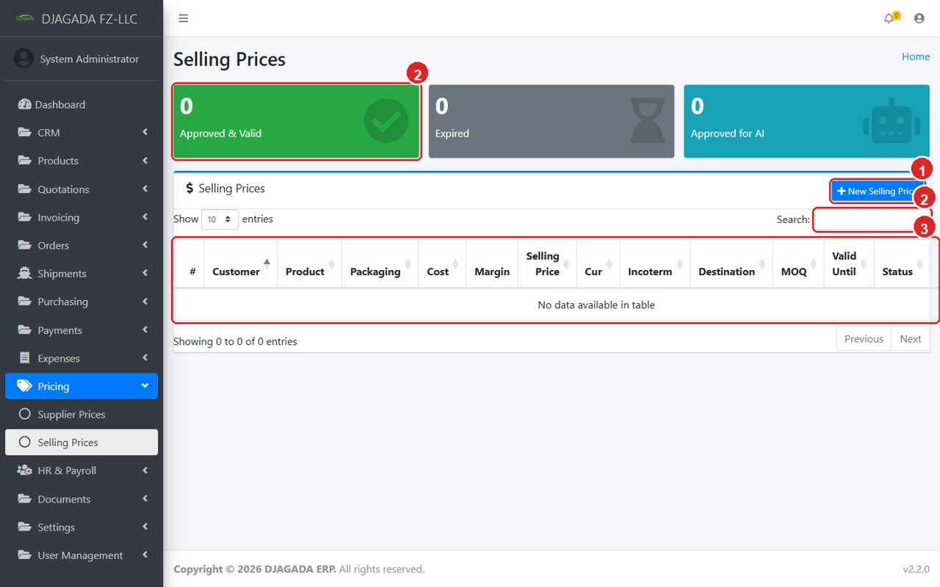
Selling Prices list page (Pricing menu > Selling Prices).
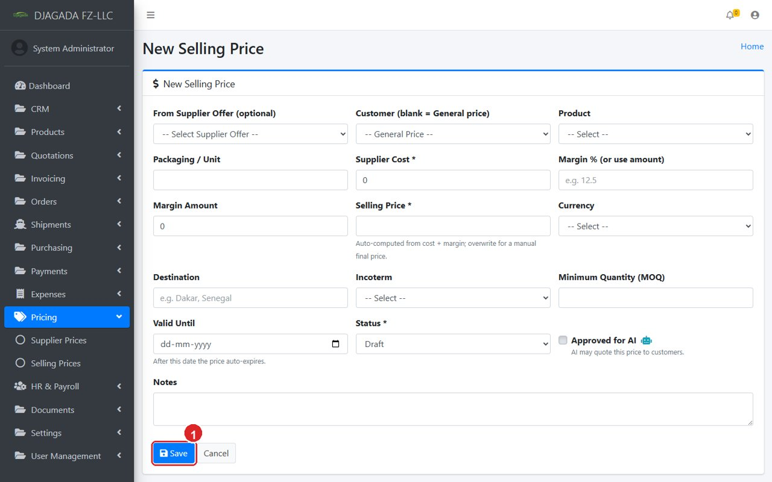
New Selling Price form — margin auto-computes the final price.

