DJAGADA ERP
User Manual — How to Use the Software
Version 2.4.0 • 06 September 2026

Contents
1. How to read this manual
2. Logging in
3. Dashboard tour
4. How the modules connect (overview diagram)
5. CRM — Customers, Leads, Follow-ups
6. Products & Suppliers
7. Pricing — Supplier & Selling Prices
8. Sales — Quotes, Invoices, Orders (with flowcharts)
9. Shipments & Delivery (with flowchart)
10. Purchasing — Purchase Orders & Supplier Bills (with flowchart)
11. Payments & Expenses
12. HR & Payroll (with flowchart)
13. Documents, Settings, Users & Roles
14. For your IT person

1. How to read this manual
In every screenshot, red circles show where to click: ① = the main button (top-right, e.g. New / Save), ② = search box or summary cards, ③ = the data table and its row buttons (view / edit / delete).
Each chapter explains one module: what it is for, then numbered steps that follow the red circles on the screenshots. Flowchart diagrams show how work moves from one module to the next (for example: Lead → Quotation → Invoice → Payment).

2. Logging in
Open the system address in your browser (your IT person gives you the link). Enter your email and password, then click Sign In.
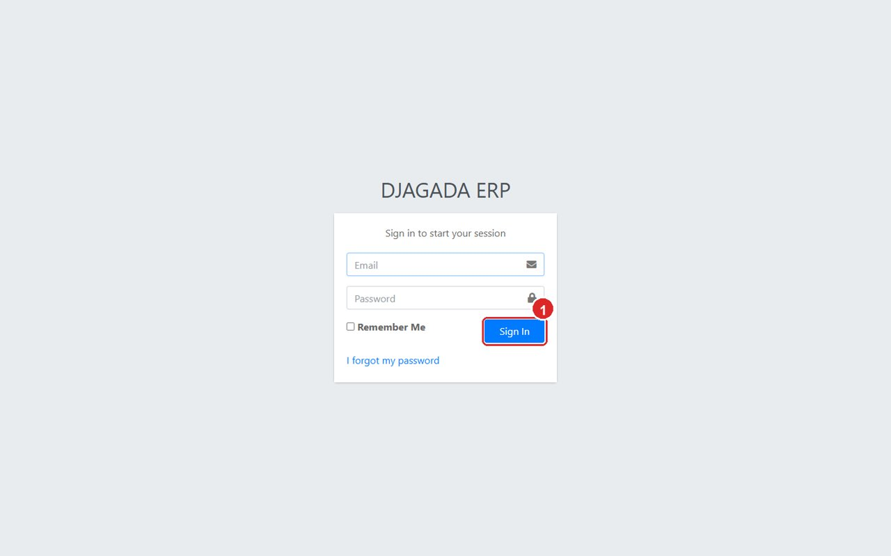
Login page — enter email + password, then Sign In.
Tip: Ask your administrator if you forget your password — they can reset it under User Management → Users.

3. Dashboard tour
After login you land on the Dashboard. It answers three questions at a glance: Are we making money? What needs attention? How much work is in progress?
- Use the period buttons (This Month / Quarter / Year / All Time) to change every Profit & Loss figure.
- Revenue / Sales = invoiced sales. Supplier Costs = supplier bills. Gross Profit = Revenue − Supplier Costs. Net Profit = Gross Profit − Operating Expenses − Salaries.
- Watch the alert boxes: Overdue invoices, Partially Paid, Shipments In Transit, Pending Quotes.
- The left sidebar holds every module, grouped: CRM, Products, Quotations, Invoicing, Orders, Shipments, Purchasing, Payments, Expenses, Pricing, HR & Payroll, Documents, Settings, User Management.
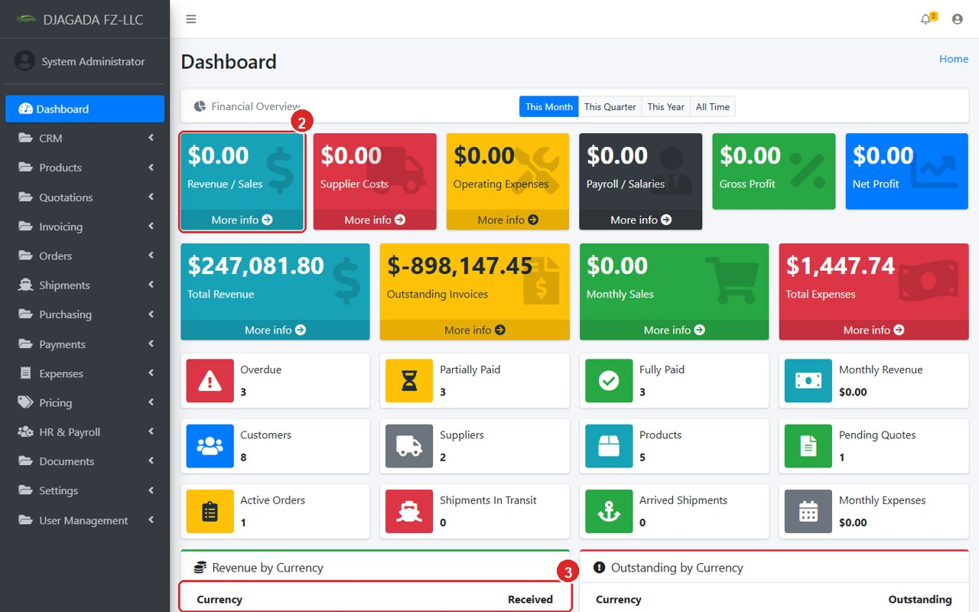
Dashboard — P&L cards, alerts and the module sidebar.

4. How the modules connect
You rarely use one module alone. A typical business day flows like this:
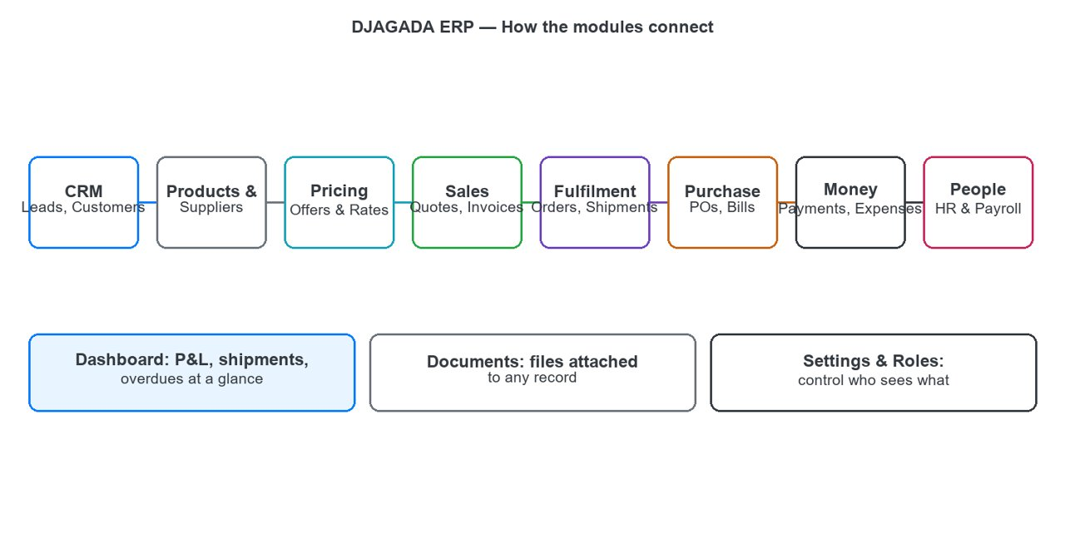
Module map — how information flows through the system.

5. CRM — Customers, Leads, Follow-ups

5.1 Customers
The customer master. Every quote, invoice, order and selling price links to a customer record.
- Click ① “New Customer” to add a customer. Fill company name, contact person, email, phone, city.
- Country ② is a searchable dropdown with about 195 countries — type a few letters to find one.
- VAT / TRN: enter the customer Tax Registration Number. It prints automatically on invoice and quote PDFs.
- Use ② Search to find any customer instantly. Row buttons in ③: view (eye), edit (pencil), delete (bin).
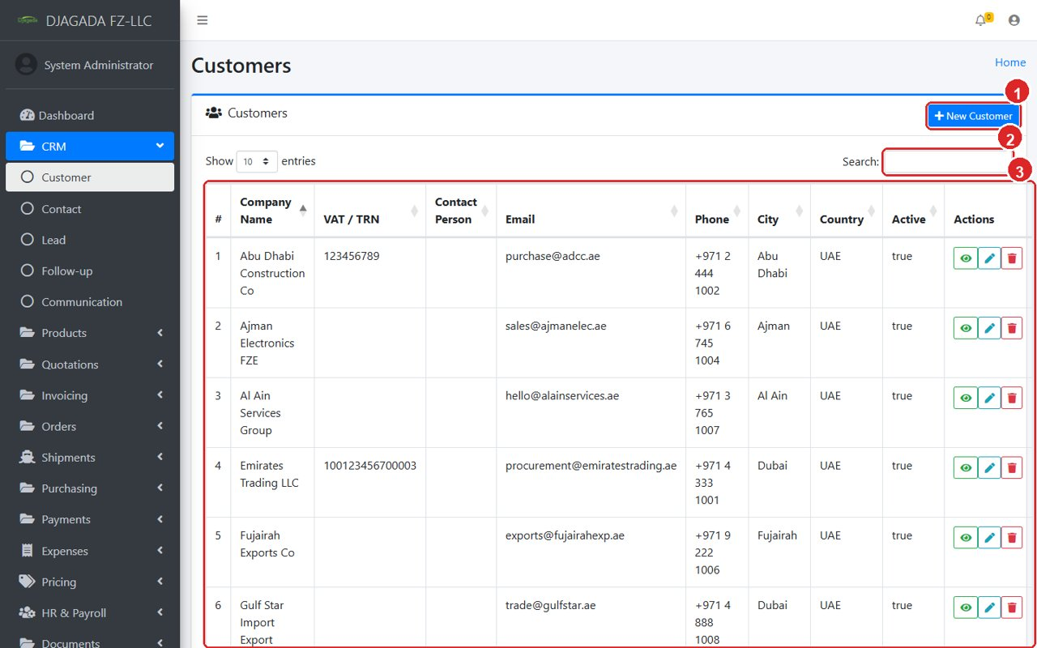
Customer list — ① New, ② Search, ③ row actions.
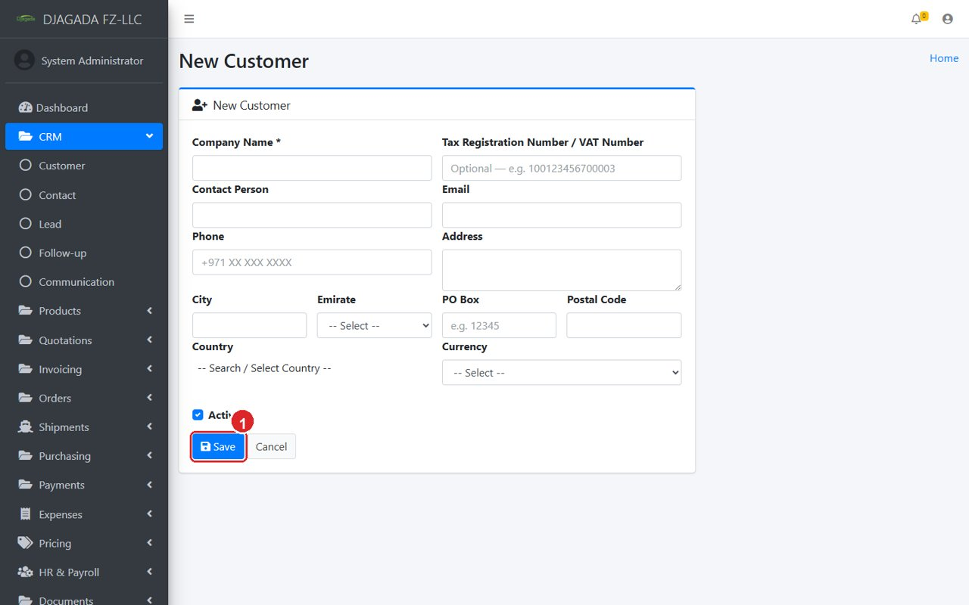
New Customer form — Country is a searchable worldwide dropdown.
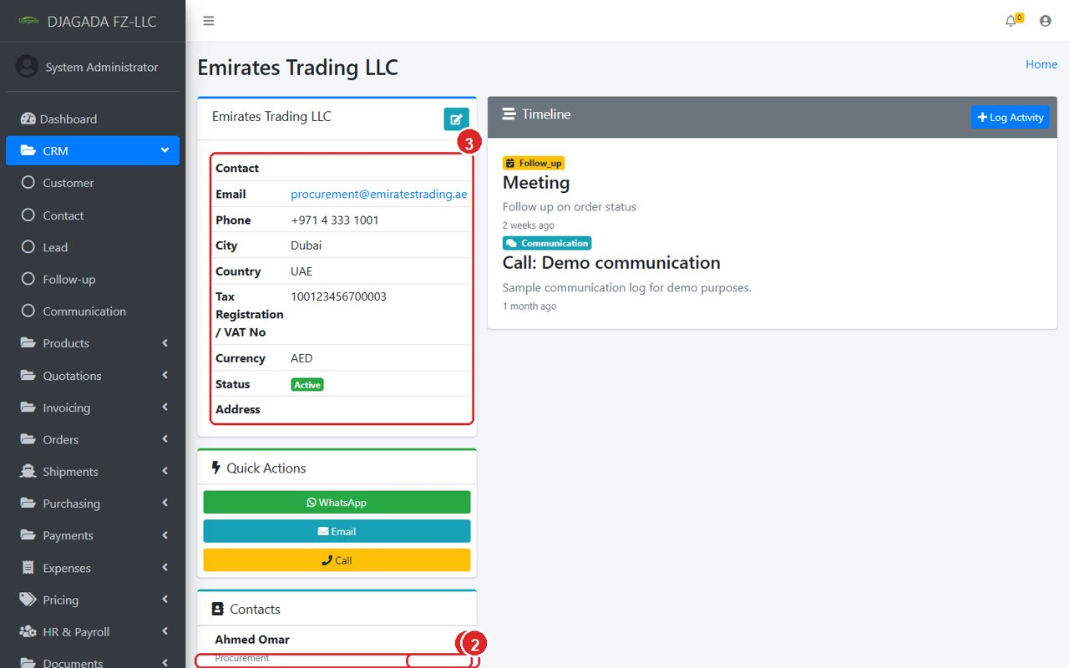
Customer profile — quotes, invoices, orders, payments and documents in one place.

5.2 Leads, Follow-ups, Communications
Leads are enquiries that are not customers yet. When a lead buys, convert it into a customer, then follow the Sales Flow (Chapter 8). Log every call or visit as a Follow-up or Communication so nothing falls through the cracks.
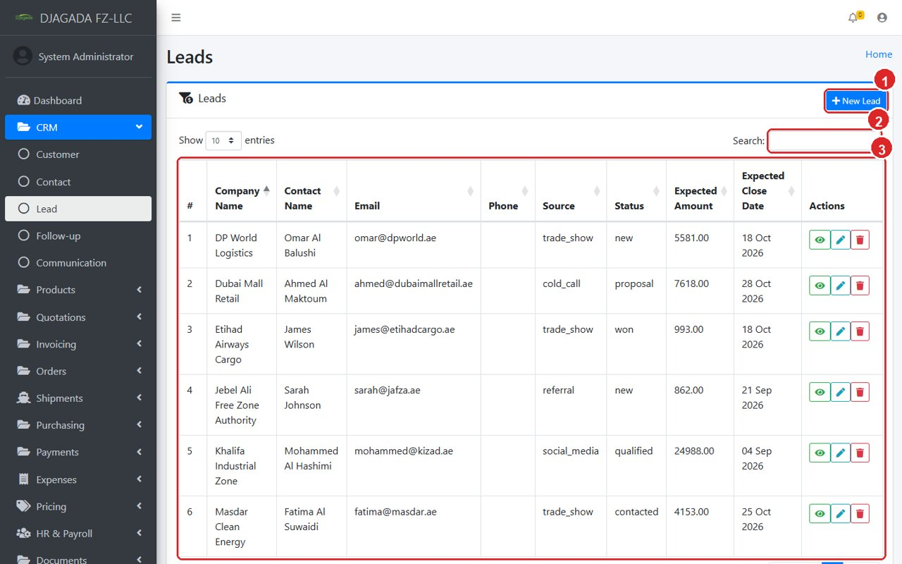
Lead list — track every enquiry until it becomes a customer.

6. Products & Suppliers

6.1 Suppliers
The supplier master. Purchase orders, supplier bills and price offers all link to a supplier.
- Click ① “New Supplier” and fill the details, including the optional TRN / VAT number.
- Open any supplier to see Purchase Orders, Bills, Payments — and the Price Offers card.
- Click “Record Offer” (top-right, or inside the Price Offers card) to save a new price from this supplier. The supplier is already selected — just add product, price and validity.
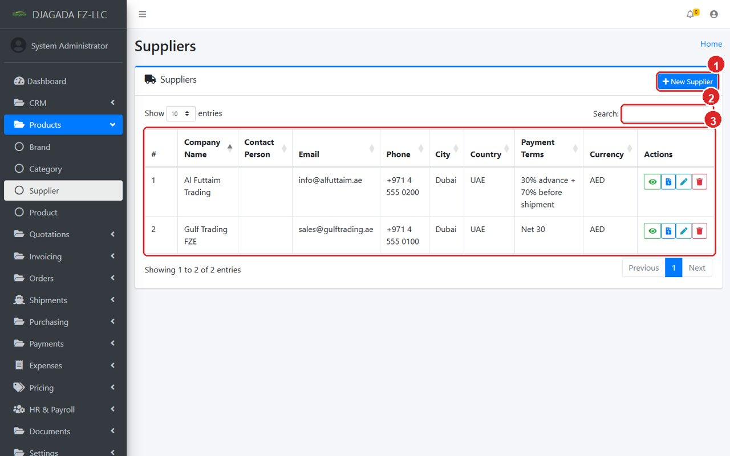
Supplier list.
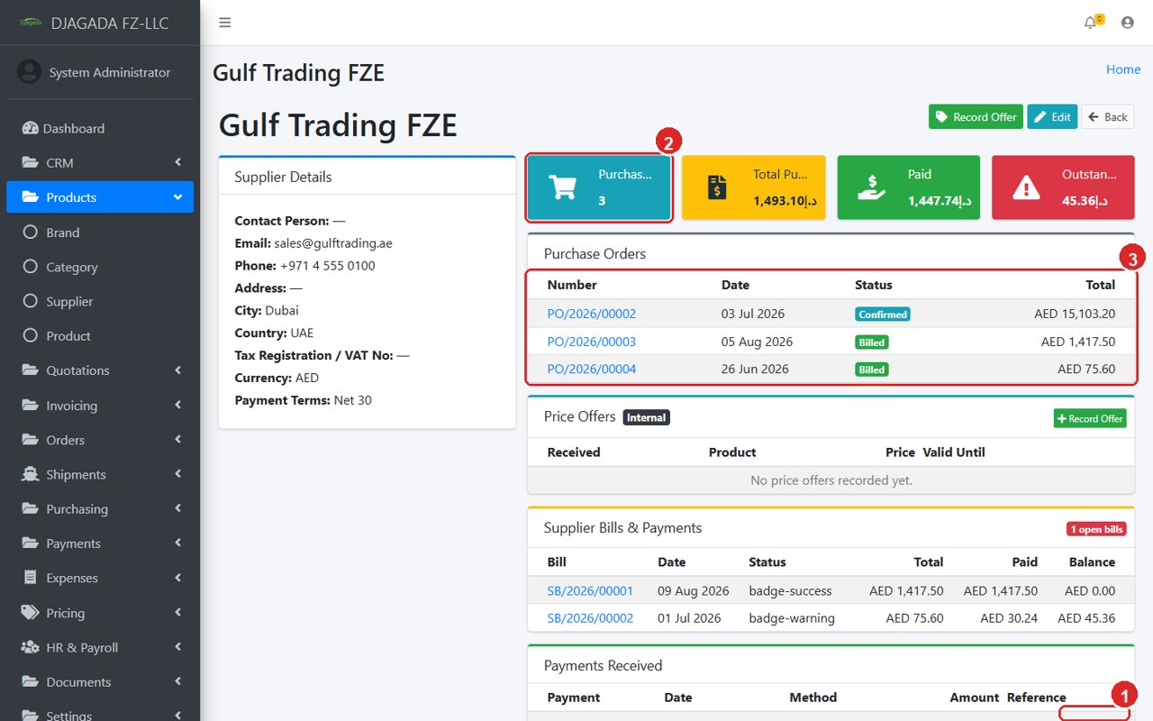
Supplier profile — Record Offer button and the Price Offers card keep pricing connected.

6.2 Products, Brands, Categories
Create Brands and Categories first (simple name lists), then Products. A product links to a default supplier, a category and a unit — these choices reappear automatically in quotes, invoices, orders and price offers.
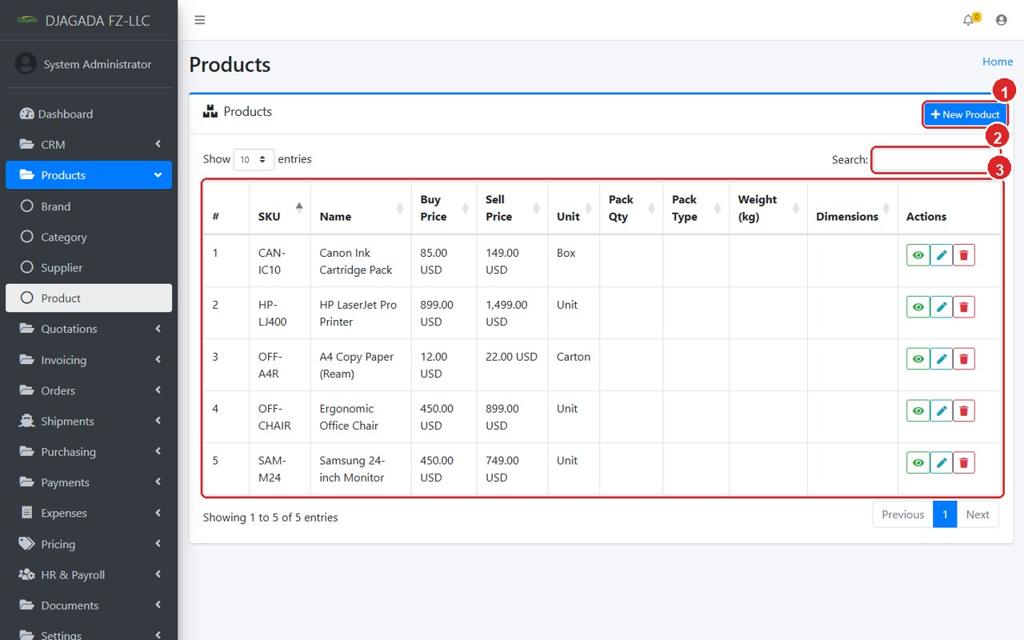
Product list — the single catalogue used everywhere.

7. Pricing — Supplier & Selling Prices
This module answers: “At what price did suppliers offer, and at what price do we sell?” Supplier prices are INTERNAL and confidential — regular staff never see cost or margin.
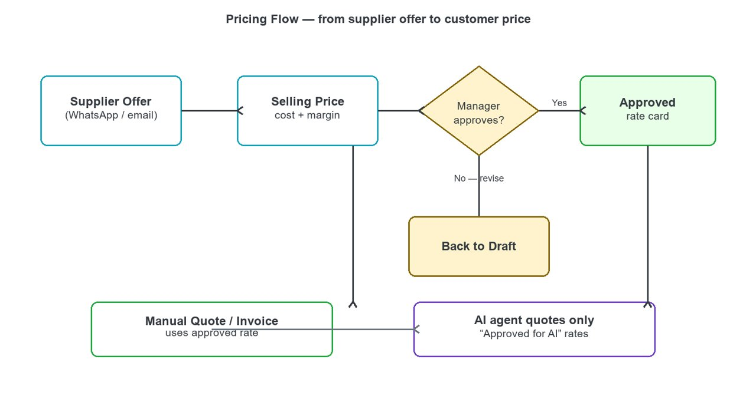
Pricing flow — offer → selling price → approval → quote.

7.1 Supplier Prices (confidential)
- Open Pricing → Supplier Prices. Click ① “Record Supplier Offer”.
- Select Supplier and Product (both come from your masters — Chapter 6), enter the offered price, currency, incoterm, destination port, quantities, date received and how long the offer is valid.
- Source records where the offer came from: WhatsApp, email or other.
- Press ① Save. The offer now appears in the list and on the supplier profile.
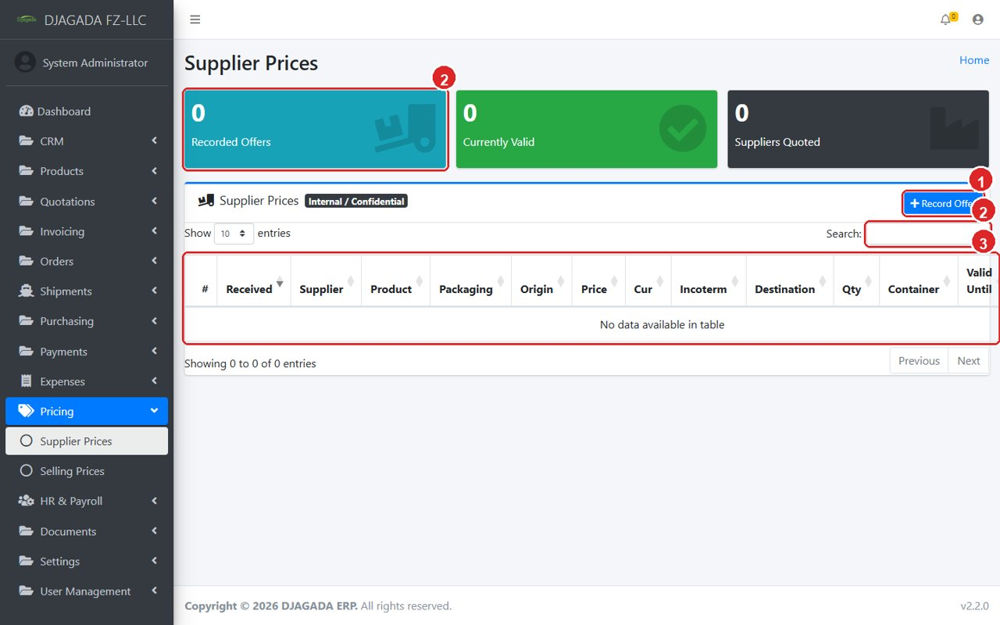
Supplier offers list — internal only.
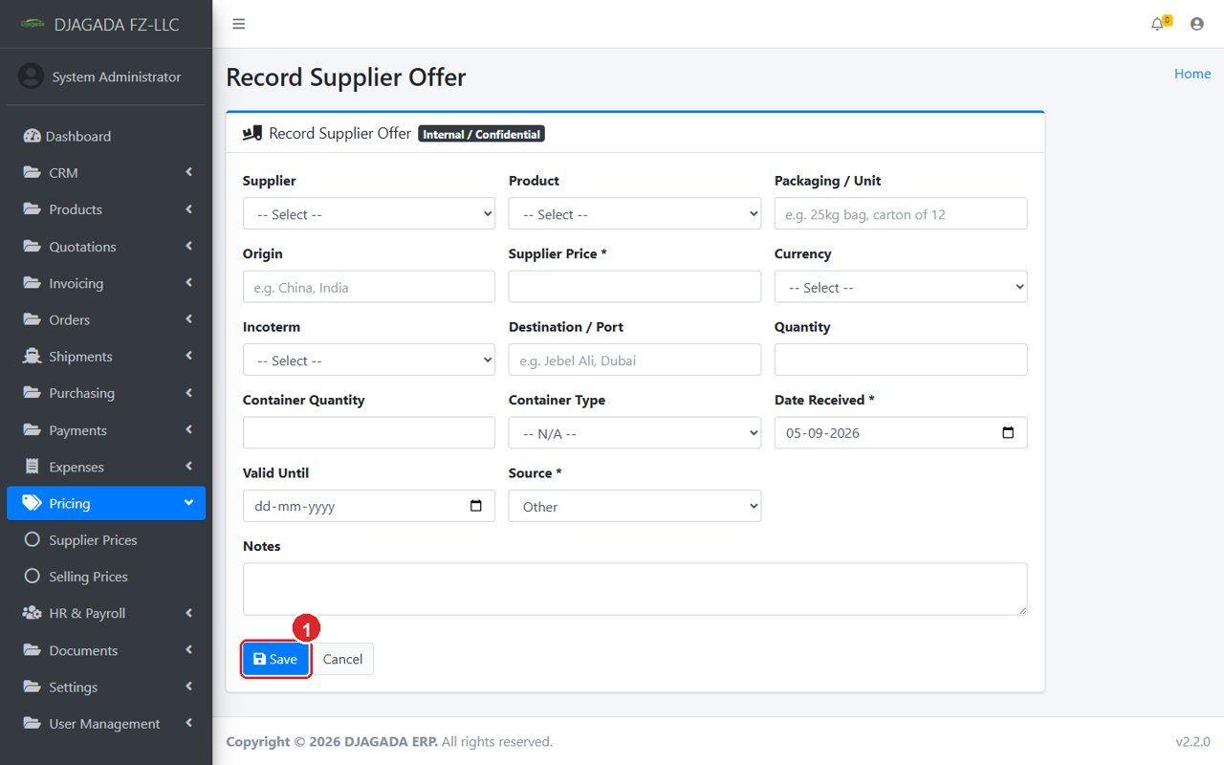
Record Supplier Offer — ① Save when done.

7.2 Selling Prices (our rates to customers)
- Open Pricing → Selling Prices. Click ① “New Selling Price”.
- Optionally pick “From Supplier Offer” — cost, product, currency, incoterm and destination fill in automatically.
- Enter Margin % (or a fixed Margin Amount). The Selling Price is calculated for you; you can still overwrite it for a manual final price.
- Leave Customer empty for a general rate, or pick a customer for a special rate.
- Set Valid Until — expired prices disappear from quoting automatically. Status starts as Draft; a manager Approves it. Tick “Approved for AI” only for rates an AI assistant may quote.
- Only users with cost permission see the Cost and Margin columns; everyone else sees just the selling price.
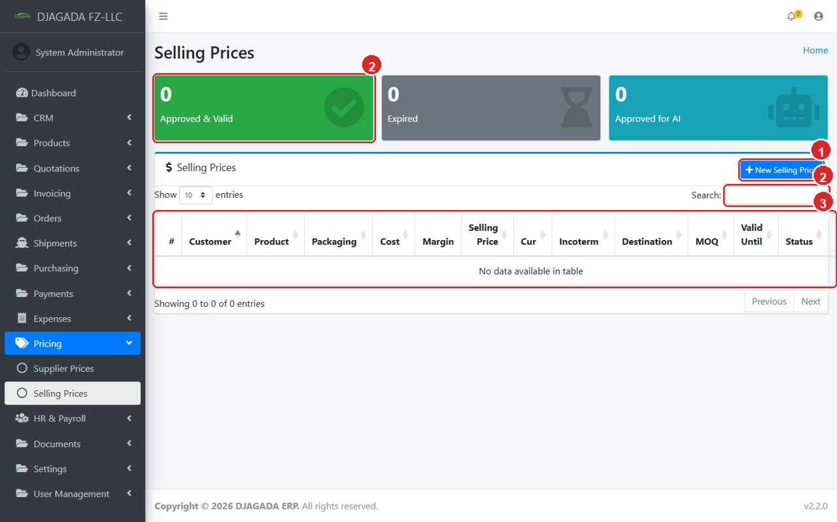
Selling prices — cost/margin visible only with permission.
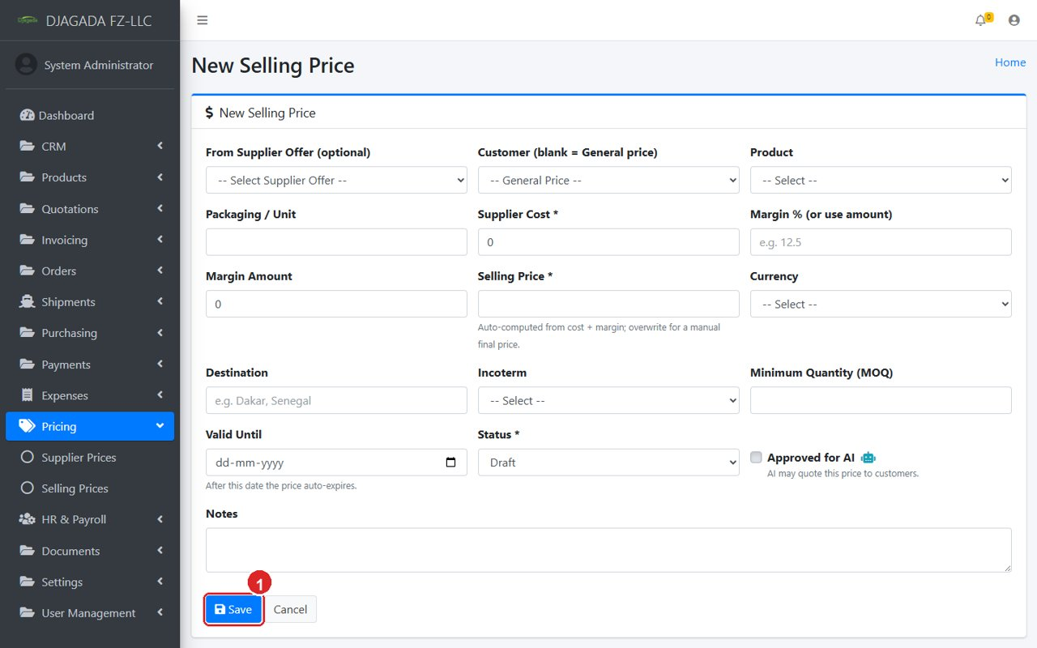
New Selling Price — margin auto-computes the final price.

8. Sales — Quotes, Invoices, Orders
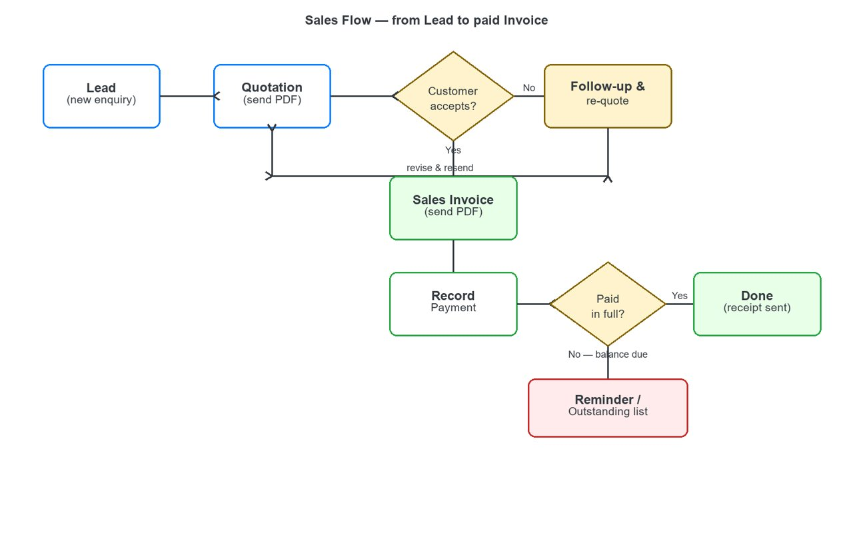
Sales flow — Lead → Quotation → Invoice → Payment.

8.1 Quotations
- Open Quotations → Quotation. Click ① “New Quotation”, choose the customer and add product lines.
- Click Download PDF to send the branded quotation to the customer.
- If the customer accepts, convert the quote into an invoice (or order) — no re-typing. If not, log a follow-up and revise.
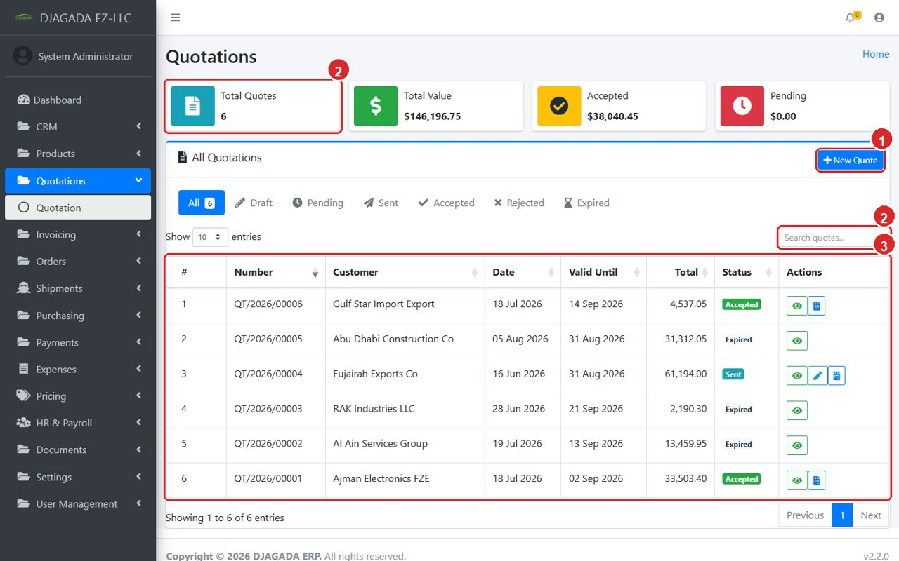
Quotation list.
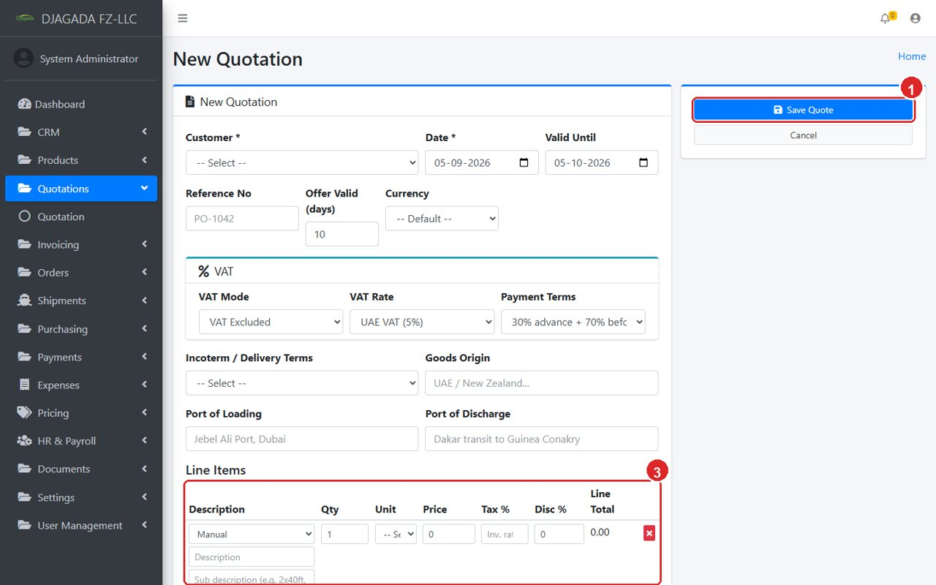
New Quotation — customer, items, totals, then Save / PDF.

8.2 Invoices & payments
- Open Invoicing → Invoice. Click ① “New Invoice” (or convert from a quote).
- The customer TRN prints on the PDF automatically. Send the Download PDF to the customer.
- When money arrives, open the invoice and click “Record Payment”: choose date, method, bank account and amount. Partial payments are allowed — the balance stays visible.
- Fully paid invoices leave the Outstanding list; overdue ones glow on the Dashboard.
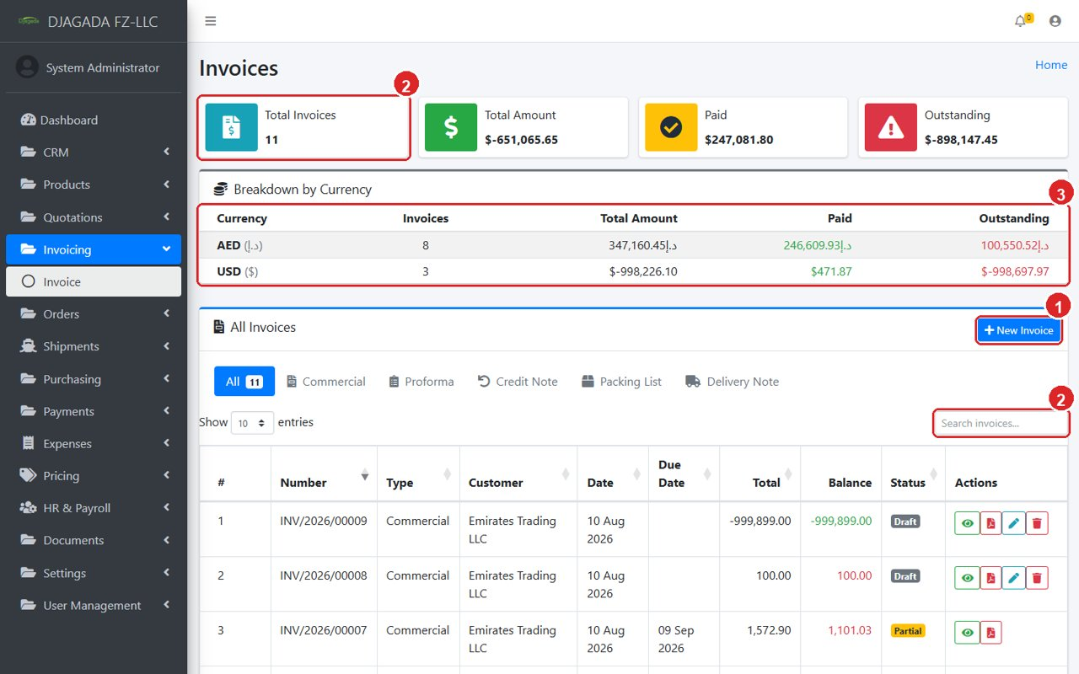
Invoice list with statuses and balances.
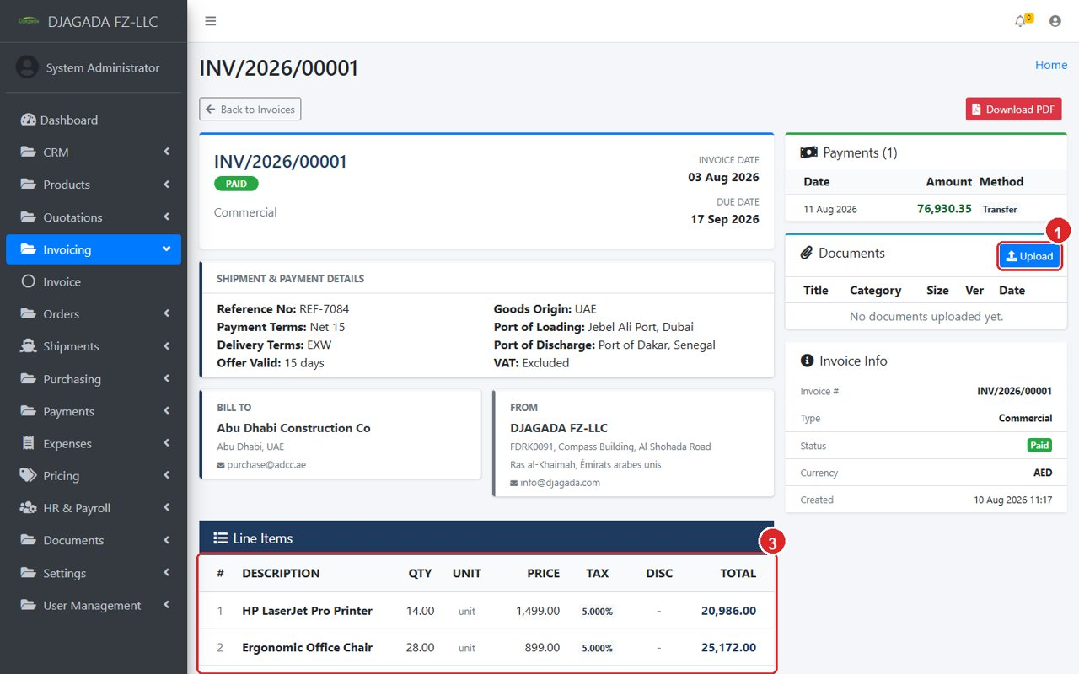
Invoice details — Download PDF and Record Payment in one place.

8.3 Orders
Orders are confirmed sales jobs. They track Loading / Production progress and feed Shipments (Chapter 9).
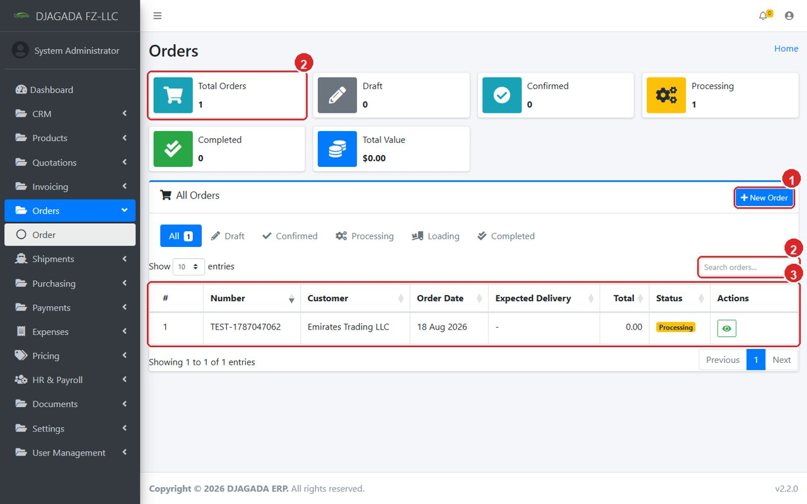
Order list — production progress at a glance.

9. Shipments & Delivery
- Open Shipments → Shipment. Click ① “New Shipment” and link it to the order.
- Enter container details: Number of Containers and size (20 ft / 40 ft), vessel, tracking number and dates.
- Move the status along: Preparing → In Transit → Arrived / Delivered. The Dashboard counters update themselves.
- Click Download PDF for the branded shipment document to share with the customer.
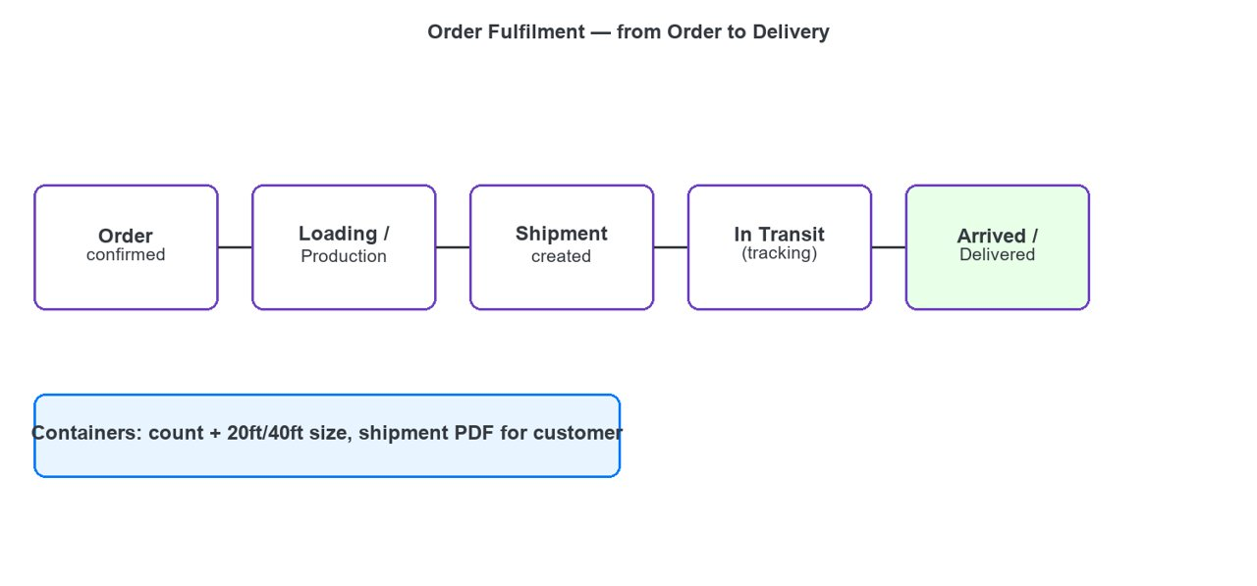
Fulfilment flow — Order → Loading → Shipment → Delivery.
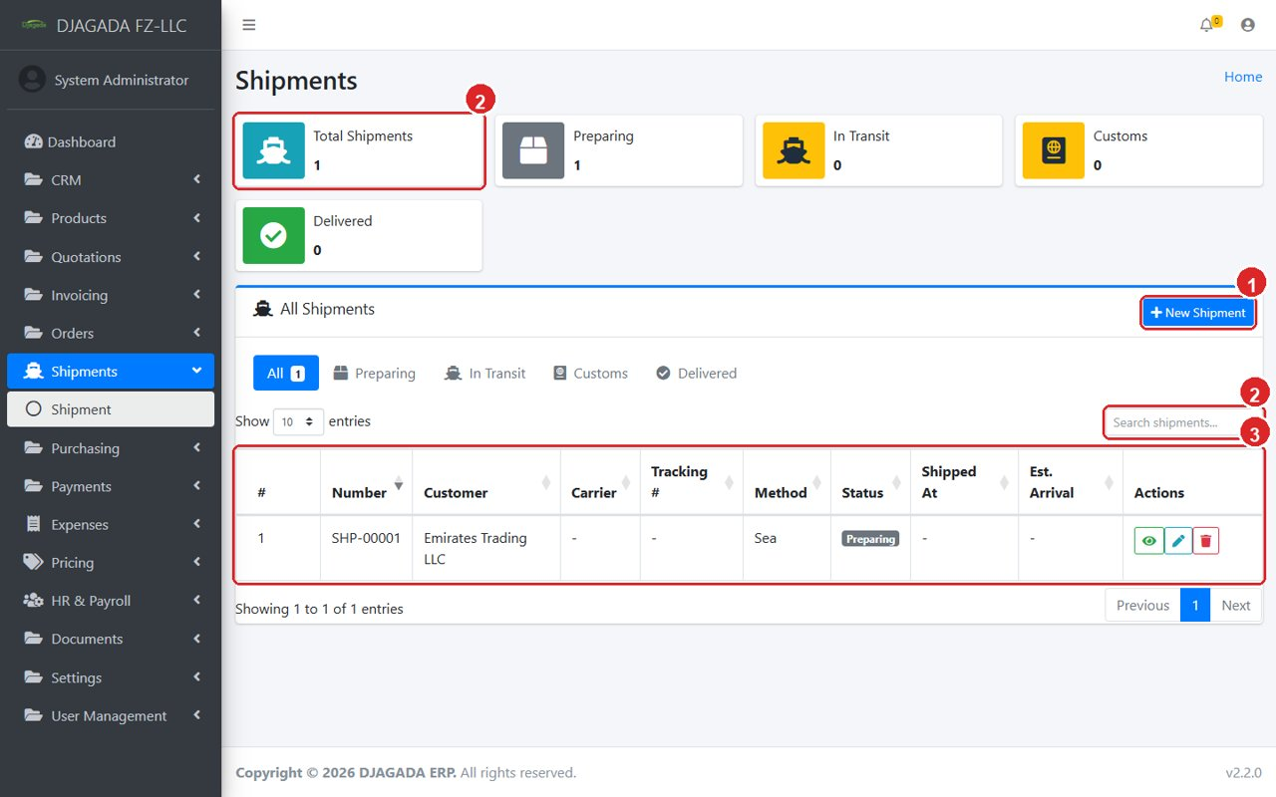
Shipment list with live statuses.
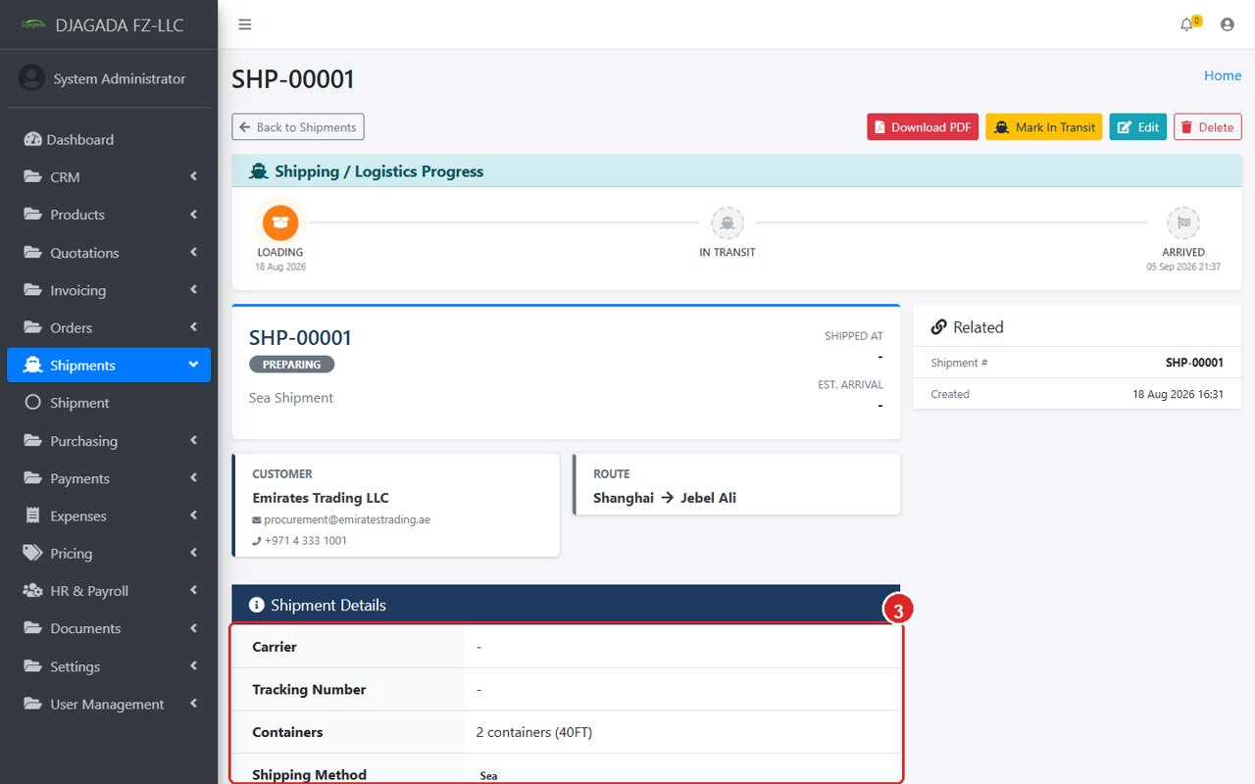
Shipment details — tracking steps, containers and PDF download.

10. Purchasing — Purchase Orders & Supplier Bills
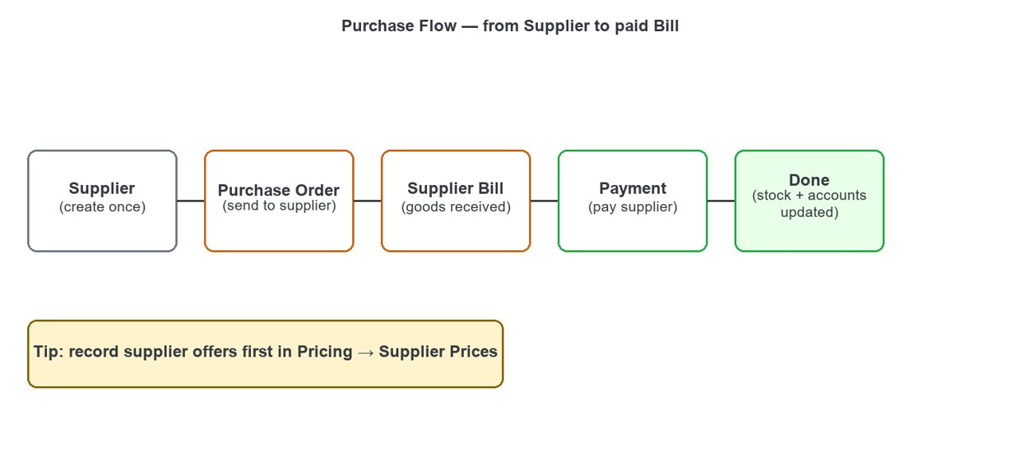
Purchase flow — Supplier → PO → Bill → Payment.

10.1 Purchase Orders
- Open Purchasing → Purchase Order. Click ① “New Purchase Order”, pick the supplier and add items.
- Send the PDF to the supplier. Track status: Draft → Sent → Confirmed → Received (or Cancelled).
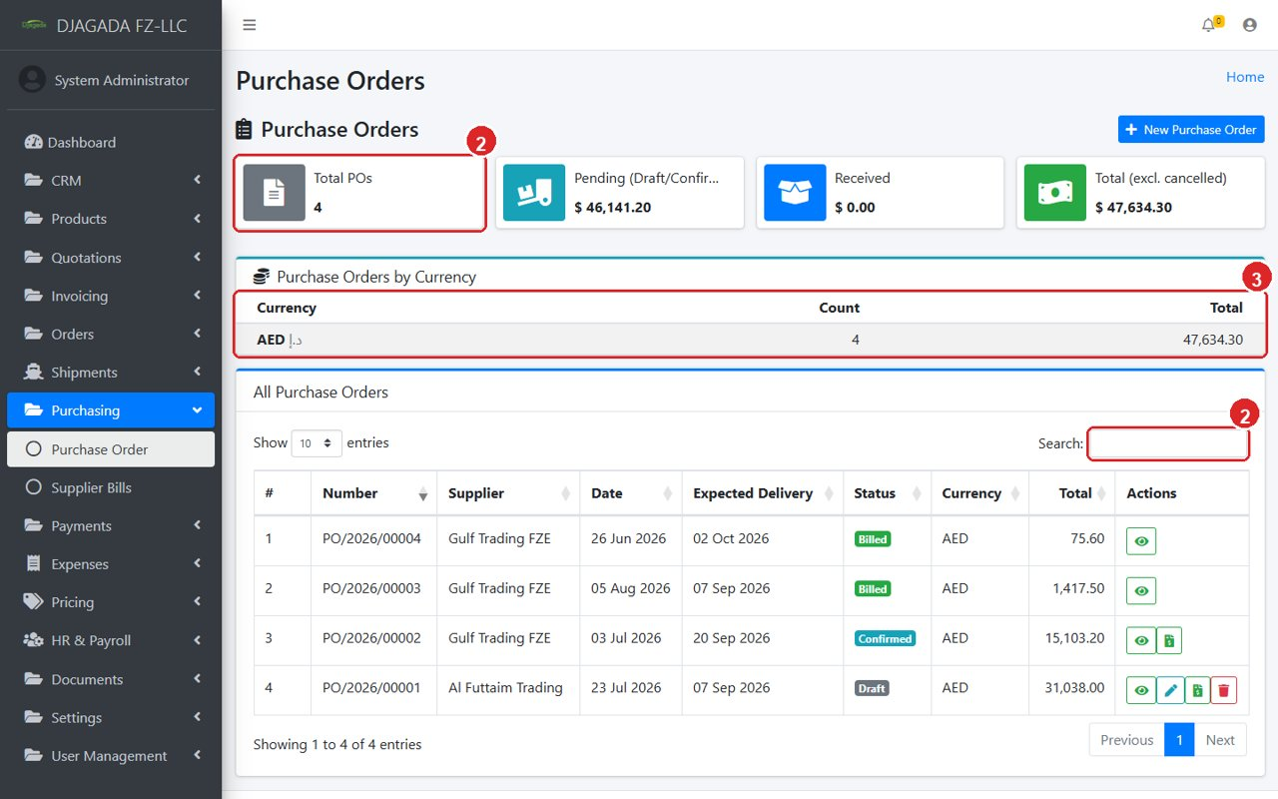
Purchase order list with statuses.

10.2 Supplier Bills & paying them
- When goods arrive with the supplier invoice, open Supplier Bills → ① “New Bill” and enter it against the supplier.
- The supplier TRN prints on the bill PDF.
- To pay, open the bill and click “Record Payment” — partial payments allowed, balance tracked like customer invoices.
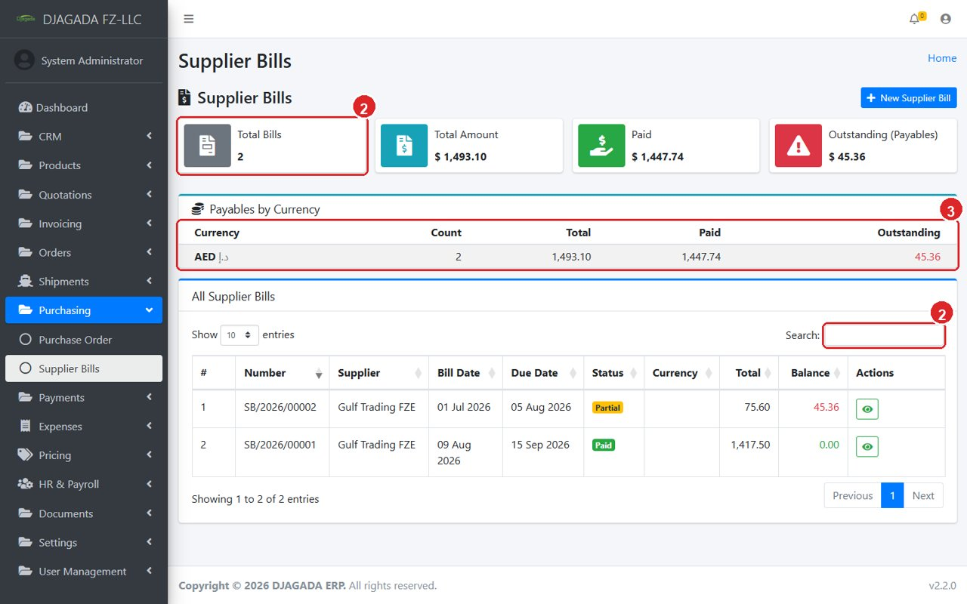
Supplier bills — what we owe and what is paid.

11. Payments & Expenses

11.1 Payments
Every payment — money IN from customers or money OUT to suppliers — lives here, always linked to its invoice or bill, method and bank account. Deleting a payment restores the invoice balance safely.
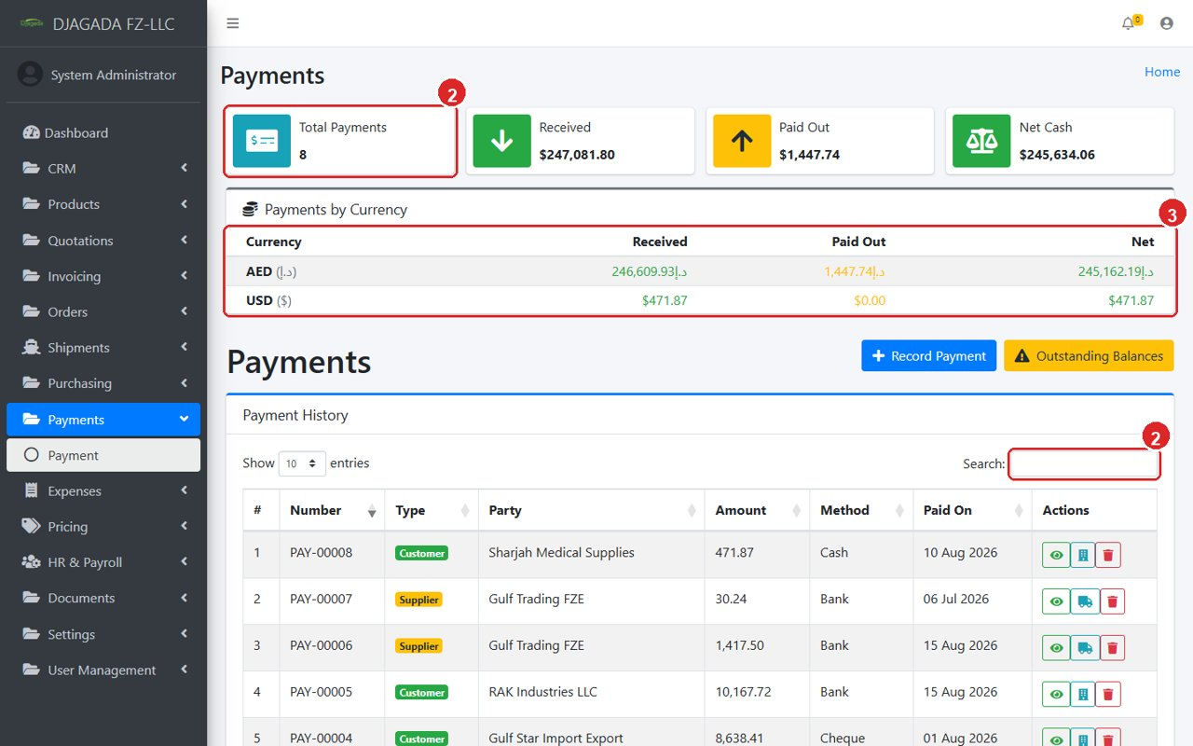
Payment list — every receipt and payout in one register.
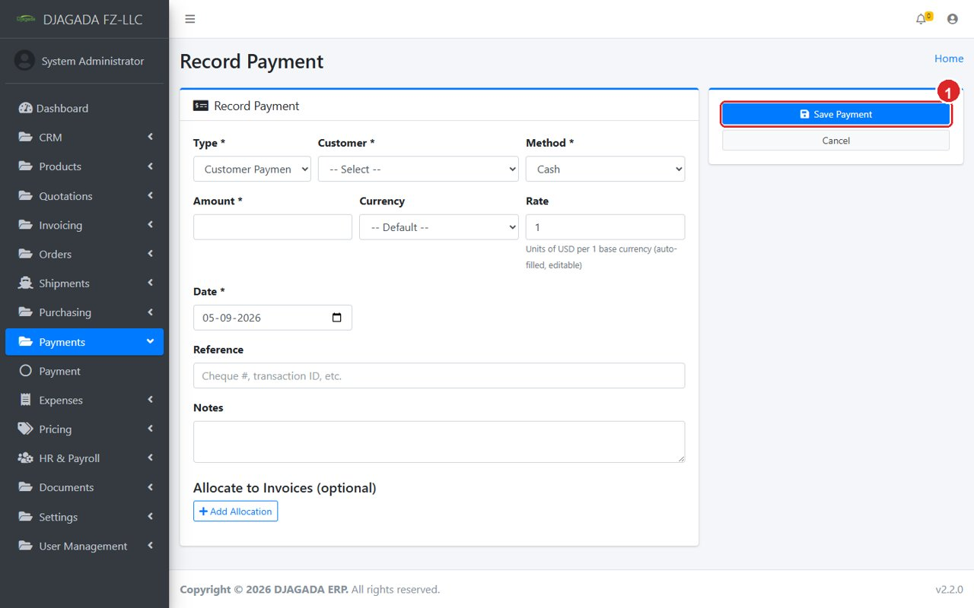
Record Payment — date, method, account, amount.

11.2 Expenses
Day-to-day company spending (rent, fuel, salaries paid outside payroll, etc.). Expenses reduce Net Profit on the Dashboard automatically. Categorise each expense so month-end review is easy.
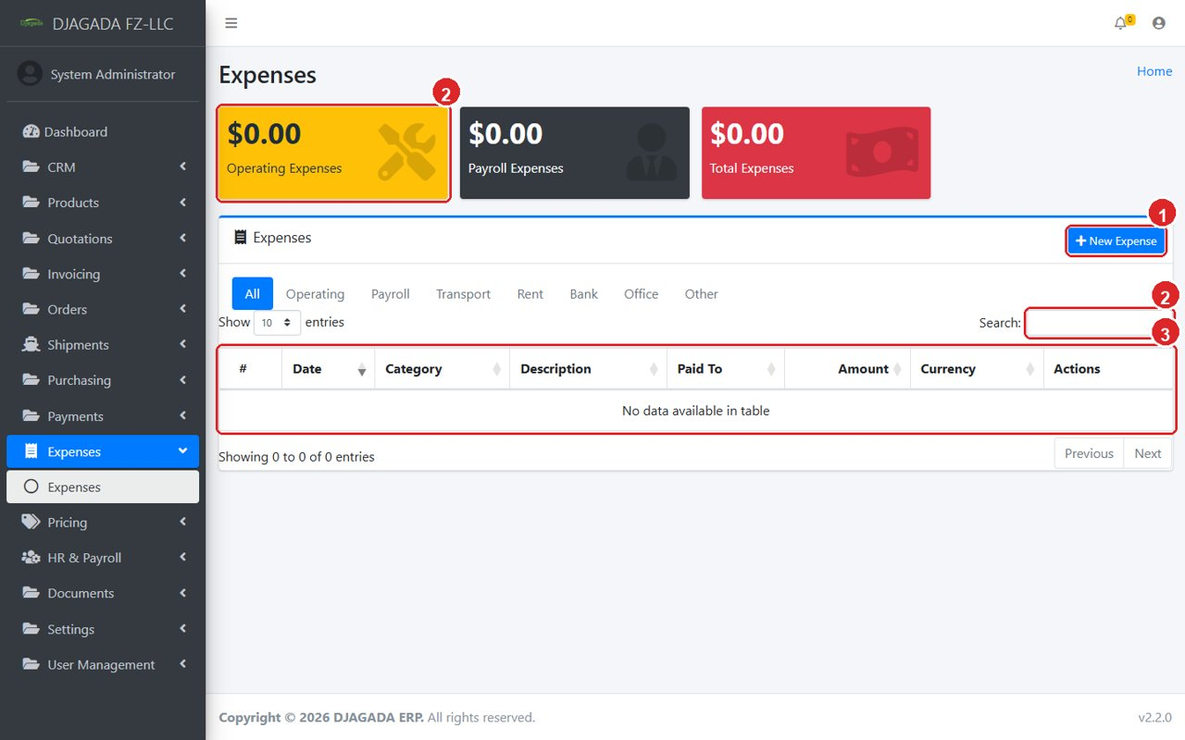
Expense list — operating costs feeding the P&L.

12. HR & Payroll
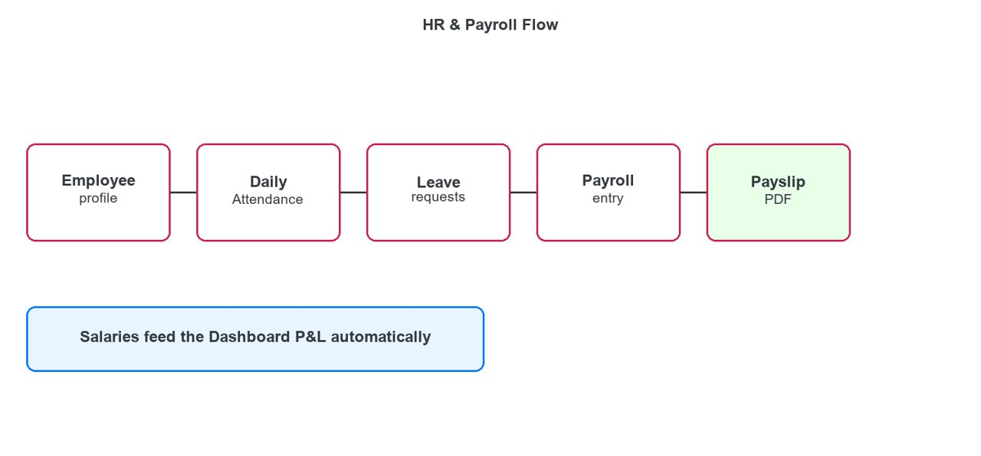
HR flow — Employee → Attendance/Leave → Payroll → Payslip.
- Employees: create one profile per staff member with salary and joining date.
- Attendance: mark daily check-in / check-out (or import). Absences without leave flag automatically.
- Leaves: staff requests (annual, sick, etc.) are approved here; approved leave explains missing attendance.
- Payroll: run a monthly entry per employee — allowances minus deductions equals net salary. Totals flow into Dashboard Salaries and Net Profit.
- Download the PDF payslip and share it with the employee.
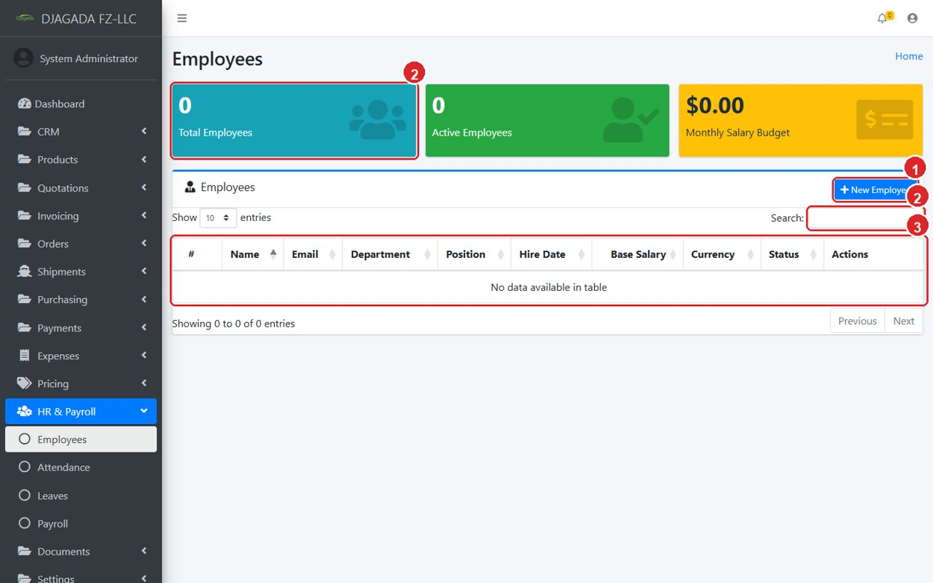
Employee list.
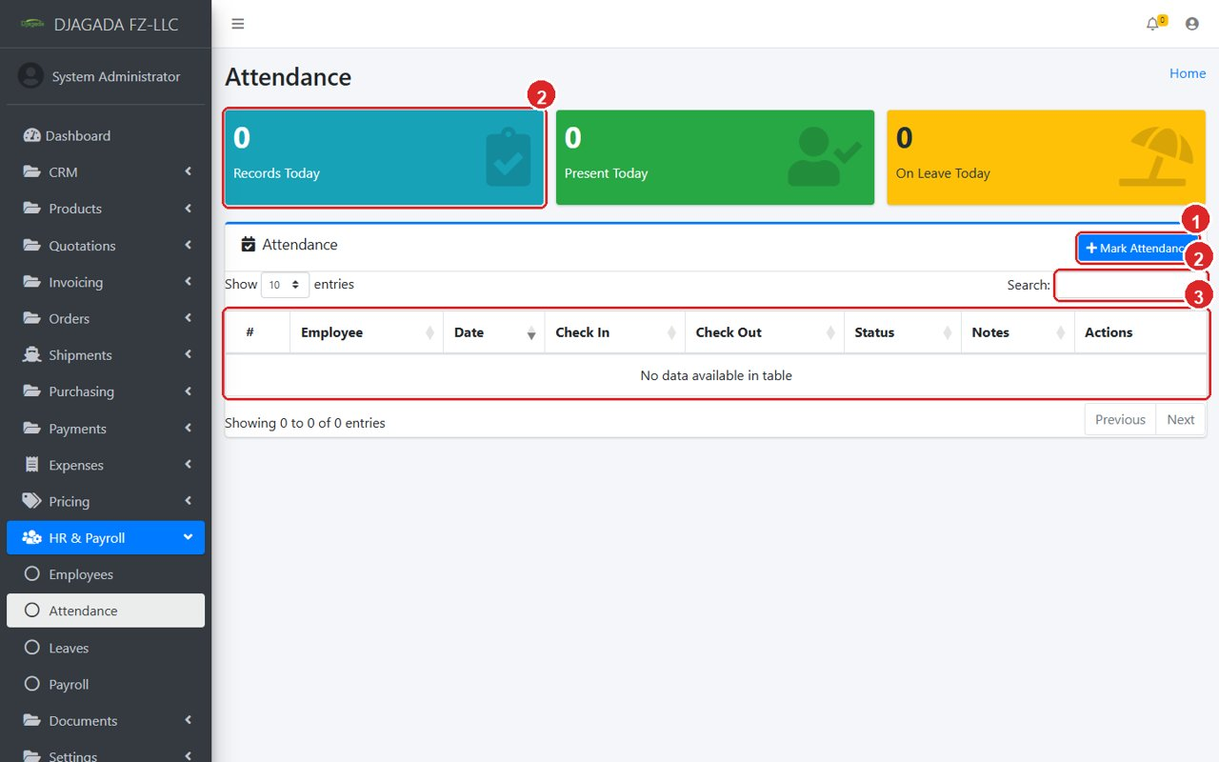
Daily attendance marking.
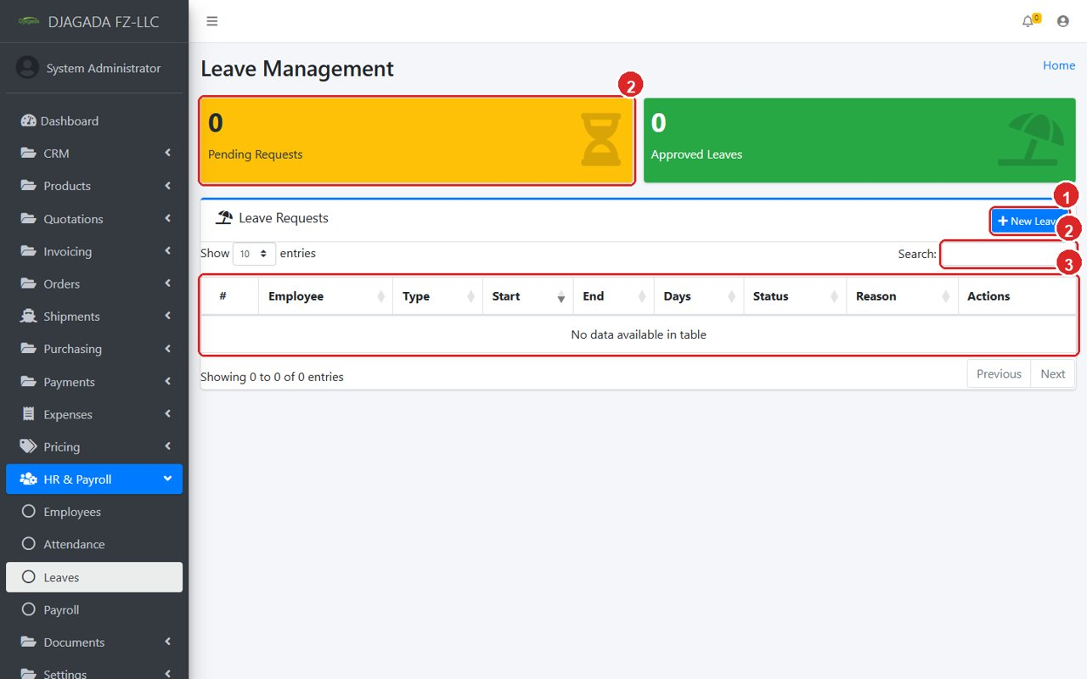
Leave requests and approvals.
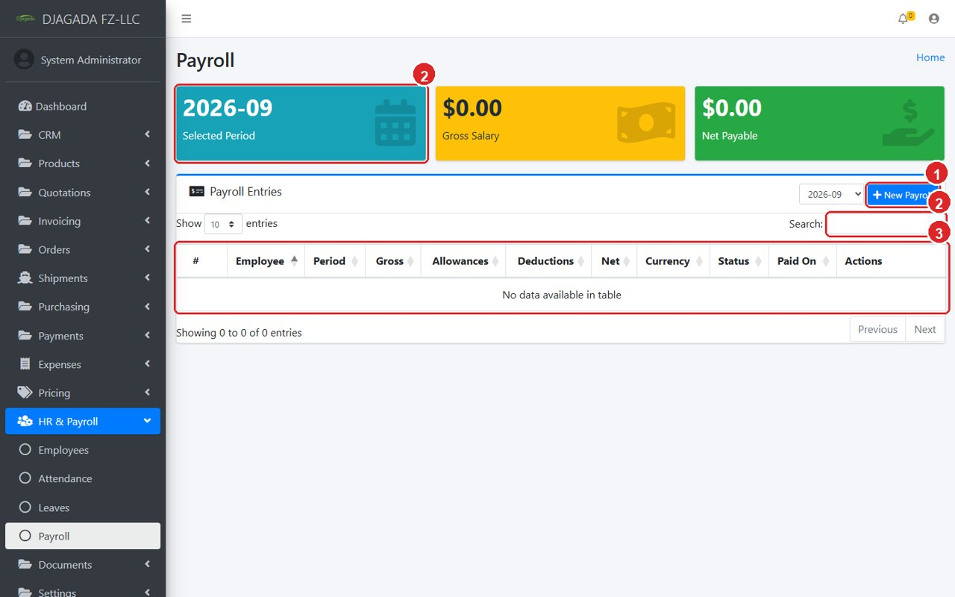
Payroll entries and net salaries.

13. Documents, Settings, Users & Roles

13.1 Documents
Attach any file (contracts, certificates, photos) to customers, suppliers, orders, shipments, employees — everything stays with the record instead of in email.
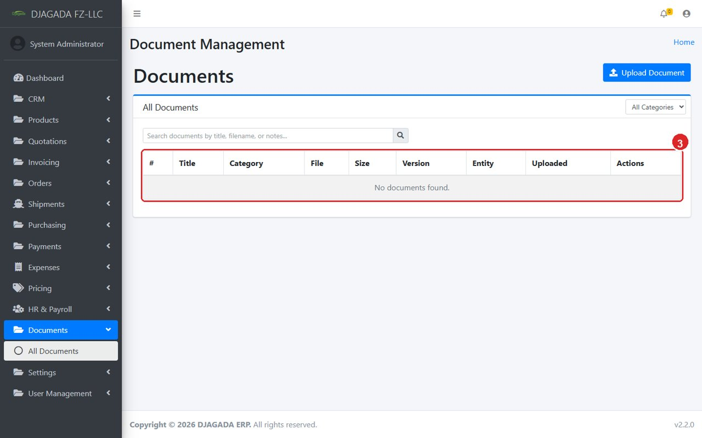
All Documents — every file attached anywhere, searchable.

13.2 Settings (one-time setup)
Company: name, logo, address, TRN and bank details — these print on every PDF. Also set Currencies (with the base currency), Taxes/VAT rates, Units, Payment Terms and Company Bank Accounts. Audit Log shows who changed what, for accountability.
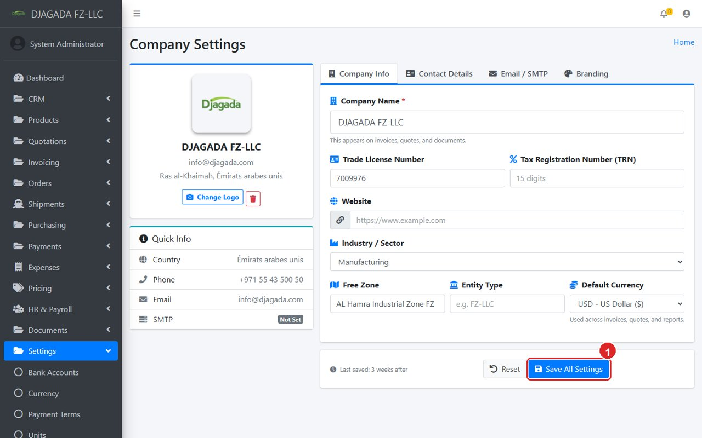
Company settings — the details printed on all PDFs.

13.3 Users & Roles
Create one user per staff member. Give each user a Role, and give the role only the permissions it needs. Examples: sales staff get quotes/invoices but NOT supplier prices; managers get pricing approval (approve-selling-prices); only trusted staff get view-pricing-costs. Super Admin sees everything.
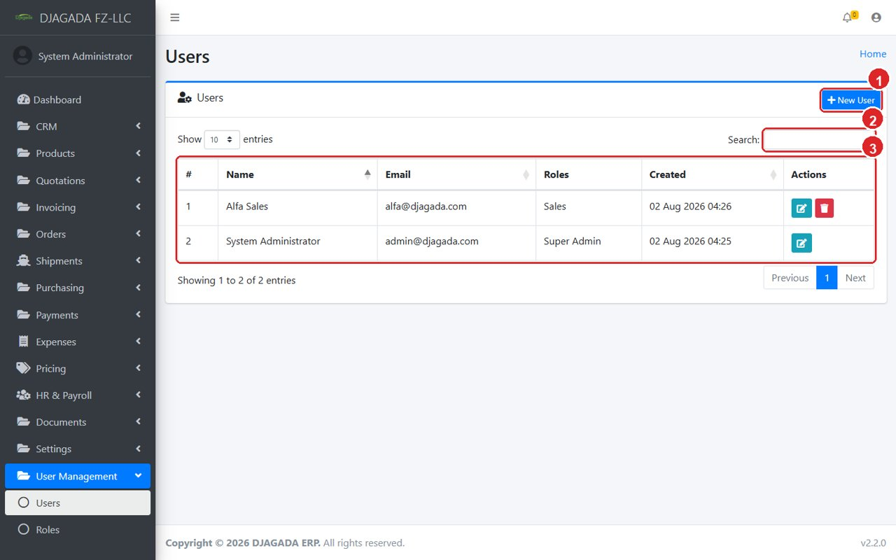
Users — one login per staff member.
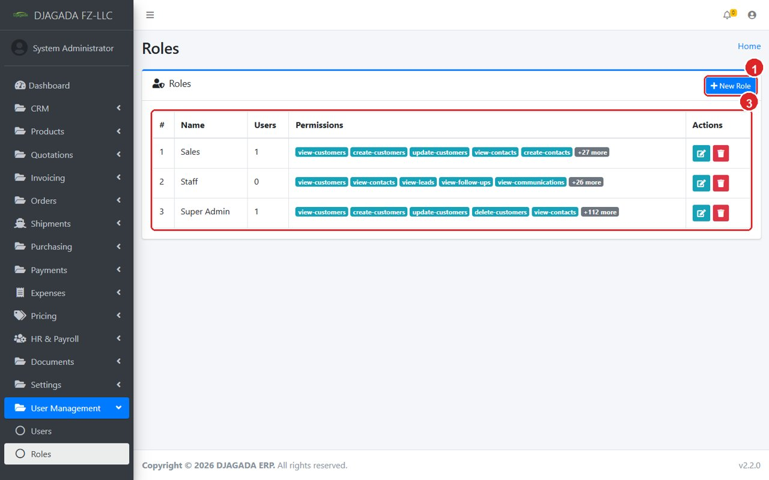
Roles — tick only the permissions each role needs.

14. For your IT person
Daily use needs no technical steps. Two one-time/server items for IT: (1) after uploading a new version, run “php artisan pdf:install-fonts” once so invoice PDFs use the Lato font; (2) optional nightly schedule “php artisan pricing:expire” to mark old selling prices expired (the system also hides them automatically). Keep regular database backups before every update.

