1.σ c1 and c2 (R) = σc1(σc2(R) )

2.σ c1 or c2 (R) = (σc1 R) ∪  (σc2 R)

3.σc(R ∪ S) = (σcR ) ∪ (σcS)

4.σc(R × S) = (σcR) × (σc S)

5.σc(R Θ S) = (σc R) Θ  (σc S)

7. πL(R Θc S ) =πL(πM(R) ΘcπN(R))

8. πL(R ∪ S ) =πL(R)∪ πL(S)

τ L (R) order by

γ pnum, sum(qty)→sum(SP)

Select pnum, sum(qty) as sum

from SP

group by pnum;

Select p.pname, p.pnum, sum(sp.qty) as sum

from Parts p, Shipments sp

where p.pnum = sp.pnum

and p.weight > 10

group by p.pname, p.pnum

having sum(sp.qty) >= 200;

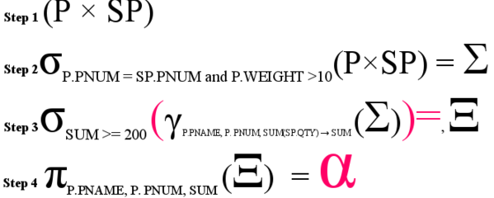

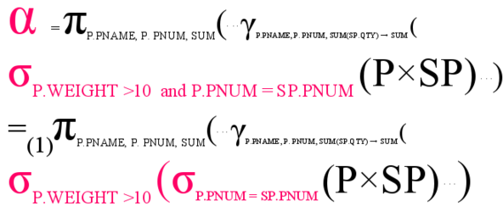

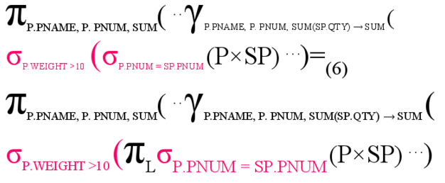

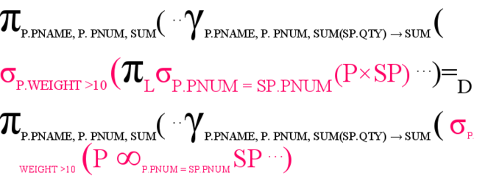

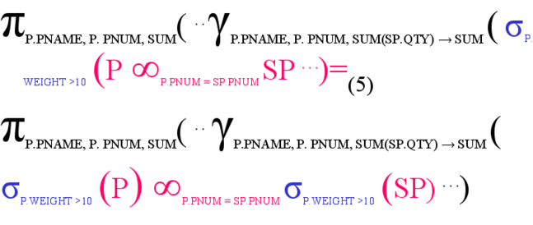

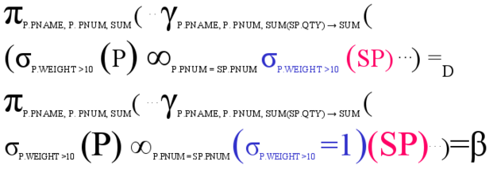

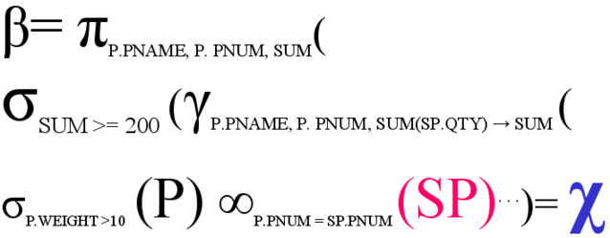

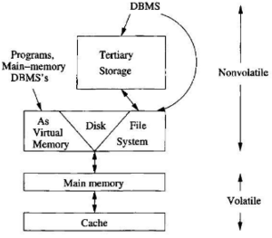

Cache: few nano, volatile

Main memory: 10-100 nano, volatile

Disk: millisecond, none volatile

Seek time-find the right track

Rotational latency-rotate to find the right block

Transfer time-reading/writing

Latency-Sum of above

Part

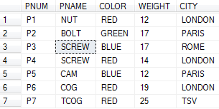

Shipment

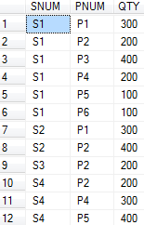

Supplier

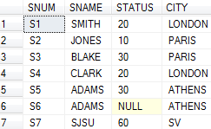

Department-------------------------------------------------------

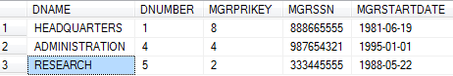

Dependent

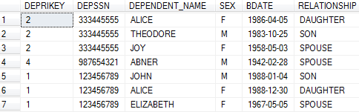

DEPT_LOCATION

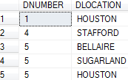

EMPLOYEE

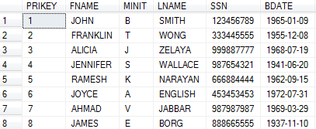

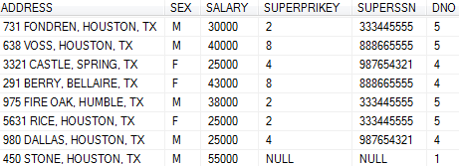  
PROJECT

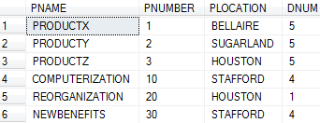  
WORK_ON

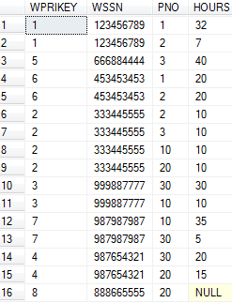

MovieExec

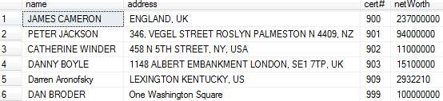

Movies

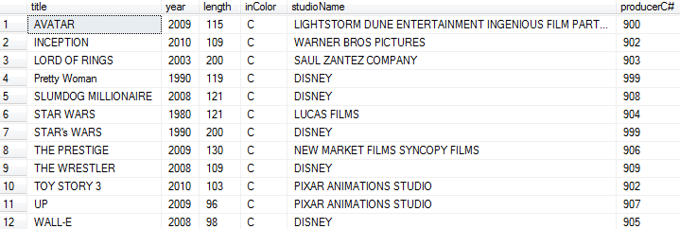

MovieStar

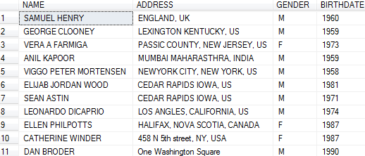

STARSIN

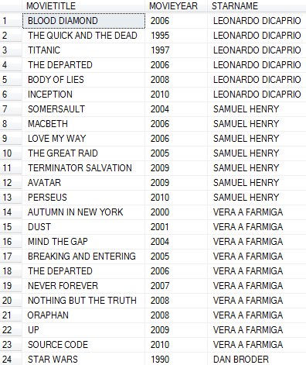

select *

from

(select  PNAME w , PNUM e, SUM(QTY) q

from (select A.PNUM,B.QTY,A.PNAME

from dbo.PARTS A INNER JOIN dbo.SHIPMENTS B

on A.PNUM=B.PNUM

where A.WEIGHT>10) Y

group by PNAME, PNUM

having SUM(QTY)>200

) X

select distinct movietitle

from starsIn

where starname in (select name

from moviestar

where birthdate

like '%1974%');

select distinct movietitle

from starsIn a, (select name

from moviestar

where birthdate like '%1974%') temp

where a.starname = temp.name;