Flight Computer PCB
Revision History & Development Log
September 2025 – February 2026
10 Revisions · ~5 Months · KiCad 8 · 4-Layer PCB · ESP32-based
Kushagra Srivastava
2nd Year Electronics & Communications Engineering

Overview
This document traces the complete design evolution of a custom 4-layer flight computer PCB, developed independently over approximately five months. Starting from a first KiCad layout with no prior PCB experience, the project progressed through ten revisions — each driven by new knowledge, manufacturer feedback, and a critique session with an industry professional.
The final board (Rev 10) is a unified avionics platform serving three applications: flight computer for a high-power rocket, test stand data logger, and ground station. It features four pyro channels with gate driver ignition, GPS and LoRa RF downlink, IMU/barometer sensor fusion, SD card data logging, and a robust multi-domain ground architecture.
Revision Summary
Revision | Period | Status | Key Milestone
Rev 1 | Sep 2025 | Scrapped | First KiCad layout, learning fundamentals
Rev 2 | Early Oct 2025 | Scrapped | Double-sided routing, vias, edge cuts
Rev 3 | Mid Oct 2025 | Scrapped | First power tree — sent to manufacturer (rejected)
Rev 4 | Late Oct 2025 | Scrapped | 4-layer board, GND planes, industry professional review
Rev 5 | Early Nov 2025 | Scrapped | Full SMD, RF module, 90%+ PSU efficiency
Rev 6 | Nov 2025 | Scrapped | Pyro channels, SMA connectors, RGB status LED
Rev 7 | Nov 2025 | Scrapped | Impedance calcs, local 3.3V pours, U.FL GPS
Rev 8 (Early) | Mid Nov 2025 | Scrapped | First fully functional design, 4 pyro channels, thermal vias
Rev 8 (Late) | Late Nov 2025 – Jan 2026 | Functional | Team symbol, test pads, failure-mode simulation
Rev 9 | Jan 2026 | Functional | Analog/digital/pyro split GND pours, L2 reference plane
Rev 10 | Feb 2026 | Final | Gate drivers, USB–UART, ESD protection, industry-grade layout

Rev 1 — September 2025
Focus: First layout — learning KiCad fundamentals
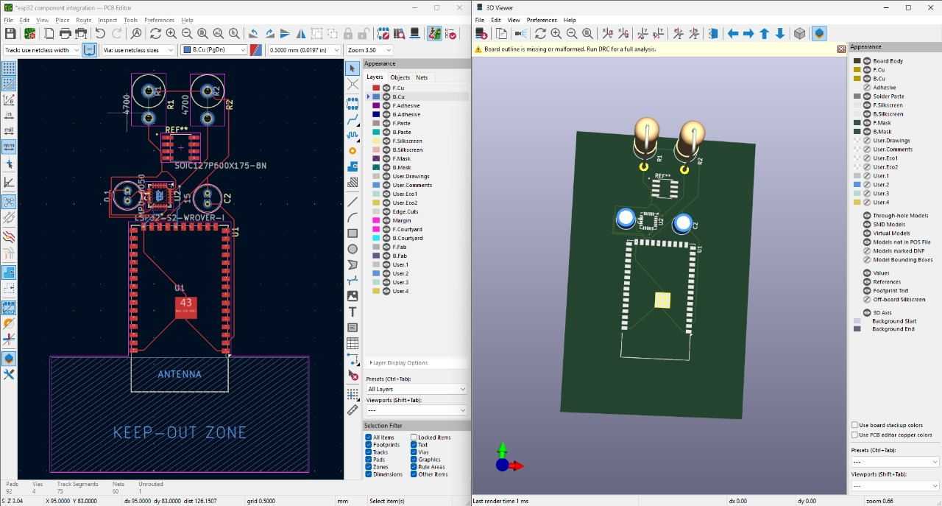
Rev 1 — First PCB layout in KiCad
The first iteration was a learning exercise in KiCad. Core skills acquired included placing footprints, using the "Update PCB from Schematic" workflow, selecting components from the footprint library, and manually routing traces.
Routing was extremely basic — traces contained 90° turns throughout, there was no concept of a power delivery tree, and signal integrity was not considered. This revision was never sent for fabrication and served purely as a familiarisation exercise.

Rev 2 — Early October 2025
Focus: Double-sided routing, vias, and edge cuts
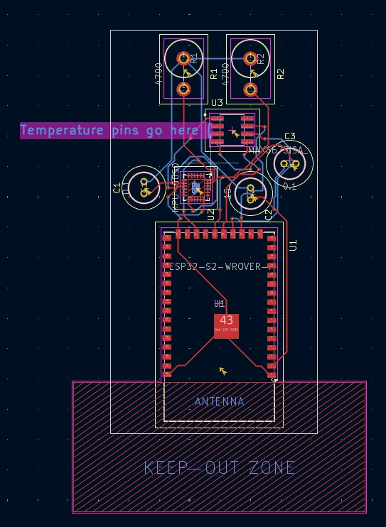
Rev 2
Rev 2 extended the design to both sides of the board for the first time. Key skills developed included via usage, more efficient trace routing, and defining board outline with edge cuts.
"Footprint has no courtyard defined" DRC warnings were resolved by adding extra silkscreen markings around all components — a misguided workaround that added unnecessary clutter. This was corrected in Rev 4.
Temporary pin labels were introduced on the silkscreen layer to assist hand-soldering during prototyping.

Rev 3 — Mid October 2025
Focus: First power tree — and a hard lesson from a manufacturer
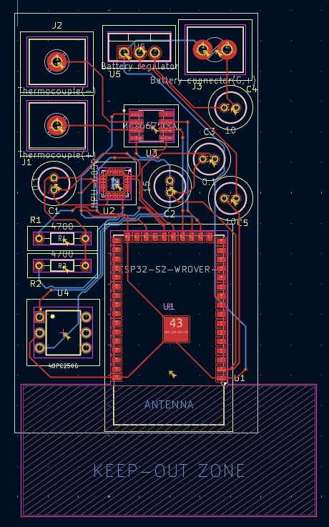

Rev 3 — First power delivery tree implemented
Rev 3 was the first design to include a structured power tree — though a flawed one. The theoretical efficiency was approximately 27%. A critical error was using default 0.2 mm traces throughout, including on power rails, which would have resulted in thermal failure under load.
- Decoupling capacitors were placed but their purpose and correct implementation were not yet understood.
- Horizontal through-hole resistors were used for the first time (footprint substitution from vertical THT).
- This revision was submitted to a PCB manufacturer.
The manufacturer reviewed the design and informed me it would have failed immediately upon powering on — the undersized power traces would have burned up. This was the first external validation that the design process needed significant improvement.
Architecture pivot: Until this revision, the plan was to design two separate boards — one for the test stand and one for the rocket. Following this feedback, subsequent revisions consolidated everything into a single 4-layer unified avionics platform for all three use cases: flight computer, test stand controller, and ground station.

Rev 4 — Late October 2025
Focus: 4-layer stackup, GND planes, industry professional review
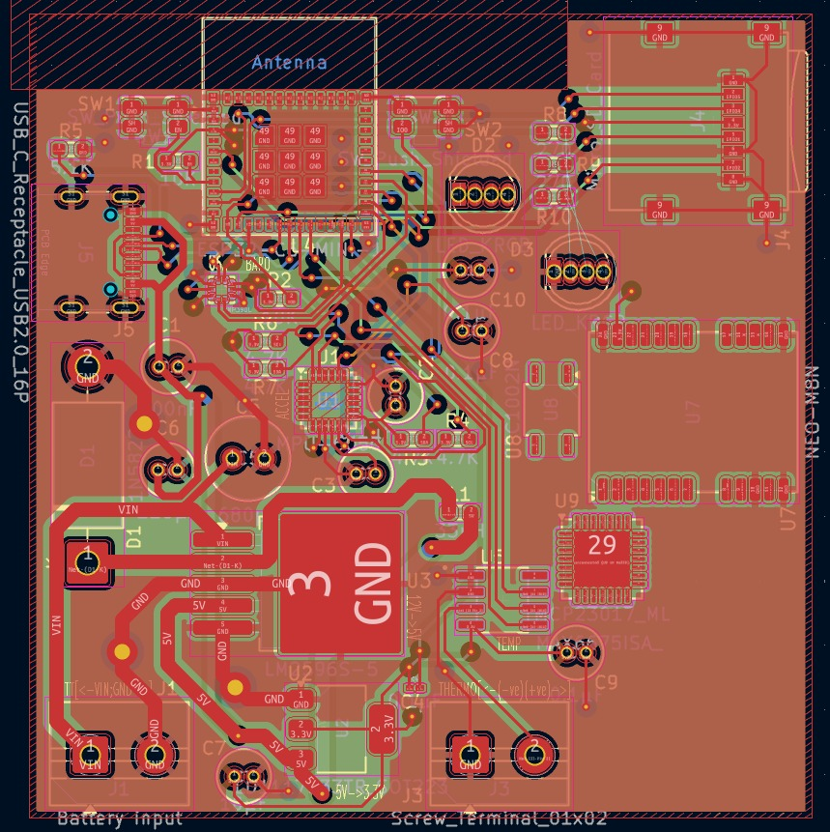

Rev 4 — Transition to 4-layer board with ground planes
Rev 4 was a major architectural upgrade. The board was redesigned from scratch on a 4-layer stackup, with Layer 2 reserved as a continuous ground reference. Power delivery efficiency improved to approximately 66%, with trace widths correctly sized for current draw.
- Ground planes introduced for the first time.
- USB-C added for firmware debugging.
- SD card slot, TVS diode on input power rail, screw terminals for battery and temperature sensors.
- GPS module, status LEDs, ESP32 boot and reset buttons, barometer — all added and routed.
- SMD resistors used for the first time (THT electrolytic caps still in use).
- Varied via sizes introduced.
Datasheets read for the first time — a turning point in design methodology.
This revision was reviewed in a 1-hour session with an industry professional. I presented for approximately 10 minutes; the reviewer spent the remaining 50 minutes critiquing the board in detail. The recurring issue: component configurations had been copied directly from datasheet application circuits without understanding why. The board was subsequently scrapped due to improper via placement, poor routing, and excessive vias on high-speed signal lines.

Rev 5 — Early November 2025
Focus: Full SMD transition, RF module, 90%+ PSU efficiency
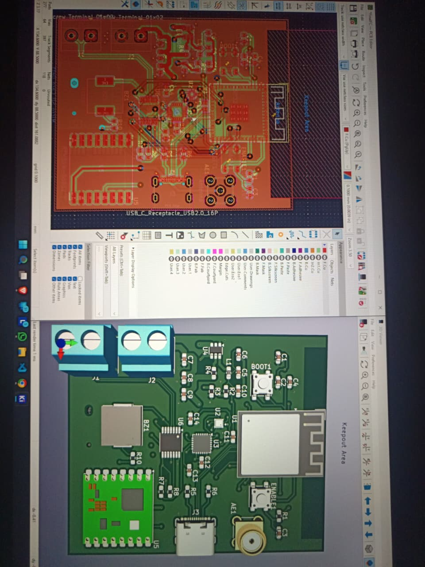

Rev 5 — Full SMD component migration
Rev 5 completed the migration to fully surface-mount components. A high-efficiency switching power supply was implemented, achieving over 90% conversion efficiency. RF communication was added via an SMA connector and RF module.
- 3D models downloaded and imported for all components in KiCad.
- Buzzer added for audio feedback.
- SD card and GPS modules relocated to the PCB back side.
- USB differential pair routed with controlled impedance for the first time.
- Board symmetry introduced for aesthetic and mechanical balance.
- IMU placed as close to the geometric centre of the board as possible.
Scrapped due to overly small board dimensions making routing impractical. Via placement remained poor and power delivery geometry was not reliable.

Rev 6 — November 2025
Focus: Pyro channels, dual antenna connectors, RGB status LED
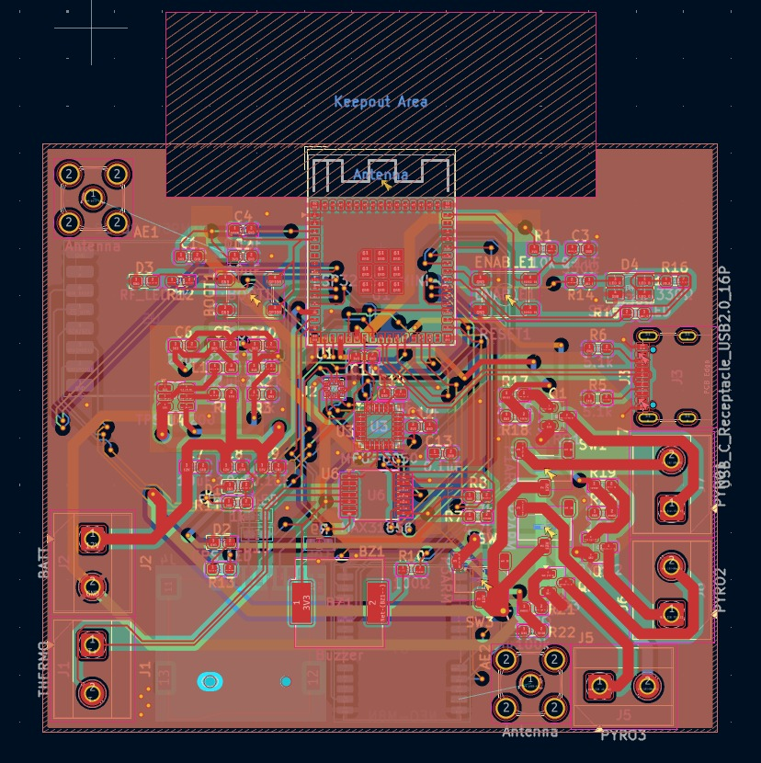
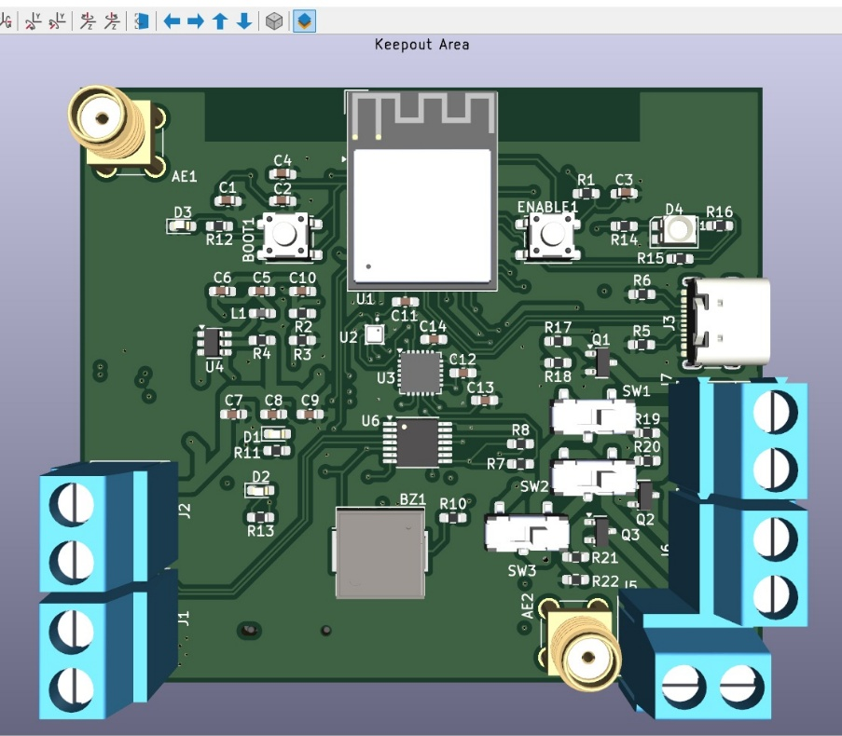
Rev 6 — First revision with pyro firing channels
Rev 6 introduced pyrotechnic (e-match) firing capability — the core requirement for apogee detection and parachute deployment. Three independent pyro channels were added, each with dedicated switching circuitry.
- Dual SMA antenna connectors: RF towards top edge, GPS towards bottom edge.
- Manual arming switches added for range safety compliance.
- RGB LED for multi-state system status indication.
- Discrete power, RF lock, and GPS lock LEDs added.
Scrapped due to poor grounding strategy and incorrect via placement throughout.

Rev 7 — Early November 2025
Focus: Impedance matching, local power pours, U.FL connector
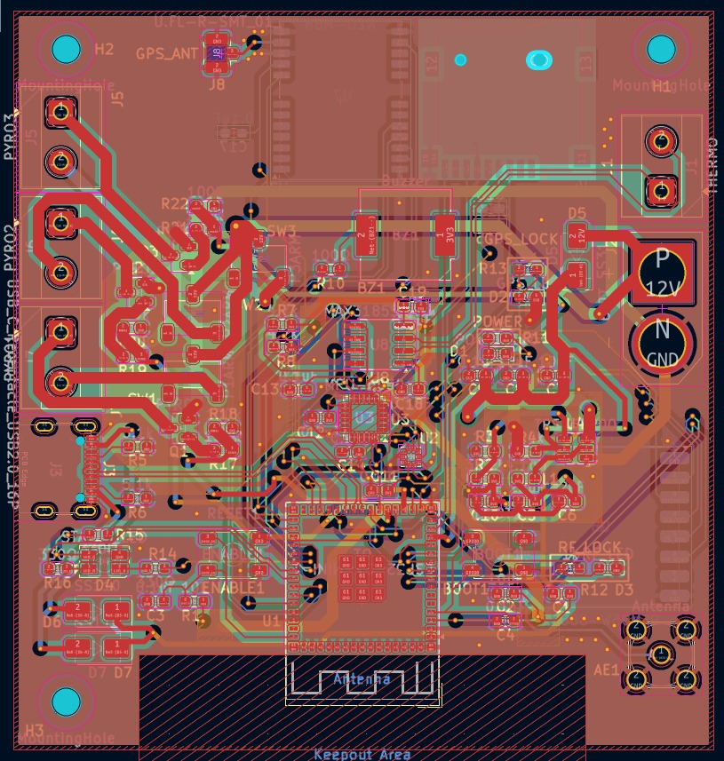
Rev 7 — Impedance-matched RF and GPS traces
Rev 7 was a refinement of the Rev 6 topology. Board orientation was flipped so the RF antenna connector faces downward and the GPS antenna connector faces upward — matching physical installation in the rocket airframe.
- TVS protection diodes added on USB-C VBUS lines.
- Local 3.3 V copper pours introduced, connected by wide traces for noise isolation between power domains.
- Three mounting holes added.
- Impedance calculations performed for GPS and RF traces for the first time.
- GPS SMA replaced with U.FL connector for reduced height profile.
- Pyro switching topology corrected.
- Stitching vias added around RF and GPS keepout zones.
- SDIO bus traces length-matched for the first time.
Scrapped: pyro switching and DC-DC converter domains were on opposite sides of the board, creating long return current paths through noise-sensitive sensor regions. Reliable sensor operation could not be guaranteed.

Rev 8 (Early) — Mid November 2025
Focus: First fully functional design
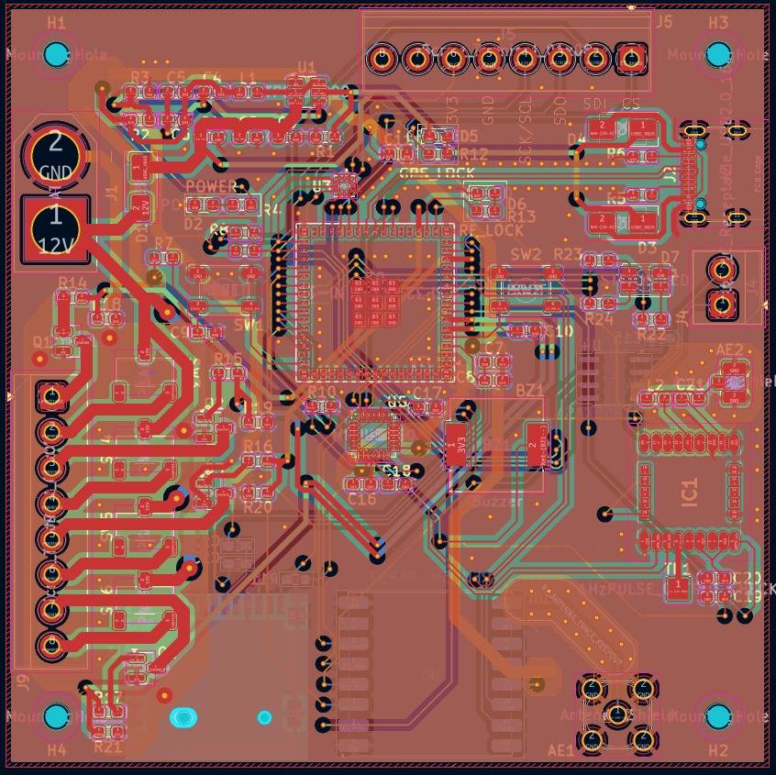
Rev 8 (Early) — First functionally complete layout
Rev 8 Early was the first revision considered functionally viable. All previous critical issues were addressed: via placement was clean, impedance calculations were applied to GPS, RF, and USB differential pairs, and dedicated ground pours were placed under pyro channels to minimise return loop area.
- Four mounting holes for M3 hardware.
- Fourth pyro channel added for redundancy.
- 1×08 connectors replaced 1×02 for improved structural stability during mating.
- XT60 connector for battery interface.
- SPI expansion port (screw terminal) for a BMP288 daughterboard planned for nose cone differential pressure measurements.
- Thermal relief vias added under the ESP32 module.
- Dedicated RF and GPS ground keepouts with via stitching.
Numerous small errors remained — this revision was retained as a checkpoint rather than a release candidate.

Rev 8 (Late) — Late November 2025 to January 2026
Focus: Failure-mode analysis, test infrastructure, near-final layout
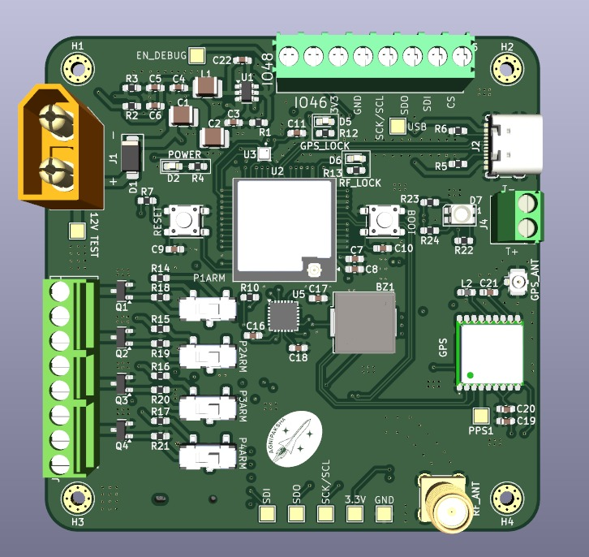
Rev 8 (Late) — Near-production layout
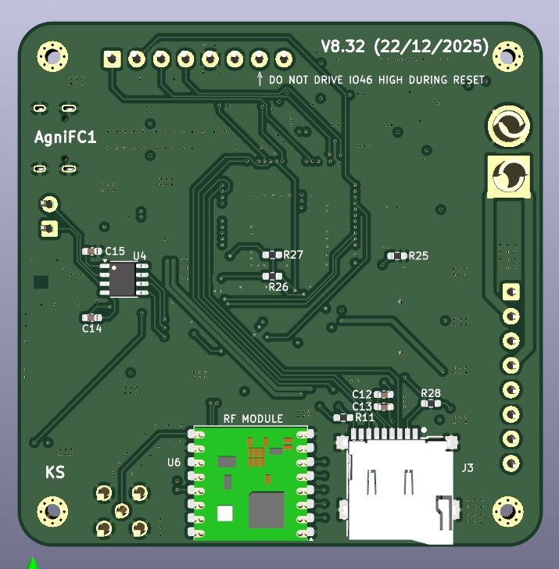
Rev 8 (Late) — 3D render
Rev 8 Late represented the first design where full confidence in functionality was achieved. All major issues from earlier revisions were resolved. Failure modes were systematically simulated, including subtle cross-coupling scenarios:
- RF reset trace proximity to the I²C SDA line — sharp switching edges on SDA could have coupled into the reset line, invalidating the entire RF subsystem.
- RF chip select proximity to the RF reset line — CS toggling (active HIGH) could have induced minor coupling into the reset trace, causing intermittent RF lock failures or poor downlink quality.
Additional improvements in this revision:
- Team/project logo added to silkscreen.
- Annular ring M.2-style screw mounting holes added.
- Test pads added at all critical nodes.
- Pyro circuitry revised for improved reliability.
- USB TVS diodes removed following mathematical proof they were unnecessary.
- All voltage/current ratings and brownout thresholds verified.
The schematic was finalised at this revision. Rev 9 and Rev 10 focused entirely on layout optimisation.

Rev 9 — January 2026
Focus: Multi-domain ground architecture, L2 reference plane
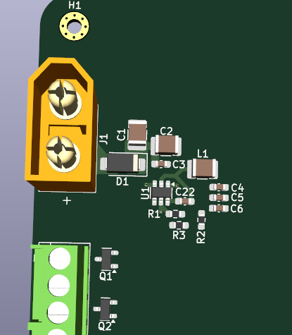
Rev 9 — Compact power tree with split ground domains
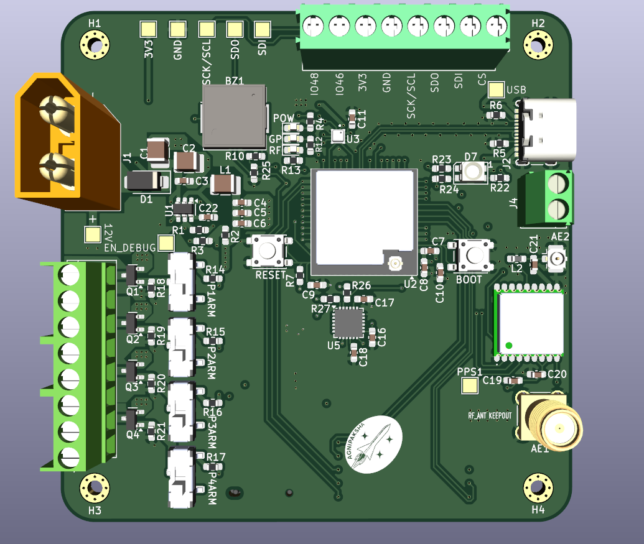
Rev 9 — Top copper layer
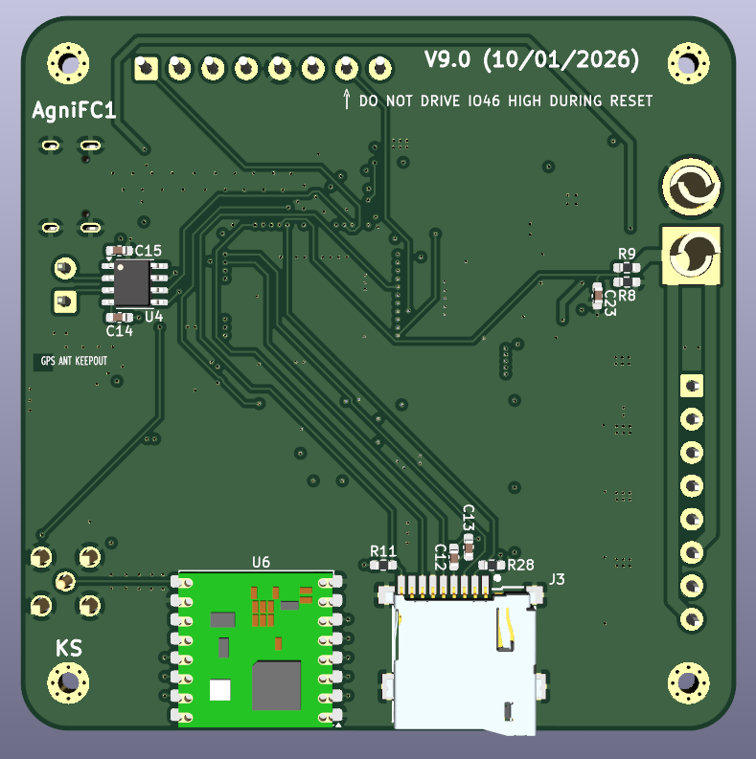
Rev 9 — 3D render
Rev 9 introduced a rigorous multi-domain ground separation strategy. Separate copper pours were defined for analog, digital, pyro, and RF domains on L1/L3. All domain grounds converge onto the L2 continuous ground plane, providing a low-impedance return path for all signals while preventing noise from one domain coupling into another.
- Analog, digital, and pyro ground pours separated on signal layers.
- L2 maintained as an unbroken common reference — no splits or slots.
- Return loops significantly reduced across all domains.
- Board clutter visibly reduced compared to Rev 8 (Late).
A load cell amplifier was considered for integration to support test stand measurements. Analysis concluded the additional noise floor and complexity would degrade overall system performance. This function was deferred to a separate dedicated board.

Rev 10 — February 2026 (Final)
Focus: Gate drivers, USB–UART, ESD protection, industry-grade passive placement
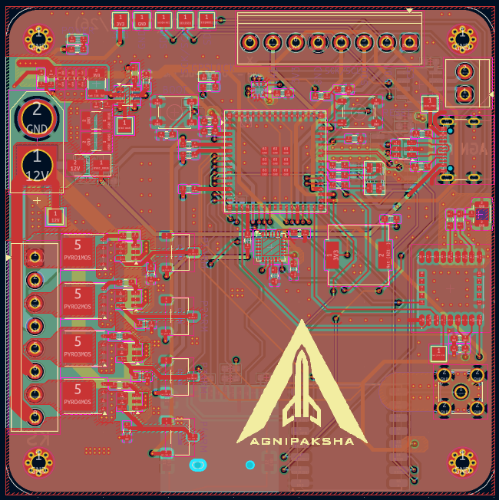
Rev 10 — Final board top layer
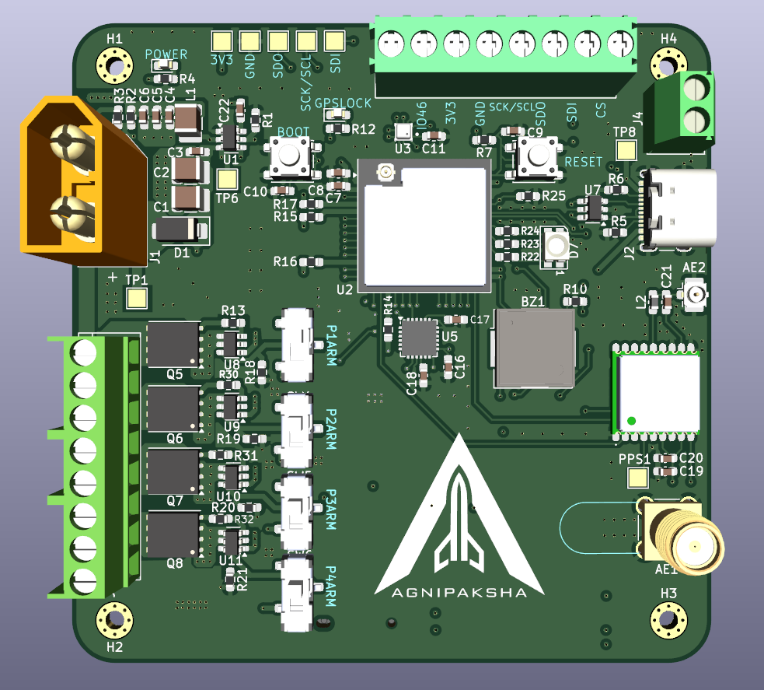
Rev 10 — Final board 3D render (top)
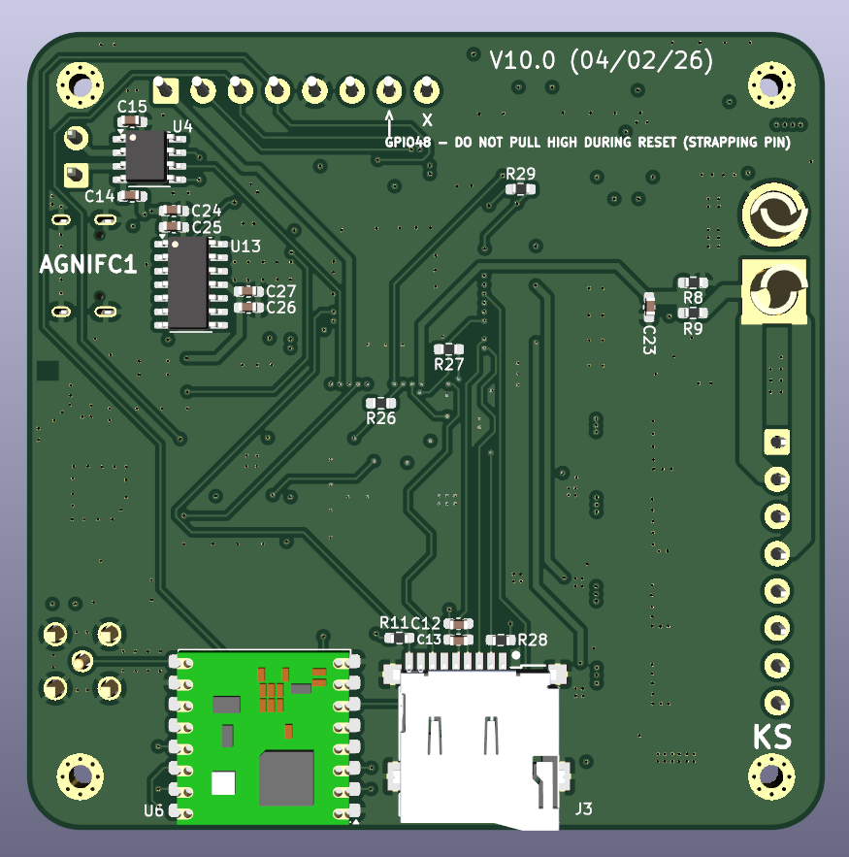
Rev 10 — Final board 3D render (bottom)
Rev 10 is the production-ready final revision. All design decisions are deliberate, calculated, and verified. The board is ready for fabrication and assembly.
Key improvements over Rev 9
- Pyro firing logic corrected — gate driver ICs now drive MOSFET gates for reliable, fast switching with proper shoot-through protection.
- MOSFETs upgraded to devices correctly rated for rocket staging, parachute deployment, and motor ignition currents.
- Crystal-free USB–UART bridge IC added for more robust and deterministic ESP32 flashing.
- UCBLC6 ESD protection IC added on USB data lines to protect against electrostatic discharge during hot-plugging.
- Length matching applied with tighter tolerances across SPI and SDIO buses.
- Trace widths on pyro and SPI buses increased to match current and EMI requirements.
- Decoupling and bypass capacitors placed with sub-millimetre proximity to IC supply pins — parasitic inductance minimised.
- RF lock LED removed (redundant given RF status reporting over UART).
- Ground split refined: digital, analog, power, pyro, and RF domains each isolated, all feeding L2 for a single low-impedance return reference.
- Power domain layout tightened around the battery input connector.
- All noise domains physically contained — no inter-domain coupling paths remain.
The final design is a complete, independent avionics platform: flight computer, test stand controller, and ground station in a single unified PCB.

Reflections
The progression from Rev 1 to Rev 10 represents a complete self-taught curriculum in PCB design — from basic footprint placement through signal integrity, power delivery architecture, and failure-mode analysis.
What the revisions taught
- Read datasheets end-to-end before designing — application circuits are starting points, not final answers.
- Manufacturer and peer feedback accelerates learning exponentially more than self-review alone.
- Ground architecture is the single most impactful design decision on a mixed-signal board.
- Impedance control and length matching are non-negotiable on any board with RF or high-speed digital signals.
- Every scrapped revision taught more than a revision that "worked".
Ten revisions. Five months. One board ready to fly.

