Input Output
Lecture example
1. Complete given table
Total inputs are always equal to total outputs. And total outputs are always equal to total input.
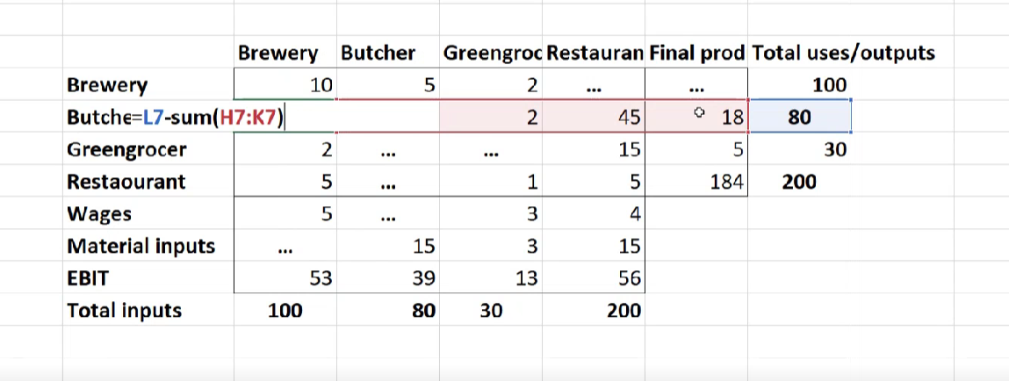
Then we are looking for a row where only one value missing and finding this value.
2. Build A matrix
Divide each value in each column in A(before Wages, where total outputs ends) by its total Input. For example, 5(butcher column) will be divided by 80(total input of butcher column).
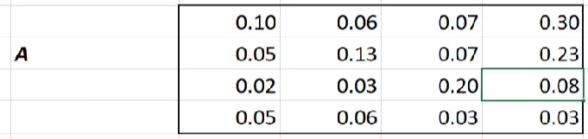
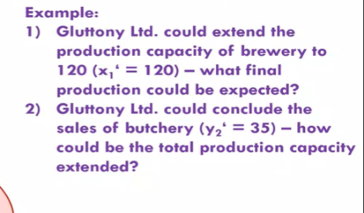
Figure 1. Coefficient Matrix A
3. Build I matrix. Always similar to lower one
1 0 0
0 1 0
0 0 1
4. Build (I-A) matrix.
5. Build new x (x – total input, total output, let’s say in task given new x1 = 120.) or new y (final uses/production, let’s say new y3 = 50)
6. New y (usually in task given new x, therefore you need to find new y)
(I-A) matrix * new x matrix
7. New x (usually in task given new y, therefore you need to find new x)
7.1 Inverse matrix (I-A)^-1
7.2 (I-A)^-1 matrix * new y
Linear programming / Simplex
Must be some kind of result of simplex. Should be something like this:
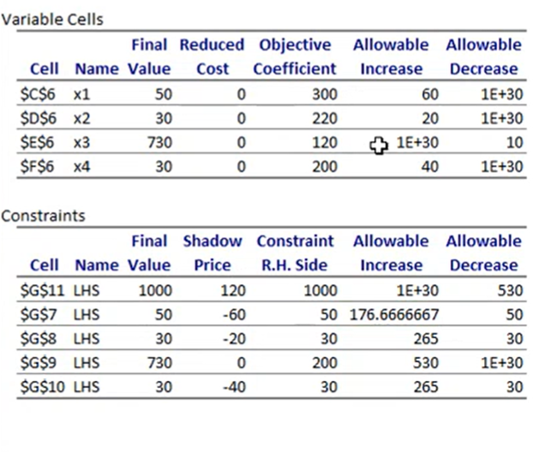
Question like what will happen if something to change?
If changing coefficients for the basic variable (top of matrix) or right hand side (RHS) inside the interval, the basis will remain same, but objective function coefficient will change (Z).
Changes in the right-hand side change the solution.
If basis variables inside the interval, the basis will not change. If it is outside of the interval, the basis will change.
Example: The objective function coefficient was 220. The profit looks like it will be 250.
Answer: The basis will change(I guess because allowable increase is 20)

1. Simulation, Monte Carlo
1.1 What is simulation?
Simulation is the imitation of the system or real-world process with goal to evaluate the system performance and improve it.
1.2 Types of simulations
Static vs Dynamic
Static simulation model simulates a system or problem at a single point of time without changes over time. Dynamic simulation, on the other hand, models changes over time.
Stochastics vs Deterministic
Stochastics involves randomness or uncertainty, it means that result of simulation will vary each time it runs. Deterministic, on the other hand, is predictable, meaning same inputs and conditions will always lead to same output
Discrete-event and Continuous simulations
A discrete simulation models a system in which events occurs at discrete points. In contrast, continuous simulations models a system in which changes occur continuously over a time
1.3 Monte Carlo simulation
Static and stochastics simulations are usually referred as Monte Carlo simulation. Monte Carlo is a method of solving problems using randomness. It involves generating lots of random numbers to simulate a problem or system.
2. Markov Chain
Markov chain is a mathematical model that describes a system moving from one state to another and it depends only on the current state and not on previous states. In other words, Markov Chains is a memoryless process where the future state only depends on the current state.
Properties of Markov chains:
Memorylessness – the probability of moving to another state depends only on the current state.
Homogeneity – The probability of moving from one state to another do not change as the chain progress.
A Markov Chain is categorized by a set of states, where each state represents possible condition or outcome of the system being modelized.
The Markov chain moves from one state to another according to a transition matrix.
3. System science, system theory, hard x soft thinking
What is a System?
System is a group of elements and relations between these elements.
Complex system.
Complex system is a system that is composed of multiple interacting elements, where the behavior of the system as a whole can’t be explained only by understanding the behavior of each its individual parts
Components of Complex system:
1. Self-organization. Complex system has an ability to organize itself without external control.
2. Emergence. Behavior of system as whole cannot be fully predicted from the behavior of its individual parts.
3. Nonlinearity. Small changes in one part of the system can have a significant effect on the system as whole.
4. Adaptation. Complex system can change its behavior or structure in response to changing conditions.
5. Feedback loops
System classification:
Closed. Closed system doesn’t need to interact with the environment to maintain its existence. Example: atoms, molecules
Open. Open system should interact with environment to maintain its existence. Example: people
System thinking
System thinking is a way of understanding and analyzing complex systems and how they work as a whole. Instead of just looking at individual parts of a system, system thinking looks on how they interact with each other to create the system. By doing this, we can understand how changes in one part of the system can lead to changes in another part of the system, and how the system can change and adapt over time.

Soft systems thinking | Hard system thinking
Oriented to learning | Oriented to goal seeking.
Assumes that world is complex and problematic but can be explored using system models. | Assumes that world has systems that can be engineered.
Assumes that system models are intellectual constructs (epistemology-based) | Assumes that system models is are models of the world (ontology-based)
Speaks of “issues” and “accommodations” | Speaks of “problems” and “solutions”
Advantage: Available to both problems owners and experts who can help. It stays connected to the personal aspect of a problem. | Advantage: Allows the use of powerful techniques.
Disadvantage: Does not produce final answers. Accepts that process of asking questions and learning new things never stops. | Disadvantage: Requires professional experts. Sometimes it can focus too much on logical aspects and ignore other important aspects.

4. Linear programming
Linear programming is a mathematical method to make the most of available resources to achieve a desired outcome, while taking into account the restrictions and limitations. So, we can say, that linear programming seeks to maximize or minimize a linear objective function
5. Input/Output
Input-Output (IO) is a modeling technique used to analyze the relationships between different sectors of an economy. The basic idea of IO is that every sector of economy is both a supplier and consumer of goods and services.
In IO each sector is represented by a matrix that shows the inputs and outputs of a sector.
5. Model, stochastic process
A model is simplified version of a real-world process or system, which is created in order to help understand, analyze, and optimize the system or process. Why? Sometimes it is impossible to experiment with original object (social experiment). Also it is cheaper, faster and reproducible.
Types of models:
Normative X Descriptive
Normative models describe what should be done, while descriptive models describe what is actually being done. Normative models are used to evaluate the best course of actions based on a set of criteria, while descriptive models are used to describe the behavior of a system or process without any judgments.
Static X Dynamic
Static models describe a system or process at a specific point of time, whereas dynamic accounts for changing over time.
Deterministic X Stochastics
Determinists model assumes that all variables are known and can be precisely determined, whereas stochastics models accounts for randomness and uncertainty in the system or process being modeled. Deterministic models are usually used when all variables are known and can be defined with high degree of accuracy, while stochastics models are used to account for random factors that can influence the system or process

