Ansible is an open source tool which help you manage 3 tasks:
- Software installation: with ansible, you can automate your software installation into various servers and machine
- Server configuration: you can add, update existing or delete configuration of server
- Software deployment

Without ansible: usually to install or configure a server, you need to ssh to the machine or server and then execute some commands.
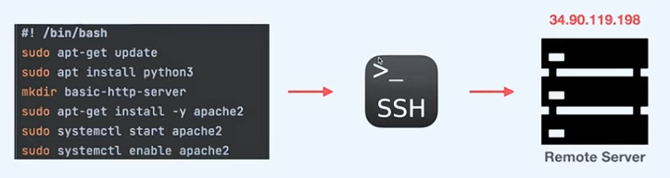

With ansible: We can write a playbook and automate all those steps. Here we automate ssh access and manually executing commands
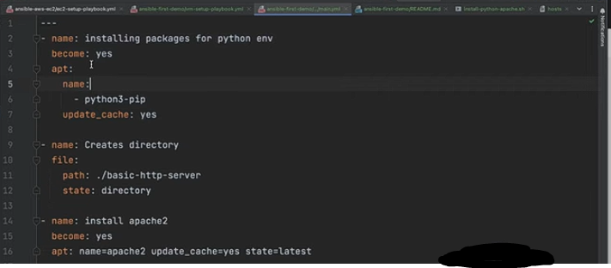

In the above playbook we have 3 tasks: install packages, creating directory and install apache2 server. Our playbook is self explanatory, so if someone read it, he knows what we are doing, in contrast to using commands directly, it is difficult to know from the beginning what is happening or what is the goal of the configuration.
1. Manual configuration (without ansible)
ssh -I /path/to/key sudowr@10.10.10.100
sudo apt update
sudo apt install python3
mkdir basic-http-server
sudo apt install -y apache2
sudo systemctl enable apache2
sudo systemctl status apache2
--
So this is the manual way, which is ssh to each machine and then execute one command at the time one by one.

2. Ansible playbook


With ansible we create a yaml file which is playbook and then we execute the following cmd:
Ansible-playbook -i ~/hosts my-playbook.yml
After executing this command, ansibe will look at the machines defined in the inventory file (~/hosts file), and then execute tasks in playbook in those machines
Now if we ssh into machines, we can see that python is installed and folder is created and also verify that apache2 is installed with systemctl status.
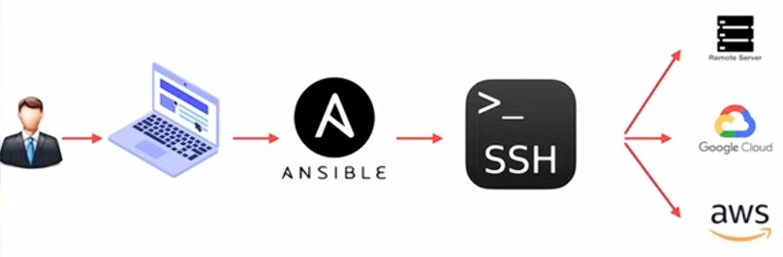
Why Ansible is called Agentless?

Here we have a developer with his machine have ansible installed and use it to manage remote server located either on premise, or in a cloud provider.
Please pay attention that ansible is always installed on the developer machine, not on targets
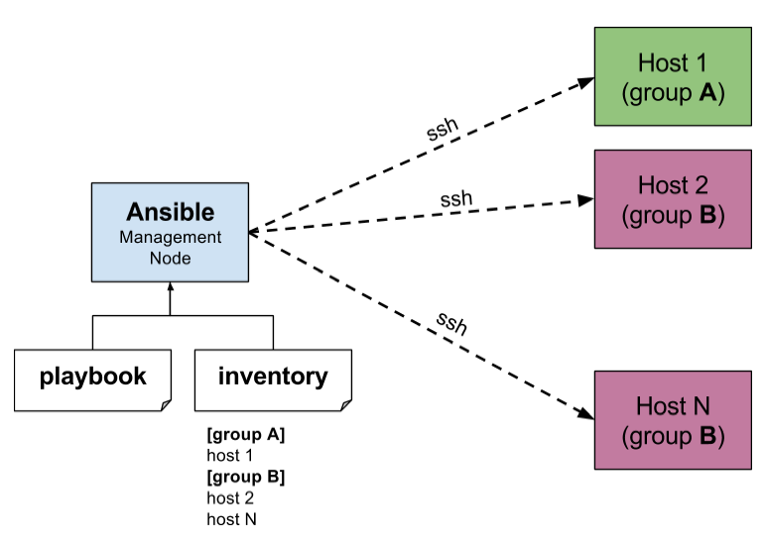
Ansible is called agentless because it does not require specialized client software, daemons, or agents to be installed on managed target nodes, unlike other automation tools. Instead, it uses standard SSH or WinRM connections to connect, push small modules, execute tasks, and then remove them.

How does Ansible works ?
You define the desired state of your
infrastructure in simple YAML-based
playbooks, which Ansible executes on
target machines listed in an inventory.

Key Concepts of How Ansible Works:
- Control Node: The machine where Ansible is installed. You run commands (like ansible or ansible-playbook) from here.
- Managed Nodes: The remote servers or network devices you are controlling. No software or "agent" needs to be installed on these machines.
- Inventory: A file (hosts.ini or hosts.yaml) that lists your servers, often grouped by role (e.g., [webservers]).
- Modules: Tiny, reusable scripts Ansible pushes to nodes to do work (e.g., installing a package, copying a file, restarting a service).
- Playbooks (YAML): A blueprint of automation. It tells Ansible which modules to run against which hosts to achieve a specific setup.
- Idempotency: A key feature where Ansible checks if the system is already in the desired state. If it is, Ansible does not make changes, making it safe to run the same playbook multiple times.

Install Ansible:
- lsb_release -a
- sudo apt update
- sudo apt install software-properties-common
- sudo apt-add-repository ppa:ansible/ansible # add ansible repo
- sudo apt update
- sudo apt install ansible
- ansible --version # check ansible is installed
Virtual machines setup for Ansible lab:
Please take a look at network-setup file to know how to setup the ansible lab on VMs.
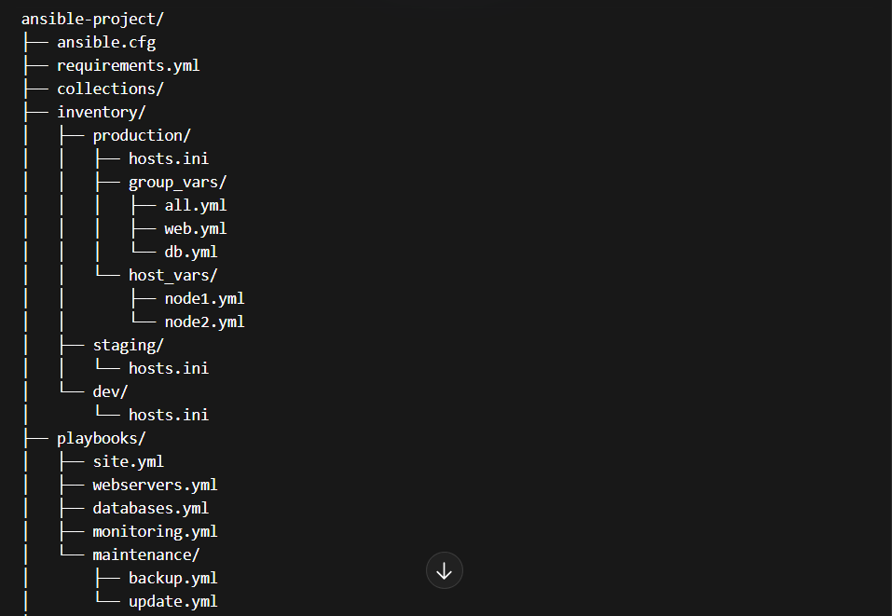
Ansible project structure: (complete folder structure)

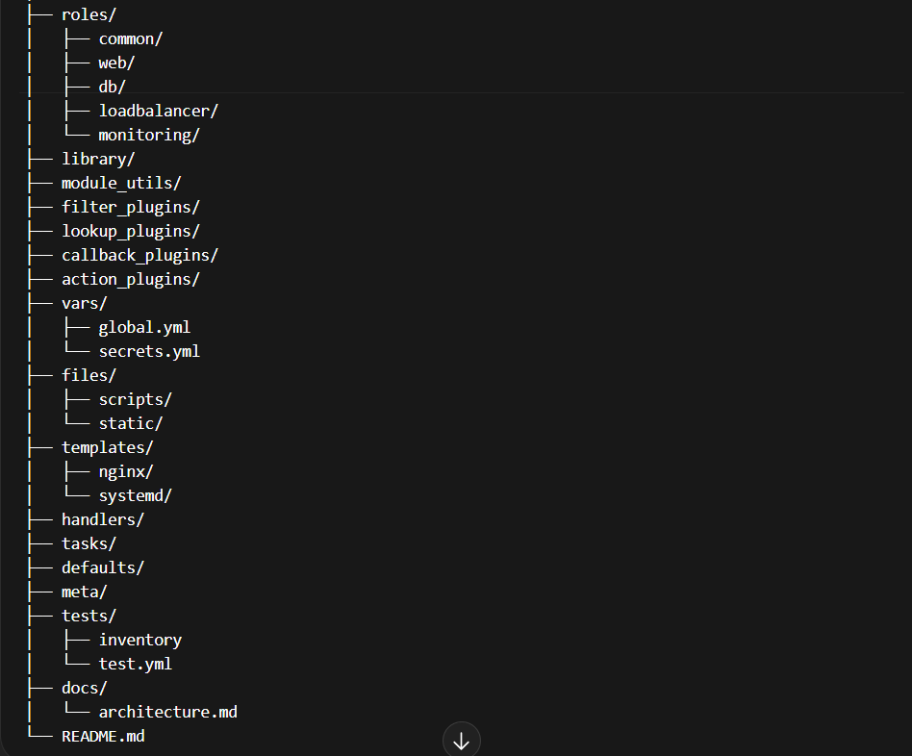
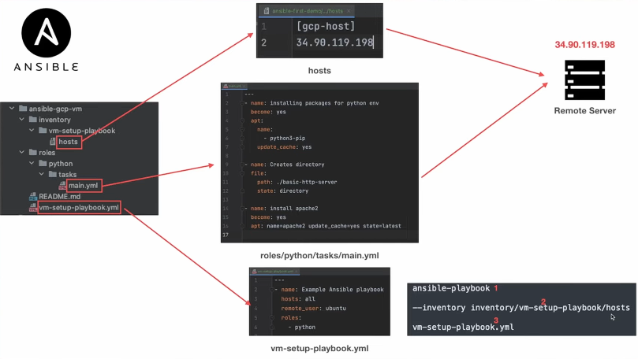
0
The ansible flow:

- Whenever we work with ansible, we need to create the hosts file, which has the target machines that ansible will configure and handle. The machines can be either ip addresses or domain names to them. (here in this example, it has only one machine)
- Roles and tasks: In the folder structure, we have roles folder, and we ave a role inside it called python. In ansible, a playbook can use/call multiple roles, and each role can have a task, here we have python role with a task that install python, create a directory and finally install apache2. (3 instructions within the python role task)
Once we execute the playbook, that particular task will be executed, then this 3 instructions will be passed to the server.
Then we have the playbook (vm-setup-playbook), which includes hosts (all), then we have remote_user which is the user ansible use in ssh (ubuntu), then we have roles: as a list of roles, in our example it is python.
To execute the playbook: ansible-playbook –inventory path/to/hosts-file playbook.yml
Then you can verify by ssh into the target machine specified in hosts and see if python3 is installed and the folder is created and if apache2 service is up and running.
===
How to use Public and Private Keys inside Ansible Playbook
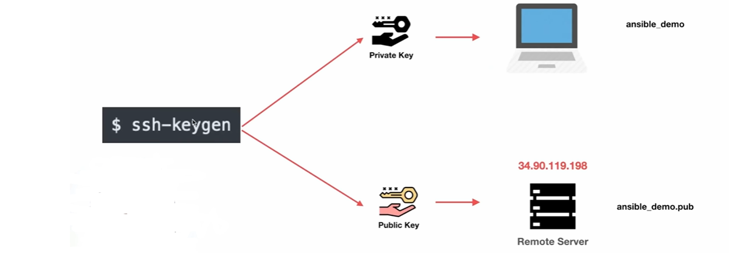
Whenever we talk about ssh keys, we talk about private and public keys, the private key remain private to our ansible playbook (local to you), and the public key will always go to the remote server.
1. Create keys: ssh-keygen
Now, ssh-keygen generates 2 keys: public and private keys, now we want to keep the private key in the control node, and then copy the public key into the remote server. To do that run:
ssh-copy-id -i /path/to/public-key <username>@<ip_addr>
The above command will ask for password of the user on the remote server
Now the public key is copied, now we want to associate our private key with the playbook
To do so, specify the path to the private key inside hosts file as following:

To test that all managed nodes are reached by managed nodes, you can do:
ansible all -i inventory.ini -m ping

YAML Basics In Ansible
Whenever you write yaml in ansible, pay attention to indentations
Always start the first line of your file with - - -
In the second line, you specify name, which describe what your task does
The second line (name) always start with dash (- name: domething)
Then specify module (example: file, apt, copy…)
After that, all remaining commands are sub lines of module
Example:
---
- name: Create the directory '/tmp/my_new_folder'
file:
path: /tmp/my_new_folder
state: directory

# whenever you work with file module, you need to specify the path where the dir will be created, and then state defines whether the fir is created or deleted.
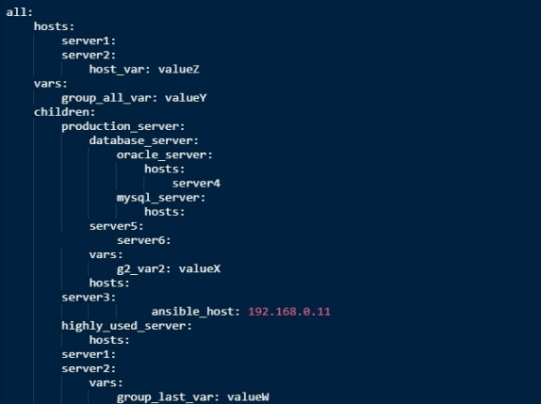
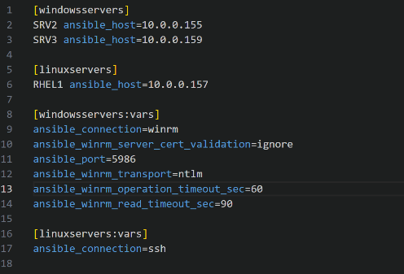
Also the playbook can have multiple tasks not just one.
Hosts can be a normal file, and
that file can exists with name
hosts or hosts.ini
But it can also be a yaml file
As showing in the right image
Always use meaningful names of hosts

Ansible Handlers:
Ansible handlers are tasks that run only when notified, usually for actions like restarting services. A handler is a task that does nothing by default and it runs only if another task reports “changed” and notifies it.
Example:
tasks:
- name: Update nginx config
template:
src: nginx.conf.j2
dest: /etc/nginx/nginx.conf
notify: restart nginx # this should match the name of handler

handlers:
- name: restart nginx
service:
name: nginx
state: restarted

What’s happening here ? If config changed → handler runs (nginx restarts), If config did not change → handler does NOT run
The idea is, whenever you want to execute something which is dependent on some task, then use ansible handlers to achieve it. Here in the example above, the dependent task is updating nginx config, and whenever that happens, we execute our handler which restart nginx to reflec the changes in configuration.
Please pay attention: handlers are not like playbook, they don’t contain hosts and become: true, it is a minimal code where you have the task you want it to be executed when notified.
The same thing for tasks, when you create aml for tasks, you only specify name and the module to work
You can have handlers specified in /handlers folder, and task to be specified in /tasks folder, then your task notify a handler, and ansible automatically by conventions will look for the handler in /handlers folder
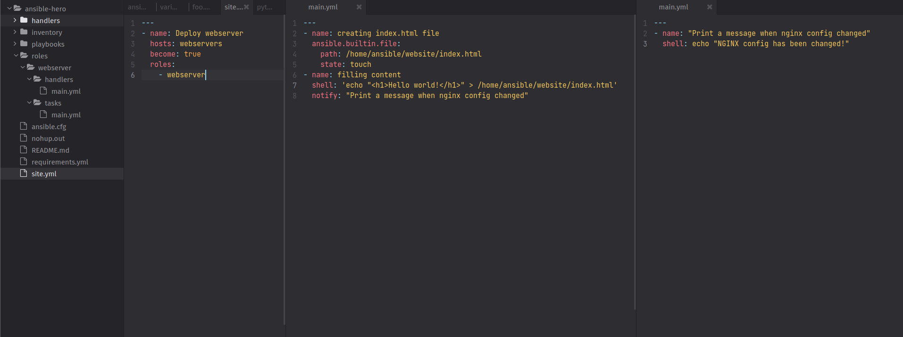

Ansible does NOT just blindly execute files. Instead, it follows this logic: see the explaination in the next page
Second task, notifies the handler to be executed
Handler

Ansible loads the role folder structure:
roles/webserver/
├── tasks/main.yml ← executed first
└── handlers/main.yml ← only executed if notified

Executes tasks/main.yml sequentially.
Example from your role:
- name: creating index.html file
ansible.builtin.file:
path: /home/ansible/website/index.html
state: touch

- name: filling content
shell: 'echo "<h1>Hello world!</h1>" > /home/ansible/website/index.html'
notify: "Print a message when nginx config changed"

Tasks run in order.
If a task uses notify, Ansible records it but does not run the handler immediately.
Once all tasks in the role are done, Ansible runs any handlers that were notified (like your "Print a message when nginx config changed").
!!!! Handlers are only executed once, even if multiple tasks notify them.

Ansible Variables:
Ansible variables are very similar to programming languages variables, where you store information. Variables used in playbooks to make the playbooks dynamic and flexible.
There are different types of variables including: playbook variables, runtime variables..
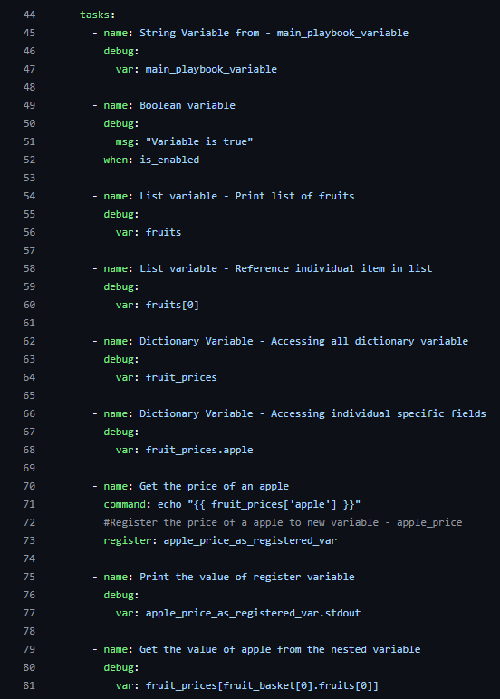
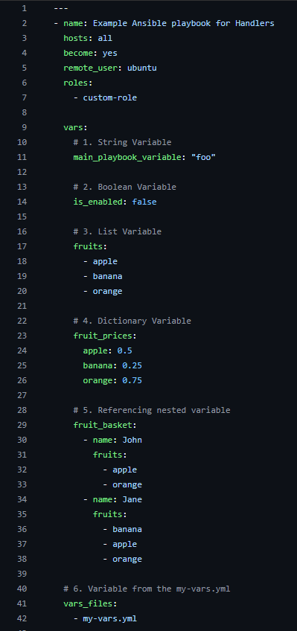
1. Playbook variables


Side note:
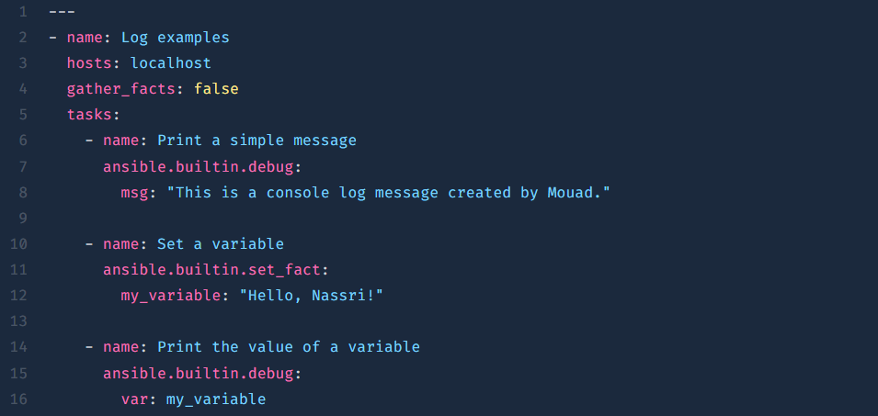
To console.log a message or content of a variable, using the debug module is the most straightforward way to print messages or variable values to the console during a playbook run. It accepts a msg parameter for custom text and a var parameter for displaying the contents of a variable

The variables yaml above notes:
= as we said, debug module is used to print out the variables content and messages.
= A variable can be a string, a Boolean, a list, a dictionary and you can also have nested variables.
= vars get declared in a playbbok under the vars key, andyou can reference them within the playbook.
= You can assign the content of a variable into another variable by printing the content of the first variable, then assign the stdout of the task into another variable using register as following:
tasks:
- name: Run a command and register the output
shell: "echo 'desired value'" # here get value of other variable or manipulate it somehow
register: command_output_var # The registered variable

- name: Display the full registered variable content
debug:
var: command_output_var

But there is a way to do it using set_fact which is more suitable (not sure of it)
= jinja2 filters: used to transform variable content like make it uppercase..
vars: cards.keys() | list | map('upper') | list
= variables can be also placed outside the playbook file in a separated variables file
-> for that we use: vars_files (we can have more than 1 vars file)
= so farm se see how to create variables inside playbook, then we see how to use variables that are outside the playbook inside a vars file, but there is also a way to pass variables at runtime. To do so we use an argument while running the playbook which is –extra-vars:
ansible-playbook pb.yaml –extra-vars ‘{foo: bar, baz: “long story”}’
You can also pass vars file as argument to your command so that the tasks can use its variables
ansible-playbook pb.yml –extra-vars “@playbooks/vars/foo.yml”
please notice that the path to vars file (foo.yml) should start from the position of your playbook
Variables precedence: (from highest to lowest)
1. Extra vars (-e) ← ALWAYS wins
2. Task vars (vars: inside a task)
3. Play vars (vars: in playbook)
4. vars_files
5. Host vars (host_vars/)
6. Group vars (group_vars/)
7. Role vars (roles/.../vars/)
8. Role defaults (roles/.../defaults/) ← weakest

Ansible Environment Variables:
When we talk about env vars, we talk about things like $PATH, $HOME, $USER..
Ansible make it possible to use those inside your playbooks, and it also provide a way to customize their values by defining environment section on your playbook and define your own env variables, and they can be specified to be in task level, or to be available into the entire playbook level.
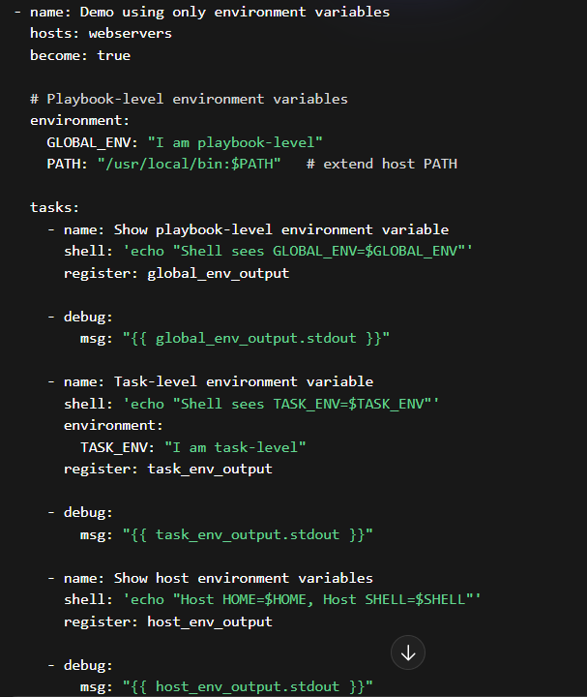
Example:

In the above code, we have two playbook environment vars which are accessible to all tasks within this playbook, and also we have env vars in each task. Note that environment variables declared in a task are only available in that task and cannot be accessed by other tasks.
- we use environments: to declare env vars in playbook
- we then define vars uppercased (like GLOBAL_VAR, and PATH)
- env vars are globally available to all tasks in the playbook
- to define env var specific to task, do it in task level under task indentation like TASK_VAR in second task
- to access the env variables, we use the $var_name to access his content
- if a task try to access a env var outside its scope it will get hard coded like $VAR_TEST instead of content
Ansible Conditional -- If/then/else:
Ansible has conditional just like normal if else in programming languages, but instead of using if, we have when condition. We can specify the condition in when in a task and decide whether this task is executed or not based on the when value; if true, then the task is executed, otherwise it will not be executed.
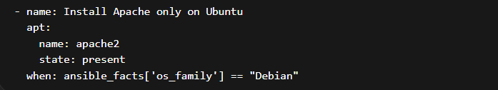

when: checks a condition. The task runs only if the condition is true. (ansible_facts are variables gathered automatically by Ansible about the host) but you can use normal variables in when condition.
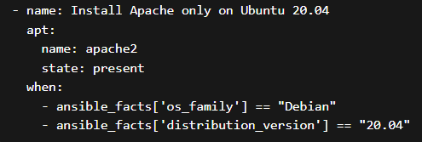
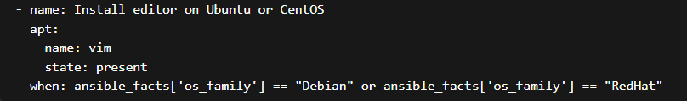
We can also have multiple conditions: wither by using list of conditions or by using or, in, and, not
The left example is using and, the example in the bottom uses or

Conditionals on variables:
In the following example, we have register the content of a file into a variable called my_output, and then we did some conditionals onto the content of that file.
If the file has hello string in its content then we console log Found hello!, then in the second task after registering, if hello string is not in the text file content then we print No hello found.
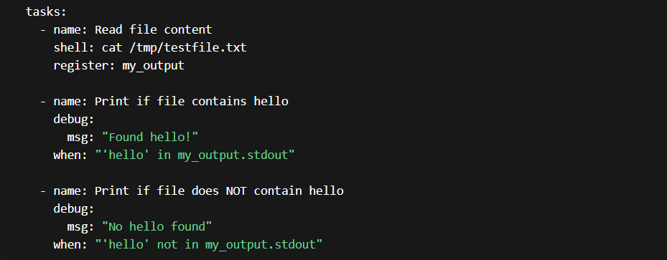

Conditional with loops:
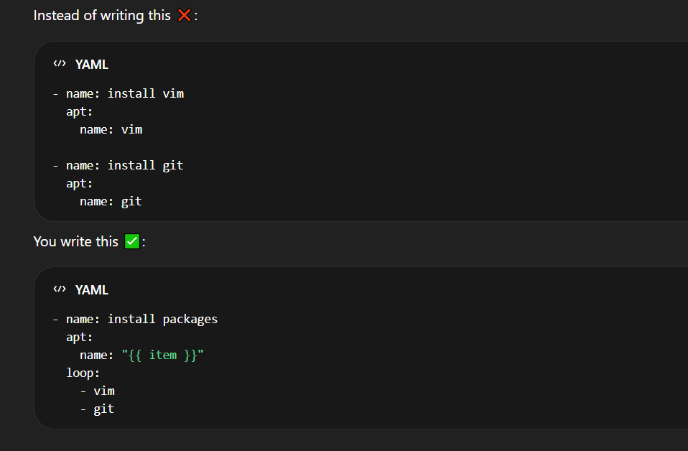
Ansible make it possible to have loops in your tasks by executing tasks multiple times and also put conditions based on the current item while looping just like loops in languages:

Ansible facts:
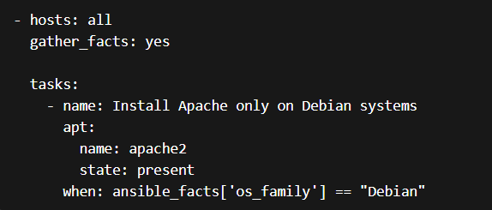
Conditions can also be applied on facts. ansible_facts are information about the target machine collected automatically by Ansible. Example along with a task to condition a value from it:
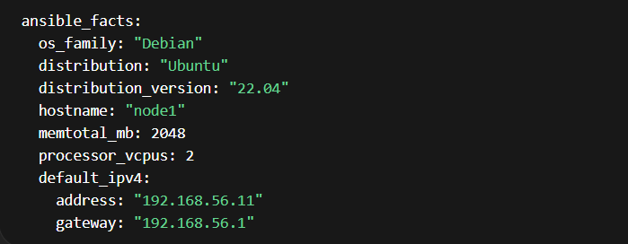

Ansible tasks and roles:
In Ansible, a task is the basic unit of work. It represents a single action performed on a managed node, such as installing a package or starting a service. A playbook is simply a list of tasks executed in order. For small automation, you can write tasks directly inside a playbook.
- hosts: all
become: true

tasks:
- name: Install nginx
apt:
name: nginx
state: present

- name: Start nginx
service:
name: nginx
state: started

For example, a playbook with a couple of tasks might look like this: ------------------------------------------------------------------------>>
Here, each task performs one clear action. This approach works well when the automation is simple, but it becomes hard to maintain as the project grows.
To solve this, Ansible introduces roles. A role is a way to organize tasks and related components into a reusable structure. Instead of writing everything in one playbook, you separate concerns into roles, each responsible for a specific function, such as configuring a web server.
A role follows a standard directory structure. At minimum, it contains a tasks directory with a main.yml file:
As your needs grow, you can extend the role by adding more directories. For example, handlers are used for actions like restarting services: ==================>
# Handler
- name: restart nginx
service:
name: nginx
state: restarted
roles/
nginx/
tasks/
main.yml
handlers/
main.yml
#roles/nginx/tasks/main.yml:
- name: Install nginx
apt:
name: nginx
state: present

- name: Start nginx
service:
name: nginx
state: started

And a task can notify that handler: ============================================>>>
- name: Update nginx config
copy:
src: nginx.conf
dest: /etc/nginx/nginx.conf
notify: restart nginx
This shows how roles group not only tasks, but also related logic such as handlers.
In practice, you do not write all tasks in the playbook. Instead, the playbook becomes very simple and just references roles:
- hosts: all
When this playbook runs, Ansible automatically executes the tasks defined in roles/nginx/tasks/main.yml.
become: true <===========
roles:
- nginx

- It is a standart practice to create main.yml file inside tasks folder, and in this main file, you define the tasks of your role.
How to use sub-tasks within your task
When your main.yml file grows, you can write your tasks In separate yaml files and then include them as a way of refactoring and splitting and separating concerns:
roles/
myrole/
tasks/
main.yml
install.yml
config.yml
# main.yml
- name: Include install tasks
include_tasks: install.yml

- name: Include config tasks
include_tasks: config.yml
# config.yml (sub-task)
- name: Copy config file
copy:
src: nginx.conf
dest: /etc/nginx/nginx.conf

- name: Start nginx
service:
name: nginx
state: started
# install.yml (sub-task)
- name: Install nginx
apt:
name: nginx
state: present

What happens during execution: Ansible runs:
- main.yml
- then includes install.yml → runs its tasks
- then includes config.yml → runs its tasks

So it’s like: main.yml → install.yml → config.yml
Key idea :main.yml = entry point, other .yml files = sub task files , include_tasks = how you call them
Why this is useful: Instead of one big file (100+ lines of tasks ❌),
You get: install.yml, config.yml, users.yml, service.yml; Much cleaner and easier to maintain.
! You can also use import_task, and here is the difference between import and include task:
- Import_task
import_tasks is static. This means the tasks are loaded and processed at playbook parsing time (before execution starts). Ansible reads the file and treats its content as if it were written directly in the playbook. Because of this, conditions (when) applied to import_tasks are evaluated early, and they affect all imported tasks as a group. Example:
In this case, Ansible decides at the beginning whether to include install.yml. If the condition is false, none of the tasks inside are even considered.
- name: Import tasks
import_tasks: install.yml
when: my_var == true
- include_task
include_tasks is dynamic. This means the file is loaded during execution, when Ansible reaches that line. Conditions are evaluated at runtime, and they can depend on variables that were set by previous tasks. Example:
- name: Include tasks
include_tasks: install.yml
when: my_var == true
Here, Ansible reaches this task during execution, checks the condition, and then decides whether to include and run the tasks.
Please note that you cannot import more than one task in the same task, so each task should do one and only one action. Also you cannot import a task and in the same task do something like using a module to do something else, the task that import or include a task should only do that.
A key practical difference is with loops and variables. include_tasks works well with loops and dynamic values:
- name: Include multiple task files
include_tasks: "{{ item }}"
loop:
- install.yml
- config.yml
This is not possible with import_tasks, because it is processed before execution and cannot loop dynamically.

In summary, import_tasks is static and resolved before execution, making it more predictable and slightly faster, while include_tasks is dynamic and resolved during execution, making it more flexible and suitable when you need conditions, loops, or runtime decisions.

Jinja2 Templates:
Jinja2 in Ansible is the templating language used to insert variables, apply logic, and generate dynamic values. You see it mainly inside {{ }} for expressions and {% %} for logic.
At its simplest, Jinja2 is just a way to replace variables inside text. For example, if you define a variable:
vars:
name: Mouad
You can use it like this:
- name: Print name
debug:
msg: "Hello {{ name }}" # Ansible will it as: Hello Mouad ({{}} interpolation syntax for insert variables)
Jinja2 template is a file with extension .j2 , example: myconfig.j2
For more complex logic, Jinja2 uses {% %} blocks, mostly inside templates (files in templates/).
In practice, you mostly use Jinja2 for:
- inserting variables
- formatting values with filters
- writing dynamic config files
To use a jinja2 template, first it has already some variables defined using interpolation syntax, and to use it you need to specify all variables that it needs like following:

# your role or playbook 2
- hosts: all
gather_facts: no

vars:
name: Mouad
site_name: MyWebsite

tasks:
- name: Generate index.html from template
template:
src: templates/index.html.j2
dest: /tmp/index.html
templates/index.html.j2 1
<html>
<body>
<h1>Hello {{ name }}</h1>
<p>Welcome to {{ site_name }}</p>
</body>
</html>

templates/index.html.j2 3
<html>
<body>
<h1>Hello {{ name }}</h1>
<p>Welcome to {{ site_name }}</p>
</body>
</html>

In jinja2 templates, you specify template keyword, then you specify the source src of your template, and then the destination where you want the parsed template to be located as dest, then you specify vars, which your template needs (the ones defined using interpolation).
Now that you have the jinja2 template, you can manipulate the vars by chaning them from one situation to other and the configuration transformed will reflext your changes.

Ansible deployment strategies:
1. Deployment Approaches: Single vs Multi-Machine
a) Single-Machine Deployment
- Definition: Updating or deploying an application on one server.
- Pros: Simple, easy to manage.
- Cons: Any error directly affects all users; downtime is usually visible.
- Example: A small website on a single VPS. When you restart the service to update files, users experience downtime.
Typical workflow on a single machine:
- Stop the service
- Deploy new code
- Restart the service
- Verify everything works
Impact on users: Users may experience temporary downtime during deployment.
b) Multi-Machine Deployment
- Definition: Deploying an application across multiple servers (web servers, app servers, database nodes).
- Pros: Can reduce downtime, provide load balancing, and allow rolling updates.
- Cons: More complex; requires orchestration to keep versions consistent.
- Example: A cluster of web servers behind a load balancer. You can update servers one at a time without affecting all users.
Impact on users: If deployed carefully, downtime can be minimized or zero. Some strategies allow users to continue interacting with the application while updates occur.

2. Deployment Strategies : Deployment strategies define how new code or configuration is released to servers.
a) Direct / Recreate Deployment
- Stop the service, deploy, restart service.
- Pros: Simple.
- Cons: Causes downtime; all users are affected simultaneously.
- Use case: Small apps or internal tools.

b) Rolling Deployment
- Update servers one at a time while others keep running.
- Pros: Reduces downtime; safer.
- Cons: Slightly slower; monitoring needed to ensure correctness.
- Impact on users: Only a fraction of users may temporarily hit an older version, but the service stays mostly available.

c) Blue-Green Deployment
- Maintain two identical environments: Blue (live) and Green (new version).
- Deploy new version to Green, then switch traffic to Green.
- Pros: Zero downtime; instant rollback possible.
- Cons: Needs double infrastructure.
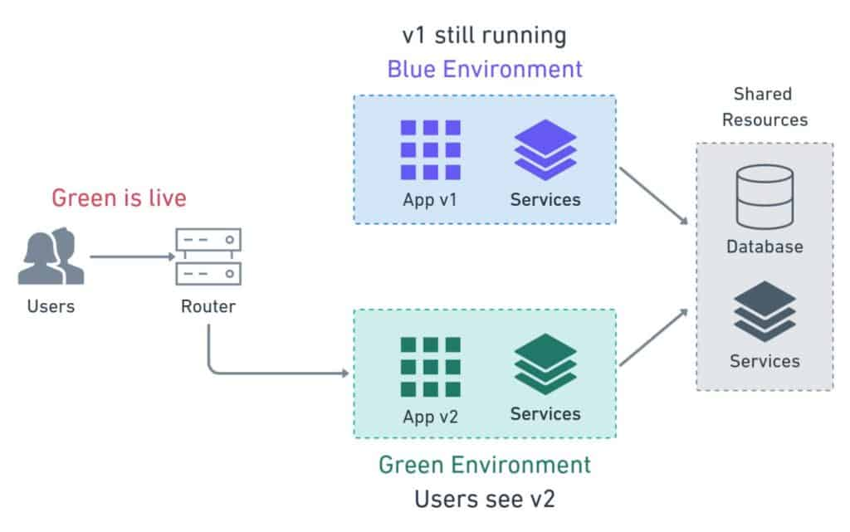
- Impact on users: Seamless; users usually don’t notice any downtime.
In ansible, we can achieve blue-green deployment by running our ansible playbook with limit option:
ansible-playbook -I /path/to/hosts playbook.yml –limit blue
after checking and monitoring and making sure everything is good, then run it for the green
ansible-playbook -I /path/to/hosts playbook.yml –limit green
Please notice that this method, only works when you have multi-servers cluster. In single-server, you only have one machine that serve the traffic and so you cannot implement any strategy to eliminate the downtime, and so you must manually stop services, do your deployment and then restart it. (Users may face some downtime)

d) Canary Deployment
- Deploy to a small subset of servers or users first.
- Monitor metrics and errors; if stable, deploy to the rest.
- Pros: Safe incremental release; risk is limited.
- Cons: Requires monitoring and careful orchestration.
- Impact on users: Some users see the new version first, which is intentional for testing; most users remain unaffected.
e) Feature Flags / A/B Testing
- Deploy code behind toggles so features can be activated per user group.
- Pros: No redeploy needed to enable/disable features.
- Cons: Adds complexity to codebase.
- Impact on users: Only selected users see the changes; allows testing new features safely.

Difference between blue-green and Rolling deployment strategies:

1. Rolling Deployment
- You update servers one at a time or in small batches.
- Old version and new version may coexist on different servers temporarily.
- Users might hit either version depending on which server they connect to.
- Pros: Reduces downtime, doesn’t need duplicate infrastructure.
- Cons: Some users may see inconsistent versions until all servers are updated.
2. Blue-Green Deployment
- You maintain two separate environments: Blue (current live) and Green (new version).
- Deploy the new version to Green while Blue serves all traffic.
- Once Green is ready, switch all traffic to it at once.
- Pros: Zero downtime, instant rollback by switching back to Blue.
- Cons: Requires double the infrastructure.

Rolling updates gradually replace servers, possibly mixing versions, while Blue-Green keeps old and new environments separate and switches traffic in one step for zero downtime.

Ansible Error Handling:
When running playbooks, tasks can fail for many reasons: A package fails to install, A service won’t start, a file doesn’t exist, network issues …
Without proper handling, a failure stops the playbook, which might leave your systems in an inconsistent state. Error handling allows you to control what happens on failure.
Common error handling tools in Ansible
a) ignore_errors
- Lets the playbook continue even if a task fails.
- Use case: A non-critical task, like cleaning up a temporary file.

- name: Delete temporary file
file:
path: /tmp/old_file
state: absent
ignore_errors: yes
b) failed_when
Customize what counts as failure: Useful when a cmd returns non-zero codes but it’s not actually an error.
- name: Check if service is running
command: systemctl is-active myservice
register: result
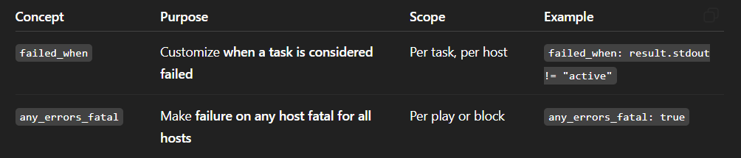
failed_when: result.stdout != "active"

c) any_errors_fatal
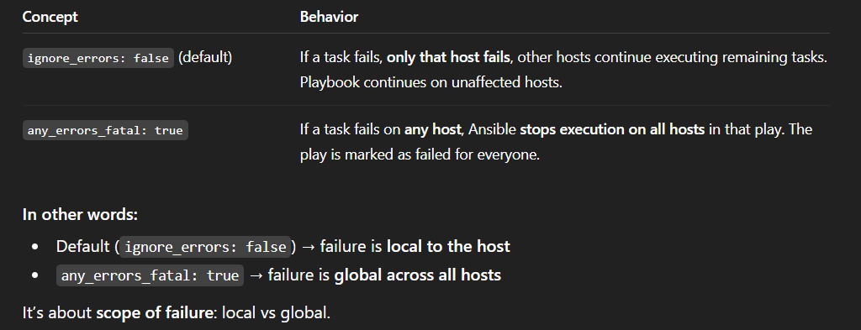
- hosts: webservers
become: true
any_errors_fatal: true #
tasks:
- name: Install nginx
apt:
name: nginx
state: present
- name: Start nginx
service:
name: nginx
state: started
Behavior: If nginx fails to install on one server, Ansible will stop execution on all other servers immediately. Useful for deployments where partial success could break the system. But please remember that if there are some tasks that ran successfully before failure, they will still be successful, and any_errors_fatal will only mark the remaining other tasks that are placed after the task that fails as failed.

d) changed_when
- Sometimes you want a task to not report as “changed” even if it runs.
- Useful in combination with error handling to avoid false alerts.
- name: Run custom script
command: ./script.sh
register: result
changed_when: false

e) block / rescue / always
- Blocks let you group tasks and define what happens if any task fails (rescue) or always runs (always).
- Similar to try/catch/finally in programming.
- Use case: Critical deployments where you want to handle failures gracefully and clean up resources.
- block:
- name: Install package
apt:
name: nginx
state: present
- name: Start service
service:
name: nginx
state: started
rescue:
- name: Notify admin if install fails
debug:
msg: "Nginx installation failed!"
always:
- name: Cleanup temporary files
file:
path: /tmp/temp_file
state: absent
f) retry / until
Retry a task until it succeeds (useful for network-dependent operations).
- name: Wait for web service to be ready
uri:
url: http://localhost
status_code: 200
register: result
retries: 5
delay: 10
until: result.status == 200
Use case: Waiting for a server, service, or database to become ready before continuing.

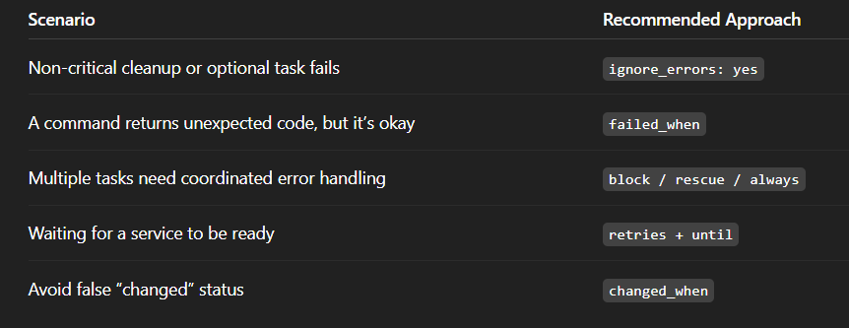

Ansible Vault:
Ansible Vault is used to encrypt sensitive data in your Ansible projects, such as passwords, API keys, or private variables. Instead of storing secrets in plain text, you protect them with encryption and a password.
Basic idea
Normally you might have: (in a yaml file) => db_password: mysecret123
With Vault, this becomes encrypted, so no one can read it without the password.

1. Create an encrypted file
ansible-vault create secrets.yml
You will be prompted for a password, then you can write:
db_user: admin
db_password: mysecret123
After saving, the file is encrypted.

To view the content, use view command: ansible-vault view groups_vars/secrets.yml
2. Use the encrypted file in a playbook
- hosts: all
vars_files:
- secrets.yml
tasks:
- name: Show username
debug:
msg: "{{ db_user }}"

Here you can get rid of vars_files, or when you are in tasks yml file where you don’t specify vars_files, in this case you can pass all variables in your secret at runtime using -e like following:
ansible-playbook site.yml -e '@group_vars/foo_vault.yml' --ask-vault-pass
3. Run the playbook
You must provide the vault password:
ansible-playbook playbook.yml --ask-vault-pass

4. Encrypt an existing file
ansible-vault encrypt secrets.yml

5. Decrypt a file
ansible-vault decrypt secrets.yml

6. Edit encrypted file
ansible-vault edit secrets.yml
This opens the file securely, then re-encrypts it when you save.

7. Change vault passowrd
ansible-vault rekey secrets.yml
This will asks for old and the new passowrds and confirm it.

8. Generate a long password and use it as vault passowrd
Create a secure passowrd
Openssl rand -base64 2048 > pass_file/ansible-vault.pass
Then we create a vault secured yaml with password specified as file we already created that has a long pass
ansible-vault create group_vars/secure_file.yml --vault-password-file pass_file/ansible-vault.pass
Then we can use the variables inside our secure file in our tasks like so:
- name: "View my encrypted long password from secure file"
debug:
var: password
Then, when running the playbook, you must specify the encrypted file as extra vars using -e option, and also specify the path to password so that he can decrypt it with it:
ansible-playbook site.yml -e '@group_vars/secure_file.yml' --vault-password-file=pass_file/ansible-vault.pass
!!!
Ansible can read the Vault password automatically from an environment variable.
Instead of passing --vault-password-file every time, you define a variable that tells Ansible:
“Use this file whenever you need to decrypt Vault data.”
This makes your commands cleaner and avoids repeating the password file path.

Command: export ANSIBLE_VAULT_PASSWORD_FILE=pass_file/ansible-vault.pass

Then just run : ansible-playbook site.yml -e '@group_vars/secure_file.yml'
No extra Vault options needed 👍

When to use Vault
- Storing passwords (database, SSH, APIs)
- Protecting private configuration
- Sharing code safely (e.g., pushing to Git)

Key idea
Vault lets you:
Write secrets normally → Encrypt them → Use them safely in playbooks

Best practices
- Never store plain-text secrets in your repo
- Use one secrets.yml or per-environment files
- Don’t hardcode vault passwords (use prompt or file)

