Bowling Alone, Scrolling Together:
In-Person Socialization, Social Isolation, and Volunteering
Across Five Generational Cohorts

Hosung You & Suzanna R. Windon
The Pennsylvania State University

Abstract
Social isolation has been declared a public health epidemic, yet its civic consequences remain underexamined. Using four waves of the Current Population Survey Civic Engagement and Volunteering Supplement (2017–2023; N = 201,168), this study combines survey-weighted logistic regression and latent profile analysis to examine whether in-person socialization predicts volunteering differently across five generational cohorts. Across all generations, the transition from no socialization to even occasional contact is associated with the largest marginal gain in volunteering probability (7–10 percentage points), a "First Step Effect" comparable in magnitude to the education gradient. Gen Z exhibits a paradox: the highest baseline volunteering probability at zero socialization yet a plateau beyond moderate socialization levels, a ceiling absent in older cohorts. These patterns predate COVID-19 and persist unchanged, establishing them as cohort characteristics. Education amplifies the socialization–volunteering gradient, but neither employment nor civic social media use alters the generational pattern. Over half of Gen Z occupies civic engagement profiles defined by social isolation. Findings suggest that declining youth volunteering reflects social disconnection rather than weakened civic motivation, with implications for low-threshold volunteer recruitment.
Keywords: volunteering, social isolation, civic engagement, generational differences, COVID-19, latent profile analysis, Current Population Survey

Introduction
In May 2023, the U.S. Surgeon General declared loneliness and social isolation a public health epidemic, documenting extensive consequences for mental health, physical well-being, and mortality (Office of the Surgeon General, 2023). Yet while the health effects of social disconnection have received considerable empirical attention, one domain remains underexamined: the civic consequences of social disconnection, and its effects on volunteering in specific. That omission is consequential. A quarter century after Putnam (2000) documented the broad decline of associational life in Bowling Alone, emerging evidence suggests that the decline in social connection has continued, and accelerated among younger cohorts, with potential implications for the civic infrastructure that depends on volunteerism.
The scale of the volunteering decline is substantial. Between 2005 and 2021, the U.S. formal volunteering rate fell from 28.8% to 23.2%, the lowest rate recorded since the Bureau of Labor Statistics began tracking the measure (AmeriCorps, 2022). Among 16-to-24-year-olds, the decline has been even steeper, falling by nearly a third from 26.4% to 17.4%. These declines have occurred despite expansions in national service programs, campus volunteer centers, and corporate volunteer initiatives. If supply-side interventions were sufficient, rates should have stabilized or increased. They did not. The barrier lies not in the availability of opportunities but in the social pathways through which individuals are recruited into them.
Twenge et al. (2019) documented that in-person social interaction among U.S. adolescents declined substantially between 2003 and 2017, a trend that predates the COVID-19 pandemic and thus cannot be attributed solely to lockdown-era disruptions. If social interaction drives civic recruitment, as both social capital theory (Putnam, 2000) and the civic voluntarism model (Verba et al., 1995) suggest, then generational declines in face-to-face socialization may be associated with lower volunteering rates in ways that existing interventions fail to address. The pathway from socialization to volunteering is not abstract: an acquaintance at a community event mentions that a local food bank needs Saturday morning help; a coworker invites a colleague to a park cleanup; a neighbor asks for company at a fundraising walk. These are the mundane, low-threshold encounters through which civic recruitment historically occurs, and they require physical co-presence.
Understanding the civic consequences of social isolation is particularly urgent for the volunteering sector. Unlike voting or charitable giving, organized volunteering requires sustained investment of time and coordination with others, making it especially dependent on social networks and in-person contact (Cacioppo & Cacioppo, 2014; Holt-Lunstad et al., 2010). Social connections reduce entry barriers by providing practical information and the social accompaniment that lowers the threshold for initial participation. Yet the empirical literature has treated social isolation primarily as a control variable rather than a central mechanism, and existing research on generational differences tends to rely on simple cohort comparisons without examining how the mechanisms driving volunteering may differ across generations. Wilson (2012) identified social networks as a consistent predictor of volunteering but noted that the field lacks a clear account of how network effects vary across demographic subgroups. The question is whether declining youth volunteering is better explained by changing values or by the weakening of the social connections that facilitate volunteering.
We address this gap using four waves of nationally representative CPS-CEV data (2017, 2019, 2021, 2023; N ≈ 201,000) to examine the association between in-person socialization frequency and volunteering across five generational cohorts. Two research questions guide the analysis, spanning variable-centered and person-centered approaches (see Purpose and Research Questions). By bracketing the COVID-19 pandemic, the four-wave design distinguishes stable cohort effects from pandemic-specific disruptions. The integrated approach, combining survey-weighted logistic regression and Latent Profile Analysis, extends the Surgeon General's health-focused framing to a civic engagement context, testing whether social isolation functions as a barrier to civic participation and whether this relationship operates differently across generations.
Literature Review
Social Capital and Civic Recruitment
Why does face-to-face contact predict civic participation? Social capital theory and the civic voluntarism model offer complementary answers. Putnam (2000) defined social capital as the networks, norms, and trust that enable coordination and cooperation among individuals. In his framework, face-to-face social interaction is more than a correlate of civic engagement; it is a generative mechanism. Repeated contact builds the trust and reciprocity norms that lower the costs of collective action. Granovetter's (1973) weak ties theory extends this insight by arguing that peripheral social contacts (acquaintances encountered through occasional socialization) serve as bridges to new information and opportunities, including awareness of volunteer organizations and direct recruitment appeals. The mechanism is as much motivational as informational: a personal request to volunteer from someone known face-to-face carries social weight that an impersonal announcement, whether posted on a bulletin board or shared on social media, does not. The CVM identifies such direct requests as the most proximate predictor of volunteering participation (Brady et al., 1995).
Verba et al.'s (1995) civic voluntarism model (CVM) identifies three categories of factors predicting civic participation: resources (time, money, civic skills), engagement (political interest, civic duty), and recruitment networks (Brady et al., 1995). Of these, the recruitment pathway matters most here: individuals who socialize more frequently are more likely to encounter direct requests to volunteer, which the CVM identifies as the most proximate predictor of participation. Coleman (1988) further emphasized that social capital is embedded in the structure of relationships: closed social networks with dense interconnections give rise to norms and sanctions that encourage prosocial behavior, including volunteering. Beyerlein and Hipp (2006) demonstrated empirically that organizational membership mediates much of the socialization–volunteering pathway, evidence that social contact promotes volunteering partly through institutional embeddedness rather than through social influence alone. The implication is that socialization may be a necessary but not sufficient condition for civic participation: frequent social contact that occurs outside institutionally anchored contexts may not generate the recruitment exposures that translate contact into voluntarism.
Generational Shifts in Socialization and Civic Participation
Situating these expectations against empirical reality requires confronting dramatic generational shifts in socialization patterns. Twenge et al. (2019) documented that in-person social interaction among U.S. adolescents declined by approximately 30% between 2003 and 2017, a trend driven primarily by the displacement of face-to-face contact by digital communication. By 2017, the average American teenager spent more than six hours per day on screen-based media; time spent with friends in person dropped to its lowest level since measurement began (Twenge, 2017). Twenge termed the post-1995 birth cohort "iGen" and documented widespread increases in loneliness, social isolation, and mental health challenges that emerged before, not as a consequence of, the COVID-19 pandemic. The result is a generation that came of age in an environment where social connection increasingly occurs through screens rather than in the shared physical spaces (Oldenburg's [1999] "third places") that historically served as incubators for civic recruitment.
Socialization shifts of this magnitude intersect with broader transformations in civic engagement documented by scholars of political participation. Zukin et al. (2006) identified generational differences in civic participation, with younger Americans more likely to engage in individualized political consumption (boycotting, "buycotting") and less likely to participate in traditional institutional forms such as voting and formal volunteerism. Dalton (2008) proposed that this represents not disengagement but a shift from "duty-based" to "engaged" citizenship, where younger cohorts pursue civic goals through informal, often digital, channels. However, Flanagan and Levine (2010) and Wray-Lake and Hart (2012) documented that these alternative forms of engagement have not compensated for declines in traditional civic participation, above all volunteering, among younger cohorts. If Dalton's "engaged citizenship" thesis were correct, if young people were simply channeling civic energy into new forms, aggregate civic participation should remain stable or rise even as traditional forms decline. It has not. The decline in formal volunteering among young adults has proceeded without a corresponding increase in measurable alternative engagement, which points to eroding civic infrastructure rather than shifting civic preferences as the more likely explanation.
Together, these perspectives generate competing predictions about the relationship between social isolation and volunteering across generations. If social capital theory is correct that face-to-face interaction is the primary mechanism through which civic recruitment occurs, then the dramatic decline in in-person socialization among Gen Z should produce a correspondingly large decline in volunteering, even after controlling for the traditional predictors emphasized by the CVM (education, income, civic skills). Alternatively, if digital communication has functionally replaced face-to-face contact as a recruitment channel, then the socialization–volunteering link should be weaker for digitally native cohorts.
Why Generation Z?
We focus on Gen Z (born after 1997) because it is the first generation to have entered adulthood entirely within a digitally mediated social environment, where the in-person settings that historically exposed young people to civic recruitment (after-school hangouts, religious youth groups, community events) have been partially displaced by screen-based interaction (Pew Research Center, 2018). CPS-CEV data consistently show that Gen Z reports the highest rates of minimal socialization, making this cohort a critical test case for whether online interaction can substitute for face-to-face contact in generating civic participation. Generation is operationalized as a moderating variable because generational membership captures shared formative experiences that shape how individuals relate to civic institutions (Hooghe, 2012; Kelle et al., 2025).
Education, Employment, and Civic Social Media
Education and employment are primary resource predictors of civic participation in the CVM framework (Verba et al., 1995; Wilson, 2012). However, whether these pathways operate with equal strength across generational cohorts has received limited attention. The resource model implicitly assumes that education and employment generate social contacts that serve as recruitment channels, an assumption that may be less reliable for Gen Z, whose social connections increasingly occur through digital rather than institutional channels (Schlozman et al., 2012; Musick & Wilson, 2008).
We also examine civic social media use as a potential moderator. Bennett and Segerberg's (2012) "connective action" framework and the "digital compensation" hypothesis (Norris, 2002) raise the possibility that online civic engagement could partially offset the volunteering deficit associated with social isolation, among digitally native cohorts especially.
Social Disconnection and Civic Consequences
In 2023, the Surgeon General's advisory noted that social isolation "undermines the social infrastructure on which democratic participation depends" (Office of the Surgeon General, 2023), a claim that has received limited empirical testing in the volunteering context. Cacioppo and Cacioppo (2014) provided a theoretical bridge: their model argues that perceived social isolation triggers a self-reinforcing cycle of social withdrawal, hypervigilance to social threat, and reduced interpersonal trust. In civic terms, the most isolated individuals are the least likely to encounter the recruitment appeals that social capital theory identifies as the primary mechanism for volunteering initiation. The prediction is nonlinear. Even small reductions in isolation may break the withdrawal cycle and yield disproportionate gains in civic participation, the "First Step Effect" hypothesis tested in this study.
Purpose and Research Questions
This study examines the association between in-person socialization frequency and volunteering across generational cohorts using four waves of nationally representative data from the Current Population Survey Civic Engagement and Volunteering Supplement (2017, 2019, 2021, 2023). We employ an integrated design that combines variable-centered regression and person-centered profiling to provide methodological triangulation. By spanning four waves that bracket the COVID-19 pandemic, this design allows us to distinguish structural cohort effects from pandemic-specific disruptions.

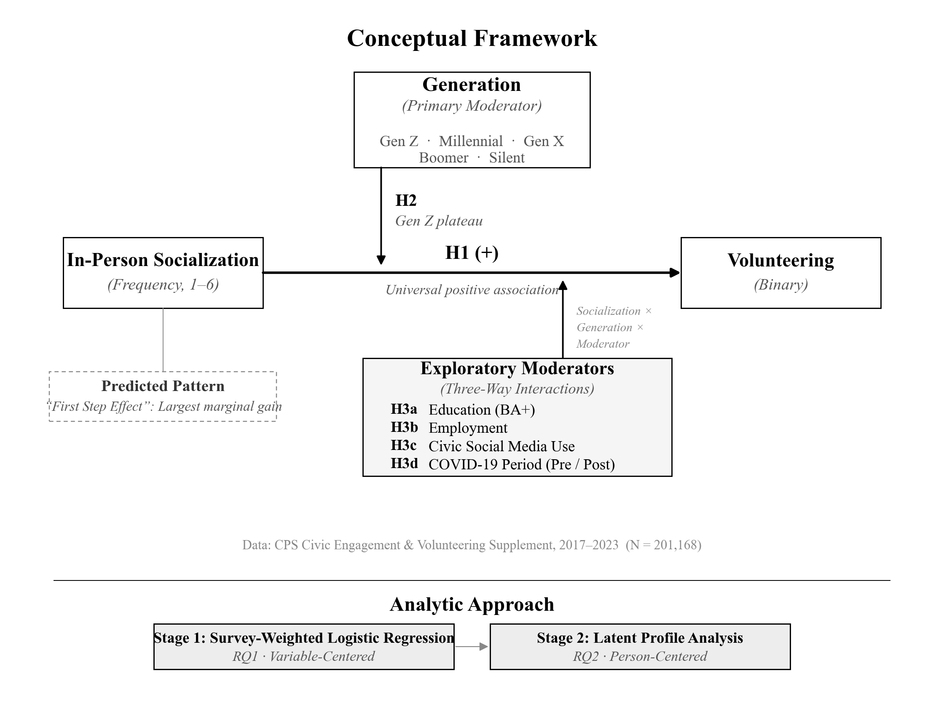
Figure 1. Conceptual framework. The primary relationship between in-person socialization (IV) and volunteering (DV) is moderated by generational cohort. Three-way interactions test whether education, employment, civic social media use, and the COVID-19 period further condition this relationship. Three analytic stages provide methodological triangulation.
The primary relationship of interest is the association between in-person socialization frequency (independent variable) and volunteering status (dependent variable), moderated by generational cohort (see Figure 1). Secondary moderation pathways examine whether education, employment status, civic social media use, and the COVID-19 pandemic condition the socialization–volunteering relationship, and whether these moderating effects differ by generation (three-way interactions). The person-centered component identifies distinct typologies of civic engagement.
Research Question 1 (Variable-Centered): How does the association between in-person socialization frequency and volunteering differ across generational cohorts, and do education, employment, civic social media use, and the COVID-19 pandemic moderate this association differently by generation?
- H1. Higher levels of in-person socialization will be positively associated with volunteering across all generational cohorts. - H2. Generation Z will exhibit a weaker socialization–volunteering association at higher socialization levels compared with older cohorts (i.e., a plateau effect). - H3a. Education will positively moderate the socialization–volunteering association, but this moderating effect will be weaker for Generation Z than for older cohorts. - H3b. Employment will positively moderate the socialization–volunteering association, with effects that are relatively consistent across generations. - H3c. Civic social media use will positively moderate the socialization–volunteering association, but the moderating effect will be stronger for older cohorts than for Generation Z. - H3d. The socialization–volunteering association will be stable across the pre- and post-COVID periods, consistent with a cohort interpretation rather than a period effect.
Research Question 2 (Person-Centered): What distinct civic engagement typologies emerge from patterns of boycotting, contacting officials, political conversation, in-person socialization, organizational membership, and charitable donation, and how are generational cohorts distributed across these typologies?
- H4. Generation Z will be disproportionately concentrated in low-engagement profiles characterized by minimal socialization and low organizational membership. - H5. High-engagement profiles will show higher volunteering rates and be overrepresented among older cohorts.
Method
Data Source and Sample
Data come from the Current Population Survey Civic Engagement and Volunteering Supplement (CPS-CEV), obtained via IPUMS-CPS (Flood et al., 2023). The CPS-CEV is administered as a supplement to the September CPS by the U.S. Census Bureau in collaboration with AmeriCorps. Approximately 57,000 households participate in each wave, making it the largest nationally representative survey measuring both volunteering behavior and civic engagement indicators simultaneously.
The CPS-CEV is uniquely suited to this study because it is the only nationally representative survey that simultaneously measures both volunteering behavior and in-person socialization frequency across a sample large enough to support subgroup analyses by generation. We pooled four waves of CPS-CEV data: September 2017, 2019, 2021, and 2023. These waves bracket the COVID-19 pandemic, allowing us to examine whether the socialization–volunteering relationship changed across this major disruption to social life. The analytic sample includes all U.S. adults aged 18 and older with valid supplement weights (VLSUPPWT > 0) and nonmissing values on the dependent variable (VLSTATUS ∈ {1, 2}), yielding N ≈ 201,000 spanning five generational cohorts.
Respondents with missing values on the key independent variable (CESOCIALIZE) were excluded from models involving socialization (less than 1% of the analytic sample). For moderating variables, cases with missing values were excluded listwise within each model. All analyses incorporate the supplement weight (VLSUPPWT) to produce nationally representative estimates. Because the CPS employs a stratified multistage cluster design, the survey design object specifies household-level clustering (using the SERIAL variable) and state-level stratification (using STATEFIP), with a lonely-PSU adjustment for strata containing a single sampling unit. IPUMS does not release the actual primary sampling unit identifiers used in the CPS design; SERIAL and STATEFIP represent the best available approximation and yield more conservative standard error estimates than a simple random sampling assumption.
Measures
Dependent Variable
Volunteering status was measured using VLSTATUS, which asks whether the respondent "did any volunteer activities through or for an organization" in the past 12 months (1 = volunteered, 2 = did not volunteer). This measure was dichotomized for logistic regression and treated as an external criterion variable for the latent profile analysis.
Key Independent Variable
In-person socialization frequency was measured using CESOCIALIZE, which asks respondents how often they "got together socially with friends, relatives, or neighbors" in the past 12 months. Response options range from 1 = "Not at all" to 6 = "Basically every day." For logistic regression, socialization is entered as a factor variable with "Not at all" as the reference category, allowing estimation of nonlinear threshold effects at each transition. For the GBM analysis, it is entered as a continuous ordinal predictor.
Generational Cohorts
Respondents were classified into five generational cohorts based on birth year (calculated as survey year minus age): Generation Z (born 1997 or later), Millennials (1981–1996), Generation X (1965–1980), Baby Boomers (1946–1964), and the Silent Generation (born before 1946). Generation Z serves as the reference category in regression models.
Moderating Variables
Four theoretically motivated moderators were examined. Education was measured using EDUC (IPUMS harmonized) and dichotomized as bachelor's degree or higher (EDUC ≥ 111) versus less than a bachelor's degree, consistent with the civic voluntarism model's emphasis on educational thresholds. Employment status was dichotomized as currently employed (EMPSTAT ∈ {10, 12}) versus not employed. Civic social media use was measured using VLSOCMEDIA, which asks how often the respondent "posted, shared, or discussed issues on civic or political topics on social media" (1 = basically every day through 6 = not at all). This was dichotomized as any civic social media use (VLSOCMEDIA ≤ 4) versus no use, following the conceptual distinction between digital civic engagement and non-engagement.
COVID-19 period was operationalized as a binary variable distinguishing pre-COVID waves (2017, 2019) from post-COVID waves (2021, 2023). This coding captures the broad disruption to social life rather than a precise epidemiological boundary, and is included to test whether the socialization–volunteering relationship is a stable feature or was altered by pandemic-related changes to social behavior.
Latent Profile Analysis Indicators
Six indicators were used to construct civic engagement typologies. Three are binary: boycotting a product for social or political reasons (CEBOYCOTT), contacting a public official (CEPUBOFF), and donating to a charitable or religious organization (VLDONATE). Two are ordinal (scaled 1–6): frequency of discussing politics (CEPOLCONV) and frequency of in-person social contact (CESOCIALIZE). The sixth, organizational membership (VLMEMBERN), is a count of the number of organizations to which the respondent belongs (respondents reporting no membership via VLMEMBER were coded as 0).
All six indicators are available across all four survey waves with approximately 94% valid response rates. Together, these indicators span multiple dimensions of civic life (political action, social connection, institutional membership, and philanthropic behavior), enabling person-centered identification of distinct engagement patterns.
Control Variables
Models controlled for age (continuous), sex (female = 1), race/ethnicity (White non-Hispanic [reference], Black non-Hispanic, Hispanic, Asian non-Hispanic, other), marital status (married = 1), family income (log-transformed midpoint), metropolitan status (metro = 1), and Census region (Northeast, Midwest, South, West [reference]). In Models 1–4, the post-COVID indicator also serves as a control; in Model 5, it is the focal moderator.
Analytic Strategy
The analysis proceeds through two integrated stages, each addressing a distinct research question while providing methodological triangulation.
Stage 1: Survey-Weighted Logistic Regression (RQ1)
To address RQ1, we estimate survey-weighted logistic regression models predicting volunteering status. Socialization frequency is entered as a categorical predictor to capture nonlinear effects without imposing functional form assumptions. Model 1 includes the socialization × generation interaction with post-COVID as a control. Models 2–4 extend to three-way interactions: socialization × generation × education (Model 2), socialization × generation × employment (Model 3), and socialization × generation × civic social media (Model 4). Model 5 tests the socialization × generation × post-COVID interaction to assess whether the socialization–volunteering relationship changed across the pandemic period.
We report odds ratios and average marginal effects (AMEs) computed via the `marginaleffects` package (Arel-Bundock, 2023). AMEs represent the average change in the predicted probability of volunteering for a one-unit change in the predictor, averaged across the covariate distribution. Wald tests assess the statistical significance of interaction terms.
Stage 2: Latent Profile Analysis (RQ2)
To address RQ2, we employ Latent Profile Analysis (LPA) to identify distinct civic engagement typologies using six standardized indicators (Collins & Lanza, 2010). We evaluate models with 2–7 profiles using the EII parameterization, selecting the optimal number based on BIC, entropy, and BLRT. Given the large sample size, model selection is conducted on a random subsample of 20,000 cases, with the selected model refit to the full sample. Profiles are characterized by indicator means, generational distribution, volunteering rates, and pre/post-COVID stability.
Software
Regression analyses used R with the `survey` (Lumley, 2020) and `marginaleffects` (Arel-Bundock, 2023) packages. LPA used `mclust` (Scrucca et al., 2016).
Robustness Checks
We conducted three robustness analyses to test the sensitivity of the regression findings. To confirm that the First Step Effect reflects a genuine threshold rather than an artifact of scale concavity, we compared the observed categorical AMEs to predictions from a smooth log-linear specification. We also added organizational membership (VLMEMBERN) as a covariate to assess whether the socialization pathway operates through institutional embeddedness. A nonlinear age control (age-squared) was included alongside the generation variable to provide partial leverage against age-cohort confounding.
Results
Pooled across four CPS-CEV waves (2017, 2019, 2021, 2023), the analytic sample comprised 201,168 respondents with an overall volunteering rate of 32.0%. Table 1 reports sample characteristics. Gen Z respondents (n = 11,038) were youngest (M = 21.1 years), least educated (14.3% BA+), and least married (9.6%). The socialization gradient was steep: nearly half of Gen Z respondents (46.3%) reported socializing no more than a few times per year, compared with 19.0% of Boomers, a rate that was stable across all four waves (range: 44.6–47.8%), indicating that Gen Z's social disconnection preceded the COVID-19 pandemic and was independent of it. The generational contrast is worth spelling out: nearly half of the youngest adult cohort in a nationally representative sample reports that their face-to-face social contact amounts to no more than a few encounters per year, a level of isolation that, for older generations, characterizes fewer than one in five respondents.
Table 1
Sample Characteristics by Generational Cohort (CPS-CEV 2017–2023, N = 201,168)
Variable | Total | Gen Z | Millennial | Gen X | Boomer | Silent | Test
N (unweighted) | 201,168 | 11,038 | 50,325 | 48,042 | 68,065 | 23,698
Age, M (SD) | 47.9 (18.2) | 21.0 (2.3) | 31.5 (5.1) | 47.5 (5.2) | 64.2 (5.8) | 79.6 (3.8) | F(4, 117406) = 665381.3***
Female, n (%) | 106,788 (51.6) | 5,507 (49.4) | 26,317 (50.2) | 24,942 (51.0) | 36,496 (52.4) | 13,526 (57.2) | F(3, 374115) = 60.6***
Race/ethnicity |  |  |  |  |  |  | F(15, 1728276) = 212.6***
White NH, n (%) | 144,946 (62.6) | 6,416 (51.6) | 32,592 (55.2) | 32,739 (60.0) | 53,428 (71.3) | 19,771 (78.5)
Black NH, n (%) | 18,583 (11.8) | 1,212 (13.6) | 4,791 (13.3) | 4,685 (11.9) | 6,208 (10.8) | 1,687 (8.0)
Hispanic, n (%) | 22,817 (16.8) | 2,315 (24.2) | 7,964 (21.0) | 6,586 (18.9) | 4,757 (11.0) | 1,195 (8.1)
Asian NH, n (%) | 9,619 (6.2) | 601 (6.2) | 3,286 (7.2) | 2,697 (6.9) | 2,343 (5.0) | 692 (4.1)
Other, n (%) | 5,203 (2.6) | 494 (4.4) | 1,692 (3.3) | 1,335 (2.3) | 1,329 (1.8) | 353 (1.3)
Education BA+, n (%) | 73,097 (34.6) | 1,582 (13.3) | 21,876 (40.8) | 19,530 (39.3) | 23,245 (33.4) | 6,864 (28.2) | F(4, 422182) = 766.5***
Employed, n (%) | 118,676 (62.1) | 6,984 (60.4) | 41,119 (80.8) | 38,611 (79.7) | 30,015 (45.0) | 1,947 (7.6) | F(4, 419255) = 6474.1***
Married, n (%) | 110,475 (52.2) | 1,061 (7.4) | 25,060 (46.6) | 30,300 (64.7) | 42,339 (62.8) | 11,715 (49.3) | F(4, 433364) = 2793.5***
Metropolitan, n (%) | 158,531 (86.3) | 8,810 (86.5) | 41,467 (88.7) | 38,649 (87.3) | 51,816 (83.9) | 17,789 (82.8) | F(4, 424107) = 114.5***
Family income ($), M (SD) | 97,683 (60,836) | 92,704 (61,417) | 100,659 (59,981) | 111,025 (60,894) | 93,007 (60,040) | 69,646 (53,038) | F(4, 117406) = 1238.7***
Socialization freq., M (SD) | 3.2 (1.7) | 2.5 (1.7) | 2.9 (1.7) | 3.2 (1.7) | 3.5 (1.7) | 3.7 (1.8) | F(4, 116828) = 1031.8***
Minimal socialization, n (%) | 74,735 (41.0) | 6,542 (60.3) | 22,800 (48.3) | 17,487 (38.1) | 20,852 (32.6) | 7,054 (32.1) | F(4, 431620) = 883.1***
Civic social media use, n (%) | 25,456 (12.8) | 1,794 (16.4) | 7,375 (14.6) | 6,418 (12.7) | 8,026 (11.5) | 1,843 (7.6) | F(4, 415137) = 127.5***
Volunteered, n (%) | 64,366 (29.4) | 2,634 (23.4) | 16,010 (28.3) | 17,656 (34.5) | 21,929 (29.7) | 6,137 (24.0) | F(4, 424814) = 175.5***
Note. Survey-weighted estimates. Minimal socialization = reported socializing not at all or a few times per year. Civic SM = used social media for civic or political purposes. Test statistics are design-corrected F-tests.
*p < .05. **p < .01. ***p < .001.

Table 6
Volunteering and Minimal Socialization Rates by Generation and Survey Wave (Survey-Weighted Estimates)
generation | wave | vol_pct | vol_se | nosoc_pct | nosoc_se | lowsoc_pct | lowsoc_se | n
Gen Z | 2017 | 25.7 | 1.2 | 44.6 | 1.4 | 56.6 | 1.4 | 1839
Millennial | 2017 | 29 | 0.5 | 33 | 0.5 | 46.6 | 0.6 | 14323
Gen X | 2017 | 38.1 | 0.5 | 21.7 | 0.4 | 34.1 | 0.5 | 15075
Boomer | 2017 | 32.3 | 0.4 | 18 | 0.3 | 29.3 | 0.4 | 20397
Silent | 2017 | 26.1 | 0.6 | 17.6 | 0.5 | 28 | 0.6 | 8103
Gen Z | 2019 | 27.1 | 1.1 | 47.5 | 1.3 | 60.2 | 1.3 | 2400
Millennial | 2019 | 29.3 | 0.5 | 36.2 | 0.6 | 50.5 | 0.6 | 13072
Gen X | 2019 | 36.9 | 0.5 | 26.1 | 0.5 | 39.4 | 0.6 | 12552
Boomer | 2019 | 31.9 | 0.5 | 21.1 | 0.4 | 33.2 | 0.5 | 17597
Silent | 2019 | 26.7 | 0.7 | 21.6 | 0.7 | 32 | 0.7 | 6607
Gen Z | 2021 | 19.2 | 0.9 | 47.8 | 1.2 | 62.4 | 1.2 | 2859
Millennial | 2021 | 23.5 | 0.5 | 35.3 | 0.6 | 50.1 | 0.6 | 11483
Gen X | 2021 | 28.9 | 0.6 | 27.1 | 0.6 | 40.9 | 0.6 | 10293
Boomer | 2021 | 25.3 | 0.5 | 22.9 | 0.5 | 35.3 | 0.5 | 14901
Silent | 2021 | 19.2 | 0.7 | 23.6 | 0.8 | 35.6 | 0.9 | 4903
Gen Z | 2023 | 23.7 | 0.9 | 47.8 | 1 | 60 | 1 | 3940
Millennial | 2023 | 31.1 | 0.6 | 31.7 | 0.6 | 45.9 | 0.6 | 11447
Gen X | 2023 | 33.9 | 0.6 | 24.5 | 0.6 | 37.9 | 0.6 | 10122
Boomer | 2023 | 29 | 0.5 | 21 | 0.5 | 32.9 | 0.5 | 15170
Silent | 2023 | 22.7 | 0.8 | 24.9 | 0.9 | 34.9 | 1 | 4085
Note. Survey-weighted estimates. Vol. = volunteering rate (%). No Soc. = reported socializing not at all (%). Low Soc. = reported socializing a few times per year or less (%). SE in parentheses. The 2021 wave was administered during the COVID-19 pandemic.

The First Step Effect
Survey-weighted logistic regression confirmed that the socialization–volunteering relationship varies across generations (socialization × generation interaction: Wald F = 5.00, df = 20, p < .001; Table 2). Figure 2 displays the predicted probabilities. Two patterns stand out.
Table 2
Survey-Weighted Logistic Regression Predicting Volunteering (Model 1: Socialization × Generation Interaction)
Variable | OR | 95% CI | p
Main Effects
Socialization: Few times/yr (ref: Not at all) | 1.684 | [1.401, 2.025] | < .001
Socialization: Once/mo | 2.449 | [2.000, 2.998] | < .001
Socialization: Few times/mo | 2.499 | [2.091, 2.986] | < .001
Socialization: Few times/wk | 2.488 | [2.081, 2.976] | < .001
Socialization: Daily | 2.744 | [2.176, 3.460] | < .001
Generation: Millennial (ref: Gen Z) | 0.738 | [0.659, 0.826] | < .001
Generation: Gen X | 0.750 | [0.656, 0.857] | < .001
Generation: Boomer | 0.533 | [0.453, 0.627] | < .001
Generation: Silent | 0.421 | [0.338, 0.525] | < .001
Age | 1.000 | [0.998, 1.003] | 0.786
Female | 1.468 | [1.434, 1.502] | < .001
Race: Black NH (ref: Asian NH) | 1.861 | [1.709, 2.027] | < .001
Race: Hispanic | 1.189 | [1.096, 1.291] | < .001
Race: Other | 2.084 | [1.862, 2.332] | < .001
Race: White NH | 2.110 | [1.967, 2.264] | < .001
Education: BA+ | 2.273 | [2.208, 2.340] | < .001
Employed | 1.172 | [1.133, 1.212] | < .001
Married | 1.331 | [1.292, 1.371] | < .001
Family income (log) | 1.240 | [1.215, 1.266] | < .001
Metropolitan | 0.929 | [0.894, 0.964] | < .001
Region: Northeast (ref: Midwest) | 0.778 | [0.743, 0.815] | < .001
Region: South | 0.819 | [0.789, 0.851] | < .001
Region: West | 0.902 | [0.866, 0.940] | < .001
Post-COVID period | 0.759 | [0.736, 0.782] | < .001
Socialization x Generation Interactions
Few times/yr x Millennial | 0.947 | [0.774, 1.159] | 0.600
Once/mo x Millennial | 0.810 | [0.650, 1.010] | 0.061
Few times/mo x Millennial | 0.861 | [0.710, 1.045] | 0.130
Few times/wk x Millennial | 1.049 | [0.864, 1.274] | 0.628
Daily x Millennial | 1.101 | [0.854, 1.420] | 0.456
Few times/yr x Gen X | 1.052 | [0.857, 1.291] | 0.630
Once/mo x Gen X | 0.917 | [0.734, 1.145] | 0.445
Few times/mo x Gen X | 1.009 | [0.831, 1.224] | 0.929
Few times/wk x Gen X | 1.335 | [1.100, 1.620] | 0.003
Daily x Gen X | 1.197 | [0.932, 1.539] | 0.160
Few times/yr x Boomer | 1.075 | [0.875, 1.319] | 0.491
Once/mo x Boomer | 1.032 | [0.827, 1.288] | 0.780
Few times/mo x Boomer | 1.167 | [0.961, 1.416] | 0.119
Few times/wk x Boomer | 1.509 | [1.243, 1.831] | < .001
Daily x Boomer | 1.603 | [1.251, 2.055] | < .001
Few times/yr x Silent | 1.106 | [0.860, 1.424] | 0.433
Once/mo x Silent | 1.011 | [0.773, 1.321] | 0.937
Few times/mo x Silent | 1.158 | [0.921, 1.456] | 0.209
Few times/wk x Silent | 1.666 | [1.332, 2.084] | < .001
Daily x Silent | 1.594 | [1.213, 2.095] | < .001
Interaction Wald Tests | F | df | p
Model 1: Soc x Generation | 5.00 | (20, 116788) | < .001
Model 2: Soc x Gen x Education | 1.90 | (20, 116759) | 0.009
Model 3: Soc x Gen x Employment | 1.55 | (20, 116759) | 0.056
Model 4: Soc x Gen x Civic SM | 0.50 | (20, 116758) | 0.969
Model 5: Soc x Gen x Post-COVID | 1.03 | (20, 116759) | 0.420
Model Fit
McFadden pseudo R² = 0.1144
N = 201,168
Note. OR = odds ratio. CI = confidence interval. Survey-weighted logistic regression (quasibinomial). All models control for age, sex, race/ethnicity, education (BA+), employment, marital status, family income (log), metropolitan status, region, and post-COVID period. Interaction Wald tests use design-corrected F-statistics. McFadden pseudo R² computed as 1 − (deviance / null deviance).
*p < .05. **p < .01. ***p < .001.

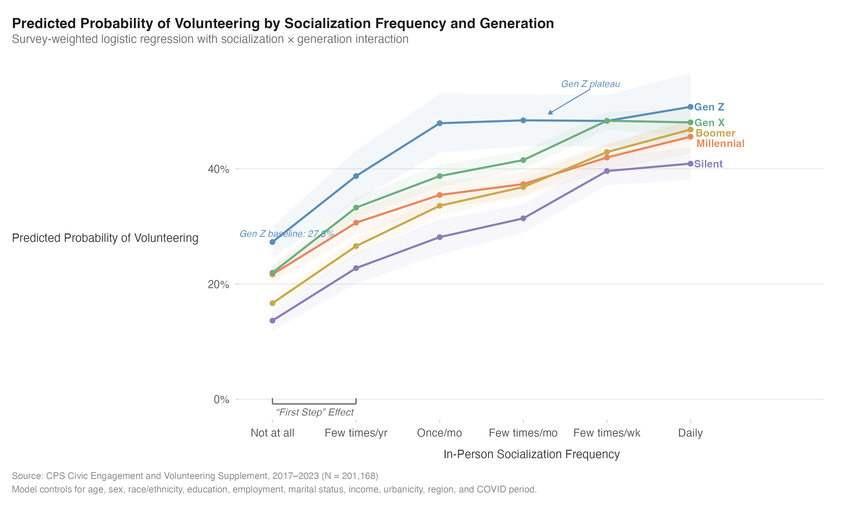
Figure 2. Predicted probability of volunteering by in-person socialization frequency and generation, from survey-weighted logistic regression (Model 1). The steep initial rise illustrates the First Step Effect; Gen Z's flattening beyond moderate socialization illustrates the generational plateau. Shaded bands represent 95% confidence intervals.

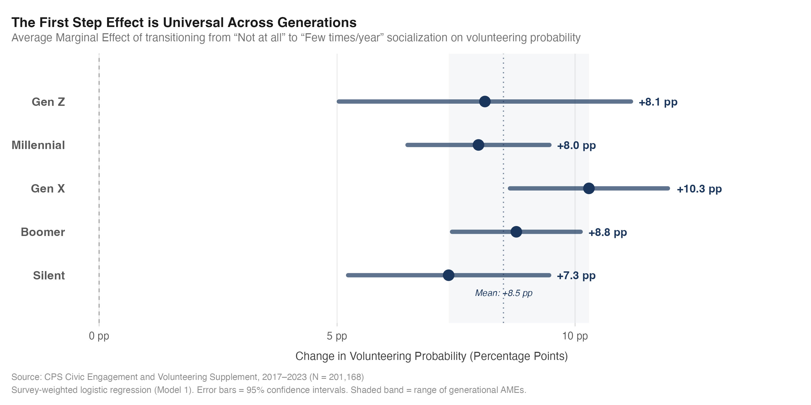
Figure 3. The First Step Effect: Average Marginal Effect of transitioning from no socialization to minimal socialization (few times per year) on volunteering probability, by generation. The effect is universal across all five cohorts (7.3 to 10.3 percentage points). Error bars represent 95% confidence intervals.
A universal threshold emerged. For every generation, the transition from no socialization to minimal socialization (a few times per year) was associated with the single largest marginal gain in volunteering probability (Table 3). This "First Step" effect ranged from 7.3 percentage points for the Silent Generation to 10.3 points for Gen X, with Gen Z at 8.1 points (95% CI [5.0, 11.2]), comparable in magnitude to the education gradient (BA+ vs. no BA). Subsequent transitions yielded progressively smaller gains, following a concave dose–response pattern: the move from isolation to minimal contact is worth roughly as much, in volunteering probability terms, as the next three transitions combined. Across all cohorts, breaking out of complete social isolation was associated with the largest marginal civic return. Robustness analyses confirmed that this threshold is genuine: the observed categorical AMEs exceeded smooth log-linear predictions by 2.4 to 4.7 percentage points across all generations, with the excess largest for Gen Z (4.7 pp). When organizational membership was added as a covariate, the First Step Effect was attenuated by approximately 30%, indicating that part of the socialization pathway operates through institutional embeddedness, but a substantial independent association remained.
Table 3
First Step Effect: Average Marginal Effects for the Transition From No Socialization to Minimal Socialization, by Generation
Generation | AME (pp) | SE | 95% CI | p
Total (pooled) | 8.7 | 0.40 | [7.9, 9.5] | < .001
Gen Z | 8.1 | 1.57 | [5.0, 11.2] | < .001
Millennial | 8.0 | 0.76 | [6.5, 9.5] | < .001
Gen X | 10.3 | 0.85 | [8.6, 12.0] | < .001
Boomer | 8.8 | 0.69 | [7.4, 10.1] | < .001
Silent | 7.3 | 1.08 | [5.2, 9.5] | < .001
Note. AME = average marginal effect; pp = percentage points; SE = standard error; CI = confidence interval. AMEs represent the estimated change in volunteering probability for the transition from "Not at all" to "Few times/year" socialization, computed via the marginaleffects package with survey weights.

Gen Z deviated from this pattern with a plateau. Gen Z's predicted volunteering probability rose sharply from 27.3% at no socialization to 48.4% at a few times per month, then flatlined, reaching only 50.8% at daily socialization. No other generation exhibited this ceiling. Boomers climbed continuously from 16.7% to 46.8%; Gen X showed the steepest overall gradient (22.0% to 48.1%). A striking baseline comparison deserves note: Gen Z's predicted volunteering probability at zero socialization (27.3%) exceeded that of every other generation, including Boomers (16.7%), which argues against the idea that low volunteering rates among Gen Z reflect weaker civic motivation. The plateau points instead to a decoupling: for Gen Z, additional face-to-face contact beyond a moderate threshold is not associated with additional civic recruitment, possibly because the social contexts in which high-frequency Gen Z socialization occurs lack ties to the community-based institutions that historically channel contact into voluntarism.
Moderators and Temporal Stability
Three-way interactions tested whether education, employment, civic social media use, or the COVID-19 period altered the socialization–volunteering–generation relationship. Education was the only significant moderator (p = .009): holding a bachelor's degree amplified the socialization–volunteering gradient for all generations, but the amplification was more pronounced for older cohorts. Among Boomers, the First Step AME was approximately 3 percentage points larger for BA+ respondents than for those without a degree; among Gen Z, the difference was less than 1 point, and the plateau persisted even among degree holders. Employment did not significantly moderate the relationship (p = .056), nor did civic social media use (p = .969). The social media null is theoretically informative: digital civic engagement does not compensate for the absence of face-to-face socialization, and this holds uniformly across generations, offering no special pathway for digitally native young adults. The near-significant employment result (p = .056) is worth noting despite failing to clear the conventional threshold: the direction of the effect suggested that employed respondents exhibited a steeper socialization–volunteering gradient than those not employed, consistent with the CVM's prediction that workplace networks provide additional recruitment channels. The effect was modest, however, and did not differ meaningfully across generations.
Perhaps the most consequential test concerned temporal stability. The socialization × generation × post-COVID interaction was not significant (p = .420), confirming that the patterns documented above (including the Gen Z plateau) were present before the pandemic and unchanged afterward. The pre-COVID First Step AME for Gen Z (10.7 points, 95% CI [5.8, 15.6]) was comparable to the full-sample estimate, and the overall relationship structure was preserved across periods. Declining youth volunteering is not a pandemic artifact; it is a cohort characteristic.
Civic Engagement Profiles
We turned to person-centered analysis to test whether the regression findings hold when individuals are classified by their full pattern of civic behavior rather than by individual predictors. LPA identified six distinct profiles (Tables 4–5; Figure 4). Three anchor the interpretive framework: the Isolated Disengaged (19.0% of sample; volunteering rate 9.0%), characterized by minimal scores on every indicator; the Mainstream Donors (33.1%; volunteering rate 41.4%), representing institutionally embedded civic engagement; and the Fully Engaged (12.0%; volunteering rate 66.7%), scoring highest on virtually every dimension. The Socially Active Non-Donors (17.5%; volunteering rate 14.6%) are theoretically important: their members reported the highest socialization of any class (M = 4.70) yet volunteered at rates below the sample mean, demonstrating that socialization without institutional anchoring does not translate into voluntarism. Two remaining profiles round out the typology: the Politically Aware Isolated (7.1%; volunteering rate 11.7%), who engaged in frequent political conversation but reported minimal social contact, and the Activist Boycotters (11.3%; volunteering rate 46.9%), defined by universal boycotting behavior alongside moderate organizational membership.
Table 4
Latent Profile Analysis Model Fit Indices (EII Parameterization, 20,000 Subsample)
Profiles | BIC | Delta BIC | Entropy | Selected
2 | -323775.8 | -- | --
3 | -315925.7 | 7850.1 | --
4 | -312648.3 | 3277.4 | --
5 | -310013.6 | 2634.7 | --
6 | -296036.5 | 13977.1 | 0.893 | Yes
7 | -291325.8 | 4710.8 | --
Note. EII = spherical, equal volume parameterization. BIC = Bayesian information criterion. ΔBIC = improvement from the previous model. Entropy reported for the selected model only. Model selection conducted on a random subsample (n = 20,000) and refit to the full sample (N = 197,497).

Table 5
Latent Profile Characteristics: Indicator Means and Volunteering Rates (6-Profile Solution, N = 197,497)
Profile | n (%) | Boycott (%) | Contact Officials (%) | Political Conv., M (SD) | Socialization, M (SD) | Org. Membership, M (SD) | Donated (%) | Volunteering (%)
1: Isolated Disengaged | 37,568 (19.0) | 1.4 | 0.7 | 1.3 (0.6) | 1.3 (0.6) | 0.1 (0.4) | 15.0 | 9.0
2: Politically Aware Isolated | 14,089 (7.1) | 0.0 | 1.2 | 4.9 (0.8) | 1.5 (0.7) | 0.1 (0.5) | 0.0 | 11.7
3: Socially Active Non-Donors | 34,520 (17.5) | 0.0 | 0.6 | 3.2 (1.8) | 4.7 (0.8) | 0.2 (0.6) | 0.0 | 14.6
4: Mainstream Donors | 65,417 (33.1) | 0.0 | 0.0 | 3.6 (1.7) | 3.8 (1.5) | 0.7 (1.2) | 99.9 | 41.4
5: Activist Boycotters | 22,266 (11.3) | 100.0 | 0.0 | 4.3 (1.6) | 3.6 (1.6) | 1.0 (1.5) | 78.0 | 46.9
6: Fully Engaged | 23,637 (12.0) | 49.7 | 100.0 | 4.6 (1.5) | 4.0 (1.5) | 1.8 (1.9) | 86.6 | 66.7
Note. Profile labels assigned post hoc based on indicator patterns. Continuous indicators reported as M (SD); binary indicators as percentages. Volunteering rate = proportion who volunteered in the past 12 months (not used as an LPA indicator).

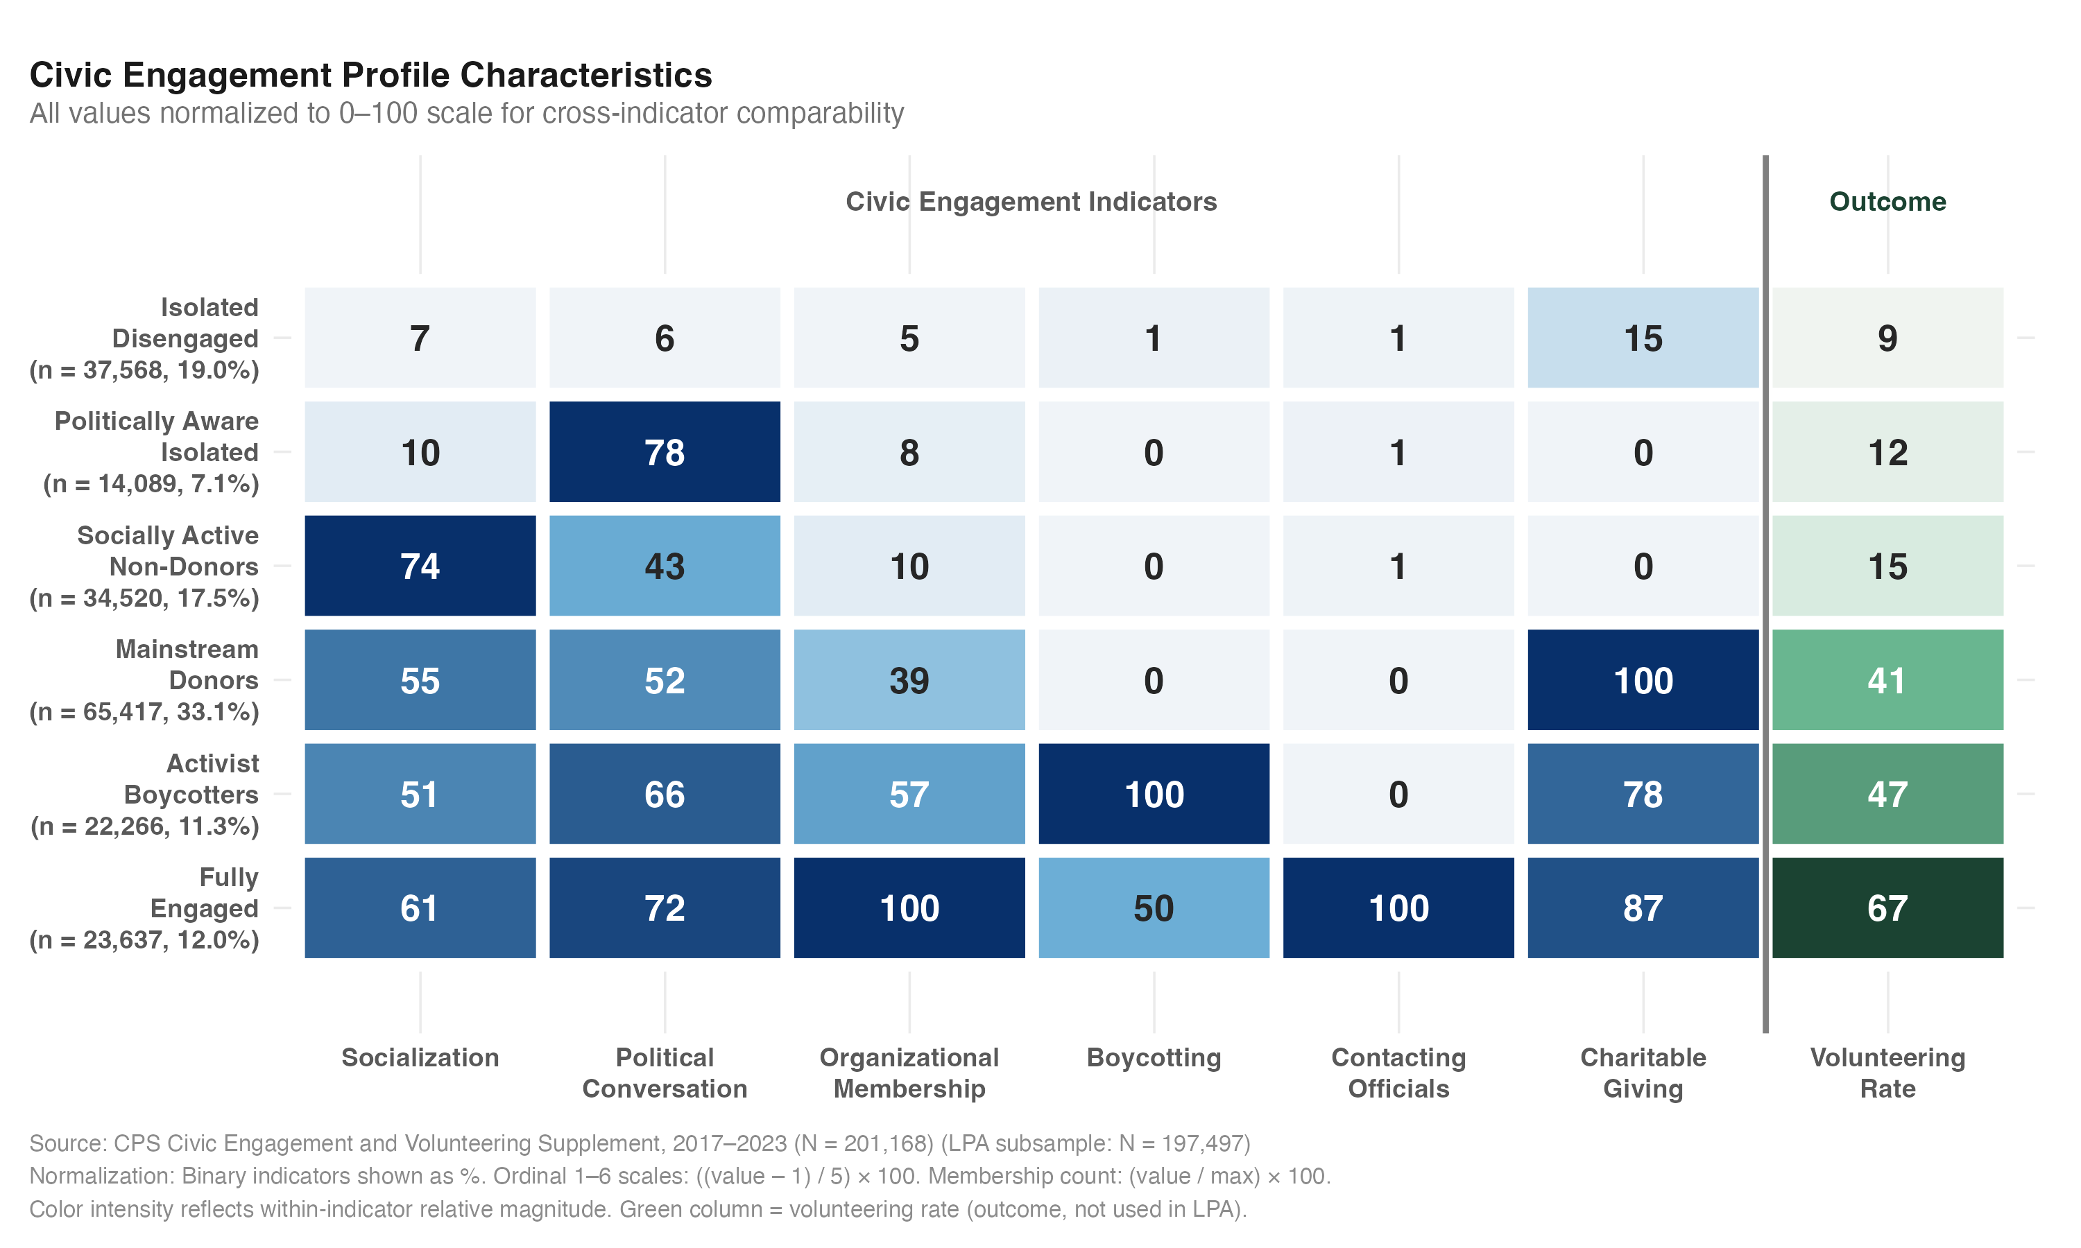
Figure 4. Civic engagement profile characteristics from latent profile analysis. All values are normalized to a 0–100 scale for cross-indicator comparability. The green column shows volunteering rate (outcome variable, not used as an LPA indicator). Color intensity reflects within-indicator relative magnitude.
Generational sorting across profiles was pronounced (Figure 3). Over a third of Gen Z (35.3%) fell into the Isolated Disengaged profile, more than double the Boomer rate (15.3%), while only 3.7% of Gen Z reached Fully Engaged status (vs. 15.1% of Boomers). Combining the two socially isolated profiles (Isolated Disengaged and Politically Aware Isolated), over half of Gen Z (50.6%) occupied profiles defined by social disconnection. Profile proportions were essentially unchanged between the pre- and post-COVID periods (Isolated Disengaged: 35.5% vs. 35.2%), providing person-centered corroboration of the regression-based temporal stability finding. The concentration of Gen Z in socially disconnected profiles is striking in absolute terms: more than one in three Gen Z respondents fell into the profile defined by minimal engagement on every civic indicator, a rate consistent with social disconnection being not a marginal phenomenon among young adults but a dominant pattern.

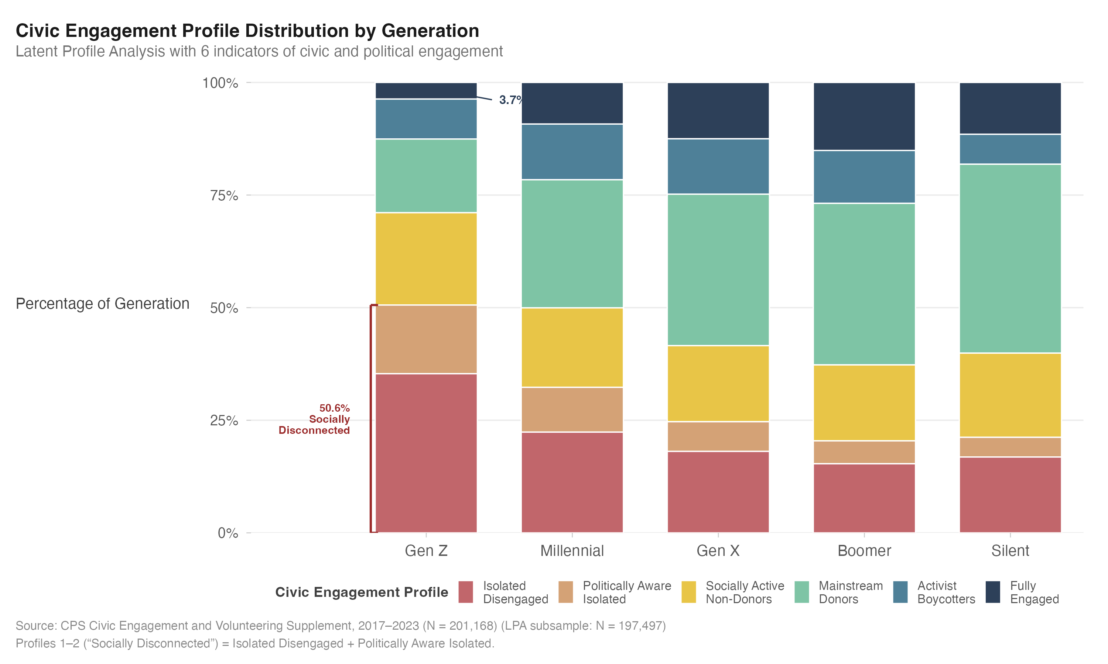
Figure 5. Generational distribution across six latent civic engagement profiles. Over half of Gen Z (50.6%) occupies the two socially disconnected profiles (Isolated Disengaged and Politically Aware Isolated), while only 3.7% reaches Fully Engaged status.
Discussion
In-person socialization is the single strongest correlate of volunteering among the most socially disconnected generation in the CPS-CEV record, and the transition from complete isolation to even occasional contact is associated with a larger civic return than any subsequent increase in social frequency. Two complementary analytic approaches (one variable-centered, one person-centered) converge on this conclusion despite sharing neither assumptions about variable roles nor distributional requirements. That convergence matters.
Consider a finding that did not have to turn out this way: Gen Z's predicted volunteering probability at zero socialization (27.3%) exceeded that of every older cohort, including Boomers (16.7%). If declining youth volunteering reflected weakened civic motivation, we would expect lower baseline rates, not higher ones. Gen Z appears more civically inclined at the individual level but less able to convert that inclination into sustained participation. The puzzle, then, is not whether young adults care about their communities (the baseline rates say they do) but why additional social contact fails to recruit them the way it recruits everyone else.
Cacioppo and Cacioppo's (2014) theorized cycle of social withdrawal predicts that even minimal social contact should disrupt the self-reinforcing dynamic of isolation and perceived social threat, yielding disproportionate gains at the lowest end of the socialization continuum. The First Step Effect confirms that prediction across all five generations. Beyond that initial threshold, generational trajectories diverged. Gen Z's volunteering probability plateaued at moderate socialization levels; no older cohort exhibited this ceiling (see Figure 1). Putnam's (2000) social capital framework, which predicts continuous returns from accumulated contact, cannot account for this plateau. We read the Gen Z ceiling as reflecting a decoupling: additional face-to-face contact occurs in contexts stripped of the institutional anchoring through which civic recruitment historically operates. In Putnam's own terms, the youngest Americans are not bowling alone by choice; they are scrolling together in a digital environment that sustains the perception of connection without providing the face-to-face encounters through which civic recruitment occurs.
Education amplified the socialization–volunteering gradient more strongly for older cohorts (p = .009), but the Gen Z plateau persisted even among degree holders. For Boomers and Gen Xers, holding a BA added roughly 3 percentage points of additional First Step return; for Gen Z, the boost was less than 1 point. Employment fell just short of conventional significance (p = .056), and civic social media use showed no moderating effect whatsoever (p = .969). If digital platforms sustain civic awareness, why don't they also sustain civic action? The social media null deserves emphasis: the digital compensation effect posited by Bennett and Segerberg's (2012) connective action framework does not operate differently for digitally native young adults. Online civic activity offers no special substitute for the face-to-face encounter in which someone says, "We need help Saturday morning, will you come?" That the most plausible compensatory pathways (education, employment, digital engagement) all failed to budge the generational pattern is itself theoretically revealing.
Nor do pandemic-era disruptions explain the pattern. The socialization × generation × post-COVID interaction was not significant (p = .420), and the pre-COVID First Step AME for Gen Z (10.7 points) matched the full-sample estimate. Gen Z's weaker conversion of social contact into volunteering was evident before COVID-19 and unchanged afterward. Twenge et al. (2019) documented that declines in adolescent socialization were well underway by 2017; the present analysis extends that finding to its civic consequences. Pandemic recovery strategies alone will not resolve the engagement deficit among young adults; the deficit predates the pandemic. The First Step Effect also points to a practical answer: target the initial transition out of social isolation. Low-threshold, single-contact strategies should take priority over sustained-commitment appeals. Creating one opportunity for in-person contact may matter more than intensifying recruitment among already-connected individuals, and digital-only campaigns offer no compensatory advantage (p = .969).
Person-centered analysis told the same story through a different lens. Gen Z was disproportionately concentrated in socially disconnected profiles (see Figure 3): over half (50.6%) occupied the Isolated Disengaged or Politically Aware Isolated classes, and only 3.7% reached Fully Engaged status. Profile proportions held steady across the pre- and post-COVID periods, corroborating the temporal stability finding from the regression models.
High socialization without institutional anchoring, it turns out, did not translate into civic action. The Socially Active Non-Donors class makes this plain. Members reported the highest socialization scores of any profile (M = 4.70) yet volunteered at only 14.6%, below the sample mean. Organizational membership was near zero (M = 0.08) and charitable giving absent. Robustness analysis confirmed the pathway: controlling for organizational membership attenuated the First Step Effect by approximately 30%, indicating that institutional embeddedness is a key mediating mechanism. Not all socializing is created equal. The distinction between bonding capital (close-knit relationships among similar individuals) and bridging capital (cross-cutting ties connecting individuals to new networks and resources) is central here (Putnam, 2000). The Socially Active Non-Donors appear rich in bonding capital but poor in the bridging capital that links individuals to civic institutions. For Gen Z, whose socialization increasingly occurs in homogeneous peer groups rather than in the institutionally diverse settings that older cohorts navigated (churches, civic associations, workplaces), this distinction may prove consequential. Klinenberg's (2018) concept of "social infrastructure" (the physical spaces and institutions that support social contact) provides a framework for intervention: Cooperative Extension, embedded at the interface of campus and community, could design programming that treats social connection as a prerequisite for volunteering rather than a byproduct of it.
A temporal shift in profile structure deserves attention. Gen Z's representation in the Activist Boycotter profile doubled from 5.9% pre-COVID to 10.7% post-COVID, even as Isolated Disengaged proportions remained stable. The post-2020 period catalyzed a politicization pathway for a subset of Gen Z without altering the broader pattern of civic disengagement. The Activist Boycotter profile (which emphasizes political consumption over institutional volunteering, with a 46.9% volunteering rate) may represent an emerging civic pathway operating alongside traditional voluntarism rather than substituting for it.
What does this convergence of evidence mean for the prevailing narrative about generational differences in civic engagement? It challenges it. Dalton (2008) and others frame declining youth participation as a value shift from "duty-based" to "engaged" citizenship, in which younger cohorts express commitment through informal and digital channels. We read the data differently. The baseline paradox (Gen Z volunteering more than similarly isolated Boomers at zero socialization) is inconsistent with a motivational deficit account. The plateau at moderate socialization levels is more consistent with an account in which Gen Z lacks the dense, multiplex social networks that Granovetter (1973) identified as conduits for weak-tie recruitment. The "scrolling together" metaphor captures this structural irony: Gen Z is the most connected generation digitally yet the most disconnected in face-to-face contact. The null finding for civic social media use (p = .969) confirms that digital civic activity does not function as a recruitment channel the way a personal encounter does. Those who socialize enough to encounter some recruitment opportunities do volunteer, but their social contexts (often peer-group gatherings without institutional anchoring) may not provide the escalating web of obligations that drove older cohorts toward deeper engagement.
The baseline paradox admits two interpretations: stronger intrinsic civic motivation cultivated through digital cause-awareness, or compositional differences (an isolated 18-year-old living with volunteering parents differs from an isolated 65-year-old retiree). Our baseline comparison controls for demographics but cannot fully account for unobserved household-level civic socialization. The more consequential finding is what happens above the baseline: Gen Z's volunteering probability plateaus where other generations' continues to climb, and it is this ceiling, not the floor, that explains the overall generational gap.
At the policy level, the Surgeon General's 2023 advisory focused predominantly on health consequences of social disconnection. Our results point to civic consequences that deserve equal attention. Workplace-based volunteer programs may serve a bridging function by providing the structured, organizationally anchored social context that the LPA analysis identified as critical for translating socialization into civic action. Federal and state civic engagement initiatives would benefit from incorporating a "social activation" component that addresses social isolation as a barrier to entry rather than assuming motivation alone is sufficient. The common thread is designing the social encounter first and the volunteer ask second, inverting the traditional model that assumes interested individuals will seek out opportunities on their own.
Limitations and Future Directions
Does the gradient reflect socialization causing volunteering, or volunteering generating social contact? The pooled cross-sectional design cannot resolve this question. People who volunteer meet others through their service, which increases their socialization frequency; the entire gradient could be partly driven by this reverse pathway, or both socialization and volunteering may reflect a common disposition such as extraversion. Two features of the results provide partial leverage against a purely reverse-causal account. The nonlinear threshold shape of the First Step Effect is more consistent with a recruitment mechanism, in which initial contact triggers awareness of opportunities, than with reverse causation, which would predict a more linear association. And the temporal stability of the pattern across four waves suggests a durable relationship rather than a context-dependent artifact. Establishing directionality will require longitudinal data. The CPS rotation group structure offers a quasi-panel design that could establish whether changes in socialization within individuals precede changes in volunteering; true panel studies (e.g., PSID, Understanding America Study) could provide more definitive evidence. The First Step Effect also implies a specific intervention design: randomized controlled trials of low-threshold, single-contact programs targeting socially isolated young adults would test whether the cross-sectional associations documented here reflect causal pathways.
Measurement constraints add further caveats. The CESOCIALIZE item captures frequency of socialization but not its quality, depth, or content; "got together socially with friends, relatives, or neighbors" conflates kin-based socialization (primarily bonding capital), friendship networks, and neighbor contact (most directly tied to community recruitment). These domains have different theoretical relationships to volunteering, and the composite measure cannot disentangle them; future research should disaggregate socialization by context (kin vs. friend vs. neighbor) and institutional setting (organizationally embedded vs. informal) to test whether institutionally anchored socialization is uniquely tied to civic recruitment. The binary COVID coding (2017/2019 vs. 2021/2023) is approximate; the 2021 wave was administered during, not after, the pandemic. A supplementary three-period specification (Pre-COVID 2017/2019, During-COVID 2021, Post-COVID 2023) yielded a non-significant three-way interaction (F = 1.04, df = 40, p = .396), confirming that the socialization–volunteering–generation relationship was stable across all three periods. The PES16F variable measuring virtual versus in-person volunteering mode is available only for the 2023 wave, preventing systematic analysis of how volunteering modality interacts with social isolation. All measures are self-reported and subject to social desirability bias, which may differentially affect reporting of socially valued behaviors such as volunteering. Generational classification by birth cohort conflates age, period, and cohort effects. Supplementary analyses (nonlinear age controls [age-squared], fixed age-band comparisons [ages 25–30 across waves], and shifted generation boundaries [Gen Z = 1995+]) confirmed that the socialization-by-generation interaction survived all specifications (p < .001) and that First Step AMEs were essentially unchanged. Such tests reduce the plausibility of a purely age-based account without eliminating it; we cannot rule out that what we attribute to generational differences reflects life-stage effects that would dissipate as Gen Z ages into the institutional roles that historically anchor civic participation. We use "generation" to mean birth-cohort-at-observed-age rather than a fixed generational identity; a formal age-period-cohort decomposition would require additional data waves. The CPS-CEV does not include a religious attendance item, a notable omission given that congregations are among the strongest institutional predictors of volunteering in U.S. studies (Putnam & Campbell, 2010; Musick & Wilson, 2008). Organizational membership count and charitable donation to religious organizations provide partial proxies, and the robustness analysis showing ~30% attenuation of the First Step Effect when controlling for membership suggests the socialization pathway partly operates through institutional channels, of which religious congregations are a major component. The dependent variable captures extensive-margin participation (volunteered yes/no in past 12 months) but not intensive-margin engagement; the CPS Volunteer Supplement includes annual volunteer hours (VLHALLORG), which could serve as a continuous alternative in future analyses.
Conclusion
The social disconnection of Generation Z is a civic engagement challenge as much as a health challenge. What the data show, with consistent convergence across methods and across time, is that one step out of isolation is associated with a larger civic return than any subsequent increase in social frequency. In 2000, Americans were bowling alone; a quarter century later, the youngest Americans are scrolling together, maintaining the appearance of social connection through digital platforms that sustain awareness of community needs without providing the face-to-face encounters that translate awareness into action. The path to volunteering begins not with appeals to duty or digital campaigns but with creating the physical social encounters, the social infrastructure that Klinenberg (2018) describes, that make civic recruitment possible.

References
AmeriCorps. (2023). Volunteering and civic life in America.
Arel-Bundock, V. (2023). marginaleffects: Predictions, comparisons, slopes, marginal means, and hypothesis tests. R package.
Bennett, W. L., & Segerberg, A. (2012). The logic of connective action. Information, Communication & Society, 15(5), 739–768.
Beyerlein, K., & Hipp, J. R. (2006). From pews to participation: The effect of congregation activity and context on bridging civic engagement. Social Problems, 53(1), 97–117.
Bode, L., Vraga, E. K., Borah, P., & Shah, D. V. (2014). A new space for political behavior. Political Communication, 31(1), 52–74.
Brady, H. E., Verba, S., & Schlozman, K. L. (1995). Beyond SES: A resource model of political participation. American Political Science Review, 89(2), 271–294.
Bureau of Labor Statistics. (2016). Volunteering in the United States, 2015.
Cacioppo, J. T., & Cacioppo, S. (2014). Social relationships and health: The toxic effects of perceived social isolation. Social and Personality Psychology Compass, 8(2), 58–72.
Coleman, J. S. (1988). Social capital in the creation of human capital. American Journal of Sociology, 94, S95–S120.
Collins, L. M., & Lanza, S. T. (2010). Latent class and latent transition analysis. Wiley.
Corporation for National and Community Service. (2018). Volunteering in America.
Dalton, R. J. (2008). The good citizen: How a younger generation is reshaping American politics. CQ Press.
Flanagan, C. A., & Levine, P. (2010). Civic engagement and the transition to adulthood. The Future of Children, 20(1), 159–179.
Flood, S., King, M., Rodgers, R., Ruggles, S., Warren, J. R., & Westberry, M. (2023). Integrated Public Use Microdata Series, Current Population Survey: Version 11.0. IPUMS.
Friedman, J. H. (2001). Greedy function approximation: A gradient boosting machine. Annals of Statistics, 29(5), 1189–1232.
Gil de Zuniga, H., Jung, N., & Valenzuela, S. (2012). Social media use for news and individuals’ social capital, civic engagement and political participation. Journal of Computer-Mediated Communication, 17(3), 319–336.
Granovetter, M. S. (1973). The strength of weak ties. American Journal of Sociology, 78(6), 1360–1380.
Holt-Lunstad, J., Smith, T. B., & Layton, J. B. (2010). Social relationships and mortality risk: A meta-analytic review. PLoS Medicine, 7(7), e1000316.
Hooghe, M. (2012). Taking part in politics? An analysis of macro-level determinants and individual-level explanations. International Review of Sociology, 22(1), 9–26.
Jennings, M. K., & Stoker, L. (2004). Social trust and civic engagement across time and generations. Acta Politica, 39, 342–379.
Kelle, N., Simonson, J., & Gordo, L. R. (2025). Generational differences in voluntary engagement among older adults. Voluntas, 36, 1–14.
Klinenberg, E. (2018). Palaces for the people: How social infrastructure can help fight inequality, polarization, and the decline of civic life. Crown.
Lim, C., & Laurence, J. (2015). Doing good when times are bad: Volunteering behaviour in economic hard times. British Journal of Sociology, 66(2), 319–344.
Lundberg, S. M., Erion, G., Chen, H., DeGrave, A., Prutkin, J. M., Nair, B., ... & Lee, S. I. (2020). From local explanations to global understanding with explainable AI for trees. Nature Machine Intelligence, 2(1), 56–67.
Lundberg, S. M., & Lee, S. I. (2017). A unified approach to interpreting model predictions. Advances in Neural Information Processing Systems, 30.
Manturuk, K., Lindblad, M., & Quercia, R. (2012). Homeownership and civic engagement in low-income urban neighborhoods. Urban Affairs Review, 48(5), 731–760.
Mauss, M. (1925/2000). The gift: The form and reason for exchange in archaic societies. W. W. Norton.
McPherson, M., Smith-Lovin, L., & Brashears, M. E. (2006). Social isolation in America: Changes in core discussion networks over two decades. American Sociological Review, 71(3), 353–375.
Musick, M. A., & Wilson, J. (2008). Volunteers: A social profile. Indiana University Press.
Muthén, B. O., & Muthén, L. K. (2000). Integrating person-centered and variable-centered analyses. Alcoholism: Clinical and Experimental Research, 24(5), 543–550.
Nesbit, R. (2012). The influence of major life cycle events on volunteering. Nonprofit and Voluntary Sector Quarterly, 41(6), 1153–1174.
Norris, P. (2002). Democratic phoenix: Reinventing political activism. Cambridge University Press.
Office of the Surgeon General. (2023). Our epidemic of loneliness and isolation: The U.S. Surgeon General’s advisory on the healing effects of social connection and community.
Putnam, R. D. (2000). Bowling alone: The collapse and revival of American community. Simon & Schuster.
Rotolo, T., & Wilson, J. (2006). Employment sector and volunteering: The contribution of nonprofit and public sector workers to the volunteer labor force. Sociological Quarterly, 47(1), 21–40.
Schlozman, K. L., Verba, S., & Brady, H. E. (2012). The unheavenly chorus: Unequal political voice and the broken promise of American democracy. Princeton University Press.
Snyder, M., & Omoto, A. M. (2008). Volunteerism: Social issues perspectives and social policy implications. Social Issues and Policy Review, 2(1), 1–36.
Stukas, A. A., Hoye, R., Nicholson, M., Brown, K. M., & Aisbett, L. (2016). Motivations to volunteer and their associations with volunteers’ well-being. Nonprofit and Voluntary Sector Quarterly, 45(1), 112–132.
Taniguchi, H. (2012). The determinants of formal and informal volunteering. Voluntas, 23, 920–939.
Tocqueville, A. de. (1835/2000). Democracy in America. University of Chicago Press.
Twenge, J. M. (2017). iGen: Why today’s super-connected kids are growing up less rebellious, more tolerant, less happy, and completely unprepared for adulthood. Atria Books.
Twenge, J. M., & Park, H. (2019). The decline in adult activities among U.S. adolescents, 1976–2016. Child Development, 90(2), 638–654.
Twenge, J. M., Spitzberg, B. H., & Campbell, W. K. (2019). Less in-person social interaction with peers among U.S. adolescents in the 21st century and links to loneliness. Journal of Social and Personal Relationships, 36(6), 1892–1913.
Verba, S., Schlozman, K. L., & Brady, H. E. (1995). Voice and equality: Civic voluntarism in American politics. Harvard University Press.
Vermunt, J. K., & Magidson, J. (2002). Latent class cluster analysis. In J. A. Hagenaars & A. L. McCutcheon (Eds.), Applied latent class analysis (pp. 89–106). Cambridge University Press.
Wilson, J. (2000). Volunteering. Annual Review of Sociology, 26, 215–240.
Wilson, J. (2012). Volunteerism research: A review essay. Nonprofit and Voluntary Sector Quarterly, 41(2), 176–212.
Wray-Lake, L., & Hart, D. (2012). Growing social inequalities in youth civic engagement? Evidence from the National Election Study. PS: Political Science & Politics, 45(3), 456–461.
Zukin, C., Keeter, S., Andolina, M., Jenkins, K., & Delli Carpini, M. X. (2006). A new engagement? Political participation, civic life, and the changing American citizen. Oxford University Press.

