The AI Divide: Latent Attitude Profiles and the Stratification
of Public Orientations Toward Artificial Intelligence
[Author Name]
[Department, University]
Author Note
Correspondence should be addressed to [Author information]. Data from the Pew Research Center American Trends Panel are publicly available. Replication code and materials are available from the authors upon request.

Abstract
Public attitudes toward artificial intelligence (AI) are typically treated as a single spectrum from enthusiasm to anxiety, obscuring qualitative differences that may reproduce social stratification. Drawing on digital divide theory, we propose a three-level AI divide framework and use latent class analysis on Pew Research Center data (N = 10,749; American Trends Panel Wave 132) to identify four attitude profiles: AI-Anxious (9%), AI-Uninformed (33%), AI-Advantaged (21%), and AI-Ambivalent (37%). These profiles replicate across a split-sample design. A sensitivity analysis removing awareness from the classification reveals that the four-class structure reduces to three classes, with the Uninformed and Advantaged profiles merging — confirming that awareness is structurally constitutive of the typology rather than incidental to it. Structural equation modeling reveals that socioeconomic status predicts class membership both directly and indirectly through AI awareness, and education effects vary by race/ethnicity (LRT p = .007), with stronger penalties for low education among Black respondents. Cross-wave validation (2022–2024) confirms structural stability. Unequal orientations toward AI constitute an emergent axis of digital inequality with implications for technology governance.
Keywords: artificial intelligence, digital divide, latent class analysis, public opinion, technology attitudes, social stratification

1. Introduction
One in three American adults has heard nothing at all about artificial intelligence. That statistic — drawn from the same 2023 Pew Research Center survey in which 52% of respondents said they were more concerned than excited about AI — is easy to overlook amid headlines about chatbots and automation anxiety, but it exposes a fracture that runs deeper than any opinion poll can capture. Recommender algorithms curate news feeds, large language models draft correspondence, and automated decision systems shape hiring, lending, and criminal sentencing. Public reactions to this transformation matter. Attitudes toward AI influence adoption behavior (Araujo et al., 2020), shape regulatory preferences (Zhang and Dafoe, 2019), and signal democratic legitimacy for emerging governance frameworks (Floridi et al., 2018). Yet most survey research treats AI attitudes as a single dimension running from excitement to concern, aggregating responses into population-level summaries that mask important heterogeneity.
A growing body of research has documented broad contours of public opinion about AI. Cross-national surveys find that a majority of adults express some mix of enthusiasm and concern, with substantial variation by country, demographic group, and the specific AI application in question (Cave et al., 2019; Eurobarometer, 2017; Neudert et al., 2020). In the United States, the Pew Research Center (2023) reported that 52% of Americans feel more concerned than excited about AI, up from 38% the previous year. Education, income, gender, and age are consistently associated with AI attitudes (Zhang and Dafoe, 2019; Ipsos, 2023). These descriptive findings are valuable, but they share a common limitation: they treat the population as varying along a single attitudinal dimension, differing only in degree. Little attention has been paid to the possibility that people relate to AI in qualitatively different ways — that the structure of attitudes, not just their valence, varies across the population.
This paper takes a different approach. Rather than asking how favorable or unfavorable the public is toward AI, we ask: What distinct orientations toward AI exist in the American public, and how are these orientations distributed across social groups? The distinction matters because qualitatively different relationships with a technology — not merely different degrees of enthusiasm — carry different implications for inequality. A person who has never heard of AI and expresses no opinion occupies a fundamentally different position from someone who is well-informed but deeply concerned, even if both register as "not excited" on a standard survey item. Similarly, someone who sees AI as uniformly beneficial across all domains differs from someone who distinguishes between health care applications they welcome and surveillance applications they reject, even though both may register as broadly positive.
To theorize these differences, we extend the digital divide framework (van Dijk, 2005, 2020; Hargittai, 2002; Robinson et al., 2015) to the domain of AI attitudes. Classic digital divide research evolved through three stages: from access gaps (first-level divide) to skills gaps (second-level divide) to outcome gaps (third-level divide). We propose an analogous three-level AI divide: (1) an awareness divide separating those who know about AI from those who do not, (2) an attitude complexity divide distinguishing nuanced from simplistic orientations, and (3) an outcome divide reflecting differential perceptions of AI's domain-specific consequences.
Empirically, we use latent class analysis (LCA) on a large, nationally representative dataset — the Pew Research Center American Trends Panel Wave 132 (August 2023; N = 10,749) — to identify naturally occurring attitude profiles. We then examine how socioeconomic status, race/ethnicity, and AI awareness predict membership in these profiles, testing whether the social stratification patterns documented in prior digital divide research extend to AI orientations.
Our analysis makes three contributions. First, we demonstrate that American adults cluster into four qualitatively distinct AI attitude profiles that replicate across independent subsamples with different domain items. Second, we show that socioeconomic status predicts profile membership both directly and indirectly through awareness, establishing AI awareness as a key mediating mechanism. Third, we document intersectional variation in these relationships, with education effects on AI attitudes differing substantially by race/ethnicity. Together, these findings suggest that public orientations toward AI are not simply a matter of individual preference but are structured by the same social forces that produce other forms of digital inequality.
We develop this argument in the context of a three-level AI divide framework, test five hypotheses using latent class analysis and structural equation modeling, and validate the resulting typology across survey waves.
2. Theoretical Framework
2.1 From Digital Divides to AI Divides
The concept of the digital divide has evolved considerably since its initial articulation in the 1990s. Early formulations focused almost exclusively on physical access to computers and the internet — a binary distinction between haves and have-nots (NTIA, 1999). As internet penetration increased, scholars recognized that access alone was insufficient; what people could do with technology mattered equally (Hargittai, 2002; DiMaggio et al., 2004). This insight gave rise to the second-level digital divide, centered on digital skills and literacy (van Dijk, 2005; Hargittai and Hinnant, 2008). More recently, a third-level divide has been theorized around tangible outcomes — the extent to which internet use translates into social, economic, and political benefits (Wei et al., 2011; Robinson et al., 2015; Ragnedda, 2018).
Van Dijk's (2005, 2020) resources and appropriation model provides the most comprehensive theoretical integration of these levels. In this framework, personal and positional categorical inequalities (including education, income, age, race, and gender) shape the distribution of resources (material, mental, social, cultural), which in turn determine successive kinds of access: motivational access, material access, skills access, and usage access. These access types are sequential and cumulative — a point that matters for what follows. Individuals who lack motivational access — awareness of and interest in a technology — never proceed to the stages where skills and beneficial use become possible.
We argue that the rapid diffusion of AI into public life has created conditions for a new domain of digital inequality that parallels this established framework but operates at the level of orientations rather than use. Unlike the internet in the early 2000s, AI presents a distinctive challenge for public engagement: many AI systems operate invisibly, most people do not directly choose to adopt or reject AI, and the consequences of AI are highly domain-specific. Moreover, public orientations toward AI are not formed in a vacuum but are shaped by what Jasanoff (2015) terms "sociotechnical imaginaries" — collectively held visions of desirable futures achievable through technology. Media framing, platform experiences, and cultural narratives about AI all contribute to the "algorithmic imaginaries" (Bucher, 2017) through which people make sense of systems they rarely observe directly. These characteristics make AI attitudes a particularly revealing site for studying how inequality shapes technology orientations: differential access to information about AI may produce not just different opinions but fundamentally different imaginative frames for understanding what AI is and does.
Prior research on AI attitudes has primarily employed variable-centered approaches — regression models predicting a single attitude outcome from demographic predictors (Araujo et al., 2020; Zhang and Dafoe, 2019; Cave et al., 2019; Neudert et al., 2020). This work has established that education, age, gender, and technology familiarity predict attitudes, but it assumes that the same model applies to all respondents. A person-centered approach, by contrast, allows for the possibility that the population contains qualitatively distinct subgroups whose attitudes are organized differently. Latent class analysis provides a statistical framework for identifying such subgroups (Hagenaars and McCutcheon, 2002; Collins and Lanza, 2010). Although LCA has been widely used in health behavior, political science, and consumer research, its application to technology attitudes remains limited. A recent exception is Wang et al. (2025), who applied LCA to a Dutch national sample (N = 1,088) and identified five AI competence profiles — ranging from "expert advocates" to "neutral unskilled" — with substantial sociodemographic stratification. Their study, grounded in Carter et al.'s (2020) three-level framework of AI knowledge, skills, and attitudes, demonstrated that person-centered methods can reveal population heterogeneity invisible to variable-centered analyses. Our study extends this emerging line of person-centered inquiry in four directions: we shift the focus from competencies to attitudes, examine a substantially larger probability-based sample (N = 10,749) from a different national context, incorporate a built-in split-sample replication that tests whether profiles generalize across domain items, and test intersectional hypotheses about how education effects on AI orientations vary by race/ethnicity — a dimension absent from Wang et al.'s analysis and largely unexamined in European studies of the AI divide.
2.2 A Three-Level AI Divide Framework
We propose a three-level framework for understanding stratified orientations toward AI:
Level 1: The Awareness Divide. Before people can form meaningful attitudes about AI, they must know that AI exists and have some understanding of what it does. This parallels van Dijk's (2005) concept of motivational access and echoes earlier findings that awareness of emerging technologies is socially stratified (Brossard et al., 2009). Survey data consistently show that awareness of AI varies by education, income, age, and race/ethnicity (Pew Research Center, 2023; Zhang and Dafoe, 2019). Those without awareness are effectively excluded from public deliberation about AI governance.
Level 2: The Attitude Complexity Divide. Among those who are aware of AI, the sophistication and differentiation of attitudes varies. Some individuals hold views that distinguish between AI applications they consider beneficial and those they find concerning. Others maintain undifferentiated positions — blanket enthusiasm or blanket anxiety — that do not reflect the domain-specific nature of AI's impacts. This echoes the distinction Hargittai and Hinnant (2008) drew between mere internet access and the quality of online engagement. We conceptualize attitude complexity not as a normative judgment about which views are "correct" but as an empirical description of how differentiated people's orientations are across AI domains.
Level 3: The Outcome Divide. At the most concrete level, people differ in whether they perceive AI as likely to help or hurt in specific life domains — healthcare, criminal justice, personal privacy, employment. These perceived outcomes shape willingness to interact with AI systems (Araujo et al., 2020), support for regulatory frameworks (Zhang and Dafoe, 2019), and capacity to advocate for one's interests in AI-mediated processes. This maps onto what Robinson et al. (2015) and Ragnedda and Muschert (2013) termed the third-level digital divide, where differential engagement patterns produce differential benefits.
The sequential logic matters here: these three levels are not independent. We theorize them as cumulative, following van Dijk's (2005) appropriation logic. Awareness (Level 1) is a precondition for developing complex attitudes (Level 2), which in turn shape domain-specific outcome perceptions (Level 3). This sequential structure implies that socioeconomic factors may influence higher-level orientations both directly and indirectly through their effects on awareness.
2.3 Hypotheses
Drawing on this framework and the empirical digital divide literature, we derive five hypotheses:
H1 (Latent heterogeneity). Distinct latent classes of AI attitudes exist in the American public, reflecting qualitatively different orientations rather than variation along a single continuum.
H2 (SES stratification). Education and income predict latent class membership, with higher SES associated with more informed AI orientations. Education should be particularly consequential because it shapes both cognitive resources for processing information about complex technologies and exposure to professional environments where AI is salient (van Dijk, 2005; Hargittai, 2002).
H3 (Awareness mediation). AI awareness mediates the SES-to-class relationship. Because awareness (Level 1) is the gateway to higher-level orientations and is itself socially stratified, a substantial portion of the SES effect should operate through this pathway — paralleling knowledge mediation in health communication (Viswanath and Bond, 2007).
H4 (Intersectional variation). The effect of education on class membership varies by race/ethnicity. Different racialized experiences with technology — including algorithmic discrimination, surveillance, and differential access to tech-sector employment (Robinson et al., 2015; Ragnedda and Muschert, 2013) — may moderate how education translates into AI orientations.
H5 (Structural stability). The latent class structure is stable across survey waves, indicating durable orientations rather than transient responses to news cycles (Lazarsfeld and Henry, 1968).
We now describe the data and analytic strategy used to test these five hypotheses.
3. Method
3.1 Data
We analyze data from the Pew Research Center's American Trends Panel (ATP), a probability-based online panel recruited through national random-digit-dial and address-based sampling. Our primary data come from Wave 132 (fielded August 7–27, 2023), which surveyed N = 10,749 U.S. adults about their attitudes toward artificial intelligence. The survey employed a split-sample design: respondents were randomly assigned to Form A (n = 5,368) or Form B (n = 5,317), with each form containing different AI domain items alongside shared items on general AI attitudes and awareness.
For cross-wave validation, we draw on Wave 119 (December 2022; N = 10,906) and Wave 152 (August 2024; N = 5,363), both of which included the same general AI attitude and awareness items. All analyses use Pew-provided survey weights to adjust for nonresponse and ensure national representativeness. The weighted sample reflects the U.S. adult population in terms of gender (50.5% female, 48.2% male), age (18.7% ages 18–29, 33.9% ages 30–49, 25.2% ages 50–64, 22.2% ages 65+), race/ethnicity (62.6% White non-Hispanic, 15.5% Hispanic, 11.5% Black non-Hispanic, 6.0% Asian non-Hispanic), and education (35.8% college graduate or higher, 30.6% some college, 33.5% high school or less).
3.2 Measures
LCA indicators. Six manifest indicators were used for each form's latent class analysis. Two indicators were shared across both forms:
AI attitude (lca_attitude): "Overall, would you say the increased use of artificial intelligence in daily life makes you feel more excited, more concerned, or an equal mix of excited and concerned?" Coded as a 3-category nominal variable (excited, concerned, equal mix).
AI awareness (lca_awareness): "How much, if anything, have you heard or read about artificial intelligence?" Coded as a 3-category ordinal variable (a lot, a little, nothing at all).
Domain-specific items: Each form included four binary items asking whether AI in a specific domain would mostly help or mostly hurt. Form A covered: (a) AI's ability to provide accurate information, (b) health care, (c) vehicle safety, and (d) customer service. Form B covered: (e) product search and recommendations, (f) personal privacy, (g) policing, and (h) the quality of a patient's relationship with their doctor. Domain items were coded as binary indicators (1 = not hurt/mostly help, 2 = hurt/mostly hurt).
Predictors for structural modeling. Education was measured in three categories: high school graduate or less (33.5%), some college (30.6%), and college graduate or higher (35.8%; reference category). Household income was coded as lower (29.4%), middle (50.5%; reference), or upper (20.1%), based on Pew's income tier classification. Race/ethnicity was measured as White non-Hispanic (reference), Black non-Hispanic, Hispanic, Asian non-Hispanic, and other. Controls included age (18–29, 30–49 [reference], 50–64, 65+), gender (male [reference], female, other), and party identification (Democrat/Lean Democrat [reference], Republican/Lean Republican).
3.3 Analytic Strategy
Our analysis uses four statistical approaches, each addressing a different question. The core method is latent class analysis (LCA), a model-based clustering technique that identifies unobserved subgroups of respondents based on their patterns of survey responses. Unlike regression, which asks "what predicts more favorable attitudes?", LCA asks "are there qualitatively different types of people in these data?" — an assumption that maps directly onto our theoretical claim that AI orientations are not merely distributed along a single spectrum but organized into distinct configurations. We complement LCA with regression, mediation, and intersectional analyses to understand who belongs to each group and why.
Our analysis proceeds in four stages, following the three-step approach recommended for latent class analysis with auxiliary variables (Vermunt, 2010; Asparouhov and Muthen, 2014).
Stage 1: Latent class analysis. We estimated LCA models with 2 through 7 classes separately for Form A and Form B using the poLCA package in R (Linzer and Lewis, 2011). Each model was estimated with 20 random starting values to guard against local maxima, with a maximum of 3,000 EM iterations. Model selection followed a multi-criteria approach: we selected the model with the lowest Bayesian Information Criterion (BIC) among models satisfying two substantive constraints — entropy above 0.6 (indicating adequate class separation) and a minimum class size exceeding 5% of the sample (ensuring interpretability). This approach balances statistical fit with practical considerations (Nylund et al., 2007). Separate estimation on each form provides a built-in replication check: if similar profile types emerge from different domain items, this supports the robustness of the typology.
Stage 2: Multinomial logistic regression. Using modal class assignments from Stage 1, we estimated a series of nested multinomial logistic regression models predicting class membership from sociodemographic characteristics and AI awareness. We compared four models: a base model with demographics and race/ethnicity only; an SES model adding education and income; an awareness model adding AI awareness; and a full model including all predictors. Model comparison used likelihood ratio tests and BIC. Average marginal effects (AME) were computed using the marginaleffects package (Arel-Bundock et al., 2024) to facilitate interpretation across the multinomial outcome. AME values express the average change in the probability of class membership associated with a one-unit change in a predictor, making effect sizes directly comparable across variables.
Stage 3: Mediation analysis. To test whether awareness explains how SES affects AI attitudes — that is, whether lower-educated respondents end up in different classes partly because they know less about AI — we estimated path models using lavaan (Rosseel, 2012). For each latent class, we modeled two pathways: a direct route from SES to class membership, and an indirect route running through awareness. Bootstrap resampling (1,000 repetitions) provided confidence intervals that do not assume normal distributions. Indirect effects were computed as the product of coefficients with bias-corrected bootstrap confidence intervals.
Stage 4: Intersectional and cross-wave analyses. We tested for race-moderated education effects using multi-group multinomial logistic regression, fitting separate models within each racial/ethnic group and comparing education coefficients. A formal interaction test was conducted by comparing a model with education-by-race interaction terms to the full additive model using the likelihood ratio test. Cross-wave validation used the two shared indicators (attitude and awareness) to estimate comparable 2-indicator LCA models across Waves 119, 132, and 152, examining whether similar profile structures and education gradients emerge in different time periods.
We present results following the order of these four analytic stages, beginning with the latent class solution.
4. Results
Our results address the sequential logic of the three-level divide framework. Section 4.1 identifies four distinct attitude profiles. Sections 4.2-4.3 test whether socioeconomic factors predict these profiles both directly and indirectly through awareness, confirming that awareness functions as the cascade's first gate. Section 4.4 examines how this cascade operates differently across racial and ethnic groups. Sections 4.5-4.6 validate these patterns across time and test whether awareness is structurally necessary for the profile distinctions we observe.
4.1 Latent Class Analysis: Identifying AI Attitude Profiles
Model selection. For both Form A and Form B, the four-class solution provided the best balance of statistical fit and interpretability. In Form A, the 4-class model yielded BIC = 38,538.8 with entropy = 0.659 and a minimum class size of 9.0% (Table 1). In Form B, the 4-class model yielded BIC = 38,343.9 with entropy = 0.643 and a minimum class size of 10.6%. While the 5-class models offered marginally lower BIC values, they produced entropy below the 0.6 threshold in Form B (0.596), suggesting inadequate class separation. The 3-class models had higher BIC in both forms. The consistent selection of four classes across independent subsamples provides initial evidence for the robustness of this typology.
Table 1. Latent class model fit indices for Form A and Form B (W132)
Form | Classes | Log-Lik | AIC | BIC | Entropy | Min Class %
A | 2 | −19,367.5 | 38,769.0 | 38,881.0 | 0.787 | 23.8%
A | 3 | −19,192.2 | 38,436.3 | 38,607.6 | 0.656 | 9.0%
A | 4* | −19,119.1 | 38,308.2 | 38,538.8 | 0.659 | 9.0%
A | 5 | −19,101.5 | 38,290.9 | 38,580.8 | 0.749 | 7.9%
B | 2 | −19,267.4 | 38,568.7 | 38,680.6 | 0.723 | 28.2%
B | 3 | −19,107.6 | 38,267.3 | 38,438.3 | 0.723 | 14.2%
B | 4* | −19,021.8 | 38,113.7 | 38,343.9 | 0.643 | 10.6%
B | 5 | −18,999.1 | 38,086.1 | 38,375.6 | 0.596 | 8.5%
Figure 1
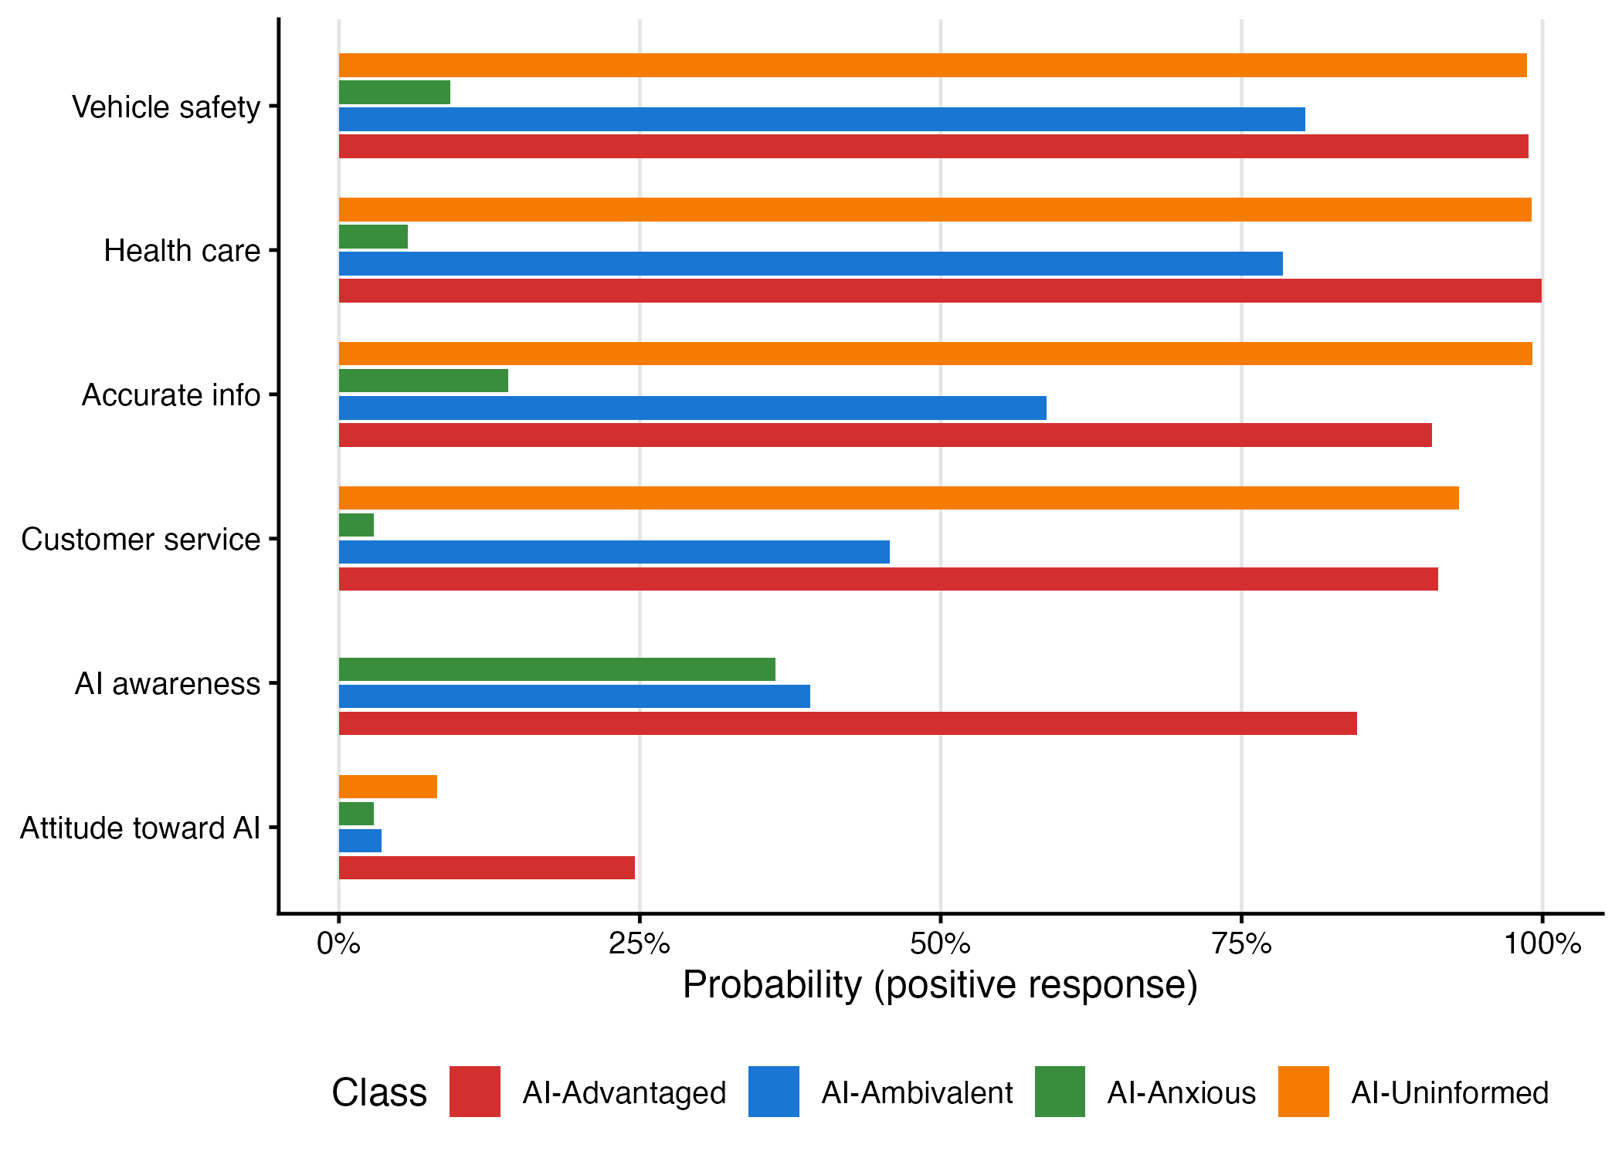
Class-conditional response probabilities for the four-class LCA solution (Form A). Bars represent the probability of each response category within each latent class. Top indicators (attitude, awareness) are shared across forms; bottom indicators (domains a–d) are Form A-specific.
Class profiles. The class-conditional response probabilities revealed four substantively distinct profiles (Figure 1).
Class 1: AI-Anxious (9.0% of Form A). The smallest class is defined by near-uniform negativity: 90% expressed concern about AI (only 3% excitement), and domain perceptions were overwhelmingly pessimistic, with the probability of seeing no harm ranging from just 3% (customer service) to 14% (accurate information). Yet 36% reported high AI awareness. These are not people who fear what they do not understand. The AI-Anxious know enough about AI to be genuinely alarmed.
Class 2: AI-Uninformed (33.1%). The defining feature of this largest class is an absence — not of opinion, exactly, but of the raw material from which opinions are formed. Essentially none reported high awareness (probability effectively zero). Their domain perceptions, however, were almost uniformly benign: 99% saw no harm from AI in health care, accurate information, or vehicle safety. We term this pattern "default non-concern" — a non-judgment that standard survey measures would code as acceptance. That roughly 40% of this class had a high school education or less points to the socioeconomic roots of this informational exclusion. Picture a warehouse worker who has encountered the word "AI" in a headline but has not thought much about it — their survey responses code as benign under conventional measures, not because they have weighed the evidence, but because AI does not yet feel relevant to their daily life.
Class 3: AI-Advantaged (20.5%). Here high awareness (85%) meets broad optimism. Members expressed the highest excitement of any profile (25%) and saw little harm across all domains (91–100%). Nearly half (47%) held a college degree. If there is a segment of the American public positioned to engage with and benefit from AI-mediated systems on its own terms, this is it. They are not uniformly tech-sector professionals, but they share the informational and economic resources to approach AI as something that works for them — and their disproportionate presence in governance conversations means their optimism risks being mistaken for public consensus.
Class 4: AI-Ambivalent (37.4%). The Uninformed default to non-concern; the Anxious default to worry. The Ambivalent class does neither — it discriminates. With moderate awareness (39% high), these respondents were relatively comfortable with AI in health care (78% not hurt) and vehicle safety (80%) but substantially more skeptical about customer service (46%) and accurate information (59%). A 69% concern rate and 38% college graduation rate place them between the Advantaged and Uninformed on both knowledge and education. This is informed, selective skepticism — the profile that most closely resembles what democratic deliberation about AI would demand.
Cross-form replication. The split-sample design allowed us to assess whether similar profiles emerged when different domain items were used. We computed Euclidean distances between Form A and Form B class profiles in the shared-indicator space (attitude and awareness). The results confirm strong cross-form correspondence: the AI-Anxious profiles matched with a distance of 0.076, the AI-Ambivalent profiles with 0.071, the AI-Uninformed profiles with 0.240, and the AI-Advantaged profiles with 0.313 (Table 2). The two profiles defined primarily by the shared indicators (Anxious and Ambivalent) showed near-perfect replication, while the two profiles more influenced by domain-specific items showed larger but still moderate distances. The emergence of the same four-type structure from different domain content supports H1 and suggests that these profiles capture genuine population heterogeneity rather than item-specific artifacts.
Table 2. Cross-form profile distances (Euclidean distance in shared-indicator space)
Form A Class | Form B Match | Distance | Label
A_C1 | B_C2 | 0.076 | AI-Anxious
A_C4 | B_C1 | 0.071 | AI-Ambivalent
A_C3 | B_C3 | 0.313 | AI-Advantaged
A_C2 | B_C4 | 0.240 | AI-Uninformed
4.2 SES, Awareness, and Class Membership
Model comparison. Table 3 presents the nested multinomial logistic regression models. Adding SES indicators (education and income) to the base demographic model significantly improved fit (LRT chi-square = 131, df = 12, p < .001). Adding AI awareness produced a much larger improvement (LRT chi-square = 3,222, df = 3, p < .001), confirming the dominant role of awareness in structuring AI attitudes. The full model, including both SES and awareness, fit substantially better than the base model (LRT chi-square = 3,265, df = 15, p < .001) and produced a BIC of 9,878, compared to 13,015 for the base model.
Table 3. Multinomial logistic regression model comparison
Model | Log-Lik | df | AIC | BIC | LRT χ² | LRT df | LRT p
Base (demographics + race) | −6,379.1 | 30 | 12,818.3 | 13,014.5 | — | — | —
+ SES | −6,313.8 | 42 | 12,711.6 | 12,986.3 | 131 | 12 | < .001
+ Awareness | −4,767.9 | 33 | 9,601.9 | 9,817.7 | 3,222 | 3 | < .001
Full (all predictors) | −4,746.8 | 45 | 9,583.6 | 9,877.9 | 3,265 | 15 | < .001
Average marginal effects. AI awareness dominated the model (Table 4). Each unit increase on the three-point awareness scale shifted respondents sharply toward the Advantaged class (AME = +1.67, p < .001) and away from all three alternatives, with the largest countervailing effect on Ambivalent membership (AME = -0.97, p < .001). The magnitude of the awareness effect — roughly 17 times larger than the next strongest predictor (age 65+, AME = +0.098) — underscores the centrality of awareness in structuring AI orientations.
Education and income effects operated in the direction predicted by H2 but were substantially smaller. High school education or less predicted increased Anxious membership (AME = +0.046, p < .001) and decreased Ambivalent membership (AME = -0.037, p = .036); upper income predicted increased Advantaged membership (AME = +0.033, p = .003). Among demographic controls, age 65+ strongly predicted Uninformed membership (AME = +0.098, p < .001), and Republican identification predicted Anxious membership (AME = +0.062, p < .001). Asian non-Hispanic respondents were notably more likely to be Advantaged (AME = +0.063, p < .001).
Table 4. Average marginal effects on class membership probability from full multinomial logistic model
Predictor | Anxious | Uninformed | Advantaged | Ambivalent
AI awareness (1-unit) | −0.198*** | −0.502*** | +1.669*** | −0.970***
HS or less | +0.046*** | −0.011 | +0.002 | −0.037*
Some college | +0.022* | −0.011 | +0.004 | −0.016
Lower income | +0.015 | +0.000 | +0.006 | −0.021
Upper income | −0.015 | +0.027 | +0.033** | −0.045*
Hispanic | −0.023* | +0.033 | −0.011 | +0.001
Black NH | +0.014 | −0.015 | −0.016 | +0.017
Asian NH | −0.032* | +0.046 | +0.063*** | −0.077**
Republican | +0.062*** | −0.055*** | −0.019* | +0.012
Female | +0.021** | −0.008 | −0.037*** | +0.024
Age 65+ | −0.048*** | +0.098*** | +0.024 | −0.074***
Figure 2
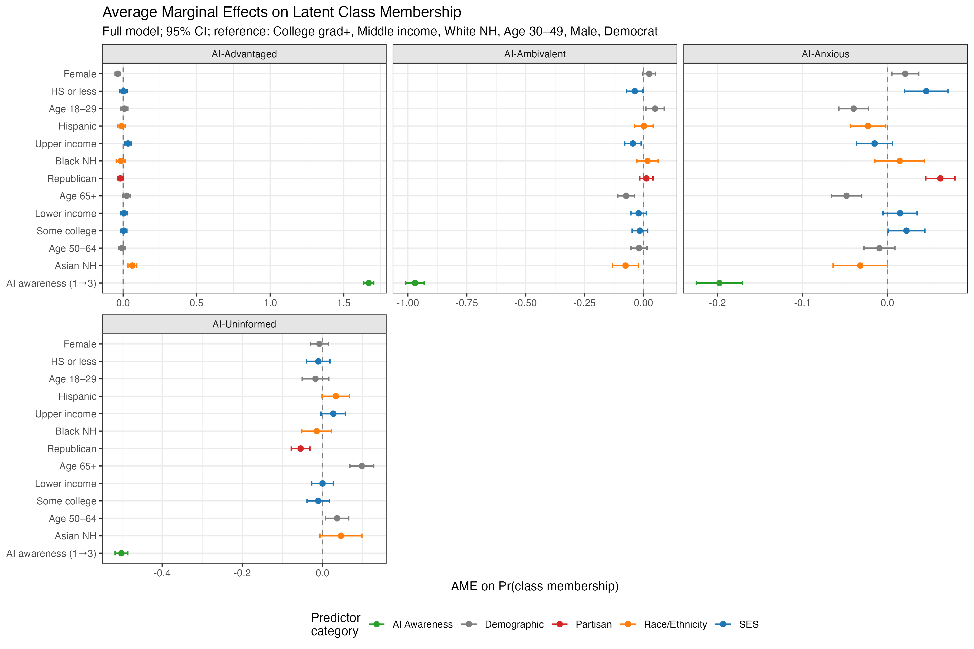
Average marginal effects of key predictors on latent class membership probability (full model). Points represent AMEs with 95% confidence intervals. Reference categories: College graduate+, Middle income, White NH, Ages 30–49, Male, Democrat/Lean Dem.
4.3 Mediation: SES, Awareness, and Class Membership
The mediation analysis tested H3 — that AI awareness mediates the SES-to-class relationship. Results from the bootstrap path models confirmed significant indirect effects through awareness for multiple class outcomes (Table 5).
For the AI-Advantaged class (Class 3), the indirect effect of high school education (relative to college graduate) through awareness was strong and negative (beta = -0.103, 95% CI [-0.123, -0.085], p < .001), indicating that lower education reduces the probability of Advantaged membership substantially through reduced awareness. In contrast, for the AI-Uninformed class (Class 2), the indirect effect of high school education through awareness was positive and of similar magnitude (beta = +0.115, 95% CI [0.094, 0.137], p < .001), indicating that lower education increases Uninformed membership through reduced awareness. Upper income showed a significant positive indirect effect on Advantaged membership through awareness (beta = +0.041, 95% CI [0.027, 0.055], p < .001).
These results establish awareness as a substantial mediator. For the Advantaged and Uninformed classes in particular, the indirect effects through awareness exceeded the direct effects of education, supporting the theoretical proposition that awareness functions as a gateway mechanism. Lower-SES individuals are less likely to be aware of AI, and this reduced awareness, in turn, channels them toward the Uninformed class and away from the Advantaged class. H3 is supported.
Table 5. Indirect effects of SES on class membership through AI awareness (bootstrap, 1,000 replications)
SES Predictor | Class Outcome | Indirect Effect (β) | 95% CI | p
HS or less | AI-Advantaged | −0.103 | [−0.123, −0.085] | < .001
HS or less | AI-Uninformed | +0.115 | [0.094, 0.137] | < .001
HS or less | AI-Anxious | −0.005 | [−0.009, −0.001] | .013
Upper income | AI-Advantaged | +0.041 | [0.027, 0.055] | < .001
Upper income | AI-Uninformed | −0.046 | [−0.062, −0.030] | < .001
Figure 3
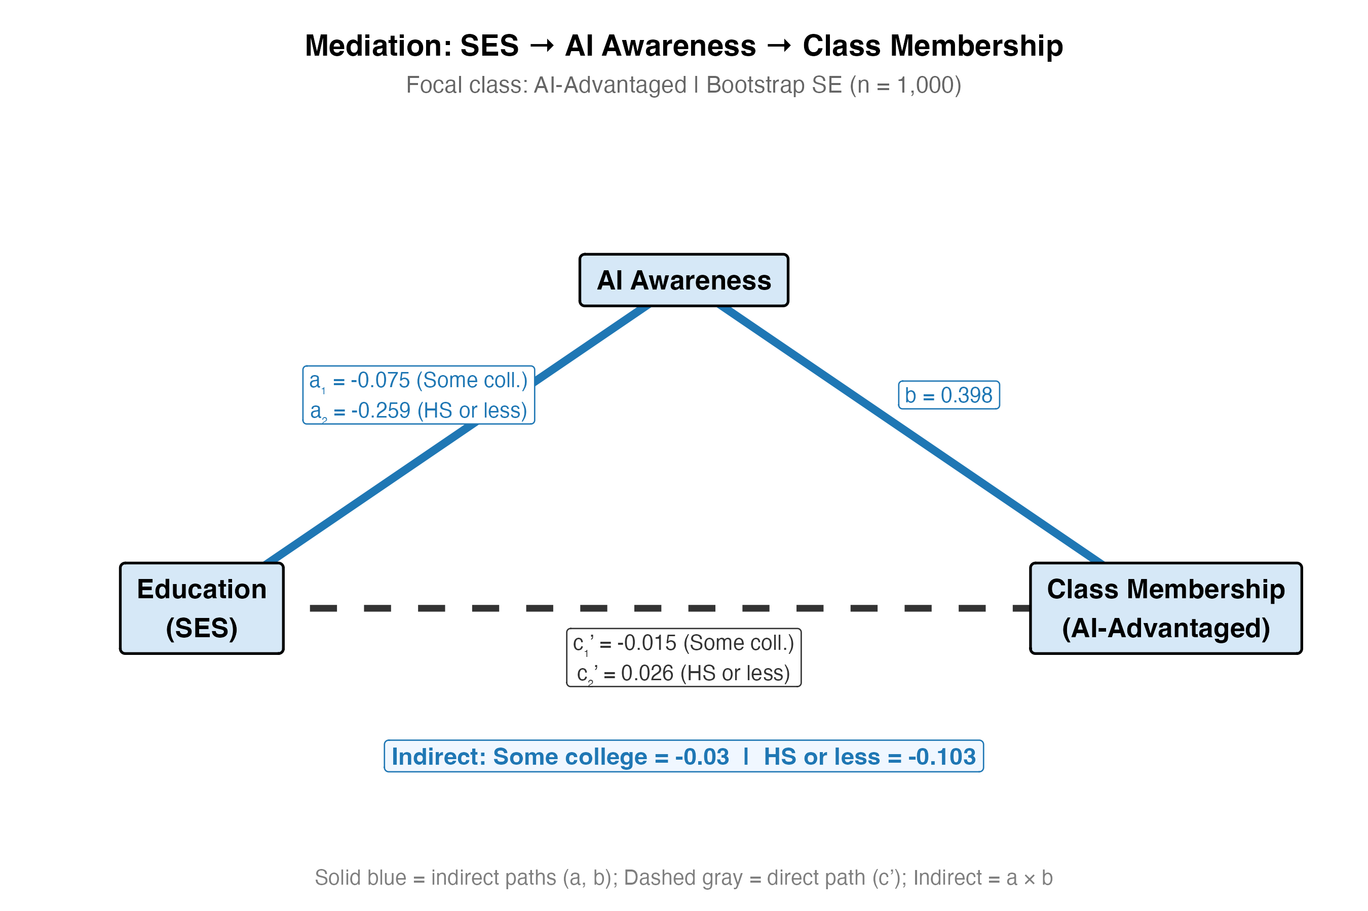
Mediation path diagram: SES to AI awareness to latent class membership. Standardized coefficients shown for the AI-Advantaged class outcome. Dashed lines represent indirect paths; solid lines represent direct paths.
4.4 Intersectional Analysis: Education Effects by Race/Ethnicity
To test H4, we examined whether education effects on class membership varied by race/ethnicity. The formal interaction test comparing the model with education-by-race interaction terms to the additive full model was statistically significant (LRT p = .007), indicating that education gradients in AI attitudes are not uniform across racial/ethnic groups.
Multi-group analysis revealed substantively important differences (Table 6). Among Black non-Hispanic respondents, having a high school education or less was associated with a 1.10 log-odds increase in Anxious class membership relative to the reference class (p = .028) — a substantially stronger effect than the 0.39 log-odds increase observed among White non-Hispanic respondents (p = .022). This suggests that the penalty for low education in terms of AI anxiety is nearly three times larger for Black than for White respondents.
Among Hispanic respondents, having some college education was associated with a 0.88 log-odds increase in Advantaged class membership (p = .013), a pattern not observed among other groups. This may reflect distinctive pathways through which education facilitates positive AI engagement in Hispanic communities. White non-Hispanic respondents showed the expected monotonic education gradient, with high school education predicting increased Anxious membership and college education predicting increased Advantaged membership.
These intersectional patterns support H4 and align with broader digital divide research documenting that the "returns" to education in technology engagement are not uniform across social positions (Robinson et al., 2015; Ragnedda and Muschert, 2013). Structural factors — including differential exposure to AI in occupational settings, varying trust in technology institutions, and racially differentiated experiences with algorithmic systems — likely contribute to these divergent education gradients.
Table 6. Education coefficients (log-odds) on Anxious class membership from multi-group multinomial logistic regression, by race/ethnicity
Race/Ethnicity | Education Level | Log-Odds (Anxious) | SE | p
White NH | HS or less | +0.386 | 0.168 | .022
Black NH | HS or less | +1.096 | 0.499 | .028
Hispanic | Some college | −0.234 | 0.448 | .602
Hispanic | HS or less | +0.307 | 0.402 | .445
Figure 4
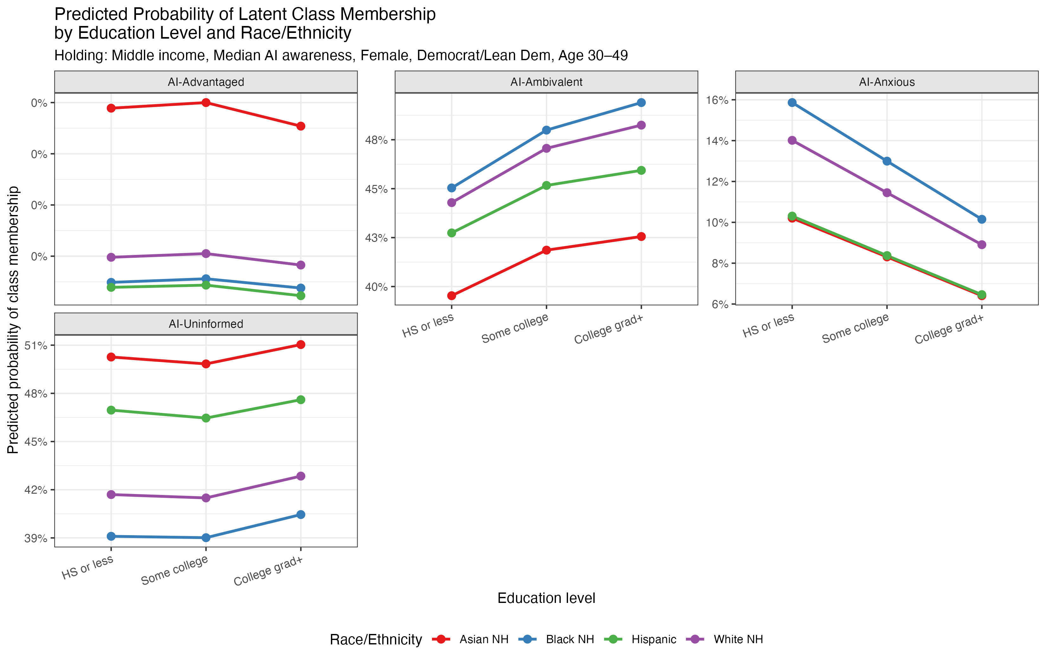
Predicted probability of latent class membership by education level and race/ethnicity. Predictions from the full multinomial logistic model, holding other variables at reference/median values.
4.5 Cross-Wave Validation
To assess structural stability (H5), we estimated comparable two-indicator LCA models using the shared attitude and awareness items across three survey waves: W119 (December 2022), W132 (August 2023), and W152 (August 2024). The BIC-optimal solution in all three waves was a two-class model (Table 7). This simpler structure reflects the reduced information available from only two indicators, which cannot resolve the full four-class typology identified in the six-indicator models. Nonetheless, the two-class solution consistently distinguished between a more engaged/polarized class and a more moderate/ambivalent class.
In W119, the two classes were labeled AI-Optimistic (higher excitement, higher awareness) and Ambivalent. In W132, they were AI-Skeptic (higher concern, moderate awareness) and Ambivalent. In W152, they were Ambivalent and AI-Skeptic. Class proportions differed significantly across waves (chi-square = 12,133.6, df = 4, p < .001), reflecting real shifts in the distribution of attitudes as AI became more prominent in public discourse between 2022 and 2024. The shift from an Optimistic/Ambivalent split in December 2022 to a Skeptic/Ambivalent split by August 2023 aligns with the public launch of ChatGPT and subsequent media coverage emphasizing both AI capabilities and risks.
Despite these distributional shifts, two structural features remained stable. First, the basic binary division between a more engaged class and a more moderate class persisted across all waves. Second, the education gradient in the more engaged class was consistent: college-educated respondents were disproportionately represented in whichever class showed higher awareness and more crystallized attitudes, whether optimistic or skeptical. This structural persistence, even amid shifting sentiment, partially supports H5 and suggests that the stratification of AI orientations reflects durable social patterns rather than momentary reactions.
Table 7. Cross-wave LCA validation: BIC-optimal two-class solutions across survey waves
Wave | Date | N | BIC (2-class) | Class Labels
W119 | Dec 2022 | 10,906 | 41,667.3 | AI-Optimistic + Ambivalent
W132 | Aug 2023 | 5,368 | 19,259.0 | AI-Skeptic + Ambivalent
W152 | Aug 2024 | 5,363 | 19,163.5 | Ambivalent + AI-Skeptic
Figure 5
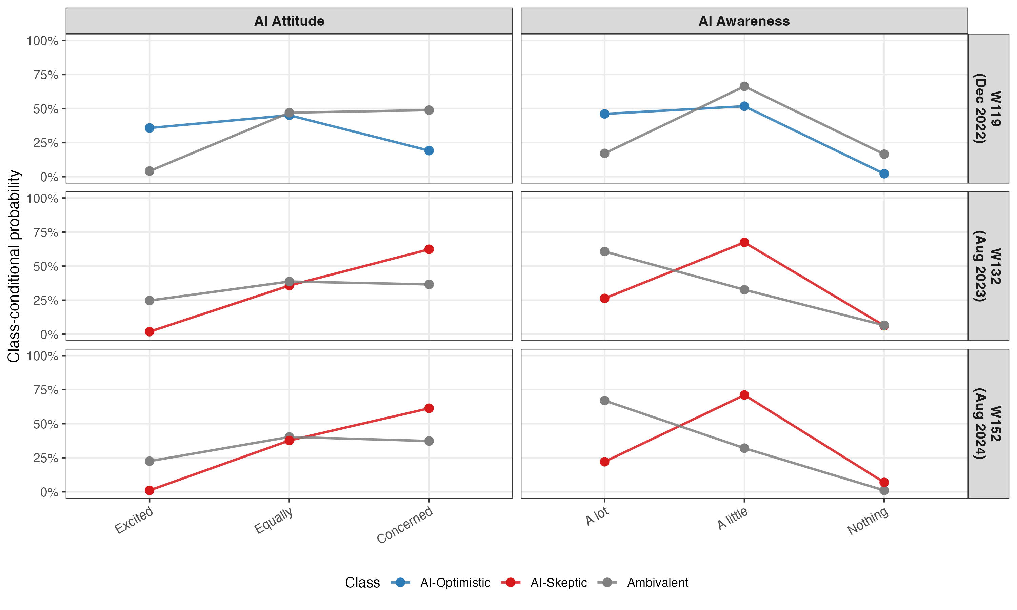
Cross-wave profile comparison: class-conditional probabilities on shared indicators (attitude and awareness) across W119 (December 2022), W132 (August 2023), and W152 (August 2024).
Figure 6
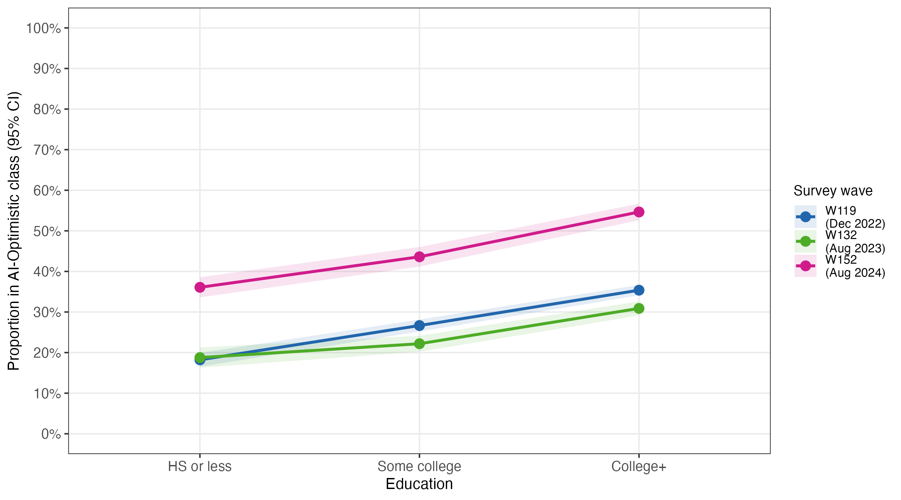
Education gradient in AI-Optimistic/Engaged class membership across survey waves. Proportion of each education group assigned to the most engaged class, with 95% confidence intervals.
4.6 Sensitivity Analysis: Awareness and Profile Structure
Because AI awareness serves a dual role in our analysis — as an LCA indicator defining the latent classes and as a predictor in the structural models — we conducted a sensitivity analysis removing awareness from the LCA indicators and re-estimating the models with the remaining five indicators (general attitude and four domain items) for both forms.
The results are revealing. With awareness removed, both Form A and Form B selected a three-class rather than four-class solution as optimal (BIC = 29,253.7 vs. 29,295.3 for 4-class in Form A; BIC = 29,338.2 vs. 29,364.2 in Form B). Cross-tabulating the original four-class assignments with the new three-class assignments showed a striking pattern: the AI-Anxious class mapped almost entirely onto one no-awareness class (99.6%), and the AI-Ambivalent class mapped onto another (95.6%). The AI-Uninformed and AI-Advantaged classes, however, merged into a single class (99.4% and 100% respectively). Awareness distributions across the three no-awareness classes were nearly identical (means ranging from 1.65 to 1.71 on the three-point scale), confirming that awareness no longer differentiated membership once removed from the classification model.
This finding carries two implications. First, it confirms that the distinction between the Uninformed and Advantaged profiles rests substantially on awareness level rather than on domain-specific attitude patterns — these two groups hold similar orientations toward AI's domain applications but differ in whether they know enough about AI to articulate those orientations. Second, and more importantly for our theoretical framework, this result provides direct empirical support for the sequential logic of the three-level AI divide: awareness (Level 1) is not merely correlated with attitude complexity (Level 2) but is structurally necessary for the differentiation we observe. Without the awareness divide, the attitude complexity divide partially collapses. The Uninformed and Advantaged classes share similar domain-level orientations; what separates them is the gateway of awareness that our framework theorizes as foundational.
The sensitivity analysis also reinforces the robustness of two features of the typology. The AI-Anxious and AI-Ambivalent profiles remain intact without awareness, indicating that these profiles reflect genuine differences in domain-level attitudes rather than awareness artifacts. The three-class solution showed high assignment stability (98.1%), suggesting that the underlying structure is well-defined even with reduced indicator sets.
Table 8. Sensitivity analysis: LCA model fit with and without awareness indicator
Form | Indicators | Classes | BIC | Entropy | Min Class (%)
A | 6 (with awareness) | 3 | 38,607.6 | 0.656 | 9.0
A | 6 (with awareness) | 4 | 38,538.8 | 0.659 | 9.0
A | 5 (no awareness) | 3 | 29,253.7 | 0.663 | 9.0
A | 5 (no awareness) | 4 | 29,295.3 | 0.689 | 2.9
B | 6 (with awareness) | 3 | 38,438.3 | 0.723 | 14.2
B | 6 (with awareness) | 4 | 38,343.9 | 0.643 | 10.6
B | 5 (no awareness) | 3 | 29,338.2 | 0.601 | 9.8
B | 5 (no awareness) | 4 | 29,364.2 | 0.704 | 2.1
Table 9. Cross-tabulation of original four-class (with awareness) and sensitivity three-class (without awareness) assignments, Form A
Original Class (6 indicators) | Sensitivity Class 1 | Sensitivity Class 2 | Sensitivity Class 3
Class 1: AI-Anxious (9.0%) | 481 (99.6%) | 2 (0.4%) | 0 (0.0%)
Class 2: AI-Uninformed (33.1%) | 0 (0.0%) | 11 (0.6%) | 1,764 (99.4%)
Class 3: AI-Advantaged (20.5%) | 0 (0.0%) | 0 (0.0%) | 1,100 (100.0%)
Class 4: AI-Ambivalent (37.4%) | 0 (0.0%) | 1,921 (95.6%) | 89 (4.4%)
Together, these analyses establish both the robustness and the theoretical meaning of the four-profile typology. We turn now to their implications.
5. Discussion
5.1 Four Orientations, Not One Spectrum
Ask Americans whether they are excited or concerned about AI, and you will get a number. You will not learn that a third of the population lacks the awareness to answer meaningfully, or that another 9% are informed enough to be alarmed, or that 21% combine high knowledge with broad optimism. The four profiles identified here challenge the common practice of reporting AI attitudes as a population average or a simple favorable/unfavorable split. An individual who has never heard of AI and defaults to non-concern (Uninformed) occupies a fundamentally different position from one who is highly informed and sees broad benefits (Advantaged), even though both might be coded as "not concerned" on a standard survey item. That this four-class structure replicated across independent split samples — using different domain items but producing profile distances as low as 0.07 on shared indicators — points to genuine population types (Savage et al., 2013), not artifacts of particular question wordings.
5.2 The AI Divide as Digital Inequality
Consider two hypothetical respondents, both registering as "not excited" about AI on a standard survey. One has never encountered the term; the other reads AI safety research for a living. A single-item measure treats them as identical. Our three-level framework exposes the inequality that this conflation conceals. The most striking confirmation comes at the awareness level: AI awareness alone dwarfs every other predictor of class membership (each step up in awareness raises the probability of Advantaged membership by 1.67 percentage points — roughly 17 times larger than any demographic factor), and awareness itself is socially stratified by education and income, creating the kind of cascading inequality van Dijk (2005) theorized for motivational access.
But the framework's deeper payoff lies in distinguishing between the Uninformed and Ambivalent classes — a distinction that a standard favorable/unfavorable survey measure would miss entirely. Both classes express low excitement about AI. Yet the Uninformed (essentially zero high awareness, 93–99% seeing no harm) represent default non-concern born of ignorance, while the Ambivalent (moderate awareness, harm perceptions ranging from 46% to 80% across domains) represent genuine if critical engagement. That the former are disproportionately lower-SES (40% high school or less) and the latter more educated (38% college graduate) demonstrates how SES shapes not just the direction but the sophistication of technology attitudes. The Ambivalent class's capacity to discriminate between domains where AI seems benign (health care, vehicle safety) and domains where it seems threatening (customer service, accurate information) exemplifies the attitude complexity our framework predicts — a capacity that the Uninformed and Anxious classes lack.
5.3 Awareness as a Gateway Mechanism
Why does education predict AI attitudes? Not primarily through the channels one might expect — not through critical thinking, not through occupational exposure, not through income-mediated access to technology. The dominant pathway runs through something far simpler: knowing that AI exists. The mediation analysis establishes this directly. Education's effect on class membership operates substantially through awareness: the indirect effect of high school education on Advantaged membership through awareness (beta = -0.103) exceeds most direct effects in the model. The sensitivity analysis sharpens this finding. When awareness is removed from the LCA, the Uninformed and Advantaged classes — which share broadly similar domain attitudes — collapse into a single class. What separates them is not how they evaluate AI applications but whether they possess the awareness to engage with AI as a recognizable object of opinion. Awareness functions as the gateway our framework theorizes. In a precise sense, it is structurally constitutive of the profile differences — meaning that without it, those differences do not merely weaken but disappear. When we remove awareness from the classification model, the Uninformed and Advantaged profiles collapse into one. This is not the behavior of a correlate; it is the behavior of a structural precondition.
The practical implications are significant. If awareness is a primary pathway through which SES shapes AI attitudes, then interventions targeting AI literacy could partially disrupt the reproduction of inequality. Unlike education or income, which are difficult to change through policy in the short term, awareness is amenable to communication strategies, media coverage, and public engagement initiatives. Our findings indicate that such efforts, if they succeed in reaching lower-SES populations, could shift individuals from the Uninformed toward the Ambivalent or even Advantaged profiles — not by making them more enthusiastic about AI, but by enabling informed engagement.
5.4 Intersectional Complexity
The same diploma does not purchase the same AI orientation across racial lines. Among Black respondents with a high school education or less, the log-odds of Anxious membership are 1.10 — nearly three times the 0.39 figure for White respondents with the same credential. That gap (LRT p = .007) cannot be reduced to a generic SES story; it demands race-specific explanation. Several mechanisms may contribute. First, Black Americans with lower education may have greater exposure to AI systems in punitive contexts — criminal justice algorithms, welfare eligibility systems, hiring screens — that promote anxiety about AI (Noble, 2018; Benjamin, 2019; Eubanks, 2018). Second, lower institutional trust among Black Americans, documented in health and technology domains (Boulware et al., 2003), may amplify the effect of low education on technology anxiety. Third, the historical exclusion of Black communities from technology development and governance may create a context where lower education more strongly predicts feeling threatened by technologies perceived as imposed rather than chosen (Benjamin, 2019).
The distinctive Hispanic pattern, where some college education predicts increased Advantaged membership, may reflect generational dynamics within Hispanic communities, where younger, more educated individuals are disproportionately engaged with technology in bilingual digital environments and serve as technology brokers for their communities (Katz and Gonzalez, 2016). These intersectional findings reinforce the argument by Robinson et al. (2015) and Ragnedda and Muschert (2013) that digital divides cannot be understood through single-axis analyses.
5.5 Stability and Change
Between December 2022 and August 2024, the American public's dominant AI orientation flipped from optimism to skepticism. Yet beneath this surface transformation, the architecture of the divide held firm. The cross-wave analysis reveals a productive tension between structural stability and distributional change. The basic divide between a more engaged class and a more moderate class persists across all three waves (2022–2024), and the education gradient within the engaged class remains consistent. Yet the content shifts — from optimism (December 2022, before widespread ChatGPT awareness) to skepticism (August 2023 onward). This decoupling of structural stability from attitudinal content carries an important implication: the AI divide is fundamentally about differential engagement with technology, not differential enthusiasm. Higher-SES individuals consistently hold more crystallized attitudes; what changes is whether those attitudes are positive or negative.
5.6 Future Research Directions
The most pressing question our findings raise is causal: do changes in AI awareness precede attitude shifts, or is the relationship more reciprocal? Longitudinal panel data tracking the same individuals through the rapid diffusion of generative AI tools (2022–2024) would allow researchers to observe profile transitions and test the sequential structure our mediation model assumes. Complementary qualitative work could illuminate what "uninformed" means in practice — whether these individuals are genuinely unaware of AI or encounter algorithmic systems without recognizing them as such, and whether the Anxious class responds to specific negative experiences or to broader narratives of technology risk. Cross-national comparison would reveal whether the four-profile structure is specific to the American context or generalizes to societies with different AI governance regimes and media environments (Helsper, 2012). Finally, linking attitudinal profiles to behavioral outcomes — adoption rates, service avoidance, passive acceptance of AI-mediated decisions — would strengthen the practical relevance of the typology and test whether the AI divide has material consequences beyond the attitudinal domain.
5.7 Limitations
Several limitations bear on interpretation. The use of modal class assignments in the structural models introduces classification error that may attenuate estimates. While three-step approaches partially address this concern (Vermunt, 2010), future work could implement bias-adjusted methods. The cross-sectional design of the primary analysis precludes causal inference about the SES-to-awareness-to-class pathway; longitudinal panel data would strengthen the mediation claims. The Pew ATP, while nationally representative, is an online panel, which may underrepresent individuals with the lowest levels of digital engagement — precisely those most likely to be in the Uninformed class. Our cross-wave validation was limited to two indicators, producing a coarser classification than the primary six-indicator models. AI awareness also serves a dual role in our analysis — as an LCA indicator that helps define the latent classes and as a predictor in the structural models. Our sensitivity analysis (Section 4.6) confirms that this dual role matters: removing awareness from the LCA reduces the solution from four to three classes, with the Uninformed and Advantaged profiles merging. We interpret this as evidence that awareness is structurally constitutive of the typology rather than merely correlated with it, but the partial circularity in the structural models should be acknowledged, and the dominance of awareness as a predictor (AME = +1.67 for Advantaged membership) should be interpreted with this caveat in mind. Finally, the moderate entropy values in our LCA models (0.643–0.659) indicate that some respondents are not crisply classified, though these values are within acceptable ranges for applied LCA (Clark and Muthen, 2009).
5.8 Implications for Policy and Practice
For technology companies and policymakers, the four-profile typology offers a more actionable segmentation than simple favorable/unfavorable polling. The 9% who are Anxious need reassurance grounded in specific domain evidence, not generic claims about AI benefits. The 33% who are Uninformed need basic awareness before they can meaningfully participate in governance conversations. The 37% who are Ambivalent — already engaged enough to differentiate across domains — need accessible channels for substantive input. And the 21% who are Advantaged, while well-positioned to participate in technical governance, should not be mistaken for the voice of the broader public.
Our findings carry implications for AI governance and public engagement. The existence of a large Uninformed class (33%) means that many Americans are effectively absent from public deliberation about AI — not because they oppose it, but because they lack the awareness needed to form opinions. Public engagement strategies that assume a baseline of AI knowledge may systematically exclude one-third of the adult population.
The awareness-mediation finding points to AI literacy initiatives as a partial remedy, but two caveats are essential. First, the intersectional results caution that one-size-fits-all approaches may be insufficient; the different education gradients by race/ethnicity imply that AI literacy programs should be sensitive to community-specific concerns — addressing algorithmic bias and surveillance for Black communities, leveraging bilingual digital engagement for Hispanic communities. Second, framing the Uninformed class purely as an information deficit risks reproducing the "deficit model" critiqued in public understanding of science research (Wynne, 1992). The one-third of Americans who lack AI awareness may not simply be missing information; their disengagement may reflect rational responses to structural exclusion from technology development, a lack of perceived relevance rooted in material circumstances, or distrust of institutions that promote technological change (Couldry and Mejias, 2019). Effective AI engagement strategies must therefore address structural conditions alongside informational ones.
6. Conclusion
This study introduced a three-level AI divide framework and documented four distinct orientations toward artificial intelligence in the American public. The AI-Anxious, AI-Uninformed, AI-Advantaged, and AI-Ambivalent profiles capture qualitative differences in how people relate to AI — differences that are systematically structured by socioeconomic status, mediated by awareness, and moderated by race/ethnicity. These findings extend the digital divide framework from technology access and use into the domain of technology attitudes, arguing that how people think about AI is no less stratified than how they use the internet.
The AI divide matters because it shapes who participates in the governance of a technology that will increasingly affect everyone. If the most informed, most engaged orientations toward AI are concentrated among higher-SES, disproportionately White and Asian populations, then the voices shaping AI policy risk reflecting a narrow slice of the public. Our findings suggest that awareness — basic knowledge of AI's existence and relevance — is the critical first step. Bridging the awareness divide will not eliminate disagreement about AI, nor should it. But it can ensure that all segments of the public have the foundation needed to participate in what may be the most consequential technology debate of the coming decades.

References
Araujo T, Helberger N, Kruikemeier S and de Vreese CH (2020) In AI we trust? Perceptions about automated decision-making by artificial intelligence. AI & Society 35(3): 611–623.
Arel-Bundock V, Greifer N and Heiss A (2024) How to interpret statistical models using marginaleffects for R and Python. Journal of Statistical Software 111(9): 1–32.
Asparouhov T and Muthén B (2014) Auxiliary variables in mixture modeling: Three-step approaches using Mplus. Structural Equation Modeling 21(3): 329–341.
Benjamin R (2019) Race After Technology: Abolitionist Tools for the New Jim Code. Polity Press.
Boulware LE, Cooper LA, Ratner LE, LaVeist TA and Powe NR (2003) Race and trust in the health care system. Public Health Reports 118(4): 358–365.
Brossard D, Scheufele DA, Kim E and Lewenstein BV (2009) Religiosity as a perceptual filter: Examining processes of opinion formation about nanotechnology. Public Understanding of Science 18(5): 546–558.
Bucher T (2017) The algorithmic imaginary: Exploring the ordinary affects of Facebook algorithms. Information, Communication & Society 20(1): 30–44.
Cave S, Coughlan K and Dihal K (2019) Scary robots: Examining public responses to AI. In: Proceedings of the 2019 AAAI/ACM Conference on AI, Ethics, and Society, pp. 331–337.
Carter L, Liu D and Cantrell C (2020) Exploring the intersection of the digital divide and artificial intelligence: A hermeneutic literature review. AIS Transactions on Human-Computer Interaction 12(4): 253–275.
Clark SL and Muthén B (2009) Relating latent class analysis results to variables not included in the analysis. Unpublished manuscript.
Collins LM and Lanza ST (2010) Latent Class and Latent Transition Analysis: With Applications in the Social, Behavioral, and Health Sciences. Wiley.
Couldry N and Mejias UA (2019) The Costs of Connection: How Data Is Colonizing Human Life and Appropriating It for Capitalism. Stanford University Press.
DiMaggio P, Hargittai E, Celeste C and Shafer S (2004) Digital inequality: From unequal access to differentiated use. In: Neckerman K (ed.) Social Inequality. Russell Sage Foundation, pp. 355–400.
Eubanks V (2018) Automating Inequality: How High-Tech Tools Profile, Police, and Punish the Poor. St. Martin's Press.
Eurobarometer (2017) Attitudes Towards the Impact of Digitisation and Automation on Daily Life. Special Eurobarometer 460. European Commission.
Floridi L, Cowls J, Beltrametti M, et al. (2018) AI4People — An ethical framework for a good AI society. Minds and Machines 28(4): 689–707.
Hagenaars JA and McCutcheon AL (eds) (2002) Applied Latent Class Analysis. Cambridge University Press.
Hargittai E (2002) Second-level digital divide: Differences in people's online skills. First Monday 7(4).
Hargittai E and Hinnant A (2008) Digital inequality: Differences in young adults' use of the internet. Communication Research 35(5): 602–621.
Hargittai E and Hsieh YP (2012) Succinct survey measures of web-use skills. Social Science Computer Review 30(1): 95–107.
Helsper EJ (2012) A corresponding fields model for the links between social and digital exclusion. Communication Theory 22(4): 403–426.
Ipsos (2023) Global Views on AI 2023. Ipsos.
Jasanoff S (2015) Future imperfect: Science, technology, and the imaginations of modernity. In: Jasanoff S and Kim SH (eds) Dreamscapes of Modernity: Sociotechnical Imaginaries and the Fabrication of Power. University of Chicago Press, pp. 1–33.
Katz VS and Gonzalez C (2016) Toward meaningful connectivity: Using multilevel communication research to reframe digital inequality. Journal of Communication 66(2): 236–249.
Lazarsfeld PF and Henry NW (1968) Latent Structure Analysis. Houghton Mifflin.
Linzer DA and Lewis JB (2011) poLCA: An R package for polytomous variable latent class analysis. Journal of Statistical Software 42(10): 1–29.
Neudert LM, Knuutila A and Howard PN (2020) Global Attitudes Towards AI, Machine Learning & Automated Decision Making. Oxford Internet Institute.
Noble SU (2018) Algorithms of Oppression: How Search Engines Reinforce Racism. NYU Press.
NTIA (National Telecommunications and Information Administration) (1999) Falling Through the Net: Defining the Digital Divide. U.S. Department of Commerce.
Nylund KL, Asparouhov T and Muthén BO (2007) Deciding on the number of classes in latent class analysis and growth mixture modeling: A Monte Carlo simulation study. Structural Equation Modeling 14(4): 535–569.
Pew Research Center (2023) Growing Public Concern About the Role of Artificial Intelligence in Daily Life. Pew Research Center.
Ragnedda M (2018) Conceptualizing digital capital. Telematics and Informatics 35(8): 2366–2375.
Ragnedda M and Muschert GW (eds) (2013) The Digital Divide: The Internet and Social Inequality in International Perspective. Routledge.
Robinson L, Cotten SR, Ono H, et al. (2015) Digital inequalities and why they matter. Information, Communication & Society 18(5): 569–582.
Rosseel Y (2012) lavaan: An R package for structural equation modeling. Journal of Statistical Software 48(2): 1–36.
Savage M, Devine F, Cunningham N, et al. (2013) A new model of social class? Findings from the BBC's Great British Class Survey experiment. Sociology 47(2): 219–250.
van Dijk JAGM (2005) The Deepening Divide: Inequality in the Information Society. Sage.
van Dijk JAGM (2020) The Digital Divide. Polity Press.
Vermunt JK (2010) Latent class modeling with covariates: Two improved three-step approaches. Political Analysis 18(4): 450–469.
Viswanath K and Bond K (2007) Social determinants and nutrition: Reflections on the role of communication. Journal of Nutrition Education and Behavior 39(2): S20–S26.
Wang C, Boerman SC, Kroon AC, Möller J and de Vreese CH (2025) The artificial intelligence divide: Who is the most vulnerable? New Media & Society 27(7): 3867–3889. DOI: 10.1177/14614448241232345.
Wei L, Teo HH, Chan HC and Tan BCY (2011) Conceptualizing and testing a social cognitive model of the digital divide. Information Systems Research 22(1): 170–187.
Wynne B (1992) Misunderstood misunderstanding: Social identities and public uptake of science. Public Understanding of Science 1(3): 281–304.
Zhang B and Dafoe A (2019) Artificial intelligence: American attitudes and trends. Center for the Governance of AI, Future of Humanity Institute, University of Oxford.

